**4.1.5 Restructure of Policy Status Outputs**

**Output Business Requirements**

|  |  |
| --- | --- |
| **EXECUTIVE OWNER:** |  |
| **BUSINESS SPONSOR:** |  |

**DOCUMENT HISTORY**

|  |  |  |  |
| --- | --- | --- | --- |
| **Version** | **Date** | **Author** | **Description** |
| 1.0 | 07/15/2010 | Suzanne Dusak | Initial draft |
| 2.0 | 07/19/2010 | Suzanne Dusak | Changes based on feedback from Jeff W, Dawn Z and Traci E. |
| 3.0 | 07/20/2010 | Suzanne Dusak | Changes based on feedback from Jeff W. |

**Table of Contents**

1. Introduction 4

1.1 Document Purpose 4

1.2 Intended Audience of This Document 4

1.3 References 4

1.4 Glossary of Terms 4

2. Scope of the Solution 4

2.1 Background & Business Objective 4

2.1.1 Problem Description 4

2.1.2 General Requirements 5

2.2 Assumptions 6

2.3 Constraints 6

2.4 Dependencies 6

2.5 Requirements Risks 6

3. Outputs 7

3.1 Dashboards/Views 7

3.1.1 Policy Dashboard 7

3.1.2 Phase List View 7

3.1.3 Status Reason List View 7

3.1.4 My Policy Summary 7

3.1.5 My Pending List View 7

3.1.6 My Active List View 7

3.1.7 My Policies with Outstanding Requirements List View 7

3.1.8 Team Pending List View 7

3.1.9 Team Active List View 8

3.1.10 Team Policies with Outstanding Requirements List View 8

3.1.11 UW Requirements List View on Policy 8

3.2 Reports 8

3.2.1 Policy Detail Report 8

3.2.2 Disposition Summary & Detail Report 8

4. Data Requirements 8

4.1 Input/Source Data 8

4.2 Data Glossary 9

5. Output Generation Requirements 13

5.1 Security/Access 13

5.2 Accessibility 14

5.3 Selection Criteria 15

5.4 Input Parameters 15

5.5 Frequency/Scheduling 16

5.6 Output Generation Trigger 16

6. Output Type Delivery Requirements 17

6.1 Output Display Requirements 17

6.2 Column Headings 18

6.2.1 Policy Dashboard 18

6.2.2 My policy list views (includes: Phase, Status Reason, Pending and Active) 18

6.2.3 Team policy list views (includes: Phase, Status Reason, Pending and Active) 18

6.2.4 My Policies w/ Outstanding Reqs List View 18

6.2.5 Team Policies w/ Outstanding Reqs List View 18

6.2.6 UW Reqs List View on Policy 18

6.3 Sorting 19

6.3.1 Policy Dashboard 19

6.3.2 My/Team policy list views (includes: Phase, Status Reason, Pending and Active) 19

6.3.3 My/Team Policies w/ Outstanding Reqs List View 19

6.3.4 UW Reqs List View on Policy 19

6.4 Grouping/Sub-Totals 19

6.4.1 Policy Dashboard 19

6.5 Design Considerations 20

6.5.1 Policy Dashboard 20

6.5.2 My Policy Summary List Views 21

6.5.3 Policy Detail Report 22

7. Quality Requirements 23

7.1 System Response/Generation Time 23

7.2 Availability 23

7.3 Reliability 23

7.4 Usability 23

8. Exception Handling & Audit Requirements 23

8.1 Audit Requirements 23

8.2 Failure Recovery 23

9. Approvals 23

10. Appendices 24

10.1 Appendix A: Policy Phase/Agent Action/CRM Policy Status Mapping 24

# Introduction

## Document Purpose

The purpose of this document is to describe all the functional, non-functional and data requirements for the Reporting/Output needs of business in a sufficient level of detail so the technical team can design a solution to satisfactorily fulfill the business need. It is also intended to describe the necessary background and related information needed to fully understand the motivations behind the specified requirements.

This document is not intended to describe the design or implementation of the end solution. However, this document may contain specific user design preferences or design constraints. These are to be considered by the technical team during design; however the solution design and delivery is the responsibility of the technical team.

## Intended Audience of This Document

The intended audiences of this document are stakeholders who are responsible for providing the business requirements, technical stakeholders responsible for design and development and QA stakeholders responsible for verifying the solution meets the stated requirements.

## References

This document references the following resources. It is recommended that readers of this specification read these references prior to reading this document.

## Glossary of Terms

A glossary of ambiguous and new terms is included in the appendix of this document.

# Scope of the Solution

## Background & Business Objective

### Problem Description

The currentcase reporting does not provide clarity to the key points in the lifecycle or where agent action is required. The data is made available as a whole, but further refinement is required to drive agents to the tasks which need to be worked.

Status mapping is changing which will allow for a greater granularity of tracking where agent action is required.

### General Requirements

|  |  |  |
| --- | --- | --- |
| **Req #** | **Item** | **Description** |
| 1. | Update existing reports and systems | Update existing reporting & systems to represent the new statuses and carrier status reasons. |
| 2. | Identify and capture Policy Phases | Create concept of a Policy Phase based on Policy Status Reasons.The Policy Phase should be captured for each policy. The Policy Phase should be captured in VUE and fed to CRM during the existing, daily policy data feed. |
| 3. | One-time update for Policy Phases - VUE | Perform a one-time update to populate the Policy Phase for existing policies based on the current Policy Status Reason. |
| 4. | Identify and capture Agent Action | Create concept of Agent Action required for a policy based on Policy Status Reasons. The Agent Action should be captured in VUE and fed to CRM during the existing, daily policy data feed. |
| 5. | One-time update for Agent Action - VUE | Perform one-time update of "Pending" policies to populate the Agent Action. |
| 6. | Change existing "My Policy Summary" in CRM | The "My Policy Summary" should be modified to contain the following items/links:   1. Pending 2. Active 3. Outstanding Requirements |
| 7. | Create List Views for "My Policy Summary" items/links | Create "My" and "Team" Views for the following items/links located under the "My Policy Summary":   1. Pending 2. Active 3. Outstanding Requirements |
| 8. | Create a Policy Dashboard in CRM | Create a dashboard that provides a summarized view of the agents' policies within the various Phases of the policy lifecycle. The dashboard should contain the following data:   1. Carrier 2. Policy Phases 3. Count of policies in each Policy Phase 4. Policy Status Reasons 5. Count of policies in each Policy Status Reason 6. Agent Action Icons 7. Legend for Agent Action Icons |
| 9. | Create List Views for Policy Dashboard | Create Views for the following items/links located on the Policy Dashboard:   1. Policy Phases 2. Policy Status Reasons |
| 10. | Create List Views for Policies w/Outstanding UW Requirements | Create "My" and "Team" Views that provide a list of Outstanding UW Requirements for Pending policies. |
| 11. | Disconnect UW Requirements Sync with CRM | The process of loading the UW Requirements data (including UW Notes) from VUE to CRM should be discontinued. The UW Requirements data should no longer be stored in CRM. Instead, the UW Views in CRM will access the UW Requirements data in VUE to display the data in CRM. |
| 12. | One-time update to remove UW Requirements - CRM | Perform one-time update to remove all UW Requirements data from CRM since the data will no longer be stored in CRM. |
| 13. | Modify existing UW Requirements Screen | The existing UW Requirements List View tied to a specific policy should be modified to allow the user to filter on UW Requirement Activity Status. In addition, there are a few changes required to the View layout. |
| 14. | Combine columns - VUE | Combine Activity Description and Comments columns for UW Requirements in VUE. This includes performing a one-time update to concatenate the existing UW Requirements data. As a result, the columns will be displayed as 1 column in CRM. |
| 15. | Policy Detail Report | Provide ability for the Policy details, including UW Requirements and Notes, to be printed in a usable layout. |
| 16. | Disposition Summary & Detail Report | Provide ability for agents to easily view policies that have been "dispositioned" within a particular time frame. |
| 17. | Update Incentive Point | Incentive Point must be updated to pull the new fields from VUE in order to meet these requirements. |
| 18. | Status Detail field in CRM | The Status Detail field on the Policy Entity should be hidden. In addition, all associated workflows should be removed. |

## Assumptions

* 1. If the CRM is utilized for the datasource, the data should be synchronized with VUE to achieve a reliable result. The ultimate datasource is the carrier feed, thus the reporting should match VUE.
  2. Updates to existing reporting and systems are being worked separately under the following JIRA tickets:
     1. INS-1532 - VUE Policy Status Updates
        1. This request has been completed in the 10.6.1.0 release.
     2. INS-1540 - Add new Policy field for Carrier Status to VUE.
        1. This request has been completed in the 10.6.1.0 release.
     3. INS-2036 - Add new Policy field for Carrier Status to CRM
        1. This request has been completed in the 10.7.3.0 release.
  3. The ability to filter by Agent Name is not included as a filter in the Policy Dashboard. However, the "Team" list views have the ability to sort by Agent Name.

## Constraints

## Dependencies

1. Data definitions and mapping between insurance carrier and Insphere are synchronized.
2. Reporting should be accessible through multiple contexts (resource center, Ops guide, etc).
3. File feed timing
4. Status feed and carrier status mapping

## Requirements Risks

* 1. Resource constraints
  2. Not all data definitions align to the same meaning
  3. Some data requested may not be captured or have an available field today

# Outputs

## Dashboards/Views

### Policy Dashboard

*Create a dashboard to provide an overview of policies by phase and policy status reason for a given agent/hierarchy. The summary page should be an on screen display and will not require printing. It should be located in CRM under Workplace (on the left navigator) and positioned below Agent Desktop. The agents should be able to drill down into a particular phase and view a list of policies currently in that phase. If possible, the agents should also be able to drill down into a particular policy status reason and view a list of the policies with that status reason as well.*

### Phase List View

*The Phase List View should contain a list of policies in a particular phase, based on the phase selected by the user from the Policy Dashboard.*

### Status Reason List View

*The Status Reason List View should contain a list of policies with a particular policy status reason, based on the status reason selected by the user from the Policy Dashboard.*

### My Policy Summary

*This is a group of links on the Agent Desktop. The entries in this section of the Desktop should be Pending policies, Policies with Outstanding Requirements and Active policies.*

### My Pending List View

*This view should contain a list of pending policies for a particular agent.*

### My Active List View

*This view should contain a list of active policies for a particular agent.*

### My Policies with Outstanding Requirements List View

*This view should contain a list of pending policies with outstanding UW requirements for a particular agent.*

### Team Pending List View

*This view should contain a list of all pending policies for the user and their downline hierarchy. The user's security in CRM should determine whether the user is eligible to see other agents' policies or only their own.*

### Team Active List View

*This view should contain a list of all active policies for the user and their downline hierarchy.. The user's security in CRM should determine whether the user is eligible to see other agents' policies or only their own.*

### Team Policies with Outstanding Requirements List View

*This view should contain a list of all pending policies with outstanding UW requirements for the user and their downline hierarchy. The data visible to the user should mimic the existing user's security in CRM.*

### UW Requirements List View on Policy

*This is an existing view attached to each policy. Modifications to the layout are needed to help the agent easily identify UW activities that require action.*

## Reports

### Policy Detail Report

*The Policy Detail report will provide an overview of the entire pending case including outstanding and completed UW Requirements, as well as UW Notes. It should be an aggregate view of all case activity in an easily read and printable report, allowing the user to view/print multiple policies at once. This should be a print function within CRM and function similar to the Lead Card functionality.*

### Disposition Summary & Detail Report

*The purpose of the decisions summary report will be to provide the agent visibility to cases which are Active>issued, Pending>Approved, or terminated within a given window. This will enable the agent to either isolate the cases where further action is required to support activation or declination activities or gain insight into recently activated cases ready for comp. Creation of a CRM View may be sufficient. However, further research and discussion is needed.*

# Data Requirements

## Input/Source Data

The following data is required to populate one or more of the new reports/screens requested in section 3:

|  |  |  |
| --- | --- | --- |
| **#** | **Data** | **Source** |
| 1. | Policy data | VUE |
| 2. | Policy Phases | VUE |
| 3. | Agent Hierarchy | VUE |
| 4. | Case Management data | CRM |
| 5. | Underwriting Requirements (including UW Notes) data | VUE |
| 6. | Agent Action | VUE |

## Data Glossary

The following table contains a list of data elements, definitions and business rules required to populate one or more of the new reports requested in section 3.

Note: Not all of the data elements listed below are available. The requirement for 3.2.1 PolicyDetail Reportis to include the data that is currently available for a policy.

| **Data Term** | **Definition** | **Field Name in VUE** | **Field Name in CRM** | **Display on Policy Detail Report?** | **Rules** |
| --- | --- | --- | --- | --- | --- |
| Activity Source |  | Activity Source | Activity Source | Yes |  |
| Activity Type |  | Activity Type | Activity Type | Yes |  |
| Admin Fee |  |  | Admin Fee | Yes |  |
| Admin Fee Base |  |  |  | Yes, if available |  |
| Agent | The first and last names of the agent tied to an application/policy. | First Name, Last Name | Agent | Yes |  |
| Agent Action | Based on the Policy Status Reason, identifies the type of action required for a policy in an effort to assist the agent with managing his business. | **Does not exist** | **Does not exist** | No | Derived field in VUE based on Policy Status Reason. Data is then passed to CRM.  Available options are:   * Definite Action Required * Possible Action Required |
| Agent Hierarchy | Management structure for the agent tied to an application/policy.  The hierarchy consists of the following levels:   * Zone * Agency Manager * Sales Leader * Agent |  |  | No |  |
| Agent ID | Unique number assigned to an agent for identification purposes. | Agent Code | Agent Code | No |  |
| Annual Premium |  | Annual Premium | Annual Premium | Yes |  |
| Application Date | The date the application was signed by the applicant. | Application Date | Application Date | Yes |  |
| Application Number |  | Application Number | Application Number | Yes |  |
| Carrier | (Insurance Carrier) - Organization that develops and offers Insurance related products. | Carrier Name | Carrier | Yes |  |
| Carrier Status Reason | Identifies the current "state" of an application/policy as provided by the Carrier. |  |  | Yes |  |
| Case Manager |  |  | Case Manager - Being added in 4.2.1 project. | Yes |  |
| Client | The name of the person(s) who applied for Insurance Coverage. | Customer ID | Insured | Yes |  |
| County |  |  |  | Yes, if available |  |
| Created On |  |  | Created On | Yes, if available |  |
| Currency |  |  |  | Yes, if available |  |
| Effective Date | The date the application/policy becomes active and effective, as provided by the Carrier. | Effective Date | Effective Date | Yes |  |
| Exchange Rate |  |  |  | Yes, if available |  |
| Face Amount |  |  | Face Amount | Yes |  |
| Insured Type |  | Customer Type | Insured Type | Yes |  |
| Issue Date |  | Issued Date | Issued Date | Yes |  |
| Line of Business (LOB) | Category of products based on market segment.  Values consist of:   * Health * Life * Disability * LTC | LOB | Line of Business | No |  |
| Modal Premium |  |  |  | Yes, if available |  |
| Modified By |  |  | Modified By | Yes |  |
| Originating Application |  |  |  | Yes, if available |  |
| Originating Opportunity |  |  | Originating Opportunity | Yes, if available |  |
| Payment Mode |  | Payment Mode | Payment Mode | Yes |  |
| Policy Expiration Date |  |  |  | Yes, if available |  |
| Policy Number | Unique account number assigned to an application/policy.  (This number is provided to VUE via a Carrier policy file.) | Policy Number | Policy Number | Yes |  |
| Policy Phases | Steps an application/policy goes through in the policy lifecycle process. Specific application/policy statuses make up each phase. There are currently 7 phases identified. | **Does not exist** | **Does not exist** | No | Derived field in VUE, based on Policy Status Reason. Data is then passed to CRM.  See Appendix A - Policy Phase / Agent Action / CRM Policy Status Mapping |
| Policy State | This is the state in which the applicant lived when they applied for Coverage and/or currently lives as provided by the Carrier. (2 digit state code) | State | State | Yes |  |
| Policy Status | Identifies the current "state" of an application/policy. | Status | Policy Status | Yes |  |
| Policy Status Date | The date in which the current policy status was loaded in VUE for an application/policy. | Status Date | Status Date | Yes |  |
| Policy Status Reason | Further identifies the current "state" of an application/policy. | Status Reason | Status Reason | Yes |  |
| Policy Status Reason Date |  | Status Reason Date | Status Reason Date | Yes |  |
| Premium Amount Quoted |  |  | Premium Amount Quoted | Yes |  |
| Product | The type of Insurance Coverage. Products roll up into specific Lines of Business. | Product Code | Product | Yes |  |
| Product Name |  | Product Name | Product Name | Yes |  |
| Requested By & Necessary Before (MN Life only) |  |  | "Necessary Before" is being added under INS-2121 & INS-2165. CR's are not assigned to a release. "Requested By" is not currently available in CRM. | Yes, if available |  |
| Requested Date |  | Requested Date | Requested Date | Yes |  |
| Requirement Status | Currently, the following statuses may be provided from the various carriers:   * Approved * Cancelled * Closed * Declined * Received * Waived * Active * Null * Outstanding * Pending * Sent to Client * Submitted | Activity Status | Activity Status | Yes | *See UW Requirements Activity Status Category |
| Split Agent Code |  |  | Agent | Yes |  |
| Split Percentage |  | Split Percentage | Split % | Yes |  |
| Status Detail |  |  |  | No | This field should be hidden and all associated workflows removed. |
| Submitted Date |  | Submitted Date | Submitted Date | Yes |  |
| Target Amount |  |  | Target Amount | Yes |  |
| UW Requirement Description |  | Req Details | Concatenated columns: Activity Description and Comments | Yes | The following columns should be concatenated in VUE and CRM as one is applicable for UW Requirements and the other for UW Notes, but both provide the same information:   * Activity Description * Comments |
| UW Requirement Name |  | Req Code | Activity Code? | Yes |  |
| UW Requirements Activity Status Category |  | **Does not exist** | **Does not exist** | No | Derived field in VUE based on UW Requirements Activity Status, which is then passed to CRM. The statuses are grouped into the following 3 categories:   * ALL - Contains all UW Requirements, regardless of status. * Closed - Contains UW Requirements in the following statuses:   + Approved   + Cancelled   + Closed   + Declined   + Received   + Waived * Outstanding - Contains UW Requirements in the following statuses:   + Active   + Null   + Outstanding   + Pending   + Sent to Client   + Submitted   *Note: The business includes ALL UW Notes in the "Outstanding" bucket as they do not have a status. |

# Output Generation Requirements

## Security/Access

The following users should have access to the dashboards/views/reports/, based on existing CRM/Resource Center security:

Note: "Wrote" (as being used below) refers to the agent tied to the policy in VUE and the Owner of the policy in CRM.

|  |  |  |  |
| --- | --- | --- | --- |
| **#** | **User** | **CRM User Role** | **Access** |
| 1. | Agent | * Insphere Agent | * Ability to see policies he/she wrote (setasdefault) |
| 2. | Sales Assistant | * Insphere Administrative Assistant * Insphere New Business Specialist | * Ability to see policies he/she wrote (set as default) * Ability to see policies written by hierarchy |
| 3. | Sales Leader | * Insphere Sales Manager | * Ability to see policies he/she wrote (set as default) * Ability to see policies written by hierarchy |
| 4. | Agency Manager | * Insphere Agency Manager | * Ability to see policies he/she wrote (set as default) * Ability to see policies written by hierarchy |
| 5. | Zone Manager | * Insphere Zone Manager | * Ability to see policies he/she wrote (set as default) * Ability to see policies written by hierarchy |
|  | Intouch Team | * Insphere National Sales Support | * Ability to see all policies. |
|  | Insphere Corporate User | * Insphere Corporate User | * Ability to see all policies. |

## Accessibility

The following table contains the requirements for the location of the dashboards/views/reports:

| **#** | **Report/View** | **Location** |
| --- | --- | --- |
| 1. | Policy Dashboard | Link located below "Agent Desktop" under Workplace in CRM |
| 2. | Phase List View | Via Policy Dashboard in CRM |
| 3. | Status Reason List View | Via Policy Dashboard in CRM |
| 5. | My Policy Summary | On "Agent Desktop" page in CRM (exists today) |
| 6. | My Pending List View | Via My Policy Summary in CRM |
| 7. | My Active List View | Via My Policy Summary in CRM |
| 8. | My Policies with Outstanding Requirements List View | Via My Policy Summary in CRM |
| 9. | Team Pending List View | Via My Policy Summary in CRM |
| 10. | Team Active List View | Via My Policy Summary in CRM |
| 11. | Team Policies with Outstanding Requirements List View | Via My Policy Summary in CRM |
| 12. | UW Requirements List View on Policy | Via Policy entity in CRM |
| 13. | Policy Detail Report | Via any policy list view in CRM |
| 14. | Disposition Summary & Detail Report | May be report in RC or Advanced Find in CRM.  Creation of a CRM view may be sufficient. Needs further research/discussion. |

## Selection Criteria

The following options should be available for the user to select when viewing the dashboards/views/reports (indicated by "**X**" below:

|  |  |  |  |  |  |  |  |
| --- | --- | --- | --- | --- | --- | --- | --- |
| **#** | **Report/View** |  |  |  |  |  |  |
| Carrier | My Policies | Team Policies | UW Reqs Status Category | Policy Status | Date Range |
| 1. | Policy Dashboard | **X** | **X** | **X** | N/A | N/A | N/A |
| 2. | Phase List View | N/A | N/A | N/A | N/A | N/A | N/A |
| 3. | Status Reason List View | N/A | N/A | N/A | N/A | N/A | N/A |
| 5. | My Pending List View | N/A | N/A | N/A | N/A | N/A | N/A |
| 6. | My Active List View | N/A | N/A | N/A | N/A | N/A | N/A |
| 7. | My Policies w/ Outstanding Reqs List View | N/A | N/A | N/A | N/A | N/A | N/A |
| 8. | Team Pending List View | N/A | N/A | N/A | N/A | N/A | N/A |
| 9. | Team Active List View | N/A | N/A | N/A | N/A | N/A | N/A |
| 10. | Team Policies w/ Outstanding Reqs List View | N/A | N/A | N/A | N/A | N/A | N/A |
| 11. | UW Reqs List View on Policy | N/A | N/A | N/A | **X** | N/A | N/A |
| 12. | Policy Detail Report | **X** | N/A | N/A | N/A | N/A | N/A |
| 13. | Disposition Summary & Detail Report | **X** | **X** | **X** | N/A | **X** | **X** |

## Input Parameters

The data for the dashboards/views/reports should be limited by the following:

Note: Policies in a Terminated (status) and (Duplicate App) status reason should be excluded from the dashboard, views and reports.

| **#** | **Report/View** | Input Parameters |
| --- | --- | --- |
| 1. | Policy Dashboard | Should contain counts of policies by Phase and Policy Status Reason based on filter criteria entered by the user. |
| 2. | Phase List View | Should contain list of policies based on:   * Phase selected on Policy Dashboard AND * Filter criteria entered by the user on Policy Dashboard |
| 3. | Status Reason List View | Should contain list of policies based on:   * Status Reason selected on Policy Dashboard AND * Filter criteria entered by the user on Policy Dashboard |
| 5. | My Pending List View | Should contain a list of policies where:   * Policy Status = Pending AND * User is the owner of the policy |
| 6. | My Active List View | Should contain a list of policies where:   * Policy Status = Active AND * User is the owner of the policy |
| 7. | My Policies w/ Outstanding Reqs List View | Should contain a list of outstanding requirements for policies where:   * Policy Status = Pending AND * UW Requirements Activity Status Category = Outstanding AND * User is the owner of the policy |
| 8. | Team Pending List View | Should contain a list of policies where:   * Policy Status = Pending AND * Policy owner is in user's hierarchy |
| 9. | Team Active List View | Should contain a list of policies where:   * Policy Status = Active AND * Policy owner is in user's hierarchy |
| 10. | Team Policies w/ Outstanding Reqs List View | Should contain a list of outstanding requirements for policies where:   * Policy Status = Pending AND * UW Requirements Activity Status Category = Outstanding AND * Policy owner is in user's hierarchy |
| 11. | UW Reqs List View on Policy | Should contain a list of all UW Requirements (regardless of status) for a particular policy. |
| 12. | Policy Detail Report | Should contain all policies where:   * Policy Status = Pending AND * Filter criteria entered by the user |
| 13. | Disposition Summary & Detail Report | Should contain policies where:   * Policy Status Date is within date range selected by the user |

## Frequency/Scheduling

The output will be generated upon arrival to the appropriate screen in CRM. No scheduling will be required. The data will be populated based on the existing VUE IP to CRM daily load schedule.

## Output Generation Trigger

Upon arrival on screen that houses output, the output should populate.

# Output Type Delivery Requirements

## Output Display Requirements

| **#** | **Report/View** | **Display Requirements** |
| --- | --- | --- |
| 1. | Policy Dashboard | * Summarized view of policy data containing counts broken out by Policy Phases and Policy Status Reasons. * Page should contain drop down select boxes for filter criteria. * Once filters are selected by the user, the page should automatically refresh. * Page should contain Agent Action icons for each Policy Status Reason. * The Policy Phases and Policy Status Reasons should be a link to the applicable list view, including selected filter criteria. * Page should contain legend for Agent Action icon. |
| 2. | Phase List View | * Use standard CRM grid/list view. |
| 3. | Status Reason List View | * Use standard CRM grid/list view. |
| 5. | My Pending List View | * Use standard CRM grid/list view. |
| 6. | My Active List View | * Use standard CRM grid/list view. |
| 7. | My Policies w/ Outstanding Reqs List View | * Use standard CRM grid/list view. * Expand Activity Description column. * Wrap the text in the Activity Description column. (This is needed so that all comments for the UW Notes are visible.) * Remove Created On column. * Add column for Requested Date.   + Column should be placed before Date Received column. |
| 8. | Team Pending List View | * Use standard CRM grid/list view. |
| 9. | Team Active List View | * Use standard CRM grid/list view. |
| 10. | Team Policies w/ Outstanding Reqs List View | * Use standard CRM grid/list view. * Expand Activity Description column. * Wrap the text in the Activity Description column. (This is needed so that all comments for the UW Notes are visible.) * Remove Created On column. * Add column for Requested Date.   + Column should be placed before Date Received column. |
| 11. | UW Reqs List View on Policy | * Use standard CRM grid/list view. * Make the Outstanding Requirements stand out from the others. (Suggestion: Either bold or change font color for requirements where the Activity Status Category = Outstanding. * Expand Activity Description column. * Wrap the text in the Activity Description column. (This is needed so that all comments for the UW Notes are visible.) * Remove Created On column. * Add column for Requested Date.   + Column should be placed before Date Received column. |
| 12. | Policy Detail Report | * Printable report containing aggregate view of all policy activitythat currently exists on the Policy entity in CRM, including UW requirements and UW Notes.   Note: See section 4.2 Data Glossary, column labeled "Display onPolicy Detail Report?" for the list of fields that should be displayed on this view/report. |
| 13. | Disposition Summary & Detail Report | * Summarized view of policies that have been "dispositioned" within a particular timeframe. |

## Column Headings

### Policy Dashboard

|  |  |  |  |
| --- | --- | --- | --- |
| Carrier | Policy Phase | Policy Status Reason | Totals |

### My policy list views (includes: Phase, Status Reason, Pending and Active)

|  |  |  |  |  |  |  |  |  |
| --- | --- | --- | --- | --- | --- | --- | --- | --- |
| **My Policies:** | | | | | | | | |
| App Date | Action Required | Carrier | Client Name | Policy Number | Policy Status | Policy Status Reason | Issue Date | Effective Date |

### Team policy list views (includes: Phase, Status Reason, Pending and Active)

|  |  |  |  |  |  |  |  |  |  |
| --- | --- | --- | --- | --- | --- | --- | --- | --- | --- |
| **My Team Policies:** | | | | | | | | | |
| Agent Name | App Date | Action Required | Carrier | Client Name | Policy Number | Policy Status | Policy Status Reason | Issue Date | Effective Date |

### My Policies w/ Outstanding Reqs List View

|  |  |  |  |  |  |  |  |  |  |  |
| --- | --- | --- | --- | --- | --- | --- | --- | --- | --- | --- |
| **My Policies with Outstanding UW Requirements:** | | | | | | | | | | |
| Policy Number | App Date | Carrier | Client Name | Activity Type | UW Requirements (Activity Code) | Requested Date | Requirement Status (Activity Status) | Description / Comment | Policy Status | Policy Status Reason |

### Team Policies w/ Outstanding Reqs List View

|  |  |  |  |  |  |  |  |  |  |  |  |
| --- | --- | --- | --- | --- | --- | --- | --- | --- | --- | --- | --- |
| **Team Policies with Outstanding UW Requirements:** | | | | | | | | | | | |
| Agent Name | Policy Number | App Date | Carrier | Client Name | Activity Type | UW Requirements (Activity Code) | Requested Date | Requirement Status (Activity Status) | Description / Comment | Policy Status | Policy Status Reason |

### UW Reqs List View on Policy

|  |  |  |  |  |  |
| --- | --- | --- | --- | --- | --- |
| **UW Requirements List View on Policy:** | | | | | |
| Activity Code | Activity Status | Activity Type | Date Requested | Date Received | Description/Comment |

## Sorting

The dashboards/views/reports should be sorted by:

### Policy Dashboard

* Carrier
* Policy Phase in the following order:
  + Application Submitted
  + Application Received
  + In Underwriting
  + UW Decision Complete
  + Policy Activation
  + Active
  + Terminated
* Within each phase, sort by Policy Status Reason.

### My/Team policy list views (includes: Phase, Status Reason, Pending and Active)

* Agent Name
* Policy Phase
* Policy Status Reason

### My/Team Policies w/ Outstanding Reqs List View

* Policy Status Date in ascending order.
* Policy number

### UW Reqs List View on Policy

* UW Requirements Activity Status Category, with Outstanding listed first.
* Created On in descending order.

## Grouping/Sub-Totals

### Policy Dashboard

* Group By:
  + Carrier
  + Policy Phase
  + Policy Status Reason
* Totals:
  + Policy Phase
* Sub-Totals:
  + Policy Status Reason

## Design Considerations

### Policy Dashboard

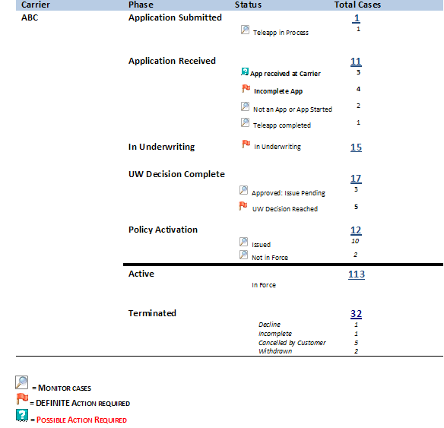

### My Policy Summary List Views

Add ability to see drop down containing all policy views.

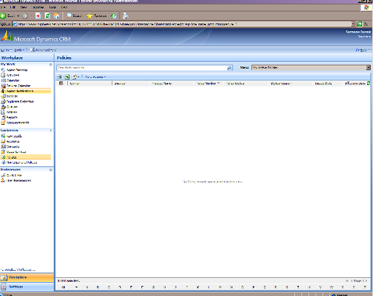

### Policy Detail Report

**DETAIL PENDING POLICY REPORT   
as of Friday, May 21, 2010**

**ABC Insurance Company**

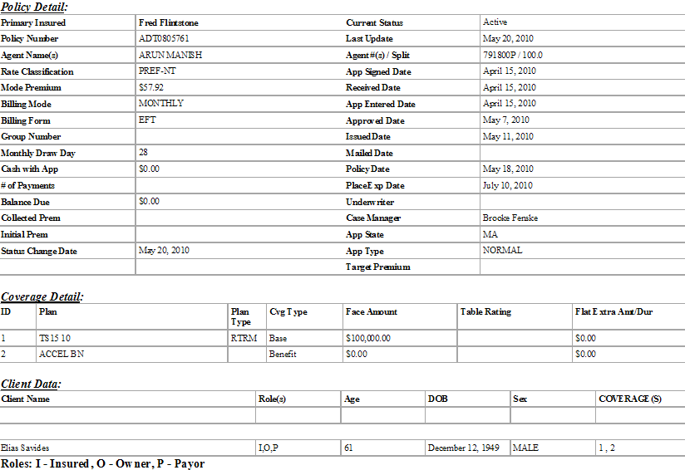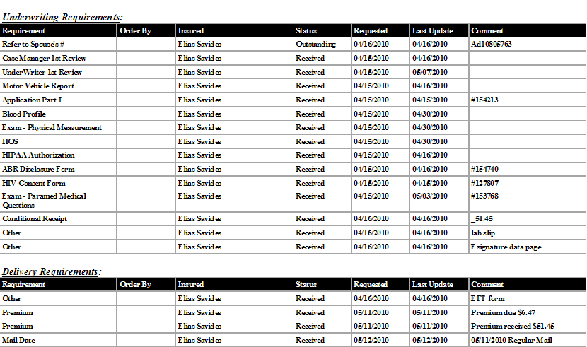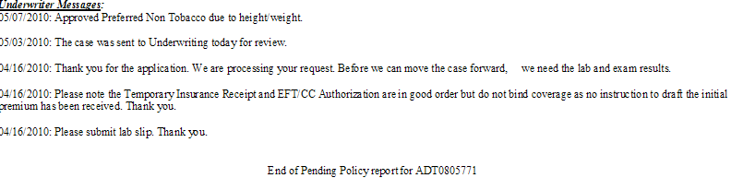

# Quality Requirements

## System Response/Generation Time

## Availability

## Reliability

## Usability

# Exception Handling & Audit Requirements

## Audit Requirements

Standard CRM audits

## Failure Recovery

# Approvals

The undersigned agree to the contents of this Output Business Requirements document. By signing this document, the approvers agree that the requirements specified in this document are complete and accurate sufficient to proceed with design and development.

**Executive Owner: Approved via email 07/19/2010**

Jeff Walker Date:

**Business Sponsor:**

Dawn Zieger Date:

**IT Lead:**

Joaquin Zaragoza Date:

# Appendices

## Appendix A: Policy Phase/Agent Action/CRM Policy Status Mapping

|  |  |  |  |  |
| --- | --- | --- | --- | --- |
| **Policy Status** | **Policy Status Reason** | **Policy Phase** | **Agent Action Identifier** | **CRM Policy Statuses** |
| ACTIVE | Re-instated | Active | Monitor Cases |  |
| ACTIVE | Replacement Conversion | Active | Monitor Cases |  |
| ACTIVE | Suspended | Active | Monitor Cases |  |
| ACTIVE | InForce | Active | Monitor Cases |  |
| ACTIVE | Issued, Not InForce | Policy Activation | Possible Action Required |  |
| PENDING | App Received By Carrier | Application Received | Possible Action Required |  |
| PENDING | Issued, Not InForce | Policy Activation | Possible Action Required |  |
| PENDING | Underwriting Decision Complete | UW Decision Complete | Monitor Cases |  |
| PENDING | Approved, Issue/Activation Pending | UW Decision Complete | Possible Action Required |  |
| PENDING | In Underwriting | In Underwriting | Possible Action Required |  |
| PENDING | Teleapp In Process | Application Submitted | Possible Action Required |  |
| PENDING | Not an App or App Started | Application Received | Monitor Cases |  |
| PENDING | Teleapp Interview Complete | Application Received | Monitor Cases |  |
| PENDING | Incomplete App | Application Submitted | Definite Action Required |  |
| PENDING | Submitted to Carrier | Application Submitted | Monitor Cases |  |
| PENDING | Delivery Receipt Outstanding | In Underwriting | Definite Action Required |  |
| PENDING | App Received | Application Received | Possible Action Required |  |
| TERMINATED | Withdrawn | Terminated | No Action Required |  |
| TERMINATED | Term After Issue | Terminated | No Action Required |  |
| TERMINATED | Deceased | Terminated | No Action Required |  |
| TERMINATED | Cancelled by Customer | Terminated | No Action Required |  |
| TERMINATED | Decline | Terminated | No Action Required |  |
| TERMINATED | Closed (Incomplete) | Terminated | No Action Required |  |
| TERMINATED | Expired | Terminated | No Action Required |  |
| TERMINATED | Replaced | Terminated | No Action Required |  |
| TERMINATED | Duplicate App | Need to exclude policies in this status. | N/A |  |