Functional Specifications
Iteration 4
12/7/2009

Table of Contents
Revision and Signoff Sheet ii
Change Record ii
Approvals ii
Overview 1
Project Summary 1
Functional Specifications 1
Opportunity Distribution 1
Point of Sales 2
Agent Desktop 3
Opportunity 5
Contact 6
Data Migration 7
Do Not Call 8
Duplicate Detection 9
Usability Items 10
Notifications 10
Integration 11
Additional Requests: 13
Out of Scope 13

Revision and Signoff Sheet

Change Record
Date | Author | Version | Change reference
11/23/2009 | K. Reid | 1.0 | Initial document completion.
11/24/2009 | K. Reid | 2.0 | Updates after meeting with Insphere team.
11/24/2009 | K. Reid | 3.0 | Updates after internal team meeting.
11/25/2009 | K. Reid | 4.0 | Updates with feedback from Vue team on integration items.
12/1/2009 | K. Reid | 5.0 | Updates with feedback from Martin and Larry.
12/7/2009 | K. Reid | 6.0 | Updates with Skype and Gryphon features.

Approvals
Date | Name | Title | Signature

Overview
This document details the functional requirements which will be used to configure Microsoft Dynamics CRM. The information listed covers the specific requirement for each feature listed as the responsibility of Sonoma Partners on the Project Scope Estimator, including a test scenario for each and high-level security role considerations.

Project Summary
InSphere would like to implement Microsoft Dynamics CRM to streamline and centralize their sales and marketing operations across their vast network of agents. CSSI has asked Sonoma Partners to assist with the installation, customization and implementation of the Microsoft Dynamics CRM application.

Functional Specifications

Opportunity Distribution
Feature | PSE ID 9: Identify ownership and viewing rules
Sonoma ID | 2,928 | Iteration | 4
Priority | 02-Major | Est. Effort | 40 - 60 hours
Dependencies
Requirement | Identify corporate, office, or individually owned leads to enable assignment rules after Opportunity creation.  Each Opportunity and Contact record will have an Owner and an Assigned Agent. The Owner of the Opportunity will represent the user or Business Unit who brought the Opportunity into the system. The Assigned Agent will represent the user who is currently working the Opportunity (for Personally Developed Leads, these users would be the same). Since the Assigned Agent will not use the native Owner field, native security cannot be applied. Therefore, Teams will be created to share the records with the appropriate users. To ensure that all of the users who should be able to see and edit the Opportunity based on the Assigned Agent have the correct permissions, each user will have their own Team. Teams will be created dynamically when a user is assigned to a Business Unit and will consist of each user, their manager, the manager above them, all the way up to the Parent Business Unit (InsphereDev in Dev, InsphereModel in Model, and Insphere in Production). In addition, any user in each Business Unit who has the Insphere Administrative Assistant role will be included in the team for the user’s Business Unit, parent Business Unit, all the way up to the hierarchy.  Any sharing to the Teams that is done on the Opportunity and Policy must also be applied to the related Contact.  - 1. Whoever creates the Opportunity is the Owner of the Opportunity. Whoever creates that Contact will always own the Contact.  - 2. Upon Opportunity creation, if the Assigned Agent on an Opportunity is not populated, automatically populate with the Owner.  - 3. Once a Policy is created, the Contact becomes owned by the corporation. That Contact needs shared with the team of the owner of the Policy.  - 4. When an Opportunity is assigned, that Opportunity and the associated Contact record are shared with user and the team associated with that user.  - 5. If the Assigned Agent on an Opportunity is changed, that Opportunity and associated Contact record are shared with the newly assigned agent and the team associated with that user. The Opportunity record is unshared with the previous Assigned Agent. If the previously Assigned Agent does not have any other active Opportunities or Policies with the Contact, the Contact is also unshared with the previously assigned agent’s team.  - 6. When a user is deactivated, all Opportunities that they own and are assigned to are inactive with a Lost Status Reason of Agent Departure.  - 7. If a new Opportunity is created through the Raw Lead process and the owner of the Contact is inactive, change the Contact's Owner to be the new Agent.  - 8. If the Assigned Agent of the Contact changes, the Contact needs to be shared with that user and the user’s team. If the previously Assigned Agent does not have any Policies or active Opportunities, unshare the Contact with the previously Assigned Agent's team.  - 9. If the Assigned Agent of the Contact changes, the Contact needs to be shared with that user and the user’s team.  - When an Insured gets assigned on a Non-Insphere Policy, the Contact selected as the Insured must be shared with the team of the owner of the Non-Insphere Policy.  When an Administrative Assistant is removed to a Business Unit, they have to be removed from all teams. When an Administrative Assistant is added to a Business Unit, the user needs to be added to the teams for all users associated to that Business unit or child Business Units.
Assumptions | Assumes that teams are established and maintained when users are created or reassigned to a Business Unit.
Testing Scenario
Security Roles
Questions

Feature | PSE ID 23: Manual Distribution
Sonoma ID | 2,929 | Iteration | 4
Priority | 02-Major | Est. Effort | 8 – 16 hours
Dependencies
Requirement | Remove the ability for users to assign records. Rather, the Assigned Agent field will be used and updates will be made appropriately to the sharing of that record based on the rules in 2,928.
Assumptions
Testing Scenario
Security Roles
Questions

Point of Sales
Feature | CR 34: Quoting Tab  Change Log ID 64: Point of Sales links
Sonoma ID | 2,940 | Iteration | 4
Priority | 02-Major | Est. Effort | 20-24 hours
Dependencies
Requirement | Create a Quote menu on the Opportunity with links to each Vendor of type Health, Life, or Long Term Care. When the link is selected, CRM will need to call the appropriate “Lily Pad” for each vendor.  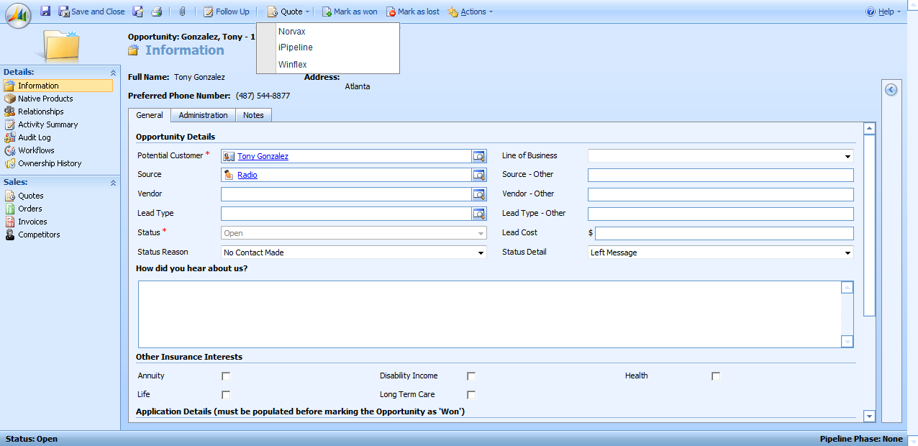  Create custom links off the Opportunity called Health, Life, and Long Term Care. When the user selects one of these options, a view with two sections will appear. The top will list each Vendor with a description pulled from the Vendor record. When selected, the user should be taken to the appropriate “Lily Pad” for each vendor. Each row will pull all active Vendor records with the type that matches that left nav entry. The bottom will display all of the active Point of Sale records associated with that parent record including name, source, created on, and modified on.  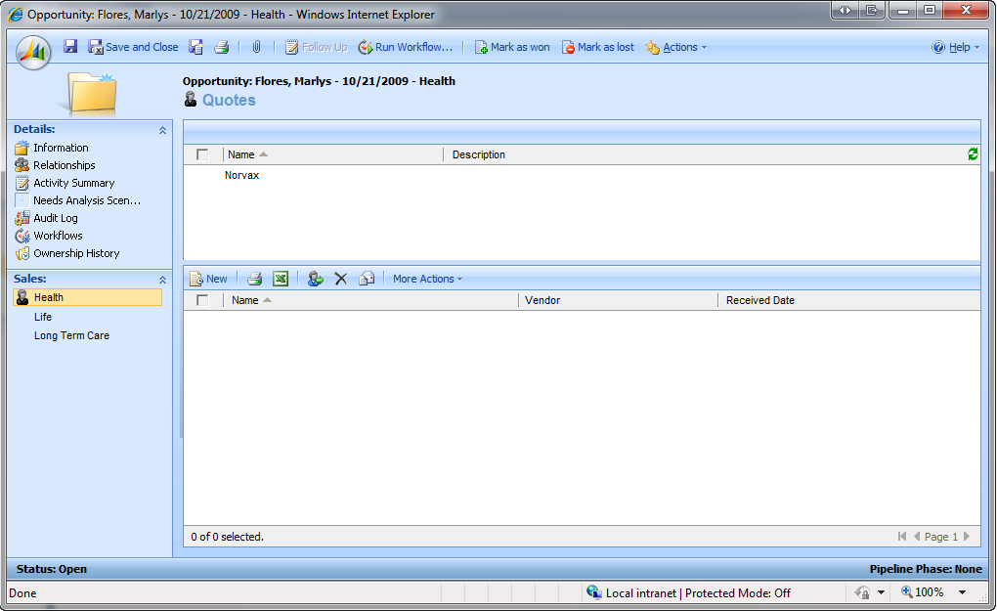
Assumptions | With either option, when the vendor’s site is opened, additional information to log the user in to the vendor site will need to be passed.
Testing Scenario
Security Roles
Questions

Feature | CR 124: Online application integration
Sonoma ID | 2,941 | Iteration | 4
Priority | 02-Major | Est. Effort | 50 – 60 hours
Dependencies
Requirement | Build all required integration points based on the Integration Plan document.
Assumptions
Testing Scenario
Security Roles
Questions

Agent Desktop
Feature | CR 188: Update the Agent Desktop with Activity Target information
Sonoma ID | 2,930 | Iteration | 4
Priority | 02-Major | Est. Effort | 16 – 24 hours
Dependencies
Requirement | Update the Agent Desktop to remove the Actuals to Target, No Contact Made, and Contact Made charts and add the Weekly Activity Actual/Target progress bars.  Remove the received date from the right summary area (Applies to CR 44 and CR 45). Rename the 'Sales Pipeline' to 'Current Inventory'?  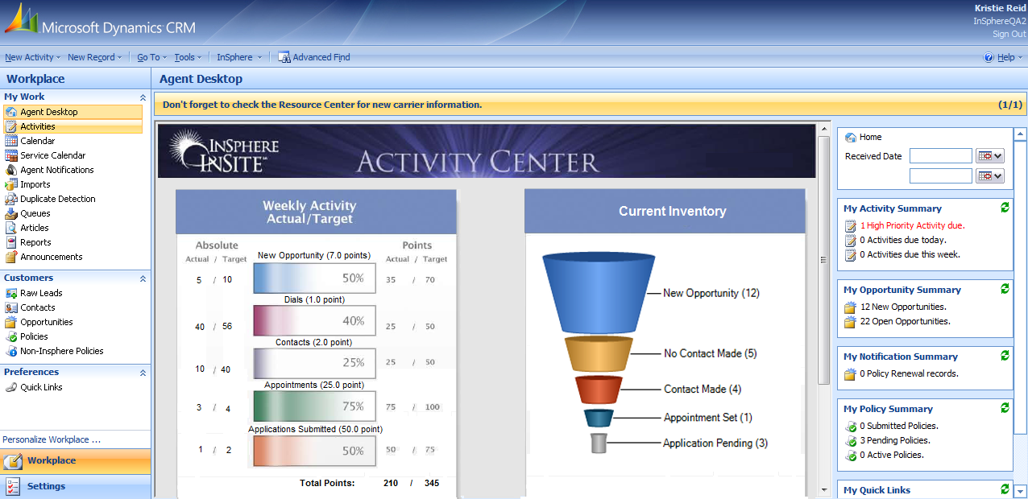  Create an Agent Activity entity which tracks the following information:  - Name (what appears in the bar graph title)  - Defined Goal – picklist with the set of Opportunity Statuses (New Opportunity, No Contact Made, Contact Made, Appointment Set, Deal in Progress), Policy Status Details (Application Submitted, Application Pending), and Activity Types (Task, Fax, Phone Call, E-mail, Letter, Appointment) by Disposition and Disposition Detail.  - Activity Dispositions  - Number of points - decimal  - Business Unit – lookup to Business Unit used to relate the Business Unit that these rules will apply to.  - Sort Order – integer (used to display the information correctly on the graphic)  Create a new Activity Goal entity which will allow managers to track the following goals per user:  - Lookup to the Agent Activity  - User – lookup to the specific user each goal applies to  - Goal – integer  For each Use the following formulas to calculate the Actual/Target figures seen – these calculations only apply to records for that week (starting on Monday):  - Absolute Actual = Count of activities per goal where the user is the owner  - Absolute Target = Goal for the user for that category  - Points Actual = Count of activities per goal * number of points for that category for the business unit  - Points Target = Goal for the Activity Goal * number of points for that category for the business unit  Also show totals of the Points Actual and Points Target.  Example scenario:  Carl has created 9 new opportunities since Monday. He has created 50 phone calls activities, 20 of which resulted in contact, created 20 appointments, and submitted 5 applications (shown as created policies). The goals set out for him were 10 new opportunities (2 points each), 100 phone calls (1/2 point each), 25 contacts (1 point each), 10 appointments (5 points each), 5 submitted apps (10 points each). The following information would display on the Activity bar charts:
  Activity | Absolute (not sure how these %s are being calculated – should they be counts?) |  | Progress Bar | Points
   | Actual | Target |  | Actual | Target
  Call List | 9 | 10 | 90% | 18 | 20
  Dials | 50 | 100 | 50% | 25 | 50
  Contacts | 20 | 25 | 80% | 20 | 25
  Appointments | 20 | 10 | 200% | 100 | 50
  Submitted Apps | 5 | 5 | 100% | 50 | 50
Assumptions
Testing Scenario
Security Roles
Questions

Opportunity
Feature | CR 52: Application grid on the Opportunity  CR 78: Default Application State
Sonoma ID | 2,931 | Iteration | 4
Priority | 02-Major | Est. Effort | 8 - 16 hours
Dependencies
Requirement | Create an application grid to capture multiple applications for each Opportunity. In this grid, only allow users to select the Products for the selected Carrier, the Product Name must be populated when the Product is selected, and the Application Number must be automatically created for each record. In addition, the State should default to the State in the address of the Contact.  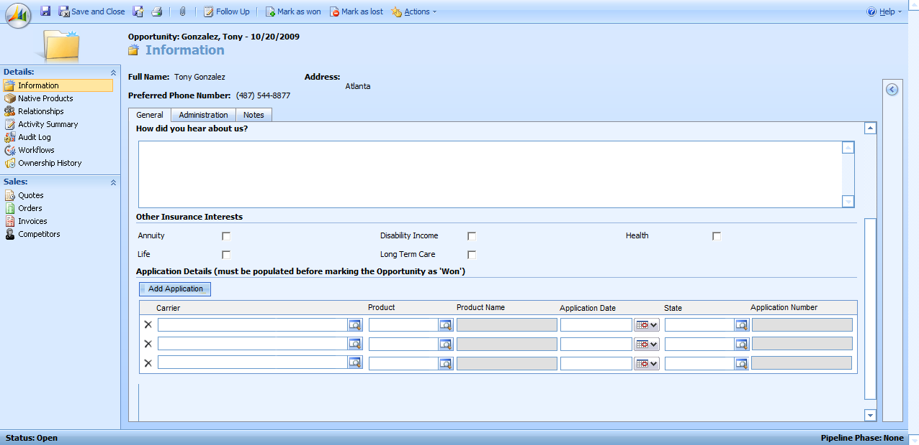  Update the push to Vue to create a separate record in Vue for each Application associated to the Opportunity. Agent ID from the assigned agent gets pushed over to Vue. If all of the Applications pushed over are not accepted, the Opportunity will remain open but the Applications must be marked as inactive with a status of Policy Created. This should also appear in the Application Details grid.  Update the message that appears when the Opportunity is marked as won to state “Marking an Opportunity as Won will create new policies in CRM and Vue for each application entered. Would you like to proceed?”  Update the Wrapper the Point of Sales vendors will call to allow for multiple applications to be submitted.
Assumptions
Testing Scenario
Security Roles
Questions

Feature | CR 145: Split commission model
Sonoma ID | 2,932 | Iteration | 4
Priority | 02-Major | Est. Effort | 8 – 12 hours
Dependencies | The Vue web service must be updated to handle this information.
Requirement | Create a commissions grid to capture split commission information for each Application. In this grid, allow users to select a user and the commission %. As agents are added, share the Application, Opportunity, and Contact with the selected user with Read, Write, Append, and Append To permissions.  Update the push to Vue to pass split % information. That information will then also need to go over to the policy.
Assumptions | Assumes that the user will be responsible for confirming that the commission total is 100% and that if that user is not on the agent’s team, manual sharing of the record will occur.
Testing Scenario
Security Roles
Questions

Contact
Feature | CR 73: When selecting a primary phone, system should check whether that phone number is populated
Sonoma ID |  | Iteration | 4
Priority | 02-Major | Est. Effort | 1–1 hours
Dependencies
Requirement | Update the dynamic form settings so that when the Primary Phone picklist is selected on a Raw Lead or Contact, the associated phone number becomes required.  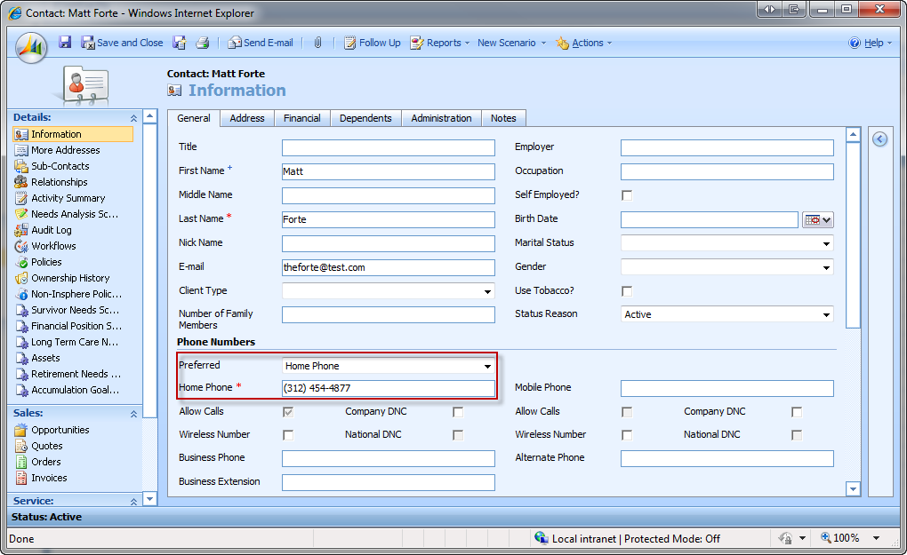
Assumptions
Testing Scenario
Security Roles
Questions

Data Migration
Feature | CR 123: Upload Non-Insphere Policy Information
Sonoma ID |  | Iteration | 4
Priority | 02-Major | Est. Effort | 20 - 28 hours
Dependencies
Requirement | Produce templates for agents to use to upload their Contacts and Non-Insphere Policy information. The Contact list will be imported into the Raw Lead entity and processed the same as manual Raw Lead entry with the following rules:  - Required Fields: First Name, Last Name, and at least one phone number or email address.  - Review duplicate rules. If a potential duplicate is found, maintain that record as a Raw Lead with a status reason of Potential Duplicate.  - Review DNC rules. If all of the phone numbers are on either the Company or National DNC list, maintain that record as a Raw Lead with a status reason of Do Not Call  - If all of the rules above pass, create a Contact and Non-Insphere Policy record.  From a standard format .csv file, allow the user to import a list of Non-Insphere Policies. Once imported, the user must have the ability to match up against and existing Contact. To do this, allow the user to batch process Non-Insphere Policy records and as records are processed, display a screen similar to the duplicate detection screen to allow the user to select which Contact record to attach the Non-Insphere Policy record to. The rules on which records to allow for selection will match the duplicate detection rules.  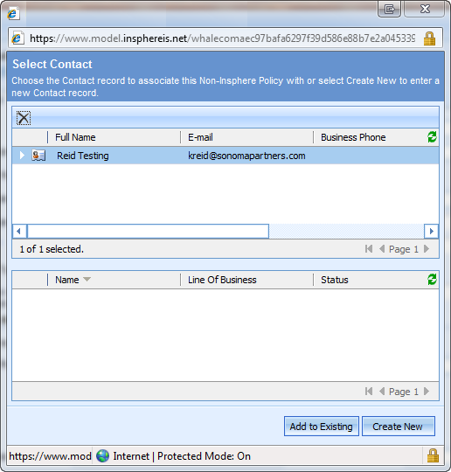  From here, if the user selects Add to Existing, the Non-Insphere Policy will be added as a record associated to the selected Contact. If the user selects Create New, review the phone numbers with the DNC rules.
Assumptions | Assumes that the only new functionality is the Non-Insphere Policy import functionality and that Contacts will be imported prior to the Non-Insphere Policies. The additional details are included to confirm requirements.
Testing Scenario
Security Roles
Questions

Do Not Call
Feature | CR 139: Allow calling
Sonoma ID |  | Iteration | 4
Priority | 02-Major | Est. Effort | 6 - 12 hours
Dependencies
Requirement | When a user selects to process a Raw Lead that displays on the DNC lists, replace the following screen: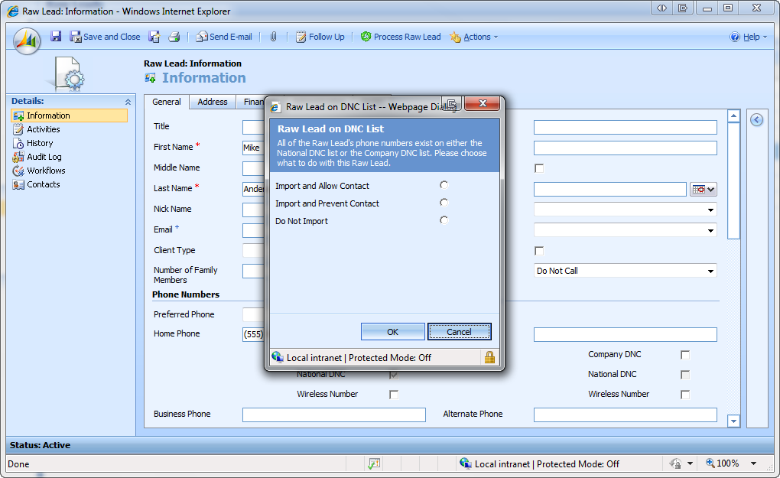  Add the following question on the Raw Lead form: "Was specific reference to Insphere made in the ad or promotion that generated this lead?" as required defaulted to No. The user has 2 options:  - Select Yes. If this occurs, check the Allow checkbox on the Contact for all phone numbers. The 30 day process then needs to update this field to unchecked if the phone number is on the Company and National do not call list.  - Select No. If this occurs, uncheck the Allow checkbox for all phone numbers unless they are only on the National Do Not Call list.  - Run the 30-day process to check the National and Company DNC lists and uncheck this bit if the phone number has been added since the last check.  The table below lists the various scenarios.  Update the current processing so that the Company Do Not Call indicator transfers over to the Contact as is. If the phone number is either on the National DNC or Company DNC when it comes in, uncheck the Allow checkbox for that number based on the matrix above.  Create a workflow to update the Allow checkbox to unchecked if the Company Do Not Call field is checked. That phone number will also be added to the Company Do Not Call list at that time.
  Answer to Question | National DNC | Company DNC | Contactable
  N | N | N | Y
  N | Y | N | Y
  N | N | Y | N
  N | Y | Y | N
  Y | N | N | Y
  Y | Y | N | Y
  Y | N | Y | Y
  Y | Y | Y | Y
Assumptions
Testing Scenario
Security Roles
Questions

Feature | CR 140: DNC Information visible at the Opportunity level
Sonoma ID | 2,936 | Iteration | 4
Priority | 02-Major | Est. Effort | 2 - 4 hour
Dependencies
Requirement | Remove the current Do Not Call banner from the Opportunity.  Display all phone numbers populated on the Contact on the Opportunity form. If the phone number has the Allow field unchecked, display the following icon next to that number:  Indicate preferred number.  Show 2 digit state.
Assumptions
Testing Scenario
Security Roles
Questions

Feature | CR 136: Update integration with Gryphon Technologies
Sonoma ID | 2,959 | Iteration | 4
Priority |  | Est. Effort | 20 – 24 hours
Dependencies
Requirement | Update the current process with Gryphon Technologies to use their standard file format.
Assumptions
Testing Scenario
Security Roles
Questions

Duplicate Detection
Feature | CR 144: Add owner to dupe window
Sonoma ID |  | Iteration | 4
Priority | High | Est. Effort | 1 hour
Dependencies
Requirement | Add Owner to the Contact section and Assigned Agent to the Opportunity/Policy section of the Duplicate Detection window.  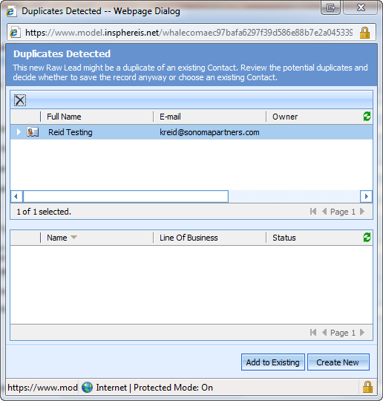
Assumptions
Testing Scenario
Security Roles
Questions

Usability Items
Feature | CR 141: Incorporate Martin’s usability feedback
Sonoma ID |  | Iteration | 4
Priority | High | Est. Effort | 1 - 2 hour
Dependencies
Requirement | Create buttons on the Opportunity for the following activities rather than having to go through the "Actions" menu:  - Phone call  - Email  - Appointment  Use the native icons for these buttons.
Assumptions
Testing Scenario
Security Roles
Questions

Notifications
Feature | CR 188: Acknowledge Notifications
Sonoma ID | 2,939 | Iteration | 4
Priority |  | Est. Effort | 1 – 3 hours
Dependencies
Requirement | From the native Notifications grid, the grid in the Agent Desktop and on the notifications form, add a Acknowledge button. This will change the status of the Notification to Acknowledged and remove from the Active Agent Notification grid (icon is loudspeaker_preferences).  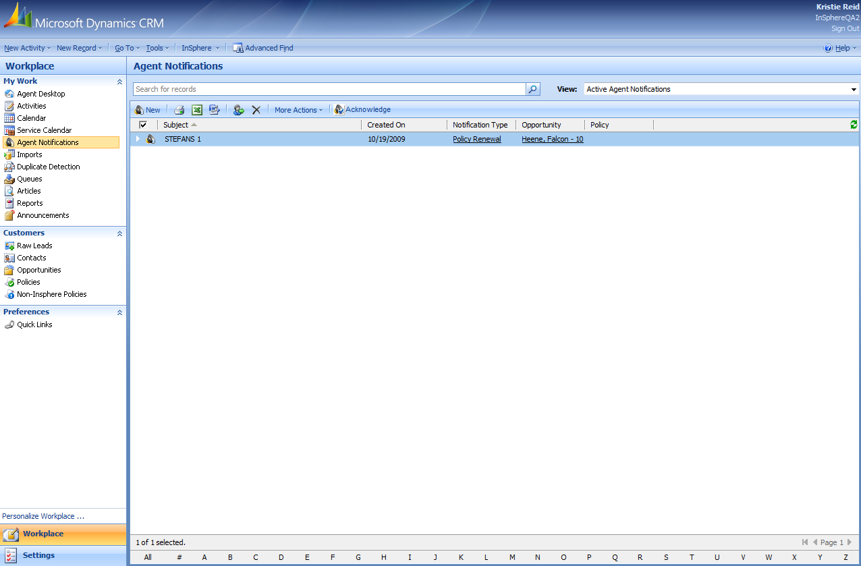
Assumptions
Testing Scenario
Security Roles
Questions

Integration
Feature | PSE ID 1: Real-time lead intake
Sonoma ID | 2,927 | Iteration | 4
Priority | High | Est. Effort | 20 – 24 hours
Dependencies
Requirement | Create a wrapper around the native CRM web-service for InSphere to use with its vendors. The web-service should be able to add Raw Lead records including the following information:  - Title  - First Name  - Middle Name  - Last Name  - Nick Name  - Email  - Number of Family Members  - Employer  - Occupation  - Self Employed  - Birth Date  - Marital Status  - Gender  - Use Tobacco  - Preferred Phone  - Home Phone  - Mobile Phone  - Business Phone  - Business Phone Extension  - Alternate Phone  - Spouse Name  - Spouse Nick Name  - Spouse Employer  - Spouse Occupation  - Spouse Birth Date  - Spouse Gender  - Source  - Source – Other  - Lead Type  - Lead Type – Other  - Vendor  - Vendor – Other  - Line of Business  - Lead Cost  - How did you hear about us  - Annuity  - Life  - Disability Income  - Long Term Care  - Health  - Home Address – Street 1  - Home Address – Street 2  - Home Address – City  - Home Address – State  - Home Address – Zip/Postal Code  - Business Address – Street 1  - Business Address – Street 2  - Business Address – City  - Business Address – State  - Business Address – Zip/Postal Code  - Owner (this would be agent ID)  - Assigned Agent (this would be agent ID)  - Preferred Method  - Preferred Day  - Preferred Time  - Was specific reference to Insphere made in the ad or promotion that generated this lead?  Once a Raw Lead record is received, reject the lead if it does not contain the minimum fields (first name, last name, and email or 1 phone number), if it is a duplicate, or if all phone numbers provided are on the Company DNC list.  Inactive the record with a status reason of declined from vendor – only keep source, source – other, lead type, lead type – other, vendor, vendor – other, line of business, home state, home zip code, business state, business zip code, created-on.  From createdon, we must respond in less than 30 seconds or keep the record.
Assumptions | Assumes that Owner and Assigned Agent would be passed by Agent ID.
Testing Scenario
Security Roles
Questions

Skype Integration
Feature | CR 64: Access to Skype
Sonoma ID | 2,958 | Iteration | 4.0
Priority |  | Est. Effort | 4 – 8 hours
Dependencies
Requirement | Allow users to call any phone numbers indicated as ‘Allowed’ using Skype. To do this on the Contact Form, enable the user to select any phone numbers where Allow checked as a link.  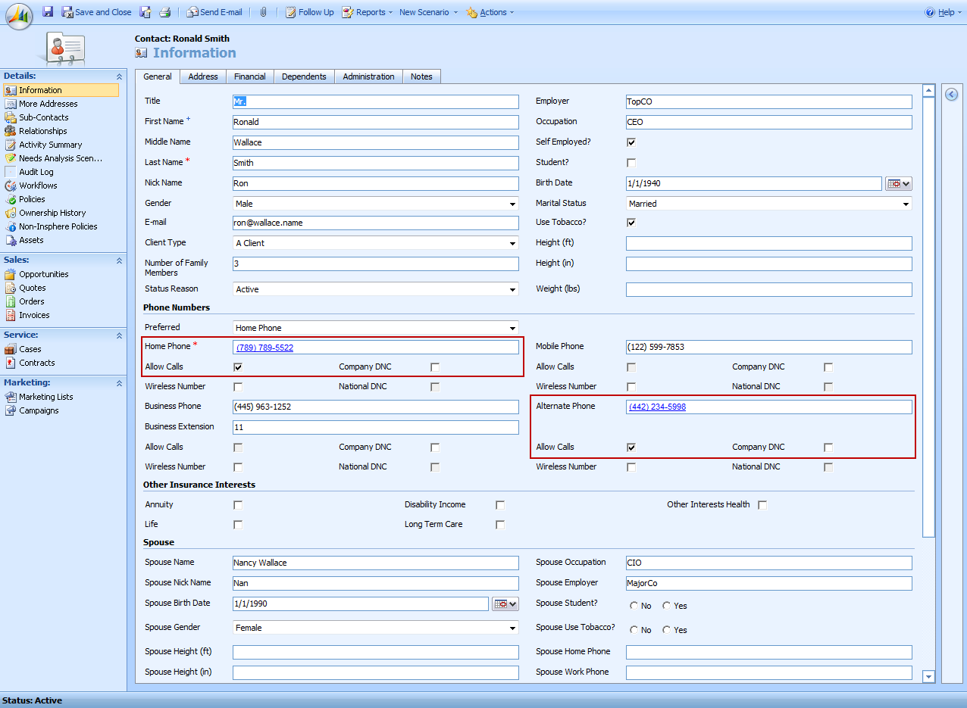  Provide the same functionality on the phone numbers listed on the Opportunity form where the phone numbers will be listed with links if Allow is checked.
Assumptions
Testing Scenario
Security Roles
Questions

Awaiting Information:
- IDA utility to run and import data
- LMS data migration finalized requirements

Out of Scope
Feature | CR 121: Matchback functionality
Sonoma ID |  | Iteration
Priority |  | Est. Effort
Dependencies
Requirement | This requirement is to handle when Applications have been created in Vue from a source other than CRM. The goals is to ensure that Vue does not create a duplicate Contact record in CRM.
Assumptions | Assumes that this requirement will be handled by CSSI.
Testing Scenario
Security Roles
Questions

