Uniform Data System
Documentation Management & Rating Engine – Application Architecture
Scope of Work
February 9, 2009
Updated on 02/10/2009

Acceptance:

____________________________________________

Table of Contents

Overview 3
Assumptions 3
Description of Efforts 3
1. Documentation Management 3
Documentation listing screen 3
Documentation Detail screen 4
Facility setup 7
Documentation Forms Printing 7
2. Rating Engine 7

Overview
This document explains the implementation of Documentation Management and Rating Engine (add-ons for UDSPROi application).

Assumptions
- N/A.

Description of Efforts
The following are the changes in the prototype site.

Documentation Management
Following are the changes in the Documentation Management screens.
- All the screens related to “Documentation management” and “Rating engine” should be in light yellow background color.

Documentation listing screen
  - Implementing “Find” functionality with four available fields (‘PatientID’, ‘First Name’, ‘Last Name’ and ‘Medical Record Number’) to perform a search on entire database (as shown in the Figure 1).
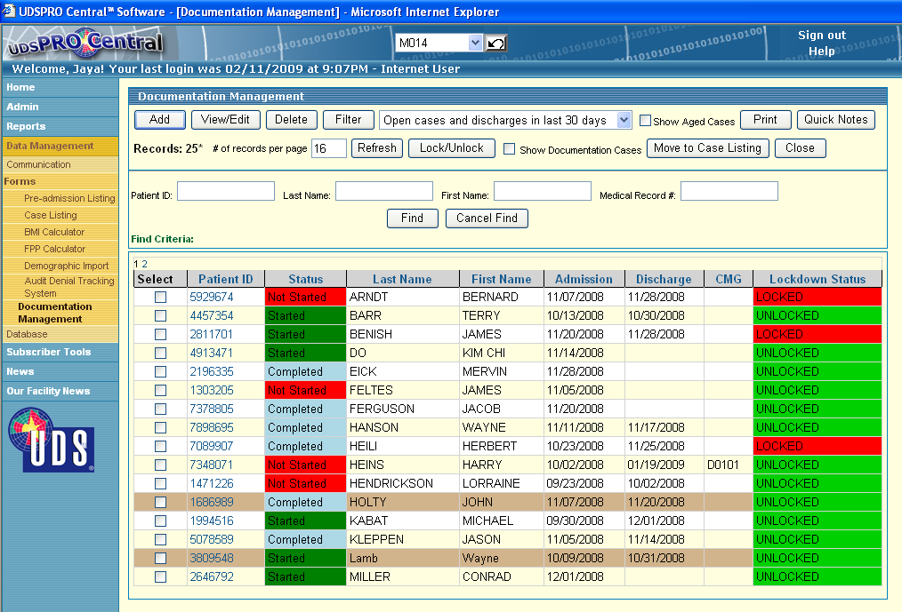
Figure 1 [Documentation listing screen]
  - Patient id will link to detail screen with all patient information (3 tabs).
  - “New” button in the documentation listing screen will open the detail screen in insert mode where patient can be added by providing the demographic information.
  - Patient’s added using Documentation screen will be marked in different color (brown), patients which exist on both databases (Documentation and UDSPRO) will be in normal color.
  - “Show Documentation cases” check box will list only the cases added from Documentation screen and which are not moved to case listing.
  - “Move to Case-listing” button will copy/move the records which are added from Documentation interface to UDSPRO database, more then one record can be selected at a time.

Documentation Detail screen
  - Documentation detail screen will have 3 tabs ‘Identification’, ‘Progress Notes’ and ‘Documentation forms’
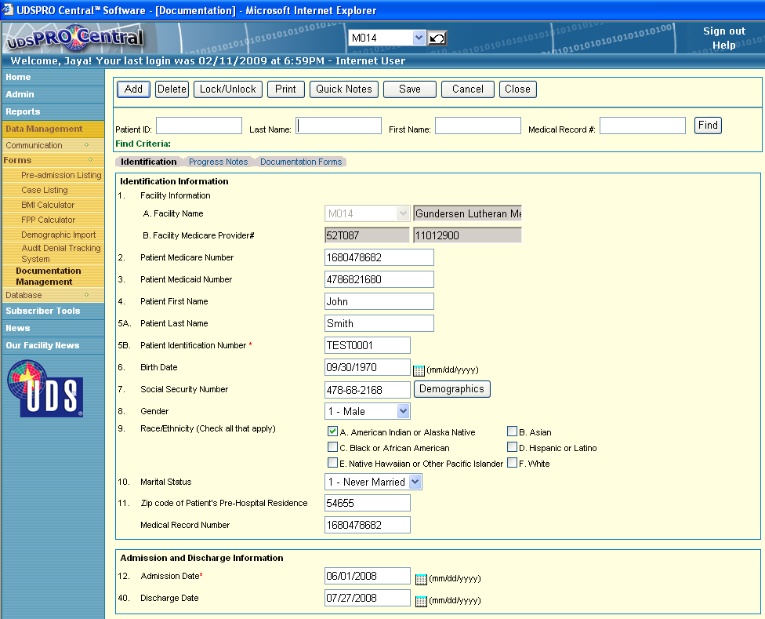
Figure 2 [Documentation listing screen]
  - ‘Identification’ tab: patient demographic information, ‘Progress Notes’ tab: details of the Notes by shift wise and ‘Documentation forms’ tab: list of all Forms to be filled for a patient.
  - New column will be added in the Patient identification tab as “Medical record number” as an identity column.
  - “Find” can be used to search another patient being in the detail screen itself, if “Find” fetch more then one case, then a popup will appear to select a single case to view the details (as shown in Figure 3).
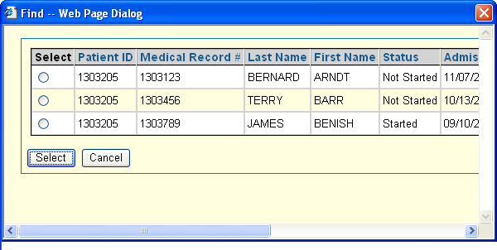
Figure 3 [‘Find’ Popup to select single case]
  - “Quick Notes” button will open a popup to enter Notes for FIM or non-FIM item which will be reflected in the progress notes screen (as shown in Figure 4).
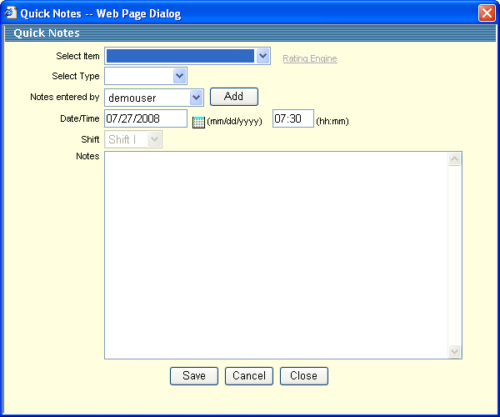
Figure 4 [‘Quick Notes’]
  - ‘Progress Notes’ tab now will show the Notes entered for every shift (S-I, S-II and S-III) for selected dates, if notes is entered for a shift check box will be checked, shift number will be linked to open Notes in new popup (as shown in Figure 5).
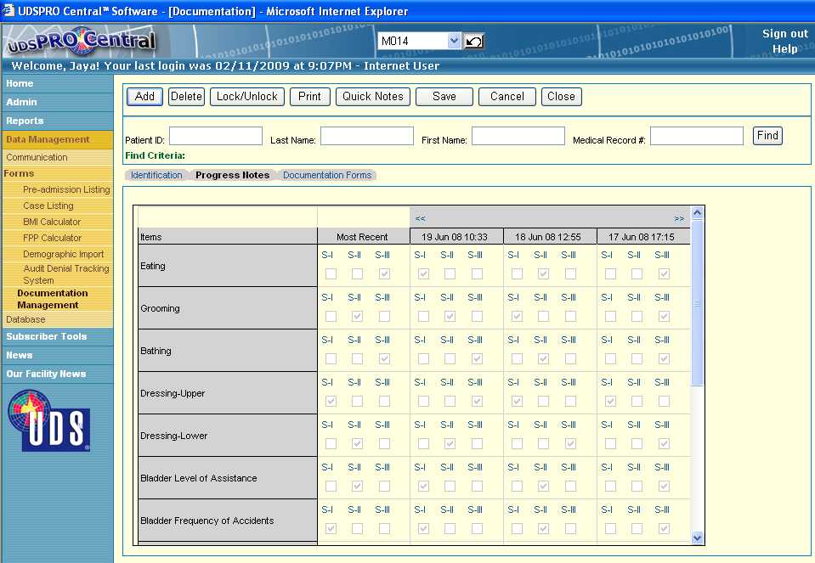
Figure 5 [‘Progress Notes’]

  - In the “Documentation Forms” tab all the forms will be listed in the grid according to the category and status will be displayed as “Not-started” (Red), “Started” (Green) and “Completed” (Blue) (as shown in Figure 6).
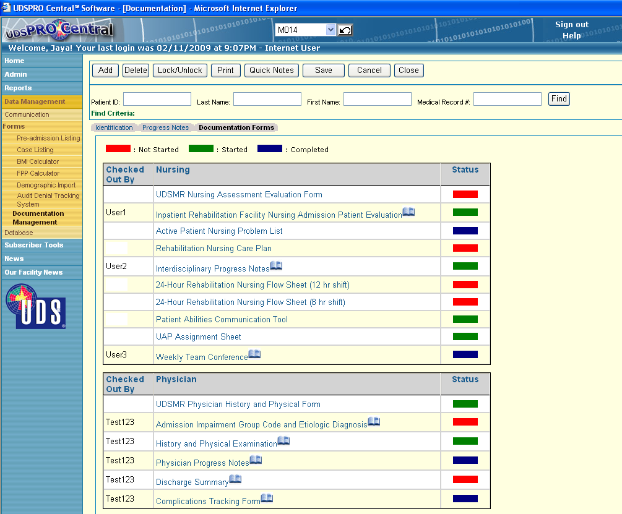
Figure 6 [‘Documentation Forms’]

  - User working on a form (checked out by) will be displayed along with the form link and an icon will be displayed and not allowing the form to be opened by current user.

Facility setup
  - In the Facility setup we need to have a checkbox for selection as “Medical Record # is same as PatientID”, if this is checked then Medical Record # and Patient ID will be having same value.

Documentation Forms Printing
  - In the Documentation listing screen and Documentation Detail screen “Print” button is used to print Documentation Forms.
  - Multiple records can be selected to perform a Print job in Documentation listing screen and a dialog will appear to select the type of Forms to print (as shown in Figure 7)
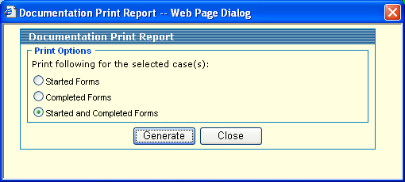
Figure 7 [Print Documentation Forms]

Documentation Notes User Login
  - New type of user will be added who will be only having access to add Notes for a patient.
  - For this kind of user only Notes screen will appear without any other link (as shown in the figure 8)
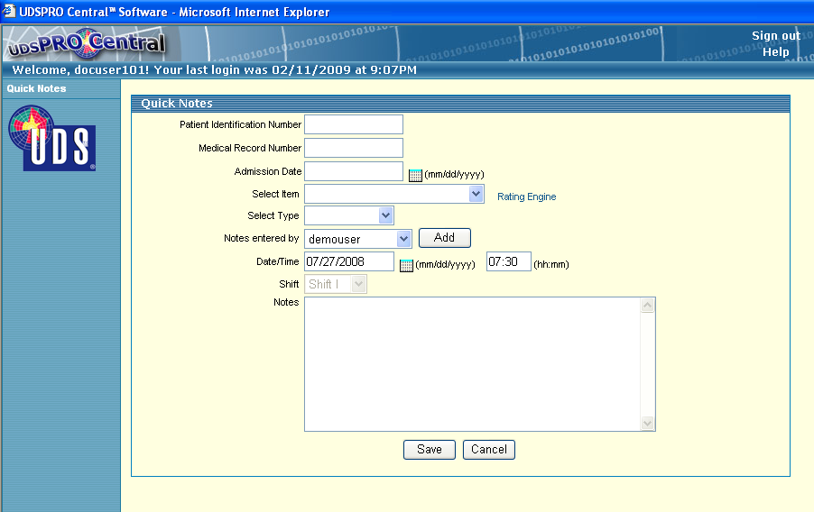
Figure 8 [Data entry screen for Notes user]

  - Identifier column will be PatientID, Medical record # and Admission date, matching case will be updated with the notes entered, if more then one matching case is found then a popup with list of cases will appear to select correct patient record.
  - If no matching record is found then an error message will be displayed.

Documentation Forms User Login
  - New type of user will be added who will be only having access to add/Edit Documentation Forms for a patient (as shown in the figure 9).
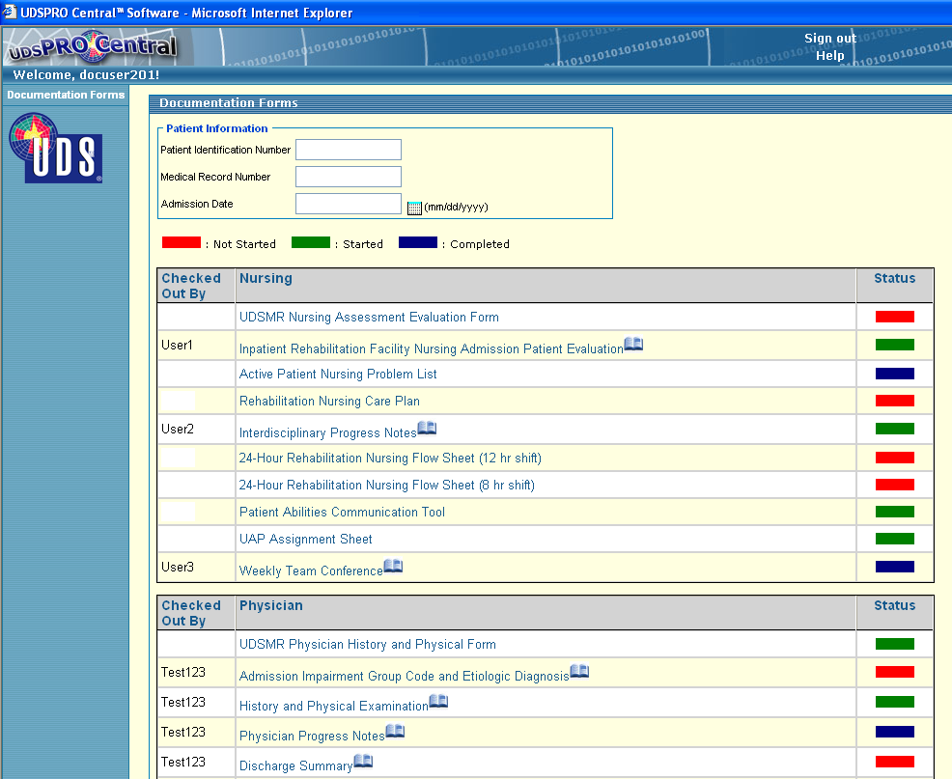
Figure 9 [Screen for Documentation Forms user]

  - Identifier column will be PatientID, Medical record # and Admission date, matching case will be updated with the notes entered, if more then one matching case is found then a popup with list of cases will appear to select correct patient record.
  - If no matching record is found then an error message will be displayed.

Rating Engine
Rating engine forms background is modified to light yellow.
- N/A.

