**Mock Interview 4**

**Business Requirements Document (BRD)**

**Project Name:** Ice Cream and Milk Products Manufacturing Management System

**Prepared For:** [XYZ]

**Prepared By:** [Manas Deepak Pandit]

**Date:** [27/12/2024]

1. **Introduction**
   1. **Business Goals**

The goal of this project is to enhance the efficiency, quality, and traceability of ice cream and milk product manufacturing, warehousing, and distribution processes by implementing an integrated software solution. This will support the company's long-term objectives of reducing operational costs, improving supply chain visibility, and ensuring regulatory compliance.

* 1. **Business Objectives**

**Improve Operational Efficiency**:

* Automate and optimize production scheduling, inventory tracking, and distribution processes to reduce manual interventions and streamline workflows.

**Ensure Product Quality**:

* Implement robust quality control mechanisms and traceability features to meet industry compliance standards and maintain product integrity.

**Enhance Supply Chain Visibility**:

* Provide real-time tracking of products, inventory levels, and logistics activities to improve transparency and decision-making.

**Reduce Costs**:

* Minimize wastage, optimize inventory turnover, and create cost-efficient delivery routes to achieve operational cost savings.

**Enable Data-Driven Decision Making**:

* Utilize advanced analytics and reporting to forecast demand, monitor KPIs, and support strategic planning.

**Strengthen Compliance**:

* Ensure adherence to food safety regulations through automated compliance reporting and lot traceability systems.
  1. **Business Rules**

**Production Rules**:

* Production schedules must be updated in real time to reflect changes in raw material availability or machinery breakdowns.
* All products must pass predefined quality control checks before being marked as completed.

**Inventory Rules**:

* Inventory levels of raw materials must trigger automatic reorder alerts when they fall below a predefined threshold.
* Perishable goods nearing their expiry date must be flagged for priority usage or disposal.

**Warehouse Rules**:

* All stock must be tagged with unique identifiers (e.g., barcodes or RFID) for efficient tracking and management.
* Warehouse space must be optimized based on product category, size, and storage requirements (e.g., temperature-controlled areas for ice cream).

**Distribution Rules**:

* Delivery routes must be optimized to minimize fuel consumption and delivery times.
* Each shipment must include complete documentation, such as invoices and compliance certificates.

**Sales and Order Processing Rules**:

* Orders must be processed in the order they are received, unless specified as priority.
* Real-time inventory checks must be conducted before confirming order fulfilment.

**Compliance and Quality Assurance Rules**:

* Lot traceability must be maintained for all products, allowing identification of production and distribution batches.
* Compliance reports must be generated automatically at regular intervals and during audits.

**User Access and Security Rules**:

* Only authorized personnel can access production and inventory data.
* Role-based access controls must be implemented to restrict users to relevant functions only.

**Reporting and Analytics Rules**:

* Key performance indicators (KPIs) must be updated daily to provide actionable insights.
* Reports must be exportable in multiple formats (e.g., PDF, Excel) for stakeholder review.
  1. **Background**

The client is a leading manufacturer and distributor of ice cream and milk products with multiple manufacturing plants and warehouses across the country. Despite their strong market presence, the company faces challenges in managing their operations efficiently due to the following factors:

1. **Operational Inefficiencies**:
   * Manual processes for production scheduling, inventory management, and logistics lead to delays and increased operational costs.
2. **Lack of Real-Time Visibility**:
   * The absence of integrated systems hinders real-time tracking of raw materials, finished goods, and logistics activities.
3. **Compliance Challenges**:
   * Ensuring adherence to stringent food safety regulations and maintaining traceability for product recalls are cumbersome tasks.
4. **Data Silos**:
   * Critical business data is scattered across disparate systems, making it difficult to generate actionable insights for decision-making.
5. **Market Demands**:
   * Growing consumer expectations for faster deliveries and product freshness require more agile and transparent supply chain operations.

To address these issues, the company aims to develop a comprehensive software solution that integrates manufacturing, inventory, warehouse, and distribution management. The proposed system will leverage modern technologies, including IoT and predictive analytics, to streamline operations, reduce costs, and ensure compliance with industry standards.

* 1. **Project Objective**

**Automate Core Processes**:

* Enhance efficiency by automating production scheduling, inventory management, and logistics workflows.

**Improve Product Quality and Compliance**:

* Incorporate robust quality control mechanisms and compliance management features to ensure adherence to food safety standards.

**Optimize Supply Chain Operations**:

* Enable real-time tracking of inventory and logistics to reduce delays, minimize waste, and meet market demands.

**Facilitate Data-Driven Decision Making**:

* Leverage predictive analytics and customizable reporting to provide actionable insights for business strategy and operations.

**Reduce Operational Costs**:

* Optimize resource utilization, improve inventory turnover, and streamline delivery routes to achieve cost savings.

**Enhance User Experience**:

* Provide a user-friendly interface and role-based access controls for seamless interaction across departments.
  1. **Project Scope**

**In-Scope:**

**Production Management**:

* + Automate production scheduling and real-time monitoring.
  + Implement quality control checkpoints during manufacturing.

**Inventory and Warehouse Management**:

* + Provide real-time inventory tracking for raw materials and finished goods.
  + Enable space optimization and expiry management for perishable goods.

**Distribution Management**:

* + Optimize delivery routes to minimize costs and time.
  + Provide order tracking and delivery updates to stakeholders.

**Sales and Order Integration**:

* + Forecast demand based on historical data and market trends.
  + Streamline order processing and integrate with existing ERP systems.

**Compliance and Traceability**:

* + Enable lot traceability for product recalls.
  + Generate automated compliance reports to meet industry regulations.

**Reporting and Analytics**:

* + Develop customizable dashboards for real-time insights.
  + Use predictive analytics to support demand forecasting and operational planning.

**System Integration**:

* + Integrate with existing ERP systems, IoT-enabled devices, and cold chain monitoring solutions.

**Out-of-Scope:**

**Hardware Procurement**:

* + The project will not include purchasing or setting up IoT devices or other hardware.

**Direct Retail Sales Management**:

* + The system will not manage direct-to-consumer retail operations.

**Third-Party Software Customization**:

* + No customization of third-party software beyond the scope of integration.

1. **Assumptions**

**Stakeholder Involvement**:

* + All stakeholders, including manufacturing, warehousing, logistics, and IT teams, will actively participate and provide timely feedback during requirement gathering, development, and testing phases.

**Data Availability**:

* + Historical data required for demand forecasting and analytics will be provided in a clean and usable format.

**Resource Allocation**:

* + Adequate resources, including personnel and technical infrastructure, will be allocated to the project throughout its lifecycle.

**Infrastructure Readiness**:

* + Existing systems, such as ERP, IoT-enabled devices, and cold chain monitoring tools, will be functional and ready for integration.

**Regulatory Compliance**:

* + The client will provide clear guidelines on the regulatory requirements to be incorporated into the system.

**Hardware and Software Procurement**:

* + All necessary hardware (e.g., barcode scanners, RFID devices) and software licenses will be procured before the start of the project.

**Change Management**:

* + End-users will be available for training sessions, and the organization will adopt the new system without significant resistance.

**Budget and Timeline**:

* + The project will operate within the allocated budget and adhere to the agreed-upon timeline unless unforeseen circumstances arise.

**Third-Party Dependencies**:

* + Third-party services or APIs required for integration will be available and operational during development and testing phases.

1. **Constraints**

**Budgetary Limitations**:

* + The project must be completed within the allocated financial budget, limiting the scope for additional features or resources beyond the initial plan.

**Timeline Restrictions**:

* + The project must adhere to the 20-week development timeline, with no flexibility for delays unless critical issues arise.

**Regulatory Compliance**:

* + The system must comply with strict food safety and quality standards, which may impose specific design and implementation constraints.

**Integration Dependencies**:

* + Successful integration with existing systems (ERP, IoT devices, cold chain monitoring) is critical and may be impacted by compatibility issues or third-party limitations.

**Infrastructure Availability**:

* + The system's performance relies on the availability and stability of cloud infrastructure and network connectivity at all operational sites.

**User Adoption**:

* + Resistance to change among employees may limit the system's effectiveness if adequate training and support are not provided.

**Resource Constraints**:

* + Limited availability of skilled personnel for specialized tasks, such as IoT integration or advanced analytics, may impact project delivery.

**Hardware Constraints**:

* + The system's functionality for inventory and warehouse management is dependent on the availability of IoT devices, barcode scanners, and RFID technology.

**Geographical Constraints**:

* + The distributed nature of manufacturing plants and warehouses may pose challenges for system deployment and coordination.

1. **Risks**

**Stakeholder Risks**:

* + **Risk**: Delays in obtaining approvals or feedback from stakeholders.
  + **Mitigation**: Schedule regular stakeholder meetings and establish clear communication protocols.

**Technical Risks**:

* + **Risk**: Challenges in integrating the system with existing ERP, IoT devices, or cold chain monitoring tools.
  + **Mitigation**: Conduct a thorough compatibility assessment and allocate time for integration testing.

**Operational Risks**:

* + **Risk**: Resistance to change from end-users, affecting system adoption.
  + **Mitigation**: Provide comprehensive training and engage users early in the project.

**Regulatory Risks**:

* + **Risk**: Non-compliance with food safety and quality standards.
  + **Mitigation**: Work closely with compliance experts to ensure the system meets all regulatory requirements.

**Resource Risks**:

* + **Risk**: Limited availability of skilled resources, such as developers or IoT specialists.
  + **Mitigation**: Plan for resource allocation in advance and consider outsourcing specialized tasks if necessary.

**Timeline Risks**:

* + **Risk**: Delays in project phases, such as development or testing, leading to missed deadlines.
  + **Mitigation**: Use an Agile methodology with iterative reviews to identify and address delays early.

**Budget Risks**:

* + **Risk**: Costs exceeding the allocated budget due to unforeseen requirements or challenges.
  + **Mitigation**: Monitor budget regularly and include a contingency fund in financial planning.

**Data Risks**:

* + **Risk**: Inaccurate or incomplete data for analytics and decision-making.
  + **Mitigation**: Ensure data cleansing and validation processes are in place.

**System Performance Risks**:

* + **Risk**: The system may not perform as expected under high loads or in real-time operations.
  + **Mitigation**: Conduct rigorous performance testing and scalability assessments.

1. **Business Process Overview**

The **Ice Cream and Milk Products Manufacturing Management System** aims to streamline the company's key business processes, ensuring efficiency, quality, and compliance at all stages.

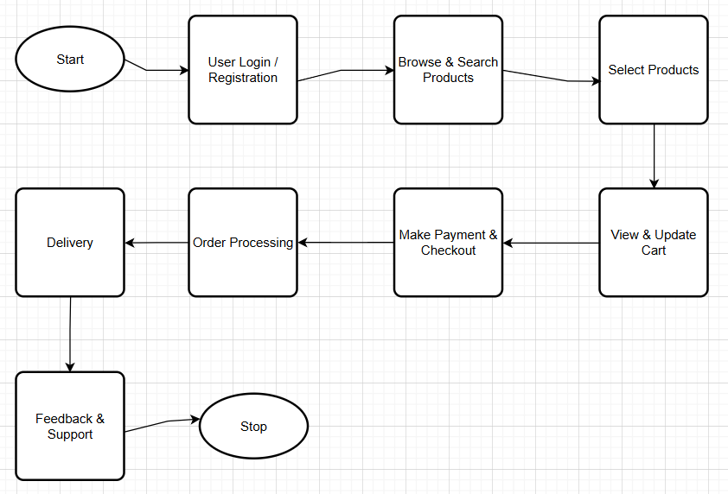

**Production Management**

**Current Process**:  
Production schedules are manually created and updated based on raw material availability and market demand, leading to inefficiencies and delays.

**Proposed Process**:

* Automate production scheduling based on real-time inventory and demand forecasts.
* Enable real-time monitoring of production lines to ensure adherence to schedules.
* Integrate quality control checkpoints to maintain product standards and regulatory compliance.

**Inventory and Warehouse Management**

**Current Process**:  
Inventory tracking is manual, often leading to discrepancies, waste due to expired products, and inefficiencies in space utilization.

**Proposed Process**:

* Use real-time inventory tracking with barcode/RFID technology.
* Automate alerts for replenishment when inventory levels reach critical thresholds.
* Implement advanced storage optimization techniques to reduce waste and maximize warehouse space.

**Distribution and Logistics**

**Current Process**:  
Delivery schedules and routes are planned manually, leading to increased transportation costs and delayed deliveries.

**Proposed Process**:

* Optimize delivery routes using AI-driven algorithms to minimize costs and time.
* Provide real-time tracking for shipments to enhance transparency and customer satisfaction.
* Ensure seamless coordination between manufacturing plants, warehouses, and distribution centres.

**Order Management and Sales**

**Current Process**:  
Orders are processed manually, which slows down the fulfilment cycle and increases the risk of errors.

**Proposed Process**:

* Automate order processing and integrate with the inventory system to ensure availability before confirming orders.
* Forecast demand using predictive analytics to avoid stockouts or overproduction.

**Compliance and Quality Assurance**

**Current Process**:  
Compliance reports and quality checks are managed manually, increasing the risk of non-compliance and recalls.

**Proposed Process**:

* Maintain complete lot traceability for all products to simplify audits and recalls.
* Automate compliance reporting to meet industry standards and regulatory requirements.

**Reporting and Analytics**

**Current Process**:  
Data from various departments is siloed, making it difficult to generate actionable insights or monitor key performance indicators (KPIs).

**Proposed Process**:

* Integrate data from all departments into a unified platform.
* Provide customizable dashboards for real-time monitoring and predictive analytics for strategic decision-making.

1. **How the Proposed System Will Address Challenges in the Legacy System ? –**

**Manual Production Scheduling and Monitoring**

**Legacy System Challenge**:

* Production schedules are created manually, leading to inefficiencies, delays, and difficulty in accommodating changes.
* Limited visibility into real-time production status.

**Proposed System Solution**:

* Automates production scheduling based on demand forecasts and inventory levels.
* Provides real-time monitoring of production lines, allowing instant adjustments to schedules and processes.

**Inaccurate and Outdated Inventory Management**

**Legacy System Challenge**:

* Manual inventory tracking leads to errors, waste due to expired products, and stockouts of critical materials.
* Poor visibility into inventory across multiple warehouses.

**Proposed System Solution**:

* Implements real-time inventory tracking with barcode/RFID technology.
* Automatically generates alerts for replenishment and monitors expiry dates to reduce waste.
* Integrates inventory data from all locations into a single system for better visibility.

**Inefficient Distribution and Logistics**

**Legacy System Challenge**:

* Delivery routes are manually planned, increasing transportation costs and delays.
* Lack of real-time updates for shipment tracking.

**Proposed System Solution**:

* Optimizes delivery routes using AI-driven algorithms, reducing fuel costs and transit time.
* Provides real-time tracking of shipments to improve transparency and customer satisfaction.

**Lack of Integrated Order Management**

**Legacy System Challenge**:

* Orders are processed manually, resulting in errors, delays, and missed opportunities for demand planning.

**Proposed System Solution**:

* Automates order processing and integrates it with the inventory system to confirm availability before order fulfilment.
* Uses predictive analytics to forecast demand and improve production planning.

**Poor Compliance and Quality Control**

**Legacy System Challenge**:

* Compliance reports and quality checks are manual, increasing the risk of non-compliance and delayed recalls.
* Limited traceability of product batches.

**Proposed System Solution**:

* Automates compliance reporting and ensures traceability for all product batches.
* Integrates quality checkpoints into production and warehouse processes, ensuring adherence to regulations.

**Limited Scalability**

**Legacy System Challenge**:

* The current system struggles to handle growing operational scale and complexity.

**Proposed System Solution**:

* Designed with scalability in mind to accommodate increased production, inventory, and distribution needs as the business grows.
* Flexible architecture to integrate with future technologies and expand functionality.

**Resistance to Change and User Adoption Issues**

**Legacy System Challenge**:

* Employees are accustomed to manual processes, leading to resistance to adopting new technologies.

**Proposed System Solution**:

* Includes comprehensive training programs for end-users to ensure smooth adoption.
* Offers an intuitive and user-friendly interface to reduce the learning curve.

**High Operating Costs**

**Legacy System Challenge**:

* Inefficiencies in production, inventory, and logistics contribute to high operational costs.

**Proposed System Solution**:

* Reduces costs through process automation, inventory optimization, and route efficiency.
* Minimizes waste and improves inventory turnover, leading to better cost management.

1. **Business Requirements**

**7.1 Functional Requirements**

**Production Management Requirements**

* Automate production scheduling based on demand forecasts and inventory levels.
* Provide real-time tracking and monitoring of production processes.
* Integrate quality checkpoints at each stage of production to ensure product standards are met.
* Generate production performance reports for management review.

**Inventory Management Requirements**

* Implement real-time tracking of raw materials and finished goods using barcode or RFID technology.
* Issue automatic alerts for low stock levels or inventory replenishment needs.
* Monitor expiry dates and ensure proper handling of perishable goods.
* Optimize warehouse space utilization to reduce storage costs and minimize waste.

**Warehouse Management Requirements**

* Enable efficient receiving, storing, and dispatching of inventory.
* Provide tools for accurate inventory counts and regular audits.
* Implement location-based inventory management for quick retrieval.
* Ensure seamless integration with IoT devices for temperature and storage condition monitoring.

**Distribution and Logistics Requirements**

* Optimize delivery routes to reduce costs and delivery times.
* Provide real-time tracking of shipments for stakeholders and customers.
* Enable automated dispatch planning based on order priorities and delivery deadlines.
* Integrate with third-party logistics systems if necessary.

**Order Management Requirements**

* Automate order processing and integrate it with inventory systems for availability checks.
* Forecast demand using historical sales data and predictive analytics.
* Allow for order modification, cancellation, and priority-based processing.
* Provide a user-friendly interface for order entry and status tracking.

**Compliance and Quality Assurance Requirements**

* Ensure compliance with food safety and industry regulations through automated checks and alerts.
* Implement full lot traceability for raw materials and finished goods to facilitate audits and recalls.
* Provide tools for generating compliance reports required by regulatory authorities.

**Reporting and Analytics Requirements**

* Offer customizable dashboards for monitoring production, inventory, and distribution KPIs.
* Provide advanced analytics capabilities for demand forecasting and trend analysis.
* Enable real-time and historical reporting for strategic decision-making.
* Support data export for integration with other business intelligence tools.

**User Management and Security Requirements**

* Allow role-based access control to ensure data security.
* Provide secure login and authentication mechanisms.
* Maintain audit logs of user activities for compliance and troubleshooting.
* Enable data backup and recovery processes to prevent data loss.

**Integration Requirements**

* Seamlessly integrate with existing ERP systems, IoT devices, and cold chain monitoring solutions.
* Ensure compatibility with third-party logistics and supplier management systems.
* Provide APIs for future system enhancements and third-party integrations.

**Scalability and Performance Requirements**

* Design the system to handle increased data volumes and operational complexity as the business grows.
* Ensure high system performance with minimal downtime during peak loads.
* Allow for easy addition of new features and modules in future phases.

**Non-functional Requirements**

**Performance Requirements**

* The system must handle up to 500 concurrent users without performance degradation.
* The system must process real-time updates (e.g., inventory changes) within 2 seconds.
* Reports should be generated within 10 seconds, even during peak usage.

**Scalability Requirements**

* The system must scale to support **10x growth** in transaction volume over the next **5 years**.
* The architecture should support the addition of new features or modules without requiring significant rework.

**Availability Requirements**

* The system should maintain an uptime of **99.9%** annually.
* Planned maintenance downtime must not exceed **2 hours per month** and should be scheduled during non-business hours.

**Security Requirements**

* The system must use **role-based access control (RBAC)** to restrict access to sensitive data.
* Data transmission between components must be encrypted using **TLS 1.3** or higher.
* The system must comply with relevant **data protection regulations** (e.g., GDPR, HIPAA).
* User authentication must include support for **multi-factor authentication (MFA)**.
* Regular security audits must be conducted every **6 months**.

**Usability Requirements**

* The system's interface should adhere to **WCAG 2.1 Level AA** accessibility standards.
* User training should require no more than **5 hours** for basic operations.
* Error messages should be intuitive and provide clear guidance for resolution.

**Reliability Requirements**

* The system must recover from hardware or software failures within **5 minutes** using backup servers.
* The system should have a fault-tolerance mechanism for critical processes, ensuring no data loss.

**Integration Requirements**

* The system must integrate seamlessly with existing ERP systems, IoT devices, and logistics platforms.
* APIs provided by the system must support at least **10,000 calls per hour**.

**Data Management Requirements**

* All data should be backed up daily and stored for a minimum of **7 years**.
* Data retrieval for audits should not take more than **30 seconds** per query.
* The system must support **real-time data synchronization** between all components.

**Compliance Requirements**

* The system must comply with **ISO 9001** for quality management.
* All processes must adhere to **FDA guidelines** for food safety.
* The system must generate compliance reports required by local and international regulatory authorities.

**Environmental Requirements**

* The system must support integration with IoT devices to monitor and minimize energy consumption.
* Cloud infrastructure should be chosen based on its commitment to **sustainability and carbon neutrality**.

**10. Development Plan**

Development Methodology – Agile

Phases and Timelines are :

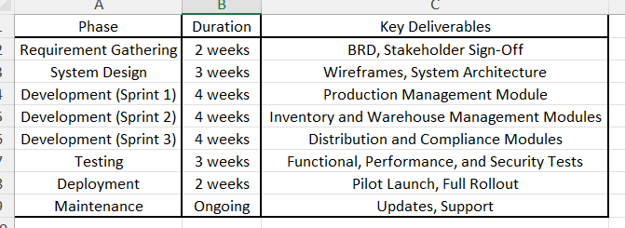

Total Estimated Duration: 20 weeks

**11. Resource Plan**

**Human Resources:**

A **Project Manager** will oversee project execution and maintain stakeholder communication.

A **Business Analyst** will document requirements, facilitate discussions, and ensure scope adherence.

The development will be handled by a team of **five Software Developers**, responsible for developing, testing, and deploying software modules.

Two **Quality Assurance (QA)** specialists will ensure all testing and quality standards are met.

A **UI/UX Designer** will focus on creating user-friendly interfaces and wireframes, while a **System Administrator** will manage deployment and server infrastructure.

**Technical Resources:**

* Cloud infrastructure (AWS/Azure/GCP)
* Development tools: Git, Jira, VS Code
* Testing tools: Selenium, JMeter

**Process Flow Diagram –**

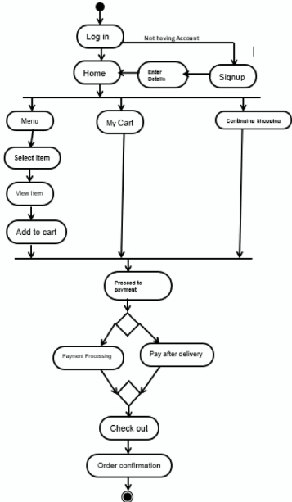

**Write an introduction letter to a client introducing yourself as a business analyst in charge of working with the client and his team to start the business understanding process.**

**Subject:** Introduction: Your Business Analyst for Inventory Management & Delivery Optimization Goal for your ice-cream and milk products software.

Dear XYZ ,

I hope this message finds you well.

My name is Manas Deepak Pandit and I am a Business Analyst assigned to work closely with you and your team as we embark on the exciting journey of developing software solutions to enhance your inventory management and streamline delivery processes for your ice-cream and milk products.

I am looking forward to collaborating with you and understanding your business needs, objectives, and any challenges you currently face in inventory management and delivery operations. My role will be to ensure that we align the project goals with your vision and deliver a solution that not only meets your expectations but also provides sustainable improvements in efficiency and customer satisfaction.

Over the course of this project, I will be facilitating discussions, gathering requirements, and providing analytical insights to ensure that the software solution we build will optimize your operations, from inventory tracking to delivery management. Together, we will work through the details of your current workflows, identify pain points, and ensure that the system we develop will support your goals for quicker deliveries and better inventory oversight.

I look forward to meeting with you and your team soon to kick off the business understanding process. Please feel free to reach out to me with any questions or to schedule our next steps.

Thank you for the opportunity to work with you, and I’m excited to get started!

Best regards,  
Manas Deepak Pandit   
Business Analyst  
Contact - +91 7262 084 084  
XYZ Infosystems.

**Prepare a brief BRD for Online Ticketing system.**

**Business Requirements Document (BRD)**

**Project Name:** Online Ticketing System  
**Prepared By:** Manas Deepak Pandit ( BA )  
**Date:** 28/12/2024

**1. Executive Summary**

The Online Ticketing System aims to streamline the process of booking tickets for events, travel, and entertainment by providing users with a convenient, fast, and user-friendly platform. This system will enable customers to browse available tickets, make secure payments, and receive digital confirmations, reducing the need for physical ticketing infrastructure and enhancing user experience.

**2. Business Goals**

The primary business goals of the Online Ticketing System are designed to align with the organization’s strategic objectives. They include:

* **Enhancing Customer Experience:**
  + Provide a seamless, user-friendly interface to simplify the ticket booking process.
  + Ensure customers can access ticketing services 24/7 from any device.
  + Enable personalized recommendations and promotions based on user preferences.
* **Increasing Revenue Streams:**
  + Leverage the digital platform to expand the customer base globally.
  + Offer cross-selling and up-selling opportunities for related services like merchandise and additional event packages.
  + Optimize pricing strategies with real-time demand and inventory data.
* **Reducing Operational Costs:**
  + Automate ticketing processes to minimize manual intervention.
  + Reduce overhead expenses associated with physical ticket distribution.
  + Enhance operational efficiency through real-time monitoring and reporting tools.
* **Building Brand Value:**
  + Position the organization as a leader in digital transformation within the ticketing industry.
  + Strengthen customer trust by implementing robust security and data privacy measures.
  + Foster long-term customer loyalty through consistent service quality and value-added features.
* **Supporting Sustainability Initiatives:**
  + Reduce the environmental impact by eliminating paper-based ticketing.
  + Encourage the use of digital tickets to promote a greener, more sustainable approach.

**3. Business Objectives**

The objectives of the Online Ticketing System are focused on delivering measurable outcomes that support the broader business goals:

* **Enhanced Accessibility:**
  + Ensure the platform is accessible 24/7 across multiple devices, including desktops, tablets, and smartphones.
* **Revenue Growth:**
  + Achieve a 20% increase in ticket sales within the first year of operation.
  + Generate additional revenue streams through value-added services such as advertising, promotions, and premium features.
* **Operational Efficiency:**
  + Reduce the manual workload for ticketing staff by 50% through process automation.
  + Implement a self-service portal to handle at least 80% of customer inquiries and transactions.
* **Customer Satisfaction:**
  + Improve customer satisfaction scores by 25% through streamlined processes and enhanced user experience.
  + Achieve an average response time of under 2 minutes for customer queries via integrated support tools.
* **Security and Compliance:**
  + Ensure compliance with global data protection regulations such as GDPR, CCPA, and PCI-DSS.
  + Implement advanced security measures to prevent data breaches and fraud.
* **Scalability and Growth:**
  + Develop a scalable platform capable of handling up to 10,000 concurrent users.
  + Support multilingual and multi-currency features to cater to a global audience.
* **Sustainability Initiatives:**
  + Reduce reliance on paper by transitioning 100% of tickets to digital formats.
  + Promote eco-friendly practices by integrating carbon offset options for travel-related ticketing.

**4. Background**

Currently, the ticketing process relies heavily on manual operations, leading to inefficiencies such as long queues, overbooking, and limited customer reach. This project intends to address these challenges by developing an online ticketing system that integrates modern technology and automation.

**5. Project Objective**

The objective of the Online Ticketing System is to deliver a comprehensive digital solution that redefines the ticket booking experience for customers and enhances operational efficiencies for stakeholders. This includes:

* **Customer-Centric Design:**
  + Develop a user-friendly platform accessible across devices to ensure seamless navigation and convenience for users.
  + Enable personalized experiences through AI-driven recommendations based on user preferences and behaviour.
* **Operational Optimization:**
  + Automate critical processes such as booking, payment, and inventory management to minimize manual intervention and errors.
  + Provide real-time insights and analytics to event organizers and administrators, facilitating data-driven decision-making.
* **Revenue Maximization:**
  + Leverage the platform's scalability to expand market reach globally, accommodating a diverse audience with multilingual and multi-currency support.
  + Integrate dynamic pricing strategies and cross-selling opportunities to enhance profitability.
* **Security and Reliability:**
  + Implement robust cybersecurity measures, including encryption and PCI-compliant payment gateways, to protect sensitive user information.
  + Ensure system uptime of 99.9% to maintain trust and reliability among users.
* **Sustainability:**
  + Transition entirely to digital tickets, eliminating paper waste and contributing to the organization's sustainability goals.
* **Stakeholder Collaboration:**
  + Foster a collaborative environment by providing tools for event organizers to manage listings, track sales, and communicate directly with attendees.

This objective aligns with the overarching goal of modernizing the ticketing process and addressing the pain points associated with legacy systems while paving the way for future growth and innovation.

**6. Project Scope**

**In-Scope:**

* User registration and login.
* Event, travel, or entertainment catalogue with search and filter options.
* Real-time availability of tickets.
* Payment processing and ticket confirmation.
* Customer support integration (live chat, FAQs).
* Reporting and analytics module.

**Out-of-Scope:**

* Physical ticket printing services.
* In-person customer service.

**7. Assumptions**

* Users will have access to an internet connection.
* Payment gateway providers will ensure compliance with regional regulations.
* Stakeholders will provide timely inputs for development and testing.

**8. Constraints**

* Development must be completed within six months.
* System must support multiple languages for a global audience.
* Budget allocation is fixed at $500,000.

**9. Risks**

* **Integration Challenges:** Delays in integrating with third-party payment gateways or external APIs.
* **Cybersecurity Threats:** The risk of data breaches or cyberattacks targeting sensitive customer and payment information.
* **User Adoption Risks:** Low user adoption due to inadequate marketing or user training.
* **Regulatory Compliance:** Potential delays in ensuring compliance with local and international regulations, such as GDPR and PCI-DSS.
* **Scalability Issues:** Performance bottlenecks if the system cannot handle peak traffic or rapid user growth.
* **Budget Overruns:** Unexpected costs arising from scope changes, resource allocation, or unforeseen development challenges.
* **Technology Risks:** Dependencies on third-party tools or technologies that may become obsolete or unsupported.
* **Project Delays:** Delays due to resource unavailability, miscommunication among stakeholders, or prolonged testing cycles.
* **Operational Risks:** Disruption of existing manual processes during the transition to the new system.
* **Customer Dissatisfaction:** Poor user experiences due to system bugs, slow response times, or unclear navigation.

**10. Business Rules**

* **User Registration:**
  + Users must register using a valid email address or social media account to access ticket booking features.
* **Payment Processing:**
  + All ticket bookings require successful payment processing before confirmation.
  + Accepted payment methods include credit/debit cards, digital wallets, and bank transfers.
* **Ticket Availability:**
  + Tickets are allocated on a first-come, first-served basis.
  + Real-time inventory updates must reflect availability across all channels.
* **Refunds and Cancellations:**
  + Refund and cancellation policies are event-specific and must be clearly communicated to users during the booking process.
* **Security Protocols:**
  + User data, including payment information, must be encrypted and stored securely.
* **Accessibility:**
  + The system must support multilingual capabilities and comply with accessibility standards to accommodate users with disabilities.
* **Admin Privileges:**
  + Only authorized personnel can create, modify, or delete event listings and ticket categories.
* **Ticket Validation:**
  + Digital tickets must include a unique QR code or barcode for validation at the venue.

**11. Business Process Overview**

**Current System:**

The current ticketing process is heavily reliant on manual operations, leading to several inefficiencies that impact both customer satisfaction and operational effectiveness. Key challenges include:

1. **Manual Booking Process**:
   * Customers are required to visit physical locations, such as ticketing offices or authorized agents, to purchase tickets. This process is time-consuming and inconvenient, especially for customers who reside in remote areas or have limited mobility.
2. **Limited Operational Hours**:
   * Ticketing offices operate within fixed hours, restricting customer access to services outside of these times. This limitation affects potential sales, especially for last-minute bookings or customers in different time zones.
3. **Long Queues and Waiting Times**:
   * Physical ticketing locations often experience long queues, especially during peak periods or for high-demand events. This leads to customer dissatisfaction and lost opportunities for sales.
4. **Overbooking and Errors**:
   * Manual tracking of ticket availability increases the risk of overbooking or misallocation of seats. This not only creates operational challenges but also leads to negative customer experiences and reputational damage.
5. **Paper-Based Tickets**:
   * The reliance on paper tickets is costly, environmentally unfriendly, and prone to issues such as loss, theft, or damage. Reissuing tickets creates additional administrative burdens.
6. **Limited Data Insights**:
   * The lack of digital systems prevents effective collection and analysis of user behaviour, ticket sales, and operational metrics, hindering data-driven decision-making and personalized customer engagement.

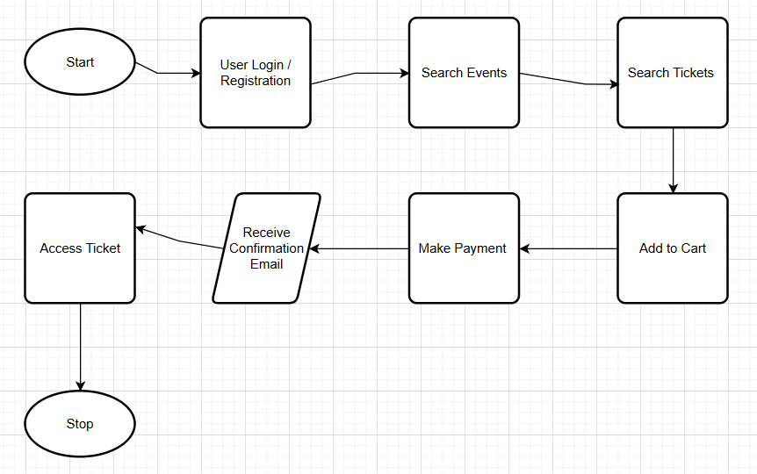

**Proposed System:**

The proposed Online Ticketing System leverages modern technology to address the shortcomings of the current system and provides a streamlined, efficient, and customer-centric ticketing experience. Key improvements include:

1. **Convenient Online Access**:
   * Customers can access the ticketing platform 24/7 via web and mobile applications, enabling them to browse, book, and manage tickets at their convenience. This eliminates the need for physical travel to ticketing offices.
2. **Real-Time Availability**:
   * The system provides real-time updates on ticket availability, preventing overbooking and ensuring that inventory is accurately reflected across all sales channels.
3. **Digital Ticketing**:
   * Customers receive digital tickets via email or SMS, complete with unique QR codes or barcodes for secure validation at the event venue. This eliminates the need for paper tickets, reducing environmental impact and administrative overhead.
4. **Enhanced Search and Filtering**:
   * Users can search for events, travel, or entertainment options based on criteria such as location, date, price, and category, making it easier to find and book relevant tickets.
5. **Personalized User Experience**:
   * The platform incorporates AI-driven recommendations based on user preferences, browsing history, and purchase behavior, enhancing customer satisfaction and driving additional sales.
6. **Secure Transactions**:
   * Integration with PCI-compliant payment gateways ensures secure handling of sensitive payment information. Multiple payment options, including credit/debit cards, digital wallets, and bank transfers, cater to diverse customer preferences.
7. **Automated Processes**:
   * Automation of booking, payment, and inventory management reduces manual intervention, minimizing errors and freeing up staff for higher-value tasks.
8. **Self-Service Portal**:
   * Customers can manage their bookings, initiate refunds or cancellations (subject to event-specific policies), and access FAQs or live chat support for queries. This reduces dependency on customer support staff.
9. **Analytics and Reporting**:
   * Event organizers and administrators gain access to real-time analytics, providing insights into sales performance, customer behaviour, and operational metrics. This data supports informed decision-making and strategy optimization.
10. **Global Scalability**:
    * The system supports multilingual and multi-currency functionalities, enabling the organization to cater to a global audience and expand its market reach.
11. **Sustainability Initiatives**:
    * The transition to 100% digital ticketing promotes eco-friendly practices, aligning with the organization’s sustainability goals and reducing the carbon footprint associated with paper-based processes.
12. **Improved Customer Experience**:
    * The platform’s intuitive design and responsive interface ensure a seamless user experience, leading to increased customer satisfaction and loyalty.

**12. How the Proposed System Will Address Challenges in the Legacy System?**

**1. Eliminating Manual Booking Processes**

* **Challenge**: The manual process requires customers to visit physical locations, leading to inefficiencies and inconvenience.
* **Solution**: The proposed system provides a fully digital platform accessible via web and mobile applications, enabling customers to browse and book tickets from anywhere, anytime, without the need to visit a physical location.

**2. Extended Operational Hours**

* **Challenge**: Limited operational hours of ticketing offices restrict customer access outside working hours.
* **Solution**: The system operates 24/7, allowing customers to book tickets at their convenience, regardless of time zone or location.

**3. Reducing Long Queues and Waiting Times**

* **Challenge**: Physical ticketing offices often face long queues, causing delays and dissatisfaction.
* **Solution**: Online booking eliminates the need for physical queues. Customers can instantly check availability, make payments, and receive confirmations within minutes.

**4. Real-Time Inventory Management**

* **Challenge**: Manual tracking of tickets often results in overbooking or incorrect inventory updates.
* **Solution**: The system incorporates real-time inventory management, ensuring accurate ticket availability across all channels and preventing overbooking.

**5. Transitioning to Digital Tickets**

* **Challenge**: Paper-based tickets are prone to loss, damage, or theft and incur additional administrative and environmental costs.
* **Solution**: The system issues secure digital tickets with QR codes or barcodes, eliminating the need for physical tickets and supporting sustainability goals.

**6. Enhancing Data Collection and Analytics**

* **Challenge**: The current system lacks the ability to track user behaviour, sales trends, or event performance effectively.
* **Solution**: The new platform integrates advanced analytics tools, providing detailed insights into sales performance, customer preferences, and operational metrics. This data empowers event organizers to make informed, data-driven decisions.

**7. Personalized User Experience**

* **Challenge**: The manual system does not cater to individual user preferences or provide tailored recommendations.
* **Solution**: AI-driven features analyse user preferences and behaviour to deliver personalized event recommendations, promotions, and notifications, enhancing customer satisfaction and loyalty.

**8. Improving Accessibility and Inclusivity**

* **Challenge**: Physical systems may not cater to users with disabilities or those in remote areas.
* **Solution**: The platform complies with accessibility standards (e.g., WCAG) and supports multilingual interfaces, ensuring inclusivity for a diverse audience.

**9. Ensuring Secure Transactions**

* **Challenge**: Manual processes lack robust security for handling payments and sensitive customer data.
* **Solution**: The system implements advanced encryption, PCI-compliant payment gateways, and fraud detection measures to ensure secure transactions and build customer trust.

**10. Automating Operational Processes**

* **Challenge**: Manual operations increase the workload for staff and are prone to errors.
* **Solution**: Automated workflows handle booking, payment processing, and inventory updates, reducing staff workload and operational errors.

**11. Scalability for Global Reach**

* **Challenge**: The existing system is not equipped to handle high demand or cater to international users.
* **Solution**: The system is built to support high concurrency, multilingual functionality, and multi-currency transactions, enabling the organization to expand its market globally.

**12. Fostering Sustainability**

* **Challenge**: Paper tickets contribute to environmental waste.
* **Solution**: Transitioning to 100% digital ticketing eliminates paper waste, aligning with sustainability objectives and reducing the organization’s carbon footprint.

**13. Streamlining Communication with Customers**

* **Challenge**: Customers face delays or difficulties when accessing support or receiving event updates.
* **Solution**: Integrated support tools such as live chat, automated notifications, and self-service portals ensure quick and efficient communication with customers.

**13. Functional Requirements**

* **User Management:**
  + Allow users to register and log in using email or social media credentials.
  + Enable users to update their profiles and view booking history.
* **Search and Booking:**
  + Provide advanced search options by date, category, location, and price.
  + Allow users to book multiple tickets in a single transaction.
* **Payment and Confirmation:**
  + Integrate secure payment gateways (e.g., credit/debit cards, digital wallets).
  + Generate digital tickets and send them via email or SMS.
* **Admin Features:**
  + Enable event organizers to upload and manage events.
  + Provide real-time sales and inventory reports.
* **Multi-User Accounts**:
* Enable the creation of sub-accounts under a primary account for businesses or families managing multiple ticket bookings simultaneously.
* **Venue Mapping and Seat Selection**:
* Integrate interactive venue maps to allow users to view seat layouts and choose their preferred seats during the booking process.

**14. Non-Functional Requirements:**

* **Performance:**

The system must be capable of handling up to 10,000 concurrent users without any degradation in performance. This includes maintaining fast response times for all actions, such as searching for events, processing payments, and generating tickets.

* **Availability:**

Ensure an uptime of 99.9%, meaning that the system should be available and fully operational for all users at all times, with minimal downtime for maintenance or updates.

* **Security:**

Implement industry-standard security protocols, such as end-to-end data encryption, secure socket layers (SSL), and token-based authentication. Ensure compliance with global standards such as PCI DSS for payment security and GDPR for data privacy.

* **Scalability:**

The platform must be designed to scale seamlessly as demand grows, allowing for the addition of new events, categories, or users without affecting system performance or requiring significant rework.

* **Reliability:**

The system should provide consistent and predictable behaviour under all conditions, with robust error-handling mechanisms to manage unexpected failures or high traffic loads.

* **Maintainability:**

Ensure that the system is easy to update and maintain by using modular design principles. Clear documentation should be provided for developers and administrators.

* **Usability:**

The platform must be intuitive and user-friendly, with a clean and responsive interface that supports seamless navigation across devices, including desktops, tablets, and smartphones.

* **Compatibility:**

Ensure compatibility with multiple operating systems (e.g., Windows, macOS, Android, iOS) and web browsers (e.g., Chrome, Firefox, Safari, Edge).

**15. Development Plan**

* **Requirement Gathering:** Month 1
* **Design:** Month 2
* **Development:** Month 3-4
* **Testing:** Month 5
* **Deployment:** Month 6

**16. Resource Plan**

* **Development Team:** 5 developers, 2 designers.
* **QA Team:** 2 testers.
* **Project Manager:** 1.
* **Budget:** $500,000 for development, testing, and marketing.

**Prepare a brief SRS for Online Ticketing system.**

**Software Requirements Specification (SRS)**

**For:** Online Ticketing System

**1. Introduction**

**1.1 Purpose**

This document outlines the requirements for an Online Ticketing System designed to facilitate ticket booking for events such as movies, concerts, and travel. The system aims to provide a user-friendly platform for customers to book, manage, and pay for tickets while enabling event organizers to manage ticket availability and schedules.

**1.2 Scope**

The Online Ticketing System will allow users to browse available events, book tickets, and make payments securely. It will also include features for cancellations, refunds, and notifications. The system will be accessible through a web application and mobile app.

**1.3 Stakeholders**

* Users: Customers booking tickets.
* Event Organizers: Entities managing event schedules and ticket availability.
* Administrators: Internal team managing the platform.

**2. Overall Description**

**2.1 Product Perspective**

The Online Ticketing System is a standalone application integrating with third-party payment gateways and notification services (e.g., email, SMS).

**2.2 User Classes and Characteristics**

* **Registered Users**: Can book, cancel, and manage their tickets.
* **Guests**: Can browse events but must register to book tickets.
* **Administrators**: Monitor transactions, manage disputes, and ensure system integrity.

**2.3 Assumptions and Dependencies**

* Users have internet access.
* Payment processing relies on third-party gateways like PayPal or Stripe.
* Notifications depend on integrated email/SMS services.

**3. Functional Requirements**

**3.1 User Registration and Login**

* Users must register using email and phone numbers.
* Secure login with optional multi-factor authentication (MFA).

**3.2 Event Browsing and Ticket Booking**

* Users can search and filter events by category, date, and location.
* Display available seats and pricing.
* Support for single and multiple ticket bookings.

**3.3 Payment and Ticket Confirmation**

* Integration with secure payment gateways.
* Generate a unique ticket ID and confirmation upon payment success.

**3.4 Cancellations and Refunds**

* Allow users to cancel bookings within a specific timeframe.
* Process partial/full refunds based on cancellation policies.

**3.5 Notifications**

* Email and SMS confirmations for bookings, cancellations, and refunds.
* Reminders for upcoming events.

**4. Non-Functional Requirements**

**4.1 Performance Requirements**

* System must handle 500 concurrent users with no significant performance degradation.

**4.2 Security Requirements**

* All user data must be encrypted during transmission and storage.
* Comply with PCI DSS for secure payment processing.

**4.3 Usability Requirements**

* Mobile-friendly UI for both web and mobile applications.
* Accessibility compliance (WCAG 2.1).

**4.4 Availability and Reliability**

* **99.9%** uptime with robust backup and recovery mechanisms.

**5. System Constraints**

* The system must integrate with external payment gateways and notification services.
* Hosted on a cloud platform to ensure scalability.

**6. Appendices**

* **Glossary:**
  + **MFA**: Multi-Factor Authentication
  + **PCI DSS**: Payment Card Industry Data Security Standard
* **References:** Industry standards and similar systems.

**Make an ERD of Ticketing life cycle**

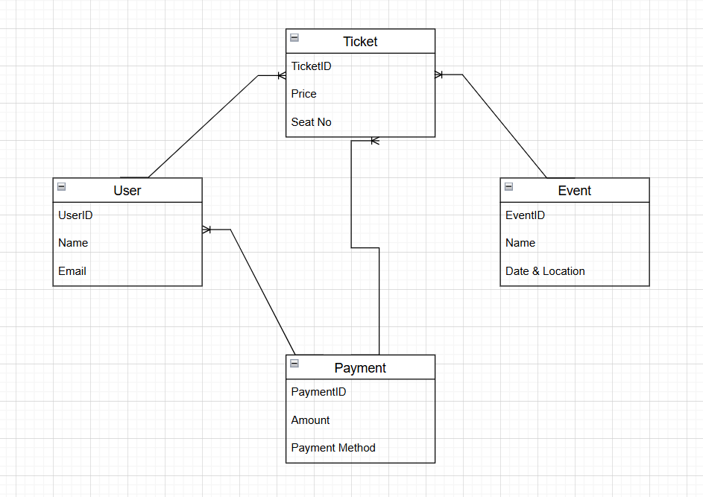

**User story of shopping from ecommerce**

**User Story 1**

**As a** customer  
**I want to** register on the platform  
**So that** I can make purchases.

**Acceptance Criteria:**

* Registration screen with text boxes for Name, Email, Password, Phone, and Address.
* Validation for mandatory fields.
* Successful registration notification.

**User Story 2**

**As a** Customer  
**I want to** log in to my account  
**So that** I can access personalized features.

**Acceptance Criteria**:

* Login screen with fields for Email/Username and Password.
* Forgot Password functionality.
* Error message for incorrect credentials.

**User Story 3**

**As a** Customer  
**I want to** browse products by category  
**So that** I can easily find what I need.

**Acceptance Criteria**:

* Categories displayed on the homepage.
* Subcategories for better filtering.
* Navigation to products within a category.

**User Story 4**

**As a** Customer  
**I want to** search for products by name  
**So that** I can quickly locate specific items.

**Acceptance Criteria**:

* Search bar available on all pages.
* Auto-suggestions for search terms.
* Results displayed with product images, names, and prices.

**User Story 5**

**As a** Customer  
**I want to** view product details  
**So that** I can make informed purchase decisions.

**Acceptance Criteria**:

* Product page with images, description, price, and reviews.
* Add-to-Cart button.
* Display of stock availability.

**User Story 6**

**As a** Customer  
**I want to** add products to my cart  
**So that** I can purchase them later.

**Acceptance Criteria**:

* Add to Cart button on product pages.
* Cart icon updates with item count.
* Cart persists until cleared or checkout is completed.

**User Story 7**

**As a** Customer  
**I want to** update the quantity of items in my cart  
**So that** I can purchase the desired quantity.

**Acceptance Criteria**:

* Quantity selector for each item in the cart.
* Cart total updates dynamically.
* Validation for stock limits.

**User Story 8**

**As a** Customer  
**I want to** remove items from my cart  
**So that** I can refine my purchase list.

**Acceptance Criteria**:

* Remove button for each cart item.
* Cart total updates after item removal.
* Confirmation message for removed items.

**User Story 9**

**As a** Customer  
**I want to** proceed to checkout  
**So that** I can complete my purchase.

**Acceptance Criteria**:

* Checkout button in the cart.
* Delivery and payment information screens.
* Confirmation of the order before placing it.

**User Story 10**

**As a** Customer  
**I want to** save multiple delivery addresses  
**So that** I can choose where to deliver my orders.

**Acceptance Criteria**:

* Option to add, edit, and delete addresses.
* Address selection during checkout.
* Default address setting.

**User Story 11**

**As a** Customer  
**I want to** pay using multiple payment methods  
**So that** I can choose the most convenient option.

**Acceptance Criteria**:

* Payment options for credit card, debit card, net banking, UPI, and COD.
* Secure payment gateway integration.
* Notification on payment success or failure.

**User Story 12**

**As a** Customer  
**I want to** track my orders  
**So that** I can know the delivery status.

**Acceptance Criteria**:

* Order history page with tracking information.
* Notifications for shipping and delivery updates.
* Estimated delivery date displayed.

**User Story 13**

**As a** Customer  
**I want to** leave reviews for purchased products  
**So that** I can share my feedback.

**Acceptance Criteria**:

* Review form with a star rating and comments.
* Option to edit or delete reviews.
* Reviews displayed on product pages.

**User Story 14**

**As a** Customer  
**I want to** receive email notifications  
**So that** I stay informed about my orders and offers.

**Acceptance Criteria**:

* Email notifications for order confirmation, shipping, and delivery.
* Subscription option for promotional emails.
* Unsubscribe link in emails.

**User Story 15**

**As a** Customer  
**I want to** save products to a wishlist  
**So that** I can view them later without adding them to my cart.  
**Acceptance Criteria**:

* Add to Wishlist button on product pages.
* Wishlist accessible from the user account menu.
* Option to move items from Wishlist to Cart.

**User Story 16**

**As a** Customer  
**I want to** apply discount codes during checkout  
**So that** I can avail of special offers.  
**Acceptance Criteria**:

* Promo code input field at checkout.
* Validation for active and applicable codes.
* Total amount updates after applying a valid code.

**User Story 17**

**As a** Customer  
**I want to** view recommended products  
**So that** I can explore items I may be interested in.  
**Acceptance Criteria**:

* Recommendations displayed on the homepage and product pages.
* Dynamic updates based on user activity.
* Recommendations based on popular or related products.

**User Story 18**

**As a** Customer  
**I want to** receive alerts for price drops on products  
**So that** I can purchase items at the best price.  
**Acceptance Criteria**:

* Price drop alert subscription option for each product.
* Email and app notifications for price changes.
* Option to unsubscribe from alerts.

**User Story 19**

**As a** Customer  
**I want to** filter and sort search results  
**So that** I can find the most relevant products easily.  
**Acceptance Criteria**:

* Filters for price range, brand, ratings, and availability.
* Sorting options by price, popularity, and relevance.
* Results update dynamically based on selected filters.

**User Story 20**

**As a** Customer  
**I want to** view product availability  
**So that** I can confirm whether an item can be delivered to my location.  
**Acceptance Criteria**:

* Check availability feature on product pages.
* Pin code input field for delivery verification.
* Notification if the item is out of stock or unavailable for delivery.

**User Story 21**

**As a** Customer  
**I want to** cancel my order  
**So that** I can avoid receiving unwanted items.  
**Acceptance Criteria**:

* Cancel button available before the order is shipped.
* Confirmation prompt before canceling.
* Refund initiated for prepaid orders.

**User Story 22**

**As a** Customer  
**I want to** return or exchange items  
**So that** I can resolve issues with incorrect or defective products.  
**Acceptance Criteria**:

* Return/Exchange request button on order details page.
* Selection of return reason and preferred resolution.
* Return label generation for eligible items.

**User Story 23**

**As a** Delivery Boy  
**I want to** view assigned orders  
**So that** I can efficiently manage my deliveries.  
**Acceptance Criteria**:

* List of pending deliveries with order details.
* Map integration for delivery locations.
* Status updates for each delivery.

**User Story 24**

**As a** Admin  
**I want to** add and manage products  
**So that** the catalog stays up-to-date.  
**Acceptance Criteria**:

* Admin panel for adding, editing, and deleting products.
* Bulk upload option for multiple products.
* Real-time inventory updates.

**User Story 25**

**As a** Admin  
**I want to** manage user accounts  
**So that** I can address any account-related issues.  
**Acceptance Criteria**:

* Admin panel to view user accounts.
* Option to deactivate or block accounts.
* Access to user order and activity history.

**User Story 26**

**As a** Admin  
**I want to** generate sales reports  
**So that** I can analyze business performance.  
**Acceptance Criteria**:

* Reports by date range, category, and region.
* Export reports in CSV and PDF formats.
* Visualization of key metrics like revenue and orders.

**User Story 27**

**As a** Customer  
**I want to** view my order history  
**So that** I can keep track of my past purchases.  
**Acceptance Criteria**:

* Order history page with order details.
* Reorder button for previous purchases.
* Filter by date range and order status.

**User Story 28**

**As a** Customer  
**I want to** chat with customer support  
**So that** I can resolve my queries quickly.  
**Acceptance Criteria**:

* Chat support available on the help page.
* Real-time communication with agents.
* Ticket generation for unresolved queries.

**User Story 29**

**As a** Customer  
**I want to** schedule deliveries  
**So that** I can receive orders at my convenience.  
**Acceptance Criteria**:

* Delivery scheduling option during checkout.
* Date and time slot selection.
* Confirmation of the selected schedule.

**User Story 30**

**As a** Customer  
**I want to** receive push notifications  
**So that** I stay informed about updates and offers.  
**Acceptance Criteria**:

* Notifications for order updates, deals, and promotions.
* Option to enable/disable notifications.
* Customizable notification preferences.

**User Story 31**

**As a** Admin  
**I want to** monitor website performance  
**So that** I can ensure smooth operations.  
**Acceptance Criteria**:

* Dashboard with metrics like active users, page load time, and error logs.
* Alerts for system downtime or performance issues.
* Tools to analyze traffic and user behavior.

**User Story 32**

**As a** Customer  
**I want to** rate my shopping experience  
**So that** I can provide feedback for improvement.  
**Acceptance Criteria**:

* Post-purchase feedback form.
* Star rating and optional comments.
* Option to skip feedback submission.

**User Story 33**

**As a** Admin  
**I want to** manage promotional banners  
**So that** I can highlight offers and deals.  
**Acceptance Criteria**:

* Banner upload and scheduling in the admin panel.
* Preview option before publishing.
* Dynamic updates on the homepage.

**User Story 34**

**As a** Customer  
**I want to** receive refunds quickly  
**So that** I can resolve payment-related issues.  
**Acceptance Criteria**:

* Refund initiation within the system for eligible returns.
* Notification for refund progress.
* Tracking of refunded amount.

**User Story 35**

**As a** Customer  
**I want to** compare similar products  
**So that** I can choose the best option.  
**Acceptance Criteria**:

* Compare button for products in the same category.
* Side-by-side comparison of features and prices.
* Highlighting of differences.

**User Story 36**

**As a** Admin  
**I want to** manage delivery logistics  
**So that** orders are fulfilled efficiently.  
**Acceptance Criteria**:

* Dashboard for tracking pending and completed deliveries.
* Assignment of delivery agents to orders.
* Alerts for delayed deliveries.

**User Story 37**

**As a** Customer  
**I want to** share products on social media  
**So that** I can recommend items to my friends.  
**Acceptance Criteria**:

* Social media share buttons on product pages.
* Pre-filled product links and descriptions.
* Option to share via email.

**User Story 38**

**As a** Customer  
**I want to** earn loyalty points on purchases  
**So that** I get rewards for shopping frequently.  
**Acceptance Criteria**:

* Points added to the account after purchases.
* Redemption options during checkout.
* Display of current points balance.

**User Story 39**

**As a** Customer  
**I want to** use guest checkout  
**So that** I can place orders without creating an account.  
**Acceptance Criteria**:

* Guest checkout option on the cart page.
* Temporary account created for the order.
* Option to convert to a full account after purchase.

**User Story 40**

**As a** Admin  
**I want to** manage customer complaints  
**So that** I can address issues promptly.  
**Acceptance Criteria**:

* Complaint logging system in the admin panel.
* Tracking of complaints by status.
* Option to communicate resolution updates to the customer.