**Document 6- Please prepare a use case diagram, activity diagram and a use**

**case specification document.**

**Use case diagram :**

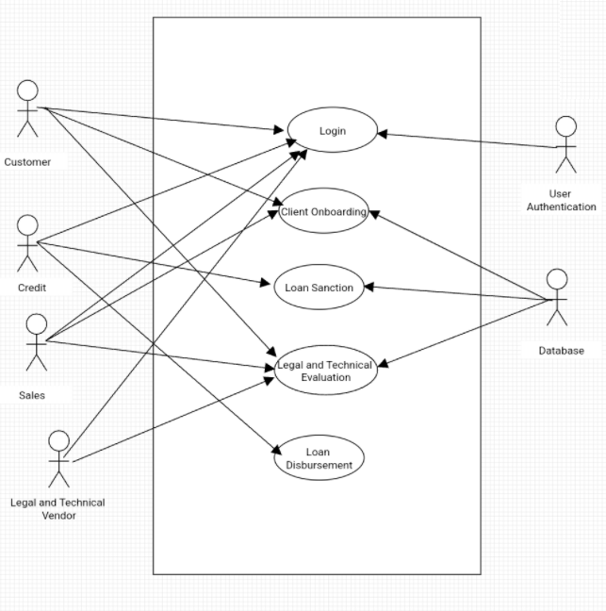

**Activity diagram :**

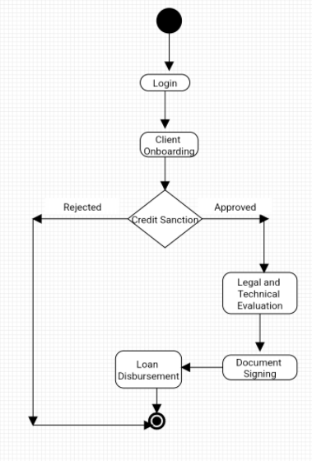

**A use case specification document**

A use case specification document is a detailed description of a use case that helps to understand how a system works and what tasks can be completed in each use case.

**Use case 1:**

|  |  |
| --- | --- |
| **Use Case Name** | Log in |
| **Use Case Description** | Login into the system |
| **Actors Primary Actors Secondary Actors** | Customer and Admin |
| **Basic Flow** | Step 1: Customer visit i-lens Web page Step 2: Customer Enters the login ID and password Step 3: Customer Clicks on login button to login into the application |
| **Alternate Flow** | In Step 3, If customer not having login credentials or entered wrong login ID and password  System should response with error message as " User doesn't exists or wrong login ID and password ". |
| **Pre- Conditions** | User should have login credentials |
| **Post-Conditions** | Customer should able to login into the application |
| **Assumptions** | Customer is well known to use computer |
| **Constraints** | NA |
| **Dependencies** | Internet connections |
| **Inputs And Outputs** | Input : Login ID and Password  Output : Login into the application |
| **Business Rules** | NA |
| **Miscellaneous Information** | NA |

**Use case 2:**

|  |  |
| --- | --- |
| **Use Case Name** | Loan Sanction |
| **Use Case Description** | Credit team need to login in the system and view the loan application for processing loan sanction |
| **Actors Primary Actors Secondary Actors** | Credit and Admin |
| **Basic Flow** | Step 1: Credit visit i-lens Web page Step 2: Credit Enters the login ID and password Step 3: Credit Clicks on login button to login into the application Step 4: Credit team will view the pending loan application for Sanction Step 5: Credit team will select the application and click and Approved to Loan |
| **Alternate Flow** | In Step 3, If credit not having login credentials or entered wrong login ID and password  System should response with error message as " User doesn't exists or wrong login ID and password ".  In Step 4, If the credit team click on approve without selecting loan application.  System should response with error message as " Loan application not selected". |
| **Pre- Conditions** | Credit team should have login credentials. Credit team should have their access role in the system. |
| **Post-Conditions** | Credit team should able to view and verify the loan for sanction |
| **Assumptions** | Credit team know about the system |
| **Constraints** | System should get auto logout if system is not in use for 10mins |
| **Dependencies** | Internet connections |
| **Inputs And Outputs** | Input : Loan Application Output : Loan Sanction |
| **Business Rules** | NA |
| **Miscellaneous Information** | NA |

**Use Case 3:**

|  |  |
| --- | --- |
| **Use Case Name** | Loan Disbursement |
| **Use Case Description** | Credit team need to login in the system and view the loan application for processing loan Disbursement |
| **Actors Primary Actors Secondary Actors** | Credit and Admin |
| **Basic Flow** | Step 1: Credit visit i-lens Web page Step 2: Credit Enters the login ID and password Step 3: Credit Clicks on login button to login into the application Step 4: Credit team will view the loan application for disbursement Step 5: Credit team will select the application and click and disburse the Loan |
| **Alternate Flow** | In Step 3, If credit not having login credentials or entered wrong login ID and password  System should response with error message as " User doesn't exists or wrong login ID and password ".  In Step 4, If the credit team click on approve without selecting loan application.  System should response with error message as " Loan application not selected". |
| **Pre- Conditions** | Credit team should have login credentials. Credit team should have their access role in the system. Loan should be sanctioned and legal and technical verification should be completed |
| **Post-Conditions** | Credit team should able to view and verify the loan for Disbursement |
| **Assumptions** | Credit team know about the system |
| **Constraints** | System should get auto logout if system is not in use for 10mins |
| **Dependencies** | Internet connections |
| **Inputs And Outputs** | Input : Loan Application Output : Loan Disbursed |
| **Business Rules** | NA |
| **Miscellaneous Information** | NA |

**Document 7- Screens and pages**

**Please follow the following steps to create the mock-ups**

1. **Login page :**

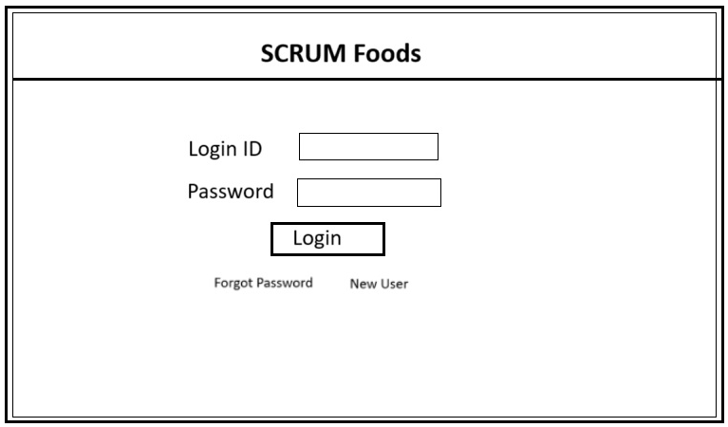

1. **Home Page :**

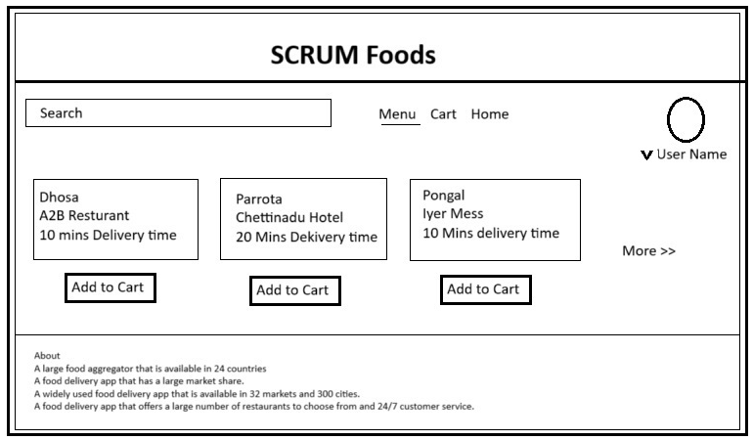

**Search page :**

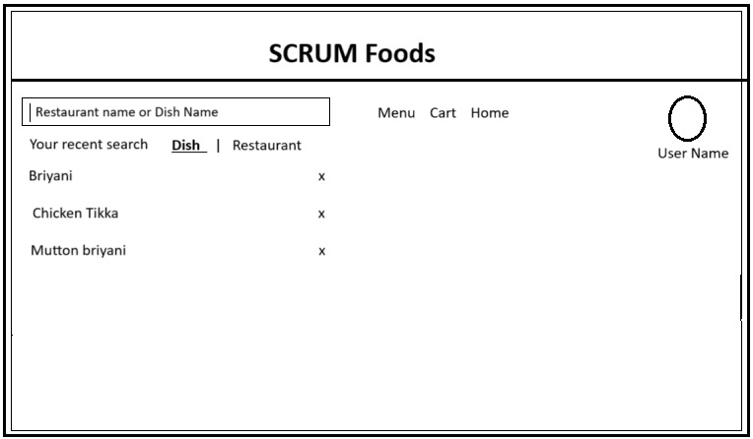

**Cart Page :**

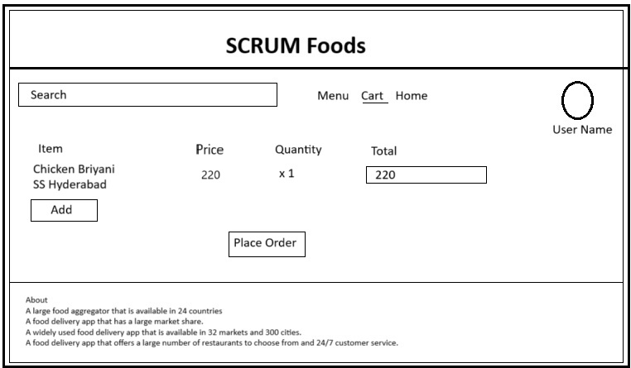

**Payment Page :**

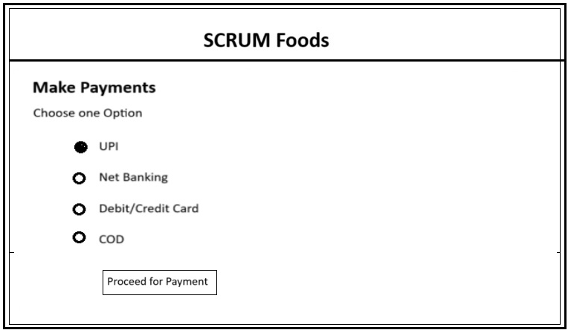

**Logout page :**

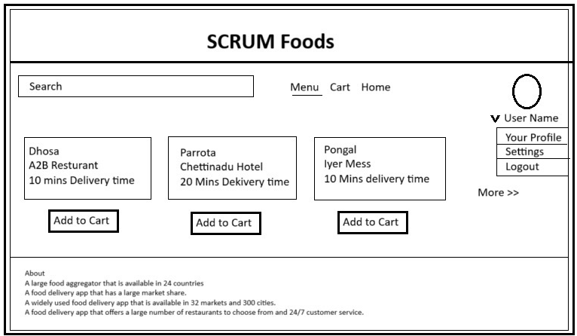

**Document 8- Tools-Visio and Axure**

**Write a paragraph on your experience using Visio and Axure for the project.**

Visio is a drawing program from Microsoft that has many uses like flow charts, Use case diagram and much more.

Main feature of using Visio is the ability to drag and drop the symbols as Visio has pre defined symbols for making the diagrams.

In this project Visio help me to create the use case and activity diagrams to represent the flow and functionality of the project without using any coding. And with the help of these diagrams it become easy to explain the flow to the development team to develop the project.

Axure is an prototyping and wire-framing tool which used to create an interactive prototypes for the project. Axure contains the pre defined diagram so that it allow us drag and drop the diagram to create and prototypes and its very useful to make some to understand the project.

In this project Axure helps me to create and interactive prototype to make demonstration to the development team and the client. Through this prototype it made me to explain the complex procedures also in an easier way.

**Document 9- BA experience**

**My experience as BA in following phases:**

1. **Requirement gathering:**

Requirement gathering is primary step in the process. Once the project is finalized, As an BA i should start gathering the requirements. To gather requirements, i use an technique called MOSCOW. Through which not only gather the requirement, we can also priority the requirement.

● During the requirement gathering phase, sometimes client will not be available for some period. So as a BA i need to source out point of contacts from his side and get the information ASAP from the next level contact of the client, who will be a backup in absent of his presence.

● Once all the requirement are gathered, The requirements need to be validate to know any duplicate requirements are available or not. For Validation we use FURPS technique ( Functionality, Usability, Reliability, Performance and Security).

● Prototyping is a technique that can help to elicit and validate requirements for a product or system. Prototyping is used to give more specific requirements.

**2. Requirement Analysis:**

Requirement analysis is a process that involves identifying, analyzing, and managing the requirements for a project.

● For Requirement analysis i draw an UML diagrams to visually describe the requirements to make a clear vision of the project and it makes to develop and understand the requirement in an easier way.

● In other hand Activity diagrams also used to describe the process flow in an diagrammatic way.

● Using the diagram as an BA i explain and communicate the flow and steps to team. If Some team members might not agree with them and might make changes. I have consider the points and note down the changes and need to discuss with stakeholders and need perform necessary modification.

● Post requirement analysis need to prepare documents like BRS and SRS, so that the requirements will be completed.

**3. Design:**

As a BA design phase is the stage where a business analyst and other stakeholders define and develop a solution to a business problem.

● At the time of requirement analysis stage i have prepare the use case diagrams from which i can prepare test cases for the project.

● Test case which prepared should be both negative test cases as well along with positive test cases, so that we can analysis and monitor the behavior of the system.

● Communicate with client on design and solution documents.

● While performing testing we should not miss even an single test case. Because it might have huge impact on project development in later stages. And it will affect the outcome of the project and project delivery time.

● Frequently we need to update RTM after each phase completed like design, testing. So that we can track and monitor all the requirements. Hence we can make sure that all the requirements are met

1. **Development:**

● During development Phase, as an BA i have to organized JAD sessions to make sure every one understand the need of the project development.

● There might be some team members who doesn't agree with the concept or who doesn’t cooperate during JAD sessions. As a BA i handle the situation gently and had one on one discussion with them. Explained how their actions are going to affect the project. Setup healthy environment within the team.

● While developing the design development team might required clarity so i have provided the clarity using the Use case diagram and Activity diagram as an reference. So the development team will understand the need.

● As and BA I have conduct regular meetings with technical team and client through virtual or meeting so that all will be in an same track of the project. But conducting meeting is and challenging one, as some team members might not be available for the meeting at a scheduled date and time. For this I have record the session and providing the recordings with missed one and had one to one discussion later with that missed person so any updated or clarification will be taken and provided.

**5. Testing:**

● As an BA I have prepare test cases from use cases diagram so that we can perform the testing and I have recorded and observed the activities if the system. Once the testing is completed I will update the RTM. So that the requirement can be tracked and monitored.

● Once the testing is completed and we got the observation as we expected for all the test case, Then we have to take signoff from client for the testing completion procedure.

● Post signoff as an BA i have given training and prepared the client for UAT observation. So client will get and fair idea about the outcome of the project.

**6. Deployment:**

● Final stage of the project is deployment of the project in an live environment. To process deployment as an BA i have circulate the updated or completed RTM to client along with the project closure document and i will taken and signoff from the client over the mail so we can process the deployment in live environment.

● And i have Coordinates between teams to complete and share end user manuals so that the client will understand how to use the project and it will provide the basic functionality of the project.

● And I have also plan and organizes an training sessions with the client and stakeholders and Make sure all the candidates attend the meeting by gathering all the members available time and sending remainders for the meeting. So that every one will attend the meeting and all will be updated with the final project.