Pallela Venkateshwar Rao



**Masqati Dairy Products**

Contents

1. Document Revisions 4

2. Approvals 4

3. RACI Chart for This Document 5

Codes Used in RACI Chart 5

RACI Chart 5

4. Introduction 6

4.1. Business Goals 6

4.2. Business Objectives 6

4.3. Business Rules 6

4.4. Background 6

4.5. Project Objective 6

4.6. Project Scope 6

4.6.1. In Scope Functionality 6

4.6.2. Out Scope Functionality 6

5. Assumptions 7

6. Constraints 7

7. Risks 7

Technological Risks 7

Skills Risks 7

Political Risks 7

Business Risks 7

Requirements Risks 7

Other Risks 7

8. Business Process Overview 8

8.1. Legacy System (AS-IS) 8

8.2. Proposed Recommendations (TO-BE) 8

9. Business Requirements 8

10. Appendices 8

10.1. List of Acronyms 8

10.2. Glossary of Terms 8

10.3. Related Documents 8

# Document Revisions

|  |  |  |
| --- | --- | --- |
| Date | Version Number | Document Changes |
| 09/08/2024 | 0.1 | Initial Draft |
|  |  |  |
|  |  |  |
|  |  |  |
|  |  |  |
|  |  |  |
|  |  |  |
|  |  |  |
|  |  |  |

# Approvals

|  |  |  |  |  |
| --- | --- | --- | --- | --- |
| **Role** | **Name** | **Title** | **Signature** | **Date** |
| Project Sponsor | charan |  |  | 2/01/2025 |
| Business Owner | anish |  |  | 2/01/2025 |
| Project Manager | varun |  |  | 2/01/2025 |
| System Architect | rahul |  |  | 2/01/2025 |
| Development Lead | rohith |  |  | 2/01/2025 |
| User Experience Lead | gagan |  |  | 2/01/2025 |
| Quality Lead | kaushal |  |  | 2/01/2025 |
| Content Lead | hari |  |  | 2/01/2025 |

# RACI Chart for This Document

### RACI Chart

|  |  |  |  |  |  |  |  |
| --- | --- | --- | --- | --- | --- | --- | --- |
| **Name** | **Position** | **\*** | **R** | **A** | **S** | **C** | **I** |
| **varun** | **Project manager** |  |  | **A** |  |  |  |
| **venkatesh** | **BA** |  | **R** |  |  |  |  |
| **charan** | **Project sponsor** |  |  |  |  |  | **I** |
| **anish** | **Stakeholder** |  |  |  |  | **C** |  |
| **pavan** | **Sr.BA** |  |  |  | **S** |  | **I** |

# 4.Introduction

## 4.1.Business Goals

The primary goals of the project are to Implement a software solution to efficiently manage inventory across manufacturing plants and warehouses. Optimize delivery routes and processes to ensure the quickest delivery of ice cream and milk products to customers.

## 4.2.Business Objectives

The business objectives of the project are as follows:

1. **Efficient Inventory Management:** Streamline the inventory management process by providing real-time tracking of stock levels, reducing manual errors, and enabling proactive management of inventory.
2. **Faster Delivery:** Implement route optimization and real-time tracking features to reduce delivery times, ensuring quicker and more efficient deliveries of ice cream and milk products to customers.
3. **Cost Reduction:** Minimize wastage through better inventory control and improve delivery efficiency to lower operational costs associated with logistics.
4. **Scalability:** Design the system to support future growth, enabling easy integration of new manufacturing plants, warehouses, and delivery regions.
5. **Data-Driven Decision Making:** Provide comprehensive reporting and analytics tools to help managers make informed decisions regarding inventory management, delivery routes, and resource allocation.

## 4.3.Business Rules

* **Inventory Management:**

1. Only authorized staff can update stock levels or transfer inventory.
2. Automated alerts for low stock and near-expiry items.
3. Expired items must be flagged and removed from active inventory.

* **Delivery Management:**

1. Only authorized delivery personnel can modify delivery schedules.
2. Real-time GPS tracking is mandatory for delivery vehicles.
3. Customers must be notified in case of delivery delays or cancellations.

* **Payment Rules:**

1. Payments must be processed via approved methods: cash, credit card, debit card, or bank transfer.
2. Refunds or cancellations require admin approval and must update inventory and financial records.

* **Access Control:**

1. Role-based access control, restricting sensitive data to authorized personnel.
2. Admins can manage user roles and permissions.

* **Data Integrity and Security:**

1. All sensitive data must be encrypted and regularly backed up.
2. Accurate and consistent data across all system modules.

* **Customer Interaction:**

1. System must send notifications for order status updates.
2. Customer support manages complaints and order adjustments.

#### 4.4. Background

The company operates multiple manufacturing plants and warehouses across the country. Currently, inventory tracking and delivery scheduling are manual and prone to errors. The proposed software will address inefficiencies, reduce wastage, and enhance overall operational performance.

## 4.5.Project Objective

* **Implement an Integrated Inventory System:** Develop and deploy a system that tracks inventory across all manufacturing plants and warehouses, with automated alerts for low stock and expiration management.
* **Optimize Delivery Operations:** Integrate a delivery management module that includes route optimization and real-time vehicle tracking, ensuring the fastest delivery times to customers.
* **Create Detailed Analytics and Reporting:** Provide dashboards and reports for key performance indicators (KPIs), including inventory turnover, delivery times, and operational efficiency.
* **Enhance User Experience:** Build an intuitive and user-friendly interface for warehouse staff, delivery teams, and administrators, ensuring smooth operations and reducing training time.
* **Ensure Scalability and Future Expansion:** Design the system to accommodate the growth of the business, supporting additional locations, increased user loads, and future feature integrations.

## 4.6.Project Scope

#### 4.6.1.In-Scope Functionality:

* **Inventory Management:**
  + Real-time tracking of stock levels across all warehouses and manufacturing plants.
  + Automated alerts for low stock levels or approaching expiration dates.
  + Ability to transfer inventory between locations seamlessly.
* **Delivery Management:**
  + Integration of route optimization algorithms to ensure efficient delivery schedules.
  + Real-time tracking of delivery vehicles.
  + Generation of delivery reports and customer feedback analysis.
* **Reporting and Analytics:**
  + Dashboard with KPIs such as inventory turnover, wastage, and delivery performance.
  + Detailed analytics on demand patterns to help in forecasting and planning.

##### 4.6.2. Out of Scope Functionality

• Integration with third-party logistics companies (current focus is on in-house delivery).

• Advanced AI-driven demand forecasting models (to be considered in future phases).

• Marketing and promotional functionalities.

# 5.Assumptions

* All manufacturing plants and warehouses are equipped with the required hardware to support the new system (e.g., barcode scanners, computers).
* Delivery vehicles are equipped with GPS devices to enable real-time tracking.
* Employees at all locations will undergo training to effectively use the new system.
* The software will integrate with existing ERP systems for seamless operations.

# 6.Constraints

* Budget allocation for this project is capped at ₹10 million for development and implementation.
* The system must be deployed and operational within six months.
* Internet connectivity at all manufacturing and warehouse locations is essential for real-time updates.
* Compliance with local and national data protection laws is mandatory.

.

# 7.Risks

## Technological Risks

• **System Integration Challenges:** Difficulty integrating the new software with existing ERP systems may lead to delays and errors in data synchronization.

• **System Downtime:** Potential for system outages during deployment, disrupting ongoing operations and inventory management.

## Skills Risks

• **Lack of Expertise:** Insufficient technical knowledge within the team could delay system development or lead to suboptimal solutions.

• **Training Gaps:** Employees may struggle with adapting to the new system, especially if training is insufficient or not tailored to user roles..

## Political Risks

• **Regulatory Compliance Issues:** Changes in local or national regulations may affect how inventory, deliveries, or customer data are managed.

• **Government Approval Delays:** Any delays in securing necessary approvals or certifications for system implementation could cause project delays.

## Business Risks

• **Operational Disruptions:** Implementation of the new system could cause temporary disruptions in daily operations, leading to inventory mismanagement or delivery delays.

• **Financial Overruns:** Unforeseen development or infrastructure costs could exceed the budget, impacting profitability.

## Requirements Risks

• **Unclear or Changing Requirements:** Ambiguities in the business requirements could result in system features being misaligned with actual business needs, requiring costly rework.

• **Scope Creep:** New, unapproved features or changes could emerge during development, delaying the project and increasing costs.

## Other Risks

* Vendor dependency for third-party integrations.

# 8. Business Process Overview

The process begins when a customer accesses the system online. New users are prompted to register by providing personal details, after which the system generates a unique user ID and password. Registered customers can log in to browse available ice cream and milk product offerings. Once satisfied with the selection, they can place an order and choose a payment method (online or in person).

After placing an order, the system updates inventory levels in real-time and schedules the nearest available delivery slot. Delivery personnel receive the optimized route and order details via the system. Customers receive notifications with real-time tracking information.

The system also allows customers to:

* Update personal details.
* View order history and booking information.
* Cancel or modify orders within the allowed time frame.
* Receive post-delivery feedback prompts.

## 8.1 Legacy System (AS-IS)

• **Manual Inventory Management:** Warehouse staff manually track inventory, leading to errors in stock levels and expiration dates.

• **Manual Delivery Scheduling:** Delivery schedules are created manually, often resulting in delays or inefficient routes.

• **Customer Orders:** Customers call or visit in person to place orders, and manual updates are made to inventory and delivery schedules.

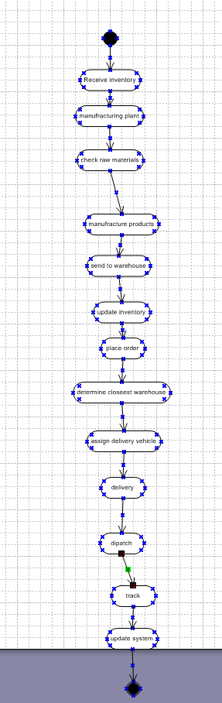

## 8.2 Proposed Recommendations (TO-BE)

* **Automated Inventory Tracking:** The system will automatically track inventory levels across warehouses and manufacturing plants, providing real-time updates and alerts for low stock or nearing expiry items.
* **Optimized Delivery Scheduling:** The software will integrate route optimization and real-time tracking features to ensure faster deliveries and minimize delays.
* **Centralized Order Management:** Customers will place orders online, and the system will automatically update inventory and delivery schedules, streamlining the order fulfillment process.

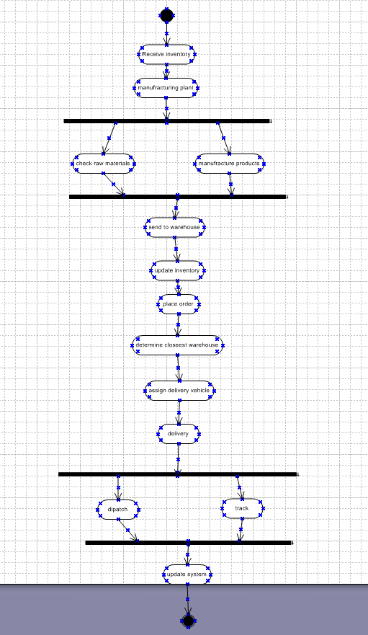

# 9. Business Requirements

|  |  |  |  |
| --- | --- | --- | --- |
| **SR.NO** | **Business Requirement** | **Functionality** | **Priority** |
| **1.** | **Real-time Inventory Tracking:**The system updates stock levels dynamically as products are purchased or replenished, ensuring accurate inventory records. | Monitoring | High |
| 2. | **Low Stock Alerts:** The system automatically notifies the admin when product quantities fall below predefined thresholds to prevent stockouts. | Notifications | High |
| 3. | **Product Expiry Management:** The system tracks product expiration dates to alert the admin and remove expired items from the inventory. | Validation | High |
| 4. | **Route Optimization for Deliveries:** The system calculates the most efficient delivery routes to minimize time and costs for distributing products. | Optimization | High |
| 5. | **Real-time Delivery Tracking:** The system allows customers and admins to monitor the live location and status of delivery vehicles. | Tracking | High |
| 6. | **Order Management System:** The system has Centralized platform to handle order placement, processing, tracking, and updates efficiently. | Processing | High |
| 7. | **Multiple Payment Options:** The system integrates diverse payment gateways to support various transaction methods like cards, wallets, UPI, and COD. | Integration | High |
| 8. | **User Role-based Access Control:**The system restricts access to features and data based on predefined user roles, such as admin, delivery personnel, or customers, ensuring secure and appropriate use. | Authorization | Medium |
| 9. | **Inventory Transfer Management:** The system tracks and manages the movement of stock between different storage locations or warehouses to maintain accurate inventory records. | Tracking | Medium |
| 10. | **Customer Notification System:** The system Sends automated updates to customers via email, SMS, or app notifications about order status, promotions, and account activities. | Messaging | High |

# 10. Appendices

## 10.1 List of Acronyms

## 10.2 Glossary of Terms

## 10.3 Related Documents

2. Prepare process flow diagram using your imagination.

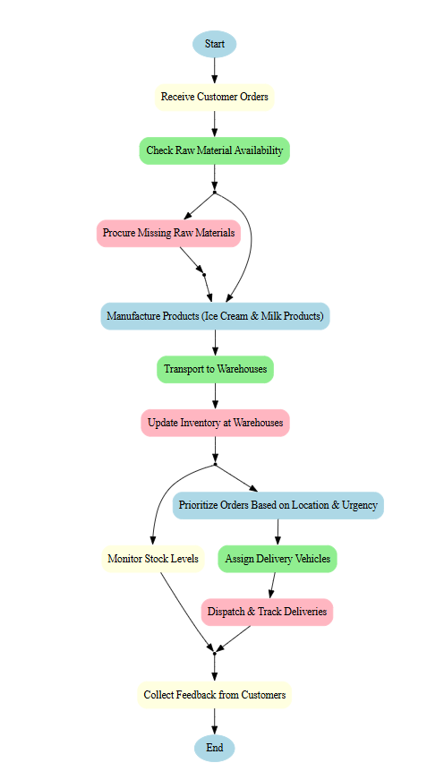

**Assignment 2:**

1. Write an introduction letter to a client introducing yourself as a business analyst in charge of working with the client and his team to start the business understanding process.

**Pallela Venkateshwar Rao**  
Business Analyst  
Beyondmiles Pvt Ltd  
pvenkatesh123@beyondmiles.com  
09/01/2025

**Charan**  
Client's Title  
Akshara Overseas  
Room no 4, Prajay Towers, mir alam mandi, Hyderabad, T.G 500079

Dear Charan,

I hope this message finds you well. My name is Venkatesh, and I am a Business Analyst with Beyond Miles. I am writing to introduce myself as the primary point of contact for collaborating with you and your team to begin the business understanding process for the Akshara overseas CRM.

As we move forward with this project, my role will involve gathering, analyzing, and documenting the business requirements to ensure the solution we develop aligns with your company’s goals and objectives. I will be working closely with you and your team to capture key insights, understand your current processes, and ensure that we have a clear and shared understanding of the project’s scope and vision.

Throughout this process, I will facilitate regular communication between all stakeholders, ensuring that we effectively address any questions, concerns, and changes as we progress. My goal is to ensure that the final outcome meets your business needs and expectations.

I look forward to working with you and your team to drive this project forward. Please do not hesitate to reach out to me if you have any initial questions or if there are any points you’d like to discuss further. I am here to support you and ensure a smooth and successful process.

Best regards,  
Pallela Venkateshwar Rao  
Business Analyst  
Beyond Miles

2. Prepare a brief BRD and SRS for a project- Horoscope or Ticketing system or online store.

Pallela Venkateshwar Rao



**Ticketing system**

Contents

1. Document Revisions 4

2. Approvals 4

3. RACI Chart for This Document 5

Codes Used in RACI Chart 5

RACI Chart 5

4. Introduction 6

4.1. Business Goals 6

4.2. Business Objectives 6

4.3. Business Rules 6

4.4. Background 6

4.5. Project Objective 6

4.6. Project Scope 6

4.6.1. In Scope Functionality 6

4.6.2. Out Scope Functionality 6

5. Assumptions 7

6. Constraints 7

7. Risks 7

Technological Risks 7

Skills Risks 7

Political Risks 7

Business Risks 7

Requirements Risks 7

Other Risks 7

8. Business Process Overview 8

8.1. Legacy System (AS-IS) 8

8.2. Proposed Recommendations (TO-BE) 8

9. Business Requirements 8

10. Appendices 8

10.1. List of Acronyms 8

10.2. Glossary of Terms 8

10.3. Related Documents 8

# Document Revisions

|  |  |  |
| --- | --- | --- |
| Date | Version Number | Document Changes |
| 09/08/2024 | 0.1 | Initial Draft |
|  |  |  |
|  |  |  |
|  |  |  |
|  |  |  |
|  |  |  |
|  |  |  |
|  |  |  |
|  |  |  |

# Approvals

|  |  |  |  |  |
| --- | --- | --- | --- | --- |
| **Role** | **Name** | **Title** | **Signature** | **Date** |
| Project Sponsor | charan |  |  | 2/01/2025 |
| Business Owner | anish |  |  | 2/01/2025 |
| Project Manager | varun |  |  | 2/01/2025 |
| System Architect | rahul |  |  | 2/01/2025 |
| Development Lead | rohith |  |  | 2/01/2025 |
| User Experience Lead | gagan |  |  | 2/01/2025 |
| Quality Lead | kaushal |  |  | 2/01/2025 |
| Content Lead | hari |  |  | 2/01/2025 |

# RACI Chart for This Document

### RACI Chart

|  |  |  |  |  |  |  |  |
| --- | --- | --- | --- | --- | --- | --- | --- |
| **Name** | **Position** | **\*** | **R** | **A** | **S** | **C** | **I** |
| **varun** | **Project manager** |  |  | **A** |  |  |  |
| **venkatesh** | **BA** |  | **R** |  |  |  |  |
| **charan** | **Project sponsor** |  |  |  |  |  | **I** |
| **anish** | **Stakeholder** |  |  |  |  | **C** |  |
| **pavan** | **Sr.BA** |  |  |  | **S** |  | **I** |

# 4.Introduction

## 4.1Business Goals

The Student Travel Planning System facilitates customers in organizing educational and recreational trips by providing online access to travel packages specifically designed for customers. The system offers comprehensive details on destinations, accommodations, and costs, enabling customers to plan trips efficiently. Upon satisfaction, customers can book trips using various payment methods, including cash, credit card, debit card, or bank transfer.

## 4.2Business Objectives

To achieve these goals, the proposed IT solution incorporates the following functionalities:

* Customers can browse complete travel packages online, eliminating the need for in-person inquiries.
* New users are prompted to register, generating a unique username and password.
* The system allows customers to update personal details, cancel reservations, and view booking information.
* Payment can be made online or in person using cash, credit card, debit card, or bank transfer.

## 4.3Business Rules

* Only authorized staff can reserve trips for customers who opt to make payments in person.
* Only administrators can add, delete, or modify travel packages.
* Registered customers can modify their travel reservations.
* The institution must have permission from the relevant educational or travel authorities.
* System should allow only valid Student to reserve ticket for the customer who choose by personally going to office to make payment
* Only administrator can add, delete, or modify tour scheme.
* Existing customers can make changes to tour reservation.
* Organization should have permission from state or central tourism ministry.

## 4.4.Background

Customers planning trips often face challenges in organizing logistics such as destination selection, accommodation, and budgeting. These difficulties can detract from the overall experience. The proposed system streamlines the process by offering a variety of student-focused travel packages, complete with destination details, costs, and accommodations, ensuring a well-planned trip.

## 4.5.Project Objective

* Capture student personal details and generate a unique username and password.
* Reduce manual trip reservation processes.
* Allow customers to select travel packages according to their preferences.
* Simplify the payment process.
* Provide the ability to update personal details, view booking details, or cancel reservations.
* Enable administrators to manage travel packages.
* Save customers time and energy by offering a one-stop platform for all travel-related information.

## 4.6.Project Scope

4.6.1. In Scope Functionality

* Recording student personal details and selected travel packages.
* Providing ID and password to new users at registration.
* Transparency in travel details such as duration, cost, accommodation, and destination information.
* Online trip reservation and payment options.
* Support for multiple payment methods: cash, credit, debit, and bank transfer.
* Customers can update their personal details within the system.
* Allowing customers to cancel reservations.
* Customers can use their system-provided ID and password for future transactions.
* Staff validation to ensure only authorized personnel can reserve trips.
* Customers can view their reservation details after booking.
* Administrators can add, modify, and delete travel packages.
* The system is accessible via mobile, computer, and tablet devices.
* Enables both individual customers and student groups (via a group leader) to reserve a trip.

##### 4.6.2. Out of Scope Functionality

* Automatic notifications (email or SMS) about new travel packages for existing user.

# 5.Assumptions

* Enhanced security measures to protect confidential student data.
* The system must be accessible online 24/7.
* customers can access the system via computers, mobile devices, or tablets.
* The system will support multiple concurrent users.

# 6.Constraints

The database must be capable of storing a large volume of student personal details and travel package information.

# 7.Risks

## Technological Risks

No significant technological risks are identified for this project.

## Skills Risks

No significant skill-related risks are identified as users are expected to have basic computer literacy.

## Political Risks

* The Student Travel Planning System must renew permissions from relevant educational or travel authorities.
* the system must account for changes in political conditions at travel destinations.

## Business Risks

Project cancellation would result in financial loss and inability to improve the service provided to customers.

## Requirements Risks

* The system must provide comprehensive travel package information to assist customers in making informed decisions.
* The system must ensure accurate and detailed information about destinations, including historical and cultural significance.
* Travel packages should cater to a wide range of student needs and preferences.

## Other Risks

None

# 8. Business Process Overview

The process begins when a student accesses the system online. New users are prompted to register by providing personal details, after which the system generates a unique user ID and password. Registered customers can log in to browse available travel packages. Once satisfied with a selection, they can confirm the trip and choose a payment method (online or in person at the institution). The system also allows customers to update personal details, view booking information, or cancel reservations.

## 8.1 Legacy System (AS-IS)

Customers traditionally had to manually organize trips, often facing challenges such as lack of detailed destination information or difficulties in arranging accommodations, leading to a less enjoyable experience.

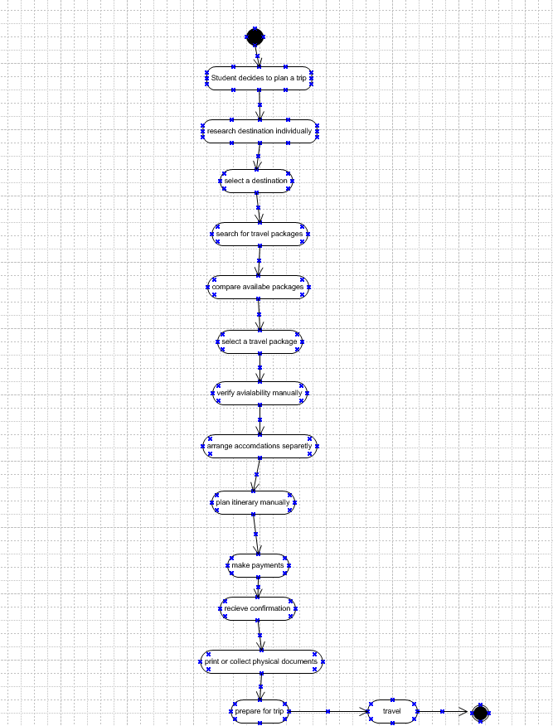

## 8.2 Proposed Recommendations (TO-BE)

The proposed system automates the process, allowing customers to browse and book travel packages online. New users must complete a registration process, after which they receive a unique username and password. Registered users can log in, select a travel package, and make payments online or in person. Customers can update personal details, view reservations, or cancel bookings, and administrators can manage travel packages.

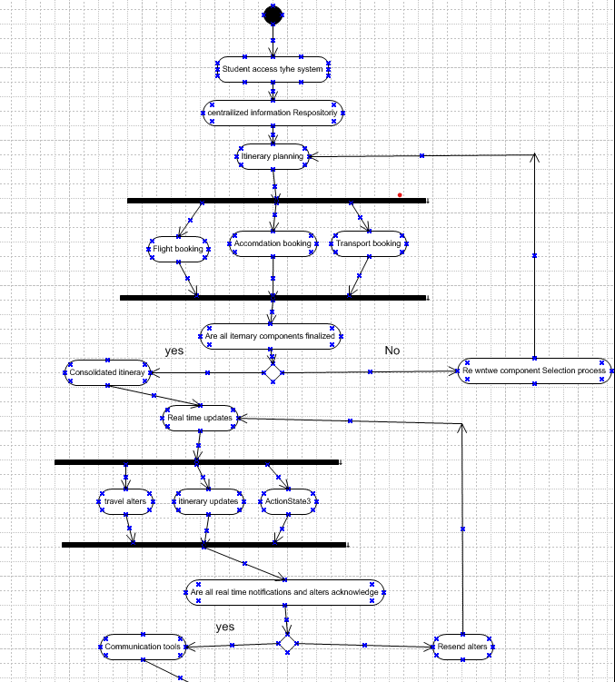

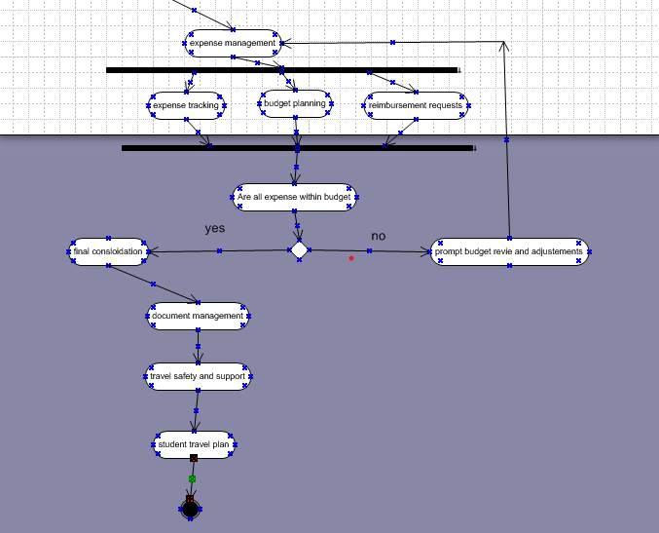

# 9. Business Requirements

|  |  |  |  |
| --- | --- | --- | --- |
| **Sr.no** | **Business Requirement** | **Functionality** | **Priority** |
| 1 | System home page should display rules and regulations related to travel | Rules and regulations | High |
| 2 | System should display complete travel information (accommodation, cost, duration, destination) | Customers information interface | High |
| 3 | System should capture personal details of new customers to generate unique username and password | customers registration functionality | High |
| 4 | Registered customers should be able to use their username and password for future transactions | customers loginninterface | High |
| 5 | Registered customers can update personal details | Student updation interface | High |
| 6 | Customers can view reservation details | Student reservation interface | High |
| 7 | Customers must be able to pay by cash, credit card, debit card, or bank transfer | Student payment interface | High |
| 8 | Customers should be able to access the system using a computer, mobile, or tablet | System accessibility functionality | Medium |
| 9 | System should check staff validity when making a reservation | System validation functionality | High |
| 10 | Administrators can add, modify, or delete travel packages | Administration functionality | High |

# 10. Appendices

## 10.1 List of Acronyms

## 10.2 Glossary of Terms

## 10.3 Related Documents

**Use Case Diagram for ticketing system**

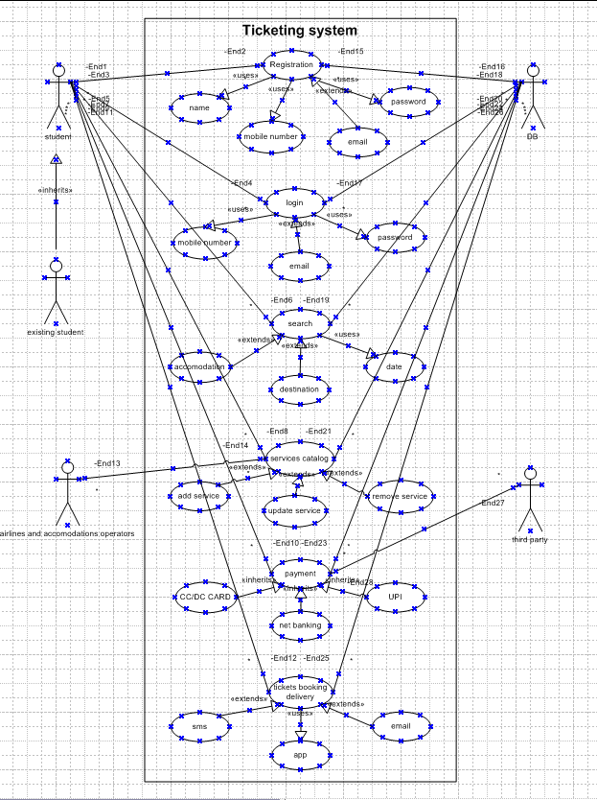

**Goal:**

The purpose of the Travel Planning System project is to develop and implement a comprehensive travel planning solution specifically designed to meet the needs of customers The system will streamline the process of organizing travel, ensuring efficiency, reliability, and an enhanced user experience.

Objective:

* Capture customer personal details and generate a unique username and password.
* Reduce manual trip reservation processes.
* Allow customers to select travel packages according to their preferences.
* Simplify the payment process.
* Provide the ability to update personal details, view booking details, or cancel reservations.
* Enable administrators to manage travel packages.
* Save customers time and energy by offering a one-stop platform for all travel-related information.

**use case specification document.**

|  |  |
| --- | --- |
| **Use Case ID** | **UC001** |
| **Use Case Name** | Register for Travel |
| **Created By** | Business Analyst |
| **Date Created** | 09/01/2025 |
| **Last Update** | 09/01/2025 |
| **Actors** | Student, Parent |
| **Description** | A student registers for the travel planning service, providing necessary personal information to create a new account for travel planning. |
| **Preconditions** | The student has access to the travel planning website or application. The student must have a valid email address. |
| **Post Conditions** | The student's account is created. The student receives a confirmation email with account activation instructions. |
| **Main Flow** | 1. The student navigates to the registration page and enters required information such as name, email, phone number, and password. 2. The system validates the provided information and checks for any existing accounts with the same email address. 3. If validation is successful, the student submits the registration form. 4. The system creates a new account for the student and sends a confirmation email with activation instructions. 5. The student verifies their email address and activates their account. |
| **Alternative Flow** | If validation fails (e.g., email already in use, invalid format), the system displays appropriate error messages and prompts the student to correct the information. |
| **Justification** | **Why:** Registering customers is essential to manage travel plans effectively and ensure personalized services. |
| **How:** It allows the system to track student details, preferences, and manage travel bookings accordingly. |

|  |  |
| --- | --- |
| **Use Case ID** | **UC002** |
| **Use Case Name** | Search for Destinations |
| **Created By** | Business Analyst |
| **Date Created** | 09/01/2025 |
| **Last Update** | 09/01/2025 |
| **Actors** | Student, Parent |
| **Description** | The student searches for travel destinations by specifying criteria such as location, date, and interests. |
| **Preconditions** | The student must be logged into their account. |
| **Post Conditions** | The student receives a list of destinations matching their search criteria. |
|  | 1. The student accesses the search functionality. 2. The student inputs search criteria such as location, travel dates, and interests. 3. The system retrieves and displays a list of destinations that match the search criteria. 4. The student reviews the list and selects a destination for more details. |
| **Alternative Flow** | If no destinations match the search criteria, the system displays a message indicating no results found and prompts the student to refine their search. |
| **Justification** | **Why:** Searching for destinations helps customers find suitable travel options based on their preferences.  **How:** It provides customers with a list of relevant destinations, making the planning process more efficient. |

|  |  |
| --- | --- |
| **Use Case ID** | **UC003** |
| **Use Case Name** | Book Travel Package |
| **Created By** | Business Analyst |
| **Date Created** | 09/01/2025 |
| **Last Update** | 09/01/2025 |
| **Actors** | Student, Parent |
| **Description** | The student books a travel package by selecting a destination, travel dates, and additional options. |
| **Preconditions** | The student must have a registered account and have selected a destination. |
| **Post Conditions** | The travel package is booked, and the student receives a confirmation email with booking details. |
| **Main Flow** | 1. The student selects a destination and travel dates.  2. The student chooses additional options such as accommodation, activities, and transportation.  3. The system calculates the total cost and displays it to the student.  4. The student reviews the booking details and confirms the booking.  5. The system processes the booking and sends a confirmation email with details. |
| **Alternative Flow** | If the payment fails or the selected options are unavailable, the system displays an error message and prompts the student to correct the issue or choose different options. |
| **Justification** | **Why:** Booking a travel package finalizes travel plans and secures necessary arrangements.  **How:** It allows the student to complete their travel arrangements efficiently and receive confirmation of their booking. |

|  |  |
| --- | --- |
| **Use Case ID** | **UC004** |
| **Use Case Name** | Cancel Travel Booking |
| **Created By** | Business Analyst |
| **Date Created** | 09/01/2025 |
| **Last Update** | 09/01/2025 |
| **Actors** | Student, Parent |
| **Description** | The student cancels an existing travel booking and receives a confirmation of cancellation. |
| **Preconditions** | The student must have a booking that is eligible for cancellation. |
| **Post Conditions** | The booking is canceled, and the student receives a confirmation email regarding the cancellation. |
| **Main Flow** | 1. The student accesses the cancellation functionality.  2. The student selects the booking to be canceled.  3. The system checks the cancellation policy and processes the request.  4. The student confirms the cancellation request.  5. The system sends a confirmation email with details of the cancellation. |
| **Alternative Flow** | If the cancellation is not allowed according to the policy, the system displays an error message and provides options for contacting customer support. |
| **Justification** | **Why:** Allowing cancellations provides flexibility to customers and manages changes in travel plans.  **How:** It ensures that customers can cancel bookings if needed and receive confirmation of the cancellation. |

|  |  |
| --- | --- |
| **Use Case ID** | **UC005** |
| **Use Case Name** | Update Travel Details |
| **Created By** | Business Analyst |
| **Date Created** | 09/01/2025 |
| **Last Update** | 09/01/2025 |
| **Actors** | Student, Parent |
| **Description** | The student updates details of an existing travel booking such as travel dates, accommodation, or activities. |
| **Preconditions** | The student must have an existing booking and be logged into their account. |
| **Post Conditions** | The travel details are updated, and the student receives a confirmation of the changes. |
| **Main Flow** | 1. The student accesses the update functionality.  2. The student selects the booking to be updated.  3. The student modifies details such as travel dates, accommodation, or activities.  4. The system updates the booking with the new details.  5. The system sends a confirmation email with the updated booking information. |
| **Alternative Flow** | If the updated details are unavailable or invalid, the system displays an error message and prompts the student to make valid selections. |
| **Justification** | **Why:** Updating travel details allows customers to modify their plans as needed.  **How:** It provides flexibility to change booking details and receive updated confirmation. |

**Functional Specifications**

|  |  |
| --- | --- |
| **Project name** | travel planning |
| **Customer name** | Akshara overseas travels |
| **Project version** | 1.0.0.1 |
| **Project sponsor** | charan |
| **Project manager** | varun |
| **Project initiation date** | 09/01/2025 |

|  |  |  |  |
| --- | --- | --- | --- |
| **Req ID** | **Req Name** | **Req Description** | **Priority** |
| **F01** | User Registration | Users can register with the system using email, social media, or student credentials. | **10** |
| **F02** | Login | Users can log in to the system using registered credentials. | **10** |
| **F03** | Password Recovery | Users can recover their password via email or mobile phone. | **8** |
| **F04** | Profile Management | Users can create, view, and update their personal profiles. | **8** |
| **F05** | Trip Creation | Users can create new trips by selecting destinations, dates, and other relevant details. | **9** |
| **F06** | Itinerary Management | Users can view, edit, and delete their trip itineraries. | **9** |
| **F07** | Group Travel Planning | Users can create and manage group trips with friends or other customers. | **8** |
| **F08** | Budget Planning | Users can set and manage a travel budget, including tracking expenses. | **7** |
| **F09** | Payment Integration | Users can make payments for bookings directly through the system. | **8** |
| **F10** | Accommodation Booking | Users can search for, book, and manage accommodations. | **9** |
| **F11** | Flight/Transport Booking | Users can book flights, buses, or trains directly from the system. | **9** |
| **F12** | Activity Suggestions | The system provides suggestions for activities based on the destination and interests. | **7** |
| **F13** | Travel Document Storage | Users can upload and store travel-related documents (e.g., passports, visas,Aadhaar etc). | **8** |
| **F14** | Notifications & Reminders | Users receive notifications for upcoming trips, deadlines, and itinerary changes. | **8** |
| **F15** | Location Sharing | Users can share their location with selected contacts while on a trip. | **6** |
| **F16** | Emergency Contact Information | Users can store and access emergency contact details. | **7** |
| **F17** | Weather Forecast | The system provides weather updates for the travel destinations. | **6** |
| **F18** | Currency Converter | Users can access a currency converter tool for international travel. | **5** |
| **F19** | Language Translation | The system offers basic translation services for common travel phrases. | **5** |
| **F20** | Travel Insurance Integration | Users can purchase travel insurance through the system. | **6** |
| **F21** | Trip Reviews | Users can write and view reviews of trips, accommodations, and activities. | **7** |
| **F22** | Map Integration | The system provides maps and directions for destinations and activities. | **8** |
| **F23** | Loyalty Programs | Users can earn and redeem points or rewards for using the system frequently. | **5** |
| **F24** | Social Media Integration | Users can share their travel plans or experiences on social media platforms. | **6** |
| **F25** | Trip History | Users can view a history of their past trips, including itineraries and expenses. | **7** |
| **F26** | Collaborative Planning | Users can collaborate with friends or family in real-time on trip planning. | **7** |
| **F27** | Multi-language Support | The system supports multiple languages for a diverse user base. | **6** |
| **F28** | FAQ and Help Center | Users can access a help center for FAQs and support. | **8** |
| **F29** | Customer Support | Users can contact customer support through chat, email, or phone. | **9** |
| **F30** | Trip Cancellation | Users can cancel trips and receive refunds based on cancellation policies. | **7** |
| **NF01** | Performance | The system should load all pages within 3 seconds under normal usage. | **9** |
| **NF02** | Scalability | The system must handle up to 50,000 concurrent users without performance degradation. | **8** |
| **NF03** | Availability | The system should have an uptime of 99.9%. | **9** |
| **NF04** | Security | User data must be encrypted in transit and at rest. | **10** |
| **NF05** | Usability | The system must be intuitive and easy to navigate for users of all technical levels. | **8** |
| **NF06** | Compatibility | The system should be compatible with major web browsers and mobile devices. | **8** |
| **NF07** | Maintainability | The system should be designed with maintainability in mind, allowing easy updates and patches. | **7** |
| **NF08** | Localization | The system should support multiple languages and regional settings. | **7** |
| **NF09** | Backup and Recovery | The system must perform daily backups and have a recovery time of no more than 2 hours. | **9** |
| **NF10** | Compliance | The system should comply with GDPR and other relevant data protection regulations. | **10** |
| **NF11** | Response Time | The system should respond to user inputs within 1 second. | **8** |
| **NF12** | Disaster Recovery | The system should have a disaster recovery plan with a recovery point objective (RPO) of 4 hours. | **9** |
| **NF13** | Data Retention | User data should be retained for a minimum of 7 years or as required by law. | **8** |
| **NF14** | Accessibility | The system must be accessible to users with disabilities, following WCAG 2.1 guidelines. | **8** |
| **NF15** | Logging and Monitoring | The system should have robust logging and monitoring capabilities to track performance and errors. | **8** |
| **NF16** | Auditability | All user actions should be auditable, with logs stored for at least 1 year. | **9** |
| **NF17** | Interoperability | The system should integrate seamlessly with third-party APIs and services. | **7** |
| **NF18** | Reliability | The system should ensure data consistency and fault tolerance. | **9** |
| **NF19** | Modularity | The system should be modular, allowing for easy feature additions or modifications. | **7** |
| **NF20** | Data Integrity | The system should ensure data accuracy and consistency across all modules. | **9** |
| **NF21** | Privacy | User data should be anonymized where necessary to protect privacy. | **10** |
| **NF22** | Efficiency | The system should use resources efficiently to minimize operational costs. | **7** |
| **NF23** | User Feedback Mechanism | The system should have a mechanism for users to provide feedback on functionality and usability. | **7** |
| **NF24** | Browser Support | The system must support the latest versions of Chrome, Firefox, Safari, and Edge. | **7** |
| **NF25** | Data Encryption | All sensitive user data should be encrypted using industry-standard algorithms (e.g., AES-256). | **10** |
| **NF26** | Power Management | The system should be optimized for low power consumption, especially on mobile devices. | **6** |
| **NF27** | Session Management | User sessions should be securely managed and timed out after 15 minutes of inactivity. | **8** |
| **NF28** | Caching | The system should use caching to reduce load times for frequently accessed data. | **7** |
| **NF29** | Error Handling | The system should handle errors gracefully and provide meaningful error messages to users. | **8** |
| **NF30** | Training and Documentation | Comprehensive training materials and user documentation should be provided for all users. | **8** |

3. Make an ERD of creating a support ticket/Ticketing life cycle.

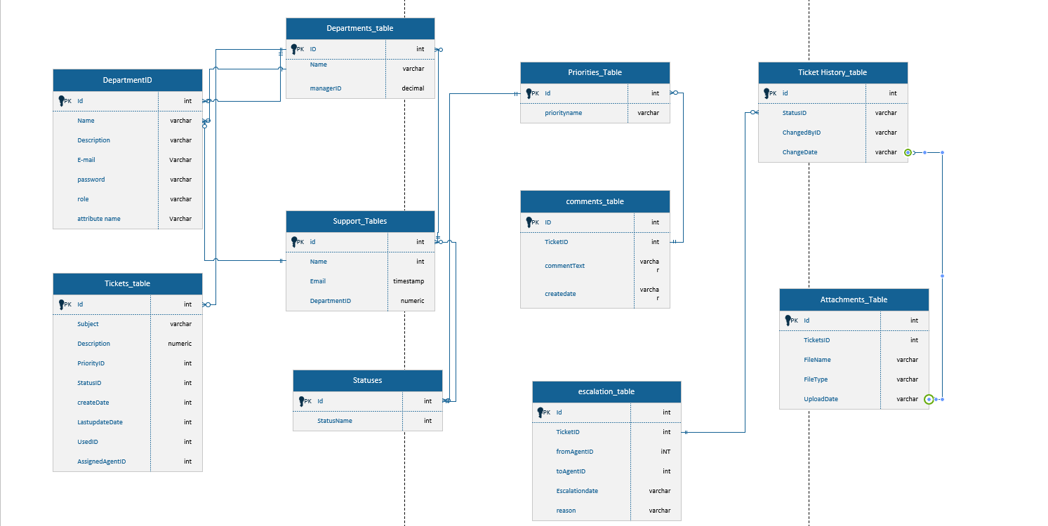

4. User story of shopping from ecommerce.

|  |  |  |
| --- | --- | --- |
| **User story: 01** | **Task:1** | **Priority: High** |
| **Value Statement:**  As a customer, I want to search for products by name so that I can quickly find specific items. |  |  |
| **BV: 100** | **CP: 10** |  |
| **Acceptance criteria:**  1.Users can type keywords in a search bar to find relevant products.  2. Search results display relevant products with images and prices. |  |  |

|  |  |  |
| --- | --- | --- |
| **User story: 02** | **Task:2** | **Priority: medium** |
| **Value Statement:**  As a customer, I want to filter products by price range so that I can view items within my budget |  |  |
| **BV: 50** | **CP:12** |  |
| **Acceptance criteria:**  1. Users can set a minimum and maximum price range.  2. Only products within the specified range are displayed. |  |  |

|  |  |  |
| --- | --- | --- |
| **User story: 03** | **Task:1** | **Priority: low** |
| **Value Statement:**  As a customer, I want to add products to a wishlist so that I can save them for future purchase. |  |  |
| **BV: 50** | **CP:15** |  |
| **Acceptance criteria:**  1.Users can add any product to their wishlist with a single click.  2. Wishlist items are saved to the user’s account for later access. |  |  |

|  |  |  |
| --- | --- | --- |
| **User story: 04** | **Task: 4** | **Priority: High** |
| **Value Statement:**  As a customer, I want to view detailed product descriptions so that I can make informed purchase decisions. |  |  |
| **BV: 100** | **CP:10** |  |
| **Acceptance criteria:**   1. Product pages display clear descriptions, specifications, and images. 2. Additional details like reviews and ratings are easily accessible. |  |  |

|  |  |  |
| --- | --- | --- |
| **User story: 05** | **Task: 5** | **Priority: medium** |
| **Value Statement:**  As a customer, I want to compare multiple products so that I can decide which one suits me best. |  |  |
| **BV: 50** | **CP:20** |  |
| **Acceptance criteria:**   1. Users can select multiple products to add to a comparison chart. 2. Comparison shows key features, prices, and user reviews side-by-side. |  |  |

|  |  |  |
| --- | --- | --- |
| **User story: 06** | **Task: 6** | **Priority: medium** |
| **Value Statement:**  As a customer, I want to view product availability in nearby stores so that I can decide whether to buy online or in-store. |  |  |
| **BV: 20** | **CP: 25** |  |
| **Acceptance criteria:**   1. Users can enter their location to check stock availability in nearby stores. 2. Store location details and available stock quantities are displayed. |  |  |

|  |  |  |
| --- | --- | --- |
| **User story: 07** | **Task:7** | **Priority: High** |
| **Value Statement:**  As a customer, I want to track my order so that I can know when it will arrive. |  |  |
| **BV: 80** | **CP: 15** |  |
| **Acceptance criteria:**   1. Users can view real-time updates on order status. 2. Tracking includes delivery date estimates and location of the shipment. |  |  |

|  |  |  |
| --- | --- | --- |
| **User story: 08** | **Task: 8** | **Priority: Medium** |
| **Value Statement:**  As a customer, I want to see personalized product recommendations so that I can discover items relevant to my preferences. |  |  |
| **BV: 100** | **CP:25** |  |
| **Acceptance criteria:**   1. Recommendations are based on previous purchases and browsing history. 2. Recommended products update dynamically based on user interactions. |  |  |

|  |  |  |
| --- | --- | --- |
| **User story:09** | **Task: 9** | **Priority: Low** |
| **Value Statement:**  As a customer, I want to set delivery preferences so that I can receive my order at a convenient time. |  |  |
| **BV: 50** | **CP:20** |  |
| **Acceptance criteria:**  1**.**Users can choose preferred delivery dates and time slots.  2.Delivery preferences are saved for future orders. |  |  |

|  |  |  |
| --- | --- | --- |
| **User story: 10** | **Task:10** | **Priority: medium** |
| **Value Statement:**  As a customer, I want to read product reviews so that I can make informed buying decisions. |  |  |
| **BV: 50** | **CP:10** |  |
| **Acceptance criteria:**   1. Reviews include user ratings, pros/cons, and verified purchase badges. 2. Review sorting options are available (e.g., newest, highest rating). |  |  |

|  |  |  |
| --- | --- | --- |
| **User story:11** | **Task:11** | **Priority: high** |
| **Value Statement:**  As a customer, I want a secure payment process so that I can feel confident when making purchases. |  |  |
| **BV:200** | **CP:30** |  |
| **Acceptance criteria:**   1. Payment pages are encrypted and display security badges. 2. Multiple payment options (e.g., credit card, digital wallets) are available. |  |  |

|  |  |  |
| --- | --- | --- |
| **User story:12** | **Task:12** | **Priority: low** |
| **Value Statement:**  As a customer, I want to receive email notifications for discounts and offers so that I can save money. |  |  |
| **BV: 50** | **CP:15** |  |
| **Acceptance criteria:**  1.Users can subscribe to receive promotional emails.  2.Notifications include personalized offers and coupon codes. |  |  |

|  |  |  |
| --- | --- | --- |
| **User story: 13** | **Task:13** | **Priority: high** |
| **Value Statement:**  As a customer, I want to return or exchange products easily so that I can shop without worrying about mistakes. |  |  |
| **BV: 100** | **CP:20** |  |
| **Acceptance criteria:**   1. Return and exchange requests can be initiated through the user account. 2. Refunds or replacements are processed within a specified timeframe. |  |  |

|  |  |  |
| --- | --- | --- |
| **User story:14** | **Task:14** | **Priority: medium** |
| **Value Statement:**  As a customer, I want to pay using multiple currencies so that I can shop globally. |  |  |
| **BV:50** | **CP:30** |  |
| **Acceptance criteria:**   1. Currency conversion is displayed in real-time during checkout. 2. Users can select their preferred currency for payments. |  |  |

|  |  |  |
| --- | --- | --- |
| **User story:15** | **Task:15** | **Priority: medium** |
| **Value Statement:**  As a customer, I want to save my payment details securely so that I can checkout faster in future purchases. |  |  |
| **BV: 50** | **CP:25** |  |
| **Acceptance criteria:**  1. Payment details are encrypted and stored securely.  2. Users can choose to save or remove saved payment details. |  |  |

|  |  |  |
| --- | --- | --- |
| **User story: 16** | **Task:16** | **Priority: high** |
| **Value Statement:**  As a customer, I want customer support options so that I can resolve issues promptly. |  |  |
| **BV: 100** | **CP:15** |  |
| **Acceptance criteria:**   1. Live chat, email, and phone support options are available. 2. Responses to queries are provided within specified SLAs (Service Level Agreements). |  |  |

|  |  |  |
| --- | --- | --- |
| **User story: 17** | **Task:17** | **Priority: medium** |
| **Value Statement:**  As a customer, I want to see a summary of my cart so that I can review my selected items before checkout. |  |  |
| **BV: 50** | **CP:12** |  |
| **Acceptance criteria:**  1**.**Cart displays all selected items, quantities, prices, and total cost.  2.Users can update item quantities or remove items directly from the cart. |  |  |

|  |  |  |
| --- | --- | --- |
| **User story:18** | **Task:18** | **Priority: high** |
| **Value Statement:**  As a customer, I want to receive order confirmation emails so that I have a record of my purchase. |  |  |
| **BV: 100** | **CP: 10** |  |
| **Acceptance criteria:**  1.Confirmation emails include order details, payment confirmation, and estimated delivery date.  2.Emails are sent immediately after checkout is completed. |  |  |

|  |  |  |
| --- | --- | --- |
| **User story: 19** | **Task:19** | **Priority: medium** |
| **Value Statement:**  As a customer, I want to apply discount codes during checkout so that I can save money on my purchases. |  |  |
| **BV:20** | **CP:15** |  |
| **Acceptance criteria:**  1.Users can enter and validate discount codes at checkout.  2. Valid codes update the order total automatically. |  |  |

|  |  |  |
| --- | --- | --- |
| **User story: 20** | **Task:20** | **Priority: low** |
| **Value Statement:**  As a customer, I want to view my purchase history so that I can keep track of my previous orders. |  |  |
| **BV: 20** | **CP:15** |  |
| **Acceptance criteria:**  1. Purchase history includes order dates, items purchased, and total amount.  2.Users can reorder items directly from the purchase history. |  |  |

|  |  |  |
| --- | --- | --- |
| **User story:21** | **Task:21** | **Priority: high** |
| **Value Statement:**  As a customer, I want an intuitive mobile app experience so that I can shop conveniently from my phone. |  |  |
| **BV: 200** | **CP:40** |  |
| **Acceptance criteria:**  1.The app offers all features available on the website.  2.Navigation is optimized for smaller screens with fast load times |  |  |

|  |  |  |
| --- | --- | --- |
| **User story: 22** | **Task:22** | **Priority: medium** |
| **Value Statement:**  As a customer, I want to subscribe to product availability notifications so that I can purchase items when they are back in stock. |  |  |
| **BV: 70** | **CP:15** |  |
| **Acceptance criteria:**  1**.**Users can opt in for notifications on specific out-of-stock items.  2.Notifications are sent via email or app when the product is restocked. |  |  |

|  |  |  |
| --- | --- | --- |
| **User story: 23** | **Task:23** | **Priority: medium** |
| **Value Statement:**  As a customer, I want to save multiple delivery addresses so that I can select them as needed. |  |  |
| **BV: 100** | **CP:20** |  |
| **Acceptance criteria:**  1. Users can add, edit, and delete saved addresses in their account.  2.Saved addresses are selectable during checkout. |  |  |

|  |  |  |
| --- | --- | --- |
| **User story: 24** | **Task:24** | **Priority: high** |
| **Value Statement:**  As a customer, I want my personal data to be secure so that I can trust the platform. |  |  |
| **BV:200** | **CP:35** |  |
| **Acceptance criteria:**   1. The platform complies with GDPR and other data protection regulations. 2. Users can access and manage their personal data settings. |  |  |

|  |  |  |
| --- | --- | --- |
| **User story:25** | **Task:25** | **Priority: medium** |
| **Value Statement:**  As a customer, I want to access a size guide for apparel products so that I can choose the right fit. |  |  |
| **BV:20** | **CP:10** |  |
| **Acceptance criteria:**  1.Size guides are available on all apparel product pages.  2.Guides include measurements and conversion charts for various regions. |  |  |

|  |  |  |
| --- | --- | --- |
| **User story: 26** | **Task:26** | **Priority: medium** |
| **Value Statement:**  As a customer, I want to use gift cards for purchases so that I can utilize preloaded balances. |  |  |
| **BV: 20** | **CP:20** |  |
| **Acceptance criteria:**  1.Users can enter gift card codes during checkout.  2.Balances are applied, and remaining amounts are shown. |  |  |

|  |  |  |
| --- | --- | --- |
| **User story:27** | **Task:27** | **Priority: low** |
| **Value Statement:**  As a customer, I want to share product links so that I can recommend items to my friends. |  |  |
| **BV:100** | **CP:15** |  |
| **Acceptance criteria:**   1. Product pages have shareable links for social media and email. 2. Links redirect to the specific product page on the platform. |  |  |

|  |  |  |
| --- | --- | --- |
| **User story:28** | **Task:28** | **Priority: high** |
| **Value Statement:**  As a customer, I want to receive real-time delivery updates so that I can stay informed about my order status. |  |  |
| **BV:100** | **CP:18** |  |
| **Acceptance criteria:**  1.Notifications are sent for key delivery stages (e.g., shipped, out for delivery, delivered).  2.Updates are accessible through the user’s account and via email/SMS. |  |  |

|  |  |  |
| --- | --- | --- |
| **User story:29** | **Task:29** | **Priority: medium** |
| **Value Statement:**  As a customer, I want to rate and review products I purchased so that I can share my feedback. |  |  |
| **BV:200** | **CP:15** |  |
| **Acceptance criteria:**  1.Users can leave reviews with a star rating and comments.  2. Only verified purchasers can leave reviews. |  |  |

|  |  |  |
| --- | --- | --- |
| **User story:30** | **Task:30** | **Priority: low** |
| **Value Statement:**  As a customer, I want to receive personalized discounts for my birthday so that I feel valued. |  |  |
| **BV:20** | **CP:15** |  |
| **Acceptance criteria:**  1.Users who share their birthday receive an automated discount email.  2.Discount codes are valid for a limited time. |  |  |

|  |  |  |
| --- | --- | --- |
| **User story:31** | **Task:31** | **Priority: high** |
| **Value Statement:**  As a customer, I want to view estimated delivery charges so that I can budget accordingly. |  |  |
| **BV:100** | **CP:10** |  |
| **Acceptance criteria:**  1. Delivery charges are calculated and displayed during checkout.  2.Users can see free shipping thresholds, if applicable. |  |  |

|  |  |  |
| --- | --- | --- |
| **User story:32** | **Task:32** | **Priority: medium** |
| **Value Statement:**  As a customer, I want to sort products by popularity so that I can see what others are buying. |  |  |
| **BV:50** | **CP:12** |  |
| **Acceptance criteria:**  1.Sorting options include "Most Popular" or "Best Selling."  2.Product listings update instantly when sorted. |  |  |

|  |  |  |
| --- | --- | --- |
| **User story:33** | **Task:33** | **Priority: high** |
| **Value Statement:**  As a customer, I want to view product bundles so that I can save money on related items. |  |  |
| **BV:100** | **CP:15** |  |
| **Acceptance criteria:**  1.Product pages display bundles with discounts on related items.  2.Users can add entire bundles or individual items to their cart. |  |  |

|  |  |  |
| --- | --- | --- |
| **User story: 34** | **Task:34** | **Priority: medium** |
| **Value Statement:**  As a customer, I want to be notified of flash sales so that I can take advantage of limited-time offers. |  |  |
| **BV:50** | **CP:10** |  |
| **Acceptance criteria:**  1.Flash sale notifications are sent via email or app push notifications.  2.Sale countdown timers are displayed on product pages. |  |  |

|  |  |  |
| --- | --- | --- |
| **User story:35** | **Task:35** | **Priority: high** |
| **Value Statement:**  As a customer, I want a seamless guest checkout option so that I can make quick purchases without creating an account. |  |  |
| **BV:50** | **CP:25** |  |
| **Acceptance criteria:**  1.Users can checkout as a guest without mandatory account creation.  2.Email and delivery details are the only required fields. |  |  |

|  |  |  |
| --- | --- | --- |
| **User story:36** | **Task:36** | **Priority: medium** |
| **Value Statement:**  As a customer, I want to schedule gift deliveries so that I can send items on special occasions. |  |  |
| **BV:100** | **CP:25** |  |
| **Acceptance criteria:**  1.Users can select a delivery date and add a gift message during checkout.  2.Delivery scheduling options are displayed for eligible items. |  |  |

|  |  |  |
| --- | --- | --- |
| **User story:37** | **Task:37** | **Priority: low** |
| **Value Statement:**  As a customer, I want a loyalty program so that I can earn rewards for frequent purchases. |  |  |
| **BV:20** | **CP:25** |  |
| **Acceptance criteria:**  1.Users earn points for every purchase.  2.Points can be redeemed for discounts or free items. |  |  |

|  |  |  |
| --- | --- | --- |
| **User story:38** | **Task:38** | **Priority: low** |
| **Value Statement:**  As a customer, I want to browse trending products so that I can stay updated on popular items. |  |  |
| **BV:50** | **CP:15** |  |
| **Acceptance criteria:**  1.A "Trending Now" section is displayed on the homepage.  2. Products in this section are updated weekly based on sales data. |  |  |

|  |  |  |
| --- | --- | --- |
| **User story: 39** | **Task:39** | **Priority: medium** |
| **Value Statement:**  As a customer, I want multi-language support so that I can shop in my preferred language. |  |  |
| **BV:100** | **CP:35** |  |
| **Acceptance criteria:**  1.Users can select their preferred language from the settings menu.  2.All product descriptions and checkout details are translated. |  |  |

|  |  |  |
| --- | --- | --- |
| **User story:40** | **Task:40** | **Priority: high** |
| **Value Statement:**  As a customer, I want the ability to cancel orders before shipment so that I can avoid unwanted purchases. |  |  |
| **BV:100** | **CP:25** |  |
| **Acceptance criteria:**  1.Users can cancel orders within a specified timeframe via their account.  2.Cancelled orders trigger an automated refund process if payment was made. |  |  |