Document 6 – Please prepare a use case diagram, activity diagram and a use case specification doc.



Activity Diagram















1. Use case Name:

Practo Application Enhancement Project

1. Use case Description:

The project aims to enhance the existing Practo application by introducing new features such as improved user login and registration, family account management, teleconsultation booking, enhanced appointment rescheduling, secure payment processing, and multilingual support.

1. Actors Primary Actors Secondary actors

Primary Actors: Patients and Doctors

Secondary Actors: Database System and Payment gateways

1. Basic Flow:

* User launches the Practo application.
* Logs in or registers a new account.
* Accesses features such as booking appointments, teleconsultations, and managing family accounts.
* Completes transactions using secure payment gateways.
* Receives notifications for appointments, and health updates.

1. ALTERNATE FLOW:

* If login fails, the system prompts for password reset.
* If payment fails, users are redirected to retry or choose alternate payment methods.
* Users can reschedule appointments through a simple interface if doctors are unavailable.

1. Exceptional flows:

* System downtime prevents access to features.
* Failed appointment booking due to unavailability of slots.
* Interrupted teleconsultation due to network issues.

1. Pre- Conditions:

* User must have the Practo application installed and updated.
* Active internet connection is required.

1. post-conditions:

* Users successfully complete their intended tasks (e.g., appointment booking, payment).
* Notifications are sent for all important updates.

1. Assumptions:

* Users are familiar with using mobile applications.
* Doctors and pharmacists actively update their availability in the system.

1. Constraints:

* Payment processing depends on third-party payment gateways.
* Feature availability may differ for Android and iOS platforms.

1. Dependencies:

* Backend services must remain operational for seamless feature integration.
* Timely updates from third-party APIs (e.g., payment) are essential.

1. Inputs and Outputs:

* Inputs: User login credentials, Appointment preferences, Payment information
* Outputs: Appointment confirmation, Payment receipts, Reminder notifications

1. Business Rules

* Users can reschedule appointments up to 24 hours before the scheduled time.
* Doctors’ availability must be updated in real-time to avoid overbooking.

1. Miscellaneous Information

* The project incorporates multilingual support to cater to diverse user bases.
* A seamless teleconsultation experience is prioritized for both patients and doctors.
* Data security is ensured through encryption for sensitive information like health records and payment details.

Document 7- Screens and pages

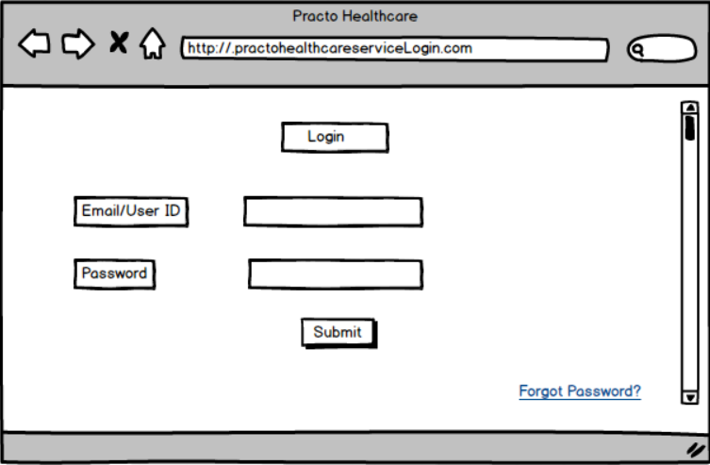

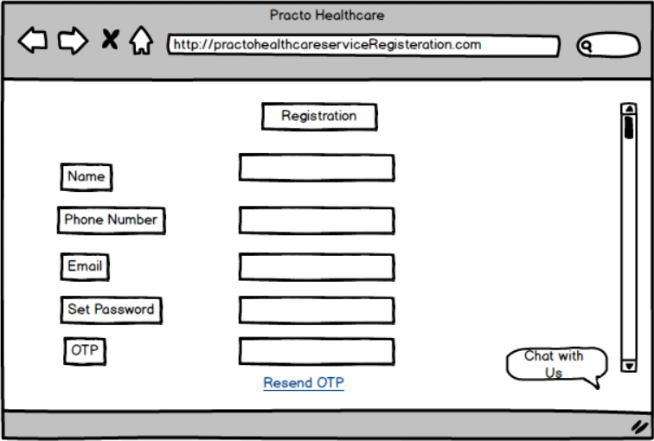

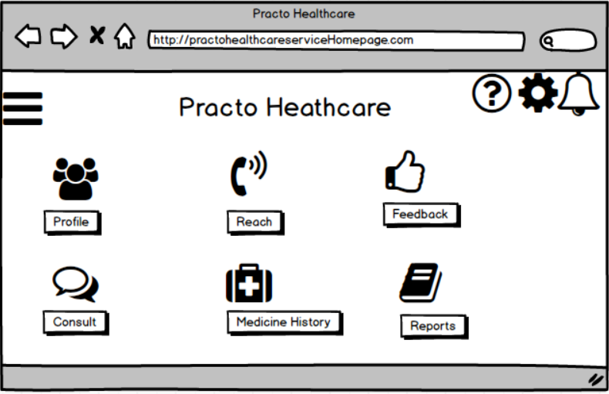

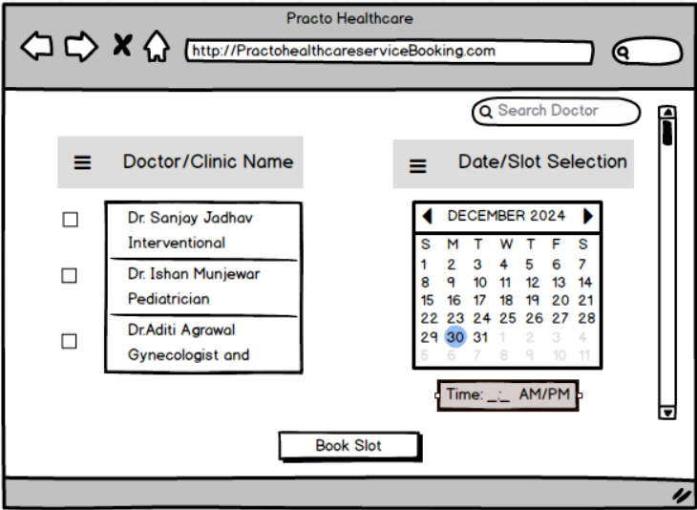

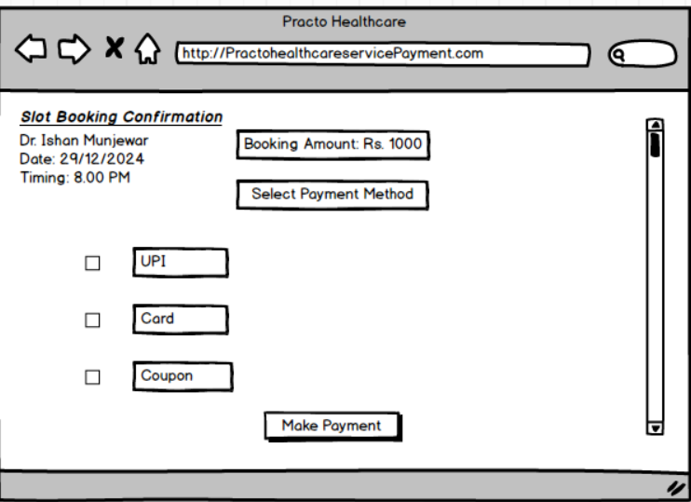

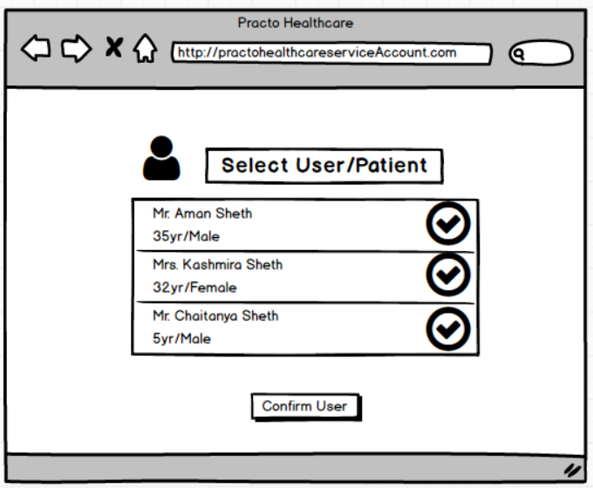

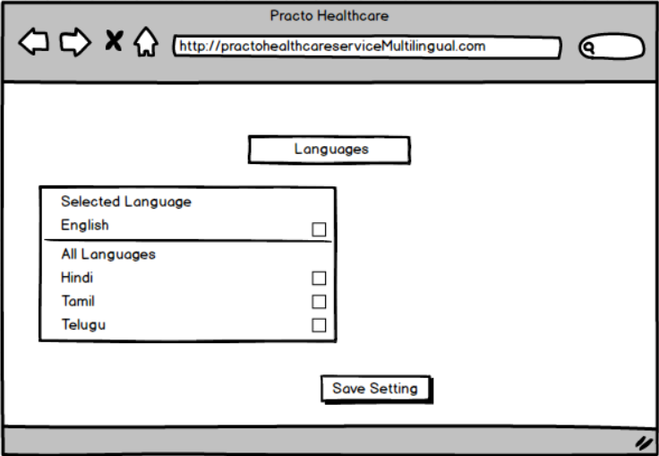

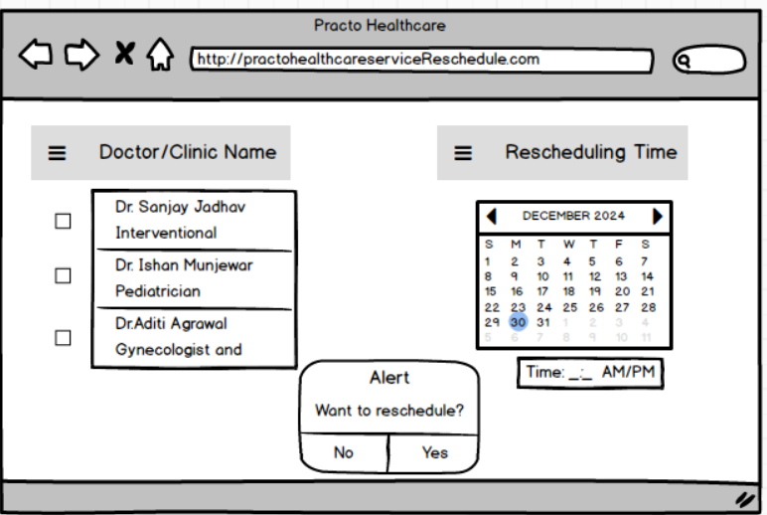

Document 8- Tools-Visio and Axure.

Using Visio and Axure for the Practo Application Enhancement project provided a structured and efficient way to document and visualize various aspects of the project. Visio was instrumental in creating clear and professional diagrams such as process flows, data flow diagrams, and use case diagrams, which is to easily understand the system’s structure and operations. Its user-friendly interface and extensive shape libraries made it easy to map out both the AS-IS and TO-BE processes.

On the other hand, **Axure** allowed us to design interactive mock-ups for key functionalities like user login, teleconsultation booking, and appointment rescheduling. Axure is invaluable in prototyping and wireframing the enhanced user interfaces.

Document 9- BA experience

1. Requirement Gathering

* I utilized the MoSCoW technique to effectively prioritize and gather requirements.
* There were times when the client was unavailable; I proactively identified alternate points of contact to ensure minimal delays.
* I validated the requirements using the FURPS technique, ensuring they met functional and non-functional needs.
* I identified and removed redundant or repeated requirements to maintain clarity in the documentation.
* By employing prototyping, I provided a clearer vision to stakeholders, which helped refine the requirements further.

2. Requirement Analysis

* I created UML diagrams to visually represent the requirements, making them easier for all stakeholders to understand.
* Activity diagrams were developed to outline the process flow in detail.
* I actively communicated the diagrams to the team, accommodated feedback, and made necessary adjustments.
* Comprehensive BRS and SRS documents were prepared to guide the team and stakeholders throughout the project.

3. Design

* From use case diagrams, I prepared both positive and negative test cases to cover all scenarios.
* I collaborated with the client to validate and finalize the design and solution documents.
* I ensured all potential scenarios were considered, as missing a test case could significantly impact later stages.
* Test data was prepared to support the testing phase effectively.
* I kept the RTM updated, ensuring every requirement was addressed in the design.

4. Development

* Organized and facilitated JAD sessions to ensure alignment among all stakeholders.
* Clarified technical team queries during coding and development phases.
* I handled team disagreements tactfully, organizing one-on-one discussions to explain project impacts and foster cooperation.
* Regularly referred to diagrams and documentation to assist developers with implementation.
* Conducted regular meetings with the team and client, recording sessions for absentees and providing follow-ups as needed.

5. Testing

* Prepared test cases from the use cases to validate functionality comprehensively.
* Conducted high-level testing to ensure the system was functioning as intended.
* Collected test data from the client to simulate real-world scenarios during testing.
* Updated the RTM to ensure all requirements were tested thoroughly.
* Secured client sign-off after successful testing and validation.
* Guided the client through UAT, ensuring they were well-prepared with proper training and documentation.

6. Deployment

* Provided the finalized RTM as part of the project closure document.
* Coordinated the preparation and distribution of end-user manuals to ensure smooth system adoption.
* Organized and conducted training sessions for end users, ensuring all participants were well-equipped to use the system.
* Ensured every candidate attended the sessions and followed up with those who missed the training.