**DHANOOP SOMASHEKAR**

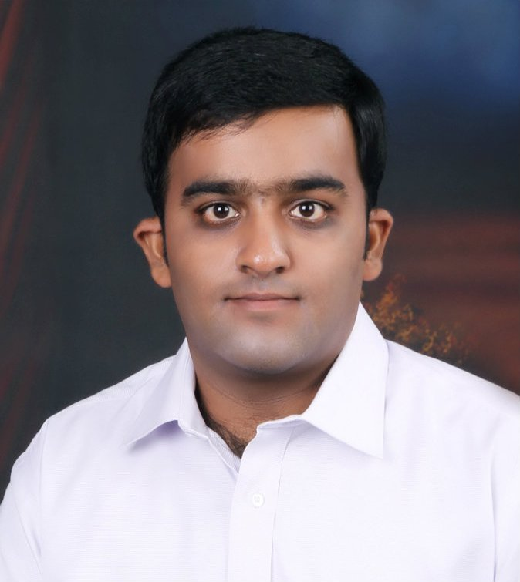

**Contact:**+91 –9008444335 / 080 - 25263500

**E-Mail:** dhanoops@gmail.com

Middle level assignments in**Project Management / Business analyst** with a leading organization of repute, preferably in IT / Electronics / Telecom / EMS industry

**PROFILE SUMMARY**

* Post Graduate in Signal Processing & Communication Technology and MBA in Project Management with **over 12 years** of experience in **Project Management and Business analyst**
* Business analyst with marketing representatives tracking and leads management, painters incentives digitization, workflow digitization
* Senior SAP Basis Admin with expertise in server periodic health checks and securities and role based access, updates and patch upgrades on DB2 database with linux environment
* IT operations Networking, surveillance modules, systems
* Expertise in complete documentation of projects in accordance with **ISO 9001:2008 & AS 9100**
* Demonstrated excellence in implementing **Documentation Application** in ERP that helped save an amount of INR 15 Lakhs/year
* Hands-on experience in **designing antennas, testing antennas & RF products and transferring technology**, etc.
* Possess sound understanding of **Six Sigma Methodologies**
* A keen communicator with honed interpersonal, problem solving and analytical abilities

**CORE COMPETENCIES**

* Ascertaining compliance to safety, economical and technical assessments to secure the best results
* Monitoring and executing projects with respect to budgeted cost, demand forecasts & time over-runs to ensure timely execution
* Working on succession planning of the workforce & shift management activities, appraising the member’s performance and providing feedback
* Conducting cost benefit analysis of the projects including feasibility studies, assessment of the requirements, interface and commissioning
* Organizing & coordinating systems/ business analysis sessions for understanding client business processes and mapping them to required project management standards
* Delivering & implementing the project as per scheduled deadlines and extending post-implementation & maintenance support; guiding teams technically and ensuring the quality & timeliness of the deliverables
* Handling resource planning, technical direction, effort estimation, tracking, risk management & mentoring; analysing user requirements & statistics to identify trends and resolve performance issues

**ORGANIZATIONAL EXPERIENCE**

**May’15 – Till date Surfa Coats India Pvt Ltd., Bangalore as Senior Sap Basis Admin & Business Analyst**

**Role:**

* Incremental backups, server monitoring for performance issues, authorization and securities, New requirements assessment and business process mapping with project requirements
* Website hosting and emails service activated on Godaddy and zoho
* Sophos firewall configured for our landscape, rules and configurations done as per operational requirement
* NAS backup server configured for storage as a cloud option for entire organization
* IT infra management (systems, workstations, networking, surveillance modules and biometric devices)
* Campaigns process set up for daily operational marketing requirements (bulk emails)
* **Marketing App business process modeled and implemented to track the activities, monitor claims and reimbursement based on kilometers travelled. 15lacs saved anually with this initiative**
* Lead management process implemented as a push notification for real time assigning of leads and managing the same, analysis of the leads assigned to conversion analysis can be achieved as the data is available
* **Painters app business process conceived and implemented successfully to suit our business needs. Replaced physical tokens and books for incentives with a QR code. Painters directly redeem the tokens and points respectively. Money directly credited to the painter upon KYC verification. About 40lacs saved annually with this initiative**
* **Purchase workflow digitization for raw material procurement as huge amount of materials were sourced even if requirement is not there. New system will have a restriction on minimum stock and maximum quantity order cap per vendor etc**
* Master data redundancies in raw materials, finished goods and across the system landscape removed by understanding the workflow and solution provided to solve the issues inherent with the system
* Archival of old data implemented to improve system performance and effective resource utilization.

**Oct’13 – Feb’15 Navavipra Solutions Pvt. Ltd., Bangalore as Senior Engineer-Projects Quality**

**Role:**

* Preparing technical proposal, project costing and competitive quote for the clients
* Implementing projects IBS, attendance systems and surveillance systems
* Coordinating with the clients to resolve the complaints related to proposal & product and ensure complete customer satisfaction
* Involved in complete documentation of projects in accordance with ISO 9001:2008
* Organizing trainings for the technicians on technical and quality tools

**Highlights:**

* Initiated Just in time measure to conclude HCG Signal booster project on time and within budget
* Implemented several measures to identify deformities, malfunctions or other abnormalities such as IR functionality restricted to lesser range, radiation pattern abnormalities in the antenna parts / components / products
* Steered the implementation of quality initiatives such as test procedures and work instructions with approval from cross functional teams that instilled basic quality philosophies of doing things right the first time, resulting in an 78% reduction in company rework cost
* Faced and overcame key challenges like vedor development
* Successfully designed & developed just in time process that helped in improving the quality

**Jul’11 – Jul’13 Kavveri Telecoms Products Ltd., Bangalore as Design Engineer & Quality Operations**

**Role:**

* Prepared technical proposal for the defence organization
* Offered support during the integration of the system
* Designed & developed complex antennae as per the requirement of the client
* Created IPC standards awareness for shop floor operators
* Documented the domestic projects and defence projects details that are executed as per ISO 9001:2008 & AS9100
* Carried out first product evaluation for identifying failures through SWOT analysis
* Coordinated with cross-functional team before releasing the design for production and planning teams
* Responsible for pilot production run at the manufacturing plant
* Developed process flow for the project that helped in managing the project deliverables and reducing bottlenecks in tasks
* Ensured transfer of technology to production team after successful pilot production (class room & on job training)

**PREVIOUS EXPERIENCE**

**Jan’11 – Jul’11 Telimart Systems, Bangalore as Assistant-Manager (QA & NPI)**

**Highlight:**

* Steered efforts in generating relevant data and providing total inputs about R&D and QA Divisions for ISO 9000 certification

**Jul’09 – Jan’11 Kavveri Telecoms Products Ltd., Bangalore as Engineer-Quality**

**Highlights:**

* Efficiently implemented Documentation Application in ERP that helped save an amount of INR 15 Lakhs
* Steered efforts in reducing inward material rejections at production from 28% to 13%
* Organized training sessions for the operators that helped in increasing the competency of shop floor from 67% to 82%

**IT SKILLS**

**Assembly Languages:** Microprocessor 8085&8086, VHDL andVxWorks

**Programming Languages:** C&C++

**Operating Systems:** Windows 98, NT, 2000 & XP and Linux

**CERTIFICATION**

* Certified in Six Sigma Black Belt

**TRAINING**

* Six Sigma Black Belt Training from Macobie, Bangalore

**ACADEMIC DETAILS**

* Post Graduate in Signal Processing and Communication Technology from University of Coventry, UK in 2014
* MBA in Project Management from Sikkim Manipal University, Bangalore in2013
* B.E.(Electronics & Communication)from New Horizon College of Engineering, Bangalore, Vishveshwarya Technological Universityin 2008

**Other Courses:**

* Diploma in Mobile Communication from UTL Technologies Limited, Bangalore in 2009
* Advanced Diploma in Real Time Operating Systems from Cranes Varsity, Bangalore in 2008

**EXTRACURRICULARACTIVITIES & OTHER ACCOLADES**

* Volunteered in intercollegiate group discussion on “The Effect of Cinema on the Present Generation” and secured 1st position
* Participated in Debate, Essay Writing, Quiz, etc. at college and school level and wasacknowledged for the same
* Conducted different technical events like technical paper presentation & annual day functions in school and college

**SOCIAL ENGAGEMENTS**

* Volunteered in ‘Youth for Seva’and helped the backend team in writing articles for newsletter
* Taught underprivileged children in government schools on weekends

**PERSONAL DETAILS**

**Date of Birth:**25th March, 1984

**Languages Known:** English, Hindi, Telugu, Kannada& Tamil

**Address:** 2878/1, HAL 2 Stage, 1st Main Kodihalli, Off 80 Feet Road, Bangalore – 560008

For other details, please refer Annexure:

**ANNEXURE**

**PROJECTS UNDERTAKEN**

**AT Surfa Coats India Pvt Ltd**

* Sap server health and authorizations and patch upgrades
* AMC for IT infra removed and managed the same
* Website hosting as per current trends on laravel and hosting the same, managed email services for the organization
* Firewall implemented and managed, policies and rules created real time to meet business needs
* Marketing app implemented to manage reimbursements and monitoring
* Lead management implemented and managed for analysis
* Painters App implemented to digitize tokens and incentives
* Workflow digitization purchase module
* Vehicle tracking and fuel card along with fastag all in one app for easy management
* Avery thermal labels introduced while removing traditional labels with wax ribbon

**At Kavveri Telecoms Products Ltd., Bangalore**

* Air Borne Blade Antennae 30-500 & 500-1200 MHz
* Wimax Base Station Antenna for Defence Application 2.3 to 2.6 MHz
* V/UHF Antenna System 30-512 MHz for Ground to Air Communication
* Dual Band Omni Antenna Tetra & 900 Band, Design of Radiator, Prototyping and Implementing Design for Manufacturability
* Panel Antenna (1710 – 2170 MHz) Design a Single Element, Design of an Array, Prototyping and Implementing Design for Manufacturability
* Omni Antenna (450-470 & 806-960 MHz) Design, Prototyping and Implementing Design for Manufacturability
* Yagi Antenna UHF Band 2, 3, 4, 8 & 10 Element Design, Prototyping and Implementing Design for Manufacturability
* Yagi Antenna 900 Band 2, 3, 4, 8 & 10 Element Design, Prototyping and Implementing Design for Manufacturability
* Yagi Antenna VHF Band 2, 3, 4, 8 & 10 Elements Design, Prototyping and Implementing Design for Manufacturability
* Implemented All The Project Requirements for AS9100 Related for Design and Development

**Design for Six Sigma Projects:**

* Implemented in Panel Antenna (1710 - 2170MHz) Project to Achieve Consistent VSWR over the Band
* Implemented in Dual Band Omni Antenna Tetra & 900 Band to Counter the Variance In The Gain
* Implemented in V/UHF Antenna System 30-100MHz to Achieve Efficient Coverage over 360 Degrees

**At Telimart Systems, Bangalore**

* Antennas in the Following Bands WiFi, WiMAX, GSM, CDMA, WLL, corDECT (800-900, 1700-1800 MHz)
* Dish Antenna, Grid Antenna for Licenced (3.3- 3.7GHz) and Unlicenced (4.9-5.85 GHz& 2.4-2.5 GHz) Bands

**At Kavveri Telecoms Products Ltd., Bangalore**

* Omni Antenna, Yagi Antenna, Patch Antenna, Monopole Sleve Antenna, Base Station Sectorial Antennas, Customer Premises Equipment Antenna, WiMax Antenna, TMA, Couplers, Power Dividers, Filters and Cable Assemblies
* DMAIC Project:
* Implementation of Documentation Process in ERP
* To Reduce the Inward Material Rejection
* Cycle Time Reduction of Flat Antenna and Bulb Antenna

**ACADEMIC PROJECTS**

**Title:** Bus Management Unit (BMU) Interface Stimulation Using Actel 1280 FPGA

**Team Size**: 4

**Organization**: ISRO, Bangalore

**Duration:** 4 months

**Description:** The system was used to test the various sub-systems present on satellite and earth stations. The various sub-systems that were tested included Digital Telemetry, Playback, Remote Multiplexing Unit (RMU) & Analog RMU.

**Title:** Airline Reservation

**Team Size**: 1

**Organization**: Cranes Varsity, Bangalore

**Duration:** 1 month

**Description:** It is a database project written in ‘C’ language used for maintaining the lists of incoming / outgoing flights & passengers and for booking air tickets.

**Title:** Automated Drunken Driving Detection

**Team Size**: 4

**Organization**: Cranes Varsity, Bangalore

**Duration:** 1 month

**Description**: It is 8051 microcontroller project that was used to test that the driver was drunk or not and if the result obtained was positive, then the automobile did not start and turned unavailable.