Capstone Project1 – Part -1/3

Q1. Identify Business Process Model for Online Agriculture Store – (Goal, Inputs, Resources, Outputs,

Activities, Value created to the end Customer)

1. **Goal:** Online Agriculture Products Store for farmers in remote areas.
2. **Inputs**: Manufacturing companies, User requests for products, financial resources, technical resources, and stakeholder requirements.
3. **Resources**: Software development team, product inventory, stakeholder support.
4. **Outputs:** Display of products on the online platform, order processing, product delivery, and customer support.
5. **Activities:**

* Develop and maintain the online platforms.
* Receive and update product details from manufacturers.
* Display products for farmers to purchase.
* Process orders and Payments.
* Provide customer support for queries and issues.

1. **Value created for the end Customer:**

Convenience, Access to a wider range of products, Time-saving, cost-effective

Q2. Mr Karthik is doing a SWOT analysis before he accepts this project. What Aspects he Should consider as Strengths, Weaknesses, opportunities, and as Threats?

* **Strengths:**
* Industry Experience: The company has experience in developing and implementing IT solutions.
* The project is handled by SOONY, providing financial stability and resources.
* CSR enhances the company's reputation and brand image.
* **Weaknesses:**
* The company has a limited budget.
* The 18-month duration may be challenging to deliver a high-quality product.
* The team lacks expertise in the agriculture sector.
* **Opportunities:**
* The agriculture sector is growing, providing opportunities for the online store to expand its customer base.
* Collaborating with agriculture organizations opens new opportunities for the project.
* **Threats:**
* Competition
* Regulatory Challenges
* Technological Risks

Question 3 – Feasibility study

Mr. Karthik’s feasibility study of implementing the online agriculture product store using Java technology, he should consider the following points:

1. **Hardware Requirements**:

* **Server:** The number and specificationof the server needs to host the application**.**
* **Networking:** Acces of networking requirements for data transfer and communication.
* **Devices:** Devices such as computers, and mobile phones that will access the application.

1. **Software Requirements:**

* **Development Tools:** Identify the software development tools and IDEs required for Java development.

1. **Budget**:

* Estimate the Development Costs, Infrastructure Costs, and Training costs.

1. **Time Frame**:

* **Development Time**: Estimate the time requires to develop the application.
* **Maintenance Time**: Estimate the time requires for maintenance and updates to the application after deployment.

Question 4 – Gap Analysis

Mr Karthik must submit Gap Analysis to Mr Henry to convince to initiate this project. What points

(compare AS-IS existing process with TO-BE future Process) to showcase in the GAP Analysis

**Gap Analysis:**

* **Technology:** Current process is manual, while the future process will be automated through an online platforms.
* **Accessibility:** Current process has limited avaibility, while the future process will increase in remote areas.
* **Communication:** Current process lacks direct communication, while the future process will enable direct communication between farmers and manufatures.
* **Efficiency:** Current process is time-consuming and inefficient, while the future process willl be streamlined and efficient.
* **Product Options:** Current process offeres limited product information and options, while the future process will expand product information and option for farmers.

Question 5 – Risk Analysis

List down different risk factors that may be involved (BA Risks And process/Project Risks)

For the online agriculture product project, there are various risks that Mr. Karthik should consider as follows:

1. **Business Analysis Risks:**

* Incomplete Requirements: Not capturing all necessary requirements, leading to a gap in the final solution.
* Changing Requirements: Requirements change during the development process, impacting project scope and timelines.
* Lack of Domain Knowledge: The BA team lacks understanding of the agriculture sector, leading to misinterpretation of requirements.
* Poor Communication: Lack of communication between the BA team, development team, and stakeholders.

1. **Process/ Project Risks:**

* Technology Risks: Issues with Java technology, such as compatibility, performance, or security.
* Resources Constraints: Insufficient resources (developers, analysts)
* Budget: Project costs exceeding the allocated budget.
* Time Constraints: Inability to meet project deadlines due to dealys in development or unexpected issues.
* Scope Creep: Continuous expansion of project scope beyond initial requirements.
* Quality Assurance: Insufficient testing and quality assurance process leading to defects in the final products.

Question 6 – Stakeholder Analysis (RACI Matrix)

Perform stakeholder analysis (RACI Matrix) to find out the key stakeholders who can take

Decisions and Who are the influencers

Stakeholder analysis is based on the ILS & RASCI Matrix

Perform the RACI Matrix to find out the key stakeholders who can make decisions and are influencers.

To perform a stakeholder analysis using a RACI matrix, we first need to identify the key stakeholders involved in the agriculture product store project.

In this matrix:

* **Responsible**: Those who are responsible for performing the tasks related to the project.
* **Accountable**: Those who are ultimately accountable for the success of the project and can make decisions.
* **Consulted**: Those who need to be consulted for their input but are not directly responsible for the tasks.
* **Informed**: Those who need to be kept informed about the project’s progress but are not directly involved in its execution.

Based on the RACI matrix, Mr. Henry, Mr. Pandu, and Mr. Dooku are the Accountable stakeholders for the project's success and take decision. Mr. Karthik is respnsible to various tasks and consulted along with other team members. Other stackholdres are consulted or informed based on their roles in the project. Peter, Kevin, and Bane are consulted as they provide requirements and feedback.

Question 7 – Business Case Document

Mr. Karthik should include the following key sections:

1. **Summary:**

* Brief overview of the project, and needs of the project.
* Summary of the expected benefits and outcomes of the project.

1. **Introduction:**

* Background information on the project, including the problems and opportunities.

1. **Project Description:**

* Overview of the project scope, including the development of the online platform for purchasing agriculture products.

1. **Market Analysis:**

* Analysis of the current market trends and demand for agriculture products.
* Identification of target customers.

1. **SWOT Analysis:**

* Strength, weaknesses, opportunities, and threats associated with the project.
* Analysis of the internal and external factors that might impact the project's success.

1. **Feasibility Study:**

* Assessment of the technical, economic, and operational feasibility of the project.
* Analysis of the hardware, software, trained resources, budget, and time required for the project.

1. **Risk Analysis:**

* Identification of potential risks identified with the project.

1. **Financial Analysis**:

* Cost-benefit analysis, including the cost of the project and expected benefits.

1. **Implementation Plan:**

* Timeline for the project, including key milestones and deliverables.
* Resources allocation plan, including roles and responsibilities of team members.

Question 8 – Four SDLC Methodologies

1. **Waterfall:**

* Description: The Waterfall SDLC model follows a linear and sequential approach, where each phase must be completed before the next one begins.
* Phases: Consist of Requirement Analysis, Design, Implementation, Testing, Deployment, and Maintenance.
* Advantages: Simple and easy to understand, well-suited for small projects with clear and stable requirements.

1. **Iterative Enhancement:**

* Description: The Iterative SDLC model divided the project into smaller iterations with each iteration involving all SDLC phases.
* Phases: Similar to the Sequential model but repeated for each iteration, allowing for feedback and changes between iterations.
* Advantages: Allow for early delivery of working software, and flexibility for changes.

1. **Evolutionary:**

* Description: The Evolutionary SDLC model focuses on creating a basic working version of the software quickly, which is then refined through multiple iterations.
* Phases: The prototype is developed based on the user requirements, which is then refined and enhanced based on feedback.
* Advantages: Quick delivery of a working prototype, high user involvement, and ability to refine requirements based on user feedback.

1. **Agile:**

* Description: The Agile SDLC model emphasizes iterative development, collaboration between cross-functional teams, and responding to change by following a strict plan.
* Phases: Agile is based on short development cycles called sprint, which typically last 1-4 weeks and include planning, development, testing, and review.
* Advantages: Highly flexible and adaptive to changing requirements, promotes continuous improvement and customer satisfaction.

Question 9 – Waterfall RUP Spiral and Scrum Models

**V-Model:**

* Description: A sequential SDLC model that emphasizes a verification and validation process corresponding to each development stage.
* Phases: Requirements, System Design, Architecture Design, Module Design, Unit testing, Integration Testing, System Testing, Acceptance Testing.
* Suitability: Best suited for projects with well-defined requirements and where testing is a critical aspect.

For the online agriculture product store project, the choice of methodology depends on factors such as project sizes, complexity, and requirements. The V- Model, with emphasis on verification and validation, could be suitable if the project has clear and stable requirements and a focus on testing is critical.

Question 10 – Waterfall Vs V-Model

The difference between the Waterfall model and the V model

|  |  |  |
| --- | --- | --- |
| **SR NO** | **Waterfall model** | **V model** |
| 1. | The cost of the Waterfall model is low. | The cost of the V model is expensive. |
| 2. | The simplicity of Waterfall model is simple. | Simplicity of V model is Intermediate. |
| 3. | The flexibility of the waterfall model is Rigid. | The flexibility of V-model is a Little flexible. |
| 4. | There is no way to return to the earlier phase. | There is no such constraint in the V model. |
| 5. | The waterfall model is a sequential execution process. | It is also a sequential execution process. |
| 6. | Waterfall model steps move in a linear way. | V-model steps don’t move in a linear way. |
| 7. | User involvement in the Waterfall model is only in the beginning. | User involvement in the V model is also only in the beginning. |
| 8. | The re-usability of the waterfall model is limited. | V-model can be Re-use to some extent. |
| 9. | In the Waterfall model testing activities start after the development activities are over. | In V-model testing, activities start with the first stage. |
| 10. | The guarantee of success through the Waterfall model is low. | The guarantee of success through the V-model is high. |
| 11. | The waterfall model is a continuous process. | V-model is a simultaneous process. |
| 12. | Less customer involvement. | More customer involvement. |
| 13. | It is not possible to test software during its development. | There is a possibility to test software during its development. |
| 14. | Debugging is done after the last phase. | Debugging can be done in between phase. |
| 15. | It is less costly as compared to V-model. | It involves more cost. |

Question 11 - As a BA, state your reason for choosing one model for this project

**Agile Model**:

* **Iterative Development:** The project requirements are expected to change, Agile allows for iterative development and frequent feedback.
* **Stakeholder Involvement:** Agile encourages stakeholder involvement throughout the project, which can lead to better alignment with their needs.
* **Flexibility:** Agile provides flexibility to adapt to change requirements and priorities, which is beneficial for projects with evolving needs.

Question 12 – Gantt Chart

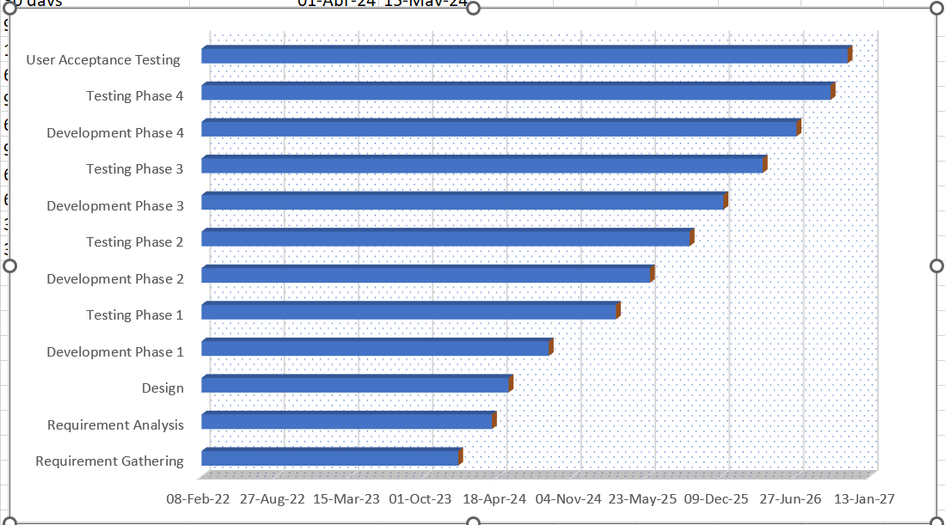

Question 13 – Fixed Bid Vs Billing

|  |  |  |
| --- | --- | --- |
| **SR NO** | **Fixed Bid** | **Billing** |
| 1. | Have clear project guidelines. | Start a long-time project |
| 2. | Want to build a simple app with a little number of features. | Don’t have a complete set of requirements. |
| 3. | Need to stick to the given timeline. | Consider quality a priority. |
| 4. | Have a limited budget. | Are open to changes that can improve the app’s performance. |
| 5. | Expect the development time to be short. | Enter the dynamic market where it’s specifically important to be up to date. |

Question 14 – Preparer Timesheets of a BA in various stages of SDLC

* **Design Timesheet of a BA**:
* Requirements Gathering: X hours/days
* Stakeholder Interviews: X hours/days
* Business Process Analysis: X hours/days
* Data Analysis: X hours/days
* UseCase/User Story Development: X hours/days
* Requirement Documentation: X hours/days
* **Development Timesheet of a BA**:
* Review and Clarification of Requirements: X hours/days
* Collaboration with Developers: X hours/days
* User Interface Design Review (UI): X hours/days
* Data Model Review: X hours/days
* Documentation Updates: X hours/days
* **Testing Timesheet of a BA**:
* Test Plan Development: X hours/days
* Test Case Development: X hours/days
* Test Data Preparation: X hours/days
* Test Execution: X hours/days
* Defect Reporting and Tracking: X hours/days
* Test Result Analysis: X hours/days
* **Development Implementation Timesheet of a BA**:
* Release Planning: X hours/days
* Change Management Support: X hours/days
* Implementation CO ordination: X hours/days