AGILE DOCUMENTS
Document 1: Definition of Done
- Definition of done is an agreement between a product team on the set of conditions that must be true in order to consider backlog items done.
- Product teams use a definition of done to bring consistency to the activities they perform for every backlog item.
- A definition of done usually clarifies how much testing your team plans to do as part of developing a backlog item.
- A definition of done helps your team decide how to address documentation.
- A definition of done may address who — if anyone — needs to sign off, or at least provide feedback on the work your team did. If there is some signoff needed, who do you need it from?
- A definition of done may identify to which environments your team deploys the code for each backlog item. Some teams include deployment to production in their definition of done. Other teams that are not in a position to deploy to production at the end of each iteration may include deployment to a preproduction environment instead and have a separate set of release criteria that indicate what needs to be true before releasing code to production. These release criteria are often applied to the results of multiple iterations.
- The best form of Definition of Done representation is a checklist of activities that has to demonstrate the agreed value and quality of a user story. So, this checklist should include:
- acceptance criteria (to satisfy customer requirements for a product)
- quality criteria (to satisfy quality requirements for a product)

Checklist for DOD:
- developed an app for required functionalities
- all the user stories assumptions met
- application function with out bugs
- pilot testing done with smaller sample size of painters
- Testing of portal for backend done
- QA done and successful
- Features ok by product owner and project manager/BA
- Refactoring done and working fine
- Feature tested against acceptance criteria
- Documentation done
- Change requests are documented
- Peer Code Review performed

Document 2- Product Vision
Scrum Project Name: | PAINTERS APP FOR INCENTIVES AND LOYALTY
Venue: | BANGALORE
Date:15-1-2025 | Start time:10AM | End time:5PM | Duration:6HRS
Client: | MD | Dhanoop
Stakeholder list: | MD | Dhanoop(BA) | Dhanoop(PM)
 | Sarita | Tamkin | Nishith
 | CLIENT SIDE STAKE HOLDERS END USERS
Scrum Team
Scrum Master: | Dhanoop
Product owner: | MD
Scrum Developer 1: | Sarita
Scrum Developer 2: | Tamkin
Scrum Developer 3: | Kushal
Scrum Developer 4: | Pradeep
Scrum Developer 5: | leander

Vision: What is your vision, your overarching goal for creating the product?
Target group  Which market segment does the product address?  Paints retail stores and any painters in general  Who are the target users and customers?  painters | Needs  What problem does the product solve?  Loyalty ie token money and scheme points will be given to painters directly without any middlemen  Which benefit does it provide?  Painters will get money directly in bank without being able to depend on dealers or marketing rep | Product  What product is it?  What makes it desirable and special?  App for QR scanning of loyalty and portal for backend to monitor.  Digital and data is available for analysis for both painter and manufacturer  Is it feasible to develop the product?  Yes absolutely | Value  How is the product going to benefit the company?  Liability will be exactly depicted without any discrepancies and we will save upto 30-40% on yearly expenditure for painter loyalty  What are the business goals?  Successfully engage painters in a loyalty program and have regular interaction with them.  What is the business model?  Digitize the loyalty program with zero scope for manipulation and discrepancies

Document 3: User stories
User story No: 1 | Tasks: 2 |  | Priority: high
Value statement: As a manufacturer, I want to add products to product master with budget and premium diffrentiator
BV: 100 |  | CP: 2
Acceptance criteria: a tab to be provided for adding the product and a drop down for selecting category
User story No: 2 | Tasks: 3 |  | Priority: high
Value statement: As a manufacturer I want to view kyc documents and approve a painter
BV: 100 |  | CP: 2
Acceptance criteria: A tab to view aadhar and pan card attachments and approval option with remarks
User story No: 3 | Tasks: 2 |  | Priority: high
Value statement: As a manufacturer I want to view list of customers with kyc completed and pending
BV: 100 |  | CP: 2
Acceptance criteria: A tab to be provided for list of customers viewing and a filter for kyc updated and pending
User story No: 4 | Tasks: 2 |  | Priority: high
Value statement: As a manufacturer I want to view redemption requests sent and initiate redemption and post transaction status
BV: 100 |  | CP: 2
Acceptance criteria: tab for viewing redemption requests, text field for posting transaction status
User story No: 5 | Tasks: 2 |  | Priority: high
Value statement: As a painter I want to view token money and scheme points to decide when to redeem
BV: 100 |  | CP: 2
Acceptance criteria: A tab for token money wallet and another tab for scheme points wallet
User story No: 6 | Tasks: 2 |  | Priority: high
Value statement: As a painter I want to redem token money and buy gifts for scheme points
BV: 100 |  | CP: 2
Acceptance criteria: Tab for redeming token money, text field for writing the amount to be redemed. Another tab for gifts option to redem against scheme points
User story No: 7 | Tasks: 2 |  | Priority: high
Value statement: As a painter I want to scan qr codes and add points and token money to my wallet
BV: 100 |  | CP: 2
Acceptance criteria: tab for scan option, text field for qr entry in case of qr not scanning
User story No: 8 | Tasks: 2 |  | Priority: high
Value statement: As a painter I want to view latest scheme paper and catalogue so that I can know latest schemes
BV: 100 |  | CP: 2
Acceptance criteria: A tab for scheme, another tab for catalogue
User story No: 9 | Tasks: 2 |  | Priority: high
Value statement: As a manufacturer I want to upload advertisement slider and catalogue so that painter sees it
BV: 100 |  | CP: 2
Acceptance criteria: Tab for uploading advertisement media and catalogue
User story No: 10 | Tasks: 2 |  | Priority: high
Value statement: As a manufacturer I want to see the liability of organization and unscanned qr codes so that I can know how much unsold material is there in the market
BV: 100 |  | CP: 2
Acceptance criteria: A tab to see all qr codes and a filter for filtering out redemed and un redemed codes

User story No: 11 | Tasks: 2 |  | Priority: high
Value statement: As a admin I want to create a painter meet QR so that painter can scan
BV: 100 |  | CP: 2
Acceptance criteria: A tab needed for creating painter meet QR

User story No: 12 | Tasks: 2 |  | Priority: high
Value statement: As a Admin I need geofencing for painter meet location so that fake scan does not happen
BV: 100 |  | CP: 2
Acceptance criteria: painter allowed successful scan if in location 500mtr geofence else outside location failed scan
User story No: 13 | Tasks: 2 |  | Priority: high
Value statement: as a admin I want to see the number of painters attended the painter meet for analysis
BV: 100 |  | CP: 2
Acceptance criteria: report of all the painters attended the meeting

User story No: 14 | Tasks: 2 |  | Priority: high
Value statement: As a painter I want to see the new launch of product so that I can buy
BV: 100 |  | CP: 2
Acceptance criteria: A banner of new launches needs to scroll all time with a expiry of 1 month

User story No: 15 | Tasks: 2 |  | Priority: high
Value statement: As a admin I want to launch scheme for monitoring
BV: 100 |  | CP: 2
Acceptance criteria: back end portal option for adding scheme

User story No: 16 | Tasks: 2 |  | Priority: high
Value statement: As a painter I want to see schemes to buy
BV: 100 |  | CP: 2
Acceptance criteria: scheme tab must be seen

User story No: 17 | Tasks: 2 |  | Priority: high
Value statement: As a painter I want tosee last year scheme for analysis
BV: 100 |  | CP: 2
Acceptance criteria: last year data tab to be available

User story No: 18 | Tasks: 2 |  | Priority: high
Value statement: As a developer I want to host app in play store so that I can use
BV: 100 |  | CP: 2
Acceptance criteria: App to be seen in playstore

User story No: 19 | Tasks: 2 |  | Priority: high
Value statement: As a developer I need to add sms pack for enterprise purpose
BV: 100 |  | CP: 2
Acceptance criteria: sms to be generated at time of login

User story No: 20 | Tasks: 2 |  | Priority: high
Value statement: As a painter I need to see token money product wise for clartiy
BV: 100 |  | CP: 2
Acceptance criteria: token money catalogue needs to be available

User story No: 21 | Tasks: 2 |  | Priority: high
Value statement: As a painter I need to see scheme points product wise for clartiy
BV: 100 |  | CP: 2
Acceptance criteria: scheme point catalogue needs to be available

User story No: 22 | Tasks: 2 |  | Priority: high
Value statement: As a painter I want notifacition on every token scan for intimation
BV: 100 |  | CP: 2
Acceptance criteria: successful notification generated

User story No: 23 | Tasks: 2 |  | Priority: high
Value statement: As a painter I want notifacition on every scheme scan for intimation
BV: 100 |  | CP: 2
Acceptance criteria: successful notification generated

User story No: 24 | Tasks: 2 |  | Priority: high
Value statement: : As a painter I want notifacition on every scheme plan that is floated during festival for intimation
BV: 100 |  | CP: 2
Acceptance criteria: successful notification generated

User story No: 25 | Tasks: 2 |  | Priority: high
Value statement: as a admin I don’t want edit option for kyc to avoid duplication
BV: 100 |  | CP: 2
Acceptance criteria: grey out the feature after successful submition

User story No: 26 | Tasks: 2 |  | Priority: high
Value statement: As admin I want to see amount transferred on token transaction for analysis
BV: 100 |  | CP: 2
Acceptance criteria: report to be available

User story No: 27 | Tasks: 2 |  | Priority: high
Value statement: As admin I want to see amount transferred on scheme transaction for analysis
BV: 100 |  | CP: 2
Acceptance criteria: report to be available

User story No: 28 | Tasks: 2 |  | Priority: high
Value statement: as a admin I want unscanned data for liability analysis
BV: 100 |  | CP: 2
Acceptance criteria: report to be available

User story No: 29 | Tasks: 2 |  | Priority: high
Value statement: As a admin I want to delete product from product master to avoid wrong activations
BV: 100 |  | CP: 2
Acceptance criteria: delete tab to be available

User story No: 30 | Tasks: 2 |  | Priority: high
Value statement: As a admin I want to block fake user scans to avoid counterfeit
BV: 100 |  | CP: 2
Acceptance criteria: scan option enable and disable option to be available

Document 4: Agile PO Experience
The Product Owner has a vision of the product keeping the domain/industry experience and the market need.
❖ Following are the responsibilities of PO in a project
➢ Market Analysis All companies have already started this kind of a program, i purchased competitor products and had a look at their qr codes and met a few painters and had hands on experience of their application
➢ Enterprise Analysis:- If we end up successfully executing this project it will digitize the claims process also we will have track of the exact liability
➢ Product Vision and Roadmap:- firstly noting down all the requirements and analysing the features that are critical to project success and having those on roadmap and constantly monitoring them
➢ Managing Product Features ▫:- Based on the requirements finalized we write user stories covering all functionalities and manage those user stories based on complexity point and business value it offers to the product
➢ Managing Product Backlog ▫ Prioritize user stories, not so important ones at this point of time goes into product backlog and will be considered at a later stage
➢ Managing Overall Iteration Progress ▫ Sprint progress review meeting conducted after each sprint ▫ Reprioritization of sprints and adding new epics if needed ▫ Sprint retrospectives with Business Analyst to ensure the work is in course for completion as per the plan
❖ From this project I have learned how to handle sprint meetings such as
➢ Sprint planning meeting
➢ Daily scrum meeting
➢ Sprint review meeting
➢ Sprint retrospective meeting
➢ Backlog refinement meeting
❖ Also, User stories creation and what things will be included in user stories such as
➢ Story no
➢ Tasks
➢ Priority
➢ Acceptance criteria
➢ BV & CP value
❖ In Scrum, a product owner serves as the liaison between multiple areas of an organization. This person communicates with business stakeholders and collaborates closely with Scrum teams to keep all areas of the business informed on a project's development.
Scrum helped me to strategically perform all the tasks and ensure the product success
❖ The product owner develops a vision of a product's function and operation, which in turn allows this Scrum team member to define product features and break those features into product backlog items.

Document 5: Product and sprint backlog and product and sprint burndown charts
Product backlog:
User story ID | User story | Tasks | Priority | BV | CP | Sprint
1 | As a painter | QR scan and 2 wallets | High | 100 | 2 | 1
2 | As a backend admin | Customer, kyc, redemption request data required | high | 100 | 2 | 1
2 | as a admin I don’t want edit option for kyc to avoid duplication | Disable, | high | 100 | 2 | 1
3 | As a developer I need to add sms pack for enterprise purpose | Add sms | High | 100 | 2 | 1
4 | : as a admin I want to see the number of painters attended the painter meet for analysis | Accumulate no of painter scans | high | 100 | 2 | 1
5 | As admin I want to see amount transferred on token transaction for analysis | Accumulate no of scans | high | 100 | 2 | 1
6 | As a manufacturer I want to upload advertisement slider and catalogue so that painter sees it | Upload doc | High | 100 | 2 | 1
7 | As a developer I want to host app in play store so that I can use | Account create, host, payment | high | 100 | 2 | 1
8 | As a manufacturer I want to view redemption requests sent and initiate redemption and post transaction status | Redemption request, initiate redemption | high | 100 | 2 | 1
9 | as a admin I want unscanned data for liability analysis | Report of unscanned data | High | 100 | 2 | 1
10 | As a Admin I need geofencing for painter meet location so that fake scan does not happen | Geofence the painter meet location | high | 100 | 2 | 1
Sprint backlog:
User story ID | User story | Tasks | Owner | Status | Estimated effort
1 | As a painter | QR scan and 2 wallets | PM | Yet to start | 10 days
2 | As a backend admin | Customer, kyc, redemption request data required | PM | Yet to start | 10 days
3 | as a admin I don’t want edit option for kyc to avoid duplication | Disable, | pm | Yet to start | 10 days
4 | As a developer I need to add sms pack for enterprise purpose | Add sms | pm | Yet to start | 10 days
5 | : as a admin I want to see the number of painters attended the painter meet for analysis | Accumulate no of painter scans | PM | Yet to start | 10 days
6 | As admin I want to see amount transferred on token transaction for analysis | Accumulate no of scans | PM | Yet to start | 10 days
7 | As a manufacturer I want to upload advertisement slider and catalogue so that painter sees it | Upload doc | pm | Yet to start | 10 days
8 | As a developer I want to host app in play store so that I can use | Account create, host, payment | pm | Yet to start | 10 days
9 | As a manufacturer I want to view redemption requests sent and initiate redemption and post transaction status | Redemption request, initiate redemption | Pm | Yet to start | 10 days
10 | as a admin I want unscanned data for liability analysis | Report of unscanned data | pm | Yet to start | 10 days

Product burndown
Product burndown chart depicts number of product or project goals accomplished by the team and the remaining work within the project but here we are pasting burn up report as it is available in jira
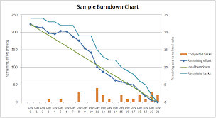
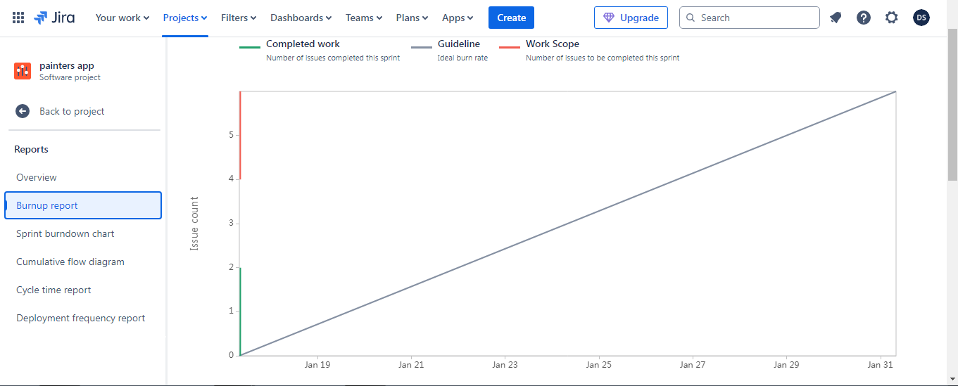
Sprint burndown
Shows amount of work completed and amount of work remaining
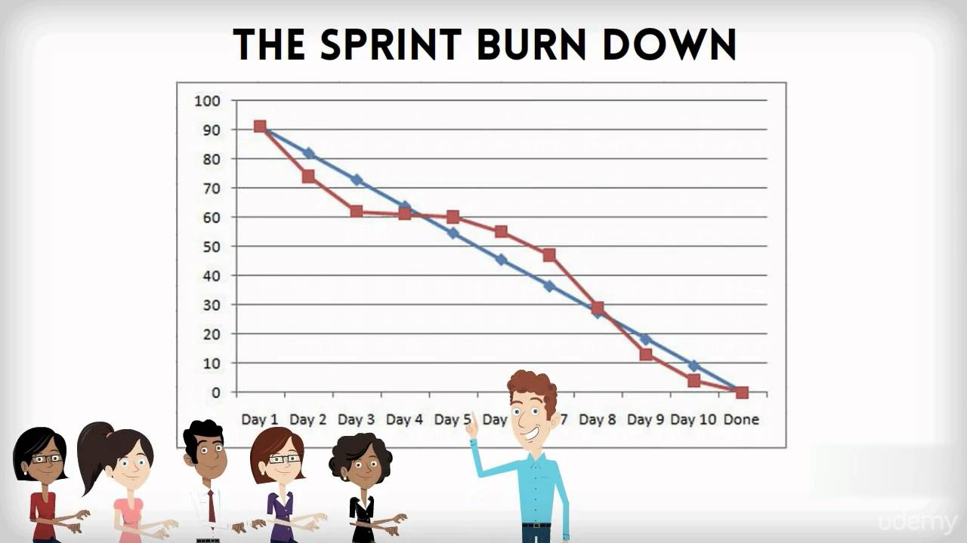
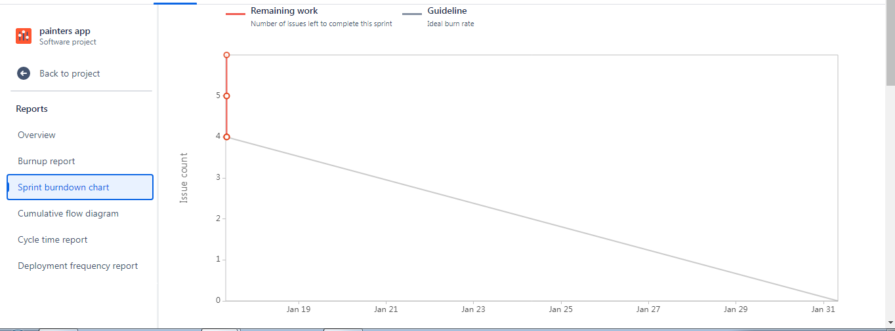
Document 6: Sprint meetings
Sprint Planning meeting
Date | 15-1-25
Time | 10 am
Location | Online
Prepared By | Scrum master
Attendees | Scrum product manager, scrum team BA
Agenda Topics
Topic | Presenter | Time allotted
Painters wallets | Scrum product manager | 2hrs
Customers onboarding | Scrum product manager | 2hrs
Other Information
Observers | All other stake holders
Resources | Team, cloud hosting space, 99.99% up time
Special Notes | Involve client keep him informed
Sprint review meeting
Date | 16-1-2025
Time | 10am
Location | Online
Prepared By | Scrum master
Attendees | Scrum product manager, scrum team BA

Sprint status | Things to demo | Quick updates | What’s next
Completed | All that is completed | Pending tasks | Add pending tasks to next sprint cycle
Sprint retrospective meeting
Date | 17-1-25
Time | 10am
Location | Online
Prepared By | Scrum master
Attendees | Scrum product manager, scrum team BA

Agenda | What went well | What didn’t go well | Questions | Reference
User story1 | QR scan | Balance viewing | What was the reason | Requirement doc can be checked
User story2 | Customers and kyc | Redemption requests | What was the reason | Requirement doc can be checked
Daily Stand-up meeting
Question | Name/Role | Week “5” (from 6-1-25 to 12-1-25)
Question | Name/Role | Monday | Tuesday | Wednesday | Thursday | Friday | Saturday | Sunday
What did you do yesterday? |  | Req  Analysis | Further  Req  analysis | Further  Req  Analysis  And  Dev plan | Start coding | Continue coding | Complete coding | testing
  Developer 1
  Developer 2
  Developer 3
What will you do today? |  | Further  Req  analysis | Further  Req  Analysis  And  Dev plan | Start coding | Continue coding | Complete coding | testing | Prepare test cases
  Developer 1
  Developer 2
  Developer 3
What (if any) is blocking your progress? |  | none | none | none | none | none | none | Bugs identified
  Developer 1
  Developer 2
  Developer 3

