**Document 6- Please prepare a use case diagram, activity diagram and a use case specification document.**

**Use Case Diagram:**

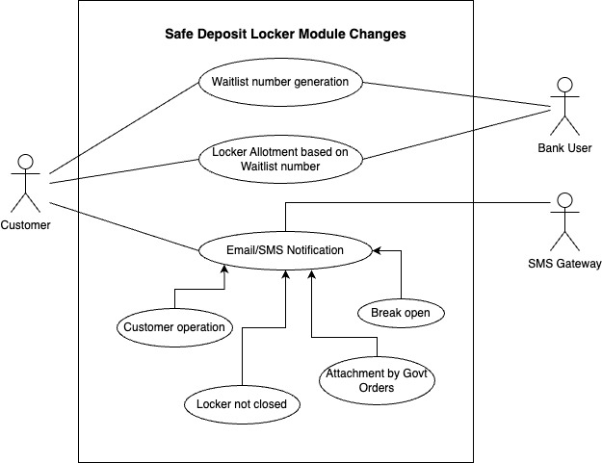

**Use Case Specification Document:**

1. **Use Case Name:**

Enhancement to the Safe Deposit Locker Module in CBS

1. **Use Case Description:**

This use case describes how the waitlist number generation and management will be handling in core banking solutions along with email/SMS generation process for the four defined locker events.

1. **Actors- Primary and Secondary:**

Primary Actor – Customer who comes the Bank

Secondary Actors - Bank Staff (User), SMS Gateway Partner

1. **Basic Flow:**
2. **Alternate Flow:**
3. **Exceptional Flow:**
4. **Pre-Conditions:**
5. **Post-Conditions:**
6. **Assumptions:**
7. **Constraints:**
8. **Dependencies:**
9. **Inputs and Outputs:**
10. **Business Rules:**
11. **Miscellaneous Information:**

**Activity Diagram:**

1. **Waitlist number generation and management:**

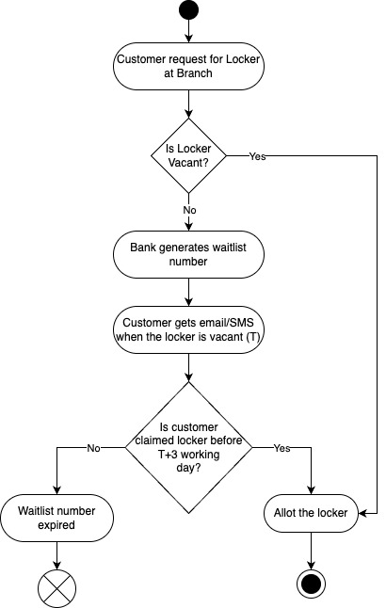

1. **Email/SMS notification for defined locker events:**

