Question 1 – write Agile Manifesto (8 Marks)

Scrum Project Name: Scrum Foods (Foods Delivery Applications) Scrum Project Description:

Scrum Foods provides fast, reliable online food delivery application targeting customers of all age group offering 24/7 service along with tracking of the delivery real time

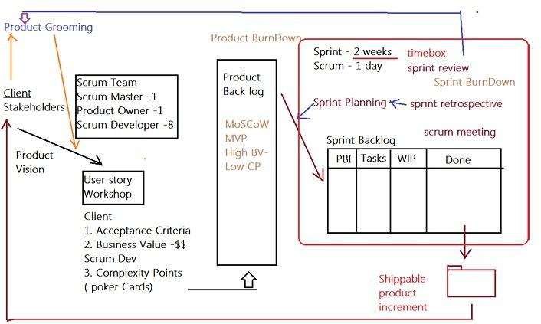

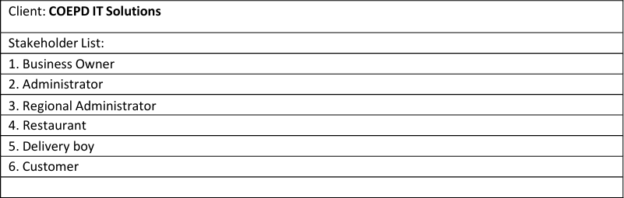

Product Vision – Meeting – Discussion – Document –

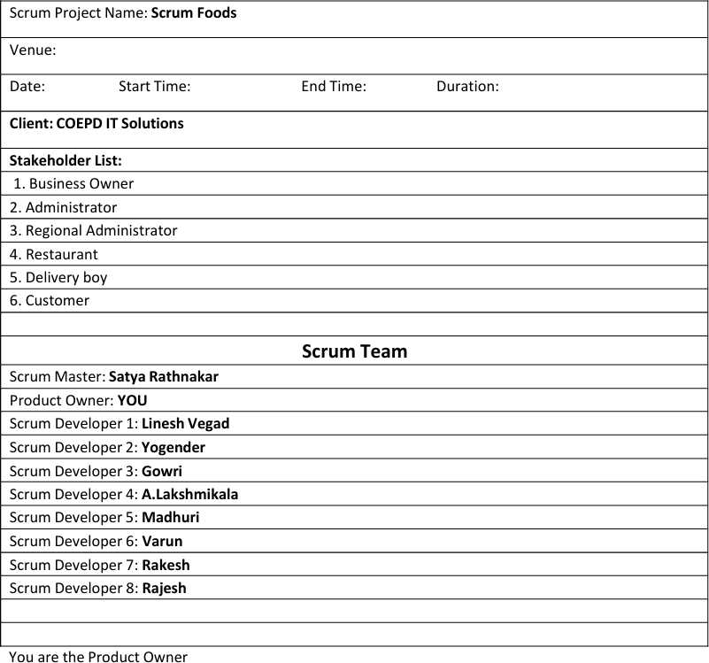

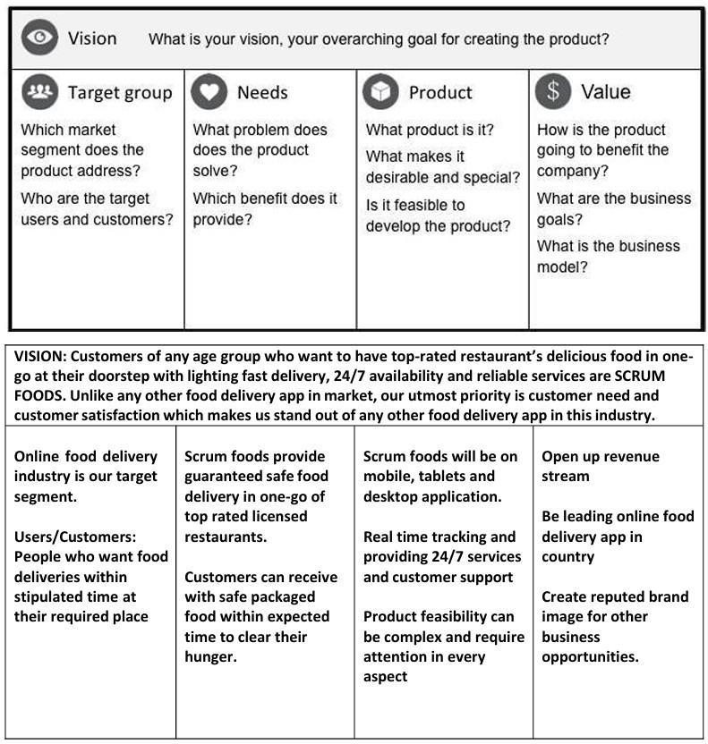

Product Vision – Description – Notes Customer:

Registration, Login, Search and View restaurants, View restaurant's menu, Order food, Payment, Tracking, Cancel order, Feedback & Rating and Logout.

Delivery Boy: Registration, Login, View orders, Select and accept orders, Order pickup and delivery, Status updates, Payment (COD), View Feedback, Raise Issues, View Deliveries report and revenue generated, Logout.

Restaurants:

Registration, Login, View Orders, Delivery Boy Verification, Payment, View Feedback, Raise Issues, View revenue generated through Scrum Food app, Logout

Regional Admin:

Admin Login, Tracking/status, Customer feedback, Managing Regional delivery boys and restaurant , View regional revenue, Issues, Refunds, View payment made to regional restaurant and Logout.

Admin: Login, Managing Regional Admin, Issues, Customer Feedback, Approval/Rejections privileges on restaurants, Delivery boy, Restaurants and Regional Admin requests, Resolve Issues and Logout

Business Owner:

Login, Issues, Reports, Update payments for restaurants and delivery boys and Logout

End of Product Vision

# User Story Workshop

How to write a user story:

Take a Sticky Note and take a contract colour Sketch Pen and write the user story in CAPITAL letters only.

Make sure the user story is short, clear and unambiguous and one Scrum Developer can develop in one agreed sprint.

If you come across complex, big User stories… these are called epics. We can divide the epics into Themes and then into User Stories Finalized User Stories Count:

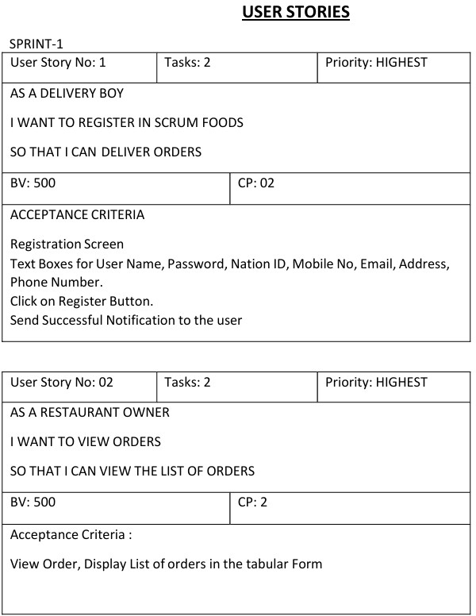

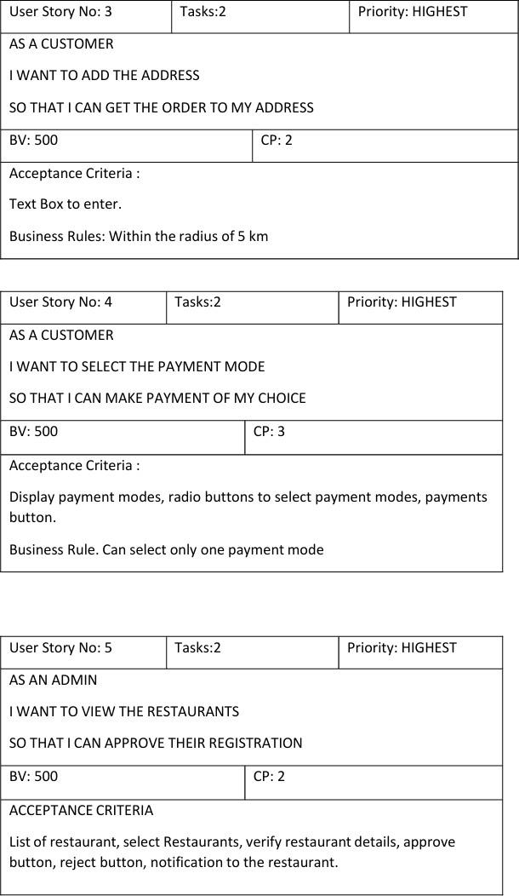

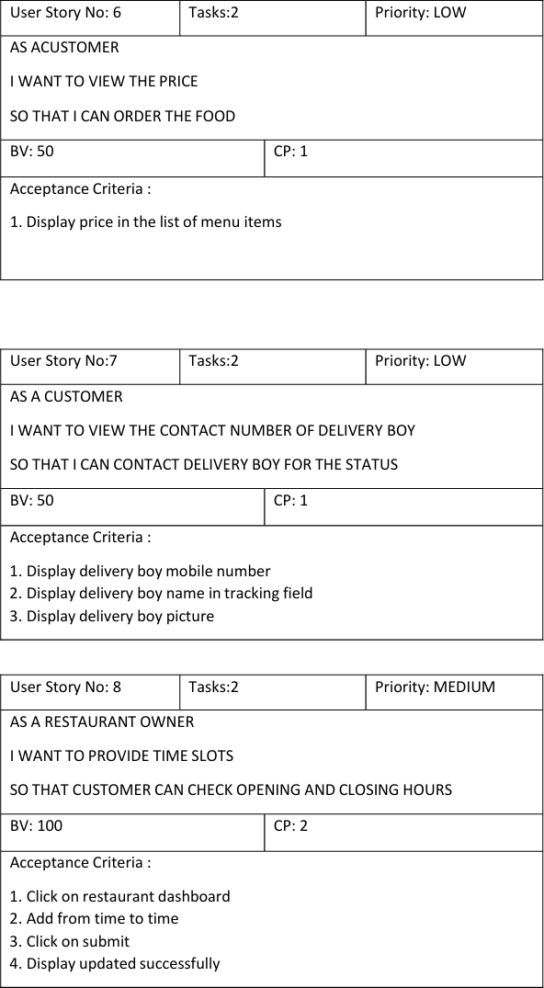

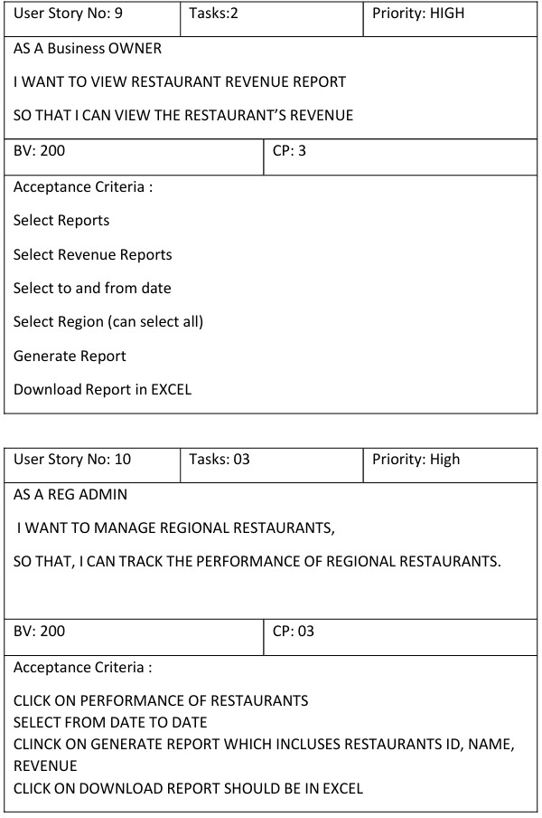

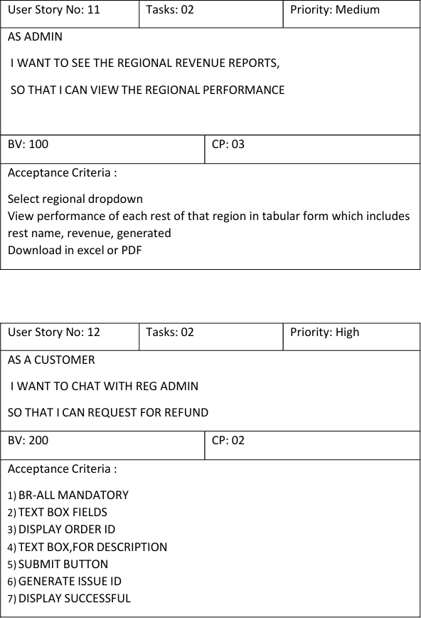

Adding BV and CP to User stories

BV – Business Value This is not the cost of Development or the complexity of the feature. Business Value is how important is this feature (user Story) to the Business. This is estimated by Scrum Currency Notes. We provide Rs 1000. Rs

500, Rs 100, Rs 50, Rs 20 and Rs 10 Denominations. These estimations are done by the Stakeholders (Clients). If different values are selected by the stakeholders, then discussions will happen, and they agree to one BV value to that user story.

CP – Complexity Points

CP is also known as Story Points (SP). CP is the effort required by the Scrum Developers to develop this feature (user story) using technology. Efforts include time taken to solve the complexity and write the code. CP is estimated by the Scrum Developers by using Poker cards. We provide pokers with values “?”, 1, 2, 3, 5, 8, 13, 20, 40, 100 and BIG. If the entire Project development takes 200 points, then this user story coding effort will be… how many points? … Thinking in this way, Scrum Developers will give CP to the User story). If different values are selected by the Scrum Developers, then discussions will happen, and they agree to one CP value to that user story.

## ANS: AGILE

### **Four Main Values**

1. **Individuals and Interactions** over processes and tools.
2. **Working Products** over comprehensive documentation.
3. **Customer Collaboration** over contract negotiation.
4. **Responding to Feedback** over following a plan.

12 Principles of Agile

1. **Customer Satisfaction**
   * Our highest priority is to satisfy the customer through early and continuous delivery of valuable products.
2. **Welcome Change**
   * Embrace changing requirements, even late in development. Agile processes harness change for the customer's competitive advantage.
3. **Frequent Delivery**
   * Deliver working products frequently, from a couple of weeks to a couple of months, with a preference for shorter timescales.
4. **Collaboration**
   * Businesspeople and cross-discipline teams must work together daily throughout the project.
5. **Motivated Individuals**
   * Build projects around motivated individuals. Trust them to get the job done.
6. **Face-to-Face Communication**
   * The most effective and efficient way to convey information is through face-to-face conversation.
7. **Working Products as a Measure**
   * A working product is the primary measure of progress.
8. **Sustainable Pace**
   * Maintain a constant pace indefinitely, avoiding burnout.
9. **Technical Excellence**
   * Continuous attention to technical excellence and good design enhances agility.
10. **Simplicity**
    * Simplicity—the art of maximizing the amount of work not done—is essential.
11. **Self-Organizing Teams**
    * The best architectures, requirements, and designs emerge from self-organizing teams.
12. **Reflection and Adjustment**
    * Teams regularly reflect on how to become more effective and adjust their behavior accordingly.

# Question 2 – User Stories- Acceptance Criteria-BV-CP

Write minimum 40 User stories and their Acceptance Criteria along with their BV and CP

| **User story:1** | **Task:**  **2** | **Priority:**  **highest** |
| --- | --- | --- |
| AS A DELIVERY BOY  I WANT TO REGISTER IN SCRUM FOODS SO THAT I CAN DELIVER ORDER |  | |
| **BV:500** | **CP:02** | |
| Acceptance criteria  Registration Screen Text Boxes for User Name, Password, Nation ID  Mobile No, Email, Address, Phone Number  Click on Register Button Send Successful Notification to the user |  | |

| **User story:2** | **Task:2** | **Priority:** |
| --- | --- | --- |

|  |  | **highest** |
| --- | --- | --- |
| AS A RESTAURANT OWNER I WANT TO VIEW ORDERS  SO THAT I CAN VIEW THE LIST OF ORDERS |  | |
| **BV:500** | **CP:02** | |
| ACCEPTANCE CRITERIA  View Order, Display List of orders in the tabular Form |  | |

| **User story:3** | **Task:** | **Priority: highest** |
| --- | --- | --- |
| As a customer  I want to add the Address  So that I can get the order to the address |  | |
| **BV:500** | **CP:02** | |
| ACCEPTANCE CRITERIA  Text Box to enter. Business Rules: Within The Radius Of 5km |  | |

| **User story:4** | **Task:0**  **2** | **Priority:**  **highest** |
| --- | --- | --- |
| As a customer  I want to select the payment mode  So that can make payment of my choice |  |  |
| **BV:500** | **CP:03** |  |
| **Acceptance criteria**  Display payment modes, radio buttons to select payment modes, payments button.  Business Rule. Can select only one payment mode |  |  |

| **User story:5** | **Task:1** | **Priority: highest** |
| --- | --- | --- |
| As an admin |  | |

| I want to view the restaurants  So that I can approve their registration |  |
| --- | --- |
| **BV 200** | **CP 2** |
| **Acceptance criteria**  Register in the platform with the details |  |

| **User story:6** | **Task:1** | **Priority: low** |
| --- | --- | --- |
| **As a customer**  I want view the price  So that I can order the food |  | |
| **BV:50** | **CP:1** | |
| **Acceptance criteria**  Display price in the list of menu items |  | |

| **User story:7** | **Task :2** | **Priority: low** |
| --- | --- | --- |
| **As a customer**  I want the contact number of delivery boy  So that I can contact delivery boy for the status |  |  |
| **BV: 50** | **CP:1** |  |
| **Acceptance criteria**  1.Display delivery boy mobile number  2.Display delivery boy name in tracking field  3.Display Delivery boy picture |  |  |

| **User story:8** | **Task:2** | **Priority: medium** |
| --- | --- | --- |
| As a restaurant owner  I want to provide time slots  So that customers able to see opening and closing hours |  | |
| **BV:100** | **CP:2** | |
| ACCEPTANCE CRITERIA   1. Click on restaurant dashboard 2. Add from time to time   3.Click On Submit  4.Display updated successfully |  | |

| **User story:9** | **Task :2** | **Priority: high** |
| --- | --- | --- |
| AS A Business OWNER IWANTTOVIEWRESTAURANTREVENUEREPORT SOTHATICANVIEWTHERESTAURANT’S REVENUE |  |  |
| **BV:200** | **CP:3** |  |
| ACCEPTANCE CRITERIA  Select Reports  Select Revenue Reports Select to and from date Select Region (can select all) Generate Report  Download Report in EXCEL |  |  |

| **User story: 10** | **Task:3** | **Priority: high** |
| --- | --- | --- |
| AS A REG ADMIN  IWANT TO MANAGE REGIONAL RESTAURANTS SO THAT, ICAN TRACK THE PERFORMANCE OF REGIONAL RESTAURANTS. |  |  |
| **BV:200** | **CP:3** |  |
| ACCEPTANCE CRITERIA CLICK ON PERFORMANCE OF RESTAURANTS  SELECT FROM DATE TO DATE  CLICK ON GENERATE REPORT WHICH INCLUDES  RESTAURANTS ID, NAME, REVENUE CLICKONDOWNLOADREPORTSHOULDBEIN EXCEL |  |  |

| User story:11 | Task:2 | Priority: medium |
| --- | --- | --- |
| AS An ADMIN  I WANT TO SEE THE REGIONAL REVENUE REPORTS, SOTHATICAN VIEW THE REGIONAL PERFORMANCE |  |  |
| BV:1OO | CP:3 |  |
| ACCEPTANCE CRITERIA  Select regional dropdown View performance of each rest of that region in tabular form which includes rest name, revenue, generated DownloadinexcelorPD |  |  |

| User story:12 | Task :2 | Priority: high |
| --- | --- | --- |
| AS A CUSTOMER  I WANT TO CHAT WITH REG ADMIN  SO THAT I CAN REQUEST FOR REFUND |  |  |
| BV:200 | CP:2 |  |
| Acceptance criteria   1. Br-all mandatory 2. text box fields 3. display order id 4. text box ,for description 5. submit button 6. generate issue id 7. display successful |  |  |

| User story:13 | Task:2 | Priority: high |
| --- | --- | --- |
| AS A HUNGRY USER I WANT TO BROWSE NEARBY RESTAURANTS SO THAT I CAN ORDER THE FOOD |  |  |
| BV:200 | CP:2 |  |
| ACCEPTANCE CRITERIA  1.Each restaurant entry displays its name, cuisine type, and rating  2.This list can be sorted by distance or rating |  |  |

| User story:14 | Task:2 | Priority: high |
| --- | --- | --- |
| AS A CUSTOMER  I WANT TO BROWSE DIFFERENT RESTAURANTS AND MENUS  SO THAT I CAN FIND A PLACE TO ORDER FOOD |  |  |
| BV:200 | CP:2 |  |
| ACCEPTANCE CRITERIA   1. The menu includes dishes, prices and descriptions 2. Show the restaurant is open or closed |  |  |

| User story:15 | Task:1 | Priority: high |
| --- | --- | --- |
| AS A CUSTOMER I WANT  TO BROWSE FOR SPECIFIC DISHES |  |  |

| AND CUISINES THAT CAN FIND A PLACE TO ORDER FOOD |  |  |
| --- | --- | --- |
| BV:200 | CP:2 |  |
| ACCEPTANCE CRITERIA  1)App displays relevant restaurant and dishes matching the query |  |  |

| User story:16 | Task:1 | Priority: high |
| --- | --- | --- |
| AS A CUSTOMER I WANT TO FILTER RESTAURANTS SEITHATI CAN FIND PLACE TO ORDER FOOD |  |  |
| BV:200 | CP:2 |  |
| ACCEPTANCE CRITERIA  1)Filter restaurants by cuisine type and dietary options (vegan, veg, nonveg, egg) |  |  |

| User story:17 | Task:2 | Priority: high |
| --- | --- | --- |
| AS A CUSTOMER I WANT  TO TRACK MY ORDER SO THAT  I KNOW THE TIME OF DELIVERY |  |  |
| BV:200 | CP:2 |  |
| ACCEPTANCE CRITERIA   1. App shows real time update on the order status 2. Display estimated delivery time |  |  |

| User story:18 | Task 2 | Priority: high |
| --- | --- | --- |
| AS A USER I WANT TO RATE AND REVIEW RESTAURANT S THAT CAN RATE AND REVIEW THE RESTAURANTS I HAVE VISITED |  |  |
| BV:200 | CP:2 |  |
| ACCEPTANCE CRITERIA  1)Can see reviews from other users to help me make dining decisions |  |  |

| User story 19 | Task 1 | Priority: high |
| --- | --- | --- |
| AS A USER I WANT |  |  |

| TO SAVE FAVOURITE RESTAURANTS AND DISHES SO THAT I CAN ORDER FROM FAVOURITES |  |  |
| --- | --- | --- |
| BV:200 | CP:2 |  |
| ACCEPTANCE CRITERIA  1)Access my list of favourites easily for future orders |  |  |

| User story 20 | Task 3 | Priority: high |
| --- | --- | --- |
| AS A USER I WANT TO VIEW PAST ORDER HISTORY SO THAT I CAN ORDER AGAIN |  |  |
| BV:200 | CP:2 |  |
| ACCEPTANCE CRITERIA  1)Can see the details such as order items, total cost and order date |  |  |

| User story 21 | Task 2 | Priority: medium |
| --- | --- | --- |
| AS A USER I WANT TO RECEIVE NOTIFICATIONS THAT CAN RECEIVE UPDATES |  |  |
| BV:200 | CP:2 |  |
| ACCEPTANCE  CRITERIA 1)Notifications for order confirmation 2)Notification for dispatch 3)Notification for delivery |  |  |

| User story 22 | Task 2 | Priority: high |
| --- | --- | --- |
| AS A CUSTOMER I WANT TOCONTACTCUSTOMERSUPPOR T SOTHATI CANSUBMIT QUERIES OR ISSUES |  |  |
| BV:200 | CP:2 |  |
| ACCEPTANCE CRITERIA  1)Customer support section with contact information |  |  |

| User story 23 | Task 2 | Priority: high |
| --- | --- | --- |
| AS A RESTAURANT OWNER I WANT TO RECEIVE AND MANAGE ORDERS SO THAT ICAN UPDATE ORDER STATUS |  |  |
| BV:200 | CP: 2 |  |

| ACCEPTANCE CRITERIA   1. Manage order status 2. Notify restaurants about incoming orders |  |  |
| --- | --- | --- |

| User story 24 | Task 1 | Priority: medium |
| --- | --- | --- |
| ‘AS A RESTAURANT OWNER I WANT TO ACCESS TO CUSTOMER REVIEWS SO THAT I CAN VIEW AND RESPOND TO CUSTOMER REVIEWS |  |  |
| BV:100 | CP:4 |  |
| ACCEPTANCE CRITERIA   1. Owners can address feedback 2. Owners can improve their services |  |  |

| User story 25 | Task 1 | Priority: medium |
| --- | --- | --- |
| AS A CUSTOMER I WANT TO APPLY PROMO CODE AND DISCOUNTS SO THAT I CAN ORDER AT LOWER PRICE |  |  |
| BV:100 | CP:4 |  |
| ACCEPTANCE CRITERIA  1)Active Promo codes |  |  |

| User story 26 | Task 7 | Priority: high |
| --- | --- | --- |
| ASA CUSTOMER I WANT APPLY PROMOCODE AND DISCOUNTS SO THAT I CAN ORDER AT LOWER PRICE |  |  |
| BV:200 | CP: 4 |  |
| ACCEPTANCE CRITERIA  1)Active Promo codes |  |  |

| User story 27 | Task 5 | Priority: high |
| --- | --- | --- |
| AS A DELIVERY BOY I WANT TO VIEW THE ORDERS SO THAT I ACCEPT THE ORDER |  |  |
| BV: 200 | CP: 4 |  |
| ACCEPTANCE CRITERIA  1)Order visibility 2)Real-time updates   1. Order details 2. Order filtering and sorting 3. Order map view 4. Order navigation 5. Order completion and confirmation |  |  |

| User story 28 | Task 5 | Priority: high |
| --- | --- | --- |
| AS ADELIVERYBOY I WANT TO LOGIN SOTHATICANACCEPTTHEORDER |  |  |
| BV:200 | CP: 4 |  |
| ACCEPTANCE CRITERIA   1. User Authentication 2. Error Handling 3. Password security 4. Multi-factor Authentication 5)Compatibility and Usability |  |  |

| User story 29 | Task 5 | Priority: high |
| --- | --- | --- |
| ASADELIVERYBOY I WANT VIEW FEEDBACK SO THAT I CAN KNOW THE CUSTOMERS FEEDBACK |  |  |
| BV:200 | CP: 4 |  |
| ACCEPTANCE CRITERIA   1. Access to feedback system 2. Feedback Visibility 3. Feedback sorting and filtering 4. Response Mechanism 5. User Support |  |  |

| User story 30 | Task 5 | Priority: high |
| --- | --- | --- |
| AS A ADMIN I WANT TO VIEW FEEDBACK SO THAT I CAN KNOW THE CUSTOMERS FEEDBACK |  |  |
| BV:200 | CP:4 |  |
| ACCEPTANCE CRITERIA   1. Access to feedback system 2. Feedback Visibility 3. Feedback sorting and filtering 4. Response Mechanism 5. User Support |  |  |

| User story 31 | Task 3 | Priority: high |
| --- | --- | --- |
| AS A RESTAURANT TO OWNER FEEDBACK SOTHATICANKNOWTHE CUSTOMER FEEDBACK |  |  |
| BV:100 | CP:3 |  |
| ACCEPTANCE CRITERIA   1. Access to feedback system 2. Feedback Visibility 3. Feedback sorting and filtering 4. Response Mechanism 5. User Support |  |  |

| User story 32 | Task 3 | Priority: high |
| --- | --- | --- |

| AS ADMIN I WANT TO KNOW THE ISSUES SO THAT I CAN RESOLVE THEM |  |  |
| --- | --- | --- |
| BV:200 | CP:4 |  |
| ACCEPTANCE  CRITERIA 1)Display issue section 2)Sorting and filtering of issues list  3)Editing and modifying the issues |  |  |

| User story 33 | Task 6 | Priority: high |
| --- | --- | --- |
| AS A REGIONAL ADMIN I WANT TO KNOW THE ISSUES SO THAT I CAN RESOLVE THEM |  |  |
| BV:200 | CP:4 |  |
| ACCEPTANCE  CRITERIA 1)Display issue section 2)Sorting and filtering of issues list  3)Editing and modifying the issues |  |  |

| **User story 34** | **Task 2** | **Priority: high** |
| --- | --- | --- |
| AS A RESTAURANT OWNER I WANT TO VIEW REVENUE GENERATED SO THAT I VIEW RESTAURANT REVENUE |  |  |
| **BV:200** | **CP:4** |  |
| ACCEPTANCE CRITERIA  Select Reports  Select Revenue Reports Select to and from date Select Region (can select all) Generate Report  Download Report in EXCEL |  |  |

| **User story 35** | **Task 2** | **Priority: low** |
| --- | --- | --- |
| AS A RESTAURANT OWNER I WANT TO KNOW DELIVERY BOY SO THAT I VERIFY THE DELIVERY BOY |  |  |
| **BV:50** | CP:1 |  |
| ACCEPTANCE CRITERIA  ID proof  Punctuality and reliability |  |  |

| **User story 36** | **Task 2** | **Priority: medium** |
| --- | --- | --- |
| AS A CUSTOMER I WANT TO VIEW THE CONTACT NUMBER OF DELIVERY BOY SO THAT I CAN CONTACT DELIVERY BOY FOR THE STATUS |  |  |
| **BV:100** | **CP: 2** |  |
| ACCEPTANCE CRITERIA   1. Display delivery boy mobile number 2. Display delivery boy name in tracking field 3. Display delivery boy picture |  |  |

| **User story 37** | Task 3 | Priority: high |
| --- | --- | --- |
| AS A RESTAURANT OWNER I WANT TO PROVIDE TIME SLOTS SO THAT CUSTOMER CAN CHECK OPENING AND CLOSING HOURS |  |  |
| **BV:200** | **CP: 2** |  |
| ACCEPTANCE CRITERIA   1. Click on restaurant dashboard 2. Add from time to time 3. Click on submit 4. Display updated successfully |  |  |

| **User story 38** | **Task 1** | **Priority: medium** |
| --- | --- | --- |
| AS A USER I WANT TO RECEIVE NOTIFICATIONS SO THAT I CAN RECEIVE UPDATES |  |  |
| **BV: 200** | **CP: 2** |  |
| ACCEPTANCE CRITERIA  1)Notifications for order confirmation 2)Notification for dispatch 3)Notification for delivery |  |  |

| **User story39** | **Task 4** | **Priority: high** |
| --- | --- | --- |
| AS A CUSTOMER I WANT TO CONTACT CUSTOMER SUPPOR T THAT CAN SUBMIT QUERIES OR ISSUES |  |  |

| **BV:200** | CP: 3 |  |
| --- | --- | --- |
| ACCEPTANCE CRITERIA  1) Customer support section with contact information |  |  |

| **User story 40** | **Task 4** | **Priority: medium** |
| --- | --- | --- |
| AS A CUSTOMER I WANT TO VIEW THE ODOR SO THAT I CAN CANCEL IT |  |  |
| **BV: 200** | **CP: 3** |  |
| ACCEPTANCE CRITERIA  Order status  Method of cancellation Refund policy Timeframe |  |  |

| **user story:40** | **task: 4** | **Priority high** |
| --- | --- | --- |
| AS A REGIONAL ADMIN I WANT TRACK THE DELIVERY SO THAT I CAN VIEW THE STATUS OF THE DELIVERY |  |  |
| **BV 200** | **CV 3** |  |
| ACCEPTANCE CRITERIA  Real time tracking Security and data privacy User friendly Interface |  |  |

Question 3– What is epic? Write 2 epics – 5 Marks

Business Value and Complexity Points

**Answer:**

### What is an Epic?

An Epic is:

1. A large user story or a collection of related user stories that represents a significant feature or functionality.
2. High-level in nature, often spanning multiple sprints or iterations.
3. Used to organize and prioritize work in a product backlog.

Examples of Epics

#### 1. Ratings and Reviews Epic

Description:  
Allow users to view and provide ratings and reviews for restaurants on Scrum Foods, enabling informed decisions and fostering a collaborative community.

User Stories:

* As a user, I want to view ratings and reviews for restaurants on Scrum Foods so that I can make informed decisions.
* As a user, I want to provide ratings and reviews to share my experiences and contribute to the community.

Acceptance Criteria:

1. Users can view average ratings and detailed reviews on a restaurant's details page.
2. Users can sort and filter reviews by rating or relevance.
3. Users can submit, edit, or delete their reviews within a specific timeframe.
4. Reviews are presented to offer useful insights to others.
5. The system ensures the authenticity of feedback.

2. Real-Time Order Tracking Epic

Description:  
Provide users with a seamless experience by allowing them to track their food orders in real-time, enhancing transparency, satisfaction, and engagement.

User Stories:

* As a customer, I want to view the live status of my order.
* As a customer, I want to track the delivery partner’s real-time location on a map.
* As a customer, I want to receive notifications for significant order updates.
* As a customer, I want to contact the delivery partner through the app.
* As a customer, I want to view the delivery route and estimated delivery time.
* As an admin, I want to monitor order tracking performance to identify improvements.

Acceptance Criteria:

1. Real-Time Updates:
   * Status updates such as "Order received," "Preparing," and "Out for delivery" are displayed in real-time.
2. Location Tracking:
   * A live map shows the delivery driver’s location and route, updated at regular intervals.
3. Delivery Notifications:
   * Users receive notifications for key events like dispatch and arrival.
4. Privacy and Security:
   * Data privacy regulations are adhered to, ensuring secure handling of location data.
5. Compatibility and Usability:
   * The feature works seamlessly on all platforms (iOS, Android, and web) and supports multiple orders.
6. Opt-Out Option:
   * Users can disable real-time tracking if desired.
7. Feedback Integration:
   * Users can rate the delivery experience and provide written feedback after the order is completed.

By delivering these epics, the product ensures improved user engagement, satisfaction, and a seamless experience, driving the overall success of the app.

**Question 4 –What is the difference between BV and CP – 2 Marks**

**Answer:**

### **1. Business Value (BV)**

**Definition**:  
Business Value is a measure of the **benefit or impact** that a feature, user story, or epic brings to the business or end-users. It reflects the **importance** and **value proposition** of delivering a specific functionality.

#### **Key Features:**

* **Purpose**: To identify and prioritize work that provides the most value to stakeholders or users.
* **Measurement**:
  + Often subjective and determined collaboratively by stakeholders, product owners, and team members.
  + Scored using techniques like numerical scales (1-10), t-shirt sizing (Small, Medium, Large), or MoSCoW (Must have, Should have, Could have, Won't have).
* **Focus**: On outcomes like increased revenue, user satisfaction, or competitive advantage.
* **Examples**:
  + A feature allowing users to track their food orders in real-time might have high BV due to enhanced customer satisfaction and reduced support inquiries.
  + Ratings and reviews might have medium BV, as they help users make decisions but don’t directly impact revenue.

#### **How BV is Used:**

* Helps prioritize the backlog by focusing on delivering high-value items first.
* Enables stakeholders to see the **ROI (Return on Investment)** for each task or feature.

**2. Complexity Points (CP)**

**Definition**:  
Complexity Points are a measure of the **effort, risk, and difficulty** involved in implementing a feature, user story, or epic. It focuses on **how challenging** the task is for the team.

#### **Key Features:**

* **Purpose**: To assess the amount of work required and plan resources accordingly.
* **Measurement**:
  + Determined by the development team using methods like story points, Fibonacci sequences (1, 2, 3, 5, 8...), or t-shirt sizing.
  + Based on factors like technical challenges, dependencies, team skills, and unknowns.
* **Focus**: On the effort required to implement a feature.
* **Examples**:
  + Real-time order tracking may have high CP due to technical challenges like GPS integration, real-time data updates, and cross-platform compatibility.
  + Ratings and reviews may have low CP since it involves basic CRUD operations (Create, Read, Update, Delete).

#### **How CP is Used:**

* Helps teams estimate how much work can be completed in a sprint or iteration.
* Balances the workload by aligning complexity with team capacity.

**Question 5 –Explain about Sprint Sprint Understanding**

**What is sprint Duration: 2 Weeks - Your sprint Value Scrum is a subunit of Sprint.**

**What is scrum Duration: 1 day – Your scrum Value?**

**PBI: Product Backlog Item**

**Task: Unit of Work done by 1 Developer in 1 Scrum WIP: Work in Progress**

**Sprint Backlog**

**Answer:**

# Sprint in Software Development

A sprint is a time-boxed, iterative development period used in software development and project management. It is a core concept of Agile methodologies like Scrum, focusing on flexibility, collaboration, and delivering value to customers in shorter cycles.

Key Characteristics and Components of a Sprint

### 1. Time Frame

* A sprint has a fixed duration, typically ranging from 1 to 4 weeks.
* The duration remains consistent across all sprints, ensuring a predictable rhythm for development and planning.

### 2. Goals and Objectives

* At the start of a sprint, the team and stakeholders select a set of user stories, features, or tasks to work on, which are referred to as the sprint backlog.

### 3. Planning

* During sprint planning, the team:
  + Breaks down selected items from the product backlog into smaller tasks.
  + Estimates the effort required for each task.
  + Commits to completing these tasks within the sprint duration.

### 4. Daily Stand-ups

* The team holds daily stand-up meetings (or daily scrums) to:
  + Discuss progress, obstacles, and plans.
  + Share updates on accomplishments, ongoing work, and challenges.
* These meetings enhance communication and foster collaboration.

### 5. Development

* The development team works on the tasks from the sprint backlog.
* Collaboration techniques like pair programming and frequent code reviews ensure high-quality work.

### 6. Continuous Integration

* Developers integrate code changes into the main codebase regularly to:
  + Maintain functionality and stability.
  + Detect and fix issues early.

### 7. Testing

* Testing is integral to a sprint:
  + Automated tests validate code changes.
  + Manual testing ensures software quality.

### 8. Review and Demo

* At the end of the sprint, the team conducts a sprint review and demo to:
  + Showcase completed work to stakeholders.
  + Gather feedback and validate delivered features.

### 9. Retrospective

* After the review and demo, the team holds a sprint retrospective to:
  + Reflect on successes and areas for improvement.
  + Plan actionable steps for the next sprint.
* This encourages continuous improvement.

### 10. Incremental Development

* Each sprint results in a potentially shippable product increment:
  + A new version of the software is available with additional features or improvements.

### 11. Adaptability

* Agile emphasizes adaptability to respond to changing requirements.
* New priorities or insights can be integrated into future sprints.

Benefits of Sprints

* Deliver value iteratively to customers and stakeholders.
* Break work into manageable chunks.
* Foster collaboration and communication.
* Reduce risks by seeking regular feedback.
* Improve the overall quality of the software.

By embracing the sprint approach, Agile teams enhance productivity, maintain focus, and ensure consistent delivery of high-value features in a controlled and predictable manner.

**Question 6 – Explain Product backlog and sprint backlog ( 5 mark)**

**print Planning Meeting: All 8 Scrum Developers will gather before the sprint starts and understand how many user stories, they can develop in 1 sprint (2 weeks), and move them from the product Backlog to the sprint Backlog. They take inputs from Sprint Retrospective meeting.**

**Scrum Meeting – Daily Stand-up Meeting End of every Scrum, Scrum Developers will participate in Scrum meeting. Here they must answer 3 Questions.**

1. **What task did you work in this scrum?**
2. **What task will you work on next scrum?**
3. **Any Challenges/impediments? When you will complete the user story?**

**Product Backlog and Sprint backlog**:

The Product Backlog is a dynamic, prioritized list of all the features, user stories, enhancements, bug fixes, and other work items that need to be addressed over the

course of a project. It represents the entire scope of the product's development and is managed by the Product Owner. The Product Backlog is continually refined and updated based on feedback, changing requirements, and new insights. The Sprint Backlog is a subset of the Product Backlog that represents the work that the development team commits to completing during a specific time period called a "Sprint."

A Sprint is a fixed-duration iteration, usually lasting two to four weeks, in which the team Works on a set of items from the Product Backlog. The Sprint Back log is created during the Sprint Planning meeting, where the development team selects a set of items to work on based on their capacity and the priorities set by the Product Owner

| **S.no** | **Product backlog** | **Sprint backlog** |
| --- | --- | --- |
| **1** | Anything that needed to Accomplish the  project vision | Anything that needed to  fulfil the sprint goal |
| **2** | Product owner owns | Development team owns |
| **3** | Contains requirements, tasks, defects | A subset of product backlog items defined as a priority by the product  owner |
| **4** | Every one contributes to the product catalogue | Sprint planning meeting is  to refine the sprint backlog items |
| **5** | Product back log evolves and changes will be  done by the PO | NO changes are all owed  to the sprint backlog items |

|  | through the product lifecycle | once the sprint has  started |
| --- | --- | --- |
| **6** | Product backlog refinement meeting is to refine the product backlog | Sprint planning meeting is to refine the sprint  backlog items |
| **7** | Release burndown metric is used | Sprint burn down metric is  used |
| **8** | Estimation is done at a user  Story level | Estimation is done at  activity or task level |
| **9** | Daily standup meeting does not discuss product backlog items | Daily standup meeting discusses the sprint backlog in accordance  with sprint goal |

**Question 7 – What is impediments log? write 2 impediments Impediments 5 marks**

**Log:**

**All challenges faced by the team will be logged in this impediments log Once the Sprint is completed**

1. **From the Done state of the sprint Backlog, we will product Increment and we can deliver it to**

**the client**

1. **Sprint Retrospective meeting: Only the Scrum Developers will participate and will discuss about**

**Challenges faced and come up with lessons learnt. We can use these lessons learnt in Sprint**

**planning meeting to select user stories for the next sprint.**

1. **Sprint Review meeting: All Stakeholders like Scrum Developers, Product owner, Scrum master,**

**Client, 3rd party reviewers will participate. What they discuss is**

* + **Velocity – How many CP is covered in this sprint**
  + **Sprint Burn Down Chart**

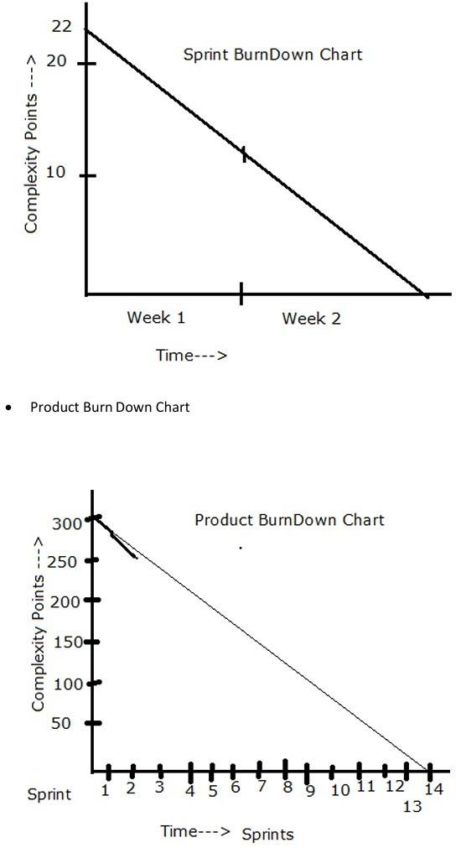

**Sprint 1**

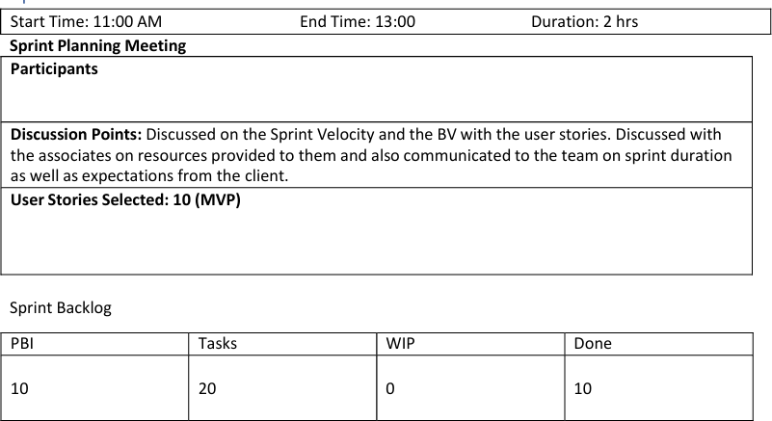

**Prepare Tasks from PBI**

**How many Scrums, we will have in this sprint? Allocate Tasks to Developers**

**Scrum 1 Start Time:**

**End Time:**

**10**

**Duration:**

**Participant and Task Selected Scrum Meeting**

**End of every Scrum, Scrum Developers will participate in Scrum meeting. Here they must answer 3**

**Questions.**

1. **What task did you work in this scrum?**
2. **What task will you work on next scrum?**
3. **Any Challenges/impediments? When you will complete the user story? Scrum 2**

**Scrum 3**

**Scrum 4**

**Repeat the same activities for all scrums Sprint 1 – Closing Activities**

**From the Done state of the sprint Backlog, we will product Increment and we can deliver it to the client**

**What is the Product Increment we made now?**



**Sprint Retrospective meeting: Only the Scrum Developers will participate and will discuss about Challenges faced and come up with lessons learnt. We can use these lessons learnt in Sprint Planning**

**Meeting to select user stories for the next sprint.**



**Sprint Review meeting: All Stakeholders like Scrum Developers, Product owner, Scrum master, Client, 3rd party reviewers will participate. What they discuss is**



## 

## 

## **ANS:**

**Impediments Log:**

An impediment log, also known as an issue log or obstacle log, is a document or tool

used in Agile software development to track and manage obstacles, bottlenecks, or any

factors that impede the progress of a project or team. 2 Impediments:

* Delivery partner shortage in a specific region
* Technical issue causing intermittent order processing failure

**Delivery partner shortage in a specific region**:

| Login ID | 1 |
| --- | --- |
| Description | Delivery partner storage in specific  region |
| Impact | Delays in order deliveries and increases |

|  | customer dissatisfaction |
| --- | --- |
| Priority | High (due to its impact on customer  experience) |
| Assigned to | Operations team and HR team |
| Status | Open |
| Action taken | The operations team is actively  recruiting new delivery partners |
| Resolution | Delivery partner recruitment efforts are ongoing and the HR  team is streamlining the onboarding process to expedite new  hires. Regular updates are being  provided in team meetings. |

**Technical issue causing intermittent order processing failure**

| Login ID | 2 |  |
| --- | --- | --- |
| Description | Technical issue causing intermittent  order processing failures |  |
| Impact | Delays in order processing and potential  revenue loss |  |
| Priority | High(due to its impact on revenue and  customer experience ) |  |
| Assigned to | Tech team and QA team |  |
| Status | In progress |  |
| Action taken | The tech team has identified the root cause and is working on a fix.  The QA team is conducting extensive  testing to ensure the issue is resolved |  |
| Resolution | The tech team has implemented a fix and conducted through testing. The issue has been resolved, and orders are  now processing smoothly. |  |

**Question 8 – Explain Velocity of the Team**

**(1 mark)**

**Velocity – How many CP is covered in this sprint**

# Team Velocity in Agile Development

Velocity is a measure of the amount of work a development team can complete during a sprint. It helps in understanding the team's capacity and is a key metric for planning future sprints.

Key Components of Team Velocity

### 1. Velocity Definition

* Represents the total completed work by the team in a sprint.
* Calculated by summing up the story points of all completed and accepted tasks during the sprint.

### 2. Story Point Estimation

Story points are a technique used in Agile to estimate the effort required for a specific task or user story.

#### Characteristics of Story Points:

* A relative measure of complexity, effort, and uncertainty.
* Not tied to fixed time units (e.g., hours or days).
* Teams establish a consistent baseline for effective planning and prioritization.

#### Factors Considered:

* Complexity of the task.
* Effort required to complete it.
* Uncertainty or risks involved.

### 3. Tracking Completed Work

Tracking completed work involves calculating the total story points completed during a sprint.

#### Steps to Track Work:

1. Identify Completed Stories: Review user stories or tasks completed and accepted as "done."
2. Sum Story Points: Add the story points of all completed stories.
   * Exclude incomplete or unaccepted tasks.
3. Calculate Total Completed Work: The total represents the team's completed work for that sprint.

#### Purpose:

* Helps in determining the team's velocity.
* Provides insights for planning future sprints.

### 4. Summing Story Points

Summing story points involves adding up the numerical values assigned to user stories or tasks.

#### Steps to Sum Story Points:

1. List Completed Stories: Gather a list of all completed tasks in the sprint.
2. Identify Story Point Values: Use assigned story point values (e.g., 1, 2, 3, 5, 8, etc.).
3. Add Up Story Points: Calculate the total story points for completed tasks.
   * Example: If completed stories have points 3, 5, and 8, the total is 16.

#### Outcome:

* Quantitative measure of work completed in the sprint.
* Used to calculate velocity.

### 5. Average Velocity

Average velocity represents the average amount of work (in story points) completed across multiple sprints.

#### How to Calculate Average Velocity:

1. Select a Time Frame: Choose a specific number of past sprints (e.g., last 5 sprints).
2. Sum Completed Story Points: Add up the total story points from each selected sprint.
3. Calculate Average: Average Velocity=Total Completed Story PointsNumber of Sprints\text{Average Velocity} = \frac{\text{Total Completed Story Points}}{\text{Number of Sprints}}Average Velocity=Number of SprintsTotal Completed Story Points​

#### Use for Planning:

* Helps in estimating the amount of work for future sprints.
* Guides the team in setting realistic sprint commitments.

#### Example Calculation:

* Sprint 1: 20 story points
* Sprint 2: 15 story points
* Sprint 3: 25 story points

**Question 9 – Draw Sprint Burn Charts and Product Burn Down Chart Sprint Burn down Chart**



**Product Burn down Chart**



Answer:

**SPRINT BURNDOWN CHART**





**Product burn down chart**



**Question 10 – Explain about Product Grooming – 2 Marks**

**Answer:**

# Product Grooming in Agile Development

Product grooming, also known as backlog grooming or refinement, is an essential process in Agile development. It ensures that items in the product backlog are well-understood, prioritized, and ready for development. This process supports efficient sprint planning and enables teams to deliver value effectively.

## Steps in the Product Grooming Process

### 1. Setting the Context

* The team and relevant stakeholders align on the project's overall goals and objectives.
* This step provides clarity and sets the foundation for backlog refinement.

### 2. Backlog Review

* The product owner and development team review the product backlog.
* Activities include:
  + Assessing user stories, tasks, and other backlog items.
  + Ensuring items are accurate, relevant, and up-to-date with project goals.

### 3. Prioritization

* Backlog items are prioritized based on:
  + Value to the product.
  + Customer or user needs.
* This ensures the team focuses on delivering the most important work first.

### 4. Refinement and Estimation

* Items are refined to provide clear, detailed descriptions.
* User stories are broken down into smaller, actionable tasks.
* The team estimates the effort required using metrics like story points.

### 5. Dependency Analysis

* Potential dependencies between backlog items are identified.
* Understanding dependencies helps:
  + Plan the sequence of implementation.
  + Manage risks and bottlenecks effectively.

### 6. Defining Acceptance Criteria

* Clear acceptance criteria are established for each backlog item.
* Acceptance criteria specify the conditions for considering an item complete and ready for delivery.
* This reduces misunderstandings and ensures alignment on expectations.

### 7. Backlog Grooming Meetings

* Recurring meetings involve the product owner and development team collaborating on:
  + Reviewing, prioritizing, and refining backlog items.
  + Preparing the sprint backlog for the upcoming sprint.
* These meetings typically occur before sprint planning sessions.

Benefits of Backlog Grooming

1. Maintains a healthy and organized product backlog.
2. Ensures a prioritized list of well-defined, estimated, and ready-to-develop items.
3. Supports efficient sprint planning and execution.
4. Helps deliver value to customers in a predictable and effective manner.

| **Criteria** | **Product owner** | **Scrum master** |
| --- | --- | --- |
| **Nature of work** | Collaborates with all the stakeholders and brings the vision of a product  into the product backlog | Acts as a team coach and is responsible for maintaining the quality of  the product |
| **Responsibility** | Responsible for | Ensures the scrum |

|  | completing the project on time. Acts as an intermediary between development team and  the customers | frameworks followed and helps the development team create a quality product |
| --- | --- | --- |
| **Accountability** | Responsible Of Project backlog and the timely completion of the product and for providing updates to the clients and  stakeholders | Accountable for the quality of the entire project and for giving updates to the management about the  completion of the product |
| **Reporting** | Reports to top management and clients | Reports to top management about the efficiency of the team and  the quality of the product |
| **Qualities** | Communication and the Leadership skills, creativity,  critical thinking and a sharp  mind are key assets for  any product owner | Thorough knowledge of scrum theory and practices. Being able to lead the team but without the sense of authority |

**Question 12 – Explain all Meetings Conducted in Scrum Project – 8 Marks**

# Meetings Conducted in a Scrum Project

Scrum projects involve several key meetings to ensure collaboration, alignment, and progress toward project goals. Each meeting serves a specific purpose in the Scrum framework.

## 1. Sprint Planning

* Purpose: Kick-starts each sprint (a time-boxed iteration, typically 2-4 weeks).
* Attendees: Product Owner, Scrum Master, and Development Team.
* Activities:
  + Collaborate to determine which backlog items (user stories, features) will be included in the sprint.
  + Break down backlog items into smaller tasks.
  + Estimate the effort required for each task.

## 2. Daily Stand-Up (Daily Scrum)

* Purpose: Facilitates quick, focused communication during the sprint.
* Frequency: Held daily (15 minutes maximum).
* Attendees: Scrum Team (Product Owner may observe but not participate).
* Focus Questions:
  1. What did I accomplish since the last stand-up?
  2. What will I work on until the next stand-up?
  3. Are there any obstacles or impediments?

## 3. Sprint Review

* Purpose: Showcase the work completed during the sprint to stakeholders.
* When: Held at the end of each sprint.
* Activities:
  + Team demonstrates the potentially shippable product increment.
  + Stakeholders and the Product Owner provide feedback.
  + Product Owner updates the backlog based on the feedback.

## 4. Sprint Retrospective

* Purpose: Reflect on the sprint to identify improvements.
* When: Held at the end of each sprint, after the Sprint Review.
* Activities:
  + Discuss what went well.
  + Identify areas for improvement.
  + Decide on actions for the next sprint to enhance efficiency and effectiveness.

## 5. Backlog Refinement (Grooming)

* Purpose: Prepare backlog items for future sprints.
* Frequency: Conducted periodically throughout the project.
* Activities:
  + Review and refine backlog items with the Product Owner.
  + Add details, clarifications, and estimates to make items "ready" for future sprints.

## 6. Product Backlog Refinement

* Purpose: Focuses on ensuring the product backlog is accurate and prioritized.
* Activities:
  + Discuss and clarify requirements and priorities with the Product Owner.
  + Update backlog items based on changing needs or feedback.

## 7. Release Planning

* Purpose: Plan the high-level scope, timeline, and goals for a release.
* When: Held at the start of a project or major release.
* Attendees: Product Owner, Development Team, and Stakeholders.
* Activities:
  + Discuss release scope and timeline.
  + Align on release goals and milestones.

## 8. Ad Hoc Meetings

* Purpose: Address specific topics or challenges as they arise.
* Examples:
  + Resolving impediments.
  + Discussing technical challenges.
  + Additional planning or collaboration sessions.

Question 13 – Explain Sprint Size and Scrum Size– 2 Marks

## Sprint Size

In Scrum, a sprint is a time-boxed iteration during which the development team works to deliver a potentially shippable product increment. The length of a sprint is called the "sprint duration" and is fixed throughout the project.

* Common Sprint Durations:
  1. 1 to 4 weeks (can vary depending on project needs).
  2. Shorter Sprint Duration: Encourages more frequent opportunities for feedback, adjustment, and adaptation.
  3. Longer Sprint Duration: Provides more time for development but may reduce the frequency of feedback.
* Factors Influencing Sprint Duration:
  1. Team Velocity: The amount of work a team can handle in a sprint.
  2. Project Complexity: Complex projects may require longer sprints to address intricate tasks.
  3. Business Needs: Shorter sprints can offer faster delivery for stakeholders, whereas longer sprints may align with specific business cycles or milestones.

## Scrum Size

The Scrum team size refers to the number of individuals who collectively contribute to the development of the product. A Scrum team is typically composed of three core roles:

1. Product Owner: Manages the product backlog, ensuring the team works on the highest-priority items.
2. Scrum Master: Facilitates Scrum processes, removes obstacles, and ensures the team follows Scrum practices.
3. Development Team: The group of professionals responsible for building the product increment.

* Recommended Development Team Size:
  + Typically 3 to 9 members.
  + A smaller team size allows for better communication, collaboration, and faster decision-making.
  + A team that is too large may face communication difficulties and reduced effectiveness.
* Team Composition: The Scrum team should be cross-functional, meaning each member possesses the necessary skills to contribute to the team’s goals, and the team can self-organize to handle the work without relying on external help.

Question 14 – Explain DOR and DOD – 2 Marks

Answer:

## Definition of Ready (DOR)

The Definition of Ready (DOR) outlines the criteria that a product backlog item (such as a user story, feature, or task) must meet before it can be considered ready to be worked on during a sprint. It ensures that the item is well-defined, understood, and prepared for efficient development. While the specific criteria can vary depending on the team, the DOR typically includes the following elements:

* Clear Description and Acceptance Criteria:
  + The requirements of the backlog item are clearly stated.
  + Acceptance criteria are well-defined to ensure there is a shared understanding of what needs to be delivered.
* Dependencies Identified:
  + Any dependencies on external teams, resources, or factors are identified and addressed before starting the work.
* Estimable:
  + The team has enough information to estimate the effort required to complete the item, ensuring that the item is manageable within the sprint.
* Testable:
  + The item is structured in a way that testing can verify whether the item has been successfully implemented.
* Minimal Ambiguity:
  + The item is free of uncertainty, and any unclear aspects are resolved before work begins.

## Definition of Done (DOD)

The Definition of Done (DOD) outlines the criteria that must be met for a product increment or backlog item to be considered complete, integrated, and potentially shippable. The DOD ensures that the team maintains consistent quality and that all necessary tasks for completing an item are finished. Though the specific criteria may vary based on the team's standards, the project’s nature, and the industry, a typical DOD includes the following:

* Code Complete:
  + All development work is finished, including coding, testing, and integration. The item is fully implemented and no further coding is required.
* Peer-Reviewed:
  + The code has been reviewed by other team members to ensure quality, adherence to coding standards, and to identify potential issues early.
* Automated Tests Passed:
  + All automated tests (unit tests, integration tests, etc.) have been successfully executed and passed, confirming that the code functions correctly.
* Functional Requirements Met:
  + The item meets all the specified acceptance criteria and functional requirements outlined in the product backlog item.
* Documentation Updated:
  + Any necessary documentation, such as user guides, release notes, or technical documentation, has been updated to reflect the completed work.

Question 15 – Explain Prioritization Techniques and MVP – 3 Marks

Answer:

## Prioritization Techniques

Prioritization techniques are methods used to determine the order in which tasks, features, or items should be tackled in a project. These techniques help teams focus on delivering the most valuable work first while effectively allocating resources. Some common prioritization techniques include:

### 1. MOSCOW

* MOSCOW stands for:
  + Must Have: Essential features or tasks that are critical to the project’s success.
  + Should Have: Important but not critical; can be delayed if necessary.
  + Could Have: Features or tasks that are desirable but not essential.
  + Won't Have: Items that are not important and will not be included in the current iteration.
* This technique helps clarify which features are non-negotiable and which can be considered optional or postponed.

### 2. Weighted Shortest Job First (WSJF)

* WSJF assigns a priority score to each item based on factors like:
  + Business Value: How much value does the item add to the business?
  + Time Sensitivity: How urgent is it to complete this item?
  + Risk Reduction/Opportunity Enablement: How much risk does this item mitigate or how much opportunity does it enable?
* Items with higher WSJF scores are considered more important and should be worked on first.

### 3. Kano Model

* This model categorizes features into three types:
  + Basic Needs: Features that users expect (e.g., login functionality).
  + Performance Needs: Features that improve user satisfaction as they increase (e.g., faster load times).
  + Delighters: Features that exceed user expectations and provide high satisfaction (e.g., innovative or surprising features).
* This technique helps prioritize features based on their potential impact on user satisfaction.

### 4. Value vs. Effort Matrix

* In this technique, items are plotted on a matrix according to their value (business impact or user benefit) and the effort required to implement them.
  + Items that provide high value with low effort are considered quick wins.
  + Items with high value but high effort might require more planning and resources.
  + This helps identify which tasks should be prioritized for maximum impact with the least effort.

### 5. Relative Prioritization

* In this technique, items are compared pairwise to determine which is more important or valuable.
  + Each item is ranked in relation to others, helping the team create a relative priority list.

### 6. Buy a Feature

* Stakeholders are given a budget and asked to "buy" features or capabilities.
  + This approach helps prioritize features based on the perceived value stakeholders place on them, as they have to make trade-offs within their given budget.

## Minimum Viable Product (MVP)

An MVP is the smallest version of a product that contains enough features to solve the core problem for early adopters and allow the team to gather feedback. The goal of an MVP is to test assumptions, learn from real users, and build iteratively. Key aspects of the MVP approach include:

### 1. Core Functionality

* An MVP focuses on delivering the core functionalities that directly address the primary needs or pain points of the target users. It ensures that the product is usable and solves the essential problem without unnecessary features.

### 2. Minimal Features

* The MVP includes only the essential features necessary to meet user needs, avoiding unnecessary complexity. This allows the team to develop and release the product quickly.

### 3. Testing Hypotheses

* The MVP is used to test assumptions and hypotheses about user behavior, market demand, and product viability. It helps validate ideas before committing to a fully-featured product.

### 4. Iterative Development

* After releasing the MVP, the product is refined and expanded based on user feedback. New features are added gradually, and the product evolves iteratively based on real-world insights.

### 5. Early Value

* By releasing the MVP early, teams can begin gathering valuable insights from users and early adopters. This helps shape the direction of future development and increases the chances of building a product that users want.

Question 16 – Difference between Business Analyst n Product Owner – 3 Marks

Answer:

| **Aspect** | **Business analyst** | **Product owner** |
| --- | --- | --- |

| **Role focus** | Understanding business needs process and  requirements | Define, prioritize and convey requirements for  the product |
| --- | --- | --- |
| **Requirement gathering** | Gathers and documented detailed business  requirements | Creates user stories and define product features |
| **Problem solving** | Identifies problems, in efficiencies and suggest  improvements | Drives the product vision, strategy and value  proposition |
| **Communication** | Act as a liaison b/w stake holders and development  team | Collaborates with stakeholders, customers  and development team |
| **Documentation** | Creates documentation of  Business rules, work flows, and requirements | Manage the product  backlog and maintains clear user stories |
| **Scope definition** | Helps define scope of the  project based on business needs | Define the product  features and enhancement |
| **Vision and strategy** | Focus specific project or process improvement | Has a holistic vision for  product and its strategic direction |
| **Backlog management** | Not typically responsible  for managing a product backlog | Mange and prioritize the product backlog items |
| **Prioritization** | Does not have primary role in prioritizing features | Prioritize features based on business needs, customer value and  market trends |
| **Decision making** | Provide inputs but not responsible for final product decisions | Make final decision on product features, enhancement and  priorities |
| **Iterative development** | May or may not involved  in iterative development | Actively participate in  sprint planning, review |

|  | life cycle | and retrospectives |
| --- | --- | --- |
| **Collaboration** | Collaborate with stake holders and development team | Collaborates closely with the stakeholders, customers and  development team |
| **Acceptance** | Ensures business requirements met | Ensures user stories met the acceptance criteria and align with product  vision |
| **Leadership and strategy** | Focus on tactical solutions and  improvements | Focus on strategic leadership and product  direction |
| **Continuous improvement** | Contributes to process  improvement and business efficiency | Incorporates feedback for  ongoing product enhancement |

Question 17 – Prepare a sample Resume of 3yrs exp Product Owner – 3 Marks

**Mukram Patel**Phone: 7406177916  
Email: mukram.patel@gmail.com  
LinkedIn: linkedin.com/in/mukram-patel  
Location: Bidar, Karnataka

### **SUMMARY**

Results-oriented and highly motivated Product Owner with 3 years of experience in managing product development, gathering requirements, and driving product innovation. Proven track record in collaborating with cross-functional teams to deliver high-value products that meet business goals and exceed user expectations. Skilled in agile methodologies, backlog management, and customer-centric development.

### **PROFESSIONAL EXPERIENCE**

**Product Owner**XYZ Technologies, City, State  
*July 2021 – Present*

* Collaborated with stakeholders, including business leaders, developers, and designers, to define and prioritize product features and improvements.
* Managed and refined product backlogs, ensuring clear and concise user stories and acceptance criteria.
* Worked closely with Scrum teams to ensure timely delivery of product increments, continuously improving the development process.
* Led sprint planning, backlog grooming, and sprint review meetings to align teams on project goals.
* Gathered and analyzed customer feedback to iterate on product features, resulting in a 20% increase in user engagement.
* Prioritized product roadmap and releases, ensuring alignment with business goals and customer needs.
* Successfully launched 3 major product updates, contributing to a 15% increase in customer satisfaction.

**Junior Product Owner**ABC Solutions, City, State  
*March 2019 – June 2021*

* Assisted senior product owners in managing product backlogs and ensuring that user stories were well-defined.
* Coordinated with cross-functional teams to ensure timely delivery of features and improvements.
* Conducted user research and gathered feedback to define product requirements and prioritize features.
* Contributed to the development of product roadmaps and release plans.
* Helped organize and participate in agile ceremonies, including sprint reviews and retrospectives.
* Monitored product performance post-launch and suggested improvements based on user feedback and analytics.

### **EDUCATION**

**Bachelor of Science in Computer Science  
VTU** University of Technology  
*Graduated: 2018*

### **SKILLS**

* **Product Management:** Backlog management, roadmap planning, user story creation, feature prioritization
* **Agile Methodologies:** Scrum, Kanban, Sprint Planning, Retrospectives, Backlog Grooming
* **Tools:** JIRA, Trello, Asana, Confluence, Microsoft Office Suite, Figma
* **Stakeholder Management:** Requirement gathering, user feedback, cross-functional team collaboration
* **Communication:** Strong verbal and written communication, presentation skills, customer-focused mindset

### **CERTIFICATIONS**

* Certified Scrum Product Owner (CSPO) – Scrum Alliance, 2020
* Agile Certified Practitioner (PMI-ACP) – Project Management Institute, 2021

### **PROJECTS**

**Product Launch for Agriculture App**

* Led the product development for a mobile app used by 10,000+ users. Defined the product roadmap, worked with the development team to deliver features on time, and ensured user feedback was implemented.
* Resulted in a 30% increase in app usage and positive feedback from key stakeholders.

**Website Redesign for ABC Solutions**

* Collaborated with the design and development teams to deliver a fully redesigned website. Managed the product backlog, prioritized features, and ensured that the user experience was optimized based on user feedback.
* Contributed to a 25% increase in website traffic and improved user retention.

### **ADDITIONAL INFORMATION**

* Languages: English (Fluent), Hindi (Fluent)
* Interests: Technology, Design Thinking, Product Innovation