**Question 1- BPM-**

Identify Business Process Model for Online Agriculture Store – (Goal, Inputs, Resources, Outputs, Activities, Value created to the end Customer).

**Goal-**

1. To provide online agriculture product buying facility to farmers and to help farmer with online product store.
2. To develop new application should be able to accept the product (fertilizers, seeds, pesticides) details from the manufacturers and should be able to display them to the Farmers.
3. To build this online store is to facilitate farmers to buy seeds, pesticides, and fertilizers from anywhere through internet connectivity.
4. To fulfil gap between farmer and agricultural product manufacture.
5. To provide N number of option to farmers at the time when they purchase fertilizers, seeds, pesticides.
6. Deliver Pesticides to farmers on time

**Inputs-**

Fertilizers, seeds and pesticides manufacturing Companies

**Resources-**

Manufacturing companies, all agriculture products, delivery channels and payment gateway internet connectivity, mobile application and web.

**Outputs-**

To build this online store is to facilitate farmers to buy seeds, pesticides, and fertilizers from anywhere through internet connectivity.

Types, Quality and Quantity available with the manufacturing companies.

Available payment method with the manufacturing company, like cash, card or wallet etc.

**Activities-**

user friendly online web and mobile application to manufacture and farmers.

delivery of agricultural product services to farmers by online product store**.**

Collect payment from farmers by varies mode of payment collection.

Farmers will login to the portal.

Checking the desired product from available lists.

Product will be selected by the farmer/purchaser.

Payment method will be chosen

**Value created to the end Customer-**

Online Agriculture Store available for all platform of mobile (web, Mobile application).

Agriculture Store have

Online Agriculture Store available for anytime and anywhere.

Time and Money saving for farmers.

This leads to increase in their productivity and quality level.

Farmers getting option to choose from variety of products from various brands.

**Question 2 – SWOT -**

Agriculture Store

Employees

Customer (farmers)

Domain

Yes

No

Process

Yes

No

Training

Yes

No

User friendly application

---

Yes

Update of manufacture product

Yes

No

SWOT stands for Strengths and Weaknesses (internal factors) Opportunities and Threats (external factors).

**Strengths**- all these internal Factor of organization which lead to success of the Project.

For example

1. Good IT team
2. Talent pool Available
3. Budget 2 Crores
4. Good experience Java developers
5. Good experience testers

**Weaknesses**- all these internal Factor of organization which barriers to success of the Project.

For example

* Limited duration of project (18 Months)
* Required huge amount of funds for marketing activity
* Project was new to team

**Opportunities**- all these external Factor of organization which lead to success of the Project.

For example

1. New to the market
2. To provide Solution for the farmers Problem
3. Entrance into the large market segment (industry)
4. Get platform to do marketing for agricultural products

**Threats**- all these external Factor of organization which barriers to success of the Project.

For example

* Market demand for new era
* Is customer (farmers) preferring to go for online store?
* How to deliver agricultural product at rural and poor part of country. • Connectivity of internet

**Question 3 – Feasibility study**

At this point we can analyse the Possibility of doing a Project Within some constraints like Technology, Budget and Time

Yes, for this agricultural project we can turn our Idea into Technology

Right now we have sufficient Fund 2cr and time 18 months

For this project we used JAVA technology

Following Resources **Hardware**-

servers, clients, peers, transmission media and connecting devices (routers, bridges, hubs, gateways and switches)

**Software** networking operating system

Protocol suite- OSI model

TCP/IP model

**Trained Resources-**

Project Manager - Mr Vandanam

Java Developer- Ms. Juhi (Senior Java Developer)

Mr. Teyson,

Ms Lucie,

Mr Tucker,

Mr Bravo are Java Developers. Total number of 5 resources for java developer

Network Admin - Mr Mike

DB Admin – John

Tester - Mr Jason and Ms Alekya are the Tester there is two testers with us.

Business analyst – Kunal Khadse

**Question 4- Gap Analysis**

It is an analytical technic in which we understood that what is current state and desired future state of particular project. According to my understanding gap analysis is difference between AS-IS and TOBE.

**Current stage (AS-IS)-**

1. farmers are used traditional technic go to physical agriculture shop and buy fertilizers, seeds and pesticides.
2. There is no closed link between manufactures and farmers.
3. There is not available home delivery facility.
4. Farmers should not able to choose agricultural product from large product segment.
5. Farmers has no platform to do Rating of agricultural Product manufacture company.
6. Farmers don’t have platform to give feedback to agricultural Product manufacture company.
7. Farmers cannot be able to buy product at anywhere and anytime.

**Desired Future state (TO-BE)-**

1. farmers will be able to go online agriculture product store to buy fertilizers, seeds and pesticides.
2. This new application should be able to accept the product (fertilizers, seeds, pesticides) details from the manufacturers and should be able to display them to the Farmers.
3. There is available of home delivery facility.
4. Farmers should able to choose agricultural product from large product segment.
5. Farmers has no platform to do Rating of agricultural Product manufacture company.
6. Farmers have platform to give feedback to agricultural Product manufacture company.
7. Farmers can be able to buy product at anywhere and anytime.

**Following things we required**

1) Mobile application of online agriculture product store

2) Agricultural web store.

3) Fast internet connectivity

4) Supporting device of mobile application and web

5) fertilizers, seeds, pesticides manufacturing companies

6) store house from which we can deliver product easily.

**Question 5 – Risk Analysis**

It is study of uncertain event or condition which can have impact on either cost, time, scope or quality of project.

Risk can be an event when can slow down the progress of the project or something cause a failure.

**BA Risk-**

1. Improper project planning
2. Improper requirement gathering
3. Lack of executive support
4. Improper priorities requirement
5. Improper use of elicitation technic
6. Improper stakeholder analysis
7. Stakeholder not able to provide the proper requirement.
8. Frequent changes in requirement from client side

**Process/Project Risk**

1. Online agriculture product stores new to market.
2. New application should be able to display the product details to farmers.
3. New application should be able to accept the product details from the manufacturers.
4. Is Time and budget being sufficient to this project.
5. Is new project able to track delivery of each agricultural product which order by farmers
6. Is there any technological changes happen complete the project?
7. Should farmers able to accept this concept of agricultural online store initially
8. Challenge to develop agricultural online store at all platforms such as Android, Apple, window and JAVA etc.
9. Unavailability of skilled employee during the project,
10. Communication gap

**Question 6 – Stakeholder Analysis (RACI Matrix)**

It is the study of identify who are the key stakeholders who can take decision and who are the influencers of project.

RACI Matrix (R-responsible, A-accountable, C-consulted and I-informed)

Mr Henry - project sponsor

Mr Pandu – financial head

Mr Dooku – Project coordinator

Peter, Kevin, Ben- Key Stakeholders

Mr Karthik- Delivery Head

Mr Vandanam – Project manager

Ms juhli – Senior java Developer

Mr Teyson, Ms Lucie, Mr Tucker, Mr Bravo -Java Developers

Mr Mike – Network Admin Mr John – DB

Mr Jason and Ms Alekya – Tester

Kunal - BA

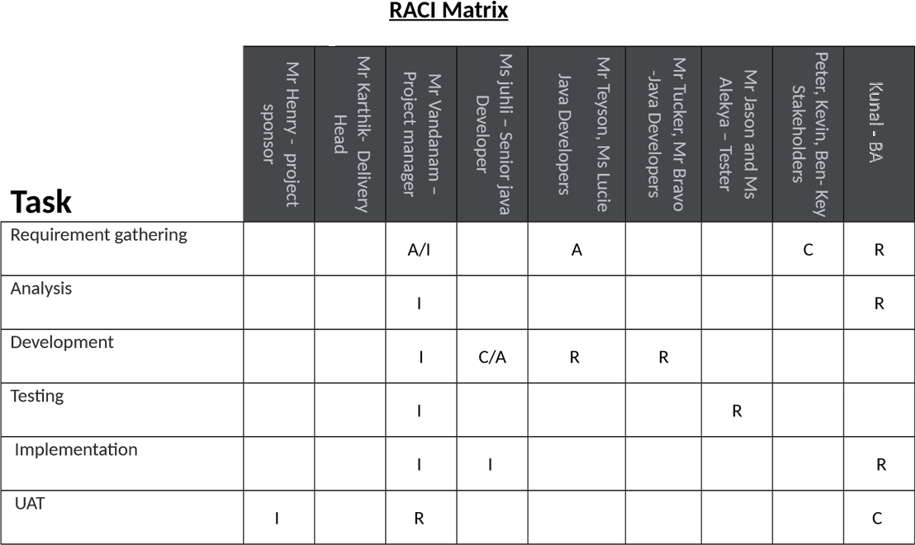

**Question 7- Business Case Document**

Generally, business case Documents are prepared by Sr. BAs, Sr. Business Manager and Business Architects. Business case documents will be help to solve some following open-ended Questions.

**Why is this project Initiated?**

In case study Mr. Henry are Successful Businessman and one of the wealthiest Persons in the city and he wants to help others to fulfil their dreams. One day Mr. Henry Meet his childhood Friends Peter, Kevin and Ben (all are farmers). In this Meeting Peter, Kevin and Ben told to Mr. Henry About their Farmer’s Problems which solve by IT solutions. And the Mr. Henry Plan to develop online agriculture Store to solve Farmers Problem.

**What Are the current problem?**

1. farmers are used traditional technic go to physical agriculture shop and buy fertilizers, seeds and pesticides?
2. There is no closed link between manufactures and farmers?
3. There is not available home delivery facility.
4. Farmers should not able to choose agricultural product from large product segment.
5. Farmers has no platform to do Rating of agricultural Product manufacture company.

**With this project how many problems could be solved?**

With the Help of this Project we are able to solve following problem

1. farmers will be able to go online agriculture product store to buy fertilizers, seeds and pesticides.
2. This new application should be able to accept the product (fertilizers, seeds, pesticides) details from the manufacturers and should be able to display them to the Farmers.
3. There is available of home delivery facility.
4. Farmers should able to choose agricultural product from large product segment.
5. Farmers has no platform to do Rating of agricultural Product manufacture company.

**What are the Resources Required?**

1) Mobile application of online agriculture product store

2) Agricultural web store.

**Time frame to recover ROI?**

This project is initiate under CSR activity. Budget for this project are 2 Crores INR and 18 Months Duration.

**How much organizational change is Required to adopt this technology?**

the online agriculture product store is new to organization and agriculture industry. Then organization required to build total new team to handle all activity organization also unaware about this industry.

**How to identify stakeholders?**

According to me ‘‘a stakeholder is any person or group of persons or an organization that are directly and indirectly effected or impacted by this online agriculture store.’’

**Question 8 – Four SDLC Methodologies**

Following Points Mr. Karthik Explained to Mr. Henry about SDLC.

1) Planning

In the Planning phase they Discuss about what are the user Registration steps. Which type of login credential are Required and which Page Show After Logout. If log in, then which type of Dashboard landing page. Which options available for manufactures to sale the product how the manufacturer connects with farmer directly. What’s thing which show at farmer’s log in page are important. How many things farmer should do from this application? All above question solves at planning stage of SDLC.

• I need to understand assumptions and constrains along with business rule and goal • For the purpose of proper planning I need to understands the project from PM • Develop some strategic Plan for conducts stakeholder’s analysis. • Understood How to look like farmer’s application home page.

2) Requirement analysis

At this stage BA take meeting with all project stakeholder (external) Discuss on User registration, User Login, Logout, Dashboard and tickets. Also BA gathered Information of all planning phase question. At requirement analysis I used prototype technic to gather some extraordinary information and this all my analysis show to stakeholder and then apply as per the requirements.

* As BA I need to identify stakeholders and documents
* Draw UML Diagram for online agriculture product store
* Prepare functional requirements from business requirements
* As an BA need to prepared RTM from SRS from client. We know that SRS is the first legal binding doc between the business and the technical team

3) Design

Following points discuss in Design

Lay out-Responsive web design

Business Rule- clear session on log out

Color scheme- Blue/Grey

Programming language- java

* As an BA I need prepare test case of online agriculture product store from the use case diagram
* Always communicates with client on the design and solution documents.
* I design I will also initiate the preparation of end user manuals
* Updates RTM on time
* GUI designer will look into transient classes and designs all possible screens for the IT solution.

1. Implementation (Coding Phase)
   * I need to organizes JAD sessions online agriculture product store • I need to understand all queries of technical team during coding.
   * Update end user manuals
   * As a team we need to conduct regular status meeting with technical team and the client and tuning client for participation in UAT.
   * Update RTM
2. Testing
   * BA performs high level testing
   * Test data is requested by BA from client
   * Take signoff from client on client project
3. Deployment
   * Plans and organizes training sessions for end users.
   * Coordinates to complete and share end user manuals.

7) Maintenance

**Sequential Waterfall**

It is the most common and classic of life cycle models, also referred to as linear-sequential life cycle model. This model is very easy to understand and use. In this model each Phase must be completed in its entirety before the next phase can begin. In the sequential model we have chance to take review takes Place to determine if the project is on path and whether or not to continue or discard the project.

**18 months’ project**

**Duration in**

**Months**

**19-20**

**4-6 7-9 10-12 13-15 16-18**

**1-3**

**Sequential**

**Iterative**

**Evolutionary**

**II II II II II**

**Agile**

**I I I I I I I I I I I I I I I I I I I I I I I I**

IIIIIIIIIIIIIIIIIIII

LLL

LLL

LLL

LLL

LLL

LL

Stages of Waterfall Model

Resources

Artifacts

Requirements Gathering

BA- Mr Kunal

PM-Mr Vandanam

BRD

Requirements Analysis

BA- Mr Kunal

PM-Mr Vandanam

Tech Team- Sol Arch, NW Arch- Mr.

FS/FRS, SSD,SRS,RTM

Mike

DB Arch-John

Design

Tech Team – Sol Arch, NW Arch-

Mr.Mike,

DB Arch-John, GUI Designer

HDD/ADD

Solution Document

Development Coding

Programmers- Ms juhli

Developers- Mr Teyson, Ms Lucie, Mr

Tucker, Mr Bravo

LDD/CDD

Application

Testing

Testers- Mr Jason and Ms Alekya

Unit, component System, System Integration, UAT

PROCESS – Configuration management – PM- Mr Vandanam

Deployment & Implementation – Release Engineers

After Implementation, maintenance Stage Starts, and Support Team Will Take care.

**Iterative- RUP (Rational Unified Process)**

Following are the main building blocks, or content elements of Iterative (RUP) Roles(who)-

It is defining a set of related skills, competencies and responsibilities.

Project manager-

Project manager skills and Responsibilities

* Activity and resource planning. ...
* Organizing and motivating a project team. ...
* Controlling time management. ...
* Cost estimating and developing the budget. ...
* Ensuring customer satisfaction. ...
* Analyzing and managing project risk. ...
* Monitoring progress.

Business Analyst-

Business Analyst have analytical skills and Responsibilities are enhancing the quality of IT products and services, analyzing data to inform business decisions, and finding technological solutions to business needs.Tester-

Tester have some this software testing skills and Responsibilities

* Analyze Specifications. Before they begin performing any tests, Testers will need to review and analyze the specifications of their company's software. ...
* Develop Tests. ...
* Execute Tests. ...
* Document Bugs. ...
* Troubleshoot Issues. ...
* Re-Test Software

Java Developers-

Java Developers have some software development skills and responsibilities

**Designing, implementing and maintaining Java-based applications**. Contributing in all phases of the development lifecycle. Writing testable, scalable and efficient code. Test and debug new applications and updates.

Work Products (what)-

In this case we are developed online agriculture store. We used Iterative model for produced working through the process.

Tasks (How)-

It describes a unit of work assigned

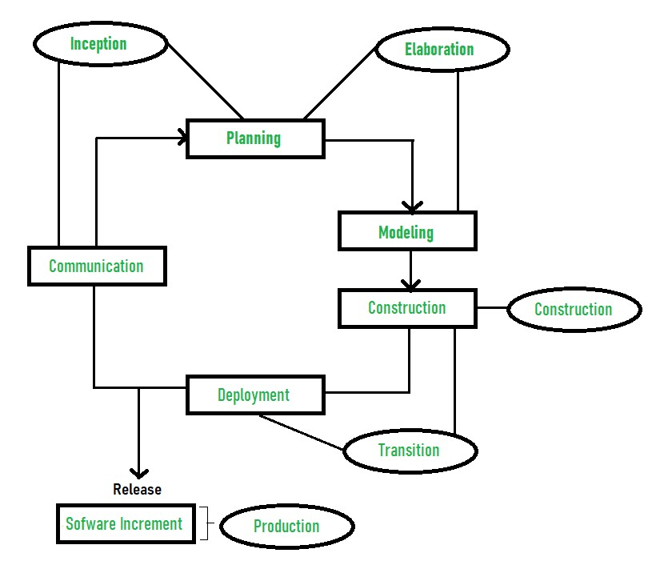

**Four Project Life Cycle Phases**

Inception-

* Communication and planning are the main ones.
* Identifies the scope of the project using a use-case model allowing managers to estimate costs and time required.
* The project plan, Project goal, risks, use-case model, and Project description, are made.

Elaboration-

* Planning and modelling are the main ones.
* A detailed evaluation and development plan is carried out and diminishes the risks.
* Executable architecture baseline.

Construction-

* The project is developed and completed.
* System or source code is created and then testing is done. • Coding takes place.

Transition-

* The final project is released to the public.
* Transit the project from development into production.
* Defects are removed from the project based on feedback from the public

**Evolutionary -Spiral**

Spiral model is combination of waterfall model iterative model. Each phase of spiral model begins with design goal and end with client reviewing. Software is developed in a series of incremental releases.

Following are the stages of spiral model for developing online agricultural product store.

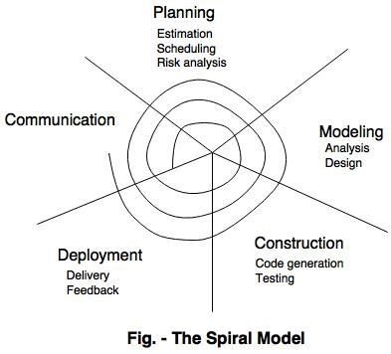

The spiral model has four phases-

* Planning

In Planning Phase Requirement gathering for online agricultural product store by business analyst.

* Risk analysis

In the risk analysis phase, a process is undertaken to identify risk and alternative solution to online agricultural product store. A prototype is produced at the end of the risk analysis phase.

* Engineering

Actually online agricultural product store software is produced in the engineering phase, and this phase end with testing phase.

* Evaluation

This phase allows to customers (farmers) to evaluate the online agricultural product store application (web) is the output of the project to date before the project continues to the next spiral.

**Agile-**

Agile Methodologies can be implemented where faster delivery is required, in this method no documentation is required coding is itself forms as documentation, Agile is the faster method to achieve the goal. It is satisfying the customer through early and continues delivery of the valuable software, Changes can easily have accepted and implemented in any phase of SDLC,

In this phase software is continuously deliver to customer from the couple of week to month, working software is the primary measure of the life cycle, to build the product with motivated individual using face to face conversation it promotes sustainable development, the best architecture requirement and Design emerge from self-organizing team.**Question 9 – Waterfall RUP Spiral and Scrum Models**

**Waterfall**: -A waterfall model is a traditional model in IT Company, the waterfall model is a classical model used in system development life cycle to create a system with linear and sequential approach. In this model software development done from one phase to another phase in download manner, output of one phase used as a input for next phase, every phase has to completed before next phase starts and here is no overlapping of the phases. it is a progressive implementation of the project which is divided into different phases of SDLC. As waterfall models have few limitations, still it was used earlier on a wide range

**RUP Model**: -Stands for Rational Unified Model This is a software development process from rational, a division of IBM, it divides the development process into four distinct phases that each involve business modelling, Analysis and design, Implementation, testing and deployment, In RUP there are four project life cycles

1. Inception
2. Elaboration
3. Construction
4. Transaction

**Spiral**: - This phase starts with gathering of business requirements in the subsequent spirals as the product matures identification of system requirement are done in this phase. This also includes understanding of system requirement by continual communication between customer and the analyst at the end of the spiral the product is deployed

**Design**: Design phase starts with the design in the baseline spiral and involves architectural, logical design of modules, physical product design and final design in the successive spirals.

**Construct**: Construct phase refers to development of the final software product at every spiral. In the spiral when the product is just thought and the design is being developed, a Proof of Concept (POC) is developed in this phase to get the users’ feedback. Then in the successive spirals with higher clarity on requirements and design a working model of the software called build is developed with a version number. These versions are sent to the users for feedback.

**Evaluation and Risk Analysis**: Risk analysis includes identifying, estimating, and observing technical feasibility such as schedule slippage and cost overrun. After testing the build, at the end of first iteration, user evaluates the software and provides the feedback. Based on the customer assessment, development process enters into the next iteration and afterwards follows the linear approach to implement the feedback provided by the user. The process of iterations along the spiral carries on with throughout the life of the software

**SCRUM**: -

Scrum is not a process technique or definitive method, rather it is a framework within which you can employ various processes and technique. It has three roles and every role has clear accountability. The product owner is responsible for maximizing the products value resulting from the development team work

The Scrum model suggests that projects progress via a series of sprints. In keeping with an agile methodology, sprints are time boxed to no more than a month long, most commonly two weeks Scrum is a lightweight agile process framework used primarily for managing software development. Scrum is often contrasted with the so-called “Waterfall” approach, which emphasizes up-front planning and scheduling of activities, followed by execution The scrum models have 5 steps also called phases in scrum.

Step 1: Product Backlog Creation.

Step 2: Sprint planning and creating backlog Step 3: Working on sprint.

Step 5: Retrospective and the next sprint planning

Since I am BA and in this project I supposed to use a V Model methodology is to be better for this project. As V-model is the most important model that is used in the process of software testing. It is also known as Verification and Validation Model. It is Introduced by the late Paul Rook in 1980s. Vmodel is a sequential process in which the next phase begins only after the completion of the present phase. In this model, steps don’t move in a linear way while the steps are bent upwards. It is similar to Waterfall model because we follow V-model from left to right as well as follow a sequential path of execution of processes like as in waterfall model. in waterfall model steps are followed as requirements, design, implementation, verification and finally maintenance. In the same way, the same steps are followed in V-model. So we can say that V-model is the alternate of the waterfall model.

**Question 10- Waterfall Vs V- Model**

The main difference between waterfall model and V model is that in waterfall model, the testing activities are carried out after the development activities are over. On the other hand, in V model, testing activities start with the first stage itself. In other words, waterfall model is a continuous process, while the V model is a simultaneous process. As compared to a software made using waterfall model, the number of defects in the software made using V model are less. This is due to the fact, that there are testing activities, which are carried out simultaneously in V model. Therefore, waterfall model is used, when the requirements of the user are fixed. If the requirements of the user are uncertain and keep changing, then V model is the better alternative. Also making changes in the software in waterfall model is a difficult task, and also proves to be a costly affair. The vice versa is true of the V model. At this stage, I would like to bring it to your notice, that any defects in the software cannot be determined, till the software reaches the testing phase. However, defects are noticed in the initial phases, due to which they can be corrected easily.

**Waterfall Model**

**V Model**

It is continuous process

It is simultaneous process

Testing activities are accomplished after the

developments activities are over

Testing activities starts with the first stage itself

Software made in waterfall model has most

defects compared to one made V fall model

Software made in V model has comparatively lesser

defects than the one made in waterfall method

Water fall model is used when the requirements of

the user are fixed

If the requirements of the user are uncertain and keep

changing, then V model is better alternate model

Making changes in the software in the water fall

mode is a costly affair

Making changes in the software in V model is

comparatively cheaper

**Question 11- Justify your choice**

As a BA I choose V model for this Projects and following are the Reason Which Influence me to choose V model instance of choosing waterfall model and other models.

* V- model is based on verification and validation of each phase of developing online agricultural product store.
* The model allows me to completed each phase must before go to next phase. Testing of developing online agricultural product store is planned in parallel with a corresponding phase of development in V-model.
* This V model properly work with small projects like developing online agricultural product store where requirements are easily understood.
* This V model also help me in the project when in case if any changes happen in midway, then the test documents along with requirements documents has to be updated.
* In V model, Testing activities like planning, [**test designing**](http://tryqa.com/what-is-test-design-or-how-to-specify-test-cases/) happens well before coding. This saves a lot of time. Hence higher chance to get success model.**Question**

**Question 12- Gantt Chart**

**Ans-**

|  |  |  |  |  |
| --- | --- | --- | --- | --- |
| **TASK** | **START DATE** | **END DATE** | **DURATION** |  |
| Requirements Gathering | 1/01/2025 | 25/02/2025 | 55 |  |
| Requirements Analysis | 16/02/2025 | 23/03/2025 | 35 |  |
| Design | 10/03/2025 | 5/05/2025 | 56 |  |
| Development 1 | 20/06/2025 | 1/09/2025 | 73 |  |
| Testing 1 | 1/08/2025 | 16/10/2025 | 76 |  |
| Development 2 | 25/09/2025 | 9/12/2025 | 75 |  |
| Testing 2 | 1/11/2025 | 15/01/2026 | 75 |  |
| Development 3 | 1/01/2026 | 17/03/2026 | 75 |  |
| Testing 3 | 1/03/2026 | 21/05/2026 | 81 |  |
| Development 4 | 1/05/2026 | 1/07/2026 | 61 |  |
| Testing 4 | 15/06/2026 | 15/08/2026 | 61 |  |
| UAT | 1/08/2026 | 1/09/2026 | 31 |  |
|  |  |  |  |  |
|  |  |  |  |  |
|  |  |  |  |  |
|  |  |  |  |  |
|  |  |  |  |  |
|  |  |  |  |  |
|  |  |  |  |  |
|  |  |  |  |  |
|  |  |  |  |  |
|  |  |  |  |  |
|  |  |  |  |  |
|  |  |  |  |  |
|  |  |  |  |  |
|  |  |  |  |  |
|  |  |  |  |  |
|  |  |  |  |  |
|  |  |  |  |  |
|  |  |  |  |  |
|  |  |  |  |  |
|  |  |  |  |  |
|  |  |  |  |  |
|  |  |  |  |  |
|  |  |  |  |  |
|  |  |  |  |  |
|  |  |  |  |  |
|  |  |  |  |  |
|  |  |  |  |  |
|  |  |  |  |  |
|  |  |  |  |  |
|  |  |  |  |  |
|  |  |  |  |  |
|  |  |  |  |  |
|  |  |  |  |  |
|  |  |  |  |  |
|  |  |  |  |  |
|  |  |  |  |  |
|  |  |  |  |  |
|  |  |  |  |  |
|  |  |  |  |  |
|  |  |  |  |  |

**Question 13 – Fixed Bid Vs Billing**

**Fixed Bid Model :-**

A Fixed Bid project is **billed using a flat amount, regardless of the number of hours worked**. This flat amount can be applied to the project as a whole, or to each week or month of the project. Since Fixed Bid projects are duration-based, they require a start and end date.

**Billing Model:-**

In this model resources working in the project will be billed to the client on hourly basis.3 Lest consider examples

* PM -$130/Hr,
* Sol Architect – $55/Hr,
* Programmers – $50/Hr
* Sr. Programmers – $80/Hr
* Network Engineer – $80/Hr
* DBA - $80/Hr
* BA- $60/Hr

**Timesheet Billing :-**

Timesheet billing is used by individuals, organizations and professionals that render services to clients that include the billable hour.

**Question 14,15,16,17,18,19,20 – Timesheets**

**RG Timesheet Of a BA**

Hourly Rate in

$

60

Gross Pay in $

3690

Date worked

In

Time

Out

Time

Total Hours

Worked

Gross pay in

$

Additional Information

Friday, 1 July, 2022

06:00

17:00

11

660

Identify the relevant stakeholders

Sunday, 3 July, 2022

07:00

18:00

11

660

Establish project goals and objectives

Monday, 4 July, 2022

08:00

17:00

9

540

Elicit requirements from stakeholders

Tuesday, 5 July, 2022

06:00

18:00

12

720

Document the requirements

Wednesday, 6 July, 2022

07:30

17:00

10

570

Confirm the requirements

Thursday, 7 July, 2022

07:00

16:00

9

540

Prioritize the requirements

**RA Timesheet of a BA**

Hourly Rate in

$

60

Gross Pay in $

3570

Saturday, 6 August, 2022

Tuesday

Wednesday, 3 August, 2022

Tuesday

Friday, 5 August, 2022

Tuesday

Thursday, 4 August, 2022

Tuesday

Tuesday, 2 August, 2022

Tuesday

Date worked

In

Time

Out

Time

Total Hours

Worked

Gross pay in

$

Additional Information

Monday, 1 August, 2022

Tuesday

06:00

16:00

10

600

User testing

07:00

17:00

10

600

Technical Elaboration & Validation

08:00

18:00

10

600

Data Analysis

06:00

18:00

12

720

Demonstrations / Showcases

07:30

17:00

10

570

Business sign-off of designs

07:00

15:00

8

480

Solution Architecture

**Design timesheet of a BA**

Hourly Rate in

$

60

Gross Pay in $

690

Date worked

In

Time

Out

Time

Total Hours

Worked

Gross pay in

$

Additional Information

Monday, 15 August, 2022

06:00

07:00

1

60

User testing

07:00

08:00

1

60

Technical Elaboration & Validation

08:00

09:00

1

60

Data Analysis

10:00

13:00

3

180

Demonstrations / Showcases

13:30

17:00

4

210

Business sign-off of designs

17:00

19:00

2

120

Solution Architecture

**Development Timesheet of a BA**

Hourly Rate in

$

60

Gross Pay in $

690

Date worked

In

Time

Out

Time

Total Hours

Worked

Gross pay in

$

Additional Information

Tuesday, 16 August, 2022

06:00

07:00

1

60

analyses the business domain

07:00

09:00

2

120

documents its processes and systems

09:00

10:00

1

60

outlines business requirements

10:00

13:00

3

180

outlines business requirements

13:30

16:00

3

150

Analysis software being

built

**Testing Timesheet of a BA**

Hourly Rate in

$

60

Gross Pay in $

630

|  |  |  |  |  |  |  |
| --- | --- | --- | --- | --- | --- | --- |
| Date worked |  | In  Time | Out Time | Total Hours Worked | Gross pay in $ | Additional Information |

Wednesday, 17 August, 2022

06:00

09:00

3

180

Work with Testing team to create system

test plans

09:00

12:00

3

180

Create and execute the system test cases

13:30

16:00

3

150

Review system cases prepared by Testing

team

16:30

18:30

2

120

Provide requirements clarifications when

required by Testing Team.

**UAT Timesheet of a BA**

Hourly Rate in

$

60

Gross Pay in $

600

Date worked

In

Time

Out

Time

Total Hours

Worked

Gross pay in

$

Additional Information

Thursday, 18 August, 2022

06:00

08:00

2

120

Develop the detailed UAT test Plan

08:00

11:00

3

180

develop the test case scenario

13:00

16:00

3

180

create UAT test cases

17:30

18:30

1

60

test case data preparation

18:30

19:30

1

60

run the test cases

**Deployment n Implementation Timesheet of a BA**

Hourly Rate in

$

60

Gross Pay in $

600

Date worked

In

Time

Out

Time

Total Hours

Worked

Gross pay in

$

Additional Information

Thursday, 18 August, 2022

06:00

08:00

2

120

design RTM and forward to client

08:00

12:00

4

240

coordinate to complete manual

13:00

16:00

3

180

training sessions for end user

17:30

18:30

1

60

prepare a lessons learning from

project

**Question 21 – Audits**

what is audit?

Audit is the examination or inspection of various books of projects by an auditor followed by physical checking of inventory to make sure that all departments are following documented system of recording transactions. It is done to ascertain the accuracy of project statements provided by the organization.

Inspection of work for Quality and for progress

As a BA we are responsible to update the progress of the project to the responsible stakeholders and concerning documents. **What is a business audit?**

A business audit is a documented evaluation of whether or not a company’s financial statements are materially correct along with the standards, evidence, and assumptions used to conduct the audit.

what is internal audit?

An internal audit may be used to assess an organization’s performance or the execution of a process against a number of standards, policies, metrics, or regulations. These audits may include examining a business’s internal controls around corporate governance, accounting, financial reporting, and IT general controls.

Following why audit will happen for BA in Quarter first Q1

In the first following this auditor will check

1. How the Enterprise Analysis did?
2. Is understand Assumptions and Constraints along with Business Rules and Goals
3. How BA conducts stakeholder’s analysis
4. What is plan of BA for approach strategy
5. Check stakeholders identify and document
6. Can BA prepare BRD by interacting with client
7. Is properly done prioritize Requirements

Following why audit will happen for BA in Q2

the following this auditor will check

1. To track records of use case and activity diagrams.
2. How to prepares functional Requirements from business Requirements
3. Is BA preparing RTM from SRS before Design Phase starts.
4. How many test cases prepared by BA?
5. What are the documents BA prepared?
6. To check BA mails formats with Client Following why audit will happen for BA in Q3

the following this auditor will check

1. Is BA will initiate the preparation of end user manuals
2. To track status of updates RTM
3. To check BA organizes JAS sessions
4. Is BA properly Clarifying queries of technical team during coding
5. Is BA forward timesheet Properly to reporting manager?
6. Can developers refer diagrams and transient of BA and code their unit

Following why audit will happen for BA in Q4

the following this auditor will check

1. BA prepares test cases from use cases or assists test manager to do so
2. To track BA performs high level testing
3. How to BA prepares client for UAT
4. Is test data BA properly send to client
5. Updates end user manuals Following why audit will happen for BA in Q5

the following this auditor will check

1. BA take signoff from client on client project acceptance form
2. Is BA forwards RTM to client or the PM which should be attached to the project closure documents
3. How BA plans and Organizes training sessions for end users
4. Is BA forward timesheet Properly to reporting manager?
5. To check BA mails formats with Client

**Question 22 BA Approach Strategy**

Write BA Approach strategy (As a business analyst, what are the steps that would be follow by to complete a project –

**Following are Elicitation Techniques**

Form above techniques as an BA I should Use following technics

1. Interviews
2. Requirement workshops
3. Surveys/Questionnaire

**Stakeholder Analysis RACI Matrix**

For the Stakeholder Analysis I need to following three steps Step 1: Identify your stakeholders

In step I need to I identify all internal as well as external stakeholders of this project such as

Following are internal stakeholders

Project Manager - Mr Vandanam

Senior Java Developer - Ms. Juhi

Java Developers - Mr Teyson, Ms Lucie, Mr Tucker, Mr Bravo Network Admin - Mr Mike DB Admin - Mr John.

Testers - Mr Jason and Ms Alekya

BA -Mr Kunal

Following are internal stakeholders

Project sponsor - Mr. Henry

Financial Head - Mr Pandu

Project Coordinator - Mr Dooku

Key stakeholders - Peter, Kevin and Ben

Step 2: Prioritize your stakeholders

**Prioritise according to the quadrant into which stakeholders fall**. If the stakeholder has low impact and low influence, they will naturally be a lower priority in engagement. The opposite is true for those who have a high impact and high influence.

Step 3: Understand your key stakeholders.

all external are key stakeholder

Project sponsor - Mr. Henry

Financial Head - Mr Pandu

Project Coordinator - Mr Dooku

Key stakeholders - Peter, Kevin and Ben

**What Document to Write**

Following documents to write

* Project vision Document.
* Business Analysis Plan.
* Business Requirements Document.
* Functional requirement specification (FRS)/ Functional Specification

Document (FSD)

* System requirement specification (SRS)/ System Requirement

Document (SRD)

**What proper follow to Sign off on the Documents**

As BA I will prefer to mode of sign off on Email and Physically sign of documents. Once the Project vision

Document are prepared email It Project sponsor - Mr. Henry and CC to Financial Head – Mr Pandu,

Project Coordinator - Mr Dooku, Key stakeholders - Peter, Kevin and Ben and Project Manager - Mr Vandanam. Once a Business Requirements Document take Physically sign of Project sponsor - Mr. Henry and take help from Peter, Kevin and Ben. Functional requirement specification (FRS)/ Functional Specification Document (FSD) and System requirement specification (SRS)/ System Requirement

Document (SRD) Document are prepared email It Project sponsor - Mr. Henry and CC to Financial Head – Mr Pandu, Project Coordinator - Mr Dooku, Key stakeholders - Peter, Kevin and Ben and Project Manager - Mr Vandanam.

**How to take Approvals from the Client?**

As BA for all business documents I would like to take approval from Project sponsor - Mr. Henry and Financial Head – Mr Pandu, Project Coordinator - Mr Dooku, Key stakeholders - Peter, Kevin and Ben on email. For Approvals I remainder them by call or top-up on this mail. Once get approval from Project sponsor - Mr. Henry and Financial Head – Mr Pandu, Project Coordinator - Mr Dooku, Key stakeholders Peter, Kevin and Ben.

**What Communication Channel to establish and implement**

Following communication channels I prefer toestablish and implement

* Face-to-face communication.

The Face-to-face communication channel I will used at requirement gathering time because I have Interview with stakeholders. This mode of communication will help me at that time.

* Video conferencing.

We all know online agricultural product store project are developed by 11 team member and they have discussion with project as team also meeting with every day morning will happen by video conferencing.

* Phone calls.

We all used phone call for one to one communication If client want to inform me something regards to project he/she will use phone calls.

* Emails.

According to me email is good why of communication because we have written records what we text with each other and it is suitable option for today world to take approvals. As BA I used Emails mostly when I want to take approvals from stakeholders.

**How to Handle Change Requests?**

By used following why I will handle change request

1. Determine the Scope of the Change
2. Determine the Scope of Incorporating the Change
3. Gain Approval or Rejection of the Change
4. Communicate and Implement an Approved Change Request

**How to update the progress of the project to the Stakeholders?**

1. Understand stakeholder needs.
2. Proactively listen to your stakeholders' concerns.
3. Develop and execute a communication plan.
4. Utilize online collaboration tools to share regular progress.
5. Send out weekly or bi-weekly status reports.

**How to take signoff on the UAT- Client Project Acceptance form**

To finish up the project sign off process, write a small report to other stakeholders or executives. Briefly describe how closely the project adhered to the initial project plan, what risks or issues occurred and whether the project was a success in general.

**Project Sign-off Sheet**

Version

Date:

**\*\*/**/\*\*\*\***

**Project**

**Name:**

online agriculture product store

**Project**

**Goals:**

1)

to provide online agriculture facility to farmers, to help farmer with online product store.

2)

new application should be able to accept the product (fertilizers, seeds, pesticides) details from the

manufacturers and should be able to display them to the Farmers.

3)

to build this online store is to facilitate farmers to buy seeds, pesticides, and fertilizers from anywhere through

internet connectivity.

**Project**

**Manager:**

-

Mr. Vandanam

**Sponsor:-**

Mr. Henry

**Start**

**Date:01/01/2025**

**Planned Completion Date:**

**31/07/2026**

**Actual Completion Date: 31/07/2026**

**31/07/2026**

**31/07/2026**

**Variance:**

Total

Project

Duration: 18 months

Days

Past the

Planned

Completion

Date:

**31/07/2026**

**Planned Budget:2 Cr**

**Actual Budget:**

**Variance:**

**Project**

**Deliverables:**

1.

By

signing

this

document,

I

acknowledge

that

I

have

delivered all the stated deliverables at the agreed to

quality

levels.

**Project**

**Manager**

**Signature:**

By

signing

this

document,

I

acknowledge

that

I

have

received all the stated deliverables at the agreed to

quality

levels.

**Sponsor**

**Signature:**

**Date:**/**/\*\*\*\***

**Date:**/**/\*\*\*\***

**Remarks:**

**Question 23 – 3-Tier Architecture**

**Ans-**

Three-tier architecture is a well-established software application architecture that organizes applications into three logical and physical computing tiers: the Business logic layer; the application tier, where data is processed and the data tier, where the data associated with the application is stored and managed.

* **Presentation layer** − This layer is also called the client layer. The front-end layer consists of a user interface. The main purpose is to communicate with the application layer.
* **Application layer** − This layer is also called the business logic layer. It acts as a middle layer between the client and the database server which are used to exchange partially processed data.
* **Data layer** − In this layer the data or information is stored. This layer performs operations like insert, update and delete to connect with the database.

Screens, Pages, Validation, on pages, Company Specific Logic, Functionality

**---------------------------------------------------------Application Layer------------------------------------------------**

All Re-usable components, Frequently changing components, Governing Body Rules & Regulations, Compliances. E.g.: Printer, Payment gateways, Mail Servers, RBI Rules for Bank, IRDA rules for insurance

**------------------------------------------------------Business Logic Layer-----------------------------------------------**

Database Components connecting to Databases

**--------------------------------------------------------------Data Layer----------------------------------------------------**

**Question 24- BA Approach Strategy for Framing Questions-**

As a business analyst I should think to I have develop the online agricultural product store which connect former and manufacture with it solutions. that’s why I need to frame the questions which clearly understood farmer problem and need.

Following questions are framing by me with keeping in mind all prospective of (Where, What, Who, When, How and other)

What is the current process farmers are adopting for purchase of fertilizers, Seeds, Pesticides?

After open URL what’s things are shown in first page

How manufacture can able to upload the new products in to application

What’s things we should in filter we farmer search product such as price, brand, delivery time and category etc.

What are the primarily requirement for user to use the application.

What should be the timeline to complete the project

What payment options should be available

Why there is need for online application store

Who: -Should be able to use the application who should get benefited due to application

When the application can be used

Where Application should be available for use Android mob a computer How the application will help to farmers and manufacturers?

How much is the budget?

How many users can have used the application at a time

What things are most suitable for user to log in the application by email or mobile number Can we also allow guest user to used application?

**Question 25 – Elicitation Techniques**

**Ans-**

Followings are Elicitation Techniques which I can aware of?

* Brain Storming

Brainstorming is a way to generate ideas within a group setting. It is usually used in the beginning stages of a project, where the possibilities for the project are not clearly understood or defined. It provides a quick means for tapping the creativity of a limited number of people for a large number of ideas. The brainstorming environment fosters an uninhibited, non-judgmental explosion of ideas, concepts, policies, decisions, and strategies. In brainstorming, all contributions are valid, and the key to a successful session is to share as many ideas as possible without evaluating them. • Document analysis

Document Analysis is a technique used to gather requirements during the requirements elicitation phase of a project. It describes the act of reviewing the existing documentation of comparable business processes or systems in order to extract pieces of information that are relevant to the current project, and therefore should be consider projects requirements. • Reverse engineering.

According to Nasheri, 2005 “Reverse engineering is a method of industrial engineering in which one begins with a known finished product and works backward to reveal the processes and specifications involved in the product's development and manufacture.” • Focus Groups

A focus group is a way of gathering ideas and opinions about a particular product or service in a collective group environment. The participants, led by a facilitator, would express their opinions, inclination, and needs.

* Observation

Business analysts use observation techniques to gather information by watching and understanding workplace activities. It is used to identify needs and opportunities, understand business processes, create performance standards, assess solution performance, and facilitate training and development.

* Workshop.

A workshop is an event attended by key stakeholders for a particular period of time. They are used by business analysts to bring stakeholders together and work together to achieve a present goal. • JAD (Joint Application Development)

Joint Application Development (JAD) is a process that accelerates the design of information technology solutions. JAD uses customer involvement and group dynamics to accurately depict the user's view of the business need and to jointly develop a solution. Before the advent of JAD, requirements were identified by interviewing stakeholders individually. The ineffectiveness of this interviewing technique, which focused on individual input rather than group consensus, led to the development of the JAD approach. • Interview

The interview is one of the main elicitation techniques used by business analysts. Sometimes, the business analyst may use the elicitation technique interview to elicit information from a person (or a group of people) in an informal or formal setting by asking questions and documenting the responses.

* Prototyping

In business analysis, a prototype, or mockup, generally means a representation of a computer screen and examples of how the user will interact with the application to accomplish a task to solve the business problem. Prototyping is an agile software development methodology. It has also been proposed as a technique to obtain the software requirements from the stakeholders. However, there are few publications proposing a prescriptive guide and show its use in practice. • questionnaire (survey)

A questionnaire is the term used to describe the set of questions you're asking an individual. A survey is the process of collecting, analyzing and interpreting data from many individuals. It aims to determine insights about a group of people. • Use case specs

A Use Case Specification is a textual description of the functionality provided by the system. It captures actor-system interaction. That is, it specifies how a user interacts with a system and how the system responds to the user actions. It is often phrased in the form of a dialog between the actor and the system.

**Question 26- This project Elicitation Techniques**

**Ans-**

Following Elicitation Techniques should I prefer as a business analyst in this Project and also clarify why select this Elicitation Techniques.

Prototyping

According to my knowledge prototyping in visual representation of your ideas allows us to test our ideas directly with users before developing into a fully-fledged product is called as prototyping.

Prototype is a scaled down version of a product.

For this online agriculture product store as a Business analyst before product launch I need to represent ideas on a paper and check with these ideas external stakeholder and internal stakeholders. It is new project to market as BA there is no project like this running in the market to check feasibility of project I need to used prototyping technical. before pending money into market solve this three questions.

* Does the product solve the user problem?
* Does it score high our user desirability?
* Is it user-friendly?

If visual representation of my Ideas solve above questions, then I go for design phase of project development.

Brainstorming

Brainstorming can have done individual or group, in this technique we collect the user ideas and those ideas reviewed and analyse and checked whether given ideas are relevant to include within the system requirement, user or stakeholder come with innovative ideas to define their requirement. Brainstorming is effective with group of 8 to 12 people it helps to get the good number of idea from user and stakeholders also it uses to find the all possible solution of the problem and understand the new opportunities

**Question 27- 10 Business Requirements**

**Ans-**

BR001 – Farmers should be able to search for available products in fertilizers, seeds, pesticides BR002 – Manufacturers should be able to upload and display their products in the application BR003 – All users (fertilizers, seeds, pesticides manufacturers and Farmers) should be able to log in. BR004 – Online Web / mobile Application should display product catalogue of fertilizers, seeds, pesticides, a search option to search for products.

BR005 – Farmer should be able to browse through the products catalogue once they visit the website.

BR006 – have a search option so that Farmer can search for any product they need BR007 – Farmer should able to buy product or add them to buy-later list.

BR008 – A fresh user should able to create a new account by submitting their email ID and creating a secure password.

BR009 – Farmers needs to have an easy-to-use payment gateway which should include cash-on delivery (COD), Credit/Debit card and UPI options so that the user’s experience should be better BR010 – User should get an email confirmation regarding their order status BR011 – farmer should able to track delivery from delivery tracker.

BR012 – Online Web / mobile Application should have feedback option for All users (fertilizers, seeds, pesticides manufacturers and Farmers)

BR013 – Farmers should have platform to do Rating of agricultural Product manufacture company BR014 – All users (fertilizers, seeds, pesticides manufacturers and Farmers) should be able to log in by submitting their email ID and password.

**Question 28- Assumptions-**

**Ans-**

* Is farmers should have at least android mobile or laptop or computer.
* Users should have valid email ID
* Is mobile application or web should be able to display stock of agricultural product to farmers.
* Can mobile application or web has offer guest facility to some farmers.
* Can application show agricultural product on top of mobile application or web home page which farmers search recently.
* New account also creates by using mobile number and password.
* Can application have alert facility to get SMS to farmer for track delivery of agricultural products.
* Farmers also have an easy-to-use payment gateway which should include mobile banking or offline payment options so that the user’s experience should be better.
* Is farmer should able to cancel the order.
* Can have chat section in application between manufactures to farmers regarding to farmer query.
* Can application have monsoon update facility.
* Can application also for government facilities regarding the farmers

**Question 29- This Project Requirements Priority**

**Ans-**

|  |  |  |  |
| --- | --- | --- | --- |
| REQ ID | REQ NAME | REQ DESCRIPTION | PRIORITY |
| BRO01 | Farmer Search for Product | Farmers should be able to search for available product in fertilizers, seeds, pesticides. | 8 |
| BRO02 | Manufacturers upload their Products | Manufacturers should be able to upload and display their products in the application | 6 |
| BR003 | Farmers browse through the products. | A Farmer should be able to browse through the products catalog once they visit the  website | 7 |
| BRO04 | Website search option | The website should have a search option so that they can search for any product they need. | 4 |
| BROO5 | Everyone can do the Everyone should be logins on website | Everyone should be able to log in to the website as the users. | 1 |
| BRO06 | Product catalog and search option in website | A product catalog of fertilizers, seeds, pesticides, and a search option to search for products, payment process, and delivery tracking should be there. | 3 |
| BR007 | Farmers need to login to order | Any farmer wants to buy any product or add them to buy-later list. they need to do the login first using their email id and password. | 5 |
| BR008 | For New user create accounts | The new user should be able to create a new account by submitting their email ID and creating a secure password. | 9 |
| BR009 | For purchasing items payment gateway | If a Farmers wants to  purchase, they should have an easy-to-use payment gateway which should include cash-on-delivery (COD), Credit/Debit card and UPI options. | 10 |
| BR010 | E-mail confirmation regarding order status | The user should get an email confirmation regarding their order status. A delivery tracker to track the whereabouts of their order. | 2 |

**Que.30- Use Case Diagram**

**Ans-**

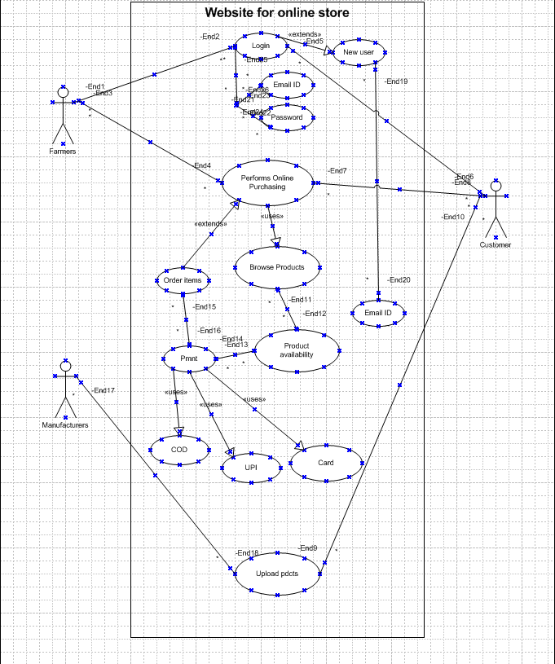

**Question 31- (minimum 5) Use Case Specs**

1st

USE- CASE SPECIFICATION FOR: <ONLINE AGRICULTURAL PROCUCT STORE FOR BUY FERTILIZER>

**Brief Description This use case describes how the customer (farmers) uses the online agricultural product store to buy fertilizer’s**

**Actors Customers (Farmer)**

**Admin**

**Pre-Conditions There is an active network connection between both mobile application and online application store connection.**

**Basic Flow 1. The use case begins when customer (farmer) search agricultural product.**

1. **Use case: validate user is performed (Customer search fertilizers)**
2. **Application displays the different alternatives that are available on this unit. In this case the customer always selects fertilizers.**
3. **The application prompts for an account. See supporting requirement SR-yyy for account type that shall be supported.**
4. **The customer selects one fertilizer product.**
5. **Account and product details is sent to admin as transaction. The admin consortium replies with a go/no go reply telling if the all things are ok.**
6. **The customer selects the product delivery location.**
7. **Then application display payment mode.**
8. **As per payment mode receipt is send to customer by SMS.**
9. **The used case end successfully.**

Alternative Flows **o Invalid user**

If in step 2 of basic flow customer the use case: validate user does not complete successfully, then

* + the used case ends with a failure condition **o Unavailable product**

if in step 5 in the basic flow the customer select product that can’t be available

* + the application shall display the message indicating that the product out of stock. Please try after 2 to 3 days.
  + The use case resume at step 5 **o Product unavailable for particular location**

if in step 7 in the basic flow the customer select location at which product that can’t be available

* + the application shall display the message indicating that the product unavailable for this location. Please try after 2 to 3 days.
  + The use case resume at step 7 **o No Response from admin**

If in step 8 of basic there is no response from the admin within 15 seconds, then

* + The application will re-try
  + If there is still no response from admin the application shall display the message ‘network unavailable- try again later’
  + Application go to home page

Key scenarios No Response from admin

Post-condition • Successful completion

The user has buy fertilizer and the internal logs have been updated • Failure condition

The logs have been updated accordingly.

Special [SpReq : WC-1] agricultural product shall dispense has per government policy

Requirement [SpReq : WC-2] The application shall keep a log, Including date and time, of all complete and incomplete

2

USE- CASE SPECIFICATION FOR: <ONLINE PAYMENT by internet banking>

Brief Description This use case describes how the customer (farmers) make online payment to agricultural product store

Actors Customers (Farmer)

Admin

Bank

Pre-Conditions There is an active network connection between mobile application, bank and payment gateway connection.

Basic Flow 11. The use case begins when customer (farmer) wants to make a payment.

1. Use case: validate user is performed
2. Application displays the different alternatives that are available on this unit. In this case the customer always selects mode of payment internet banking.
3. The application prompts for select bank. See supporting requirement SR-yyy for bank that shall be supported.
4. The customer selects one particular bank and inter log in credential.
5. Account and product details is sent to bank as transaction. The admin consortium replies with a go/no go reply telling if the all things are ok.
6. The customer selects the pay now option and make payment.
7. Then application display successful payment.
8. As a payment done receipt is send to customer by SMS or email.
9. The used case end successfully.

Alternative Flows **o Invalid user**

If in step O of basic flow customer, the use case: validate user does not complete successfully, then

transactions with the admin.

* + the used case ends with a failure condition **o Unavailable funds in account**

if in step Q in the basic flow the customer select amount that can’t be available in bank account

* + the application shall display the message indicating that insufficient balance. Please try with another account.
  + The use case resume at step N **o Amount exceeds transfer limit**

if in step Q in the basic flow the customer selects amount exceeds withdrawal limit bank account • The internet banking shall display a warning SMS and ask the customer to reenter the amount.

* + The use case resume at step Q.

**o No Response from admin**

If in step Q of basic there is no response from the admin within 15 seconds, then

* + The application will re-try
  + If there is still no response from admin the application shall display the message ‘network unavailable- try again later’
  + Application go to home page

Key scenarios No Response from admin and bank

Post-condition • Successful completion

The user has susses fully make a payment and the internal logs have been updated • Failure condition

The logs have been updated accordingly.

Special [SpReq : WC-1] the maximum transaction limit XYZ amount.

Requirement [SpReq : WC-2] The application shall keep a log, Including date and time, of all complete and incomplete transactions with the admin.

USE- CASE SPECIFICATION FOR: <USER ID and PASSWORD CREATE by mobile number>

Brief Description This use case describes how the customer (farmers) Create user id and password of online agricultural product store

Actors Customers (Farmer)

Admin

Pre-Conditions There is an active network connection between mobile application and online agricultural product store Basic Flow 21. The use case begins when customer (farmer) wants to Create user id and password.

1. Use case: validate user is performed
2. Application displays the different alternatives that are available on this unit. In this case the customer always selects mode Create user id and password by Mobile number.
3. The application prompts for admin. See supporting requirement SR-yyy for admin that shall be supported.
4. The customer inters user details (Name, Surname, Mobile number and email ID) and send OTP to mobile number by SMS.
5. Customer create New user ID
6. Customer inter valid OTP
7. Customer create password
8. Then application display successful create user ID and Password.
9. As a create user ID and Password receipt is send to customer by SMS or email.
10. The used case end successfully.

Alternative Flows **o Invalid OTP inter by customer**

If in step 27 of basic flow customer, the use case: validate user does not inter valid OTP, then • the application shall display the message indicating that invalid OTP. Please type valid OTP.

* + The use case resume at step 27 **o Available of user ID**

if in step 26 in the basic flow the customer creates user ID that available in system.

* + the application shall display the message indicating that already this user ID create. Please try with another on and show some options.
  + The use case resume at step 26 **o Already used mobile number**

if in step 25 in the basic flow the customer inters mobile number which already used to create account • The application shall display mobile number already used please try with another number.

* + The use case resume at step 25.

**o Already used email ID**

if in step 25 in the basic flow the customer inters email id which already used into another account • The application shall display email ID already used please try with another email id.

* + The use case resume at step 25.

Key scenarios No Response from admin

Post-condition • Successful completion

The user id has been susses fully completed and the internal logs have been updated • Failure condition

The logs have been updated accordingly.

Special [SpReq : WC-1] The application shall keep a log, Including date and time, of all complete and incomplete Requirement transactions with the admin.

USE- CASE SPECIFICATION FOR: <AGRICULTURE PRODUCT UPDATION PROCESS TO MANUFACTURE>

Brief Description This use case describes how the manufacture update the product at online agricultural product store

Actors Customers (manufacture)

Admin

Pre-Conditions There is an active network connection between mobile application and online agricultural product store Basic Flow 32. The use case begins when manufacture wants to update any new agriculture product at agricultural product store.

1. Use case: validate user is performed
2. Application displays the different alternatives that are available on this unit. In this case the manufacture always selects sale agricultural product option.
3. The application prompts for admin. See supporting requirement SR-yyy for admin that shall be supported.
4. Manufacture choose product categories.
5. The manufacture inters product details (Name, type of product, applicable of products, price and offers on product and delivery date).
6. Application displays the new product detail update successfully.
7. For the conformation manufacture also get receipt by SMS or email.
8. The used case end successfully.

Alternative Flows **o Region wise product price display to customer**

If in step 37 of basic flow manufacture, the use case: validate application does not display price of product region wise, then

* + the application shall display the product price region wise. Please type valid price.
  + The use case resume at step 37

**o Manufacture have option to choose product categories**

if in step 36 in the basic flow the manufacture has available options to choose product categories in system.

* + the application shall display the message indicating that choose product categories. Please try with another on and show some options.
  + The use case resume at step 26

Key scenarios No Response from admin

Post-condition • Successful completion

The product has been susses fully updated and the internal logs have been updated • Failure condition

The products have been updated accordingly.

Special [SpReq : WC-1] The application shall keep a log, Including date and time, of all complete and incomplete Requirement transactions with the admin.

USE- CASE SPECIFICATION FOR: < User should able to cancel the product> Brief Description This use case describes how user cancel the product at online agricultural product store

Actors Customers (manufacture)

farmer Admin

Pre-Conditions There is an active network connection between mobile application and online agricultural product store Basic Flow 41. The use case begins when user wants to cancel agriculture product at agricultural product store.

1. Use case: validate user is performed
2. Application displays the different alternatives that are available on this cart unit. In this case the manufacture always selects agricultural product those user wants to cancel.
3. The application prompts for admin. See supporting requirement SR-yyy for admin that shall be supported.
4. System pop up text box with headline please provide reason to cancel the product.
5. User should provide reason and press ok.
6. Application displays the agricultural product pick date, time and location.
7. Application displays the cancel request has update successfully.
8. For the conformation manufacture also get receipt by SMS or email.
9. The used case end successfully.

Alternative Flows **o Cancel period is over**

If in step 45 of basic flow manufacture, the use case: validate application does not display price of product region wise, then

* + the application shall display the you cannot return this product. Please type valid price.
  + The use case resume at step 43 **o Farmer are too available on that date**

if in step 47 in the basic flow the manufacture has available options to choose product categories in system.

* + the application shall display the message indicating that agricultural product pick date, time and location. But farmer not available on that day system should show option choose date, time and location.
  + The use case resume at step 45 Key scenarios No Response from admin

Post-condition • Successful update cancel request

The product has been successfully cancel and the internal logs have been updated • Failure condition

The products have been cancel accordingly.

Special [SpReq : WC-1] The application shall keep a log, Including date and time, of all complete and incomplete Requirement transactions with the admin.

**Question 32- (minimum 5) Activity Diagram**

**1st activity diagram**

.

**2nd activity diagram log in**



**3rd Activity Diagram Online Store**



**4th activity diagram Buy Agricultural Product**



**5th diagram Buy Agricultural Product**



**6th diagram Seller Prospective Agriculture Product**



**Question 33- Identify minimum 20 functional requirement.**

**Ans-**

|  |  |  |  |
| --- | --- | --- | --- |
| REQ ID | REQ NAME | REQ DESCRIPTION | PRIORITY |
| FR0001 | Farmer Registration | armers should be able to register with the application. | 8 |
| FR0002 | Farmer Search for Products | Farmer should be able to search for available products in fertilizers, seeds, pesticides | 9 |
| FR0003 | Printer print the package slip | When an order is fulfilled, the local printer shall print a packing slip | 8 |
| FR0004 | Adding the product to the cart | Farmer should be able to add to cart once they select the product | 6 |
| FR0005 | Product tracking | Farmers should able must to track the ordered item | 7 |
| FR0006 | New user email verification | For a new customer he  has should do the email verification for the doing login | 6 |
| FR0007 | Payment option for the customer | The farmers should  have the payment options either UPI cod or through cards | 5 |
| FR0008 | After Cancellation refund option | After cancellation is  initiated the refund to  be followed. | 6 |
| FR0009 | Manufacture tracking facility | When item is in the payment the OTP is send to registered mobile number. | 7 |
| FR0010 | OTP initiation for payment | When item is in the payment the OTP is send to registered mobile number. | 8 |
| FR0011 | Address update option | the farmer should be able to update his address every time of checkouts. | 9 |
| FR0012 | Return Policy | Availability of product return policy option /Cancelation of product in the application | 5 |
| NFR0013 | Page Loading Time | Each Page should load  within 2 seconds time | 6 |
| NFR0014 | Payment receipt | The farmer should get the receipt with in a hour of order. | 7 |
| NFR0015 | Page timeout | After 15minute of activity the page will  logout | 7 |
| NFR0016 | Fascinating Home page | The home page should not contain much information and should look good. | 7 |
| NFR0017 | Quick Payment option | Payment options should be quick and  fast | 8 |
| FR0018 | Review option | After every order customers should be able to give review. | 8 |
| NFR0019 | Security of data | Information of farmers could should not be shared | 8 |
| NFR0020 | WCAG 2.1. | The system must meet Web Content Accessibility Guidelines WCAG 2.1 | 9 |

**Question 34–Minimum 5 pages designs**

**Ans-**

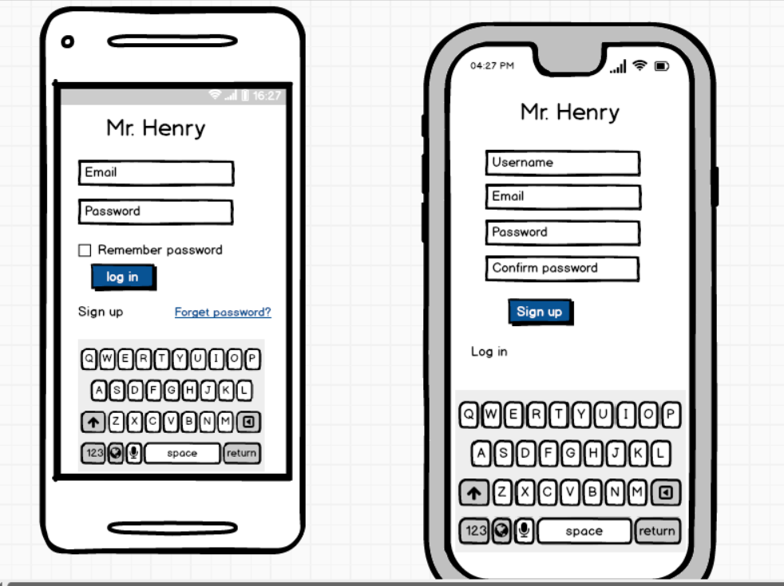

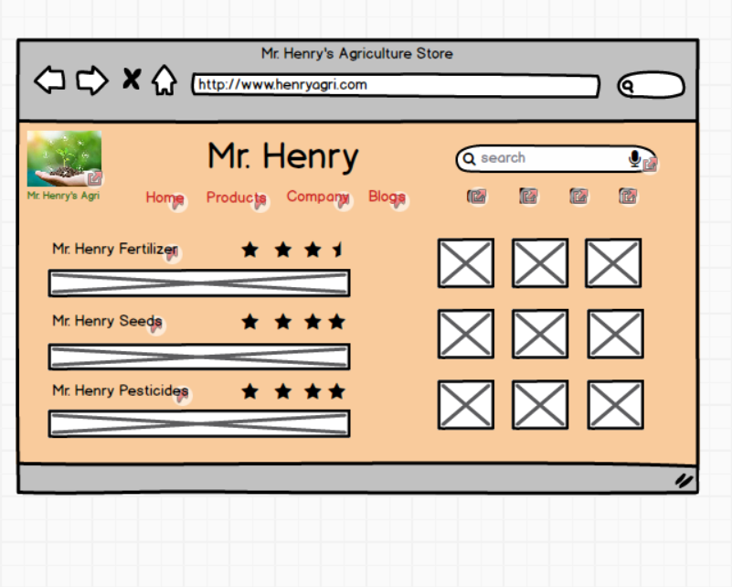

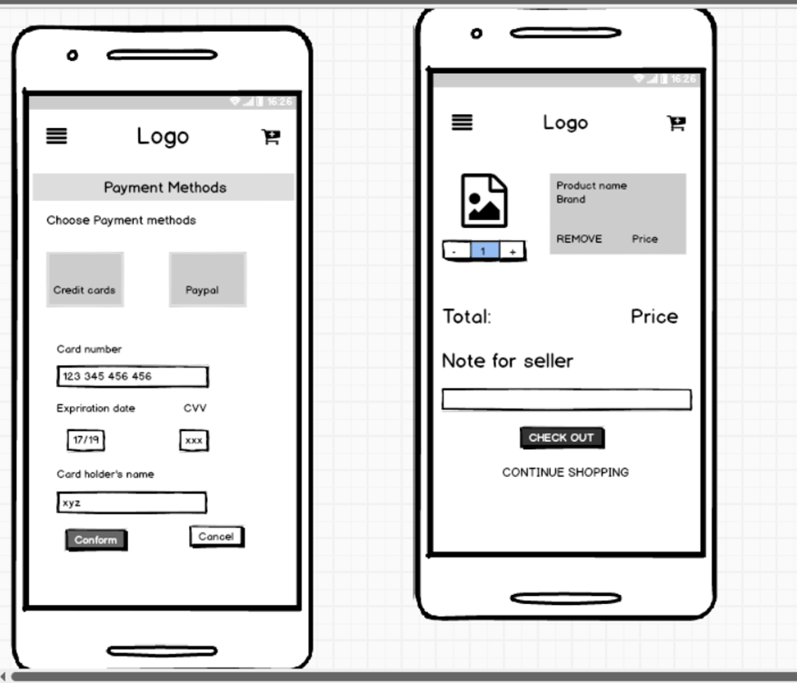

**Question 35 – Tools (Visio, Balsamiq)**

**Microsoft Visio-**

**Microsoft Visio** is a diagramming and [vector graphics](https://en.wikipedia.org/wiki/Vector_graphics) application and is part of the [Microsoft](https://en.wikipedia.org/wiki/Microsoft_Office)

[Office](https://en.wikipedia.org/wiki/Microsoft_Office) family. It is used to create diagram types such as [Flowcharts,](https://en.wikipedia.org/wiki/Flowcharts) [Org Charts,](https://en.wikipedia.org/wiki/Organizational_chart) [Floor Plans,](https://en.wikipedia.org/wiki/Floor_Plans) [Network Diagrams,](https://en.wikipedia.org/wiki/Network_diagram) [UML Diagrams,](https://en.wikipedia.org/wiki/UML) [Mind maps](https://en.wikipedia.org/wiki/Mind_maps) and more. It is also commonly used for scenarios such as [Process Mapping](https://en.wikipedia.org/wiki/Process_Mapping) and Visual Collaboration. The latest version of Visio also has [data visualization](https://en.wikipedia.org/wiki/Data_visualization) that allows users to create diagrams from Excel data and also embed Visio diagrams in [Power BI](https://en.wikipedia.org/wiki/Power_BI) dashboards.

**Microsoft Office Visio** is a tool that eases the process of making complex diagrams. Especially for business purposes. It can help in the making of presentations, floor plans, org charts, etc. Listed below are some uses of Visio:

Followings things can draw BA by using MS Office Visio

1. **Flowchart**: A flowchart is helps to show the steps in sequential order. These are steps that

need to be taken to complete a certain process. It is effective in conveying information. Thus, it can

be used in various other fields too.

1. **Organization Chart:** An org chart displays the roles and reporting relationships in a business organization. It can be used in also any other organization. It depicts the names and positions of

employees in a company. In short, we can say it shows the structure of an organization.

1. **Floor Plan**: A floor plan is the structure of a room or a floor. Architects use floor plans to

place doors, windows, and other objects. Visio also offers a floor plan template.

1. **Business Process Modelling Notation**: BPMN is a flowchart method of displaying all the

processes in a business that is to be taken. In other words, it is helps in give a clear understanding of

the processes in a particular business through visual representation.

**Balsamiq**-

Balsamiq Mockups is an effective tool for presenting the software requirements in the form of wireframes. This helps the software development team to visualize how the software project will look like in the very early stages of development. This is a small tutorial where we will cover all the basic steps needed to start with Balsamiq Mockups.

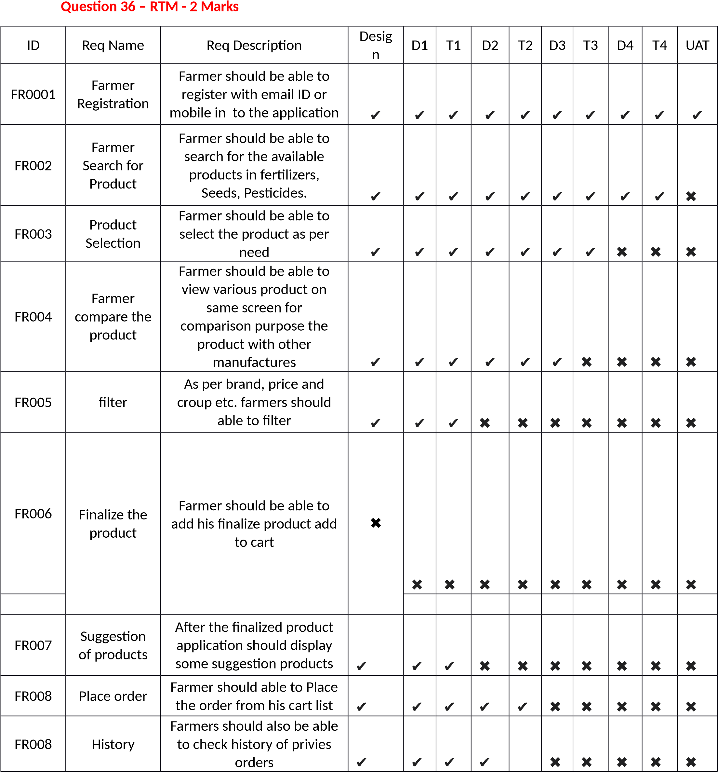

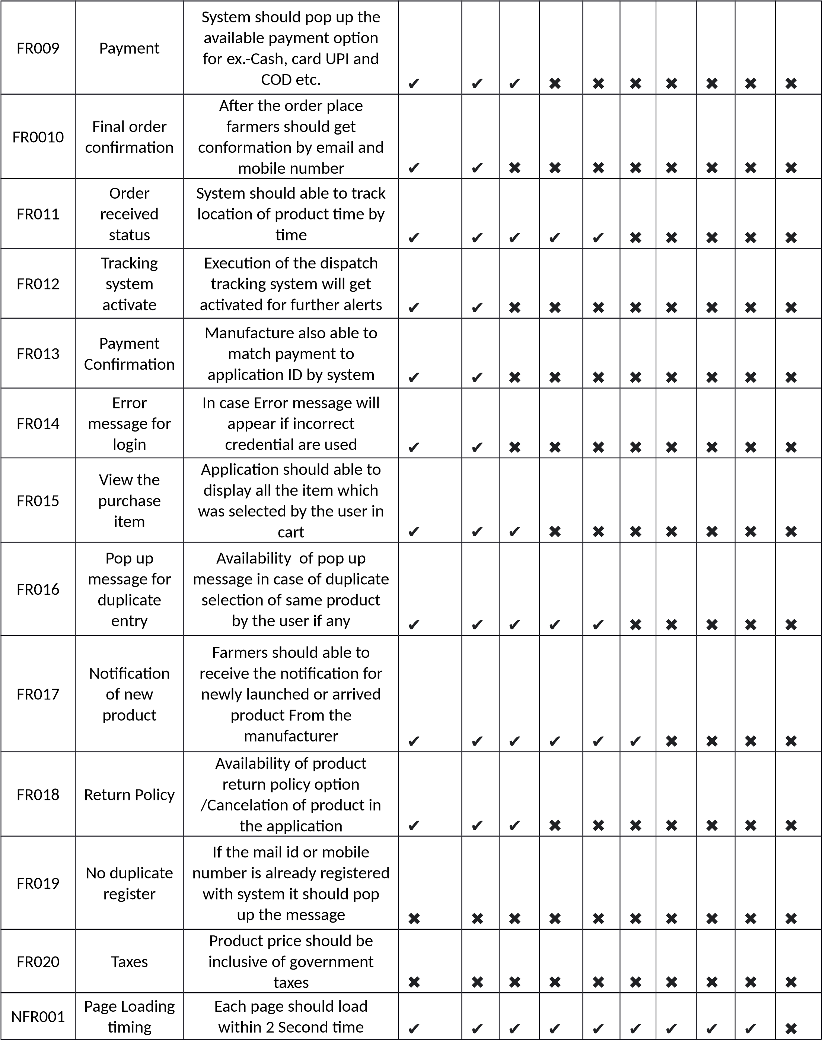

**Que. 37. 10 Test case documents.**

**Ans-**

1.

|  |  |  |  |
| --- | --- | --- | --- |
| Test Case ID | PQ9437 | Test Case Name | login |
| Project ID | 1234 | Project Name | Farmers website |
| PMID | 786 | PM Name | Mr. Vandanam |
| Test strategy ID | PQ9437 | Tester ID |  |
| Test plan ID | PQ9437 | Tester name |  |
| Test schedule ID | PQ9437 | Date of test |  |

|  |
| --- |
| Scenario: website for online shopping of farm products, in that we have login we have 4inputs 3compulsory 1 optional and after that results are being shown |
| Link to that page |

|  |  |  |  |  |  |
| --- | --- | --- | --- | --- | --- |
|  | Set 1 |  |  |  |  |
| Input data | 1.Userid  2.password  3.capcha  4.otp |  |  |  |  |

|  |  |  |  |  |  |
| --- | --- | --- | --- | --- | --- |
|  |  |  |  |  |  |
| Expected behavior | Home page /error page  pops up |  |  |  |  |
| Actual behavior | Home page /error page  pops up |  |  |  |  |
| comments | Test was good |  |  |  |  |
| Pass/fail | Pass |  |  |  |  |

2.

|  |  |  |  |
| --- | --- | --- | --- |
| Test Case ID | PQ9437 | Test Case Name | New user |
| Project ID | 1234 | Project Name | Farmers website |
| PMID | 786 | PM Name | Mr. Vandanam |
| Test strategy ID | PQ9437 | Tester ID |  |
| Test plan ID | PQ9437 | Tester name |  |
| Test schedule ID | PQ9437 | Date of test |  |

|  |
| --- |
| Scenario: website for online shopping of farm products, in that we have new user we have 1 4compulsory 1 optional and after that results are being shown |
| Link to that page |

|  |  |  |  |  |  |
| --- | --- | --- | --- | --- | --- |
|  |  |  |  |  |  |
| Input data | 1.User name  2.set password  3. mail  4.capcha  5. mobile OTP |  |  |  |  |
| Expected behavior | Registered  done and  home page  shows |  |  |  |  |
| Actual behavior | Home page comes |  |  |  |  |
| comments | Test was good |  |  |  |  |
| Pass/fail | Pass |  |  |  |  |

3.

|  |  |  |  |
| --- | --- | --- | --- |
| Test Case ID | PQ9437 | Test Case Name | Online purchasing |
| Project ID | 1234 | Project Name | Farmers website |
| PMID | 786 | PM Name | Mr. Vandanam |
| Test strategy ID | PQ9437 | Tester ID |  |
| Test plan ID | PQ9437 | Tester name |  |
| Test schedule ID | PQ9437 | Date of test |  |

|  |
| --- |
| Scenario: website for online shopping of farm products, in that we perform online purchasing we have 1 1compulsory 1 optional and after that results are being shown |
| Link to that page |

|  |  |  |  |  |  |
| --- | --- | --- | --- | --- | --- |
|  |  |  |  |  |  |
| Input data | 1.Product name  2.filters |  |  |  |  |
| Expected behavior | Product option |  |  |  |  |
| Actual behavior | Different  product pops |  |  |  |  |
| comments | Test was good |  |  |  |  |
| Pass/fail | Pass |  |  |  |  |

4.

|  |  |  |  |
| --- | --- | --- | --- |
| Test Case ID | PQ9437 | Test Case Name | Product availability |
| Project ID | 1234 | Project Name | Farmers website |
| PMID | 786 | PM Name | Mr. Vandanam |
| Test strategy ID | PQ9437 | Tester ID |  |
| Test plan ID | PQ9437 | Tester name |  |
| Test schedule ID | PQ9437 | Date of test |  |

|  |
| --- |
| Scenario: website for online shopping of farm products, in that we should have product available in which we have 3 inputs 3 compulsory and after that results are being shown |
| Link to that page |

|  |  |  |  |  |  |
| --- | --- | --- | --- | --- | --- |
|  |  |  |  |  |  |
| Input data | 1.Manufacturing code  2.capcha  3. password |  |  |  |  |
| Expected behavior | stock  information |  |  |  |  |
| Actual behavior | Same as  expected |  |  |  |  |
| comments | Test was good |  |  |  |  |
| Pass/fail | Pass |  |  |  |  |

5.

|  |  |  |  |
| --- | --- | --- | --- |
| Test Case ID | PQ9437 | Test Case Name | Payment gateway |
| Project ID | 1234 | Project Name | Farmers website |
| PM ID | 786 | PM Name | Mr. Vandanam |
| Test strategy ID | PQ9437 | Tester ID |  |
| Test plan ID | PQ9437 | Tester name |  |
| Test schedule ID | PQ9437 | Date of test |  |

|  |
| --- |
| Scenario: website for online shopping of farm products, in that we should have payment gateway in which we have 4 inputs 4 compulsory and after that results are being shown |
| Link to that page |

|  |  |  |  |  |  |
| --- | --- | --- | --- | --- | --- |
|  |  |  |  |  |  |
| Input data | 1.Expiry  2.cvv  3. OTP  4. name |  |  |  |  |
| Expected behavior | Transaction  page |  |  |  |  |
| Actual behavior | Same as  expected |  |  |  |  |
| comments | Test was good |  |  |  |  |
| Pass/fail | Pass |  |  |  |  |

6.

|  |  |  |  |
| --- | --- | --- | --- |
| Test Case ID | PQ9437 | Test Case Name | Browse product |
| Project ID | 1234 | Project Name | Farmers website |
| PM ID | 786 | PM Name | Mr. Vandanam |
| Test strategy ID | PQ9437 | Tester ID |  |
| Test plan ID | PQ9437 | Tester name |  |
| Test schedule ID | PQ9437 | Date of test |  |

|  |
| --- |
| Scenario: website for online shopping of farm products, in that we should have browse product in which we have 4 inputs 4 compulsory and after that results are being shown |
| Link to that page |

|  |  |  |  |  |  |
| --- | --- | --- | --- | --- | --- |
|  |  |  |  |  |  |
| Input data | 1.category  2.size  3.availability  4.price range |  |  |  |  |
| Expected behavior | Different  product  options |  |  |  |  |
| Actual behavior | Same as  expected |  |  |  |  |
| comments | Test was good |  |  |  |  |
| Pass/fail | Pass |  |  |  |  |

7.

|  |  |  |  |
| --- | --- | --- | --- |
| Test Case ID | PQ9437 | Test Case Name | Experience rating |
| Project ID | 1234 | Project Name | Farmers website |
| PM ID | 786 | PM Name | Mr. Vandanam |
| Test strategy ID | PQ9437 | Tester ID |  |
| Test plan ID | PQ9437 | Tester name |  |
| Test schedule ID | PQ9437 | Date of test |  |

|  |
| --- |
| Scenario: website for online shopping of farm products, in that we should have browse product in which we have 4 inputs 3 compulsory and after that results are being shown |
| Link to that page |

|  |  |  |  |  |  |
| --- | --- | --- | --- | --- | --- |
|  |  |  |  |  |  |
| Input data | 1.experience  2.name 3.phone number |  |  |  |  |
| Expected behavior | Review done |  |  |  |  |
| Actual behavior | Same as  expected |  |  |  |  |
| comments | Test was good |  |  |  |  |
| Pass/fail | Pass |  |  |  |  |

8.

|  |  |  |  |
| --- | --- | --- | --- |
| Test Case ID | PQ9437 | Test Case Name | Product cancel |
| Project ID | 1234 | Project Name | Farmers website |
| PM ID | 786 | PM Name | Mr. Vandanam |
| Test strategy ID | PQ9437 | Tester ID |  |
| Test plan ID | PQ9437 | Tester name |  |
| Test schedule ID | PQ9437 | Date of test |  |

|  |
| --- |
| Scenario: website for online shopping of farm products, in that we should have product cancel in which we have 2 inputs and click ok and after that results are being shown |
| Link to that page |

|  |  |  |  |  |  |
| --- | --- | --- | --- | --- | --- |
|  |  |  |  |  |  |
| Input data | Order id Captcha |  |  |  |  |
| Expected behavior | Order cancellation page |  |  |  |  |
| Actual behavior | Yes Same as  expected |  |  |  |  |
| comments | Test was good |  |  |  |  |
| Pass/fail | Pass |  |  |  |  |

9.

|  |  |  |  |
| --- | --- | --- | --- |
| Test Case ID | PQ9437 | Test Case Name | Helpline |
| Project ID | 1234 | Project Name | Farmers website |
| PM ID | 786 | PM Name | Mr. Vandanam |
| Test strategy ID | PQ9437 | Tester ID |  |
| Test plan ID | PQ9437 | Tester name |  |
| Test schedule ID | PQ9437 | Date of test |  |

|  |
| --- |
| Scenario: website for online shopping of farm products, in that we have helpline option in which we have 4 inputs and click ok and after that results are being shown |
| Link to that page |

|  |  |  |  |  |  |
| --- | --- | --- | --- | --- | --- |
|  |  |  |  |  |  |
| Input data | Name  Number  Query |  |  |  |  |
| Expected behavior | Call person calls you |  |  |  |  |
| Actual behavior | Same as  expected |  |  |  |  |
| comments | Test was good |  |  |  |  |
| Pass/fail | Pass |  |  |  |  |

10.

|  |  |  |  |
| --- | --- | --- | --- |
| Test Case ID | PQ9437 | Test Case Name | Download Payment Receipt |
| Project ID | 1234 | Project Name | Farmers website |
| PM ID | 786 | PM Name | Mr. Vandanam |
| Test strategy ID | PQ9437 | Tester ID |  |
| Test plan ID | PQ9437 | Tester name |  |
| Test schedule ID | PQ9437 | Date of test |  |

|  |
| --- |
| Scenario: website for online shopping of farm products, in that we have payment receipt option in which we have 3 inputs and click ok and after that results are being shown |
| Link to that page |

|  |  |  |  |  |  |
| --- | --- | --- | --- | --- | --- |
|  |  |  |  |  |  |
| Input data | Order id captcha password |  |  |  |  |
| Expected behavior | Shows Payment receipt |  |  |  |  |
| Actual behavior | Same as  expected |  |  |  |  |
| comments | Test was good |  |  |  |  |
| Pass/fail | Pass |  |  |  |  |

**Question 38- DB Design**

**Ans- Database Schema Diagram for online agricultural Product Store**

|  |
| --- |
| Products |
| ID  Name  Price  Weight Descriptions Image Category Stock |

|  |
| --- |
| Option |
| ID  Option Name |

|  |
| --- |
| Product option |
| ID  Option ID  Product ID |

|  |
| --- |
| Product Categories |
| ID  Product ID  Category ID |

|  |
| --- |
| Categories |
| ID  Name  Description |

|  |
| --- |
| Orders |
| ID  Customer ID  Amount ID  Shipping Address Order Address Order Email  Order Date  Order Status |

|  |
| --- |
| Customers |
| ID  Email ID  Password  Full Name  Billing Address District  Mobile Number |

|  |
| --- |
| Order details |
| ID  Order ID  Product ID  Price  Quantity |



Belons to

**Question 39- Data flow Diagram**

**Ans-**

According to Wikipedia.org a data flow diagram is a way of representing a flow of data through a process or a system. The DFD also provides Information about the outputs and inputs of each entity and the process itself. A data-flow diagram has no control flow there are no decision rules and no loops.

**Context level DFD- 0**

**level**

Creates Products Details

Stores into database

Views Products

Agricultural product records

Seller

Online agriculture

product store

User

User Login Records

order

Customer and order Information

acknowledgement

D1 Farmer

Database

Debit card Number and

And order Amount

Approval or

rejection

Confirmation

And delivery date

Order Information

Product type and amount

Farmer

1

. Online Process

order

2

. Cyber Check verify

Debit Card

Debit Card

Company

3

. Shipping ship order

D2 Inventory

**Question 40- Change Request-**

Definition of a “Change”

For the purposes of this document, a Change is defined as the addition, modification, or removal of a configuration item (CI), service, or service component, and/or its associated elements.

When as a I receives a request of change from the client Due to change in government taxation structure, I will analyses the request and clarifies exactly what the request is asking me to do in that agriculture product store. I will perform some activities to improvise and change the project as per the Clients Requirement.

They are:

1.Feasibilty Study

Basically, this is the first step I am as Business Analyst does whenever come across the Change Requests. This Feasibility Study helps me in answering the possible question like “Are we supposed to proceed with the proposed project change requirements?”. If yes, he will go accept the change request and goes to the Impact Analysis.

This change has occurred due to change in governments taxation structure change as BA we need to change privies taxation structure change.

When a change is requested, as a Business Analyst I should follow the following steps. In simple terms,

1. Firstly, I need to documents the change requests.
2. BA identifies whether the change in the ongoing project is really worth it or not.

The taxation structure change by government is priority to consider point according to that I need to develop documents and into on-going sprint.

1. Project Manager should approve the change requests. If yes, the project will move furtherly.As a BA I will Take Approval from PM and PO on Email and forward this mail to all team and done this change on priority Bases.
2. Business Analyst along with the Project Manager ensure whether the change is a minor or a major change.

If the policy change by government the it is major change request according to the government instruction, we need to make change with a given time.

1. If the new requirement is a major change, they make sure that it should not impact the delivery date of the project or any changes in the project scope.
2. Also try to help the other stakeholders to understand the importance of change requests which helps to reduce the negative impact of the project.

**Change Request Form**

**(Change in the Government Taxation structure)**

**1.) SUBMITTER - GENERAL INFORMATION**

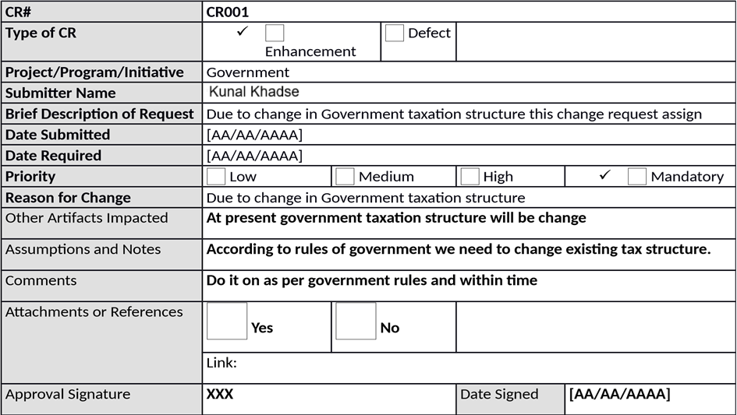

2.)

PROJECT MANAGER - INITIAL ANALYSIS

Hour Impact

**[30**

**hrs**

**]**

**For all team it will take minimum 60 hrs**

Duration Impact

**[3**

**dys**

**]**

**For all team we finished this job within three days**

Schedule Impact

**[**

**XXX**

**]**

**[**

**AA/AA/AAAA] To [AA/AA/AAAA**

**]**

Cost Impact

$80/Hr.

**This will cost around**

$2400

Comments

**Kindly approve**

Recommendations

**From project sponsor**

Approval Signature

**XXX**

Date Signed

**[**

**AA/AA/AAAA**

**]**

3.) CHANGE CONTROL BOARD - DECISION

**Decision**

✓

**Approved**

**Approved**

**with Conditions**

**Rejected**

**More**

**Info**

**Decision Date**

**[[**

**AA/AA/AAAA**

**]**

**Decision Explanation**

**Due to change in rules of government we need to change existing tax**

**structure.**

**Conditions**

**This change will be utilizing when this government utilize this new taxation**

**structure.**

Approval Signature

**XXX**

Date

Signed

**[**

**AA/AA/AAAA**

**]**

**Question 41- Change Request Vs an Enhancement**

According to my understanding change Request mean in any IT project we can change all process or we add new process or system instance of old remove. Enhancement is a part of change request. For example, we provide only service through web and we are not available at application services and we lunch new application at android platform that change request

Enhancement mean add something new in existing process or system for example if farmer can process payment by only UPI and Debit card and now we add new feature farmer can pay payment by credit card and online banking.

According to IBM.com A change request is a proposal from a stakeholder in the software development process to change something in a product or in a product process.

According to IBM.com Common change requests include defects and requests for product enhancements or new features

As the project is in process, Ben and Kevin have contacted you. The reason is to inform you that they want the Farmers to sell their crop yields through this application i.e. Farmers should be able to add their crop yields or products and display to general public and should be able to sell them. They also want to introduce Auction system for their Crop yields. As a BA, what will be your response?

As BA I will check introduce new link in online product store Buy and sale product from farmers. And in that add auction link also farmers can able to sale their agricultural product to other farmers by location wise we are already into delivery service of small amount of agricultural product is sale by farmer then can choose delivery service through application also

**Question 42- Estimations** -

* PM -$130/Hr,

PM work every Month 60 Hr

For Entire Project He work 1080 Hr

Total work Cost $64800

* Sol Architect – $55/Hr,

Sol Architect work every Month 80 Hr

For Entire Project He work 1440 Hr

Total Work cost $115200

* Programmers – $50/Hr

Programmers work every Month 90 Hr

For Entire Project He work 1620 Hr

Total work cost $145800

* Sr. Programmers – $80/Hr

Sr. Programmers work every Month 85 Hr

For Entire Project he works 1530 Hr Total Work cost $122400

* Network Engineer – $80/Hr NE work every Month 65 Hr

For Entire Project He work 1170 Hr

Total Work cost $93600

* DBA - $80/Hr

DBA work every Month 70Hr

For Entire Project He work 1260 Hr

Total Work Cost $88200

* BA- $60/Hr

BA work every Month 90 Hr

For Entire Project He work 1620 Hr

Total Work Cost $145800

Total man-hours Required for project = 9720 Hr

Total Cost for the Project = $775,800

**Question 43- UAT-**

The Business Analyst role is all about ensuring that online agricultural product store project delivers the value the business needs and expects. Actively participating in planning for and running User Acceptance Testing is an important way for the BA to ensure that value is indeed delivered.

Following why I handle the situation

I understand the functionality the system is supposed to deliver and as such, have the knowledge needed to validate the system (confirm whether the solution meets business needs or not). The fact that a system has been built to specification does not make it automatically acceptable. UAT helps stakeholders to determine whether the system can be put to use in real-life business scenarios or not.

Steps in UAT

Analyse Requirements –Requirements should be analysed and documented properly before conducting a UAT session. Even the users agreed with the Software Requirement Specification, there will be change requests after going through a UAT. That’s where the users get the real look and feel of the system.

Identify major Test scenarios and Prepare the UAT Plan – UA Test plan is the document that outline to identify test cases which validate the deliverables.

Create UAT test cases - Test Cases are the steps to the user to guide the system in testing. It’s important to write the proper test cases to conduct a good UA Test. User cases which identified in requirements elicitation can be used to write the UA test cases.

Run the Test – To run the UAT test cases, testers should be the real world end users of the business.

Record the results – When conducting a proper UAT scenario, it need to be documented the progress and Issues in a defect log. Defects need to be documented to evaluate and fix.

Confirm the Business objectives are met – If the requirement hasn’t met the product will send to further development. If there any change requests from users, they will be hand over to the development.

UAT Documents Created by Business analyst

UAT plan

UAT Test cases

Defect Log (after conducting the UAT)

Challenges when conducting a UAT session

UAT environment installation and proceeding. In some cases, it’s difficult to allocate time from end users and their environment as not to distract the business process

Problems can be arising when the test plan is not completed properly. UAT plan is one important document that needs to be organized and accurate to conduct the UA Test.

Users with low business process knowledge and lack of training. When selecting testers, select end users with a good business knowledge.

I hope this article will help Business analysts and those who want to learn about UAT. Your reviews are mostly welcome)

**Question 44- Project Closer Document-**

The project closure doc prepaid the main purpose document of to make note of what went wrong the correct approach adopted deposit vive and negatives during the project. Varies initiatives taken by the team issues face by the members and solution obtaining in short this document is existing of all positives negatives of the project which helps to avoid same mistake in future project it also helps to improve performance of the team member in future. In short closure report is a tool for management to access success of the project and its team members

**Project Closure**

Online Agriculture Product Store

Version: 1.0

Revision Date: MM/DD/YYYY

*Submit the document to the Project Sponsor, Business Owner, and PPMO/PMO Division Director; and archive this closure document with the project artifacts once completed.*

**Approver**

**Name**

**Title / Role**

**Signature**

**Date**

Peter and Ben

Project Stakeholder*

ok

Xx/xx/xxxx

Mr. Henry

Exec Sponsor (AVP or Exec.

Dir)*

ok

Xx/xx/xxxx

Mr. Pandu

Financial Head

ok

Xx/xx/xxxx

Mr. Vandanam

Project Manager

ok

Xx/xx/xxxx

Mr. Kartik

Delivery head

ok

Xx/xx/xxxx

Mr. Dooku

Project Coordinator

ok

Xx/xx/xxxx

*By authorizing this Project Closure, the Project Champion, Project Stakeholder(s), and Executive Sponsor agree to all terms within this document.

**Revision History**

*Identify document changes.*

**Version**

**Date**

**Name**

**Description**

1.0

Xx/xx/xxxx

Mr. Henry

Ok to process

Section 1. General Information

***Project Activity***

**Date**

Project Start

[01/01/2025]

Project Closure

1

[31/07/2026]

**Section 2. Business Deliverables**

*As identified in section 2.2 of the Business Case.*

**Business**

**Case Ref**

**ID**

**Business Objective**

**Met/Not**

**Met**

**Comments**

BI0001

Farmer should able to buy and send

agricultural product by online

Yes

Ok

*In addition to the project specific goals and objectives identified by the project champion/project stakeholders, University of Houston-Clear Lake requires business solutions uphold the integrity of the university by complying with

**Section 3. Customer Expectation Management**

**Item**

**Question**

**Description**

1

Were all expected benefits and business outcomes realized?

Yes

2

Were all expected performance standards satisfied?

Yes

1 Date of Project Closure refers to the project finish date, meaning all project tasks have been completed.

**Item**

**Question**

**Description**

**Comments**

**ok**

**Section 4. Outstanding Action Item and Issues**

***Action Item and/or Issue***

***Transition and/or Resolution***

**Section 5. Project Office Checklist**

***Deliverable***

***Description***

Risk Assessment completed and posted on suitable shared storage.

✓

Yes

No

Business Case completed and posted on suitable shared storage.

✓

Yes

No

Project Charter completed and posted on suitable shared storage.

✓

Yes

No

Meeting Notes completed and posted on suitable shared storage.

✓

Yes

No

Additional project documentation and artifacts posted on suitable shared

storage, including Requirements Template, Project Change Requests,

Milestone Timeline, Work Breakdown Structure, etc.

✓

Yes

No

Lessons Learned documented.

✓

Yes

No

Project folder moved

*completed-projects*

on suitable shared storage.

✓

Yes

No

***Deliverable***

***Description***

Support Handover Document completed, archived, and provided to UCT

Support Center and Student Assistance Center.

✓

Yes

No

**Comments**

Ok to process application running properly.