**Project 3 Part 2**

**Question 1 - What is the difference between Brainstorming and JAD Sessions?**

|  |  |  |
| --- | --- | --- |
| **Aspect** | **Brainstorming** | **JAD Sessions** |
| **Definition** | A creative problem-solving technique to generate ideas in a free-flowing manner. | A structured and collaborative session involving stakeholders to gather and refine requirements. |
| **Purpose** | Focuses on generating as many ideas as possible for a given problem or topic. | Focuses on defining and documenting business requirements for a project. |
| **Participants** | Usually involves a small, diverse group of individuals for creativity. | Includes key stakeholders, subject matter experts, and facilitators directly related to the project. |
| **Structure** | Informal and unstructured; allows free flow of ideas. | Highly structured with a defined agenda, roles, and objectives. |
| **Facilitation** | Facilitated by a moderator to encourage participation. | Led by a JAD facilitator or moderator to ensure discussions remain focused. |
| **Outcome** | A broad range of ideas, suggestions, or solutions without immediate evaluation. | Well-defined, documented requirements and decisions for project implementation. |
| **Focus Area** | Creativity and innovation for problem-solving or idea generation. | Requirement gathering and decision-making for projects. |
| **Timeframe** | Shorter duration, typically lasting a few hours. | Can last multiple days depending on project complexity. |
| **Documentation** | May or may not include formal documentation of ideas. | Detailed documentation of outcomes, decisions, and requirements. |
| **Tools/Techniques** | Mind maps, sticky notes, whiteboards, etc. | Prototyping, workflows, use cases, and other requirement-gathering tools. |
| **Decision Making** | Does not emphasize decision-making; ideas are explored. | Focuses on achieving consensus and finalizing decisions. |

**Question 2 - Why Document Analysis is one of the compulsory technique we use in a Project? Justify**

* **Document Analysis** is a business analysis technique used to review and evaluate existing documentation, such as reports, policies, procedures, manuals, system specifications, and contracts, to gather relevant information for a project. It helps identify existing processes, requirements, and gaps, providing valuable insights to understand the current state and define project needs or improvements.

Document Analysis is a compulsory technique used in a project because it plays a critical role in understanding existing processes, requirements, and system functionalities. Below is a detailed justification of its importance:

**1. Understanding Existing Systems and Processes**

* Document analysis involves reviewing existing documents such as process manuals, system design documents, policies, procedures, and reports.
* This provides insights into how the current system operates, what gaps exist, and how these gaps can be addressed in the new project.

Example: For a project automating the loan processing system, analyzing current loan application forms, risk evaluation policies, and approval workflows is essential to ensure the new system aligns with existing business rules.

**2. Requirement Gathering**

* Documents often contain explicit or implicit requirements for the project. By analyzing documents, business analysts can extract detailed and accurate requirements without relying solely on stakeholder interviews.
* This ensures that critical requirements are not overlooked and that the project aligns with organizational objectives.

Example: In a project for developing a food delivery app, analyzing customer feedback reports and order cancellation logs helps identify pain points like delivery delays or app usability issues.

**3. Historical and Legal Context**

* Reviewing contracts, regulations, or compliance documents ensures that the project adheres to legal, regulatory, or contractual obligations.
* It avoids costly mistakes or non-compliance that could lead to penalties or project failure.

Example: A project in the healthcare domain must analyze HIPAA compliance documents to ensure patient data privacy and security standards are met.

**4. Stakeholder Alignment**

* Documents such as previous project plans, charters, and business case reports help in aligning the new project’s objectives with stakeholder expectations and organizational goals.
* It avoids miscommunication and ensures the project stays on track.

**5. Efficient Use of Time and Resources**

* Document analysis reduces the need to gather information repeatedly through interviews or workshops. This saves time, especially in large organizations where many stakeholders might need to be consulted.
* It provides a foundation for further stakeholder discussions, allowing meetings to be more focused.

**6. Identifying Risks and Constraints**

* Documents often highlight constraints (e.g., budget, timeline, or technical limitations) and risks (e.g., dependency on outdated technologies or resource shortages).
* Recognizing these early in the project lifecycle helps in proactive risk management.

**7. Establishing Baselines**

* Document analysis provides a baseline or benchmark for measuring the success of the project. It helps in comparing the “before” and “after” states to evaluate the impact of the project.

Example: For a retail analytics project, analyzing historical sales data serves as a baseline to measure the effectiveness of new predictive analytics models.

**8. Ensures Continuity in Case of Stakeholder Unavailability**

* Stakeholders might not always be available for interviews or workshops. Document analysis ensures that the information required for the project can still be obtained through existing records.

**Question 3 - In Which Context we will use Reverse Engineering**

* Reverse Engineering is the process of analyzing a product or system to understand its components, functions, design, and working mechanism, often to extract valuable information or recreate a similar product. In software development, it involves examining software or hardware to uncover design features, functionality, and structure without access to source code or documentation. Here are the key contexts in which reverse engineering is typically used:

1. **Legacy System Modernization**  
   Reverse engineering is often used when an organization has an old system that lacks proper documentation. It helps analyze the current system architecture, codebase, or database structure to understand how it functions. This understanding can then be used to redesign or reimplement the system using modern technologies.
2. **Product Development and Improvement**  
   When a new product needs to be developed or an existing product needs improvement, reverse engineering can help by examining competing products in the market. By breaking down the competitor's product, companies can identify strengths and weaknesses, leading to better design choices.
3. **Software Debugging and Maintenance**  
   If the source code of a software system is not available or has become corrupted, reverse engineering can be used to understand the system’s behavior, identify bugs, and perform maintenance or upgrades.
4. **Compliance and Security Audits**  
   Reverse engineering is often used for security audits to identify vulnerabilities in a system, software, or product. It helps security professionals analyze how the product works internally, which can lead to identifying and fixing security risks.
5. **Integration with New Systems**  
   In projects where existing systems need to be integrated with new systems or platforms, reverse engineering can be useful for understanding the communication protocols, data structures, and workflows of legacy systems to ensure smooth integration.

### ****Types of Reverse Engineering:****

1. **Black-box Reverse Engineering:** In black-box reverse engineering, the internal workings of a system are not known to the engineer. The focus is on analyzing the system’s input-output behavior. The engineer tests the system with various inputs and observes its outputs, trying to deduce its function or structure without knowledge of the internal code or design.

This type is useful when the software or system is proprietary, and the goal is to understand its behavior or replicate it without access to the source code.

1. **White-box Reverse Engineering:** In white-box reverse engineering, the engineer has access to the internal workings of the system. This can involve analyzing the source code, data flow, algorithms, or system architecture to understand the design and structure. It’s a more thorough approach compared to black-box reverse engineering.

White-box reverse engineering is typically used when the source code is available or can be accessed, and the goal is to understand the internal logic, identify errors, or modify the system.

**Question 4 - What is the difference between Brainstorming and Focus Groups?**

|  |  |  |
| --- | --- | --- |
| **Aspect** | **Brainstorming** | **Focus Groups** |
| **Definition** | A creative problem-solving technique where participants generate ideas or solutions in an open, free-flowing discussion. | A moderated group discussion aimed at gathering opinions, feedback, or insights about a product, service, or topic. |
| **Purpose** | To generate a wide range of ideas quickly without judgment or critique. | To gather qualitative data, insights, and opinions from participants to understand their attitudes or experiences. |
| **Participants** | A diverse group of individuals, often from different backgrounds or areas of expertise. | A selected group of people (usually 6-12) who represent a target audience or demographic for focused discussions. |
| **Structure** | Informal and unstructured; participants are encouraged to contribute freely and spontaneously. | Structured and guided by a moderator who ensures the discussion stays on topic and covers key areas. |
| **Facilitation** | Led by a facilitator who encourages creative thinking and idea generation without criticism. | Led by a moderator who guides the discussion, asks specific questions, and keeps the conversation focused. |
| **Outcome** | A broad set of ideas or solutions without immediate evaluation or refinement. | Deep insights into participants' views, opinions, and attitudes, often used for research or decision-making. |
| **Focus Area** | Idea generation, problem-solving, or innovation. | Feedback, opinions, and insights on specific products, services, or issues. |
| **Timeframe** | Shorter duration, typically 30 minutes to an hour. | Longer sessions, often 1-2 hours, depending on the complexity of the discussion. |
| **Documentation** | Ideas are often recorded, but there is minimal formal documentation. | Detailed notes or transcripts are taken to document key points, responses, and insights. |
| **Decision Making** | No immediate decision-making; ideas are explored without judgment. | Insights from the discussion can inform decision-making or guide future actions. |

**Question 5 – Explain Observation Technique – Explain both Active and Passive approaches**

The **Observation Technique** is a method used to collect data by watching and recording behaviors, activities, or events in their natural setting. It is a valuable tool for understanding how individuals or groups interact with systems, processes, or products. Observation can provide insights that might not be captured through interviews or surveys.

There are two main approaches in observation: **Active** and **Passive**.

### ****Active Observation****

**Definition:**  
In **Active Observation**, the observer is directly involved in the environment or activity being studied. This means that the observer interacts with the participants or subjects in some way, either by asking questions, participating in the activities, or giving instructions.

**Key Characteristics:**

* **Involvement:** The observer is actively engaged in the situation, which can help gather detailed, firsthand information.
* **Interaction:** The observer may communicate with participants, asking questions or providing feedback.
* **Transparency:** The participants are aware that they are being observed, which may affect their behavior (also known as the **Hawthorne Effect**).

**Advantages:**

* Can gain deeper insights into the context and behaviors through direct interaction.
* Provides a more personal understanding of the processes and issues being studied.
* Allows for real-time clarification of questions or actions.

**Examples:**

* A business analyst sitting in on team meetings, asking questions about the workflow.
* A researcher participating in a user experience testing session, observing user behavior while interacting with a product.

### ****Passive Observation****

**Definition:**  
In **Passive Observation**, the observer does not interact with the participants and remains unobtrusive. The observer watches the activities or behaviors without influencing them or asking questions.

**Key Characteristics:**

* **Non-intervention:** The observer stays out of the way, allowing natural behaviors to occur without interference.
* **No Interaction:** There is no direct communication with the participants, and the observer remains silent.
* **Transparency:** The participants may or may not be aware of the observation, and the observer often maintains a low profile.

**Advantages:**

* Provides more natural, unbiased data since participants are not aware of being observed (or if they are, they are less likely to alter their behavior).
* Less chance of influencing the observed process or behavior.
* Can observe a broader range of activities over time without interrupting the flow.

**Examples:**

* A researcher sitting quietly in a public space, watching customer interactions in a retail store.
* A business analyst observing employees’ use of software without engaging in the process.

**Question 6 - How do you conduct the Requirements Workshop**

* A **Requirements Workshop** is a structured, collaborative session where key stakeholders come together to define, clarify, and prioritize requirements for a project. It’s an essential part of the business analysis process, helping ensure that all relevant perspectives are considered, and that the requirements are clear and aligned with business goals.

**1. Preparation Phase**

**Objective:** Ensure that all stakeholders are aligned on the workshop's goals and that necessary resources are in place.

**Steps:**

* **Define the Purpose:** Clearly articulate the goals of the workshop (e.g., gather business requirements, clarify ambiguities, prioritize features).
* **Select Participants:** Identify key stakeholders, such as business users, subject matter experts (SMEs), technical teams, and project sponsors. Ensure the group is diverse and represents all aspects of the project.
* **Set an Agenda:** Create a detailed agenda outlining the topics to be covered, and allocate time for each section. Typical agenda items might include introductions, current state analysis, future state discussion, and prioritization.
* **Prepare Materials:** Ensure you have all necessary documents (e.g., business process flows, existing systems documentation, user stories, etc.) and tools (e.g., whiteboards, sticky notes, collaboration software).
* **Set Ground Rules:** Establish ground rules such as staying on topic, respecting all opinions, and avoiding solutions until requirements are fully defined.

### ****2. Workshop Execution****

**Objective:** Facilitate discussions, gather requirements, and document decisions made.

**Steps:**

* **Kickoff the Session:** Introduce yourself as the facilitator, explain the objectives of the workshop, and present the agenda. Establish a professional and objective tone for the meeting while emphasizing the importance of collaboration. Clearly introduce the goals and the structure of the session.
* **Enforce Structure and Ground Rules:** As the facilitator, ensure that all participants adhere to the ground rules, such as respecting others' opinions, staying on topic, and avoiding discussions of solutions before defining the requirements. Enforce discipline and maintain a structured approach to discussions.
* **Gather and Clarify Requirements:**
  + Encourage participants to propose ideas or solutions for requirements.
  + Ask participants to describe how they expect to interact with the system or product.
  + Identify the strengths, weaknesses, opportunities, and threats associated with the proposed system.
  + Compare the current state with the desired future state to identify gaps.
* **Obtain Consensus on Conflicting Views:** If conflicts or disagreements arise, act as a mediator to resolve them. Facilitate decision-making, ensuring that all views are heard and that consensus is reached on key issues. Encourage open discussions and ensure that all participants contribute their perspectives.
* **Maintain Focus on Objectives:** Continuously validate the session's activities with the workshop’s stated objectives. Keep discussions focused on the requirements at hand and steer the group back on track if they deviate from the core goals.
* **Ensure Full Participation:** Actively encourage all stakeholders to participate and have their input heard. Ask the right questions and probe further when needed to clarify information and uncover deeper insights. Use techniques such as round-robin or silent brainstorming to ensure quieter voices are also included in the discussion.
* **Document Requirements:** The Scribe should capture all discussed requirements in the format agreed upon prior to the workshop. This documentation should include both functional and non-functional requirements, as well as any decisions made or unresolved issues that may require follow-up.

### ****3. Post-Workshop Follow-Up****

**Objective:** Ensure that the outcomes of the workshop are properly documented, validated, and communicated.

**Steps:**

* **Compile the Workshop Outputs:** Summarize the requirements gathered, decisions made, and any unresolved issues. Create a clear and organized document or report.
* **Share with Stakeholders:** Distribute the workshop results to all participants and relevant stakeholders for review and validation.
* **Resolve Open Issues:** If any requirements were unclear or disagreements were unresolved, schedule follow-up meetings or discussions to finalize these points.
* **Get Sign-Off:** Once the requirements have been validated and any necessary adjustments made, get formal sign-off from key stakeholders to ensure that there is consensus.
* **Maintain Traceability:** Keep track of the requirements as they evolve, ensuring that any changes are reflected in the project scope and documentation.

**Question 7 – In which context, Interview Technique can be conducted by a BA ? How may approaches are there in conducting Interviews? (Structured – Unstructured) Explain them. Explain the difference between Open Ended Questions and Closed ended Questions**

* The **Interview Technique** is commonly used by Business Analysts (BAs) to gather detailed and specific information from stakeholders, users, or subject matter experts. Interviews are typically conducted to clarify requirements, explore pain points, understand existing systems, and gather insights into business processes.

BAs can conduct interviews in various contexts, such as:

* **Eliciting Requirements:** When gathering functional and non-functional requirements for a new system or process.
* **Understanding Business Needs:** To understand the business challenges, goals, and objectives that the solution should address.
* **Clarifying Stakeholder Expectations:** To ensure that stakeholders’ needs and expectations are accurately captured and understood.
* **Evaluating Current Processes:** To assess existing workflows or systems and identify areas for improvement.
* **Assessing User Needs:** To understand how users interact with a system and what features they require or desire.
* **Confirming Priorities:** To validate and prioritize the requirements that stakeholders need from the system.

### ****Approaches to Conducting Interviews****

The two primary approaches to conducting interviews are:

### ****1. Structured Interviews****

**Definition:**  
In **structured interviews**, the interviewer follows a pre-determined set of questions, often in a specific order, and the scope of the interview is predefined. This approach ensures that the same set of questions is asked to all interviewees, providing consistency and easier comparison of responses.

**Key Characteristics:**

* **Predefined Questions:** The interviewer uses a standardized set of questions.
* **Closed Format:** Questions are often closed-ended and aimed at extracting specific data or answers.
* **Objective:** Aims to collect specific information in a systematic way.

**Examples of Use:**

* When interviewing stakeholders for specific project requirements that need to be consistent across various departments or teams.
* When gathering quantitative data on specific processes or issues.

### ****2. Unstructured Interviews****

**Definition:**  
In **unstructured interviews**, the interviewer has no specific set of questions to follow. The conversation is open-ended, and the questions evolve based on the flow of the discussion. This approach allows for more in-depth exploration of topics and the freedom to adapt to the needs of the interviewee.

**Key Characteristics:**

* **Flexible:** The interviewer can ask follow-up questions and delve deeper into topics as they arise.
* **Exploratory:** Designed to gather qualitative insights, opinions, and perspectives.
* **No Fixed Agenda:** The interviewer may start with general questions and let the conversation guide further questions.

**Examples of Use:**

* When trying to understand complex, ambiguous business problems or brainstorming potential solutions.
* In interviews with stakeholders who may have valuable insights but are unsure of how to articulate their needs in structured formats.

### ****Open-Ended & Closed-Ended Questions****

**1. Open-Ended Questions**

**Definition:**  
Open-ended questions are those that allow the interviewee to provide detailed and expansive answers. These questions cannot be answered with a simple "yes" or "no" and encourage the interviewee to elaborate on their thoughts, experiences, and opinions.

**Characteristics:**

* Encourages detailed responses.
* Promotes discussion and exploration.
* Responses can vary significantly between individuals.

**Example Questions:**

* "Can you describe how you currently handle this process?"
* "What challenges have you faced with the current system?"
* "What features would you like to see in the new solution?"

**2. Closed-Ended Questions**

**Definition:**  
Closed-ended questions are those that prompt a specific, often brief, response. These can typically be answered with a "yes," "no," or a short factual answer, such as a number or a choice between options.

**Characteristics:**

* Provides specific, concise answers.
* Easy to analyze and quantify.
* Less scope for detailed answers or elaboration.

**Example Questions:**

* "Do you use this system every day?"
* "Is the current process meeting your needs?"
* "Which of the following options would you prefer: A or B?”

**Question 8 - Questionnaire Technique – Where we will use? Give one example**

* The **Questionnaire Technique** is a widely used method for data collection in various contexts, especially when gathering structured data from a large group of stakeholders, users, or customers. It is typically employed when a Business Analyst (BA) needs to collect quantitative or standardized qualitative information quickly and efficiently.

**Common contexts for using the questionnaire technique:**

* **Requirements Elicitation:** When you need to gather specific requirements from users or stakeholders who might not be available for in-depth interviews.
* **User Feedback:** To understand user satisfaction or gather feedback on a product, service, or process.
* **Surveys and Market Research:** To collect data about customer preferences, market trends, or business needs.
* **Process Evaluation:** To evaluate how current processes or systems are functioning and identify areas of improvement.
* **Assessment of Knowledge or Competence:** When evaluating stakeholders’ or employees' understanding of a topic or system.

### ****Example:**** Suppose you are a BA working on a project to improve the customer service process for an e-commerce platform. You need to gather customer feedback on the usability of the current system.

**Example of Questionnaire:**

* **Purpose:** To assess the current satisfaction level of customers with the platform's customer service.
* **Questions:**
  + On a scale of 1 to 5, how satisfied are you with the response time of customer service?
  + Have you experienced any issues when trying to contact customer support? (Yes/No)
  + How would you rate the knowledge of the customer service representatives? (Poor/Fair/Good/Excellent)
  + What improvements would you suggest for our customer service process? (Open-ended)

This questionnaire can be distributed to a large number of customers, helping the BA gather structured feedback on the system's performance and areas that need improvement.

### ****Advantages of Using a Questionnaire:****

* **Scalability:** It allows you to collect responses from a large number of people in a short amount of time.
* **Standardization:** All respondents answer the same set of questions, making the data easy to analyze and compare.
* **Cost-effective:** It is generally less expensive and less time-consuming than conducting individual interviews or focus groups.

**Question 9 -** **How to Sort the Requirements – Where we will use? Give one example**

* Sorting the requirements is an essential step in the requirements gathering and prioritization process for a Business Analyst (BA). By sorting requirements, you can organize them in a structured manner to ensure they are understood, prioritized, and can be effectively communicated with stakeholders. Requirements can be sorted based on various factors such as their **functional vs. non-functional nature, user role, or time dependency.**

### ****Where Will It Be Used?****

Sorting requirements is used throughout the **project lifecycle**, particularly during the **requirements elicitation, analysis, and prioritization** phases. It is useful for:

* **Requirements Analysis:** To organize and understand the collected requirements.
* **Project Planning:** To create a roadmap or timeline for the implementation of various features.
* **Stakeholder Communication:** To ensure that each stakeholder's needs are captured and addressed.
* **Prioritization:** To help prioritize requirements based on urgency, dependencies, and business value.

### ****Methods of Sorting Requirements****

1. **Functional vs. Non-functional Requirements**
   * **Functional Requirements:** These describe what the system should do, the specific behaviors, functions, or tasks the system must perform (e.g., user authentication, payment processing).
   * **Non-functional Requirements:** These define how the system should perform certain tasks or the quality attributes of the system (e.g., performance, security, scalability).

**Use :** Sorting requirements into functional and non-functional categories helps ensure that both the core functionalities and the quality attributes of the system are addressed.

**Example:**

* + **Functional:** "The system must allow users to log in with a username and password."
  + **Non-functional:** "The system must authenticate users within 2 seconds."

1. **User Role Sorting**
   * Requirements can be sorted based on different **user roles** (e.g., administrator, end-user, manager, etc.). This ensures that each user’s needs are clearly understood and prioritized.

**Use :** Sorting by user role ensures that the needs of each role are met and that there is no overlap or confusion about the functionality that each role requires.

**Example:**

* + **Admin:** "Admin should be able to create, update, and delete user accounts."
  + **End-user:** "End-users should be able to search for products by category."
  + **Manager:** "Managers should be able to view monthly sales reports."

1. **Time Dependency Sorting**
   * Time dependency sorting involves categorizing requirements based on when they are needed or their **priority** (e.g., critical, high priority, medium priority, low priority).

**Use :** Sorting based on time dependency helps in planning the project timeline and allocating resources effectively. This is especially useful for **sprints** in Agile methodologies, where certain requirements must be delivered within a specific time frame.

**Example:**

* + **Critical:** "The system must allow users to complete a purchase transaction."
  + **High Priority:** "The system must display product details, including price and description."
  + **Medium Priority:** "The system should offer personalized recommendations based on user preferences."
  + **Low Priority:** "The system should allow users to share products on social media."

**Example of Sorting Requirements for an E-commerce Platform Project:**

### ****1. Functional vs. Non-functional Sorting****

* **Functional Requirement:**
  + "The system must allow users to register and log in with an email address and password."
  + "The system must allow users to add products to their cart."
  + "The system must enable users to place orders and make payments."
* **Non-functional Requirement:**
  + "The system must be able to handle 1,000 concurrent users."
  + "The platform should have a response time of less than 2 seconds for each page load."
  + "The platform must be compatible with multiple web browsers (Chrome, Firefox, Safari)."

### ****2. User Role Sorting****

* **Admin Role:**
  + "Admin should be able to manage the product catalog (add, edit, delete products)."
  + "Admin should be able to view sales reports for analysis."
* **End-user Role:**
  + "End-users must be able to search for products by category, price, and rating."
  + "End-users must be able to check out and choose payment options like credit card or PayPal."
* **Guest User Role:**
  + "Guest users should be able to browse products and add them to the cart without needing to log in."
  + "Guest users must be able to see product reviews without creating an account."

### ****3. Time Dependency Sorting****

* **Critical (Immediate Priority):**
  + "The system must process payments securely and send an order confirmation email to the user."
  + "The platform must allow users to create and manage an account."
* **High Priority:**
  + "The platform should support a user-friendly checkout process with an option for delivery address input."
  + "The system should allow users to track their orders in real-time."
* **Medium Priority:**
  + "The platform should have a recommendation engine for personalized product suggestions."
  + "The system should support guest checkout without requiring account creation."
* **Low Priority:**
  + "The platform should support multiple languages and currencies for international users."
  + "The system should offer loyalty points for purchases.

**Question 10 – Explain Prioritize the Requirements – Where we will use? Give one example**

* Prioritizing requirements is a crucial task in project management, particularly for **Business Analysts (BAs).** This process involves determining the relative importance of different requirements based on factors such as business value, stakeholder needs, urgency, and resource availability. By prioritizing requirements, a BA ensures that the most critical features or functionality are addressed first, leading to a more efficient and focused development process.

### ****Techniques Used for Prioritization:****

* **MoSCoW (Must Have, Should Have, Could Have, Won't Have)**: Categorizes requirements based on their importance.
* **Kano Model**: Helps understand customer satisfaction based on different types of requirements.
* **100-Point Method**: Stakeholders assign points to requirements based on priority.
* **Value vs. Effort Matrix**: Prioritizes requirements based on the business value and the effort required to implement them.

### ****Where Will It Be Used?****

1. **Product Development and Release Planning:**
   * Prioritizing requirements is essential when deciding which features or functionalities should be implemented in the first release and which can be deferred for future releases.
2. **Project Scoping and Resource Allocation:**
   * Helps the BA and stakeholders decide where to focus efforts and allocate resources, ensuring the most valuable features are built first.
3. **Agile or Scrum Framework:**
   * In **Agile methodologies**, requirements are often prioritized in product backlogs, and the highest priority requirements are tackled in the next sprint.
4. **Stakeholder Management and Communication:**
   * It is essential to prioritize requirements when dealing with stakeholders' diverse expectations and needs. Clear prioritization helps manage scope and expectations effectively.
5. **Risk Management:**
   * Prioritization helps in mitigating risks by focusing on high-impact, high-urgency requirements that may affect the system’s overall success.

### ****Example of Prioritizing Requirements****

Let's assume you are a Business Analyst working on an **E-commerce Website** project. You need to prioritize the following requirements for the first release:

1. **User Account Management (Functional Requirement)**
   * "The system must allow users to create and manage their accounts with a password."
2. **Product Search (Functional Requirement)**
   * "The platform must allow users to search for products by name, category, and price."
3. **Payment Gateway Integration (Functional Requirement)**
   * "The platform should allow users to make payments using credit cards, debit cards, and PayPal."
4. **Product Recommendations (Non-functional Requirement)**
   * "The platform should provide product recommendations based on previous browsing behavior."
5. **Multi-language Support (Non-functional Requirement)**
   * "The platform should support multiple languages for international users."

**Prioritization Process:**

* **Must Have (Critical for Launch):**
  + **User Account Management**: This is a basic requirement for users to interact with the platform and place orders. Without it, the platform cannot function.
  + **Product Search**: This is essential for users to find products quickly and efficiently on the website.
* **Should Have (Important but not Critical):**
  + **Payment Gateway Integration**: While essential for transactions, the system can launch with a limited payment method (e.g., only credit card payments) and expand later.
* **Could Have (Nice-to-have):**
  + **Product Recommendations**: This enhances the user experience but isn’t necessary for the platform to function initially.
* **Won’t Have (Low Priority for This Release):**
  + **Multi-language Support**: The platform can launch in one language (e.g., English), and multi-language support can be added in later phases.

**Question 11 – Explain Weekly status reporting – How we will drive?**

* **Weekly status reporting** is a crucial aspect of project management, where the Business Analyst (BA) or project team communicates the progress, challenges, and updates regarding the project to stakeholders, managers, and team members. This helps ensure everyone is aligned on the project’s status, upcoming tasks, risks, and roadblocks, and facilitates decision-making and problem-solving.

### **How Will We Drive Weekly Status Reporting?**

1. **Define the Structure:**
   * **Report Format**: Establish a standardized template for reporting, which could be in a document, spreadsheet, or project management tool.
   * **Content to Include**:
     + **Project Milestones**: Highlight the key milestones reached during the week.
     + **Tasks Completed**: List the tasks that have been completed in the current week.
     + **Ongoing Tasks**: Outline the tasks that are currently in progress.
     + **Upcoming Tasks**: Share what’s planned for the next week and any dependencies.
     + **Risks and Issues**: Mention any risks or issues that could affect the project timeline or quality.
     + **Dependencies**: Indicate any dependencies on external teams or stakeholders.
     + **Team Health**: Mention any concerns related to team performance or resource availability.
     + **Action Items**: List any action items or follow-up activities that need attention.
2. **Collect Information:**
   * Collect updates from relevant stakeholders, such as the project team, developers, testers, and other departments. This could be done through meetings, email updates, or collaborative platforms.
   * The BA ensures that all the project team members contribute their weekly progress and blockers.
3. **Consolidate Information:**
   * As the BA, consolidate the collected information into the report. Ensure that it is clear, concise, and aligned with the objectives and scope of the project.
4. **Review and Validate:**
   * Ensure the report is accurate and complete. Verify with the team or stakeholders if necessary to ensure there are no missing updates or misunderstandings.
5. **Distribute and Present:**
   * Distribute the weekly status report to stakeholders, project managers, and team members. This can be done via email, project management tools (e.g., Jira, Asana), or in a formal meeting (e.g., weekly stand-up).
   * If necessary, present the report in a team meeting or to senior management, explaining the key highlights and addressing any issues or concerns.

**Questions Are Asked in Weekly Status Reporting -**

#### **1. Progress & Completion**

* **What tasks were completed this week?**
* **Have any milestones been achieved?**
* **Were there any tasks delayed or missed? If so, why?**

#### **2. Ongoing Work**

* **What tasks are in progress this week?**
* **Are there any tasks that require more time than planned?**
* **What percentage of work is completed for ongoing tasks?**

#### **3. Upcoming Tasks**

* **What tasks are planned for the upcoming week?**
* **Are there any new tasks or changes to existing tasks?**
* **Are there any dependencies or prerequisites for upcoming tasks?**

#### **4. Risks & Issues**

* **Are there any new risks or issues that could impact the project?**
* **What steps are being taken to mitigate these risks?**
* **Have any previously identified risks escalated or changed in scope?**

#### **5. Dependencies**

* **Are there any dependencies that need to be managed this week?**
* **Are external teams, vendors, or departments affecting progress?**

#### **6. Resources & Team Health**

* **Is the project team adequately resourced?**
* **Are there any team-related issues (e.g., personnel availability, skill gaps)?**
* **Are there any roadblocks that the team needs help with?**

#### **7. Timeline & Budget**

* **Is the project still on track in terms of timeline?**
* **Are there any changes to the project budget or resource allocation?**
* **Do we need to adjust any deadlines or scope due to unforeseen challenges?**

#### **8. Action Items**

* **What actions need to be taken next week?**
* **Are there any follow-up actions or decisions required from stakeholders?**

#### **9. Feedback and Collaboration**

* **What feedback have we received from stakeholders or users?**
* **Are there any collaborative efforts or inter-departmental actions required?**

**Question 12 - Meeting Minutes Document – prepare One Sample**

* A **Meeting Minutes document** is a formal record of the key discussions, decisions, and action items from a meeting. It serves as a reference for all attendees and stakeholders to track what was discussed, the decisions made, and the follow-up actions needed. It is particularly useful for ensuring accountability, preventing miscommunication, and providing transparency in the decision-making process.
* Minutes of Meeting (MoM) is a formal written document that summarizes the discussions, decisions, and actions taken during a meeting.
* It serves as an official record of what transpired during the meeting and helps to ensure that everyone is on the same page regarding key points and action items.
* MoM is particularly important for tracking project progress, documenting decisions, and assigning responsibilities.

### ****Explanation of Each Field:****

1. **Meeting Title**: Clearly indicates the subject of the meeting, typically describing the purpose of the discussion (e.g., weekly status update, sprint review, etc.).
2. **Date and Time**: Specifies when the meeting was held to keep track of when decisions and discussions took place.
3. **Location**: Indicates where the meeting was held. This is useful for both physical and virtual meetings.
4. **Attendees**: Lists the names of everyone who attended the meeting. This is important for reference and accountability.
5. **Agenda**: A bullet-point list of the topics that were planned to be discussed during the meeting. It helps to keep the meeting focused and on track.
6. **Discussion Summary**: A brief description of what was discussed in the meeting. It summarizes the key points for each agenda item.
7. **Decisions Made**: Clearly outlines the decisions that were made during the meeting, ensuring everyone is aware of what was agreed upon.
8. **Action Items**: Lists tasks that need to be completed as a result of the meeting. It specifies who is responsible for each task and when it is due.
9. **Owner**: The person assigned to carry out each action item. This helps ensure accountability.
10. **Due Date**: The date by which the action item should be completed.
11. **Agenda Summary**: A concise summary of the discussions for each agenda item, which helps contextualize the meeting outcomes.
12. **Next Meeting**: Details about the next meeting, including the title, date, time, location, and expected attendees. This helps the team prepare for the next steps in the project.

By maintaining and sharing these **Meeting Minutes**, the project team can stay aligned on goals, track progress, and ensure that decisions and action items are followed up on in a timely manner.

### ****Sample Meeting Minutes: Agriculture Project****

|  |  |
| --- | --- |
| **Meeting Title** | Agriculture Product Store: Weekly Status Update |
| **Date and Time** | 23rd December 2024, 3:00 PM – 4:00 PM |
| **Location** | APT IT Solutions Conference Room |
| **Attendees** | Jhanvi (BA), Rajesh (Project Manager), Yogender (Developer), Madhuri (Tester), Rakesh (DB Admin), Varun (Network Admin) |
| **Agenda** | 1. Review progress on login feature for farmers.  2. Discuss product catalog and search options.  3. Update on payment gateway integration. |
| **Discussion Summary** | - **Login Feature**: The login page has been developed but requires validation with stakeholders.  - **Product Catalog**: Some issues with categorization of products need to be fixed.  - **Payment Gateway**: Testing for the initial payment gateway integration is underway, but the API documentation needs clarification. |
| **Decisions Made** | - Login feature validation with stakeholders will be scheduled for next week.  - Immediate action to fix categorization issues in the product catalog.  - Payment gateway API clarification to be obtained from the vendor by end of this week. |
| **Action Items** | 1. Schedule login feature validation with stakeholders.  2. Fix product catalog categorization issues.  3. Clarify payment gateway API details with the vendor. |
| **Owner** | 1. Jhanvi (BA)  2. Madhuri (Tester)  3. Rajesh (Project Manager) |
| **Due Date** | 1. 29th December 2024  2. 26th December 2024  3. 25th December 2024 |
| **Agenda Summary** | The team reviewed ongoing tasks including login feature development, product catalog issues, and payment gateway integration. The main focus was to ensure timely delivery of the first set of features for testing. |
| **Next Meeting** | |
| **Meeting Title** | Agriculture Product Store: Sprint Review |
| **Date & Time** | 30th December 2024, 3:00 PM – 4:00 PM |
| **Location** | APT IT Solutions Conference Room |
| **Expected Attendees** | Jhanvi (BA), Rajesh (Project Manager), Yogender (Developer), Madhuri (Tester), Rakesh (DB Admin), Varun (Network Admin) |

**Question 13 - Change Tracker – Document - – prepare one Sample**



A **Change Tracker document** is used to record and track changes made to a document or project throughout its lifecycle. It is essential for maintaining version control and ensuring that everyone involved is aware of modifications, updates, and approvals. This document is particularly useful in projects where documents or requirements undergo multiple revisions.

### ****Purpose of Change Tracker****:

1. **Version Control**: It ensures all updates and revisions are documented along with version numbers.
2. **Transparency**: Helps track changes and updates, making it clear who made what changes and when.
3. **Approval Process**: Tracks approval by relevant stakeholders, ensuring proper authorization for each change.
4. **Historical Record**: Provides a history of all changes made, which can be useful for future reference.

### ****Format of Change Tracker Document****:

The document typically includes the following columns:

* **Date**: When the change was made.
* **Version Number**: The version of the document after the change.
* **Document Changes**: A summary of what changes were made.
* **Name**: The person who made the change.
* **Title**: The role or title of the person who made the change.
* **Signature**: The signature (or approval) of the person who made the change.
* **Approved By**: The person who approved the changes.

### ****Sample Change Tracker Document****

|  |  |  |  |  |  |  |
| --- | --- | --- | --- | --- | --- | --- |
| **Date** | **Version Number** | **Document Changes** | **Name** | **Title** | **Signature** | **Approved By** |
| 23-Dec-2024 | 1.0 | Initial creation of document. | Jhanvi | Business Analyst | [Signature] | Satya Rathnakar |
| 25-Dec-2024 | 1.1 | Added new section for project timeline. | Linesh | Developer | [Signature] | Satya Rathnakar |
| 27-Dec-2024 | 1.2 | Updated risk mitigation plan. | Yogender | Developer | [Signature] | Satya Rathnakar |
| 30-Dec-2024 | 1.3 | Revised deliverables and milestones. | Madhuri | Tester | [Signature] | Satya Rathnakar |

**Question 14 - Difference between Traditional Development Model and Agile Development Models**



|  |  |  |
| --- | --- | --- |
| **Aspect** | **Traditional Development Model (Waterfall)** | **Agile Development Model** |
| **Development Approach** | Linear and sequential approach. Phases must be completed before moving to the next. | Iterative and incremental approach. Development is done in cycles (sprints). |
| **Project Phases** | Phases are distinct and non-overlapping: Requirements, Design, Development, Testing, and Deployment. | Phases overlap and are repeated across sprints: Planning, Design, Development, Testing, Review. |
| **Flexibility to Changes** | Changes are difficult to implement once the project is in progress, especially after requirements are defined. | High flexibility to adapt to changes even after the development process has begun. |
| **Documentation** | Extensive documentation is created at each stage (requirements, design, code, etc.). | Minimal documentation; focus is on delivering working software and maintaining clear communication. |
| **Customer Involvement** | Customer involvement is typically limited to initial requirements gathering and final delivery. | Continuous customer collaboration throughout the project with regular feedback and review. |
| **Delivery Cycle** | Deliverables are typically provided at the end of the project after full completion. | Frequent, smaller deliverables or working increments of the product are provided at the end of each sprint (usually 2-4 weeks). |
| **Risk Management** | Risks are identified at the start, but often arise unexpectedly due to inflexibility. | Continuous risk management, with risks addressed and adjusted for during each sprint. |
| **Team Collaboration** | Teamwork is often siloed, with specialized teams handling different phases (e.g., development, testing). | Highly collaborative, cross-functional teams work together across all phases of the project. |
| **Time to Market** | Long time to market since all phases need to be completed before release. | Shorter time to market as software is delivered incrementally after each sprint. |
| **Quality Assurance** | QA is done after the development phase, which may lead to identifying defects late in the project. | Testing is continuous and integrated throughout the project in each sprint, ensuring quicker identification of issues. |
| **Project Size** | Better suited for large projects with well-defined and fixed scope. | Suitable for both small and large projects, especially when requirements are not fully known upfront. |
| **Client Feedback** | Limited or no feedback until the project is completed or close to completion. | Continuous feedback from the client during every sprint, allowing for adjustments based on client needs and priorities. |
| **Project Tracking and Reporting** | Progress is often tracked via milestones and documentation, making it harder to track ongoing progress until completion. | Progress is tracked visually, often using tools like burndown charts, and regular sprint reviews, making progress easier to monitor. |

**Question 15** - **Explain Brainstorming Technique – Where to use**

* Brainstorming is a group creativity technique used to generate a large number of ideas or solutions to a problem or challenge. It encourages free thinking and the expression of ideas without criticism or judgment, allowing participants to explore possibilities and think outside the box.

**Where to Use Brainstorming:**

Brainstorming is commonly used in the following situations:

1. **Idea Generation for Problem-Solving**:
   * When a team needs to generate ideas to solve a specific problem or challenge, brainstorming helps produce multiple solutions quickly.
   * Example: When defining new features for a software product, a team may use brainstorming to gather different ideas and features to prioritize.
2. **Requirement Gathering**:
   * Brainstorming is helpful during the requirements gathering phase of a project, where stakeholders discuss and share their needs and expectations.
   * Example: A Business Analyst may use brainstorming to gather functional and non-functional requirements from stakeholders during early project phases.
3. **Process Improvement**:
   * When looking for ways to optimize or improve business processes, brainstorming can help generate innovative ideas and strategies for enhancing efficiency.
   * Example: In a manufacturing company, brainstorming sessions can be used to identify areas for process improvement or cost-cutting.
4. **Risk Identification**:
   * Brainstorming can be used to identify potential risks that may impact a project, allowing teams to take preventive measures early on.
   * Example: During the planning phase of a new project, a team may brainstorm to identify potential risks to project timelines or resources.
5. **Innovation and Creative Solutions**:
   * For generating innovative ideas, brainstorming is ideal as it fosters creativity and encourages out-of-the-box thinking.
   * Example: When launching a new marketing campaign, a team may brainstorm new, creative strategies for reaching a wider audience.
6. **Team Building**:
   * Brainstorming can also be used as a team-building activity, fostering collaboration and improving communication among team members.
   * Example: During a team meeting, brainstorming is used to build relationships, encourage team collaboration, and increase collective problem-solving ability.
7. **Product Development**:
   * In product development, brainstorming is often used to generate design ideas, feature lists, and solutions to technical or functional challenges.
   * Example: During the design phase of a mobile application, the product development team may brainstorm different user interface ideas and functionalities.

**Advantages of Brainstorming:**

* Encourages creativity and innovative thinking.
* Generates a large number of ideas in a short amount of time.
* Promotes team collaboration and shared understanding.
* Helps uncover hidden solutions that might not be immediately obvious.
* Non-judgmental environment, encouraging even the most unconventional ideas.

**Question 16 - What reports Accounts Departments will generate (minimum 5 reports)**

**Loan Approval Report**

The **Loan Approval Report** highlights the number of loans approved and tracks the details of the loan approval process. Key visualizations include:

* **Total Approved Loans (Card)**: Displays the total count of loans approved.
* **Approval Status by Department (Bar Chart)**: Shows how many loans have been approved in each department.
* **Approval Over Time (Line Chart)**: Visualizes the trend of loan approvals over a specified period, helping to identify peak approval times.

**Key Findings**:

* Provides an overview of how many employees have received loan approvals.
* Shows which departments have the highest approval rates.
* Helps identify patterns or seasonal trends in loan approvals.

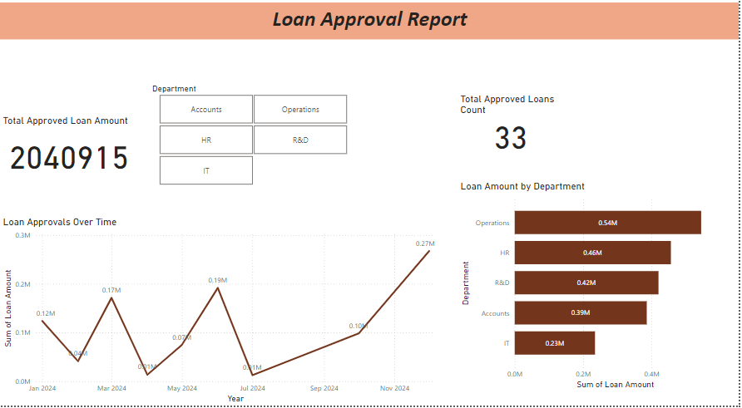

**Loan Repayment Report**

The **Loan Repayment Report** tracks employee loan repayments, focusing on the outstanding balance and monthly deductions. Key visualizations include:

* **Total Repayments (Card)**: Displays the sum of all loan repayments.
* **Remaining Loan Balance (Bar Chart)**: Shows the remaining loan balance for each employee.
* **Monthly Deductions (Line Chart)**: Visualizes monthly repayment deductions over time.

**Key Findings**:

* Provides an overview of total repayments made by employees.
* Tracks the remaining balance for each employee, helping manage loan settlements.
* Visualizes trends in loan repayments, which can assist in predicting future deductions.

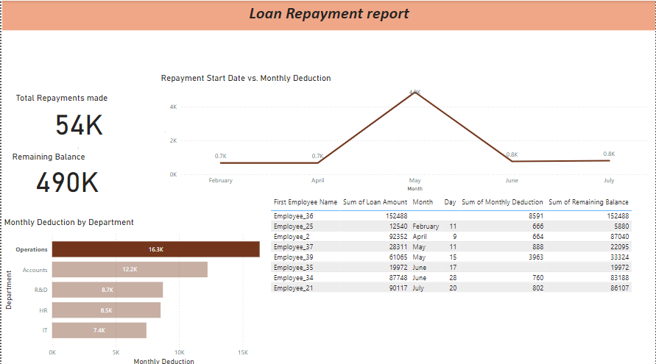

**Loan Rejection Report**

The **Loan Rejection Report** focuses on the reasons behind loan rejections and the distribution of rejections by department. Key visualizations include:

* **Total Rejected Loans (Card)**: Displays the number of rejected loans.
* **Rejection Reasons Distribution (Pie Chart)**: Shows the percentage of rejections by reason (e.g., insufficient credit score, incomplete documentation).
* **Rejections by Department (Bar Chart)**: Visualizes the number of rejections by department.
* **Rejected Loans Over Time (Line Chart)**: Tracks rejections over a specified period.

**Key Findings**:

* Provides insights into the total number of loan rejections.
* Identifies the most common rejection reasons.
* Shows which departments have higher rejection rates.
* Helps recognize any trends in loan rejections over time, aiding decision-making in improving the loan approval process.

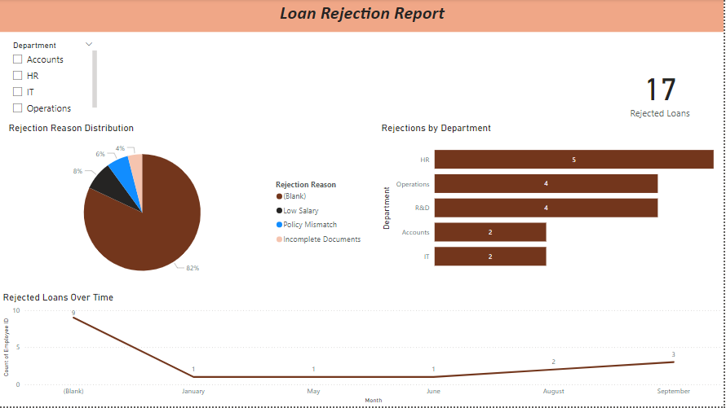

**Salary Deduction Report**

The **Salary Deduction Report** tracks the monthly salary deductions due to employee loans. Key visualizations include:

* **Total Salary Deductions (Card)**: Displays the total amount deducted from employees' salaries.
* **Salary Deductions by Department (Bar Chart)**: Shows how salary deductions are distributed across departments.
* **Salary Deduction vs Loan Amount (Scatter Chart)**: Visualizes the relationship between loan amount and the corresponding salary deductions.
* **Monthly Deductions Over Time (Line Chart)**: Tracks the monthly salary deductions over time.

**Key Findings**:

* Offers a comprehensive view of the total salary deductions made for employee loans.
* Highlights department-wise deduction patterns.
* Helps understand the relationship between loan amounts and monthly deductions.
* Tracks how deductions evolve over time, which is useful for financial forecasting and planning.

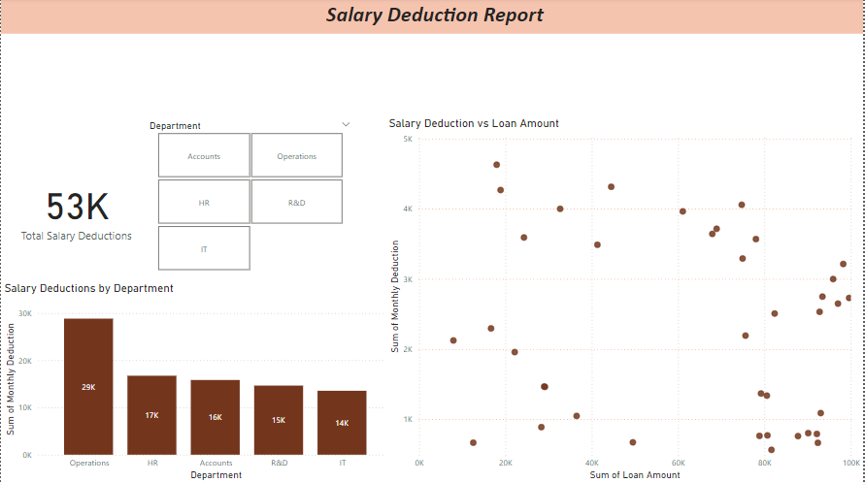

**Loan Eligibility and Utilization Report**

The **Loan Eligibility and Utilization report** evaluates the loan eligibility of employees and their actual utilization, offering insights into loan usage trends across departments and individuals.

* **Total Loan Eligibility and Utilization (Card Visuals):** Shows the sum of the eligible loan amounts and the total loans utilized across the organization.
* **Loan Utilization by Department:** Compares the total eligible loan amount and total utilized amount for each department.
* **Employee-wise Loan Utilization:** Displays individual employee data, including eligible loan amount, loan utilized, and utilization percentage.
* **Loan Utilization Percentage:** Depicts the average loan utilization percentage across all employees.

**Key Findings:**

* Departments with high utilization may indicate effective loan usage or greater financial needs.
* Low utilization percentages highlight potential underuse of loan facilities, suggesting policy or awareness gaps.
* Individual insights help HR and Accounts Departments address disparities in loan usage or refine loan policies.

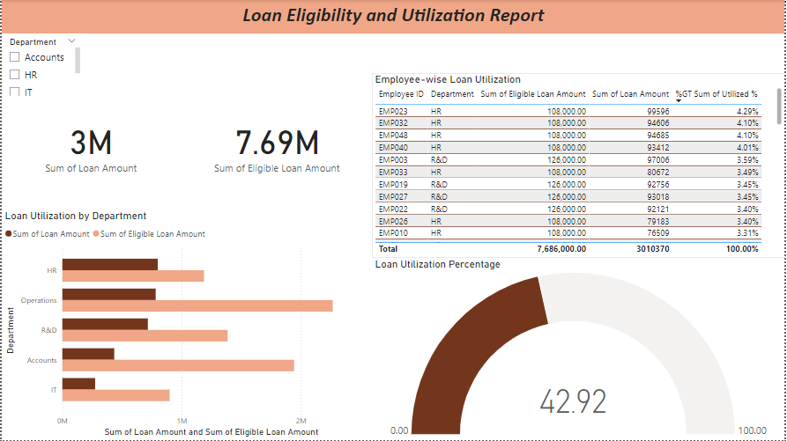

**Question 17 - What is the structure of the message/mail communicated from the HR department to the employee in case the Loan is rejected?**

* The structure of a message or email communicated from the HR department to the employee in case the loan is rejected should be professional, clear, and respectful. Here's how it can be structured:

**1. Subject Line**

* **Example**: Loan Application Status – Rejection Notification

**2. Greeting**

* Start with a polite and professional greeting.
  + **Example**: Dear [Employee Name],

**3. Introduction and Purpose**

* Clearly state the purpose of the email.
  + **Example**: We regret to inform you that your loan application has not been approved.

**4. Reason for Rejection**

* Provide a clear and concise explanation for the rejection. This could be due to criteria such as insufficient eligibility, credit history, or other relevant reasons.
  + **Example**: After careful consideration, we have determined that your application does not meet the required eligibility criteria, specifically [mention the reason, e.g., insufficient tenure with the company, credit score concerns, etc.].

**5. Offer Further Assistance or Clarification**

* If applicable, mention that the employee can reach out for further clarification or support.
  + **Example**: Should you require further clarification regarding this decision, please feel free to reach out to the HR department.

**6. Acknowledge and Encourage Future Applications (if applicable)**

* If applicable, offer encouragement for future loan applications or other financial assistance options.
  + **Example**: We encourage you to apply for a loan in the future once you meet the eligibility requirements. Additionally, if you need assistance with financial planning, we can connect you with our financial advisory services.

**7. Closing Remarks**

* End with a courteous closing statement, maintaining a professional tone.
  + **Example**: Thank you for your understanding, and we appreciate your continued dedication to the company.

**8. Signature**

* Include the HR representative's name and position, along with any relevant contact information.
  + **Example**:  
    Best regards,  
    [Your Name]  
    HR Department  
    [Company Name]  
    [Email Address]

**Sample Mail** :

### ****Subject****: Notification of Loan Application Outcome

**Hello [Employee Name],**

I trust this message finds you well.

I regret to inform you that, after a thorough review, your application for a loan has not been approved at this time. The decision was made based on the following criteria: [mention specific reason, e.g., insufficient eligibility, tenure, credit score, etc.].

We understand that this may be disappointing, and we encourage you to reach out should you require further clarification regarding this decision. Additionally, if you believe there has been an error in the review process or if there is additional information you wish to provide, please do not hesitate to contact the HR department.

You may wish to reapply for the loan at a future time, provided you meet the required criteria. We also encourage you to explore any other financial assistance programs offered by the company that may be available to you.

We appreciate your understanding in this matter and remain committed to supporting your professional growth and well-being within [Company Name].

**Thank you for your attention to this notification.**

**Sincerely,**  
[Your Full Name]  
[Your Position]  
HR Department  
[Company Name]  
[Company Email Address]  
[Phone Number]

**Question 18 - What is the structure of the message/mail communicated from the HR department to the employee in case the Loan is approved?**

* The structure of a message or email communicated from the HR department to the employee in case the loan is approved should be formal, clear, and professional. It should convey the good news, outline the next steps, and provide the necessary details regarding the loan approval. Here’s the structure:

**1. Subject Line**

* **Example**: Loan Application Approval – Next Steps

**2. Greeting**

* Address the employee politely.
  + **Example**: Dear [Employee Name],

**3. Introduction and Good News**

* Clearly state the purpose of the email and convey the approval.
  + **Example**: We are pleased to inform you that your loan application has been approved.

**4. Loan Details (Amount, Terms, and Conditions)**

* Provide the key details of the loan, such as the loan amount, terms, repayment schedule, and any important conditions.
  + **Example**: Your loan of [Amount] has been approved with the following terms:
    - Loan Amount: [Amount]
    - Interest Rate: [Interest Rate]
    - Repayment Schedule: [Time Period/Monthly Installments]
    - Loan Terms: [Any specific terms and conditions]

**5. Next Steps (Action Required)**

* Outline what the employee needs to do next to accept the loan offer and any actions required.
  + **Example**: Kindly review the attached loan agreement for detailed terms and conditions. If you agree to the terms, please sign and return the agreement by [Date].

**6. Loan Disbursement Process**

* Explain how and when the loan will be disbursed.
  + **Example**: Upon receiving your signed agreement, the loan amount will be credited to your account within [Time Period].

**7. Acknowledgment and Contact Information**

* Encourage the employee to reach out for any further clarifications.
  + **Example**: Should you have any questions or require further clarification regarding the loan or the process, please do not hesitate to contact the HR department at [Contact Information].

**8. Closing Remarks**

* End with a courteous and professional closing statement.
  + **Example**: We look forward to supporting you throughout this process. Thank you for your continued dedication to [Company Name].

**9. Signature**

* Include the HR representative’s name, position, and contact details.
  + **Example**: **Sincerely,**  
    [Your Full Name]  
    [Your Position]  
    HR Department  
    [Company Name]  
    [Company Email Address]  
    [Phone Number]

**Sample Email:**

**Subject**: Loan Application Approval – Next Steps

**Hello [Employee Name],**

I hope this message finds you well.

We are pleased to inform you that your loan application has been approved. Below are the details of the loan:

* **Loan Amount**: [Amount]
* **Interest Rate**: [Interest Rate]
* **Repayment Schedule**: [Duration/Monthly Installments]
* **Terms and Conditions**: [Brief Overview of Terms]

Please review the attached loan agreement, which provides detailed information about the loan terms. If you agree with the terms and conditions, kindly sign and return the agreement by [Date]. Upon receipt of the signed agreement, the loan amount will be credited to your account within [Time Period].

If you have any questions or need further assistance, please feel free to contact the HR department at [Contact Information].

We appreciate your dedication to [Company Name] and are happy to support you with this financial assistance.

**Sincerely,**  
[Your Full Name]  
[Your Position]  
HR Department  
[Company Name]  
[Company Email Address]  
[Phone Number]

**Question 19 - Design a sample report on the Loans applications Received by the accounts department**

* The **Loan Applications Summary Report** provides a comprehensive view of the loan requests received by the Accounts Department. It includes the following key sections:

1. **Executive Summary**: Highlights the total loan applications, approval/rejection rates, and pending applications to give a quick snapshot of the loan processing status.
2. **Loan Application Details**: Lists each loan application with details like employee name, loan amount, type, application date, and current status. It also includes reasons for rejections.
3. **Loan Application Status Summary**: Displays the distribution of applications (approved, rejected, pending) using charts, helping stakeholders quickly understand the overall trends.
4. **Loan Application Approval Trends**: Breaks down the data weekly to track the flow of loan applications over time, identifying patterns or anomalies.
5. **Outstanding Loan Applications**: Focuses on pending applications, helping the department prioritize follow-ups to avoid delays.
6. **Loan Application Rejection Reasons**: Summarizes reasons for rejections, enabling better understanding of common issues and potential areas for process improvement.
7. **Action Items and Recommendations**: Provides actionable steps, such as addressing pending applications, reassessing loan limits, and improving credit score guidance for employees.

### ****Purpose****:

This report aims to enhance transparency, streamline the loan management process, and assist in decision-making by providing critical insights into application statuses and trends.

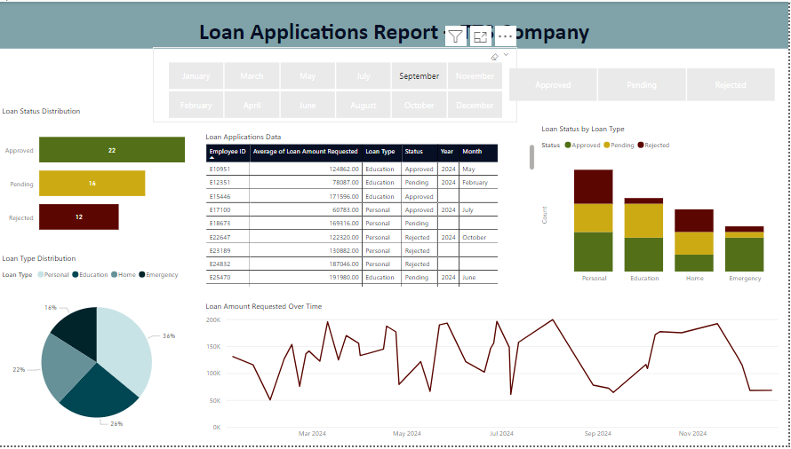

**Question 20 - Which reporting Tools we will use for generating reports.**

* For generating reports, various reporting tools can be used based on the specific needs of an organization or project. These tools help in extracting, analyzing, and presenting data in a structured and comprehensible format. Here’s a detailed breakdown of some of the most commonly used reporting tools and their features:

**1. Power BI**

* Power BI is a business analytics tool by Microsoft. It helps visualize data, share insights, and generate interactive reports and dashboards.
* **Key Features**:
  + **Data Visualization**: Allows users to create a wide range of interactive and visually appealing reports and dashboards.
  + **Integration**: Can connect to multiple data sources, including databases, Excel files, cloud-based data, and more.
  + **Collaboration**: Reports can be shared with stakeholders and published to Power BI services.
  + **Custom Visuals**: Supports custom visualizations and third-party integrations.
* Organizations that need advanced reporting and data visualization tools. Ideal for both operational and strategic reporting.

**2. Tableau**

* Tableau is another powerful data visualization tool that enables users to create interactive reports and dashboards. It's known for its ease of use and user-friendly interface.
* **Key Features**:
  + **Drag-and-Drop Interface**: Users can easily create reports and dashboards with a drag-and-drop interface.
  + **Data Integration**: Connects to various data sources like SQL, Google Analytics, Excel, and cloud-based services.
  + **Real-Time Analytics**: Offers real-time reporting and analytics.
  + **Visualization**: Extensive range of visualization options like heat maps, tree maps, and geographic maps.
* Users who require powerful reporting with dynamic visualizations and easy data exploration.

**3. Google Data Studio**

* A free tool from Google, Google Data Studio allows users to create customizable and shareable reports with data from multiple sources.
* **Key Features**:
  + **Google Integration**: Works seamlessly with Google Analytics, Google Ads, Google Sheets, and other Google services.
  + **Customization**: Offers the ability to design highly customizable reports.
  + **Collaboration**: Reports can be easily shared with other users for collaboration and feedback.
  + **Free Tool**: Free to use with no licensing cost, making it ideal for small businesses.
* Teams using Google Analytics, Google Ads, and other Google services that need free reporting tools.

**4. Excel**

* Excel is one of the most widely used tools for generating simple to moderately complex reports. It is available in almost every organization and offers great flexibility in report generation.
* **Key Features**:
  + **Data Analysis**: Advanced functions for statistical analysis, pivot tables, and data manipulation.
  + **Charts & Graphs**: Allows users to create a variety of charts and graphs for data visualization.
  + **Custom Reporting**: Users can create custom templates, macros, and formulas to generate specialized reports.
  + **Integration**: Works with numerous data sources, including CSV, databases, and cloud-based systems.
* Individuals or small teams needing simple, customizable reports with the flexibility to integrate various data sources.

**5. Crystal Reports**

* Crystal Reports is a business intelligence application used to design and generate reports from a wide range of data sources. It allows the creation of highly formatted, interactive reports.
* **Key Features**:
  + **Report Formatting**: Offers advanced formatting features to create professional-looking, print-ready reports.
  + **Data Integration**: Supports connections to a variety of databases, including SQL, Oracle, and SAP.
  + **Subreports**: Allows users to include multiple subreports in a single report for a more detailed view.
  + **Interactive Reports**: Provides drill-down functionality for interactive reports.
* Organizations that require highly formatted, complex, and detailed reports for large-scale business operations.

**6. SAS (Statistical Analysis System)**

* SAS is a suite of software tools used for advanced analytics, business intelligence, and data management. It is commonly used for complex statistical and analytical reporting.
* **Key Features**:
  + **Advanced Analytics**: Powerful statistical analysis tools and predictive modeling capabilities.
  + **Data Management**: Offers extensive data management and preparation capabilities.
  + **Custom Reports**: Ability to create highly customized reports, including forecasting and trend analysis.
  + **Automation**: SAS allows automating the reporting process, reducing manual effort.
* Organizations that require advanced statistical analysis and data management in their reports.

**7. SQL Reporting Services (SSRS)**

* SQL Server Reporting Services (SSRS) is a server-based reporting tool from Microsoft that allows the creation, management, and delivery of reports.
* **Key Features**:
  + **Report Creation**: Users can design detailed, tabular, and matrix reports using a visual designer.
  + **Data Connectivity**: Integrates well with SQL Server databases and allows pulling data from various data sources.
  + **Scheduled Reports**: Reports can be scheduled and automated for delivery at specific intervals.
  + **Interactive Reports**: Reports can be made interactive for users to drill down into the data.
* Organizations that use SQL Server for their databases and need advanced server-based reporting with automation capabilities.

**8. Zoho Analytics**

* Zoho Analytics is a cloud-based data analytics and reporting tool that helps create visualizations, reports, and dashboards.
* **Key Features**:
  + **Drag-and-Drop Interface**: Users can easily create reports and dashboards through an intuitive drag-and-drop interface.
  + **Data Integration**: Connects with various third-party applications like Google Analytics, Facebook, and SQL databases.
  + **Automated Reporting**: Allows the scheduling of reports for automatic delivery to stakeholders.
  + **Collaboration**: Easy to share reports and collaborate in real-time.
* Small to mid-sized businesses looking for a cost-effective cloud-based reporting solution.

**9. JasperReports**

* JasperReports is an open-source reporting tool widely used for generating rich reports in PDF, Excel, HTML, and other formats.
* **Key Features**:
  + **Open Source**: A free and open-source reporting solution for organizations with development teams.
  + **Data Integration**: Supports integration with various data sources, including JDBC, XML, and CSV files.
  + **Customizable Reports**: Developers can customize report templates and layouts.
  + **Report Server**: Comes with JasperReports Server, which allows for scheduling, security, and management of reports.
* Organizations that prefer open-source solutions or need custom reporting embedded in their applications.