**PROJECT NAME: I-CONNECT – TERM DEPOSIT**

**Business Case Document**

**Background:** Term Deposits has been one of the favorable products in banking industry since a long time. This has been one of the major USP for banks to attract clients by offering competitive interest rates.

In an ideal situation, post receipt of term deposit request from client end the requests are booked in single day from the bank end. The current process at the bank end is that term deposit request is received at branch end and after initial scrutiny of request letter the same is sent to Central Processing Team by uploading request in application – **I - Connect**.

However it was observed that while processing of the request at the branch end there were mis-outs, errors by the branch user i.e. the maker, leading to delay in term deposit booking and ultimately affecting the FTR (First Time Right) criteria for the respective branch performance and further leading to customer dis-satisfaction situations.

To overcome this problem the bank decided to modify its procedural methods by enhancing a new feature in the application by **creating an E-checklist** to be updated at a maker and checker level. This was seen as an opportunity to get term deposits being booked in a few hours’ time and resulting to client delight.

**Goal:** The purpose of this project is to mitigate the delay in processing of term deposits and avoiding potential client complaints and possible loss in terms of penal action from client end.

We have identified **I - Connect** application enabled with E-checklist to ensure that term deposits are processed at FTR (First Time Right).

By this application, the request would flow seamlessly from Branch end to Central Processing Team. By the introduction of this new application feature the bank would be able to increase it funds flow in the form of deposits received from client, increase in client base, increase in efficiency of term deposit processing.

Approach: IDFC First Bank has identified its team for this project as below:

* Bank Committee : Ms. Priyanka – Project Head

Mr. Rajesh – SME

Ms. Harshita & Ms. Devika – End User

* I-Connect Team : Mr. Hanumant - Project Leader

Mr. Rohit – Business Analyst

Mr. Gajanan & Mr. Yogesh - Java Developers

Ms. Madhuri & Ms. Anshika – Testers

Ms. Sneha – Database Admin

In terms of organizational changes, there would be an introduction of maker and checker concept pertaining to term deposit bookings. Time frame for return on investment would be 2 to 3 years. To identify the stakeholders we would implement RACI Matrix.

**BA Strategy**

To complete the project the below steps have been incorporated

1. **What elicitation techniques have been applied**

* **Document Analysis** – Document analysis is done by examining the available documents / materials and understanding the product, process and project. We can consult the Subject Matter Expert (SME) here for better clarity on the documentation, which needs to be the latest version.
* **Reverse Engineering –** Reverse engineeringalso known as back engineering is the process of extraction of knowledge or design information from existing system and then re-working on the same.

**White box engineering –** we know about the functionality of the system

* **Brainstorming Session** – Brainstorming can be done either individually or in groups. The purpose of brainstorming is to generate as many new ideas and after reviewing the same identify the most suitable as the best solution
* **Observation –** Observation relies on studying people doing their routine job also known as job shadowing. Below observation technique was

**Active Observation –** here we ask questions **5W1H** – What, Who, Where, When, Why and How. Observation can be daily or adhoc.

1. **Stakeholder analysis**

Stakeholder are person or group of persons who are directly or indirectly associated with the project. They are as follows

* Business Stakeholder
* Project Stakeholder
* 3rd Party Stakeholder
* Negative Stakeholder

**RACI Matrix** stands for **Responsible, Accountable, Consulted and Informed** stakeholders vis a vis respective tasks assigned for this project.

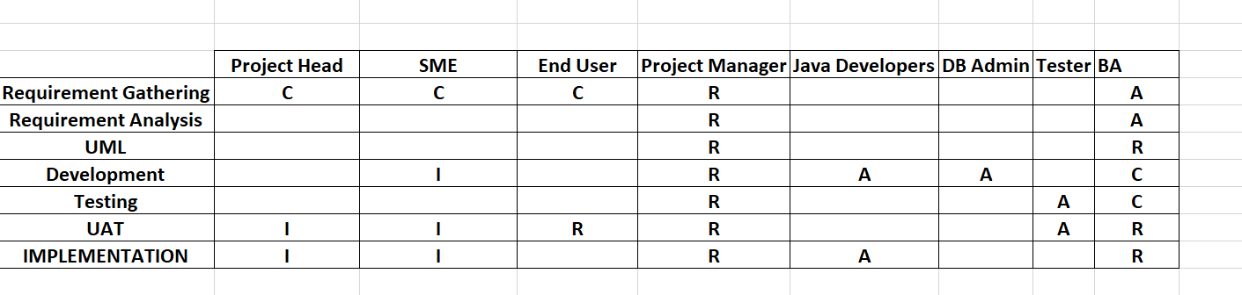

1. **Documentations**

* **Business Case Document** consists of why was the project initiated, what are the current problem, who are the stakeholders associated with this project, what are the resources required and expertise expected from them, what technology would be used in the project and the ROI for this project
* **Business Requirement Document** consists of business requirement of the client as to what software / application is expected to satisfy their needs. It includes project description, project scope, current state, future state, functional and non-functional requirements.
* **Functional Requirement Document** consists of requirements needed to achieve the business needs. It emphasizes on functionalities that are required in the application / software that ultimately meets the client requirements. The development team works on these functionalities to take things forward.
* **Use Case document** consists of how users interact with a system or product. It mentions the elements of use case such as Goal, actors, system boundaries, preconditions, main flow and alternative flow.
* **Change Request document** consists of any changes asked from the client end for the existing software / applications. The same also requires sign off from client end.

1. **Documentations Sign Off**

Sign off to be take on System Requirement Specification, which is very critical in the entire process. Sign Off can be taken by email confirmation from the Bank Committee – Project Head.

1. **Approvals**

This was done by arranging a formal meeting with the Bank Committee Members to keep them informed and get continuous feedback

1. **Communications**

This was done by conducting regular meetings with frequency of weekly, bi weekly, and monthly to update the stakeholder. Also updates mails were sent to Bank Committee regarding the status.

1. **UAT – Client Acceptance Form**

We prepared User Acceptance Testing and conducted UAT with end users, fixed the issues, prepared the acceptance form, conduct final review meeting with the the Bank Committee Members and obtained sign off for the same.

**Functional Specifications**

|  |  |
| --- | --- |
| **Project Name** | I-Connect – Term Deposit Booking |
| **Client Name** | IDFC First Bank Ltd |
| **Project Version** | 5.0 |
| **Project Sponsor** | Ms. Priyanka – Project Head |
| **Project Initiation Date** | 01.12.2024 |

**Functional Requirement Specifications**

|  |  |  |  |
| --- | --- | --- | --- |
| **Requirement ID** | **Requirement Name** | **Requirement Description** | **Priority** |
| **FR001** | Login | Employee should be able to Login with Employee ID and Password | 10 |
| **FR002** | Login ID | Employee Login ID should be employee ID Only | 10 |
| **FR003** | Login Password | Employee Login Password should be alpha numeric with a special character subject to maximum 12 characters | 10 |
| **FR004** | Term Deposit Page | E-Checklist Tab to enabled on Term Deposit Page | 1 |
| **FR005** | Term Deposit E-Checklist | E-Checklist Tab consist of the following Branch Code, Term Deposit Value Date, Product Code, Signature Verification Confirmation, Maker Name, Checker Name and Save Button | 1 |
| **FR006** | Branch Code - Mandatory | Branch Code should be 4 digit only | 1 |
| **FR007** | Term Deposit Value Date - Mandatory | Term Deposit Value Date should be in DDMMYYYY format only | 1 |
| **FR008** | Product Code - Mandatory | Product Code should be 8 digit only | 1 |
| **FR009** | Signature Verification - Mandatory | Signature Verification Confirmation to be mandatory | 1 |
| **FR010** | Signature Verification - Mandatory | Signature Verification Confirmation to be mandatory | 1 |
| **FR011** | Make Name - Mandatory | Maker Name to auto fetch details post inputting Name and Surname | 1 |
| **FR012** | Checker Name - Mandatory | Checker Name to auto fetch details post inputting Name and Surname | 1 |
| **FR013** | Save Tab - Mandatory | Save Tab to be enable incase all mandatory fields are updated by maker and checker | 1 |
| **FR014** | Term Deposit – Documents Page | E-checklist to be saved in Pdf format only | 2 |