**Question-1 Identify minimum 20 functional requirements.**

|  |  |  |  |
| --- | --- | --- | --- |
| **Req ID** | **Req Name** | **Req Description** | **Priority** |
| FR001 | User Registration | Users Should be able to register with Application | 10 |
| FR002 | Search for the Product | Users should be able to search for the available products | 8 |
| FR003 | Adding Product to Cart | Users Should be able to add Products to the Cart | 8 |
| FR004 | Adding Product to wish list (Buy Later) | Users should be able to add products to Wishlist | 8 |
| FR005 | Payment with Different Modes | Users should be able to make a payment with different modes. (Cards/Wallet/UPI) | 9 |
| FR006 | Order Confirmation on Email | Users should get the order confirmation through email | 7 |
| FR007 | Delivery Tracking | Users should get the shipment status through the application | 7 |
| FR008 | Catalogue Browsing | Users should be able to browse the catalogue | 9 |
| FR009 | Simple Payment Method | User should be able to make payment without any complications | 8 |
| FR010 | Buy Later | User should be able to view Wishlist (buy later) item by login into application | 6 |
| FR011 | Add Product to Catalogue | Manufacturers should be able to add product to catalogue | 10 |
| FR012 | View Orders | Manufacturers should be able to view orders in their dashboard | 8 |
| FR013 | Update Orders | Manufactures should be able to update order status to WIP/Ready for courier/ Dispatched | 8 |
| FR014 | Tracking Details | Manufactures should be able to update the delivery tracking number post-dispatch | 7 |
| FR015 | Inventory Level Status | Manufactures should be able to check inventory level status in their login dashboard | 7 |
| FR016 | Minimum Inventory level Notification | Manufactures should get an email alert once a product item reaches minimum/Reorder level | 6 |
| Fr017 | Replenish Inventory | Manufactures should be able to replenish (fill) inventory level in the product dashboard | 10 |
| FR018 | Order History | Users can view their order history | 5 |
| FR019 | Cash On Delivery | User should be able to choose cash on delivery option | 9 |
| FR019 | Forgot User ID/Pwd | User should be able to recover User ID and password | 7 |
| FR020 | Feedback on Products | User Should be able to provide feedback on purchased products | 5 |

Non-Functional Requirements

|  |  |  |  |
| --- | --- | --- | --- |
| Req ID | Req Name | Req Description | Priority |
| NFR0001 | Page Loading Time | Page should load under 2 sec | 10 |
| NFR0002 | App Availability | App should be available for Desktop, Android and Apple | 10 |
| NFR0003 | User Interface | The UI should be intuitive and require minimal effort to navigate, First-time users should be able to understand and operate the interface without extensive guidance | 9 |
| NFR0004 | Search Item Listing | The system must display search results within 2 seconds after the user initiates a query, Results must be sorted and filtered according to user preferences, such as price, popularity, and ratings | 9 |
| NFR0005 | Approx Shipping Time | Each selected product should mention the approximate shipping time to user’s location based on PIN Code/Zip Code | 8 |
| NFR0006 | Ratings/Feedback | User should be able to give ratings on a 5 star scale and add their feedbacks as comments under each product listing post purchase | 7 |
| NFR0007 | Ratings/Feedback visibility | The ratings/feedback given by users in NFR0006 should reflect under product while browsing by other users (Post Moderation by Admin) | 5 |
| NFR0008 | FAQ for products | The product listing should provide facility of asking questions and providing answers by other users or manufacturing companies to answer frequently asked questions | 4 |
| NFR0009 | Data Privacy | The user’s sensitive data should be protected and must not be shared with 3rd parties, The data must be used according to data privacy laws of the country and only be used with user’s consent. | 10 |
| NFR0010 | Browser Compatibility | The desktop application should be compatible to all frequently used browsers viz. Chrome, Edge, Safari, Opera etc. | 8 |

**Question 2–Minimum 5 page designs - 15 Marks -** Make wireframe and prototypes

Answer - Login Page-1

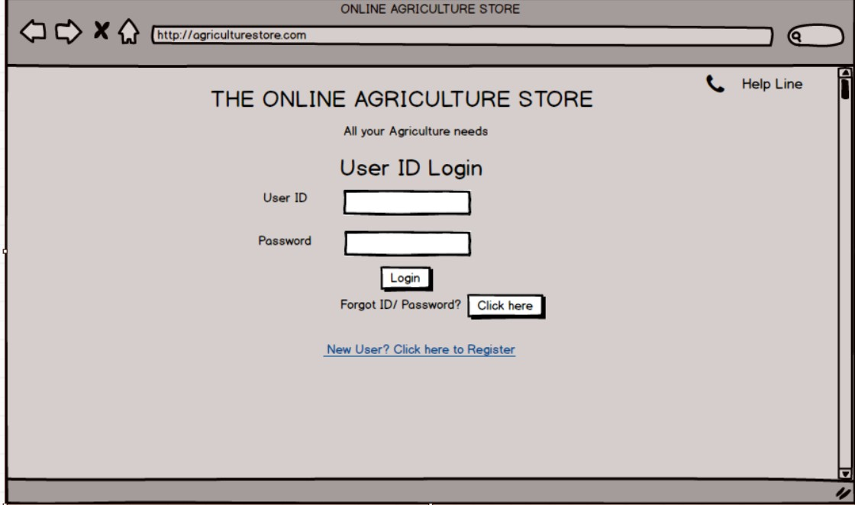

Registration Page-2

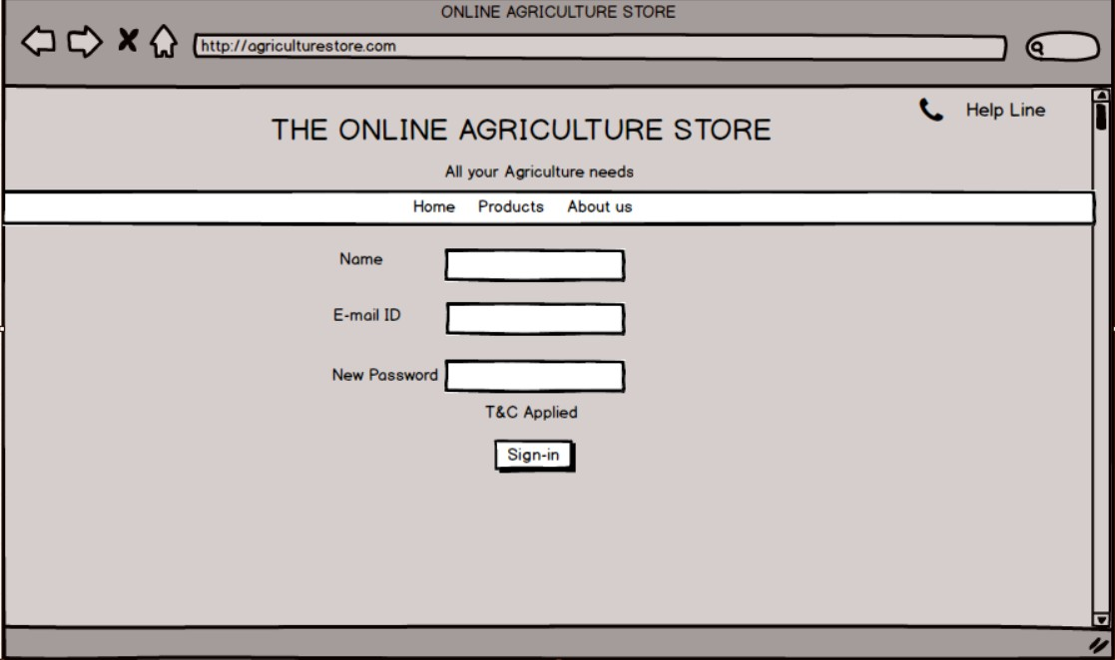

Welcome Page-3

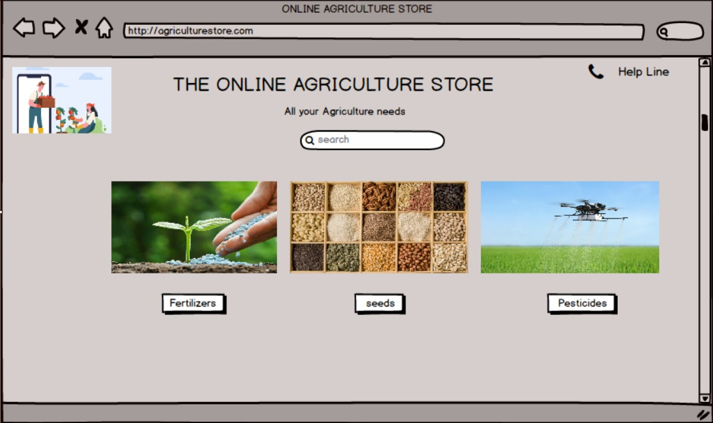

Search Item Display-4

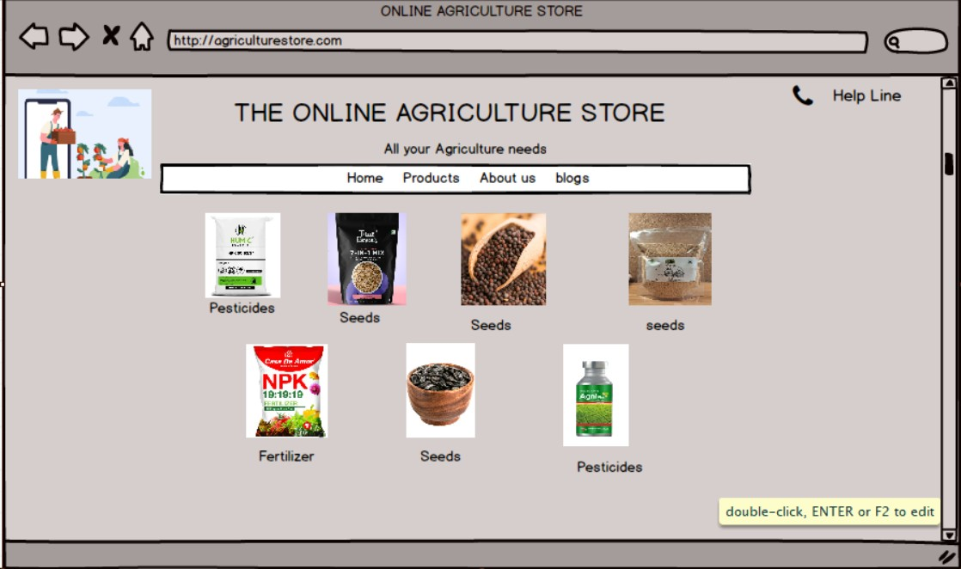

Item Display Page-5

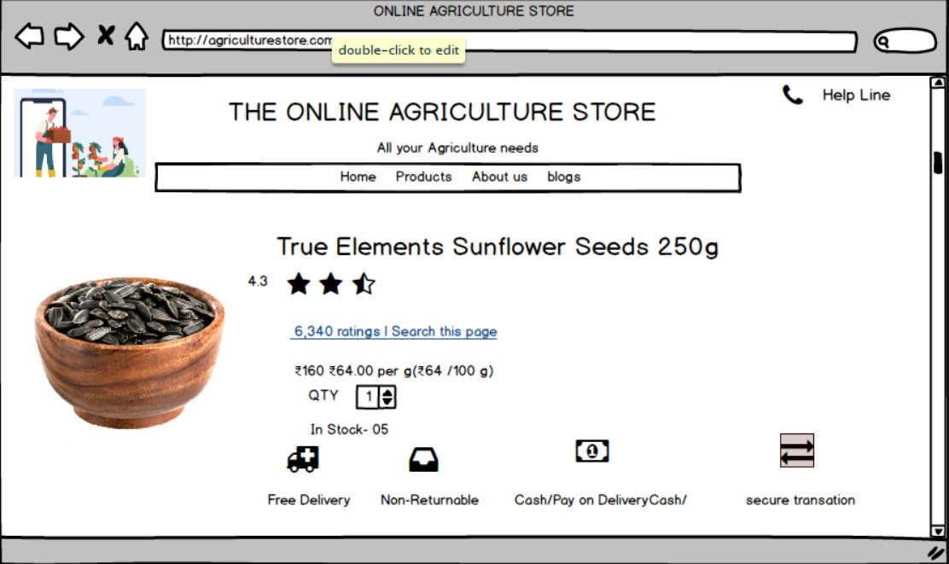

**Question 3 –** Make a note of the Tools, which you are using for above concepts. Tools (Visio, Balsamiq)

**Answer –**

**Microsoft Visio -**

Microsoft Visio is a diagrammatic and vector graphics application, Microsoft Visio is a software for drawing a variety of diagrams, these includes flowcharts, org charts, building plans, data flow diagrams, Process flow diagrams, Business process modelling, UML Modelling, 3D maps and many more.

With Visio we can visually organize complex ideas like:

* Create Diagrams- We can create a variety of diagram, including flowcharts, timelines, organization charts, network diagrams and much more.
* Add Content- We can add shapes, text, pictures for the diagrams
* Link to Data-We can link the diagrams to data from Excel, Access or SharePoint
* Save and Share- We can save the diagrams to cloud and share them with other through a browser.
* Integrate with Microsoft 365- We can create, view, edit, and collaborate on Visio diagrams from within Microsoft Teams.

UML Diagrams in Microsoft Visio

* Class Diagrams
* Component Diagrams
* Deployment Diagrams
* Sequence Diagrams
* Activity Diagrams
* State Machine Diagrams
* Use Case Diagrams
* Communication Diagrams
* Database Notation Diagrams

**BALSAMIQ-**

Balsamic is a wireframing tool that helps users create visual representations of software interfaces, like websites, applications and dashboards.

Balsamiq is used by a wide range of people in software industry like Product Managers, Developers, Business Analysts and UI/UX designers.

The intend use of Balsamiq is in the early stages of the software development process

**Features of Balsamiq**

* Drag and Drop Design
* Real time collaboration
* Premade templates, symbols and UX elements
* Interface replicates hand drawn sketches

.

**Question 4 – (**RTM) **-** A business analyst’s key responsibilities are to keep track of the requirements and make sure that no requirement is missed. Mr. Henry and peter have approached you regarding the current status of the project. How will you tackle this situation? Prepare RTM.

|  |  |  |  |  |  |  |  |  |  |
| --- | --- | --- | --- | --- | --- | --- | --- | --- | --- |
| Req ID | Req Name | Req Description | Design | Code | Unit Testing T1 | Component Testing T2 | System Testing T3 | System Integration Testing T4 | UAT |
| FR001 | User Registration | Users Should be able to register with Application | Complete | Complete | Complete | Complete | Complete | Complete | Complete |
| FR002 | Search for the Product | Users should be able to search for the available products | Complete | Complete | Complete | Complete | Complete | Complete | Complete |
| FR003 | Adding Product to Cart | Users Should be able to add Products to the Cart | Complete | Complete | Complete | Complete | Complete | Complete | Complete |
| FR004 | Adding Product to wish list (Buy Later) | Users should be able to add products to Wishlist | Complete | Complete | Complete | Complete | Complete | Complete | Complete |
| FR005 | Payment with Different Modes | Users should be able to make a payment with different modes. (Cards/Wallet/UPI) | Complete | Complete | Complete | Complete | Complete | Complete | Complete |
| FR006 | Order Confirmation on Email | Users should get the order confirmation through Email | Complete | Complete | Complete | Complete | Complete | Complete | Complete |
| FR007 | Delivery Tracking | Users should get the shipment status through the application | Complete | Complete | Complete | Complete | Complete | Complete | Complete |
| FR008 | Catalogue Browsing | Users should be able to browse the catalogue | Complete | Complete | Complete | Complete | Complete | Complete | Complete |
| FR009 | Simple Payment Method | User should be able to make payment without any complication | Complete | Complete | Complete | Complete | Complete | Complete | Complete |
| FR010 | Buy Later | User should be able to view wishlist (buy later) item by login into application | Complete | Complete | Complete | Complete | Complete | Complete | Complete |

**Question 5 –** Prepare 10 Test Case Documents

**Answer- Test Case Doc 1**

|  |  |  |  |
| --- | --- | --- | --- |
| Test Case ID |  | Test Case Name |  |
| Project ID |  | Project Name |  |
| PM ID |  | PM Name |  |
| Test Strategy ID |  | Tester ID |  |
| Test Plan ID |  | Tester Name |  |
| Test Schedule ID |  |  |  |

|  |
| --- |
| **Scenario:** New Account Creation/Registration |
| **Link to that Page:** |

|  |  |  |  |  |  |
| --- | --- | --- | --- | --- | --- |
| Input Data | Set 1  Input Name : Kiran  Input Email : [test1@aptit.com](mailto:test1@aptit.com)  Pwd: H1ndut@n | Set 2  Input Name : Manas  Input Email : [test2@aptit.com](mailto:test2@aptit.com)  Pwd: Newt0n#3 | Set 3  Input Name : Jeckob  Input Email : [test3@aptit.com](mailto:test3@aptit.com)  Pwd: S1ngap@re | Set 4  Input Name : Hendry  Input Email : [test4@aptit.com](mailto:test4@aptit.com)  Pwd: Perth@2024 | Set 5  Input Name : slok  Input Email : [test5@aptit.com](mailto:test5@aptit.com)  Pwd: T@rminat0r |
| Expected Behaviour | Successful ID creation & Email Notification | Successful ID creation & Email Notification | Successful ID creation & Email Notification | Successful ID creation & Email Notification | Successful ID creation & Email Notification |
| Actual Behaviour |  |  |  |  |  |
| Comments |  |  |  |  |  |
| Result (Pass/Fail) |  |  |  |  |  |

**Test Case Doc 2**

|  |  |  |  |
| --- | --- | --- | --- |
| Test Case ID |  | Test Case Name |  |
| Project ID |  | Project Name |  |
| PM ID |  | PM Name |  |
| Test Strategy ID |  | Tester ID |  |
| Test Plan ID |  | Tester Name |  |
| Test Schedule ID |  |  |  |

|  |
| --- |
| **Scenario:** Login |
| **Link to that Page:** |

|  |  |  |  |  |  |
| --- | --- | --- | --- | --- | --- |
| Input Data | Set 1  Input Email : [test1@aptit.com](mailto:test1@aptit.com)  Pwd: H1ndut@n | Set 2  Input Email : [test2@aptit.com](mailto:test2@aptit.com)  Pwd: Newt0n#3 | Set 3  Input Email : [test3@aptit.com](mailto:test3@aptit.com)  Pwd: S1ngap@re | Set 4  Input Email : [test4@aptit.com](mailto:test4@aptit.com)  Pwd: Perth@2024 | Set 5  Input Email : [test5@aptit.com](mailto:test5@aptit.com)  Pwd: T@rminat0r |
| Expected Behaviour | Successful login, User Dashboard page | Successful login, User Dashboard page | Successful login, User Dashboard page | Successful login, User Dashboard page | Successful login, User Dashboard page |
| Actual Behaviour |  |  |  |  |  |
| Comments |  |  |  |  |  |
| Result (Pass/Fail) |  |  |  |  |  |

**Test Case Doc 3**

|  |  |  |  |
| --- | --- | --- | --- |
| Test Case ID |  | Test Case Name |  |
| Project ID |  | Project Name |  |
| PM ID |  | PM Name |  |
| Test Strategy ID |  | Tester ID |  |
| Test Plan ID |  | Tester Name |  |
| Test Schedule ID |  |  |  |

|  |
| --- |
| **Scenario:** Add to Cart |
| **Link to that Page:** |

|  |  |  |  |  |  |
| --- | --- | --- | --- | --- | --- |
| Input Data | Set 1  Select & Add to cart item 1, item 2,3 | Set 2  Select & Add to cart item 4, item 5, 6 | Set 3  Select & Add to cart item 7, item 8, 9 | Set 4  Select & Add to cart item 4, item 8, 6 | Set 5  Select & Add to cart item 9, item 13, 2, 10 |
| Expected Behaviour | Cart Page should reflect item 1, item 2,3 | Cart Page should reflect item 4, item 5, and 6 | Cart Page should reflect item 7, item 8, and 9 | Cart Page should reflect item 4, item 8, and 6 | Cart Page should reflect item 9, item 13, item 2, and Item 10 |
| Actual Behaviour |  |  |  |  |  |
| Comments |  |  |  |  |  |
| Result (Pass/Fail) |  |  |  |  |  |

**Test Case Doc 4**

|  |  |  |  |
| --- | --- | --- | --- |
| Test Case ID |  | Test Case Name |  |
| Project ID |  | Project Name |  |
| PM ID |  | PM Name |  |
| Test Strategy ID |  | Tester ID |  |
| Test Plan ID |  | Tester Name |  |
| Test Schedule ID |  |  |  |

|  |
| --- |
| **Scenario:** Move to Payment Page |
| **Link to that Page:** |

|  |  |  |  |  |  |
| --- | --- | --- | --- | --- | --- |
| Input Data | Set 1  Select & Add to cart item 1, item 6, 7, Click on payment link | Set 2  Select & Add to cart item 11, item 5, 9, Click on payment link | Set 3  Select & Add to cart item 3, item 2, 12, Click on payment link | Set 4  Select & Add to cart item 4, item 8, 15, Click on payment link | Set 5  Select & Add to cart item 9, item 13, 2, 10, Click on payment link |
| Expected Behaviour | Payment Page should open | Payment Page should open | Payment Page should open | Payment Page should open | Payment Page should open |
| Actual Behaviour |  |  |  |  |  |
| Comments |  |  |  |  |  |
| Result (Pass/Fail) |  |  |  |  |  |

**Test Case Doc 5**

|  |  |  |  |
| --- | --- | --- | --- |
| Test Case ID |  | Test Case Name |  |
| Project ID |  | Project Name |  |
| PM ID |  | PM Name |  |
| Test Strategy ID |  | Tester ID |  |
| Test Plan ID |  | Tester Name |  |
| Test Schedule ID |  |  |  |

|  |
| --- |
| **Scenario:** Move to Payment Page |
| **Link to that Page:** |

|  |  |  |  |  |  |
| --- | --- | --- | --- | --- | --- |
| Input Data | Set 1  Select Payment by Card and select Debit/ Credit Card | Set 2  Select payment by UPI and select Mobile number/UPI App/UPI address | Set 3  Select Pay by Wallet and Select desired Wallet type | Set 4  Select Cash on Delivery from available options | Set 5 |
| Expected Behaviour | The Pay by Debit/Credit radio button should appear for choosing the card type | Post selecting Pay by UPI, The options should open up with radio buttons for choosing Mobile Number/UPI App/UPI Address | Post Selecting Pay By Wallet, The options (Paytm/Mobikwik/Payzapp/Others) should appear | The payment page should confirm the option by asking for OTP and move to Order Confirmation Page |  |
| Actual Behaviour |  |  |  |  |  |
| Comments |  |  |  |  |  |
| Result (Pass/Fail) |  |  |  |  |  |

**Test Case Doc 6**

|  |  |  |  |
| --- | --- | --- | --- |
| Test Case ID |  | Test Case Name |  |
| Project ID |  | Project Name |  |
| PM ID |  | PM Name |  |
| Test Strategy ID |  | Tester ID |  |
| Test Plan ID |  | Tester Name |  |
| Test Schedule ID |  |  |  |

|  |
| --- |
| **Scenario:** Order Confirmation |
| **Link to that Page:** |

|  |  |  |  |  |  |
| --- | --- | --- | --- | --- | --- |
| Input Data | Set 1  On payment page - Enter test credit card No (123412341234 CVV 111) and click on pay | Set 2  On payment page – Pay by test UPI address testpay@aptit | Set 3  On Payment page select pay by Wallet- Select Paytm and pay by test wallet assigned | Set 4  On Payment page select Cash on Delivery and authenticate using test mobile number 961111111 and OTP 123123 | Set 5 |
| Expected Behaviour | Payment Confirmation page should be displayed and will move to Order Confirmed page | Payment Confirmation page should be displayed and will move to Order Confirmed page | Payment Confirmation page should be displayed and will move to Order Confirmed page | Order Confirmation page should be displayed |  |
| Actual Behaviour |  |  |  |  |  |
| Comments |  |  |  |  |  |
| Result (Pass/Fail) |  |  |  |  |  |

**Test Case Doc 6**

|  |  |  |  |
| --- | --- | --- | --- |
| Test Case ID |  | Test Case Name |  |
| Project ID |  | Project Name |  |
| PM ID |  | PM Name |  |
| Test Strategy ID |  | Tester ID |  |
| Test Plan ID |  | Tester Name |  |
| Test Schedule ID |  |  |  |

|  |
| --- |
| **Scenario:** Email Notification for Order Confirmation |
| **Link to that Page:** |

|  |  |  |  |  |  |
| --- | --- | --- | --- | --- | --- |
| Input Data | Set 1  On payment page - Enter test credit card No (123412341234 CVV 111) and click on pay | Set 2  On payment page – Pay by test UPI address testpay@aptit | Set 3  On Payment page select pay by Wallet- Select Paytm and pay by test wallet assigned | Set 4  On Payment page select Cash on Delivery and authenticate using test mobile number 961111111 and OTP 123123 | Set 5 |
| Expected Behaviour | Email confirmation for order should be received on user registered email within 5 mins. | Email confirmation for order should be received on user registered email within 5 mins. | Email confirmation for order should be received on user registered email within 5 mins. | Email confirmation for order should be received on user registered email within 5 mins. |  |
| Actual Behaviour |  |  |  |  |  |
| Comments |  |  |  |  |  |
| Result (Pass/Fail) |  |  |  |  |  |

**Test Case Doc 7**

|  |  |  |  |
| --- | --- | --- | --- |
| Test Case ID |  | Test Case Name |  |
| Project ID |  | Project Name |  |
| PM ID |  | PM Name |  |
| Test Strategy ID |  | Tester ID |  |
| Test Plan ID |  | Tester Name |  |
| Test Schedule ID |  |  |  |

|  |
| --- |
| **Scenario:** Order Tracking |
| **Link to that Page:** |

|  |  |  |  |  |  |
| --- | --- | --- | --- | --- | --- |
| Input Data | Set 1  Open Order Tracking page, Enter Test Order No – FAM24100900001  (Click Submit) | Set 2  Open Order Tracking page, Enter Test Order No – FAM24100900002  (Click Submit) | Set 3  Open Order Tracking page, Enter Test Order No – FAM24100900003  (Click Submit) | Set 4  Open Order Tracking page, Enter Test Order No – FAM24100900004  (Click Submit) | Set 5 |
| Expected Behaviour | Tracking page should open with Shipping Status as updated by Manufacturing Company | Tracking page should open with Shipping Status as updated by Manufacturing Company | Tracking page should open with Shipping Status as updated by Manufacturing Company | Tracking page should open with Shipping Status as updated by Manufacturing Company |  |
| Actual Behaviour |  |  |  |  |  |
| Comments |  |  |  |  |  |
| Result (Pass/Fail) |  |  |  |  |  |

**Test Case Doc 8**

|  |  |  |  |
| --- | --- | --- | --- |
| Test Case ID |  | Test Case Name |  |
| Project ID |  | Project Name |  |
| PM ID |  | PM Name |  |
| Test Strategy ID |  | Tester ID |  |
| Test Plan ID |  | Tester Name |  |
| Test Schedule ID |  |  |  |

|  |
| --- |
| **Scenario:** Product Rating |
| **Link to that Page:** |

|  |  |  |  |  |  |
| --- | --- | --- | --- | --- | --- |
| Input Data | Set 1  Open Test Product (No Ratings Yet) page and on Ratings Tab Click submit Ratings – Give a 3 Star Rating, Reopen the page and check the rating | Set 2  Open Test Product (As opened in Set 1) page and on Ratings Tab Click submit Ratings – Give a 5 Star Rating, Reopen the page and check the rating | Set 3  Open Test Product (As opened in Set 1,2) page and on Ratings Tab Click submit Ratings – Give a 1 Star Rating, Reopen the page and check the rating | Set 4  Open Test Product (As opened in Set 1,2,3) page and on Ratings Tab Click submit Ratings – Give a 4 Star Rating, Reopen the page and check the rating | Set 5 |
| Expected Behaviour | Rating should display 3 Star | Rating should be average of last rating and current rating i.e. 4 Star | Rating should be average of last ratings and current rating i.e 2.7 Star | Rating should be average of last rating and current rating i.e 3.4 Star |  |
| Actual Behaviour |  |  |  |  |  |
| Comments |  |  |  |  |  |
| Result (Pass/Fail) |  |  |  |  |  |

**Test Case Doc 9**

|  |  |  |  |
| --- | --- | --- | --- |
| Test Case ID |  | Test Case Name |  |
| Project ID |  | Project Name |  |
| PM ID |  | PM Name |  |
| Test Strategy ID |  | Tester ID |  |
| Test Plan ID |  | Tester Name |  |
| Test Schedule ID |  |  |  |

|  |
| --- |
| **Scenario:** Incorrect Username |
| **Link to that Page:** |

|  |  |  |  |  |  |
| --- | --- | --- | --- | --- | --- |
| Input Data | Set 1  Open login page and enter unregistered test email id [test6@aptit.com](mailto:test6@aptit.com) pwd Test@r34 | Set 2  Open login page and enter unregistered test email id [test7@aptit.com](mailto:test7@aptit.com) pwd Test@r35 | Set 3  Open login page and enter unregistered test email id [test7@aptit.com](mailto:test7@aptit.com) pwd Test@r35 | Set 4  Open login page and enter unregistered test email id [test7@aptit.com](mailto:test7@aptit.com) pwd Test@r35 | Set 5 |
| Expected Behaviour | Error page display with link for forgot id/password | Error page display with link for forgot id/password | Error page display with link for forgot id/password | Error page display with link for forgot id/password |  |
| Actual Behaviour |  |  |  |  |  |
| Comments |  |  |  |  |  |
| Result (Pass/Fail) |  |  |  |  |  |

**Test Case Doc 10**

|  |  |  |  |
| --- | --- | --- | --- |
| Test Case ID |  | Test Case Name |  |
| Project ID |  | Project Name |  |
| PM ID |  | PM Name |  |
| Test Strategy ID |  | Tester ID |  |
| Test Plan ID |  | Tester Name |  |
| Test Schedule ID |  |  |  |

|  |
| --- |
| **Scenario:** Order Detail Update by Manufacturer on portal |
| **Link to that Page:** |

|  |  |  |  |  |  |
| --- | --- | --- | --- | --- | --- |
| Input Data | Set 1  Open login page and select order id OD000123 Click on update details, Update drawdown to ready to ship, Check order status page by entering order id | Set 2  Open login page and select order id OD000123 Click on update details, Update drawdown to “Picked by Courier”, Check order status page by entering order id | Set 3  Open login page and select order id OD000123 Click on update details, Update drawdown to “In Transit”, Check order status page by entering order id | Set 4  Open login page and select order id OD000123 Click on update details, Update drawdown to “Out for Delivery”, Check order status page by entering order id | Set 5  Open login page and select order id OD000123 Click on update details, Update drawdown to “Delivered to UserName”, Check order status page by entering order id |
| Expected Behaviour | Order Status page should reflect “Ready to Ship” | Order Status page should reflect “Picked by Courier” | Order Status page should reflect “In Transit” | Order Status page should reflect “Out for Delivery” | Order Status page should reflect “Delivered” |
| Actual Behaviour |  |  |  |  |  |
| Comments |  |  |  |  |  |
| Result (Pass/Fail) |  |  |  |  |  |

**Question 6 –** After the requirements are thoroughly explained to the entire project team by business analyst, the Database architects have decided to do the database design and also to represent the in-flow and out-flow of data. Draw database schema and ER diagram

Answer:

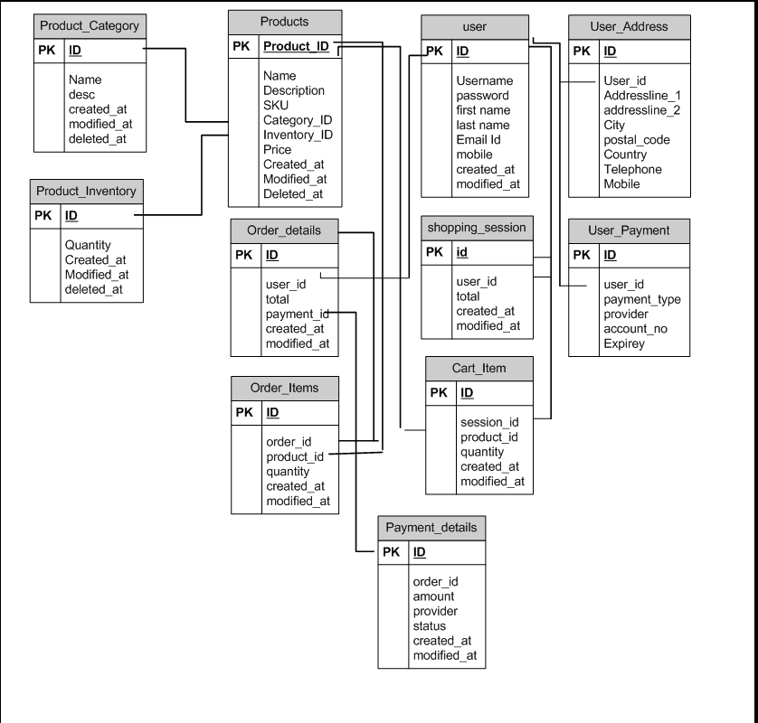

**Question 7 –** What is a data flow diagram? Draw a data flow diagram to represent the in-flow and out-flow of data when a Farmer is placing an order for the product

**Answer-**

**Question 8 –** Due to change in the Government Taxation structure. we should change the Tax structure; how do you handle change requests in a project?

**Answer** – Handling change requests in a project involves a structured and systematic approach to ensure that the requested changes align with the project's goals, timeline, and budget while minimizing disruption to ongoing development. Here's how I, as a Business Analyst (BA), would handle the change request related to the Government Taxation structure.

**Change Request Handling –**

Change Management impact the project scope. Thus, any requirement which was not part of initial business requirements document, must be managed properly through change management/control techniques and the BA along with PM to carefully review and follow rigorous change control process.

1. BA will document the change request
2. BA will analyse the change request to find out that it is really a change request, or a defect discovered by previous need communication.
3. The Change Manager or the PM must provide an initial approval so that BA can move further to analyse the change which is requested.
4. BA and PM will decide whether the change is a complex one or a minor change
5. If the change is complex, Then it will lead to project scope expansion in big way which will further lead to increase in delivery time.
6. BA will do the Impact Analysis, which the change will have on the organization and help minimize the negative impact resulting from the particular change. IT includes Project Scope, Schedule, Budget, Resources and Risks.
7. Prioritize change request based on urgency, importance and impact on the project.
8. Seek approval from the project sponsor for the change request.
9. Communicate the change request and its potential impacts to all relevant stakeholders including the project team.

**Question 9 –** As the project is in process, Ben and Kevin have contacted you. The reason is to inform you that they want the Farmers to sell their crop yields through this application i.e. Farmers should be able to add their crop yields or products and display to general public and should be able to sell them.

They also want to introduce Auction system for their Crop yields. As a BA, what will be your response?

Is this a change request or an enhancement??

**Answer –**

The current requests of Selling crop yields through the application, adding auction and Holiday giveaway would be considered **as enhancements** as it involves adding new feature to the system.

As new requests are given, I would:

1. I will document the new requirements
2. I will work with the development team to determine the feasibility and impact of the new features.
3. I would also consider the potential benefits, risk and cost associated with the enhancement before making any recommendations to the client.
4. As an enhancement, the impact on the timeline and budget should be limited. However, a detailed feasibility study would determine the exact effort required.
5. Adding these functionalities should remain intuitive and user-friendly to avoid overwhelming farmers.
6. Present this as an enhancement idea to the project committee (Mr. Henry, Mr. Pandu, and Mr. Dooku).
7. Highlight the benefits, increases farmer empowerment by providing new income opportunities.
8. Makes the application more comprehensive and attractive to users.

Framing this request as an enhancement emphasizes that it adds value to the current application without drastically altering its scope. This approach might make it more acceptable to stakeholders, especially if the enhancement is introduced incrementally and does not significantly affect the timeline or budget.

**Question 10 –** Come up with estimations – How many Manhours required

**Answer -** Duration of the Project – 18 Months – (72 Weeks)

Manpower –

PM -1, BA 1, Developers 5, NW Admin – 1, DB Admin – 1, Testers – 2

Total – 11 People

Work Week = 30 hours

Total Manpower Hours = 11*72*30

= 23,760 Manhours.

**Question 11 –**Project has finally completed all the stages i.e., design, development, testing etc. Now, it is the role of a business analyst to contact the client for testing of the final product and have to successfully complete it. How are you going to handle this situation? And once it is done, what will be the process to close the project?

Explain UAT Acceptance process

**Answer –**

UAT (User Acceptance Testing) is the final stage of the software development lifecycle where the end users of the system test the product to ensure that it meets their requirements and is ready for deployment. The UAT process involves the following steps:

**Planning** – The BA works with the client to plan the UAT phase, including and defining the test scenario and cases. Blue prints are made to implement UAT for every feature that needs to test and minimum criteria for accepting the tests.

**Designing** – The test cases are designed to hide all the possibilities of software package in real world environment.

**UAT Testers** – A team of end users is made who meets the criteria for implementing the testing. These members should know the test case and their functionalities.

**Bug Fixing**- The development team works on the bugs found during the testing phase and fixes them, thus making the software error free.

**Sign Off**- Post bug fixing, the testing team indicates the acceptance of the completion of the bugs. Here all the stakeholders come to conclusion that the software is ready for Go Live and sign it off.

**Question 12 –** Explain Project closure document

**Answer –**

Project closure document is also known as Project Closure Report, It is a formal document that summarizes the outcomes of the project after it has been completed. It is a record of the project’s performance, captures lessons learned and provides a final assessment of whether the project met its objectives. The project closure report should contain the following elements:

* Project Overview
* Achievements
* Lessons Learned
* Quality Assurance
* Resources Utilization
* Risk Management
* Challenges

|  |  |  |  |
| --- | --- | --- | --- |
| **S. No** | **Points to Include** | **Details** | **Reference Links** |
| 1. | Did the Client Sign off on the UAT Testing? |  |  |
|  | 1. Date of Signoff | 08/01/2023 |  |
|  | 1. Name of the resource |  |  |
| 2 | Objectives of the project |  |  |
|  | 1. Objective 1 | Achieved |  |
|  | 1. Objective 2 | Achieved |  |
|  | 1. Objective 3 | Achieved |  |
| 3 | Functionalities worked on |  |  |
|  | 1. Functionality 1 | Achieved |  |
|  | 1. Functionality 2 | Achieved |  |
|  | 1. Functionality 3 | Achieved |  |
| 4 | Infrastructure |  |  |
|  | 1. Software Installed | Achieved |  |
|  | 1. Hardware Purchased | Achieved |  |
| 5 | Funding |  |  |
|  | 1. Amount Approved | INR 2 Cr. |  |
|  | 1. Amount Used | INR 1.5 Cr |  |
|  |  |  |  |
| 6 | Overall Project Information |  |  |
|  | 1. Escalations | 15 (Resolution Done) |  |
|  | 1. Customer Satisfactions | High |  |
| 7 | Value to the company |  |  |
|  | 1. Positive/Negative | Positive  Better Edge over competitors  Clients Increased  Client satisfaction Increased  New Projects in pipeline. |  |