**Q1. 4 Quarterly Audits are planned Q1, Q2, Q3, Q4 for this Project What is your knowledge on how these Audits will happen for a BA ?**

Ans.

The knowledge that a Business Analyst needs to have during these audits is as follows:

1. Q1 is the Requirement Gathering Phase

* Focus:
  + Requirements Gathering & Documentation
  + Project Initiation and Planning
* BA Responsibilities:
  + Present documented business requirements (e.g., Business Requirements Document, Use Case Specifications).
  + Ensure stakeholder requirements have been captured and validated.
  + Demonstrate alignment of requirements with project objectives.
  + Participate in discussions about scope, timelines, and initial system design.

2. Audit – Requirement Analysis Phase

* Focus:
  + Requirements Refinement
  + Design Approval and Development Progress
* BA Responsibilities:
  + Ensure updated requirements are reflected in the design documents.
  + Address any changes to requirements (scope creep or updates).
  + Validate that development aligns with the documented requirements.
  + Collaborate with developers and testers to ensure a shared understanding of use cases.

3. Audit – Design Phase

* Focus:
  + Testing Activities
  + System Readiness
* BA Responsibilities:
  + Review and validate test cases to ensure they align with requirements.
  + Participate in User Acceptance Testing (UAT) planning.

4. Audit – Development Phase

* Focus:
  + Deployment Readiness
  + End-to-End System Validation
* BA Responsibilities:
  + Validate that the system meets all documented requirements and stakeholder expectations.
  + Ensure all UAT issues are resolved.
  + Review deployment plans and ensure readiness for go-live.
  + Gather feedback post-deployment for lessons learned and continuous improvement.

5. Audit Testing Phase

* Test Case Summary
* Training report to end users
* Lessons Learnt Document
* Provide clarification to testers on requirements.
* Analyze reported defects to identify requirement gaps or ambiguities

**Q2. Before the Project is going to Kick Start, The Committee asked Mr Karthik to submit BA Approach Strategy Write BA Approach strategy (As a business analyst, what are the steps that you would need to follow to complete a project – What Elicitation Techniques to apply, how to do Stakeholder Analysis RACI/ILS, What Documents to Write, What process to follow to Sign off on the Documents, How to take Approvals from the Client, What Communication Channels to establish n implement, How to Handle Change Requests, How to update the progress of the project to the Stakeholders, How to take signoff on the UAT- Client Project Acceptance Form ). Technical Team have assembled to discuss on the Project approach and have finalised to follow 3-tier architecture for this project.**

**Ans.**

**Business Analyst Approach Strategy**

**1. Understanding the Project Scope and Objectives**

* + Review the project brief, objectives, and constraints.
  + Understand the primary goals of the online agriculture product store.
  + Identify critical success factors, assumptions, and dependencies.

**2. Stakeholder Analysis**

* **Steps:**
  + Identify all stakeholders (e.g., Mr. Henry, farmers, manufacturers, committee members, project team).
  + Perform Stakeholder Analysis
* **Responsible**: BA, Developers, Testers for requirement gathering, design, and testing.
* **Accountable**: Project Manager for deliverables.
* **Consulted:** Stakeholders (farmers, manufacturers, committee members) for requirements.
* **Informed:** Delivery Head, Financial Head, and other stakeholders on progress.

**3. Elicitation Techniques**

* Conduct sessions using the following techniques:
  + **Workshops:** Collaborate with stakeholders to gather high-level and detailed requirements.
  + **Interviews:** One-on-one meetings with key stakeholders for in-depth insights.

**4. Document Deliverables**

* Create and maintain the following documents:
  + **Business Requirements Document (BRD)**: Captures high-level requirements.
  + **Functional Specification Document (FSD):** Detailed system functionalities.

**5. Requirement Sign-Off Process**

* + Review and validate requirements with stakeholders.
  + Obtain sign-off from key stakeholders and client representatives.
  + Maintain signed documents as project records.

**6. UAT and Client Acceptance**

* + Collaborate with testers to prepare UAT test cases.
  + Conduct UAT sessions with stakeholders.
  + Record feedback and ensure fixes are implemented.
  + Obtain formal sign-off on the UAT Client Project Acceptance Form.

**11. Technical Approach**

* **3-Tier Architecture:**
  + **Presentation Layer:** User interface for farmers and manufacturers (web and mobile applications).
  + **Application Layer:** Business logic and application functionalities.
  + **Data Layer:** Database to store product details, orders, and user information.
* Collaborate closely with developers, testers, and architects to ensure alignment with technical strategy.

**Q3. Explain and illustrate 3-tier architecture?**

Layers in 3-Tier Architecture

1. Presentation Layer (User Interface):
   * Purpose: This is the topmost layer where users interact with the application.
   * Components: Web browsers, mobile apps, or desktop interfaces.
   * Functions: Handles user input, displays output, and sends user requests to the Application Layer.
2. Application Layer (Business Logic):
   * Purpose: This is the middle layer that processes business logic and rules.
   * Components: Backend servers, APIs, and business logic code.
   * Functions: Processes user requests from the Presentation Layer, communicates with the Data Layer, and sends responses back.
3. Data Layer (Database):
   * Purpose: This is the bottom layer responsible for storing and retrieving data.
   * Components: Relational databases (e.g., MySQL, PostgreSQL) or NoSQL databases (e.g., MongoDB).
   * Functions: Executes data operations like Create, Read, Update, and Delete (CRUD).

Illustration of 3-Tier Architecture

Below is an example of a 3-tier architecture for the online agriculture product store:

1. Presentation Layer:
   * User Interface: Farmers use a mobile app or website to browse products (e.g., seeds, fertilizers).
   * Technologies: HTML/CSS/JavaScript, ReactJS, or Angular.
2. Application Layer:
   * Business Logic: Processes user actions like product searches, order placements, and payments.
   * Technologies: Java Spring Boot, Node.js, or .NET Core.
   * Middleware: API Gateway to route requests between UI and database.
3. Data Layer:
   * Database: Stores product details, user profiles, order data, and transaction history.
   * Technologies: MySQL, PostgreSQL, MongoDB, or Firebase.

**Q4. Business Analyst should keep What points in his/her mind before he frames a Question to ask to the Stakeholder ( 5W 1H – SMART – RACI – 3 Tier Architecture – Use Cases, Use case Specs, Activity Diagrams,Models, Page designs)**

**Ans.**

### **Key Points for Framing Questions**

#### **1. Apply the 5W 1H Framework**

* **Who:** Who are the end-users or stakeholders impacted by this requirement or feature?
* **What:** What specific functionality, process, or outcome is required?
* **When:** When should this feature/process occur in the workflow?
* **Where:** Where will the feature be used (e.g., web, mobile, specific location)?
* **Why:** Why is this functionality or requirement necessary?
* **How:** How should this requirement be implemented or executed?

#### **2. Use SMART Principles**

* + **Specific:** Ask about precise needs or expectations (e.g., "What format should the reports be generated in?").
  + **Measurable**: Clarify metrics or success criteria (e.g., "What is the acceptable page load time?").
  + **Achievable:** Focus on realistic and feasible goals (e.g., "Can this process be automated within the current budget?").
  + **Relevant:** Align the question with project goals (e.g., "How does this feature support farmers?").
  + **Time-bound**: Discuss timelines (e.g., "When do you expect this feature to be delivered?").

#### **3. RACI Considerations**

* + **Responsible:** Who provides the primary input?
  + **Accountable:** Who makes the final decision?
  + **Consulted:** Who should be consulted for insights?
  + **Informed:** Who needs to be updated about the outcome?

1. With Respect to 3-Tier Architecture

Presentation Layer (User Interface):

* Questions to ask:
  + "What specific features should be available on the homepage/dashboard?"
  + "What input fields are required for farmers to search for products?"
  + "Are there accessibility requirements for mobile or web users?"

Application Layer (Business Logic):

* Questions to ask:
  + "What business rules apply to order validation (e.g., minimum quantities or payment confirmations)?"
  + "Are there any approval processes for product uploads by manufacturers?"
  + "Should there be a system for notifying farmers of promotions or stock updates?"

Data Layer (Database):

* Questions to ask:
  + "What key data fields are required for product details (e.g., name, description, price)?"
  + "What reports or analytics are needed for stakeholders?"
  + "What level of data security is expected for sensitive information?"

2. With Respect to Use Cases

* + "What are the key actions farmers should be able to perform (e.g., searching, ordering, tracking)?"
  + "What should happen when a farmer cancels an order?"
  + "Are there any system restrictions or limits to certain actions?"

Use Case Specifications:

* + "What are the preconditions and postconditions for this process?"
  + "What alternate flows or error conditions should be considered?"
  + "Are there specific inputs and outputs for this activity?"

3. With Respect to Activity Diagrams

* + "Does this flow accurately represent the steps in your process?"
  + "Are there any decision points missing in this workflow?"
  + "What happens after this step if the action fails?"

4. With Respect to Models

* + "What information do you need to store for each product or transaction?"
  + "Are there relationships between entities (e.g., products, orders, users)?"
  + "What reports or analytics do you expect to be generated?"

5. With Respect to Page Designs

* Questions to ask:
  + "What are the essential elements you want on this page (e.g., filters, buttons)?"
  + "Are there any branding guidelines or themes to follow?"
  + "Do you need options for exporting data or reports from this page?"

**Q5. As a Business Analyst, What Elicitation Techniques you are aware of? ( BDRFOWJIPQU)**

And.

B: Brainstorming

* Generate a wide range of ideas and solutions in a short time.
* When exploring new features, solutions, or improving processes.
* Conducting a session with stakeholders to list all challenges farmers face in procuring products.

D: Document Analysis

* Review existing documents to gather historical or procedural information.
* At the beginning of the project or when documentation exists (e.g., contracts, reports).
* Analyzing product catalogs or previous vendor agreements for insights.

R: Reverse Engineering

* Study an existing system or process to understand its components and functionality.
* When replacing or improving legacy systems.
* Analyzing the current manual order process to design a digital solution.

F: Focus Groups

* Engage a selected group of stakeholders to discuss requirements, feedback, or ideas.
* When consolidating feedback from similar stakeholders (e.g., farmers).
* Hosting a focus group with farmers to understand their purchasing behaviors.

O: Observation

* Watch users perform tasks in their natural environment to gather insights.
* When documenting actual workflows or uncovering hidden requirements.
* Observing farmers' interactions with distributors to identify bottlenecks.

W: Workshops

* Facilitate collaborative sessions with multiple stakeholders to gather or refine requirements.
* When aligning stakeholders on goals or resolving conflicts.
* Conducting a workshop to finalize the features of the online platform.

J: Job Shadowing

* Work alongside users to gain hands-on understanding of their tasks.
* When gathering detailed insights into user workflows.
* Spending a day with farmers to see how they source products.

I: Interviews

* Conduct one-on-one or group discussions to gather detailed information.
* When in-depth information or specific expertise is needed.
* Interviewing manufacturers to understand their data submission process.

P: Prototyping

* Create mockups or models of a system to visualize requirements.
* When clarifying user interface or workflow needs.
* Designing wireframes of the product catalog for farmer feedback.

Q: Questionnaires and Surveys

* Collect structured responses from a large group.
* When stakeholder input is needed from geographically dispersed participants.
* Sending a survey to farmers to prioritize features like search filters or delivery options.

U: Use Case Analysis

* Define interactions between actors and the system to achieve goals.
* When detailing functional requirements.
* Creating use cases for farmers searching, ordering, and tracking products.

**Q6. Which Elicitation Techniques can be used in this Project and Justify your selection of Elicitation Techniques? Prototyping Use case Specs Document Analysis Brainstorming Fertilizers, seeds, pesticides details from the manufacturers and should be able to display them to the Farmers.**

### ****Ans.****

### **1. Prototyping**

* Visualizing the product catalog, search features, login flow, and payment gateway ensures stakeholders can better articulate their expectations.
* Helps in refining the user interface and user experience (UI/UX), as stakeholders can provide feedback on how easy it is for farmers to navigate the system.

### **2. Use Case Specifications**

* Use cases are ideal for capturing detailed functional requirements for scenarios like product search, login, order placement, and delivery tracking.
* They help align expectations between technical and non-technical stakeholders by providing clear workflows and alternate paths.

### **3. Document Analysis**

* Existing documents, such as SOONY’s reports, manuals, or contracts with manufacturers, can provide insights into current processes and constraints.
* Helps in identifying key data points like product details (fertilizers, seeds, pesticides) that need to be captured and displayed.

### **4. Brainstorming**

* Engaging stakeholders like Peter, Kevin, and Ben in brainstorming sessions ensures that all perspectives are captured, including edge cases.
* Promotes collaborative idea generation for features like search filters, payment methods, and delivery tracking.  
  **Identified Business Requirements (Including Stakeholder Requirements)**

**Q7.** Make suitable Assumptions and identify at least 10 Business Requirements.

Ans.

1. BR001: The system should allow farmers to search for available products in fertilizers, seeds, and pesticides using keywords, categories, and filters (e.g., price, brand, type).
2. BR002: Manufacturers should be able to upload product details, including name, description, price, stock availability, and images, to display them on the platform.
3. BR003: The platform should provide a secure login and account management system for all users, including farmers and manufacturers.
4. BR004: Farmers should be able to create an account by providing an email ID and creating a password. Account verification should be done via email.
5. BR005: Farmers should be able to add products to a shopping cart or a "buy-later" list before completing a purchase.
6. BR006: The system should support multiple payment methods, including Cash-on-Delivery (COD), Credit/Debit Cards, and UPI, to facilitate transactions.
7. BR007: Farmers should receive email notifications for order confirmations, updates on order status, and delivery tracking.
8. BR008: The platform should provide a delivery tracking feature, allowing farmers to view the real-time status of their orders.
9. BR009: Administrators should be able to manage user accounts, monitor transactions, and resolve disputes between farmers and manufacturers.
10. BR010: The platform should include basic analytics and reporting features for manufacturers, such as sales performance, product popularity, and stock levels.

**Q8. List your assumptions**

**Ans.**

1. The farmers and manufacturers have access to basic internet connectivity and smartphones or computers.
2. Manufacturers are responsible for updating product information and ensuring stock availability.
3. Farmers prefer a simple and user-friendly interface, as many users may not be tech-savvy.
4. The platform supports both web and mobile applications for accessibility.
5. There are logistics partners available to facilitate product delivery.
6. Security measures, such as password encryption and secure payment gateways, are implemented to protect user data.
7. There is a centralized customer support system for resolving disputes and queries.
8. Notifications (e.g., email confirmations) are automated to ensure timely updates to users.
9. The system complies with legal and regulatory requirements related to online transactions and user data protection.
10. The platform should scale to accommodate future features like multi-language support or integration with government schemes.

**Q9. Give Priority 1 to 10 numbers ( 1 being low priority – 10 being high priority) to these Requirements after discussions with the stakeholders**

**Ans.**

**Prioritization of Requirements**

|  |  |  |
| --- | --- | --- |
| **Number** | **Requirement** | **Priority** |
| BR001 | Search and filters for products | 3 |
| BR002 | Manufacturers uploading product details | 4 |
| BR003 | Secure login and account management system | 2 |
| BR004 | : Farmer account creation and verification | 1 |
| BR005 | Shopping cart and "buy-later" list | 7 |
| BR006 | Multiple payment methods | 5 |
| BR007 | Email notifications for order updates | 6 |
| BR008 | Delivery tracking feature | 10 |
| BR009 | Administrative controls for user and dispute management | 8 |
| BR010 | Analytics and reporting for manufacturers | 9 |

**Q10. Draw use case diagram**

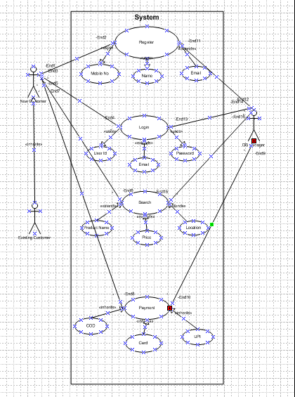

**Q11. Prepare use case specs for all use cases**

### Use Case 1: ****Browse Products****

**Actor(s):** Farmer

**Description:** The Farmer browses the list of available products (fertilizers, seeds, pesticides) provided by manufacturers.

**Preconditions:**

* The Farmer must have an account and be logged into the system.
* Product details must be available in the database.

**Trigger:** The Farmer accesses the application and selects the "Browse Products" option.

**Basic Flow:**

1. The system displays product categories: Fertilizers, Seeds, and Pesticides.
2. The Farmer selects a category.
3. The system displays a list of products within the selected category.
4. The Farmer clicks on a product to view detailed information.

**Alternative Flow:**

* **Product Search:**
  + The Farmer enters keywords in the search bar.
  + The system displays relevant products based on the search criteria.

**Postconditions:**

* The Farmer views product details successfully.

### Use Case 2: ****Request to Buy Products****

**Actor(s):** Farmer

**Description:** The Farmer selects products and places a request to buy them.

**Preconditions:**

* The Farmer must be logged in.
* Products must be available in stock.

**Trigger:** The Farmer clicks on "Add to Cart" and then selects "Checkout."

**Basic Flow:**

1. The Farmer adds desired products to the cart.
2. The Farmer clicks on "Checkout."
3. The system prompts the Farmer to confirm the delivery address.
4. The Farmer confirms the address.
5. The system displays the total price and payment options.
6. The Farmer selects a payment method and confirms the purchase.
7. The system generates an order confirmation.

**Alternative Flow:**

* **Insufficient Stock:**
  + The system notifies the Farmer if any product in the cart is out of stock.
  + The Farmer removes or replaces the unavailable product.

**Postconditions:**

* An order is placed successfully.
* The Farmer receives a confirmation.

### Use Case 3: ****Add Product Details****

**Actor(s):** Manufacturer

**Description:** The Manufacturer uploads product details to the system.

**Preconditions:**

* The Manufacturer must have an account and be logged in.

**Trigger:** The Manufacturer clicks on "Add Product" from their dashboard.

**Basic Flow:**

1. The Manufacturer selects "Add Product."
2. The system prompts for product details (name, category, description, price, stock quantity).
3. The Manufacturer fills in the details and uploads a product image.
4. The Manufacturer clicks on "Submit."
5. The system saves the product details and makes them visible to Farmers.

**Alternative Flow:**

* **Incomplete Details:**
  + The system validates all required fields.
  + If any field is missing, the system prompts the Manufacturer to complete it.

**Postconditions:**

* Product details are successfully added to the database and visible to Farmers.

### Use Case 4: ****Manage Orders****

**Actor(s):** Farmer, Manufacturer

**Description:** Farmers track their orders, and Manufacturers manage received orders.

**Preconditions:**

* The Farmer or Manufacturer must be logged in.
* Orders must exist in the system.

**Trigger:**

* Farmer selects "My Orders."
* Manufacturer selects "Manage Orders."

**Basic Flow (Farmer):**

1. The Farmer clicks on "My Orders."
2. The system displays a list of the Farmer's orders.
3. The Farmer selects an order to view its status.

**Basic Flow (Manufacturer):**

1. The Manufacturer clicks on "Manage Orders."
2. The system displays a list of received orders.
3. The Manufacturer updates the order status (e.g., Processing, Shipped, Delivered).

**Alternative Flow:**

* **Order Discrepancy:**
  + The Farmer or Manufacturer raises an issue with an order.
  + The system notifies the relevant actor for resolution.

**Postconditions:**

* Farmers can track their orders.
* Manufacturers can update order statuses.

### Use Case 5: ****User Registration****

**Actor(s):** Farmer, Manufacturer

**Description:** New users register for an account to access the application.

**Preconditions:**

* The user must have a valid email address and contact information.

**Trigger:** The user clicks on "Register."

**Basic Flow:**

1. The user selects their role (Farmer or Manufacturer).
2. The system prompts for registration details (name, email, phone number, password, etc.).
3. The user fills in the details and clicks "Submit."
4. The system sends a confirmation email.
5. The user verifies their email.
6. The system activates the account.

**Alternative Flow:**

* **Invalid Email:**
  + The system prompts the user to enter a valid email.

**Postconditions:**

* The user is successfully registered and can log in to the application.

### Use Case 6: ****Payment Processing****

**Actor(s):** Farmer, Payment Gateway

**Description:** Farmers make payments for their orders.

**Preconditions:**

* The Farmer must have items in the cart and proceed to checkout.

**Trigger:** The Farmer selects a payment method during checkout.

**Basic Flow:**

1. The Farmer selects a payment method (credit card, UPI, etc.).
2. The system redirects to the payment gateway.
3. The Farmer completes the payment.
4. The system confirms the payment and updates the order status.

**Alternative Flow:**

* **Payment Failure:**
  + The system notifies the Farmer of the failure.
  + The Farmer retries or selects an alternative payment method.

**Postconditions:**

* Payment is processed successfully.
* The system updates the order status to "Paid."

**Q12. Activity diagrams**

**Ans.**

* + 1. **Login**

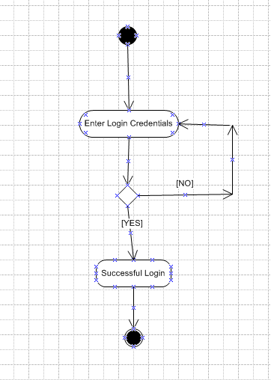

* + 1. **Add Product**

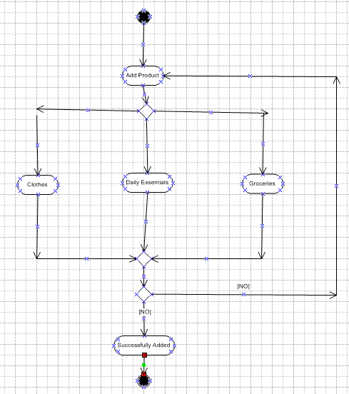

* + 1. **Product Delivery**

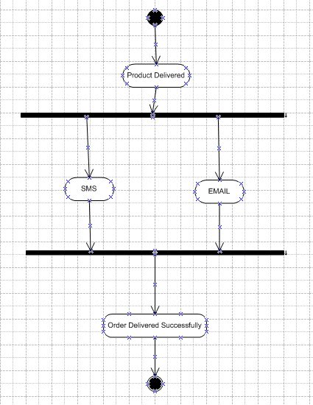

* + 1. **Making A Payment**

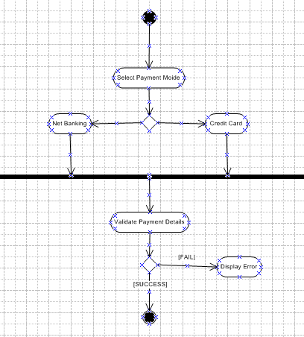

* + 1. **Search Products**

