### **Assignment 1**

#### **1. Business Requirements Document (BRD)**

#### **1. Project Overview**

#### Project Name: Inventory and Delivery Management System for Dairy Products

#### Objective: To develop a system that manages inventory across manufacturing plants and warehouses while ensuring the quickest delivery of ice-cream and milk products to customers.

#### Scope:

#### Inventory Management: Tracking raw materials, finished products, and stock levels at multiple locations.

#### Delivery Management: Optimizing routes for timely deliveries and integrating with third-party logistics.

#### **2. Business Objectives**

#### Efficient inventory management across multiple locations.

#### Real-time stock updates and automated reordering.

#### Optimized delivery routes for quickest dispatch and customer satisfaction.

#### Integration with existing systems (if any).

#### **3. Key Stakeholders**

#### Primary Stakeholders: Company’s Management, Inventory Managers, Logistics Team.

#### Secondary Stakeholders: IT Team, End Customers, Suppliers.

#### **4. Functional Requirements**

#### Inventory tracking by location and product type.

#### Automated alerts for low stock.

#### Delivery scheduling and route optimization.

#### Reporting and analytics dashboard.

#### **5. Non-Functional Requirements**

#### High system availability and reliability.

#### User-friendly interface for ease of use.

#### Scalability to accommodate future growth.

#### **6. Assumptions and Constraints**

#### Existing IT infrastructure will be used.

#### The system must comply with local transportation regulations.

#### **Development and Resource Plan**

#### **1. Development Phases**

#### Phase 1: Requirement Gathering and Analysis

#### Phase 2: Design and Prototyping

#### Phase 3: Development

#### Phase 4: Testing and Quality Assurance

#### Phase 5: Deployment and Training

#### Phase 6: Maintenance and Support

#### **2. Resource Allocation**

#### Business Analyst: Requirement gathering, BRD, and stakeholder communication.

#### UI/UX Designer: Interface design.

#### Developers: Frontend and Backend development.

#### QA Engineers: Testing and bug tracking.

#### Project Manager: Overseeing project progress.

#### Support Staff: Post-deployment support.

#### **3. Timeline**

#### Total Duration: 6 months

#### Each phase lasts approximately one month, with overlapping for seamless transition.

#### 

#### 

#### 2. Process Flow Diagram

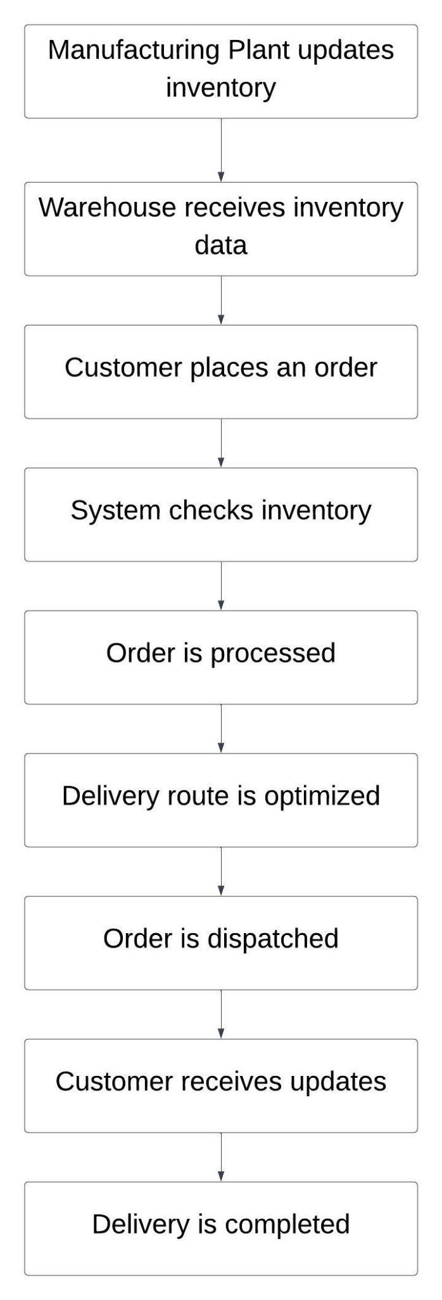

### **Assignment 2**

#### **1. Introduction Letter**

Subject: Introduction as Your Business Analyst for [Project Name]

Dear [Client's Name],

I am Bhakti, your assigned Business Analyst for the upcoming [Project Name]. I am excited to collaborate with you and your team to gather detailed requirements, ensure seamless communication, and deliver a solution that meets your business needs.

My role will involve understanding your business processes, identifying key challenges, and translating them into actionable requirements for our development team. I look forward to starting this journey together and achieving your project goals.

Please feel free to reach out if you have any questions or require further information.

Best Regards,  
Bhakti  
Business Analyst

#### 

#### **2. Brief BRD and SRS for a Ticketing System**

**BRD**

**Project Overview**

* Project Name: Online Store Platform
* Objective: Develop an e-commerce platform for customers to browse, order, and receive products conveniently.
* Scope:
  + Product catalog with categories and search functionality.
  + User registration, login, and profile management.
  + Shopping cart and checkout process.
  + Payment gateway integration.
  + Order tracking and customer support.

**Key Stakeholders**

* Business Owner, IT Team, Marketing Team, Customers.

**Functional Requirements**

* Product listing, filtering, and sorting.
* Secure user authentication.
* Shopping cart management.
* Multiple payment options.
* Order confirmation and tracking.

**Non-Functional Requirements**

* High performance and scalability.
* Secure data handling.
* Mobile responsiveness.

#### **SRS**

**Software Requirements Specification (SRS)**

**1. Introduction**

* Purpose: To outline the functional and non-functional requirements for the online store.
* Scope: The system will allow users to browse products, place orders, and track deliveries.

**2. Functional Requirements**

* User Registration and Login
* Product Search and Filtering
* Shopping Cart Management
* Checkout and Payment Processing
* Order Tracking and Management

**3. Non-Functional Requirements**

* System Reliability and Availability
* Data Security and Privacy
* Usability and Accessibility

**4. System Architecture**

* Frontend: Web and Mobile Applications
* Backend: Server-side logic and database management

#### 

#### **3. ERD of Ticketing System**

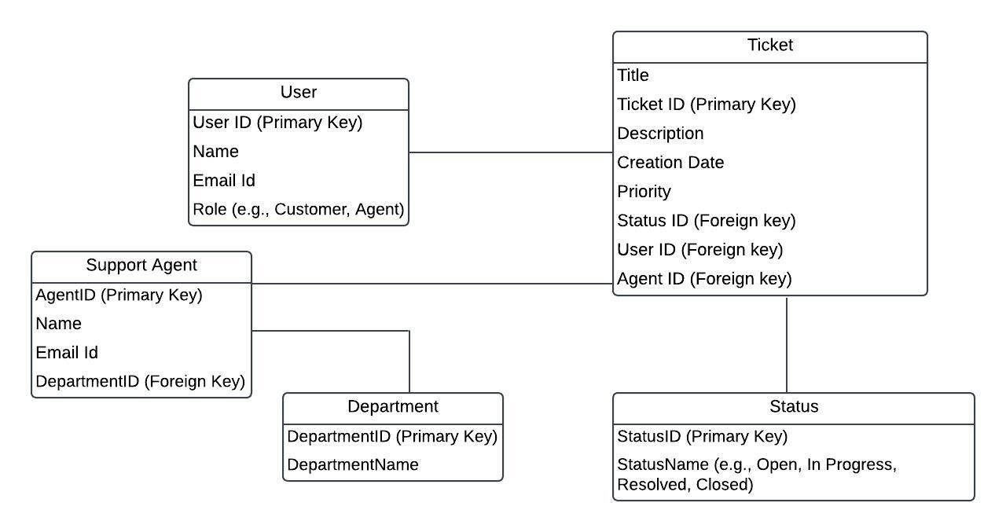

**4. User Story for E-commerce Shopping**

Title: Shopping on an E-commerce Platform

As a customer,  
I want to browse products, add them to my cart, and securely checkout,  
So that I can conveniently purchase items online.

Acceptance Criteria:

1. The user can search for and filter products.
2. The user can view detailed product descriptions.
3. The user can add items to the shopping cart.
4. The user can proceed to checkout and complete the purchase using multiple payment options.
5. The user receives an order confirmation and can track their order status.