**AGILE DOCUMENTS**

Agile Project – 100 Marks -

**Document 1: Definition of Done**

As Per Agile Extension to the BABOK® Guide v2, Definition of Done is a technique where the team agrees on, and prominently displays, a list of criteria which must be met before a backlog item is considered done.

That is the team has to create a well-defined, unambiguous, measurable, agreed-upon, and shared Definition of Done between all team members.

The best form of Definition of Done representation is a checklist of activities that has to demonstrate the agreed value and quality of a user story. So, this checklist should include:

▪ acceptance criteria (to satisfy customer requirements for a product)

▪ quality criteria (to satisfy quality requirements for a product)

Definition of Done may be defined for different levels of project work. For example, in Agile / Scrum framework these levels of work could be user story, sprint, and release.

The Definition of Done outlines the criteria that must be met for a product increment or backlog item to be considered complete and potentially shippable.The DOD ensures that the team maintains a consistent level of quality andcompleteness in their work. The specific criteria in the DOD can vary based on the team's standards, the nature of the project, and the industry, but commonly include elements such as:

**Checklist for DOD:**

1. Code complete: All development work is finished, including coding,testing, and integration.
2. Peer-reviewed: Code has been reviewed by other team members for quality and adherence to coding standards.
3. Automated tests passed: Automated tests (unit tests, integration tests,etc.) have been successfully executed and passed.
4. Functional requirements met: The item meets all specified acceptance criteria and functional requirements.
5. Documentation updated: Any necessary documentation, user guides, or technical documentation has been updated.
6. Unit test written and passing: unit tests to be effective and manageable, each test should have only one test case. That is, the test should have only one assertion. It sometimes appears that to properly test a feature, you need several assertions.
7. Project deployed on the test environment identical to production platform: A test environment allows software developers to check how a code/program will behave in a live environment.

8.QA performed & issues resolved: Serving as an overarching quality gate, the DoD ensures the meticulous application of appropriate development and testing processes by the team.

9. Feature is tested against acceptance criteria: A set of test scenarios that define the specific functionality a user story must meet to be complete. Acceptance criteria are low-level conditions that apply to specific user stories or features.

10. Refactoring completed: The goal of refactoring is to improve internal code by making many small changes without altering the code's external behavior.

**Definition of Done (DOD):**

The Definition of Done outlines the criteria that must be met for a product increment or backlog item to be considered complete and potentially shippable.The DOD ensures that the team maintains a consistent level of quality and completeness in their work. The specific criteria in the DOD can vary based on the team's standards, the nature of the project, and the industry, but commonly include elements such as:

1. Code complete: All development work is finished, including coding,testing, and integration.
2. Peer-reviewed: Code has been reviewed by other team members for quality and adherence to coding standards.
3. Automated tests passed: Automated tests (unit tests, integration tests,etc.) have been successfully executed and passed.
4. Functional requirements met: The item meets all specified acceptance criteria and functional requirements.
5. Documentation updated: Any necessary documentation, user guides, or technical documentation has been updated.

**Document 2- Product Vision**

|  |  |  |  |
| --- | --- | --- | --- |
| **Scrum Project**  **Name:** | **E-commerce Application** |  |  |
| **Venue: Pune** |  |  |  |
| **Date: 27/10/24** | **Start time: 10.00 AM** | **End time: 5.00 PM** | **Duration: 6 H** |
| **Client: MS RAO** |  |  |  |
| **Stakeholder list:** | **Vishal** | **Vivek** | **Rathi** |
|  | **Sachin** | **Pankaj** | **Abhi** |
|  |  |  |  |

**Scrum Team**

|  |  |  |  |
| --- | --- | --- | --- |
| **Scrum Master:** | **Yogesh** |  |  |
| **Product owner:** | **Yastha** |  |  |
| **Scrum Developer 1:** | **Baghi** |  |  |
| **Scrum Developer 2:** | **Rohan** |  |  |
| **Scrum Developer 3:** | **Nilesh** |  |  |
| **Scrum Developer 4:** | **Mangesh** |  |  |
| **Scrum Developer 5:** | **Bachan** |  |  |

**VISION**: Customers of any age group who want to have top-rated restaurant’s delicious food in one-go at their doorstep with lighting fast delivery, 24/7 availability and reliable services are SCRUMFOODS. Unlike any other food delivery app in market, our utmost priority is customer need and customer satisfaction which makes us stand out of any other food delivery app in this in this industry

|  |  |  |  |
| --- | --- | --- | --- |
| Online Application industry is our target segment.  Users/Customers: People who want food deliveries within stipulated time at their required place | Scrum foods provide guaranteed safe food delivery in one-go of top rated licensed restaurants.  Customers can receive with safe packaged food within expected time to clear their hunger. | Scrum foods will be on mobile, tablets and desktop application.  Real time tracking and providing 24/7 services and customer support Product feasibility can be complex and require attention in every aspect | Open up revenue stream Be leading online food delivery app in country Create reputed brand image for other business opportunity |

**Product Vision – Description – Notes**

Customer: Registration, Login, Search and View restaurants, View restaurant's menu, Order food,Payment, Tracking, Cancel order, Feedback & Rating and Logout.

Delivery Boy: Registration, Login, View orders, Select and accept orders, Order pickup and delivery,Status updates, Payment (COD), View Feedback, Raise Issues, View Deliveries report and revenue generated, Logout.

Restaurants: Registration, Login, View Orders, Delivery Boy Verification, Payment, View Feedback, Raise Issues, View revenue generated through Scrum Food app, Logout.

Regional Admin: Admin Login, Tracking/status, Customer feedback, Managing Regional delivery boys and restaurant, View regional revenue, Issues, Refunds, View payment made to regional restaurant and Logout.

Admin: Login, Managing Regional Admin, Issues, Customer Feedback, Approval/Rejections privileges on restaurants, Delivery boy, Restaurants and Regional Admin requests, Resolve Issues and Logout.

Business Owner: Login, Issues, Reports, Update payments for restaurants and delivery boys and Logout.

**Document 3: User stories**

|  |  |  |
| --- | --- | --- |
| User story no.1 | Tasks 2 | Priority - highest |
| AS A DELIVER BOY  I WANT TO REGISTER IN SCRUM FOOD  SO I CAN DELIVER THE ORDER | | |
| BV- 500 | | CP - 02 |
| ACCEPTANCE CRITERIA  Registration screen  Text boxes for user name ,password,nation ID  Mobile no.,address,phone number  Click on register button  Send successful notification to the user |  |  |

|  |  |  |
| --- | --- | --- |
| User story no.2 | Tasks 2 | Priority - highest |
| AS A RESTAURANT OWNER  I WANT TO VIEW ORDERS  SO THAT I CAN VIEW THE LIST OF ORDERS | | |
| BV- 500 | | CP - 02 |
| ACCEPTANCE CRITERIA  View order ,display list of orders in the tabular form |  |  |

|  |  |  |
| --- | --- | --- |
| User story no.3 | Tasks 2 | Priority - highest |
| AS A CUSTOMER  I WANT TO ADD THE ADDRESS  SO THAT I CAN GET THE ORDER TO MY ADDESS | | |
| BV- 200 | | CP - 02 |
| ACCEPTANCE CRITERIA  Text box to enter  Within the radius of 5 km |  |  |

|  |  |  |
| --- | --- | --- |
| User story no.4 | Tasks 2 | Priority - highest |
| AS A CUSTOMER  I WANT TO SELECT THE PAYMENT MODE  SO THAT I CAN GET THE ORDER TO MY ADDRESS | | |
| BV- 500 | | CP - 3 |
| ACCEPTANCE CRITERIA  Display payment modes ,radio button to select modes and payment button |  |  |

|  |  |  |
| --- | --- | --- |
| User story no.5 | Tasks 1 | Priority - highest |
| AS A ADMIN  I WANT TO VIEW THE RESTAURANT  SO THAT I CAN APPROVE THEIR REGISTRATION | | |
| BV- 200 | | CP - 02 |
| ACCEPTANCE CRITERIA  Register in the platform with the details |  |  |

|  |  |  |
| --- | --- | --- |
| User story no.6 | Tasks 1 | Priority - low |
| AS A CUSTOMER  I WANT TO VIEW THE PRICE  SO THAT I CAN ORDER THE FOOD | | |
| BV- 50 | | CP - 1 |
| ACCEPTANCE CRITERIA  Display price in the list of menu item |  |  |

|  |  |  |
| --- | --- | --- |
| User story no.7 | Tasks 2 | Priority - low |
| AS A CUSTOMER  I WANT TO VIEW THE CONTACT NO.OF DELIVERY BOY  SO THAT I CAN CONTACT DELIVERY BOY FOR THE STATUS | | |
| BV- 200 | | CP - 02 |
| ACCEPTANCE CRITERIA  Display delivery boy mobile number  Display delivery boy name in tracking field  Display delivery boy picture |  |  |

|  |  |  |
| --- | --- | --- |
| User story no.8 | Tasks 2 | Priority - medium |
| AS A RESTAURANT OWNER  I WANT TO PROVIDE TIME SLOTS  SO THAT CUSTOMER CAN CHECK OPENING AND CLOSING HOURS | | |
| BV- 100 | | CP - 02 |
| ACCEPTANCE CRITERIA  Click on restaurant dashboard  Add from time to time  Click on submit  Display updated successfully |  |  |

|  |  |  |
| --- | --- | --- |
| User story no.9 | Tasks 2 | Priority - highest |
| AS A BUSNIESS OWNER  I WANT TO VIEW RESTAURANT REVENUE REPORTS  SO THAT I CAN VIEW THE RESTAURANT REVENUE | | |
| BV- 200 | | CP - 3 |
| ACCEPTANCE CRITERIA  Select reports  Select revenue reports  Select to and from date  Select region  Generate reports  Download report in excel |  |  |

|  |  |  |
| --- | --- | --- |
| User story no.10 | Tasks 3 | Priority - highest |
| AS A REG ADMIN  I WANT TO MANAGE REGIONAL RESTAURANTS  SO THAT I CAN TRACK THE PERFORMANCE OF REGIONAL RESTAURANT | | |
| BV- 200 | | CP - 3 |
| ACCEPTANCE CRITERIA  Click on the performance of the restaurants  Select from date to date  Click on generate reports which includes restaurant ID name  Click on download reports should be in excel |  |  |

|  |  |  |
| --- | --- | --- |
| User story no.11 | Tasks 2 | Priority - medium |
| AS A ADMIN  I WANT TO SEE REGIONAL REVENUE REPORTS  SO THAT I CAN VIEW REGIONAL | | |
| BV- 100 | | CP - 3 |
| ACCEPTANCE CRITERIA  Select regional drop down  View performance of each rest that region in tabular from which includes rest name revenue generated |  |  |

|  |  |  |
| --- | --- | --- |
| User story no.12 | Tasks 2 | Priority - highest |
| AS A CUSTOMER  I WANT TO CHAT WITH REGIONAL ADMIN  SO THAT I CAN REQUEST FOR REFUND | | |
| BV- 200 | | CP - 02 |
| ACCEPTANCE CRITERIA  Text box fields  Display order ID  Text box for description  Submit button  Generate issue ID  Display successful |  |  |

|  |  |  |
| --- | --- | --- |
| User story no.13 | Tasks 2 | Priority - highest |
| AS A HUNGRY USER  I WANT TO BROWSE NEARBY RESTAURANT  SO THAT I CAN ORDER FOOD | | |
| BV- 200 | | CP - 02 |
| ACCEPTANCE CRITERIA  Each restaurant entry display its name,cuisine type,and rating  This list can be sorted by distance or rating |  |  |

|  |  |  |
| --- | --- | --- |
| User story no.14 | Tasks 2 | Priority - highest |
| AS A CUSTOMER  I WANT TO BROWSE DIFFERENT RESTAURANT AND MENU  SO THAT I CAN FIND A PLACE TO ORDER FOOD | | |
| BV- 200 | | CP - 02 |
| ACCEPTANCE CRITERIA  The menu include dishes ,price and description  Show the restaurant is open or closed |  |  |

|  |  |  |
| --- | --- | --- |
| User story no.15 | Tasks 2 | Priority - highest |
| AS A CUSTOMER  I WANT TO BROWSE FOR SPECIFIC DISHES AND CUINES  SO THAT I CAN FIND A PLACE TO ORDER FOOD | | |
| BV- 200 | | CP - 02 |
| ACCEPTANCE CRITERIA  Registration screen  App displays relevant restaurant and dishes matching the query |  |  |

|  |  |  |
| --- | --- | --- |
| User story no.16 | Tasks 2 | Priority - highest |
| AS A CUSTOMER  I WANT TO FILTER RESTAURANTS  SO THAT I CAN FIND A PLACE TO ORDER FOOD | | |
| BV- 200 | | CP - 02 |
| ACCEPTANCE CRITERIA  Filter restaurant by cuisine type and dietary options (veg,non-veg) |  |  |

|  |  |  |
| --- | --- | --- |
| User story no.17 | Tasks 2 | Priority - highest |
| AS A CUSTOMER  I WANT TO TRACK TRACK MY ORDER  SO THAT I CAN KNOW THE TIME OF DELIVERY | | |
| BV- 200 | | CP - 02 |
| ACCEPTANCE CRITERIA  App shows real time update on the order status  Display estimated delivery time |  |  |

|  |  |  |
| --- | --- | --- |
| User story no.18 | Tasks 2 | Priority - highest |
| AS A USER  I WANT TO RATE AND REVIEW RESTAURANTS  SO THAT I CAN RATE AND REVIEW THE RESTAURANT I HAVE VISITED | | |
| BV- 200 | | CP - 02 |
| ACCEPTANCE CRITERIA  Can see review from other users to help me make dining decision |  |  |

|  |  |  |
| --- | --- | --- |
| User story no.19 | Tasks 2 | Priority - highest |
| AS A USER  I WANT TO VIEW PAST ORDER HISTORY  SO THAT I CAN ORDER FROM MY FAVORITES | | |
| BV- 200 | | CP - 02 |
| ACCEPTANCE CRITERIA  Can see the details such as order item total cost and order date |  |  |

|  |  |  |
| --- | --- | --- |
| User story no.20 | Tasks 3 | Priority - highest |
| AS A USER  I WANT TO RECEIVE NOTIFICATION  SO THAT I CAN RECEIVE UPDATES | | |
| BV- 200 | | CP - 02 |
| ACCEPTANCE CRITERIA  Notification for order confirmation  Notification for dispatch  Notification for delivery |  |  |

|  |  |  |
| --- | --- | --- |
| User story no.21 | Tasks 1 | Priority - MEDIUM |
| AS A CUSTOMER  I WANT TO CONTACT CUSTOMER SUPPORT  SO THAT I CAN SUBMIT QUERIES OR ISSUES | | |
| BV- 200 | | CP - 02 |
| ACCEPTANCE CRITERIA  Customer support section with contact information |  |  |

|  |  |  |
| --- | --- | --- |
| User story no.22 | Tasks 2 | Priority - highest |
| AS A RESTAURANT OWNER  I WANT TO RECEIVE AND MANAGE ORDER  SO THAT I CAN UPDATE ORDER STATUS | | |
| BV- 200 | | CP - 02 |
| ACCEPTANCE CRITERIA  Manage order status  Notify restaurant about incoming orders |  |  |

|  |  |  |
| --- | --- | --- |
| User story no.23 | Tasks 2 | Priority - highest |
| AS A CUSTOMER  I WANT TO ACCESS TO CUSTOMER REVIEW  SO THAT I CAN VIEW AND RESPOND TO CUSTOMER REVIEW | | |
| BV- 200 | | CP - 02 |
| ACCEPTANCE CRITERIA  Owners can address feedback  Owners can improve their services |  |  |

|  |  |  |
| --- | --- | --- |
| User story no.24 | Tasks 1 | Priority - medium |
| AS A CUSTOMER  I WANT TO APPLY PROMOCODES AND DISCOUNT  SO THAT I CAN ORDER AT LOWER PRICE | | |
| BV- 100 | | CP - 04 |
| ACCEPTANCE CRITERIA  Active promo codes |  |  |

|  |  |  |
| --- | --- | --- |
| User story no.25 | Tasks 1 | Priority - HIGH |
| AS A USER  I WANT TO SAVE FAVOURITES RESTAURANTS AND DISHES  SO THAT I CAN ORDER FROM MY FAVOURITES | | |
| BV- 200 | | CP - 02 |
| ACCEPTANCE CRITERIA  Access my list of favourite easily for future order |  |  |

|  |  |  |
| --- | --- | --- |
| User story no.26 | Tasks 1 | Priority - medium |
| AS A DELIVERY BOY  I WANT TO VIEW THE ORDERS  SO THAT I ACCEPT THE ORDER | | |
| BV- 200 | | CP - 4 |
| ACCEPTANCE CRITERIA  Order visibility  Real time update  Order detail  Order filtering and sorting  Order map view  Order navigation  Order completion and confirmation |  |  |

|  |  |  |
| --- | --- | --- |
| User story no.27 | Tasks 5 | Priority - highest |
| AS A DELIVERY BOY  I WANT TO LOGIN  SO THAT I CAN ACCEPT THE ORDER | | |
| BV- 200 | | CP - 4 |
| ACCEPTANCE CRITERIA  User authentication  Error handling  Password security  Multi factor authentication  Compatibility and usability |  |  |

|  |  |  |
| --- | --- | --- |
| User story no.28 | Tasks 5 | Priority - medium |
| AS A DELIVERY BOY  I WANT TO VIEW FEEDBACK  SO THAT I CAN KNOW THE CUSTOMER FEEDBACK | | |
| BV- 500 | | CP - 02 |
| ACCEPTANCE CRITERIA  Access to feed back system  Feedback visibility  Feedback sorting and filtering  Response mechanism |  |  |

|  |  |  |
| --- | --- | --- |
| User story no.29 | Tasks 5 | Priority - MEDIUM |
| AS A ADMIN  I WANT TO VIEW FEEDBACK  SO THAT I CAN KNOW THE FEEDBACK | | |
| BV- 200 | | CP - 4 |
| ACCEPTANCE CRITERIA  Access to feed back system  Feedback visibility  Feedback sorting and filtering  Response mechanism  User support |  |  |

|  |  |  |
| --- | --- | --- |
| User story no.30 | Tasks 5 | Priority - medium |
| AS A RESTAURANT OWNER  I WANT TO VIEW FEEDBACK  SO THAT I CAN KNOW THE CUSTOMER FEEDBACK | | |
| BV- 200 | | CP - 4 |
| ACCEPTANCE CRITERIA  Access to feed back system  Feedback visibility  Feedback sorting and filtering  Response mechanism  User support |  |  |

|  |  |  |
| --- | --- | --- |
| User story no.31 | Tasks 3 | Priority - highest |
| AS A ADMIN  I WANT TO KNOW THE ISSUES  SO THAT I CAN RESOLVE THEM | | |
| BV- 100 | | CP - 3 |
| ACCEPTANCE CRITERIA  Display issue section  Sorting and filtering of issue list  Editing and modifying the issues |  |  |

|  |  |  |
| --- | --- | --- |
| User story no.32 | Tasks 3 | Priority - highest |
| AS A REGIONAL ADMIN  I WANT TO KNOW THE ISSUE  SO THAT I CAN RESOLVE THEM | | |
| BV- 200 | | CP - 4 |
| ACCEPTANCE CRITERIA  Display issue section  Sorting and filtering of issue list  Editing and modifying the issues |  |  |

|  |  |  |
| --- | --- | --- |
| User story no.33 | Tasks 6 | Priority - highest |
| AS A RESTAURANT OWNER  I WANT TO VIEW REVENUE GENERATED  SO THAT I CAN VIEW RESTAURANT REVENUE | | |
| BV- 200 | | CP - 4 |
| ACCEPTANCE CRITERIA  Select reports  Select revenue reports  Select to and from date  Select region  generate reports  Download report in excel |  |  |

|  |  |  |
| --- | --- | --- |
| User story no.34 | Tasks 2 | Priority - highest |
| AS A RESTAURANT OWNER  I WANT TO KNOW DELIVERY BOY  SO THAT I CAN VERIFY THE DELIVERY BOY | | |
| BV- 200 | | CP - 4 |
| ACCEPTANCE CRITERIA  ID proof  Punctuality and reliability |  |  |

|  |  |  |
| --- | --- | --- |
| User story no.35 | Tasks 2 | Priority - low |
| AS A CUSTOMER  I WANT TO VIEW THE CONTACT NUMBER OF DELIVERY BOY  SO THAT I CAN CONTACT DELIVERY BOY FOR THE STATUS | | |
| BV- 50 | | CP - 1 |
| ACCEPTANCE CRITERIA  Display delivery boy mobile number  Display delivery boy name in tracking field  Display delivery boy picture |  |  |

|  |  |  |
| --- | --- | --- |
| User story no.36 | Tasks 2 | Priority - medium |
| AS A RESTAURANT OWNER  I WANT TO PROVE TIME SLOTS  SO THAT CUSTOMER CAN CHECK OPENING AND CLOSING HOURS | | |
| BV- 100 | | CP - 02 |
| ACCEPTANCE CRITERIA  Click on restaurant dashboard  Add from time to time  Click on submit  Display updated successfully |  |  |

|  |  |  |
| --- | --- | --- |
| User story no.37 | Tasks 3 | Priority - highest |
| AS A USER  I WANT TO RECEIVE NOTIFICATION  SO THAT I CAN RECEIVE UPDATES | | |
| BV- 200 | | CP - 02 |
| ACCEPTANCE CRITERIA  Notification for order confirmation  Notification for dispatch  Notification for delivery |  |  |

|  |  |  |
| --- | --- | --- |
| User story no.38 | Tasks 1 | Priority - medium |
| AS A CUSTOMER  I WANT TO CONTACT CUSTOMER SUPPORT  SO THAT I CAN SUMBIT QUERIES OR ISSUES | | |
| BV- 200 | | CP - 02 |
| ACCEPTANCE CRITERIA  Customer support section with contact information |  |  |

|  |  |  |
| --- | --- | --- |
| User story no.39 | Tasks 4 | Priority - medium |
| AS A CUSTOMER  I WANT TO VIEW THE ORDER  SO THAT I CAN CANCELLED IT | | |
| BV- 100 | | CP - 3 |
| ACCEPTANCE CRITERIA  Order status  Method of cancellation  Refund policy |  |  |

|  |  |  |
| --- | --- | --- |
| User story no.40 | Tasks 4 | Priority - highest |
| AS A REGIONAL ADMIN  I WANT TO TRACK THE DELIVERY  SO THAT I CAN VIEW THE STATUS OF THE DELIVERY | | |
| BV- 100 | | CP - 3 |
| ACCEPTANCE CRITERIA  Real time tracking  Security and data privacy  User friendly interface |  |  |

**Document 4: Agile PO Experience**

The Product Owner has a vision of the product keeping the domain/industry experience and the market need.

❖ Following are the responsibilities of PO in a project

➢ Market Analysis ▫ Analysis of market need/demand ▫ Availability of similar products in the market

* **Understanding the customer**: A PO is aware of the needs of the people who will use the product, whether they are internal or external to the organization.
* **Identifying problems**: A PO should identify problems that are worth solving.
* **Developing solutions**: A PO should develop solutions that address a range of customer needs.
* **Using metrics**: A PO should regularly analyze metrics to measure the effectiveness of the team's practices, the value delivered to customers, and the overall health of the product.
* **Making data-driven decisions**: Agile product development is a data-driven decision making system.
* **Bridging the gap between stakeholders and the team**: A PO needs to be able to say no to stakeholders if their desires are out-of-reach

➢ Enterprise Analysis ▫ Due diligence on the market opportunity

**Analytical, problem-solving, and communication skills**

The BA must be able to communicate effectively with all members of the team and stakeholders.

**Understanding of business requirements**

The BA must be able to translate business requirements into technical requirements.

**Knowledge of Agile methodology**

The BA must have a deep knowledge of Agile methodology and principles.

**Facilitate sprint planning**

The BA is responsible for facilitating sprint planning and backlog refinement sessions.

➢ Product Vision and Road map ▫ Product vision keeping the need analysis in mind ▫ Product road map with high-level features and timeline

* **Communicates product growth**: A road map clearly communicates product growth to all stakeholders.
* **Prioritizes professionally**: A road map helps the team to prioritize professionally.
* **Helps focus the product backlog**: A road map helps the team to focus the product backlog.
* **Facilitates portfolio management**: A road map makes portfolio management easier.
* **Helps acquire budget**: A road map helps in acquiring budget, as you can easily state the product benefits.

➢ Managing Product Features ▫ Managing stakeholder expectations and prioritizing needs ▫ Prioritization of the epics, stories, and features based on criticality and ROI involved

**Prioritizing features**

The PO is responsible for maintaining the product backlog, defining user stories, and deciding what to build and when. They use their organizational skills and attention to detail to prioritize tasks based on their value and impact.

**Building relationships**

The PO is the primary customer advocate and link to business and technology strategy. They build and manage key relationships with Product Management and the Agile team.

➢ Managing Product Backlog ▫ Prioritization of user stories ▫ Re prioritization based on stakeholders' needs ▫ Epics planning

Product owners should review the backlog before each iteration planning meeting to ensure prioritization is correct and feedback from the last iteration has been incorporated. Regular review of the backlog is often called "backlog grooming" in agile circles (some use the term backlog refinement).

➢ Managing Overall Iteration Progress ▫ Sprint progress review ▫ Re prioritization of sprints and epics if needed ▫ Sprint retrospectives with Business Analyst

**Iteration planning**

The PO presents high-priority stories and initial iteration goals. The team estimates the effort to complete each item and discusses implementation options. The PO and team then select the stories to work on.

**Iteration events**

The Scrum Master or Team Coach facilitates events like planning sessions, daily stand-ups, review meetings, and retrospectives.

**Iteration activities**

The team designs, develops, tests, and reviews product increments. They collaborate daily to synchronize work and discuss challenges

❖ From this project I have learned how to handle sprint meetings such as

 This meeting kicks off each sprint, which is a time-boxed iteration of work, usually spanning 2-4 weeks. During this meeting, the Scrum team, including the Product Owner, Scrum Master, and Development Team,collaborates to determine which backlog items (user stories, features, etc.) will be worked on in the upcoming sprint. The team also breaks down these items into tasks and estimates the effort required.

**Daily Stand-up (Daily Scrum):**

 Held daily during the sprint, this short meeting aims to facilitate quick and focused communication among team members. Each team member answers three key questions: What did I accomplish since the last stand-up? What will I work on until the next stand-up? Are there any obstacles or impediments in my way? This meeting helps keep everyone aligned and informed about the progress and challenges.

**Sprint Review:**

 At the end of each sprint, the team holds a review meeting to showcase the work completed during the sprint to stakeholders, customers, and the Product Owner. The team demonstrates the potentially shippable product increment and gathers feedback. Based on this feedback, the Product Owner can update the backlog.

**Sprint Retrospective:**

 Also held at the end of each sprint, the retrospective is dedicated time for the team to reflect on their processes and practices. The team discusses what went well, what could be improved, and any potential changes they'd like to make in the next sprint to enhance their efficiency and effectiveness.

**Backlog Refinement (Grooming)**

: While not officially part of the Scrum events,backlog refinement is an important ongoing activity. During these sessions, the team and the Product Owner review and refine backlog items, adding details,clarifications, and estimates to make them ready for inclusion in future sprints.

**Product Backlog Refinement**

: This meeting focuses on refining the product backlog items. The team and the Product Owner discuss and clarify requirements, priorities, and any changes needed in the backlog items. This ensures that the backlog is well-prepared for upcoming sprints.

❖ Also, User stories creation and what things will be included in user stories such as

➢ Story no

**Story points**

A metric used to estimate the difficulty of a user story. Story points are based on factors like effort, risk, and complexity

➢ Tasks

Tasks are usually defined by the people doing the work, such as developers or QA. They should be action items that can be completed in eight hours or less.

➢ Priority

This makes it possible to compare different stories and confidently decide which one is the right one for the development team to start with.

➢ Acceptance criteria

They are an essential part of user stories and are used to confirm that a feature or functionality is working as intended.

➢ BV & CP value

**Business value**

Indicates the importance of a user story from the customer's perspective. The most valuable user stories should be implemented early in the development process.

**Acceptance criteria**

The criteria that should be met and tested to ensure that the user requirements have been met. Good acceptance criteria are clear, concise, testable, and result-oriented. They should be defined before the development team starts working on a user story.

❖ In Scrum, a product owner serves as the liaison between multiple areas of an

organization. This person communicates with business stakeholders and collaborates closely with Scrum teams to keep all areas of the business informed on a project's development.

❖ The product owner develops a vision of a product's function and operation, which in turn allows this Scrum team member to define product features and break those features into product backlog items

**Document 5: Product and sprint backlog and product and sprint burn down charts**

**Product backlog:**

|  |  |  |  |  |  |  |
| --- | --- | --- | --- | --- | --- | --- |
| User story ID | User story | Tasks | Priority | BV | CP | Sprints |
| 1 | AS A DELIVER BOY  I WANT TO REGISTER IN SCRUM FOOD  SO I CAN DELIVER THE ORDER | 2 | High | 500 | 02 | Registration screen  Text boxes for user name ,password,nation ID  Mobile no.,address,phone number  Click on register button  Send successful notification to the user |
| 2 | AS A RESTAURANT OWNER  I WANT TO VIEW ORDERS  SO THAT I CAN VIEW THE LIST OF ORDER | 2 | High | 500 | 02 | View order ,display list of orders in the tabular form |
| 3 | AS A CUSTOMER  I WANT TO ADD THE ADDRESS  SO THAT I CAN GET THE ORDER TO MY ADDESS | 2 | High | 200 | 02 | Text box to enter  Within the radius of 5 km |
| 4 | AS A CUSTOMER  I WANT TO SELECT THE PAYMENT MODE  SO THAT I CAN GET THE ORDER TO MY ADDRESS | 2 | High | 500 | 03 | Display payment modes ,radio button to select modes and payment button |
| 5 | AS A ADMIN  I WANT TO VIEW THE RESTAURANT  SO THAT I CAN APPROVE THEIR REGISTRATION | 1 | High | 200 | 02 | ACCEPTANCE CRITERIA  Register in the platform with the details |
| 6 | AS A CUSTOMER  I WANT TO VIEW THE PRICE  SO THAT I CAN ORDER THE FOOD | 1 | High | 200 | 02 | Display price in the list of menu item |
| 7 | AS A CUSTOMER  I WANT TO VIEW THE CONTACT NO.OF DELIVERY BOY  SO THAT I CAN CONTACT DELIVERY BOY FOR THE STATUS | 2 | Low | 500 | 03 | Display delivery boy mobile number  Display delivery boy name in tracking field  Display delivery boy picture |
| 8 | AS A RESTAURANT OWNER  I WANT TO PROVIDE TIME SLOTS  SO THAT CUSTOMER CAN CHECK OPENING AND CLOSING HOURS | 3 | High | 100 | 03 | Click on restaurant dashboard  Add from time to time  Click on submit  Display updated successfully |
| 9 | AS A BUSNIESS OWNER  I WANT TO VIEW RESTAURANT REVENUE REPORTS  SO THAT I CAN VIEW THE RESTAURANT REVENUE | 2 | High | 200 | 03 | Select reports  Select revenue reports  Select to and from date  Select region  Generate reports  Download report in excel |
| 10 | AS A REG ADMIN  I WANT TO MANAGE REGIONAL RESTAURANTS  SO THAT I CAN TRACK THE PERFORMANCE OF REGIONAL RESTAURANT | 3 | Low | 200 | 03 | Click on the performance of the restaurants  Select from date to date  Click on generate reports which includes restaurant ID name  Click on download reports should be in excel |
| 11 | AS A ADMIN  I WANT TO SEE REGIONAL REVENUE REPORTS  SO THAT I CAN VIEW REGIONA | 1 | High | 500 | 03 | Select regional drop down  View performance of each rest that region in tabular from which includes rest name revenue generated |
| 12 | AS A CUSTOMER  I WANT TO CHAT WITH REGIONAL ADMIN  SO THAT I CAN REQUEST FOR REFUND | 2 | High | 300 | 03 | Text box fields  Display order ID  Text box for description  Submit button  Generate issue ID  Display successful |
| 13 | AS A HUNGRY USER  I WANT TO BROWSE NEARBY RESTAURANT  SO THAT I CAN ORDER FOOD | 3 | Low | 400 | 03 | AS A HUNGRY USER  I WANT TO BROWSE NEARBY RESTAURANT  SO THAT I CAN ORDER FOOD |
| 14 | AS A CUSTOMER  I WANT TO BROWSE DIFFERENT RESTAURANT AND MENU  SO THAT I CAN FIND A PLACE TO ORDER FOOD | 1 | High | 200 | 01 | The menu include dishes ,price and description  Show the restaurant is open or closed |
| 15 | AS A CUSTOMER  I WANT TO BROWSE FOR SPECIFIC DISHES AND CUINES  SO THAT I CAN FIND A PLACE TO ORDER FOOD | 2 | High | 500 | 02 | Registration screen  App displays relevant ressurant and dishes matching the query |
| 16 | AS A CUSTOMER  I WANT TO FILTER RESTAURANTS  SO THAT I CAN FIND A PLACE TO ORDER FOOD | 3 | Low | 300 | 01 | Filter restaurant by cuisine type and dietary options (veg,non-veg) |
| 17 | AS A CUSTOMER  I WANT TO TRACK TRACK MY ORDER  SO THAT I CAN KNOW THE TIME OF DELIVERY | 1 | Low | 200 | 02 | App shows real time update on the order status  Display estimeted delivery time |
| 18 | AS A USER  I WANT TO RATE AND REVIEW RESTAURANTS  SO THAT I CAN RATE AND REVIEW THE RESTAURANT I HAVE VISITED | 2 | High | 400 | 03 | Can see review from other users to help me make dining decision |
| 19 | AS A USER  I WANT TO VIEW PAST ORDER HISTORY  SO THAT I CAN ORDER FROM MY FAVORITES | 2 | High | 500 | 03 | Can see the details such as order item total cost and order date |
| 20 | AS A USER  I WANT TO RECEIVE NOTIFICATION  SO THAT I CAN RECEIVE UPDATES | 3 | High | 200 | 01 | Notification for order confirmation  Notification for dispatch  Notification for delivery |
| 21 | AS A CUSTOMER  I WANT TO CONTACT CUSTOMER SUPPORT  SO THAT I CAN SUBMIT QUERIES OR ISSUES | 2 | High | 500 | 01 | Customer support section with contact information |
| 22 | AS A RESTAURANT OWNER  I WANT TO RECEIVE AND MANAGE ORDER  SO THAT I CAN UPDATE ORDER STATUS | 2 | Low | 500 | 02 | Manage order status  Notify restaurant about incoming orders |
| 23 | AS A CUSTOMER  I WANT TO ACCESS TO CUSTOMER REVIEW  SO THAT I CAN VIEW AND RESPOND TO CUSTOMER REVIEW | 1 | Low | 300 | 03 | Owners can address feedback  Owners can improve their services |
| 24 | AS A CUSTOMER  I WANT TO APPLY PROMOCODES AND DISCOUNT  SO THAT I CAN ORDER AT LOWER PRICE | 1 | Low | 300 | 02 | Active promo codes |
| 25 | AS A USER  I WANT TO SAVE FAVOURITES RESTAURANTS AND DISHES  SO THAT I CAN ORDER FROM MY FAVOURITES | 1 | Low | 100 | 03 | Access my list of favourites easily for future order |
| 26 | AS A DELIVERY BOY  I WANT TO VIEW THE ORDERS  SO THAT I ACCEPT THE ORDER | 2 | High | 200 | 01 | Order visibility  Real time update  Order detail  Order filtering and sorting  Order map view  Order navigation  Order completion and confirmation |
| 27 | AS A DELIVERY BOY  I WANT TO LOGIN  SO THAT I CAN ACCEPT THE ORDER | 2 | High | 300 | 01 | User authentication  Error handling  Password security  Multi factor authentication  Compatiblity and usability |
| 28 | AS A DELIVERY BOY  I WANT TO VIEW FEEDBACK  SO THAT I CAN KNOW THE CUSTOMER FEEDBACK | 2 | High | 400 | 02 | Access to feed back system  Feedback visibility  Feedback sorting and filtering  Response mechanism |
| 29 | AS A ADMIN  I WANT TO VIEW FEEDBACK  SO THAT I CAN KNOW THE FEEDBACK | 3 | High | 300 | 04 | Access to feed back system  Feedback visibility  Feedback sorting and filtering  Response mechanism  User support |
| 30 | AS A RESTAURANT OWNER  I WANT TO VIEW FEEDBACK  SO THAT I CAN KNOW THE CUSTOMER FEEDBACK | 2 | Low | 200 | 02 | Access to feed back system  Feedback visibility  Feedback sorting and filtering  Response mechanism  User support |
| 31 | AS A ADMIN  I WANT TO KNOW THE ISSUES  SO THAT I CAN RESOLVE THEM | 3 | Low | 100 | 03 | Display issue section  Sorting and filtering of issue list  Editing and modifying the issues |
| 32 | AS A REGIONAL ADMIN  I WANT TO KNOW THE ISSUE  SO THAT I CAN RESOLVE THEM | 1 | High | 200 | 01 | Display issue section  Sorting and filtering of issue list  Editing and modifying the issues |
| 33 | AS A RESTAURANT OWNER  I WANT TO VIEW REVENUE GENERATED  SO THAT I CAN VIEW RESTAURANT REVENUE | 2 | Low | 500 | 02 | Select reports  Select revenue reports  Select to and from date  Select region  generate reports  Download report in excel |
| 34 | AS A RESTAURANT OWNER  I WANT TO KNOW DELIVERY BOY  SO THAT I CAN VERIFY THE DELIVERY BOY | 2 | High | 500 | 02 | ID proof  Punctuality and reliability |
| 35 | AS A CUSTOMER  I WANT TO VIEW THE CONTACT NUMBER OF DELIVERY BOY  SO THAT I CAN CONTACT DELIVERY BOY FOR THE STATUS | 3 | Low | 500 | 02 | Display delivery boy mobile number  Display delivery boy name in tracking field  Display delivery boy picture |
| 36 | AS A RESTAURANT OWNER  I WANT TO PROVE TIME SLOTS  SO THAT CUSTOMER CAN CHECK OPENING AND CLOSING HOURS | 2 | High | 400 | 03 | Click on restaurant dashboard  Add from time to time  Click on submit  Display updated successfully |
| 37 | AS A USER  I WANT TO RECEIVE NOTIFICATION  SO THAT I CAN RECEIVE UPDATES | 3 | Low | 300 | 03 | Notification for order confirmation  Notification for dispatch  Notification for delivery |
| 38 | AS A CUSTOMER  I WANT TO CONTACT CUSTOMER SUPPORT  SO THAT I CAN SUMBIT QUERIES OR ISSUES | 1 | High | 500 | 01 | Customer support section with contact information |
| 39 | AS A CUSTOMER  I WANT TO VIEW THE ORDER  SO THAT I CAN CANCELLED IT | 3 | High | 300 | 01 | Order status  Method of cancellation  Refund policy |
| 40 | AS A REGIONAL ADMIN  I WANT TO TRACK THE DELIVERY  SO THAT I CAN VIEW THE STATUS OF THE DELIVERY | 1 | High | 300 | 03 | Real time tracking  Security and data privacy  User friendly interface |

**Sprint backlog:**

|  |  |  |  |  |  |
| --- | --- | --- | --- | --- | --- |
| User story ID | User story | TASKS | Owner | Status | Estimated effort |
| 1 | AS A CUSTOMER  I WANT TO VIEW THE PRICE  SO THAT I CAN ORDER THE FOOD | 1 | Sachin | Complete | 1 |
| 2 | AS A CUSTOMER  I WANT TO VIEW THE CONTACT NO.OF DELIVERY BOY  SO THAT I CAN CONTACT DELIVERY BOY FOR THE STATUS | 2 | Sachin | Complete | 1 |
| 3 | AS A RESTAURANT OWNER  I WANT TO PROVIDE TIME SLOTS  SO THAT CUSTOMER CAN CHECK OPENING AND CLOSING HOURS | 2 | Sachin | Complete | 2 |
| 4 | AS A BUSNIESS OWNER  I WANT TO VIEW RESTAURANT REVENUE REPORTS  SO THAT I CAN VIEW THE RESTAURANT REVENUE | 2 | Sachin | Complete | 1 |
| 5 | AS A REG ADMIN  I WANT TO MANAGE REGIONAL RESTAURANTS  SO THAT I CAN TRACK THE PERFORMANCE OF REGIONAL RESTAURANT | 3 | Sachin | Complete | 2 |
| 6 | AS A CUSTOMER  I WANT TO FILTER RESTAURANTS  SO THAT I CAN FIND A PLACE TO ORDER FOOD | 2 | Sachin | Complete | 2 |
| 7 | AS A CUSTOMER  I WANT TO TRACK TRACK MY ORDER  SO THAT I CAN KNOW THE TIME OF DELIVERY | 2 | Sachin | Complete | 2 |
| 8 | AS A USER  I WANT TO RATE AND REVIEW RESTAURANTS  SO THAT I CAN RATE AND REVIEW THE RESTAURANT I HAVE VISITED | 3 | Sachin | Complete | 3 |
| 9 | AS A USER  I WANT TO VIEW PAST ORDER HISTORY  SO THAT I CAN ORDER FROM MY FAVORITES | 1 | Sachin | Complete | 2 |
| 10 | AS A USER  I WANT TO RECEIVE NOTIFICATION  SO THAT I CAN RECEIVE UPDATES | 3 | Sachin | Complete | 3 |

**Product burn down**

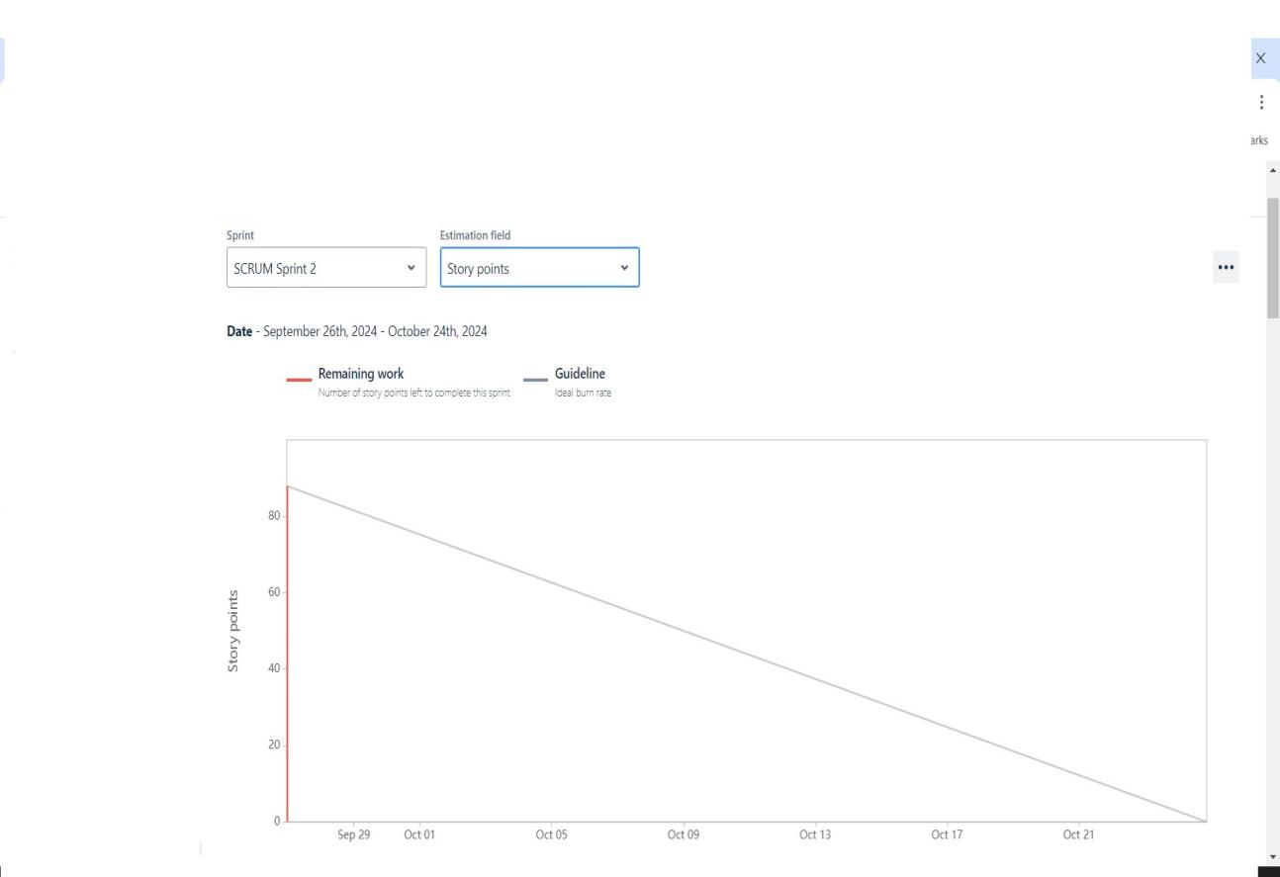

**Sprint burn down**

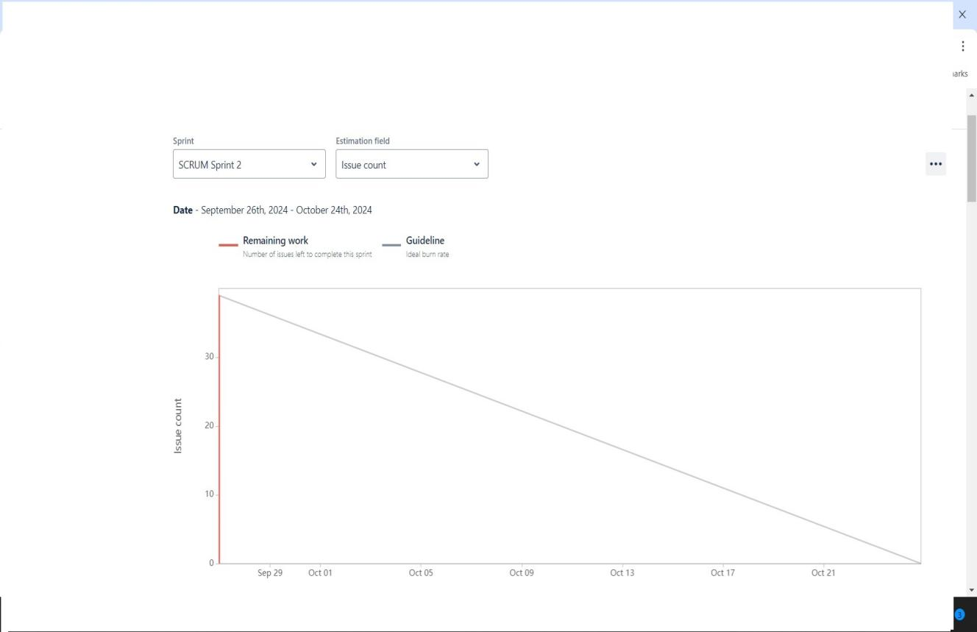

**Sprint Burn up Chart.**

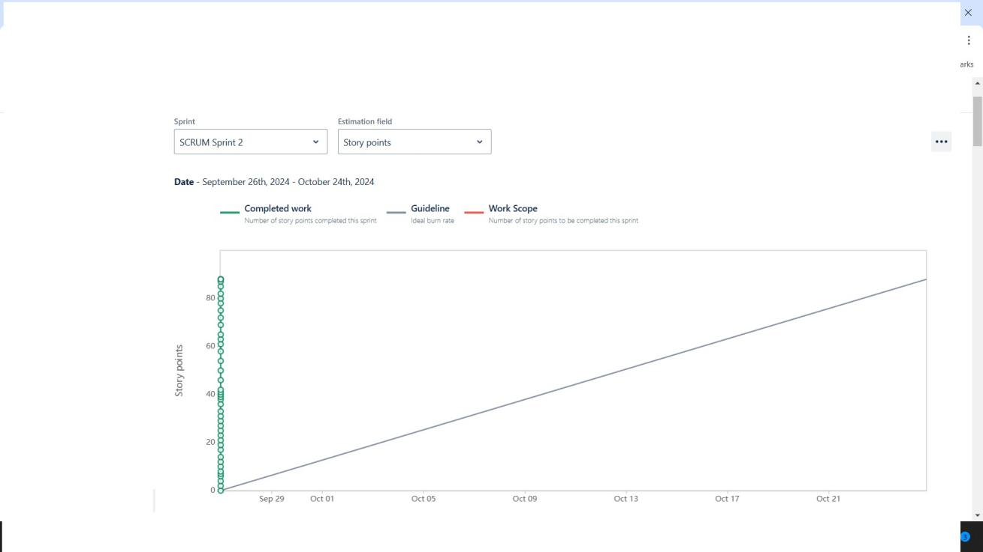

**Document 6: Sprint meetings**

**Meeting Type 1: Sprint Planning meeting**

|  |  |
| --- | --- |
| Date | 5/1/2025 |
| Time | 10.00 AM |
| Location | Pune |
| Prepared By | Diksha Tupe |
| Attendee | Vivek, Vishal, Yogesh |

**Agenda Topics**

|  |  |  |
| --- | --- | --- |
| Topic | Presenter | Time Alloted |
| Update | Mr.Henry | 1 Hr |
| Change Request | Mr.John | 1 Hr |

**Other Information**

|  |  |
| --- | --- |
| Observer | Mr.Bell |
| Resource | Requirements |
| Special Note | Project completed in 3 Months |

**Meeting Type 2: Sprint review meeting**

|  |  |
| --- | --- |
| Date | 5/1/2025 |
| Time | 10.00 AM |
| Location | Pune |
| Prepared By | Diksha Tupe |
| Attendee | Vivek, Vishal, Yogesh |

|  |  |  |  |
| --- | --- | --- | --- |
| Sprints Status | Things to demo | Quick Updates | Whats next |
| Complete | Project | Change request | Any technical Bugs |

**Meeting Type 3: Sprint retrospective meeting**

|  |  |
| --- | --- |
| Date | 5/1/2025 |
| Time | 10.00 AM |
| Location | Pune |
| Prepared By | Sachin Lahane |
| Attendee | Vivek, Vishal, Yogesh |

|  |  |  |  |  |
| --- | --- | --- | --- | --- |
| Agenda | What went well | What didn’t go well | Questions | Reference |
| Change request | Solve and updated to client | Requirements not given by client | Needs to find Every requirement | Clients requirements |
| Technical Issue | Solve the technical Bugs | Some technical Are Pending | Not come Again this technical Bugs | From stake holder and technical team |

**Meeting Type 4: Daily Stand-up meeting**

|  |  |  |  |  |  |  |  |  |
| --- | --- | --- | --- | --- | --- | --- | --- | --- |
| Question | Name /Role | Monday | Tuesday | Wednesday | Thursday | Friday | Saturday | Sunday |
| What did  you do  yesterday? | Developer 1  Developer 2  Developer 3 | Login | Registration | Payment | Delivery report | Orders |  |  |
| What will  you do  today? | Developer 1  Developer 2  Developer 3 | Search option | Location | Delivery | Database | Payment Reports |  |  |
| What (if  any) is  blocking  your  progress? | Developer 1  Developer 2  Developer 3 | No blocking | No blocking | No blocking | No blocking | No blocking |  |  |