**Question 1- BPM-**

Identify Business Process Model for Online Agriculture Store – (Goal, Inputs, Resources, Outputs, Activities, Value created to the end Customer).

**Goal-**

1. To provide online agriculture product buying facility to farmers and to help farmer with online product store.
2. To develop new application should be able to accept the product (fertilizers, seeds, pesticides) details from the manufacturers and should be able to display them to the Farmers.
3. To build this online store is to facilitate farmers to buy seeds, pesticides, and fertilizers from anywhere through internet connectivity.
4. To fulfil gap between farmer and agricultural product manufacture.
5. To provide N number of option to farmers at the time when they purchase fertilizers, seeds, pesticides.
6. Deliver Pesticides to farmers on time

**Inputs-**

Fertilizers, seeds and pesticides manufacturing Companies

**Resources-**

Manufacturing companies, all agriculture products, delivery channels and payment gateway internet connectivity, mobile application and web.

**Outputs-**

To build this online store is to facilitate farmers to buy seeds, pesticides, and fertilizers from anywhere through internet connectivity.

Types, Quality and Quantity available with the manufacturing companies.

Available payment method with the manufacturing company, like cash, card or wallet etc.

**Activities-**

user friendly online web and mobile application to manufacture and farmers.

delivery of agricultural product services to farmers by online product store**.**

Collect payment from farmers by varies mode of payment collection.

Farmers will login to the portal.

Checking the desired product from available lists.

Product will be selected by the farmer/purchaser.

Payment method will be chosen

**Value created to the end Customer-**

Online Agriculture Store available for all platform of mobile (web, Mobile application).

Agriculture Store have

Online Agriculture Store available for anytime and anywhere.

Time and Money saving for farmers.

This leads to increase in their productivity and quality level.

Farmers getting option to choose from variety of products from various brands.

**Question 2 – SWOT -**

Agriculture Store

Employees

Customer (farmers)

Domain

Yes

No

Process

Yes

No

Training

Yes

No

User friendly application

---

Yes

Update of manufacture product

Yes

No

SWOT stands for Strengths and Weaknesses (internal factors) Opportunities and Threats (external factors).

**Strengths**- all these internal Factor of organization which lead to success of the Project.

For example

1. Good IT team
2. Talent pool Available
3. Budget 2 Crores
4. Good experience Java developers
5. Good experience testers

**Weaknesses**- all these internal Factor of organization which barriers to success of the Project.

For example

* Limited duration of project (18 Months)
* Required huge amount of funds for marketing activity
* Project was new to team

**Opportunities**- all these external Factor of organization which lead to success of the Project.

For example

1. New to the market
2. To provide Solution for the farmers Problem
3. Entrance into the large market segment (industry)
4. Get platform to do marketing for agricultural products

**Threats**- all these external Factor of organization which barriers to success of the Project.

For example

* Market demand for new era
* Is customer (farmers) preferring to go for online store?
* How to deliver agricultural product at rural and poor part of country. • Connectivity of internet

**Question 3 – Feasibility study**

At this point we can analyse the Possibility of doing a Project Within some constraints like Technology, Budget and Time

Yes, for this agricultural project we can turn our Idea into Technology

Right now we have sufficient Fund 2cr and time 18 months

For this project we used JAVA technology

Following Resources **Hardware**-

servers, clients, peers, transmission media and connecting devices (routers, bridges, hubs, gateways and switches)

**Software** networking operating system

Protocol suite- OSI model

TCP/IP model

**Trained Resources-**

Project Manager - Mr Vandanam

Java Developer- Ms. Juhi (Senior Java Developer)

Mr. Teyson,

Ms Lucie,

Mr Tucker,

Mr Bravo are Java Developers. Total number of 5 resources for java developer

Network Admin - Mr Mike

DB Admin – John

Tester - Mr Jason and Ms Alekya are the Tester there is two testers with us.

Business analyst – Kunal Khadse

**Question 4- Gap Analysis**

It is an analytical technic in which we understood that what is current state and desired future state of particular project. According to my understanding gap analysis is difference between AS-IS and TOBE.

**Current stage (AS-IS)-**

1. farmers are used traditional technic go to physical agriculture shop and buy fertilizers, seeds and pesticides.
2. There is no closed link between manufactures and farmers.
3. There is not available home delivery facility.
4. Farmers should not able to choose agricultural product from large product segment.
5. Farmers has no platform to do Rating of agricultural Product manufacture company.
6. Farmers don’t have platform to give feedback to agricultural Product manufacture company.
7. Farmers cannot be able to buy product at anywhere and anytime.

**Desired Future state (TO-BE)-**

1. farmers will be able to go online agriculture product store to buy fertilizers, seeds and pesticides.
2. This new application should be able to accept the product (fertilizers, seeds, pesticides) details from the manufacturers and should be able to display them to the Farmers.
3. There is available of home delivery facility.
4. Farmers should able to choose agricultural product from large product segment.
5. Farmers has no platform to do Rating of agricultural Product manufacture company.
6. Farmers have platform to give feedback to agricultural Product manufacture company.
7. Farmers can be able to buy product at anywhere and anytime.

**Following things we required**

1) Mobile application of online agriculture product store

2) Agricultural web store.

3) Fast internet connectivity

4) Supporting device of mobile application and web

5) fertilizers, seeds, pesticides manufacturing companies

6) store house from which we can deliver product easily.

**Question 5 – Risk Analysis**

It is study of uncertain event or condition which can have impact on either cost, time, scope or quality of project.

Risk can be an event when can slow down the progress of the project or something cause a failure.

**BA Risk-**

1. Improper project planning
2. Improper requirement gathering
3. Lack of executive support
4. Improper priorities requirement
5. Improper use of elicitation technic
6. Improper stakeholder analysis
7. Stakeholder not able to provide the proper requirement.
8. Frequent changes in requirement from client side

**Process/Project Risk**

1. Online agriculture product stores new to market.
2. New application should be able to display the product details to farmers.
3. New application should be able to accept the product details from the manufacturers.
4. Is Time and budget being sufficient to this project.
5. Is new project able to track delivery of each agricultural product which order by farmers
6. Is there any technological changes happen complete the project?
7. Should farmers able to accept this concept of agricultural online store initially
8. Challenge to develop agricultural online store at all platforms such as Android, Apple, window and JAVA etc.
9. Unavailability of skilled employee during the project,
10. Communication gap

**Question 6 – Stakeholder Analysis (RACI Matrix)**

It is the study of identify who are the key stakeholders who can take decision and who are the influencers of project.

RACI Matrix (R-responsible, A-accountable, C-consulted and I-informed)

Mr Henry - project sponsor

Mr Pandu – financial head

Mr Dooku – Project coordinator

Peter, Kevin, Ben- Key Stakeholders

Mr Karthik- Delivery Head

Mr Vandanam – Project manager

Ms juhli – Senior java Developer

Mr Teyson, Ms Lucie, Mr Tucker, Mr Bravo -Java Developers

Mr Mike – Network Admin Mr John – DB

Mr Jason and Ms Alekya – Tester

Kunal - BA

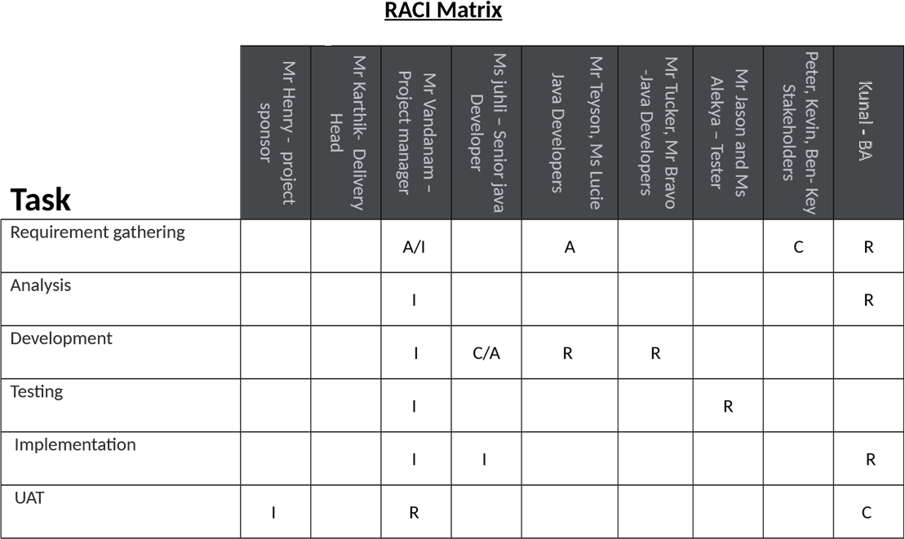

**Question 7- Business Case Document**

Generally, business case Documents are prepared by Sr. BAs, Sr. Business Manager and Business Architects. Business case documents will be help to solve some following open-ended Questions.

**Why is this project Initiated?**

In case study Mr. Henry are Successful Businessman and one of the wealthiest Persons in the city and he wants to help others to fulfil their dreams. One day Mr. Henry Meet his childhood Friends Peter, Kevin and Ben (all are farmers). In this Meeting Peter, Kevin and Ben told to Mr. Henry About their Farmer’s Problems which solve by IT solutions. And the Mr. Henry Plan to develop online agriculture Store to solve Farmers Problem.

**What Are the current problem?**

1. farmers are used traditional technic go to physical agriculture shop and buy fertilizers, seeds and pesticides?
2. There is no closed link between manufactures and farmers?
3. There is not available home delivery facility.
4. Farmers should not able to choose agricultural product from large product segment.
5. Farmers has no platform to do Rating of agricultural Product manufacture company.

**With this project how many problems could be solved?**

With the Help of this Project we are able to solve following problem

1. farmers will be able to go online agriculture product store to buy fertilizers, seeds and pesticides.
2. This new application should be able to accept the product (fertilizers, seeds, pesticides) details from the manufacturers and should be able to display them to the Farmers.
3. There is available of home delivery facility.
4. Farmers should able to choose agricultural product from large product segment.
5. Farmers has no platform to do Rating of agricultural Product manufacture company.

**What are the Resources Required?**

1) Mobile application of online agriculture product store

2) Agricultural web store.

**Time frame to recover ROI?**

This project is initiate under CSR activity. Budget for this project are 2 Crores INR and 18 Months Duration.

**How much organizational change is Required to adopt this technology?**

the online agriculture product store is new to organization and agriculture industry. Then organization required to build total new team to handle all activity organization also unaware about this industry.

**How to identify stakeholders?**

According to me ‘‘a stakeholder is any person or group of persons or an organization that are directly and indirectly effected or impacted by this online agriculture store.’’

**Question 8 – Four SDLC Methodologies**

Following Points Mr. Karthik Explained to Mr. Henry about SDLC.

1) Planning

In the Planning phase they Discuss about what are the user Registration steps. Which type of login credential are Required and which Page Show After Logout. If log in, then which type of Dashboard landing page. Which options available for manufactures to sale the product how the manufacturer connects with farmer directly. What’s thing which show at farmer’s log in page are important. How many things farmer should do from this application? All above question solves at planning stage of SDLC.

• I need to understand assumptions and constrains along with business rule and goal • For the purpose of proper planning I need to understands the project from PM • Develop some strategic Plan for conducts stakeholder’s analysis. • Understood How to look like farmer’s application home page.

2) Requirement analysis

At this stage BA take meeting with all project stakeholder (external) Discuss on User registration, User Login, Logout, Dashboard and tickets. Also BA gathered Information of all planning phase question. At requirement analysis I used prototype technic to gather some extraordinary information and this all my analysis show to stakeholder and then apply as per the requirements.

* As BA I need to identify stakeholders and documents
* Draw UML Diagram for online agriculture product store
* Prepare functional requirements from business requirements
* As an BA need to prepared RTM from SRS from client. We know that SRS is the first legal binding doc between the business and the technical team

3) Design

Following points discuss in Design

Lay out-Responsive web design

Business Rule- clear session on log out

Color scheme- Blue/Grey

Programming language- java

* As an BA I need prepare test case of online agriculture product store from the use case diagram
* Always communicates with client on the design and solution documents.
* I design I will also initiate the preparation of end user manuals
* Updates RTM on time
* GUI designer will look into transient classes and designs all possible screens for the IT solution.

1. Implementation (Coding Phase)
   * I need to organizes JAD sessions online agriculture product store • I need to understand all queries of technical team during coding.
   * Update end user manuals
   * As a team we need to conduct regular status meeting with technical team and the client and tuning client for participation in UAT.
   * Update RTM
2. Testing
   * BA performs high level testing
   * Test data is requested by BA from client
   * Take signoff from client on client project
3. Deployment
   * Plans and organizes training sessions for end users.
   * Coordinates to complete and share end user manuals.

7) Maintenance

**Sequential Waterfall**

It is the most common and classic of life cycle models, also referred to as linear-sequential life cycle model. This model is very easy to understand and use. In this model each Phase must be completed in its entirety before the next phase can begin. In the sequential model we have chance to take review takes Place to determine if the project is on path and whether or not to continue or discard the project.

**18 months’ project**

**Duration in**

**Months**

**19-20**

**4-6 7-9 10-12 13-15 16-18**

**1-3**

**Sequential**

**Iterative**

**Evolutionary**

**II II II II II**

**Agile**

**I I I I I I I I I I I I I I I I I I I I I I I I**

IIIIIIIIIIIIIIIIIIII

LLL

LLL

LLL

LLL

LLL

LL

Stages of Waterfall Model

Resources

Artifacts

Requirements Gathering

BA- Mr Kunal

PM-Mr Vandanam

BRD

Requirements Analysis

BA- Mr Kunal

PM-Mr Vandanam

Tech Team- Sol Arch, NW Arch- Mr.

FS/FRS, SSD,SRS,RTM

Mike

DB Arch-John

Design

Tech Team – Sol Arch, NW Arch-

Mr.Mike,

DB Arch-John, GUI Designer

HDD/ADD

Solution Document

Development Coding

Programmers- Ms juhli

Developers- Mr Teyson, Ms Lucie, Mr

Tucker, Mr Bravo

LDD/CDD

Application

Testing

Testers- Mr Jason and Ms Alekya

Unit, component System, System Integration, UAT

PROCESS – Configuration management – PM- Mr Vandanam

Deployment & Implementation – Release Engineers

After Implementation, maintenance Stage Starts, and Support Team Will Take care.

**Iterative- RUP (Rational Unified Process)**

Following are the main building blocks, or content elements of Iterative (RUP) Roles(who)-

It is defining a set of related skills, competencies and responsibilities.

Project manager-

Project manager skills and Responsibilities

* Activity and resource planning. ...
* Organizing and motivating a project team. ...
* Controlling time management. ...
* Cost estimating and developing the budget. ...
* Ensuring customer satisfaction. ...
* Analyzing and managing project risk. ...
* Monitoring progress.

Business Analyst-

Business Analyst have analytical skills and Responsibilities are enhancing the quality of IT products and services, analyzing data to inform business decisions, and finding technological solutions to business needs.Tester-

Tester have some this software testing skills and Responsibilities

* Analyze Specifications. Before they begin performing any tests, Testers will need to review and analyze the specifications of their company's software. ...
* Develop Tests. ...
* Execute Tests. ...
* Document Bugs. ...
* Troubleshoot Issues. ...
* Re-Test Software

Java Developers-

Java Developers have some software development skills and responsibilities

**Designing, implementing and maintaining Java-based applications**. Contributing in all phases of the development lifecycle. Writing testable, scalable and efficient code. Test and debug new applications and updates.

Work Products (what)-

In this case we are developed online agriculture store. We used Iterative model for produced working through the process.

Tasks (How)-

It describes a unit of work assigned

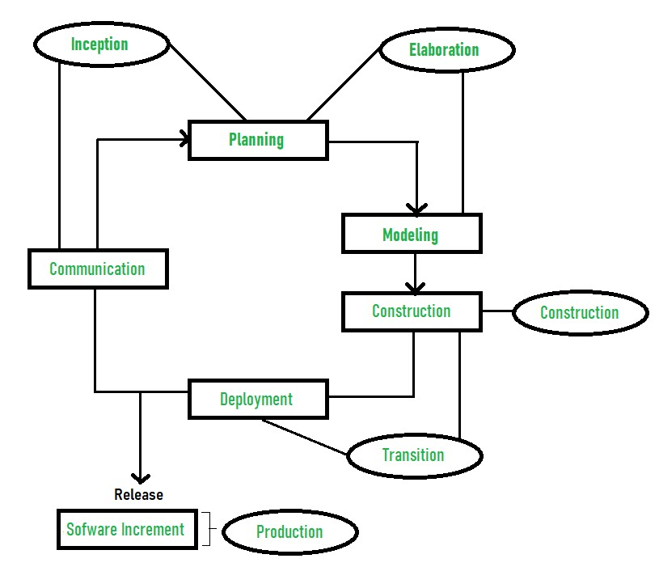

**Four Project Life Cycle Phases**

Inception-

* Communication and planning are the main ones.
* Identifies the scope of the project using a use-case model allowing managers to estimate costs and time required.
* The project plan, Project goal, risks, use-case model, and Project description, are made.

Elaboration-

* Planning and modelling are the main ones.
* A detailed evaluation and development plan is carried out and diminishes the risks.
* Executable architecture baseline.

Construction-

* The project is developed and completed.
* System or source code is created and then testing is done. • Coding takes place.

Transition-

* The final project is released to the public.
* Transit the project from development into production.
* Defects are removed from the project based on feedback from the public

**Evolutionary -Spiral**

Spiral model is combination of waterfall model iterative model. Each phase of spiral model begins with design goal and end with client reviewing. Software is developed in a series of incremental releases.

Following are the stages of spiral model for developing online agricultural product store.

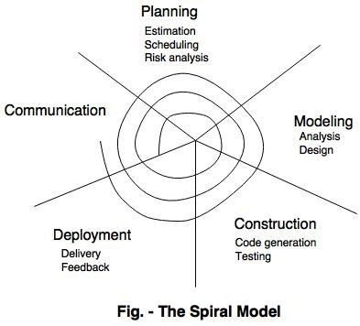

The spiral model has four phases-

* Planning

In Planning Phase Requirement gathering for online agricultural product store by business analyst.

* Risk analysis

In the risk analysis phase, a process is undertaken to identify risk and alternative solution to online agricultural product store. A prototype is produced at the end of the risk analysis phase.

* Engineering

Actually online agricultural product store software is produced in the engineering phase, and this phase end with testing phase.

* Evaluation

This phase allows to customers (farmers) to evaluate the online agricultural product store application (web) is the output of the project to date before the project continues to the next spiral.

**Agile-**

Agile Methodologies can be implemented where faster delivery is required, in this method no documentation is required coding is itself forms as documentation, Agile is the faster method to achieve the goal. It is satisfying the customer through early and continues delivery of the valuable software, Changes can easily have accepted and implemented in any phase of SDLC,

In this phase software is continuously deliver to customer from the couple of week to month, working software is the primary measure of the life cycle, to build the product with motivated individual using face to face conversation it promotes sustainable development, the best architecture requirement and Design emerge from self-organizing team.**Question 9 – Waterfall RUP Spiral and Scrum Models**

**Waterfall**: -A waterfall model is a traditional model in IT Company, the waterfall model is a classical model used in system development life cycle to create a system with linear and sequential approach. In this model software development done from one phase to another phase in download manner, output of one phase used as a input for next phase, every phase has to completed before next phase starts and here is no overlapping of the phases. it is a progressive implementation of the project which is divided into different phases of SDLC. As waterfall models have few limitations, still it was used earlier on a wide range

**RUP Model**: -Stands for Rational Unified Model This is a software development process from rational, a division of IBM, it divides the development process into four distinct phases that each involve business modelling, Analysis and design, Implementation, testing and deployment, In RUP there are four project life cycles

1. Inception
2. Elaboration
3. Construction
4. Transaction

**Spiral**: - This phase starts with gathering of business requirements in the subsequent spirals as the product matures identification of system requirement are done in this phase. This also includes understanding of system requirement by continual communication between customer and the analyst at the end of the spiral the product is deployed

**Design**: Design phase starts with the design in the baseline spiral and involves architectural, logical design of modules, physical product design and final design in the successive spirals.

**Construct**: Construct phase refers to development of the final software product at every spiral. In the spiral when the product is just thought and the design is being developed, a Proof of Concept (POC) is developed in this phase to get the users’ feedback. Then in the successive spirals with higher clarity on requirements and design a working model of the software called build is developed with a version number. These versions are sent to the users for feedback.

**Evaluation and Risk Analysis**: Risk analysis includes identifying, estimating, and observing technical feasibility such as schedule slippage and cost overrun. After testing the build, at the end of first iteration, user evaluates the software and provides the feedback. Based on the customer assessment, development process enters into the next iteration and afterwards follows the linear approach to implement the feedback provided by the user. The process of iterations along the spiral carries on with throughout the life of the software

**SCRUM**: -

Scrum is not a process technique or definitive method, rather it is a framework within which you can employ various processes and technique. It has three roles and every role has clear accountability. The product owner is responsible for maximizing the products value resulting from the development team work

The Scrum model suggests that projects progress via a series of sprints. In keeping with an agile methodology, sprints are time boxed to no more than a month long, most commonly two weeks Scrum is a lightweight agile process framework used primarily for managing software development. Scrum is often contrasted with the so-called “Waterfall” approach, which emphasizes up-front planning and scheduling of activities, followed by execution The scrum models have 5 steps also called phases in scrum.

Step 1: Product Backlog Creation.

Step 2: Sprint planning and creating backlog Step 3: Working on sprint.

Step 5: Retrospective and the next sprint planning

Since I am BA and in this project I supposed to use a V Model methodology is to be better for this project. As V-model is the most important model that is used in the process of software testing. It is also known as Verification and Validation Model. It is Introduced by the late Paul Rook in 1980s. Vmodel is a sequential process in which the next phase begins only after the completion of the present phase. In this model, steps don’t move in a linear way while the steps are bent upwards. It is similar to Waterfall model because we follow V-model from left to right as well as follow a sequential path of execution of processes like as in waterfall model. in waterfall model steps are followed as requirements, design, implementation, verification and finally maintenance. In the same way, the same steps are followed in V-model. So we can say that V-model is the alternate of the waterfall model.

**Question 10- Waterfall Vs V- Model**

The main difference between waterfall model and V model is that in waterfall model, the testing activities are carried out after the development activities are over. On the other hand, in V model, testing activities start with the first stage itself. In other words, waterfall model is a continuous process, while the V model is a simultaneous process. As compared to a software made using waterfall model, the number of defects in the software made using V model are less. This is due to the fact, that there are testing activities, which are carried out simultaneously in V model. Therefore, waterfall model is used, when the requirements of the user are fixed. If the requirements of the user are uncertain and keep changing, then V model is the better alternative. Also making changes in the software in waterfall model is a difficult task, and also proves to be a costly affair. The vice versa is true of the V model. At this stage, I would like to bring it to your notice, that any defects in the software cannot be determined, till the software reaches the testing phase. However, defects are noticed in the initial phases, due to which they can be corrected easily.

**Waterfall Model**

**V Model**

It is continuous process

It is simultaneous process

Testing activities are accomplished after the

developments activities are over

Testing activities starts with the first stage itself

Software made in waterfall model has most

defects compared to one made V fall model

Software made in V model has comparatively lesser

defects than the one made in waterfall method

Water fall model is used when the requirements of

the user are fixed

If the requirements of the user are uncertain and keep

changing, then V model is better alternate model

Making changes in the software in the water fall

mode is a costly affair

Making changes in the software in V model is

comparatively cheaper

**Question 11- Justify your choice**

As a BA I choose V model for this Projects and following are the Reason Which Influence me to choose V model instance of choosing waterfall model and other models.

* V- model is based on verification and validation of each phase of developing online agricultural product store.
* The model allows me to completed each phase must before go to next phase. Testing of developing online agricultural product store is planned in parallel with a corresponding phase of development in V-model.
* This V model properly work with small projects like developing online agricultural product store where requirements are easily understood.
* This V model also help me in the project when in case if any changes happen in midway, then the test documents along with requirements documents has to be updated.
* In V model, Testing activities like planning, [**test designing**](http://tryqa.com/what-is-test-design-or-how-to-specify-test-cases/) happens well before coding. This saves a lot of time. Hence higher chance to get success model.**Question**

**Question 12- Gantt Chart**

**Ans-**

|  |  |  |  |  |
| --- | --- | --- | --- | --- |
| **TASK** | **START DATE** | **END DATE** | **DURATION** |  |
| Requirements Gathering | 1/01/2025 | 25/02/2025 | 55 |  |
| Requirements Analysis | 16/02/2025 | 23/03/2025 | 35 |  |
| Design | 10/03/2025 | 5/05/2025 | 56 |  |
| Development 1 | 20/06/2025 | 1/09/2025 | 73 |  |
| Testing 1 | 1/08/2025 | 16/10/2025 | 76 |  |
| Development 2 | 25/09/2025 | 9/12/2025 | 75 |  |
| Testing 2 | 1/11/2025 | 15/01/2026 | 75 |  |
| Development 3 | 1/01/2026 | 17/03/2026 | 75 |  |
| Testing 3 | 1/03/2026 | 21/05/2026 | 81 |  |
| Development 4 | 1/05/2026 | 1/07/2026 | 61 |  |
| Testing 4 | 15/06/2026 | 15/08/2026 | 61 |  |
| UAT | 1/08/2026 | 1/09/2026 | 31 |  |
|  |  |  |  |  |
|  |  |  |  |  |
|  |  |  |  |  |
|  |  |  |  |  |
|  |  |  |  |  |
|  |  |  |  |  |
|  |  |  |  |  |
|  |  |  |  |  |
|  |  |  |  |  |
|  |  |  |  |  |
|  |  |  |  |  |
|  |  |  |  |  |
|  |  |  |  |  |
|  |  |  |  |  |
|  |  |  |  |  |
|  |  |  |  |  |
|  |  |  |  |  |
|  |  |  |  |  |
|  |  |  |  |  |
|  |  |  |  |  |
|  |  |  |  |  |
|  |  |  |  |  |
|  |  |  |  |  |
|  |  |  |  |  |
|  |  |  |  |  |
|  |  |  |  |  |
|  |  |  |  |  |
|  |  |  |  |  |
|  |  |  |  |  |
|  |  |  |  |  |
|  |  |  |  |  |
|  |  |  |  |  |
|  |  |  |  |  |
|  |  |  |  |  |
|  |  |  |  |  |
|  |  |  |  |  |
|  |  |  |  |  |
|  |  |  |  |  |
|  |  |  |  |  |
|  |  |  |  |  |

**Question 13 – Fixed Bid Vs Billing**

**Fixed Bid Model :-**

A Fixed Bid project is **billed using a flat amount, regardless of the number of hours worked**. This flat amount can be applied to the project as a whole, or to each week or month of the project. Since Fixed Bid projects are duration-based, they require a start and end date.

**Billing Model:-**

In this model resources working in the project will be billed to the client on hourly basis.3 Lest consider examples

* PM -$130/Hr,
* Sol Architect – $55/Hr,
* Programmers – $50/Hr
* Sr. Programmers – $80/Hr
* Network Engineer – $80/Hr
* DBA - $80/Hr
* BA- $60/Hr

**Timesheet Billing :-**

Timesheet billing is used by individuals, organizations and professionals that render services to clients that include the billable hour.

**Question 14– Timesheets**

**RG Timesheet Of a BA**

Hourly Rate in

$

60

Gross Pay in $

3690

Date worked

In

Time

Out

Time

Total Hours

Worked

Gross pay in

$

Additional Information

Friday, 1 July, 2022

06:00

17:00

11

660

Identify the relevant stakeholders

Sunday, 3 July, 2022

07:00

18:00

11

660

Establish project goals and objectives

Monday, 4 July, 2022

08:00

17:00

9

540

Elicit requirements from stakeholders

Tuesday, 5 July, 2022

06:00

18:00

12

720

Document the requirements

Wednesday, 6 July, 2022

07:30

17:00

10

570

Confirm the requirements

Thursday, 7 July, 2022

07:00

16:00

9

540

Prioritize the requirements

**RA Timesheet of a BA**



Hourly Rate in

$

60

Gross Pay in $

3570

Saturday, 6 August, 2022

Tuesday

Wednesday, 3 August, 2022

Tuesday

Friday, 5 August, 2022

Tuesday

Thursday, 4 August, 2022

Tuesday

Tuesday, 2 August, 2022

Tuesday

Date worked

In

Time

Out

Time

Total Hours

Worked

Gross pay in

$

Additional Information

Monday, 1 August, 2022

Tuesday

06:00

16:00

10

600

User testing

07:00

17:00

10

600

Technical Elaboration & Validation

08:00

18:00

10

600

Data Analysis

06:00

18:00

12

720

Demonstrations / Showcases

07:30

17:00

10

570

Business sign-off of designs

07:00

15:00

8

480

Solution Architecture

**Design timesheet of a BA**

Hourly Rate in



$

60

Gross Pay in $

690

Date worked

In

Time

Out

Time

Total Hours

Worked

Gross pay in

$

Additional Information

Monday, 15 August, 2022

06:00

07:00

1

60

User testing

07:00

08:00

1

60

Technical Elaboration & Validation

08:00

09:00

1

60

Data Analysis

10:00

13:00

3

180

Demonstrations / Showcases

13:30

17:00

4

210

Business sign-off of designs

17:00

19:00

2

120

Solution Architecture

**Development Timesheet of a BA**



Hourly Rate in

$

60

Gross Pay in $

690

Date worked

In

Time

Out

Time

Total Hours

Worked

Gross pay in

$

Additional Information

Tuesday, 16 August, 2022

06:00

07:00

1

60

analyses the business domain

07:00

09:00

2

120

documents its processes and systems

09:00

10:00

1

60

outlines business requirements

10:00

13:00

3

180

outlines business requirements

13:30

16:00

3

150

Analysis software being

built

**Testing Timesheet of a BA**

Hourly Rate in

$

60

Gross Pay in $

630

|  |  |  |  |  |  |  |
| --- | --- | --- | --- | --- | --- | --- |
| Date worked |  | In  Time | Out Time | Total Hours Worked | Gross pay in $ | Additional Information |



Wednesday, 17 August, 2022

06:00

09:00

3

180

Work with Testing team to create system

test plans

09:00

12:00

3

180

Create and execute the system test cases

13:30

16:00

3

150

Review system cases prepared by Testing

team

16:30

18:30

2

120

Provide requirements clarifications when

required by Testing Team.

**UAT Timesheet of a BA**

Hourly Rate in

$

60

Gross Pay in $

600

Date worked

In

Time

Out

Time

Total Hours

Worked

Gross pay in

$

Additional Information

Thursday, 18 August, 2022

06:00

08:00

2

120

Develop the detailed UAT test Plan

08:00

11:00

3

180

develop the test case scenario

13:00

16:00

3

180

create UAT test cases

17:30

18:30

1

60

test case data preparation

18:30

19:30

1

60

run the test cases

**Deployment n Implementation Timesheet of a BA**

Hourly Rate in

$

60

Gross Pay in $

600

Date worked

In

Time

Out

Time

Total Hours

Worked

Gross pay in

$

Additional Information

Thursday, 18 August, 2022

06:00

08:00

2

120

design RTM and forward to client

08:00

12:00

4

240

coordinate to complete manual

13:00

16:00

3

180

training sessions for end user

17:30

18:30

1

60

prepare a lessons learning from

project