Waterfall Deliverables – Part -2/2

**Waterfall Model Documents**

Waterfall Project1 – Part -2/2

**Part 2/2 Evaluation**

Document 6- Please prepare a use case diagram, activity diagram and a use case specification

document.

Document 7- Screens and pages

Document 8- Tools-Visio and Axure

Document 9- BA experience

My experience as BA in following phases:

1. Requirement gathering:

2. Requirement Analysis:

3. Design:

4. Development:

5. Testing:

6. Deployment:

**Document 6- Please prepare a use case diagram, activity diagram and a use**

**case specification document.**

1. Use case Name

2. Use case Description

3. Actors Primary Actors Secondary actors

4. Basic Flow

5. ALTERNATE FLOW

6. Exceptional flows

7. Pre- Conditions

8. post-conditions

9. Assumptions

10. Constraints

11. Dependencies

12. Inputs and Outputs

13. Business Rules

14.Miscellaneous Information

Answer:

 **Activity Diagram –**

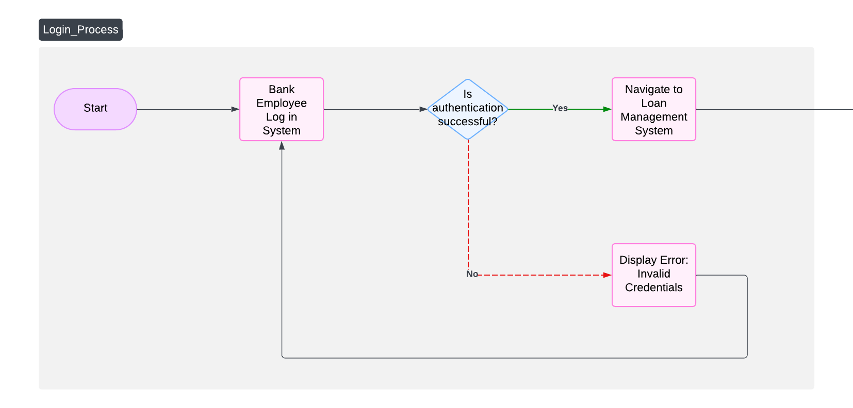

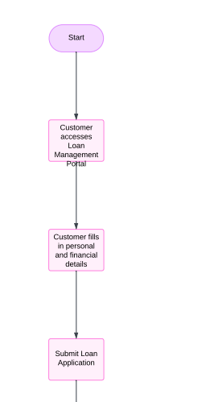

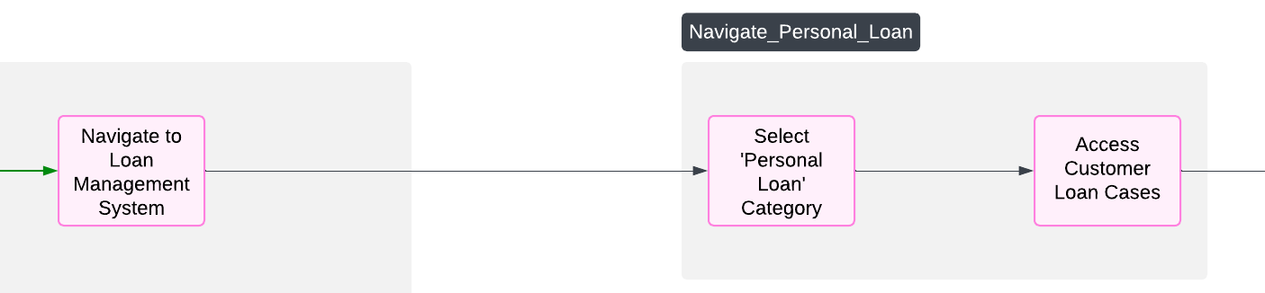

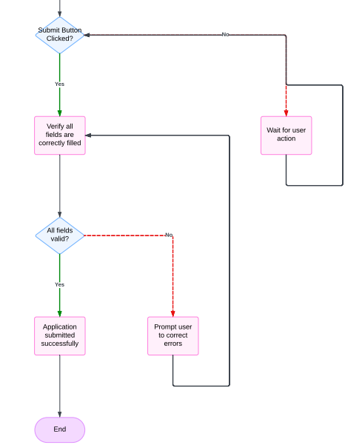

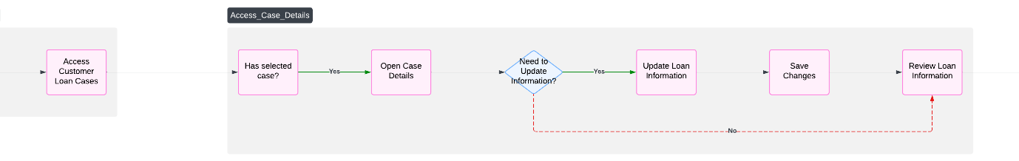

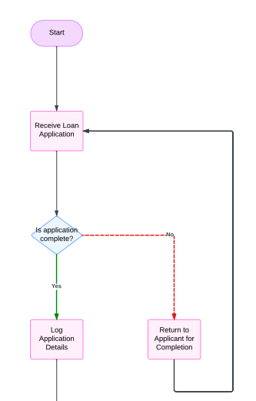

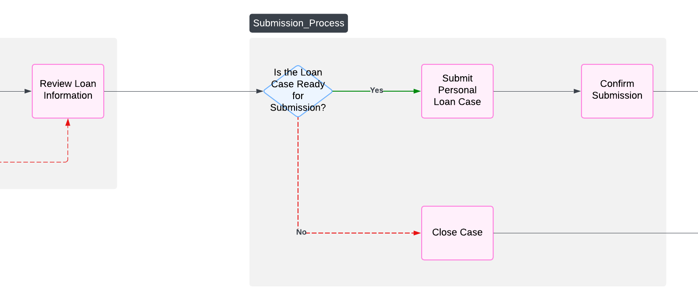

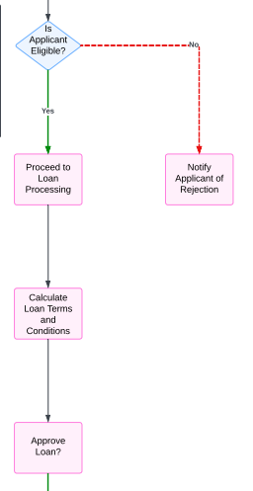

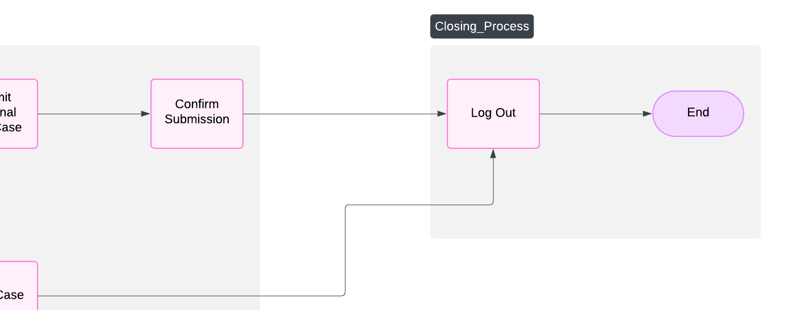

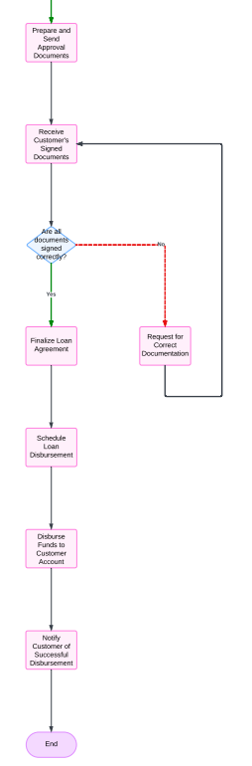

**Use Case Specification Document**

**Project: Personal Loan Management System**

**Methodology: Waterfall**

**Use Case 1: Bank Employee Login**

**1. Use Case Name**  
Bank Employee Login

**2. Use Case Description**  
Allows bank employees to securely log into the loan management system to process loan applications.

**3. Actors**

* **Primary Actors:** Bank Employee
* **Secondary Actors:** System Admin

**4. Basic Flow**

1. Employee accesses the login page.
2. Employee enters a valid username and password.
3. System authenticates the credentials.
4. System grants access to the employee dashboard.

**5. Alternate Flow**

* **Invalid Credentials:** If the username or password is incorrect, the system prompts the employee to retry.

**6. Exceptional Flows**

* Account locked after three failed login attempts.
* System error while authenticating.

**7. Pre-Conditions**

* Employee must be registered in the system.
* System is operational.

**8. Post-Conditions**

* Employee gains access to the system.
* System logs the login activity.

**9. Assumptions**

* Employees have unique credentials.

**10. Constraints**

* Login session timeout set to 15 minutes of inactivity.

**11. Dependencies**

* Employee database and authentication service.

**12. Inputs and Outputs**

* **Inputs:** Username and password.
* **Outputs:** Access to the dashboard or error messages.

**13. Business Rules**

* Password must meet complexity requirements.

**14. Miscellaneous Information**

* Implemented with two-factor authentication in the future.

**Use Case 2: Customer Login for Application**

**1. Use Case Name**  
Customer Login with Mobile Number and PAN

**2. Use Case Description**  
Allows customers to log into the portal using their mobile number and PAN to apply for a loan.

**3. Actors**

* **Primary Actors:** Customer
* **Secondary Actors:** Support Team

**4. Basic Flow**

1. Customer accesses the login page.
2. Customer enters their mobile number and PAN.
3. System verifies the credentials.
4. System grants access to the loan application section.

**5. Alternate Flow**

* **Incorrect PAN or Mobile Number:** System prompts for retry.

**6. Exceptional Flows**

* PAN mismatch with mobile number.
* Mobile number not registered.

**7. Pre-Conditions**

* Customer is pre-registered in the bank database.

**8. Post-Conditions**

* Customer gains access to the application form.

**9. Assumptions**

* Mobile number is verified with an OTP.

**10. Constraints**

* OTP expires in 5 minutes.

**11. Dependencies**

* PAN database verification service.

**12. Inputs and Outputs**

* **Inputs:** Mobile number, PAN, and OTP.
* **Outputs:** Access to application form or error messages.

**13. Business Rules**

* Mobile number and PAN must match bank records.

**14. Miscellaneous Information**

* Future integration with biometric login.

**Use Case 3: Basic Details of Customer**

**1. Use Case Name**  
Basic Details of Customer

**2. Use Case Description**  
Captures the essential personal details of the customer required for loan processing.

**3. Actors**

* **Primary Actors:** Customer
* **Secondary Actors:** Customer Support

**4. Basic Flow**

1. Customer enters their full name, father's name, email ID, and Aadhaar number.
2. System validates the format of the entered details.
3. Details are saved in the system.

**5. Alternate Flow**

* **Validation Errors:** Prompts the customer to correct the details.

**6. Exceptional Flows**

* System fails to save the details due to a technical error.

**7. Pre-Conditions**

* Customer is logged in.

**8. Post-Conditions**

* Details are saved in the system.

**9. Assumptions**

* Aadhaar number is valid and matches the format.

**10. Constraints**

* Mandatory fields cannot be left blank.

**11. Dependencies**

* Aadhaar validation service.

**12. Inputs and Outputs**

* **Inputs:** Full name, father's name, email ID, Aadhaar number.
* **Outputs:** Confirmation of data saved.

**13. Business Rules**

* Name must match Aadhaar records.

**14. Miscellaneous Information**

* Plan for automatic retrieval of Aadhaar-linked data in future.

**Use Case 4: Other Details of Customer**

**1. Use Case Name**  
Other Details of Customer

**2. Use Case Description**  
Captures additional details required for eligibility assessment.

**3. Actors**

* **Primary Actors:** Customer
* **Secondary Actors:** Bank System

**4. Basic Flow**

1. Customer fills in company name, net take-home salary, existing EMIs, and bank account details.
2. System validates and saves the information.

**5. Alternate Flow**

* **Incomplete Details:** Prompts the customer to complete missing fields.

**6. Exceptional Flows**

* System fails to save the data due to a technical error.

**7. Pre-Conditions**

* Customer has filled in basic details.

**8. Post-Conditions**

* Details are stored in the database.

**9. Assumptions**

* Customer knows their financial information.

**10. Constraints**

* Details must be verified for accuracy.

**11. Dependencies**

* Bank account verification service.

**12. Inputs and Outputs**

* **Inputs:** Company name, salary, EMI, bank account.
* **Outputs:** Confirmation of data saved.

**13. Business Rules**

* Salary must be above a minimum threshold.

**14. Miscellaneous Information**

* Integration with credit bureau planned.

**Use Case 5: System Check and Loan Application Submission**

**1. Use Case Name**  
Eligibility Check and Loan Submission

**2. Use Case Description**  
Assesses loan eligibility, allows the customer to select tenure, upload documents, and generates a loan application number.

**3. Actors**

* **Primary Actors:** Customer
* **Secondary Actors:** Bank Employee

**4. Basic Flow**

1. System checks customer eligibility based on entered details.
2. Customer selects loan tenure and amount.
3. Customer uploads required documents (e.g., ID proof, income proof).
4. System generates a unique loan application number.

**5. Alternate Flow**

* **Ineligible for Loan:** System displays a rejection message with reasons.

**6. Exceptional Flows**

* Document upload fails due to network issues.

**7. Pre-Conditions**

* Customer has filled in all required details.

**8. Post-Conditions**

* Application is submitted, and the loan application number is generated.

**9. Assumptions**

* Customer has the necessary documents in the required format.

**10. Constraints**

* Maximum loan amount depends on eligibility.

**11. Dependencies**

* Eligibility criteria engine and document storage service.

**12. Inputs and Outputs**

* **Inputs:** Loan amount, tenure, uploaded documents.
* **Outputs:** Application status and loan number.

**13. Business Rules**

* Loan amount cannot exceed 60% of net monthly income.

**14. Miscellaneous Information**

* Loan tracking feature under development.
* **Document 7- Screens and pages**
* **Answer –**

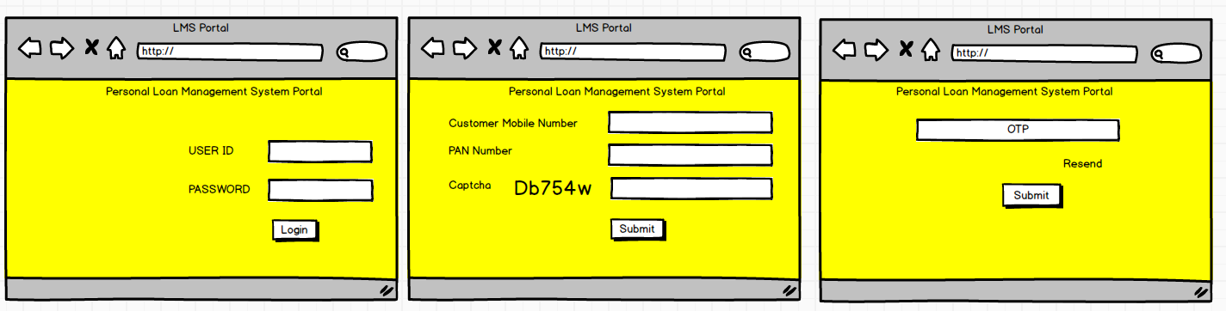

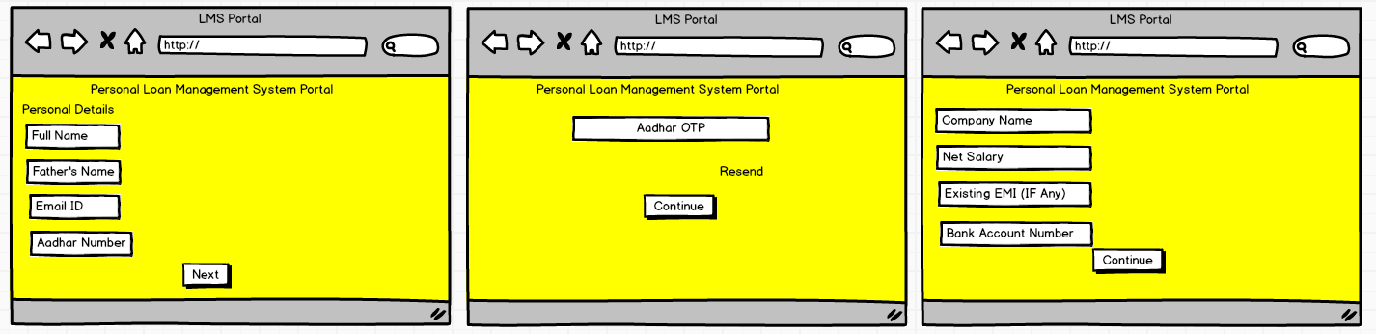

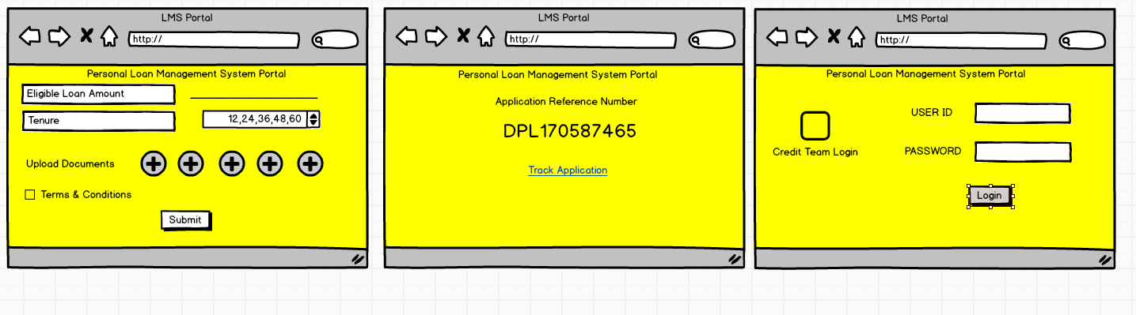

* **Document 8- Tools-Visio and Axure**
* **Answer -**

As a Business Analyst working on a Loan Management System (Personal Loan) project using the waterfall methodology, my experience with Visio and Axure was instrumental in ensuring the project's success. In the initial stages, I used Visio to create detailed flowcharts and process diagrams to document the loan management workflow, including application submission, eligibility verification, approval, and repayment tracking. These visual aids facilitated clear communication among stakeholders and ensured alignment on requirements. Later, Axure became essential for developing interactive prototypes of the user interface, enabling the team to visualize and validate the customer journey before development began. The combination of Visio for process documentation and Axure for prototyping helped bridge the gap between business requirements and technical implementation, ensuring a well-structured, user-focused system. The waterfall approach provided a linear framework that allowed me to meticulously gather requirements and deliver documentation for each phase, maintaining a structured and predictable workflow throughout the project.

* **Document 9- BA experience**
* **My experience as BA in following phases:**

**1. Requirement gathering:**

● To gather requirements, we used MOSCOW technique.

● Client is not available for some period of time during this phase. So as a BA i

need to source out point of contacts from his side and get the information

ASAP.

● I validate the requirements using FURPS technique

● There are many requirements which are duplicated or repeated. We need to

remove them immediately

● Prototyping is used to give more specific requirements

**2. Requirement Analysis:**

● We need to draw UML diagrams to visually describe the requirements

● Activity diagrams also used to describe the process flow

● Communicate the diagrams to team. Some team members might not agree

with them and might make changes. As a BA we need to consider the points

and make modifications

● Prepare BRS and SRS

**3. Design:**

● From the use case diagrams, we prepare test cases

● Communicate with client on design and solution documents

● Write negative test cases as well along with positive test cases.

● Do not miss a single test case. It might have huge impact on project

development in later stages

● Prepare test data for testing

● Update RTM. This is just as we need to make sure that all the requirements

are met

**4. Development:**

● Organized JAD sessions

● Clarifying queries of tech team during coding

● There might be some team members who doesn't agree with the concept or

who doesn’t cooperate during JAD sessions. As a BA i handle the situation

gently and had one on one discussion with them. Explained how their actions

are going to affect the project. Setup healthy environment within the team.

● Referred diagrams to code the Unit

● Conduct regular meetings with technical team and client which is challenging.

Some team members might not be available for the meeting. Recording the

session and providing that to missed one and having one to one discussion

later with that missed person is all i need to do

**5. Testing:**

● Prepare test cases from use cases

● Perform high level testing

● Test data is requested by BA from client

● Updated RTM

● Take signoff from client

● Prepare client for UAT

**6. Deployment:**

● Forwarded RTM to client which should be attached to project closure

document

● Coordinates to complete and share end user manuals

● Plans and organizes training sessions

● Make sure all the candidates attend the meeting

* **Answer –**

As a Business Analyst for the Loan Management System project using the Waterfall methodology, I played a critical role across all phases, ensuring the delivery of a robust and user-centric solution.

1. **Requirement Gathering**:  
   Using the MOSCOW technique, I prioritized client requirements to distinguish critical needs from optional ones. During periods of client unavailability, I proactively identified alternative points of contact to gather information swiftly. I validated requirements using the FURPS framework to ensure functional, usability, reliability, performance, and scalability aspects were covered. To refine and clarify requirements, I leveraged prototyping, eliminating duplicate or repetitive inputs to maintain clarity.
2. **Requirement Analysis**:  
   I developed UML diagrams and activity diagrams to provide visual clarity of the processes and flows. These diagrams were shared with stakeholders, and iterative feedback was incorporated to achieve consensus. I prepared both the Business Requirements Specification (BRS) and Software Requirements Specification (SRS) to document and formalize the requirements comprehensively.
3. **Design**:  
   From the use case diagrams, I derived detailed test cases, including both positive and negative scenarios, ensuring comprehensive test coverage. Collaboration with the client on design and solution documents ensured alignment. Maintaining an updated Requirements Traceability Matrix (RTM) helped track requirement fulfillment across the lifecycle, preventing any omissions.
4. **Development**:  
   I facilitated Joint Application Development (JAD) sessions to align the development team on requirements and design, addressing concerns and fostering collaboration. I handled team dynamics, including resolving disagreements and ensuring cooperation, by organizing one-on-one discussions to promote understanding. My role involved constant engagement with the technical team, clarifying queries, and referencing diagrams to support accurate implementation.
5. **Testing**:  
   During the testing phase, I prepared test cases, coordinated high-level testing, and ensured that test data requirements were fulfilled. I maintained the RTM to confirm all requirements were verified, obtained client signoff, and guided them in preparing for User Acceptance Testing (UAT).
6. **Deployment**:  
   For project closure, I compiled and forwarded the RTM to the client as part of the documentation. I coordinated the creation and distribution of end-user manuals and organized training sessions to familiarize users with the system. I ensured maximum attendance and engagement in these sessions to facilitate a smooth transition to production use.

Throughout the project, my role demanded attention to detail, proactive communication, and the ability to adapt to evolving challenges, ensuring the successful delivery of the Loan Management System.

Top of Form

Bottom of Form