**Nurturing Process- Capstone Project1– Part-3/3**

**Question 1– Functional Requirements**

**Functional Requirements:**

It describes the systems features and functions. It describes what a system feature should do to accomplish the requirements of the user.

|  |  |  |  |
| --- | --- | --- | --- |
| **Req Id** | **Req Name** | **Req Description** | **Priority** |
| FR0001 | Farmer Registration | Farmers should be able to register with the application | 8 |
| FR0002 | Farmer Search for Products | Farmers should be able to search for available products in fertilizers, seeds, pesticides | 8 |
| FR0003 | Manufacturer Registration | Manufacturers should be able to register with the application | 8 |
| FR0004 | Login Function | Farmers and Manufacturer’s should be able to login into the portal using the registered Email id/ Mob number and correct password created during account creation | 10 |
| FR005 | Home Page | Farmers and Manufacturer’s should be directed to the home page where the basic information about the application and all the features are displayed. | 8 |
| FR006 | Manufacturers product updating | The manufacturer should be able to update all the details regarding the product in the portal | 9 |
| FR007 | Product Details display | When the customer searches the product all the details of the product like description, rate, usage, quantity should be displayed in the page. | 8 |
| FR008 | Upload Reference | The farmer should be able to search for any product by uploading a reference picture in the search option. | 6 |
| FR009 | Filter functionality | The farmers should be able to filter the products based on price, brand and location. | 7 |
| FR010 | Add To Cart | Farmers should be able to add the products to the shopping cart for purchase | 8 |
| FR011 | Purchase Product | Farmers should be able to purchase the product directly by clicking on a button “Purchase Now”. | 9 |
| FR012 | Wishlist Functionality | Farmers should be able to add the products to Wishlist if they want to purchase it later | 7 |
| FR013 | Payment Methods | Multiple payment modes like COD, Net banking, UPI, Debit/Credit card options should be available for the comfort of the farmers. | 10 |
| FR014 | Payment Confirmation | Once the order has been placed successfully after the payment a confirmation Email and an invoice should be displayed for the farmer. | 5 |
| FR015 | Order Cancellation | Farmer should be able to cancel the order that was placed with a valid reason. | 6 |
| FR016 | Cart Management | Farmers should be able to do various options in the shopping cart like addition or deletion of the products | 8 |
| FR017 | Sending Notification to Manufacturer | Once an order has been place the farmer’s details such as name, address, required product, quantity details should be sent through Email to the respective Manufacturer. | 9 |
| FR018 | Order History | The Farmers should be able to view the products that they have purchased till date in the application | 6 |
| FR019 | Order Tracking | On the confirmation of the payment the order tracking link should be sent to the Farmer through Email | 9 |
| FR020 | Account Management | Farmers and manufacturers should be allowed to change their profile like User Name, Password, address, Mobile number etc. | 4 |
| FR021 | Reviews and Ratings | The Users should be able to provide their reviews and ratings under each product. | 6 |
| FR022 | Product Recommendations | The application should provide personalized recommendations based on user browsing history and preferences | 6 |

**Non-Functional Requirements:**

It describes the general properties of a system.

|  |  |  |  |
| --- | --- | --- | --- |
| **Req Id** | **Req Name** | **Req Description** | **Priority** |
| NFR0101 | Page Loading Time | Each Page should load within 2 seconds time | 9 |
| NFR0102 | WCAG2.1. | The system must meet Web Content Accessibility Guidelines WCAG 2.1. | 8 |
| NFR0103 | Password | The users should be intimated to change the password every 90 days | 6 |
| NFR0104 | Timeout time for page inactivity | The inactive pages should be timed out in 7 min | 7 |
| NFR0105 | Timeout time for OTP | Validity time for entering OTP should limited to 5 Min | 8 |
| NFR0106 | Internet connectivity | The system should have an active internet connection | 8 |
| NFR0108 | Data Backup | All the activities done by user should be backup automatically | 5 |
| NFR0109 | Mobile Number | The user should have an active Mobile number to receive OTP. | 6 |
| NFR0110 | Email Address | The user should have an active Email address to receive all the updates. | 6 |
| NFR0111 | Operating System | The allocation should be working on all the operating systems | 8 |
| NFR0112 | Stock Alerts | The Manufacturer should be receiving a balance available stock details every week | 7 |
| NFR0113 | Net Banking | The use should have Net Banking option activated for the bank account for payment process | 5 |
| NFR0114 | UPI Payment | The User should have at least 1 bank account added to the UPI portal to do payment. | 5 |
| NFR0115 | Check Stock | Once the product is sold the stock of the product should be reduced | 7 |
| NFR0116 | Payment Receipt | Payment details should be printed on a white paper of size 4”6 | 5 |
| NFR0117 | Data Security | The personal details of the user should be protected with high security. | 9 |

**Question 2–Minimum 5 page designs**

Make wireframe and prototypes

**Wireframes:**

A wireframe is a simple, low-fidelity representation of a website or application's layout. It's like a blueprint or skeleton of the interface, showing the arrangement of elements and their relationships to each other. Wireframes are used to plan the layout of a website or application before any design work is done, helping to ensure that the interface is user-friendly, functional, and meets the target audience's needs.

**Prototype:**

A prototype is a working model of a product or system that is used to test and refine ideas before they are put into production. It is an early sample, model, or release of a product built to test a concept or process.

**Front Page**

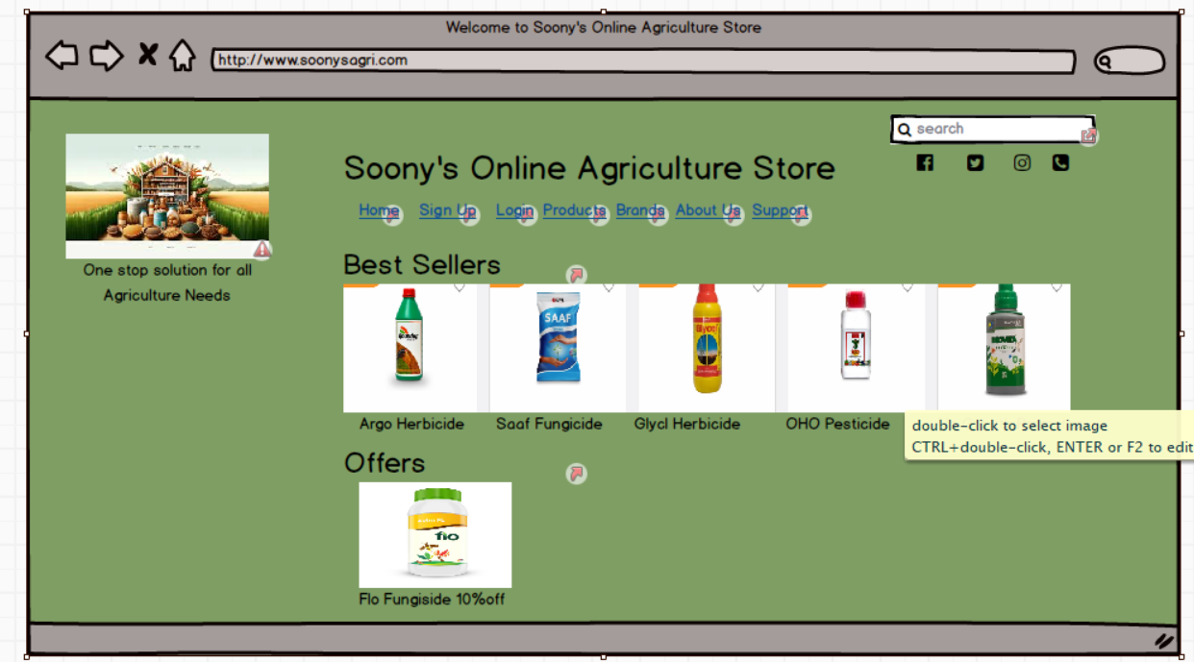

**Home Page**

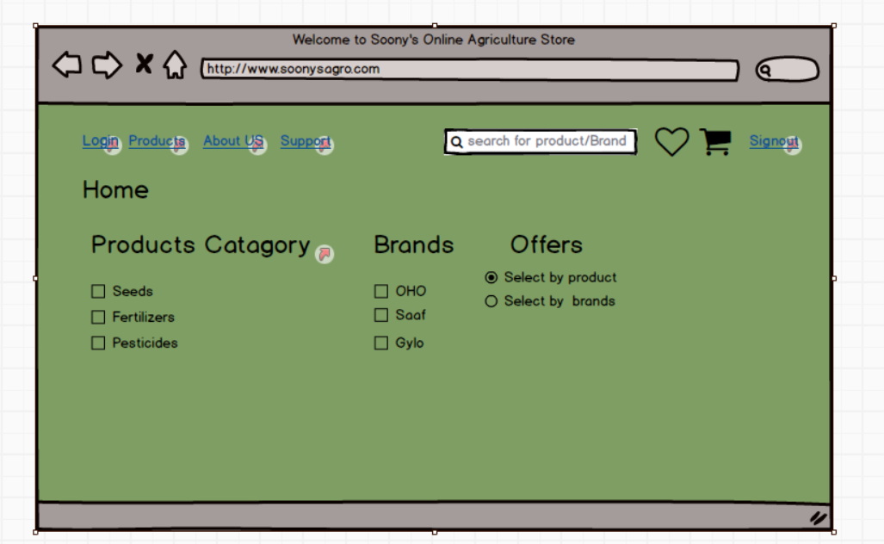

**Sign-Up**

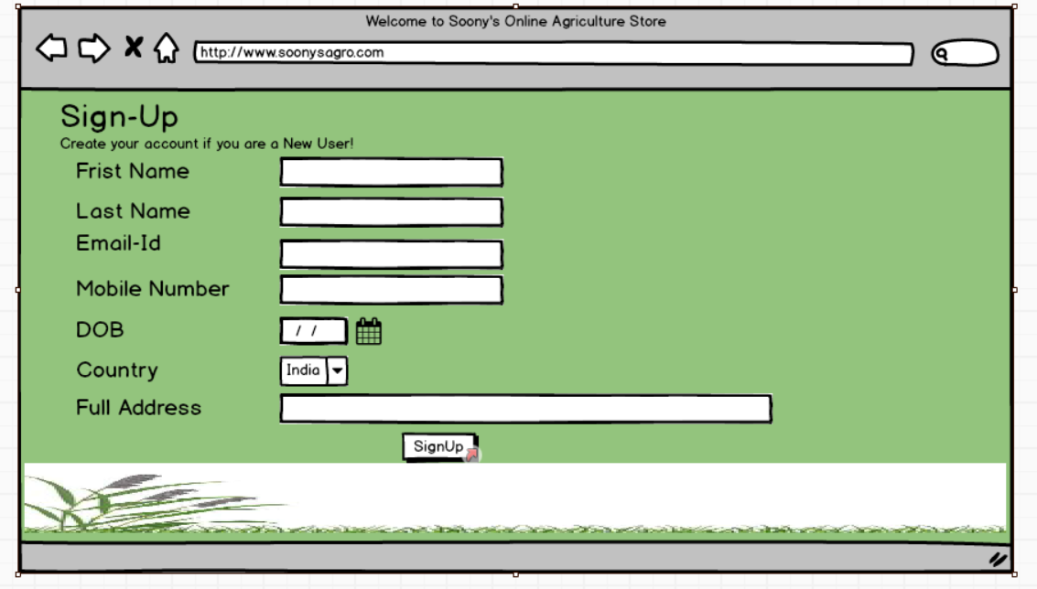

**Login**

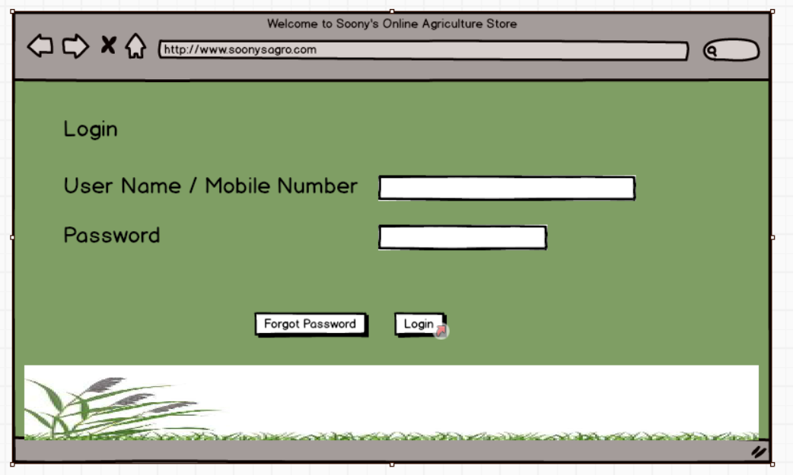

**Products**

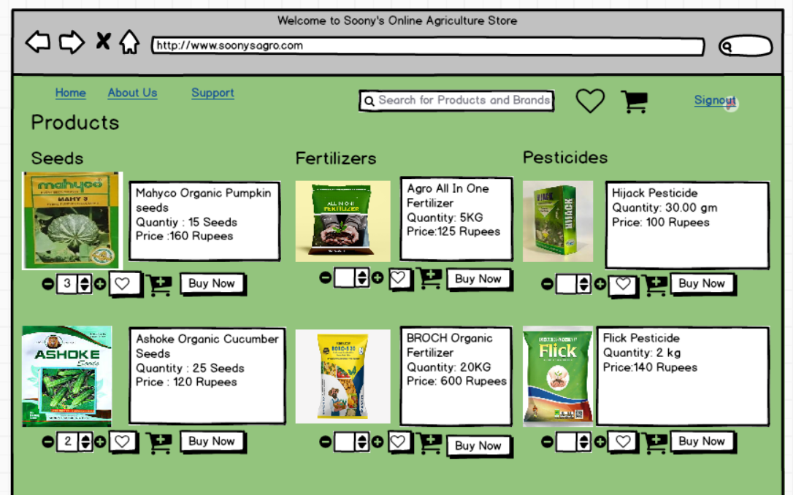

**Question 3– Tools(Visio, Balsamiq)**

Make a note of the Tools, which you are using for above concepts

**Visio:**

MS Visio is a Microsoft Product sold as an addition to MS Office. Microsoft Visio is software for drawing a variety of diagrams. These include flowcharts, org charts, building plans, floor plans, data flow diagrams, process flow diagrams, business process modelling, swimlane diagrams, 3D maps, and many more.

* **Flowcharts:**

A Flowchart helps to show the flow of the process in a sequential manner. These steps indicate the flow which has to be followed to complete the process. It is easy to understand the flow and more effective in conveying information.

* **Organization Charts:**

It is used to show the Organizational structure of an organization. It displays the roles and reporting relationships in an organization.

* **Floor Plan:**

Floor Plan helps to create the structure of a floor or a room. It is used by Architects to design buildings.

* **Business Process Modelling:**

A Flowchart helps to show the flow of the process in a sequential manner. These steps indicate the flow which has to be followed to complete the process. It is easy to understand the flow and more effective in conveying information.

* **Data Flow Diagram:**

It helps to document the logical flow of data through a set of processes or Procedures.

**Balsamiq:**

Balsamiq is a rapid wireframing tool. It creates mockups and wireframes for websites, web apps, and desktop software. It has a simple drag-and-drop interface. It focuses on the structure and content of the product rather than visual details. The main goal of Balsamiq is to facilitate effective communication between teams about user interface design. It encourages discussion and feedback on early designs before developers start coding the product.

**Axure RP:**

Axure RP is a powerful prototyping tool that enables to create interactive and dynamic prototypes. It offers advanced features for creating complex interactions and user flows.

**Question 4– RTM**

Prepare RTM

Requirement Traceability Matrix is a document used to ensure that the requirements defined for a system are linked at every point during the verification process. An initial list of requirements are regularly updated to validate the progress of the project.

|  |  |  |  |  |  |  |  |  |  |  |  |  |
| --- | --- | --- | --- | --- | --- | --- | --- | --- | --- | --- | --- | --- |
| Req ID | Req Name | Req Description | Design | D1 | T1 | D2 | T2 | D3 | T3 | D4 | T4 | UAT |
| FR0001 | Farmer Registration | Farmers should be able to register with the application | Y | Y | Y | Y | Y | Y | Y | Y | Y | N |
| FR0002 | Farmer Search for Products | Farmers should be able to search for available products in fertilizers, seeds, pesticides | Y | Y | Y | Y | Y | Y | Y | Y | Y | N |
| FR0003 | Manufacturer Registration | Manufacturers should be able to register with the application | Y | Y | Y | Y | Y | Y | Y | Y | Y | N |
| FR0004 | Login Function | Farmers and Manufacturer’s should be able to login into the portal using the registered Email id/ Mob number and correct password created during account creation | Y | Y | Y | Y | Y | Y | Y | Y | Y | N |
| FR005 | Home Page | Farmers and Manufacturer’s should be directed to the home page where the basic information about the application and all the features are displayed. | Y | Y | Y | Y | Y | Y | Y | Y | Y | N |
| FR006 | Manufacturers product updating | The manufacturer should be able to update all the details regarding the product in the portal | Y | Y | Y | Y | Y | Y | Y | Y | Y | N |
| FR007 | Product Details display | When the customer searches the product all the details of the product like description, rate, usage, quantity should be displayed in the page. | Y | Y | Y | Y | Y | Y | Y | Y | Y | N |
| FR008 | Upload Reference | The farmer should be able to search for any product by uploading a reference picture in the search option. | Y | Y | Y | Y | Y | Y | Y | N | N | N |
| FR009 | Filter functionality | The farmers should be able to filter the products based on price, brand and location. | Y | Y | Y | Y | Y | Y | Y | N | N | N |
| FR010 | Add To Cart | Farmers should be able to add the products to the shopping cart for purchase | Y | Y | Y | Y | Y | Y | Y | N | N | N |
| FR011 | Purchase Product | Farmers should be able to purchase the product directly by clicking on a button “Purchase Now”. | Y | Y | Y | Y | Y | Y | Y | N | N | N |
| FR012 | Wishlist Functionality | Farmers should be able to add the products to Wishlist if they want to purchase it later | Y | Y | Y | Y | Y | N | N | N | N | N |
| FR013 | Payment Methods | Multiple payment modes like COD, Net banking, UPI, Debit/Credit card options should be available for the comfort of the farmers. | Y | Y | Y | Y | Y | N | N | N | N | N |
| FR014 | Payment Confirmation | Once the order has been placed successfully after the payment a confirmation Email and an invoice should be displayed for the farmer. | Y | Y | Y | Y | Y | N | N | N | N | N |
| FR015 | Order Cancellation | Farmer should be able to cancel the order that was placed with a valid reason. | Y | Y | Y | N | N | N | N | N | N | N |
| FR016 | Cart Management | Farmers should be able to do various options in the shopping cart like addition or deletion of the products | Y | Y | Y | N | N | N | N | N | N | N |
| FR017 | Sending Notification to Manufacturer | Once an order has been place the farmer’s details such as name, address, required product, quantity details should be sent through Email to the respective Manufacturer. | Y | Y | Y | N | N | N | N | N | N | N |
| FR018 | Order History | The Farmers should be able to view the products that they have purchased till date in the application | Y | Y | Y | N | N | N | N | N | N | N |
| FR019 | Order Tracking | On the confirmation of the payment the order tracking link should be sent to the Farmer through Email | Y | Y | Y | N | N | N | N | N | N | N |
| FR020 | Account Management | Farmers and manufacturers should be allowed to change their profile like User Name, Password, address, Mobile number etc. | Y | Y | Y | N | N | N | N | N | N | N |
| FR021 | Reviews and Ratings | The Users should be able to provide their reviews and ratings under each product. | Y | Y | Y | N | N | N | N | N | N | N |
| FR022 | Product Recommendations | The application should provide personalized recommendations based on user browsing history and preferences | Y | Y | Y | N | N | N | N | N | N | N |

|  |  |  |  |  |  |  |  |  |  |  |  |  |
| --- | --- | --- | --- | --- | --- | --- | --- | --- | --- | --- | --- | --- |
| Req ID | Req Name | Req Description | Design | D1 | T1 | D2 | T2 | D3 | T3 | D4 | T4 | UAT |
| NFR0101 | Page Loading Time | Each Pageshould loadwithin 2seconds time | Y | Y | Y | Y | Y | Y | Y | Y | Y | N |
| NFR0102 | WCAG2.1. | The system must meet Web Content Accessibility Guidelines WCAG 2.1. | Y | Y | Y | Y | Y | Y | Y | Y | Y | N |
| NFR0103 | Password | The users should be intimated to change the password every 90 days | Y | Y | Y | Y | Y | Y | Y | Y | Y | N |
| NFR0104 | Timeout time for page inactivity | The inactive pages should be timed out in 7 min | Y | Y | Y | Y | Y | Y | Y | N | N | N |
| NFR0105 | Timeout time for OTP | Validity time for entering OTP should limited to 5 Min | Y | Y | Y | Y | Y | Y | Y | N | N | N |
| NFR0106 | Internet connectivity | The system should have an active internet connection | Y | Y | Y | Y | Y | Y | Y | Y | Y | N |
| NFR0108 | Data Backup | All the activities done by user should be backup automatically | Y | Y | Y | Y | Y | Y | Y | Y | Y | N |
| NFR0109 | Mobile Number | The user should have an active Mobile number to receive OTP. | Y | Y | Y | Y | Y | Y | Y | Y | Y | N |
| NFR0110 | Email Address | The user should have an active Email address to receive all the updates. | Y | Y | Y | Y | Y | Y | Y | Y | Y | N |
| NFR0111 | Operating System | The allocation should be working on all the operating systems | Y | Y | Y | Y | Y | Y | Y | Y | Y | N |
| NFR0112 | Stock Alerts | The Manufacturer should be receiving a balance available stock details every week | Y | Y | Y | Y | Y | Y | Y | N | N | N |
| NFR0113 | Net Banking | The use should have Net Banking option activated for the bank account for payment process | Y | Y | Y | Y | Y | Y | Y | N | N | N |
| NFR0114 | UPI Payment | The User should have at least 1 bank account added to the UPI portal to do payment. | Y | Y | Y | Y | Y | Y | Y | N | N | N |
| NFR0115 | Check Stock | Once the product is sold the stock of the product should be reduced | Y | Y | Y | Y | Y | N | N | N | N | N |
| NFR0116 | Payment Receipt | Payment details should be printed on a white paper of size 4”6 | Y | Y | Y | N | N | N | N | N | N | N |
| NFR0117 | Data Security | The personal details of the user should be protected with high security. | Y | Y | Y | Y | Y | N | N | N | N | N |

**Question5–10Test Case Documents**

Prepare 10 Test Case Documents

**Test Case Document 1:**

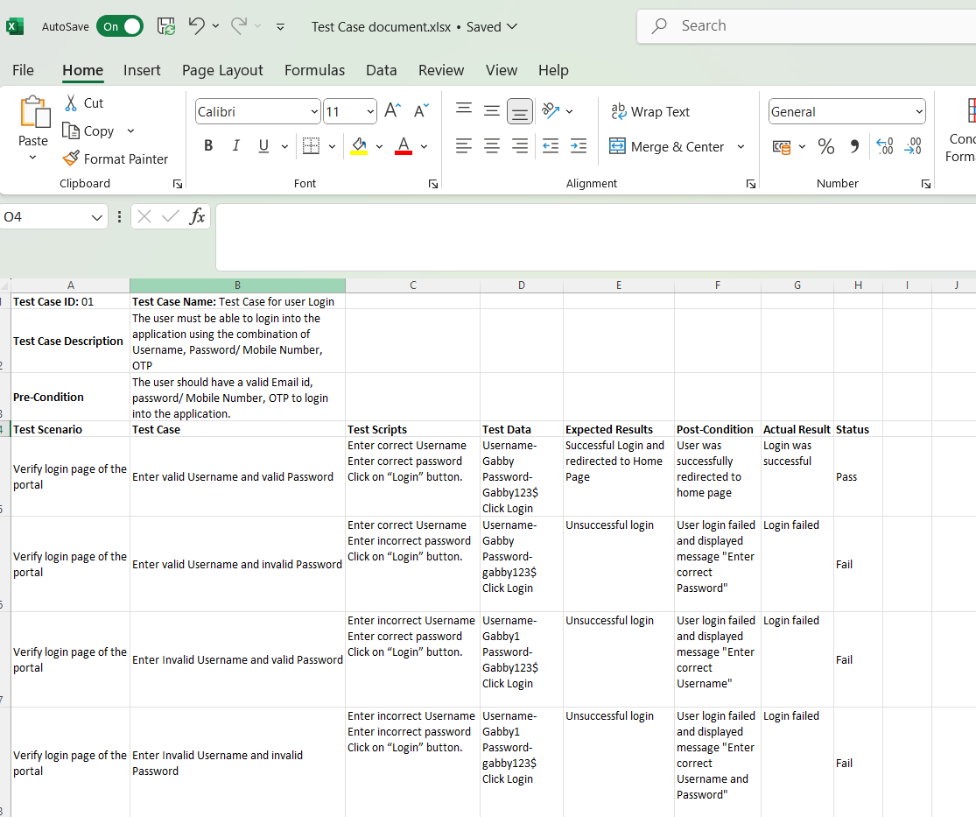

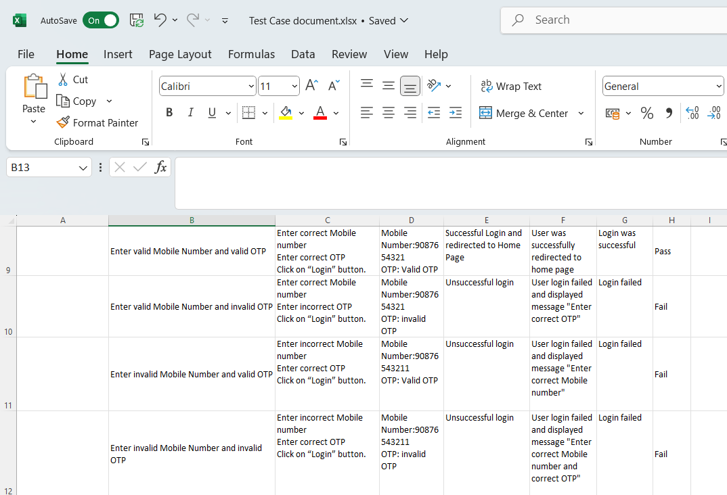

**Test Case Document 2:**

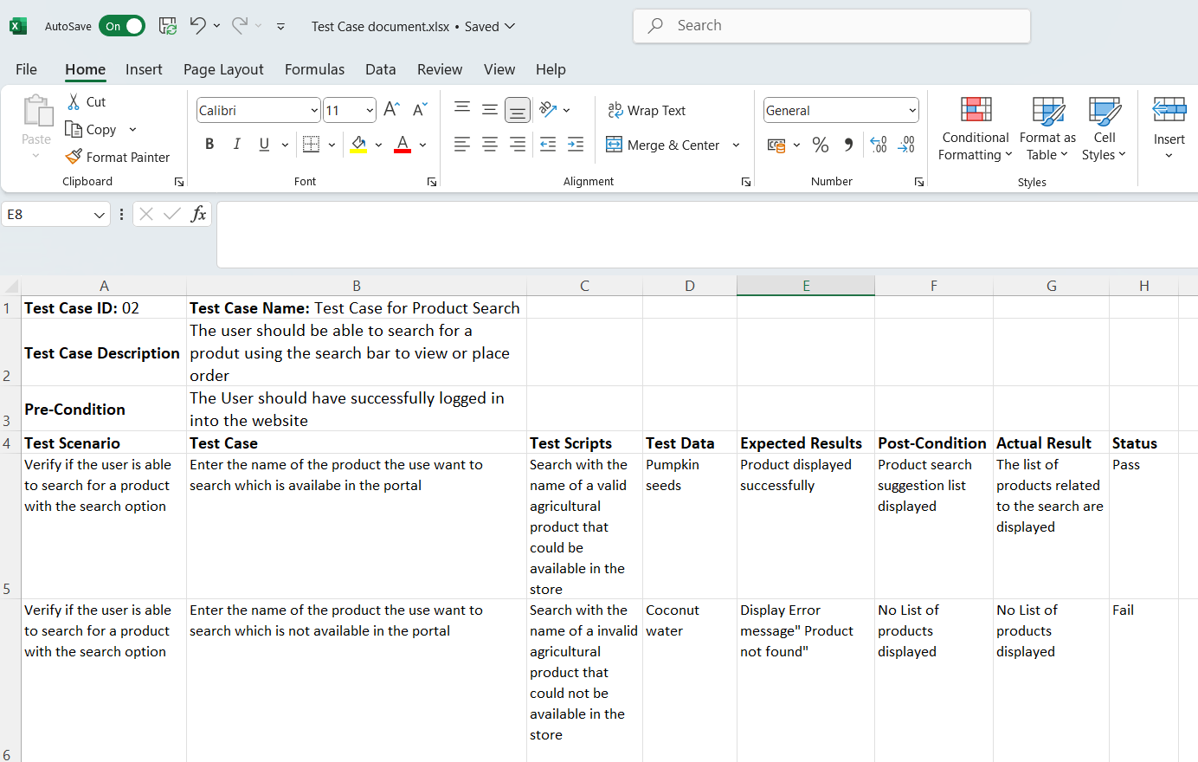

**Test Case Document 3:**

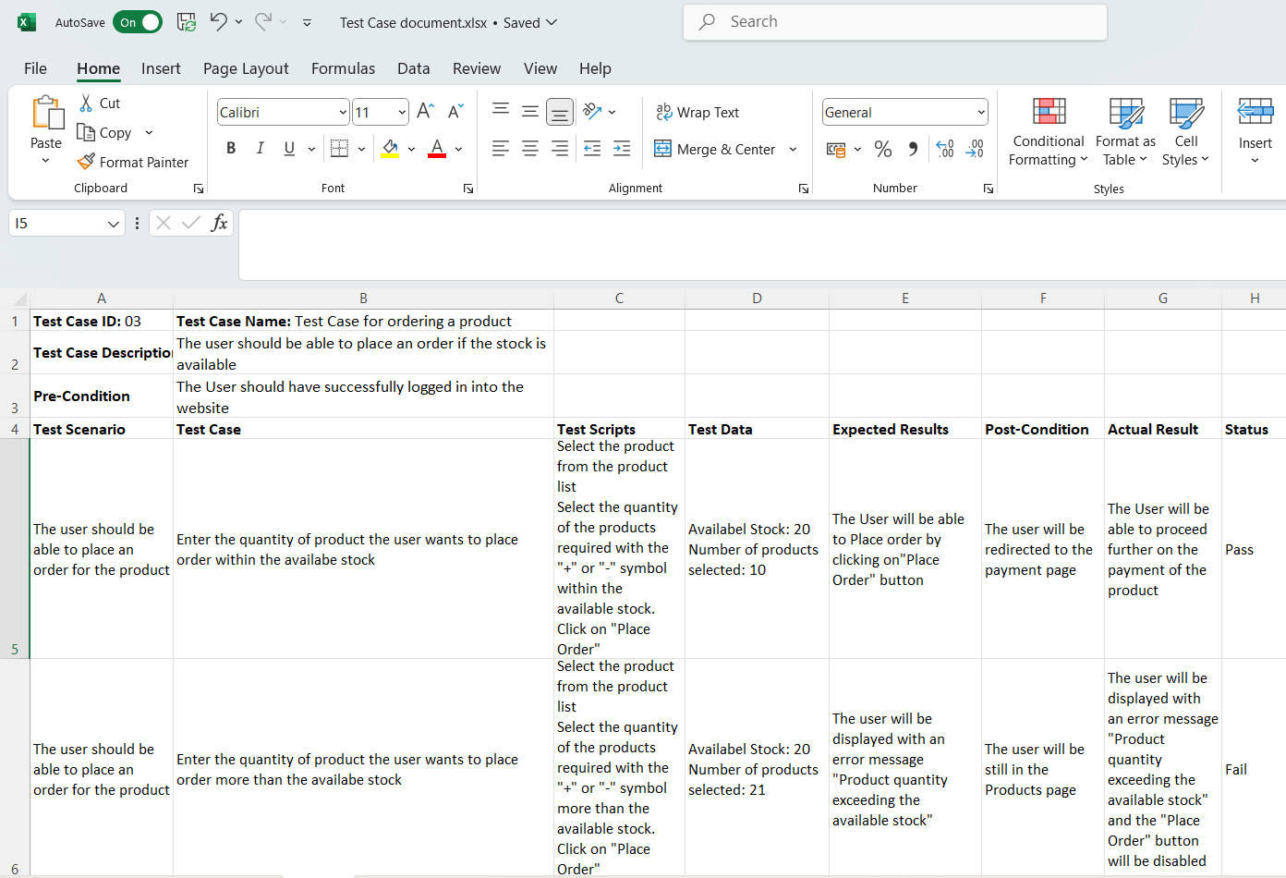

**Test Case Document 4:**

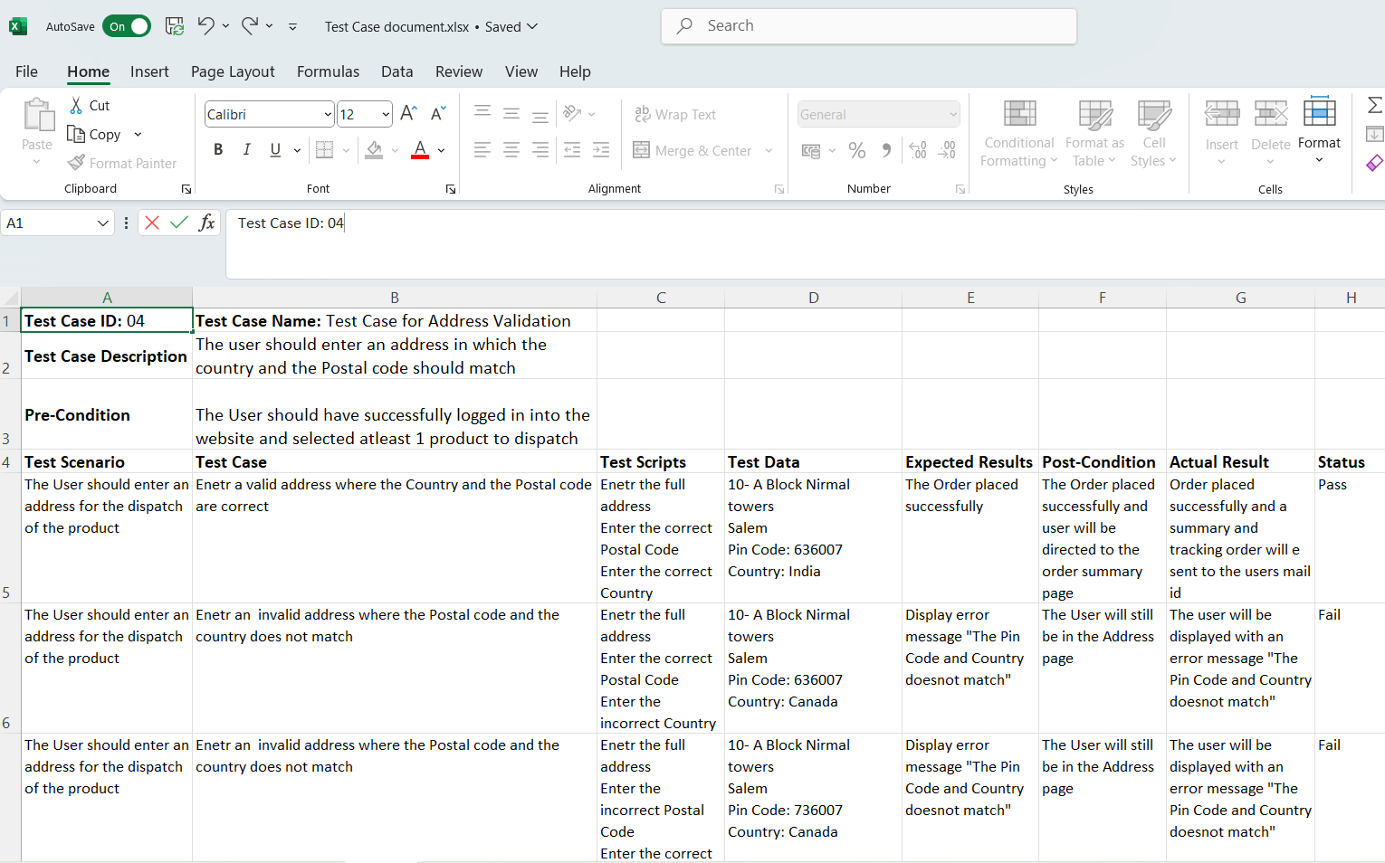

**Test Case Document 5:**

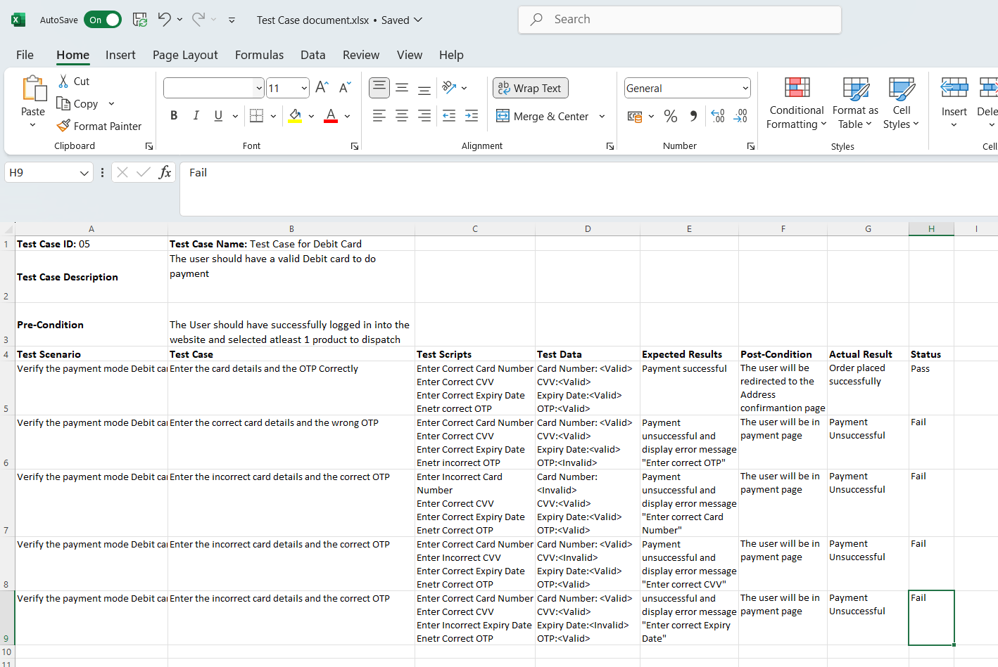

**Test Case Document 6:**

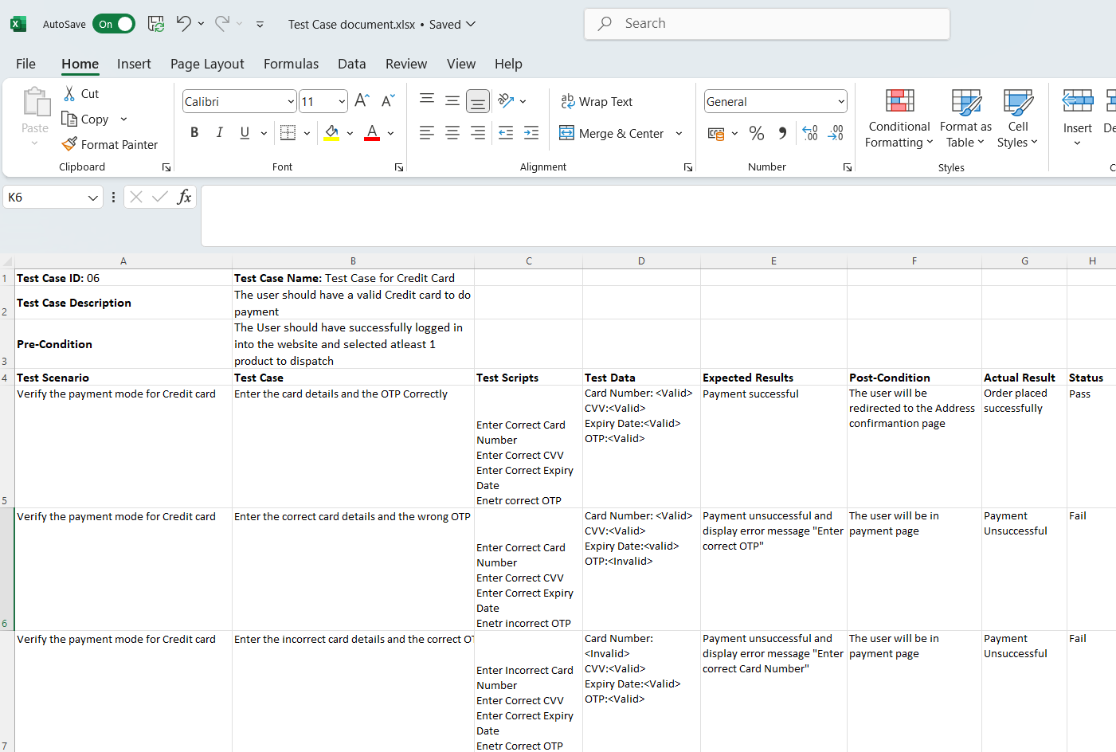

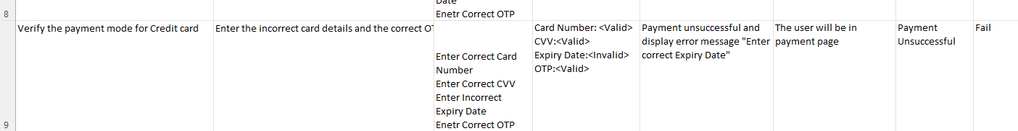

**Test Case Document 7:**

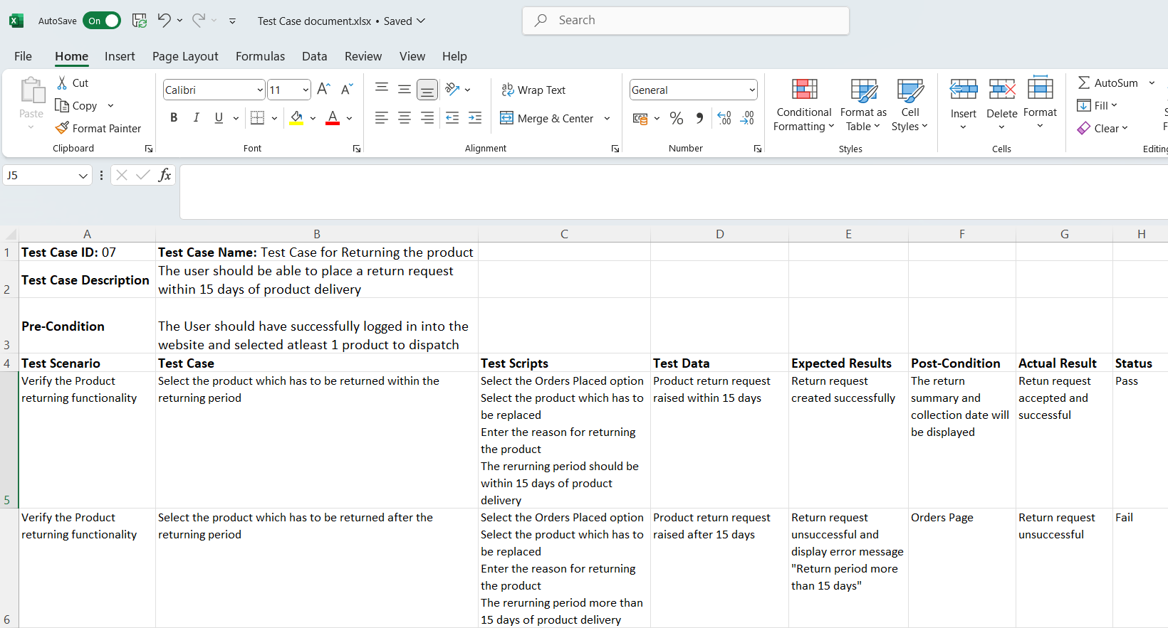

**Test Case Document 8:**

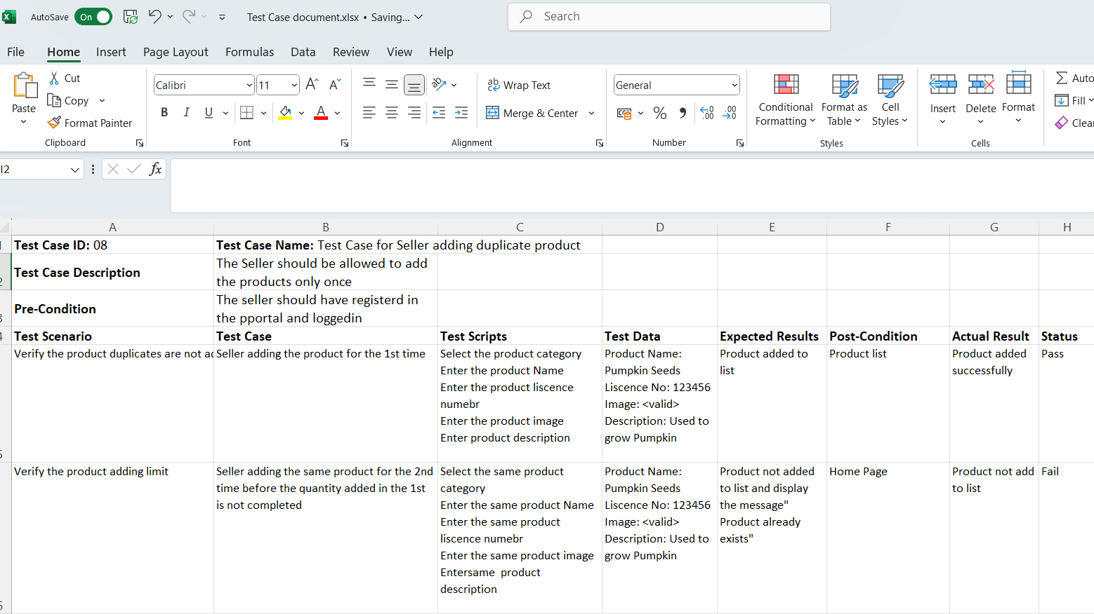

**Test Case Document 9:**

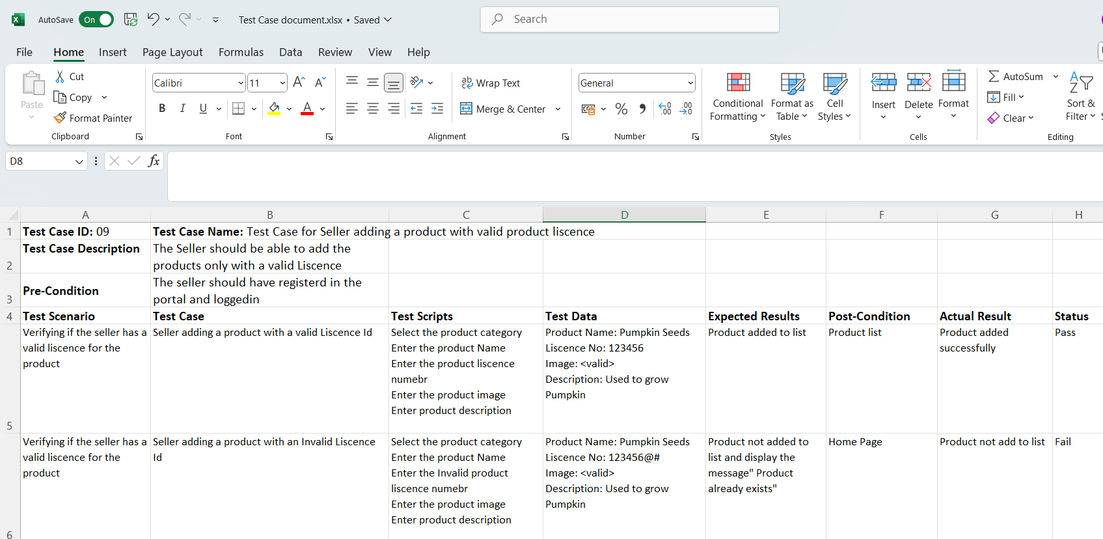

**Test Case Document 10:**

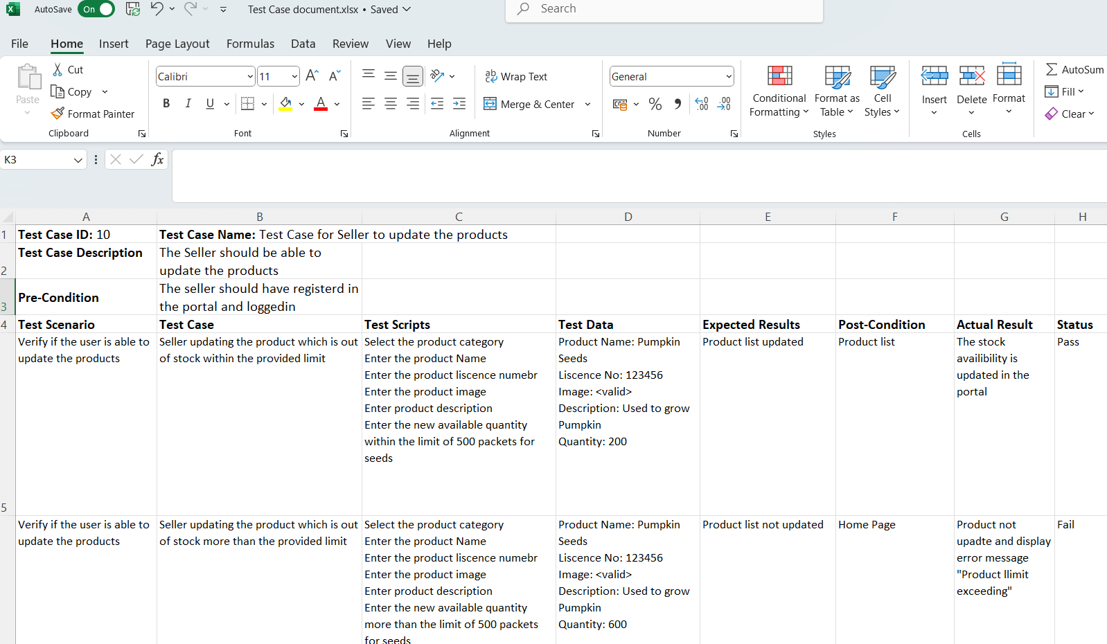

**Question 6–DB Design**

Draw data base schema and ER diagram

**Data Base Schema:**

A database schema is a logical representation of data that shows how the data in a database should be stored logically. It shows how the data is organized and the relationship between the tables. Database schema contains table, field, views and relation between different keys like Primary Key, Foreign Key.

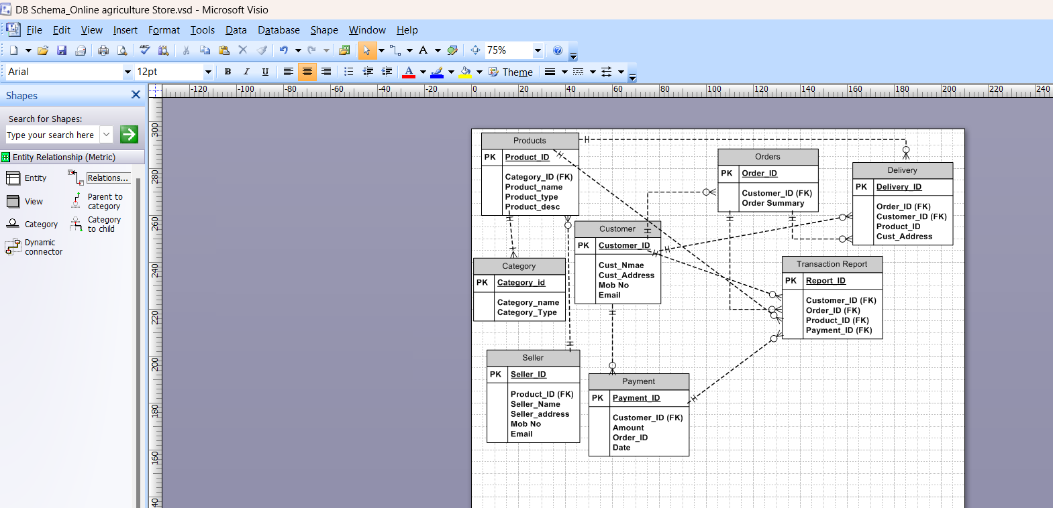

**ER Diagram:**

ER model stands for an Entity-Relationship model. It is a high-level data model. This model is used to define the data elements and relationship for a specified system. It develops a conceptual design for the database. It also develops a very simple and easy to design view of data.

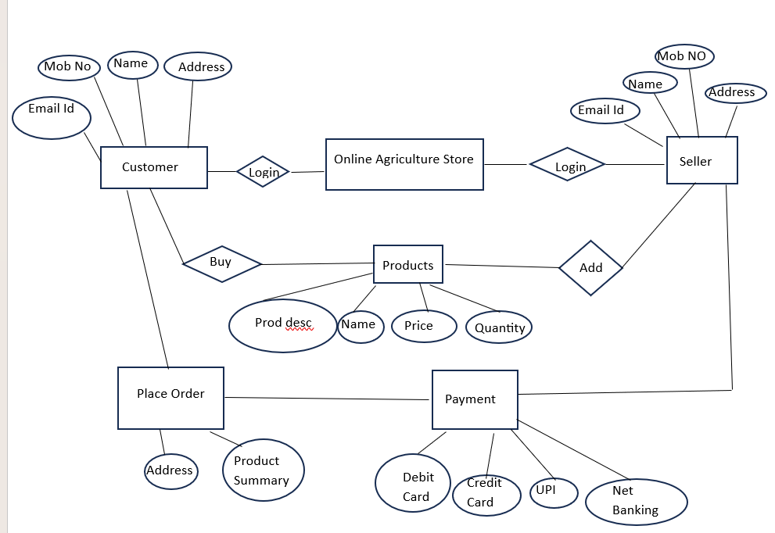

**Question 7–Data Flow Diagram**

What is a data flow diagram? Draw a data flow diagram to represent the in -flow and out-flow of data when a Farmer is placing an order for the product

**Data Flow Diagram:**

The flow of data in a system or process is represented by a Data Flow Diagram (DFD). It also gives insight into the inputs and outputs of each entity and the process itself.



**Question 8–Change Request**

How do you handle change requests in a project?

Change Requests can be described as a change that has been requested by a Stakeholder, Client, Internal team or a department to make changes to the processes or deliverables that had already been decided in the project scope. Handling Change Requests in a project involves a systematic process to ensure the changes are effectively managed while minimizing disruption to the project’s scope, timelines and resources.

As a BA a it is necessary to clearly understand the new requirement that has been provided and what exactly the changes has to be done with the current process with the stakeholders. Next a Feasibility study has to be done to understand if the new process would hinder any process flow in the current project.

In this case as the change request has come up as a government mandate it has to be implemented compulsorily. So the below steps has to be followed.

1. **Change Request Identification:** Identify and document the Change Request, the reason for change and its potential impact on the project.
2. **Change Impact Analysis:** Analyse the effect the change request would bring on the Project Timelines, Resources, Scope, Process, Cost. Also analyse the risk that may arise of the changes. Do a feasibility study on the implications of implementing the changes.
3. **Change Evaluation:** Review the Change Request with all the Key Stakeholders, Clients and relevant team members. Discuss the impact the change would bring on the project including the benefits, risks and conflicts.
4. **Change Prioritization:** Prioritize the implementation of the change request based on the urgency, impact and alignment with project goals. Determine if the change is very critical and implemented immediately or it cam be implemented in the future releases.
5. **Change Approval:** Obtain a formal approval form all the stakeholders, clients and the change control board. Ensure that all the stakeholders are in agreement with the change request and the impacts that it would bring on the project. Also inform the stakeholders the timelines, cost and resources needed for the implementation of the change.
6. **Change Implementation:** Incorporate the approved change into the project plan including the changes that would be impacting the project scope, budget, timelines and resources. Communicate the changes to the project team and all the relevant stakeholders. Include the change request in all the documents such as BRD, SRS and Test documents.
7. **Change Communication:** Clearly communicate the change request to all the internal stakeholders which include the Project Manager, Development team, testing team and other internal stakeholders. Explain them the Change Request, the need for the change, the timelines, the requirements clearly and the impact that it would create on the project.
8. **Change Tracking and Documentation:** Track and document all the communications and changes that has been implemented as part of the change request. Maintain a Change Log with all the dates and communications happened in to ensure the transparency and accountability throughout the project.
9. **Change Control and Monitoring:** Monitor the impact of the changes made to the project if it causes any risks. Continuously monitor the progress and quality of the newly implemented changes. Have a clear communication with all the stakeholders regarding the concerns or issues that the new changes might bring at any point of time.

By following the above process we can efficiently manage the Change requests with high quality and deliver the project on the fixed timelines without hindering the current processes.

**Question 9–Change Request Vs an Enhancement**

Is this a change request or an enhancement?

**Change Request:** It is the modification of any existing functionality or requirements.

**Enhancement**: It is the addition of new features to the existing application which were not specified in the initial stages of the project.

The request given by Ben and Ken should be treated as an Enhancement Request as they have asked to add a new feature to the current application where the Farmers can sell their crops and products to the public. And there is another new requirement stated by them where they want to introduce a new concept of auction. As these two requirements have come as an additional feature to the project and was not initially specified, we need to consider this as an Enhancement request.

Hence as a BA, I should analyse the request given and discuss with all the stakeholders to gather all the necessary requirements. After that I need to create a project plan, requirements documentation, design, testing plan. I must also prepare an Enhancement requirement form and analyse on the manpower, Timelines for delivery and Budget to complete the requirement and get it approved from the stakeholders. Once all the approvals are obtained this communication should be passed on to the PM, Dev team and Testing Team and all the documents in each phase of the development and testing of the enhancement should be documented.

**Question 10– Estimations**

Come up with estimations– How many Man hours required

**Manhours Required = Total number of working hours Per Day *Total number of Members*Total Number of days worked over the specific project.**

Number of working hours per day = 8 Hours

Number of Members = 12 Members

Project Duration = 18 Months = 548 days

Assuming weekends = 158 days

Assuming sick leaves and festivals = 10 days

Total Number of holidays = 168 days

Total number of working days = 548-168 = 380 days

Estimated hours = 8 hours * 12 Members * 380 working days = **36,480 Manhours**.

**We need 36,480 Manhours to complete this project.**

**Question 11– UAT**

Explain UAT Acceptance process

UAT stands for User Acceptance Testing. It is a phase in the Software Development Lifecycle where the users of the application will validate all the features of the product to check if all their requirements are met.

As a BA it is important to make sure all the validations on system, environment and application are done before the UAT is done. It is important to identify if any possible defects could arise and how to deal with these defects.

Steps in UAT

1. **Test Plan:** Define the scope of UAT and identify the key features and functionalities that needs to be tested. Prepare Test Scenarios and test cases according to the requirements provided.
2. **Set-up Test** Environment: Ensure the test environment is setup and the platform is available for the client for testing purpose. Also ensure that all the required access and additional requirements needed are provided to the client.
3. **Identify Test scenarios and Test Cases:** Test scenarios are created based on high-level business process and all the Test Cases should have detailed explanation of the steps involved in testing. Test cases should cover all the UAT Scenarios. Test cases are created with the help of Business Requirements that are provided.
4. **Preparation of test data:** In UAT we use live test data hence privacy of the data should be assured. Testers should be aware of the data flow.
5. **Test Execution:** Perform testing for all the Test Scenarios mentioned by following all the Test Cases provided. Evaluate the outcome of the process and verify if each requirements meets the client’s needs.
6. **Defect Identification:** If there is a deviation in the results of the process from the clients’ expectations we call it as defects. If any defects are identified during the UAT process it has to be documented clearly with the exact steps to reproduce the issue. This defect document should be then communicated to the Development team for resolution.
7. **Defect Resolution:** The Development team has to perform the fixes for the defects that were identified during the UAT process. Once the defects are fixed the Testing team should perform the scenario again to ensure the requirements are now fulfilled.
8. **UAT Sign-off:** Once all the test scenarios are tested and all the defects are fixed and the client is satisfied with the UAT results obtain a formal Sign-off or Approval. This indicates that the client is satisfied with the results and is ready to move forward to deployment of the product in Production system.
9. **UAT Closure:** Document the UAT results, including the test execution summary, outstanding issues and overall assessment of the product.

**Question 12– Project Closure Document**

Explain Project closure document

A Project Closer Document is a report that summarizes the project Lifestyle, outcomes, and lessons learnt. It serves as a formal record for confirmation of project completion and provides important information for future references.

