**CAPSTONE PROJECT PREP -1 PART -2**

1. ***4 Quarterly Audits are planned Q1, Q2, Q3, Q4for this Project. What is your knowledge on how these Audits will happen for a BA?***

**Ans:** The objective of conducting audits is to ensure that whether projects is progressed based on the goal and adhering to agree upon the requirements and standards. In this audit process we have four phase like preparation, execution, reporting and follow up phase.

In preparation phase, we will do documentation review, stakeholder feedback and self-assessment. In execution phase, we will participate in audit meeting along with stakeholders, requirements verification, and compliance check. In Reporting phase, we will prepare detailed audit report along with recommendations. In follow up phase, we will work with project team to develop with action plan, implement the corrective actions and use insights to improve for future projects.

Here is an detailed 4 quarterly audits planned for the project,

**Quarter 1 – Requirements Gathering & Analysis**

|  |  |
| --- | --- |
| **Stage** | **Audit Report - Requirements Gathering & Analysis Phase** |
| **Completed** | 9 weeks (week 1 to week 9) |
| **Check List** | * Validate elicitation techniques and verify the stakeholder   identification and analysis.   * Approved BRD and Group of Functionalities and clients sign off * RTM preparation * Email Communications to project team and stakeholders |

**Quarter 2 – Design**

|  |  |
| --- | --- |
| **Stage** | **Audit Report - Design Phase** |
| **Completed** | 7 weeks (week 10 to week 16 ) |
| **Check List** | * Validate requirements are signed off. * Initiate and Validate UML diagrams and other prototypes. * Signed off FRS requirements. * Update RTM and Initiate test case preparation. * Email Communications to project team and stakeholders |

**Quarter 3 – Development and Testing**

|  |  |
| --- | --- |
| **Stage** | **Audit Report - Development and Testing Phase** |
| **Completed** | 46 weeks (week 17 to week 63) |
| **Check List** | * Validate the development progress along the requirements. * Organise JAD sessions and clarify queries. * Verify the test case preparation along with requirements * Ensure and Update RTM, end user manuals. * Ensure sign off from project acceptance form. * Email Communications to project team and stakeholders |

**Quarter 4 – Deployment and Implementation**

|  |  |
| --- | --- |
| **Stage** | **Audit Report - Deployment and Implementation Phase** |
| **Completed** | weeks (week 64 to week 73) |
| **Check List** | * UAT scripts and Sign off requirements * Ensure stakeholder involvement in UAT * Validate end user manuals * Forward RTM to client for project acceptance form |

1. ***Write BA Approach strategy (As a business analyst, what are the steps that you would need to follow to complete a project.***

Ans: Strategy is the direction and scope of the project goal which helps in getting values to the requirements.

* 1. ***What Elicitation Techniques to apply***

Ans: Here we can use some of the suitable elicitation techniques such as

**Brainstorming –** This technique can be effective way to generate lots of ideas on a specific issue and then determine which ideas is the best and we can come up with very innovative ideas and requirements and efficient way for stakeholders to define their requirements. Here we can define with farmers and manufacturers to refine their requirements.

**Interview –** It is a systematic approach to elicit information from a person in informal or formal way of talking to a person. Here BA is the interviewer. So, in this case, I will have one on one conversation with stakeholders like Mr. Henry and manufactures to understand their points.

**Document Analysis –** It is an important gathering technique and evaluating the documentation of current system can drive the gap analysis for scoping of migration projects. So by reviewing existing policies, system and similar CSR projects helps in minimise the redundancy work and improves accurate requirements.

**Questionnaire/Survey:** It can useful in obtaining limiting system requirements details from stakeholders which have minor input or are geographically remote. In this case, it helps in gathering the requirements from the farmers and manufactures especially when time is limited for individuals interactions and capture broad feedback for payments, products features.

* 1. ***How to do Stakeholder Analysis RACI/ILS,***

Ans: Step 1: Identify the Stakeholders:

Business Stakeholders – Mr. Henry and his committee ( Mr. Pandu, Mr. Dooku) because they define the needs , allocate the project and monitor the progress. Mr Peter, Kevin, Ben who specify the requirements.

Projects Stakeholders – APT IT solutions team (PM, Sr.dev, BA, tester, etc) who are responsible for design, developments and implementation of the project.

Step 2: Stakeholder Listing Document:

In this documents, we have detailed information about each stakeholder and their roles.

|  |  |  |  |
| --- | --- | --- | --- |
| Stakeholders | Type | Role | Impact |
| Mr. Henry | Business | Business Sponsor | Project approver |
| Mr. Pandu, Dooku | Business | Operations | Allocate Budget, Project progress |
| Mr. Peter, Kevin, Ben | Business | Process Experts | Provide the clear requirements |
| APT IT solutions | Project | Project Delivery team | Understand and implement the requirements. |

Step 3: Stakeholder Summary:

In this we will analyse the stakeholder’s summary based on influence and interest framework

|  |  |  |
| --- | --- | --- |
| Stakeholders | Influence and interest | Strategy |
| Mr. Henry | High | Provide detailed updates on decisions |
| Mr. Peter, Kevin and Den | Medium and High | Provide detailed communication on requirements. |
| SOONY Committee | High | Regular updates on project meetings  and approves on milestones. |
| APT IT solutions | High and Medium | Ensure clear communication and documentation of requirements. |

Step 4: RACI Matrix:

RACI matrix is a tool used for stakeholder analysis which tells about the roles and responsibilities of the team members and stakeholders for specific projects/tasks.

|  |  |  |  |  |
| --- | --- | --- | --- | --- |
|  | **RESPONSIBLE** | **ACCOUNTABLE** | **CONSULTED** | **INFORMED** |
| **HENRY** |  | **Y** | **Y** | **Y** |
| **PANDU (FH)** |  | **Y** | **Y** | **Y** |
| **DOOKU (PC)** | **Y** |  | **Y** | **Y** |
| **Henry’s Friends** |  |  | **Y** | **Y** |
| **KARTHICK (DH)** | **Y** |  | **Y** | **Y** |
| **VANDANAM (PM)** | **Y** | **Y** |  | **Y** |
| **JUHI (Sr. DEVL)** | **Y** | **Y** |  | **Y** |
| **Tyson, 3 other (DEV)** | **Y** | **Y** |  | **Y** |
| **Sarath (BA)** | **Y** | **Y** |  | **Y** |
| **Askaya ,Jason (Tester)** | **Y** | **Y** |  | **Y** |
| **Mike (NA)** | **Y** | **Y** | **Y** | **Y** |
| **John (DBA)** | **Y** | **Y** |  | **Y** |

* 1. ***What Documents to Write***

Ans: **BRD ( Business Requirement Document**) : It tells the high level business needs and goal of the projects which includes Scope (payment, delivery, product catalogue) , high level risk and mitigations, assumption and constraints.

**FRD ( Functional Requirement Document**): It tells the details of the functional and technical solutions of project based on BRD.

**Use Case Document**: It includes Use case diagrams ( based on users perspective), use case description documents ( precondition, post condition, assumptions, constraints, basic flow, alternate flow, exception flow, definition, input, output, actors(primary and secondary) based on functional requirements.

**Activity Diagrams:** It shows the visualisation of activities involved based on system perspective. We identifies the list of activities (payments, product selections, etc), conditions and events based on functional requirements.

**RTM (Requirement Traceability matrix):** We ensure all the requirements from BRD and FRD are progressed through the project time. We mark the status of the reports, unique requirements, routing the test cases and deliverables.

**Handle change request Log**: Track and manages changes in Requirements.

**Test Cases and UAT document**: To define test case scenario and met the functional requirements. Includes Test case id, definition, actual output, expected output, input and output and also UAT scripts for stakeholders to test functionality and UAT sign off from clients.

**Training and End manuals**: Provide the detailed view of using the application to the users like troubleshooting tips, FAQ’s, step by step instructions

**Client Project Acceptance form**: It is the overall completion status of the projects in formal document includes client feedback, summary of deliverable.

* 1. ***What process to follow to Sign off on the Documents,***

Ans: Step 1: Prepare and draft the documents from gathering of requirements and ensure that it validates the stakeholder’s needs and project goal.

Step 2: Share the Documents to PM/stakeholders for internal review and refine the documents based on their feedback.

Step 3: Share the refined documents to stakeholders like SOONY Company and set the review timelines.

Step 4: Conduct and arrange the review meeting, ask their concerns and clarify their doubts.

Step 5: Review the document based on stakeholder (incorporate) feedback suggestions and share the refined documents for final review.

Step 6: Share the sign off application document and collect the email approval or sign of the stakeholders.

Step 7: Communicate the sign off document to the project team and share the approved documents with all parties.

Step 8: Store the approved version of documents in repository for future reference.

* 1. ***How to take Approvals from the Client,***

Ans: After Ensuring of all documents ( BRD, FRD, UAT, prototypes) with client suggestions review with your PM and schedule the meeting to clarify their doubts. Refine the document based on their client suggestions. Share the updated document along with sign off formal acceptance sheet and request the email acknowledgement stating the approval and track the approval from the system using Project management tool like JIRA.

* 1. ***What Communication Channels to establish and implement***

Ans: Through emails, project management tools like JIRA or trello, scheduling meeting in MS teams, webex, Zoom etc..

* 1. ***How to Handle Change Requests***

Ans: Step 1: Record the change in LOG (description, request date, stakeholder change request)

Step 2: Acknowledge the request with confirmation of PM and explain the process and its evaluation.

Step 3: Analyse the impact including budget, timeline, resources, scope and share and discuss with stakeholders in meetings,

Step 4: Obtain the approval from decision makers (PM, SOONY Company) and sign off in formal document with them. Revise BRD, FRS and RTM to update the changes.

Step 5: Inform the stakeholders about the changes with the tasks (development team) and monitor the progress to ensure time delivery.

Step 6: Regularly update the change request from LOG to reflect the status and document the change related one for traceability and audits.

* 1. ***How to update the progress of the project to the Stakeholders***

Ans: Conduct Meeting: Having weekly meeting or bi week meeting to convey the issue, risk, progress and gather the feedback from them.

Communications Channels: Emails, Project management tools like JIRA, weekly meetings

* 1. ***How to take signoff on the UAT- Client Project Acceptance Form )***

Ans: Step 1: Prepare the UAT document (test case scenarios), align with requirements with validity functionality.

Step 2: Schedule the UAT sessions: Inform them how to use the application with the test case for all key stakeholders (farmers, manufactures) and coordinate with them.

Step 3: Conduct the UAT sessions: Facilitate the testing of the application features and validate the testing requirements against defined criteria.

Step 4: Use Log issue report to note all the issue, bugs, and feedback during testing session. Address the issues and retest the bugs.

Step 5: Create the UAT Sign off document which includes the test cases executed and status (In progress/ completed), list of resolved issues, stakeholder’s acknowledgement with system requirements.

Step 6: Prepare the client project acceptance form includes project summary, objectives met, deployment for final approval with client comments and signatures.

Step 7: Obtain official sign off from the stakeholders using digital sign with email acknowledgement after their review the document. Store the document in repository.

1. ***Explain and illustrate 3-tier architecture?***

Ans: In this 3 tier architecture we have three layer like,

The first top layer represents **Application Layer** which represents the interface between user and application. It is responsible for GUI (graphical user interfaces likes screens, pages, organisation specific business logic). It also retrieves and shows the user data and make sure the seamless user experience. The primary goal of this layer is to provide a user friendly interface while abstracting the complexity of the underlying process and it get input from forms, buttons on the user pages and send to business logic layer. Some of the applications includes, mobile apps, web applications.

A Second Layer represents **Business Logic Layer** meets by implementing the business logic and rules to meet the functionality of the requirements. It acts as intermediate between application layer and database layer. This layer handles complex computations, business rules and ensuring the data is consistent and efficient. Also it ensures that is maintainable, scalable excluding other two layer. For example, all reusable components, frequently changing components, governing body rules and regulations includes payments gateways, mail servers etc.

A Third layer represents **Data Base Layer** is responsible for managing and retrieving the data with the system. It directly interacts with data base system which includes inserting, selecting, updating, deleting the data from the system which ensures the security, consistency, and integrity while abstracting the data complexity from the top layer. Some of the components includes DBMS, DAO’s.

BUSINESS LOGIC LAYER

DATA LAYER

APPLICATION LAYER

1. ***Business Analyst should keep What points in his/her mind before he frames a Question to ask to the Stakeholder ( 5W 1H – SMART – RACI – 3 Tier Architecture – Use Cases, Use case Specs, Activity Diagrams, Models, Page designs):***

Ans: Based on the case study as BA we should keep points in framing question like

* If we need to extract consistent requirements then probe in these directions **5W 1H** tools,

|  |  |
| --- | --- |
| Where | Where will be the product will be used and Is it accessible in remote areas?  Where will the farmers will use this platform in mobile or desktop?  Where will be the product will be sourced from small /large suppliers? |
| Why | Why the need for online platform for agriculture store is efficient and what are the expected outcomes for manufactures and farmers?  Why the involvement for key stakeholders is is crucial for project success  Why is the need to facilitate the relationship between manufactures and farmers? |
| When | When will be the application will be accessible for farmers in rural areas?  When will be the MVP of the product will be launched?  When will be farmer receive first batch of order after post launch of the application? |
| Who | Who will be responsible for maintenance of customer support after post launch?  Who is going to have the collaboration between the different stakeholders?  Who will take care of product listings from manufacturing? |
| What | What type of initial products to be supported for online platform after immediate post launch?  What type of communication mechanism to be introduced between manufactures and farmer?  What are the key challenges were faced by the farmers will using the platform? |
| How | How will the data security and other farmer information will handle in this platform?  How will you the customer feedback will be integrated with continuous improvement of the platform?  How will the payment method to be initiated and delivery location to be automated? |

* **SMART -**  A well-formed requirement should comply with,

|  |  |
| --- | --- |
| **S – Specific** | What are the specific payment methods that you to use in platform?  What exact information the farmers should see when they browse the product catalogue? |
| **M – Measurable** | How many products you want to see in the single page? How will you see the product review based on which criteria?  How often the sales and order reports should be generated? |
| **A – Attainable** | Should the application support offline functionality for viewing saved products?  Can we integrate the third party logistics providers with defined budget? |
| **R – Realistic** | Should only essential features be prioritized for the first release of the application?  Should a delivery tracking updates requires a simple representation or detailed map view of the application? |
| **T – Time bound** | What are the expected time line to solve a critical issues during a UAT?  When should a manufacturers can upload a product details in application for initial testing? |

* **RACI**

|  |  |
| --- | --- |
| **Responsible** | Who will manage the user registration and authentication process  Who will manage updates to provide product pricing or availability |
| **Accountable** | Who is approve final designs and functionalities of the project  Who will authorise to change the budget time or scope of the project |
| **Consulted** | Which delivery partners should be engaged to ensure smooth transition over delivery products  Which should say input for the performance reports like sales, user activity |
| **Informed** | Who need to updated or informed about the project of each milestone  Which stakeholders needs to informed about the updates in scope of the project |

* **3 tier architecture**

|  |  |
| --- | --- |
| **Application Layer** | What language should a application will appear to cater farmers in remote areas  Should the application be optimized for mobile, desktop or both  What kind of updates or notification do expect for example delivery, payment, offers  Is there any accessibility features that should be includes like fonts, text colour etc. |
| **Business Logic Layer** | Should there be automated reminders for specifying pending payments orders  Should there be different workflows for manufacturing uploading vs farmer purchasing products  How payment process must be handled  How should track delivery system or should real time tracking system automated |
| **Data Base Layer** | Which data should be stored for product details  How long does the data must frequently do backups to prevent data loss  Are they any specific compliance requirements for storage of data  Should the farmer and manufacturers can download their transaction voices history |

* **Use case –** How user interacts with system to achieve specific goal.The question can be asked like ,
* What specific things does manufacture to do perform in the application?
* Should user need to get updates on product availabilities or orders
* What specific thing s does farmers need to perform on the applications?
* **Use Case description –** It gives details about the use case precondition, post conditions etc., the question can be asked like
* What preconditions must be met for farmer to orders a product?
* What should the system shows if the payment method is failed?
* What should display when login credentials is invalid?
* **Activity Diagrams –** It usually shows how the users performs in system interaction
* Can you describe the farmers to search , select the products
* How should the tracking system should process from payment to delivery
* Should we have any alternate paths for delivery payments to fails
* **Model -** Model includes data models, system architecture etc.
* Are any existing models or data system to integrate with it?
* What are the data fields required to type in the application
* What reports are analysed and imported from data?
* **Page Designs –** It determines the page layout and structure of the user interface
* What are the essential elements to be listed in the main homepage
* How error should look like when there is no search result
* Are there pages should look feature or whether pages should follow brand logo guidelines

1. ***As a Business Analyst, What Elicitation Techniques you are aware of?***

Ans: Some of the elicitation techniques are,

* 1. **Brainstorming:**
* Brainstorming can be done either individually or groups which can be effective away to generate lot of ideas on a specific issue and to determine the best solution.
* It is utilized in requirements elicitation to gather variety of ideas from a group of people. The ideas collected then can reviewed and where relevant included within the system requirements.
* Step 1: Prepare the Brainstorming – Develop a clear and concise definition of the area of interest and determine the time limit of the group. Decide who want to participate in the topic of discussion. Establish the evaluation criteria and rating of the ideas
* Step 2: Conduct the Brainstorming – Discuss the new ideas without any discussion or evaluation. Record all the ideas and encourage participants to be creative and build the ideas on others. Don’t limit the number of ideas as the goal is to elicit to as many ideas as possible within the time of period
* Step 3: Wrap up the Brainstorming – Once the time is reached, then determine the evaluation criteria and discuss then evaluate the ideas. Create a list and combine the ideas where appropriate and eliminating duplicates and rate and prioritize the ideas and distribute the final list of ideas to appropriate the parties.

**Advantage:** Can come up with very innovative ideas and requirements. It can be efficient way use for users to define their requirements.

**Disadvantage:** People can’t be easily to do this technique as it requires lot of experience in facilitate the sessions.

* 1. **Document Analysis:**
* In a current system, we have documentation which will be helpful in providing some of the inputs to the requirements of the future system. Some of the documentation includes, interface details, user manuals, and software vendor manuals.
* Step 1: Prepare the document analysis – Evaluate the existing system and business documentation are relevant and appropriate to studied
* Step 2: Analyse the document: Study the material and identify the relevant business details. Document business details as well as questions for follow up with SME’s.
* Step 3: Post document analysis wrap up - Review and confirm the selected details with SME’s. Obtain answer to follow up questions.

**Advantages:** Could be a lot of information and easy to transfer to a new system requirements.

**Disadvantages:** Existing Document may be out of date and reports may have changed out of all recognition.

* 1. **Reverse Engineering:**
* It exists in the situation where system has outdated documentation and it is necessary to understand what the system has actually does, so this technique can extract implemented requirements from the software code.
* There are two types: Black Box RE – System is studied without examining its internal structure. White Box RE – Inner working of the system are studied

**Advantages –** Improves knowledge of legacy system and reduces efforts of development system

**Disadvantages –** Can be resource intensive, risk of violating intellectual property

* 1. **Focus Groups:**
* It elicit ideas about a specific product service or opportunity in a interactive group environment. It usually has 6-12 attendees, and it may require to invite twice as many individual to allow for no shows.
* The topic of the focus group will influence who will recruited. If topic about a new product then, we can an existing users who are experts.
* Two types – Homogeneous – Individuals with similar characteristics. But differing in perspectives will not be shared. Possible solution to conduct separate session for different homogeneous group. Heterogeneous - Individual were have diverse backgrounds, perspectives. But individuals may self-censor if not comfortable with others background resulting in lower quality of data collected.
  1. **Observation:**
* It generally, observing or shadowing of users or even doing part of the job which can provide information of existing process, inputs and outputs.
* Two types : Passive / Invisible Observation - In this BA will observe SME working through the business routine but doesn’t ask any questions and write the notes about what they sees and wait till entire process has been completed. Active / Visible Observation – In this BA will observe the current process and takes notes he/ she may dialog with the worker. When the BA ask question with SME right away and even if it breaks the routine of the person being observed and even BA can have appreciation for how the current process works.

**Advantage –** It is useful when user is not able to clearly explain what they do or their requirements for the new systems.

**Disadvantage –** Relatively slow, focused on existing processes rather than the new system.

* 1. **Workshop:**
* It usually performed with 6 – 10 of more stakeholders working together to identify the requirements.
* A requirement workshop is a structured way to capture requirements and used to define, prioritise and reach closure on requirements for the target systems.
* Step 1: Prepare for the Requirements - Clarify the stakeholder’s needs and the purpose of the workshop. Identify the critical stakeholders who should participate and define the agenda. Schedule the session and determine what document the output of the workshop and send material in advance to go through for attendees
* Step 2: Co Conduct Requirements – Elicit, analyse and document requirements. Maintain focus by frequently validating the session activities. Now facilitator have responsibility to establish objective tone for the meeting. Manage the meeting and keep the team on track. Facilitate a process of decision making and build consensus but avoid participating in the content of the discussion. Ask the right questions, analyse the information being provides at the session by the stakeholders and follow up with probing question if necessary.
* Step 3: Post Requirements/ wrap up by facilitator – Follow up on any open action items that were recorded at the workshop. Complete the documentation and distribute it to the workshop attendees and the sponsor

**Advantages:** Faster than group interviews for obtaining requirements, particularly for common or system wide requirements.

**Disadvantages:** More preparation is needed. Facilitating workshop requires more skill with possibly an extra IT person retarding details.

* 1. **JAD (Joint Application Development):**
* It involves collaboration between stakeholder and systems analysts to identify needs or requirement in a concentrated and focuses effort.
* The JAD team is the heart of the process and the selection of stakeholders is critical to the overall success of a JAD session. The team should consists of a mixture of skills like BA, BP owner, operations managers, client representatives, HR etc.
* Step 1: Define Session – To define the scope of the JAD session, selecting the JAD team and obtain commitment to attend session from the appropriate stakeholders and schedule the session. Research the product and become more familiar and prepare any visual aids, developing any realistic agenda will more effective.
* Step 2: Conduct Session – Follow the agenda to gather and document the project needs and requirements. Prepare the formal documents. The information captured in the JAD session is further refined through analysis efforts, open questions or issues discovered through the sessions are resolved.

**Advantages:** This technique allows for the simultaneous gathering and consolidating of large amount of information and gives relatively large amounts of high quality information in short period of time.

**Disadvantages:** Requires significant planning and scheduling effort. Required trained and experienced personnel for facilitation and recording.

* 1. **Interviews:**
* It is systematic approach to elicit information from a person or group of people in an informal or formal setting by talking to the person.
* Interviews of users and stakeholders are important in creating wonderful software. Without knowing any expectations and goal of the stakeholders and users we can high unlikely to satiate them.
* Here The interviewee, asking relevant questions and documenting the responses. The BA will be the interviewer.

**Advantages:** It can be done with minimal preparation and easy with small groups and require the planning and scheduling effort than large workshops

**Disadvantages:** The questions used in the interview may reflect the interviewers preconceived ideas, which can influence the response.

* 1. **Prototyping:**
* It preliminary version of the system techniques Such as wireframe, interactive mock up, to visualise the features and workflows to gather information and feedback of the stakeholders requirements.
* Use the finalized prototype to document detailed requirements, ensuring all stakeholders align with the solution. This approach helps clarify expectations, identify gaps early, and engage stakeholders effectively.
* Mock-ups helps the business representatives or clients visualise the functionality of the system. This the big advantage to help analyst and stakeholders identify problems early.
* Screen mock-ups with a written description will help and they fall short of describing the end to end processes that the system must support.
* Once great disadvantages is if we introduce them early, business clients will have tendency to change the screen design based on new elicit ideas they get and specifying the controls needed on a screen detracts from the true requirements of the system and often results in an adequate level of discussion around why a system must support certain functionality.
  1. **Questionnaire (Survey):**
* It can be useful for obtaining limited system requirements details from stakeholders who have minor input or are geographically remote. The design of the questionnaire and type of questions are important and can influence the answers.

**Advantages:** Can send to many hundreds of users at low cost who are long distance away. Receive written replies which can be easier to work and analyse and same time typing.

**Disadvantages:** We may not get a good response as filling in questionnaire is often a low priority for many people.

* 1. **Use Case Specs:**
* Use case Specifications technique usually helps in how users interact with system requirements to achieve a specific goal which primarily focus on workflows, input , output
* First we need to identify the actor who interacts with system who to be considered as primary actor and as secondary actors. Specify the goal we want to achieve the requirements. Determine the precondition and post condition before and after the use case proceed through the workflow of the system
* Use Case usually gives a clear communication between technical and non-technical stakeholders and ensuring everyone who understands the system functionalities
* They usually covers all possible scenarios includes basic flow, alternate flows and exceptional flows to avoid overlook
* It creates baseline for creating & validating all test cases for all possible scenarios

**Advantages:** Improves clarity, enhances modular documentation, and supports development and testing processes.

**Disadvantages:** Writing detailed use case take more time consuming, prior to misinterpretation and requires more stakeholder’s involvement.

1. ***Which Elicitation Techniques can be used in this Project and Justify your selection of Elicitation Techniques?***

Ans:

* 1. **Prototyping:**
* It preliminary version of the system techniques Such as wireframe, interactive mock up, to visualise the features and workflows to gather information and feedback of the stakeholders requirements.
* In this case study we can create visual mock-ups like product search list, catalogue and other login registration etc. So it helps for non-technical user like farmer to visualise the portal
* Develop low fidelity to wireframes to stakeholders to review and refine and use high fidelity prototypes to validate UX for farmer and manufacturers.
* Also, it allows early testing of the use case before initiating the development cycle ensure we have low cost changes later.
* Stakeholders can identify the missing features, earlier usability issue and promotes user friendly applications.
* Decision-makers like Mr. Henry and the SOONY Committee can better understand and validate requirements when they see a visual representation rather than text-heavy documents.
* Therefore, it is the best elicitation technique for this project as it clarifies requirements visually, and supports iterative improvements. This technique ensures the development of a user-friendly, functional platform aligned with stakeholders.
  1. **Use case Specs**
* Use case Specifications technique usually helps in how users interact with system requirements to achieve a specific goal which primarily focus on workflows, input, output.
* As, it does document interactions like place orders, upload history, delivery tracking etc.
* As it enable to define actor and ensures clear communication between technical and non-technical stakeholders to understand system functionality
* So this can’t be used as this only useful for detailed documentation, it’s text-heavy and may not be easily understood by non-technical stakeholders like farmers.
  1. **Document Analysis**
* In this system, we have documentation which will be helpful in providing some of the inputs to the requirements of the future system. Some of the documentation includes, interface details, user manuals, and software vendor manuals.
* It helps for reviewing existing CSR reports and CSR documentation for insights of agricultural ecommerce platforms.
* Therefore it doesn’t justify in this project as on pre-existing documents, which may not adequately capture the specific needs of farmers or manufacturers in this unique project.
  1. **Brainstorming**
* It is utilised in requirements elicitation to gather variety of ideas from a group of people. The ideas collected then can reviewed and where relevant included within the system requirements.
* Conducting Brainstorming can understand the pain points of farmers to purchase a products. Engage manufactures to review their difficulty in uploading their products
* We can collaborative with SOONY committee to delivery additional features like multi lingual support
* Therefore, it is not justify as it effective for eliciting the ideas but due to their complex system and structure need more clarity to validate.

1. ***Make suitable Assumptions and identify at least 10 Business Requirements?***

Ans:

|  |  |  |
| --- | --- | --- |
| **Requirement**  **ID** | **Requirement Title** | **Requirement Description** |
| BR001 | Product Browsing | Farmers should able to view the products details without login in their account |
| BR002 | Product search for farmers | Farmers should able to search the product availability with using filters |
| BR003 | Account login & creation | Farmers should able to login their account to purchase the product or new user must registered to order |
| BR004 | Order Confirmation Mail | Farmers will get email confirmation in their registered mail Id once they order their product |
| BR005 | Payment Gateways | Farmers should use only payment available options like COD, Credit/Debit card and other UPI options |
| BR006 | Product Listing for manufacturers | Manufacturers should able to upload and manage their product listing in the catalogue |
| BR007 | Delivery Trackers of Orders | Farmers should able to track real time delivery status of their orders |
| BR008 | Order updates notifications | Farmers should able to receive real time notification for order updates |
| BR009 | System Securities | The platform must ensure all data stored in secured access |
| BR010 | Multi Devices Compatibility | Users must have access in both mobile as well as desktop to use their application |
| BR011 | Admins dashboard monitoring | Admins should have access monitor the users activity, sales, system health and product list in dashboard |
| BR012 | Buy Later feature | Farmers should be able to save products in buy later option for reference |

1. **List your assumptions?**

Ans:

* User must able to login for advanced features like ordering of products. Farmers must have digital literacy to get access with smartphones or desktop.
* Each Product must be categorised, apply filters with their consistent features like name, price, colour etc.
* Farmers & manufacturers should have necessary resources like internet connectivity especially in remote geographical locations
* Manufacturers should remain actively in order update their product list in platform.
* Payment options like COD and other must be support by chosen payment gateway providers and they must able to store and secure the payment information according to PCI compliance
* Farmer will receive automated updates on real time delivery tracking status
* User data must be securely stored and will be encrypted like login details and payment information
* Initial phase of portal will support two or three languages of region were farmers lived
* Adequate budget and timeline support all technical and functional to meet their requirements like reporting.
* APIs from payment gateways and logistics will be functional and stored in secured ways

1. ***Give Priority 1 to 10 numbers ( 1 being low priority – 10 being high priority) to these Requirements after discussions with the stakeholders***

|  |  |  |  |
| --- | --- | --- | --- |
| **Requirement**  **ID** | **Requirement Title** | **Requirement Description** | **Priority** |
| BR001 | Product Browsing | Farmers should able to view the products details without login in their account | 10 |
| BR002 | Product search for farmers | Farmers should able to search the product availability with using filters | 9 |
| BR003 | Account login & creation | Farmers should able to login their account to purchase the product or new user must registered to order | 10 |
| BR004 | Order Confirmation Mail | Farmers will get email confirmation in their registered mail Id once they order their product | 8 |
| BR005 | Payment Gateways | Farmers should use only payment available options like COD, Credit/Debit card and other UPI options | 9 |
| BR006 | Product Listing for manufacturers | Manufacturers should able to upload and manage their product listing in the catalog | 9 |
| BR007 | Delivery Trackers of Orders | Farmers should able to track real time delivery status of their orders | 8 |
| BR008 | Order updates notifications | Farmers should able to receive real time notification for order updates | 7 |
| BR009 | System Securities | The platform must ensure all data stored in secured access | 9 |
| BR010 | Multi Devices Compatibility | Users must have access in both mobile as well as desktop to use their application | 8 |
| BR011 | Admins dashboard monitoring | Admins should have access monitor the users activity, sales, system health and product list in dashboard | 7 |
| BR012 | Buy Later feature | Farmers should be able to save products in buy later option for reference | 6 |

1. ***Draw use case diagram?***

Ans:

* Use Case diagram is a high level diagram, so the main focus of the diagram is to how external interfaces will be interacting with the proposed IT systems. It can be used to describe the functionality of a system in a horizontal way. UCD’s represents only the positive flow.
* We have elements so by integrating with our study we have,

1. Actor - The system you are describing interacts with, (Farmers, Manufacturers, Delivery service, Admin).
2. Primary Actor (who directly interacts with the system) – Farmer
3. Secondary actor (who supports and contributes the system to fulfil the primary actor) - manufacturers, Delivery Service , Admin
4. System – Itself, the rectangular box ( Online Application Store)
5. Use case – which the system know how to perform. In this case we have, Register/Login, Search Products , View Products, Update Products, Add to Cart, Purchase Products , Buy out, payment Track Delivery, system Monitoring .

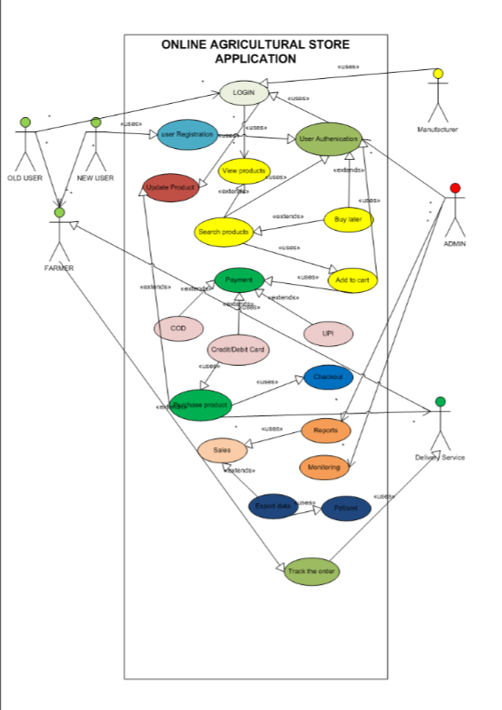

1. ***Prepare use case specs for all use cases?***

Ans:

|  |  |
| --- | --- |
| **Use Case Spec** | **Login** |
| **Description** | Allows user to login into the system |
| **Actors** | Farmers, Manufacturers, Admin |
| **Pre-conditions** | User need valid Password and mail id |
| **Post Conditions** | System check and validates User credentials |
| **Basic Flows** | User name and Password correct |
| **Alternate Flows** | Password is wrong, mail id is wrong, or both wrong |
| **Exceptional Flows** | Forgot username or password |
| **Assumptions** | Users have digital literacy and English |
| **Constraints** | User name cannot be names |
| **Dependencies** | User should exist- registration process |
| **Input** | User mail id – [abc@gmail.com](mailto:abc@gmail.com)  Password – abe#123 |
| **Output** | User dashboard |
| **Business rules** | Valid mail id, password with special characters |
| **Miscellaneous Info’s** | Interactive design and browser compatible |

|  |  |
| --- | --- |
| **Use Case Spec** | **View products** |
| **Description** | Display detailed products information |
| **Actors** | Farmers |
| **Pre-conditions** | Farmers selects a product |
| **Post Conditions** | App shows detailed product information |
| **Basic Flows** | 1. Farmers select and view a product 2. System retrieves product information 3. Display product info price, type |
| **Alternate Flows** | 1. Product unavailable 2. shows out of stock |
| **Exceptional Flows** | 1. Incorrect data 2. shows error message |
| **Assumptions** | Product info will change once manufacturers updates it |
| **Constraints** | Price and availability are dynamic |
| **Dependencies** | Product name, category |
| **Input** | Seeds, pesticides |
| **Output** | Product details |
| **Business rules** | Product price, description |
| **Miscellaneous Info’s** | Product colour and design of the product |

|  |  |
| --- | --- |
| **Use Case Spec** | **Payment** |
| **Description** | Manage the payment process for selected products |
| **Actors** | Farmers |
| **Pre-conditions** | Farmers select payment methods and proceeds |
| **Post Conditions** | Payment completed and order receipt generated |
| **Basic Flows** | 1. Farmers selects “ Proceed to checkout” 2. enters the payment details |
| **Alternate Flows** | 1. Invalid payment 2. retry options |
| **Exceptional Flows** | 1. Incorrect OTP 2. wrong pin generated |
| **Assumptions** | Supported payment gateways |
| **Constraints** | Payment gateways responsiveness |
| **Dependencies** | Payment details like UPI, COD |
| **Input** | UPI ID: sarathraj@okhdfc |
| **Output** | Payment confirmed |
| **Business rules** | Payment success, failure |
| **Miscellaneous Info’s** | Incorrect payment details |

|  |  |
| --- | --- |
| **Use Case Spec** | **Sales report generation** |
| **Description** | To generate sales report for tracking sales performance |
| **Actors** | Admins |
| **Pre-conditions** | System is logged in appropriate permissions |
| **Post Conditions** | Sales reports is generated and preview is available |
| **Basic Flows** | 1. Admin selects ”shows sales reports” 2. chose reports and select filters like data , product categories etc. |
| **Alternate Flows** | 1. Display error message 2. invalid filters |
| **Exceptional Flows** | System under maintenance work |
| **Assumptions** | Sales data is available for generated |
| **Constraints** | System performance and data accuracy |
| **Dependencies** | Sales data , performance data |
| **Input** | Select filters, chose the sales tab |
| **Output** | Sales report appear in pdf, xml |
| **Business rules** | Data accuracy, report format |
| **Miscellaneous Info’s** | Models, graphs etc. |

|  |  |
| --- | --- |
| **Use Case Spec** | **Update the product** |
| **Description** | Enable product availability to update the product list |
| **Actors** | Manufacturers |
| **Pre-conditions** | Manufacturer must logged in with correct credentials |
| **Post Conditions** | Product details updated successfully |
| **Basic Flows** | 1. Manufacturers logged in to apps 2. navigate to manage products 3. select and update products |
| **Alternate Flows** | 1. Invalid error 2. wrong product |
| **Exceptional Flows** | Server under maintenance |
| **Assumptions** | Changes should reflect immediately |
| **Constraints** | Availability may be depend on stock level |
| **Dependencies** | Product ID, name, colour |
| **Input** | Seeds, Rs.500, green |
| **Output** | Updated product |
| **Business rules** | Product updated are valid |
| **Miscellaneous Info’s** | Manufacturers detail |

1. **Activity diagrams?**

**Ans:** Activity diagram are the dynamic aspects of the system which essentially a flowchart showing flow of control from activity to activity. It says the system through system perspective but not user perspective. They are used to how the system should function in order to achieve business logic, business functionality and business objectives.

* 1. **Login/ Registration of User:**

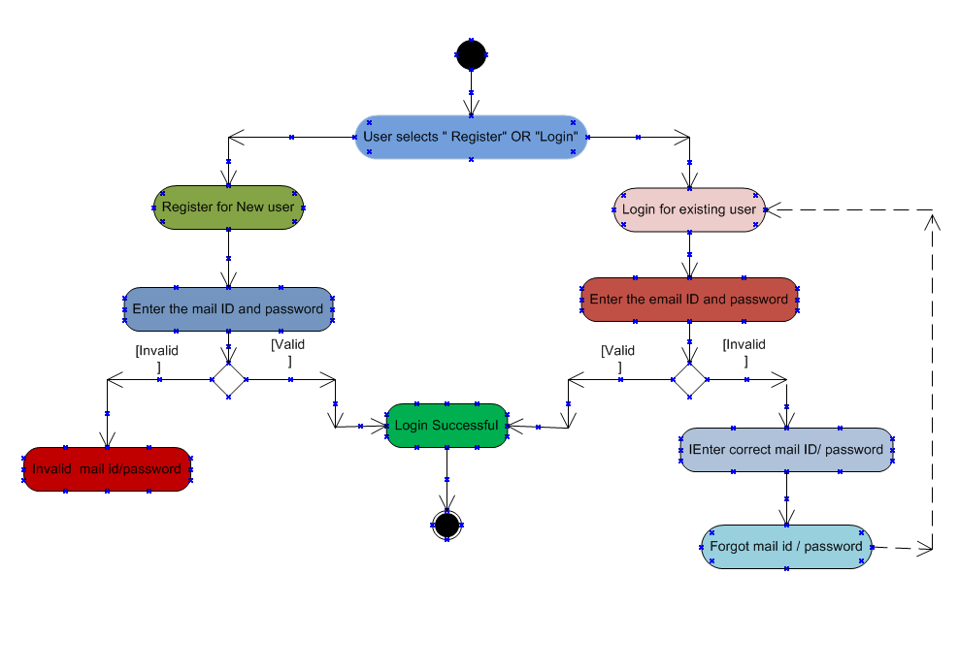

* 1. **View the product :**

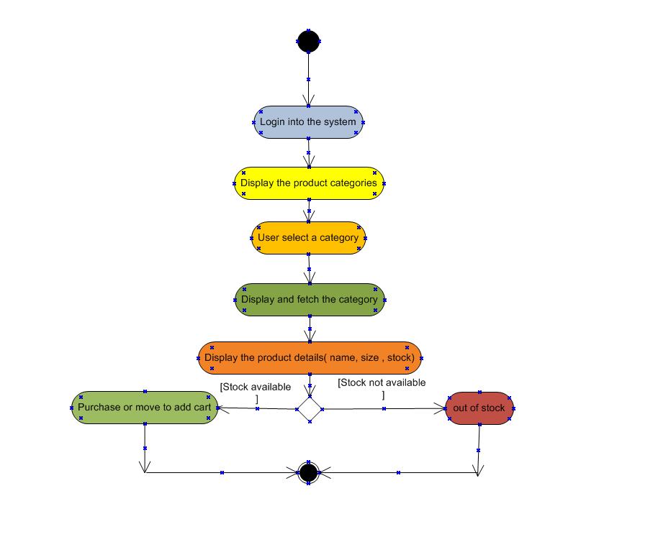

* 1. **Payment of the Product:**

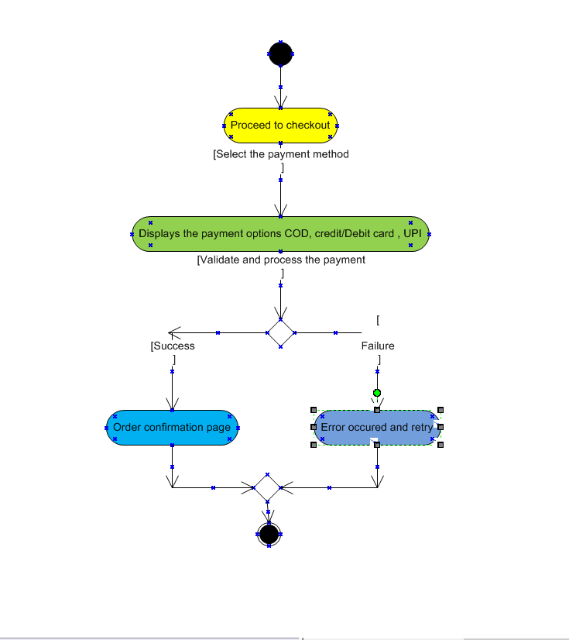

* 1. **Sales Report generation and System Monitoring:**

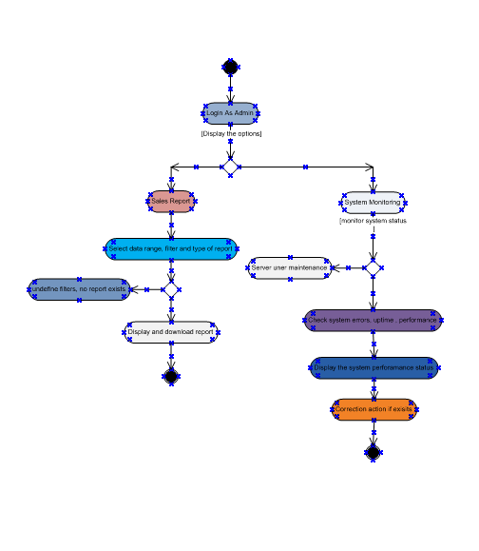

* 1. **Update the product:**

