**Online Agriculture Products Store**

**Question 1 : Functional Requirements**

Identify minimum 20 functional requirements -

|  |  |  |  |
| --- | --- | --- | --- |
| REQ ID | REQ NAME | REQ DESCRIPTION | PRIORITY |
| FR0001 | FARMER REGISTRATION | Farmer should be able to register with the application with email ID and secured password | 9 |
| FR0002 | MANUFACTURER LOGIN | Manufacturer should be able to login into the application. | 9 |
| FR0003 | FUTURE SCOPE | Scope to include new farmers and manufacturers in the future should be made | 8 |
| FR0004 | PRODUCT IMAGE | Manufacturers should be able to upload product images | 8 |
| FR0005 | INTERNET CONNECTIVITY | Internet connectivity should be available at all times. | 8 |
| FR0006 | FARMER SEARCH PRODUCT | Farmer should be able to search products with the search option | 7 |
| FR0007 | FARMER PAYMENT OPTION | Farmer should be able to make payment using cash, card or UPI option | 9 |
| FR0008 | FARMER TRACKING | Farmer should be able to track his order. | 7 |
| FR0009 | FARMER BROWSING | Farmer should be able to browse the product catalogue | 7 |
| FR0010 | BUY LATER OPTION | Farmer should be able to put products in buy later list | 7 |
| FR0011 | BUY DESIRED PRODUCT | Farmer should be able to buy the desired product. | 7 |
| FR0012 | MANUFACTURER PRODUCT UPLOAD | Manufacturer should be able to upload products in the cart when they go below a certain level. | 8 |
| FR0013 | PRINT SLIP | Packing slip to be printed when order is placed. | 7 |
| FR0014 | PRINT PAYMENT RECEIPT | Payment receipt to be printed once payment is made by the farmer. | 7 |
| FR0015 | PRINT ORDER SUMMARY | Order summary slip to be printed when order is uploaded to the manufacturers. | 7 |
| FR0016 | BROWSE COMPETITORS | Manufacturers to browse details of the local competitors. | 8 |
| FR0017 | MANUFACTURER TRACKING DELIVERY | Manufacturer to also track if the product has reached the farmer or not | 8 |
| FR0018 | NET CONNECTIVITY | Net connectivity to have a good speed at all times. | 8 |
| FR0019 | PAYMENT MODE | There should be different payment methods such as COD, UPI, debit/credit cards | 8 |
| FR0020 | FAQ | FAQ page would provide farmers some answers to their questions without contacting customer support. | 8 |

**Question 2 : Minimum 5 page designs- Wireframe and Prototypes**

**Wireframe :**

1. Log In Page

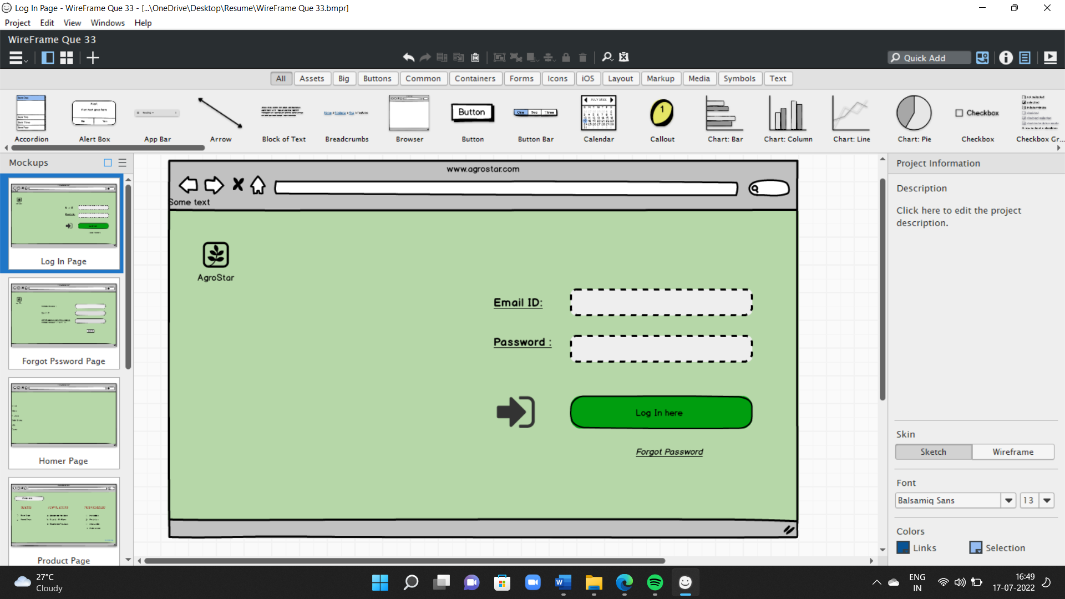

1. Forgot Password Page

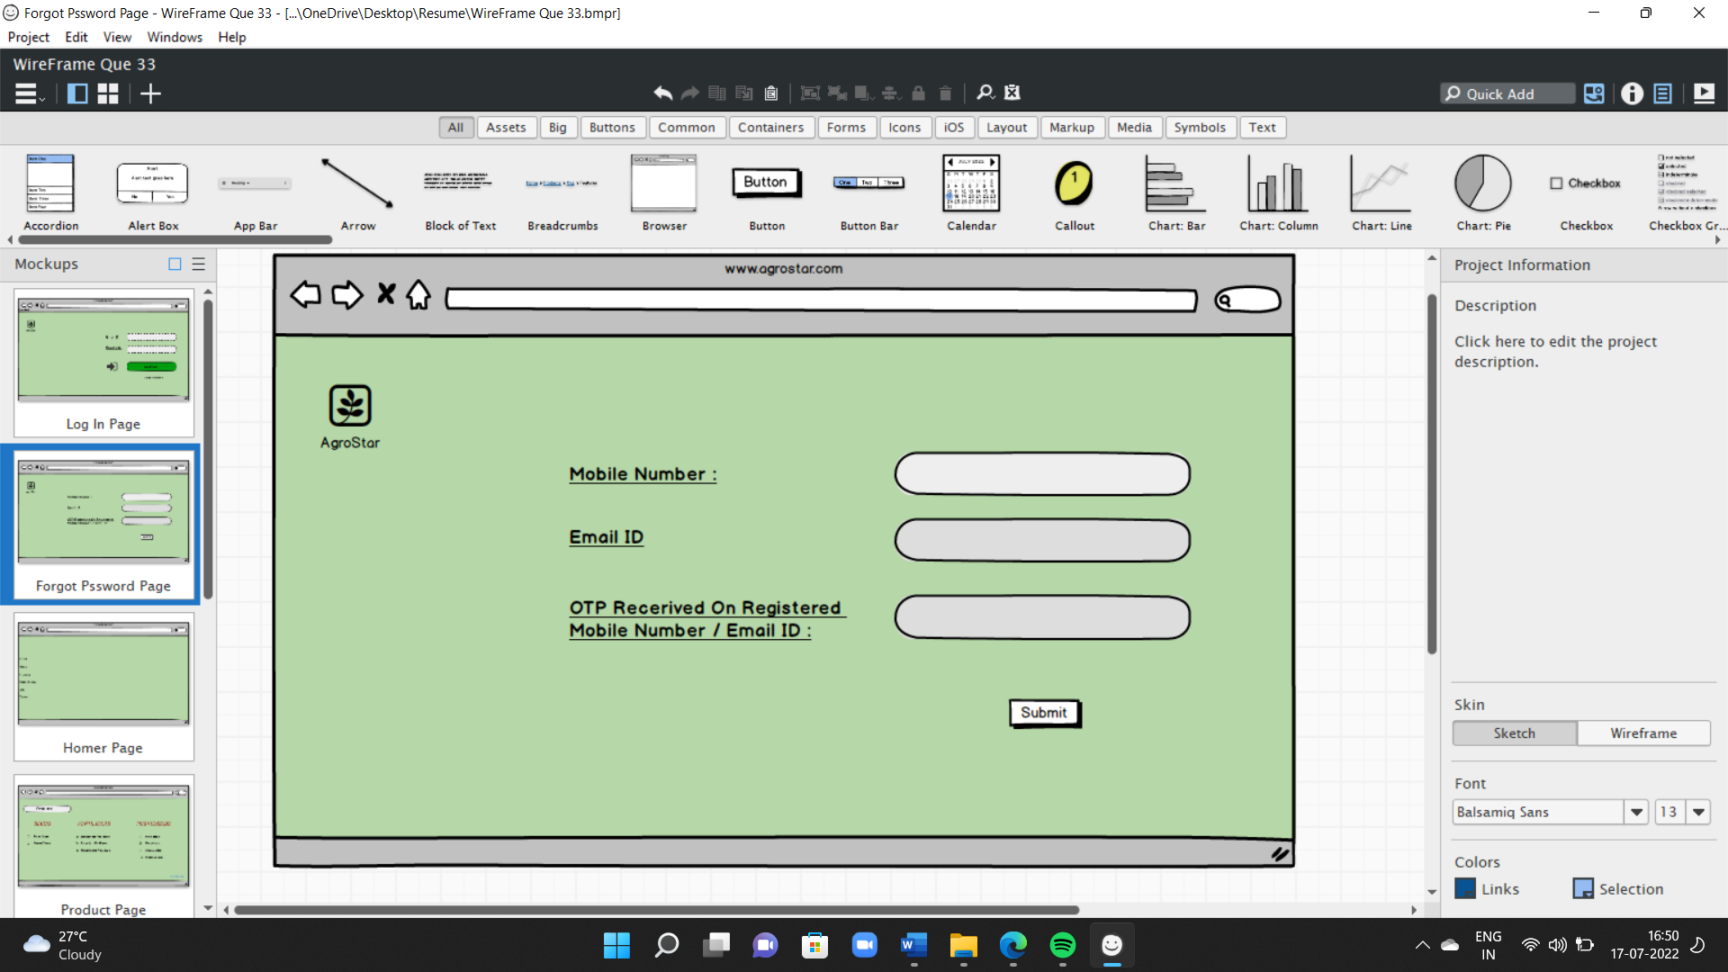

1. Home Page

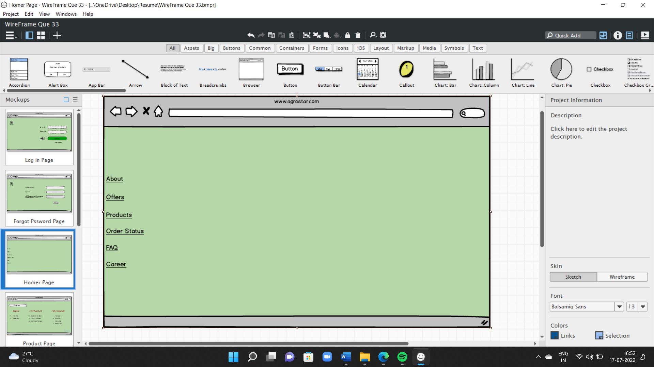

1. Product Page

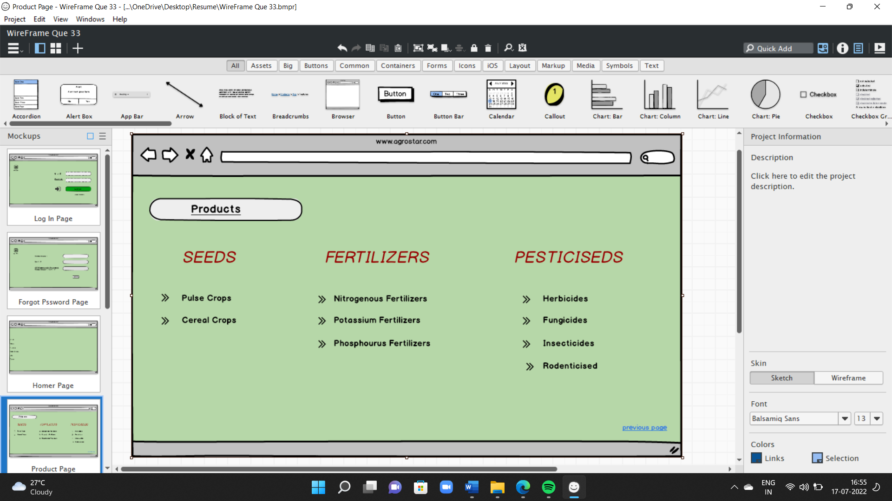

1. Payment Page

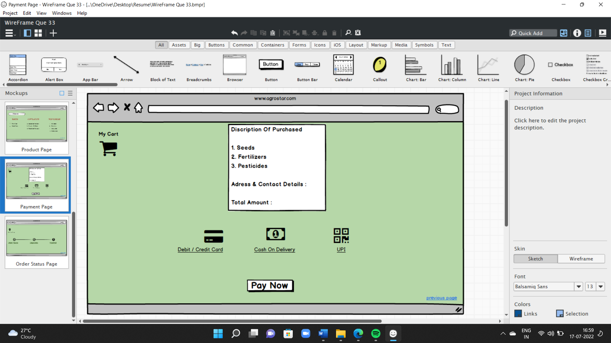

1. Order Status Page

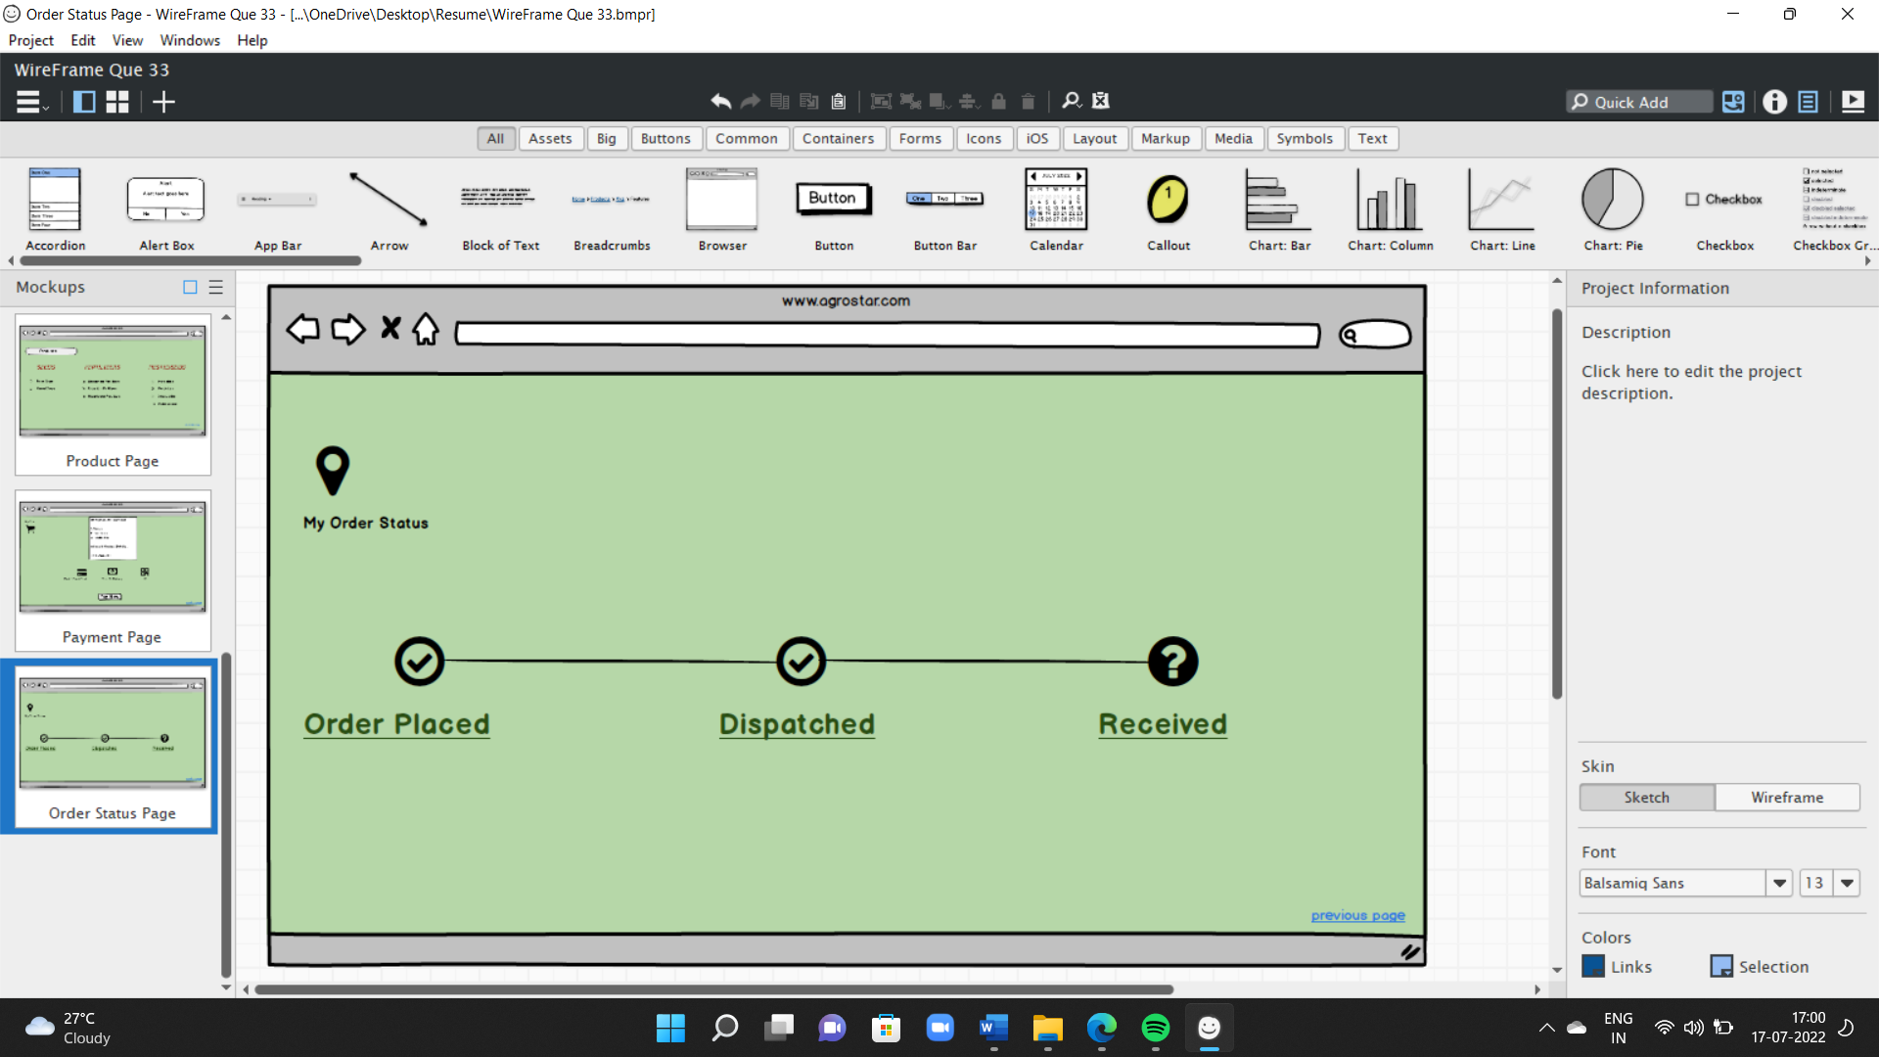

**Prototypes –**

1. Log In Page

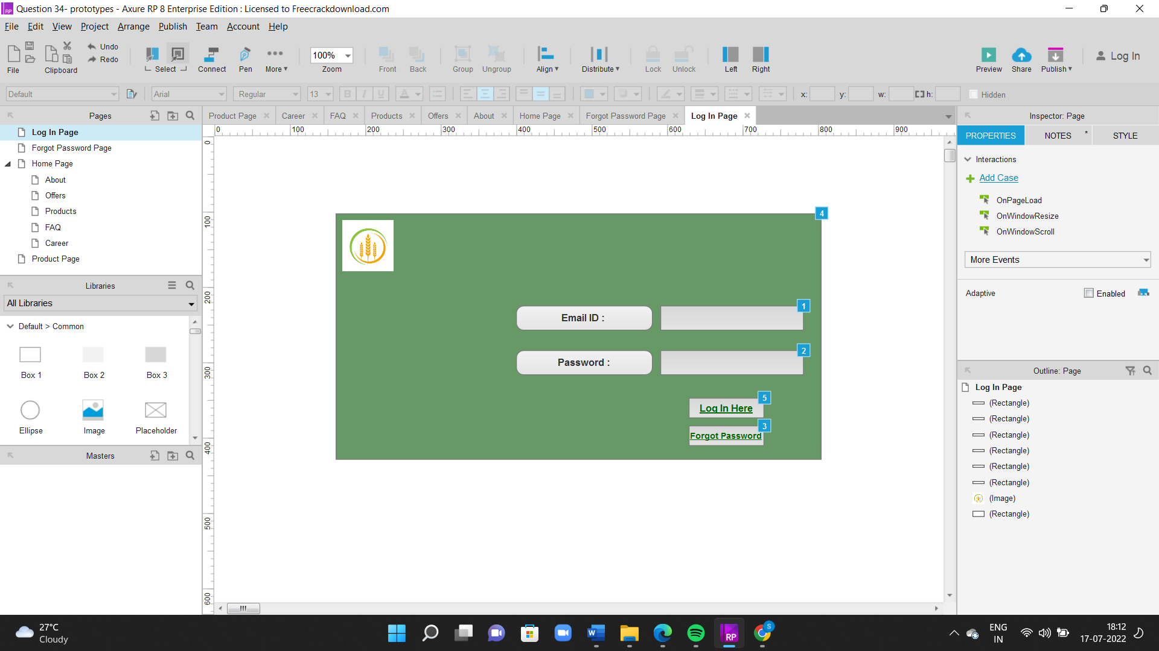

1. Forgot Password Page

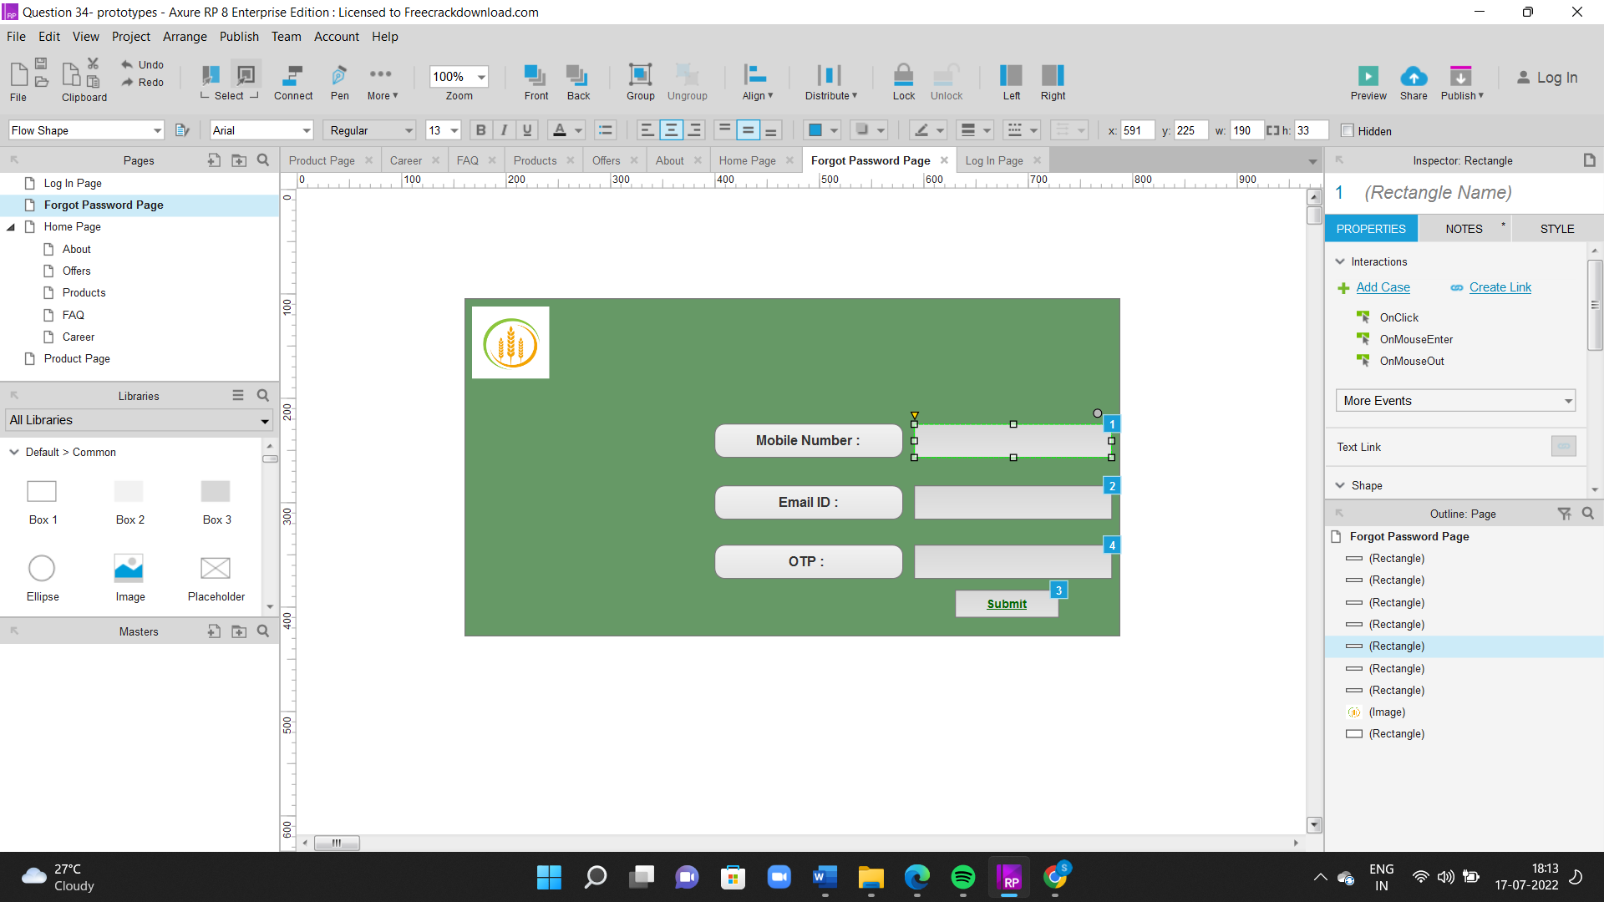

1. Home Page

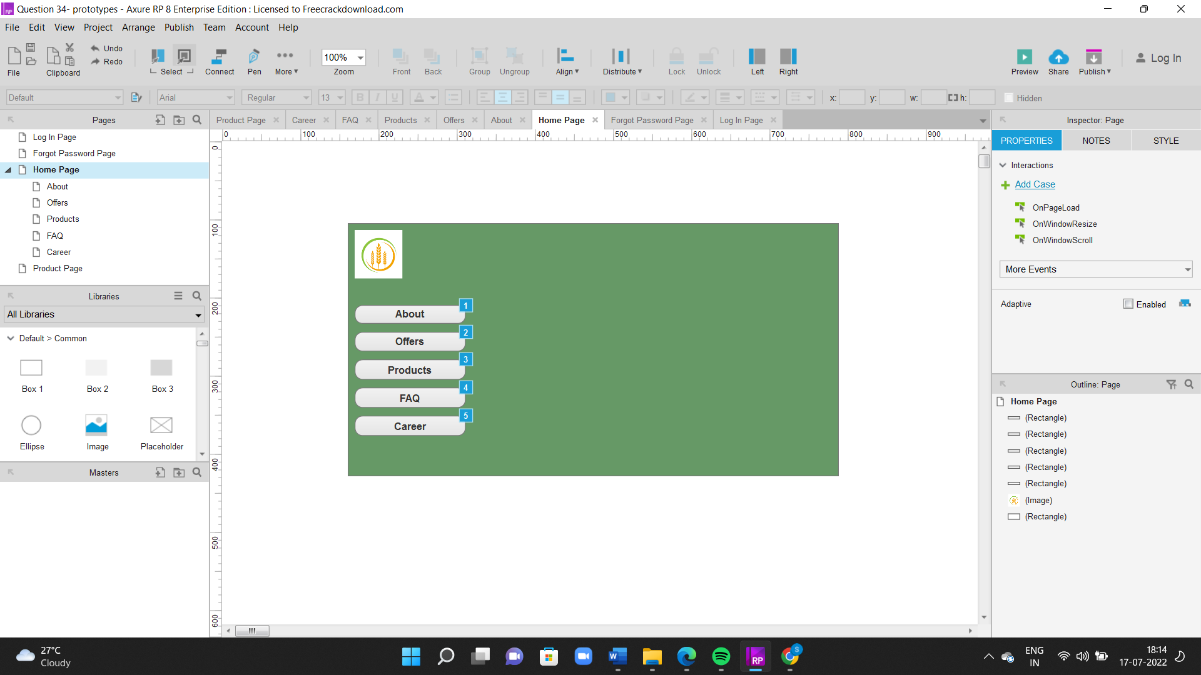

1. Home Page – Child Page – About

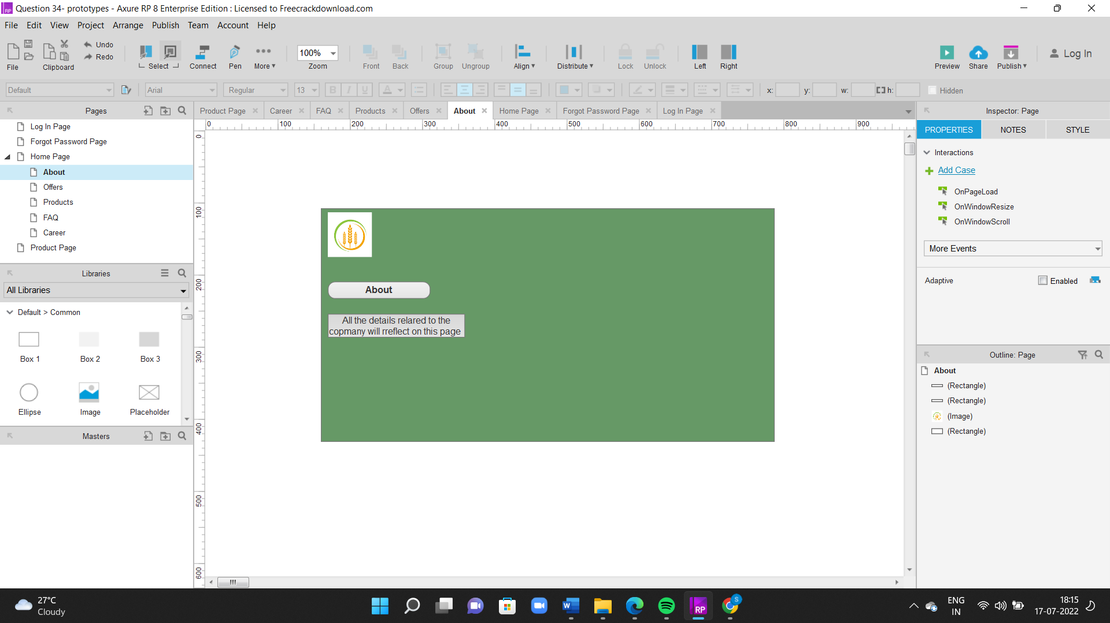

1. Products

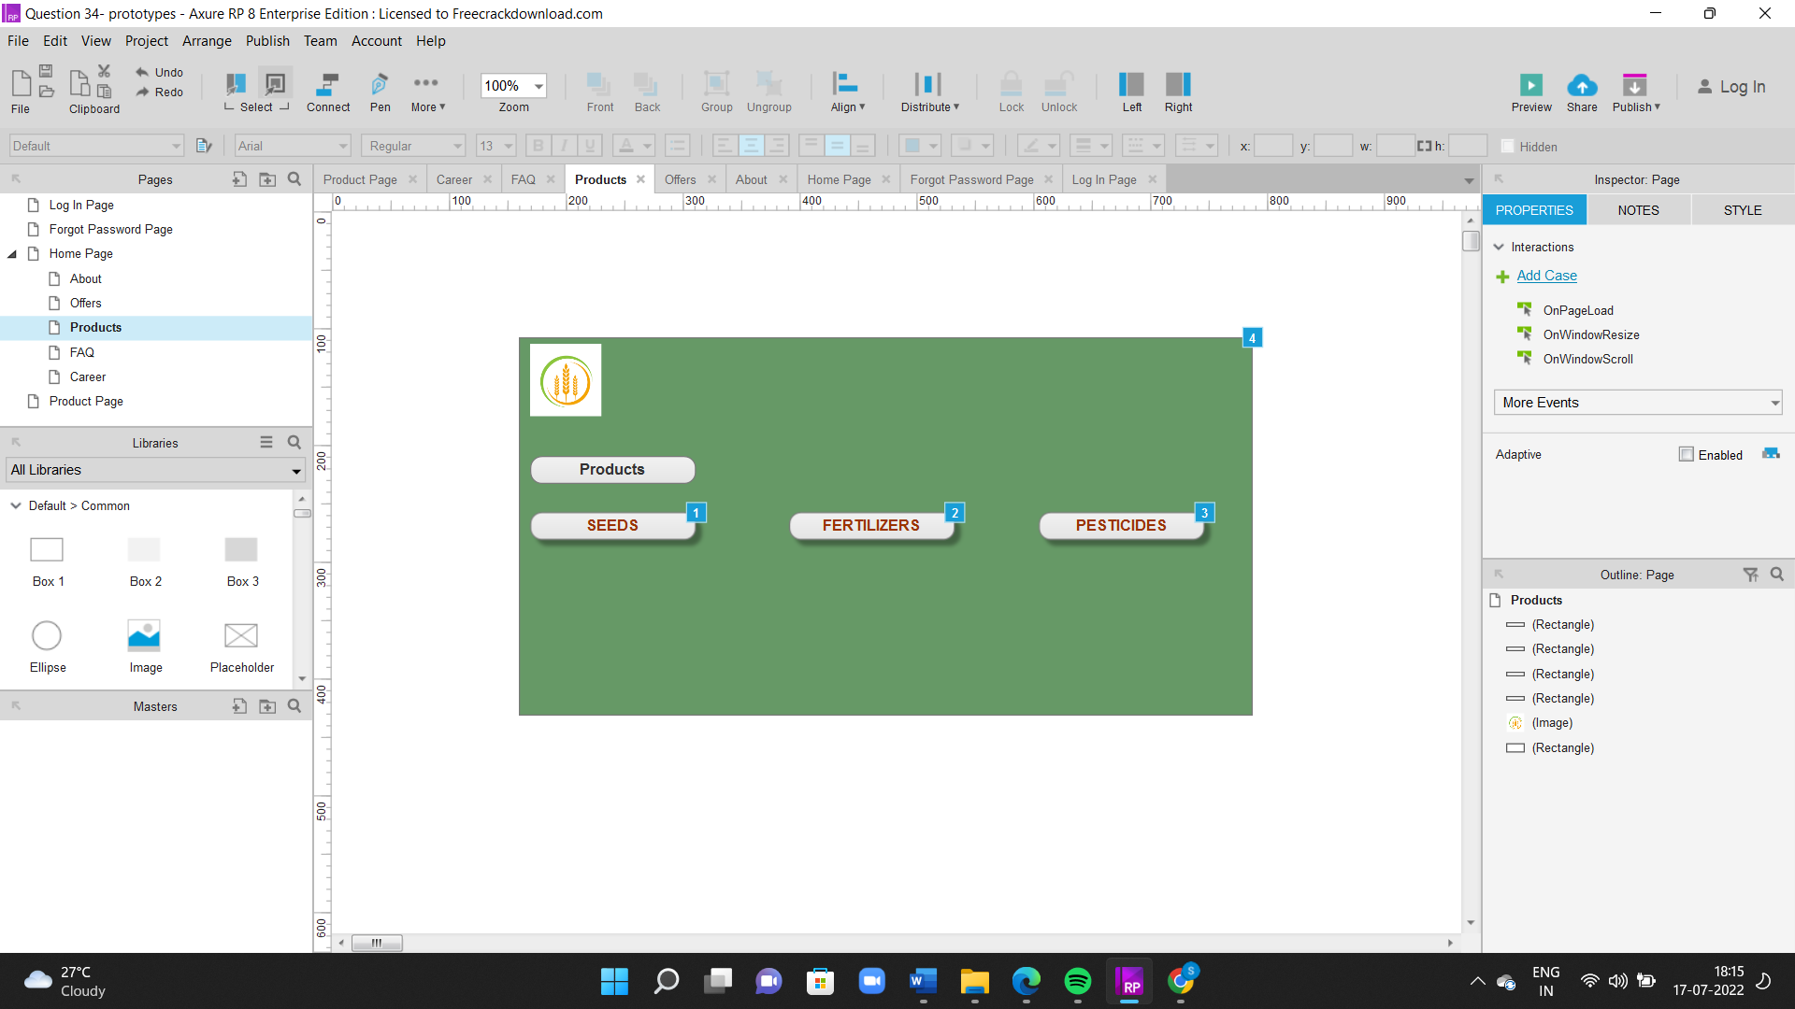

**Question 3 : Tools (Visio, Balsamiq)**

* **Visio -** Microsoft Visio is software for drawing a variety of diagrams. These include flowcharts, org charts, building plans, floor plans, data flow diagrams, process flow diagrams, business process modeling, swimlane diagrams, 3D maps, and many more. It share functionality with MS Office Word and Excel, such as text and color choices, and allow data feeds directly from MS Excel and Access. As with other diagram software, Visio provides a library of templates and shapes for various types of charts to help you get started.
* **Balsamiq -** Balsamiq Cloud is a web-based user interface design tool for creating wireframes (sometimes called mockups or low-fidelity prototypes). We can use it to generate digital sketches of your idea or concept for an application or website, to facilitate discussion and understanding before any code is written. The completed wireframes can be used for user testing, clarifying your vision, getting feedback from stakeholders, or getting approval to start development.

**Question 4 : RTM**

|  |  |  |  |  |  |  |  |  |  |  |  |  |
| --- | --- | --- | --- | --- | --- | --- | --- | --- | --- | --- | --- | --- |
| **Req ID** | **Req name** | **Req description** | **Design** | **D1** | **T1** | **D2** | **T2** | **D3** | **T3** | **D4** | **T4** | **UAT** |
| FR0001 | Farmer Registration | Farmers should be able to register with the application | Design the module on farmer registration with email id | Y | Y | Y | Y | Y | Y | Y | Y | Y |
| FR0002 | Farmer Search for Products | Farmers should be able to search for available products in fertilizers, seeds, pesticides | Search functionality module should be available to search for product through name or id | Y | Y | Y | Y | Y | Y | Y | Y | Y |
| NFR0101 | Page Loading Time | Each Page should load within 2 seconds time | Page loading time module should be within 2 seconds | Y | Y | Y | Y | Y | Y | Y | N | N |
| NFR0102 | WCAG 2.1. | The system must meet Web Content Accessibility Guidelines WCAG 2.1. | Web content accessibility module shoule be as WCAG 2.1 guideline | Y | Y | Y | Y | N | N | N | N | N |

**Question 5 : 10 Test Case Documents**

1. Test case senario - Ability of the system to make a successful Registration

|  |  |
| --- | --- |
| **Request ID** | **1** |
| Test Case ID | TC001 |
| Test Case Name | Verify Registration details |
| Precondition | Should have active email and number |
| Input | Name – Kaustubh, Number – 9999999999, email – [kaustubhdeshmukh3999@gmail.com](mailto:kaustubhdeshmukh3999@gmail.com) |
| Output | Registration successful |
| Actual Test Result | Successful Registration |
| Expected Test Result | Successful Registration |
| Test Result | Pass |

1. Test case senario – Ability of the system to make a successful login by Farmers

|  |  |
| --- | --- |
| **Request ID** | **2** |
| Test Case ID | TC002 |
| Test Case | Verify Login with correct username and password |
| Precondition | Should be Registered user |
| Input | Username – John, Password – qwerty |
| Output | Home Page access |
| Actual Test Result | Successful Login |
| Expected Test Result | Successful Login |
| Test Result | Pass |

1. Test case senario – Ability of the system to make a Product search

|  |  |
| --- | --- |
| **Request ID** | **3** |
| Request Description | Ability of the system to make a Product search |
| Test Case ID | TC003 |
| Test Case Name | Verify Specific product search |
| Precondition | Should have product details in database and search option available |
| Input | Search seeds |
| Output | Seeds are displayed on the page |
| Actual Test Result | Successful Search result |
| Expected Test Result | Successful Search Result |
| Test Result | Pass |

1. Test case senario – Ability of the system to add products to the cart

|  |  |
| --- | --- |
| **Request ID** | **4** |
| Test Case ID | TC004 |
| Test Case Name | Verify products are added to cart |
| Precondition | Product should be listed and available. |
| Input | Select Fertilizer from products and add to cart |
| Output | Product added to Cart |
| Actual Test Result | Successful add to Cart |
| Expected Test Result | Successful add to Cart |
| Test Result | Pass |

1. Test case senario – Ability of the system to Add to wishlist

|  |  |
| --- | --- |
| **Request ID** | **5** |
| Test Case ID | TC005 |
| Test Case Name | Verify products are added to wishlist |
| Precondition | Product should be listed and available. |
| Input | Select Seeds from products and add to Wishlist |
| Output | Product added to Wishlist |
| Actual Test Result | Successful add to Wishlist |
| Expected Test Result | Successful add to Wishlist |
| Test Result | Pass |

1. Test case senario – Ability of the system to make a successful login by Manufacturer

|  |  |
| --- | --- |
| **Request ID** | **6** |
| Test Case ID | TC006 |
| Test Case Name | Verify Login with correct username and password |
| Precondition | Should be Registered user |
| Input | Username – Kaustubh, Password – qwerty |
| Output | 404 Error |
| Actual Test Result | Unsuccessful Login |
| Expected Test Result | Successful Login |
| Test Result | Fail |

1. Test case senario – Ability of the system to track delivery status

|  |  |
| --- | --- |
| **Request ID** | **7** |
| Test Case ID | TC007 |
| Test Case Name | Verify orders are tracked |
| Precondition | Should be confirmed order |
| Input | Check delivery status |
| Output | Delivery details displayed |
| Actual Test Result | Successful display of delivery status |
| Expected Test Result | Successful display of delivery status |
| Test Result | Pass |

1. Test case senario – Ability of the system to display mode of payment

|  |  |
| --- | --- |
| **Request ID** | **8** |
| Test Case ID | TC008 |
| Test Case Name | Verify payment methods are displayed |
| Precondition | Product should be selected |
| Input | Go to checkout after product is selected |
| Output | Payment modes displayed |
| Actual Test Result | Successful display of mode of payment |
| Expected Test Result | Successful display of mode of payment |
| Test Result | Pass |

1. Test case senario – Ability of the system to make order confirmation

|  |  |
| --- | --- |
| **Request ID** | **9** |
| Test Case ID | TC009 |
| Test Case Name | Verify order is confirmed |
| Precondition | Payment should be successful |
| Input | checkout order and have completed payment |
| Output | Payment confirmation |
| Actual Test Result | Successful Payment confirmation |
| Expected Test Result | Successful Payment confirmation |
| Test Result | Pass |

1. Test case senario - Ability of the system to Cancel order

|  |  |
| --- | --- |
| **Request ID** | **10** |
| Request Description | Ability of the system to Cancel order |
| Test Case ID | TC010 |
| Test Case Name | Verify order cancellation |
| Precondition | Product confirmation |
| Input | Cancel confirmed order |
| Output | Order Canceled |
| Actual Test Result | Successful Order Canceled |
| Expected Test Result | Successful Order Canceled |
| Test Result | Pass |

**Question 6 : Draw database schema and ER diagram**

**PRODUCT CATEGORY**

Pesticides

Seeds

Fertilizers

**PAYMENT ID**

Payment invoice

Payment mode

status of payment

**PRODUCTS**

Product ID

Product Name

Product Vatalogue

**SUB** **CATEGORY**

Sub category ID

Sub Category Name

**ORDERS**

Oreder ID

Order amount

Order status

**USER**

User ID

User Email ID

User password

user location

**Question 7 : Data Flow Diagram**

Customer

Customer email ID

Customer ID

Customer password

Location

web app

log in

verification

oroduct category

seeds

fertilizers

pesticides

aayment mode

payment ID

payment invoice

cart Item

total cart items

Total price

Product

Product ID

Price

Location

**Question 8 : Change Request**

It is inevitable that some things needs to be changed that affect the project and so the requirements will also change. When the change requests come, the BA should initially perform the feasibility study to accept the change and then impact analysis to measure the change to project and finally effort estimation to implement the changes to the project. BA has to follow the following steps :-

* Document the change request.
* Analyse the change request.
* Seek approval from change manager or project manager.
* Identify if the change request is a complex one or minor change.
* Help stakeholders in minimising the negative impact that results in the change.
* Articulate a realistic or convincing vision.
* Communicate a state of urgency to stakeholders and bring them to an agreement and avoid conflicts which could delay the project.

**Question 9 : Change Request Vs an Enhancement**

This is a change request to the existing project. AS a BA we should be ready to accept the change . Never say NO to the client. Consult an SME for clarification. This should be done in consideration with the cost and timelines.

**Question 10 : Estimations**

Man-hour estimations:-

500-1000 Man-hours as this is a medium project.

PM:-250 MH

BA-250 MH

JAVA DEVELOPER-100 MH

TESTERS-80 MH

NW ADMIN-50 MH

DB ADMIN- 60 MH

**Question 11 : UAT**

In testing stage the

* BA prepares test cases or assists the test managers.
* Then BA performs high level testing, prepares client for UAT.
* Test data is requested by BA from client.
* Updates end user manuals.
* Updates RTM.
* Takes sign offs from client on Client project acceptance form.

Closure of the project:- This is the deployment and implementation stage where:-

* BA forwards the RTM to client or PM which is attached to project closure document.
* Coordinate to complete and share end user manuals.
* Plan and organise training sessions for the end users.
* Prepare lessons learnt from the project for future reference and precautions if any.

**Question 12 : Project Closure Document**

The BA should keep the following into consideration during project closure:-

* Did the project achieve its goal
* What was the planned and actual cost
* What was the estimated time vs actual time taken to complete the project.
* Was their proper documentation and record of the same.
* Was the testing successful.
* Was the training session conducted successfully.

|  |  |
| --- | --- |
| **Name** | Online Agriculture Store |
| **Project Code** | V0002 |
| **Project Manager** | Mr Vandanam |
| **Project Cost** | INR 2 Cr |
| **Brief about Project** | Online E-commerce platform where manufacturers can sell their products directly to farmers through website. |
| **Project Accomplishment** | Successfully made the website according to client requirement within stipulated time |
| **Duration** | 18 months |
| **Lesson Learnt** | Many Smaller Team works better as compared to few Large teams |
| **Final position** | Complete |
| **Transfer of Operation** | From BA to Sponsor |
| **Risk** | Moderate Risk |
| **Documentation** | BRD and FRD, Test case |
| **Tools** | Balsmiq for wireframe, Axure for Prototype and Visio for Use case and Activity Diagram |
| **Project Manager Comments** | It was wonderful experience to work with such a good team be it internal team or client side. Looking forward for more such projects. |