**Question 1 –Audits - 5 Marks**   
  
  
Quarterly Audits are regular checks done every 3 months to review and access where the area of business are getting failed or getting completed – everything will undergo checks.   
  
Audits will help us to identify the progress of the particular case study or project is.   
It ensures project is on track and meets the objectives, it identifies the issues, it also helps in improving the accuracy of the data by verifying the reports etc.   
  
Quarter 1 Audit Report   
  
Stage – Requirement gathering phase  
Completed – 10 Weeks ( Week 1 – Week 10)  
Check list – BRD Template , Elicitation result report , Duplicate requirement report, Grouping of functionalities, Email Communication – To, CC, BCC  
  
Quarter 2 Audit Report   
  
Stage – Requirement analysis phase  
Completed – 7 Weeks ( Week 15 – Week 22)  
Check list – UML Diagram , Client sign off documents , RTM document version control , Email Communication – To, CC, BCC  
  
Quarter 3 Audit Report   
  
Stage – Design  
Completed – 7 Weeks ( Week 31 – Week 38)  
Check list –Utilization of tools, Document evidence on client communication, Stakeholder MOM, Email Communication – To, CC, BCC  
  
Quarter 4 Audit Report   
  
Stage – Development  
Completed – 20 Weeks ( Week 40 – Week 60)  
Check list – JAD session report, End user manual preparation document, BA and Developer MOM, Email Communication – To, CC, BCC  
  
  
Quarter 5 Audit Report   
  
Stage – Testing   
Completed – 20 Weeks ( Week 58 – Week 78)  
Check list – Test case summary, Training report to end user, Email Communication – To, CC, BCC  
  
  
**Question 2 – BA Approach Strategy - 6 Marks**What Elicitation Technique to apply – Brainstorming , Document Analysis , Reverse Engineering, Focus Groups, Observations etc  
  
How to do Stakeholder Analysis RACI – Stakeholder Analysis can be done by using the RACI matrix involves identifying stakeholders and defining their roles and responsibilities within a project. Create RACI matrix, assign RACI roles  
  
What documents to write – Business Required Document, Functional Required Document, Use Case Documentation, Test Case Documents etc.   
  
What process to follow to Sign off on the Document – Sign Off to be taken on Software Requirement Specification as this is the primary and important document . It can be taken by using Email confirmation from client.  
  
How to take approvals from the client – Establish a formal meeting with the clients to keep them informed and get continuous feedback.   
  
What communication channels to establish and implement – Regular meetings , Weekly status meeting , Bi–weekly sprint reviews, and monthly stakeholder updates.  
  
How to handle change requests – Change request form, do impact analysis, approval process, and documentation.   
  
How to update the progress of the project to the stakeholders – Weekly Status Reports, Monthly Review Meetings  
  
How to take signoff on the UAT – Client Project Acceptance Form – UAT Preparation, Conduct UAT , Fix Issues , Acceptance Form, Final Review Meeting, Obtain Sign-off.  
  
  
**Question 3 – 3-Tier Architecture - 5 Marks**Three-tier architecture is a software development model that separates an application into three logical tiers: the presentation tier, the application tier, and the data tier.  
  
Application Layer – Topmost layer of the architecture – also known as Presentation Layer. It handles UI components such as screens , pages .  
  
Example – E commerce Website  
  
Business Logic Layer – Middle layer of the architecture – acts as an intermediary between the presentation layer and the data storage layer – it contains the core logic of the application.   
  
Example – Printer , Payment gateways  
  
Database Layer – Bottom most layer of the architecture – responsible for storing and retrieving data.   
  
Example – MySQL, Oracle database.  
  
  
  
**Question 4 – BA Approach Strategy for Framing Questions – 10 Marks**The 5W1H framework is a useful tool for gathering information and understanding a situation by answering questions about who , what , when , where , why and how.  
  
The SMART technique can help in creating questions: Specific – Measurable - Attainable – Relevant and Time Bound  
  
RACI charts help define and clarify roles and responsibilities within a team by outlining who is responsible, accountable, consulted and informed for each task.  
  
UML – Unified Modeling Language is a standardized way of diagramming and modeling software systems to aid in design, development and communication between team members.   
  
  
**Question 5 – Elicitation Techniques - 6 Marks**Elicitation techniques are methods used to gather information that is not readily available, or to get learners to provide information they already know.  
  
Brainstorming - Brainstorming is considered a business analysis elicitation technique, and you might think of it as just the spontaneous generation of ideas, often in a larger group of people with a white board or some capture mechanism.  
  
Document Analysis - Document analysis involves actively reading a document, such as a regulation, a standard, a competitive product review, or customer suggestion logs.  
  
Reverse Engineering - The Reverse Engineering business model is a process by which an existing technology or competitor's product is analyzed and the information obtained is used to develop a similar or compatible product.

Focus Groups - Focus group discussion is frequently used as a qualitative approach to gain an in-depth understanding of issues. The method aims to obtain data from a purposely selected group of individuals rather than from a statistically representative sample of a broader population.  
  
Observations - Observation requires a business analyst to go and look at the work – for example, observing the business processes in scope of the project. The elicitation technique observation is an effective means of understanding how a user does their job by assessing their work environment. This technique can be used to understand requirements and provide context to the requirements.   
  
Workshops - A workshop elicitation technique is a structured meeting where stakeholders and content experts work together to define, create, and finalize deliverables.   
  
JAD - Joint application development (JAD) is a process for improving system design and delivery through a series of workshops and sessions in order to define the requirements from the perspective of business ideas and technology implementations.  
  
Interview - Interviews involve asking questions, listening to the answers, and asking follow-up questions. Interviews can be done one-on-one, but they can also be done in a small group setting if you’re careful to get all the perspectives out.  
  
  
Prototype - Prototyping is the process of creating mock-ups or simulations of the final product or solution, such as user interfaces, workflows, or functionalities. Prototyping can help you test and validate requirements, as you can check whether they meet the expectations and needs of the users and the business.  
  
Questionnaire - Survey and questionnaires are used to gather information from many people who answer a specific question.  
  
Use Case Specifications - Use cases are a powerful requirements elicitation tool to discover and explore the user-valuable transactions a solution must provide. Each time a user interacts with a product, they have intent in mind, something they wish to accomplish.  
  
  
  
  
**Question 6 – This project Elicitation Techniques - 5 Marks**Prototyping - Helps avoid costly mistakes, it allows designers to identify and fix problems early on, saving time and money. It also helps understand user needs. It also helps explore new ideas.  
  
Use case Specs - Use cases are used to identify, clarify, and organize system requirements. They help ensure that the system can perform its intended functions and meet user expectations.  
  
Document Analysis - This involves reviewing existing documentation related to the system, such as user manuals, design documents, and previous requirements documents. This can give you a good understanding of the existing functionality and help you identify any gaps in the current requirements.  
  
Brain Storming - The goal of brainstorming is to generate many ideas quickly, and “out-of-the-box” thinking can be encouraged. The ideas are then discussed, merged, and refined. The group eventually works to achieve a consensus on the final list or best approach to solve the problem.  
  
  
  
   
  
**Question 7 – 10 Business Requirements- 10 Marks**Business requirements are the specific needs or conditions that a business must meet to achieve its objectives.  
  
Example -   
  
BR01 – Users should be able to search products in the app.  
BR02 – Users should be able to browse through the product catalog.  
BR03 – Users need to create login id and password.  
BR04 – If the user is a new user, first he should create the login id and password.  
BR05 – To provide and IT solution to farmers to buy pesticides, fertilizers and seeds online.  
BR06 – To make agriculture much more effective.  
BR07 – Users should be able to get the delivery of the product at their places.  
BR08 – Users can compare and buy.  
BR09 – Users can buy pesticides, seeds and fertilizers directly from Manufacturers.   
BR10 – Users can get variety of options to choose from variety of brands.  
  
  
**Question 8 – Assumptions- 5 Marks**A user can create an online web store to help farmers increase productivity.  
  
A user can buy pesticides, seeds and fertilizers from online web store.  
  
Online purchase giving more variety and options to choose.  
  
This is helping in fulfilling the gap between the farmer and agricultural product manufacturer.  
  
The customers have online accounts for secured payment processing.  
  
  
 **Question 9 – This project Requirements Priority - 8 Marks**Requirements prioritization is the practice of identifying and managing the importance of various requirements to acknowledge the limited resources available.  
We will use the MoScoW method to give the priority points.   
  
The MoScoW Method

This system employs four priority categories instead of numbers: MUST have, SHOULD have, COULD have, and WON’T have. The abbreviation stands for the following:

MUST(Mandatory)  
SHOULD (Of high priority)  
COULD (Preferred but not necessary)  
WOULD (Can be postponed and suggested for future execution)

|  |  |  |  |
| --- | --- | --- | --- |
| Req .id | Req name | Req description | priority |
| BR01 | Product info | Farmers should get info regarding products | 6 |
| BR02 | Farmers search for products | Farmers should be able to search for available products in fertilizers, seeds, pesticides | 3 |
| BR03 | Manufacturers upload their Products | Manufacturers should be able to upload and display their products in the application | 2 |
| BR04 | User create login | Farmers should be able to create login if he is a new user | 1 |
| BR05 | Email confirmation | Farmers should get email confirmation for their order | 4 |
| BR06 | Payment Gateway | All the payment gateway methods(COD/Credit card/Debit card/UPI)should be available. | 5 |
| BR07 | Manufacturer can add products in the product catalog | Manufacturer must be able to add the products and also should be able in display the products. | 7 |
| BR08 | Product delivery tracking | Farmers can track their orders | 9 |
| BR09 | Add to cart option | Farmers must be able to add items to cart if they want to buy these items later. | 8 |

**Question 10 – Use Case Diagram - 10 Marks**A use case diagram is a visual representation of the interactions between users - Actors and a system.  
  
  
  
 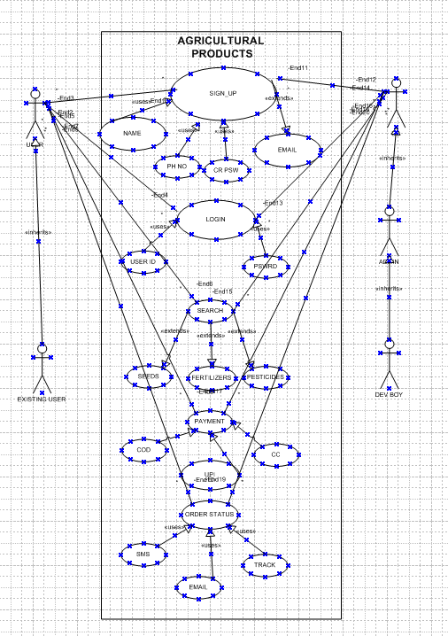  
  
 **Question 11 – Use Case Specs - 15 Marks**A use case specification document which provides a detailed description of a use case outlining how users ( actors ) will interact with the system to achieve a specific goal.

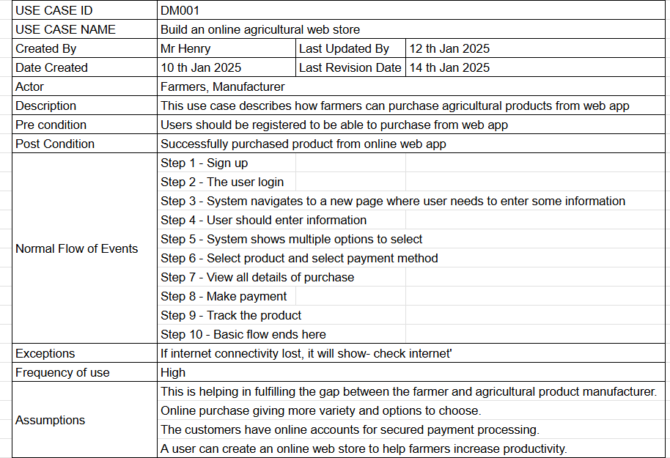  
  
  
  
  
  
  
  
  
  
  
  
  
  
  
  
  
  
  
  
  
  
  
  
  
  
  
  
  
  
  
  
  
  
  
  
  
  
  
  
  
  
  
**Question 12 – Activity Diagrams - 15 Marks**An activity diagram is a type of diagram in the UML that visually represents the flow of activities within a system.  
  
Here we have created activity diagrams on -   
  
User Login  
Search Products  
Login Validation  
Payment  
Order status