**Capstone Project-1 Preperation-3**

**Online Agriculture Product Store**

**Q.1)** Identify minimum 20 functional requirements?

Ans.1)

|  |  |  |  |
| --- | --- | --- | --- |
| **Req Id** | **Functional Req** | **Req Description** | **Priority** |
| FR001 | Create new account | System shall allow user to create new account & login securely | 10 |
| FR002 | Search product | System shall allow user to search their product | 9 |
| FR003 | Add item | System shall allow user to add their item into the cart | 9 |
| FR004 | Track status | System shall user to track the status of their order | 8 |
| FR005 | Modify account | System shall allow user to modify or edit their personnel information | 7 |
| FR006 | Feedback | System shall allow user to leave their feedback after shopping | 7 |
| FR007 | Transaction history | System shall allow user to view their transaction history | 8 |
| FR008 | Reset PW | System shall allow user to reset their password if forgotten | 7 |
| FR009 | Multiple payment  Gateways | System shall allow user to have multiple gateways while doing payment | 8 |
| FR010 | Order Placement | System shall allow user to place their order by specifying qty & address | 9 |
| FR011 | Order confirmation | System shall send the order confirmation with details such qty,total amount, estimated delivery | 8 |
| FR012 | Order History | System shall allow user to view their order history including past orders, order details and status | 7 |
| FR013 | Customer Support | System shall allow user to connect with customer service in case of any query | 8 |
| FR014 | Cancel or modify order | System shall allow user to cancel or modify their order till delivery | 7 |
| FR015 | Admin product mgmt.. | System shall allow admin to manage product inventory & pricing | 9 |
| FR016 | Product recommendation | Platform must provide product recommendation to user based on their past purchases & browsing history | 7 |
| FR017 | User rating & reviews | System shall allow user to leave their reviews(with images) after using the product and can give their product rating | 8 |
| FR018 | Discount coupons & rewards | Platform must have a discount & reward section to allow user to view their reward points and availability of various discount coupons | 7 |
| FR019 | Product sharing | Platform shall allow user to share their preferred product with friends & relatives | 7 |
| FR020 | Manufacturer product listing | System shall allow manufacturer to upload new products with registration | 8 |

Q.2) Make wireframe and prototypes?

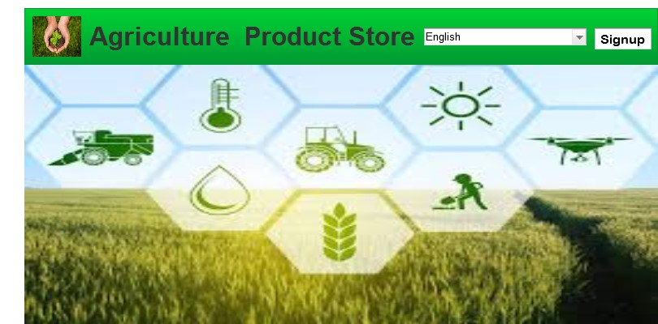

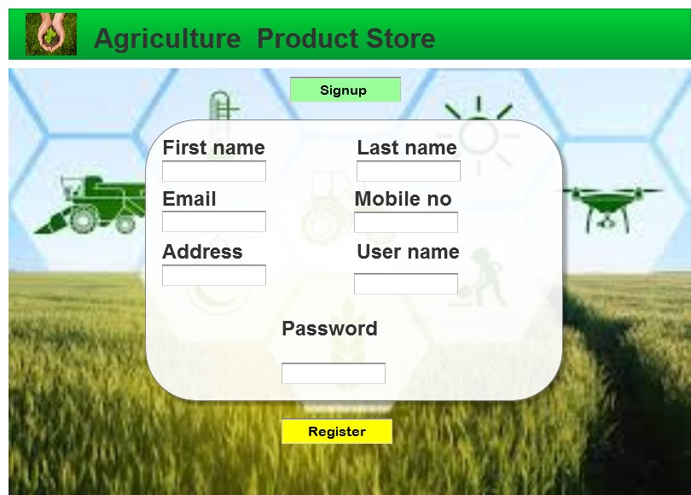

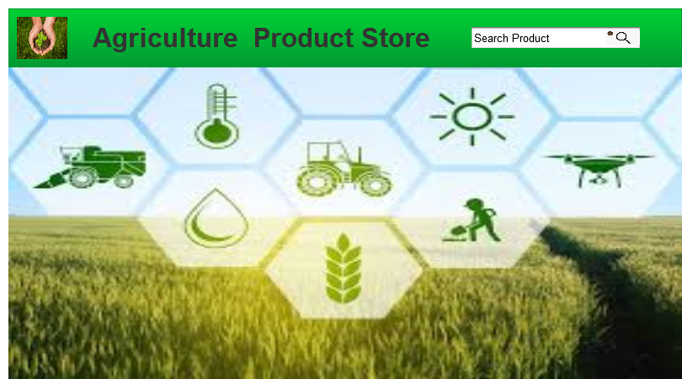

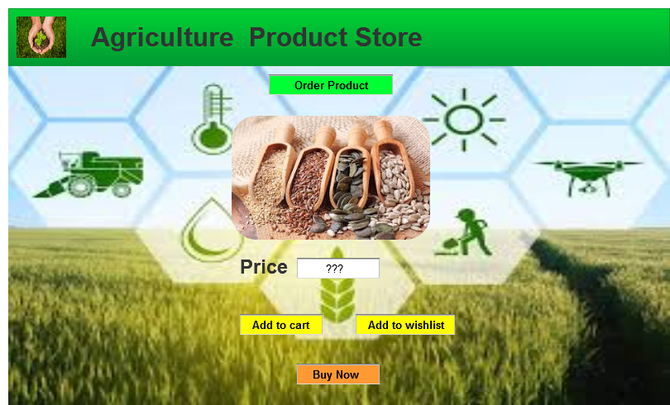

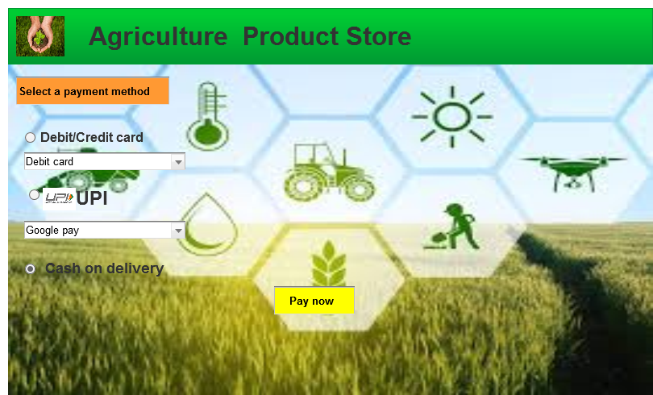

Q.3) Make a note of the Tools, which you are using for above concepts.?

Ans.3) **Axure RP**: - It is a software tool that helps professional to create prototypes and wireframes, specification and design for mobile or desktop application. The protypes include realistic and functional prototypes without writing codes. It also creates data driven interfaces and grids that can be sorted and filtered.

It gives plenty of features including pop-ups, drag & drop functionality, formatting of widgets, adding images, resizing.

**MS Visio**: - MS Visio a diagramming and vector graphics application and is a part of Microsoft office family. The product was first introduced by Visio corporation (American software company) in 1992.it helps professional to create diagrams such as flowcharts, network diagrams diagrams and mind maps. It is also used for scenarios such as process mapping.

Q.4) Mr. Henry and peter have approached you regarding the current status of the project. How will you tackle this situation? Prepare RTM ?

Ans.4)

|  |  |  |  |  |  |  |  |  |  |
| --- | --- | --- | --- | --- | --- | --- | --- | --- | --- |
| **Req Id** | **Req name** | **Req des** | **Design** | **D1** | **T1** | **T2** | **T3** | **T4** | **UAT** |
| FR001 | Website layout | Developers will develop the layout | Completed | ✓ | ✓ | ✓ | ✓ | ✓ | ✓ |
| FR002 | Login | User will be allowed to create new account | Completed | ✓ | ✓ | ✓ |  |  |  |
| FR003 | Search option | User can search products | Completed | ✓ | ✓ |  |  |  |  |
| FR004 | Product catalog | User will have access to product catalog | Completed | ✓ |  |  |  |  |  |
| FR005 | Homepage | User will see the homepage after successful registration | Completed | ✓ | ✓ | ✓ | ✓ | ✓ | ✓ |
| FR006 | Add item | User can add their item to cart | Completed | ✓ | ✓ |  |  |  |  |
| FR007 | Add to Wishlist | User can add their item to Wishlist for future reference | Completed | ✓ | ✓ |  |  |  |  |
| FR008 | Payment option | User will have choices to select diff payment method | Completed | ✓ |  |  |  |  |  |
| FR009 | COD | User can pay after delivery | Completed | ✓ |  |  |  |  |  |
| FR010 | Cancel order | User can cancel their order | Completed | ✓ | ✓ | ✓ |  |  |  |
| FR011 | Edit/modify account details | User can add or modify their personnel details | Completed | ✓ | ✓ |  |  |  |  |
| FR012 | Email confirmation | User will get email confirmation after product order | Completed | ✓ | ✓ | ✓ | ✓ | ✓ | ✓ |
| FR013 | Track order | User can track order after product order | Completed | ✓ | ✓ |  |  |  |  |
| FR014 | Customer support | User can chat or call the customer support in case of any query | Completed | ✓ | ✓ | ✓ |  |  |  |
| FR015 | Transaction history | User, can view their past transaction history | Completed | ✓ | ✓ |  |  |  |  |
| FR016 | Upload product | Seller can upload their product on platform |  | ✓ |  |  |  |  |  |
|  |  |  |  |  |  |  |  |  |  |
|  |  |  |  |  |  |  |  |  |  |
| NFR0101 | FAQ | FAQ for farming product for users | Completed | ✓ | ✓ |  |  |  |  |
| NFR0102 | Page loading time | How much time require to load the page | Completed | ✓ | ✓ | ✓ | ✓ | ✓ | ✓ |
| NF0103 | Help & Support | User will have support function to help hem in ordering product | Not Completed |  |  |  |  |  |  |

Q.5) Prepare 10 Test Case Documents?

Ans.5)

|  |  |  |  |
| --- | --- | --- | --- |
| Test case ID | ABCD0001 | Test case name | Search query |
| Project ID | ABCD | Project name | Online agriculture product store |
| Test strategy | ABCD0001 | Tester ID | T1234 |
| Test plan ID | ABCD00P1 | Date of test |  |
| Test schedule id | ABCD0S1 |  |  |

|  |  |  |  |
| --- | --- | --- | --- |
|  | **Set 1** | **Set 2** | **Set 3** |
| **Input** | Fertilizers | Seeds | Pesticides |
|  | 1 kg | 1 qty | 1 ton |
|  | 500 Rs is cost | 200/kg | 1000/ton |
| **Expected behavior** | 100 farmers should visit and order for above data |  |  |
| **Actual behavior** | 65 farmers visited and ordered successfully |  |  |
| **Comment** | Tester completed the testing and UAT is done |  |  |
| **Result (Pass/fail)** | Pass |  |  |

|  |  |  |  |
| --- | --- | --- | --- |
| Test case ID | ABCD0002 | Test case name | Registration details |
| Project ID | ABCD | Project name | Online agriculture product store |
| Test strategy | ABCD00RD | Tester ID | T1235 |
| Test plan ID | ABCD00P2 | Date of test |  |
| Test schedule id | ABCD0S2 |  |  |

|  |  |  |
| --- | --- | --- |
|  | **Set 1** | **Set 2** |
| **Input** | Mail id | First name |
|  | Mobile number | Last name |
|  | Password | OTP |
|  |  |  |
| **Expected behavior** | Mandatory fields are marked in star |  |
| **Actual behavior** | Register button will appear after all the mandatory details are filled |  |
| **Comment** | Successfully registered, UAT done |  |
| **Result (Pass/fail)** | Pass |  |

|  |  |  |  |
| --- | --- | --- | --- |
| Test case ID | ABCD0003 | Test case name | Product details page |
| Project ID | ABCD | Project name | Online agriculture product store |
| Test strategy | ABCD00PD | Tester ID | T1235 |
| Test plan ID | ABCD00P3 | Date of test |  |
| Test schedule id | ABCD0S3 |  |  |

|  |  |  |
| --- | --- | --- |
|  | **Set 1** | **Set 2** |
| **Input** | Images of product | reviews |
|  | Price of product | Payment option |
|  | Product specification | Available/out of stock |
|  |  |  |
| **Expected behavior** | Select the required product |  |
| **Actual behavior** | After selecting the product page will take you to payment options |  |
| **Comment** | Order placed |  |
| **Result (Pass/fail)** | Pass |  |

|  |  |  |  |
| --- | --- | --- | --- |
| Test case ID | ABCD0004 | Test case name | Payment method |
| Project ID | ABCD | Project name | Online agriculture product store |
| Test strategy | ABCD00PM | Tester ID | T1234 |
| Test plan ID | ABCD00P4 | Date of test |  |
| Test schedule id | ABCD0S4 |  |  |

|  |  |  |
| --- | --- | --- |
|  | **Set 1** | **Set 2** |
| **Input** | Check diff payment options | Receives OTP |
|  | Enter card details | Check total amount |
|  | Enter UPI details |  |
|  |  |  |
| **Expected behavior** | Order number will be generated after payment confirmation |  |
| **Actual behavior** | User will be able to select different payment option and press pay button |  |
| **Comment** | Payment done successfully; Order has been placed |  |
| **Result (Pass/fail)** | Pass |  |

|  |  |  |  |
| --- | --- | --- | --- |
| Test case ID | ABCD0005 | Test case name | Tracking order |
| Project ID | ABCD | Project name | Online agriculture product store |
| Test strategy | ABCD00TO | Tester ID | T1236 |
| Test plan ID | ABCD00P5 | Date of test |  |
| Test schedule id | ABCD0S5 |  |  |

|  |  |  |
| --- | --- | --- |
|  | **Set 1** | **Set 2** |
| **Input** | Check mobile no. is correct | Check order status |
|  | Name and address is correct | Check estimated delivery |
|  | Item ordered is same as shown in product catalog |  |
|  |  |  |
| **Expected behavior** | Order number will be generated after payment confirmation |  |
| **Actual behavior** | User will be able to select different payment option and press pay button |  |
| **Comment** | Payment done successfully; Order has been placed |  |
| **Result (Pass/fail)** | Pass |  |

|  |  |  |  |
| --- | --- | --- | --- |
| Test case ID | ABCD0006 | Test case name | Delivery partner Tracking |
| Project ID | ABCD | Project name | Online agriculture product store |
| Test strategy | ABCD00DT | Tester ID | T1236 |
| Test plan ID | ABCD00P6 | Date of test |  |
| Test schedule id | ABCD0S6 |  |  |

|  |  |  |
| --- | --- | --- |
|  | **Set 1** | **Set 2** |
| **Input** | Link provided is correct | Tracking ID no.is correct |
|  | Link can ve viewed easily |  |
|  | Link can be viewed through any browser |  |
|  |  |  |
| **Expected behavior** | If user clicks on tracking link oven by the delivery partner it must open with clicking on it |  |
| **Actual behavior** | Page should display the correct tracking details |  |
| **Comment** | Page will display the delivery status |  |
| **Result (Pass/fail)** | Pass |  |

|  |  |  |  |  |  |  |
| --- | --- | --- | --- | --- | --- | --- |
| Test case ID | ABCD0007 | | Test case name | | Order details | |
| Project ID | ABCD | | Project name | | Online agriculture product store | |
| Test strategy | ABCD00OD | | Tester ID | | T1238 | |
| Test plan ID | ABCD00P7 | | Date of test | |  | |
| Test schedule id | ABCD0S7 | |  | |  | |
|  | | | **Set 1** | | **Set 2** | |
| **Input** | | | View order details | | Return order | |
|  | | | Cancel order | |  | |
|  | | |  | |  | |
|  | | |  | |  | |
| **Expected behavior** | | | User will have various option after order is placed | |  | |
| **Actual behavior** | | | User will able to select only one option at a time | |  | |
| **Comment** | | | If the selected option is correct the page will display text confirmation | |  | |
| **Result (Pass/fail)** | | | Pass | |  | |

|  |  |  |  |
| --- | --- | --- | --- |
| Test case ID | ABCD0008 | Test case name | Transaction details |
| Project ID | ABCD | Project name | Online agriculture product store |
| Test strategy | ABCD00TD | Tester ID | T1233 |
| Test plan ID | ABCD00P8 | Date of test |  |
| Test schedule id | ABCD0S8 |  |  |

|  |  |  |
| --- | --- | --- |
|  | **Set 1** | **Set 2** |
| **Input** | Check transaction history | Check cashback |
|  | Check past order transaction |  |
|  |  |  |
|  |  |  |
| **Expected behavior** | User will click be able to check transaction history |  |
| **Actual behavior** | Transaction history can be checked only after order confirmation |  |
| **Comment** | Transaction history checked and UAT done |  |
| **Result (Pass/fail)** | Pass |  |

|  |  |  |  |
| --- | --- | --- | --- |
| Test case ID | ABCD0009 | Test case name | Contact Us |
| Project ID | ABCD | Project name | Online agriculture product store |
| Test strategy | ABCD00CU | Tester ID | T1235 |
| Test plan ID | ABCD00P9 | Date of test |  |
| Test schedule id | ABCD0S9 |  |  |

|  |  |  |
| --- | --- | --- |
|  | **Set 1** | **Set 2** |
| **Input** | Email & phone no of customer care | Chat option |
|  | Escalation to higher authority | Registered office address |
|  |  |  |
|  |  |  |
| **Expected behavior** | User will be able chat or email their queries only after successful order placement |  |
| **Actual behavior** | User will interact with customer care through this page |  |
| **Comment** | Testing done will all possible scenarios and UAT done |  |
| **Result (Pass/fail)** | Pass |  |

|  |  |  |  |
| --- | --- | --- | --- |
| Test case ID | ABCD00010 | Test case name | Invoice generation |
| Project ID | ABCD | Project name | Online agriculture product store |
| Test strategy | ABCD00ING | Tester ID | T1237 |
| Test plan ID | ABCD00P10 | Date of test |  |
| Test schedule id | ABCD0S10 |  |  |

|  |  |  |
| --- | --- | --- |
|  | **Set 1** | **Set 2** |
| **Input** | Product name | Total amount |
|  | Order detail | Discount applied |
|  | Delivery address | Bill prepared with which payment option |
|  | Seller address & GSt no. |  |
| **Expected behavior** | Testing of invoice generation done |  |
| **Actual behavior** | Amount paid by user though different payment methods |  |
| **Comment** | There will be option to download the invoice in this page |  |
| **Result (Pass/fail)** | Pass |  |

Q.6) After the requirements are thoroughly explained to the entire project team by business analyst, the Database architects have decided to do the database design and also to represent the in-flow and out-flow of data. Draw database schema and ER diagram?

Ans.6) Database Schema Diagram: -

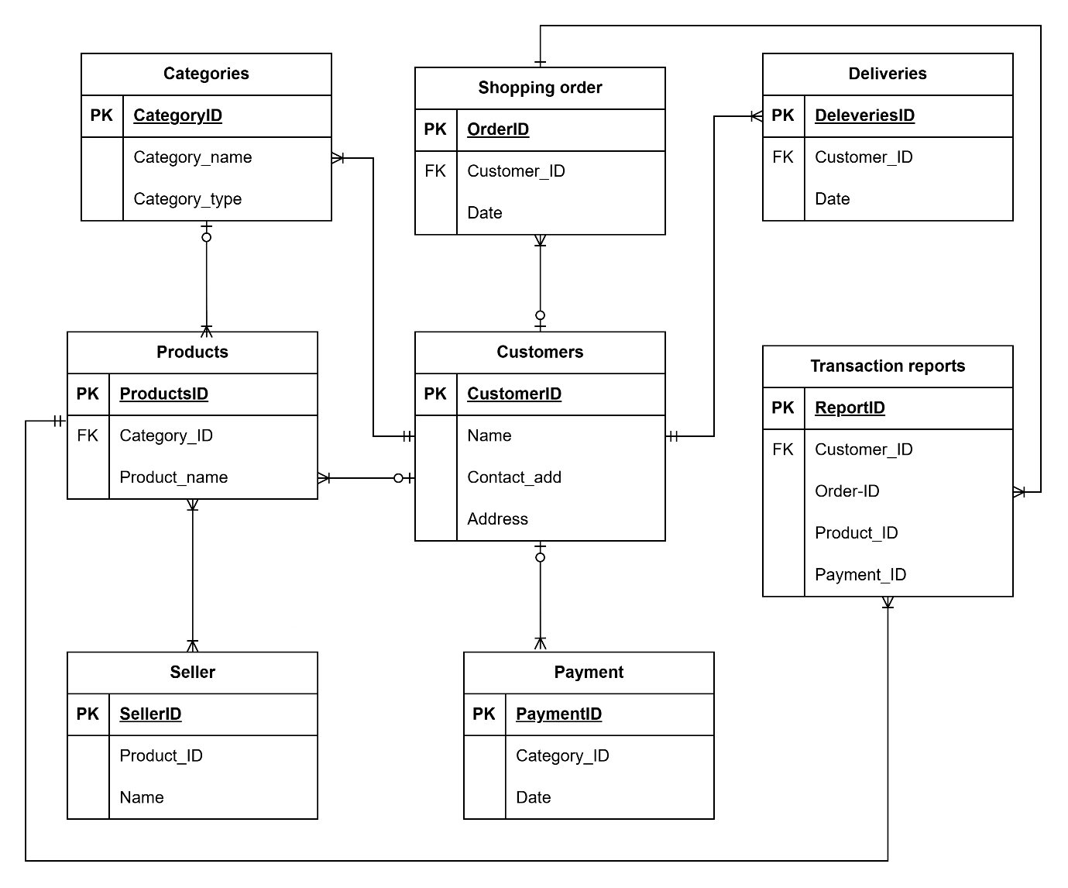

ER Diagram: -

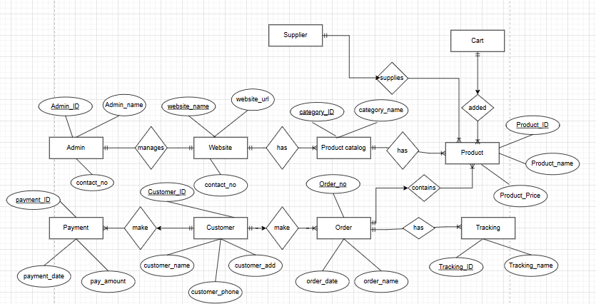

Q.7) What is a data flow diagram? Draw a data flow diagram to represent the in-flow and out-flow of data when a Farmer is placing an order for the product?

Ans.7) Data flow diagram also known as ‘DFD’ through which we can represent the flow of data graphically in the information system. It is also known as ‘Bubble chart’.

By using ’DFD’ we can understand the overall functionality of the system because diagram represents the incoming data flow and outgoing dataflow and stored in the graphical form. It represents how data is processed in terms of input & output.

The ‘DFD’ model uses no. of notations or symbols to represent the flow of data i.e Externa entity, Data flow, Process or bubble and data storage)

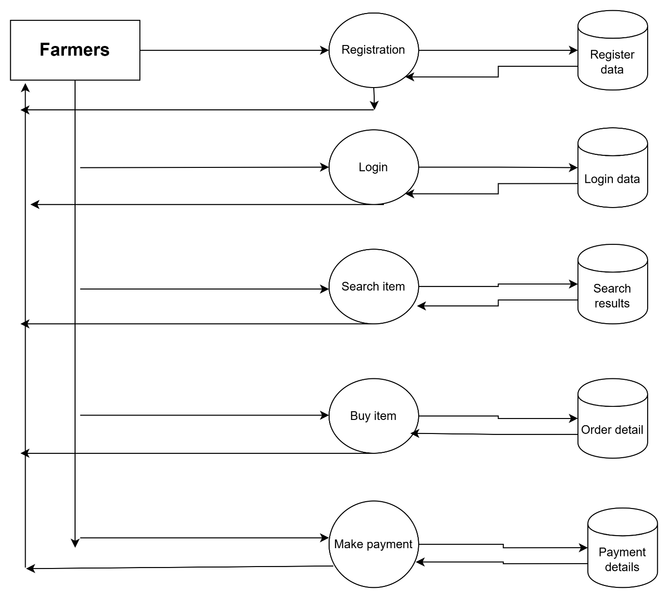

Q.8) Due to change in the Government Taxation structure . we should change the Tax structure How do you handle change requests in a project?

Ans.8) Handing change request in the project requires structured process to ensure that any changes are properly evaluated, approved & implemented in a way it minimizes hurdles n the project schedule & budget.

1. **Documenting the change request**: - The first step is to document the change request including the reason of the change, scope of the change and the potential impact on the project.
2. **Evaluating the impact on the change**: - The project team must evaluate the impact of the change on project schedule, budget and other aspects of the project plan.

This evaluation must also include identifying any additional resources that will be required to fulfill the change request.

1. **Determine the feasibility**: - Based on evaluation, the project team must determine whether the change request is feasible or not, if it is found not feasible then the team must propose some alternate solution.
2. **Take approvals**: - Once the feasibility test is done the project manager must take approvals from the appropriate stakeholders.
3. **Implementation**: - Once the approval is taken, the team must implement the change request in structure manner by proper documentation, necessary updates, considering project timelines & budget.
4. **Monitor the impact of change**: - After the change has been implemented the team must monitor the impact of the change on project, If any issue arises then team must promptly address the same to minimize the risk.

Q.9) Is this a change request or an enhancement?

Ans.9) As a BA, my response will be that as this request from Ben & Kevin is an addition or enhancement to the existing project scope. As the initial scope was that the farmers would be able to buy agriculture products from the application, but this enhancement add the feature of the farmers to add their own crop yields to the application and sell them through an auction system.

To move further with this enhancement, we would have to conduct a feasibility study to determine whether this change request is feasible with technical capabilities or not. We would also need to gather information from the key stakeholders such as Ben, Kevin, Farmers & buyers as well to gather all the requirements such that the new features meet their demand. We will have to gather resources required to implement the enhancements.

Overall addition of this features will greatly benefit the application by increasing the variety of features by providing new platform to sell their products.

Q.10) Come up with estimations – How many Manhours required?

Ans.10) Estimating the number of manhours will depend on the complexity of the features, size of the development team, development methodology and technical aspects of the enhancement.

However, as a rough estimate for developing this new feature we can assume that nearly something in between 200-300 manhours will be required considering the activities such as:

**Requirement gathering: - Approx. (20-30) manhours**

This phase will include gathering requirements from stakeholder such as ben. Kevin, farmers, buyers

**Feasibility study: - Approx (20-30) manhours**

This phase will include the project team to study the feasibility of the new features based on technical aspects.

**Designing the feature: - Approx (40-50) manhours**

This phase will be including building of UI interface for the new feature.

**Developing the back end & front-end functionality: - Approx (100-150) manhours**

This phase will include developing the actual new features, writing the development codes and integration of this feature with existing module.

**Testing & Quality assurance: - Approx (20-40) manhours**

This phase will include writing test cases, performing unit testing, integration testing and ensuring proper functionality and stability of the added features.

**Deployment & UAT: - Approx (10-20) manhours**

This phase will include deployment of new feature in the testing environment, conducting user acceptance testing and resolving any issue.

**Documentation & training: - Approx (10-20) manhours**

This phase will include updating documents, updating user manuals and providing brief training to farmers and new users.

Q.11) Explain UAT Acceptance process?

Ans.11) As BA,My approach to handle this situation would be that I would first confirm with the development team whether the final product is ready for testing with complete functionality or not. Then I would coordinate with the client to schedule the UAT testing and ensure that they are well informed about the procedure to carry out the testing.

During UAT, the client will be allowed all the access to the application and will be asked to carry out all the tests thoroughly to ensure it meets the requirement. And their expectations. During testing If any issue or bug is detected then it will be documented and will be prioritized to the development team to fix the issue.

Once the UAT is completed and all the issue has been resolved then the product will ready to be released to the client. The project will then be moved to the project closure phase which will include: -

1. Handover: - Final deliverables and documents will be handed over to the client and all the resources are released.
2. Post implementation review: - It is done to review the project success and identify any improvements in future projects.
3. Project closure documentation: - Documentation is created to close the project, including financial reports, lesson learned from the project.

UAT acceptance process involves Planning & preparation, execution, issue resolution, acceptance

The client will provide a sign-off indicating that they are satisfied with the product functionality and usability.

Q.12) Explain Project closure document?

Ans.12) A project closure documented is a formal document that outlines the final status and outcomes the project This document is created at the end of the project and it summarizes the results, achievements, challenges and lesson learned the project lifecycle.

1. Executive summary: - A brief summary of the project, including objectives, scope and results.
2. Project results: - A description including project achievement, milestone and performance matrix.
3. Lesson learned: - A detailed review of project challenges & improvement in future projects.
4. Financial analysis: - A summary of complete project budget including any variance and differences.
5. Project closeout: - A list of activities necessary to complete the project including final payments, document, stakeholder review.
6. Recommendation: -Suggestion for impacting project management process and strategies future improvements.