Capstone project 1 part2

Q1) Quaterly Audits
- Q1
Stage | Quarter 1- Audit Report  (Requirement Gathering Phase)
Completed | 10 Weeks (Week1 to Week10)
Check List | BRD template
Elicitation results report
Duplicate requirements report
Grouping of functionalities/ features client sign off

 | Email communication-TO,CC,BCC

Q2
Stage | Quarterly 2- Audit Report  (Requirements Analysis Phase)
Completed | 7 Weeks (Week 16 to Week 23)
Check List
 | UML Diagrams
 | Business to functional requirements mapping
 | Client sign off documents
 | RTM document version control
 | Email Communication-To ,CC,BCC

Q3
Stage | Quarter 3 Audit Report  (Design Phase)
Completed | 7 Weeks ( Week 30 Week 37)
Check List
 | Utilization of Tools
 | Documented Evidence on Client Communication
 | Stakeholders MOM
 | Email Communication To,CC,BCC

Q4

Stage | Quarter 4- Audit Report  (Development Phase)
Completed | 20 Weeks (Week 40 to Week 60)
Check List | JAD session report
 | End user Manual preparation document
 | BA and developer MOM
 | Email ommunication-To,CC,BCC

Q5

Stage | Quarter 5 -Audit Report  (Testing Phase)
Completed | 20 Weeks (Week 58 to Week 78)
Check List | Test Case Summary
 | Training report to end users
 | Lessons learnt Document
 | Email Communication -To, CC,BCC

Q2) BA Approach Strategy

- What Elicitation Techniques to apply:
We have many elicitation techniques to apply used to gather requirements. Some of them are:
- Brainstorming
- Document Analysis
- Reverse Engineering
- Focus Groups
- Observation

- How to do Stakeholders Analysis RACI:
Stake holders analysis can be done by using the RACI matrix involves
- Identify Stakeholders.
- Define Roles and Responsibilities.
- Create RACI Matrix.
- Assign RACI Roles.

- What documents to write:
The documents to write are
- BRD-Business requirements Document.
- FRD-Functional Requirements document.
- Use case Documentation
- Test Case Documents etc

- What process to follow to sign off on the documents:
Sign off to be taken on
- SRS as this is primary and important document.
- E-Mail Confirmation from client.

- How to take approvals from client:
Approvals from client
- Establish a formal meeting with the clients to keep them informed
- Get continuous feedback.

- What communication channels to establish and implement:
Communication Channels
- Regular meetings
- Weekly status meetings
- Bi-weekly sprint reviews
- Monthly stakeholder updates.

- How to handle change requests.
- Change request form.
- Do Impact Analysis.
- Approval Process.
- Documentation.

- How to update the progress of the project to the stakeholders
- Weekly status reports.
- Monthly Review reports.

- How to take signoff on the UAT-client project acceptance form:
- UAT Preparation.
- Conduct UAT
- Fix issues.
- Acceptance Form
- Final Review Meetings
- Obtain Signoff

Q3) 3-tier architecture
There are 3 logical layers
- Application Layer
- Top most layer of the architecture
- Also known as Presentation Layer.
- It handles user interface(UI) Components.
- Screens, pages, Validations on the page.
- Company specific logic, Functionality.
- EX- E-Commerce website.
- Business Logic Layer
- Middle layer of the architecture
- Acts as an intermediatory between the presentation layer and the data storage layer.
- All re-usable components, Frequently changing components.
- Governing body rules and regulations, Compliances.
- This layer contains the core logic of the application.
- EX-Printer, payment gateways.
- Database Layer
- Bottom most layer of the architecture
- Responsible for storing and retrieving data.
- Database components connecting to databases.
- EX-MySQL, Oracle database.

Q4) Points in Business Analyst mind before he/she frames a question to ask Stakeholders
Ans) The approach strategy to frame questions.
- The 5W 1H frame work is a useful tool for gathering information and understanding a situation by answering questions about who , what ,where , why and how.
- Asking stakeholders who are all participating in the project.
- What are the current problems we have.
- When this project should be completed.
- Why is this project initiated.

- The SMART Technique cam help in creating questions.
- Specific, Measurable, Attainable, Relevant and Time Bound.
- This is a Technique which is used to create questions.
- Specific means goals and objectives should be specific.
- Relevant: Is this relevant to project or not.
- Time bound: can we be able to finish the project in time bound or not.

- RACI chart
- Help define and clarify roles and responsibilities within a team by outlining who is responsible , accountable, consulted and informed for each task.
- UML
- Unified Modelling Language.
- It is a standardized way of diagramming and modelling software systems to aid in design, development and communication between team members.

Q5) Elicitation Techniques
Ans) They are BDRFOWJIPQU
- Brainstorming.
- Document analysis.
- Reverse Engineering
- Focus Groups
- observation
- Workshops
- JAD
- Interview
- Prototype
- Questionnaire.
- Use Case Specs.

Q6) What Elicitation Techniques are used?
Ans) Elicitation Techniques
1)Brainstorming
- This can be done either individually or in groups. The ideas collected during the brainstorming session are reviewed or analyzed.
- It is an effective way to generate lots of ideas on a specific issue and then determine which idea is the best solution.
2) Document Analysis
- It is done through reading a document and understanding the product, process and project.
3)Reverse Engineering
- Also called as back engineering.
- It is the process of extracting knowledge or design information from anything man made and re-producing anything based on the extracted information.
- The process often involves dissembling something and analyzing its components and workings in detail.
- Majorly used in migration projects.
4)Focus Groups
- It is a means to elicit ideas and attitudes about a specific product, service or opportunity in an interactive group environment.
5)Observations
- Observing, shadowing users or doing a part of their job can provide information of existing processes, inputs and outputs.
6)Workshops
- A requirement workshop is a structured approach to capture requirements. A Workshop may be used to scope, discover, define, prioritize and reach closure on requirements for the target system.
7)JAD
- Joint Application Development.
- Application developed through JAD has a higher customer satisfaction and less number of errors as user is directly involved in the development process.
8)Interview
- Interview of a user and stakeholders are important in creating software.
- An interview is a systematic approach where interviewee is going to ask relevant questions related to software and documenting the responses.

9)Prototyping
- Prototyping is an attractive idea for complicated and large systems for which there is no manual process or existing system to help determining the requirements.
10) Questionnaire / Survey
- Questionnaire can be useful for obtaining limited system requirements details form the users/ stakeholders, who have minor input or are geographically remote.
11) use case: The main purpose of use case is to identify the requirement and are designed to explain how external user are interacting with the system.
Q6) This project elicitation techniques
Prototyping: This helps the business representatives or clients visualize the functionality of the system. This can be great advantage to help analysts and stakeholders identify problems early on.
Document Analysis: we have a lot of information and it is easy to transfer to a new system requirements document. It is one of the compulsory elicitation technique for any project.
Brainstorming: In this technique we can come up with very innovative ideas and requirements. It can be an efficient way for users/ stakeholders to define their requirements .It is used in identifying all possible solutions to problems and simplifies the detail of opportunities. It casts a broad net determining various discreet possibilities.
Use Case spec: the main purpose of use case is to identify the requirement. use case are designed to explain how external user are interacting with the system.
Use case specification
- Use case name.
- Use case description.
- Actors: primary actor , secondary actor.
- Basic flow
- Alternative flow
- Exceptional flows
- Pre-conditions
- Post conditions
- Assumptions
- Constraints
- Dependencies.
- Input and outputs
- Business rules
- Miscellaneous information.

Q7) 10 business requirements
BR001- All users should have a login and password.
BR002- Users should be able to search products from the product catalogue.
BR003- Users should be able to search the payment process.
BR004 -Users should be able to track their delivery.
BR005- Users should be able have easy to use payment gateway which includes COD, Credit /Debit card and UPI options.
BR006-Users should get an email confirmation regarding their order status.
BR007- If it’s a new user then should create login and password first.
BR008- Users should be able to browse the product catalogue.
BR009- Manufacturers should be able to upload and display their products in the application.
BR010- Users should be able to get details of their selected products.
BR011- users should be able to add items to cart if they want to buy those items later.
Q8)Assumptions
A1: A user should have knowledge of fertilizers, seeds, pesticides.
A2: Online shopping trend is increasing, The customers prefer online shopping.
A3: The customers have online accounts for secured payment process.
A4: Manufacturers display their products in the application, the need for the application is ever growing.
A5: A user will be able to login through Facebook or google account.

Q9) Project requirements priority.
Req ID | Req name | Req Description | Priority
BR001 | Users create login | All users should have a login and password. | 1
BR002 | Users search for products | Users should be able to search products from the product catalogue. | 4
BR003 | Users search for payment. | Users should be able to search the payment process. | 5
BR004 | Product delivery tracking | Users should be able to track their delivery. | 11
BR005 | Payment Gateway | Users should be able have easy to use payment gateway which includes COD, Credit /Debit card and UPI options. | 6
BR006 | Email Confirmation | Users should get an email confirmation regarding their order status. | 10
BR007 | New users registration | If it’s a new user then should create login and password first. | 2
BR008 | Users browse through products. | Users should be able to browse the product catalogue. | 3
BR009 | Manufacture products | Manufacturers should be able to upload and display their products in the application. | 9
BR010 | Product Information | Users should be able to get details of their selected products. | 7
BR011 | Add to cart options | users should be able to add items to cart if they want to buy those items later. | 8

Q10) Use Case Diagram

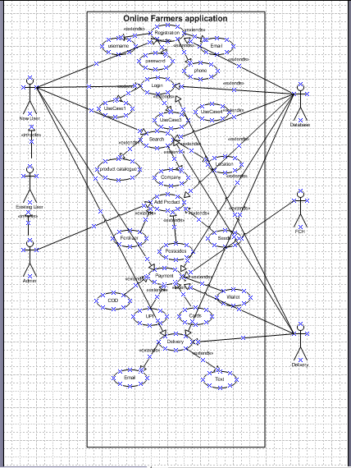

Q11) A Use Case Specification document which provides a detailed description of a use case outlining how users will interact with the system to achieve a specific goal.
- Login
- Registration.
- Searching items.
- Payment
- Delivery.
 | Use Case ID | US_001
 | Use Case Name | Login
 | Created By | Mrs.Padma | Last Updated  Date | Dec 10 2024
 |  | Dec 8 2024 | Last Reviewed Date | Dec 15 2024
 | Actors | Customer, Database
 | Description | This use case describes how a customer can login in to their account to browse through the items they want to buy.
 | Pre-Condition | It should have internet connectivity.  Users should have registered in the app or website.
 | Post-Condition | Successfully able to login to the application.
 | Normal Flow of events | Step 1: customer need to login in to their account.  Step2: They need a username and password to Login.  Step 3: The password needs to be unique with special characters Step 4: Last 5 passwords should not be repeated.  Step 5: once the customer types their correct username and password, then they would be able to login successfully in to the homepage.  Step 6: Now the customer can browse through the items.
 | Alternative flow of the events | Step 1: if the customer forgets their username or password.  Step 2: they should click on forget username and password.  Step 3: the screen will ask to type their email id.  Step 4: once they login in to their email id, they should have received a new password.  Step 5: now they can login with the new password they got in the email.  Step 6 : the system will prompt them to enter a new password and confirm the password.  Step 7: now customer has successfully logged in to the homepage and can start browsing the things to buy.
 | Exceptions | The customer can loose the internet connectivity.
 | Frequency | High
 | Assumptions | The customer should be able to remember the username and password.  The customer should have knowledge about computer.
Use Case ID |  | US_002
Use Case Name |  | Register
Created By |  | Mrs.Padma | Last Updated  Date | Dec 10 2024
Date Created |  | Dec  2024 | Last Reviewed Date | Dec 15 2024
Actors |  | Customer, Database
Description |  | This use case describes how a customer can Register and create an account to browse through the items they want to buy.
Pre-Condition |  | It should have internet connectivity.  Users should be ready with a username and password.
Post-Condition |  | Successfully able to login to the application.
Normal Flow of events |  | Step 1: customer need to register first and create an account.  Step2: customer click on register.  Step 3: A new form of registration will be opened.  Step 3: The customer needs to Type his first and last name.  Step 4: Email Id, create a Password and confirm the password.  Step 5: once all the required fields are filled, at the end customer should press submit button.  Step 6: Now the customer will receive an email that he has successfully registered their account.
Alternative flow of the events |  | Step 1: if the customer does not receive an confirmation email of his account registered in the first one hour.  Step 2: The customer needs to check if he has given correct email-id.  Step 3: The customer needs to register again with correct email id.  Step 4: The customer needs to fill all the required fields.
Exceptions |  | The customer can loose the internet connectivity.  The customer can forget sometimes which email-id has been given.
Frequency |  | High
Assumptions |  | The customer should have knowledge about computer.

Use Case ID | US_003
Use Case Name | Searching items
Created By | Mrs.Padma | Last Updated  Date | Dec 10 2024
Date Created | Dec  2024 | Last Reviewed Date | Dec 15 2024
Actors | Customer, Database, admin
Description | This use case describes how a customer can browse through the items by searching items from the product catalogue they want to buy.
Pre-Condition | It should have internet connectivity.  Users should be know what items they need to buy  Customers should be able to know which product catalogue they need to search for like fertilizers or pesticides or seeds.
Post-Condition | Successfully able to browse through the items from the product catalogue and add them to the cart to buy.
Normal Flow of events | Step 1: once the customer has successfully logged on to their account.  Step 2: The customer will navigate through the home page.  Step 3: The customer should be able to see the product catalogue.  Step 4: The customer can search depending on what item they want, for example fertilizers, pesticides and seeds.  Step 5: the customer should be able to navigate through which manufacturing company they would require.  Step 6: Customer should be able to add the required items to the cart.
Alternative flow of the events | Step 1: once logged in to their account, the customer should be able to see the home page.  Step 2: if not able to see, then customer should close the application and open again.  Step 3 : the customer need to select which product they need.  Step 4 : once the customer selects the item , they should be able to add it to the cart.  Step 5 : customer can pay it later.
Exceptions | The customer can loose the internet connectivity.  The customer can forget that he added the items to the cart.  Customer can sometimes forget the cart and close the computer.
Frequency | High
Assumptions | The customer should have knowledge about computer.

Use Case ID | US_004
Use Case Name | Payment
Created By | Mrs.Padma | Last Updated  Date | Dec 10 2024
Date Created | Dec  2024 | Last Reviewed Date | Dec 15 2024
Actors | Customer, Database, financial house
Description | This use case describes how a customer can do the payment for the items selected in the cart.
Pre-Condition | It should have internet connectivity.  Users should be know what items they need to buy  Customers should be able to buy the items with atleast one payment method.
Post-Condition | Once the products have been selected , they are bought with any payment method.
Normal Flow of events | Step 1: the customer selects the products they need.  Step 2: add them to the cart  Step 3: once the customer is ready to pay, they click on the cart  Step 4: the customer has final chance to look at the products before they press checkout.  Step 5 : now the customer can pay for the products with one of the methods.  Step 6: all the payment methods are secure.  Step 6: for some payment methods their bank might ask for proof check.  Step 6: once the payment is made the customer is given a reference number.  Step7: the customer receives an email confirmation of his products with a tentative date of delivery.
Alternative flow of the events | Step 1: the customer must make sure to pay with atleast one method of payment.  Step 2: they must enter all the card details correctly to make the payment.  Step 3: make sure the right email and phone details are given to receive the confirmation details.  Step 4: a secure payment of the products id done.
Exceptions | The customer can loose the internet connectivity.  The customer can forget that he added the items to the cart.  Customer can sometimes forget the cart and close the computer.  Customer card might have expired.  Customer might have entered wrong phone number.
Frequency | High
Assumptions | The customer should have knowledge about computer.

Use Case ID | US_005
Use Case Name | Delivery
Created By | Mrs.Padma | Last Updated  Date | Dec 10 2024
Date Created | Dec  2024 | Last Reviewed Date | Dec 15 2024
Actors | Customer, Database, delivery boy
Description | This use case describes how the items will be delivered to the given location in the given time.
Pre-Condition | It should have an internet connection.  Customers should give the correct address for the products to be delivered on time.
Post-Condition | Once the products have been bought online, they should be delivered promptly.
Normal Flow of events | Step 1: after the customer has done the secured payment, they will receive a confirmation of payment with reference number.  Step 2: the customer will also receive a email confirmation with the details of the products bought and when the products will be delivered.  Step 3: the customer will keep receiving information regarding the update about delivery.  Step 4: the products are delivered to the customer given address.
Alternative flow of the events | Step 1: if the products are not delivered correctly, the customer can call back customer relations using the reference number.  Step2: check if the delivering address is given correct.  Step 3: check each detail of the address so that products  Step 4: any problem occurring with the update of the delivery can be solved by calling the customer service.
Exceptions | The customer can loose the internet connectivity.  The customer can forget that he added the items to the cart.  Customer can sometimes forget the cart and close the computer.  Giving a small mistake in delivering address can delay the delivery of the product.
Frequency | High
Assumptions | The customer should have knowledge about computer.

Q12) Activity diagrams
- Login
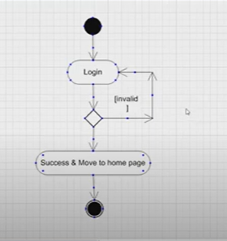
- Payment(branch and merge)
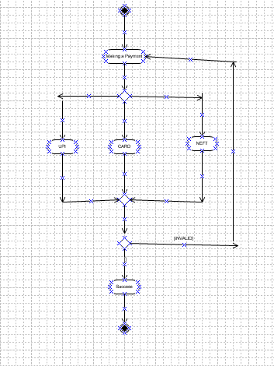

3)SMS notification (fork and join)
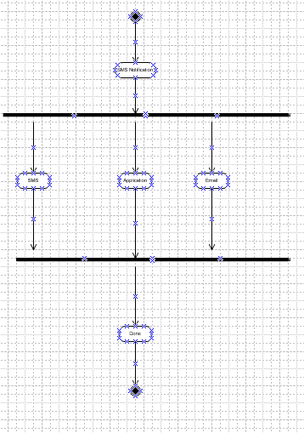

4)Receive order and confirm order
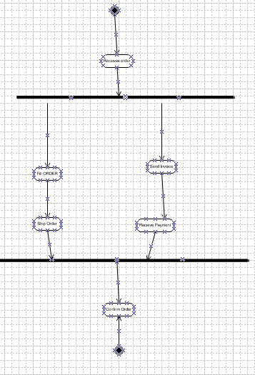

5)Delivery

