**CAPSTONE PROJECT PART -2**

Answer:1

Audits :

|  |  |
| --- | --- |
| Stage | Quarter 1 : Audit Report (Requirement Gathering and Analysis Phase) |
| Completed | 16 weeks( week 1-week 16)- 4 months |
| Checklist | BRD template  UML diagram  Business to functional requirements mapping  Client signoff documents  RTM document version control  Email communications , To CC, BCC |
|  |  |

|  |  |
| --- | --- |
| Stage | Quarter 2 : Audit Report (Audit Report Design) |
| Completed | 12 weeks (Week 17-week 24) – 3 months |
| Check list | Utilization of tools  Documented evidence on client communication  Stakeholder MOM  Email communications , To CC, BCC |

|  |  |
| --- | --- |
| Stage | Quarter 3: Audit Report (Development phase) |
| Completed | 20 weeks - 5 montns |
| Check list | JAD session report  End user’s manual preparation document  BA and developer MOM  Email communication , To CC, BCC |
|  |  |

|  |  |
| --- | --- |
| Stage | Quarter 4 : Audit Report ( Testing phase) |
| Completed | 24 weeks - 6 months |
| Check list | Test case summary  Training report to end users  Lessons learnt document  Email communications , To CC, BCC |
|  |  |

Ans-2

Business Approach strategy : **Business Approach Strategy** is a structured plan that outlines how an organization will perform business analysis activities to achieve project goals, solve problems, or capitalize on opportunities. It defines the methods, processes, tools, and stakeholder engagement techniques that will be used throughout the project lifecycle to ensure that business needs are accurately captured, analysed, and delivered as actionable solutions.

1. Which Elicitation technique to apply ?

Requirements Elicitation technique is the process of digging out the information from the stakeholders , it serves the foundation in documenting the requirements.

Some of them are : Brainstorming, Document analysis, Reverse engineering, Focus groups, observation, Interview etc.

Brainstorming : It can be done either individually or in groups. The ideas collected can then be reviewed/analysed and where relevant included within the system requirements. Ideas can come from what users/stakeholders have seen or experienced elsewhere.

Advantages : Can come up with very innovative ideas and requirements. It can be an efficient way of users/stakeholders to define their requirements.

Disadvantages: Some people can’t easily brainstorm and share ideas upfront.

* **Brainstorming** is utilized in the Requirements elicitation technique to gather good number of ideas from a group of people. Usually brainstorming is used in identifying all possible solutions to problems and simplifies. The detail of opportunities.
* **Document Analysis**
* Prepare for document analysis.
* Analyse the documents
* Post- document analysis wrap up.
* **Focus Group :** A focus group is a means to elicit ideas and attitudes about a specific product , service or opportunity in an interactive group environment. It has typically 6-12 attendees.

*Homogenous

*Heterogenous

* **Observation :** Observation, shadowing users or even doing part of their jobs , can provide information of existing processes, inputs and outputs.

Active and Passive.

1. How to do stakeholder analysis RACI

Stakeholder analysis can be done by using the RACI matrix involves identifying stakeholders and defining their roles and responsibilities within a project-

1. Identify stakeholders
2. Define roles and responsibilities
3. Create the RACI Matrix
4. Assign RACI Roles
5. What documents to write ?

BRD

FRD

Use case

Test case documents

1. What process to follow to sign off on the documents?

Sign off to be taken on SRS as this is the primary and important document. It can be taken using e-mail confirmation from client.

1. How to take approvals from client

Establish a formal meeting with the clients to keep them informed and get continuous feedback.

1. What communication channels to establish and implement?

Regular meetings- Weekly status meetings , bi-weekly sprint reviews, monthly stakeholder updates.

1. How to handle change request : Change request form, do impact analysis , Approval process documentation.
2. How to update the progress of the project to the stakeholders: weekly status reports, monthly review meetings.
3. How to take signoff on the UAT – Client project acceptance form : UAT Preparation, conduct UAT, Fix Issues, Acceptance Form, Final Review meeting, Obtain Sign off.

**Ans-3**

Three tier architecture : It is divided into 3 logical layers.

1)Application layer: Topmost layer of the architecture, also known as “Presentation layer”. It handles user interface , components such as screens and pages. Ex- E-commerce website.

2) Business Logic layer : Middle layer of the architecture – acts as an intermediary between the presentation layer and the data storage layer- layer contains the core logic of the application. Ex- printer, payment gateways.

3) Database layer: Bottom most layer of the architecture – responsible for storing and retrieving data. Ex- MySQL , Oracle database.

**Ans-4**

* 5W1H : Framework is a useful tool for gathering information and understanding a situation by answering questions about who, what , when , where, why , and how.

What :

1. What is the project ?
2. What are the objectives?
3. What are the products and services to be included?
4. What are the requirements of the project ?
5. What are the timeline ?
6. What is the budget?
7. What are the pros and cons?

Who

1. Who is the Client?
2. Who are the users?
3. Who the members/ stakeholders of the team?

Why

1. Why is the project needed?

Where

1. Where would be the reach of the project?

When

1. When would be the project initiated?
2. When would the project be completed ?

How

1. How will be the team managed?
2. How will the budget and timelines managed?

* SMART : Technique can help in Specific , measurable, attainable , Relevant and Time bound).
* RACI: It helps define and clarify roles and responsibilities within a team by outlining who is responsible, accountable , consulted and informed for each task.
* UML , or Unified modelling language , is a standardized way of diagramming and modelling software systems to aid in design, development, communication between team members.

**Answer -5**

Elicitation Techniques :

Requirements Elicitation technique is the process of digging out the information from the stakeholders , it serves the foundation in documenting the requirements. Some of them are : Brainstorming, Document analysis, Reverse engineering, Focus groups, observation, Interview etc.

* **Brainstorming :** It can be done either individually or in groups. The ideas collected can then be reviewed/analysed and where relevant included within the system requirements. Ideas can come from what users/stakeholders have seen or experienced elsewhere.

1. Prepare for brainstorming: Develop a clear and concise definition of the area of interest. Determine a time limit for the group to generate ideas, the larger the group , the more time required. To be decided who will be included in the session and their role, participant or facilitator, Aim for participants who would represent range of background and experience with the topic. Establish criteria for evaluating and rating the ideas.
2. Conduct Brainstorming session- Share new ideas without any discussion , criticism or evaluation. Visibly record all ideas. Encourage participants to be creative. Don’t limit.
3. Wrap up Brainstorming: Once it’s done, distribute the final list of ideas to appropriate parties.

Advantages : Can come up with very innovative ideas and requirements. It can be an efficient way of users/stakeholders to define their requirements.

Disadvantages: Some people can’t easily brainstorm and share ideas upfront.

* **Document Analysis**

May document about current system which could provide some of the input for the new system requirements. Such documentation could include interface details , user manuals , and software vendor manuals.

Advantages: Could be a lot information and easy to transfer to a new system requirements document.

Disadvantages : Existing documentation may often be old and out of date. Systems , interfaces, processes and reports may have changed out of all recognition. Care needs to be taken, as it may not reflect what you may need from a new system.

Document analysis is an important gathering technique. Evaluating the documentation of a present system can assist when making AS-IS process documents and also when driving the gap analysis for scoping of the migration projects.

* Prepare for document analysis.
* Analyse the documents
* Post- document analysis wrap up.
* **Focus Group :** A focus group is a means to elicit ideas and attitudes about a specific product , service or opportunity in an interactive group environment. It has typically 6-12 attendees.

*Homogenous

*Heterogenous

* **Observation :** Observation, shadowing users or even doing part of their jobs , can provide information of existing processes, inputs and outputs.

Active : In this approach , the business analyst observes the current process and takes notes, he/she may dialog with the worker. When the BA has any questions as to why

Passive: In this approach , the analyst observes the subject matter expect working through the business analyst observes the subject matter expert working through the business routine but does not ask questions. The business analyst writes notes about what he/she sees, but otherwise stays out of the way , as if he/she was invisible. The business analyst waits until the entire process has been completed before asking any questions. The business analyst should observe process multiple times to ensure he/she understands how the process works today and why it works the way it does.

* **Reverse Engineering:** In situationswhere the softwarefor an existingsystem has little or outdated documentation and it is necessary to understand what the system actually does, reverse engineering is an elicitation technique that can extract implemented requirements from the software code.

**Two types :** Black Box : The system/ product is studied without examining its internal structure.

White Box : The inner workings of the system/product are studied.

* **JAD**

The Joint Application development technique is an extended, facilitated workshop. It involves collaboration between stakeholders and systems analysts to identify needs or requirements in a concentrated and focused effort.

* **Interview**

Interviews of users and stakeholders are important in creating wonderful software. Without knowing the expectations and goal of the stakeholders and users, you are highly unlikely to satiate them. You also have to understand the perspective of every interviewee, in order to properly address and weigh their inputs. Like a good reporter , listening is a quality that assists an excellent analyst to gain better value through an interview as compared to an average analyst.

* **Prototyping**

Screen mock-ups can support the requirements gathering process when introduced at the right time, but if introduced too early they can become problematic.

* **Questionnaire**

Questionnaires can be useful for obtaining limited system requirements details from users/stakeholders, who have a minor input or are geographically remote. The design of the questionnaire (whether off line or web based) and types of questions are important and can influence the answers, so care is needed.

* **UML-** UML , or Unified modelling language , is a standardized way of diagramming and modelling software systems to aid in design, development, communication between team members.

Anwer-6

As a BA , I would suggest Brainstorming and Protypying.

**Prototyping** is a technique that allows to create a simplified or tangible version of system or product and test it with potential users. It can help you elicit and validate requirements , identify gaps and issues, and improve user satisfaction and engagement.

It would help in : visualizing the system ; validate the requirements, helps generating feedbacks, boosts stakeholders participation.

**Brainstorming :** It can be done either individually or in groups. The ideas collected can then be reviewed/analysed and where relevant included within the system requirements. Ideas can come from what users/stakeholders have seen or experienced elsewhere.

Answer -7

Business requirements :

Business requirements are the specific needs or conditions that a business must meet to achieve its objectives.

|  |  |
| --- | --- |
| **BR ID** | **Business Requirements** |
| BR 01 | A login for all its users (fertiliser, seeds, pesticides, manufactures and farmers) |
| BR 02 | A product catalogue fertilizers, seeds, pesticides, a search option to search for products, payment process, and delivery tracking |
| BR 03 | Farmers/users should be able to search for available products in fertiliser, seeds , pesticides. |
| BR 04 | User should be able to create log in with email id and password |
| BR 05 | If New user , they can create a new account by submitting their email id and creating a secure password |
| BR 06 | User/farmer must be able to add the products they want to buy in cart or buy-later list |
| BR 07 | Users should be able to browse through the category |
| BR 08 | Users should be able to find appropriate product with keywords |
| BR 09 | If user forgets log in id and password , they should be able to retrieve the account with the help of phone number or email id. |
| BR 10 | There should be multiple options for payment – COD, UPI, Debit/credit |
| BR 11 | The transaction process or payment gateways should safe , secure and reliable , easy to use. |
| BR 12 | User should get an email confirmation regarding their order status. |
| BR 13 | The delivery tracker to track the whereabouts of their order |
| BR 14 | The exchange and return option should there |
| BR 15 | Customer support should be available through the app. |
| BR 16 | Manufacturers should be able to upload and display their products in the application |

Answer -8

**Assumptions :** These are the factors in a project that are considered true without proof.

Assumption 1: To use an application for buying fertilizers and agricultural products.

Assumption 2 : User/Farmers have knowledge of using the technology and internet

Assumption 3: User friendly enough for farmers/users to buy products

Assumption 4: User can login using Id and password.

Assumption 5: Users have online a/c for payments.

Answer- 9

|  |  |  |
| --- | --- | --- |
|  |  | **Priority** |
| BR001 | A login for all its users (fertiliser, seeds, pesticides, manufactures and farmers | 1 |
| BR002 | If New user , they can create a new account by submitting their email id and creating a secure password | 1 |
| BR003 | User should be able to create log in with email id and password | 1 |
| BR004 | If user forgets log in id and password , they should be able to retrieve the account with the help of phone number or email id | 1 |
| BR005 | A product catalogue of fertilizers, seeds, pesticides, a search option to search for products, payment process, and delivery tracking. | 2 |
| BR006 | Farmers/users should be able to search for available products in fertiliser, seeds , pesticides. | 3 |
| BR007 | Users should be able to browse through the category | 4 |
| BR008 | Users should be able to find appropriate product with keywords | 5 |
| BR009 | User/farmer must be able to add the products they want to buy in cart or buy-later list | 6 |
| BR010 | There should be multiple options for payment – COD, UPI, Debit/credit | 7 |
| BR011 | The transaction process or payment gateways should safe , secure and reliable , easy to use. | 8 |
| BR012 | User should get an email confirmation regarding their order status | 9 |
| BR013 | The delivery tracker to track the whereabouts of their order | 1 |
| BR014 | The exchange and return option should there | 10 |
| BR015 | Customer support should be available through the app | 10 |

**Answer-10**

**Use case diagram**

A use case diagram is a visual representation of the interactions between users (Actors ) and a system.

It is of 2 types : Essential and Supportive.

Types : Include

Extends

Use case Generalisation

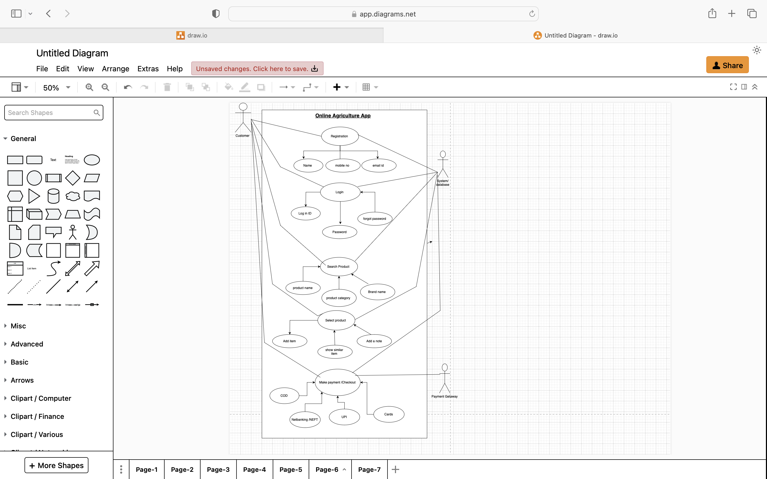

**Answer-11**

**Use case Specs**

|  |  |
| --- | --- |
| Use Case ID | UC001 |
| Use case Name | Register account |
| Created by | Madhumita |
| Last updated | 22/12/2024 |
| Actor(s) | Farmer, Manufacturer, Sponsor |
| Description | This use case allows user to register in to the Online agricultural app to create their account. |
| Trigger | The user wants to register and create id and password to create their account. |
| Pre-condition | The user must have access to the online agriculture application. |
| Normal Flow | 1. The customer opens the registration page. 2. The customer enters their **Name**, **Mobile Number**, and **Email ID**. 3. The system validates the input and creates a new account. 4. The system saves the registration details in the database. |
| Post Condition | The customer account is created successfully. |
| Alternate Flow | If the mobile number or email ID is already registered, the system shows an error message |
| Assumptions | 1. The user has email Id. 2. Internet connectivity 3. Knowledge of using it |

|  |  |
| --- | --- |
| Use Case ID | UC002 |
| Use case Name | Login into account |
| Created by | Madhumita |
| Last updated | 22/12/2024 |
| Actor(s) | Farmer, Manufacturer, Sponsor |
| Description | This use case allows registered user to log in to the Online agricultural app to access their account and system features. |
| Trigger | The user wants to log in to access their account. |
| Pre-condition | The customer must have already registered. |
| Normal Flow | 1. The customer navigates to the login page. 2. The customer provides their Email ID and Password. 3. The system validates the credentials against the database. 4. The customer is granted access to the application |
| Post Condition | Customer logged in successfully |
| Alternate Flow | 1. If the credentials are invalid, the system displays an error message. 2. If the customer forgot their password, they can use the **Forgot Password** option to reset it. |
| Assumptions | 1. The user has log in credentials 2. Internet connectivity 3. Knowledge of using it. |

|  |  |
| --- | --- |
| Use Case ID | UC003 |
| Use case Name | Search Product |
| Created by | Madhumita |
| Last updated | 22/12/2024 |
| Actor(s) | Farmer, Manufacturer, Sponsor |
| Description | This use case allows registered user to search product on Online agricultural app according to their needs and wish. |
| Trigger | The user wants to search product as per category. |
| Pre-condition | The customer must log in. |
| Normal Flow | 1. The customer enters a **Product Name**, **Product Category**, or **Brand Name** in the search bar. 2. The system retrieves matching products from the database. 3. The search results are displayed to the customer. |
| Post Condition | Relevant product details are displayed. |
| Alternate Flow | If no products match the search criteria, the system displays a "No Results Found" message. |
| Assumptions | * The user is aware of categories and product names * Knowledge of using it |

|  |  |
| --- | --- |
| Use Case ID | UC004 |
| Use case Name | Select Product |
| Created by | Madhumita |
| Last updated | 22/12/2024 |
| Actor(s) | Farmer, Manufacturer, Sponsor |
| Description | This use case allows user to select product on Online agricultural app according to their needs and wish. |
| Trigger | The user wants to search product as per category. |
| Pre-condition | The customer must have searched for products. |
| Normal Flow | * The customer selects a product from the search results. * The customer can Add Item to their cart, Show Similar Item or Add a Note for personal reference. * The selected product is added to the shopping cart. |
| Post Condition | Relevant product details are displayed. |
| Alternate Flow | If the customer changes their mind, they can return to the product search.. |
| Assumptions | The user is aware of categories and product names  Knowledge of using it |

|  |  |
| --- | --- |
| Use Case ID | UC005 |
| Use case Name | Make Payment |
| Created by | Madhumita |
| Last updated | 22/12/2024 |
| Actor(s) | Farmer, payment getaway |
| Description | This use case allows user to proceed for online payment. |
| Trigger | The user wants to search product as per category. |
| Pre-condition | The customer must have searched for products. |
| Normal Flow | * The customer proceeds to the payment page. * The customer selects a payment method: Cash on Delivery (COD), Net Banking or NEFT, Cards or UPI. * The system interacts with the payment gateway to process the transaction. * The system confirms the payment and updates the database. |
| Post Condition | The payment is processed successfully, and an order confirmation is generated. |
| Alternate Flow | If the payment fails, the system displays an error message and allows the customer to retry |
| Assumptions | Customer has a online account.  Safety Transaction. |

**Answer-12**

Activity Diagrams

Activity Diagrams describe how activities are coordinated to provide a service which can be at different levels of abstraction. Typically, an event needs to be achieved by some operations, particularly where the operation is intended to achieve a number of different things that require coordination, or how the events in a single use case relate to one another, in particular, use cases where activities may overlap and require coordination. It is also suitable for modelling how a collection of use cases coordinate to represent business workflows.

1. Registration

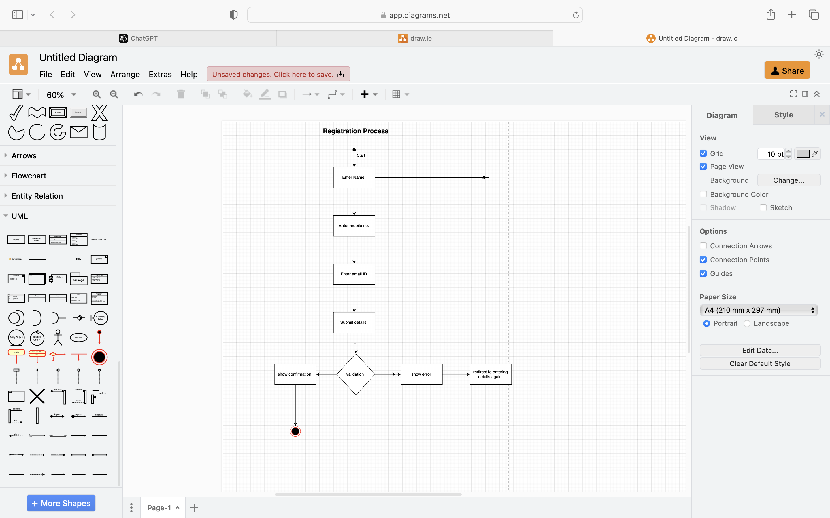

1. Login

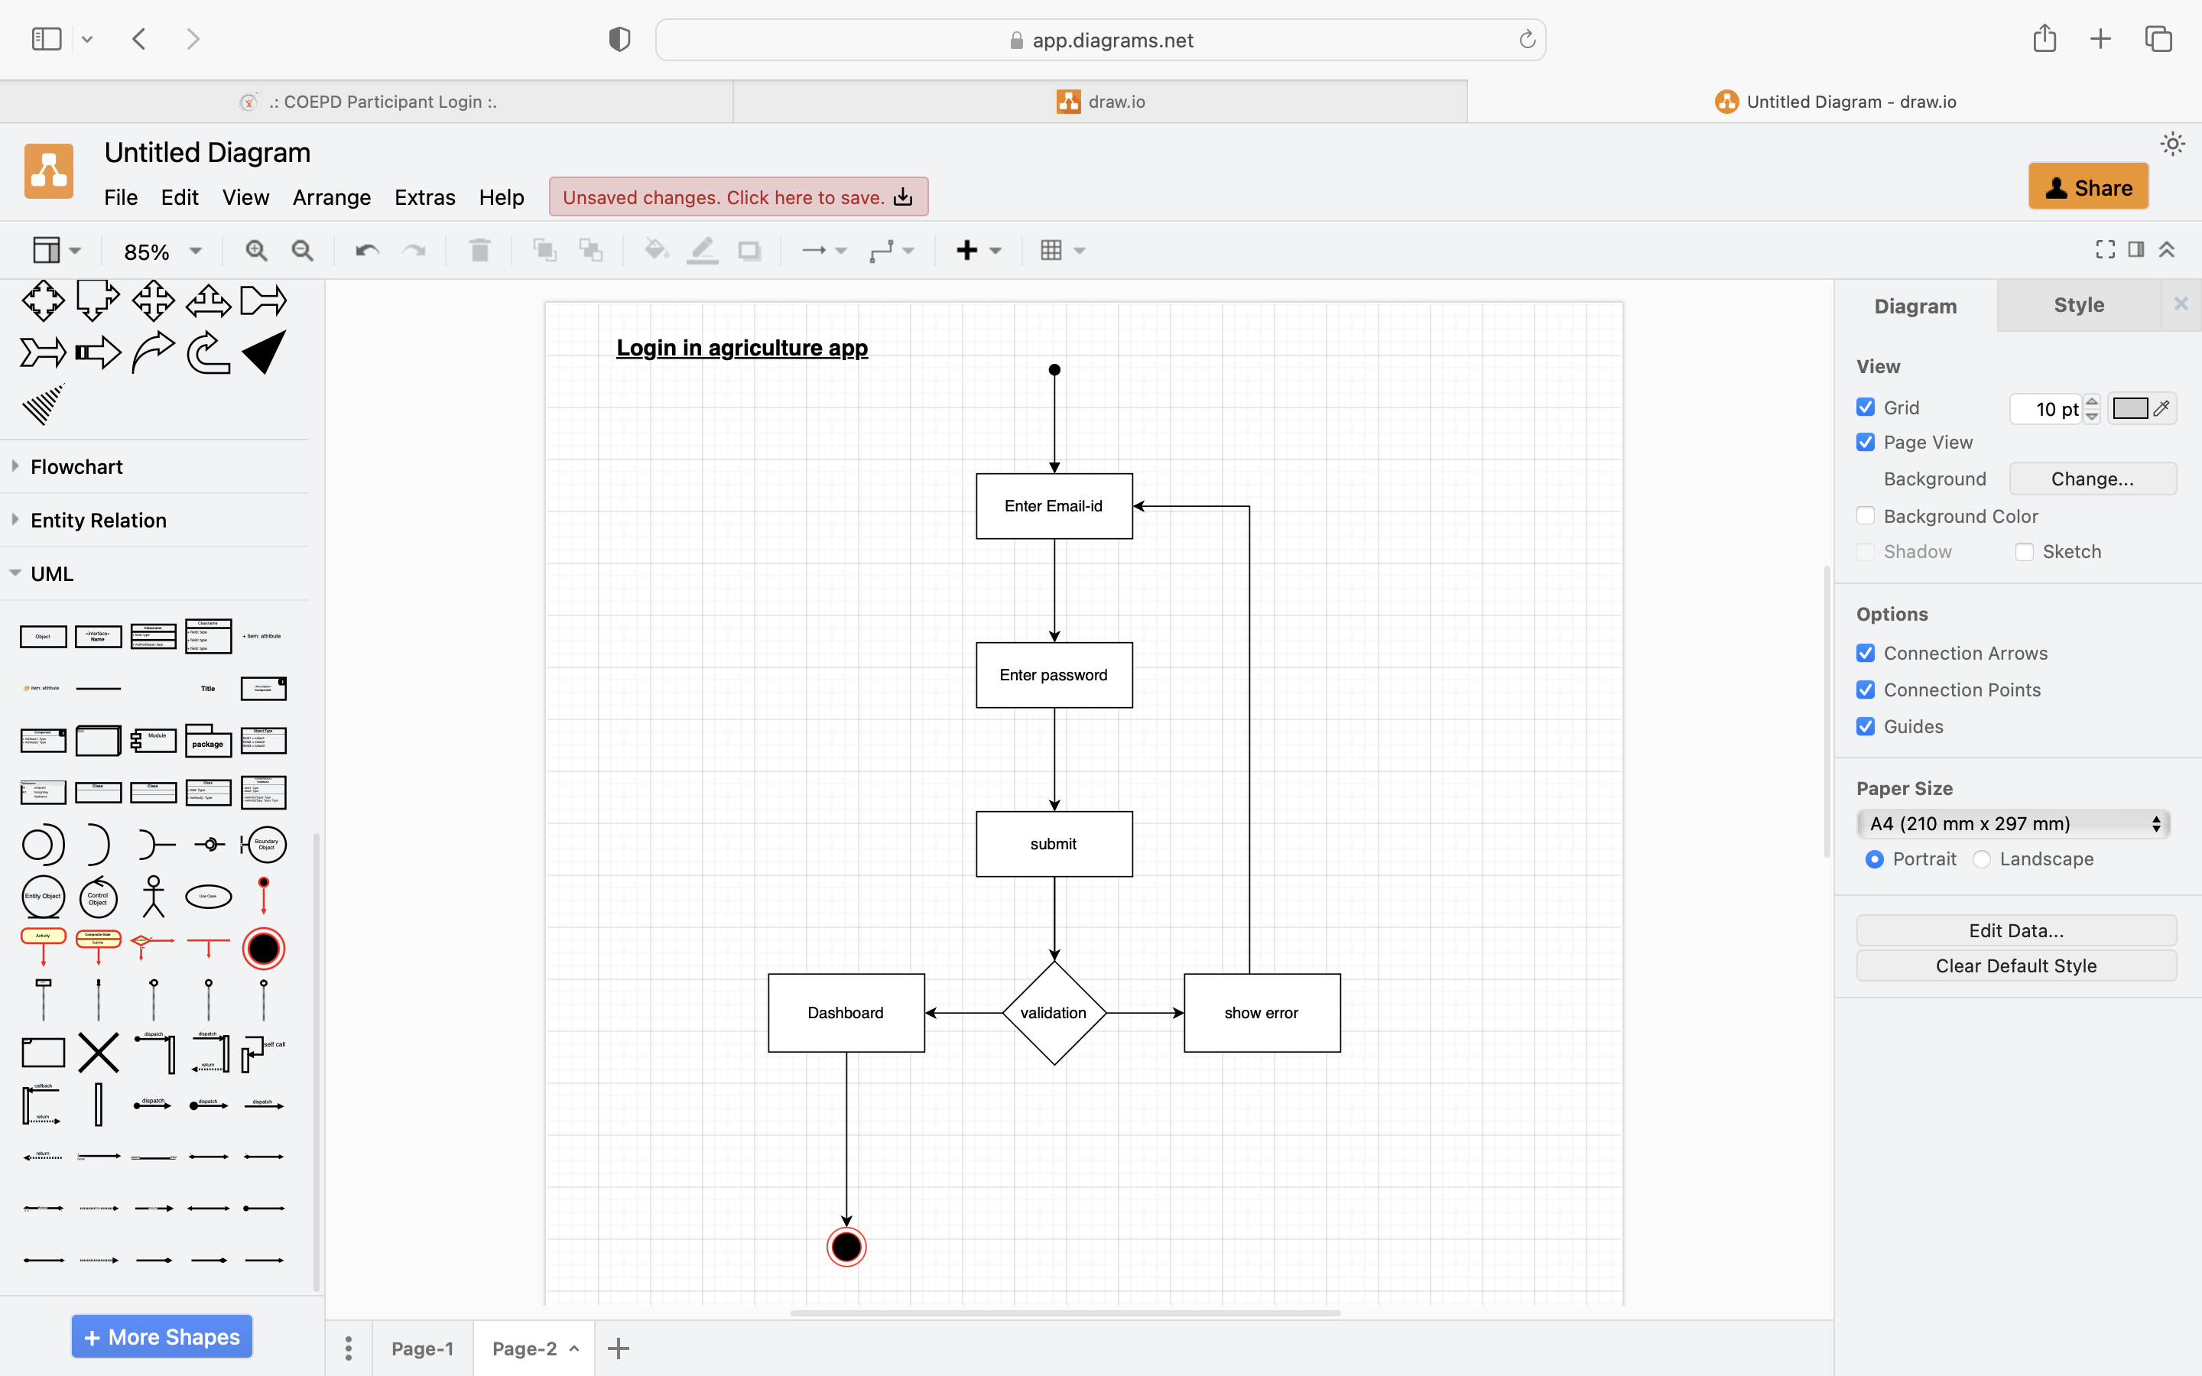

1. Search product functionality

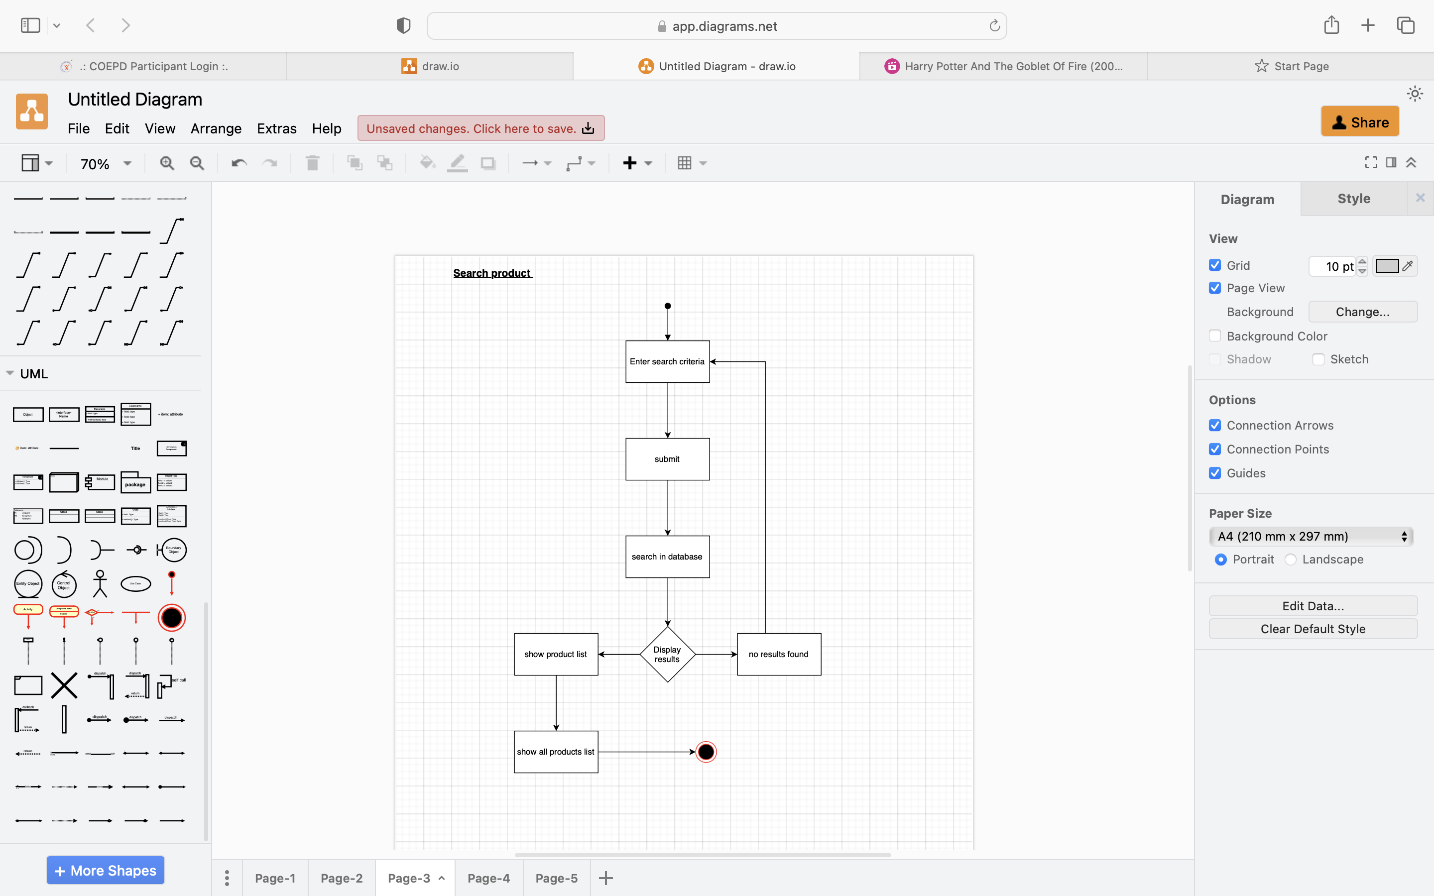

1. Product Selection

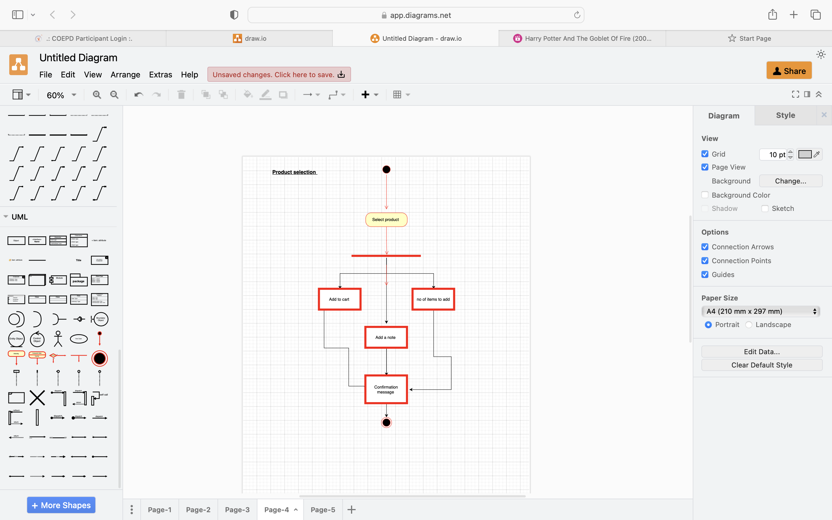

1. Payment Process

