**Document 6- Please prepare a use case diagram, activity diagram and a use case specification document.**

**Use Case Diagram:**

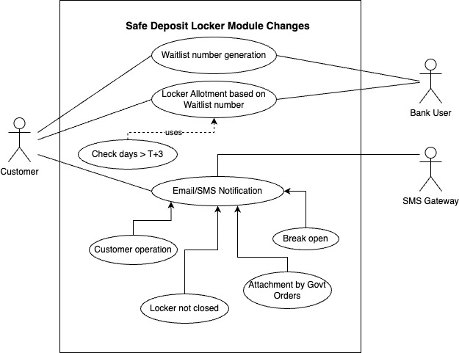

**Use Case Specification Document:**

1. **Use Case Name:**

Enhancement to the Safe Deposit Locker Module in CBS as per RBI dircetives.

1. **Use Case Description:**

This use case describes how the waitlist number generation and management will be handling in core banking solutions along with email/SMS generation process for the four defined locker events.

1. **Actors- Primary and Secondary:**

Primary Actor – Customer who comes the Bank

Secondary Actors - Bank Staff (User), SMS Gateway Partner

1. **Basic Flow:**
2. Waitlist number generation Use Case: Customer visit the branch and request for the locker. Bank User will generate waitlist number and shared to the customer since the locker is not available at the moment.
3. Locker allotment Use Case: Customer will get the Email/SMS when locker is available and visit the branch again within 3 working days.
4. Supporting Use Case for Locker Allotment: If the customer visits after T+3 days, waitlist number will be expired and wont able to get the locker if not available or (locker available and other active waitlist number is present).
5. Email or SMS Notification Use Case: Email or SMS will be triggered to the registered email and mobile number of the customer when any of the generalized use cases are executed based on the 4 events mentioned in those use cases. SMS Gateway partner will be involved to send the SMS to the mobile numbers. Email will be send using the internal email generation system.
6. **Alternate Flow:**

5.1 Vacant Lockers available:

When a customer comes for the locker and if the required locker size is already vacant, existing flow of locker allotment will be followed and there will not be any waitlist number generation in this case.

5.2 When Customer visit the branch after T+3 days once getting email/sms as locker is available:

Customer will get email/SMS after receiving waitlist number from branch whenever the required locker is vacant. Then he/she should visit the branch before 3 working days to claim the locker. Else waitlist number will be invalid. Then customer have option to get the locker only if there is a vacant locker and no active locker waitlist is present.

1. **Exceptional Flow:**

6.1 When customer does not have any account:

When a customer comes to have a locker and he is not related with the Bank in any way, he/she should open an account at first and be a customer of the Bank first. Then follow the steps 4 or 5 as applicable.

6.2 When email or mobile number is not registered in case of email/SMS use case:

There may be a scenario when the customer is already having a relationship with the Bank but his email or mobile number is not registered with the Bank. Notification is an important step in managing waitlist number and locker critical events in this project. Customer should register their email or mobile number to have all the process to follow as expected.

1. **Pre-Conditions:**
2. Branches should have Lockers and Locker inventory management system.
3. Customer should have active accounts (CASA and security deposit)
4. Customer should have active email id and mobile number which are registered with the Bank
5. **Post-Conditions:**
6. Customer will get locker if he followed the rules related to waitlist number properly
7. Customer won't get locker if he does not follow the rules related to waitlist number
8. Customer will get the email/SMS if active email id and mobile number is registered with the Bank.
9. **Assumptions:**
10. SMS gateway partner will provide the support as per the RBI timelines
11. User will be trained to use the new system
12. Customer approach and ask for the waitlist number and Bank will provide it mandatorily if locker is not available at that moment.
13. Customer visits the branch with waitlist number within 3 working days to avail the locker once they get the email/SMS for the vacancy of lockers else it will be invalid.
14. **Constraints:**
15. System must comply to RBI regulations.
16. Project should complete in 6 months to adhere to the deadline given by RBI.
17. Budget constraint is there with a maximum limit of 10 Lakhs.
18. Resources are assigned as per the existing work load for other change requests (8 in numbers).
19. **Dependencies:**
20. SMS notification is dependent on the SMS gateway partner.
21. Proposed system is dependent on the availability of lockers.
22. Locker allotment is dependent on the customer after getting the notification for vacant lockers.
23. **Inputs and Outputs:**

For Waitlist generation:

Inputs: Customer Number, Locker Size, related CASA account

Outputs: Waitlist Number

For Email/SMS notification:

Inputs: Events trigger for four events- Marking of entry time for locker operation, marking of locker not closed status, marking of break open status and marking of locker attachment due to govt orders.

Outputs: Configured Email/SMS to registered email id or mobile number.

1. **Business Rules:**
2. Only exiting customers will be allowed to get the waitlist number. Else be the customer first by opening the accounts.
3. One customer cannot have multiple active locker waitlist numbers in the same branch for same locker sizes but can have it for different locker sizes.
4. One customer can have waitlist numbers in the different branches.
5. Implement this functionality without interrupting the current process.
6. **Miscellaneous Information:**

None.

**Activity Diagram:**

1. **Waitlist number generation and management:**

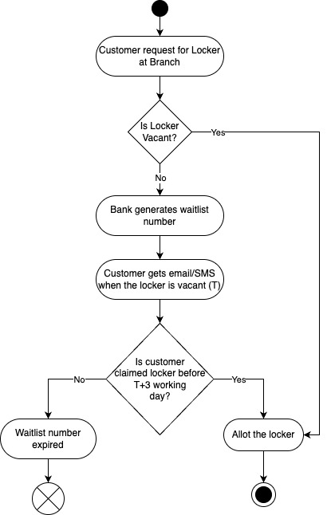

1. **Email/SMS notification for defined locker events:**

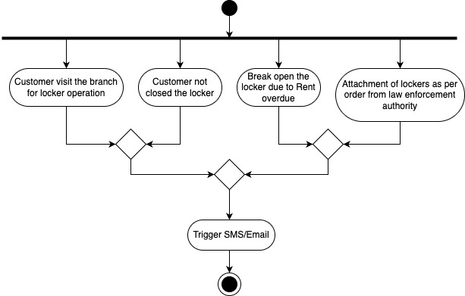

**Document 7- Screens and pages:**

I have shown all the screens as per the basic flow in use case diagram or description. This wireframe sequence also indicates the events required for email/SMS triggers.

1. Home page of Core Banking Solution with new sub menu options under Safe Deposit Locker

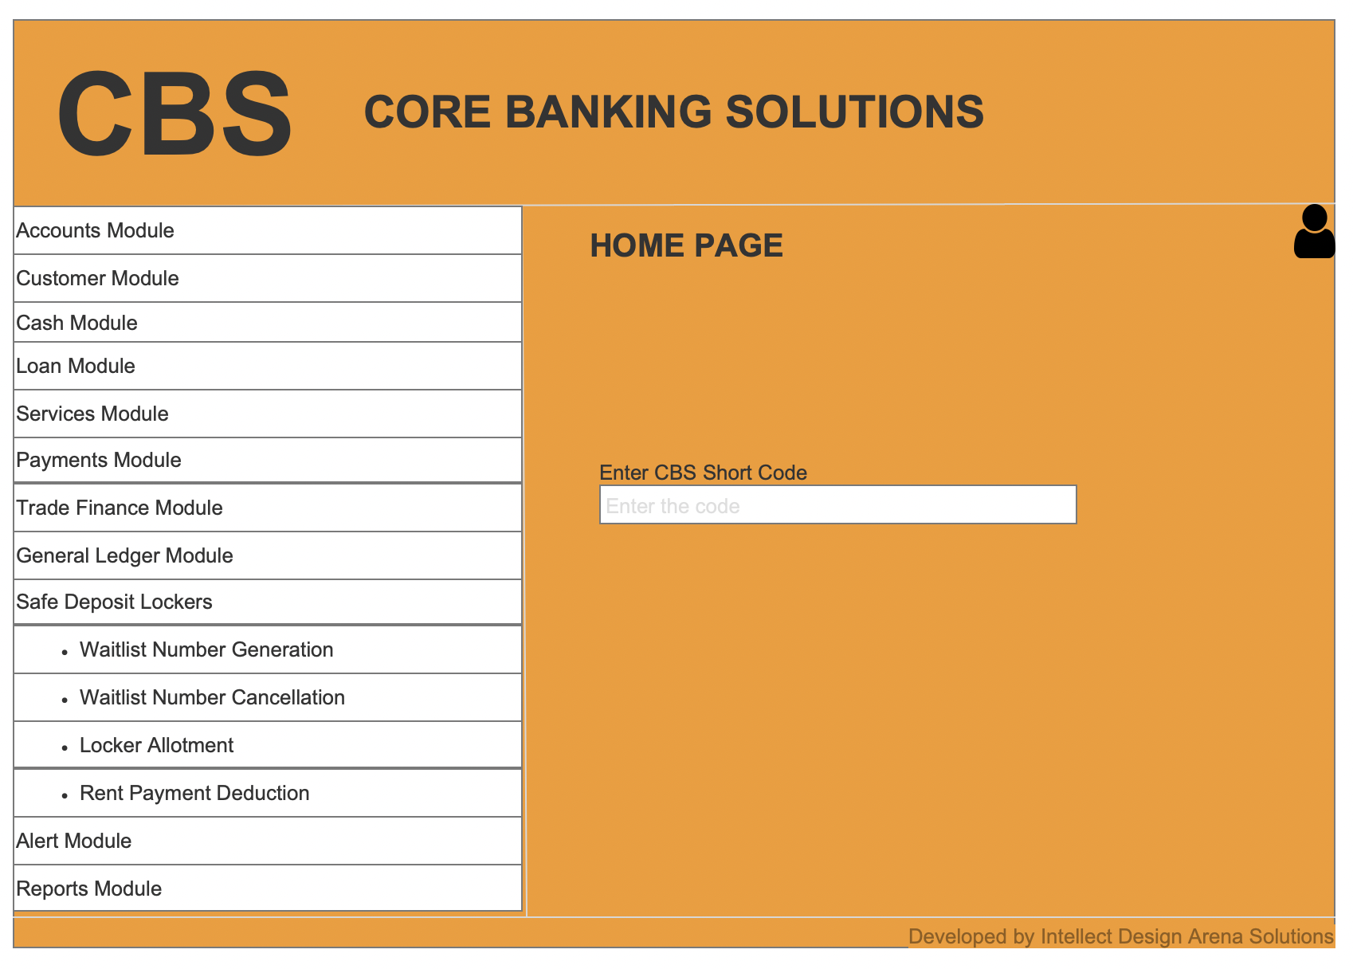

1. Open Waitlist generation page to generate the waitlist number

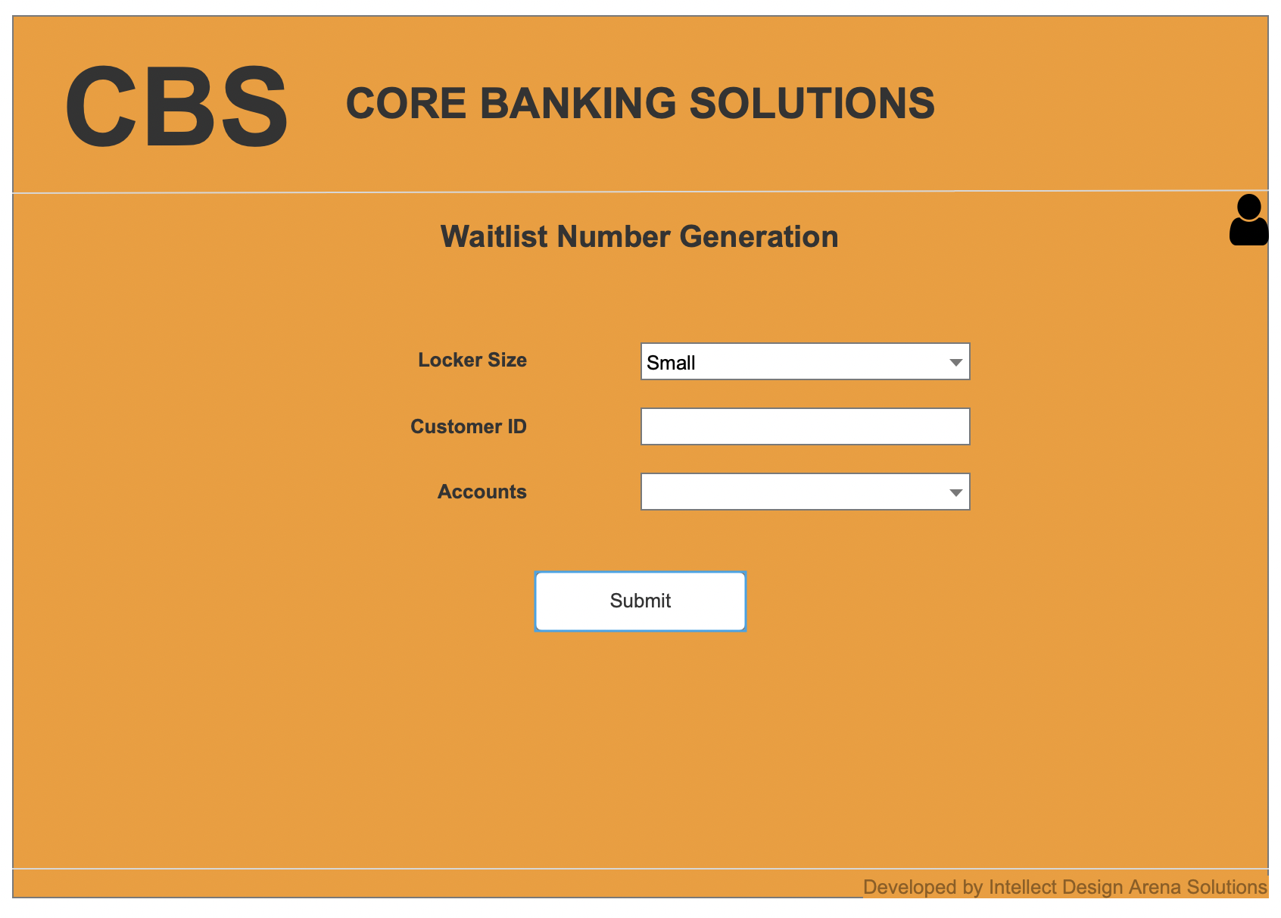

1. Waitlist number is generated successfully after submission

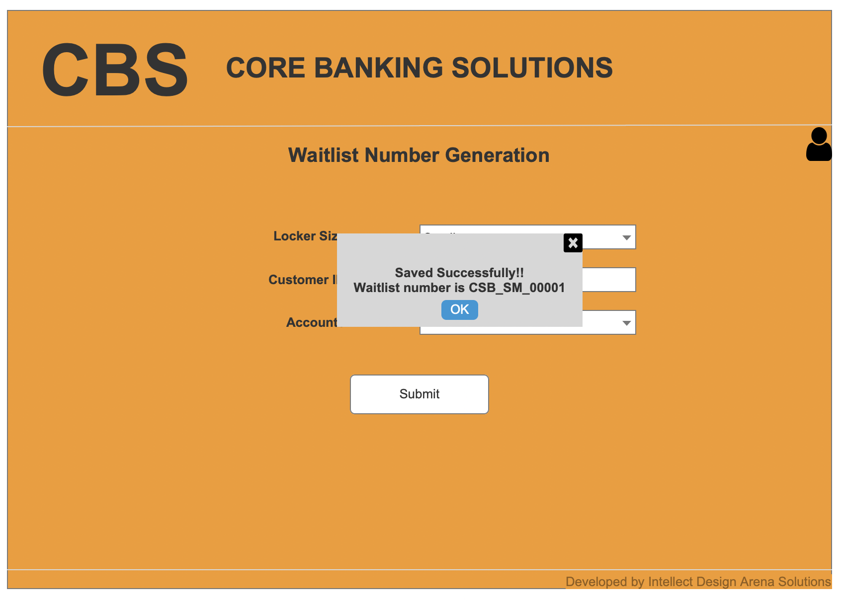

1. Open Locker Allotment Page- There are 4 tabs. View of General Tab below. Add for the new locker allotment or modify for the existing allotted locker.

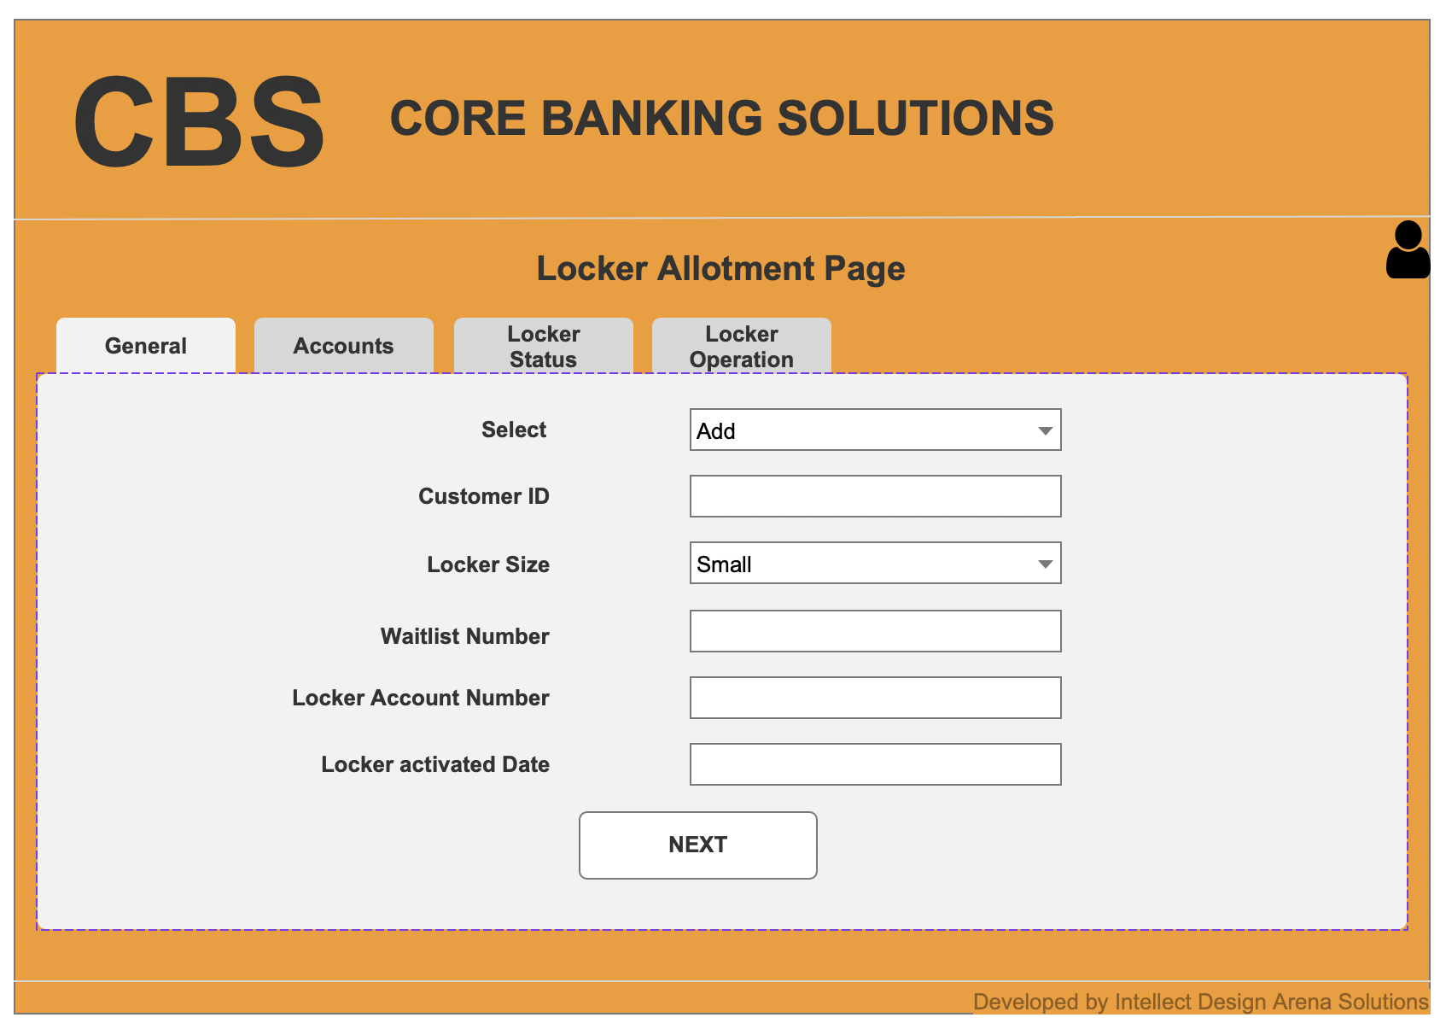

1. View of second tab- Account

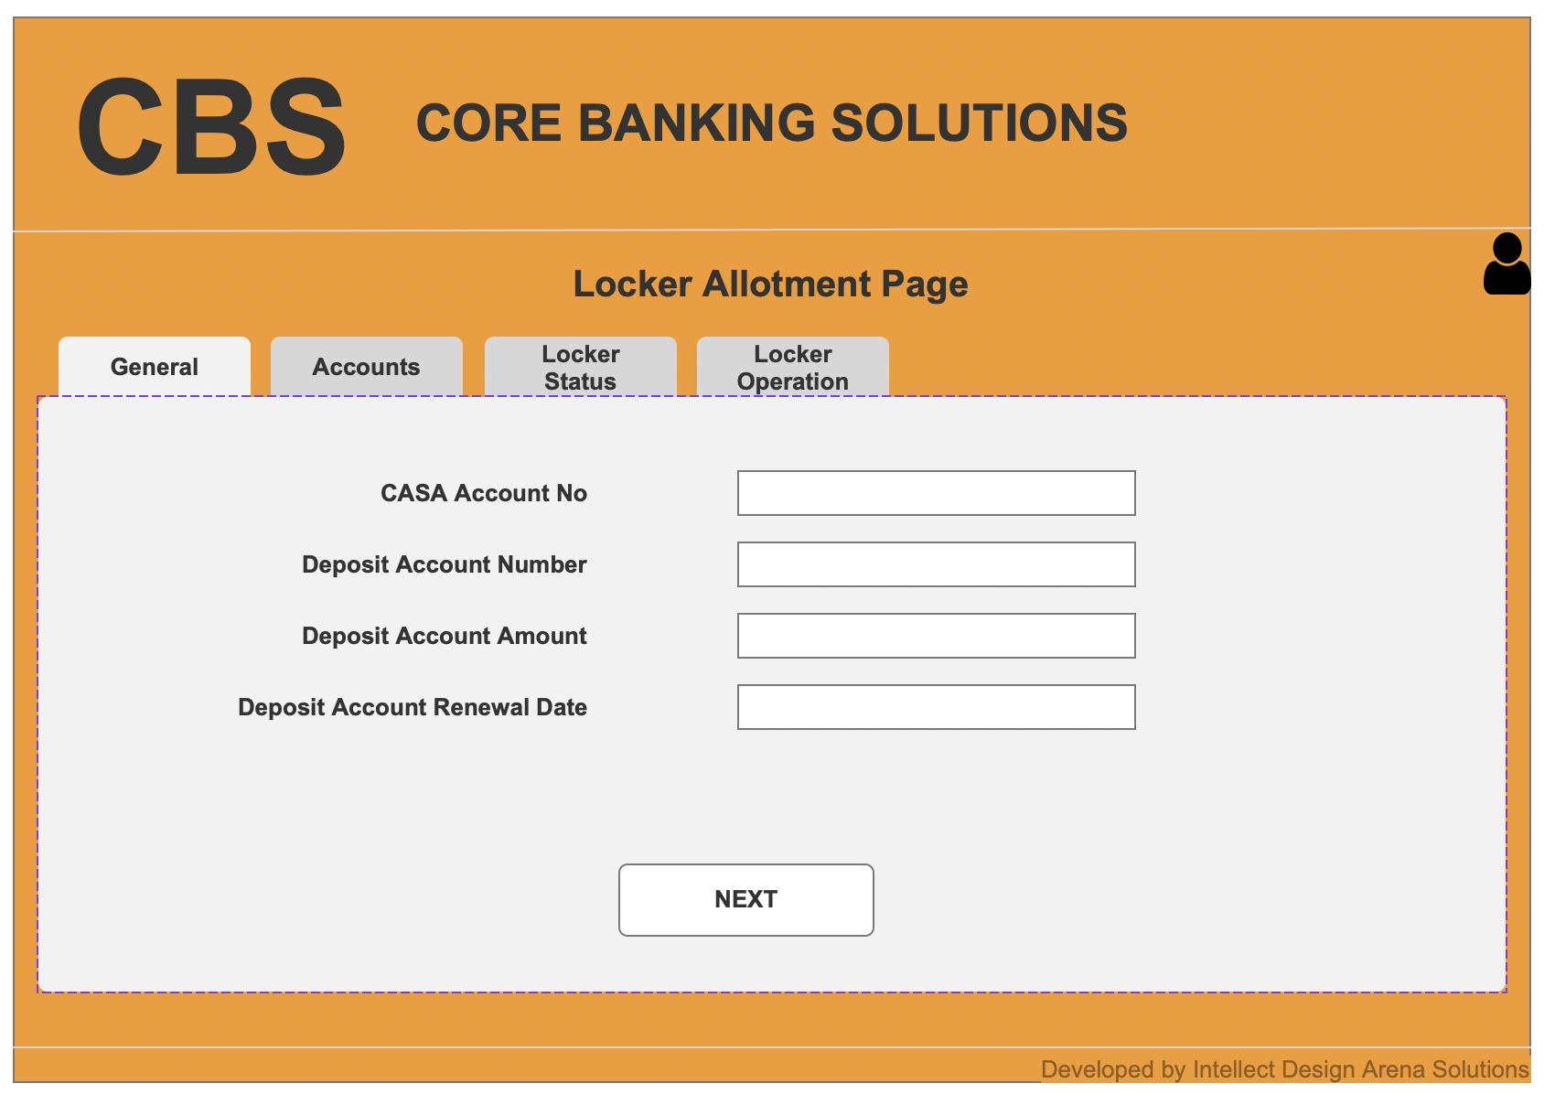

1. View of third tab- Locker Status. Here 2 new statuses are added as “Locker Break Open” and “Locker Attachment due to Govt orders” in the dropdown option for Locker Status. Based on this status, email/SMS events will be triggered (Last 2 notifications) as per the requirement.

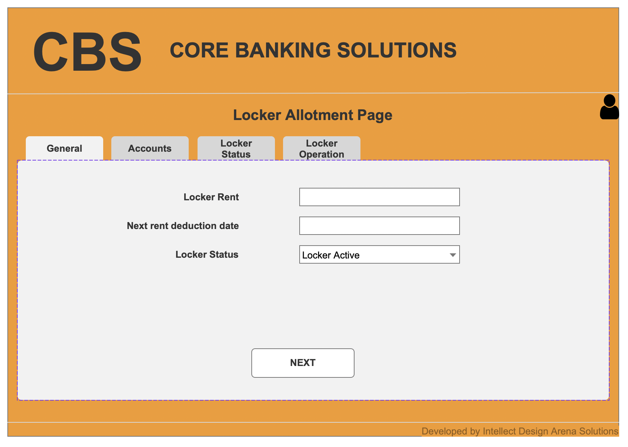

1. View of fourth tab- Locker Operation. Here email/SMS are triggered based on the events logged for Locker operation (Entry and closure) and locker not closed properly as in this fourth tab (First 2 notifications) as per the requirement. Logged details will show in the table below in this same tab.

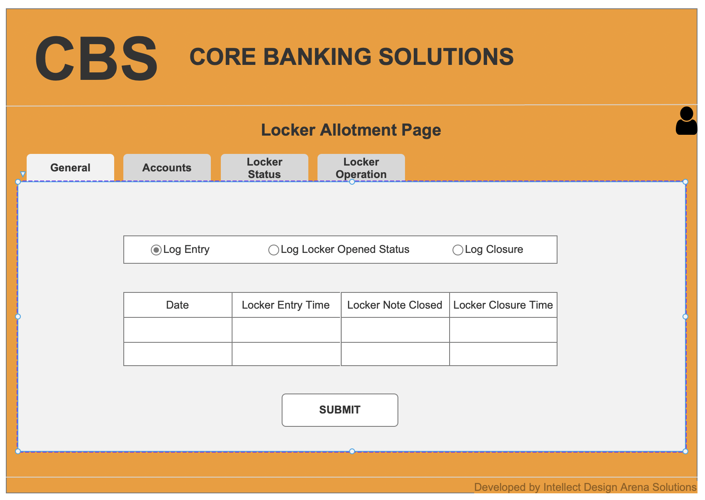

1. Submitting the addition or modification entry and message box pop up.

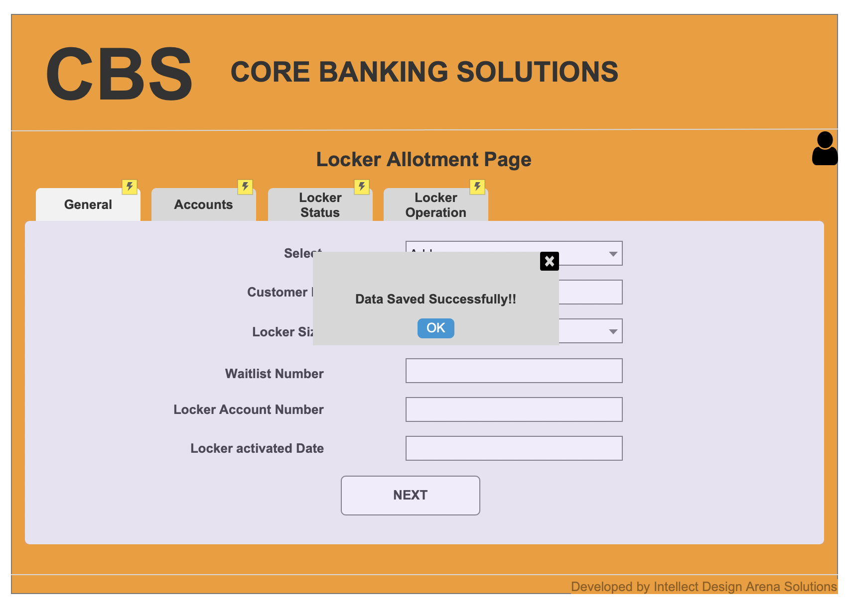

**Document 8- Tools-Visio and Axure:**

I have used MS Visio to draw the use case diagram and 2 activity diagrams. To create the wireframes for core banking screens for the basic flow represented in use case diagram, I have used Axure RP.

**MS Visio Experience:**

In this project, I utilized MS Visio to create detailed and structured visual representations of processes and system functionalities related to safe deposit locker operations. The activity diagrams were particularly useful in showcasing the flow of actions, decisions, and notifications, providing clarity on processes such as locker allotment and customer notifications. The use case diagram effectively captured the interactions between the various actors- customers, bank users, and external systems- highlighting key module changes. MS Visio’s intuitive interface and drag-and-drop features enabled me to efficiently organize workflows into clean, professional visuals. This experience not only improved my understanding of the system requirements but also enhanced my ability to communicate ideas effectively to stakeholders.

**Axure Experience:**

For this project, I used Axure RP to design and prototype screens for the safe deposit locker module in core banking solution (CBS). Axure's dynamic capabilities allowed me to create interactive wireframes that simulated real user interactions, such as generating waitlist number, use waitlist to allot locker and mark events which are required to trigger the four email/SMS notifications as described in RBI circular. The tool’s drag-and-drop widgets, extensive library, and ability to define conditional logic helped me design user-friendly and functional interfaces. Various widgets like tabs, icons and their interactive nature as in a real webpage unlike Balsamiq helps me to create an exact core banking pages as it is in the current system. These prototypes provided a clear visualization of the module’s workflow and functionality, making it easier to gather feedback from stakeholders and ensure alignment with business requirements. This experience enhanced my skills in creating interactive prototypes and underscored the importance of user-centered design in core banking solutions.

**Document 9- BA experience:**

My experience as BA in the following phases are given

1. **Requirement Gathering:**

When the request for this project came from client, and I have done the gap analysis initially to find out the gaps between existing system and proposed system for Safe Deposit Locker Module. Documents available for the current module in Core Banking helped a lot to get to know the exact as-is process. After identifying the key stakeholders to collect the requirements, used the elicitation techniques workshops and interviews. I have arranged workshops with the bank stakeholders to extract the exact requirements and to finalize the logic related to waitlist generation and management. I have asked to send the people on deputation if any of the key stakeholders are not available during the 2-day workshops at Bank’s CBS office. I have created prototypes and wireframes which helped to show visually the flow of process. I have applied MoSCoW technique to prioritize the requirements and applied FURPS to validate the requirements. There were duplicate requirements and removed those duplicate items and sorted the requirements before doing the requirement analysis.

1. **Requirement Analysis:**

Once the Business requirements are collected, finalized, prioritized and sorted, I have identified use case for each process which described how the user is interacting with the system. Use case diagram and description is created using MS Visio and shared to all the stakeholders. Activity diagram is also accompanied to show the flow of processes. Based on the feedback from the stakeholders, some modifications are done on the activity diagram to meet their expectations. I have defined functional requirements which are translated from use cases. I have created the Business requirement document (BRD). Then I have checked the technical feasibility of these requirements with my development team and confirmed that the functionalities are feasible to implement. Once these agreed requirements which are technically feasible and aligned with business requirements, I created the Functional Specification document (SRS).

1. **Design:**

I have worked with the QA team to create test scenarios from use cases and wrote the test cases out of test scenarios. Both positive and negative test cases are written for all the test scenarios and made sure that all the test cases are covered. Design components based on the use cases and test cases are shared with all the stakeholders and got the confirmation of it. All the requirements are logged in the Requirement Traceability Matrix (RTM) to trace all throughout the project life cycle. I have worked with technical team, business team and testers closely to clear all the ambiguity in terms of requirements, design and test cases.

1. **Development:**

Worked and coordinated with technical team very closely during the development stage to clear all their doubts. Use case and activity diagrams were referred along with prototypes to show them the business requirements actually want the business to be implemented in the system. Functionalities are explained and conducted JAD sessions with all the stakeholders during the Locker Allotment Page design to get the clarity on making the waitlist number as a mandatory field and their effects when add or edit this page. Enabled a continuous communication and feedback loops and it helped to present all the concern of development team and get it solved immediately.

1. **Testing:**

Development team gave the build to deploy in SIT environment after their unit testing. I have done an initial BA level testing at the high level to validate the system. Test cases prepared during the design stage is refined with the testing team. Helped the team to execute the actual testing as per test plan. I have validated the result against business expectations and verified the results and test documents are updated with all the details. Updated RTM with all the updates against each requirement. I have shared all the test details with client team along with test results to get the sign off from the team. Also, prepared the client team to perform the UAT and arranged the environment with the technical team. Facilitated the UAT, cleared all the doubts of client team, coordinated with development team if there is any issue or bug raised, validated the issue before reporting to development team and completed the UAT. Shared the complete testing documents, plan and results with the client for the UAT signoff and received the signoff. Shared the project acceptance form with the client with all the deliverables.

1. **Deployment:**

I worked closely with the implementation team when we received the UAT signoff from client. I have worked with PM to create the release planning. Also, prepared the questionnaire to collect the feedback from the Bank Users by conducting a survey through email on the enhanced safe deposit locker module. I have prepared the user manual to guide the users on how to use the enhanced module. I have checked with the Bank team to arrange the initial training session to the Bank users to give an awareness of the new features added as part of this change. Since it is not practically possible to give the training to all the Bank users at a time, Bank has selected few members zone wise to attend the training so that these members will provide the training to the rest of the users without interrupting the operation of the Bank. I have made sure that all the existing and proposed functionalities are working as expected after the release.