Document 1:

The best form of Definition of Done representation is a checklist of activities that has to demonstrate the agreed value and quality of a user story. So, this checklist should include:

♣ Acceptance criteria (to satisfy customer requirements for a product)

♣ Quality criteria (to satisfy quality requirements for a product) Definition of Done may be defined for different levels of project work. For example, in Agile/ Scrum framework these levels of work could be user story, sprint, and release.

**Checklist for DOD:**

• Produced code for presumed functionalities

• Assumptions of User Story met

• Project builds without errors

• Unit tests written and passing

• Project deployed on the test environment identical to production platform

• Tests on devices/browsers listed in the project assumptions passed

• Feature ok-ed by UX designer

• QA performed & issues resolved

• Feature is tested against acceptance criteria

• Feature ok-ed by Product Owner

• Refactoring completed

• Any configuration or build changes documented

• Documentation updated

• Peer Code Review performed

Document 2: Product Vision

|  |  |  |  |
| --- | --- | --- | --- |
| Scrum Project Name: | iCRM Dashboard |  |  |
| Venue: | Regional head office, Pune. |  |  |
| Date: | Start Time: 1st Jan 24 | End Time: 24th Jan 24 | Duration: 3-4 weeks |
| Clients: | ICICI BANK |  |  |
| Stakeholder List: | Mr. Bakshi | Mr. Swami | Mr. Narayan |
|  | Ms. Daksha | Mr. Vijay R | Mr. Koshy |
|  |  |  |  |
| Scrum Team | | | |
| Scrum Master: | Mr. Roy |  |  |
| Product Owner: | Mr. Will |  |  |
| Scrum Developer 1: | Mr. Tom |  |  |
| Scrum Developer 2: | Ms. Jenny |  |  |
| Scrum Developer 3: | Ms. Lilly |  |  |
| Scrum Developer 4: | Mr. Tim |  |  |
| Scrum Developer 5: | Mr. Harry |  |  |

**Vision**: The iCRM application aims to centralize client information, including documents, meeting notes, financial details, and team discussions, to improve collaboration, decision-making, and client relationships. It will be secure, user-friendly, and scalable, enhancing productivity while ensuring compliance and driving business growth.

**Targer Group:** The iCRM application addresses the **B2B (Business-to-Business) and B2C (Business-to-Consumer)** market segments, specifically targeting organizations that require efficient client management and collaboration tools. This includes industries such as

:**Financial Services**: Banks, insurance companies, and investment firms needing a unified view of personal and corporate client accounts. The primary customers for the iCRM application include: ICICI employees (Sales and Ops team.)  
Professional Services: Consulting, legal, and accountancy firms for managing client interactions and documentation.  
Sales and Marketing: Teams looking to track client interactions, product usage, and ensure alignment across departments.  
Customer Support: Companies needing detailed client histories for personalized support and issue resolution.

**Needs:** (Problems product solves) 1.Lack of Centralized Information. 2. Inefficient Team Collaboration.3.Data Silos Across Departments. 4. Time Wasted in Information Retrieval. 5. Disjointed Client Communication. 6. Compliance and Security Risks. 7. Missed Opportunities. Benefits- Improved Collaboration Enhanced Productivity, Better Client Relationships, Streamlined Operations, Data Security and Compliance. Informed decision making, Scalability.

**Product:** The product is iCRM (Intelligent Client Relationship Management software), a centralized platform designed to manage all client-related information, such as documents, meeting notes, financial details, and team discussions. It ensures seamless collaboration and provides a 360-degree view of client interactions across departments. Spealities-1.Centralized Client Information, Team Alignment, Enhanced Productivity, Security and Compliance, Customizable Features, Data-Driven Insights. Feasibility to develop the product : Technology Availability, Resource, Timeframe, Security, Integration capability, Market demand.

**Value:** The iCRM application will benefit the company in the following ways:Improved Efficiency, Stronger Client Relationships, Enhanced Collaboration, Revenue Growth, Cost Savings, Competitive Edge. Goals- Increase Client Retention: Achieve higher satisfaction and loyalty by ensuring consistent and personalized client interactions.  
Boost Revenue: Drive growth through enhanced cross-selling and upselling opportunities.  
Improve Employee Productivity: Reduce operational inefficiencies by equipping employees with easy access to client data.  
Strengthen Data Security: Protect sensitive client information to maintain trust and meet compliance requirements.  
Scale Operations: Support business expansion with a system that can handle a growing client base and evolving needs.  
Enhance Decision-Making: Provide actionable insights and analytics to inform strategic business decisions. Business model-The iCRM business model could follow these approaches:  
Subscription-Based Model: Offer the software as a SaaS (Software as a Service) solution with tiered pricing plans (e.g., Basic, Professional, Enterprise) based on user numbers and feature sets.  
Custom Implementation Services: Charge additional fees for setup, customization, and integration with the client's existing systems.  
Maintenance and Support: Offer optional annual support and maintenance packages for updates, training, and troubleshooting.  
Add-On Features: Provide advanced modules (e.g., AI analytics, integration with premium third-party tools) as paid add-ons.  
Data Analytics Services: Monetize actionable insights generated by the platform for clients to enhance their strategies.

Document3: User Stories

|  |  |  |
| --- | --- | --- |
| User Story No :1 | Task : 2 | Priority: HIGHEST |
| **AS A** ACCOUNT MANAGER  **I WANT TO** CHECK THE FD MADE  **SO THAT** I CAN INFORM THE CLIENT | | |
|  | CP: 02 | |
| BV: 500 |  | |
| ACCEPTANCE CRITERIA |  |  |
| Enter Login details  Enter the Account Number  Click on Deposits  FD Details will appear. |  |  |

|  |  |  |
| --- | --- | --- |
| User Story No :2 | Task : 2 | Priority: HIGHEST |
| **AS A** ACCOUNT MANAGER  **I WANT TO** Download Statement  **SO THAT** I CAN SEND IT TO CLIENT | | |
|  | CP: 02 | |
| BV: 200 |  | |
| ACCEPTANCE CRITERIA |  |  |
| Enter Login details  Enter the Account Number  Click on Statement Centre  Select the date of the Statement.  Click on “Download” |  |  |

|  |  |  |
| --- | --- | --- |
| User Story No :3 | Task : 3 | Priority: Medium |
| **AS A** ACCOUNT MANAGER  **I WANT TO** Enter Meeting details for the client(MOM)  **SO THAT** I CAN update the profile | | |
|  | CP: 02 | |
| BV: 200 |  | |
| ACCEPTANCE CRITERIA |  |  |
| Enter Login details  Enter the Account Number  Click on Update MOM  Select the date.  Click on “Enter MOM”  Enter the Meeting discussion points.  Click on update. |  |  |

|  |  |  |
| --- | --- | --- |
| User Story No :4 | Task : 3 | Priority: High |
| **AS A** ACCOUNT MANAGER  **I WANT TO** Check the credit History  **SO THAT** I can pitch the next product | | |
|  | CP: 05 | |
| BV: 500 |  | |
| ACCEPTANCE CRITERIA |  |  |
| Enter Login details  Enter the Account Number  Click on Credit History tab  Select Personal / Corporate  Select ‘Enter’ |  |  |

|  |  |  |
| --- | --- | --- |
| User Story No :5 | Task : 3 | Priority: Medium |
| **AS A** ACCOUNT MANAGER  **I WANT TO** Check the status of Chequebook  **SO THAT** I can update the client | | |
|  | CP: 05 | |
| BV: 500 |  | |
| ACCEPTANCE CRITERIA |  |  |
| Enter Login details  Enter the Account Number  Click on “General Information”  Select “Deliverable”  Select “Chequebook”  Check the status. |  |  |

|  |  |  |
| --- | --- | --- |
| User Story No :6 | Task : 3 | Priority: High |
| **AS A** ACCOUNT MANAGER  **I WANT TO** Check the status of Debit Card  **SO THAT** I can update the client | | |
|  | CP: 05 | |
| BV: 500 |  | |
| ACCEPTANCE CRITERIA |  |  |
| Enter Login details  Enter the Account Number  Click on “General Information”  Select “Deliverable”  Select “Debit Card”  Check the status. |  |  |
|  |  |  |

|  |  |  |
| --- | --- | --- |
| User Story No :7 | Task : 3 | Priority: High |
| **AS A** ACCOUNT MANAGER  **I WANT TO** Check the status of Credit Card  **SO THAT** I can update the client | | |
|  | CP: 05 | |
| BV: 500 |  | |
| ACCEPTANCE CRITERIA |  |  |
| Enter Login details  Enter the Account Number  Click on “General Information”  Select “Deliverable”  Select “Credit Card”  Check the status. |  |  |
|  |  |  |

|  |  |  |
| --- | --- | --- |
| User Story No :8 | Task : 3 | Priority: Medium |
| **AS A** ACCOUNT MANAGER  **I WANT TO** Check the clear Balance  **SO THAT** I can update the client | | |
|  | CP: 06 | |
| BV: 300 |  | |
| ACCEPTANCE CRITERIA |  |  |
| Enter Login details  Enter the Account Number  Click on “General Information”  Select “Clear Balance”  Real time balance is shown. |  |  |
|  |  |  |

|  |  |  |
| --- | --- | --- |
| User Story No :9 | Task : 3 | Priority: High |
| **AS A** ACCOUNT MANAGER  **I WANT TO** download Statement  **SO THAT** I can send statement to the client | | |
|  | CP: 05 | |
| BV: 500 |  | |
| ACCEPTANCE CRITERIA |  |  |
| Enter Login details  Enter the Account Number  Click on “General Information”  Select “Statement Centre”  Select the To date to From Date.  Select “OK and Download” |  |  |
|  |  |  |

|  |  |  |
| --- | --- | --- |
| User Story No :10 | Task : 3 | Priority: High |
| **AS A** ACCOUNT MANAGER  **I WANT TO** Update the Signature  **SO THAT** I can take further documentation for process | | |
|  | CP: 05 | |
| BV: 500 |  | |
| ACCEPTANCE CRITERIA |  |  |
| Enter Login details  Enter the Account Number  Click on “Customer Signature Updation”  Click on “upload Documents”  Upload the scan cop of the documents  Click on “Submit”  The signature will be updated after 2 hrs. |  |  |
|  |  |  |
| User Story No :11 | Task : 3 | Priority: High |
| **AS A** ACCOUNT MANAGER  **I WANT TO** Udate the Mobile Number  **SO THAT** all communication will happen over new Mobile number | | |
|  | CP: 05 | |
| BV: 500 |  | |
| ACCEPTANCE CRITERIA |  |  |
| Enter Login details  Enter the Account Number  Click on “Customer Mobile Number Updation”  Click on “upload Documents”  Upload the scan cop of the documents  Click on “Submit”  The Mobile number will be updated after 2 hrs. |  |  |

|  |  |  |
| --- | --- | --- |
| User Story No :12 | Task : 3 | Priority: High |
| **AS A** ACCOUNT MANAGER  **I WANT TO** Update the Company Stamp  **SO THAT** I can take further documentation for process | | |
|  | CP: 05 | |
| BV: 500 |  | |
| ACCEPTANCE CRITERIA |  |  |
| Enter Login details  Enter the Account Number  Click on “Update Company Stamp”  Click on “Upload Documents”  Upload the documents  Click on “Submit”  The Company stamp will be updated in 1 Hr. |  |  |
|  |  |  |
| User Story No :13 | Task : 3 | Priority: High |
| **AS A** ACCOUNT MANAGER  **I WANT TO** Update the Email Id  **SO THAT** all communication will happen over new Email Id | | |
|  | CP: 05 | |
| BV: 500 |  | |
| ACCEPTANCE CRITERIA |  |  |
| Enter Login details  Enter the Account Number  Click on “Customer Email Id Updation”  Click on “upload Documents”  Upload the scan cop of the documents  Click on “Submit”  The Email Id will be updated after 2 hrs. |  |  |

|  |  |  |
| --- | --- | --- |
| User Story No :14 | Task : 3 | Priority: High |
| **AS A** ACCOUNT MANAGER  **I WANT TO** Update the Communication Address  **SO THAT** I can update client profile | | |
|  | CP: 05 | |
| BV: 500 |  | |
| ACCEPTANCE CRITERIA |  |  |
| Enter Login details  Enter the Account Number  Click on “Update Communication Address”  Click on “Upload Documents”  Upload the documents  Click on “Submit”  The Communication Address will be updated in 1 Hr. |  |  |
|  |  |  |
| User Story No :15 | Task : 3 | Priority: High |
| **AS A** ACCOUNT MANAGER  **I WANT TO** Update the LEI number  **SO THAT** | | |
|  | CP: 05 | |
| BV: 500 |  | |
| ACCEPTANCE CRITERIA |  |  |
| Enter Login details  Enter the Account Number  Click on “Customer Email Id Updation”  Click on “upload Documents”  Upload the scan copy of the documents  Click on “Submit”  The LEI Number will be updated after 2 hrs. |  |  |

|  |  |  |
| --- | --- | --- |
| User Story No :16 | Task : 3 | Priority: Medium |
| **AS A** ACCOUNT MANAGER  **I WANT TO** Update the Company GST Number  **SO THAT** I can update client profile | | |
|  | CP: 05 | |
| BV: 500 |  | |
| ACCEPTANCE CRITERIA |  |  |
| Enter Login details  Enter the Account Number  Click on “Update Company GST Number”  Click on “Upload Documents”  Upload the documents  Click on “Submit”  The Company GST Number will be updated in 1 Hr. |  |  |
|  |  |  |
| User Story No :17 | Task : 3 | Priority: High |
| **AS A** ACCOUNT MANAGER  **I WANT TO** Update the “Bank Guarantee ”  **SO THAT** I can update he client. | | |
|  | CP: 05 | |
| BV: 500 |  | |
| ACCEPTANCE CRITERIA |  |  |
| Enter Login details  Enter the Account Number  Click on “Customer Credit Updation”  Click on “upload Documents”  Upload the scan cop of the documents  Click on “Submit”  The Bank Guarantee will be updated after 1 hrs. |  |  |

|  |  |  |
| --- | --- | --- |
| User Story No :18 | Task : 3 | Priority: Medium |
| **AS A** ACCOUNT MANAGER  **I WANT TO** Update the Company GST Number  **SO THAT** I can update client profile | | |
|  | CP: 05 | |
| BV: 500 |  | |
| ACCEPTANCE CRITERIA |  |  |
| Enter Login details  Enter the Account Number  Click on “Update Company GST Number”  Click on “Upload Documents”  Upload the documents  Click on “Submit”  The Company GST Number will be updated in 1 Hr. |  |  |
|  |  |  |
| User Story No :19 | Task : 2 | Priority: Low |
| **AS A** ACCOUNT MANAGER  **I WANT TO** Update the “Birthdays of other colleague”  **SO THAT** I can wish and maintain team spirit. | | |
|  | CP: 05 | |
| BV: 500 |  | |
| ACCEPTANCE CRITERIA |  |  |
| Enter Login details  Enter the Account Number  Click on “Birthdays”  Enter the name and date.  Upload any KYC  Click on “Submit”  The birthday will reflect in 15 mins. |  |  |

|  |  |  |
| --- | --- | --- |
| User Story No :20 | Task : 2 | Priority: HIGHEST |
| **AS A** ACCOUNT MANAGER  **I WANT TO** Take the mapping of the client  **SO THAT** the Account manager will be assigned to client | | |
|  | CP: 02 | |
| BV: 100 |  | |
| ACCEPTANCE CRITERIA |  |  |
| Enter Login details  Enter the Account Number  Click on Mapping.  Enter Name and Emp Id.  Click on “Update” |  |  |

|  |  |  |
| --- | --- | --- |
| User Story No :21 | Task : 2 | Priority: HIGHEST |
| **AS A** ACCOUNT MANAGER  **I WANT TO** update Risk Report  **SO THAT** I can judge the amount of loan can be given. | | |
|  | CP: 02 | |
| BV: 500 |  | |
| ACCEPTANCE CRITERIA |  |  |
| Enter Login details  Enter the Account Number  Click on “Update the risk report”.  Click on “Upload Documents”  Select the scan copy of the document.  Click on “Submit” |  |  |

|  |  |  |
| --- | --- | --- |
| User Story No :22 | Task : 2 | Priority: Medium |
| **AS A** ACCOUNT MANAGER  **I WANT TO** View income  **SO THAT** I can offer next product to client | | |
|  | CP: 02 | |
| BV: 300 |  | |
| ACCEPTANCE CRITERIA |  |  |
| Enter Login details  Enter the Account Number  Click on “Income One View”  Select the TO date and FROM date.  Select “Submit” |  |  |

|  |  |  |
| --- | --- | --- |
| User Story No :23 | Task : 2 | Priority: Medium |
| **AS A** ACCOUNT MANAGER  **I WANT TO** view Shares purchased  **SO THAT** I can offer next product | | |
|  | CP: 02 | |
| BV: 500 |  | |
| ACCEPTANCE CRITERIA |  |  |
| Enter Login details  Enter the Account Number  Click on “Share Purchased”  Select the TO date and FROM date.  Select “Submit” |  |  |

|  |  |  |
| --- | --- | --- |
| User Story No :24 | Task : 2 | Priority: Medium |
| **AS A** ACCOUNT MANAGER  **I WANT TO** view Mutual Funds purchased  **SO THAT** I can offer next product | | |
|  | CP: 02 | |
| BV: 500 |  | |
| ACCEPTANCE CRITERIA |  |  |
| Enter Login details  Enter the Account Number  Click on “Mutual funds”  Select the TO date and FROM date.  Select “Submit” |  |  |

|  |  |  |
| --- | --- | --- |
| User Story No :25 | Task : 2 | Priority: Medium |
| **AS A** ACCOUNT MANAGER  **I WANT TO** view all the products purchased by client  **SO THAT** I can offer him better products | | |
|  | CP: 02 | |
| BV: 500 |  | |
| ACCEPTANCE CRITERIA |  |  |
| Enter Login details  Enter the Account Number  Click on “Product 360”  Select the TO date and FROM date.  Select “Submit” |  |  |

|  |  |  |
| --- | --- | --- |
| User Story No :26 | Task : 2 | Priority: Medium |
| **AS A** ACCOUNT MANAGER  **I WANT TO** view Insurance details  **SO THAT** I can pitch new product | | |
|  | CP: 02 | |
| BV: 300 |  | |
| ACCEPTANCE CRITERIA |  |  |
| Enter Login details  Enter the Account Number  Click on “Product 360”  Select “iPru”  Select the TO date and FROM date.  Select “Submit” |  |  |

|  |  |  |
| --- | --- | --- |
| User Story No :27 | Task : 2 | Priority: High |
| **AS A** ACCOUNT MANAGER  **I WANT TO** View Car Loan details  **SO THAT** I can give the best offer to the client | | |
|  | CP: 03 | |
| BV: 500 |  | |
| ACCEPTANCE CRITERIA |  |  |
| Enter Login details  Enter the Account Number  Click on “ Product 360”  Select “ Car Loan”  Select “Submit” |  |  |

|  |  |  |
| --- | --- | --- |
| User Story No :28 | Task : 2 | Priority: Medium |
| **AS A** ACCOUNT MANAGER  **I WANT TO** Update the Education Loan  **SO THAT** the profile is updated. | | |
|  | CP: 02 | |
| BV: 300 |  | |
| ACCEPTANCE CRITERIA |  |  |
| Enter Login details  Enter the Account Number  Click on “ Product 360”  Select “Education Loan ”  Select the TO date and FROM date.  Click on “upload documents”  Select “Submit” |  |  |

|  |  |  |
| --- | --- | --- |
| User Story No :29 | Task : 2 | Priority: Medium |
| **AS A** ACCOUNT MANAGER  **I WANT TO** View CIB dashboard  **SO THAT** I can update the client. | | |
|  | CP: 02 | |
| BV: 300 |  | |
| ACCEPTANCE CRITERIA |  |  |
| Enter Login details  Enter the Account Number  Click on Select “CIB user details”  Select “Submit” |  |  |

|  |  |  |
| --- | --- | --- |
| User Story No :30 | Task : 2 | Priority: High |
| **AS A** ACCOUNT MANAGER  **I WANT Report a Suspicion**  **SO THAT** I can prevent fraudulent act | | |
|  | CP: 02 | |
| BV: 500 |  | |
| ACCEPTANCE CRITERIA |  |  |
| Enter Login details  Enter the Account Number  Click on “General Information”  Click on “Report Suspicion”  Fill the form and  Select “Submit” |  |  |

|  |  |  |
| --- | --- | --- |
| User Story No :31 | Task : 2 | Priority: High |
| **AS A** ACCOUNT MANAGER  **I WANT view the news feed**  **SO THAT** I can update the client | | |
|  | CP: 02 | |
| BV: 500 |  | |
| ACCEPTANCE CRITERIA |  |  |
| Enter Login details  Click on “Market update”  Select the sector  Select “Submit” |  |  |

|  |  |  |
| --- | --- | --- |
| User Story No :32 | Task : 2 | Priority: Medium |
| **AS A** ACCOUNT MANAGER  **I WANT to know the currency rates**  **SO THAT** I can update the client | | |
|  | CP: 02 | |
| BV: 300 |  | |
| ACCEPTANCE CRITERIA |  |  |
| Enter Login details  Click on “Forex Today”  Select the Country  Select “Submit” |  |  |

|  |  |  |
| --- | --- | --- |
| User Story No :33 | Task : 2 | Priority: High |
| **AS A** ACCOUNT MANAGER  **I WANT view the digital signature**  **SO THAT** I can process the transaction | | |
|  | CP: 02 | |
| BV: 500 |  | |
| ACCEPTANCE CRITERIA |  |  |
| Enter Login details  Enter the Account number  Click on “General Information”  Click o “iDSC”  Select “Submit” |  |  |

|  |  |  |
| --- | --- | --- |
| User Story No :34 | Task : 2 | Priority: High |
| **AS A** ACCOUNT MANAGER  **I WANT View the Monthly Liability Balance**  **SO THAT** | | |
|  | CP: 02 | |
| BV: 500 |  | |
| ACCEPTANCE CRITERIA |  |  |
| Enter Login details  Enter the Account number  Click on “General Information”  Click on “Liability”  Select to date to from date  Select “Submit” |  |  |

|  |  |  |
| --- | --- | --- |
| User Story No :35 | Task : 2 | Priority: Medium |
| **AS A** ACCOUNT MANAGER  **I WANT View Income**  **SO THAT I can Update MIS** | | |
|  | CP: 02 | |
| BV: 300 |  | |
| ACCEPTANCE CRITERIA |  |  |
| Enter Login details  Enter the Account number  Click on “General Information”  Click on “Income One View ”  Select to date to from date  Select “Submit” |  |  |

|  |  |  |
| --- | --- | --- |
| User Story No :36 | Task : 2 | Priority: Medium |
| **AS A** ACCOUNT MANAGER  **I WANT to view the next product to pitch**  **SO THAT** I can gain income | | |
|  | CP: 02 | |
| BV: 300 |  | |
| ACCEPTANCE CRITERIA |  |  |
| Enter Login details  Enter the Account number  Click on “General Information”  Click on “Next Best Conversation”  Select “Submit” |  |  |

|  |  |  |
| --- | --- | --- |
| User Story No :37 | Task : 4 | Priority: Medium |
| **AS A** ACCOUNT MANAGER  **I WANT view the Income Planning of client**  **SO THAT** I can gain Income | | |
|  | CP: 02 | |
| BV: 300 |  | |
| ACCEPTANCE CRITERIA |  |  |
| Enter Login details  Enter the Account number  Click on “General Information”  Click on “Income Planning”  Select “Submit” |  |  |

|  |  |  |
| --- | --- | --- |
| User Story No :38 | Task : 4 | Priority: Medium |
| **AS A** ACCOUNT MANAGER  **I WANT view the Disbursement Planning**  **SO THAT** I can update the client | | |
|  | CP: 02 | |
| BV: 300 |  | |
| ACCEPTANCE CRITERIA |  |  |
| Enter Login details  Enter the Account number  Click on “General Information”  Click on “Disbursement Planning”  Select “Submit” |  |  |

|  |  |  |
| --- | --- | --- |
| User Story No :39 | Task : 4 | Priority: High |
| **AS A** ACCOUNT MANAGER  **I WANT to view all request from client**  **SO THAT** I can provide fast service | | |
|  | CP: 02 | |
| BV: 500 |  | |
| ACCEPTANCE CRITERIA |  |  |
| Enter Login details  Enter the Account number  Click on “General Information”  Click on “Requests and Queries”  Select “Submit” |  |  |

|  |  |  |
| --- | --- | --- |
| User Story No :40 | Task : 4 | Priority: High |
| **AS A** ACCOUNT MANAGER  **I WANT to view Pending Compliance**  **SO THAT** I can provide fast service | | |
|  | CP: 02 | |
| BV: 300 |  | |
| ACCEPTANCE CRITERIA |  |  |
| Enter Login details  Enter the Account number  Click on “Compliance and Complains”  Select From date to To date  Select “Submit” |  |  |

Document 4: Agile PO Experience

The Product Owner has a vision of the product keeping the domain/industry experience and

the market need.

**Key Responsibilities**

**1. Market Analysis**

* Analyzed market demand and customer needs to ensure product-market fit.
* Researched and evaluated the availability and functionality of similar products to position the product competitively.

**2. Enterprise Analysis**

* Performed due diligence on market opportunities to assess the feasibility and business potential of the product.
* Prepared comprehensive analysis reports to guide strategic decision-making.

**3. Product Vision and Roadmap**

* Created a product vision that addressed identified market gaps and organizational objectives.
* Developed a product roadmap with high-level features, milestones, and timelines to ensure a structured delivery plan.

**4. Managing Product Features**

* Worked closely with stakeholders to gather, clarify, and prioritize requirements.
* Prioritized epics, user stories, and features based on their criticality, ROI, and alignment with the product vision.

**5. Product Backlog Management**

* Maintained and refined the product backlog, ensuring all user stories were well-defined, prioritized, and aligned with sprint goals.
* Adapted priorities in response to evolving business needs and stakeholder feedback.
* Collaborated with Business Analysts to plan and break down epics into actionable user stories.

**6. Iteration Progress Management**

* Regularly reviewed sprint progress to ensure alignment with sprint goals and overall product vision.
* Facilitated sprint retrospectives to identify areas for improvement and adjust priorities if needed.

**Sprint Meetings Management**

Learned and effectively handled various Agile sprint meetings:

1. **Sprint Planning Meeting**: Defined sprint goals, prioritized user stories, and collaborated with the team on sprint commitment.
2. **Daily Scrum Meeting**: Monitored daily progress and helped the team resolve blockers to maintain momentum.
3. **Sprint Review Meeting**: Demonstrated completed features to stakeholders and gathered feedback for the next sprint.
4. **Sprint Retrospective Meeting**: Facilitated discussions to reflect on the sprint and identify process improvements.
5. **Backlog Refinement Meeting**: Reviewed, refined, and reprioritized the backlog to ensure readiness for upcoming sprints.

**User Story Creation Expertise**

Developed well-defined user stories that included:

* **Story Number**: A unique identifier for easy tracking.
* **Tasks**: Subtasks required to implement the story.
* **Priority**: Clearly defined based on business value and urgency.
* **Acceptance Criteria**: Conditions to verify the story's completion.
* **BV (Business Value) & CP (Complexity Points)**: Metrics to evaluate story importance and effort.

**Collaboration and Communication**

* Acted as a liaison between business stakeholders and Scrum teams, ensuring transparent communication and alignment on project progress.
* Collaborated with developers, testers, and designers to ensure requirements were understood and implemented as intended.
* Kept all organizational areas informed about project milestones, changes, and risks.

**Key Takeaways**

* Gained deep insight into Agile methodologies and sprint ceremonies.
* Learned to balance stakeholder expectations with team capacity while delivering maximum business value.
* Improved skills in backlog management, prioritization, and iterative delivery to ensure continuous value delivery.

This hands-on experience has equipped me with the skills to lead Agile teams effectively, manage dynamic priorities, and deliver high-quality, customer-centric products.

Document 5:

Product and sprint backlog and product and sprint burndown charts

|  |  |  |  |  |  |  |
| --- | --- | --- | --- | --- | --- | --- |
| **User Story ID** | **User Story** | **Task** | **Priority** | **BV** | **CP** | **Sprint** |
| US-001 | As an employee, I want to search for a client’s details using their name or ID so that I can retrieve relevant information quickly. | - Design search functionality. | High | 8 | 3 | Sprint 1 |
| - Implement database query. |
| - Test for accuracy. |
| US-002 | As an employee, I want to upload client-related documents so that they are accessible to my team. | - Develop file upload UI. | High | 9 | 5 | Sprint 1 |
| - Configure secure storage. |
| - Validate file formats. |
| US-003 | As a user, I want to view the complete history of a client’s interactions so that I can understand the context of their relationship. | - Create interaction history page. | Medium | 7 | 4 | Sprint 2 |
| - Implement filters by date range. |
| - Test UI. |
| US-004 | As a user, I want to add meeting notes (MOM) for client discussions so that everyone is aligned on action items. | - Design MOM template. | High | 8 | 4 | Sprint 2 |
| - Add save/edit functionality. |
| - Validate data. |
| US-005 | As a user, I want to tag team members in meeting notes so that they are notified of key points. | - Enable tagging functionality. | Medium | 6 | 3 | Sprint 3 |
| - Configure notifications. |
| - Test notifications. |
| US-006 | As an employee, I want to view a client’s financial details (personal/corporate) so that I can provide accurate service. | - Design financial summary view. | High | 9 | 6 | Sprint 3 |
| - Integrate with financial database. |
| - Test data. |
| US-007 | As a manager, I want to generate reports on a client’s financial activity so that I can share them with stakeholders. | - Create report generation functionality. | Medium | 7 | 5 | Sprint 4 |
| - Add export options (PDF/Excel). |
| US-008 | As a team member, I want to see a list of other team members working with the same client so that I can collaborate effectively. | - Create team member view. | High | 8 | 4 | Sprint 4 |
| - Add role and task details. |
| - Test synchronization. |
| US-009 | As a team member, I want to leave comments on client discussions so that I can share updates with my team. | - Implement comments section. | Medium | 6 | 3 | Sprint 5 |
| - Configure permissions. |
| - Test comment visibility. |
| US-010 | As an admin, I want to assign access levels to employees so that client data security is maintained. | - Create role-based access system. | High | 9 | 5 | Sprint 5 |
| - Add user management dashboard. |
| - Test roles. |

Sprint Backlog-

|  |  |  |  |  |  |
| --- | --- | --- | --- | --- | --- |
| **User Story ID** | **User Story** | **Task** | **Owner** | **Status** | **Estimated Efforts** |
| US-001 | As an employee, I want to search for a client’s details using their name or ID. | Design search functionality | Developer A | In Progress | 3 hours |
|  |  | Implement database query | Developer B | Not Started | 4 hours |
|  |  | Test for accuracy | QA Engineer | Not Started | 2 hours |
| US-002 | As an employee, I want to upload client-related documents. | Develop file upload UI | Developer C | In Progress | 5 hours |
|  |  | Configure secure storage | Developer D | Not Started | 4 hours |
|  |  | Validate file formats | QA Engineer | Not Started | 2 hours |
| US-003 | As a user, I want to view the complete history of a client’s interactions. | Create interaction history page | Developer A | In Progress | 6 hours |
|  |  | Implement filters by date range | Developer B | Not Started | 3 hours |
|  |  | Test UI | QA Engineer | Not Started | 3 hours |
| US-004 | As a user, I want to add meeting notes (MOM) for client discussions. | Design MOM template | Developer C | Completed | 4 hours |
|  |  | Add save/edit functionality | Developer D | In Progress | 5 hours |
|  |  | Validate data | QA Engineer | Not Started | 2 hours |
| US-005 | As a user, I want to tag team members in meeting notes. | Enable tagging functionality | Developer A | Not Started | 4 hours |
|  |  | Configure notifications | Developer B | Not Started | 3 hours |
|  |  | Test notifications | QA Engineer | Not Started | 2 hours |
| US-006 | As an admin, I want to assign access levels to employees so that client data security is maintained. | Create role-based access system | Developer C | Not Started | 5 hours |
|  |  | Add user management dashboard | Developer D | Not Started | 4 hours |
|  |  | Test roles | QA Engineer | Not Started | 3 hours |
| US-007 | As a user, I want to view performance metrics for my team’s interactions with clients. | Design performance metrics dashboard | Developer A | In Progress | 6 hours |
|  |  | Implement API for performance data | Developer B | Not Started | 5 hours |
|  |  | Test metrics calculations | QA Engineer | Not Started | 3 hours |
| US-008 | As a team member, I want to leave comments on client discussions so that I can share updates. | Implement comment section functionality | Developer C | Not Started | 5 hours |
|  |  | Configure permissions for comments | Developer D | Not Started | 3 hours |
|  |  | Test comment visibility | QA Engineer | Not Started | 2 hours |
| US-009 | As a user, I want to view trends in client interactions over time. | Design trend analytics module | Developer A | Not Started | 7 hours |
|  |  | Develop charts and graphs for trends | Developer B | Not Started | 5 hours |
|  |  | Test trend filtering options | QA Engineer | Not Started | 3 hours |
| US-010 | As a manager, I want to generate reports on client financial activity. | Create reporting interface | Developer C | Not Started | 5 hours |
|  |  | Add export functionality (PDF/Excel) | Developer D | Not Started | 4 hours |
|  |  | Validate report accuracy | QA Engineer | Not Started | 3 hours |

### ****Legend****

• **User Story ID:** Unique identifier linking the sprint task to the original product backlog.

• **User Story:** Brief description of the requirement.

**Task:** Specific activity required to complete the user story.

• **Owner:** Individual responsible for completing the task.

• **Status:** Current status of the task (e.g., Not Started, In Progress, Completed).

• **Estimated Efforts:** Time required completing the task in hours/days.

• **US-006:** Assigning access levels for secure client data handling.

• **US-007:** Viewing team performance metrics for better insights.

• **US-008:** Commenting on client discussions for team collaboration.

• **US-009:** Analyzing client interaction trends over time.

• **US-010:** Generating client financial activity reports.

This format aligns user stories with actionable tasks and sprint goals for streamlined delivery.

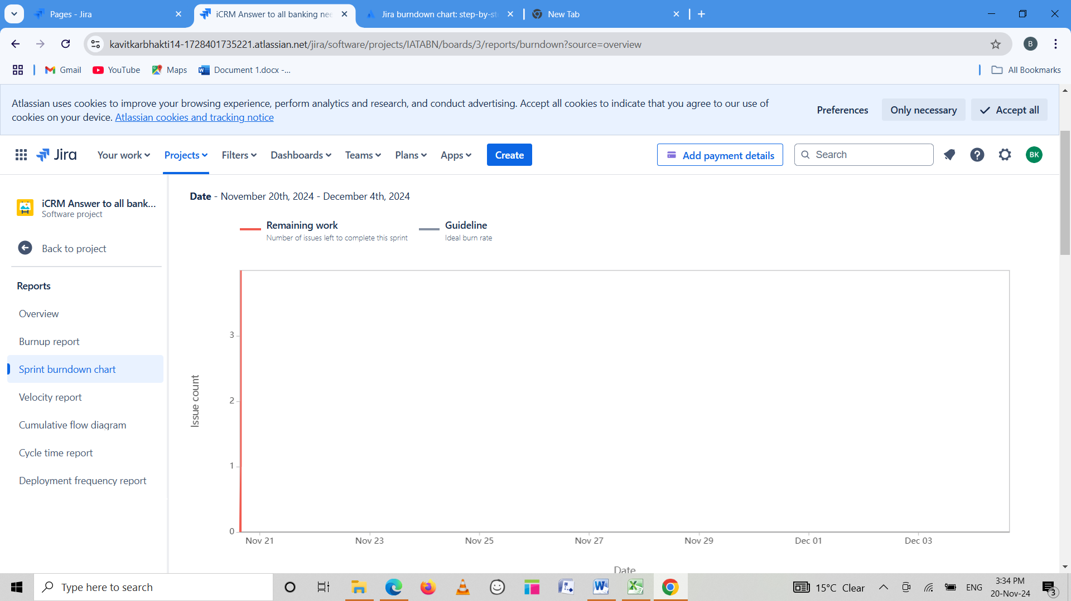

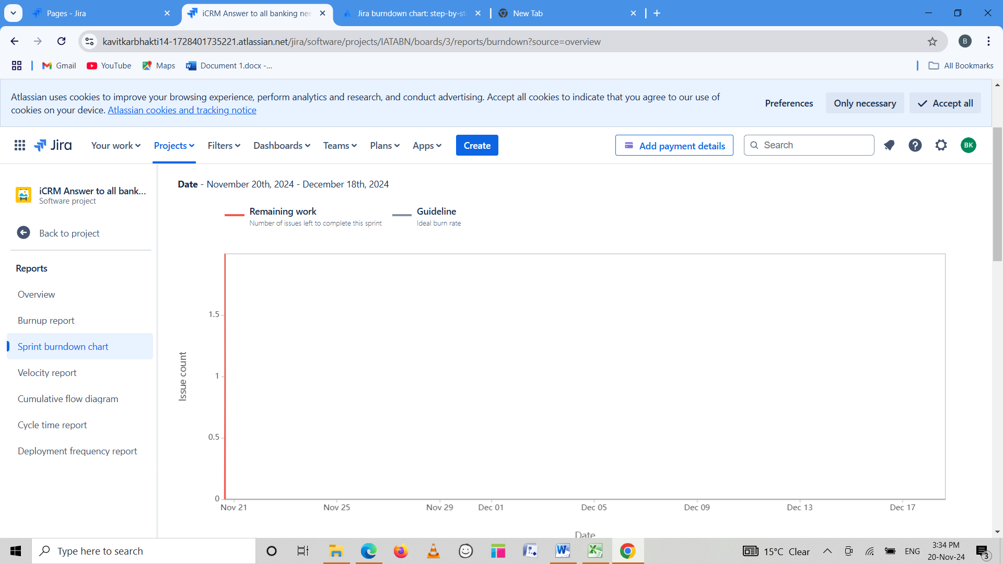

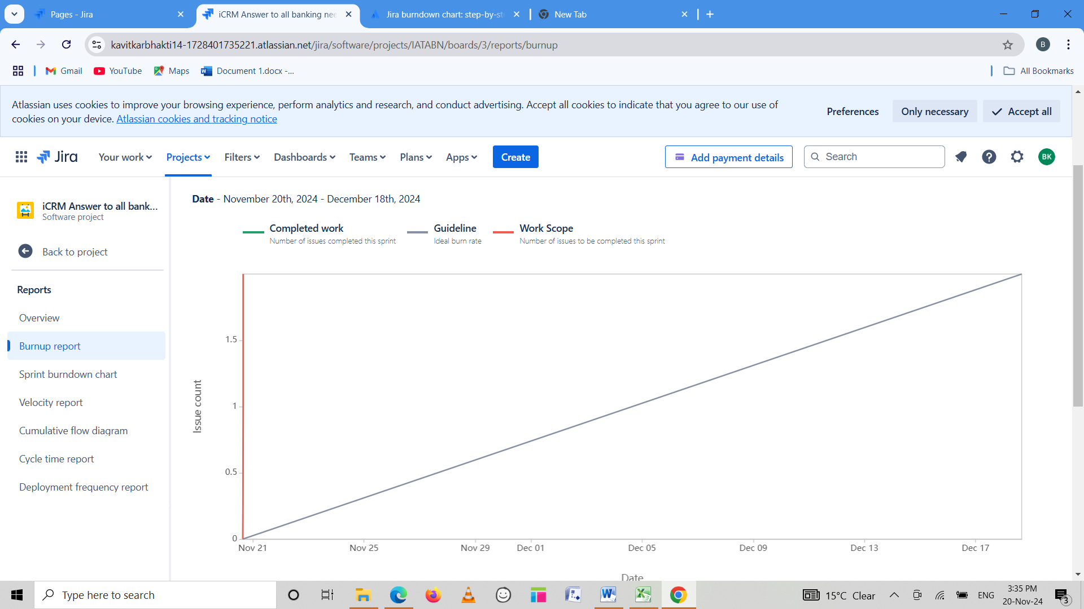

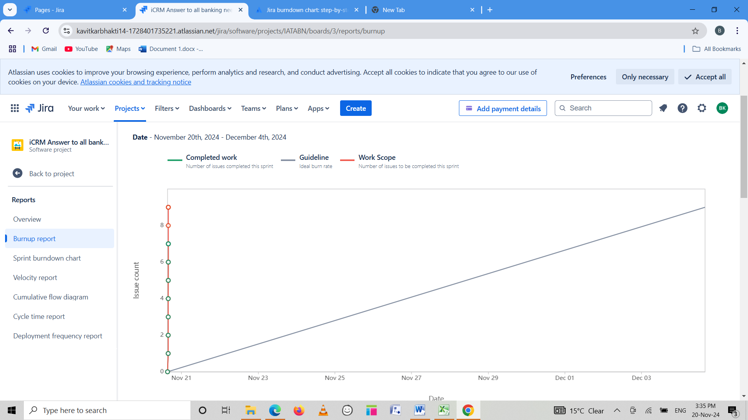

Document 6: Sprint meetings

Meeting Type 1: Sprint planning meeting

|  |  |
| --- | --- |
| Date | 02/05/2024 |
| Time | 10am -12pm |
| Location | ICICI BANK –Bund Garden |
| Prepared By | Mr. Roy |
| Attendees | Mr. Koshy , Mr. Swami , Mr. Will, Ms. Lilly, Mr. Harry |

Agenda Topics

**Agenda with Topics** for the Sprint Planning Meeting:

|  |  |  |
| --- | --- | --- |
| **Topic** | **Presenter** | **Time Allotted** |
| |  | | --- | | **Welcome and Meeting Overview** | | **Previous Sprint Recap** | | **Sprint Goal Definition** | | **Product Backlog Review** | | **User Story Clarifications** | | **Task Breakdown** | | **Effort Estimation** | | **Capacity Planning** | | **Task Assignments** | | **Dependencies and Risks** | | **Confirmation and Wrap-Up** | | |  | | --- | | Scrum Master | | Scrum Master | | Product Owner | | Product Owner | | Product Owner, Team | | Development Team | | Development Team, QA Team | | Scrum Master | | Scrum Master, Team Leads | | Scrum Master, Product Owner | | Scrum Master | | |  | | --- | | 5 minutes | | 10 minutes | | 10 minutes | | 15 minutes | | 15 minutes | | 20 minutes | | 15 minutes | | 10 minutes | | 20 minutes | | 10 minutes | | 5 minutes | |

**Total Duration:** ~2 hours

Other Information

|  |  |
| --- | --- |
| Observers | Mr. Koshy , Mr. Swami |
| Resources | • **Technical Resources:**   * Laptops, monitors, and development environments set up for the sprint. * Access to project management tools (e.g., Jira, Trello).   • **Documents:**   * Updated product backlog. * Previous sprint review report. * Capacity planning worksheet.   • Meeting room (onsite) or Zoom/Teams setup (remote).  • Whiteboard or virtual collaboration tools (e.g., Miro, Mural). |
| Special Notes | Ensure all user stories selected align with the sprint goal and are achievable within the sprint duration. |

Meeting Type 2: Sprint review meeting

|  |  |
| --- | --- |
| Date | 02/01/24 |
| Time | 10am to 11am |
| Location | Pune |
| Prepared By | Mr. Roy |
| Attendees | Mr. Swami , Mr. Will, Mr. Roy, Ms. Lilly |

|  |  |  |  |
| --- | --- | --- | --- |
| Sprint status | Things to demo | Quick updates | What’s next |
| • Summary of completed vs. planned work for the sprint.  • Highlight any unfinished tasks or carryovers to the next sprint.  • Report on metrics (e.g., velocity, burndown chart). | • Demonstrate completed user stories and features.  • Showcase functionality, UI/UX updates, and system performance improvements.  • Gather immediate feedback from stakeholders. | • Discuss challenges encountered during the sprint.  • Share key learning’s and any unexpected outcomes.  • Provide updates on resolved bugs or technical debt. | • Present the focus and goal for the upcoming sprint.  • Highlight high-priority backlog items for the next iteration.  • Identify any new risks, dependencies, or stakeholder requirements. |

Meeting Type 3: Sprint retrospective meeting

|  |  |
| --- | --- |
| Date | 5/1/24 |
| Time | 11am-12am |
| Location | Pune |
| Prepared By | Mr. Roy |
| Attendees | Mr. Koshy , Mr. Swami , Mr. Will, Ms. Lilly, Mr. Harry |

|  |  |  |  |  |
| --- | --- | --- | --- | --- |
| Agenda | What went well | What didn’t go well | Questions | Reference |
| To prepare dashboard | Delivered all planned features on time.  Strong team collaboration during development and testing. | Mid-sprint requirement changes caused delays.  Technical debt accumulated in key components. | Should we revise how we estimate story points?  How can we handle stakeholder communication more efficiently? | Sprint Metrics: Velocity, Burndown chart, or other sprint data to analyze performance.  Sprint Review Notes: Feedback from stakeholders or team members.  Backlog: Items carried over or completed to assess alignment with sprint goals.  . |
|  |  |  |  |  |

Meeting Type 4 : Daily Stand-up meeting

|  |  |  |  |  |  |  |  |  |
| --- | --- | --- | --- | --- | --- | --- | --- | --- |
| Questions | Name/Role | Week"X" 5th Feb - 11th Feb | | | | | | |
|  |  | Monday | Tuesday | Wednesday | Thursday | Friday | Saturday | Sunday |
| What did you do yesterday? | Developer 1 Developer 2 Developer 3 | Created the first half of dashboard | Preparing all generic report tabs | Preparing MOM tabs | Preparing the statement tabs | Preparing credit history tabs | OFF | OFF |
| What will you do today? | Developer 1 Developer 2 Developer 3 | Will focus on clickable items and half of the dashboard | Creating reports dashboard | Recording MOM Record based files | Creating the dashboard for Statement download | Preparing the rekyc tabs. | OFF | OFF |
| What is (if any) blocking your progress? | Developer 1 Developer 2 Developer 3 |  | Format of the report |  |  |  | OFF | OFF |