**Document 1: Definition of Done:**

Definition of Done (DOD) checklist for my project “Implementation of front running alert in ATS system is given below.

**Produced Code for Presumed Functionalities:**

The code developed should fulfill the functionalities outlined in the user stories.

All intended features and scenarios should be implemented as described.

**Assumptions of User Story Met:**

All assumptions and conditions specified in the user stories should be validated and met.

User stories should be reviewed to ensure that all implicit and explicit assumptions are addressed.

**Project Builds Without Errors:**

The project should build successfully in the development environment.  
There should not be any compilation or build errors.

**Unit Tests Written and Passing:**

Unit tests should be created for all new features and functionalities.

All unit tests should pass successfully, ensuring the code behaves as expected.

**Project Deployed on the Test Environment Identical to Production Platform:**

The application which is deployed to a test environment should be the replication of the production setup.

Deployment scripts and procedures should be tested and validated.

**Tests on Devices/Browsers Listed in the Project Assumptions Passed:**

The application should be tested on all specified devices and browsers.

Compatibility and performance tests should be conducted to ensure cross-platform functionality.

**Feature OK-ed by UX Designer:**

The feature should be reviewed and approved by the UX designer.

Design and usability criteria should met, ensuring a positive user experience.

**QA Performed & Issues Resolved:**

Quality Assurance (QA) testing should be completed, including functional, regression, and performance tests.

All identified issues and bugs should be resolved before marking the user story as done.

**Feature Tested Against Acceptance Criteria:**

The feature should be tested thoroughly against the predefined acceptance criteria.

Acceptance tests should be documented and results should be reviewed with the Product Owner.

**Feature OK-ed by Product Owner:**

The Product Owner should review and approve the feature.

Any feedback or changes requested by the Product Owner should be addressed.

**Refactoring Completed:**

Code is refactored to improve readability, maintainability, and performance.

Refactoring should not introduce new bugs or regressions.

**Any Configuration or Build Changes Documented:**

All configuration changes and build processes should be documented.

Documentation should be updated to reflect the current state of the project.

**Documentation Updated:**

User manuals, technical documentation, and help guides should be updated to include new features and changes.

Documentation should be reviewed for accuracy and completeness.

**Peer Code Review Performed:**

Code changes should be peer-reviewed by other developers.

Feedback from code reviews should be incorporated, and any issues raised should be addressed.

**Document 2- Product Vision:**

|  |  |  |  |
| --- | --- | --- | --- |
| **Scrum Project Name** | Implementation of Front Running Alert in ATS | | |
| **Venue** | Meeting Room at Client Location | | |
| **Date** | **Start Time:** | **End Time:** | **Duration:** |
| **Client** | CBA | | |
| **Stakeholder List** | Business Team | Compliance Team of Bank | |
| Trade Desk | |
| Bank Users | |
| Bank Technology Team | Abinitio Team | |
| Scrum Team | Product Owner | |
| Scrum Master | |
| Business Analyst | |
| 2 Kdb Developers | |
| 2 Testers | |
| **Scrum Team** | | | |
| **Scrum Master** | Julian Jacobs | | |
| **Product Owner** | Rahul Ramesh O | | |
| **Kdb Developer 1** | Jaganmayee Sahoo | | |
| **Kdb Developer 2** | Amit Kumar | | |

|  |  |  |  |
| --- | --- | --- | --- |
| **Vision** | **To establish a robust and efficient Front Running Alert mechanism within the Automated Trade Surveillance (ATS) system that ensures proactive detection of potential market abuse, safeguards market integrity, and enhances compliance with regulatory standards by leveraging advanced analytics, real-time data processing, and intuitive dashboards.** | | |
| **Market Segment** Financial institutions in institutional banking and capital markets, focusing on regulatory compliance and trade surveillance and Organizations in regulated markets requiring automated monitoring solutions to prevent market manipulation.   **Target Users** **Primary Users:** Compliance Officers, Trade Surveillance Teams, and Risk Management Professionals at CBA. **Secondary Users:** Regulatory Auditors and IT/Data Teams supporting the ATS system. | **Needs:** -Detects and prevents front running, a type of market manipulation, by analyzing order and trade data in real-time -Addresses gaps in existing trade surveillance systems by providing automated alerts for suspicious activities. -Reduces compliance risks by ensuring adherence to regulatory standards.   **Benefits Provided:** **Enhanced Market Integrity:** Builds trust by identifying and mitigating potential market abuse. **Improved Efficiency:** Automates the detection process, reducing manual efforts and investigation time. **Regulatory Compliance:** Ensures CBA meets local and international trade surveillance requirements. **User-Friendly Insights:** Offers intuitive dashboards for quick and effective alert review and decision-making. | **Product:** The Front Running Alert is a feature integrated into CBA's Automated Trade Surveillance (ATS) system. It is designed to detect and flag potential front running activities by analyzing order and trade data in real-time, ensuring proactive monitoring and compliance.   **What Makes It Desirable and Special?** **Proactive Detection:** Identifies suspicious trading patterns before they escalate into significant risks. **Data-Driven Insights:** Leverages high-performance Kdb and an intuitive Kx dashboard for actionable analytics. **Customization:** Offers configurable thresholds and filters to meet specific regulatory and business requirements. **Streamlined Investigations:** Provides a user-friendly interface with features like date selection for quick alert analysis.  **Is It Feasible to Develop the Product?** **Existing Infrastructure:** Leveraging CBA's ATS system and established data pipelines like MODS and Abinitio. **Technical Capability:** High-performance Kdb and Kx dashboard ensure scalability and real-time processing. **Vendor Expertise:** Luxoft's experience in developing surveillance systems and implementing regulatory solutions for financial institutions. | **How Is the Product Going to Benefit the Company?** -Ensures regulatory compliance and reduces penalties. -Builds trust by enhancing market integrity. -Automates monitoring, cutting costs and manual efforts. -Mitigates financial and reputational risks.    **What Are the Business Goals?** -Ensure regulatory compliance. -Reduce risks of market manipulation. -Improve monitoring efficiency and accuracy. -Strengthen client trust through robust surveillance.    **What Is the Business Model?** -Use existing ATS infrastructure for cost efficiency. -Avoid fines through compliance-driven ROI. -Provide a scalable system for future needs. -Regularly optimize based on market and regulatory changes. |

**Document 3: User stories:**

I have created 15 user stories as below.

|  |  |  |
| --- | --- | --- |
| **User Story No: 1** | **Task:** Display Alert in Kx Dashboard | **Priority: High** |
| **As a Trade Analyst,** I want to view a list of front running alerts on the Kx Dashboard, so I can quickly identify suspicious trading activities. | | |
| **BV: 500** | **CP: 13** |  |
| **Acceptance Criteria:**  **Display Alerts:**   * The Kx Dashboard must display a list of front-running alerts in a tabular format. * Each alert should include the following details:   + Alert ID   + Order ID   + Trade ID   + Timestamp   + Suspicious Activity Indicator   + Trader ID (or Entity)   + Order and Trade Volume   + Order and Trade Price   + Other relevant metadata (e.g., Market or Instrument). | | |

|  |  |  |
| --- | --- | --- |
| **User Story No: 2** | **Task:** Customization of Kx Dashboard | **Priority: Medium** |
| **As a Trade Analyst,** I want to filter alerts by date range, so I can focus on a specific time period for my investigation. | | |
| **BV: 200** | **CP: 5** |  |
| **Acceptance Criteria:**   * **Date Range Selection:**   Provide a date picker to select a start and end date for filtering alerts.   * **Default Display:**   Show the most recent day’s alerts when no date range is selected.   * **Filtered Results:**   Display only alerts that fall within the selected date range.   * **Validation:**   Ensure the selected start date is earlier than or equal to the end date.   * **Real-Time Update:**   Refresh the displayed alerts dynamically based on the selected date range. | | |

|  |  |  |
| --- | --- | --- |
| **User Story No: 3** | **Task:** Trade and Order Data checking | **Priority: High** |
| **As a Trade Analyst,** I want to view detailed trade and order data for each alert, so I can analyze the underlying patterns. | | |
| **BV: 500** | **CP: 13** |  |
| **Acceptance Criteria:**   * **Drill-Down View:**   Each alert must provide a drill-down feature to view detailed trade and order data.   * **Data Details:** * Include the following information:   + Order ID, Trade ID, Timestamp   + Trader ID, Instrument, Market   + Order and Trade Volume, Price   + Execution details (e.g., counterparty, trade type). * **Navigation:**   Allow users to return to the main alert list after viewing details.   * **Data Accuracy:**   Ensure the detailed data matches the source ATS system records.   * **Performance:**   Load detailed data within 2 seconds of selecting an alert. | | |

|  |  |  |
| --- | --- | --- |
| **User Story No: 4** | **Task:** Exporting the report | **Priority: Medium** |
| **As a Trade Analyst,** I want to export alert details in a report format, so I can share findings with my team or regulators. | | |
| **BV: 200** | **CP: 8** |  |
| **Acceptance Criteria:**   * **Export Functionality:**   Provide an option to export alert details in commonly used formats (e.g., CSV, Excel, PDF).   * **Customizable Export:**   Allow users to select specific alerts or filter criteria for the export.   * **Report Contents:**   Include relevant alert details:   * + Alert ID, Order ID, Trade ID, Timestamp   + Trader ID, Volume, Price, Severity Level   + Market/Instrument details. * **Formatting:**   Ensure the report is well-structured and readable, with clear headers and data alignment.   * **Access Control:**   Restrict export functionality to authorized users.   * **Performance:**   Generate and download the report within 5 seconds. | | |

|  |  |  |
| --- | --- | --- |
| **User Story No: 5** | **Task:** Status marking of alerts | **Priority: Medium** |
| **As a Trade Analyst,** I want to mark alerts as reviewed or under investigation, so I can track their status effectively. | | |
| **BV: 100** | **CP: 5** |  |
| **Acceptance Criteria:**   * **Mark Status:**   Provide options to mark alerts as **Reviewed** or **Under Investigation**.   * **Status Update:**   Ensure the alert status can be updated directly from the dashboard.   * **Visual Indicators:**   Display distinct visual markers (e.g., icons or color codes) for each status.   * **Filter by Status:**   Allow filtering of alerts based on their status.   * **Audit Trail:**   Log status changes with details such as the user who made the update and timestamp. | | |

|  |  |  |
| --- | --- | --- |
| **User Story No: 6** | **Task:** Alert notification | **Priority: High** |
| **As a Compliance Officer,** I want to receive notifications for high-priority front running alerts, so I can take immediate action. | | |
| **BV: 500** | **CP: 5** |  |
| **Acceptance Criteria:**   * **Notification Triggers:**   Send notifications for high-priority alerts based on predefined criteria.   * **Delivery Channels:**   Provide notifications via email and/or dashboard alerts.   * **Content Details:**   Include Alert ID, Timestamp, Severity, Trader ID, and Instrument in the notification.   * **Timeliness:**   Deliver notifications within 1 minute of alert generation.   * **Access Control:**   Ensure only Compliance Officers receive these notifications. | | |

|  |  |  |
| --- | --- | --- |
| **User Story No: 7** | **Task:** Front running alert summary | **Priority: High** |
| **As a Compliance Officer,** I want to access a summary of front running trends, so I can identify recurring patterns and mitigate risks. | | |
| **BV: 200** | **CP: 3** |  |
| **Acceptance Criteria:**   * The summary should display aggregated front-running alerts grouped by key attributes (e.g., trader, instrument, time period). * Trends must be visualized using graphs or charts (e.g., line, bar). * The summary must update in near real-time as new alerts are generated. | | |

|  |  |  |
| --- | --- | --- |
| **User Story No: 8** | **Task:** Configuring thresholds (Amount/Time Window) | **Priority: High** |
| **As a Compliance Officer,** I want to configure thresholds for triggering alerts, so the system aligns with regulatory requirements. | | |
| **BV: 500** | **CP: 5** |  |
| **Acceptance Criteria:**   * The system should allow configuration of thresholds for time intervals, price deviation, and volume percentage. * Thresholds must be editable through a user-friendly interface. * Changes to thresholds must be logged with timestamps and user details for audit purposes. * The system should validate inputs to ensure thresholds are within permissible ranges. * Alerts must reflect the updated thresholds immediately after configuration changes. | | |

|  |  |  |
| --- | --- | --- |
| **User Story No: 9** | **Task:** Regulatory report generation | **Priority: Medium** |
| **As a Compliance Officer,** I want to generate regulatory compliance reports based on front running alerts, so I can demonstrate adherence to authorities. | | |
| **BV: 200** | **CP: 5** |  |
| **Acceptance Criteria:**   * Reports must include key details: alert ID, trader, instrument, timestamp, threshold breached, and alert status. * The system should allow selecting a date range and filtering by trader or instrument for report generation. * Reports must be exportable in regulatory-compliant formats (e.g., PDF, Excel). * The system should maintain a history of generated reports for at least 12 months. * Each report must display a unique identifier and generation timestamp for traceability. | | |

|  |  |  |
| --- | --- | --- |
| **User Story No: 10** | **Task:** Auditing the history of alerts | **Priority: Medium** |
| **As a Compliance Officer,** I want to audit the history of alerts and their resolution, so I can ensure accountability and transparency. | | |
| **BV: 100** | **CP: 5** |  |
| **Acceptance Criteria:**   * The system must display a log of all alerts, including alert ID, timestamp, trader, instrument, threshold breached, and status (e.g., pending, resolved). * Each alert entry should include resolution details such as action taken, resolution timestamp, and the responsible user. * The system must support filtering and sorting by date, status, trader, and instrument. * Audit logs must be immutable and retain data for a minimum of 24 months. * An export option should be available for audit logs in CSV and PDF formats. | | |

|  |  |  |
| --- | --- | --- |
| **User Story No: 11** | **Task:** Validation of Abinitio ingestion | **Priority: Low** |
| **As a Bank User** I want to validate that all data from Abinitio is accurately ingested into the ATS system, so I can ensure data integrity. | | |
| **BV: 50** | **CP: 3** |  |
| **Acceptance Criteria:**   * The system must log all data ingested from Abinitio with timestamps and record counts. * A validation process should compare ingested data against source data to ensure completeness and accuracy. * The system should provide a summary of ingestion validation results, including success and error metrics. * Logs and validation results must be retained for audit purposes for at least 12 months. | | |

|  |  |  |
| --- | --- | --- |
| **User Story No: 12** | **Task:** Performance testing under high data loads | **Priority: Medium** |
| **As a Bank User,** I want to test the performance of the Front Running Alert system under high data loads, so I can ensure reliability. | | |
| **BV: 100** | **CP: 5** |  |
| **Acceptance Criteria:**   * The system must process at least 10 transactions per second under high data load conditions without performance degradation. * Alerts should be generated within a maximum of 10 seconds from data ingestion under high data loads. * The system must maintain a response time of less than 10 seconds for dashboard queries during stress testing. * Error rates during high-load scenarios must not exceed 5% of total transactions. * A detailed performance report must be generated post-test, including metrics such as throughput, latency, and error rate. | | |

|  |  |  |
| --- | --- | --- |
| **User Story No: 13** | **Task:** Checking regulatory compliance | **Priority: High** |
| **As a Bank User,** I want to review the system’s compliance with regulatory standards, so I can ensure it meets legal requirements. | | |
| **BV: 200** | **CP: 5** |  |
| **Acceptance Criteria:**   1. The system must provide a compliance checklist mapped to applicable regulatory standards. 2. A compliance summary report should highlight areas of adherence and non-compliance. 3. Reports must include details such as regulatory requirements, implemented controls, and gaps, if any. 4. The system should allow users to attach evidence or comments to compliance checkpoints for review. 5. Compliance reports must be exportable in standard formats (e.g., PDF) and retained for a minimum of 24 months. | | |

|  |  |  |
| --- | --- | --- |
| **User Story No: 14** | **Task:** Training for dashboard features | **Priority: Medium** |
| **As a Bank User,** I want to have a dashboard training session, so I can understand its features and use it effectively. | | |
| **BV: 200** | **CP: 8** |  |
| **Acceptance Criteria:**   * The training session must cover all key dashboard features, including navigation, filtering, and report generation. * The session should include a hands-on demonstration with real or simulated data. * Users must receive a training manual or quick reference guide post-session. * A Q&A segment must be included to address user-specific queries. * Feedback from participants should be collected to assess the training's effectiveness and identify improvement areas. | | |

|  |  |  |
| --- | --- | --- |
| **User Story No: 15** | **Task:** Tracking project progress | **Priority: Medium** |
| **As a Bank User,** I want to monitor implementation progress and receive regular updates, so I can track the project’s alignment with business goals. | | |
| **BV: 200** | **CP: 3** |  |
| **Acceptance Criteria:**   * Jira should provide a progress displaying key milestones, current status, and completion percentages. * Updates must include details on tasks completed, in progress, and pending, along with timelines. * Notifications or email updates should be sent weekly, summarizing progress and any risks or delays. * A download option for progress reports should be available in PDF and Excel formats. | | |

|  |  |  |
| --- | --- | --- |
| **User Story No: 16** | **Task:** Core detection logic | **Priority: High** |
| **As a system**, I want to implement the core detection logic for front running pattern so I can generate the alert if it found in the order and trade data. | | |
| **BV: 500** | **CP: 13** |  |
| **Acceptance Criteria:**   * Analyze order and trade data * Find out the patterns which breached threshold time window, asset type, order and trade price, order and trade volume * Generate alert for these trades to display in the Kx dashboard * Create logs for found patterns | | |

**Document 4: Agile PO Experience:**

**Document 5: Product and sprint backlog and product and sprint burndown charts:**

**Product Backlog:**

|  |  |  |  |  |  |  |
| --- | --- | --- | --- | --- | --- | --- |
| **User story ID** | **User Story** | **Tasks** | **Priority** | **BV** | **CP** | **Sprint** |
| US001 | As a Trade Analyst, I want to view a list of front running alerts on the Kx Dashboard, so I can quickly identify suspicious trading activities. | Display Alert in Kx Dashboard | High | 500 | 13 | S1 |
| US002 | As a Trade Analyst, I want to filter alerts by date range, so I can focus on a specific time period for my investigation. | Customization of Kx Dashboard | Medium | 200 | 5 | S2 |
| US003 | As a Trade Analyst, I want to view detailed trade and order data for each alert, so I can analyze the underlying patterns. | Trade and Order Data checking | High | 500 | 13 | S1 |
| US004 | As a Trade Analyst, I want to export alert details in a report format, so I can share findings with my team or regulators. | Exporting the report | Medium | 200 | 8 | S2 |
| US005 | As a Trade Analyst, I want to mark alerts as reviewed or under investigation, so I can track their status effectively. | Status marking of alerts | Medium | 100 | 5 | S2 |
| US006 | As a Compliance Officer, I want to receive notifications for high-priority front running alerts, so I can take immediate action. | Alert notification | High | 500 | 5 | S1 |
| US007 | As a Compliance Officer, I want to access a summary of front running trends, so I can identify recurring patterns and mitigate risks. | Front running alert summary | High | 200 | 3 | S1 |
| US008 | As a Compliance Officer, I want to configure thresholds for triggering alerts, so the system aligns with regulatory requirements. | Configuring thresholds (Amount/Time Window) | High | 500 | 5 | S2 |
| US009 | As a Compliance Officer, I want to generate regulatory compliance reports based on front running alerts, so I can demonstrate adherence to authorities. | Regulatory report generation | Medium | 200 | 5 | S3 |
| US010 | As a Compliance Officer, I want to audit the history of alerts and their resolution, so I can ensure accountability and transparency. | Auditing the history of alerts | Medium | 100 | 5 | S3 |
| US011 | As a Bank User I want to validate that all data from Abinitio is accurately ingested into the ATS system, so I can ensure data integrity. | Validation of Abinitio ingestion | Low | 50 | 3 | S4 |
| US012 | As a Bank User, I want to test the performance of the Front Running Alert system under high data loads, so I can ensure reliability. | Performance testing under high data loads | Medium | 100 | 5 | S3 |
| US013 | As a Bank User, I want to review the system’s compliance with regulatory standards, so I can ensure it meets legal requirements. | Checking regulatory compliance | High | 200 | 5 | S2 |
| US014 | As a Bank User, I want to have a dashboard training session, so I can understand its features and use it effectively. | Training for dashboard features | Medium | 200 | 8 | S4 |
| US015 | As a Bank User, I want to monitor implementation progress and receive regular updates, so I can track the project’s alignment with business goals. | Tracking project progress | Medium | 200 | 3 | S4 |
| US016 | As a system, I want to implement the core detection logic for front running pattern so I can generate the alert if it found in the order and trade data | Core detection logic | High | 500 | 13 | S1 |

**Sprint Backlog (For 2 sprints):**

|  |  |  |  |  |
| --- | --- | --- | --- | --- |
| **User story ID** | **User Story** | **Owner** | **Status** | **Estimated Effrots** |
| US001-S1 | As a Trade Analyst, I want to view a list of front running alerts on the Kx Dashboard, so I can quickly identify suspicious trading activities. | Trade Analyst Desk |  | 13 |
| US003-S1 | As a Trade Analyst, I want to view detailed trade and order data for each alert, so I can analyze the underlying patterns. | Trade Analyst Desk |  | 13 |
| US006-S1 | As a Compliance Officer, I want to receive notifications for high-priority front running alerts, so I can take immediate action. | Compliance Team |  | 5 |
| US007-S1 | As a Compliance Officer, I want to access a summary of front running trends, so I can identify recurring patterns and mitigate risks. | Compliance Team |  | 3 |
| US016-S1 | As a system, I want to implement the core detection logic for front running pattern so I can generate the alert if it found in the order and trade data | Business Logic (Business Team) |  | 13 |
| US002-S2 | As a Trade Analyst, I want to filter alerts by date range, so I can focus on a specific time period for my investigation. | Trade Analyst Desk |  | 5 |
| US004-S2 | As a Trade Analyst, I want to export alert details in a report format, so I can share findings with my team or regulators. | Trade Analyst Desk |  | 8 |
| US005-S2 | As a Trade Analyst, I want to mark alerts as reviewed or under investigation, so I can track their status effectively. | Trade Analyst Desk |  | 5 |
| US008-S2 | As a Compliance Officer, I want to configure thresholds for triggering alerts, so the system aligns with regulatory requirements. | Compliance Team |  | 5 |
| US013-S2 | As a Bank User, I want to review the system’s compliance with regulatory standards, so I can ensure it meets legal requirements. | Compliance Team |  | 5 |

**Product Burndown chart** can be prepared in paid version of Jira, so I just attached the screenshot of product backlog and sprint backlog here as below from Jira.

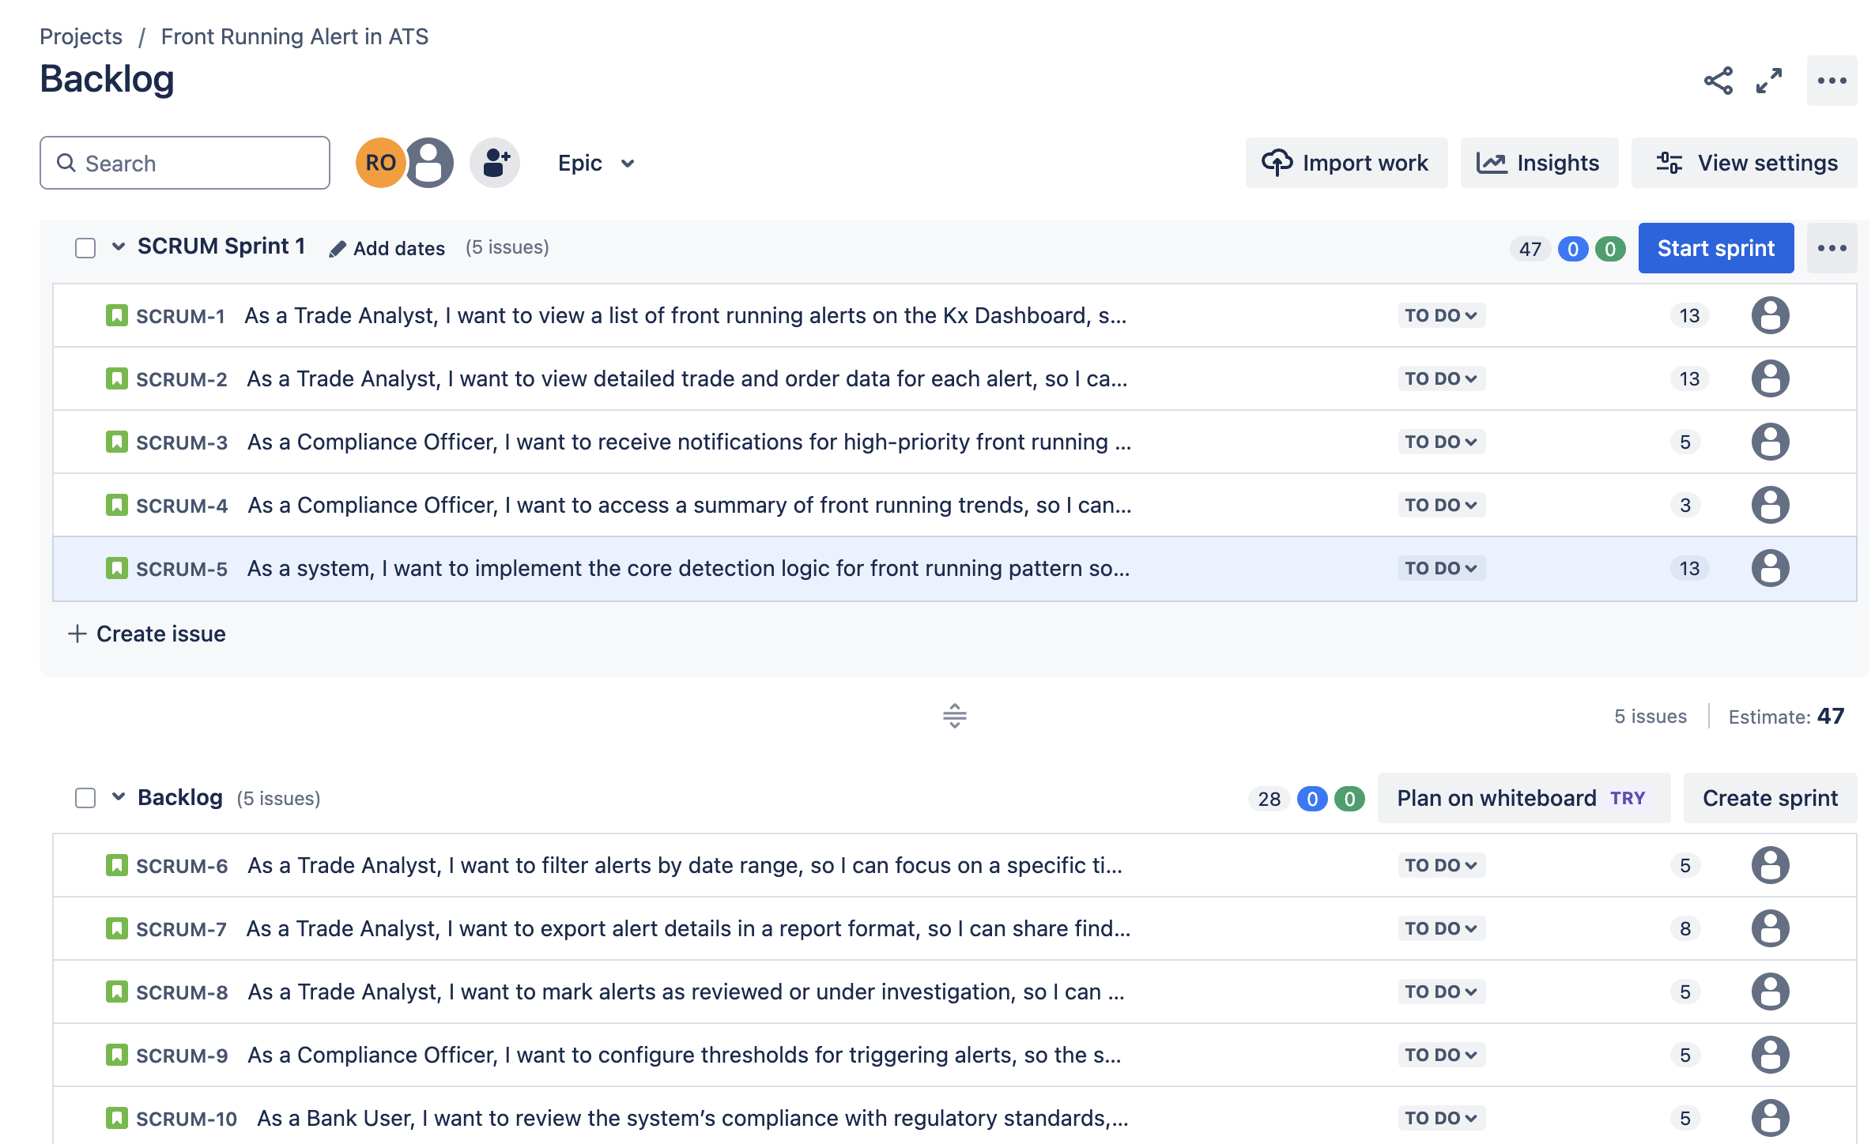

**Sprint Burndown Chart:**

Sprint burndown chart for the Sprint-1 is attached below from Jira software. Except one story with 3 CPs, all other stories are completed in the first sprint. Incomplete story is moved to next sprint.

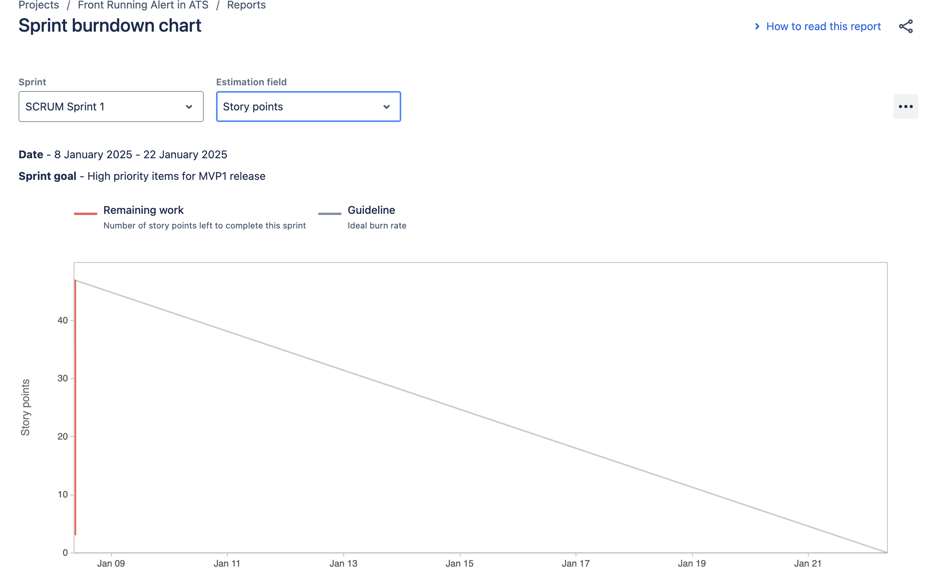

**Velocity Report:**

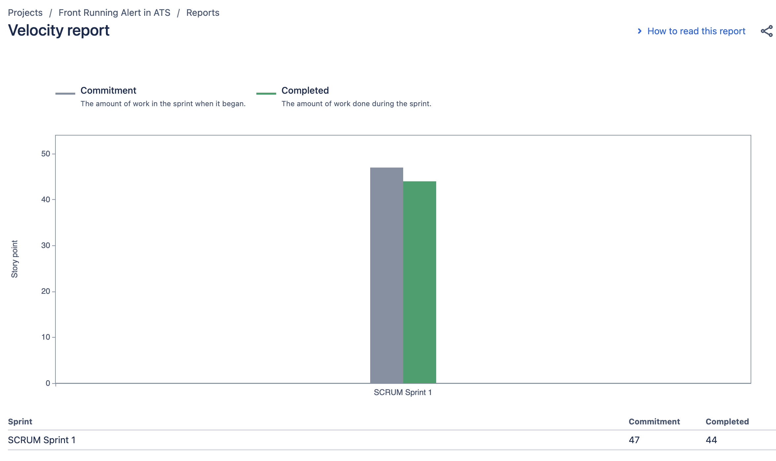

**Burnup Chart:**

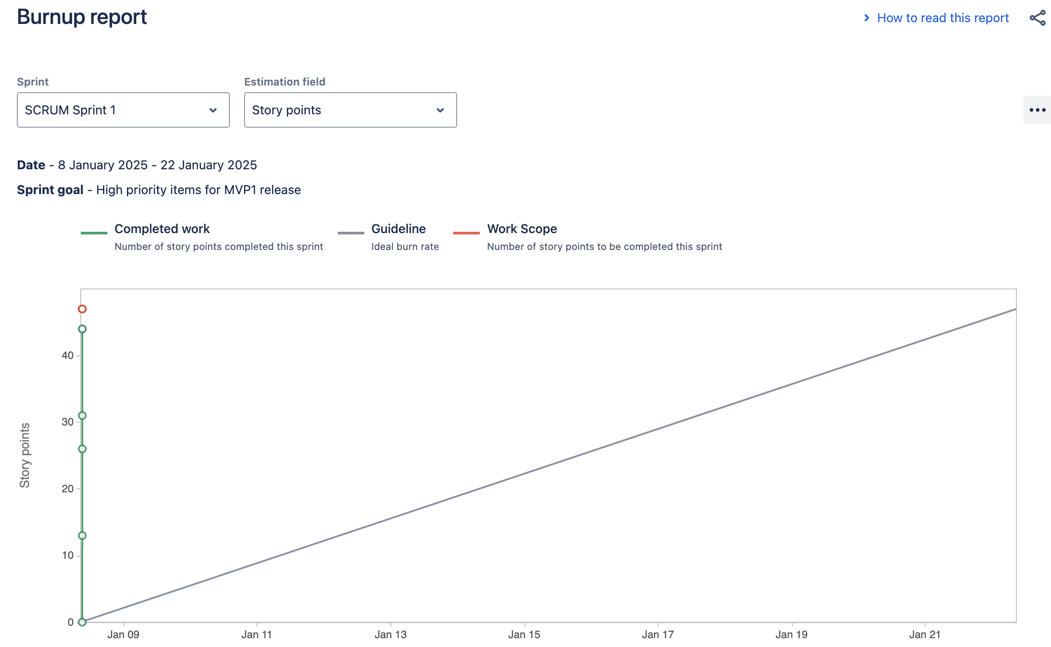

**Document 6: Sprint meetings:**