Question 1. What is your knowledge on how these Audits will happen for a BA?

Ans: Internal audit checks how well a company maintains operational efficiency and manages accounting processes while complying with its standard rules and regulations. Conducting audits from time to time ensures the firms are strict enough in following the administrative fundamentals and sticking to a maximum accuracy rate so far as financial reporting is concerned.

For a BA, Internal audits will go through the

-Are the project is progressing with the company’s objective or not.

- whether various risks are being managed effectively by BA.

-Are the process are being followed properly by BA.

-What all process can be improved are being suggested.

Question 2. BA strategy

ANS: The steps I would need to start with to complete this project are:

Business requirement initiation (gathering stage), Identifying the stakeholders through the ILS. i.e., Identify the stakeholders, List the stakeholders, summarize the stakeholder.

Business stakeholders-Mr. Henry, Mr. Pandu and MR. Dooku Peter, Kevin, and Ben.

Project stakeholders- Project Manager - Mr Vandanam Senior Java Developer - Ms. Juhi Java Developers Mr.Teyson, Ms.Lucie, Mr. Tucker, Mr. Bravo Network Admin ,Mr. Mike DB Admin Mr. John. Testers – Mr.Jason and Ms. Alekya BA – You

3rd party stakeholder- Peter, Kevin, and Ben

-Applying elicitation technique to gather requirements from these stakeholders for the project. For this of projects we will apply interviews like it can take the interview either it in individual or groups .so that actual need of the stakeholders are being collected. we can do the group interview for collecting relevant information about the project.

Also, we can use brainstorming sessions for better understanding of requirements

-Ideation- we can list out ideas to convert BRD to FRD.

Prioritize the requirement.

We will apply MOSCOW technique to prioritize the requirement from the client. So that we can reach toa mutual understanding with the stakeholder on the importance of each requirement.

M is Must for the project scope.

S is should be for the project.

C is could be for the project.

W is as per for the future aspect of the project.

Question3 – 3-Tier Architecture?

Ans: Three-tier architecture is a well-established software application architecture that organizes applications into three logical and physical computing tiers: the Business logic layer; the application tier, where data is processed and the data tier, where the data associated with the application is stored and managed.

pages, screens, validations on pages

 ----------------------------Application layer--------------------------

All reusable components, frequently changing components, governing body rules and regulations. Ex-printer, payment gateways.

--------------------------In Business logic layer----------------------- Data base components connecting to databases.

-------------------------------Data Layer---------------------------------

Question 4 – BA Approach Strategy for Framing Questions

Ans: Before framing question, we should take care 5W 1H

For gathering information from the stakeholder, we should use the 5W1H. ie

-What is this product.

-Why this project was initiated.

-who are the benefited from this project.

-where did requirement was spotted.

-when will the project get initiated

-how we should be doing the project.

Next we should check whether the requirement collected is being SMART or not.

i.e

Specific

Measurable

Attainable

Realistic

Timebound

Then while preparing question we need to figure out who comes under which category so we use the RACI Matrix.i.e responsible ,accountable, consultant and informed.

Then we will prepare 3tier architecture under which we will be categorizing in 3 different stages

-Application layer, business logic layer and data layer.

-then we will prepare to identify the requirement. Use case is prepare to know how external system is interacting with the system.

While preparing use case we will be looking at use case specs.i.e use case specification. under which we need to categorize the requirements gathered under basic flow and alternative flow. An activity diagram is drawn to model how the system should function in order to achieve Business Logic, Business Functionality and Business Objectives. Activity diagram is basically a fow chart to represent the fow form one activity to another activity. We will use either use case or activity to prepare the model the requirements.

Question5. – Elicitation Techniques?

Ans:

a. Document Analysis: Document analysis is done through reading a document and understanding the product, process and project.

b. Reverse Engineering also called back engineering, is the processes of extracting knowledge or design information from anything man-made and reproducing it or re-producing anything based on the extracted information.

c. Focus Groups A focus group is a means to elicit ideas and attitudes about a specific product, service or opportunity in an interactive group environment.

d. Observations Observing, shadowing users or doing a part of their job, can provide information of existing processes, inputs and outputs.

e. Workshop A requirement workshop is a structured approach to capture requirements. A workshop may be used to scope, discover, define, prioritize and reach closure on requirements for the target system.

f. JAD (Joint Application Development) Application developed through JAD has higher customer satisfaction and less number of errors as user is directly involved in the development process.

g. Interview-An interview is a systematic approach where interviewee is going to ask relevant questions related to software and documenting the responses.

H. Prototyping: Prototyping is an attractive idea for complicated and large systems for which there is no manual process or existing system to help determining the requirements.

I. Survey/ Questionnaire: Questionnaire can be useful for obtaining limited system requirements details form the users/ stakeholders, who have minor input or are geographically remote.

j. Brainstorming- Brainstorming is an effective way to generate lots of ideas on a specific issue and then determine which idea is the best solution.

Question 6. Which Elicitation Techniques can be used in this Project and Justify your selection of Elicitation Techniques?

Ans: Brainstorming can be used in this project because this type of project is completely new so understanding the requirement sitting together what possible needs of the farmers and to make it a user- friendly we need the client too. We can have multiple ideas coming from other side would also add helping hand to the project.

Question 7 .10 Business Requirements.

Ans:

BR001 – Farmers should be able to search for available products in fertilizers, seeds, pesticides.

BR002 – Manufacturers should be able to upload and display their products in the application.

BR003- A Farmer should be able to browse through the products catalogue once they visit the website.

BR004- The website should have a search option so that they can search for any product they need.

BR005- Everyone should be able to log in to the website as the users.

BR006- A product catalogue of fertilizers, seeds, pesticides, and a search option to search for products, payment process, and delivery tracking should be there.

BR007-Any farmer wants to buy any product or add them to buy-later list, they need to do the login first using their email id and password.

BR008- The new user should be able to create a new account by submitting their email ID and creating a secure password.

BR009-If a Farmers wants to purchase, they should have an easy-to-use payment gateway which should include cash-on-delivery (COD), Credit/Debit card and UPI options.

BR010-The user should get an email confirmation regarding their order status. A delivery tracker to track the whereabouts of their order.

Question 8. Assumptions: The assumptions for the project are

-Application built for the project will deliver the product to farmers in quick time.

-The manufactures would be able to look at mostly ordered items and can able to maintain stocks by knowing it.

-In offline mode the farmers can track the orders.

-The website would require very less maintenance.

Question 9. – This project Requirements Priority.

|  |  |  |  |
| --- | --- | --- | --- |
| REQ ID | REQ NAME | REQ DESCRIPTION | PRIORITY |
| BR001 | Farmer search for products | Farmers should be able to search for available products in fertilizers, seeds, pesticides | 8 |
| BR002 | Manufacturers upload their products | Manufacturers should be able to upload and display their products in the application. | 6 |
| BR003 | Farmers browse through the products | A Farmer should be able to browse through the products catalogue once they visit the website. | 7 |
| BR004 | Website search option | The website should have a search option so that they can search for any product they need. | 4 |
| BR005 | Everyone can do logins on website | Everyone should be able to log in to the website as the users. | 1 |
| BR006 | Product catalogue and search option in website | A product catalogue of fertilizers, seeds, pesticides, and a search option to search for products, payment process, and delivery tracking should be there. | 3 |
| BR007 | Farmers need to login to order | Any farmer wants to buy any product or add them to buy-later list, they need to do the login first using their email id and password. | 5 |
| BR008 | For new user create accounts | The new user should be able to create a new account by submitting their email ID and creating a secure password. | 9 |
| BR009 | For purchasing items payment gateway | If a Farmers wants to purchase, they should have an easy-to-use payment gateway which should include cash-on-delivery (COD), Credit/Debit card and UPI options. | 10 |
| BR010 | E-mail confirmation regarding order status | The user should get an email confirmation regarding their order status. A delivery tracker to track the whereabouts of their order. | 2 |

Question 10: Use case diagram

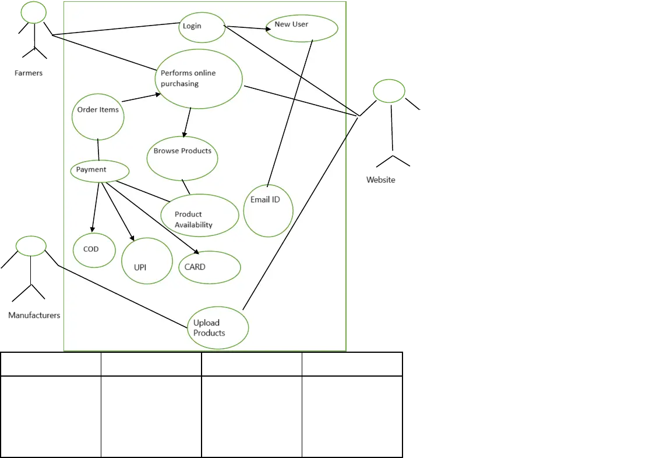

Question 11: Prepare Use case specs for all use cases

Ans: (1)

Use case spec-Login

Description-username, password

Actors-Farmers, website

Preconditions-active internet connection,2.browser compatible

Postconditions-home page should be displayed

Basic flows: username and password is correct

Alternate flow: password is wrong

User name is wrong

Username and password is wrong

Exceptional flow: forget password

Forget username

Assumptions: users have basic computer knowledge, English

Constraints: usernames cannot be special character

Dependents: user should exist-registered done

Inputs: username an password

Output: status flag or error code.

Business rules-username should use valid mai ld password should use special character

Mis information-interactive design and browser compatible

2)

Use case spec-Order items

Description-add to cart, purchase

Actors: farmers, website

Preconditions: active internet connection, browse through different products

Postcondition: able to add items to cart and directed to payment page.

Basic flow: items selected are correctly captured by the system.

Alternative flow: wrong items captured while adding to cart.

Exceptional flow: While adding to cart different pages pops out.

(3)New user Use case spec-New user

Description-registration and email Verification

Actors-Farmers, website

Preconditions-active internet connection,2.have gmail account  
Postconditions-able to register and login to website

Basic flows: otp verification and gmail verification done

Alternate flow: OTP is not going to the number Verification mail is not going to the mail Otp and verification mail not going to the mail

Exceptional flow: gmail account not there Number out of service

Assumptions: users have basic mobile knowledge, have a gmail account

Constraints: both mobile and gmail need to verified to do the registration

Dependents: user should have gmail and number to be linked

Inputs: OTP and Gmail

Output: registration done and able to login the website

Business rules-username should use valid maild password should use special character

Mis information-interactive design and browser compatible.

(4)upload products

Use case spec-upload products

Description-track item, refill stock

Actors-manufacturers, website

Preconditions-stock replenishment data to be generated, easy controlling of website

Postconditions-stock are available all the time for demanded products

Basic flows: stock information is provided correctly

Alternate flow: stock information is not provided correctly

Exceptional flow: takes more time show stock data No control on the data

Assumptions: manufacturers gets notified about the stock of products.

Constraints: stock cannot be refilled for just one product

Dependents: if order is there the stock are being met

Inputs: refill signal goes to manufacturer

Output: product available or not available

Business rules-once all old stock is finished then only new stocks will be come.

Mis information-interactive design and browser compatible.

(5) Use case spec-Payment

Description-card details, Payment option

Actors-farmers, website

Preconditions-the item to be in the cart

Postconditions-the farmer to be able to make payment through UPI card or cod

Basic flows: able to make payment

Alternate flow: not able to make payment

Exceptional ow: card blocked UPI not registered

Assumptions: have basic knowledge about using cards, know how to make UPI payments.  
Constraints: from gpay cannot make payment

Dependents: orders need to be in cart

Inputs: card details

Output: payment gateway or error page

Business rules-card should be either visa or maestro.

Mis information-interactive design and browser compatible

Question 12: Activity Diagrams

Answer: An activity diagram is a behavioral diagram in UML that models the flow from one activity to another activity.

1. User Registration
2. Search Products
3. Add Products to the cart
4. Making Payment
5. Delivery

