**Question 1 .Functional Requirements**

|  |  |  |
| --- | --- | --- |
| Req ID | Request name | Request description |
| FR0001 | Farmer registration | Farmer should be able to  register with application |
| FR0002 | Farmer login | Farmer should be able to login to the portal |
| FR0003 | Product search | Farmer should be able to search the product |
| FR0004 | Item wishlist | Farmer should be able to wishlist the item for late purchase |
| FR0005 | Adding to cart | Farmer should able to add the item to cart before completing the payment |
| FR0006 | Delivery address updation | Farmers should be able to add / edit delivery address  before buying the products. |
| FR0007 | Payment mode selection | Farmers should be able to select payment options fromCOD/ Debit card / credit card  /net banking / UPI |
| FR0008 | Save default payment mode for quick payment | Farmers should be able to save default payment option for future quick payment |
| FR0009 | Save card details for quick payment | Farmers should be able to save card details for quick payment in the next order. |
| FR0010 | ORDER CONFIRMATION ALERT | FARMER should receive order confirmation details on |
| FR0011 | Payment failure | Farmers should be able to re-process the order if payment failed on the last screen. |
| FR0012 | Delivery tracking | Farmer should be able to track the order |
| FR0013 | Delivery alerts | Farmers should get alerts of shipment delivery on mobile OR Email. |
| FR0014 | option for repeat order | Farmer should be able to repeat the same order in  future; |
| FR0015 | Rate and Reviews | Farmers should be able to give rating and reviews on  their orders |
| FR0016 | Manufacture registration | Manufacturer should be able to create his account with product details |
| FR0017 | Update product list | Manufacturer should be able to update the product ist |
| FR0018 | Product database updation | Product database should get 6 updated as and when new product bought / order  canceled / new product |

**Question 2–Minimum 5 page designs**

**Make wireframe and prototypes**

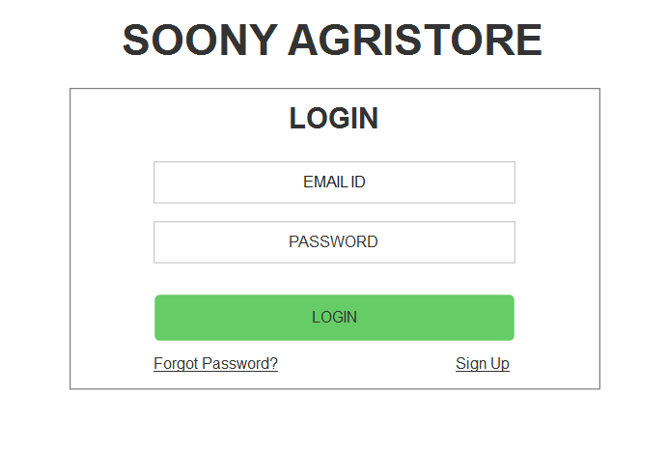

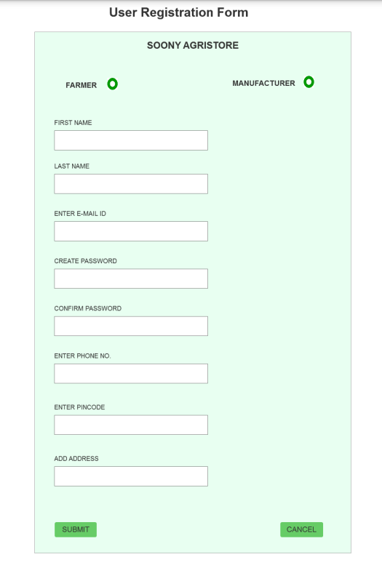

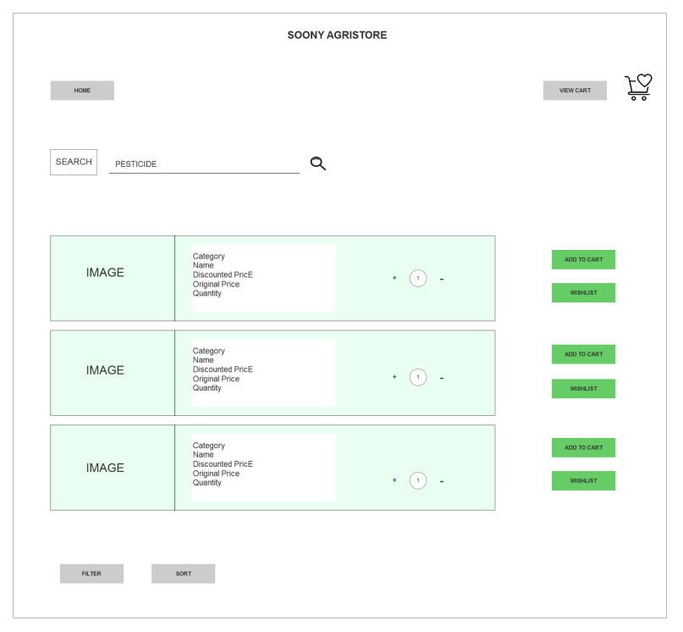

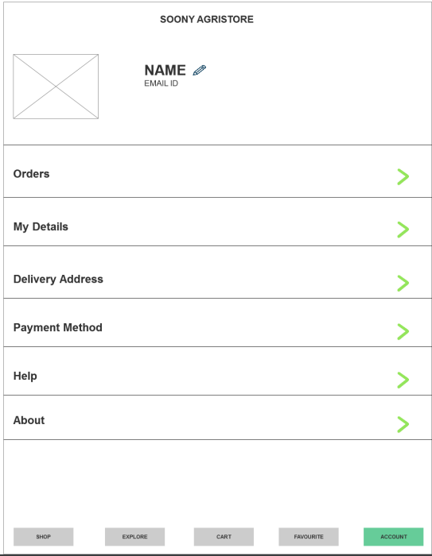

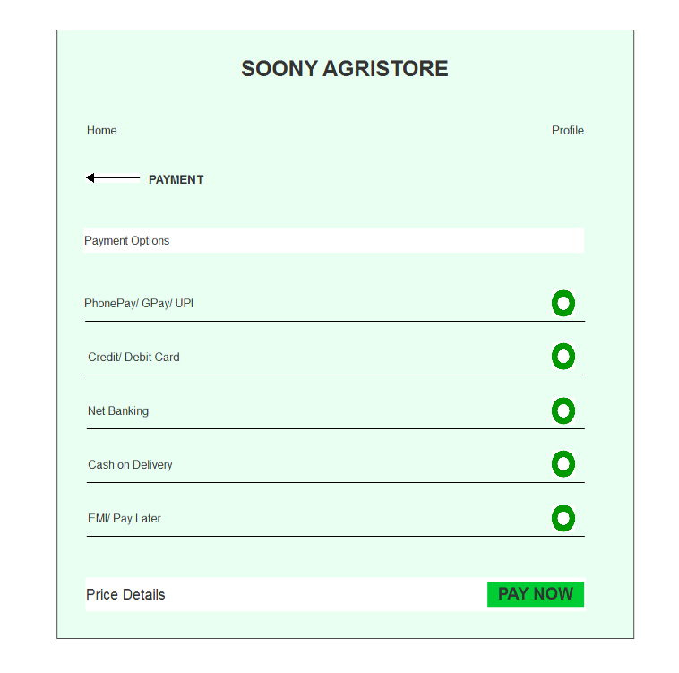

**Question 3 – Tools (Visio, Balsamiq)**

**Make a note of the Tools, which you are using for above concepts**

1. Microsoft Visio – This tool is used to draw UML diagrams. We can draw Activity diagram, Use case diagram , sequence diagram, etc.Visio file gets saved with extension .vsd.

2. Balsamiq – Balsamiq Mockups is a user interface design tool for creating wireframes. It is used to generate digital sketches of project ideas. These files get saved with extension

**Question 4 – RTM**

A Requirements Traceability Matrix (RTM) is used for linking product requirements from the time of their identification to their fulfillment. It ensures the delivery of documented requirements as requested by stakeholders. Requirements Traceability Matrices track requirements backwards to their objectives and forward to their deliverables.

1. RTMs can be used for managing project scope changes and for assessing the impact of changes. For example, if you know the relationship between two or more requirements, you will be better able to assess the impact of making changes to any of them.
2. With RTMs, stakeholders can ensure that each requirement is traced back to the objectives of the project and ultimately to solution components.
3. RTMs also ensure that it is only approved requirements that are delivered at the end of the day – nothing more. Traceability ensures that every requirement can be linked back to a business objective and that no requirement is superfluous.

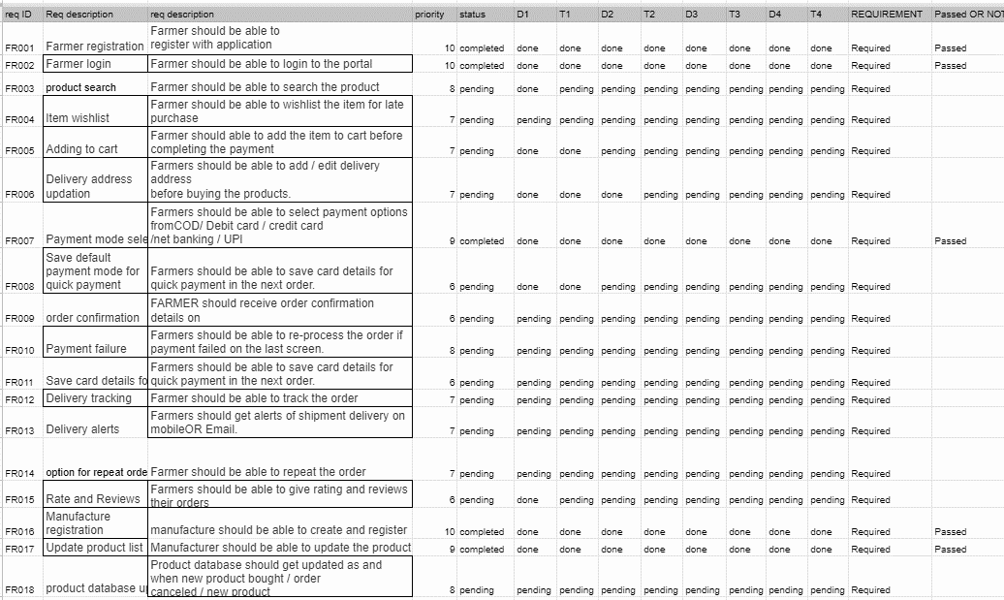

**Question 5 – 10 Test Case Documents**

|  |  |
| --- | --- |
| Test case name- | Account login |
| Test case Id | PQ0422TS10 |
| Project Id | PQ0434 |
| PM name | Mr. Vandanam |
| Tester Name | Mr Jason |
| Pre conditions | Valid account details and login credential |
| Test data | Username and password for login |
| Steps to be executed | Enter username and password, and click login |
| Expected result | User logged in |
| Actual result | User would be either successfully logged in or not depending on login credential |
| Pass or fail result | pass |

|  |  |
| --- | --- |
| Test case name | Account creation |
| Test case Id | PQ0422TS11 |
| Project Id | PQ0434 |
| PM name | Mr. Vandanam |
| Tester Name | Mr. Jason |
| Input data | Valid data and login details |
| Expected result | Display message- data saved, user account created  Account details will be provided inSMS and email  User database created |
| Actual result | Display msg- data saved, user account created  Account details will be provided in sms and email  User database created |
| comment | working successfully |
| Pass or fail | pass |

|  |  |
| --- | --- |
| Test case name | Forgot password |
| Test case Id | PQ0422TS12 |
| Project Id | PQ0434 |
| PM name | Mr. Vandanam |
| Tester Name | Mr Jason |
| Input data | User Id, OTP |
| Expected result | OTP should get triggered to registered mobile no,New password should get saved in user database |
| Actual result | OTP received on registered mobile no  successfully and new password saved in  database |
| comment | Working successful |
| Pass or fail | pass |

|  |  |
| --- | --- |
| Test case name | Product search |
| Test case Id | PQ0422TS12 |
| Project Id | PQ0434 |
| PM name | Mr. Vandanam |
| Tester Name | Mr Jason |
| Input data | Click on search, click on category |
| Expected result | upon clicking on search, categories will be  displayed. Fertilizers , seeds, pesticides    2. Upon selecting category, product catalogue will get displayed |
| Actual result | Catalouge will be displayed |
| comment | Working successfully |
| Pass or fail | pass |

|  |  |
| --- | --- |
| Test case name | Add to cart |
| Test case Id | PQ0422TS12 |
| Project Id | PQ0434 |
| PM name | Mr. Vandanam |
| Tester Name | Mr Jason |
| Input data | Click on add to cart |
| Expected result | 1.after clicking on cart section, user can checkout |
| Actual result | Product is available for user in cart |
| comment | Working successfully |
| Pass or fail | pass |

|  |  |
| --- | --- |
| Test case name | Check out |
| Test case Id | PQ0422TS12 |
| Project Id | PQ0434 |
| PM name | Mr. Vandanam |
| Tester Name | Mr Jason |
| Input data | select products in cart section |
| Expected result | After clicking on checkout , bill will be dispalyed |
| Actual result | Final bill will be displayed |
| Comment | Working successfully |
| Pass or fail | Pass |

|  |  |
| --- | --- |
| Test case name | Selecting delivery address |
| Test case Id | PQ0422TS12 |
| Project Id | PQ0434 |
| PM name | Mr. Vandanam |
| Tester Name | Mr Jason |
| Input data | 1. Select delivery address and enter pincode |
| Expected result | Select address and pincode, if address is and pincode is available order is processed |
| Actual result | If address is available order is processed successfully |
| Comment | Working successfully |
| Pass or fail | Pass |

|  |  |
| --- | --- |
| Test case name | Check out /Payment |
| Test case Id | PQ0422TS12 |
| Project Id | PQ0434 |
| PM name | Mr. Vandanam |
| Tester Name | Mr Jason |
| Input data | 1. Click on check out; |
| Expected result | Will display option for mode of payment, click on selected mode of payment |
| Actual result | Will display option for mode of payment, click on selected mode of payment and proceed to transaction |
| Comment | Working successfully |
| Pass or fail | Pass |

|  |  |
| --- | --- |
| Test case name | Order tracking |
| Test case Id | PQ0422TS12 |
| Project Id | PQ0434 |
| PM name | Mr. Vandanam |
| Tester Name | Mr Jason |
| Input data | Click on orders, click on track order |
| Expected result | Tracking records will be displayed with tracking Id, and shipping status |
| Actual result | Tracking records will be displayed with tracking Id, and shipping status |
| Comment | Working successfully |
| Pass or fail | Pass |

**Question 6 – DB Design**

After the requirements are thoroughly explained to the entire project team by a business analyst, the Database architects have decided to do the database design and also to represent the in-flow and out-flow of data. Draw database schema and ER diagram.

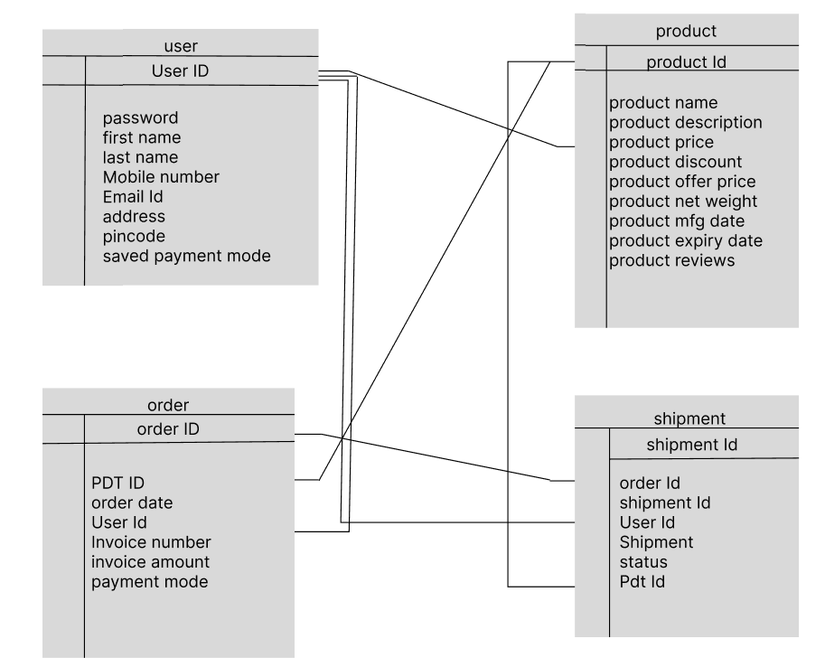

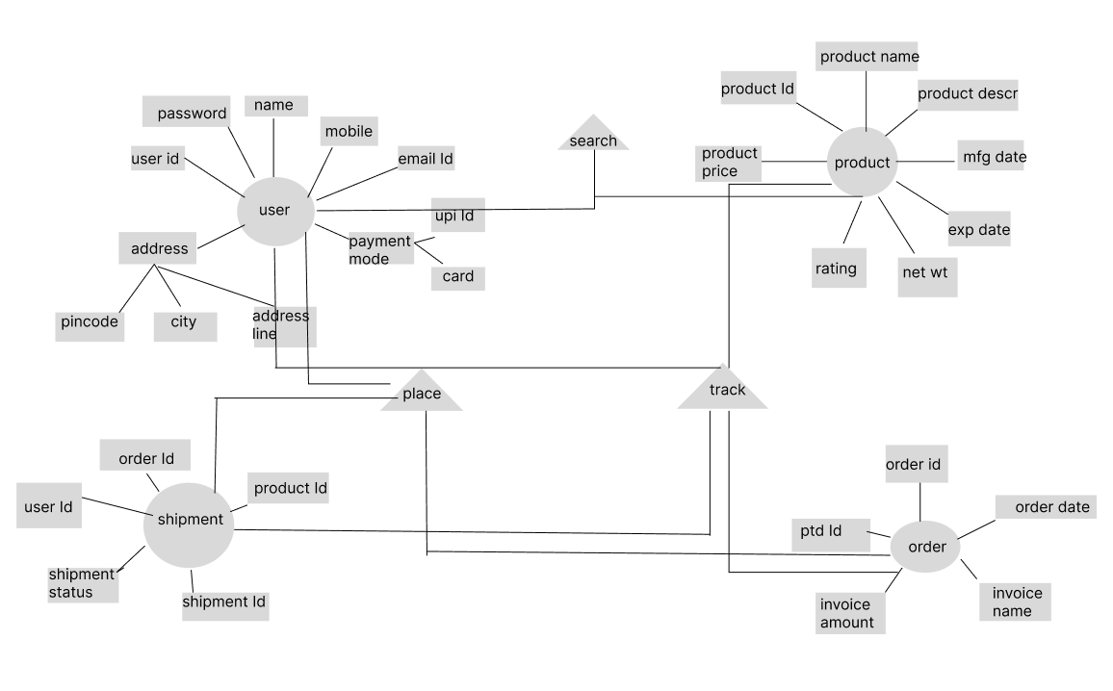

**Question 7 – Data Flow Diagram**

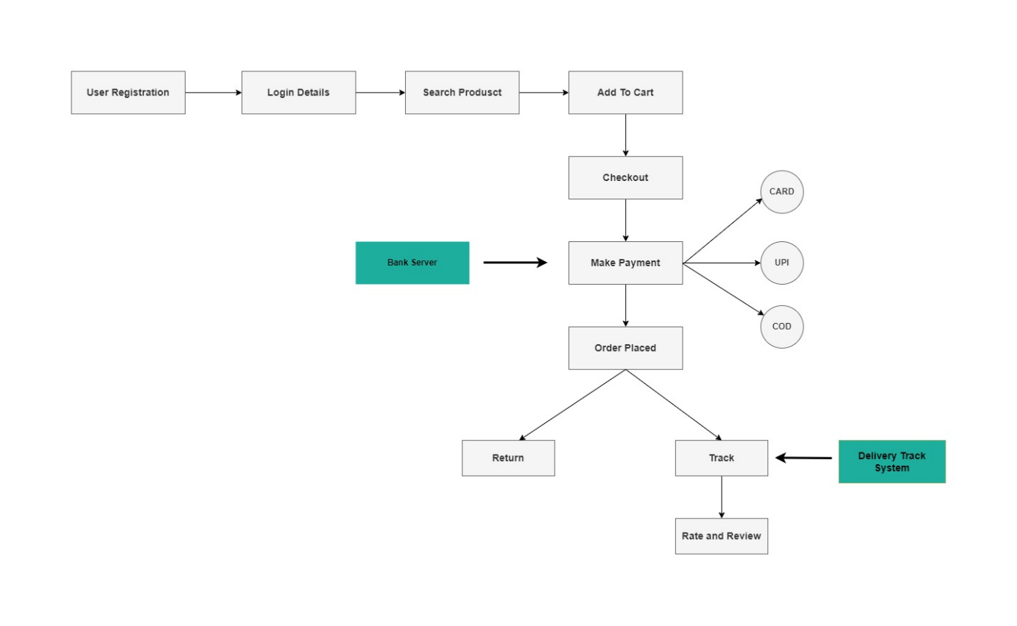What is a data flow diagram? Draw a data flow diagram to represent the in-flow and out-flow of data when a Farmer is placing an order for the product.

**Question 8 – Change Request**

Due to change in the Government Taxation structure . We should change the Tax structure. How do you handle change requests in a project?

We have to incorporate this change request in design, as it is affecting pricing. Revised taxation formula to be applied in Product database-&gt;price.

1. I will document the change request

2. I will analyze the change request

3. Since this change has to be incorporated in the project, I will ask for initial approval from the Project manager or change manager.

4. I will arrange an emergency meeting with key stakeholders to discuss the impact of this change request on scope of project, man hours and performance of application.

**Question 9 – Change Request Vs an Enhancement**

As the project is in process, Ben and Kevin have contacted you. The reason is to inform you that they want the Farmers to sell their crop yieldsthrough this application i.e. Farmers should be able to add their crop yields or products and display them to the general public and should be able to sell them.

They also want to introduce Auction system for their Crop yields. As a BA, what will be your response?Is this a change request or an enhancement???

I think it is an enhancement. Entire project is designed to shop online. And now farmers want the option to sell their crops on this online portal. So, this is

an additional requirement raised by the user. This can be developed in existing projects in the next updated version.

**Question 10 – Estimations**

Come up with estimations – How many Man Hours required

As per the Gantt chart and timesheets, I have done estimation of approx. 3040 man hours. (68 weeks * 40 hours in a week = man hours)

**Question 11 – UAT**

Project has finally completed all the stages i.e., design, development, testing etc. Now, it is the role of a business analyst to contact the client for testing of the final product and having to successfully complete it. How are you going to handle this situation? And once it is done, what will be the process to close the project?

**Explain UAT Acceptance process**

User Acceptance Testing (UAT) is a type of testing performed by the end user or the client to verify/accept the software system before moving the software application to the production environment. UAT is done in the final phase of testing after functional, integration and system testing is done

UAT is done by the intended users of the system or software. This type of Software Testing usually happens at the client location which is known as Beta

Testing. Once Entry criteria for UAT are satisfied, following are the tasks need to be performed by the testers:

* Analysis of Business Requirements
* Creation of UAT test plan
* Identify Test Scenarios
* Create UAT Test Cases
* Preparation of Test Data(Production like Data)
* Run the Test cases
* Record the Results
* Confirm business objectives

**Question 12 – Project Closure Document**

**Explain Project closure document**

The Project Closure Document is a summary report for a completed project, covering its goals, schedule, budget, and overall performance. It reflects on what went well and what could be improved, providing valuable lessons for future projects. By evaluating resource use, risk management, and the quality of the work, the document serves as a guide for project managers. Once everyone agrees that everything is wrapped up, the project is officially closed with a thank-you to everyone involved.