**1.**

**Module Name:** Admin.

**Feature Name:** Add Associate.

**Page URL:** <https://aptdlm.aptits.com/Admin/Employee>

**Description:** In this page, we can add an associate by entering the relevant details.

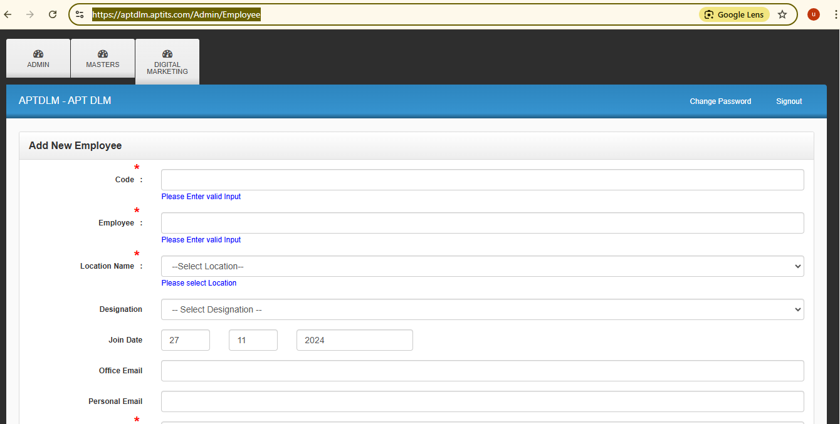

**2.**

**Module Name:** Admin.

**Feature Name:** Assign Features to Associates.

**Page URL:** <https://aptdlm.aptits.com/Admin/FeatureAccessSearch>

**Description**: In this page, we can assign portal features to associates based on their designation, making them visible and accessible through their individual logins.

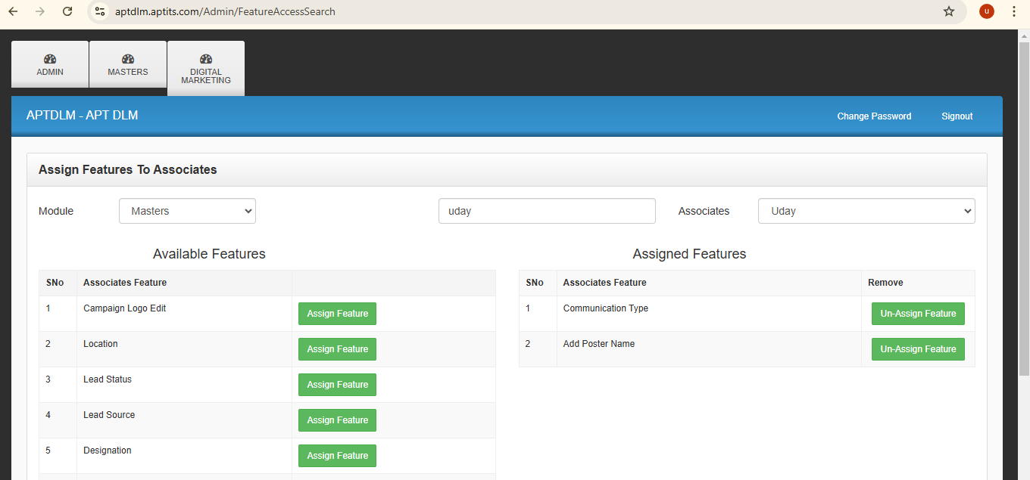

**3.**

**Module Name:** Admin.

**Feature Name:** View Password List .

**Page URL:** <https://aptdlm.aptits.com/Admin/UserPwds>

**Description:** In this page, we can retrieve the usernames and passwords of the associates.

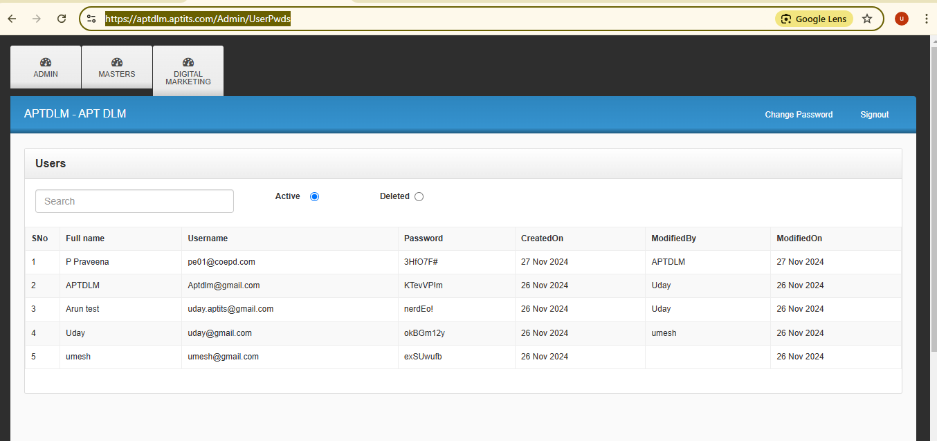

**4.**

**Module Name:** Admin.

**Feature Name:** Associate Feature List.

**Page URL:** <https://aptdlm.aptits.com/Admin/Feature>

**Description:**  In this page, we can add a new feature by filling in the displayed fields with the page address.

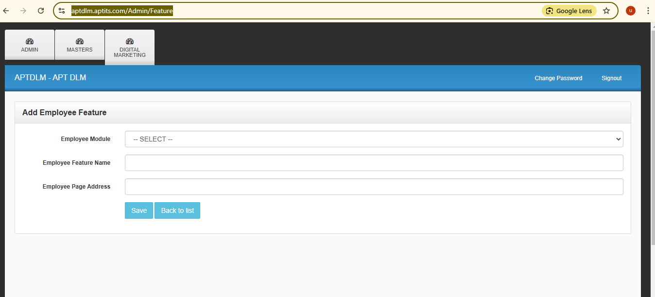

**5.**

**Module Name:** Admin.

**Feature Name:** Associate Module List.

**Page URL:** <https://aptdlm.aptits.com/Admin/Feature>

**Description:** On this page, we can add a new module by filling in the displayed field, which will then appear in the dropdown list when adding a new feature.

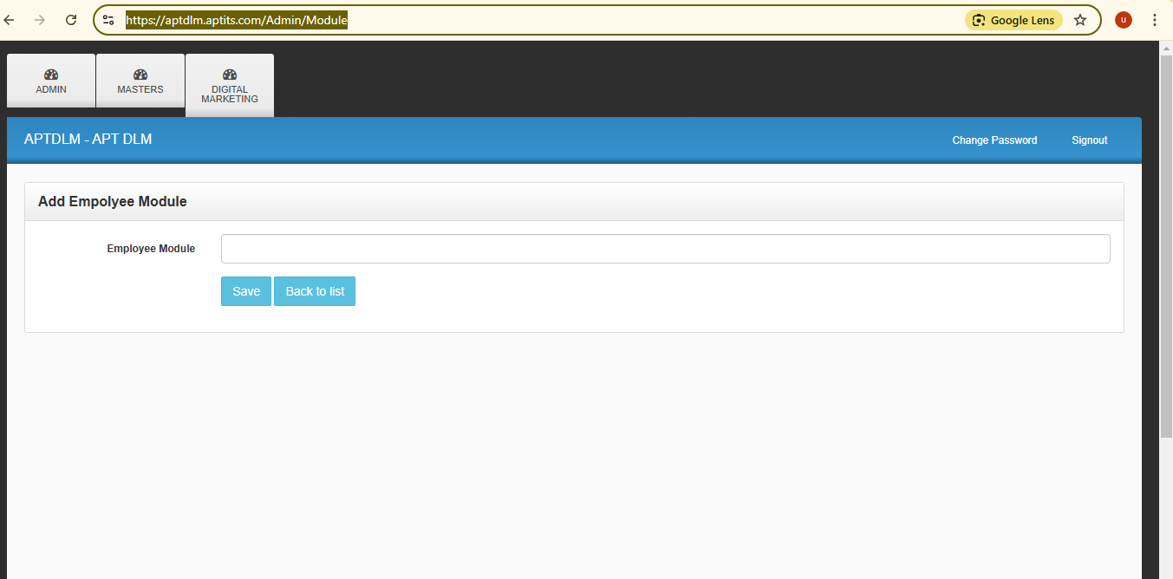

**6.**

**Module Name:** Masters.

**Feature Name:** Communication Type.

**Page URL:** <https://aptdlm.aptits.com/Admin/CommunicationType>

**Description:** On this page, we can add a new communication type by clicking the "Add New" button, making it appear in the dropdown list in future forms when filling them out.

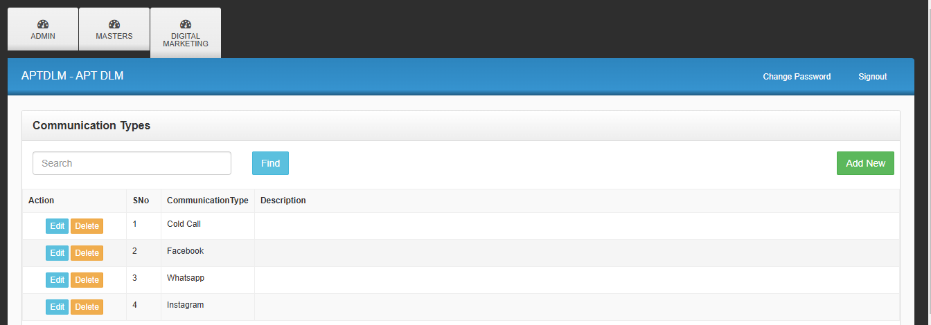

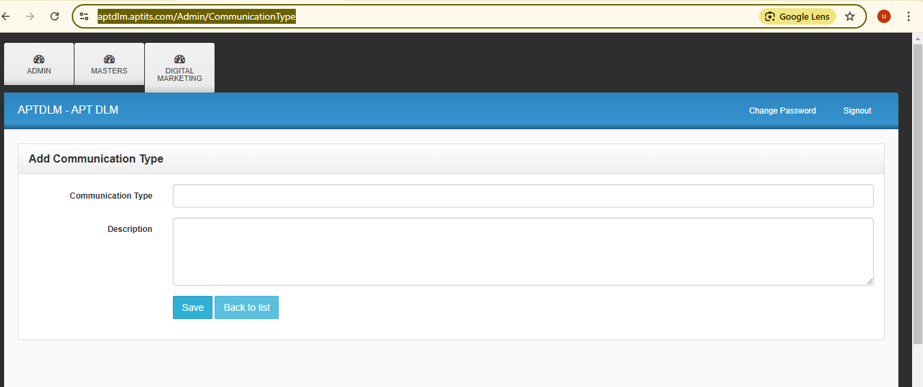

**7.**

**Module Name:** Masters.

**Feature Name:** Location.

**Page URL:** https://aptdlm.aptits.com/Admin/Location

**Description:** On this page, we can add a new location name by clicking the "Add New" button, which will then appear in the dropdown list in future forms when filling them out.

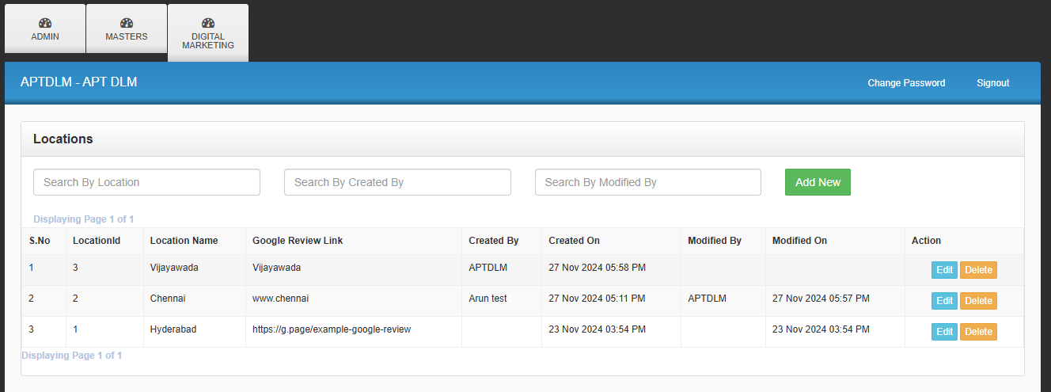

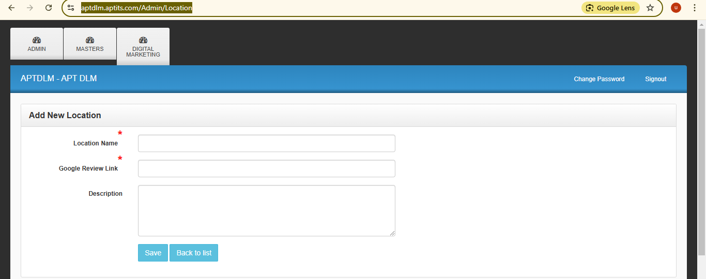

**8.**

**Module Name:** Masters.

**Feature Name:** Add Poster Name.

**Page URL:** <https://aptdlm.aptits.com/Admin/AptAddPosters>

**Description**: On this page, we can add a new poster name for future categorization when uploading posters, allowing the poster names to appear in the dropdown list during the upload process.

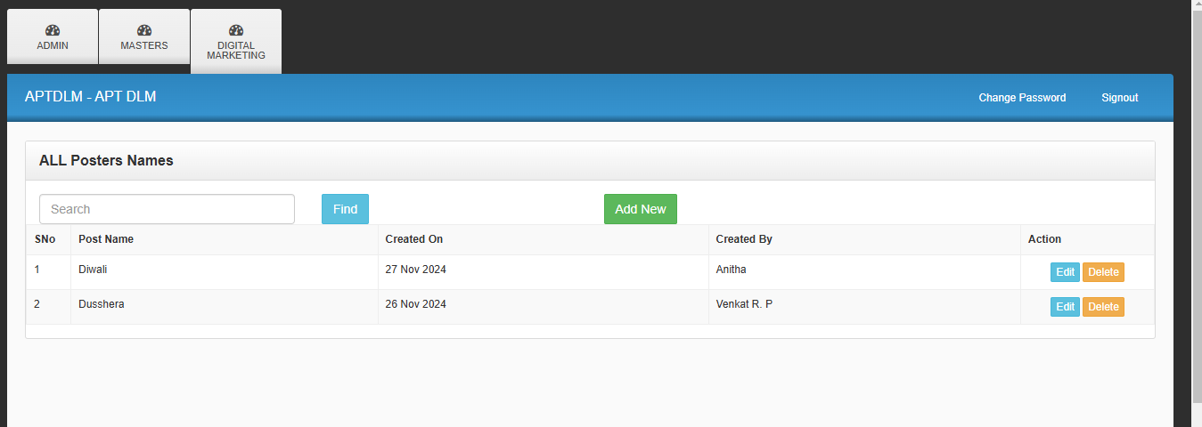

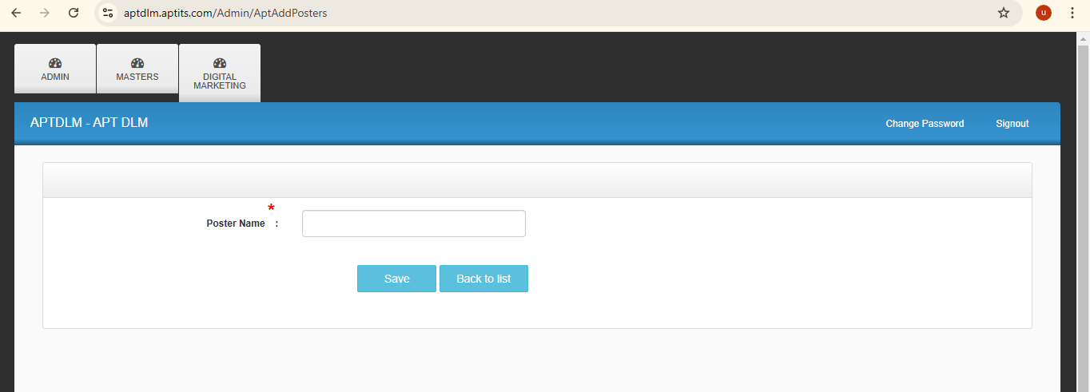

**9.**

**Module Name:** Masters.

**Feature Name:** Lead Status.

**Page URL:** <https://aptdlm.aptits.com/Admin/LeadStatus>

**Description:** On this page, we can add a new lead status, which will then appear in the dropdown list in future forms when following up on leads.

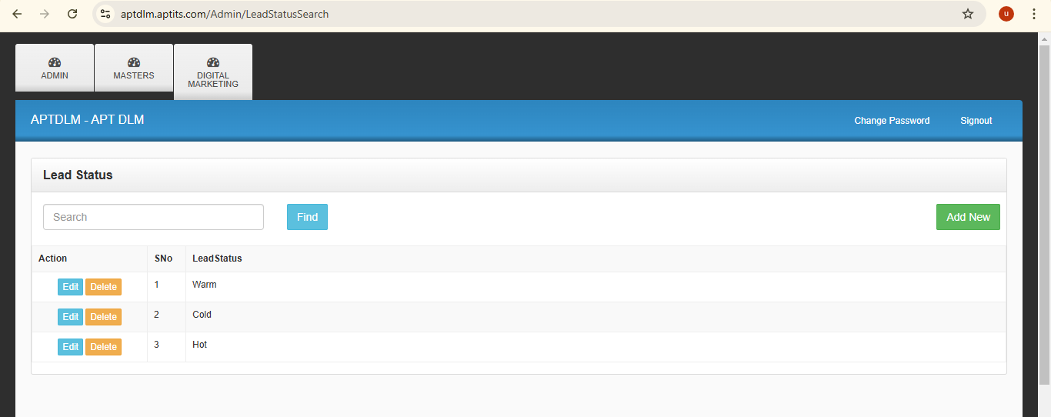

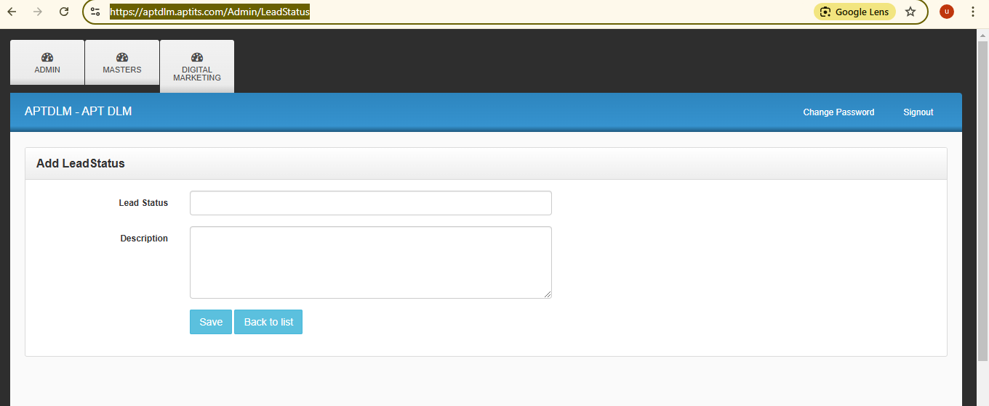

**10.**

**Module Name:** Masters.

**Feature Name:** Lead Source.

**Page URL:** <https://aptdlm.aptits.com/Admin/LeadSource>

**Description:** On this page, we can add a new lead source, which will then appear in the dropdown list in future forms when adding a new lead.

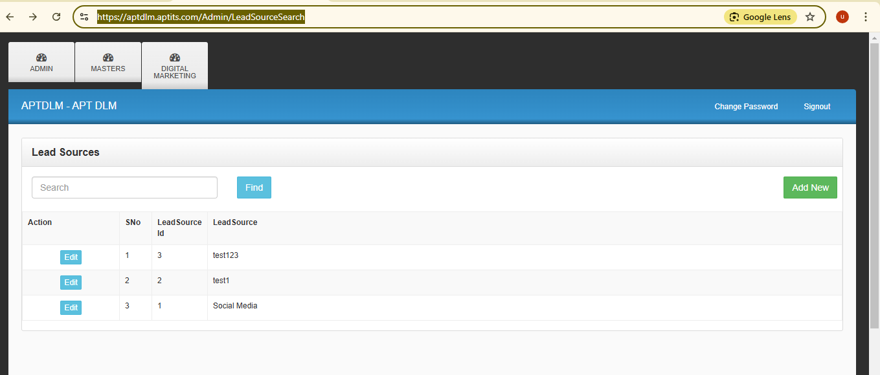

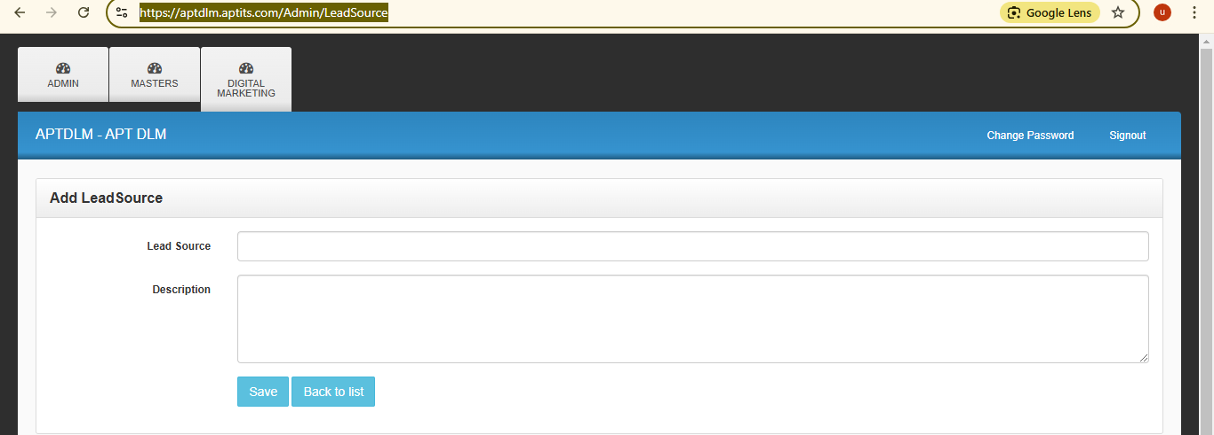

**11.**

**Module Name:** Masters.

**Feature Name:** Designation.

**Page URL:** https://aptdlm.aptits.com/Admin/Designation

**Description:** On this page, we can add a new designation, which will then appear in the dropdown list in future forms when adding a new associate or employee.

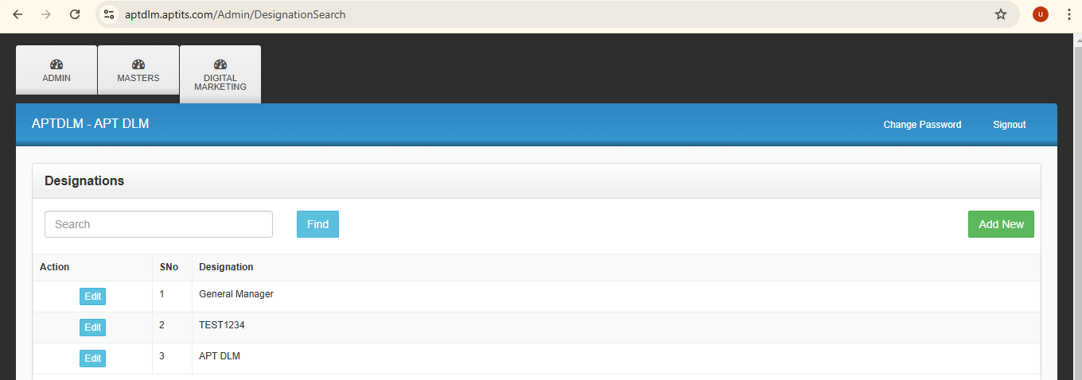

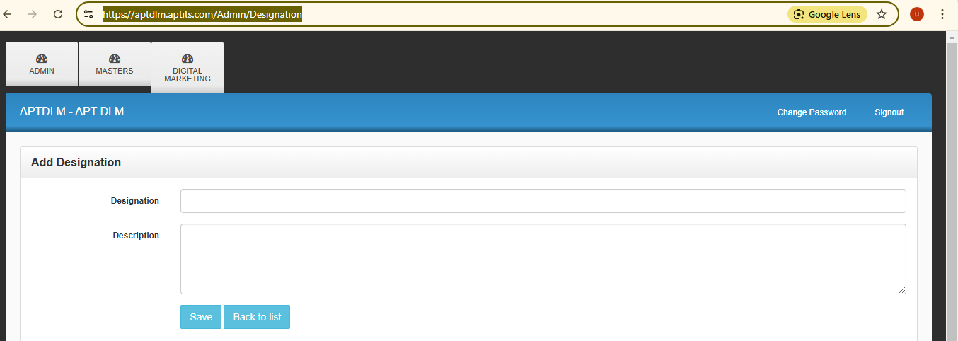

**12.**

**Module Name:** Masters.

**Feature Name:** Service.

**Page URL:** <https://aptdlm.aptits.com/Admin/LeadSource>

**Description:** On this page, we can add a new service, which will then appear in the dropdown list in future forms when adding a new lead.

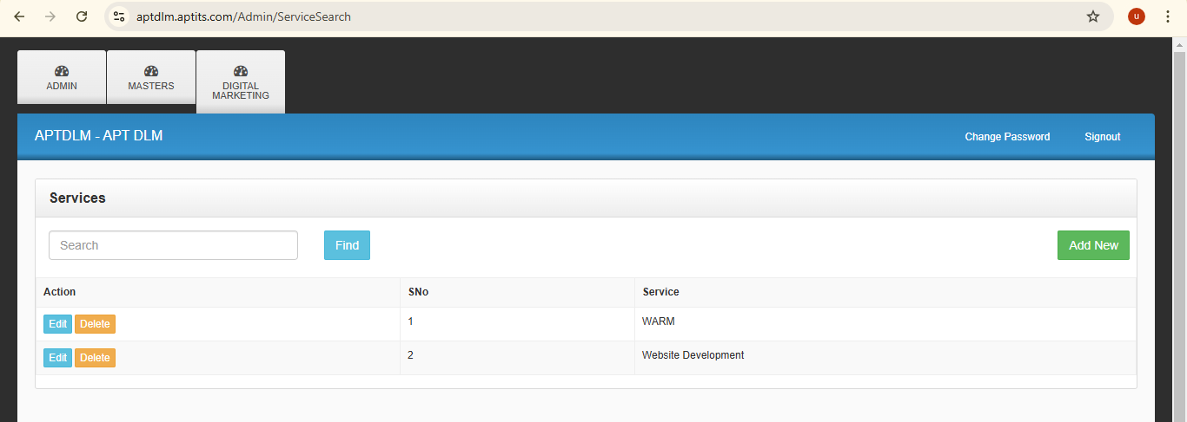

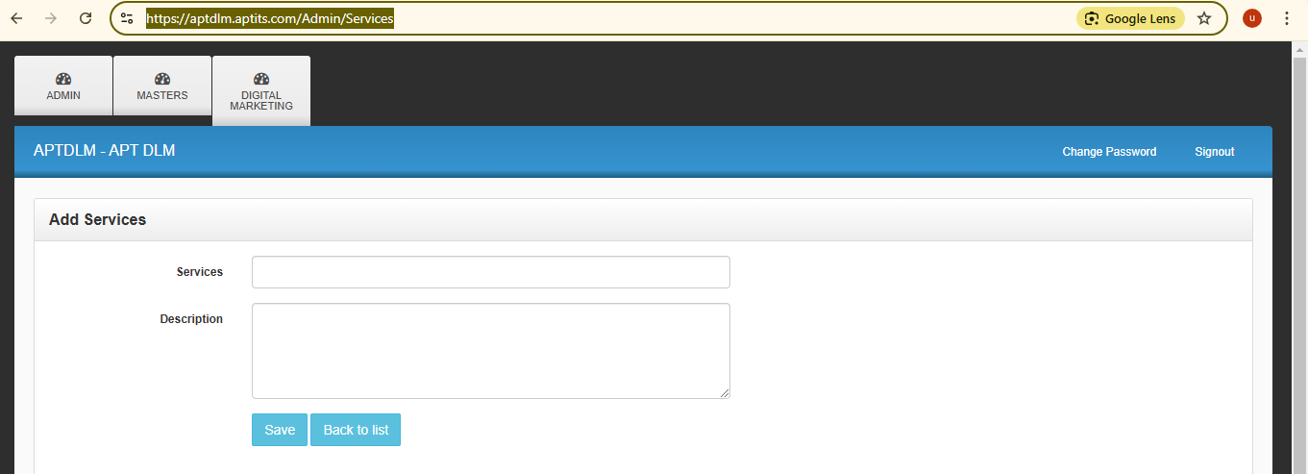

**13.**

**Module Name:** Digital Marketing.

**Feature Name:** Generate Campaign URL.

**Page URL:** https://aptdlm.aptits.com/Admin/CampaignWebinar

**Description:** On this page, we can enter all the required fields to generate a campaign URL that will display the entered details such as title, logo, USP points. Additionally, the URL will collect information from individuals accessing it by asking them to fill in fields like name, contact, and email.

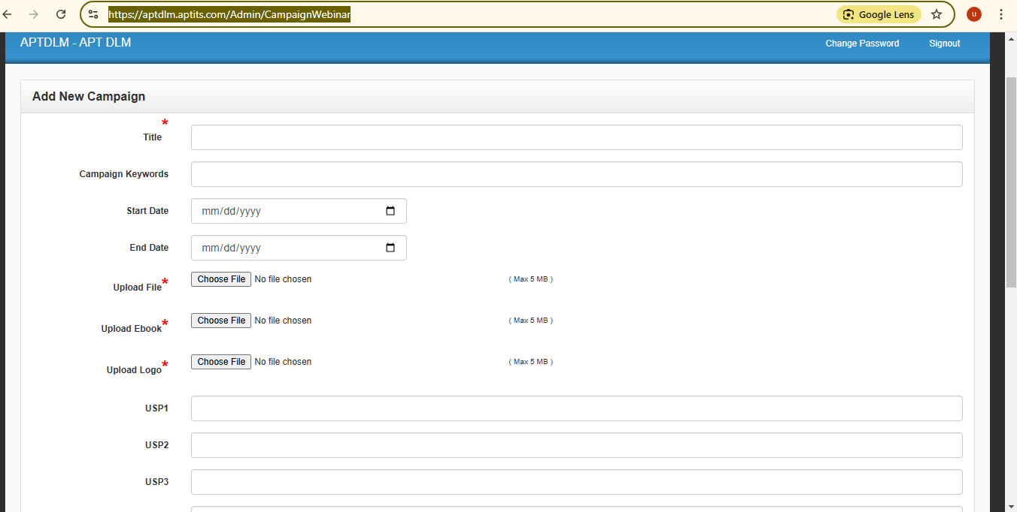

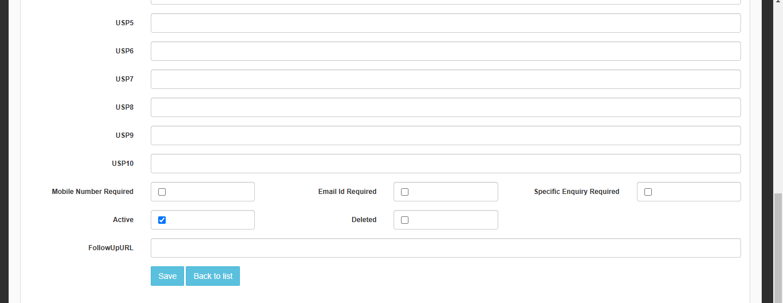

**14.**

**Module Name:** Digital Marketing.

**Feature Name:** Generate Campaign URL.

**Page URL:** <https://aptdlm.aptits.com/Admin/CampaignWebinarSearch>

**Description:** On this page, we can view the records of URLs generated by submitting the form after clicking the "Add New" button. The generated URLs will be displayed in a grid view, allowing us to use and share them on various platforms to capture leads.

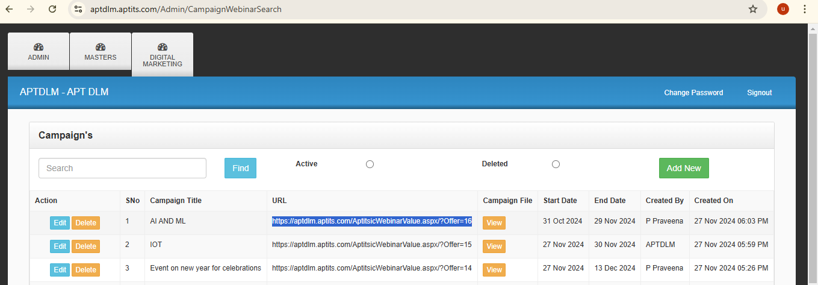

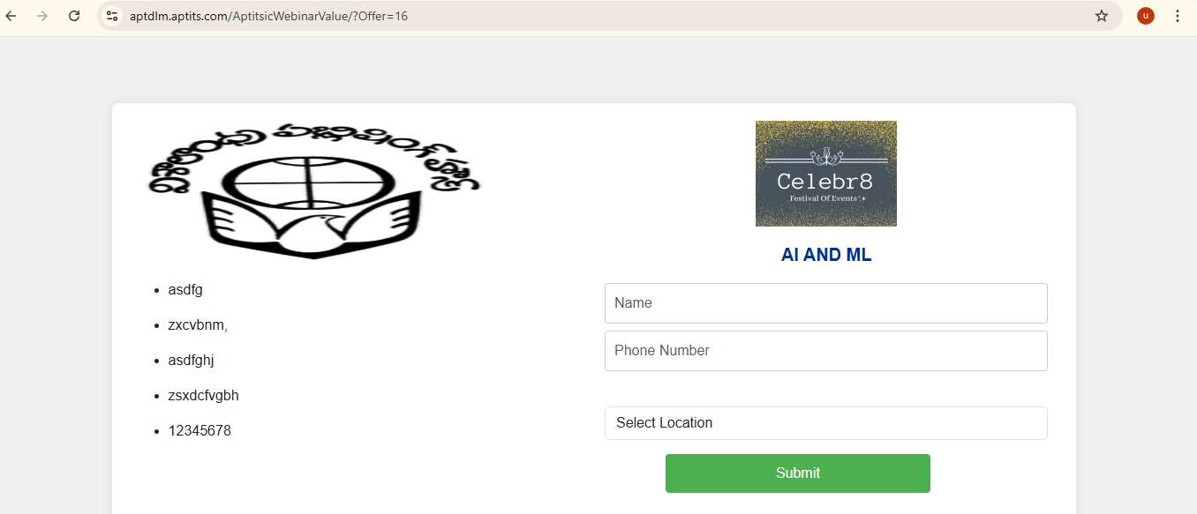

**15.**

**Module Name:** Digital Marketing.

**Feature Name:** Campaign Leads.

**Page URL:** https://aptdlm.aptits.com/Admin/CampaignWebinarLeadSearch

**Description:**  This is the search page where all leads are displayed in a grid view, along with the respective details captured from the generated campaign URLs.

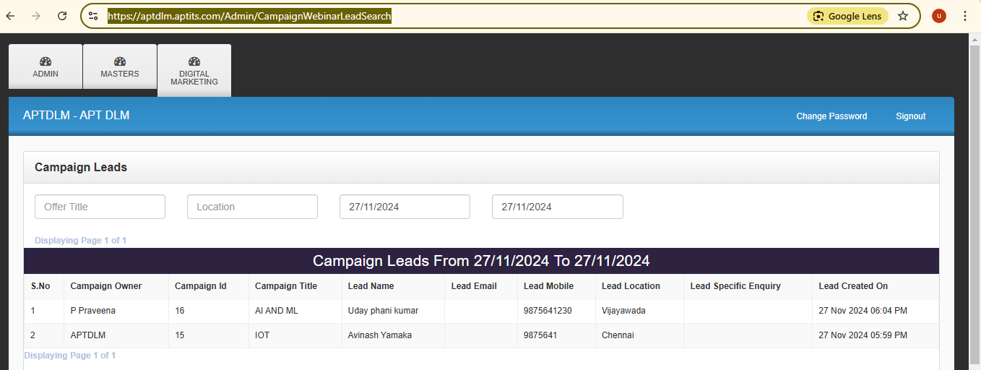

**16.**

**Module Name:** Digital Marketing.

**Feature Name:** Add New Lead.

**Page URL:** <https://aptdlm.aptits.com/Admin/CentralLead>

**Description:** On this page, by clicking the "Add New" button, we can enter lead data by filling in all the mandatory fields and saving it. This allows us to follow up on the leads later based on the availability of follow-up dates.

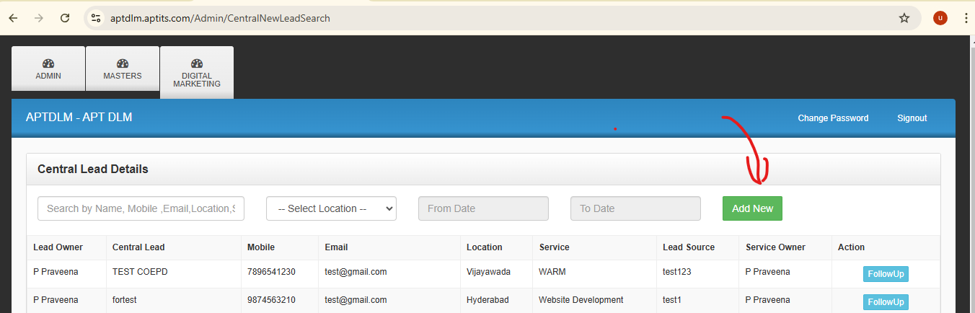

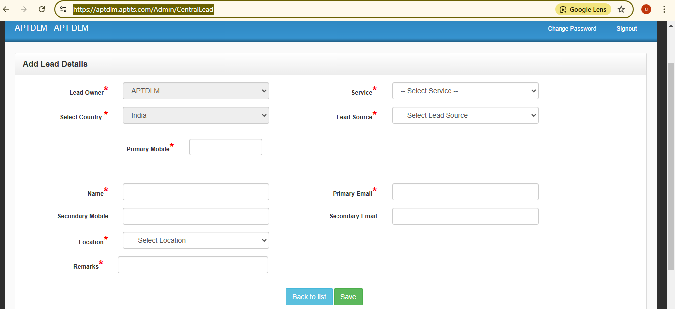

**17.**

**Module Name:** Digital Marketing.

**Feature Name:** Follow-up.

**Page URL:** <https://aptdlm.aptits.com/Admin/CentralFollowUp?ItemId=8>

**Description** After adding a new lead, we can perform the first follow-up by clicking the "Follow-up" button in the grid view. We can then fill in the mandatory fields, allowing us to track the upcoming follow-ups in the follow-up feature.

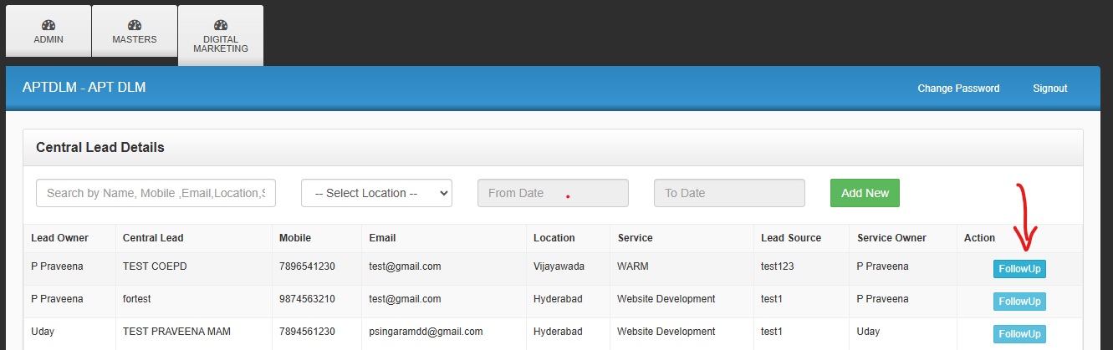

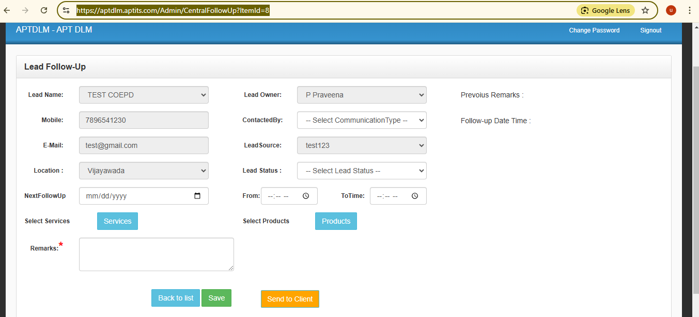

**18.**

**Module Name:** Digital Marketing.

**Feature Name:** Poster Library.

**Page URL:** <https://aptdlm.aptits.com/Admin/PosterSearch>

**Description:** On this page, by clicking the "Add New" button, we can upload posters according to their categories. We can also view and download the posters we have uploaded.

