**Document 6- Please prepare a use case diagram, activity diagram and a use case specification document.**

**Use Case Diagram:**

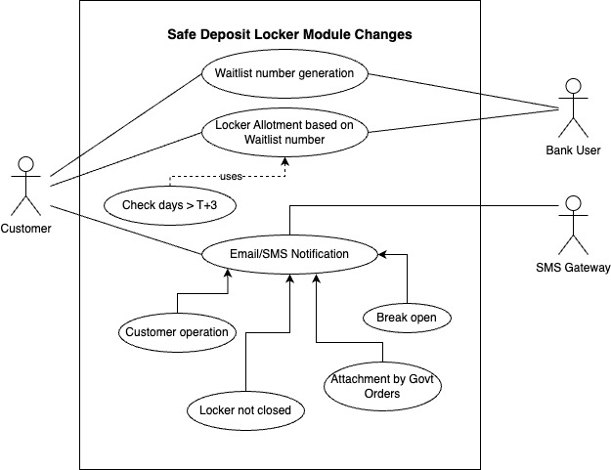

**Use Case Specification Document:**

1. **Use Case Name:**

Enhancement to the Safe Deposit Locker Module in CBS as per RBI dircetives.

1. **Use Case Description:**

This use case describes how the waitlist number generation and management will be handling in core banking solutions along with email/SMS generation process for the four defined locker events.

1. **Actors- Primary and Secondary:**

Primary Actor – Customer who comes the Bank

Secondary Actors - Bank Staff (User), SMS Gateway Partner

1. **Basic Flow:**
2. Waitlist number generation Use Case: Customer visit the branch and request for the locker. Bank User will generate waitlist number and shared to the customer since the locker is not available at the moment.
3. Locker allotment Use Case: Customer will get the Email/SMS when locker is available and visit the branch again within 3 working days.
4. Supporting Use Case for Locker Allotment: If the customer visits after T+3 days, waitlist number will be expired and wont able to get the locker if not available or (locker available and other active waitlist number is present).
5. Email or SMS Notification Use Case: Email or SMS will be triggered to the registered email and mobile number of the customer when any of the generalized use cases are executed based on the 4 events mentioned in those use cases. SMS Gateway partner will be involved to send the SMS to the mobile numbers. Email will be send using the internal email generation system.
6. **Alternate Flow:**

5.1 Vacant Lockers available:

When a customer comes for the locker and if the required locker size is already vacant, existing flow of locker allotment will be followed and there will not be any waitlist number generation in this case.

5.2 When Customer visit the branch after T+3 days once getting email/sms as locker is available:

Customer will get email/SMS after receiving waitlist number from branch whenever the required locker is vacant. Then he/she should visit the branch before 3 working days to claim the locker. Else waitlist number will be invalid. Then customer have option to get the locker only if there is a vacant locker and no active locker waitlist is present.

1. **Exceptional Flow:**

6.1 When customer does not have any account:

When a customer comes to have a locker and he is not related with the Bank in any way, he/she should open an account at first and be a customer of the Bank first. Then follow the steps 4 or 5 as applicable.

6.2 When email or mobile number is not registered in case of email/SMS use case:

There may be a scenario when the customer is already having a relationship with the Bank but his email or mobile number is not registered with the Bank. Notification is an important step in managing waitlist number and locker critical events in this project. Customer should register their email or mobile number to have all the process to follow as expected.

1. **Pre-Conditions:**
2. Branches should have Lockers and Locker inventory management system.
3. Customer should have active accounts (CASA and security deposit)
4. Customer should have active email id and mobile number which are registered with the Bank
5. **Post-Conditions:**
6. Customer will get locker if he followed the rules related to waitlist number properly
7. Customer won't get locker if he does not follow the rules related to waitlist number
8. Customer will get the email/SMS if active email id and mobile number is registered with the Bank.
9. **Assumptions:**
10. SMS gateway partner will provide the support as per the RBI timelines
11. User will be trained to use the new system
12. Customer approach and ask for the waitlist number and Bank will provide it mandatorily if locker is not available at that moment.
13. Customer visits the branch with waitlist number within 3 working days to avail the locker once they get the email/SMS for the vacancy of lockers else it will be invalid.
14. **Constraints:**
15. System must comply to RBI regulations.
16. Project should complete in 6 months to adhere to the deadline given by RBI.
17. Budget constraint is there with a maximum limit of 10 Lakhs.
18. Resources are assigned as per the existing work load for other change requests (8 in numbers).
19. **Dependencies:**
20. SMS notification is dependent on the SMS gateway partner.
21. Proposed system is dependent on the availability of lockers.
22. Locker allotment is dependent on the customer after getting the notification for vacant lockers.
23. **Inputs and Outputs:**

For Waitlist generation:

Inputs: Customer Number, Locker Size, related CASA account

Outputs: Waitlist Number

For Email/SMS notification:

Inputs: Events trigger for four events- Marking of entry time for locker operation, marking of locker not closed status, marking of break open status and marking of locker attachment due to govt orders.

Outputs: Configured Email/SMS to registered email id or mobile number.

1. **Business Rules:**
2. Only exiting customers will be allowed to get the waitlist number. Else be the customer first by opening the accounts.
3. One customer cannot have multiple active locker waitlist numbers in the same branch for same locker sizes but can have it for different locker sizes.
4. One customer can have waitlist numbers in the different branches.
5. Implement this functionality without interrupting the current process.
6. **Miscellaneous Information:**

None.

**Activity Diagram:**

1. **Waitlist number generation and management:**

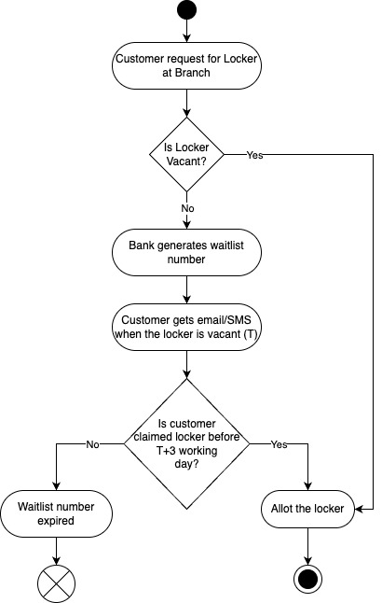

1. **Email/SMS notification for defined locker events:**

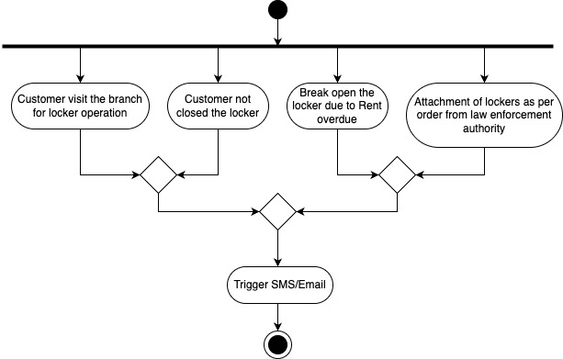

**Document 7- Screens and pages:**

I have shown all the screens as per the basic flow in use case diagram or description. This wireframe sequence also indicates the events required for email/SMS triggers.

1. Home page of Core Banking Solution with new sub menu options under Safe Deposit Locker

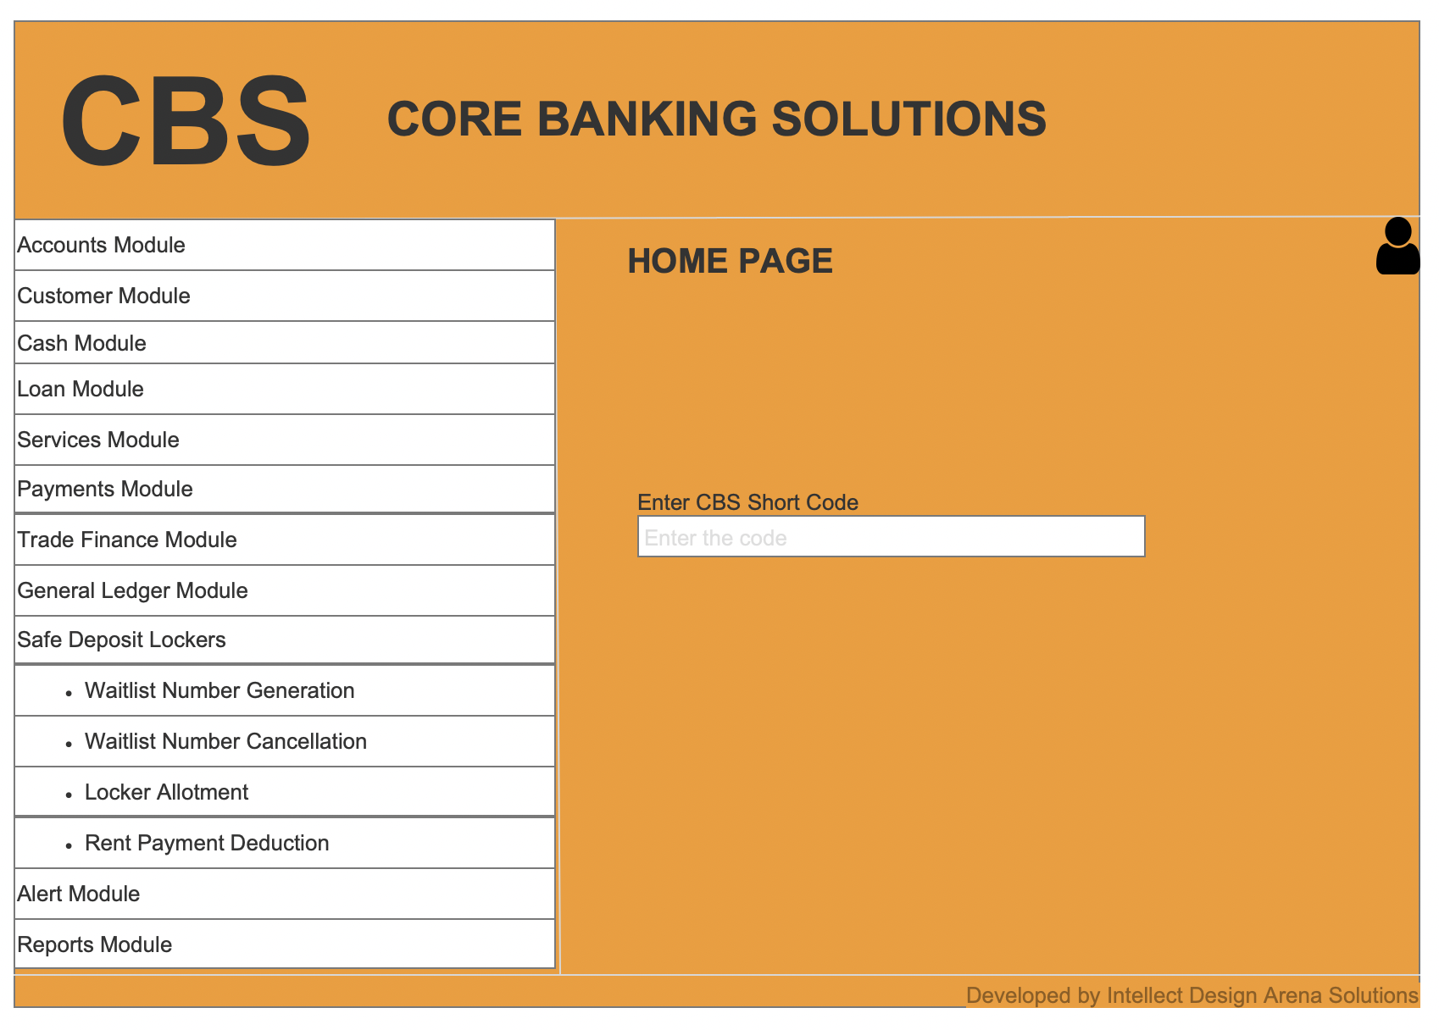

1. Open Waitlist generation page to generate the waitlist number

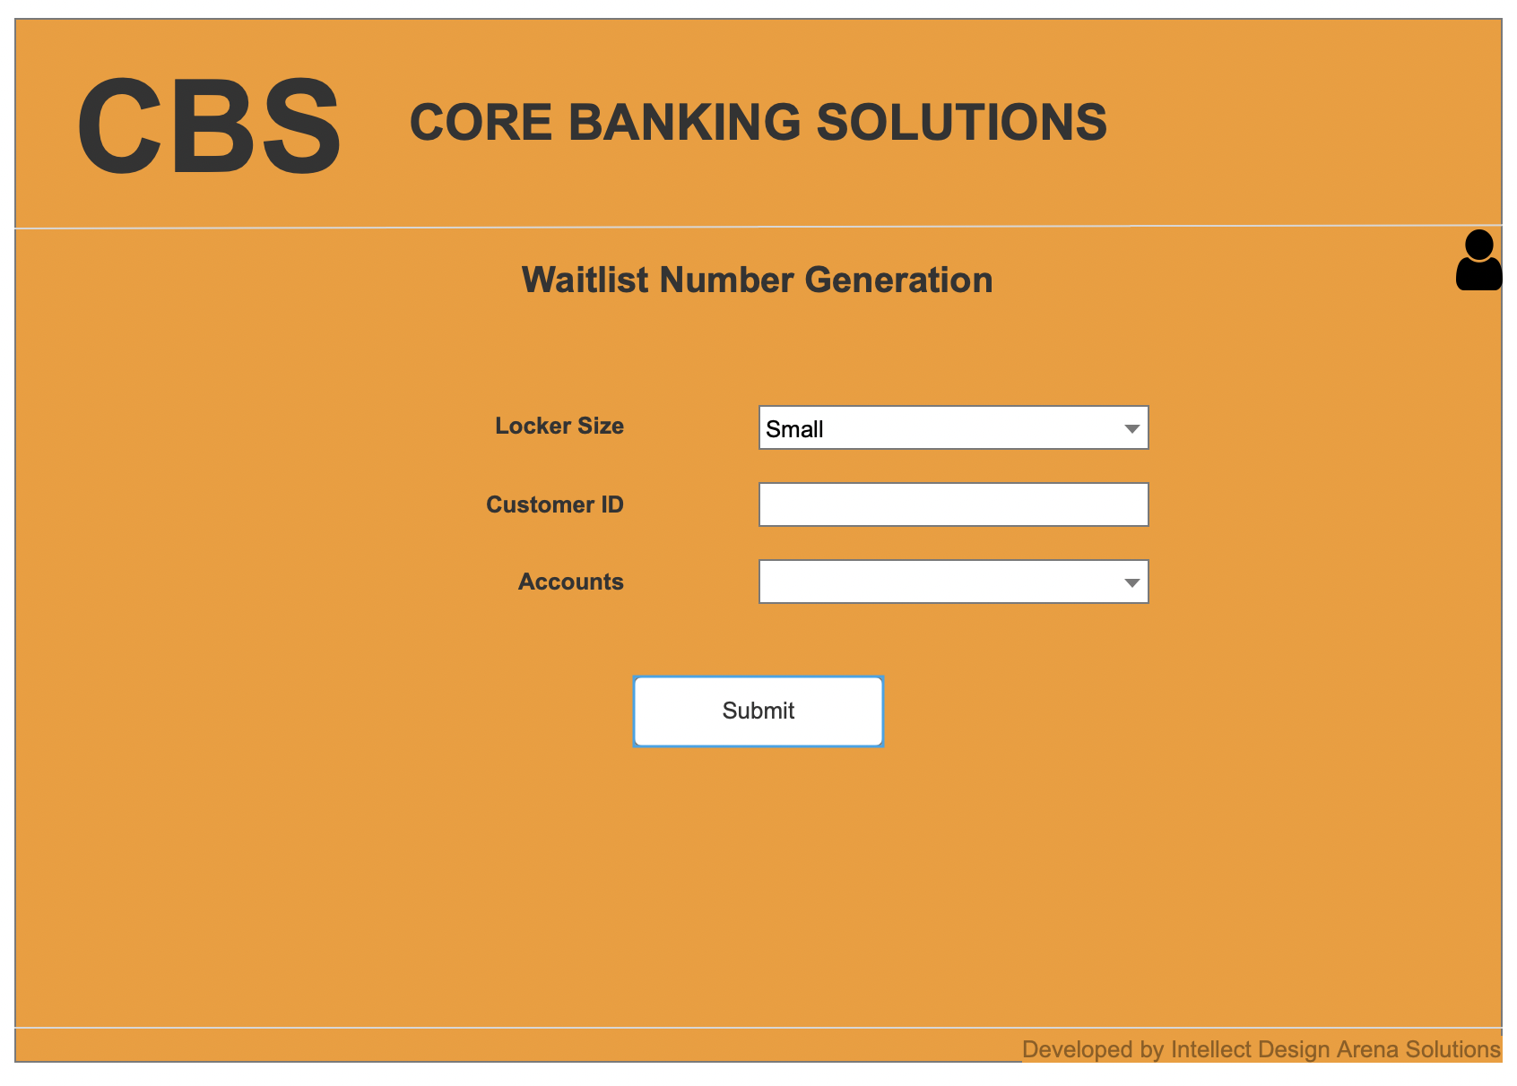

1. Waitlist number is generated successfully after submission

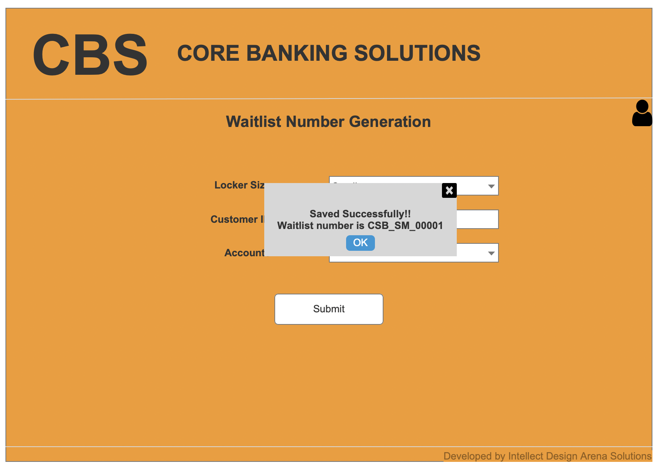

1. Open Locker Allotment Page- There are 4 tabs. View of General Tab below. Add for the new locker allotment or modify for the existing allotted locker.

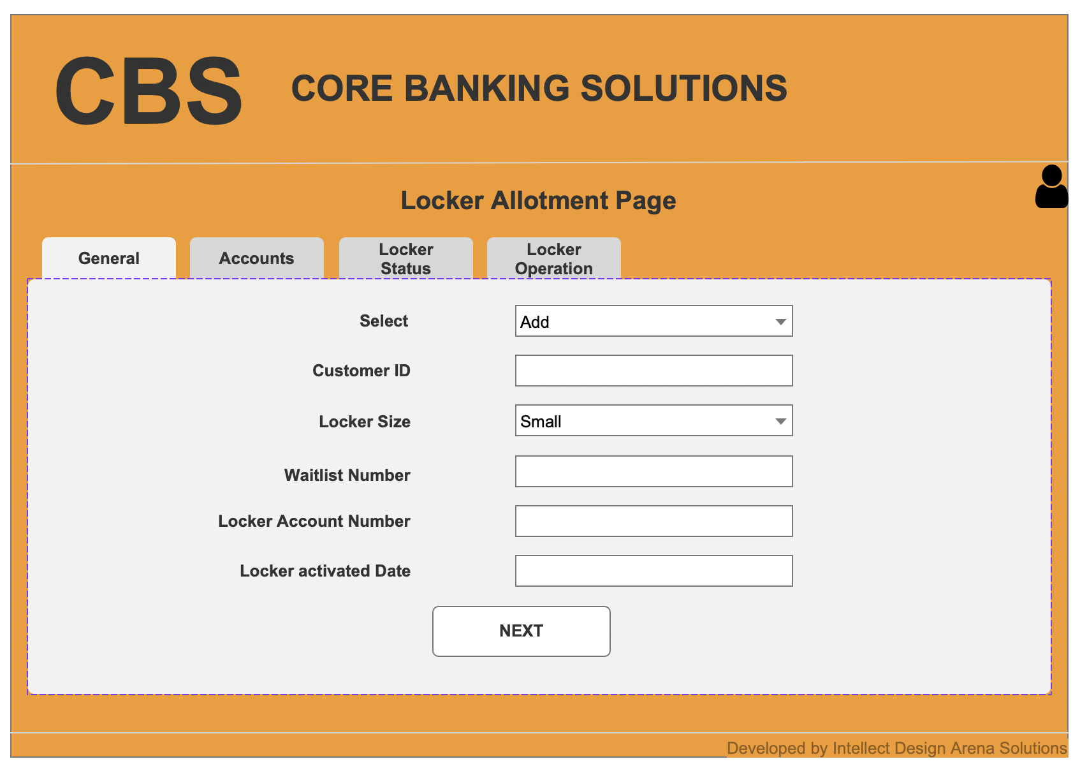

1. View of second tab- Account

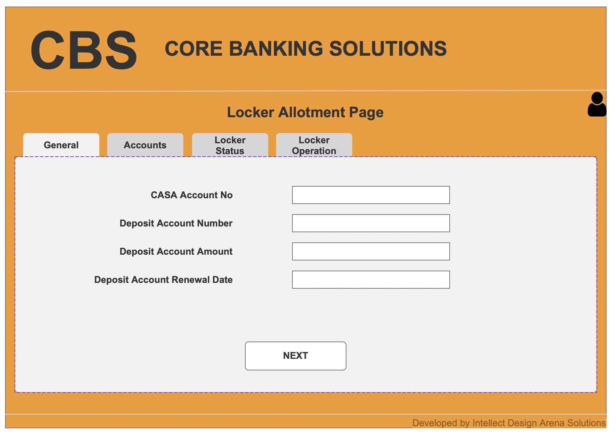

1. View of third tab- Locker Status. Here the 2 new statuses are added as “Locker Break Open” and “Locker Attachment due to Govt orders”. Based on this status, 2 new email/SMS events will be triggered (Last 2 notifications).

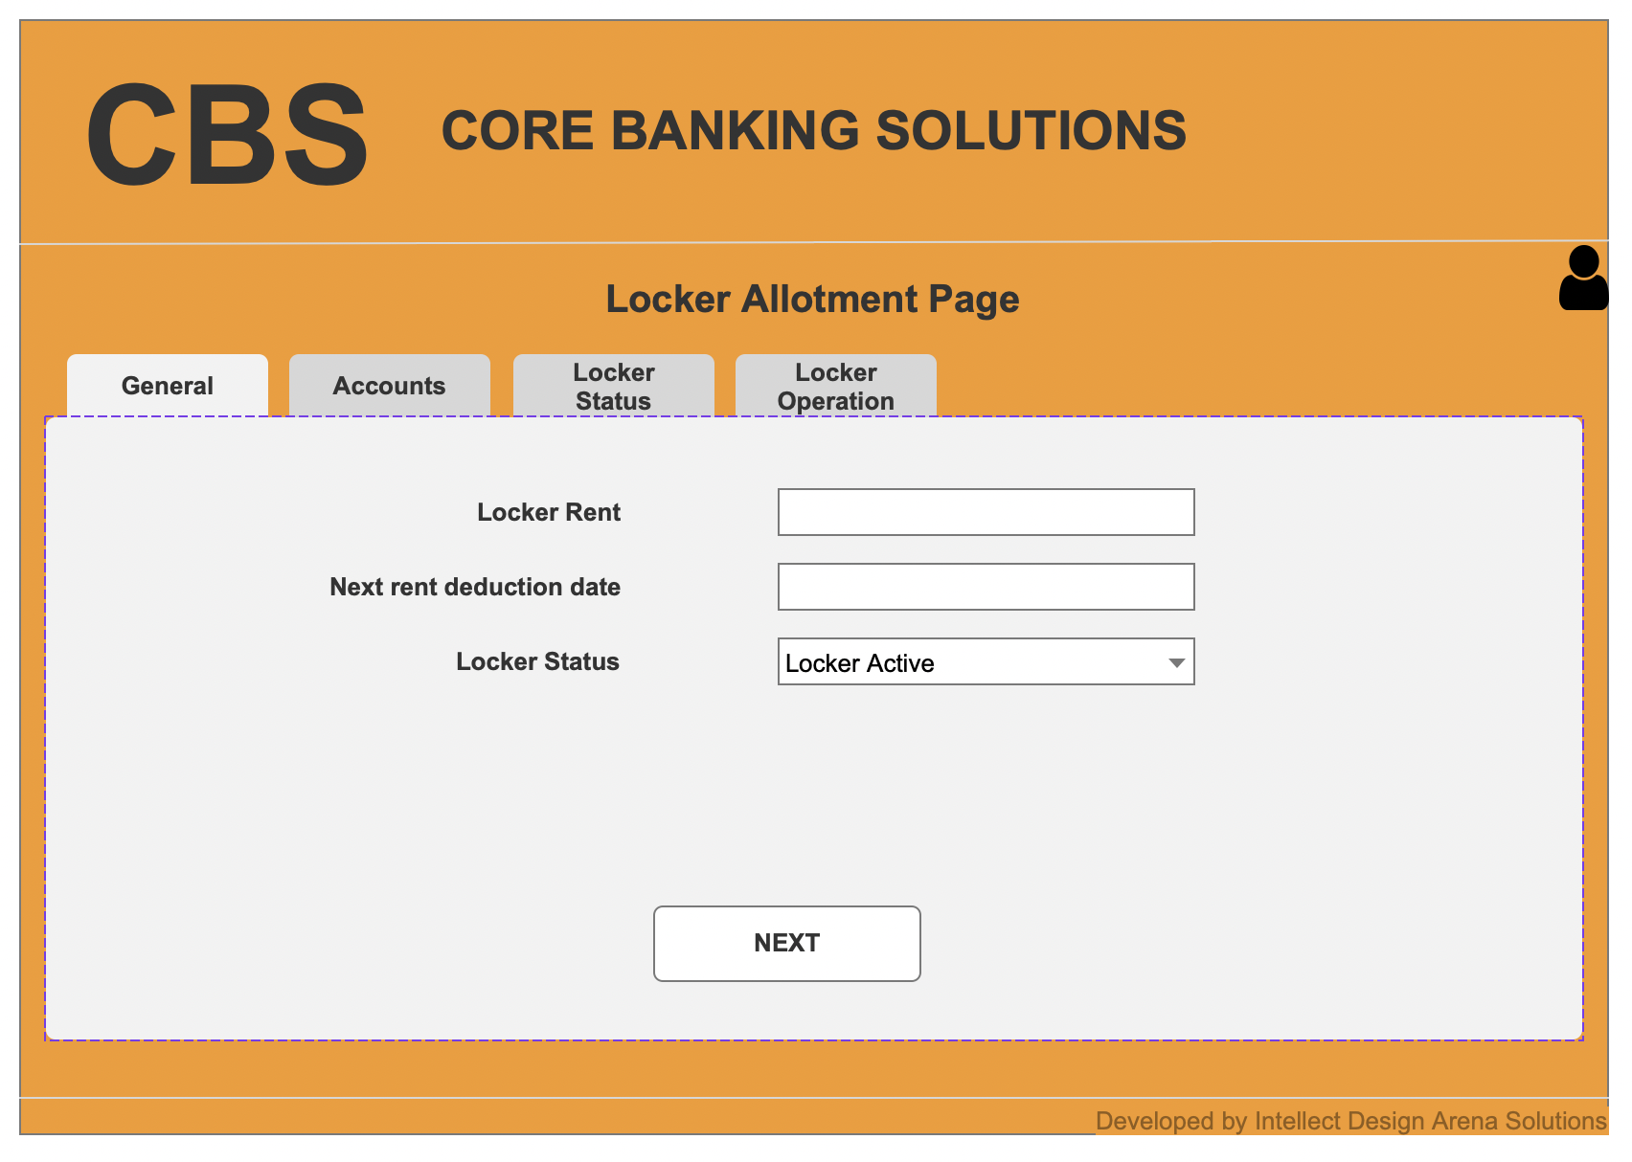

1. View of fourth tab- Locker Operation. Here email/SMS are triggered based on the events logged for Locker operation and locker not closed properly as in this fourth tab (First 2 notifications).

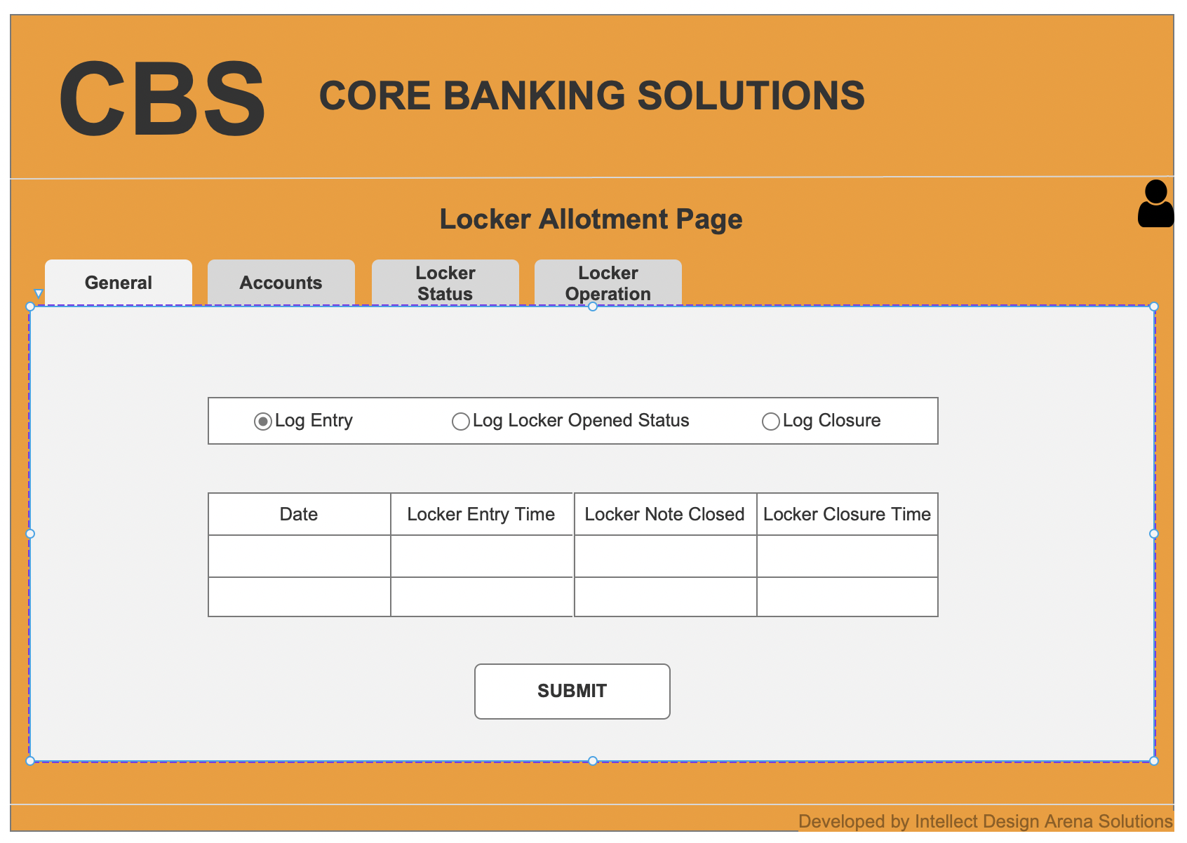

1. Submitting the addition or modification entry and message box pop up.

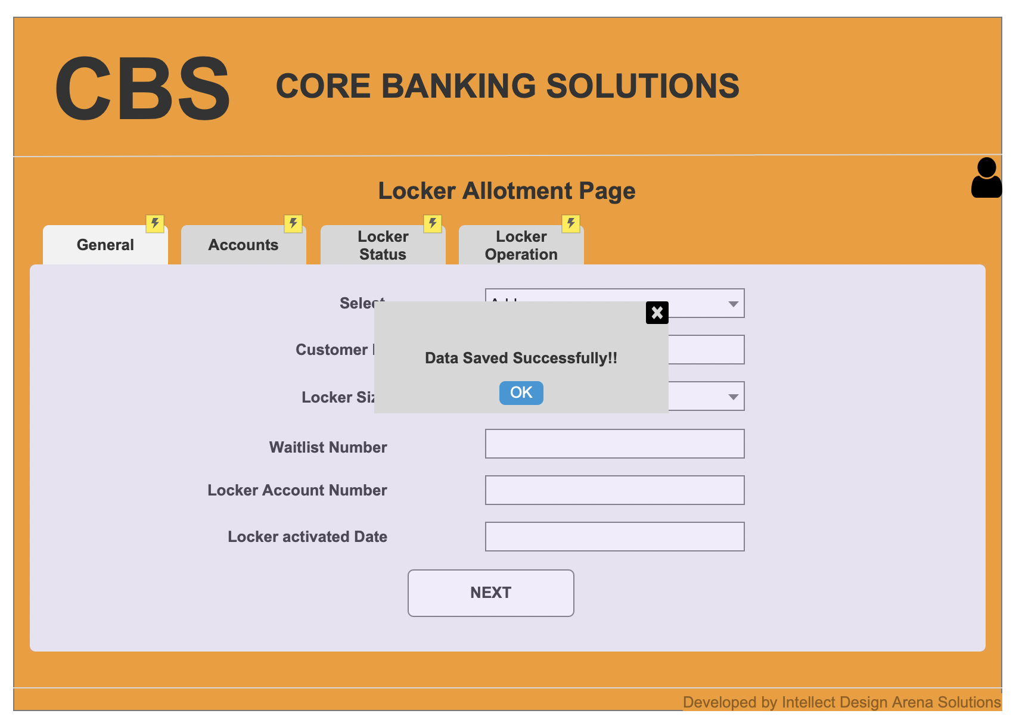

**Document 8- Tools-Visio and Axure:**

**Document 9- BA experience:**