**Vivek Kumar**

**Nurturing Process – Waterfall Deliverables – Part -1/2- V2D2 August 2024**

**Waterfall Model Documents**

**Waterfall Project1 – Part -1/2 – 100 Marks - Pass 60 %  
  
_________________________________________________________________________________**

**Q1.** **Document 1- Business case document template.**

**Ans:**

**Business Case Document**

**Project Title:**

Development of an Applicant Tracking System (ATS) for Recruitment Company

**1. Why is this project initiated?**

This project is initiated to address the inefficiencies and limitations of current recruitment processes, which are heavily reliant on outdated or manual systems. A modern ATS will streamline candidate management, automate repetitive tasks, enhance the candidate experience, and provide valuable data-driven insights to improve decision-making. This initiative aligns with the organization's goals of reducing time-to-hire, improving recruitment efficiency, and enhancing operational performance.

**2. What are the current problems?**

1. **Manual Processes:** Significant time is spent on manual tasks such as resume screening and interview scheduling.
2. **Lack of Integration:** Current systems do not integrate with modern tools like job boards, CRM platforms, or social media.
3. **Limited Data Insights:** Absence of analytics to track recruitment performance, trends, and bottlenecks.
4. **Inefficient Candidate Management:** Difficulty in tracking and managing candidate pipelines.
5. **Poor Candidate Experience:** Lack of timely communication and engagement with candidates.
6. **Outdated Technology:** Existing systems are not scalable or flexible to meet growing recruitment needs.

**3. With this project, how many problems could be solved?**

This project aims to address and resolve the majority of the identified problems:

* Automating manual tasks like resume parsing and interview scheduling.
* Enhancing system integration with job boards, CRM tools, and social media platforms.
* Providing real-time analytics and data insights to improve recruitment strategies.
* Streamlining candidate management with a centralized pipeline view.
* Enhancing candidate experience with automated communication and transparent status updates.
* Implementing scalable and modern technology to future-proof recruitment processes.

**4. What are the resources required?**

**Human Resources:**

* Project Manager
* IT Team (Developers, System Administrators)
* Recruitment Team
* Training Specialists

**Technological Resources:**

* ATS Software
* Cloud Hosting Services
* Integration APIs for third-party tools (job boards, CRMs, etc.)

**Financial Resources:**

* Budget for software licensing, customization, and implementation.
* Training and onboarding costs.
* Maintenance and support post-implementation.

**Other Resources:**

* Vendor consultations and third-party assessments.
* Dedicated support for data migration.

**5. How much organizational change is required to adopt this technology?**

Moderate organizational change will be required, including:

* Training recruitment and hiring teams on the new ATS functionalities.
* Adjusting workflows to leverage automation and data-driven decision-making.
* Introducing change management strategies to ensure smooth adoption.
* Aligning policies and procedures to accommodate the capabilities of the new system.

**6. Time frame to recover ROI?**

The estimated time frame to recover the Return on Investment (ROI) is **12-18 months**, based on the following factors:

* Reduction in time-to-hire and operational costs.
* Improved productivity through automation.
* Enhanced quality of hires leading to reduced turnover costs.
* Increased recruiter efficiency and optimized resource allocation.

**7. How to identify Stakeholders?**

Stakeholders can be identified by analysing their roles, responsibilities, and influence on or interest in the project. Key stakeholders include:

1. **Internal Stakeholders:**
   * Recruitment Team: Primary users of the ATS.
   * Hiring Managers: Collaborate on candidate evaluation and selection.
   * IT Department: Responsible for system implementation and maintenance.
   * Senior Management: Oversees project alignment with organizational goals.
2. **External Stakeholders:**
   * Candidates: End-users who will experience the application process.
   * ATS Vendor/Provider: Supplies and supports the software solution.
   * Clients: Companies hiring through the recruitment firm who benefit from improved recruitment efficiency.

Methods to identify stakeholders:

* Conduct stakeholder mapping exercises.
* Analyze organizational charts and workflows.
* Hold discussions and workshops with key departments.

**Q2.** **Document 2: BA Strategy.  
Write BA approach strategy(as a business analyst, what are the steps that you need to follow to complete a project - what elicitation techniques to apply, how to do stakeholder analysis RACI/ILS, what documents to write, what process to follow to sign off on the documents ,how to take approval from the clients, what communication channels to establish and implement ,how to handle change requests, how to update the progress of the project to the stakeholders, how to take signoff on the UAT - Client Project Acceptance form)**

**Ans:**  
  
**Business Analyst Approach Strategy**

**1. Steps to Complete the Project**

**1.1 Project Initiation**

* First things first, we need to ensure that everyone is aligned with the project's scope, goals, and overall objectives. We’ll set up an initial meeting with key stakeholders to get a clear understanding of their expectations and priorities.
* Identifying the right people from the client side and internally is crucial – these stakeholders will help guide the project, provide feedback, and give approvals at different stages.
* To kick things off, I will organize a project kick-off meeting where we'll align expectations, review timelines, and ensure that everyone understands their roles.

**1.2 Requirement Elicitation**

* Workshops: We’ll set up collaborative workshops to brainstorm and discuss requirements. These meetings will be interactive to make sure we capture everything.
* Interviews: I will personally conduct one-on-one interviews with Subject Matter Experts (SMEs) and key stakeholders to dig deeper into their needs.
* Surveys/Questionnaires: To collect inputs from a larger group, especially when we want quantitative data or feedback from end-users, we’ll send out surveys.
* Observation: We’ll shadow team members to observe their current workflows. It’s a great way to understand how they perform tasks today and identify areas that need improvement.
* Document Analysis: I’ll review existing documentation, reports, and policies to understand the current processes, as these can offer valuable insights into how things work and what needs to change.
* Prototyping: Where necessary, I will create mock-ups or wireframes to help stakeholders visualize the final product and clarify any ambiguity around requirements.

**1.3 Stakeholder Analysis**

* I'll build a Stakeholder Matrix to classify stakeholders based on their level of influence and interest in the project. This helps us understand who needs to be involved at what stage.
* Using the RACI model (Responsible, Accountable, Consulted, Informed), I’ll define who is responsible for each task, who has final accountability, who needs to be consulted for their input, and who should simply be kept in the loop.
* I'll also document stakeholder preferences, communication needs, and expectations to ensure we’re delivering exactly what they want, and how they want to be engaged.

**1.4 Documentation**

* As we move forward, I'll be creating key documents such as the Business Requirements Document (BRD) to outline the high-level business goals and detailed Functional Requirements Specification (FRS) that will guide development.
* Use Case/Process Flows will be drafted to map out user interactions, system behavior, and business processes. These will be crucial for understanding functional needs and aligning development teams.
* We’ll also create Wireframes/Mock-ups to get early visual feedback from stakeholders and ensure we're on the right track.
* I’ll create a Traceability Matrix to track all requirements through the development lifecycle, ensuring we don’t miss anything.
* Change Request Forms will be in place to capture any modifications to requirements throughout the project.
* Additionally, we’ll draft UAT Test Cases to ensure that all requirements are met at the testing stage, and a Client Project Acceptance Form will be used to formally close the project once everything is approved.

**1.5 Requirement Sign-off Process**

* I’ll circulate draft documents with stakeholders, allowing them time to review and provide feedback.
* After addressing any concerns and refining the documents, I'll get formal sign-off, either through email, digital approval tools, or signatures.

**1.6 Client Approval Process**

* Once all documents are finalized, we’ll set up a formal review meeting to present everything to the client.
* I’ll make sure to check off all deliverables against the client’s expectations to ensure we’re all on the same page.
* The final step here will be obtaining formal approval through a Client Acceptance Form.

**2. Communication Channels and Implementation**

**2.1 Internal Communication Channels**

* I will rely on Project Management Tools like Jira or Asana to track progress, tasks, and deadlines. Everyone will have access to monitor the project’s status.
* For quick, informal communication, Instant Messaging tools like Slack or Microsoft Teams will be used, enabling us to resolve queries in real time.
* Emails will be used for formal updates, decisions, and approvals.
* We’ll hold weekly status meetings where I’ll report on progress, discuss blockers, and make sure everyone is aligned.

**2.2 External Communication Channels**

* For client-facing reports, I’ll prepare and send out detailed reports over email on a regular basis.
* Scheduled stakeholder meetings (weekly/bi-weekly) will ensure that we stay aligned with client expectations and gather ongoing feedback.
* To ensure transparency, I’ll set up project dashboards for real-time updates, allowing the client to monitor progress at any time.
* Regular feedback sessions and status calls will be scheduled to keep everyone in the loop and address any concerns immediately.

**3. Handling Change Requests**

**3.1 Process**

* When a change request comes in, it will be formally received through a pre-defined form.
* I’ll work with the team to analyze the impact on scope, timeline, and budget, and communicate these potential effects to the stakeholders.
* After internal discussions, I’ll update the requirement documents and Traceability Matrix to reflect the change.
* I’ll then send the updated documents to the client for approval.

**3.2 Documentation**

* A Change Request Log will be maintained throughout the project. This log will record the details of each change request, including the requester, description, priority, and impact analysis.

**4. Progress Updates to Stakeholders**

**4.1 Frequency**

* Progress updates will happen weekly or bi-weekly depending on the project’s pace and criticality.
* I’ll send out email status reports and ensure the client has access to a real-time project dashboard.

**4.2 Methods**

* Regular status reports will be sent via email.
* The project dashboard will give stakeholders an at-a-glance view of current progress and pending tasks.
* I’ll use milestone tracking to measure progress against key project stages.
* If there are any risks or issues, I’ll highlight them in the report and provide a clear mitigation plan.

**4.3 Content of Updates**

* I’ll include updates on completed tasks and upcoming milestones.
* If there are issues or risks, I’ll provide the steps we're taking to mitigate them.
* I’ll also mention if there are any changes to scope, timeline, or resources.

**5. User Acceptance Testing (UAT) and Sign-Off Process**

**5.1 Preparation for UAT**

* I’ll prepare UAT Test Cases based on the functional requirements that were agreed upon in earlier stages.
* Scheduling UAT sessions with stakeholders is critical – I’ll ensure the right people are available to test the system.
* I’ll also train users on testing procedures so they know exactly what to look for.

**5.2 Executing UAT**

* During UAT, I’ll monitor the sessions, ensuring that any issues are logged.
* I’ll record all feedback and bugs in a tracking system and work with the team to address them.
* Once bugs are fixed, we’ll revalidate and ensure everything is working correctly.

**5.3 Client Project Acceptance Form**

* After UAT is complete, I’ll summarize the outcomes in a report and share it with the client.
* If any defects are still open, we’ll document whether they are acceptable or require further action.
* Finally, I’ll get the formal sign-off from the client using the Client Project Acceptance Form.

**Q3.** **Document 3- Functional Specifications.  
Ans:**

|  |  |
| --- | --- |
| **Project name** | Development of an Applicant Tracking System (ATS) for Recruitment Company |
| **Customer name** | YUGMA INC |
| **Project Version** | 2.0 |
| **Project Sponsor** | Prayag Wade |
| **Project Manager** | Mr. Alex |
| **Project Initiation date** | 10/01/2025 |

|  |  |  |  |
| --- | --- | --- | --- |
| **REQ ID** | **REQ NAME** | **REQ DESCRIPTION** | **PRIORITY** |
| FR-001 | Job Posting Management | Allow admin to create, edit, and manage job postings on multiple job boards. | High |
| FR-002 | Resume Parsing | Automatically parse resumes to extract key information into structured formats. | High |
| FR-003 | Candidate Profile Management | Enable candidates to create and update profiles with personal and professional details. | High |
| FR-004 | Application Tracking | Track the status of applications across different stages of the hiring process. | High |
| FR-005 | Interview Scheduling | Facilitate interview scheduling with automated calendar integrations. | Medium |
| FR-006 | Candidate Notifications | Notify candidates about their application status at different stages. | High |
| FR-007 | User Role Management | Define and manage roles and permissions for different user types. | High |
| FR-008 | Pipeline Visualization | Provide visual dashboards for candidate pipelines to monitor progress. | Medium |
| FR-009 | Reporting and Analytics | Generate reports on recruitment metrics like time-to-hire and source effectiveness. | High |
| FR-010 | Multi-language Support | Support multiple languages to cater to diverse candidate pools. | Low |
| FR-011 | Integration with Job Boards | Integrate with major job boards like LinkedIn, Indeed, and Glassdoor. | High |
| FR-012 | Mobile Accessibility | Provide mobile-friendly access for recruiters and candidates. | Medium |
| FR-013 | Assessment Integration | Integrate third-party assessment tools for candidate evaluation. | Medium |
| FR-014 | Document Upload | Allow candidates to upload resumes, cover letters, and other documents. | High |
| FR-015 | Email Templates | Provide customizable email templates for recruiter communication. | Medium |
| FR-016 | GDPR Compliance | Ensure the system complies with data protection regulations like GDPR. | High |
| FR-017 | Duplicate Detection | Identify and merge duplicate candidate profiles. | Medium |
| FR-018 | Feedback Management | Allow hiring managers to provide structured feedback on candidates. | Medium |
| FR-019 | Candidate Search | Enable recruiters to search for candidates using advanced filters. | High |
| FR-020 | Offer Management | Generate and track job offers for candidates. | Medium |
| FR-021 | Onboarding Integration | Integrate with onboarding tools for post-hire processes. | Low |
| FR-022 | Calendar Sync | Sync recruiter calendars with the system for real-time availability. | Medium |
| FR-023 | Social Media Integration | Post job openings on social media platforms directly. | Low |
| FR-024 | Internal Talent Pool | Maintain a database of internal candidates for quick referrals. | Medium |
| FR-025 | Video Interview Support | Support video interviews within the system. | Medium |
| FR-026 | Candidate Scoring | Provide a scoring system to evaluate candidates based on predefined criteria. | Medium |
| FR-027 | Bulk Actions | Enable bulk actions like sending emails or updating statuses for multiple candidates. | Medium |
| FR-028 | Real-Time Notifications | Send real-time notifications to recruiters and hiring managers. | Medium |
| FR-029 | Accessibility Features | Ensure the system is accessible to users with disabilities. | Low |
| FR-030 | Backup and Recovery | Implement automatic data backup and recovery processes. | High |
|  |  |  |  |
| NFR ID | Requirement Name | Description | Priority |
| NFR-001 | System Availability | The system should have an uptime of 99.9% to ensure continuous access for users. | High |
| NFR-002 | Performance | The system must process 10,000 candidate profiles within 2 seconds during peak usage. | High |
| NFR-003 | Scalability | The ATS must support up to 1,000 concurrent users without performance degradation. | High |
| NFR-004 | Data Security | The system must comply with GDPR and encrypt all sensitive candidate data both at rest and in transit. | High |
| NFR-005 | Usability | The user interface should have an average usability score of 90% in user feedback surveys conducted post-implementation. | Medium |
| NFR-006 | Compatibility | The system must support the latest two versions of major browsers (e.g., Chrome, Firefox, Edge) and work seamlessly on mobile devices. | Medium |
| NFR-007 | Backup and Recovery | Daily backups must be automated, and data recovery should be possible within 30 minutes in case of system failure. | High |
| NFR-008 | Response Time | The system should respond to user actions (e.g., opening a candidate profile) within 1 second under normal operating conditions. | High |
| NFR-009 | Maintainability | The system should allow for minor updates and patches to be implemented within 4 hours and major updates within 2 business days. | Medium |
| NFR-010 | Audit Trail | The system must maintain an audit log of all actions performed, including user login, data updates, and status changes, for at least 2 years. | High |

**Q4.** **Document 4- Requirement Traceability Matrix.  
Ans:**

|  |  |  |  |  |  |  |  |
| --- | --- | --- | --- | --- | --- | --- | --- |
| **REQ ID** | **REQ NAME** | **REQ DESCRIPTION** | **DESIGN D1** | **TEST T1** | **DESIGN D2** | **TEST T2** | **UAT** |
| FR-001 | Job Posting Management | Allow admin to create, edit, and manage job postings on multiple job boards. | Complete | Complete | Complete | Complete | Incomplete |
| FR-002 | Resume Parsing | Automatically parse resumes to extract key information into structured formats. | Complete | Complete | Complete | Complete | Incomplete |
| FR-003 | Candidate Profile Management | Enable candidates to create and update profiles with personal and professional details. | Complete | Complete | Complete | Incomplete | Incomplete |
| FR-004 | Application Tracking | Track the status of applications across different stages of the hiring process. | Complete | Complete | Complete | Complete | Incomplete |
| FR-005 | Interview Scheduling | Facilitate interview scheduling with automated calendar integrations. | Complete | Complete | Complete | Complete | Complete |
| FR-006 | Candidate Notifications | Notify candidates about their application status at different stages. | Complete | Complete | Complete | Complete | Incomplete |
| FR-007 | User Role Management | Define and manage roles and permissions for different user types. | Complete | Complete | Complete | Incomplete | Incomplete |
| FR-008 | Pipeline Visualization | Provide visual dashboards for candidate pipelines to monitor progress. | Complete | Complete | Complete | Complete | Incomplete |
| FR-009 | Reporting and Analytics | Generate reports on recruitment metrics like time-to-hire and source effectiveness. | Complete | Complete | Complete | Incomplete | Incomplete |
| FR-010 | Multi-language Support | Support multiple languages to cater to diverse candidate pools. | Complete | Complete | Complete | Complete | Incomplete |
| FR-011 | Integration with Job Boards | Integrate with major job boards like LinkedIn, Indeed, and Glassdoor. | Complete | Complete | Complete | Complete | Complete |
| FR-012 | Mobile Accessibility | Provide mobile-friendly access for recruiters and candidates. | Complete | Complete | Complete | Complete | Incomplete |
| FR-013 | Assessment Integration | Integrate third-party assessment tools for candidate evaluation. | Complete | Complete | Complete | Complete | Incomplete |
| FR-014 | Document Upload | Allow candidates to upload resumes, cover letters, and other documents. | Complete | Complete | Complete | Complete | Complete |
| FR-015 | Email Templates | Provide customizable email templates for recruiter communication. | Complete | Complete | Complete | Complete | Incomplete |
| FR-016 | GDPR Compliance | Ensure the system complies with data protection regulations like GDPR. | Complete | Complete | Complete | Incomplete | Incomplete |
| FR-017 | Duplicate Detection | Identify and merge duplicate candidate profiles. | Complete | Complete | Complete | Complete | Incomplete |
| FR-018 | Feedback Management | Allow hiring managers to provide structured feedback on candidates. | Complete | Complete | Complete | Incomplete | Incomplete |
| FR-019 | Candidate Search | Enable recruiters to search for candidates using advanced filters. | Complete | Complete | Complete | Complete | Incomplete |
| FR-020 | Offer Management | Generate and track job offers for candidates. | Complete | Complete | Complete | Complete | Complete |
| FR-021 | Onboarding Integration | Integrate with onboarding tools for post-hire processes. | Complete | Complete | Complete | Complete | Incomplete |
| FR-022 | Calendar Sync | Sync recruiter calendars with the system for real-time availability. | Complete | Complete | Complete | Incomplete | Incomplete |
| FR-023 | Social Media Integration | Post job openings on social media platforms directly. | Complete | Complete | Complete | Complete | Incomplete |
| FR-024 | Internal Talent Pool | Maintain a database of internal candidates for quick referrals. | Complete | Complete | Complete | Incomplete | Incomplete |
| FR-025 | Video Interview Support | Support video interviews within the system. | Complete | Complete | Complete | Complete | Incomplete |
| FR-026 | Candidate Scoring | Provide a scoring system to evaluate candidates based on predefined criteria. | Complete | Complete | Complete | Complete | Complete |
| FR-027 | Bulk Actions | Enable bulk actions like sending emails or updating statuses for multiple candidates. | Complete | Complete | Complete | Complete | Incomplete |
| FR-028 | Real-Time Notifications | Send real-time notifications to recruiters and hiring managers. | Complete | Complete | Complete | Incomplete | Incomplete |
| FR-029 | Accessibility Features | Ensure the system is accessible to users with disabilities. | Complete | Complete | Complete | Complete | Incomplete |
| FR-030 | Backup and Recovery | Implement automatic data backup and recovery processes. | Complete | Complete | Complete | Incomplete | Incomplete |
| **REQ ID** | **REQ NAME** | **REQ DESCRIPTION** | **DESIGN D1** | **TEST T1** | **DESIGN D2** | **TEST T2** | **UAT** |
| NFR-001 | System Scalability | Support up to 1,000 concurrent users without performance degradation. |  |  |  |  |  |
| NFR-002 | Security Compliance | Ensure system meets GDPR and data encryption requirements. |  |  |  |  |  |
| NFR-003 | Performance | System response time should not exceed 3 seconds under peak load. |  |  |  |  |  |
| NFR-004 | Mobile Compatibility | Ensure mobile accessibility across major browsers and devices. |  |  |  |  |  |
| NFR-005 | Accessibility | Ensure compliance with WCAG 2.1 standards for accessibility. |  |  |  |  |  |

**Q5.** **Document 5- BRD Template.  
  
Ans:**



**BRD (Business Requirement Document) for the project :** **Development of an Applicant Tracking System (ATS) for Recruitment Company**

**<** **Development of an Applicant Tracking System (ATS) for Recruitment Company >**

**<ATS001>**

**<1.001>**

**<Vivek Kumar>**

Contents

1. Document Revisions 8
2. Approvals 8
3. RASCI Chart for This Document 8

Codes Used in RASCI Chart 9

RASCI Chart 9

1. Introduction 9
   1. Business Goals 9
   2. Business Objectives 9
   3. Business Rules 10
   4. Background 10
   5. Project Objective 10
   6. Project Scope 10
      1. In Scope Functionality 10
      2. Out Scope Functionality 10
2. Assumptions 10
3. Constraints 10
4. Risks 10

Technological Risks 11

Skills Risks 11

Political Risks 11

Business Risks 11

Requirements Risks 11

Other Risks 11

1. Business Process Overview 11
   1. Legacy System (AS-IS) 11
   2. Proposed Recommendations (TO-BE) 11
2. Business Requirements 11
3. Appendices 12
   1. List of Acronyms 12
   2. Glossary of Terms 12
   3. Related Documents 12

**1.Document Revisions**

|  |  |  |
| --- | --- | --- |
| **Date** | **Version Number** | **Document Changes** |
| 05/02/2024 | 0.1 | Initial Draft |
| 08/02/2024 | 0.2 | Updated [UI Req]. |
| 12/02/2024 | 0.3 | Updated [UI Req]. |
| 18/02/2024 | 0.4 | Updated [Thirds party vendors]. |
| 24/02/2024 | 0.5 | Updated [Dependencies]. |
| 26/02/2024 | 0.6 | Updated [Functional requirement- Admin role]. |
| 28/02/2024 | 0.7 | Finalized document after approval. |
| 05/03/2024 | 0.8 | Added/Modified [Time constraint]. |
| 09/03/2024 | 0.9 | Added/Modified [Resources]. |

**2.Approvals**

|  |  |  |  |  |
| --- | --- | --- | --- | --- |
| **Role** | **Name** | **Title** | **Signature** | **Date** |
| Project Sponsor |  |  |  |  |
| Business Owner |  |  |  |  |
| Project Manager |  |  |  |  |
| System Architect |  |  |  |  |
| Development Lead |  |  |  |  |
| User Experience Lead |  |  |  |  |
| Quality Lead |  |  |  |  |
| Content Lead |  |  |  |  |

**3.RACI Chart for This Document**

The RACI chart identifies the persons who need to be contacted whenever changes are made to this document. RACI stands for responsible, accountable, consulted, and informed. These are the main codes that appear in a RACI chart, used here to describe the roles played by team members and stakeholders in the production of the BRD. They are adapted from charts used to assign roles and responsibilities during a project. ( RACI Can be made for IT side[Project stakeholder] as mentioned above, apart from that Can also Be made for Client side[Business Stakeholder]).

The following describes the full list of codes used in the table:

Codes Used in RACI Chart

* Authorize Has ultimate signing authority for any changes to the document.

1. Responsible Responsible for creating this document.

A Accountable Accountable for accuracy of this document (for example, the project manager)

1. Supports Provides supporting services in the production of this document

|  |  |  |
| --- | --- | --- |
| C | Consulted | Provides input (such as an interviewee). |
| I | Informed | Must be informed of any changes. |

|  |  |  |  |  |  |  |  |
| --- | --- | --- | --- | --- | --- | --- | --- |
| **Name** | **Position** | **Authorize** | **R** | **A** | **S** | **C** | **I** |
| Business Analyst |  |  | X |  | X |  |  |
| Project Sponsor |  | X |  | X |  |  |  |
| Development Lead |  |  |  |  | X | X |  |
| Recruitment Team Lead |  |  |  |  |  | X | X |

**4. Introduction**

**4.1. Business Goals**

The ATS project is aimed at creating a streamlined and efficient recruitment platform that automates processes, enhances data-driven decision-making, and improves both recruiter and candidate experiences.

**4.2. Business Objectives**

The objectives of this project are:

* Develop an ATS platform to automate and streamline recruitment tasks such as resume parsing, interview scheduling, and candidate tracking.
* Provide an intuitive user interface for candidates and recruiters.
* Enhance integration with third-party platforms such as job boards, social media, and CRM tools.
* Offer real-time analytics and reporting for recruitment insights.

**4.3. Business Rules**

* All candidate data must comply with GDPR and other regional data protection regulations.
* Only authorized users can access sensitive candidate information.
* Job postings must follow company-defined approval workflows.

**4.4. Background**

Recruitment processes currently rely on manual systems that are inefficient and prone to errors. The absence of a centralized system results in delays, lack of transparency, and poor candidate experiences. The ATS project was initiated to address these challenges and align recruitment operations with modern technological standards.

**4.5. Project Objectives**

To design and deploy an ATS platform that:

* Reduces time-to-hire by automating manual processes.
* Enhances candidate and recruiter interactions.
* Integrates seamlessly with existing HR tools and external platforms.

**4.6. Project Scope**

**4.6.1. In-Scope Functionality**

* Resume parsing and candidate profile creation.
* Job posting management on multiple platforms.
* Automated interview scheduling.
* Candidate pipeline visualization.
* Reporting and analytics tools.
* Mobile-friendly user access.

**4.6.2. Out-of-Scope Functionality**

* Third-party Integrations: Integration with external job boards or HR software outside the specified list.
* Payroll Management: Handling payroll and compensation will be excluded as it’s outside the recruiting workflow.
* Candidate Onboarding: Any features related to candidate onboarding such as document management or training will not be part of the scope.
* Advanced Reporting: Reporting functionalities beyond the basic recruiting analytics (like detailed workforce analysis) may be excluded.
* Job Board Creation: Building new job boards or other external web development beyond the ATS itself.
* Employee Performance Tracking: Performance evaluation or management of current employees won’t be considered in this ATS project.
* Support for Non-Staffing Agencies: The system will only cater to staffing companies and won’t support other industries.
* Mobile Application: A mobile app may be excluded if the system is only required to function via desktop or web-based applications.

**5. Assumptions**

* **Availability of Resources**: Development teams, infrastructure, and staffing support will be available as per the project schedule.
* **Data Availability**: All required candidate and job data will be provided in an accessible format for integration.
* **Stakeholder Engagement**: Key stakeholders (hiring managers, recruiters) will be available for feedback and testing during key phases.
* **Stable Technological Environment**: The development team assumes that existing systems and technologies (like the ATS platform) will remain stable during the project duration.
* **Legal and Compliance Compliance:** The ATS will follow the necessary data protection laws, such as GDPR or CCPA, during development and implementation.
* **Cloud Infrastructure**: The project assumes cloud-based storage and computing infrastructure for scalability and data storage unless otherwise specified.
* **User Training:** End-users will have basic familiarity with using ATS systems, and training requirements will be minimal.
* **No Major Platform Changes**: The core functionalities of the ATS software won’t change drastically during development.

**6. Constraints**

* **Budget:** Limited budget for the development, deployment, or ongoing maintenance of the ATS.
* **Timeframe:** Fixed deadlines for project milestones, beta testing, and full deployment.
* **Resources:** Constraints regarding the availability of the development team or other resources (e.g., technical expertise, infrastructure).
* **Data Privacy Regulations:** Compliance with legal requirements such as GDPR, HIPAA, etc., which may limit the handling and storage of sensitive data.
* **Technology Stack:** A set technology stack (e.g., programming languages, frameworks) that the team must adhere to, limiting flexibility in choosing other tools or platforms.
* **Compatibility with Existing Systems:** The ATS must integrate with the existing CRM, HR systems, or job boards, which could pose compatibility issues.

**7. Risks**

* **Data Breach:** Risk of sensitive candidate or company data being compromised due to security vulnerabilities.
* **Technology Risk:** The chosen technology stack might become obsolete or fail to meet performance expectations.
* **User Adoption:** Low adoption rate by internal users or candidates due to an interface that’s not user-friendly.
* **Integration Failures**: Difficulty integrating with external systems like job boards, CRM tools, or other databases, causing delays or additional costs.
* **Regulatory Non-compliance:** The ATS may fail to meet compliance standards related to data storage or privacy laws.
* **Performance Issues:** The system may face performance issues such as slow load times or inability to scale with increasing user data or traffic.
* **Budget Overrun:** The project might face additional costs due to unforeseen technical issues, design changes, or scope creep.
* **Change Management:** Resistance to adopting new ATS tools or processes by staff members who are accustomed to older systems.
* **Delays in Development:** Schedule delays due to unexpected technical difficulties or resource shortages.
* **Vendor Risk:** Risk of third-party vendors not delivering quality services on time (e.g., cloud service providers, consultants).

**8. Business Process Overview**

**8.1. Legacy System (AS-IS)**

Recruitment tasks are managed through spreadsheets and manual tracking, causing inefficiencies and delays.

* **Manual Data Entry:** Recruiters manually enter candidate details into spreadsheets or outdated ATS platforms, increasing the chances for errors or duplicates.
* **Job Posting Management**: Jobs are posted across multiple job boards manually, and there is little automation to track or manage job postings.
* **Interview Scheduling**: The process of scheduling interviews might involve back-and-forth emails or phone calls, leading to potential scheduling conflicts or missed opportunities.
* **Communication Management:** Recruiters communicate with candidates primarily via email or phone, which may lack consistency or personalization.
* **Candidate Evaluation**: The evaluation process could be entirely manual (e.g., paper resumes, individual assessments), leading to fragmented and inconsistent decision-making.  
    
  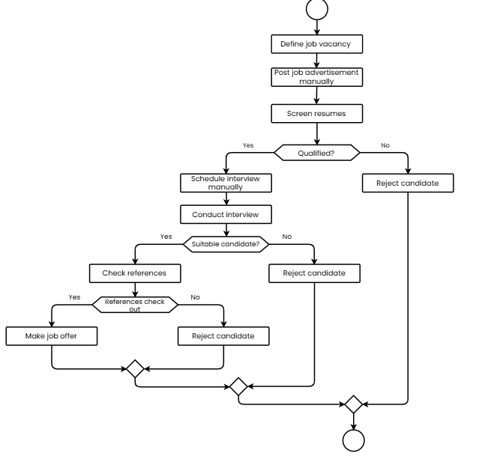

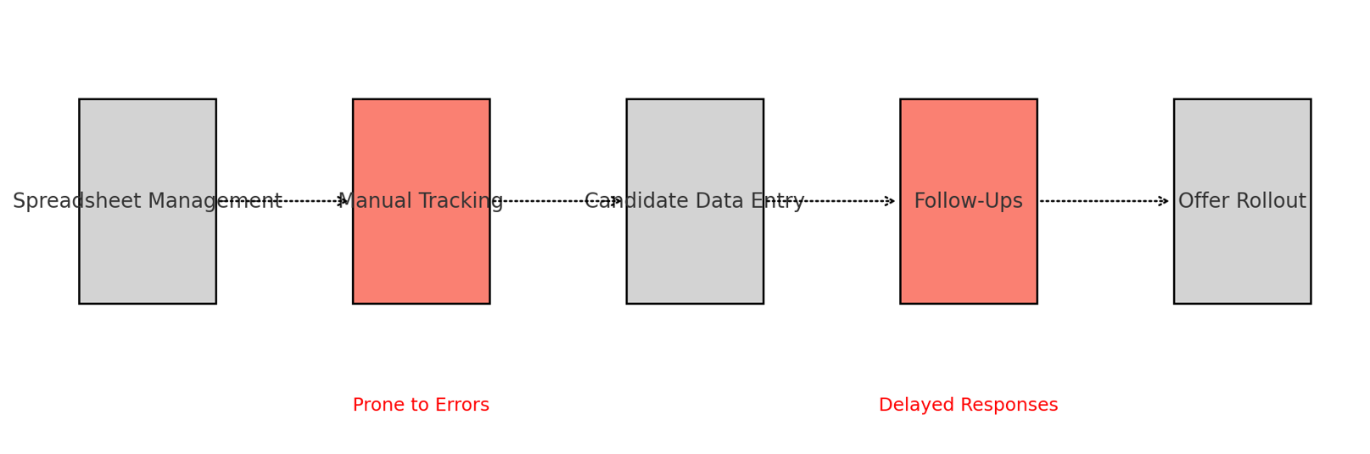

**8.2. Proposed Recommendations (TO-BE)**

The proposed ATS will replace manual processes with an automated and centralized platform, improving speed, accuracy, and user satisfaction.  
  
 **Automated Job Posting**:

* The ATS automatically posts job openings to various job boards (LinkedIn, Indeed, etc.), saving time and ensuring consistent and timely postings.

**Centralized Candidate Data**:

* The ATS serves as a centralized repository for all candidate data, including resumes, interview notes, and communication history, providing a 360-degree view of each candidate.

**AI-powered Screening & Matching**:

* The ATS uses AI or machine learning algorithms to pre-screen resumes based on job requirements and match candidates with the best-fitting roles, reducing the workload of recruiters.

**Automated Communication**:

* Automated email templates and notifications are sent to candidates, keeping them informed throughout the process (e.g., interview confirmations, rejection emails, etc.).

**Interview Scheduling Integration**:

* The ATS integrates with calendar tools (e.g., Google Calendar, Microsoft Outlook) to allow automated interview scheduling, reducing the back-and-forth of manual coordination.

**Enhanced Collaboration**:

* Internal teams (e.g., hiring managers, recruiters) can collaborate more efficiently by sharing candidate profiles, leaving notes, and evaluating candidates within the ATS platform.

**Data Analytics & Reporting**:

* Real-time reporting and analytics are available for tracking metrics like time-to-hire, cost-per-hire, and candidate source effectiveness. Recruiters and management can make data-driven decisions.

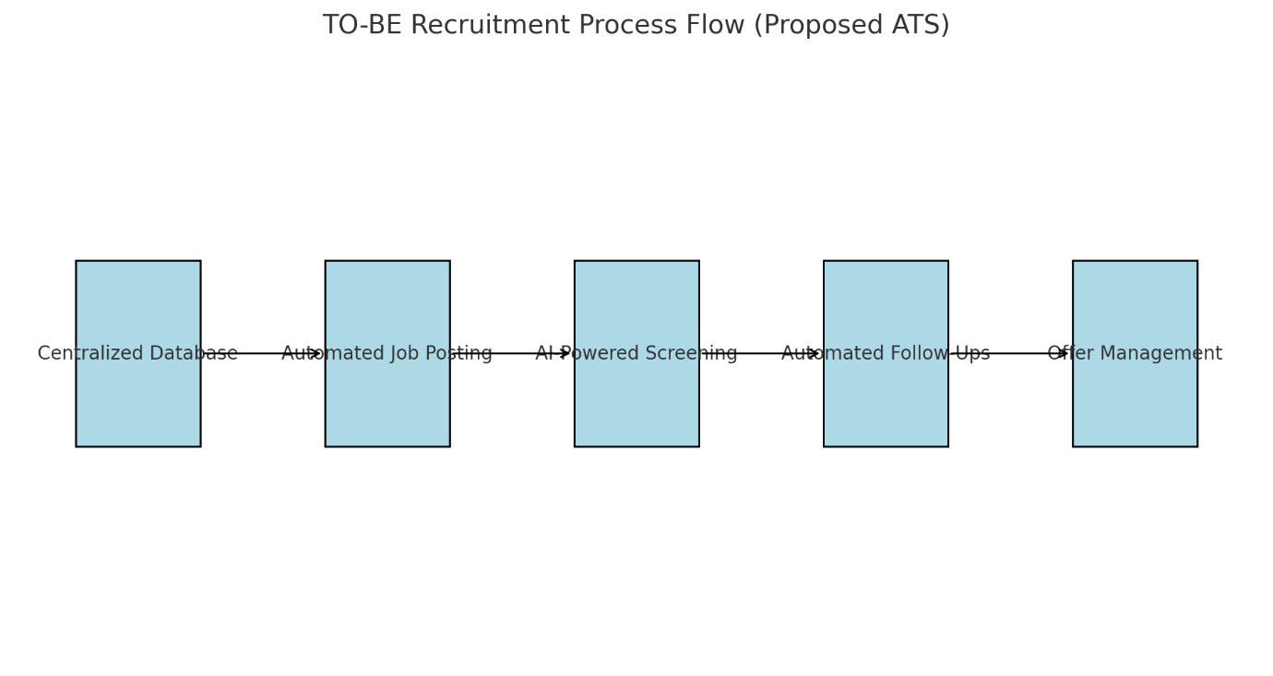

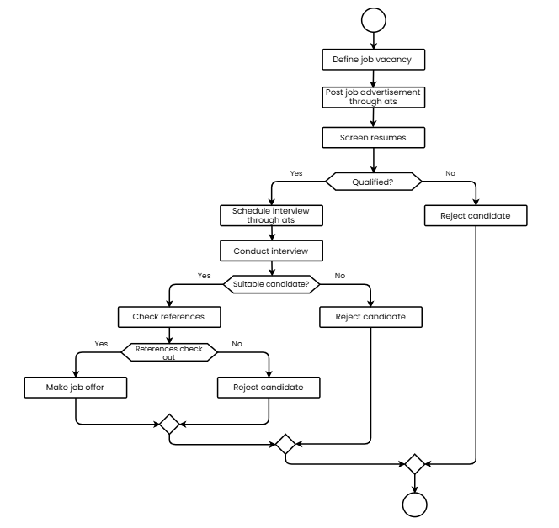

**9. Business Requirements**

|  |  |  |  |
| --- | --- | --- | --- |
| **REQ ID** | **REQ NAME** | **REQ DESCRIPTION** | **PRIORITY** |
| FR-001 | Job Posting Management | Allow admin to create, edit, and manage job postings on multiple job boards. | High |
| FR-002 | Resume Parsing | Automatically parse resumes to extract key information into structured formats. | High |
| FR-003 | Candidate Profile Management | Enable candidates to create and update profiles with personal and professional details. | High |
| FR-004 | Application Tracking | Track the status of applications across different stages of the hiring process. | High |
| FR-005 | Interview Scheduling | Facilitate interview scheduling with automated calendar integrations. | Medium |
| FR-006 | Candidate Notifications | Notify candidates about their application status at different stages. | High |
| FR-007 | User Role Management | Define and manage roles and permissions for different user types. | High |
| FR-008 | Pipeline Visualization | Provide visual dashboards for candidate pipelines to monitor progress. | Medium |
| FR-009 | Reporting and Analytics | Generate reports on recruitment metrics like time-to-hire and source effectiveness. | High |
| FR-010 | Multi-language Support | Support multiple languages to cater to diverse candidate pools. | Low |
| FR-011 | Integration with Job Boards | Integrate with major job boards like LinkedIn, Indeed, and Glassdoor. | High |
| FR-012 | Mobile Accessibility | Provide mobile-friendly access for recruiters and candidates. | Medium |
| FR-013 | Assessment Integration | Integrate third-party assessment tools for candidate evaluation. | Medium |
| FR-014 | Document Upload | Allow candidates to upload resumes, cover letters, and other documents. | High |
| FR-015 | Email Templates | Provide customizable email templates for recruiter communication. | Medium |

**10. Appendices**

**10.1. List of Acronyms**

* ATS: Applicant Tracking System
* GDPR: General Data Protection Regulation

**10.2. Glossary of Terms**

* Candidate Pipeline: The flow of candidates through the recruitment process stages.

**10.3. Related Documents**

* Functional Specification Document
* Project Charter