**Project 2- Scrum Foods**

Question 1:

Agile Manifesto:

Agile manifesto is a set of values and principles that guide how teams should work together to deliver software (or other projects) quickly, efficiently, and with a focus on customer needs.

4 values:

1. **Individual and interaction over using processes and tools**
2. **Working software over comprehensive documentation**
3. **Customer collaboration over contract negotiations**
4. **Responding to change over following a plan**

12 principles:

1. **Customer satisfaction through early and continuous software delivery**
2. **Accommodate changing requirements throughout the development process**
3. **Frequent delivery of working software**
4. **Collaboration between the business stakeholders and developers throughout the project**
5. **Support, trust, and motivate the people involved**
6. **Enable face-to-face interactions**
7. **Working software is the primary measure of progress**
8. **Agile processes to support a consistent development pace-** **Work at a steady pace that can be maintained over time, without burning out the team.**
9. **Attention to technical detail and design enhances agility**
10. **Simplicity-** **Focus on the essentials and avoid unnecessary work or features that don’t add value.**
11. **Self-organizing teams encourage great architectures, requirements, and designs-** **Teams should have the freedom to make decisions and organize their work because they know best how to achieve the project goals.**
12. **Regular reflections on how to become more effective-** **Continuously evaluate and improve how the team works, to become more efficient and productive over time.**

Question 2:

User story-

A user story is a simple description of a feature or requirement written from the perspective of the end user. It helps teams to understand what the user wants and why.

User story 1

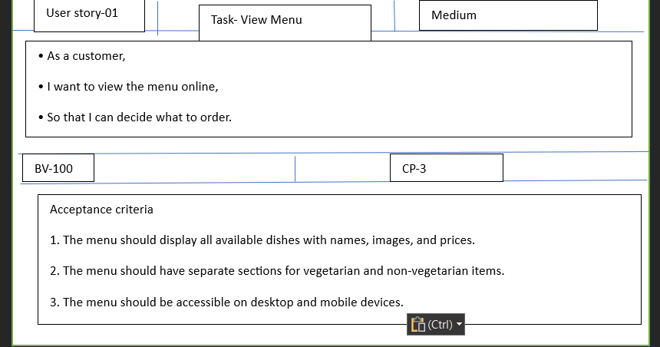

2)

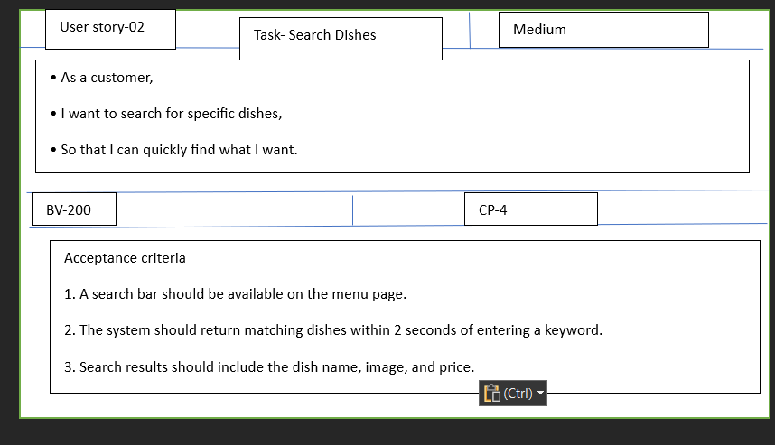

3)

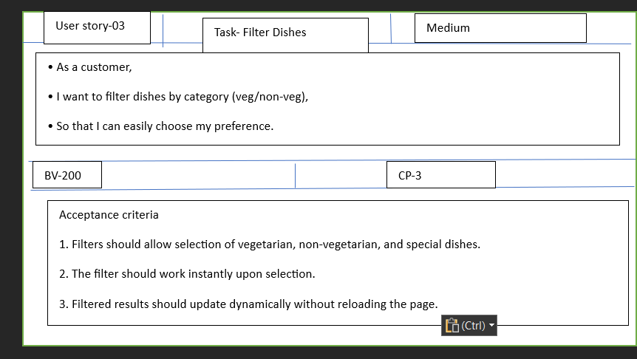

4)

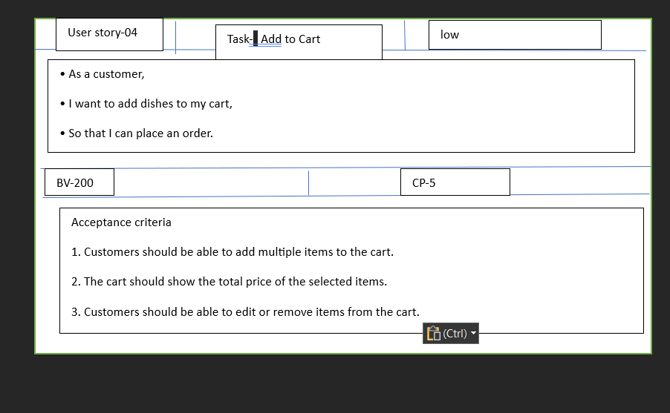5)

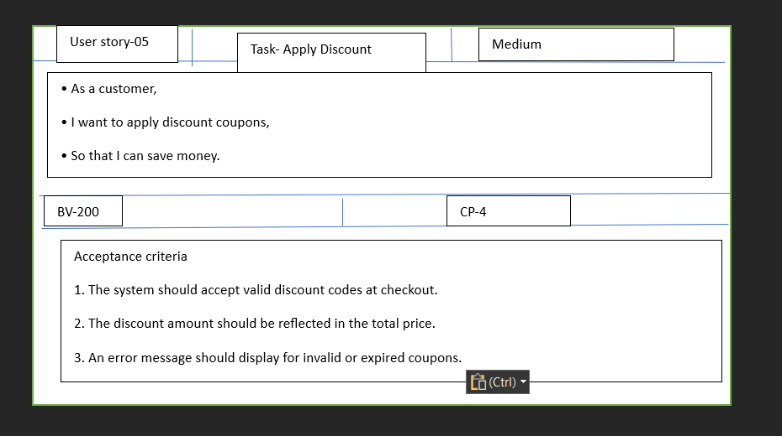

6)

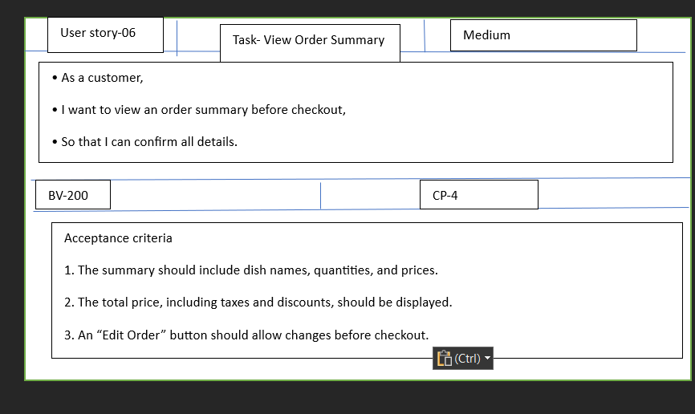

7)

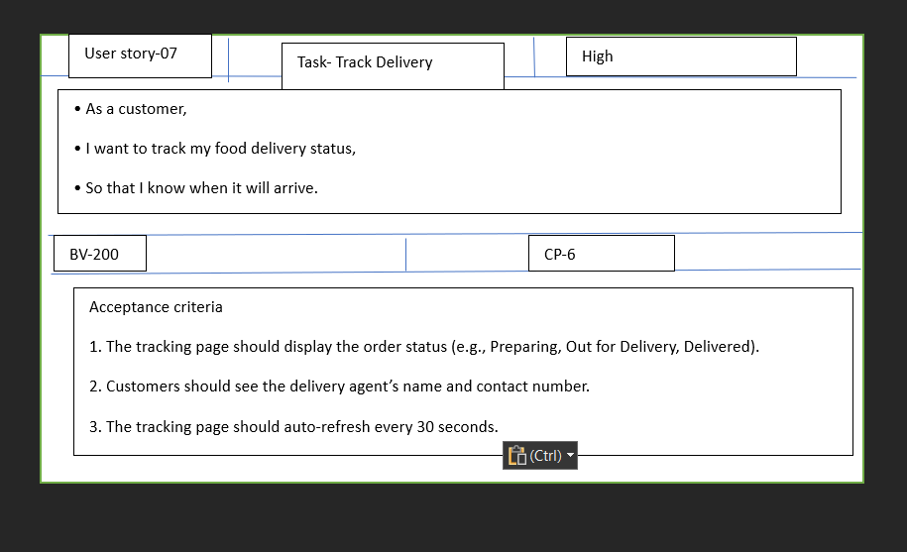

8)

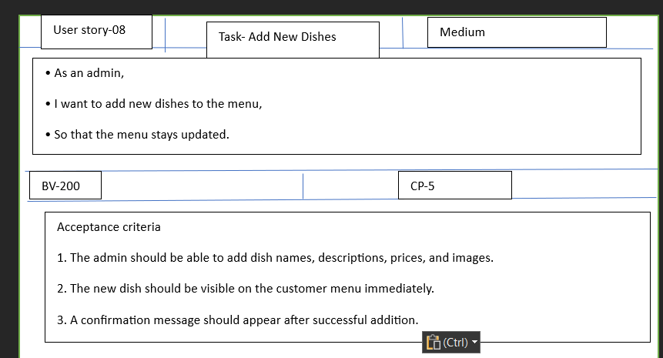

9)

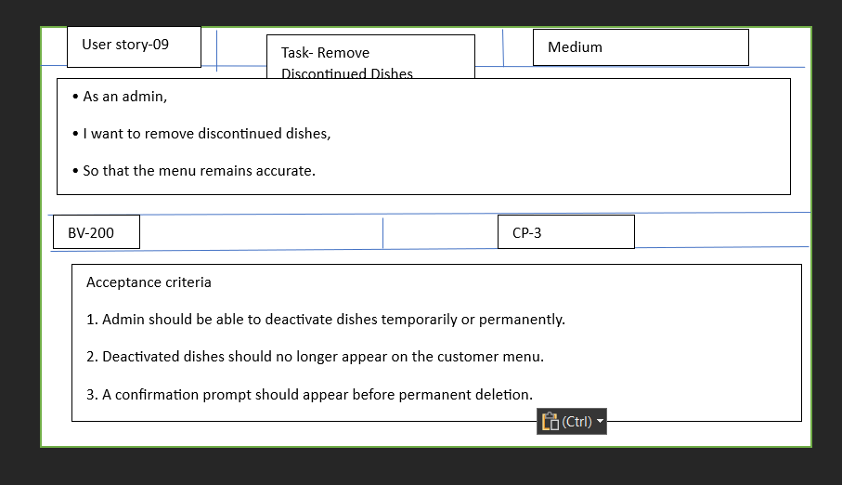

10)

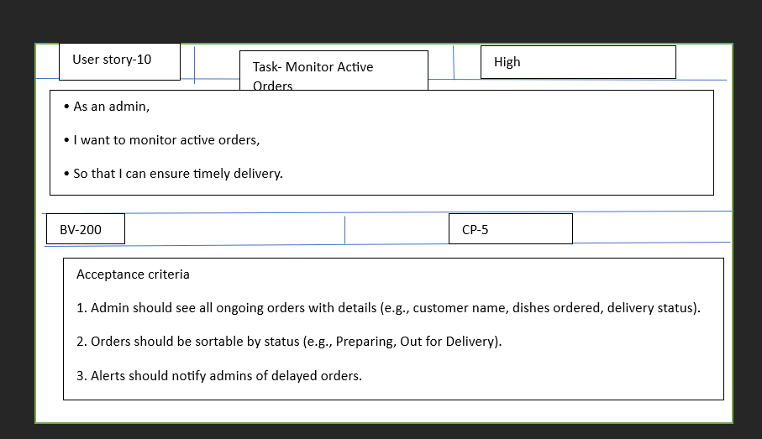

11)

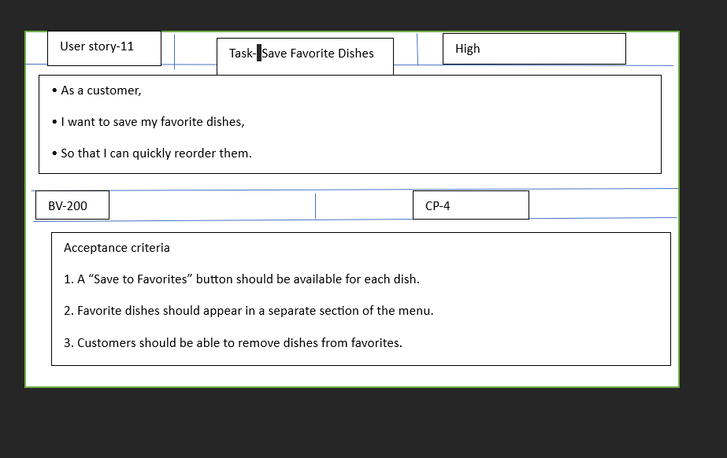

12)

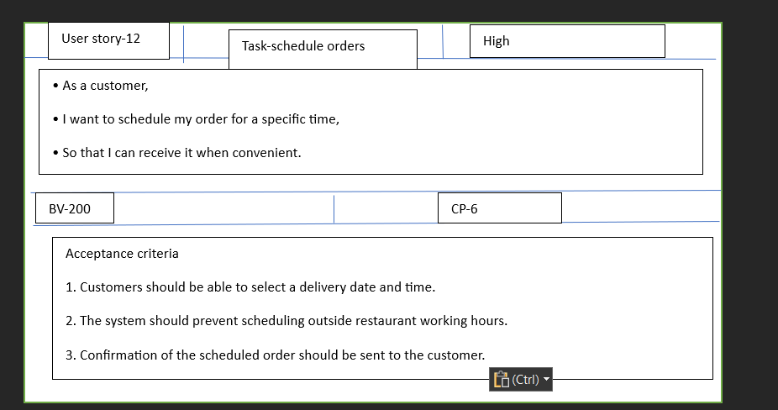

13)

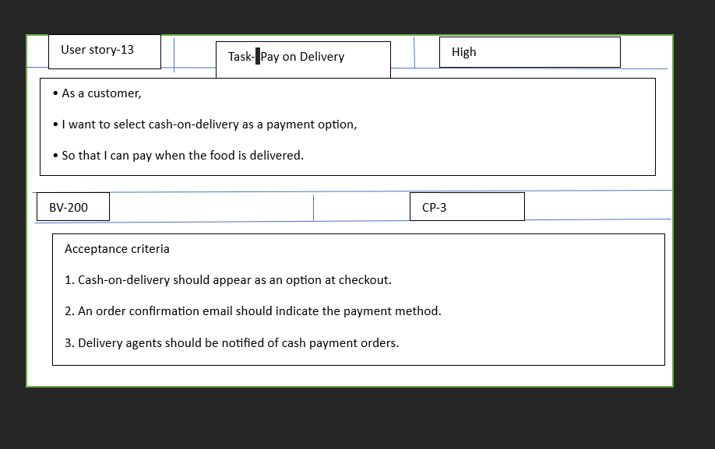

14)

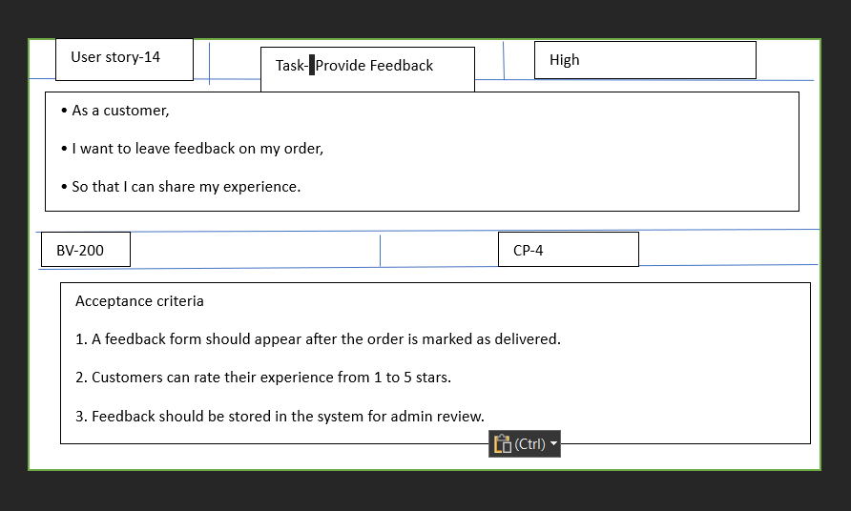

15)

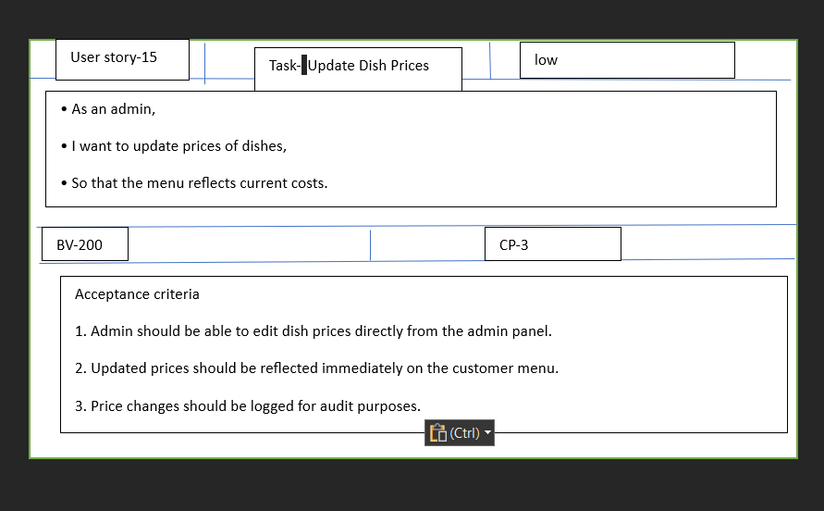

16)

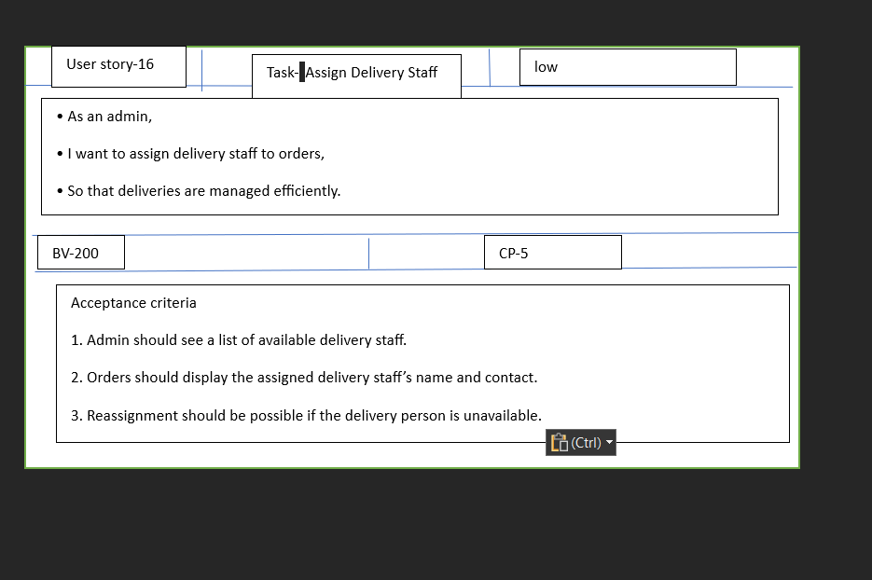

17)

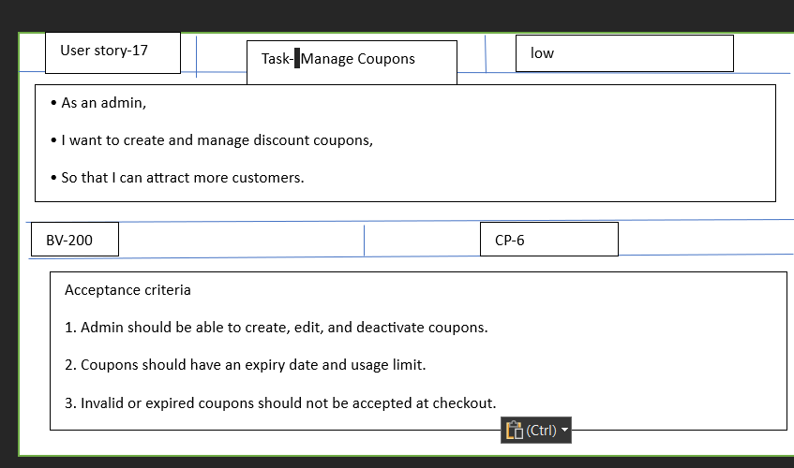

18)

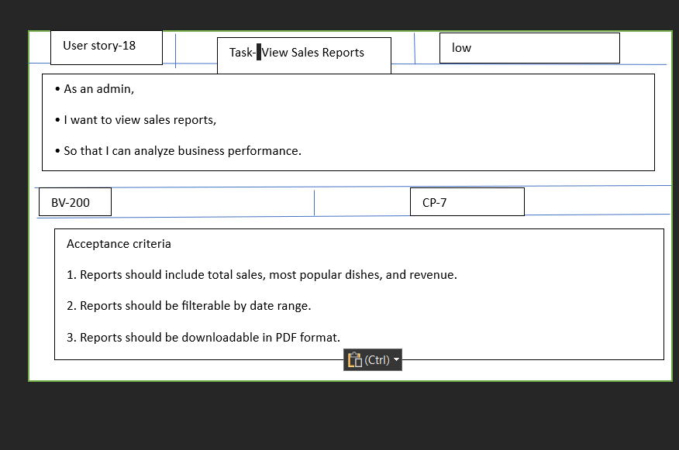

19)

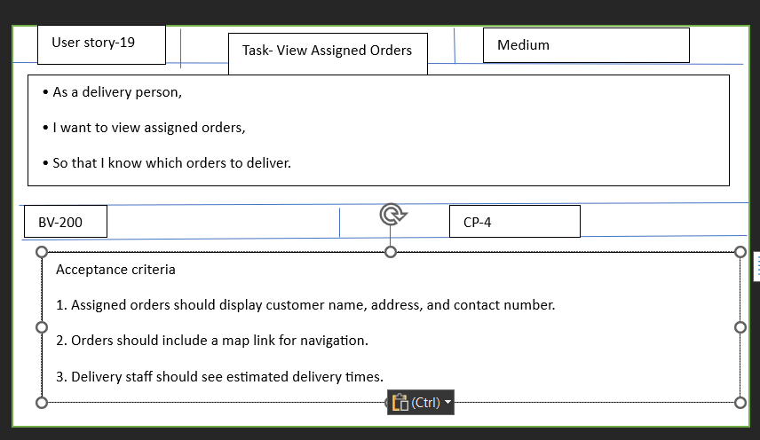

20)

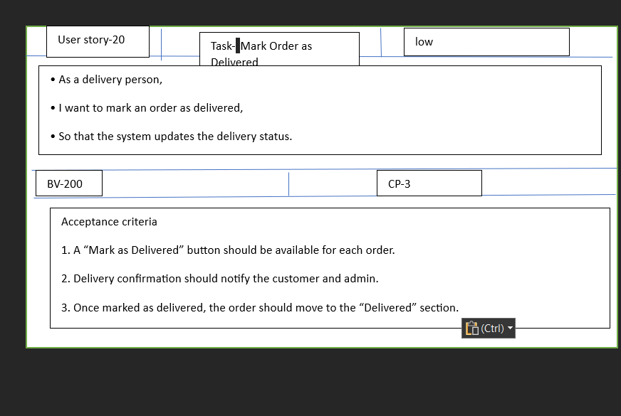

21)

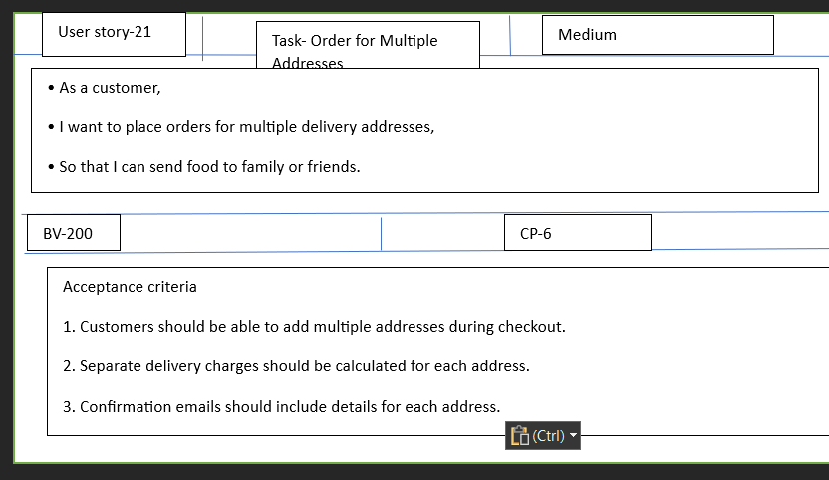

22)

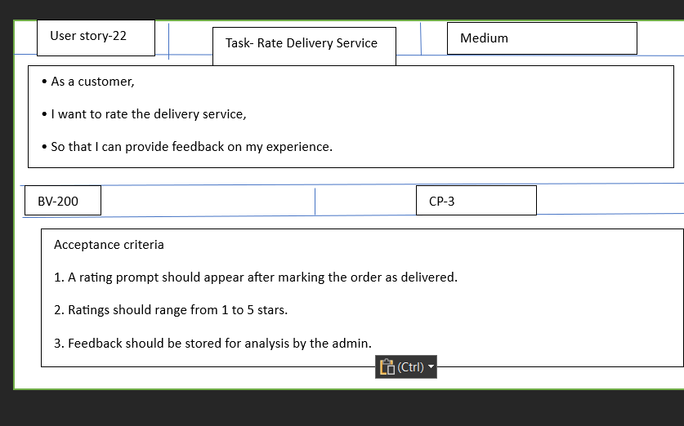

23)

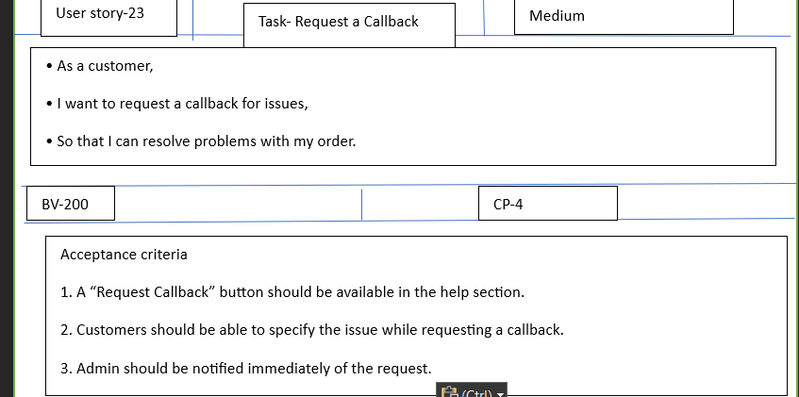

24)

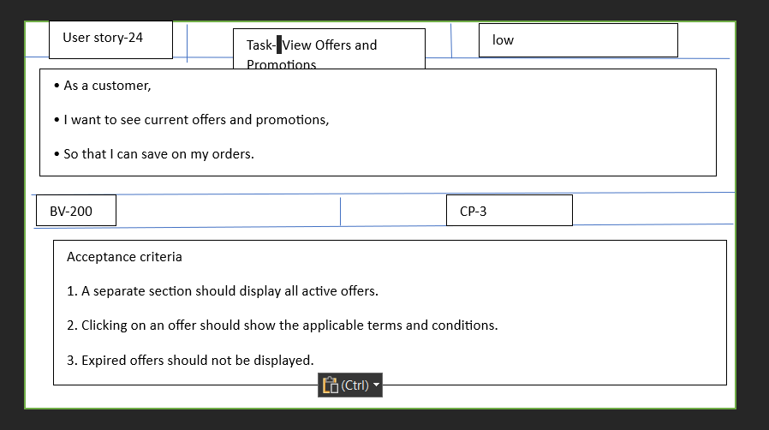

25)

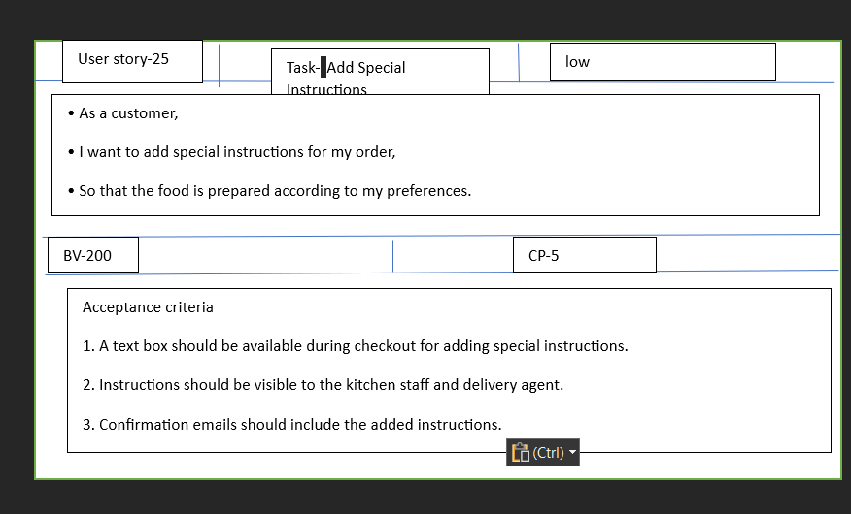

26)

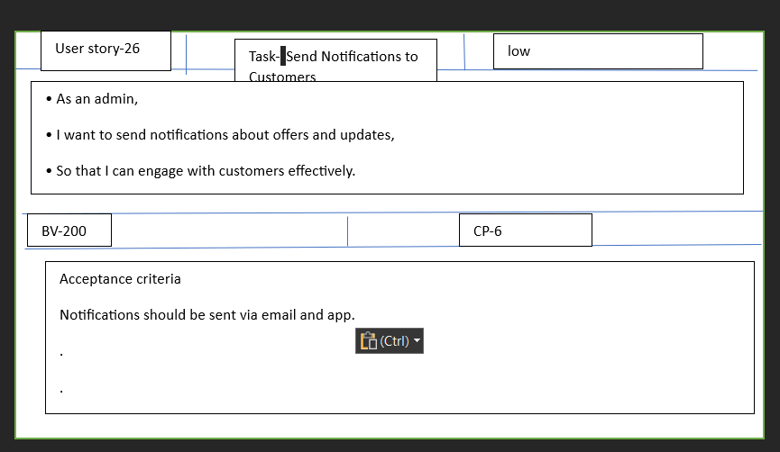

27)

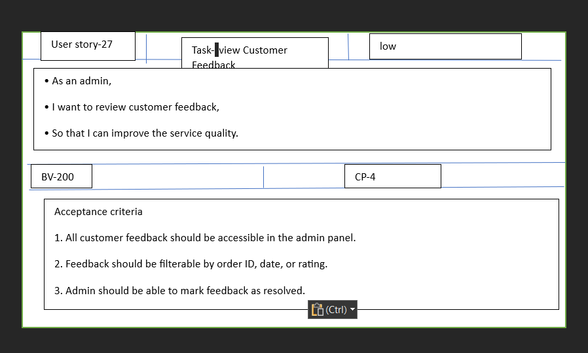

28)

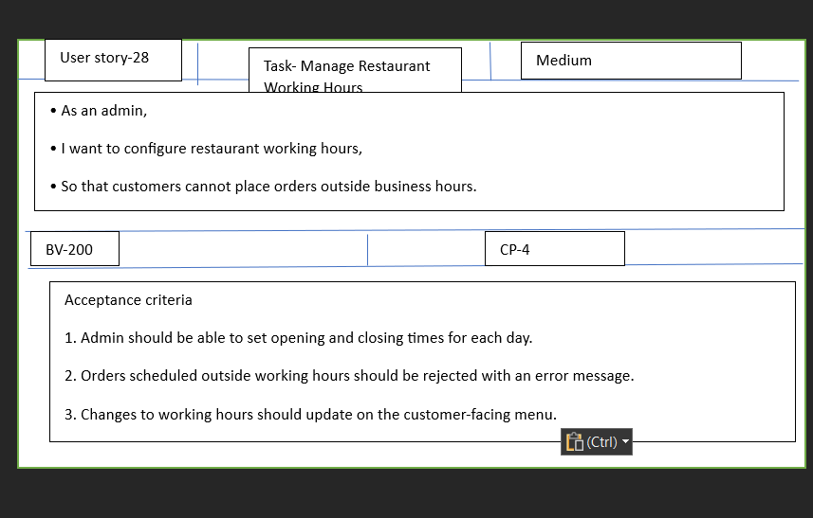

29)

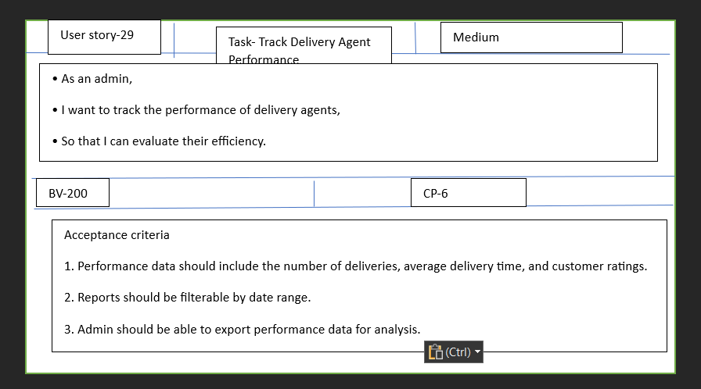

30)

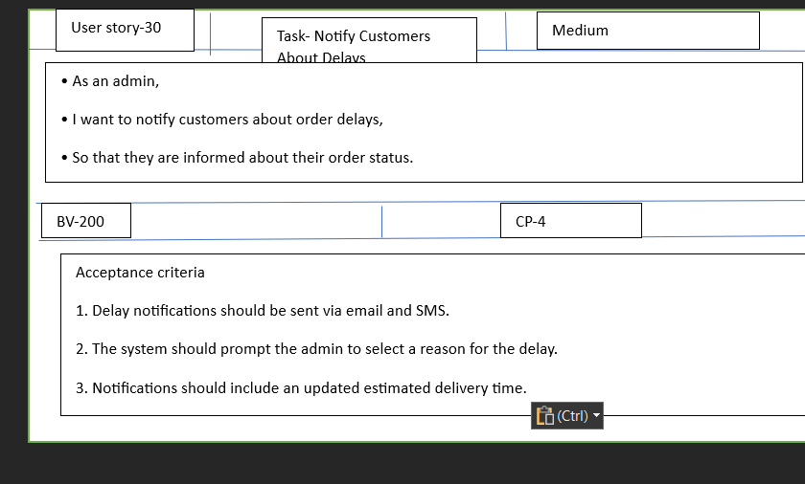

31)

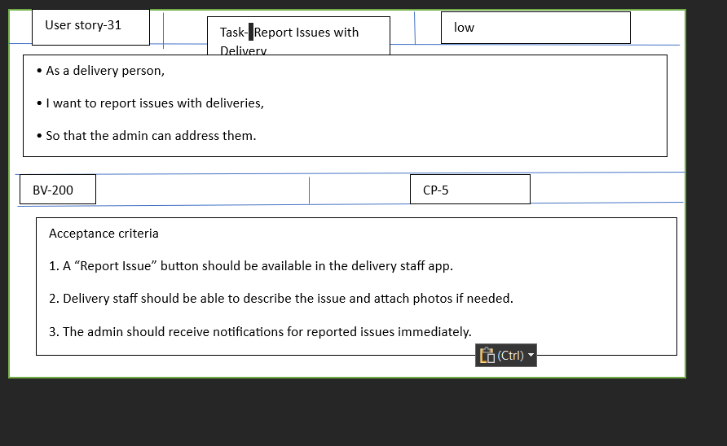

32)

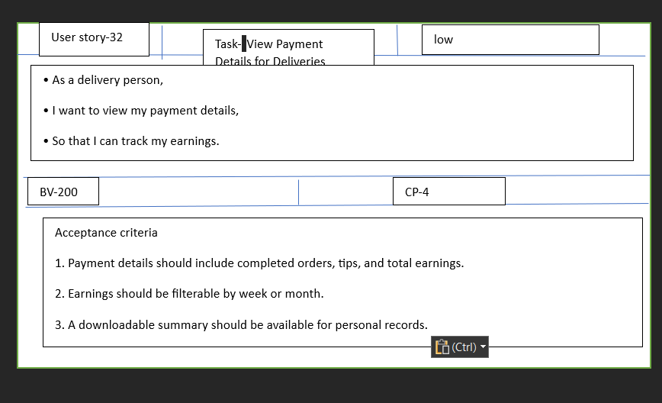

33)

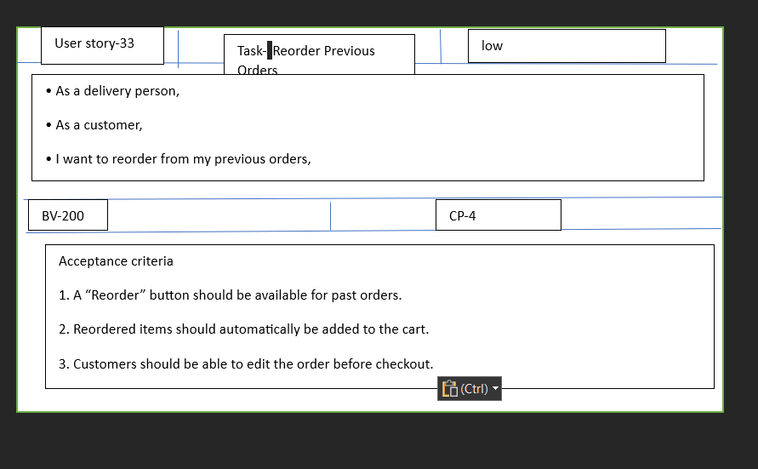

34)

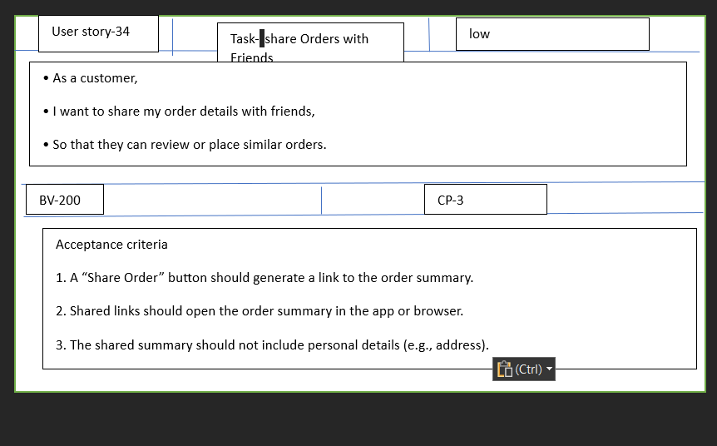

35)

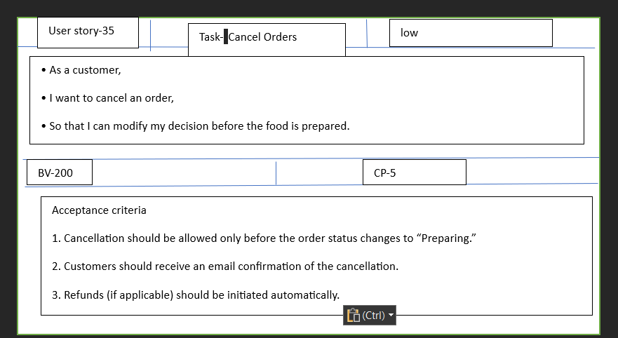

36)

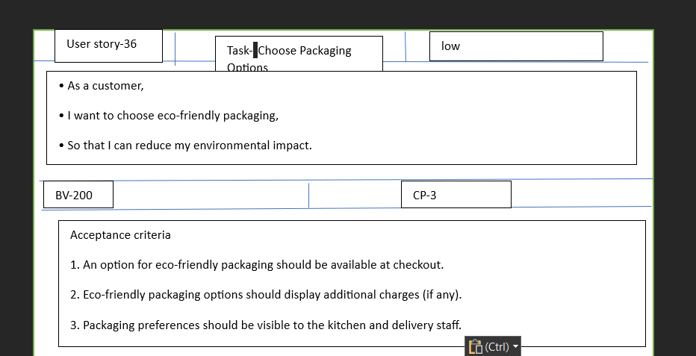

37)

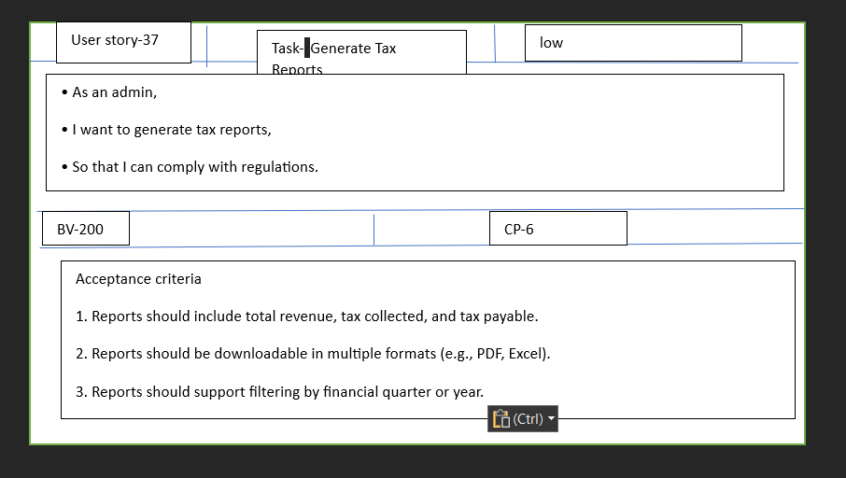

38)

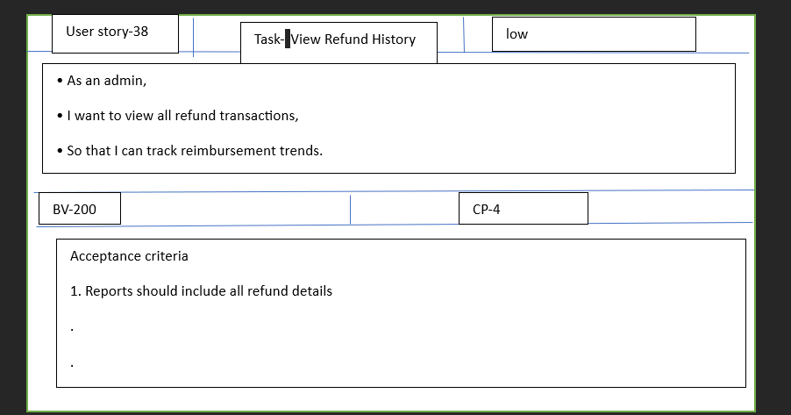

39)

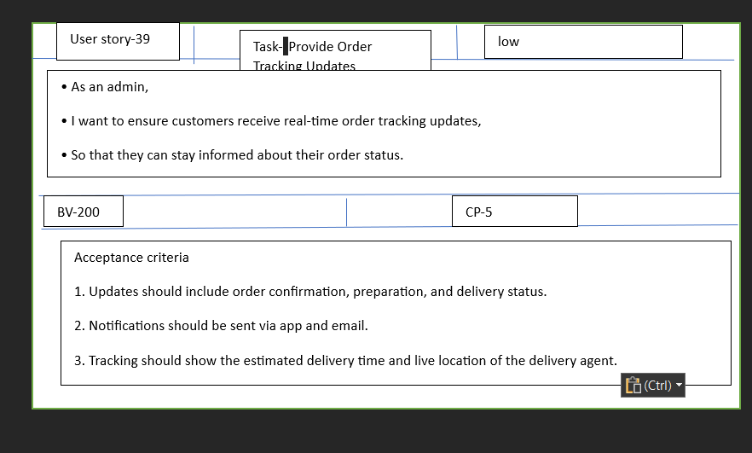

40)

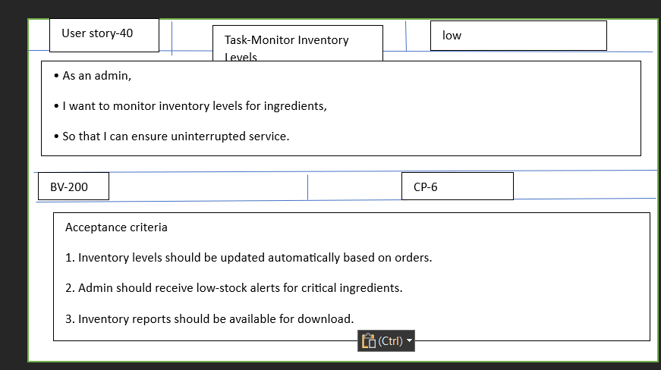

Question 3:

Epics-

An Epic is a big broad idea or large piece of work in a project that can be broken down into smaller tasks, called user stories. It represents a high-level goal or requirement.

1. Ratings and reviews:

As a user, I want to view ratings and reviews for restaurants on scrum foods, so that I can make informed decisions about where to order food from.

As a user, I want to provide ratings and reviews for restaurants on scrum foods, so that I can share my experiences with other users and contribute to the community

Acceptance criteria

1. Users can view average ratings and reviews for each restaurant on the restaurants details page
2. Usera can read detailed review and comments left by other customers
3. Users can sort and filter reviews based on criteria such as ratings and relevance
4. Users can rate the restaurants and leave a review after placing the order
5. User can edit or delete their own reviews within a specified time frame
6. Reviews are displayed in a way that provides helpful insights to other users
7. The ratings and review system maintains the integrity and authenticity of user feedback
8. Epic- real time order- Order tracking for food delivery app

Description

The real time order tracking epic aims to provide users with a seamless and transparent experience by allowing them to track the status and location of their food orders in real time. This feature enhances customer satisfaction and improve overall user engagement

User stories:

As a customer I want to see the live status of my order

1. Display the current status of order such as order confirmed, preparing, out for delivery and delivered
2. Provide real time update as the order progresses through various stages, as a customer I want to track the location of my delivery

As a customer I want to track the location of my delivery

1. Integrate GPS or location services to show the delivery partner real time location on map
2. Allow customers to view the estimated time of arrival based on the delivery partner, location

As a customer I want to receive notifications for order updates

1. Send push notifications or SMS updates to inform customers about order confirmation, preparation and delivery status changes
2. Provide delivery partner details including name, contact information and a profile picture

As a customer I want to contact the delivery partner directly

1. Enable in app chat or call functionality to allow customers to communicate with the assigned delivery partner
2. Ensure privacy by using masked phone numbers

As a customer, I want to view the delivery route

1. Display the delivery route on the map, showing the path the delivery partner will take to reach the destination
2. Allow customers to track the progress of the delivery in real time along the route

As a customer I want to provide feedback on the delivery experience

1. Allow customers to rate the delivery partner and overall delivery experience after the order is delivered
2. Implement a feedback system with written comments to gather valuable insights

As a customer, I want to see estimated delivery time adjustments.

A) Account for real-time traffic conditions and other factors that may affect the delivery time.

B) Update the estimated delivery time accordingly and inform the customer promptly.

 As a customer, I want to have a seamless tracking experience across platforms.

1. Ensure the real-time order tracking feature is available and consistent on all supported platforms (e.g., mobile app, web).

As an admin, I want to monitor order tracking performance.

A) Provide analytics and reporting on order tracking metrics, such as average delivery time and customer satisfaction ratings.

B) Use data to identify areas for improvement and optimize the delivery process.

Acceptance Criteria:

Real-Time Order Updates:

1) The app should provide real-time updates on the status of the user's order, such as "Order received," "Preparing," "Out for delivery," and "Delivered. "Order Location Tracking:

2) The app should display the live location of the delivery driver while enroute to the user's address.

3)The map should update at regular intervals to reflect the driver's movement accurately.

Estimated Delivery Time:

1. The app should provide an accurate estimated time of delivery (ETA)based on the driver's current location, distance to the delivery address, and traffic conditions.

Delivery Notifications:

!)  Users should receive push notifications or in-app alerts for significant order updates, such as when the order is dispatched for delivery or when it is near the delivery address.

Map Zoom and Interaction:

1) Users should be able to zoom in and out on the map to view the delivery driver's route more closely.

2)  The map should support standard interactions, such as panning and rotating, to improve the user experience.

Delivery Status History:

Users should have access to the delivery status history, allowing them to see the timeline of their order from placement to delivery completion.

Accuracy and Reliability:

1) The real-time tracking information should be accurate and reliable, providing users with the most up-to-date data available.

2) The system should handle location updates efficiently, minimizing delays or inaccuracies.

Question 4:

**Difference between BV and CP**

Business Value (BV):

 Business Value refers to the perceived or quantifiable worth or benefit that a specific task, feature, or requirement brings to the business or project.

1) It is typically determined based on factors such as revenue generation, cost savings, customer satisfaction, market competitiveness, strategic alignment, and other business-related criteria.

2)  Business Value helps prioritize tasks or features based on their importance to the overall project goals and objectives.

Examples of Business Value considerations: Increased revenue, improved user experience, compliance with industry regulations, competitive advantage.

**Complexity Point:**

 CP is also known as Story Points (SP). CP is the effort required by the Scrum Developers to develop this feature (user story) using technology. Efforts include time taken to solve the complexity and write the code. CP is estimated by the Scrum Developers by using Poker cards. We provide pokers with values “?”, 1, 2, 3, 5, 8, 13, 20, 40, 100 and BIG.

The main difference between the BV and CP is that the BV value is decided or given the client according to the importance or the priority of task to be performed. However, the CP value is identified or given by the development team according to the effort

Question 5:

Sprints are time boxed iterations of a continuous project development cycle-short repeatable phases that last between one- and four-weeks sprints lie at the core of agile and scrum methodologies, an approach that takes large, complex product development projects and breaks them down into smaller, more manageable pieces.

Sprint is short, fixed period of time during which a particular task or activites is to be completed.

What is sprint duration-2 weeks-your sprint value

Scrum is a sub unit of sprint. What is scrum duration-1 day-your scrum value

PBI- product backing item task: unit of work done by 1 developer in 1 scrum WIP- work in progress

Sprint backlog

|  |  |  |  |
| --- | --- | --- | --- |
| PBI | TASKS | WIP | DONE |
| REGISTERATION | 3 | 2 | 1 |
| LOGIN | 2 | 2 | 0 |
| ADD RESTAURANTS | 3 | 2 | 1 |
| ORDER FOOD | 3 | 0 | 3 |
| MAKE PAYMENT | 3 | 3 | 0 |
| TRACK DELIVERY | 3 | 3 | 0 |
| CUST FEEDBACK | 3 | 3 | 0 |

Question 6:

Product backlog:

The product backlog is a list that complies all the tasks and user stories that must be done to complete the whole project. But it’s not just a simple task list. An effective product backlog breaks down each of the backlog items into a series of steps that help the development team.

The product backlog is very important for product management, the implementation of agile and it’s also one of the seven scrum artifacts, which shape the scrum methodology. But even if it’s been planned out, the product backlog is not set in stone. Like most aspects of agile project management, there are going to change. Flexibility is crucial

The product backlog shows project tasks and user stories, as well as their deadline, who is assigned to complete them, their priority level and percent complete. Managers can easily drag and drop these tasks to refine the products backlog. in addition, project manager also allows team members to interact in real time

Sprint backlog- The sprint backlog is a subset of the product backlog. The sprint backlog comes from the product backlog but it contains only the product backlog items that can be completed during each agile sprint. Think of it as the marching orders for the team as they go off on their short sprint

The complexity of the project will determine the sprint backlog but overall, the idea is to dedicate the team only to those tasks that can be completed during the sprint, of course if it is a complete project the sprint backlog can also grow in complexity and length

Unlike the product backlog, though the sprint backlog is unchanged during the period of sprint, it can be changed but only during the spring sprint planning meeting. Once agreed upon, the items Ans tests to complete them are frozen for the length of sprint

Question 7:

Impediments- in terms of scrum, they are blockers that prevent the scrum team from completing work, which in return impacts velocity. Anything that prohibits the team from doing work is considered an impediment.

Impediments are hurdles or obstacles and these are recorded in impediment logs. They are blockers preventing the scrum team from completing work and should be included within impediment logs

All challenges faced by the team will be logged in the impediment log

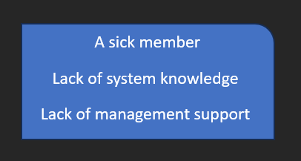

A sick member- A sick member is considered an impediment because their absence can affect the task progress if that member is handling a critical task, it may delay completion, therefore overall productivity will decrease, also other team member might depend on the sick members output to process

Lack of system knowledge- Team members may take more time to understand the system before implementing solutions, it may also lead to errors, they may also rely heavily on others.

Lack of management support- Lack of management may undermine the team ability as it would results in delay in approvals or access to necessary resources, sometimes it would also result in misunderstanding between management vision and team goals which may leave team members feel undervalued

Question 8

According to scrum, inc. team velocity is a measure of the amount of work a team can tackle during a single sprint and is the key metric in scrum. When you complete a sprint, you will total the points for all fully completed user stories and over time find the average number of points you complete per sprint.

Velocity- How many complexity points is covered in this sprint. Velocity of team is 8

Question 9

Product Backlog-

Sprint backlog-

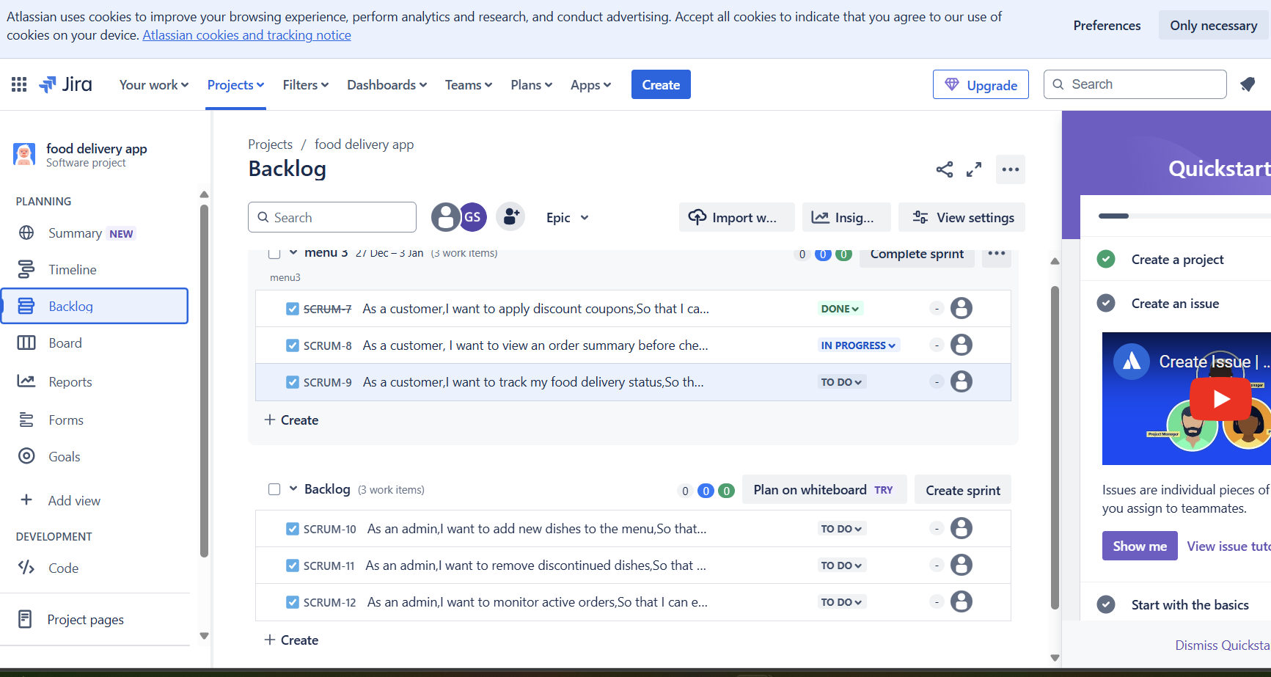

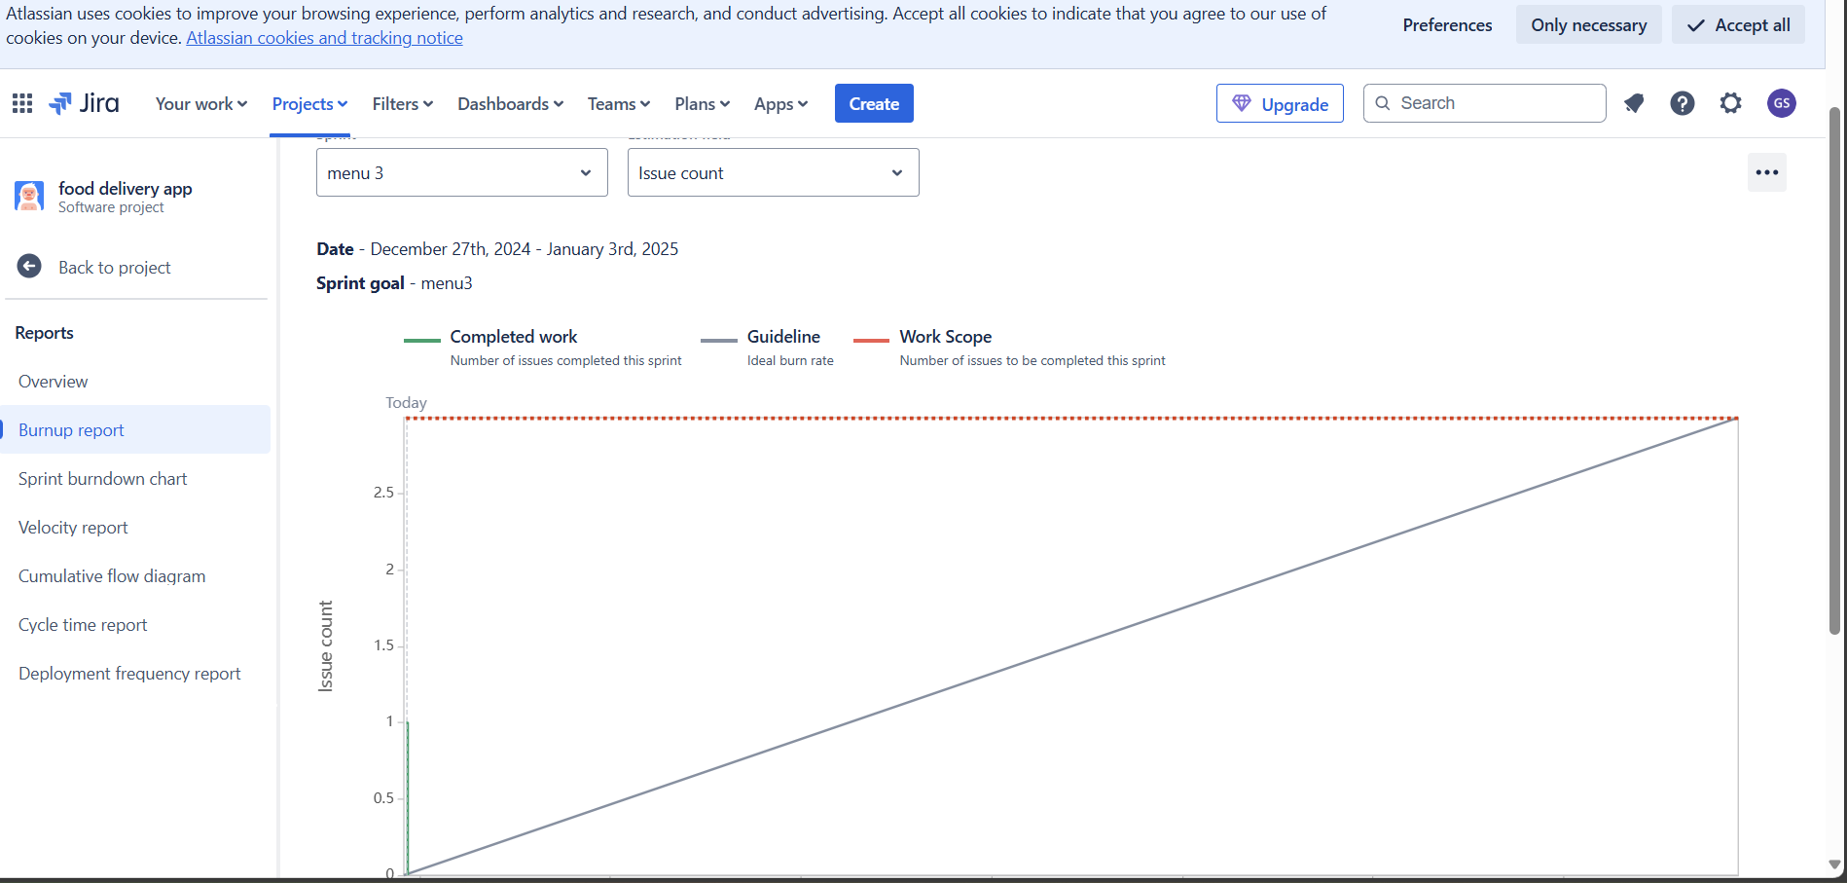

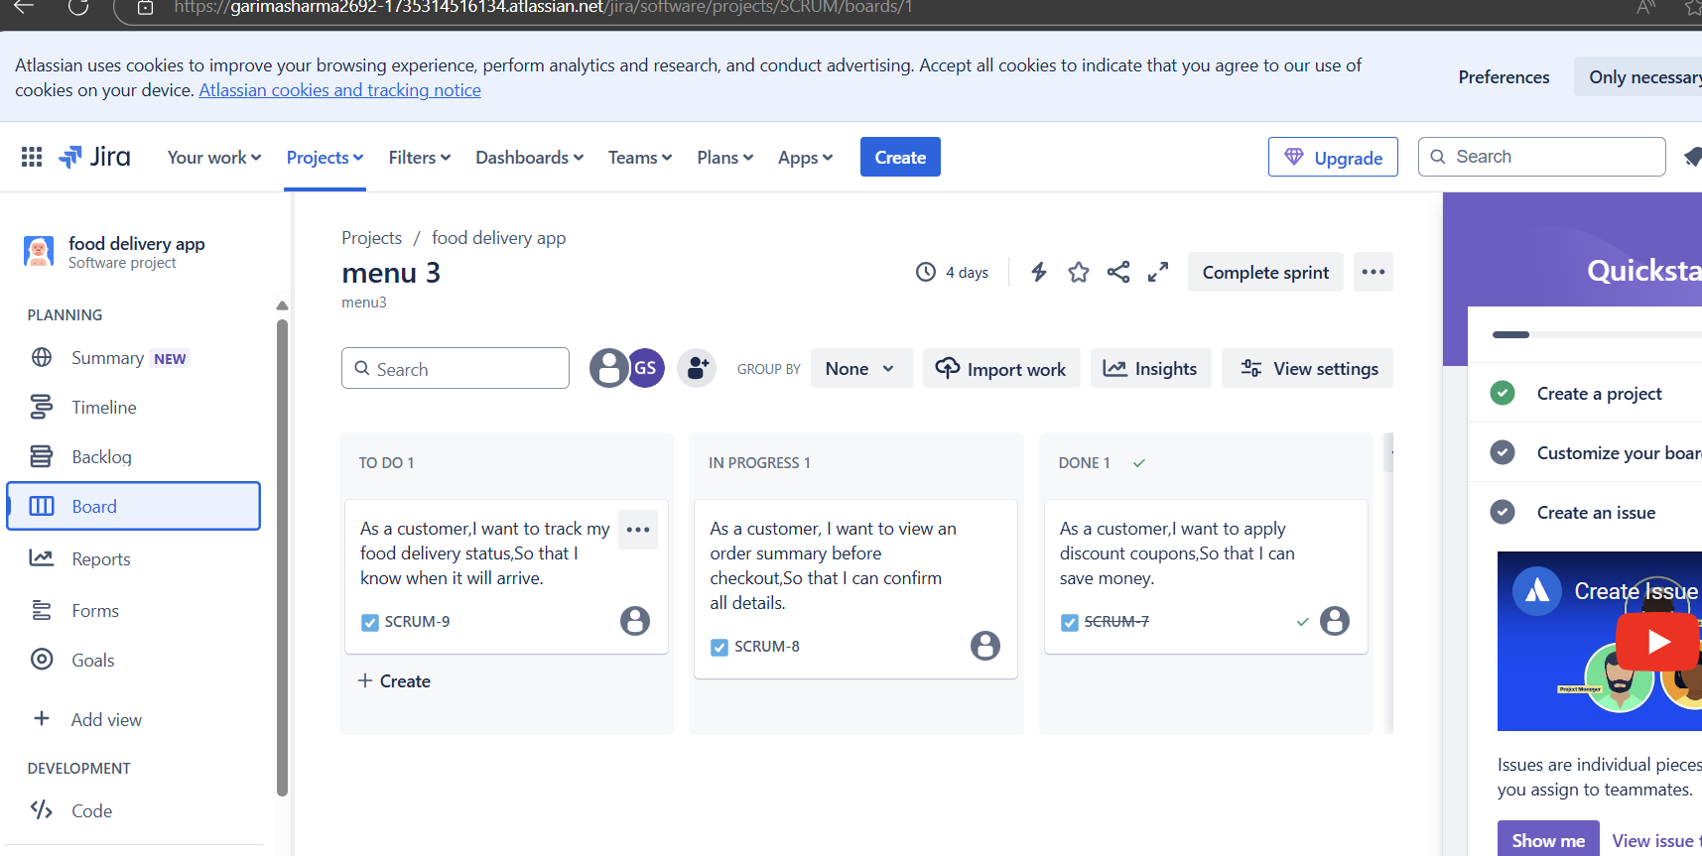

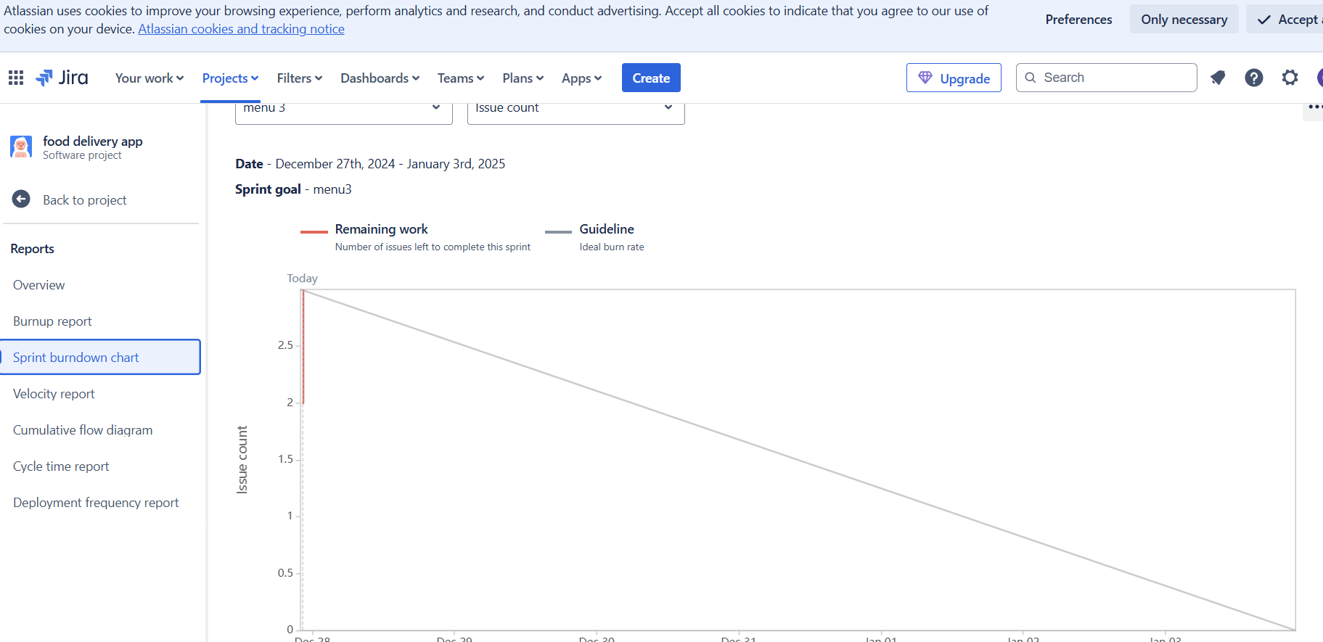

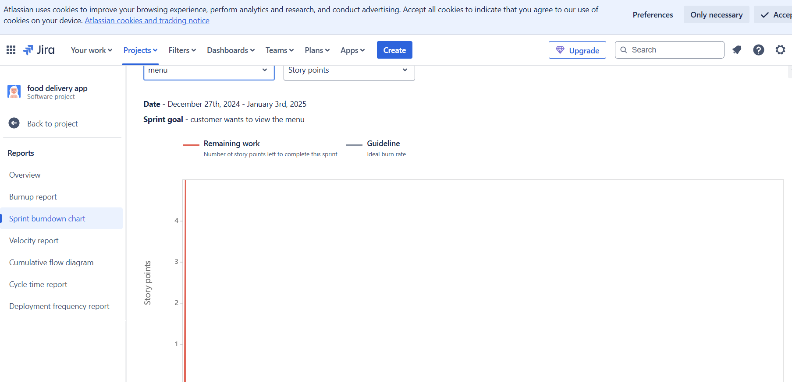

Question 10:

Product grooming/ product refinement

Product grooming is the session in which the vision or goal of the project or product is discussed and who will be your target group in which market segment does the product address. What are the needs and solution does the product required. Also, what benefits the client will get

Also to identify the EPICS from the product backlog. Product grooming is process of planning the project and understanding the needs

Thus, product grooming includes the refinement understand what does the stakeholder require and why does it require and what is the value addition is to be done

Question 11

The scrum master is accountable for establishing scrum as defined in the scrum guide. They do this by helping everyone understand scrum theory and practice. Both within the scrum team and the organization. The scrum master is accountable for the scrum team effectiveness. They do this by enabling the scrum team to improve its practices, within the scrum framework.

The product owner is accountable for maximizing the value of the product resulting from the work of the scrum team. The product owner is one person, not a committee. The product owner may represent the needs of many stakeholders in the product backlog. Those wanting to change the product backlog can do so by trying to convince the product owner.

Scrum master- the day-to-day activity of a scrum maser involves servant leadership where they are involved in performance planning, coaching, self-organization, removing obstacles, resolving conflicts and serving the team.

Product owner- the first responsibility of the product owner is customer satisfaction and this they carry out by ensuring that customer requirements are given priority and there is transparency between development team and stakeholders.

The product owner guarantees stakeholder satisfaction by ensuring product success and building a product which meets business requirements.

The scrum master ensures project success, by assisting the product owner and the team in using the right scrum processes for creating the end product and establishing the agile principles. The product owner interacts with the users and customers, stakeholders, the development team and the scrum master to deliver a successful product.

The product owner and the scrum master are both invaluable members of a scrum project team, as they build the perfect relation with the development team and strive to deliver the best results

Question 12:

There are 5 types of scrum meetings held during the scrum process which are as follows

1. Sprint planning meeting
2. Daily scrum meeting
3. Sprint review meeting
4. Sprint retrospective meeting
5. Backlog refinement meeting

Sprint planning meeting

This meeting begins with the product owner in this meeting the PO explains their vision and how the team should go about completing this step of the project. During this meeting team members decide the amount of work they can complete within the sprint. This is also when the team moves work from the product backlog to the sprint backlog. This step requires a lot of planning and can take several hours for the group to decide on a finalized spirit.

Daily scrum meeting

From the planning meeting, we move into the daily scrum meetings. Every single day for 15 mins, the team gathers together to report any issues or progress on their tasks. Though brief, this meeting is an essential part of the scrum process. It is designed to keep all group members on track in a cohesive manner. Normally the product owner is present during all daily scrum meetings to assist in any way

Daily stand-up meeting end of every scrum. Scrum developers will participate in scrum meeting. Here they must answer 3 questions a- what task did you work in this scrum b- what task will you work on next scrum c- Any challenges/impediments when you will complete the user story

Sprint review meeting

This meeting is used to showcase a live demonstration of the work completed. During this meeting the product owner scrum master and stakeholders are present to review the product and suggest charges or improvements

They will see the velocity- how many CP is covered in this sprint

Sprint retrospective meeting

This meeting is held to facilitate a team reflection on their progress this team speaks openly about their organizational concerns and teamwork. During this meeting, dialogue should remain friendly nonjudgmental and impartial; This review session is a key part of team building and development and it’s also very important for future scrum projects. In this meeting team will discuss about challenges faced and come up with lessons learnt. We can use these lessons learnt in sprint planning meeting to select user stories for the next sprint

Backlog refinement meeting

Last, is the backlog refinement meeting, in this meeting team members focus on the quality and skill of the work involved during the sprints. This meeting is necessary for the business owners to connect with the development team and is used to assess the quality of the final product. This meeting involves important reflection on the team backlogs

Question 13

Sprint size the whole concept of sprint is to identify user stories that the scrum team would work on and complete within a specific sprint duration. Typically known as the sprint length. Sprints can be of 1,2,3,4 weeks long at the max. Anything beyond 4 weeks it’s never agile scrum project management

Scrum Size scrum team size can be of 8-10 people

1. Product owner
2. Scrum master
3. Developers 8

Question 14

The definition of ready DOR

The product owner could work together with the team to define an artifact called the definition of ready for ensuring that items at the top of the backlog are ready to be moved into a sprint so that the development team can confidently commit and complete them by the end of a sprint

The term definition of ready isn’t described in the scrum guide similar to the user stories and the acceptance criteria embedded in it. Perhaps, you may consider the definition of ready is an integral part of the backlog refinement activity. Instead of using the definition of ready as a sequential and phase gate checklist. Backing refinement is an ongoing process, therefore it’s not restricted to an event but considered an activity.

Definition of done- DOD

The definition of done is structured as a list of items, each one used to validate a user story or PBU, which exists to ensure that the development team agree about the quality of work they are attempting to produce. It serves as a checklist that is used to check each product backlog item or user story for completeness. Items in the definition of done are intended to be applicable to all items in the product backlog, not just a single user story, it can be summarized as follows.

DOR and DOD are practices that are needed while improving a product. To ensure that the product meets customer expectations. Certain features and ideas have to be added to it from time to time and defining the criteria for the features to be added is absolutely necessary and that’s when the DOR and DOD come into play.

Question 15

Prioritization of requirements is an important aspect of all software development approaches, but it is especially important in agile software development. When we talk about some of the product owners’ activities in scrum products such as ordering items in the product backlog to best achieve mission and objectives. Demonstrate what the scrum team would work on next and streaming the quality of the work the developers perform we are actually talking about workload prioritization. All we are attempting to do is prioritize the issues in the backlog. in essence we are attempting to discover the user priority tasks and rank them accordingly while also taking into account certain additional characteristics. For example, we may utilize five priority factors to rank user stories such as the important users place on product vision, urgency, time restrictions, technical difficulty and stakeholder interests. Project must be correctly prioritized for both the overall project objectives and the individual activities that will fulfill the objectives in order to be successful. As a result, we address the prioritizing issue on two levels.

Product level- evaluate which elements of the product might contribute more to the project major aims.

Tasks level- Specify which work items must be completed and in what sequence during the software product development cycle.

Types of Agile prioritization techniques

MoSCoW Agile prioritization techniques

Its analysis a business analyst prioritizing approach advocated in the IIBA BABOK and derived from the DSDM (dynamic software development method) According to the strategy, a collection of needs or user stories should be divided into four categories

M- must describes a criterion that must be met in the final solution for it to be judged successful

S- Should- it represents a high priority component that, if feasible should be included in the solution. This is a frequently a vital criterion, but it can be met in other ways if absolutely required

C- Could Describes a criterion that is desirable but not required if time and resources allow, this will be added

W- Will not represents a demand that the stakeholders have decided will not be executed in a particular release but will be addressed in the future

After categorizing the needs into 4 groups, they are rated in order of priority within each category

Priority poker

It is a simple design game for ranking objects in order of importance. It is named from the fact that it is quite similar to arranging poker (a technique for evaluating the costs of the user stories widely used in agile development projects)

Before the game begins, the moderator collects all the individuals who need to be engaged in prioritizing process such as stakeholders, product managers, strategists, programmers, domain experts and sometimes even consumers. The moderator must also prepare a list of tasks to prioritize as well as collection of priority cards to distribute to each player. The volume of cards in this set is determined by how many degrees of priority are useful in this specific instances. In certain circumstances, a 5-point scale (very high priority, medium priority, low priority, very low priority), a 3-point scale (high urgency, medium urgency, low urgency) or even a 10-point urgency may be used. The number of cards matches to the scale numbers.

The supervisor then reviews a piece of functionality. each participant selects the card that they believe represents the best ranking for that assignment and sets it face down on the table. After each player has made their selection. All of the cards are turned over at the same time. The disparities are addressed and the game continues until the estimations are roughly equal.

Cost of delay:

This agile prioritization technique is a concept that assists you in determining the amount of money you risk losing if certain features are unavailable. Essentially you are putting yourself in the path of those who are combating fires. As a result, it is a proactive struggle to guarantee that there are no money bleeding situations.

You may estimate how urgent they are by calculating how much money the organization lose every day if the feature or job is delayed. As a consequence, you will have a well-planned timetable that will contribute to total budget savings. As a result, this prioritizing strategy is motivated only by financial considerations and has nothing to do with user experience or customer happiness.

Although these factors may be considered when calculating the cost of delay, they are not the primary goal of these agile prioritization methods. The benefits of employing the priority technique in conjunction with others would be both financially and emotionally justifiable.

Conclusion:

These agile prioritization methods are critical components of project planning and management. You, may wind up losing a lot of money on the project if you don’t have appropriate agile prioritization techniques in place. Furthermore, the initiative may have little influence on the intended clients. As a result, it is critical, to employ an objective prioritizing grading system that adds to the success of an agile product development project.

MVP- - Minimum value product- the core of the agile methodology, an MVP is a concept from agile scrum that refers to a product that had just enough features to satisfy the needs of early customers and more importantly give them something to provide feedback on to shape the future of the product.

Question 16:

|  |  |  |  |
| --- | --- | --- | --- |
| **Aspect** | **Business Analyst** | **Product owner** |  |
| Role Focus | understanding business needs, processes and requirements | Define, prioritize and convey requirements for the product |  |
| Requirement gathering | gathers and documents detailed business requirements | creates user stories and define product features |  |
| Problem solving | identifies problem, inefficiencies and suggest improvement | drive the product vision strategy and value proposition |  |
| Communication | acts as a liasoning between business stakeholders and development team | collaborate with stakeholders, customers and the development team |  |
| Scope definition | helps define the scope of projects based on business needs | defines the scope of product features and enhancements |  |
| vision and strategy | focus on specific project or process improvements | has a holistic vision for the product and its strategic direction |  |
| backlog management | not typically responsible for managing a product backlog | manages and prioritizes based on business value ,user needs and market trends |  |
| prioritization | doesn’t have a primary role in prioritizing features | prioritize features based on business value user needs and market needs |  |
| decision making | provides input but not responsible for final product decisions | makes final decisions on product features enhancements and priorities |  |
| iterative development | may or may not be involved in iterative development cycles | actively participates in sprint planning, reviews and retrospectives |  |
| collaboration | collaborates with business stakeholders and development teams | collaborates closely with stakeholders customers and the development team |  |
| acceptance | ensures business requirements are met | ensures user stories meet acceptance criteria and align with product vision |  |

Question 17

Garima Sharma

[Garima.sharma2692@gmail.com](mailto:Garima.sharma2692@gmail.com)

8146404364

Objective-

Motivated and forward-thinking product owner with 6 + years of experience. Eager to support team with leadership and guidance over a wide range of product development efforts

Work experience:

Agile product owner

IDFC FIRST BANK, Mumbai

2023

a) Acted as a liaison between business, sales and IT teams to refine the product and incorporate featured based on market demands

b) partnered with IT and product leadership to drive and manage the solution development process and ensure the product team understands the direction and vision

c) collaborated with teams to discover and deliver the best solutions to the market presented by the product team lead and the business

d) created and maintained the solution vision, roadmap and backing of work through the project life cycle

e) translated features into user stories within the team backlog while managing, ranking, and prioritizing this backlog to reflect stakeholder requirements

f) effectively negotiated sprint goals with the team, which resulted in slashing delivery time by 20 %in a single quarter.

Scrum product owner

1. Collaborated with stakeholder to understand business problem statements and convert them into user stories
2. Articulated product vision and user stories in a way clearly understandable to development teams
3. Managed backlog of user stories for 2 products simultaneously
4. Established user story acceptance criteria and refined stories with scrum teams
5. Created sprint release plans with input from development teams
6. Applied agile methods and processes to promote a disciplined and transparent project management process
7. Key achievement
8. Planned and estimated 2 weeks sprints in a realistic yet time efficient manner that allowed the teams to deliver 97% of the MVP according to the company roadmap

Education

Mcom

Panjab university

Key skills

1. Conceptual skills
2. User centered design processes
3. Design quality standards
4. Service and product design methodologies
5. Agile and scrum
6. Conducting design sprints
7. User validation
8. Analytical skills
9. Collaboration and team work
10. Communication