**MOCK 4**

* **By Janhvi Bhute**

A company is having manufacturing plants and warehouses in various parts of the country.

They manufacture ice-cream and milk products. They want to build software to achieve two

goals.

• Manage the inventory

• Quickest delivery to the customers

**Assignment - 1**

1. Please make a BRD which can be presented to the client along with complete

development and resource plan.

*BRD*

**Dairy Management System**

**PQ786BRDV1D2**

**BRDV1D2**

**Janhvi Bhute**

Contents

1. Document Revisions 4

2. Approvals 4

3. RASCI Chart for This Document 5

Codes Used in RASCI Chart 5

RASCI Chart 5

4. Introduction 6

4.1. Business Goals 6

4.2. Business Objectives 6

4.3. Business Rules 6

4.4. Background 6

4.5. Project Objective 6

4.6. Project Scope 6

4.6.1. In Scope Functionality 6

4.6.2. Out Scope Functionality 6

5. Assumptions 7

6. Constraints 7

7. Risks 7

Technological Risks 7

Political Risks 7

Business Risks 7

Requirements Risks 7

Other Risks 7

8. Business Process Overview 8

8.1. Legacy System (AS-IS) 8

8.2. Proposed Recommendations (TO-BE) 8

9. Business Requirements 8

10. Development Plan………………………………………………………………………………………………………….8

11. Resource Plan………………………………………………………………………………………………………………….8

12. Appendices 8

1. Document Revisions

|  |  |  |
| --- | --- | --- |
| **Date** | **Version Number** | **Document Changes** |
| 05/02/2025 | 0.1 | Initial Draft |
| 10/03/2025 | 0.2 | Updated project scope and objectives based on stakeholder feedback. |
| 22/03/2025 | 0.3 | Added detailed functional requirements for patient registration and admission processes. |
| 15/04/2025 | 0.4 | Incorporated system architecture diagrams and clarified user roles in the project |
| 30/04/2025 | 1.0 | Finalized document after addressing quality review comments and obtaining approvals. |
|  |  |  |

1. Approvals

|  |  |  |  |  |
| --- | --- | --- | --- | --- |
| **Role** | **Name** | **Title** | **Signature** | **Date** |
| Project Sponsor | Amit Solanki | Company Director | Amit Solanki | 24/07/2025 |
| Business Owner | Mohnish Bahl | Chief Dairy Officer | Mohnish Bahl | 29/07/2025 |
| Project Manager | Avanti Jain | Project Manager-DMS | Avanti Jain | 31/07/2025 |
| System Architect | Poonam Kapoor | System architect-DMS | Poonam Kapoor | 01/08/2025 |
| Development Lead | Sanjay Pal | Software Development lead | Sanjay Pal | 07/08/2025 |
| User Experience Lead | Tarun Singhania | UX/UI lead | Tarun Singhania | 10/08/2025 |
| Quality Lead | Roshan Dsouza | QA lead | Roshan Dsouza | 30/09/2025 |
| Content Lead | Shankar Pant | Content management lead | Shankar Pant | 10/10/2025 |

1. RACI Chart for This Document

The RACI chart identifies the persons who need to be contacted whenever changes are made to this document. RACI stands for responsible, accountable, consulted, and informed. These are the main codes that appear in a RACI chart, used here to describe the roles played by team members and stakeholders in the production of the BRD. They are adapted from charts used to assign roles and responsibilities during a project. ( RACI Can be made for IT side[Project stakeholder] as mentioned above, apart from that Can also Be made for Client side[Business Stakeholder]).

The following describes the full list of codes used in the table:

Codes Used in RACI Chart

* Authorize Has ultimate signing authority for any changes to the document.

R Responsible Responsible for creating this document. **(BA)**

A Accountable Accountable for accuracy of this document.   
 **(for example, the project manager)**

S Supports Provides supporting services in the production of this document

C Consulted Provides input (such as an interviewee).

I Informed Must be informed of any changes.

RACI Chart

|  |  |  |  |  |  |  |  |
| --- | --- | --- | --- | --- | --- | --- | --- |
| **Name** | **Position** | **\*** | **R** | **A** | **S** | **C** | **I** |
| Avanti Jain | **Project Manager** |  |  | **A** |  |  |  |
| Janhvi Bhute | **BA** |  | **R** |  |  |  |  |
| Amit Solanki | **Project Sponsor** |  |  |  |  |  | **I** |
| Veer Mahatma | **Stakeholder** |  |  |  |  | **C** |  |
| Payal Vyas | **Sr. BA** |  |  |  | **S** |  | **I** |

4. Introduction

This document outlines the requirements for developing software for XYZ, a manufacturer of

ice-cream and milk products with a network of manufacturing plants and warehouses across the

country. The proposed system will focus on two primary objectives: effective inventory

management and enabling the quickest delivery to customers. By achieving these goals, the

company aims to enhance operational efficiency, minimize waste, and improve customer

satisfaction.

4.1. Business Goals

* Streamlined Inventory Management: Ensure real-time monitoring of inventory levels
* across all warehouses and plants to reduce spoilage and optimize stock levels.
* Enhanced Delivery Efficiency: Implement a system to identify the fastest delivery
* routes and automate order allocation based on proximity and inventory availability.
* Improved Customer Satisfaction: Minimize order fulfilment time and ensure product
* freshness at delivery.

4.2. Business Objectives

* Develop a centralized system to track and manage inventory across all locations.
* Automate order processing, allocation, and dispatch based on inventory and location
* proximity.
* Integrate delivery route optimization with real-time traffic and weather data.
* Reduce inventory wastage by implementing an expiry-date tracking mechanism.
* Enable reporting and analytics for better decision-making and demand forecasting.

4.3. Business Rules

* Inventory must be updated in real-time upon receipt, dispatch, or adjustment.
* Orders should only be fulfilled if the inventory is available and meets the required shelf-
* life criteria.
* Delivery routes must prioritize freshness while minimizing transportation costs.
* Customer priority orders (e.g., bulk orders) must be flagged for immediate action.
* Warehouse reordering thresholds should trigger automated purchase orders.
* Scope of the System

4.4. Background

This project was initiated due to the persistent challenges and inefficiencies observed within the existing management system. The reliance on manual processes led to prolonged wait times, errors in customer data entry, and inadequate resource allocation. These issues highlighted the pressing need for a more advanced and integrated solution to modernize the hospital's operations. The initiative aimed to overcome these longstanding hurdles, enhance customer care, and optimize the utilization of resources by introducing a comprehensive Dairy Management System.

4.5. Project Objective

The objectives of a dairy management system can include:

* Storing data

A dairy management system can store information about milk and milk products.

* Tracking transactions

A dairy management system can track transactions to make processes more efficient.

* Maintaining records

A dairy management system can help keep consumer records and sales and expenses organized.

* Generating reports

A dairy management system can generate reports on milk collection for farmers and employees.

* Updating prices

A dairy management system can update milk prices based on market standards

4.6. Project-Scope

In this project we are trying to create an integrated system for efficient manage of inventory and fastest delivery of products to customers.

4.6.1. In-Scope

* Inventory tracking at manufacturing plants and warehouses.
* Order management and allocation.
* Delivery route optimization.
* Analytics and reporting dashboards.

4.6.2. Out-of-Scope:

* Manufacturing process management.
* •Customer relationship management (CRM).

5. Assumptions

1. All warehouses and plants have internet connectivity for real-time updates.
2. Delivery vehicles are GPS-enabled to support route optimization.
3. Data from external sources (e.g., traffic, weather) is available via APIs.

6. Constraints

1. Budget limitations may restrict the scope of features.
2. Integration with legacy systems may pose technical challenges.
3. Project timelines must align with the company’s peak season schedules.

7. Risk Analysis

Technical Risk

* Integration issues with existing systems.
* System scalability with increasing business demand.

Political Risks:

* Resistance from employees due to new processes and technology.
* Potential vendor lock-in with third-party tools.

Requirement Risks:

* Incomplete or evolving requirements from stakeholders.

Business Risks:

* Downtime during system rollout.
* Customer dissatisfaction due to transition delays.

8. Business Process Overview

8.1 Legacy System (AS-IS):

* Inventory is managed manually or using isolated systems.
* Order allocation is manually determined, leading to inefficiencies.
* Delivery routes are planned based on experience, not optimized.

8.2 Proposed Recommendations (TO-BE):

* A centralized system enables automated inventory management.
* Orders are allocated and dispatched through an intelligent algorithm.
* Delivery routes are optimized dynamically for speed and cost.

9. Business Requirements

**1. Inventory Management Module:**

* Real-time inventory tracking across locations.
* Expiry-date monitoring and alerts for perishable items.

**2. Order Management Module:**

* Automated order allocation based on location and inventory.
* Bulk order prioritization.

**3. Delivery Optimization Module:**

* Integration with GPS and real-time data for route planning
* dynamic routing in case of delay

**4. Reporting Module:**

* Insights into inventory levels, order trends, and delivery performance.

10. Development Plan

**Development Plan:**

* Phase 1: Requirement gathering, stakeholder workshops, and system design (4 weeks).
* Phase 2: Development of core modules (Inventory, Order, Delivery) (12 weeks).
* Phase 3: Integration with external systems (APIs, GPS) and legacy systems (6 weeks).
* Phase 4: Testing and quality assurance (4 weeks).
* Phase 5: Deployment, training, and support (4 weeks).

11. Resource Plan:

* Project Manager: 1 FTE
* Developers: 3 FTE (Backend, Frontend, Integration specialists)
* QA Engineers: 2 FTE
* Business Analyst: 1 FTE
* Support Team: 2 FTE

**2. Prepare process flow diagram using your imagination.**

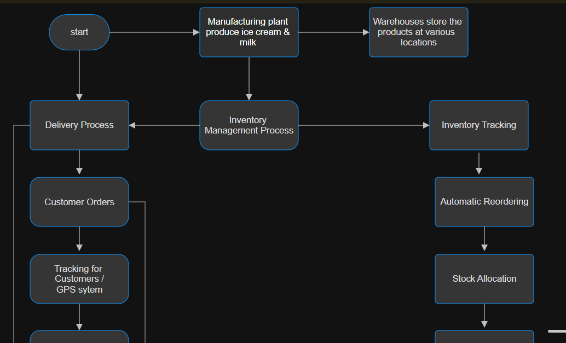

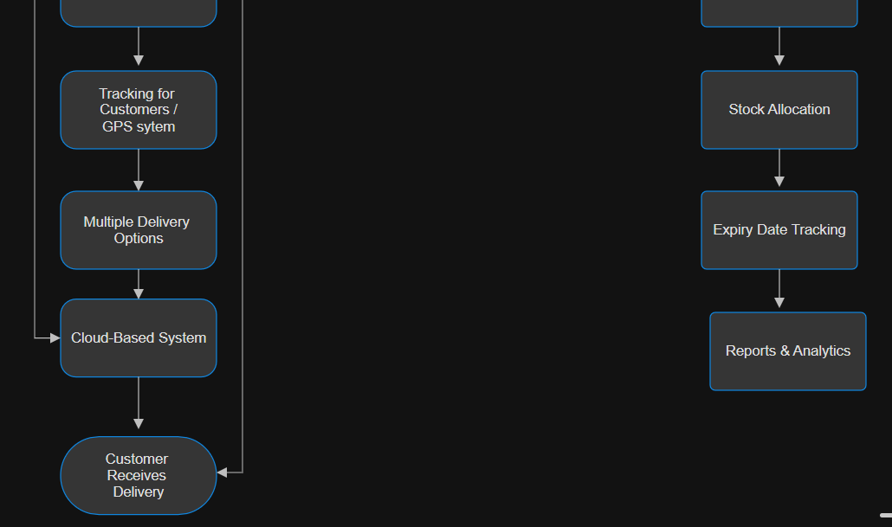

**Assignment 2**

1. Write an introduction letter to a client introducing yourself as a business analyst in

charge of working with the client and his team to start the business understanding process.

Subject: Introduction as Your Business Analyst Partner

Dear Sanjay Rawat,

I hope this message finds you well. My name is Janhvi Bhute, and I am delighted to

introduce myself as the Business Analyst assigned to collaborate with you and your team on this

exciting project.

Understanding the challenges and opportunities within the manufacturing and logistics sectors,

particularly in delivering exceptional customer service, is a domain I am passionate about. With

your vision of managing inventory and ensuring the quickest delivery of your ice-cream and milk

products, my role will be to work closely with you to transform these goals into a robust, tailor-

made software solution.

To begin, I aim to thoroughly understand your current processes, challenges, and aspirations.

Together, we will explore your operational workflows, identify key requirements, and map out a

strategic plan that aligns with your business objectives. Your insights will be invaluable in

ensuring the solution we design is practical, scalable, and optimized for your unique needs.

I look forward to discussing your expectations and gathering inputs from your team during our

initial meetings. In the meantime, please feel free to share any documents, current processes, or

initial thoughts that could help us hit the ground running.

Thank you for the opportunity to collaborate on this project. I am confident that, together, we

will develop a solution that adds significant value to your business operations. Please let me

know a convenient time for us to connect further.

Looking forward to working with you.

Warm regards,

Janhvi Bhute

Business Analyst

+91 7400*****

2. Prepare a brief BRD and SRS for a project- **Ticketing system**

Business Requirements Document (BRD)

*BRD*

**Ticketing System**

**PR786BRDV1B2**

**BRDV2D1**

**Janhvi Bhute**

**05/01/2025**

Contents

1. Document Revisions 4

2. Approvals 4

3. RASCI Chart for This Document 5

Codes Used in RASCI Chart 5

RASCI Chart 5

4. Introduction 6

4.1. Business Goals 6

4.2. Business Objectives 6

4.3. Business Rules 6

4.4. Background 6

4.5. Project Objective 6

4.6. Project Scope 6

4.6.1. In Scope Functionality 6

4.6.2. Out Scope Functionality 6

5. Assumptions 7

6. Constraints 7

7. Risks 7

Technological Risks 7

Skills Risks 7

Political Risks 7

Business Risks 7

Requirements Risks 7

Other Risks 7

8. Business Process Overview 8

8.1. Legacy System (AS-IS) 8

8.2. Proposed Recommendations (TO-BE) 8

9. Business Requirements 8

10. Appendices 8

10.1. List of Acronyms 8

10.2. Glossary of Terms 8

10.3. Related Documents 8

1. **Document Revision**

|  |  |  |
| --- | --- | --- |
| **Date** | **Version Number** | **Document Changes** |
| 05/02/2025 | 0.1 | Initial Draft |
| 10/03/2025 | 0.2 | Updated project scope and objectives based on stakeholder feedback. |
| 22/03/2025 | 0.3 | Added detailed functional requirements for patient registration and admission processes. |
| 15/04/2025 | 0.4 | Incorporated system architecture diagrams and clarified user roles in the project |
| 30/04/2025 | 1.0 | Finalized document after addressing quality review comments and obtaining approvals. |
|  |  |  |

**2.Approvals**

|  |  |  |  |  |
| --- | --- | --- | --- | --- |
| **Role** | **Name** | **Title** | **Signature** | **Date** |
| Project Sponsor | Amit Solanki | Ticket Director | Amit Solanki | 24/07/2025 |
| Business Owner | Mohnish Bahl | Chief Ticket Officer | Mohnish Bahl | 29/07/2024 |
| Project Manager | Avanti Jain | Project Manager-TMS | Avanti Jain | 31/07/2024 |
| System Architect | Poonam Kapoor | System architect-TMS | Poonam Kapoor | 01/08/2024 |
| Development Lead | Sanjay Pal | Software Development lead | Sanjay Pal | 07/08/2024 |
| User Experience Lead | Tarun Singhania | UX/UI lead | Tarun Singhania | 10/08/2024 |
| Quality Lead | Roshan Dsouza | QA lead | Roshan Dsouza | 30/09/2024 |
| Content Lead | Shankar Pant | Content management lead | Shankar Pant | 10/10/2024 |

**3.RACI Chart for This Document**

The RACI chart identifies the persons who need to be contacted whenever changes are made to this document. RACI stands for responsible, accountable, consulted, and informed. These are the main codes that appear in a RACI chart, used here to describe the roles played by team members and stakeholders in the production of the BRD. They are adapted from charts used to assign roles and responsibilities during a project.( RACI Can be made for IT side[Project stakeholder] as mentioned above, apart from that Can also Be made for Client side[Business Stakeholder]).

The following describes the full list of codes used in the table:

Codes Used in RACI Chart

* Authorize Has ultimate signing authority for any changes to the document.

R Responsible Responsible for creating this document. **(BA)**

A Accountable Accountable for accuracy of this document.   
 **(for example, the project manager)**

S Supports Provides supporting services in the production of this document

C Consulted Provides input (such as an interviewee).

I Informed Must be informed of any changes.

RACI Chart

|  |  |  |  |  |  |  |  |
| --- | --- | --- | --- | --- | --- | --- | --- |
| **Name** | **Position** | **\*** | **R** | **A** | **S** | **C** | **I** |
| Avanti Jain | **Project Manager** |  |  | **A** |  |  |  |
| Janhvi Bhute | **BA** |  | **R** |  |  |  |  |
| Amit Solanki | **Project Sponsor** |  |  |  |  |  | **I** |
| Veer Mahatma | **Stakeholder** |  |  |  |  | **C** |  |
| Payal Vyas | **Sr. BA** |  |  |  | **S** |  | **I** |

**4. Introduction:**

The objective of the Ticketing System project is to implement a comprehensive solution for managing customer support tickets effectively. The system will streamline the process of ticket creation, tracking, resolution, and closure. It will be designed to ensure seamless communication between users, support agents, and managers, improving the overall efficiency of customer support operation. Additionally, the system will include advanced features for monitoring service level agreement (SLA)compliance, enhancing reporting capabilities, and integrating with a knowledge base for faster problem resolution.

* 1. **Business Goals**
* **Streamline Issue Resolution** - Enable users to easily raise and track tickets while ensuring quick and efficient resolution by support teams.
* **Enhance Transparency** - Provide users and stakeholders with real-time updates on ticket status and resolution timelines.
* **Improve Accountability** - Introduce clear ownership of tickets through automated assignments and escalation mechanisms.
* **Boost Operational** **Efficiency** - Automate routine processes such as ticket routing and SLA monitoring to reduce manual intervention and errors.
* **Enable Data-Driven Decisions -** Generate actionable insights through reporting and analytics to identify patterns, improve service quality, and optimize resources
  1. **Business Objectives**
* Enhanced Customer Satisfaction: By reducing resolution time and ensuring timely

support through SLA compliance.

* Optimized Support Team Performance: By providing tools for assigning tickets to the

appropriate agents, managing workloads, and tracking performance.

* Better Decision-Making: By offering detailed reports on ticket trends, SLA

performance, and agent efficiency.

* Cost Efficiency: By automating routine support processes, reducing human error, and

speeding up the resolution process, leading to a reduction in operational costs.

**4.3 Business Rules**

* Tickets must be assigned to agents within 15 minutes of creation.
* Tickets cannot be closed until all required information is provided, and the issue is fully

resolved.

* Support agents must adhere to the SLAs defined for each ticket type.
* A ticket must be reopened if a customer reports the issue again within 30 days of closure.

**4.4 Background**

The company’s current ticketing system is inefficient, causing slow response times,

missed SLAs, and manual processing. To address these issues, the company will

implement a new Ticketing System that automates ticket management, tracks SLAs,

integrates a knowledge base, and provides detailed reporting. This system will streamline

support processes, improve customer satisfaction, and ensure compliance with SLAs.

The project aims to enhance efficiency, reduce costs, and provide better data insights for

decision-making. Key stakeholders include customer support, IT, and business

leadership. The project will be completed in 6 months, with phased rollout and ongoing

support.

**4.6 Project Scope**

**In-Scope:**

* User portal for raising tickets.
* Admin/Support team portal for ticket management.
* Automated ticket assignment and prioritization based on predefined rules.
* SLA tracking and notification alerts for pending tickets.
* Reports and dashboards for performance analysis.

**Out-of-Scope:**

* Integration with third-party tools (to be planned in future phases).
* Hardware procurement and setup.

**5. Assumptions**

* All users will have access to a computer or mobile device with an internet connection.
* Support teams will adhere to SLA policies as defined by the organization.

**6. Constraints:**

* The system must be developed and implemented within a 6-month timeline.
* The system should be scalable to handle up to 10,000 tickets per day without
* performance degradation.
* It must comply with applicable data privacy regulations.

**7. Risk**

**1. Technical Risk:**

* Risk: Integration and compatibility issues with existing systems (CRM, email, chat, etc.)

could lead to delays or functionality problems, causing disruptions in the ticket

management process.

* Mitigation: Conduct detailed technical assessments and integration testing to ensure

compatibility with current systems. Allocate time for troubleshooting and ensure robust

APIs for seamless data exchange.

**2. Political Risk:**

* Risk: Internal organizational changes, such as shifts in key personnel or management

priorities, could affect the project's support or direction, causing delays or shifting project

goals.

* Mitigation: Maintain regular communication with key stakeholders and senior leadership

to ensure alignment. Create clear documentation to keep all parties informed, regardless

of organizational changes.

**3. Requirement Risk:**

* Risk: The requirements for the ticketing system might not be fully understood or

documented, leading to misalignment between business needs and the delivered solution.

* Mitigation: Engage stakeholders early in the project to define detailed requirements. Use

iterative feedback and validation (e.g., user stories and prototypes) to refine the system

according to actual needs.

**4. Business Risk:**

* Risk: The new ticketing system might not achieve the expected improvements in

customer satisfaction or operational efficiency, leading to a lack of return on investment

(ROI).

* Mitigation: Set clear, measurable business objectives before the project starts (e.g.,

reduced response time, SLA compliance). Regularly assess the system post-implementation and adjust processes as needed based on feedback and performance metrics.

**8. Business Process Overview**

**1. Legacy System (AS-IS)**

The current ticketing process is largely manual, involving several disconnected systems and

processes that result in inefficiencies and delays. Below are the key elements of the legacy

system:

* **Ticket Creation:** Customers submit support tickets via email or phone, which are manually entered into the system by agents. This often leads to errors in ticket categorization and delays in assignment.
* **Ticket Assignment**: Tickets are manually assigned to support agents based on availability or expertise. This process is time-consuming and lacks prioritization, leading to unequal workload distribution among agents.
* **SLA Management:** SLA compliance is monitored manually through spreadsheets or ad hoc tracking, which is prone to human error. Tickets often exceed SLA timelines, leading to customer dissatisfaction.
* **Resolution & Closure:** Agents resolve tickets based on available information, but often have limited access to knowledge resources, requiring them to solve recurring issues rom scratch. The closure process is also manual and lacks consistency, leading to reopened tickets.
* **Reporting:** Reporting is done manually through ad hoc data collection and spreadsheets, making it difficult to track key performance metrics (KPIs) like ticket resolution time, agent performance, and SLA adherence.
* **Knowledge Sharing:** Information related to past issues and resolutions is stored across different systems, making it challenging for agents to quickly access relevant solutions.

**2. Proposed Recommendations (TO-BE)**

The proposed ticketing system aims to address the inefficiencies of the legacy system by

automating and streamlining key processes. The following changes will improve the overall

ticketing process:

* **Ticket Creation:** The new system will allow customers to create tickets through multiple

channels (email, web portal, chat, etc.). The system will automatically capture key details

such as issue type, urgency, and customer information, eliminating manual data entry and

reducing errors.

* **Ticket Assignment:** The system will automatically categorize and prioritize tickets based

on predefined rules (e.g., urgency, issue type). Tickets will be assigned to the most

appropriate agent based on their expertise and availability, ensuring a more efficient

workload distribution.

* **SLA Management:** The new system will include automated SLA tracking, with real-

time alerts and escalations for tickets nearing or exceeding their resolution deadlines.

This will help ensure that tickets are resolved on time and SLAs are met.

* **Resolution & Closure:** The system will integrate a knowledge base, allowing agents to

quickly access solutions for common issues. Automated workflows will guide agents

through the ticket resolution process, ensuring consistency and reducing resolution time.

Tickets will be automatically closed once all resolution steps are completed, and

customers are satisfied.

* •**Reporting:** The system will include built-in reporting features, providing real-time

dashboards and detailed reports on KPIs such as ticket volume, resolution time, agent

performance, and SLA compliance. These reports will be customizable, enabling

managers to monitor performance and identify areas for improvement.

* •**Knowledge Sharing:** A centralized knowledge base will be integrated into the system,

allowing agents to search for and contribute solutions to recurring issues. This will help

reduce resolution times, improve consistency, and enable new agents to ramp up more

quickly.

**9. Business Requirements**

* **Ticket Creation and Submission**

The system must allow customers to submit tickets through multiple channels, including email, web portal, and chat, ensuring seamless ticket creation across various platforms.

* **Automated Ticket Categorization and Prioritization**

The system must automatically categorize and prioritize tickets based on predefined criteria such as issue type, urgency, and customer profile.

* **SLA Management and Alerts**

The system must track and monitor ticket SLAs automatically, providing real-time alerts and escalation notifications for tickets approaching or breaching their SLA deadlines.

* **Ticket Assignment and Routing**

The system must automatically assign tickets to the most appropriate agent based on factors such as expertise, workload, and availability.

* **Knowledge Base Integration**

The system must integrate a centralized knowledge base that allows agents to access solutions for recurring issues. The knowledge base must be easily searchable and allow agents to contribute new solutions.

* **Ticket History and Audit Trail**

The system must maintain a complete history of all interactions related to each ticket, including agent notes, customer updates, and actions taken.

* **Reporting and Dashboards**

The system must include customizable reporting features and real-time dashboards to track KPIs such as ticket volume, resolution time, SLA compliance, and agent performance.

* **User Roles and Permissions**

The system must have configurable user roles and permissions to restrict access to sensitive data and ensure that agents and managers can only view or edit information relevant to their roles.

* **Multi-Language Support**

The system must support multiple languages to cater to a diverse customer base, allowing customers and agents to interact in their preferred language.

* **Mobile Access for Support Agents**

The system must provide mobile access for support agents, allowing them to view and manage tickets from anywhere.

* **Customer Feedback and Satisfaction Tracking**

The system must allow customers to provide feedback on ticket resolution and agent performance, and this data must be captured and analyzed for continuous improvement.

* **Security and Data Privacy Compliance**

The system must comply with relevant data privacy regulations (e.g., GDPR) and ensure secure handling of sensitive customer data.

**2. Prepare a brief BRD and SRS for a project- Ticketing system**

Software Requirement Specification Document (SRS)

**Software Requirements Specification**

**for**

**<Ticketing System>**

**Version 1.0 approved**

**Prepared by <Janhvi Bhute>**

**Table Of Content**

1. **Introduction………………………………………………………………………………….1**
2. **Goal………………………………………………………………………………………………1**
3. **Objective……………………………………………………………………………………….2**
4. **Use Case Diagram…………………………………………………………………………..4**
5. **Use Case Specification…………………………………………………………………….6**
6. **Functional & Non-Functional Requirement………………………………………8**
7. **Introduction**

A ticketing system is a software tool that helps businesses manage customer and internal support requests. It organizes requests into tickets, which can be tracked, prioritized, and resolved efficiently. Here are some benefits of a ticketing system:

Centralized communication - A ticketing system provides a centralized repository for communication between the service provider and recipient.

Improved customer service - A ticketing system can help businesses handle high volumes of requests, which can improve customer service quality.

Automated tasks - A ticketing system can automate service tasks, such as sending automated responses to request

**2.Business Goal**

The goal of the Ticketing Life Cycle System is to streamline the process of issue reporting,

tracking, and resolution within an organization. It provides users with a platform to create tickets

for their concerns or inquiries, assigns these tickets to appropriate agents, and ensures timely

updates on their progress. The system fosters effective communication between users and

support teams, enhancing customer satisfaction while improving the efficiency of ticket

management processes.

**A business goal for a ticketing system can be to improve customer service and streamline the process of addressing customer issues:**

* **Efficient issue resolution** - A ticketing system can help businesses ensure that customer problems are addressed quickly and efficiently.
* **Centralized management** - A ticketing system can help streamline the process by providing a single platform for managing all customer tickets.
* **Enhanced communication** - A ticketing system can help ensure transparency throughout the resolution process by providing continuous updates between the support team and customers.
* **Performance tracking** - A ticketing system can help businesses track the performance of their support team and ensure compliance with Service Level Agreements (SLAs).
* **Improved customer service quality** - A ticketing system can help businesses handle high volumes of requests, which can significantly enhance customer service quality

**3.Business Objective**

A business can use a ticketing system to achieve several objectives, including:

* **Efficient issue resolution** - A ticketing system can help ensure that customer issues are addressed efficiently.
* **Centralized management** - A ticketing system can help streamline the process by providing a single platform for managing all customer tickets.
* **Enhanced communication** - A ticketing system can help ensure transparency throughout the resolution process by providing continuous updates between the support team and customers.
* **Performance tracking** - A ticketing system can help businesses track the performance of their support team and ensure compliance with Service Level Agreements (SLAs).
* **Improved team collaboration** - A ticketing system can help facilitate teamwork among support staff, allowing for better handling of complex issues.
* **Data and insights** - A ticketing system can provide valuable analytics for understanding common issues, monitoring performance, and making data-driven decisions.
* **Automation** - A ticketing system can automate repetitive tasks, improving agent productivity and efficiency.

1. **Use Case Diagram**

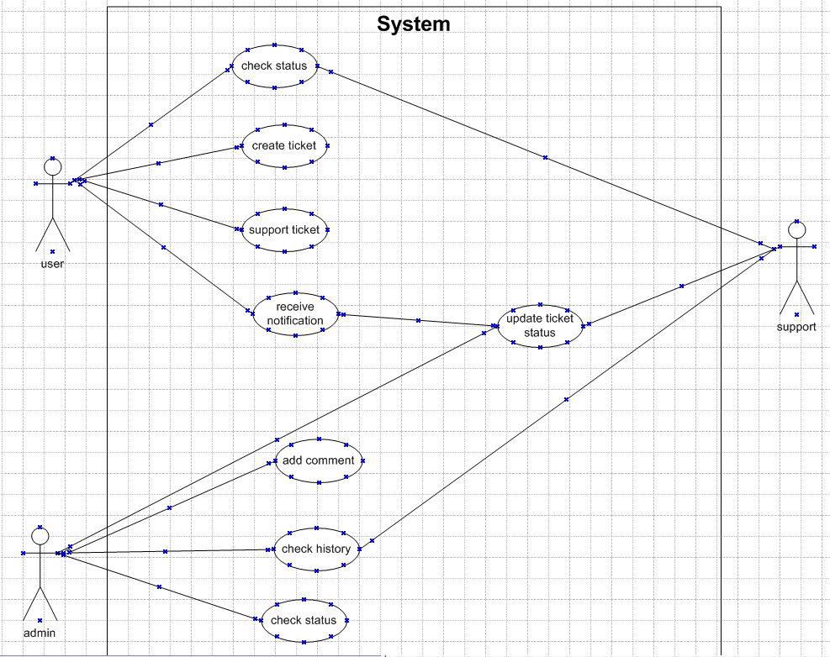

1. **Use Case Specification**

**Use Case 1: Raise a New Ticket**

**1. Use Case Name:** Raise a New Ticket

**2.** **Description**: A user creates a ticket to report an issue, provide details, and request assistance.

**3.** **Actors:** •Primary: End-User •Secondary: System

**4**. **Basic Flow:**

* User logs into the ticketing system.
* User navigates to the "Raise a Ticket" section.
* User selects the issue type.
* User provides a detailed description of the issue.
* User attaches files, if necessary.
* User sets the ticket priority.
* User submits the ticket.
* System generates a unique ticket ID and confirms submission.

**5.** **Alternate Flow:**

* User saves the ticket as a draft instead of submitting it.
* System stores the ticket as a draft for later editing.

**6.Exceptional Flow:**

* Required fields are incomplete: System highlights missing fields and prevents submission.
* File exceeds the allowed size limit: System displays an error and prevents file upload.

**7. Pre-Conditions:** User must have an active account.

**8. Post-Conditions:** •Ticket is logged in the system and assigned a unique ID.

•Notification is sent to the user.

**9. Assumptions**: Users know how to navigate the ticketing system interface.

**10. Constraints:** Attachments must not exceed 5MB per file,Submission allowed only during system operational hours.

**12. Inputs and Outputs:**

**Inputs:** Issue type, description, priority, optional attachments.

**Outputs**: Ticket ID, confirmation notification.

**Use Case 2: View Ticket Details**

**1. Use Case Name:** View Ticket Details

**2. Description:** A user views the details of a previously submitted ticket.

**3. Actors:** Primary: End-User ,,Secondary: System

**4. Basic Flow:**

* User logs into the system.
* User navigates to "My Tickets."
* User selects a ticket to view.
* System displays ticket details: ID, issue type, description, status, and history.

**5. Alternate Flow:** If the ticket is closed: System displays resolution details.

**6. Exceptional Flow:** Ticket is not accessible,,,System displays "Ticket not found" error.

**7. Pre-Conditions:** User must have access rights to the ticket.

**8. Post-Conditions:** Ticket details are displayed to the user.

**9. Assumptions:** System’s database is up-to-date.

**10. Constraints:** Users can view only their own tickets.

**11. Inputs and Outputs:**

•Inputs: Ticket ID or selection from list.

•Outputs: Detailed ticket information.

**Use Case 3: Edit Draft Ticket**

**1. Use Case Name:** Edit Draft Ticket

**2. Description:** User updates the details of a saved draft ticket.

**3. Actors:** •Primary: End-User •Secondary: System

**4. Basic Flow:**

* User logs into the system.
* User navigates to the "My Drafts" section.
* User selects a draft ticket.
* User updates fields and saves changes or submits the ticket

**5. Alternate Flow:**

* If the user decides not to submit the ticket:
* User saves changes and exits without submitting.

**6. Exceptional Flow:** Draft is not found,,,System displays "Draft not found" error.

**7. Pre-Conditions:** A draft ticket must exist in the system.

**8. Post-Conditions:** Draft is updated, or ticket is submitted.

**9. Assumptions:** User has edit rights for the draft.

**10. Constraints:** Drafts expire after 30 days.

**11. Inputs and Outputs:**

•Inputs: Updated ticket details.

•Outputs: Updated draft or new ticket ID.

**Use Case 4: Attach Files to a Ticket**

**1. Use Case Name**: Attach Files to a Ticket

**2. Description:** Users can upload files to provide additional context for a ticket.

**3. Actors:** •Primary: End-User •Secondary: System

**4. Basic Flow:**

* User navigates to the ticket submission or update page.
* User clicks "Attach File."
* User selects a file from their device.
* System uploads and attaches the file to the ticket.

**5. Alternate Flow:** User removes the attachment before submitting the ticket.

**6. Exceptional Flow:** File exceeds size limit,,System displays an error message and cancels the upload.

**7. Pre-Conditions:** Ticket must be in draft or active status.

**8. Post-Conditions:** File is successfully attached to the ticket.

**9. Assumptions:** User has the required file ready to upload.

**10. Constraints:** •Maximum file size is 5MB. •Only specific file types (e.g., PDF, PNG) are allowed.

**11. Inputs and Outputs:**

•Inputs: File.

•Outputs: Confirmation of successful upload.

**Use Case 5: Receive Confirmation for Ticket Submission**

**1. Use Case Name:** Receive Confirmation for Ticket Submission

**2. Description:** Users receive a confirmation notification after submitting a ticket.

**3. Actors:** •Primary: System •Secondary: End-User

**4. Basic Flow:**

* User submits a ticket.
* System generates a unique ticket ID.
* System sends a confirmation email to the user.

**5. Alternate Flow:** Confirmation is sent via SMS instead of email.

**6. Exceptional Flow:** Email server is unavailable,,System queues the email for later delivery.

**7. Pre-Conditions:** Ticket submission process is completed successfully.

**8. Post-Conditions:** User is notified of ticket submission.

**9. Assumptions:** User’s contact information is accurate.

**10. Constraints**: Email notifications are sent within 5 minutes of submission.

**11. Inputs and Outputs:**

•Inputs: Ticket ID, user email

•Outputs: Confirmation email.

1. **Business Requirements**

**Functional Requirement**

| **RegID** | **Reg Name** | **Reg. Description** | **Priority** |
| --- | --- | --- | --- |
| BR001 | User Registration | System should capture personal details of the customers to generate unique username and password | High |
| BR002 | User login | The system shall allow registered users to log in using their email and password | High |
| BR003 | Ticket Creation | Users shall be able to create new tickets by entering a title, description, | High |
| BR004 | Ticket Priority update | The system shall allow users or agents to update the ticket's priority | High |
| BR005 | View Ticket Detail | Users and agents shall be able to view all ticket details, including status, category, and assigned agent | Medium |
| BR006 | Customer Records | System should Maintain records of permanent details of customer. | High |
| BR007 | User Dashboard | Users shall have a dashboard displaying their open and closed tickets. | High |
| BR008 | Agent dashboard | Agents shall have a dashboard displaying assigned tickets with filters for status and priority | High |
| BR009 | Ticket search | Users and agents shall be able to search for tickets using keywords or filters like status and priority | Medium |
| BR010 | Email Notification | The system shall send email notifications for ticket  updates, such as status changes or new comments | High |
| BR011 | Auto-assign Ticket to Agent | The system shall use predefined rules to assign tickets automatically to agents based on their availability and category | High |
| BR012 | Add Attachments to ticket | Users and agents shall attach files to tickets for additional context or support | High |
| BR013 | View Ticket History | Users and agents shall view the history of changes made to a ticket, including status and priority updates | Medium |
| BR014 | Priority-Based  Alerts | The system shall notify agents about high-priority tickets through pop-up alerts or email. | Medium |
| BR015 | Multi-Language  Support | The system shall support multiple languages for users in different regions. | High |

**Non-Functional Requirement**

| **Reg Name** | **Reg. Description** | **Priority** |
| --- | --- | --- |
| System Availability | The system shall maintain an uptime of 99.9% to ensure uninterrupted access to users and agents | High |
| Performance | The system shall handle up to 1,000 concurrent users without degradation in performance. | High |
| Scalability | The system shall scale horizontally to accommodate up to 10,000 users and 50,000 tickets per month | High |
| Security | The system shall comply with industry security standards, such as OWASP guidelines, to prevent unauthorized access | High |
| Data Encryption | All sensitive data, including passwords and ticket information, shall be encrypted at rest and in transit. | Medium |
| Response Time | The system shall provide responses to user actions, such as ticket creation, within 2 seconds under normal load. | High |
| Browse Compatibility | The system shall support all major browsers, including Chrome, Firefox, Safari, and Edge. | High |
| Mobile Compatibility | The system shall provide a responsive design for seamless operation on mobile devices | High |
| Maintainability | The system shall allow developers to update or extend features. | Medium |
| Backup & Recovery | The system shall perform daily backups and provide data recovery within 2 hours in case of failure | High |
| Usability | The system shall provide an intuitive user interface, requiring no more than 30 minutes of training for basic operation | High |

**3. Make an ERD of creating a support ticket/Ticketing life cycle.**

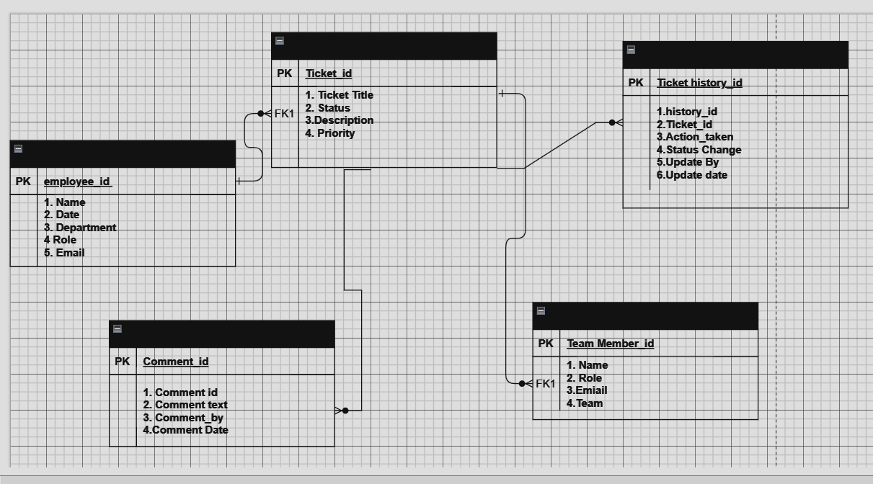

1. **User story of shopping from ecommerce.**

|  |  |  |  |
| --- | --- | --- | --- |
| **User story No: 1** | **Tasks: 2** | | **Priority: Highest** |
| **Value statement: Registration by customer**  As a customer  I want to register in FreshBuy  So that I can order fresh products | | | |
| **BV: 500** | | **CP:2** | |
| **Acceptance criteria:**   1. Go to the registration page and fill in your name, email, password, and contact info. 2. Ensure all mandatory fields are completed before submitting. 3. Check your email for a confirmation after successful registration. 4. Log in immediately using your registered email and password. 5. Move seamlessly from registration to browsing food items 6. Receive guidance or support in case of registration issues or queries | | | |

|  |  |  |  |
| --- | --- | --- | --- |
| **User story No: 2** | **Tasks: 2** | | **Priority: Highest** |
| **Value statement: Addition of delivery address**  AS A CUSTOMER  I WANT TO ADD THE ADDRESS  SO THAT I CAN GET THE ORDER TO MY ADDRESS | | | |
| **BV: 500** | | **CP:2** | |
| **Acceptance criteria:**   1. System presents an option for customers to add a delivery address. 2. Address entry includes fields for street, city, postal/ZIP code, and country. 3. Validation ensures mandatory fields are filled before address submission. 4. Customers can save multiple addresses for future orders. 5. Error message prompts if incomplete or incorrect address details are entered. | | | |

|  |  |  |  |
| --- | --- | --- | --- |
| **User story No: 3** | **Tasks: 2** | | **Priority: Highest** |
| **Value statement: Contact details of delivery boy**  AS A CUSTOMER  I WANT TO VIEW THE CONTACT NUMBER OF DELIVERY BOY  SO THAT I CAN CONTACT DELIVERY BOY FOR THE ORDER STATUS | | | |
| **BV: 500** | | **CP:2** | |
| **Acceptance criteria:**   1. Display delivery boy's contact number post-order confirmation. 2. Accessible in order details for easy reference. 3. Ensure accuracy and ease of use. 4. Clear guidance on contacting for order status. 5. Display delivery boy name in tracking field | | | |

|  |  |  |  |
| --- | --- | --- | --- |
| **User story No: 4** | **Tasks: 2** | | **Priority: Highest** |
| **Value statement: Selection of payment mode**  AS A CUSTOMER  I WANT TO SELECT THE PAYMENT MODE  SO THAT I CAN MAKE PAYMENT OF MY CHOICE | | | |
| **BV: 500** | | **CP:2** | |
| **Acceptance criteria:**   1. Option to choose from various payment modes (credit card, debit card, PayPal, etc.). 2. Each payment mode should be clearly labelled and easily accessible during checkout. 3. The system should securely store and handle payment information for future use if selected by the customer. 4. Clear instructions should guide me through the payment process for each mode. 5. Confirmation of successful payment should be immediate and clearly displayed. 6. In case of payment failure, the system should provide an error message with guidance on resolving the issue. | | | |

|  |  |  |  |
| --- | --- | --- | --- |
| **User story No: 5** | **Tasks: 2** | | **Priority: Highest** |
| **Value statement: Checking the price of item**  AS A CUSTOMER  I WANT TO VIEW THE PRICE  SO THAT I CAN ORDER THE GROCERY ITEM | | | |
| **BV: 500** | | **CP:2** | |
| **Acceptance criteria:**   1. Prices for each food item should be clearly displayed alongside the item name. 2. The price display should be intuitive and easily noticeable on the menu. 3. Prices should be inclusive of any additional charges or taxes. 4. Prices should update based on selected options (sizes, add-ons, etc.) if applicable. 5. The price display should remain consistent across different sections of the menu. 6. Prices should be visible without requiring extra actions (e.g., hovering, clicking). 7. Customers should have easy access to a summary of total prices before checkout. | | | |

|  |  |  |  |
| --- | --- | --- | --- |
| **User story No: 6** | **Tasks: 2** | | **Priority: Highest** |
| **Value statement: Regional revenue reports**  AS A ADMIN  I WANT TO SEE THE REGIONAL REVENUE REPORTS  SO THAT I CAN VIEW THE REGIONAL PERFORMANCE | | | |
| **BV: 500** | | **CP:2** | |
| **Acceptance criteria:**   1. Select regional drop down 2. View performance of each rest of that region in tabular form which includes 3. Rest name, revenue generated. 4. Download in excel or pdf | | | |

|  |  |  |  |
| --- | --- | --- | --- |
| **User story No: 7** | **Tasks: 2** | | **Priority: Highest** |
| **Value statement: Chat support to customers**  AS A CUSTOMER  I WANT TO CHAT WITH ADMIN  SO THAT I CAN REQUEST FOR REFUND | | | |
| **BV: 500** | | **CP:2** | |
| **Acceptance criteria:**   1. Br-all mandatory 2. text box fields 3. display order id 4. text box, for description 5. submit button 6. generate issue id 7. display successful | | | |

|  |  |  |  |
| --- | --- | --- | --- |
| **User story No: 8** | **Tasks: 2** | | **Priority: Highest** |
| **Value statement: Search grocery items for customers**  AS A USER  I WANT TO SEARCH Grocery ITEMS  SO THAT I CAN ORDER Groceries | | | |
| **BV: 500** | | **CP:2** | |
| **Acceptance criteria:**   1. A search bar should be prominently visible for finding different products 2. Users can search by category, name of specific food items. 3. Search results should display relevant items matching the search query. 4. The search should provide suggestions or auto-complete options for ease of use. 5. Users can apply filters (e.g., location, ratings, price) to refine search results. | | | |

|  |  |  |  |
| --- | --- | --- | --- |
| **User story No: 9** | **Tasks: 2** | | **Priority: Highest** |
| **Value statement: Addition of grocery items**  AS A CUSTOMER  I WANT TO ADD Grocery ITEMS IN CART  SO THAT I CAN PROCEED FOR PAYMENT TO OREDR FOOD | | | |
| **BV: 500** | | **CP:2** | |
| **Acceptance criteria:**   1. Each grocery item should have an 'Add to Cart' option for selection. 2. The system should display a visual indication of items successfully added to the cart. 3. Users can view the contents of their cart and the total order summary. 4. Ability to edit quantity or remove items from the cart before proceeding to payment. 5. Clear instructions guiding users from the cart to the payment process. 6. The system should save cart contents for users between sessions. | | | |

|  |  |  |  |
| --- | --- | --- | --- |
| **User story No: 10** | **Tasks: 2** | | **Priority: Highest** |
| **Value statement: Cart viewing to confirm items**  AS A CUSTOMER  I WANT TO VIEW CART  SO THAT I CAN CONFIRM ITEMS FOR ORDER | | | |
| **BV: 500** | | **CP:2** | |
| **Acceptance criteria:**   1. Clicking on the 'Cart' should display a summary of selected items and their quantities. 2. The cart summary should show the total price and allow for easy visibility of added items. 3. Users should have the ability to adjust quantities or remove items from the cart. 4. The cart view should dynamically update when items are added or removed. 5. Clear navigation from the cart back to browsing or adding more items.   6. The option to proceed to checkout directly from the cart for easy order placement | | | |

|  |  |  |  |
| --- | --- | --- | --- |
| **User story No: 11** | **Tasks: 2** | | **Priority: Highest** |
| **Value statement: Making payment of items**  AS A CUSTOMER  I WANT TO MAKE PAYMENT OF SELECTED ITEMS  SO THAT I CAN ORDER THE FOOD | | | |
| **BV: 500** | | **CP:2** | |
| **Acceptance criteria:**   1. Display payment options for selected items. 2. Select preferred payment method. 3. Confirmation of successful payment 4. Clear guidance for payment failure issues. 5. Receive order confirmation post payment | | | |

|  |  |  |  |
| --- | --- | --- | --- |
| **User story No: 12** | **Tasks: 2** | | **Priority: Highest** |
| **Value statement: Order cancellation by customer**  AS A CUSTOMER  I WANT TO CANCEL ORDER  SO THAT REFUND CAN BE INITIATED | | | |
| **BV: 500** | | **CP:2** | |
| **Acceptance criteria:**   1. Customers should have an option to cancel an order before it's processed. 2. The system should provide a 'Cancel Order' button or option 3. Clear confirmation or verification step before finalizing the cancellation.. 4. Confirmation message displaying successful order cancellation. 5. Users should receive an email or notification confirming the cancellation.   7. The refund should be reflected in the user's account within the specified timeframe | | | |

|  |  |  |  |
| --- | --- | --- | --- |
| **User story No: 13** | **Tasks: 2** | | **Priority: Highest** |
| **Value statement:** **Update delivery instructions**  AS A CUSTOMER  I WANT TO UPDATE DELIVERY INSTRUCTIONS  SO THAT ORDER WILL GET DELIVERED AS PER MY REQUIREMENT | | | |
| **BV: 500** | | **CP:2** | |
| **Acceptance criteria:**   1. Accessible option to update delivery instructions before order confirmation. 2. Ability to add or edit specific instructions for the delivery person. 3. Clear guidance on where and how to add delivery instructions. 4. Instructions should cover preferences or special requirements for delivery. 5. Users can update instructions even after order confirmation but before delivery.   6. Normal , contactless ouside door , contactless at gate | | | |

|  |  |  |  |
| --- | --- | --- | --- |
| **User story No: 14** | **Tasks: 2** | | **Priority: Highest** |
| **Value statement: Order tracking by customers**  AS A CUSTOMER  I WANT TO TRACK MY ORDER  SO THAT I CAN CHECK WHERE MY ORDER HAS REACHED | | | |
| **BV: 500** | | **CP:2** | |
| **Acceptance criteria:**   1. My order screen page should be displayed 2. Option to track the order should be shown. 3. Online gps tracking system showing current location of delivery boy | | | |

|  |  |  |  |
| --- | --- | --- | --- |
| **User story No: 15** | **Tasks: 2** | | **Priority: Highest** |
| **Value statement: Notification for order updates**  AS A USER  I WANT TO GET NOTIFICATIONS OF ORDER UPDATES  SO THAT I WILL BE UPDATED ABOUT MY ORDER | | | |
| **BV: 500** | | **CP:2** | |
| **Acceptance criteria:**   1. Accessible option to enable order update notifications in the user settings. 2. Notifications should cover order confirmation, processing, and delivery updates. 3. Users can choose preferred notification channels (email, SMS, app notifications). 4. Notifications should include relevant details like order status changes or estimated delivery times. 5. Timely and real-time notifications reflecting the latest order updates. | | | |

|  |  |  |  |
| --- | --- | --- | --- |
| **User story No: 16** | **Tasks: 2** | | **Priority: Highest** |
| **Value statement: Refund request processing**  AS A ADMIN  I WANT TO PROCESS REFUND REQUEST  SO THAT I CAN PROVIDE REFUND OF CANCELED ORDER TO CUSTOMER | | | |
| **BV: 500** | | **CP:2** | |
| **Acceptance criteria:**   1. Should be able to view refund request 2. Should be able to view order 3. check ordered time and cancellation time 4. click on recommend refund to admin 5. intimation mail alert to restaurant, admin and business owner | | | |

|  |  |  |  |
| --- | --- | --- | --- |
| **User story No: 17** | **Tasks: 2** | | **Priority: Highest** |
| **Value statement: Approval of delivery boy registration**  AS A ADMIN  I WANT TO APPROVE DELIVERY BOY REGISTRATION  SO THAT DELIVERY BOYS WILL START SERVICING | | | |
| **BV: 500** | | **CP:2** | |
| **Acceptance criteria:**   1. Access dashboard to review and approve restaurant/delivery boy registrations. 2. Detailed info for each request with options to approve or reject. 3. Notifications sent upon approval/rejection with reasons for rejection. 4. Clear categorization of approved and pending registrations. 5. Access to history of approved/rejected registrations for reference. | | | |

|  |  |  |  |
| --- | --- | --- | --- |
| **User story No: 18** | **Tasks: 2** | | **Priority: Highest** |
| **Value statement: Application of coupon codes for discount**  As a customer  I want to apply coupon code while making payment  So that i will get discount on my payment | | | |
| **BV: 500** | | **CP:2** | |
| **Acceptance criteria:**   1. apply coupon on payment screen 2. view available coupon offers 3. select coupon 4. revise the final billing after applying coupon doscount 5. business rule : check coupon validity and eligibility | | | |

|  |  |  |  |
| --- | --- | --- | --- |
| **User story No: 19** | **Tasks: 2** | | **Priority: Highest** |
| **Value statement: Delivery boy verification by admin**  As a admin  I want to verify delivery boy for handing over the order  So that correct delievery boy will deliver the order | | | |
| **BV: 500** | | **CP:2** | |
| **Acceptance criteria:**   1. Accessible option to verify assigned delivery boy before order handover. 2. Display details of the assigned delivery boy, including name and ID. 3. Ensure that the displayed delivery boy matches the assigned one for the order. 4. The system should prevent handover if the assigned delivery boy doesn’t match. 5. Clear indications or alerts for the correct assigned delivery boy for the order. | | | |

|  |  |  |  |
| --- | --- | --- | --- |
| **User story No: 20** | **Tasks: 2** | | **Priority: Highest** |
| **Value statement: Review and ratings by customer**  As a user  I want to leave reviews and ratings for products  So that I can provide feedback. | | | |
| **BV: 500** | | **CP:2** | |
| **Acceptance criteria:**   1. Options for text feedback and star ratings. 2. User be able to rate and review. 3. Confirm button to submit the text feedback | | | |

|  |  |  |  |
| --- | --- | --- | --- |
| **User story No: 21** | **Tasks: 2** | | **Priority: Highest** |
| **Value statement: Security for customers**  As a customer  I want to securely log in to my account.  So that I can put my information. | | | |
| **BV: 500** | | **CP:2** | |
| **Acceptance criteria:**   1. Secure login using valid credentials. 2. Text boxes to input Email/Phone and password. 3. Submit button to confirm the inputs 4. Password encryption to ensure data privacy. 5. Option for password recovery in case of forgotten credentials. | | | |
|  | | | |
| **User story No: 22** | **Tasks: 2** | | **Priority: Medium** |
| **Value statement: Update profile**  As a customer  I want to update my profile information, including delivery address and contact details  So that I can get order on accurate address | | | |
| **BV: 500** | | **CP:2** | |
| **Acceptance criteria:**   1. Ability to update profile information, including delivery address and contact details. 2. Text boxes to input details. 3. Changes should reflect accurately in the system for future orders. 4. Secure verification process when updating sensitive information | | | |

|  |  |  |  |
| --- | --- | --- | --- |
| **User story No: 23** | **Tasks: 2** | | **Priority: Highest** |
| **Value statement: Order cancellation by customer**  As a Customer  I want to cancel my order  So that refund can begin | | | |
| **BV: 500** | | **CP:2** | |
| **Acceptance criteria:**   1. Customers should have an option to cancel an order before it's processed. 2. The system should provide a 'Cancel Order' button or option 3. Clear confirmation or verification step before finalizing the cancellation. 4. Confirmation message displaying successful order cancellation. 5. Users should receive an email or notification confirming the cancellation.   7. The refund should be reflected in the user's account within the specified timeframe | | | |
| **User story No: 24** | **Tasks: 2** | | **Priority: Highest** |
| **Value statement: Receive feedback from customers**  As a delivery person  I want to receive feedback from customers about my service  So that I can improve performance | | | |
| **BV: 500** | | **CP:2** | |
| **Acceptance criteria:**   1. Delivery persons receive prompt feedback from customers about their service. 2. The feedback includes a rating system for a quick and easy review. 3. Feedback comments are optional but encouraged for more detailed insights. 4. The platform notifies the delivery person of new feedback. 5. Delivery persons have a designated section to view and reflect on customer feedback | | | |

|  |  |  |  |
| --- | --- | --- | --- |
| **User story No: 25** | **Tasks: 2** | | **Priority: Highest** |
| **Value statement: Create bucket list of choice products**  As a customer  I want to create a bucket list of my choice products  So that I can buy in later. | | | |
| **BV: 500** | | **CP:2** | |
| **Acceptance criteria:**   1. Customers can effortlessly create and manage a bucket list of choice products. 2. The bucket list is easily accessible for quick future purchases. 3. Option to share the bucket list with others through various communication methods. 4. The platform sends notifications when bucket list items are on sale or restocked. 5. Customers can efficiently add or remove items from their bucket list. | | | |
| **User story No: 26** | **Tasks: 2** | | **Priority: Highest** |
| **Value statement: Manage customer and delivery profiles**  As an admin  I want to manage customer and delivery person profiles  So that I can save their details. | | | |
| **BV: 500** | | **CP:2** | |
| **Acceptance criteria:**   1. Admin has dedicated tools to manage customer and delivery person profiles. 2. Ability to update and verify customer and delivery person details for accuracy. 3. Secure access controls are in place to protect sensitive user information. 4. Admin can easily retrieve and view historical data related to user profiles | | | |

|  |  |  |  |
| --- | --- | --- | --- |
| **User story No: 27** | **Tasks: 2** | | **Priority: Highest** |
| **Value statement: Manage payment options**  As an admin  I want to manage and configure payment gateway options  So that customer can pay seamlessly | | | |
| **BV: 500** | | **CP:2** | |
| **Acceptance criteria:**   1. Admin has access to tools for managing and configuring payment gateway options. 2. Integration with secure and popular payment gateways is seamless. 3. Admin can easily update and configure payment methods available on the platform. 4. The system provides a testing environment for validating payment gateway configurations | | | |

|  |  |  |  |
| --- | --- | --- | --- |
| **User story No: 28** | **Tasks: 2** | | **Priority: Medium** |
| **Value statement: Coupon code application**  As a customer  I want to apply coupon codes during checkout  So that I can available discounts | | | |
| **BV: 100** | | **CP:2** | |
| **Acceptance criteria:**   1. Ability to apply coupon codes during the checkout process. 2. System validates and applies the correct discount based on the coupon code. 3. Clear indication of the applied discount on the order summary. | | | |

|  |  |  |  |
| --- | --- | --- | --- |
| **User story No: 29** | **Tasks: 2** | | **Priority: Lowest** |
| **Value statement: Tracking the route for delivery**  As a delivery person  I want the most optimized route  So that I can do efficient deliveries. | | | |
| **BV: 200** | | **CP:2** | |
| **Acceptance criteria:**   1. The platform provides delivery persons with the most optimized route for efficient deliveries. 2. The route takes into account real-time traffic data for accurate estimations. 3. Turn-by-turn directions are clear and easy to follow. 4. Delivery persons have the option to choose alternative routes if needed. 5. The system continuously updates the route for any changes during the delivery process. | | | |

|  |  |  |  |
| --- | --- | --- | --- |
| **User story No: 30** | **Tasks: 2** | | **Priority: Highest** |
| **Value statement: Receive notifications for update on delivery**  As a customer  I want to receive notifications and details for update for delivery  So that I can track my purchase | | | |
| **BV: 500** | | **CP:2** | |
| **Acceptance criteria:**   1. Customer should receive timely notifications on new delivery. 2. The notification includes information about the assigned delivery partner. 3. Notifications are sent through the preferred communication method chosen by the delivery person. 4. The system ensures the accuracy of information in the notification. | | | |

|  |  |  |  |
| --- | --- | --- | --- |
| **User story No: 31** | **Tasks: 2** | | **Priority: Highest** |
| **Value statement: Application of coupon codes fro discount**  As a customer  I want to apply coupon code while making payment  So that i will get discount on my payment | | | |
| **BV: 500** | | **CP:2** | |
| **Acceptance criteria:**   1. apply coupon on payment screen 2. view available coupon offers 3. select coupon 4. revise the final billing after applying coupon doscount 5. business rule : check coupon validity and eligibility | | | |

|  |  |  |  |
| --- | --- | --- | --- |
| **User story No: 32** | **Tasks: 2** | | **Priority: Highest** |
| **Value statement: Delivery boy verification by admin**  As a admin  I want to verify delivery boy for handing over the order  So that correct delievery boy will deliver the order | | | |
| **BV: 500** | | **CP:2** | |
| **Acceptance criteria:**   1. Accessible option to verify assigned delivery boy before order handover. 2. Display details of the assigned delivery boy, including name and ID. 3. Ensure that the displayed delivery boy matches the assigned one for the order. 4. The system should prevent handover if the assigned delivery boy doesn’t match. 5. Clear indications or alerts for the correct assigned delivery boy for the order. | | | |

|  |  |  |  |
| --- | --- | --- | --- |
| **User story No: 33** | **Tasks: 2** | | **Priority: Highest** |
| **Value statement: Review and ratings by customer**  As a user  I want to leave reviews and ratings for products  So that I can provide feedback. | | | |
| **BV: 500** | | **CP:2** | |
| **Acceptance criteria:**   1. Options for text feedback and star ratings. 2. User be able to rate and review. 3. Confirm button to submit the text feedback | | | |

|  |  |  |  |
| --- | --- | --- | --- |
| **User story No: 34** | **Tasks: 2** | | **Priority: Medium** |
| **Value statement: Mange delivery options for customers**  As a customer  I want multiple delivery options, including same-day, next-day, and scheduled deliveries  So that I can receive item as per preference. | | | |
| **BV: 500** | | **CP:2** | |
| **Acceptance criteria:**   1. Customers have the flexibility to choose from multiple delivery options during checkout. 2. Delivery options include same-day, next-day, and scheduled deliveries. 3. Clear information on delivery charges for each option is provided. 4. Customers receive notifications confirming the chosen delivery option. 5. The platform allows customers to change the delivery option before completing the order. | | | |

|  |  |  |  |
| --- | --- | --- | --- |
| **User story No: 35** | **Tasks: 2** | | **Priority: Highest** |
| **Value statement: Manage customer and delivery profiles**  As an admin  I want to manage customer and delivery person profiles  So that I can save their details. | | | |
| **BV: 500** | | **CP:2** | |
| **Acceptance criteria:**   1. Admin has dedicated tools to manage customer and delivery person profiles. 2. Ability to update and verify customer and delivery person details for accuracy. 3. Secure access controls are in place to protect sensitive user information. 4. Admin can easily retrieve and view historical data related to user profiles | | | |

|  |  |  |  |
| --- | --- | --- | --- |
| **User story No: 36** | **Tasks: 2** | | **Priority: Highest** |
| **Value statement: Manage product catalogue**  As an admin  I want to add, update, or remove products from the catalog  So that I can manage the product catalogue | | | |
| **BV: 500** | | **CP:2** | |
| **Acceptance criteria:**   1. Admin can effortlessly add, update, or remove products from the platform catalog. 2. Product management includes categorization and organization for user-friendly navigation. 3. The system updates product availability in real-time to reflect accurate stock information. 4. Admin receives notifications for low-stock products and can take prompt action. 5. Changes to the product catalog do not disrupt ongoing customer transactions. | | | |

|  |  |  |  |
| --- | --- | --- | --- |
| **User story No: 37** | **Tasks: 2** | | **Priority: Highest** |
| **Value statement: Details of sales, deliveries and user activity**  As an admin  I want details for sales, deliveries, and user activity  So that I can generate reports | | | |
| **BV: 500** | | **CP:2** | |
| **Acceptance criteria:**   1. Admin can generate detailed reports on sales, deliveries, and user activity. 2. Filter options for specific time periods, product categories, and user segments are available. 3. Reports include key metrics such as total sales, successful deliveries, and user engagement. 4. Export functionality allows admin to share reports with relevant stakeholders. 5. The reports section is designed to provide a comprehensive overview of platform performance. | | | |

|  |  |  |  |
| --- | --- | --- | --- |
| **User story No: 38** | **Tasks: 2** | | **Priority: Highest** |
| **Value statement: Tools to monitor platform**  As an admin  I want tools for monitoring the platform  So that I can ensure the security of the platform. | | | |
| **BV: 500** | | **CP:2** | |
| **Acceptance criteria:**   1. Admin has user-friendly tools for monitoring the overall platform. 2. Real-time data on platform health, performance, and user activity is accessible. 3. Alerts are in place to notify the admin of any irregularities or security concerns. 4. The monitoring tools provide insights into system responsiveness and uptime. 5. 5. Admin can easily navigate between different monitoring categories. | | | |

|  |  |  |  |
| --- | --- | --- | --- |
| **User story No: 39** | **Tasks: 2** | | **Priority: Highest** |
| **Value statement:Manage payment gateway options**  As an admin  I want to manage and configure payment gateway options  So that customer can pay seamlessly | | | |
| **BV: 500** | | **CP:2** | |
| **Acceptance criteria:**   1. Admin has access to tools for managing and configuring payment gateway options. 2. Integration with secure and popular payment gateways is seamless. 3. Admin can easily update and configure payment methods available on the platform. 4. The system provides a testing environment for validating payment gateway configurations | | | |

|  |  |  |  |
| --- | --- | --- | --- |
| **User story No: 40** | **Tasks: 2** | | **Priority: Highest** |
| **Value statement: Create wishlist of favourite products**  As a customer  I want to create a wishlist of favorite products  So that I can quickly buy in future. | | | |
| **BV: 500** | | **CP:2** | |
| **Acceptance criteria:**   1. Customers can effortlessly create and manage a wishlist of favorite products. 2. The wishlist is easily accessible for quick future purchases. 3. Option to share the wishlist with others through various communication methods. 4. The platform sends notifications when wishlist items are on sale or restocked. 5. Customers can efficiently add or remove items from their wishlist. | | | |