**Agile Documents**

**Document 1: Definition of Done**

The Definition of Done outlines the criteria that a user story of any other backing item must meet to be considered complete and ready for release. It establishes a shared understanding of what it means for work to be considered as done and ensures that all necessary aspects such as quality, testing, and documentation are addressed. As per Agile, it is a technique where the team displays a list of criteria which must be met before a backlog item is considered done.

**Checklist for DOD:**

* Product code met the basic functionality
* All user stories have been met
* Basic Flow met
* Code is free of critical or high-severity bugs
* Acceptance Criteria met
* Testing is done for Acceptance Criteria
* Unit Testing done and passed
* Quality performed
* All the changes are documented
* UAT Performed and all feedbacks addressed
* Production environment is ready
* Sprint is ready and deployed
* Product owners approved the implementation
* Final demonstration has been conducted with the stakeholders
* Deployment and rollback plans are documented
* User Guide and training material are created
* End user is trained
* Project is deployed in the test environment

**Document 2- Product Vision**

|  |  |  |  |
| --- | --- | --- | --- |
| **Scrum Project Name:** | Cadence Enhancement System | | |
| **Venue:** | Conference Room 1 | | |
| **Date:** | **Start time:** 20/01/2025 | **End time:** 20/11/2025 | **Duration:** 10 Months |
| **Client:** | USAA | | |
| **Stakeholder list:** | USAA Loan Management, Nitin & Amit | | |

|  |  |
| --- | --- |
| **Scrum Team** | |
| **Scrum Master:** | Mayank |
| **Product owner:** | Mike |
| **Scrum Developer 1:** | Juhi |
| **Scrum Developer 2:** | Neha |
| **Scrum Developer 3:** | Priyank |
| **Scrum Developer 4:** | Nikhil |

|  |  |  |  |
| --- | --- | --- | --- |
| **Vision:** The goal is to enhance the existing system so that it will be able to accommodate increased number of loans with efficiency. | | | |
| **Target group** | **Needs** | **Product** | **Value** |
| It targets the loan banking sector | It solves the problem of inability of system of handling large workflow | Loan Management System to track the loan process from start to end | The product will benefit the company by increasing customer satisfaction and ease the work |
| The target users and customers are Bank representatives and employees | The benefit is that the system will be easily integrated with the third-party software | User friendly and enhancing the ability of system | The business goal is to provide platform to bank representative so that there is efficiency and accuracy in their work |
|  |  | Yes, it is feasible to develop the product | The business model is Loan Management System |

**Document 3: User stories**

|  |  |  |  |  |  |  |  |  |
| --- | --- | --- | --- | --- | --- | --- | --- | --- |
| User Story No. 1 | Tasks: 4 | Priority: Highest | User Story No. 2 | Tasks: 4 | Priority: Medium | User Story No. 3 | Tasks: 5 | Priority: Low |
| AS A MANAGER I WANT DETAILED REPORTS SO THAT I CAN ANALYZE THE HEALTH OF THE PROJECT | | | AS A MANAGER I WANT TO RECEIVE ALERTS WHEN A TASK DEADLINE IS MISSED SO THAT I CAN TAKE CORRECTIVE ACTIONS PROMPTLY | | | AS A MANAGER I WANT TO ASSIGN TASKS TO TEAM MEMBERS SO THAT I CAN SET DEADLINES TO ENSURE PROJECT TIMELINES ARE MET | | |
|  |
|  |
| BV: 500 | | CP: 02 | BV: 100 | | CP: 01 | BV: 50 | | CP: 02 |  |
| ACCEPTANCE CRITERIA Reports include task completion rates, overdue tasks, and resource utilization Reports can be exported as PDF | | | ACCEPTANCE CRITERIA Managers receive overdue task alerts via email Alerts include task details and responsible users | | | ACCEPTANCE CRITERIA Managers can assign tasks to specific users Managers can set task priorities and deadlines | | |  |
|  |
|  |
|  |
|  |

|  |  |  |  |  |  |  |  |  |
| --- | --- | --- | --- | --- | --- | --- | --- | --- |
| User Story No. 4 | Tasks: 4 | Priority: Highest | User Story No. 5 | Tasks: 5 | Priority: Medium | User Story No. 6 | Tasks: 2 | Priority: Highest |
| AS A MANAGER I WANT TO REVIEW TEAM PROGRESS ON MY MOBILE DEVICE SO THAT I CAN STAY UPDATED WHILE TRAVELING | | | AS A TEAM MEMBER I WANT TO VIEW MY ASSIGNED TASKS SO THAT I CAN MANAGE MY RESPONSIBILITIES EFFECTIVELY | | | AS A DEVELOPER I WANT TO ACCESSS THE DATABASE SECURELY SO THAT I CAN SECURELY RETRIEVE AND UPDATE DATA FOR MAINTENANCE PURPOSES | | |
|  |
|  |
| BV: 500 | | CP: 01 | BV: 100 | | CP: 01 | BV: 500 | | CP: 01 |  |
| ACCEPTANCE CRITERIA Mobile app includes dashboard views for team performance Managers can approve or reassign tasks via the app | | | ACCEPTANCE CRITERIA Users see a list of their tasks, sorted by priority and due date Tasks display status (e.g., Pending, In Progress, Completed) | | | ACCEPTANCE CRITERIA Access to the database is restricted to authorized developers via secure methods All database queries are logged for auditing | | |  |
|  |
|  |
|  |
|  |

|  |  |  |  |  |  |  |  |  |
| --- | --- | --- | --- | --- | --- | --- | --- | --- |
| User Story No. 7 | Tasks: 2 | Priority: Highest | User Story No. 8 | Tasks: 2 | Priority: Highest | User Story No. 9 | Tasks: 2 | Priority: Medium |
| AS A DEVELOPER I WANT TO INTEGRATE THE SYSTEM WITH THIRD-PARTY SOFTWARE SO THAT WORKFLOWS CAN BE STREAMLINED | | | AS AN BUSINESS OWNER I WANT TWO-WAY AUTHENTICATION SO THAT I CAN HAVE A MORE SECURED SOFTWARE | | | AS A USER I WANT TO SYNC MY TASKS WITH MY CALENDAR SO THAT I CAN AVOID MISSING DEADLINES | | |
|  |
|  |
| BV: 500 | | CP: 02 | BV: 500 | | CP: 02 | BV: 100 | | CP: 01 |  |
| ACCEPTANCE CRITERIA The system supports API connections for task updates and notifications Integration settings are configurable in the admin panel | | | ACCEPTANCE CRITERIA All sensitive data is encrypted in transit and at rest | | | ACCEPTANCE CRITERIA Users can sync tasks with Google Calendar or Outlook Task updates are reflected in the calendar in real-time | | |  |
|  |
|  |
|  |
|  |

|  |  |  |  |  |  |  |  |  |
| --- | --- | --- | --- | --- | --- | --- | --- | --- |
| User Story No. 10 | Tasks: 2 | Priority: Highest | User Story No. 11 | Tasks: 2 | Priority: Low | User Story No. 12 | Tasks: 2 | Priority: Low |
| AS A USER I WANT MY DATA TO BE ENCRYPTED TO ENSURE CONFIDENTIALITY AND SECURITY | | | AS A USER I WANT TO ACCESS THE TRAINING MATERIALS  SO THAT I CAN LEARN HOW TO USE THE SYSTEM EFFECTIVELY | | | AS A USER I WANT TO BE INFORMED ABOUT THE SYSTEM UPDATES SO THAT I CAN KNOW HOW THEY IMPACT MY WORKFLOW TO ADJUST ACCORDINGLY | | |
|  |
|  |
| BV: 500 | | CP: 01 | BV: 50 | | CP: 01 | BV: 50 | | CP: 01 |  |
| ACCEPTANCE CRITERIA All sensitive data is encrypted in transit and at rest Users are notified of any unusual login activity | | | ACCEPTANCE CRITERIA System includes a help centre with tutorials and FAQs Users can request live support through chat or email | | | ACCEPTANCE CRITERIA Users receive advance notifications about upcoming upgrades Release notes are provided to explain new features or changes Minimal downtime is ensured during upgrades | | |  |
|  |
|  |
|  |
|  |

|  |  |  |  |  |  |  |  |  |
| --- | --- | --- | --- | --- | --- | --- | --- | --- |
| User Story No. 13 | Tasks: 2 | Priority: Medium | User Story No. 14 | Tasks: 2 | Priority: Medium | User Story No. 15 | Tasks: 2 | Priority: Highest |
| AS A USER I WANT TO VIEW MY PERFORMANCE METRICS  SO THAT I CAN CACCESS MY PRODUCTIVITY | | | AS A USER I WANT THE SYSTEM TO PROCESS MY ACTIONS QUICKLY SO THAT I CAN SAVE TIME AND IMPROVE PRODUCTIVITY | | | AS AN ADMIN I WANT TO ENFORCE POLICIES AND STANDARDS WITHIN THE SYSTEM SO THAT I CAN ENSURE COMPLIANCE AND CONSISTENCY | | |
|  |
|  |
| BV: 100 | | CP: 01 | BV: 100 | | CP: 01 | BV: 500 | | CP: 01 |  |
| ACCEPTANCE CRITERIA Users can view completed tasks, overdue tasks, and average task completion time | | | ACCEPTANCE CRITERIA System processes user inputs (e.g., saving tasks, generating reports) in under 2 seconds Feedback or confirmation is provided immediately after-action completion | | | ACCEPTANCE CRITERIA Admins can create and manage policies in the admin panel Users must acknowledge updated policies upon login Policy updates are tracked with version control and change logs | | |  |
|  |
|  |
|  |
|  |

|  |  |  |  |  |  |  |  |  |
| --- | --- | --- | --- | --- | --- | --- | --- | --- |
| User Story No. 16 | Tasks: 2 | Priority: Highest | User Story No. 17 | Tasks: 2 | Priority: Highest | User Story No. 18 | Tasks: 2 | Priority: Low |
| AS AN ADMIN I WANT THE ABILITY TO UPGRADE THE SYSTEM WITH MINIMAL DISRUPTION TO ONGOING OPERATIONS SO THAT I CAN ENSURE THE LATEST FEATURES AND SECURITY UPDATES ARE AVAILABLE | | | AS AN ADMIN I WANT A READ-ONLY VIEW OF CRITICAL DATABASE INFORMATION TO MONITOR SYSTEM HEALTH | | | AS AN ADMIN I WANT DETAILED DOCUMENTATION  SO THAT I CAN MANAGE AND TROUBLESHOOT THE SYSTEM | | |
|  |
|  |
| BV: 500 | | CP: 01 | BV: 500 | | CP: 02 | BV: 50 | | CP: 01 |  |
| ACCEPTANCE CRITERIA System upgrades can be scheduled during off-peak hours Notifications are sent to users before and after the upgrade A rollback option is available in case of upgrade failure | | | ACCEPTANCE CRITERIA Admins can view database status and usage metrics without modifying data Access is granted through the admin panel with secure authentication | | | ACCEPTANCE CRITERIA Admin guide includes setup instructions, FAQs, and troubleshooting steps Support is available for escalated issues | | |  |
|  |
|  |
|  |
|  |

|  |  |  |  |  |  |
| --- | --- | --- | --- | --- | --- |
| User Story No. 19 | Tasks: 2 | Priority: Medium | User Story No. 20 | Tasks: 2 | Priority: Highest |
| AS AN ADMIN I WANT TO ADD, EDIT AND DEACTIVATE USERS  SO THAT I CAN ENSURE ONLY AUTHORISED PERSONNEL HAVE ACCESS TO THE SYSTEM | | | AS AN ADMIN I WANT TO SET ROLE BASED PERMISSIONS  TO CONTROL USER ACCESS LEVELS | | |
|  |
|  |
| BV: 100 | | CP: 03 | BV: 500 | | CP: 01 |  |
| ACCEPTANCE CRITERIA Admin can create new users with roles Admin can edit user details Admin can deactivate/reactivate user accounts | | | ACCEPTANCE CRITERIA Admins can define custom roles with specific permissions Permissions are enforced consistently across the system | | |  |
|  |
|  |
|  |
|  |

**Document 4: Agile PO Experience**

The Product Owner has a vision to make sure that the work is done with utmost accuracy and efficiency to provide maximum customer satisfaction.

Following are the responsibilities of PO in a project -

* **Market Analysis:** As with the growing industry everything is getting automated, so the PO had to make sure to minimize manual work to improve the accuracy.
* **Enterprise Analysis:** PO will perform RCA to check the inefficiency, which resulted in building a system with minimum manual intervention.
* **Product Vision and Roadmap:** Product will be built in such a way that users can complete the work in the customer portal itself and with time, more new features will be added.
* **Managing Product Features:** PO will keep in mind the MVP and prioritize the work according to the stakeholder’s requirement.
* **Managing Product Backlog:** As per the stakeholder’s requirement and Sprint review meeting, PO will refine the product backlog and prioritize the user stories accordingly.
* **Managing Overall Iteration Progress:** PO will follow up with the scrum team and make sure that all the Sprints are going well.

From this project I have learned how to handle sprint meetings such as -

* **Sprint planning meeting**: In the Sprint planning meeting, we prioritize the user stories and move them from Product backlog to sprint backlog.
* **Daily scrum meeting:** In the Daily scrum meeting we will handle if there are any issue which the developers are experiencing while building the code.
* **Sprint review meeting:** In the Sprint review meeting we check the overall sprint progress and we will take the lessons learned as the feedback for next sprint.
* **Sprint retrospective meeting:** In the Sprint retrospective meeting we follow up with the developers if any help is required for the next sprint.
* **Backlog refinement meeting:** In Backlog refinement meeting we refine the product backlog according to the stakeholder’s requirement or according to the feedback received during sprint review meeting.

Once the User Stories are created, we make sure that the basic flow/Alternative flow/Exceptional flow criteria are taken from the stakeholder and accordingly Business value is given to the user’s stories by stakeholder. We will then assign the story no and prioritize the user stories and the developer will give complexity point to the user stories.

The product owner understands the product very well, which in turn help the scrum team to build the product backlog and work on it, he collaborates with the stakeholder and communicate the requirements with the scrum team and keep track of the overall development of the project.

**Document 5: Product and sprint backlog and product and sprint burndown charts**

**Product Backlog:**

* In the product backlog all stories and all requirements are included that is needed to accomplish the project vision.
* Product Owner owns the product backlog.
* It includes requirements, defects, feature ideas, bug fix, and documentation.
* Everyone contributes to the product backlog.
* Release burndown metric is used.
* Estimation is done at user story level.
* It is never complete and dynamic.

**Sprint Backlog:**

* In the sprint backlog anything needed to fulfil the sprint goal is included.
* The development team owns the sprint backlog.
* It is a subset of product backlog and defined as a priority by the product owner.
* Only the development team contributes to the sprint backlog.
* Sprint planning meeting is to refine the sprint backlog items.
* No changes are allowed to sprint backlog items once the sprint has started.
* Sprint burn down metric is used.
* Estimation is done at the activity or task level.
* Daily stand-up meeting discusses the sprint backlog in accordance with sprint goal.

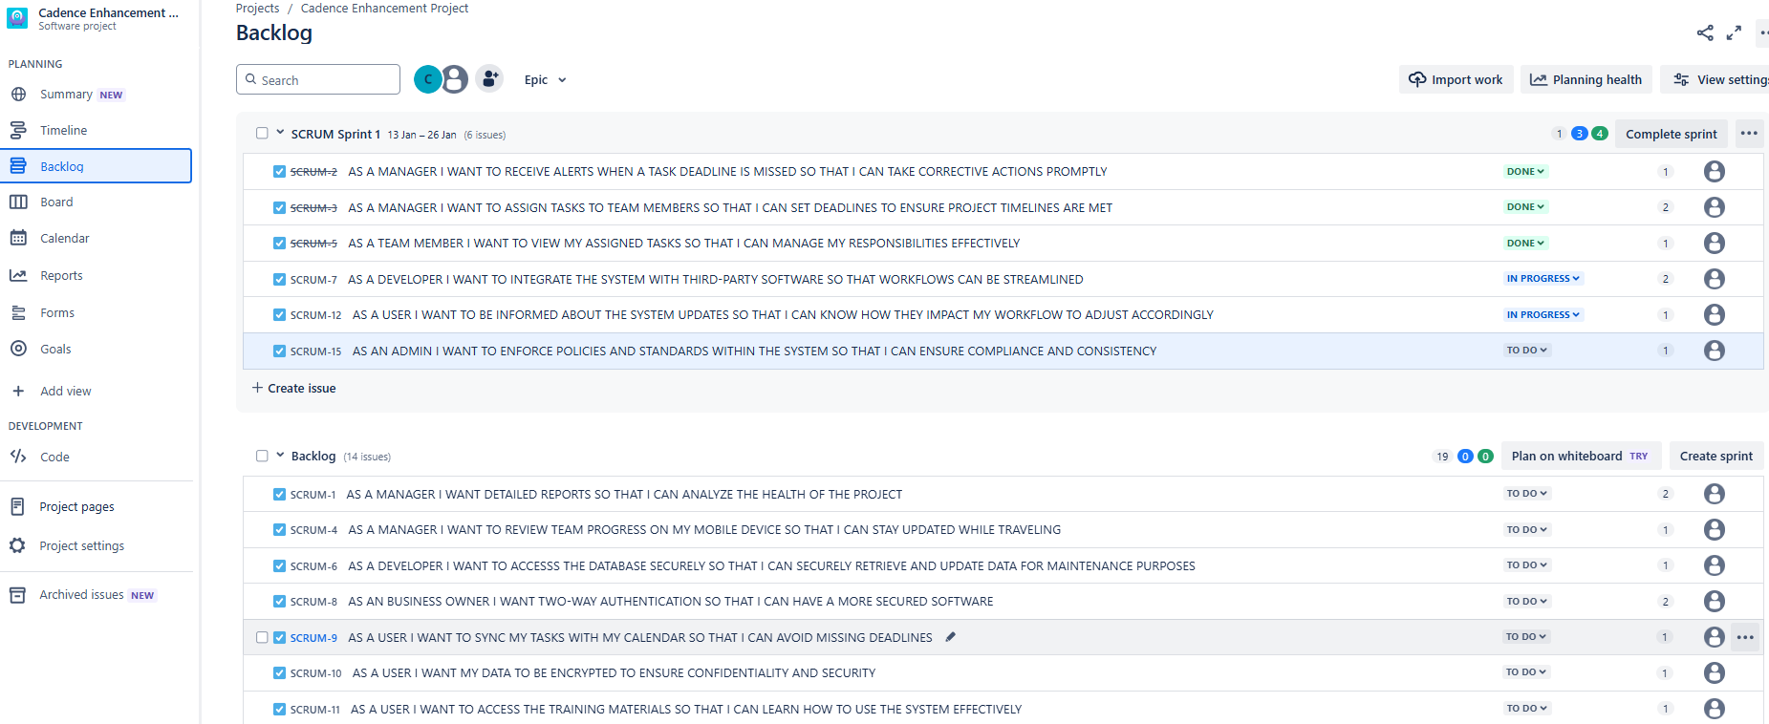

**Sprint Burn Up Chart:**

A burn-up chart shows the amount of work that has been done and how much work is left. It is used for tracking work in a project schedule or during a sprint in a scrum and total scope of the project.

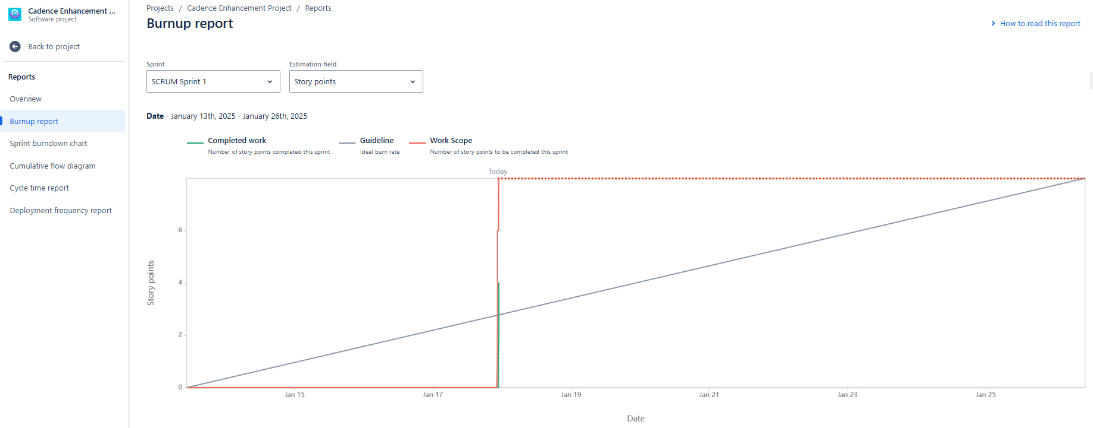

**Sprint Burn Down Chart:**

A burndown chart shows the amount of work that has been completed in an epic or sprint, and the total work remaining. Burndown charts are used to predict the team's likelihood of completing their work in the time available.

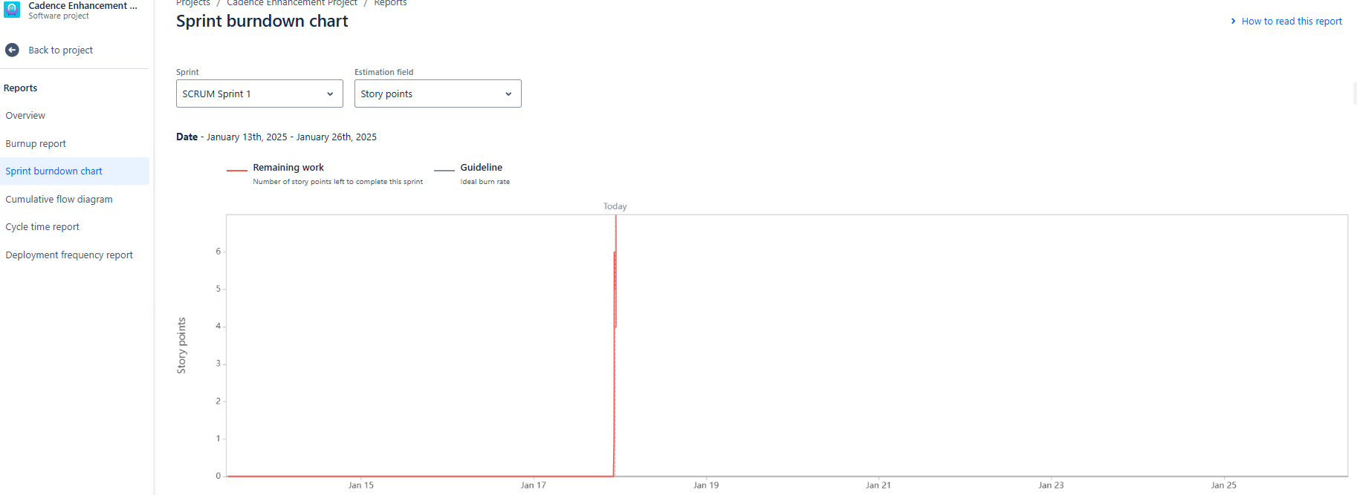

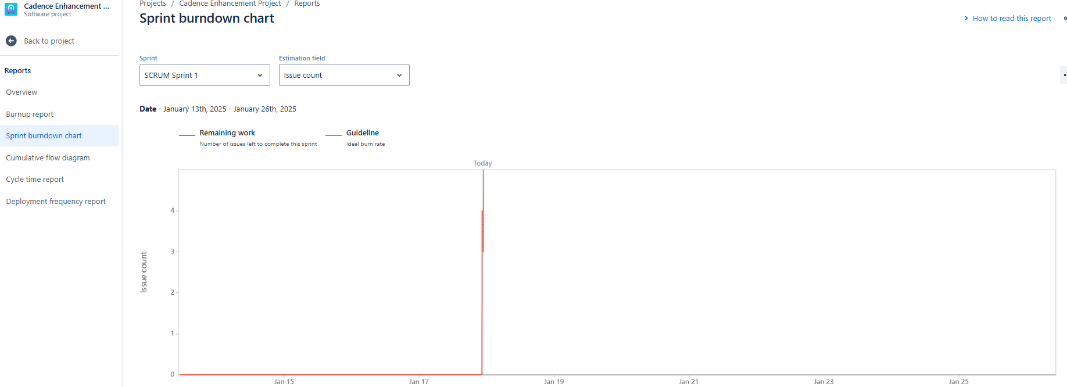

**Product Burn Down Chart:**

A product burndown chart shows how much work remains for the entire project. A product burndown chart collects a larger amount of data.

The Scrum Burndown Chart is a visual measurement tool that shows the completed work per day against the projected rate of completion for the current project release. The purpose is to enable the project is on the track to deliver the expected solution within the desired schedule.

**Document 6: Sprint meetings**

**Meeting Type 1: Sprint Planning Meeting**

|  |  |
| --- | --- |
| **Sprint Planning Meeting** | |
| **Date** | 16-01-2025 |
| **Time** | 11:00 AM |
| **Location** | Conference Room 1 |
| **Prepared By** | Mike (Product Owner) |
| **Attendees** | Mike (Product Owner), Mayank (Scrum Master), Chandni (BA), Juhi, Neha, Priyank, Nikhil (Developers) |

|  |  |  |
| --- | --- | --- |
| **Agenda Topics** | | |
| **Topic** | **Presenter** | **Time allotted** |
| Sprint Backlog | Mike (Product Owner) | 4 hours |
| User Stories | Chandni (BA) | 2 weeks |

|  |  |
| --- | --- |
| **Other Information** | |
| **Observers** | Stakeholders |
| **Resources** | Mike (Product Owner), Mayank (Scrum Master), Chandni (BA), Juhi, Neha, Priyank, Nikhil (Developers), Gayatri, Namrata, Ankit (Testers), DB Admin (John Wick), Sahil (SME) |
| **Special Notes** | The duration of the implementation project is 10 months |

**Meeting Type 2: Sprint review meeting**

|  |  |
| --- | --- |
| **Sprint Review Meeting** | |
| **Date** | 30-01-2025 |
| **Time** | 11:00 AM |
| **Location** | Conference Room 1 |
| **Prepared By** | Mike (Product Owner) |
| **Attendees** | Mike (Product Owner), Mayank (Scrum Master), Chandni (BA), Juhi, Neha, Priyank, Nikhil (Developers), Sahil (SME) |

|  |  |  |  |
| --- | --- | --- | --- |
| **Sprint status** | **Things to demo** | **Quick updates** | **What’s next** |
| Completed | Policies are categorised and reflecting in most recent update on top. All the type of reports should be updated at a single place | Need to work on policies user stories and will have to work on product backlog | Sprint 2 |

**Meeting Type 3: Sprint retrospective meeting**

|  |  |
| --- | --- |
| **Sprint Review Meeting** | |
| **Date** | 27-02-2025 |
| **Time** | 11:00 AM |
| **Location** | Conference Room 1 |
| **Prepared By** | Mike (Product Owner) |
| **Attendees** | Mike (Product Owner), Mayank (Scrum Master), Chandni (BA), Juhi, Neha, Priyank, Nikhil (Developers), Sahil (SME) |

|  |  |  |  |  |
| --- | --- | --- | --- | --- |
| **Agenda** | **What went well** | **What didn’t go well** | **Questions** | **Reference** |
| Sprint Feedback and lessons learned | Assigned user stories were completed on time | Need to focus and complete the assigned task | New Sprint Agenda and user stories | Product Backlog and Product chart |

**Meeting Type 4: Daily Stand-up Meeting**

|  |  |  |  |  |  |  |  |  |
| --- | --- | --- | --- | --- | --- | --- | --- | --- |
| **Question** | **Name/ Role** | **Week 1 (from 20-01-2025 to 26-01-2025)** | | | | | | |
| **Monday** | **Tuesday** | **Wednesday** | **Thursday** | **Friday** | **Saturday** | **Sunday** |
| **What did you do yesterday?** | **Juhi** | Worked on assigned Task and completed the assigned task. | Worked on assigned Task and completed the assigned task. | Worked on assigned Task and completed the assigned task. | Worked on assigned Task and completed the assigned task. | Worked on assigned Task and completed the assigned task. Neha will be working extra on Saturday. | Week-Off | Week-Off |
| **Neha** | Week-Off | Week-Off |
| **Priyank** | Week-Off | Week-Off |
| **Nikhil** | Week-Off | Week-Off |
| **What will you do today?** | **Juhi** | Will be working on Policies user stories | Will be working on Policies user stories | Will be working on Policies user stories | Will be working on Policies user stories | Will be working on Policies user stories | Week-Off | Week-Off |
| **Neha** | Week-Off | Week-Off |
| **Priyank** | Week-Off | Week-Off |
| **Nikhil** | Week-Off | Week-Off |
| **What (if any) is blocking your progress?** | **Juhi** | NA | NA | NA | NA | System issue for Neha. She will be working extra on Saturday to complete the assigned task. | Week-Off | Week-Off |
| **Neha** | Week-Off | Week-Off |
| **Priyank** | Week-Off | Week-Off |
| **Nikhil** | Week-Off | Week-Off |