**CAPSTONE PROJECT PREPARATION 1 PART 3:**

**Question 1 – Functional Requirements:**

Identify minimum 20 functional requirements

Example:

Functional requirement: When an order is fulfilled, the local printer shall print a packing slip. Non-Functional Requirement: Packing slips shall be printed on both sides of 4”x 6” white paper, the standard size for packing slips used by local printers.

|  |  |  |  |
| --- | --- | --- | --- |
| **Req ID** | **Req Name** | **Requirement Description** | **Priority** |
| FR0001 | Farmer Registration | Farmers should be able to register with the application | 8 |
| FR0002 | Farmer Search for Products | Farmers should be able to search for available products in fertilizers, seeds, pesticides | 8 |
|  |  |  |  |
|  |  |  |  |
| NFR0101 | Page Loading Time | Each Page should load within 2 seconds time | 9 |
| NFR0102 | WCAG 2.1. | Each Page should load within 2 seconds time | 8 |
|  |  |  |  |
|  |  |  |  |

**Answer:**

Functional Requirements: Functional Requirements define the specific behaviour, functions or operations of a system.

Non Functional Requirements: Non FRQ describes the qualities and attributes of a system focusing on how the system performs rather than the specific behaviour or functions.

|  |  |  |  |
| --- | --- | --- | --- |
| **Req ID** | **Req Name** | **Requirement Description** | **Priority** |
| FR0001 | Farmer Registration | Framers should to register with the application | 10 |
| FR0002 | Farmers search for products | Farmers should able search for the products in fertilizers, seeds etc. | 10 |
| FR0003 | Shopping cart | Allow farmers to add the products to cart | 7 |
| FR0004 | Payment processing | Provide secure payment processing to customers | 7 |
| FR0005 | Order management | Allow farmers to view their order history and track the status | 6 |
| FR0006 | Search | Implement a search bar option to find the products for customers | 5 |
| FR0007 | Product reviews and ratings | Allow customers to provide reviews and ratings. | 4 |
| FR0008 | Wish list | Allow customers to save products they are interested. | 8 |
| FR0009 | Shipping & delivery | Provide customers with shipping options and estimated delivery | 5 |
| FR0010 | Return & refund policy | Outline the return and refund policy for customers to ensure a positive customer experience and minimize complaints | 5 |
| FR0011 | Availability of product | If the product is out of stock or sold out, it will be mentioned below the product. | 8 |
| FR0012 | Search products | After selecting a particular product category, customers will further be able to filter products based on different attributes available of product like price, newly added, category | 9 |
| FR0013 | Availability of product | If the product is out of stock or sold out, it will be mentioned below the product.  The inventory updates will be integrated at the back end. | 8 |
| FR0014 | New deals and festive offers | Banners of all deals and offers will be showcased on homepage, so that user can view all products under that deal or offer in one click. | 7 |
| FR0015 | Company logo and name | Users will be able to view company logo and name. | 8 |
| FR0016 | Search | When three words for search are typed in search bar, the auto suggestions give suggestions to users as they enter their query. | 8 |
| FR0017 | Buy now | On clicking ‘buy now’, the customer will be redirected to the checkout page:- payment gateway | 9 |
| FR0018 | Product comparison | Farmers can view and compare multiple products | 7 |
| FR0019 | Product delivery | Farmers should get real time notifications on their products | 6 |
| FR0020 | Product return | Farmers should able to initiate return option if they don’t like the product | 8 |

Non Functional Requirements:

|  |  |  |  |
| --- | --- | --- | --- |
| **Req ID** | **Req Name** | **Requirement Description** | **Priority** |
| NFRQ001 | Page Loading Time | Each Page should load within 2 seconds time | 8 |
| NFRQ002 | WCAG 2.1 | The system must meet Web Content Accessibility Guidelines WCAG 2.1. | 7 |
| NFRQ003 | Usability | The application should have an initiative and user-friendly | 8 |
| NFRQ004 | Security | The application must ensure secure user authentication | 8 |
| NFRQ005 | Response time | The application should respond the user inputs within 2 sec | 7 |

**Question 2–Minimum 5 page designs:**

Make wireframe and prototypes

1. 2.

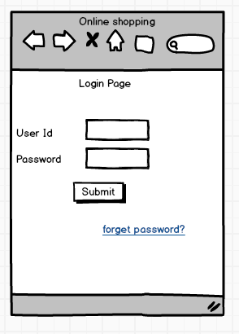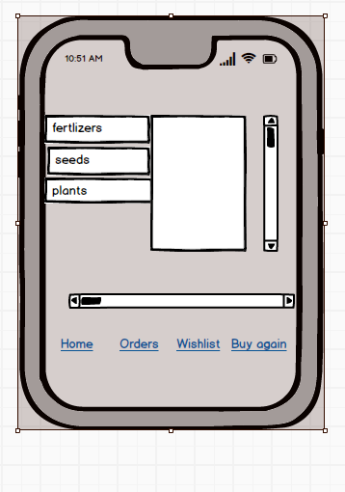

**3.**

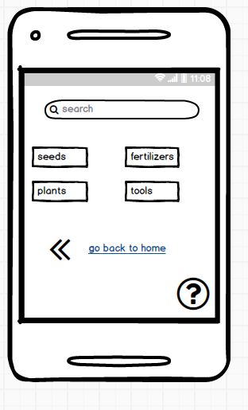

**4.**

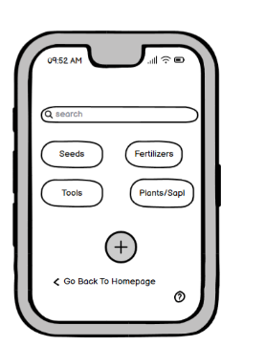

**5.**

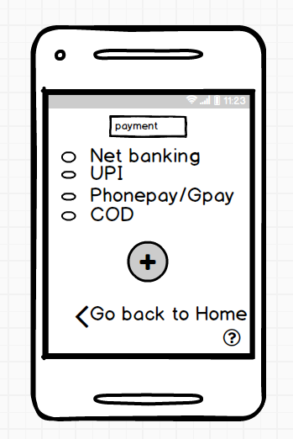

**Question 3 – Tools (Visio, Balsamiq):**

Make a note of the Tools, which you are using for above concepts?

Answer:

Ms Visio: Microsoft Visio is a software tool for drawing a variety of diagrams. These include flowcharts, org charts, building plans, floor plans, data flow diagrams, process flow diagrams, business process modelling, swim lane diagrams, 3D maps, and many more.

Balsamiq: Balsamiq is a rapid wire framing tool. It creates mock-ups and wireframes for websites, web apps, and desktop software. It allows us to picture ideas and concepts through a simple drag-and-drop interface. The wireframes created using Balsamiq have a hand-drawn style. It focuses on the structure and content of the product rather than visual details.

Wireframes: Blueprint of screens and images-BA

Mock-ups: Advanced of wireframes which includes colours and shapes.

Prototypes: complete application with the help of devops 🡪 front end & back end.

Axure: Axure is a UX design tool used for creating wireframes and interactive prototypes. Axure is especially useful for designers of desktop and mobile applications, and it is highly regarded among enterprise for the high level of functionality and visual detail that can be built into its prototypes.

**Question 4 – RTM:**

A business analyst’s key responsibilities are to keep track of the requirements and make sure that no requirement is missed.

Mr Henry and peter have approached you regarding the current status of the project. How will you tackle this situation?

|  |  |  |  |  |  |  |  |  |
| --- | --- | --- | --- | --- | --- | --- | --- | --- |
| **Req ID** | **Req Name** | **Requirement Description** | **Design** | **D1** | **T1** | **…** | **T4** | **UAT** |
| FR0001 | Farmer Registration | Farmers should be able to register with the application |  |  |  |  |  |  |
| FR0002 | Farmer Search for Products | Farmers should be able to search for available products in fertilizers, seeds, pesticides |  |  |  |  |  |  |
|  |  |  |  |  |  |  |  |  |
|  |  |  |  |  |  |  |  |  |
| NFR0101 | Page Loading Time | Each Page should load within 2 seconds time |  |  |  |  |  |  |
| NFR0102 | WCAG 2.1. | The system must meet Web Content Accessibility Guidelines WCAG 2.1 |  |  |  |  |  |  |
|  |  |  |  |  |  |  |  |  |
|  |  |  |  |  |  |  |  |  |

**Answer:**

**RTM:** Requirements traceability matrix is a document to track the requirements throughout the project life cycle and ensure that they are met and no requirements are overlooked.

|  |  |  |  |  |  |  |  |  |
| --- | --- | --- | --- | --- | --- | --- | --- | --- |
| **Req ID** | **Req Name** | **Requirement Description** | **Design** | **D1** | **T1** | **…** | **T4** | **UAT** |
| FR0001 | Farmer Registration | Farmers should be able to register with the application | completed | completed | completed | completed | completed | completed |
| FR0002 | Farmer Search for Products | Farmers should be able to search for available products in fertilizers, seeds, pesticides | Completed | completed | completed | completed | completed | completed |
|  |  |  |  |  |  |  |  |  |
| NFR0101 | Page Loading Time | Each Page should load within 2 seconds time | completed | completed | completed | completed | completed | completed |
| NFR0102 | WCAG 2.1. | The system must meet Web Content Accessibility Guidelines WCAG 2.1 | completed | completed | completed | completed | completed | completed |
| NFR0103 | Bill printing | Bill should be printed on page both sides | completed | completed | completed | completed | completed | completed |
|  |  |  |  |  |  |  |  |  |

**Question 5 – 10 Test Case Documents:**

Prepare 10 Test Case Documents?

Answer:

A test case document is defined as the detailed outline used by testers to ensure that a software application or a system is working as expected.

|  |  |  |  |
| --- | --- | --- | --- |
| **Test case ID** | TC001 | **Test case name** |  |
| **Project ID** | OAA | **Project Name** | Online Agriculture Product store |
| **PM ID** |  | **PM Name** | Mr Vandanam |
| **Test strategy ID** |  | **Tester ID** |  |
| **Test plan ID** |  | **Tester Name** | Mr Jason |
| **Test schedule ID** |  | **Date of test** | 1-dec-24 |
| **Scenario** | To authenticate a successful user login on Gmail.com | | |
| **Link to the page** |  | | |
| **Input data** | Name, contact number, Email id | | |
| **Expected Behaviour** | Once username and password are entered, the web page redirects to the user’s inbox, displaying and highlighting new emails at the top. | | |
| **Actual Behaviour** | As expected | | |
| **Comments** | NA | | |
| **Result** | Pass | | |

|  |  |  |  |
| --- | --- | --- | --- |
| **Test case ID** | TC002 | **Test case name** |  |
| **Project ID** | OAA | **Project Name** | Online Agriculture Product store |
| **PM ID** |  | **PM Name** | Mr Vandanam |
| **Test strategy ID** |  | **Tester ID** |  |
| **Test plan ID** |  | **Tester Name** | Miss Alekya |
| **Test schedule ID** |  | **Date of test** | 02-dec-24 |
| **Scenario** | Seller product creation | | |
| **Link to the page** |  | | |
| **Input data** | Product id, Product pictures, product prices | | |
| **Expected Behaviour** | Authenticated sellers can access authorized product creation panels under authorized categories | | |
| **Actual Behaviour** | As expected | | |
| **Comments** | NA | | |
| **Result** | Pass | | |

|  |  |  |  |
| --- | --- | --- | --- |
| **Test case ID** | TC003 | **Test case name** |  |
| **Project ID** | OAA | **Project Name** | Online Agriculture Product store |
| **PM ID** |  | **PM Name** | Mr Vandanam |
| **Test strategy ID** |  | **Tester ID** |  |
| **Test plan ID** |  | **Tester Name** | Mr Jason |
| **Test schedule ID** |  | **Date of test** | 03-dec-24 |
| **Scenario** | Filter Results | | |
| **Link to the page** |  | | |
| **Input data** | Product key names, product alternative names | | |
| **Expected Behaviour** | The users should be able to see results with default search criteria when at least one of the filter parameters isn’t mandatory | | |
| **Actual Behaviour** | As expected | | |
| **Comments** | NA | | |
| **Result** | Pass | | |

|  |  |  |  |
| --- | --- | --- | --- |
| **Test case ID** | TC004 | **Test case name** |  |
| **Project ID** | OAA | **Project Name** | Online Agriculture Product store |
| **PM ID** |  | **PM Name** | Mr Vandanam |
| **Test strategy ID** |  | **Tester ID** |  |
| **Test plan ID** |  | **Tester Name** | Miss Alekya |
| **Test schedule ID** |  | **Date of test** | 04-dec-24 |
| **Scenario** | Product details | | |
| **Link to the page** |  | | |
| **Input data** | Product colour alternatives, product quantity, product quality | | |
| **Expected Behaviour** | Test that all the product details are displayed correctly and that no empty/invalid details are displayed. | | |
| **Actual Behaviour** | As expected | | |
| **Comments** | NA | | |
| **Result** | Pass | | |

|  |  |  |  |
| --- | --- | --- | --- |
| **Test case ID** | TC005 | **Test case name** |  |
| **Project ID** | OAA | **Project Name** | Online Agriculture Product store |
| **PM ID** |  | **PM Name** | Mr Vandanam |
| **Test strategy ID** |  | **Tester ID** |  |
| **Test plan ID** |  | **Tester Name** | Mr Jason |
| **Test schedule ID** |  | **Date of test** | 05-dec-24 |
| **Scenario** | Shopping Cart | | |
| **Link to the page** |  | | |
| **Input data** | Item prices, Item quantity | | |
| **Expected Behaviour** | Test that all added items have at least a quantity, price, and delete option associated with it | | |
| **Actual Behaviour** | As expected | | |
| **Comments** | NA | | |
| **Result** | Pass | | |

|  |  |  |  |
| --- | --- | --- | --- |
| **Test case ID** | TC006 | **Test case name** |  |
| **Project ID** | OAA | **Project Name** | Online Agriculture Product store |
| **PM ID** |  | **PM Name** | Mr Vandanam |
| **Test strategy ID** |  | **Tester ID** |  |
| **Test plan ID** |  | **Tester Name** | Mr Jason |
| **Test schedule ID** |  | **Date of test** | 06-dec-24 |
| **Scenario** | Checkout Page | | |
| **Link to the page** |  | | |
| **Input data** | Item price, coupon details, price breakup | | |
| **Expected Behaviour** | User should be shown the total amount with the necessary breakup as applicable | | |
| **Actual Behaviour** | As expected | | |
| **Comments** | NA | | |
| **Result** | Pass | | |

|  |  |  |  |
| --- | --- | --- | --- |
| **Test case ID** | TC007 | **Test case name** |  |
| **Project ID** | OAA | **Project Name** | Online Agriculture Product store |
| **PM ID** |  | **PM Name** | Mr Vandanam |
| **Test strategy ID** |  | **Tester ID** |  |
| **Test plan ID** |  | **Tester Name** | Miss Alekya |
| **Test schedule ID** |  | **Date of test** | 07-dec-24 |
| **Scenario** | Payment Page | | |
| **Link to the page** |  | | |
| **Input data** | Saved payment method, card numbers, UPI, Customer ID of net banking | | |
| **Expected Behaviour** | For returning customers, they should be redirected to log in for checkout | | |
| **Actual Behaviour** | As expected | | |
| **Comments** | NA | | |
| **Result** | Pass | | |

|  |  |  |  |
| --- | --- | --- | --- |
| **Test case ID** | TC008 | **Test case name** |  |
| **Project ID** | OAA | **Project Name** | Online Agriculture Product store |
| **PM ID** |  | **PM Name** | Mr Vandanam |
| **Test strategy ID** |  | **Tester ID** |  |
| **Test plan ID** |  | **Tester Name** | Mr Jason |
| **Test schedule ID** |  | **Date of test** | 08-dec-24 |
| **Scenario** | Session log out if page left idle for more than 10 minutes | | |
| **Link to the page** |  | | |
| **Input data** | Time for page loading | | |
| **Expected Behaviour** | Maintain a session for each user and test verify the session times out after a while | | |
| **Actual Behaviour** | As expected | | |
| **Comments** | NA | | |
| **Result** | Pass | | |

|  |  |  |  |
| --- | --- | --- | --- |
| **Test case ID** | TC009 | **Test case name** |  |
| **Project ID** | OAA | **Project Name** | Online Agriculture Product store |
| **PM ID** |  | **PM Name** | Mr Vandanam |
| **Test strategy ID** |  | **Tester ID** |  |
| **Test plan ID** |  | **Tester Name** | Miss Alekya |
| **Test schedule ID** |  | **Date of test** | 09-dec-24 |
| **Scenario** | Update Product details | | |
| **Link to the page** |  | | |
| **Input data** | Product colour alternatives, product quantity, product quality | | |
| **Expected Behaviour** | Test that all the product details are displayed correctly and that no empty/invalid details are displayed. | | |
| **Actual Behaviour** | As expected | | |
| **Comments** | NA | | |
| **Result** | Pass | | |

|  |  |  |  |
| --- | --- | --- | --- |
| **Test case ID** | TC010 | **Test case name** |  |
| **Project ID** | OAA | **Project Name** | Online Agriculture Product store |
| **PM ID** |  | **PM Name** | Mr Vandanam |
| **Test strategy ID** |  | **Tester ID** |  |
| **Test plan ID** |  | **Tester Name** | Mr Jason |
| **Test schedule ID** |  | **Date of test** | 10-dec-24 |
| **Scenario** | App Installation/ uninstallation | | |
| **Link to the page** |  | | |
| **Input data** | Device details, auto fill up, contact number | | |
| **Expected Behaviour** | The application is installed and works correctly/ The application is uninstalled. The app’s icon isn’t displayed on the device’s OS. | | |
| **Actual Behaviour** | As expected | | |
| **Comments** | NA | | |
| **Result** | Pass | | |

**Question 6 – DB Design:**

After the requirements are thoroughly explained to the entire project team by business analyst, the Database architects have decided to do the database design and also to represent the in-flow and out-flow of data.

Draw database schema and ER diagram

Answer:

DB Schema: Database Schema is a blueprint that outlines the structure of a database, including its tables, fields, relationships, constraints and other characteristics.

ER-Diagram: An ER diagram is a virtual representation of the relationships between entities in database. It depicts the entities such as tables, attributes and relationship between them.

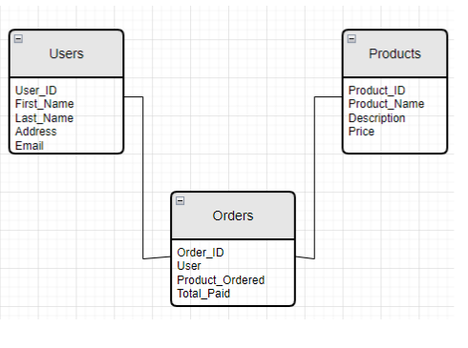

**Question 7 – Data Flow Diagram:**

What is a data flow diagram? Draw a data flow diagram to represent the in-flow and out-flow of data when a Farmer is placing an order for the product?

Answer:

A Data flow diagram (DFD) is a graphical representation of flow of data within a system; it usually shows how data moves from one particular process to another, how it’s stored and where t ends up.

It maps out the flow of information for any process or system. It uses defined symbols like rectangles, circles, and arrows plus short test labels to show data inputs, outputs, storage points and the routes between each destination.

1. External entity- Rectangle
2. Data flow- arrow
3. Process or bubble- circle(process)
4. Data store- parallel lines( Back end

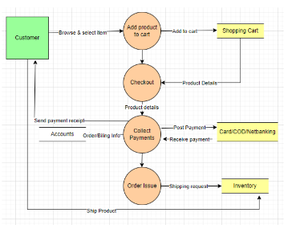

**Question 8 – Change Request:**

Due to change in the Government Taxation structure, we should change the Tax structure how do you handle change requests in a project?

As the project is in process, Ben and Kevin have contacted you. The reason is to inform you that they want the Farmers to sell their crop yields through this application i.e. Farmers should be able to add their crop yields or products and display to general public and should be able to sell them. They also want to introduce Auction system for their Crop yields. As a BA, what will be your response?

Is this change request or Enhancement?

Answer:

Change information should include the following:

The reason/business justification for the change

Why the change is needed- giving detailed information on implications of not implementing the change- i.e. security risks, government taxation, compliances etc.

Known risks or impact to the business of implementing the change—consideration should also be given to the risk and impact to the business of not implementing the change.

Required resources—including people, time, and investment/costs.

The change manager assigns the change a priority based on the following information: Priority is based on how quickly the change needs to be implemented.

High: Needs doing within 48 hours.

Medium: No severe impact, but rectification cannot be differed until the next scheduled release or upgrade.

Low: Needs doing by the indicated date.

A change request is a formal proposal for an alteration to some product or system. In project management, a change request arises when the client wants an addition or alteration to the agreed-upon deliverables for a project. Such a change may involve an additional feature or customization or an extension of service, among other things.

An Enhancement project is one in which new capabilities are added to an existing system. Enhancement projects might also involve correcting defects, adding new reports, and modifying functionality to comply with revised business rules or needs.

So, this is an enhancement in the project.

**Question 10 – Estimations:**

Come up with estimations – How many Man hours required?

|  |  |  |  |
| --- | --- | --- | --- |
| **Best Resource Structure** |  |  |  |
| **Type of Resource** | **Week’s** | **No of Resources** | **Total weeks** |
| **BA** | 8 | 1 | 8 |
| **Design(web)** | 8 | 1 | 8 |
| **Angular Back end** | 10 | 4 | 32 |
| **HTML Front end** | 8 | 2 | 16 |
| **Testing** | 4 | 2 | 8 |
| **Devops** | 2 | 1 | 2 |
|  |  | Total man weeks | 74 |
|  |  | **Total cost in INR** | **2000000** |

**Question 11 – UAT:**

Project has finally completed all the stages i.e., design, development, testing etc. Now, it is the role of a business analyst to contact the client for testing of the final product and have to successfully complete it. How are you going to handle this situation? And once it is done, what will be the process to close the project?

Explain UAT Acceptance process

Answer:

Planning: Blueprints are made to Implement UAT testing for every feature that needs to test and minimum standards for accepting the test.

Designing: Test cases are designated to hide all possibilities of software packages in a real-world environment.

UAT Testers: A testing team consists of end users that meet the criteria for the implementation testing. The end user must have expertise in subject matter, the ability to report all problems.

Bug Fixing: The development team works on whatever bugs are found during UAT testing to make the software error free.

Sign off: After removing all bugs, the testing team indicates acceptance of the completion of the bugs. In this phase, all the stakeholders conclude that the software is ready to GO Live and sign it off.

**Question 12 – Project Closure Document:**

Explain Project closure document?

Answer:

A project closure document, also known as project closure report is a formal document that summarizes the key outcomes, lessons learned, and final details of completed project.

|  |  |  |  |  |  |  |  |  |  |  |  |  |
| --- | --- | --- | --- | --- | --- | --- | --- | --- | --- | --- | --- | --- |
| **S NO** | | **Points to include** | | **Details** | | | **Reference Link** | | | | | |
| **1** | | **Did the Client sign off on the UAT Testing** | | | | | | | | | | |
|  | | Date of sign off | | | 15-dec-24 | | |  | | | | |
|  | | Name of resources | | | Mr Henry | | | ABC Doc | | | | |
| 2 | | **Objectives of the project** | | | | | | | | | | |
|  | | User friendliness | Achieved | | | |  | | | | | |
| Customer satisfaction | ROI in 6 months | | | |
| More categories | Achieved | | | |
| 3 | | **Functionalities worked on** | | | | | | | | | | |
|  | | Secured payment processing | | | Achieved | | | |  | | | |
| categories | | | Achieved | | | |  | | | |
| 4 | | **Infrastructure** | | | | | | | | | | |
|  | | Software installed | | |  | | | | |  | | |
| Laptops purchased | | |  | | | | |  | | |
| 5 | | Funding | | | | | | | |  | | |
|  | | Amount approved | | | | 2 Cr | | | | XYZ Doc | | |
| Amount used | | | | 2 Cr | | | |
| **6** | | **Overall project information** | | | | | | | | | | |
|  | | Escalations | | | 25 | | | | | |  | |
| Customer satisfaction | | | high | | | | | |
| 7 | | **Value to company** | | | | | | | | | | |
|  | Positive/negative | | | | | Positive 95%  Company has successfully made an app to help remote farmers to get the products on doorstep.  Upcoming projects  Increased users | | | | | |  |