*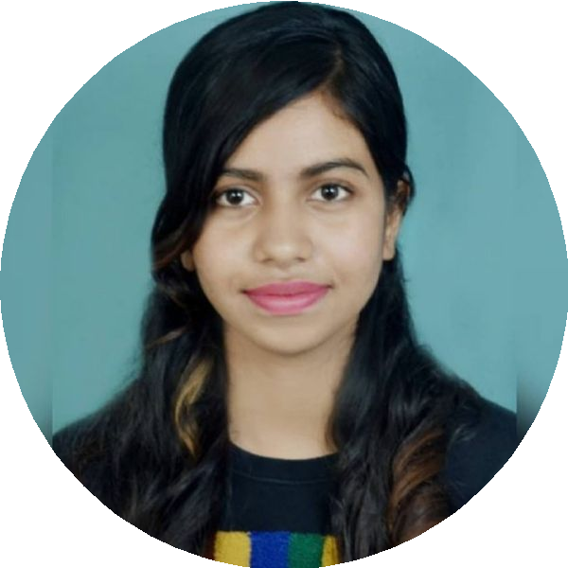***Aliva Das** *Business Analyst*

[](mailto:dasaaliva@gmail.com) [dasaaliva@gmail.com](mailto:dasaaliva@gmail.com)  Hyderabad

 8926072737

[linkedin.com/in/alivadas- 590302296](https://linkedin.com/in/alivadas-%20590302296)

# Profile

Highly motivated and detail-oriented Business Analyst with a strong foundation in Agile methodologies, requirements gathering, and process improvement. Leveraging 6 months of recent Business Analysis experience, combined with a background as a .NET MVC Developer, to bridge the gap between technical and business teams.

# Professional Experience

## Business analyst Intern

***COEPD 04/2024 – 12/2024***

**Requirements Gathering**: Assisted in gathering business and technical requirements through meetings, interviews with stakeholders.

**Documentation**: Helped create and maintain Business Requirements Documents **(BRD)**, Functional Requirements Documents **(FRD)**, and **Use Case** documents.

**Process Mapping**: Worked on mapping business processes using **Visio** and **flowcharts** to identify areas for process improvement.

## Associate .Net Developer

***Ray Business Technology 05/2023 – 10/2023***

Developed, maintained, and debugged web applications using [**ASP.NET** [**MVC**](http://asp.net/)[and](http://asp.net/) [**C#**. Collaborated with cross-](http://asp.net/) [functional teams to gather requirements and deliver efficient, scalable solutions.](http://asp.net/)](http://asp.net/)

Created and optimized **SQL Server** queries to enhance application performance.

Participated in code reviews and ensured adherence to best practices for coding and software development.

# Projects

## Project Name: CMS Application (Waterfall)

**Project Description**: We are developing an innovative College Management System (CMS) designed to optimize and streamline talent acquisition processes for educational institutions. The system focuses on reducing manual workload, improving efficiency, and enhancing communication with candidates.

## Responsibilities:

* Conducted **Enterprise Analysis** and assisted in creating a Business Case Document, **Stakeholder Analysis**, and Gathered requirements from business heads using **Elicitation Techniques** and created a **BRD** Translated **BRD** into **FRD**, collaborated with the technical team, and prepared **SRS** Document.
* Created **UML diagrams** and **wireframes** using **MS Visio, Balsamiq,** and **Axure.**
* Created and maintained **RTM** throughout the project.
* Assisted in Testing Team by preparing **Test Case Scenarios** and ensuring successful UAT.

## Project Name: EBB Project (Agile)

**Project Description:** Facilitated the development of an innovative solution for EvoLush Beauty Blender, designing and optimizing a business process for the creation and launch of an eco- friendly, professional-grade makeup blending tool as a prominent brand in the cosmetics industry.

· Interacted with stakeholders and gathered requirements using various **elicitation technique.**

* Created user stories with **acceptance criteria**, added them to the **product backlog** using **JIRA**
* Prioritized and validated requirements using MoSCoW and FURPS techniques, and added user stories to the sprint backlog.
* Collaborated with the Product Owner and Scrum Master for **BV** and **CP**, and assisted with the creation of **DOR**

and **DOD** checklists.

* Participated in **Sprint ceremonies** to remove project roadblocks.
* Generated Sprint and **Product Burndown/Burnup charts** to track progress.

# Skills

## Technical Skill

 Documentation Tools: MS Suite.

 Prototyping & Wire frames Tools : Axure &Balsamiq  Modeling Tools : MS Visio.

 Database : Sql Server 2019

 Project Management tool :JIRA

ReportingTools:PowerBI,&Tableau.



 Framework: .Net.

## Core Competencies

 Requirement Analysis .  Gap Analysis Analysis.  Business Analysis .

 Requirement Life cycle Management .  Software Development Life cycle.

 Feasibility Study.

# Certificates

## IIBA-EEP(ECBA)

*COEPD,Hyderabad*

## .Net Technology

*Naresh IT,Hyderabad*

# Education

## Bachelor of Technology in Computer Science Biju Patnaik University of Technology (BPUT), Odisha

2015 – 2019

## Council of Higher Secondary Education, Odisha )CHSE, Odisha)

2012 – 2014

# Languages

 English  Hindi

 Odia