Document 1 - Definition of Done

DOD for User Story:
- Code written for the functionality match coding standards with proper indentation and the code written into respective Business Layer, Application Layer and Database Layer
- The database is properly populated according to the tables
- Documentation done for the code explaining the code and the functionality with test cases explained in it
- The functionality is running with no errors found
- The code is reviewed by the Lead Developer or Team Lead
- Unit tests written and passing
- The code is committed on GIT with no errors and conflicts found
- Site accessible on the test environment with user able to login
- The functionality checked for all possible test cases passing
- The user access checked on the test environment for all functionalities
- The basic working of all functionalities checked on the test environment
- Feature is tested against acceptance criteria
- Errors resolved for the code if any and test case passing
- The demo for the functionality is presented to the stakeholders
- The feedback from the stakeholders is worked upon and implemented

DOD for Release
- The code is written and tested for all the new functionalities added in the release
- No incomplete code is committed in the new release
- All the functionalities in the release are complete
- All unit tests are green
- All the acceptance criteria for new functionalities are met
- Backup for the old release is taken before deploying the new release
- The new release is deployed on the test environment successfully
- The new release is tested with basic functionalities login, registration, create proposal and review proposal working
- The new release is tested with new added functionalities checked with all possible test cases
- The new release is working for all browsers and all test cases checked
- The new release is working on mobile application and all test cases checked
- The errors and bugs if any are fixed and deployed onto the test environment
- The demo presented to the client for the new release
- The feedback noted down from the client for the next release
- Notify Client the time production will be down for release
- The release is deployed onto the production successfully
- Basic UI check on the Production

Document 2 – Product Vision

Scrum Project  Name: | WCRA
Venue: | WCRA Office, Pune
Date: 18/12/2024 | Start Time: 11:00 A.M. | End Time: 4:00 P.M. | Duration: 4 hours
Client: WCRA
Stakeholder list: | WCRA Chairperson – Dr. Srinath Anand  Secretary – Dr. Venkatesh Prasad  Scheduler – Dr. Prashant Patil  Scrum Team
Scrum Team
Scrum Master: | Abhijeet Deolalikar
Product Owner: | Nilesh Sabale
Scrum Developer 1: | Ashish Siwalakar
Scrum Developer 2: | Nagesh Madale
Scrum Developer 3: | Yogesh Chaurse

Vision: To help WCRA to reach out scientists and researchers all over the world and efficiently manage process of assigning facilities to the scientists and researchers for their study

Target Group  The website will target the people in the field of Astrophysics  The target group would be researchers, scientist and PHD students related to the field | Needs  The website is useful as it will help researchers to submit their research and request time to use facilities at WCRA  The WCRA can efficiently manage the research submitted and can decide on time allocation with ease through the website | Product  The website is a platform for the researchers all around the world to submit their research to request time to use facilities for research at WCRA. The website also helps WCRA in efficiently managing the operations at WCRA | Value  The website will help WCRA increase its efficiency and help decide which research they allot time to.  The aim of the website is to have a common platform where researchers can find WCRA to request facilities for research and WCRA can analyze and allot time accordingly

Document 3 – User Stories

User Story No: 1 | Tasks: 2 |  | Priority: Highest
AS A RESEARCHER/SCIENTIST
I WANT TO REGISTER TO WCRA
SO THAT I CAN SUBMIT RESEARCH AND REQUEST FACILITES

BV: 500 |  | CP: 02
Acceptance Criteria:
Registration Screen
Text Boxes/Dropdown to enter Username Password, Mobile number, Email, Institution, Address, Nationality
Click on Register Button
Successful User Registration and Email Sent

User Story No: 2 | Tasks: 2 |  | Priority: Highest
AS A RESEARCHER/SCIENTIST
I WANT TO LOGIN TO WCRA
SO THAT I CAN USE THE WEBAPP FEATURES

BV: 500 |  | CP: 01
Acceptance Criteria:
Login Screen
Text box Enter Username and Password
Click Login Button and redirect to Homepage

User Story No: 3 | Tasks: 2 |  | Priority: Highest
AS A RESEARCHER/SCIENTIST
I WANT TO SUBMIT RESEARCH PAPER
SO THAT I CAN REQUEST TIME TO USE FACILITIES

BV: 500 |  | CP: 03
Acceptance Criteria:
User able to enter research details and upload documents to request time
User needs to enter all required fields
Review and Submit option available
User receives email on successfully submitting proposal

User Story No: 4 | Tasks: 2 |  | Priority: Medium
AS A RESEARCHER/SCIENTIST
I WANT TO VIEW SUBMITTED PROPSAL
SO THAT I CAN CHECK DETAILS OF PROPOSAL

BV: 200 |  | CP: 01
Acceptance Criteria:
View Proposal Option Available
User able to view details of submitted proposal

User Story No: 5 | Tasks: 2 |  | Priority: Highest
AS A CHAIRPERSON
I WANT TO LOGIN TO WCRA
SO THAT I CAN PERFORM DIFFERENT WCRA TASKS

BV: 500 |  | CP: 02
Acceptance Criteria:
Login Screen
Enter Username and Password
Successful login to chairperson account

User Story No: 6 | Tasks: 2 |  | Priority: Highest
AS A CHAIRPERSON
I WANT TO START WCRA CYCLE
SO THAT WCRA CAN ACCEPT PROPOSALS

BV: 200 |  | CP: 01
Acceptance Criteria:
Start Cycle Option
Enter Details
Cycle Begins and Researchers get option to submit proposals

User Story No: 7 | Tasks: 2 |  | Priority: Highest
AS A CHAIRPERSON
I WANT TO VIEW ALL SUBMITTED PROPOSALS
SO THAT I CAN REVIEW THE PROPOSALS

BV: 200 |  | CP: 02
Acceptance Criteria:
Select Cycle
View the Submitted Proposals List

User Story No: 8 | Tasks: 2 |  | Priority: Medium
AS A CHAIRPERSON
I WANT TO ADD RATING AND COMMENTS TO PROPOSAL
SO THAT I CAN RANK PROPOSALS

BV: 500 |  | CP: 02
Acceptance Criteria:
Option to rank proposals and add comments
Secretary and other committee members should see comments and rank on proposals

User Story No: 9 | Tasks: 2 |  | Priority: Medium
AS A CHAIRPERSON
I WANT TO ACCEPT/REJECT PROPOSAL
SO THAT I CAN REPLY TO RESEARCHERS

BV: 200 |  | CP: 03
Acceptance Criteria:
Send Accept / Reject Mail Option
Researcher receive the accept/reject mail

User Story No: 10 | Tasks: 2 |  | Priority: Medium
AS A TAC MEMBER
I WANT TO VIEW PROPOSALS OF MY EXPERTISE
SO THAT I CAN ADD RATING AND COMMENTS

BV: 200 |  | CP: 02
Acceptance Criteria:
View Proposals of Only Area Expertise
Add Rating and Comment Option
Comments and Rating should be visible to Chairperson and Secretary

User Story No: 11 | Tasks: 2 |  | Priority: Low
AS AN ADMIN
I WANT TO ASSIGN ROLES FOR CYCLE
SO THAT I CAN DEFINE ROLES FOR THE CYCLE

BV: 100 |  | CP: 01
Acceptance Criteria:
Select Cycle
Assign/Change roles for Chairperson Secretary Scheduler and TAC Members
Save the Roles
The roles reflect in next cycle

User Story No: 12 | Tasks: 2 |  | Priority: Medium
AS AN ADMIN
I WANT TO MAKE CHANGES IN THE CYCLE DETAILS
SO THAT I CAN DEFINE CYCLE ACCORDING TO REQUIREMENTS
BV: 200 |  | CP: 02
Acceptance Criteria:
Edit cycle details
Save details
Details reflect in next cycle

User Story No: 13 | Tasks: 2 |  | Priority: Medium
AS A SCHEDULER
I WANT TO SCHEDULE TIME FOR ACCEPTED PROPOSALS
SO THAT I CAN SEND TIME DETAILS TO RESEARCHER

BV: 500 |  | CP: 03
Acceptance Criteria:
Select proposal
Enter Details to Schedule time
Send mail to researcher for scheduled time details

User Story No: 14 | Tasks: 2 |  | Priority: Medium
AS A RESEARCHER/SCIENTIST
I WANT TO RESET PASSWORD TO WCRA
SO THAT I LOGIN WITH NEW PASSWORD

BV: 100 |  | CP: 01
Acceptance Criteria:
Login Screen
Forgot Password Link
Send reset password link to mail

User Story No: 15 | Tasks: 2 |  | Priority: Low
AS A RESEARCHER/SCIENTIST
I WANT TO RECEIVE PROPOASL SUBMISSION MAIL
SO THAT I CAN CONFIRM SUBMITTED PROPOSAL

BV: 100 |  | CP: 01
Acceptance Criteria:
User receives mail on the registered email on proposal submission

User Story No: 16 | Tasks: 2 |  | Priority: Low
AS A RESEARCHER/SCIENTIST
I WANT TO MANAGE PROFILE
SO THAT I CAN UPDATE PROFILE DETAILS

BV: 100 |  | CP: 02
Acceptance Criteria:
Update Profile option available
Researcher able to edit fields and update profile

User Story No: 17 | Tasks: 2 |  | Priority: Low
AS A RESEARCHER/SCIENTIST
I WANT TO REVOKE PROPOSAL
SO THAT I CAN REVOKE THE PROPOSAL

BV: 100 |  | CP: 01
Acceptance Criteria:
REVOKE option on submitted proposals
Email received on revoke

User Story No: 18 | Tasks: 2 |  | Priority: Highest
AS A RESEARCHER/SCIENTIST
I WANT TO UPLOAD ATTACHMENT
SO THAT I CAN UPLOD DOCUMENTS

BV: 200 |  | CP: 02
Acceptance Criteria:
Upload attachment option while submitting proposal
Attachment should be of required size and type

User Story No: 19 | Tasks: 2 |  | Priority: Low
AS A RESEARCHER/SCIENTIST
I WANT TO ADD SUGGESTED REVIEWVERS
SO THAT I CAN SUGGEST PEOPLE TO REVIEW THE PROPOSAL

BV: 200 |  | CP: 01
Acceptance Criteria:
Suggested Reviewer Option during proposal submission

User Story No: 20 | Tasks: 2 |  | Priority: Medium
AS A CHAIRPERSON
I WANT TO DOWNLOD ATTACHMENT IN PROPOSLS
SO THAT I CAN VIEW THE DOCUMENT

BV: 200 |  | CP: 01
Acceptance Criteria:
Download attachment option available for proposals

User Story No: 21 | Tasks: 2 |  | Priority: Medium
AS A CHAIRPERSON
I WANT TO VIEW OTHER MEMBERS RATING AND COMMENTS
SO THAT I CAN REVIEW THE PROPOSAL

BV: 500 |  | CP: 01
Acceptance Criteria:
See Rating and Comments on the proposal

User Story No: 22 | Tasks: 2 |  | Priority: Medium
AS A CHAIRPERSON
I WANT TO REQUEST PROPOSAL REVIEW
SO THAT I CAN TAKE FEEDBACK FROM THE REVIEWVER

BV: 200 |  | CP: 02
Acceptance Criteria:
Send Review request to proposal option on proposals
Reviewer receives mail to accept/reject the review request

User Story No: 22 | Tasks: 2 |  | Priority: Medium
AS A CHAIRPERSON
I WANT TO VIEW OTHER MEMBERS RATING AND COMMENTS
SO THAT I CAN REVIEW THE PROPOSAL

BV: 200 |  | CP: 01
Acceptance Criteria:
See Rating and Comments on the proposal

User Story No: 23 | Tasks: 2 |  | Priority: Medium
AS A CHAIRPERSON
I WANT TO SORT BASED ON RATING OF PROPOSALS
SO THAT I CAN SORT THE PROPOSALS

BV: 200 |  | CP: 02
Acceptance Criteria:
Sort option available on proposal list
Proposal sort in descending order on click

User Story No: 24 | Tasks: 2 |  | Priority: Medium
AS A CHAIRPERSON
I WANT SAVE EMAIL TEMPLATE
SO THAT I CAN USE THE TEMPLATE LATER

BV: 200 |  | CP: 02
Acceptance Criteria:
Save Template option on proposal email

User Story No: 25 | Tasks: 2 |  | Priority: Medium
AS A CHAIRPERSON
I WANT TO CREATE EMAIL TEMPLATE BASED ON PROPOSAL
SO THAT I CAN SEND EMAIL TO RESEARCHER

BV: 200 |  | CP: 01
Acceptance Criteria:
Email template created in send proposal email

User Story No: 26 | Tasks: 2 |  | Priority: Low
AS A CHAIRPERSON
I WANT TO COPY TAC MEMBER OR REVIEVER COMMENTS
SO THAT I CAN ATTACH COMMENTS TO PROPOSL EMAIL

BV: 100 |  | CP: 01
Acceptance Criteria:
Add TAC/Reviewer Comment on Send Email Template

User Story No: 27 | Tasks: 2 |  | Priority: Medium
AS A CHAIRPERSON
I WANT TO VIEW COLOR CODING FOR PROPOSAL STATUS
SO THAT I CAN IDENTIFY PROPOSAL

BV: 500 |  | CP: 02
Acceptance Criteria:
Color Coding for Proposals
Green – Accepted Proposal
Red- Rejected
Yellow – Email In Draft
Gray – Proposal not reviewed yet

User Story No: 28 | Tasks: 2 |  | Priority: Medium
AS A CHAIRPERSON
I WANT TO VIEW ACCEPT/REJECT REQUEST FOR REVIEW ON PROPOSAL
SO THAT I CAN SEE REVIEWER RESPONSE

BV: 200 |  | CP: 01
Acceptance Criteria:
See comments if review request accepted
Receive mail on accept/reject review request

User Story No: 29 | Tasks: 2 |  | Priority: Medium
AS A TAC MEMBER
I WANT TO SORT BASED ON RATING OF PROPOSALS
SO THAT I CAN SORT THE PROPOSALS

BV: 200 |  | CP: 02
Acceptance Criteria:
Sort option available on proposal list
Proposal sort in descending order on click

User Story No: 30 | Tasks: 2 |  | Priority: Medium
AS A SECRETARY
I WANT TO SORT BASED ON RATING OF PROPOSALS
SO THAT I CAN SORT THE PROPOSALS

BV: 200 |  | CP: 02
Acceptance Criteria:
Sort option available on proposal list
Proposal sort in descending order on click

User Story No: 31 | Tasks: 2 |  | Priority: Medium
AS A CHAIRPERSON
I WANT TO ASSIGN CO-CHAIRPERSON
SO THAT THE CO-CHAIRPERSON CAN FUNCTION IN CHAIRPERSON ABSENCE

BV: 200 |  | CP: 01
Acceptance Criteria:
Assign Co-chairperson option for cycle in cycle details

User Story No: 32 | Tasks: 2 |  | Priority: Medium
AS A CO-CHAIRPERSON
I WANT TO VIEW PROPOSALS SUBMITTED BY CHAIRPERSON
SO THAT I CAN REVIEW THE PROPOSAAL

BV: 200 |  | CP: 01
Acceptance Criteria:
Chairperson proposal available to view for
Add comments/rating to proposal and accept/reject option

User Story No: 33 | Tasks: 2 |  | Priority: Medium
AS A SECRETARY
I WANT TO ACCEPT/REJECT PROPOSAL
SO THAT I CAN REPLY TO RESEARCHERS

BV: 200 |  | CP: 03
Acceptance Criteria:
Send Accept / Reject Mail Option
Researcher receive the accept/reject mail

User Story No: 34 | Tasks: 2 |  | Priority: Medium
AS A SCHEDULER
I WANT TO PREPARE DOCUMENT FOR RESEARCHER
SO THAT THE RESEARCHER CAN VIEW DETAILS IN DOCUMENT

BV: 500 |  | CP: 03
Acceptance Criteria:
Create Excel File option based on the details of proposal
File created and attached on mail

User Story No: 35 | Tasks: 2 |  | Priority: Medium
AS A SCHEDULER
I WANT TO SEE SCHEDULED PROPOSALS LIST
SO THAT I CAN SEE MAILS SCHEDULED

BV: 200 |  | CP: 02
Acceptance Criteria:
See Scheduled and Nonscheduled proposal list

User Story No: 36 | Tasks: 2 |  | Priority: Medium
AS A SCHEDULER
I WANT TO SORT PROPOSALS BASED ON RATING
SO THAT I CAN SORT PROPOSALS

BV: 200 |  | CP: 01
Acceptance Criteria:
Sort option available on proposals
Proposals sorted in descending order on click

User Story No: 37 | Tasks: 2 |  | Priority: Medium
AS A CHAIRPERSON
I WANT TO SEE DASHBOARD FOR CYCLE
SO THAT I CAN SEE PROPOSAL LIST AND DETAILS

BV: 200 |  | CP: 02
Acceptance Criteria:
Dashboard for Cycle having list of proposals and Comments and Ratings for TAC Members

User Story No: 38 | Tasks: 2 |  | Priority: Medium
AS A CHAIRPERSON
I WANT TO SEE LIST OF TAC MEMBERS ACCORDING TO AREA OF EXPERTISE
SO THAT I CAN SEE TAC MEMBERS FOR THE CYCLE

BV: 200 |  | CP: 01
Acceptance Criteria:
See list of TAC Members according to area of expertise

User Story No: 39 | Tasks: 2 |  | Priority: Low
AS AN ADMIN
I WANT TO EDIT END DATE OF CYCLE
SO THAT I CAN CLOSE THE CYCLE

BV: 200 |  | CP: 01
Acceptance Criteria:
End date option available to end the cycle

User Story No: 40 | Tasks: 2 |  | Priority: Low
AS A CHAIRPERSON
I WANT TO SEARCH PROPOSAL
SO THAT I CAN VIEW REQUIRED PROPOSAL

BV: 200 |  | CP: 01
Acceptance Criteria:
Search box available on list of proposals
Search matching proposal based on text entered

Document 4 – Agile PO Experience
- Market Analysis - In this project I have learned how to perform market analysis keeping in mind need and demand of the product. WCRA needed a website to help researchers around the world reach them and submit their research which was difficult otherwise

- Enterprise Analysis – WCRA needed the website which was not available to efficiently manage the incoming requests from the researchers around the world. This allowed researcher to easily access the website and submit heir proposal with ease. The aim was to help ease the process of WCRA to manage the proposals

- Product Vision and Roadmap – The project taught me how to build a product vision and roadmap. The product was a website which allowed researchers to submit their proposal and WCRA to manage it efficiently. The product roadmap was built keeping in mind the essential features to be delivered first such as Login, Registration, Proposal Submission and Accept/Reject Proposal

- Managing Product Features – All the product features were noted down and managed with the essential features like Login, Registration, Proposal Submission marked as priority and additional features as required by the customer. Multiple meetings were help to discuss the essential features with the customer and a plan to deliver them on priority was discussed. The Solution document included all the essential features

- Managing Product Backlog – The product backlog was managed with all the features included in it as discussed with the customer. The essential features were marked with the effort required and criticality of the feature. The feature was taken into sprint from product backlog on priority. In this project I learner how to manage the product backlog. JIRA tool was used to maintain the product backlog with all the essential and non-essential features noted in epics and user stories

- Managing Overall Iteration Progress – The overall progress was managed through sprints with each sprint of 4 weeks long. Managing the sprint meetings and handling the essentials of sprint such as sprint planning, daily scrum meeting, sprint backlog, sprint review, sprint retrospective and backlog refinement. Managing User Stories, the details involved in each user story such as effort required, priority of the user story, acceptance criteria and business value. Incorporating the review given in the retrospective meeting by team members and suggestions given in the sprint review meeting by client and other stakeholders
From this project I have learned how to handle sprint meetings such as

- Sprint planning meeting - The planning before each sprint on what user stories to be considered for the sprint, the effort that would be required for each sprint and assigning the user stories to individual

- Daily scrum meeting – Daily scum meeting where each team member updated their work progress and if they are facing any difficulty or blocker

- Sprint review meeting – Sprint review meeting where the demo of the features implemented in the sprint took place. Presenting the ppt to the stakeholders and noting down the feedback from them was an essential part

- Sprint retrospective meeting – This meeting was essential as each team member shared within the team about what went well in the sprint and what can we improve. Many suggestions from teammates on the process helped improve progress in further sprints

- Backlog refinement meeting – This meeting was essential to maintain the backlog items and go over them to check if there is any change needed in the backlog items and if any essential feature need to be updated according to the client feedback for the next sprints

❖Also, User stories creation and what things will be included in user stories such as
- Story no – The number of the user story as created
- Tasks Priority – Priority of the user story based on essential features discussed with the client
- Acceptance criteria – The acceptance criteria which should be met in order to complete the user story and mark it as closed
- BV &CP value – The business values of the user story and how important it is from business point of view. CP value which would give the effort estimate for the story so that the sprint can accommodate stories which can be completed in given time

Document 5 – Product and sprint backlog and product and sprint burndown charts

Product Backlog

User Story ID | User Story | Tasks | Priority | BV | CP | Sprint
UST010 | Chairperson/TAC Member/Scheduler – Add Ratings and Comments to Proposal | 02 | Medium | 500 | 02 | 1
UST011 | Admin – Assign Roles for cycle | 02 | Low | 100 | 01 | 2
UST012 | Admin – Make Changes in Cycle Details | 02 | Medium | 200 | 02 | 2
UST013 | Scheduler – Schedule Proposals | 03 | Medium | 500 | 02 | 2
UST014 | Chairperson – Search Proposal | 02 | Low | 200 | 01 | 4
UST015 | Chairperson- View Dashboard | 02 | Medium | 200 | 02 | 4
UST016 | CO-Chairperson – View Chairperson Proposal | 02 | Medium | 200 | 01 | 3
UST017 | Chairperson – Assign Co- Chairperson | 02 | Medium | 200 | 01 | 3
UST018 | Chairperson – Create Email Template | 02 | Low | 200 | 02 | 4
UST019 | Chairperson – Sort Proposal | 02 | Medium | 200 | 02 | 4
UST020 | TAC Member – View Proposal | 02 | Medium | 200 | 02 | 4

Sprint Backlog

User Story ID | User Story | Tasks | Owner | Status | Estimated Effort
UST005 | Chairperson – View Submitted Proposals | 02 | Highest | In Progress | 2
UST006 | Researcher – Revoke Proposal | 02 | Highest | In Progress | 2
UST007 | Researcher – Upload Documents | 02 | Highest | To be Done | 5
UST008 | Researcher – Add Suggested Reviewer | 02 | Medium | To be Done | 1

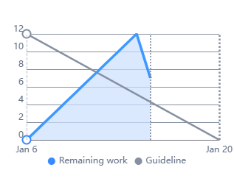

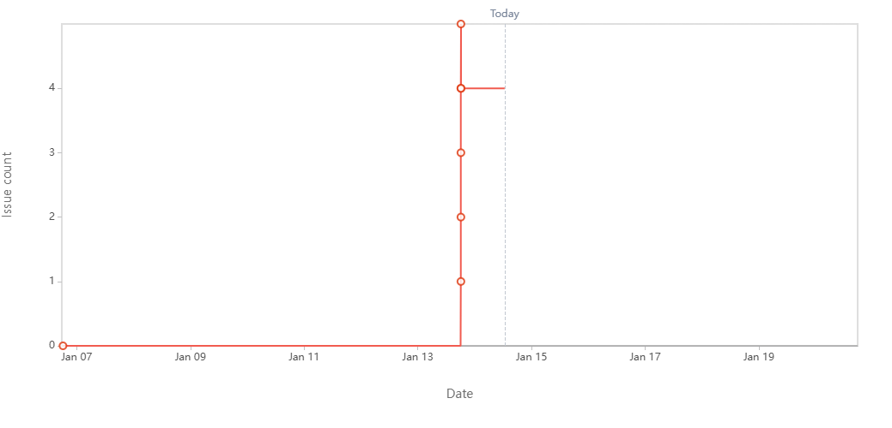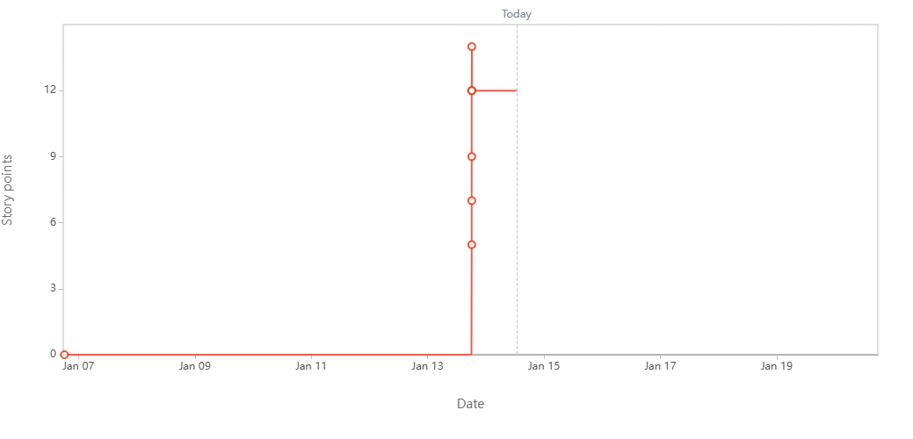

Sprint Burndown Chart

Document 6 – Sprint Meeting

- Sprint Planning Meeting

Date | 2/12/2024
Time | 10:00 A.M.
Location | Office
Prepared by | Abhijeet Deolalikar
Attendees | Ashish Siwalkar, Yogesh Chaurse, Nagesh Madale

Agenda Topics
Topic | Presenter | Time Allotted
Login Functionality | Abhijeet Deolalikar | 20 mins
Registration Functionality | Abhijeet Deolalikar | 20 mins
Chairperson – Start Cycle | Abhijeet Deolalikar | 10 mins
Researchers – Submit Proposals | Abhijeet Deolalikar | 10 mins

Other Information
Observers | None
Resources | None
Special Notes | Discuss that the start cycle option should have and end date or automatically closed after time

- Sprint Review Meeting

Date | 16/12/2024
Time | 10:00 A.M.
Location | Office
Prepared by | Abhijeet Deolalikar
Attendees | Ashish Siwalkar, Yogesh Chaurse, Nagesh Madale

Sprint status | Things to demo | Quick Updates | What’s next
Closed | - Login Functionality  - Register Functionality  - Chairperson Start Cycle | Chairperson – View Proposals and Add Comments and Rating functionality is in progress and will move to next sprint | Add Single Sign-On Option to Login and Register by Gmail  Check Time for editing after submitting proposals

- Sprint Retrospective Meeting

Date | 16/12/2024
Time | 11:00 A.M.
Location | Office
Prepared by | Abhijeet Deolalikar
Attendees | Developers, Testers, Manager, Team Lead

Agenda | What went well | What didn’t go well | Questions | Reference
Completing User Stories | Completed major functionalities Login and Registration and tested them efficiently | All the user stories could not be completed | Did the effort estimate for the user stories was right? | None

- Daily Standup Meeting

Question | Name/Role | Week 1 (from 02-12-2024 to 6-12-2024)
 |  | Monday | Tuesday | Wednesday | Thursday | Friday
What did you do yesterday? | Ashish Shiwalkar | Prepared plan, flowchart, DFD for Login functionality | Prepared database schema for WCRA | Worked on Logic of login functionality and wrote code for it | Write logic for API call of logic functionality | Sync API call with Logic and Database Layer
 | Nagesh Madale | Prepared a design of webpage for Login functionality | Prepared a design of webpage for Login functionality | Wrote code for webpage design | Wrote API call for the login functionality | Wrote API call for the login functionality
 | Yogesh Chaurse | Prepared plan, flowchart, DFD for Login functionality | Prepared database schema for WCRA | Created and Setup Database | Checked Database Connection and write data retrieval code | Synced API call with Logic and Database Layer
What will you do today? | Ashish Shiwalkar | Prepare database schema for WCRA | Work on Logic of login functionality | Write logic for API call of logic functionality | Prepare database schema for WCRA | Test the Functionality and fix bug
 | Nagesh Madale | Prepare a design of webpage for Login functionality | Write code for webpage design | Write API call for the login functionality | Write API call for the login functionality | Test the Functionality and fix bug
 | Yogesh Chaurse | Prepare database schema for WCRA | Create and Setup Database | Check Database Connection and write data retrieval code | Sync API call with Logic and Database Layer | Test the Functionality and fix bug
What (if any) is blocking your progress? | Ashish Shiwalkar | Software Installation Pending | Eclipse editor not installed | None | Error in Unit Testing | API endpoint not accessible
 | Nagesh Madale | Software Installation pending | Software Installation pending | None | None | API endpoint not accessible
 | Yogesh Chaurse | Software Installation pending | Eclipse editor not installed | None | None | API endpoint not accessible

Question | Name/Role | Week 2 (from 09-12-2024 to 13-12-2024)
 |  | Monday | Tuesday | Wednesday | Thursday | Friday
What did you do yesterday? | Ashish Shiwalkar | Prepared plan, flowchart, DFD for Registration functionality | Worked on Logic of login registration functionality and wrote code for it | Sync Database Layer with Application Layer logic | Write logic for API call of logic functionality | Test Registration and Create Cycle
 | Nagesh Madale | Prepared a design of webpage for Registration functionality and Create Cycle | Prepared a design of webpage for Registration functionality and Create Cycle | Wrote code for webpage design and API call | Wrote code for webpage design and API call | Test Registration and Create Cycle
 | Yogesh Chaurse | Prepared plan, flowchart, DFD for Registration functionality | Database Layer Logic for Registration functionality | Sync Database Layer with Application Layer logic | Worked on Create Cycle functionality | Test Registration and Create Cycle
What will you do today? | Ashish Shiwalkar | Worked on Logic of login registration functionality and wrote code for it | Sync Database Layer with Application Layer logic | Write logic for API call of logic functionality | Test Registration and Create Cycle | Fix bugs for Registration functionality
 | Nagesh Madale | Prepared a design of webpage for Registration functionality and Create Cycle | Wrote code for webpage design and API call | Wrote code for webpage design and API call | Test Registration and Create Cycle | Fix bugs for Registration functionality
 | Yogesh Chaurse | Database Layer Logic for Registration functionality | Sync Database Layer with Application Layer logic | Worked on Create Cycle functionality | Test Registration and Create Cycle | Fix bugs for Registration functionality
What (if any) is blocking your progress? | Ashish Shiwalkar | Need mandatory field to be included in registration | None | None | None | None
 | Nagesh Madale | None | None | None | Created cycle not closing on date | None
 | Yogesh Chaurse | Need mandatory field to be included in registration | None | None | None | None

