Question1: Identify minimum 20 functional requirements

Example:

Functional requirement: When an order is fulfilled, the local printer shall print a packing slip.

Non-Functional Requirement: Packing slips shall be printed on both sides of 4”x 6” white paper, the standard size for packing slips used by local printers.

Answer:

|  |  |  |  |
| --- | --- | --- | --- |
| REQ ID | REQ NAME | REQ DESCRIPTION | PRIORITY |
| FR0001 | Farmer Registration | Farmers should be able to register with the application | must |
| FR0002 | Farmer search for products | Farmers should be able to search for available products in fertilizers, seeds, pesticides | Should |
| FR0003 | Printer print the package slip | When an order is fulfilled, the local printer shall print a packaging slip | Should |
| FR0004 | Adding the product to the cart | Farmer should be able to add to cart once they select the product | Could |
| FR0005 | Product tracking | Farmers should be able to track the ordered items. | must |
| FR0006 | New user email verification | For a new customer he has should do the email verification for doing login | Could |
| FR007 | Payment option for the customer | The farmers should have the payment options either upi cod or through cards | must |
| FR008 | After cancellation refund option | After cancellation is initiated the refund is to be followed | Must |
| FR009 | Manufacture tracking facility | Manufacture should be able to track the stock | could |
| FR010 | OTP initiated for payment | When item is in the payment the OTP is sent to registered mobile number | could |
| FR012 | Address update option | The farmer should be able to update his address every time of check outs | would |
| NFR0013 | Page Loading | Each page should load within 2 seconds time | Could |
| NFR0014 | Payment receipt | The farmer should get the receipt within a hour of order | must |
| NFR0015 | Page timeout | After 15 min of activity the page will logout | Would |
| NFR0016 | Fascinating home page | The home page should not contain much information and should look good | Could |
| NFR0017 | Quick payment option | Payment options should be quick and fast | Won’t |
| NFR0018 | Review option | After every order customers should be able to give review | Must |
| NFR0019 | Security of data | Information of farmers should not be shared | Could |
| NFR0020 | WCAG2.1 | The system must meet web content accessibility guidelines WCAG2.1 | Could |

Question2: Minimum 5 page designs

Answer:

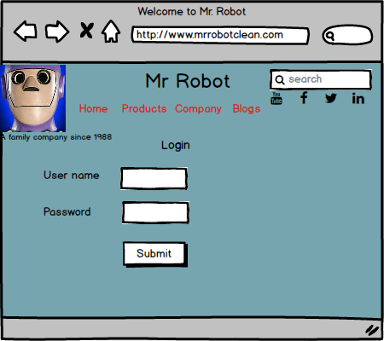

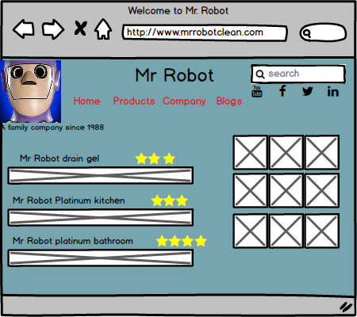

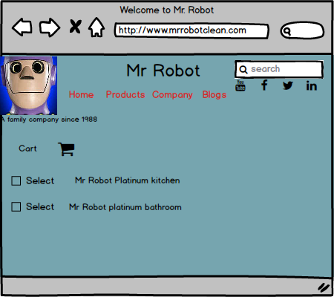

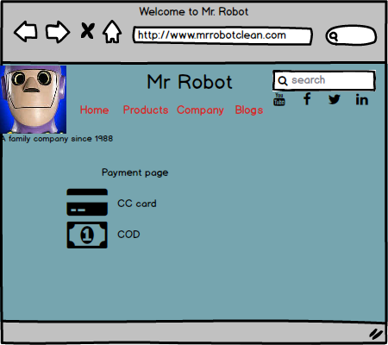

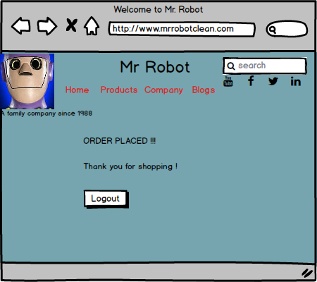

Question3: Tools (Visio, Balsamiq) Make a note of the Tools, which you are using for above concepts.

Answer:- Microsoft Visio: Definition:- Microsoft Visio is a diagramming and vector graphics application to create diagrams, flowcharts and other visual representations of complex information.

Microsoft Visio is software for drawing a variety of diagrams. These include flowcharts, org charts, building plans, floor plans, data flow diagrams, process Flow diagrams, business process modeling, swimlane diagrams, 3D maps, and many more.

- Basically utilized for formats and charts. They can be utilized for building pictures like flowcharts, choice graphs and network diagrams. It indeed has sufficient charts to form arranging a straight forward space format for a conference precise

-Balsamiq : Definition- Balsamiq is a rapid wireframing tool used to create mock ups and and prototypes of user interfaces.

Balsamiq Wireframes is a user interface design tool for creating wireframes (sometimes called mock ups or low-fidelity prototypes). You can use it to generate digital sketches of your idea or concept for an application or website, to facilitate discussion and understanding before any code is written.

Axure: - Definition :- Axure is a more advanced prototyping tool used to create high- fidelity, interactive wireframes and prototypes for web and mobile applications.

Question4: RTM (Requirement traceability matrix)

Answer: Definition: It is a document to track the requirements throughout the project lifecycle, ensuring that they are met and that no requirements are overlooked.

|  |  |  |  |  |  |  |  |  |  |
| --- | --- | --- | --- | --- | --- | --- | --- | --- | --- |
| Req ID | Req Name | Req description | Design | Code | (UT)Unit testing | (CT)Component testing | (ST)System testing | SIT | UAT(User Acceptance testing) |
| FR0001 | Farmer Registration | Farmers should be able to register with the application | Complete | Complete | Complete | Complete | Complete | Complete | Incomplete |
| FR0002 | Farmer search for products | Farmers should be able to search for available products in fertilizers, seeds, pesticides | Complete | Complete | Complete | Complete | Incomplete | Incomplete | Incomplete |
| FR0003 | Printer print the package slip | When an order is fulfilled, the local printer shall print a packaging slip | Complete | Complete | Complete | Complete | Incomplete | Incomplete | Incomplete |
| FR0004 | Adding the product to the cart | Farmer should be able to add to cart once they select the product | Complete | Complete | Complete | Complete | Incomplete | Incomplete | Incomplete |
| FR0005 | Product tracking | Farmers should be able to track the ordered items. | Incomplete | Incomplete | Complete | Complete | Incomplete | Incomplete | Incomplete |
| FR0006 | New user email verification | For a new customer he has should do the email verification for doing login | Incomplete | Complete | Complete | Incomplete | Incomplete | Incomplete | Incomplete |
| FR007 | Payment option for the customer | The farmers should have the payment options either upi cod or through cards | Complete | Incomplete | Complete | Complete | Complete | Incomplete | Incomplete |
| FR008 | After cancellation refund option | After cancellation is initiated the refund is to be followed | Incomplete | Complete | Complete | Complete | Incomplete | Incomplete | Incomplete |
| FR009 | Manufacture tracking facility | Manufacture should be able to track the stock | Incomplete | Incomplete | Incomplete | Incomplete | Incomplete | Incomplete | Incomplete |
| FR010 | OTP initiated for payment | When item is in the payment the OTP is sent to registered mobile number | Complete | Complete | Complete | Incomplete | Incomplete | Incomplete | Incomplete |
| FR012 | Address update option | The farmer should be able to update his address every time of check outs | Complete | Complete | Complete | Complete | Complete | Complete | Complete |
| NFR0013 | Page Loading | Each page should load within 2 seconds time | Incomplete | Complete | Complete | Incomplete | Complete | Complete | Incomplete |
| NFR0014 | Payment receipt | The farmer should get the receipt within a hour of order | Complete | Incomplete | Incomplete | Complete | Incomplete | Incomplete | Incomplete |
| NFR0015 | Page timeout | After 15 min of activity the page will logout | Complete | Incomplete | Complete | Complete | Incomplete | Incomplete | Incomplete |
| NFR0016 | Fascinating home page | The home page should not contain much information and should look good | Incomplete | Incomplete | Incomplete | Incomplete | Complete | Complete | Complete |
| NFR0017 | Quick payment option | Payment options should be quick and fast | Complete | Incomplete | Complete | Incomplete | Complete | Incomplete | Incomplete |
| NFR0018 | Review option | After every order customers should be able to give review | Incomplete | Incomplete | Complete | Complete | Complete | Incomplete | Incomplete |
| NFR0019 | Security of data | Information of farmers should not be shared | Incomplete | Complete | Incomplete | Complete | Complete | Incomplete | Complete |
| NFR0020 | WCAG2.1 | The system must meet web content accessibility guidelines WCAG2.1 | Incomplete | Incomplete | Complete | Incomplete | Complete Complete | Incomplete | Incomplete |

Question 5: Test Case Documents. Prepare 10 Test case Documents

Answer:

|  |  |  |  |
| --- | --- | --- | --- |
| Test Case ID | PQ9437 | Test case name | login |
| Project ID | 1234 | Project name | Farmers website |
| PM ID | 786 | PM name | Mr Vandanam |
| Test strategy ID | PQ9437 | Tester ID |  |
| Test Plan ID | PQ9437 | Tester name |  |
| Test Schedule ID | PQ9437 | Date of test |  |

|  |
| --- |
| Scenario: website for online shopping of farm products, in that we have login we have 4inputs3compulsory 1 optional and after that results are being shown |
| Link to that page |

|  |  |  |  |  |
| --- | --- | --- | --- | --- |
|  | **set 1** |  |  |  |
| Inputdata | 1.User id  2.password  3.capcha  4.otp |  |  |  |
| Expected behavior | Home page/error page pops up |  |  |  |
| Actual behavior | Home page/error page pops up |  |  |  |
| comments | Test was good |  |  |  |
| Pass/fail | Pass |  |  |  |

2:

|  |  |  |  |
| --- | --- | --- | --- |
| Test Case ID | PQ9437 | Test case name | New User |
| Project ID | 1234 | Project name | Farmers website |
| PM ID | 786 | PM name | Mr Vandanam |
| Test strategy ID | PQ9437 | Tester ID |  |
| Test Plan ID | PQ9437 | Tester name |  |
| Test Schedule ID | PQ9437 | Date of test |  |

|  |
| --- |
| Scenario: website for online shopping of farm products, in that we have new user we have 14compulsory 1 optional and after that results are being shown |
| Link to that page |

|  |  |  |  |  |
| --- | --- | --- | --- | --- |
|  |  |  |  |  |
| Inputdata | 1.username  2.set password  3.mail verification  4.capcha  5.mobile otp |  |  |  |
| Expected behavior | Registered done and home page shows |  |  |  |
| Actual behavior | Home page comes |  |  |  |
| comments | Test was good |  |  |  |
| Pass/fail | Pass |  |  |  |

3:

|  |  |  |  |
| --- | --- | --- | --- |
| Test Case ID | PQ9437 | Test case name | Online Purchasing |
| Project ID | 1234 | Project name | Farmers website |
| PM ID | 786 | PM name | Mr Vandanam |
| Test strategy ID | PQ9437 | Tester ID |  |
| Test Plan ID | PQ9437 | Tester name |  |
| Test Schedule ID | PQ9437 | Date of test |  |

|  |
| --- |
| Scenario: website for online shopping of farm products, in that we perform online purchasing wehave 1 compulsory 1 optional and after that results are being shown |
| Link to that page |

|  |  |  |  |  |
| --- | --- | --- | --- | --- |
|  |  |  |  |  |
| Inputdata | 1 Product name  2 filter options |  |  |  |
| Expected behavior | Product options |  |  |  |
| Actualbehavior | Different product pops up |  |  |  |
| comments | Test was good |  |  |  |
| Pass/fail | Pass |  |  |  |

4:

|  |  |  |  |
| --- | --- | --- | --- |
| Test Case ID | PQ9437 | Test case name | Product Availability |
| Project ID | 1234 | Project name | Farmers website |
| PM ID | 786 | PM name | Mr Vandanam |
| Test strategy ID | PQ9437 | Tester ID |  |
| Test Plan ID | PQ9437 | Tester name |  |
| Test Schedule ID | PQ9437 | Date of test |  |

|  |
| --- |
| Scenario: website for online shopping of farm products, in that we should have product available in which we have 3 inputs 3 compulsory and after that results are being shown |
| Link to that page |

|  |  |  |  |  |
| --- | --- | --- | --- | --- |
|  |  |  |  |  |
| Inputdata | 1.Manufacturing code  2.capcha  3.Password |  |  |  |
| Expectedbehavior | Stock information |  |  |  |
| Actualbehavior | Same as expected |  |  |  |
| comments | Test was good |  |  |  |
| Pass/fail | Pass |  |  |  |

5:

|  |  |  |  |
| --- | --- | --- | --- |
| Test Case ID | PQ9437 | Test case name | Payment Gateway |
| Project ID | 1234 | Project name | Farmers website |
| PM ID | 786 | PM name | Mr Vandanam |
| Test strategy ID | PQ9437 | Tester ID |  |
| Test Plan ID | PQ9437 | Tester name |  |
| Test Schedule ID | PQ9437 | Date of test |  |

|  |
| --- |
| Scenario: website for online shopping of farm products, in that we have payment gateway in which we have4 inputs 4 compulsory and after that results are being shown |
| Link to that page |

|  |  |  |  |  |
| --- | --- | --- | --- | --- |
|  |  |  |  |  |
| Inputdata | 1.expiry  2.cvv  3.otp  4name |  |  |  |
| Expectedbehavior | Transaction page |  |  |  |
| Actualbehavior | Same as expected |  |  |  |
| comments | Test was good |  |  |  |
| Pass/fail | Pass |  |  |  |

6:

|  |  |  |  |
| --- | --- | --- | --- |
| Test Case ID | PQ9437 | Test case name | Browse product |
| Project ID | 1234 | Project name | Farmers website |
| PM ID | 786 | PM name | Mr Vandanam |
| Test strategy ID | PQ9437 | Tester ID |  |
| Test Plan ID | PQ9437 | Tester name |  |
| Test Schedule ID | PQ9437 | Date of test |  |

|  |
| --- |
| Scenario: website for online shopping of farm products, in that we have browse product option in which we have4 inputs 4 compulsory and after that results are being shown |
| Link to that page |

|  |  |  |  |  |
| --- | --- | --- | --- | --- |
|  |  |  |  |  |
| Inputdata | 1.category  2.size  3.availabilty  4.price range |  |  |  |
| Expectedbehavior | Different product options |  |  |  |
| Actualbehavior | Same as expected |  |  |  |
| comments | Test was good |  |  |  |
| Pass/fail | Pass |  |  |  |

7:

|  |  |  |  |
| --- | --- | --- | --- |
| Test Case ID | PQ9437 | Test case name | Experience rating |
| Project ID | 1234 | Project name | Farmers website |
| PM ID | 786 | PM name | Mr Vandanam |
| Test strategy ID | PQ9437 | Tester ID |  |
| Test Plan ID | PQ9437 | Tester name |  |
| Test Schedule ID | PQ9437 | Date of test |  |

|  |
| --- |
| Scenario: website for online shopping of farm products, in that we have experience option in which we have 4 inputs 3 compulsory and after that results are being shown |
| Link to that page |

|  |  |  |  |  |
| --- | --- | --- | --- | --- |
|  |  |  |  |  |
| Inputdata | 1.experience  2.names  3.phonenumber |  |  |  |
| Expectedbehavior | Review done |  |  |  |
| Actualbehavior | Same as expected |  |  |  |
| comments | Test was good |  |  |  |
| Pass/fail | Pass |  |  |  |

8:

|  |  |  |  |
| --- | --- | --- | --- |
| Test Case ID | PQ9437 | Test case name | Product Cancel |
| Project ID | 1234 | Project name | Farmers website |
| PM ID | 786 | PM name | Mr Vandanam |
| Test strategy ID | PQ9437 | Tester ID |  |
| Test Plan ID | PQ9437 | Tester name |  |
| Test Schedule ID | PQ9437 | Date of test |  |

|  |
| --- |
| Scenario: website for online shopping of farm products, in that we have product cancel option in which we have2 inputs and click ok and after that results are being shown |
| Link to that page |

|  |  |  |  |  |
| --- | --- | --- | --- | --- |
|  |  |  |  |  |
| Inputdata | Order Id capcha |  |  |  |
| Expectedbehavior | Order cancellation page |  |  |  |
| Actualbehavior | Same as expected |  |  |  |
| comments | Test was good |  |  |  |
| Pass/fail | Pass |  |  |  |

9:

|  |  |  |  |
| --- | --- | --- | --- |
| Test Case ID | PQ9437 | Test case name | Helpline |
| Project ID | 1234 | Project name | Farmers website |
| PM ID | 786 | PM name | Mr Vandanam |
| Test strategy ID | PQ9437 | Tester ID |  |
| Test Plan ID | PQ9437 | Tester name |  |
| Test Schedule ID | PQ9437 | Date of test |  |

|  |
| --- |
| Scenario: website for online shopping of farm products, in that we helpline option in which we have 4 inputs and click ok and after that results are being shown |
| Link to that page |

|  |  |  |  |  |
| --- | --- | --- | --- | --- |
|  |  |  |  |  |
| Inputdata | 1.name  2.number  3.query |  |  |  |
| Expectedbehavior | Call person  Calls you |  |  |  |
| Actualbehavior | Same as expected |  |  |  |
| comments | Test was good |  |  |  |
| Pass/fail | Pass |  |  |  |

10:

|  |  |  |  |
| --- | --- | --- | --- |
| Test Case ID | PQ9437 | Test case name | Download payment receipt |
| Project ID | 1234 | Project name | Farmers website |
| PM ID | 786 | PM name | Mr Vandanam |
| Test strategy ID | PQ9437 | Tester ID |  |
| Test Plan ID | PQ9437 | Tester name |  |
| Test Schedule ID | PQ9437 | Date of test |  |

|  |
| --- |
| Scenario: website for online shopping of farm products, in that we have payment receipt option in which we have3 inputs and click ok and after that results are being shown |
| Link to that page |

|  |  |  |  |  |
| --- | --- | --- | --- | --- |
|  |  |  |  |  |
| Inputdata | Order Id  Captcha  Password |  |  |  |
| Expectedbehavior | Shows payment receipt |  |  |  |
| Actualbehavior | Same as expected |  |  |  |
| comments | Test was good |  |  |  |
| Pass/fail | Pass |  |  |  |

Question6: DB Design. After the requirements are thoroughly explained to the entire project team by business analyst, the Database architects have decided to do the database design and also to represent the in-flow and out-flow of data. Draw database schema and ER diagram

Answer: DB schema is a blueprint that outlines the structure of a database, including its tables, fields, relationships, constraints, and other characteristics.

An entity relationship diagram (ERD) is a visual representation of the relationships between entities in a database. It depicts the entities (such as tables), attributes (properties or fields), and relationships between them.

Question7:

What is a data flow diagram? Draw a data flow diagram to represent the in-flow and out-flow of data when a Farmer is placing an order for the product-

Answer: A data-flow diagram is a way of representing a flow of data through a process or a system (usually an information system). The DFD also provides information about the outputs and inputs of each entity and the process itself. A data-flow diagram has no control flow there are no decision rules and no loops. Specific operations based on the data can be represented by a flowchart.

Question8: Due to change in the Government Taxation structure. we should change the Tax structure. How do you handle change requests in a project?

Answer: A change request is a formal proposal for an alteration to some product or system. In project management, a change request often arises when the client wants an addition or alteration to the agreed-upon deliverables for a project. Such a change may involve an additional feature or customization or an extension of service, among other things. When there is sudden change in the tax structure by the government the entire project cost gets effected we will call for a meeting and discuss how we are going to tackle the system. We will discuss the areas where we can do the cost cutting and if we are not able to do it then we will reach to our client and make him understand the situation and then convince him to increase the budget

There are a lot of obstacles to overcome when trying to deliver on a project. A change request will often come up throughout the course of most projects so it is a good idea to have a plan for how tohandle them ahead of time. Often, change requests are necessary and can offer many benefits. Managing this process in an effective way can allow for greater internal communication, efficiency, and alignment with overall business goals. Here are five tips on effectively managing change requests: Request any supporting materials You want the person who is making the change to be as specific as possible. Ask that person to put their request in writing and provide any supporting materials that might be helpful. Have that person articulate why they are requesting this change and what the anticipated benefit of their change request is. This will help your team determine whether or not the change request is worth the effort.

Determine whether the change request is in inside or outside the scope

It is a good idea to consider what the scope of the change request is. If your team chooses to implement this change, what new requirements will this put on the project? You will want to consider all aspects of the project that will be impacted by implementing this change request. If the request is outside of the scope, a lot of problems might end up popping up – going over- budget,for example. Or having to waste too much time on a project you’d never even agreed on. Have your team assess the priority of the change request. Before your team implements any changes to the project you should consider any possible risks. What is the expected benefit of the change being proposed? Is this change request the result of an actual need to respond to a change in the marketplace or would it simply be nice to have? You can consider the opinion of the person who proposed the change request, but at the same time, use common sense. The client might not know what’s in their own best interests.Have clearly defined guidelines for evaluating the urgency as there may be varying opinions amongst team members.

Approve or reject the change request. Now that you know how important (or unimportant) the change request is and understand the impact itwill have on the project, the team can either approve or reject the request. Different organizations will have different ways of going about the approval process. Generally, a change request that will require minimal additional work can be approved within the team. Whereas a change request that would require a month’s worth of additional work may require executive approval. Decide on a course of action going forward. If the change request is approved then the project deliverables will need to be updated. This can include p lans and schedules, business process documents, and the requirements documents. Once these updates have been made, the project manager can communicate the new course of action to everyone who will be impacted. Now you can delegate the necessary tasks to the people in charge of implementing these new changes.

Question 9 – Change Request Vs an Enhancement

As the project is in process, Ben and Kevin have contacted you. The reason is to inform you that they want the Farmers to sell their crop yields through this application i.e. Farmers should be able to add their crop yields or products and display to general public and should be able to sell them. They also want to introduce Auction system for their Crop yields. As a BA, what will be your response? Is this a change request or an enhancement???

Answer: It is a change request because they said Farmers should be able to sell their crop yields through this application but it was initially not told .so it is an change request.

Question 10 – Estimations

Come up with estimations – How many Manhours required?

Total man hours as a whole we required is 700 man hours-Project Manager - Mr Vandanam-100 men hours

Senior Java Developer - Ms. Juhi-100 men hours

Java Developers - Mr Teyson, Ms Lucie, Mr Tucker, Mr Bravo-100 men hours

Network Admin - Mr Mike-50 men hoursDB Admin - Mr John.-50 men hoursTesters - Mr Jason and Ms Alekya-200 men hoursBA – me-100 men hours

Question 11 – UAT

Project has finally completed all the stages i.e., design, development, testing etc. Now, it is the role of a business analyst to contact the client for testing of the final product and have to successfully complete it. How are you going to handle this situation? And once it is done, what will be the process to close the project? Explain UAT Acceptance process

Answer:

1. PlanningPlanning is all about outlining your strategy for the UAT test that has to be performed on your product.There is no one strategy used here; in fact, people have different approaches to outlining the strategy,but you should always go for the one that aligns with your business requirements in the best possibleway. For example, what part of the app should you perform the tests on? Which end-user will test whichpart of the app?
2. Test ScenariosOnce you have planned the UAT test, it is time to think of the different test scenarios. Here we arereferring to all the situations that can arise while using the product and what needs to happen in eachsituation. These scenarios help with the creation of test cases. Let us assume that you have asked a webdevelopment agency for an e-commerce website. One test case would be to test the website during thesales season. As there would be many customers, testing the web site's functionality, load speed, andoverall user experience is a must-have test scenario.
3. ExecutionOnce the previous steps are complete, it is time to begin the UAT testing. It is best to record anddocument the entire process. While the developers are not a part of the UAT team, ensure that theywitness the entire UAT session. The reason for this is because the end-users might not explain theproblems in a way that developers expect or need. So, by having them witness the entire test, they willunderstand potential issues better. Furthermore, there may be times when end-users don’t report a problem, but developers see it themselves when watching the UAT session. So it is well worth the timeof your developers to witness the UAT session.
4. Final DecisionThe UAT test is there to analyze if the product is per the business requirements or not. If the answercomes in positive, the product is ready for launch into the market. If the answer is negative, you'll haveto go through another round of UAT testing after fixing all the bugs and glitches.

Question 12 – Project Closure Document

Explain Project closure document

Answer: This document is the final deliverable submitted when the project ends and it determines the prosperity of the project generally. It is the responsibility of the project manager to keep a record of allthe details of every stage of the project.This assists the managers along with senior members to estimate the progress and find out the areaswhere more effort is needed. With the aid of this report, an organization can evaluate the ways to enhance efficiency in the future. Such reports also depict the hard work of the team and the way they accomplished their particular objectives.