**CAPSTONE PROJECT PREPARATION 1 PART 2:**

**Question 1**: 4 Quarterly Audits are planned Q1, Q2, Q3, Q4 for this Project what is your knowledge on how these Audits will happen for a BA?

**Answer**:

|  |  |
| --- | --- |
| **Stage** | **Requirements gathering phase** |
| **Status** | Completed |
| **Checklist** | BRD template |
|  | Elicitation requirements report |
|  | Duplicate requirements report |
|  | Grouping of functionalities/features-Client signoff |

|  |  |
| --- | --- |
| **Stage** | **Requirements Analysis phase** |
| **Status** | Completed |
| **Checklist** | UML Diagrams |
|  | Business to functional requirements mapping |
|  | Client Sign-off |
|  | RTM Document version control |

|  |  |
| --- | --- |
| **Stage** | **Design phase** |
| **Status** | Completed |
| **Checklist** | Utilization of tools |
|  | Documented evidence on client communication |
|  | Stakeholder MOM |

|  |  |
| --- | --- |
| **Stage** | **Development phase** |
| **Status** | Completed |
| **Checklist** | Created detailed checklist of requirement |
|  | Creating timeline and task with list of deliverables and deadlines |
|  | Meeting with project development team |

|  |  |
| --- | --- |
| **Stage** | **Testing phase** |
| **Status** | Completed |
| **Checklist** | Discussion with QA team on the details such as automation code, where to store the automation code and who will need access to it, who’s running the tests and writing test cases |
|  | Meeting with QA team to identify where the tests will run |

**Question 2: BA Approach Strategy**:

Before the Project is going to Kick Start, The Committee asked Mr Karthik to submit BA Approach Strategy Write BA Approach strategy (As a business analyst, what are the steps that you would need to follow to complete a project – What Elicitation Techniques to apply, how to do Stakeholder Analysis RACI/ILS, What Documents to Write, What process to follow to Sign off on the Documents, How to take Approvals from the Client, What Communication Channels to establish n implement, How to Handle Change Requests, How to update the progress of the project to the Stakeholders, How to take signoff on the UAT- Client Project Acceptance Form )

Your Team

|  |
| --- |
| Project Manager – Mr Vandanam  Senior Java Developer – Ms Juhi |
| Java Developers – Mr Teyson, Ms Lucie, Mr Tucker, Mr Bravo  Network Admin - Mr Mike | | | | |
| DB Admin - Mr John. | | |
| Testers- Mr Jason and Ms Alekya | | |
| BA-You | | |

Technical Team have assembled to discuss on the Project approach and have finalised to follow3-tier architecture for this project

**Answer**:

**What Elicitation Techniques to apply:** I would be using the Brainstorming Technique.

**Stakeholder Analysis**:

Business Analyst- Ravi

Delivery Head- Mr Karthik

Project Manager- Mr Vanadanam

Development Team- MS Juhi, Mr Teyson, Ms Lucie, Mr Tucker, Mr Bravo

Testing team- Mr Jason and Ms Alekya

Network Admin- Mr Mike

DB Admin is John

**Business Stakeholders:**

Business Sponsor- Mr. Henry

Influencers- Peter, Kevin and Ben.

Finance team- Mr Pandu

Project team- Mr Dooku

**What Documents to Write**: BRD, FRD, Use case Documentation and Test case documents, Scope, In- Scope features/services, Solution Architecture Diagram, Technology Specifications, Project timeline, Risks and mitigation plan etc.

**What process to follow to signoff the Documents**?

Sign off can be taken on SRS as this is the primary and important document, Sign off can be taken by using E mail confirmation from the client.

Project sign-off is executed during the contract closure phrase-the company presents the results of the work done to the client and then, after getting the necessary acceptance from them, should get a client statement to verify that the job was completed.

* Name of the project.
* All relevant dates.
* Key roles in the project.
* Project deliverables.

**How to take Approvals from the client**?

Establish a formal meeting with the clients to keep them informed and get continuous feedback.

Whenever we seek approval from a manager or a client, we will have to draft a request for an approval letter.

Write an email to addressing the relevant signing stakeholders and reviewers as per below format.

**What communication channels to establish and implement?**

Regular meetings- weekly status meetings, bi-weekly sprint reviews and monthly stakeholder updates.

Face to face communication/In person meeting.

Video Conferencing

Phone calls

Emails

Text messages

Online message platforms (Skype, teams etc.)

**How to handle change request**?

Change Request form, Do Impact Analysis, Approval process, Documentation.

During or upon further deliverables review following the session, the approvers/reviewers may provide changes/feedback to be incorporated in to deliverable.

The team lead will drive the deliverable to completion integrating all changes submitted during or after review session into the deliverable. Ensure to communicate any major changes to the reviewers and to track these in the version tracking section of the deliverable.

**How to update the progress of the project to the Stakeholders**?

**How to take signoff on the UAT- Client Project Acceptance Form?**

Weekly status reports and monthly review meetings.

User acceptance testing (UAT) is a type of testing performed by the end user or the client to verify/accept the software system before moving the software application to the production environment. UAT is done in the final phase of testing after functional, integration and system testing are done. Deliverables for UAT testing are Test plan, UAT scenarios and Test cases, Test Results and Defect Log.

Once executions is over, and as many defects are possible are resolved, it is time to sign off on UAT and go live.

The sign-off approval indicates that the change meets business requirements and is ready for deployment.

UAT Preparation, Conduct UAT, Fix issues, Acceptance Form, Final Review meeting, Obtain Sign off.

Business Analysts or UAT Testers needs to send a sign off mail after the UAT testing. After signoff, the product is good to go for production.

**Question 3: 3-Tier Architecture**

**Explain and Illustrate 3-tier Architecture**?

**Ans**: Three-tier architecture is a software application architecture that separates an application into three logical tiers.

|  |
| --- |
| Logic tier  Server |

|  |
| --- |
| Data tier  Data base |

|  |
| --- |
| Presentation tier  Client |

**Presentation layer**: This is the top most layers in User Interface and this refers what we see in the screens in the form of presentations.

**Business logic layer**: This contains where the developers are writing the code and testing process runs and deploying the code is done in Logic tier.

**Data layer**: This contains the data base where the data is stored and retrieved.

**Question 4: BA Approach Strategy for framing Questions?**

Business Analyst should keep what points in his/her mind before he frames a Question to ask to the Stakeholder?

(5W 1H – SMART – RACI – 3 Tier Architecture – Use Cases, Use case Specs, Activity Diagrams, Models, and Page designs)

**Answer:** The 5W1H framework is useful tool for gathering information and understanding a situation by answering questions about who, what, when, where, why and how.

Why: This entails clarifying why the issue, problem or situation at hand occurred. It aims to identify the triggers and rationalizes the occurrence of an issue or a problem. It explains in detail the reason and objectives behind the need for action or why there’s a need to do 5W1H method in the first place.

What: What element should clearly describe the situation, the specific problem, or basically explain the purpose of the method usage. If possible, it should be also state the overall goal for implementing the solution that would be identified.

Who: Refers to the specific people or group relevant to the issue or the situation. It should include the person who discovered the problem.

Where: where element should contain the exact location or position of the recognized issue. It can be a place, facility, or even a certain process where the solution is to be implemented.

When: it include all the components of the situation pertaining to anything related to dates. It should state the timeline, deadline, duration, or any other details that could help in the resolution of the problem.

How: specifies the steps on how the identified plans should be carried out. It should also include all the resources, tools, methods, means, and even the expenditure needed for the endeavours to be effective.

SMART: Specific, Measurable, Attainable, Realistic & Time Bound.

Specific: has one meaning.

Measurable: able to measure.

Attainable: able to reach.

Realistic: able to understand in real scenarios.

Time bound: within time limits should be completed.

RACI: This Chart helps to define and clarify roles and responsibilities within a team by outlining who is responsible, accountable, consulted and informed for each task.

**3- Tier Architecture**:

**CLIENT UI===🡺 Application Server===🡺Database Server**

Use case: A use case is a concept used in software development, product design, and other fields to describe how a system can be used to achieve specific goals and tasks.

Use case Specs:

Use case description: A user login to system to access the functionality of the system.

Actors: Henry, PM, all the stake holders.

Precondition: System must be connected to the network.

Post condition: After a successful login a notification mail is sent to the User mail id.

|  |  |
| --- | --- |
| **Actors** | User |
| **Requirement Definition** | User will be able to browse through the website |
| **Pre-Condition** | User has successfully logged in to the app |
| **Post- Condition** | User will be able to browse through the website |
| **Business Rules/ Logic** | User will able to login/register |

**Question 5 – Elicitation Techniques**

As a Business Analyst, What Elicitation Techniques you are aware of (BDRFOWJIPQU)?

Elicitation technique: Elicitation technique is defined as a meeting with a client held which has a specific objective

**Answer:**

Brainstorming: Brainstorming is the process where a group of domain experts, SME’S assemble for the given challenge and presenting you the ideas in different ways in order to solve the problem.

Identify what’s the problem is and take the approval from project manager and identify the domain SME’S and we have to send them invitation and block the calendar and arrange a meeting.

Document Analysis: Document Analysis is compulsory for all the projects, when you read a document and understand the process or project of the product is defined as document analysis.

Ex: series of mail exchange and whenever you read any text and understand.

Reverse Engineering: Analysing an existing system, product or process to derive its components and functionality is called as Reverse Engineering, this will be done in migration projects, without knowing the functionality of the project or process we have been trying to apply.

Focus Groups: A small group of stakeholders, often including the end users gathered to discuss a particular topic or an issue is defined as focus groups.

Ideal for obtaining feedback on product features, understanding user preferences or identifying problems with existing systems.

There are two types of focus groups, they are

1. Homogeneous: The group of people related to same domain.
2. Heterogeneous: the group of people related to different domains.

Observations: The process of observing the stakeholder and or the person, who explains the session whenever a session is conducting and understand the process.

Observations is of two types they are

1. Active: Asking questions and understanding the process.
2. Passive: As a Ba we cannot disturb a stake holder and only observe and listen

Workshops: Workshops are the sessions conducted in which what are the inputs the client would take and what are the outputs will generate and also what is the process and prototype of inputs and outputs.

Everybody in the meeting understands everything and after the workshop all the participants will know the big picture of the topic and conducted in weekly basis.

JAD: As a Business Analyst we sometimes require to work different technical things, in such a case we take the help of technical resources, Network resources for networking project to discuss about the requirements called as JAD (Joint Application Development).

Interview: Job Interviews etc.

Few requirements contradict with other requirements, in such case we take the help of responsible stake holders and ask them.

Structured Approach: One by one

Unstructured approach: Direct Q & A.

Open ended: like explanation.

Close ended: yes/no.

Prototype: Creating early versions of a product or system from stakeholders to review and provide feedback.

Showing the sample of working model and it generally starts with reference of the client like ERP, CRM’S etc.

Questionnaire: Question and answers, survey forms, feedback forms, MCQ and ratings comes under questionnaire.

Use case specs: When the client is given you the requirement parallel we start use case diagrams and prepare the document by using various tools, techniques and analysis etc.

A lot of questions from client by seeing the use case diagram, pre-requisites, basic flows, assumptions etc.

**Question 6 – This project Elicitation Techniques**.

Which Elicitation Techniques can be used in this Project and Justify your selection of Elicitation Techniques?

Prototyping

Use case Specs

Document Analysis

Brainstorming

Fertilizers, seeds, pesticides details from the manufacturers and should be able to display them to the Farmers. To gather the business requirements from the client, you went to SOONY and met Mr Henry. When Mr. Henry was asked about the project and what are they expecting from the project, Mr. Henry stated that he is expecting to have a login for all its users (fertilizers, seeds, pesticides manufacturers and Farmers) , a product catalog of fertilizers, seeds, pesticides, a search option to search for products, payment process, and delivery tracking. After doing the stakeholder analysis, you have found out that Peter, Kevin, Ben are the key stakeholders and you have scheduled an appointment to meet them. After meeting with them and trying to gather the stakeholder requirements, Kevin said that, a Farmer should be able to browse through the products catalog once they visit the website and need to have a search option so that they can search for any product they need. Peter said that, if a farmer wants to buy any product or add them to buy-later list, they need to login first using their email id and password. If it is a new user, then they can create a new account by submitting their email ID and creating a secure password. Ben added saying that, Farmers needs to have an easy-to-use payment gateway which should include cash-on-delivery (COD), Credit/Debit card and UPI options so that the user’s experience should be better. Kevin mentioned that, a user gets an email confirmation regarding their order status. A delivery tracker to track the whereabouts of their order

**Identify Business Requirements (which includes Stakeholder Requirements)**

BR001 – Farmers should be able to search for available products in fertilizers, seeds, pesticides

BR002 – Manufacturers should be able to upload and display their products in the application

**Answer:**

I would be using Workshop and will invite all Stakeholders and will set up agenda, discussion, requirement gathering, and client expectation.

I would be using use case specs as it helps for early designs, mock-ups, prototypes with real users.

BR001 – Farmers should be able to search for available products in fertilizers, seeds, pesticides.

BR002 – Manufacturers should be able to upload and display their products in the application.

BR003- Farmers need to login first using their email id and password to make and purchase or add to buy list.

BR004-Farmers need to have an easy to use payment gateway which should include cash-on-delivery (COD), Card and Net banking options.

BR005-Users must get an email notification regarding their order status and delivery tracker to track the order.

**Question 7: 10 Business Requirements**.

Make suitable Assumptions and identify at least 10 Business Requirements?

**Answer:**

Assumption1: Users can login using FB, Google Yahoo account.

Assumption2: Users should have basic technical knowledge to browse website or make purchase.

Assumption 3: Due to boom in online shopping trend, customers will prefer online shopping.

Assumption4: The dealers/traders need to display good quality product in the application to increase their sales.

Assumption4: Users should have knowledge on agricultural products, its usage and longevity.

Assumption5: Customers should have online accounts for secured payment processing.

**Question 9 – This project Requirements Priority**.

Give Priority 1 to 10 numbers (1 being low priority – 10 being high priority) to these Requirements after discussions with the stakeholders?

Once the requirements are finalized, as a business analyst, one of the major roles is to act as a liaison between the client and the project team. To gather the requirements correctly from the client side and then to deliver those requirements to the project team in a way they understand. To make the project team understand the requirements, you need to convert those requirements into UML diagrams and screen mock-ups.

**Answer:**

|  |  |  |  |  |
| --- | --- | --- | --- | --- |
| S.NO | Requirement ID | Requirement category | Description | Priority |
| 1 | BR001 | Search | Customers should be able to search for products | 3 |
| 2 | BR002 | Upload & display | Dealers should be able to upload and display their products in app | 4 |
| 3 | BR003 | Browse | Customers should able to browse | 7 |
| 4 | BR004 | Chat | Dealers should be able to communicate with customers | 1 |
| 5 | BR005 | Login | Should be available for all users | 1 |
| 6 | BR006 | Track delivery | Customers should be able to track the deliveries | 9 |
| 7 | BR007 | Add cart | Customers should be able to add items to cart | 2 |
| 8 | BR008 | Registration | New user can create ne a/c by using email and mobile verification | 2 |
| 9 | BR009 | Payment processing | Customers should be able to do payment | 2 |
| 10 | BR010 | Order confirmation | Customer should get order confirmation after successfully placed the order | 8 |

**Question 10 – Use Case Diagram**

**Draw use case diagram**?

Answer:

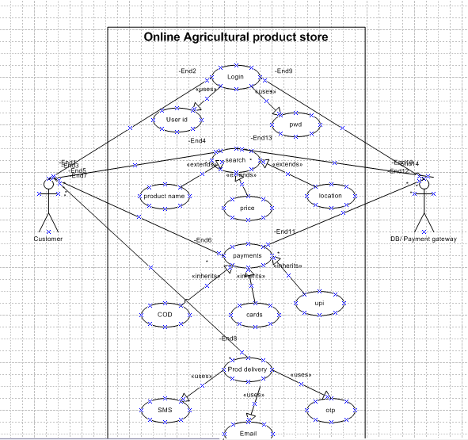

**Question 11 – (minimum 5) Use Case Specs**

**Prepare use case specs for all use cases?**

|  |  |  |  |
| --- | --- | --- | --- |
| **Use Case ID** | UC001 | | |
| **Use Case Name** | This shows how the user can buy Agriculture product from this app | | |
| **Created By** | MR ABC | Last updated by | 04 Apr- 24 |
| **Date Created** | 25th mar-24 | Last Revision date | 01= Apr-24 |
| **Actor** | Customers/Farmers | | |
| **Description** | Describing how page should respond if there is no internet | | |
| **Pre- condition** | Farmers having an internet condition | | |
| **Post condition** | Success- farmers can place the order successfully  Failure-farmers unable to login | | |
| **Normal flow of events/ Basic flow/ Happy path** | The use case starts when the farmers do the registration with valid email and login, pwd.  Use case validate the user is performed.  Then farmers can view products, add to cart and place the order. | | |
| **Alternative Flow** | Invalid user: wrong a/c id; wrong pwd | | |
| **Exceptions** | If internet connection lost during activity, then display” check your connection” | | |
| **Frequency of use** | High | | |
| **Assumptions** | Assumed that the customer is registered and has computer knowledge | | |

|  |  |  |  |
| --- | --- | --- | --- |
| **Use Case ID** | UC002 | | |
| **Use Case Name** | This shows how the farmers can register on app | | |
| **Created By** | MR ABC | Last updated by | 05- Apr- 24 |
| **Date Created** | 26th mar-24 | Last Revision date | 02- Apr-24 |
| **Actor** | Customers/Farmers | | |
| **Description** | Describing how page should respond if they don’t put OTP for registration | | |
| **Pre- condition** | Farmers having an internet condition | | |
| **Post condition** | Success- farmers can register successfully  Failure-farmers unable to register are updated accordingly. | | |
| **Normal flow of events/ Basic flow/ Happy path** | The use case starts when the farmers do the registration with valid email and login, pwd.  Then farmers can register using OTP. | | |
| **Alternative Flow** | Incorrect OTP, No successful authentication | | |
| **Exceptions** | If internet connection lost during activity, then display” check your connection” | | |
| **Frequency of use** | High | | |
| **Assumptions** | Assumed that the customer has an email id and mobile for authentication | | |

|  |  |  |  |
| --- | --- | --- | --- |
| **Use Case ID** | UC003 | | |
| **Use Case Name** | This shows how sellers can upload the products in app | | |
| **Created By** | MR ABC | Last updated by | 06- Apr- 24 |
| **Date Created** | 27th mar-24 | Last Revision date | 03- Apr-24 |
| **Actor** | Sellers/dealers | | |
| **Description** | Describing how to upload the new product details | | |
| **Pre- condition** | Sellers have basic technical knowledge and an internet condition | | |
| **Post condition** | Success- sellers can upload product description successfully  Failure-sellers unable to upload products accordingly. | | |
| **Normal flow of events/ Basic flow/ Happy path** | The use case starts when the sellers login with email and login, pwd.  Then sellers can login using OTP.  Sellers then upload the products | | |
| **Alternative Flow** | Sellers can login using OTP.  Sellers can upload products | | |
| **Exceptions** | If internet connection lost during activity, then display” check your connection” | | |
| **Frequency of use** | High | | |
| **Assumptions** | Assumed that sellers have details about their products | | |

|  |  |  |  |
| --- | --- | --- | --- |
| **Use Case ID** | UC004 | | |
| **Use Case Name** | This shows how the farmers can add products to cart. | | |
| **Created By** | MR ABC | Last updated by | 07- Apr- 24 |
| **Date Created** | 28th mar-24 | Last Revision date | 04- Apr-24 |
| **Actor** | Customers/Farmers | | |
| **Description** | Describing how to purchase products. | | |
| **Pre- condition** | Farmers having basic technical knowledge & an internet condition | | |
| **Post condition** | Success- farmers can add products to cart successfully  Failure-farmers unable to add products. | | |
| **Normal flow of events/ Basic flow/ Happy path** | Farmers search for desired products and browse.  Farmers select desired quantity and no of items and add to cart. | | |
| **Alternative Flow** | Farmers can directly add products to cart from their past purchase. | | |
| **Exceptions** | If internet connection lost during activity, then display” check your connection” | | |
| **Frequency of use** | High | | |
| **Assumptions** | Assumed that farmers have basic knowledge of browsing the products. | | |

|  |  |  |  |
| --- | --- | --- | --- |
| **Use Case ID** | UC005 | | |
| **Use Case Name** | This shows how the farmers can initiate refund/return. | | |
| **Created By** | MR ABC | Last updated by | 08- Apr- 24 |
| **Date Created** | 29th mar-24 | Last Revision date | 05- Apr-24 |
| **Actor** | Customers/Farmers | | |
| **Description** | Describing how to initiate refund and return. | | |
| **Pre- condition** | Farmers having an internet condition | | |
| **Post condition** | Success- farmers can initiate refund.  Failure-farmers unable to initiate refund. | | |
| **Normal flow of events/ Basic flow/ Happy path** | Farmers go to purchase history and initiate refund/return.  Farmers then select reason for return and agree T&C. | | |
| **Alternative Flow** | Farmers can get refund added to their wallet. | | |
| **Exceptions** | If internet connection lost during activity, then display” check your connection” | | |
| **Frequency of use** | High | | |
| **Assumptions** | Assumed that the farmers have basic knowledge of products. | | |

**Question 12 – (minimum 5) Activity Diagrams**

**Activity diagrams:**

**Answer**:

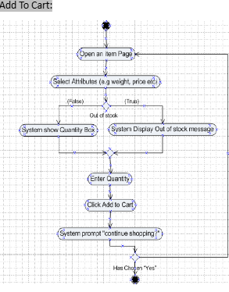

Payment:

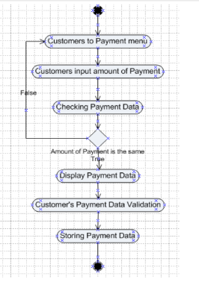

Delivery boy:

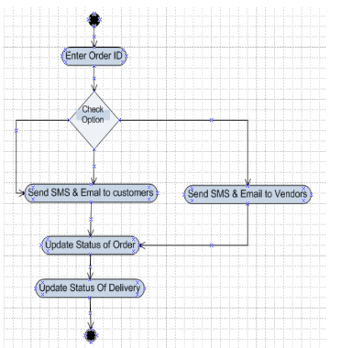

Customer login:

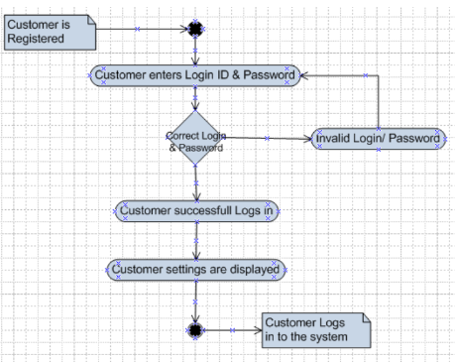

Return:

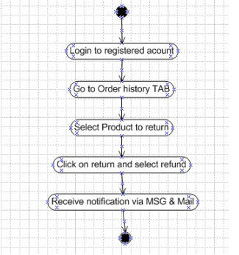

Business Stakeholders:

•Business Sponsor - Mr. Henry

•Influencers - Peter, Kevin and Ben.

•Finance team - Mr Pandu

•Project Team - Mr Dooku

Business Stakeholders:

•Business Sponsor - Mr. Henry

•Influencers - Peter, Kevin and Ben.

•Finance team - Mr Pandu

•Project Team - Mr Dooku

Business Stakeholders:

•Business Sponsor - Mr. Henry

•Influencers - Peter, Kevin and Ben.

•Finance team - Mr Pandu

•Project Team - Mr Dooku