Capstone Project 3

**Question 1** – Functional Requirements - 15 Marks

Identify minimum 20 functional requirements

Example:

Functional requirement: When an order is fulfilled, the local printer shall print a packing slip.

Non-Functional Requirement: Packing slips shall be printed on both sides of 4”x 6” white paper, the standard size for packing slips used by local printers.

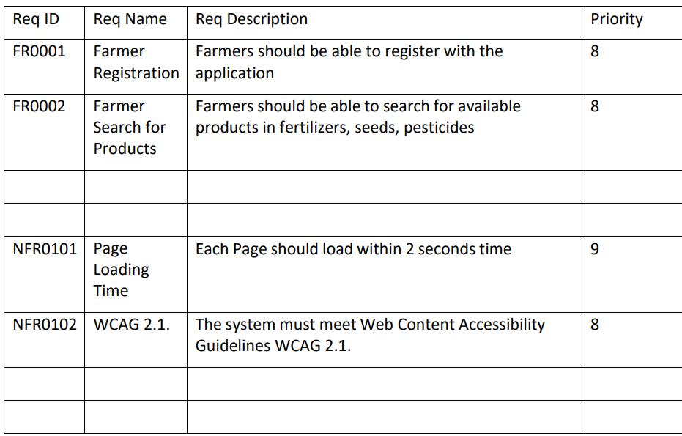

**Answer:**

Functional Requirement are specific behaviour of a system when user performs any action in the webpage/mobile application which is eventually the goal/objective of the project and nonfunctional requirements will support to the functional requirement.

Some of the top functional and nonfunctional requirement are:

|  |  |  |  |
| --- | --- | --- | --- |
| **Functional Requirements** | | |  |
| **Req ID** | **Req Name** | **Req Description** | **Priority** |
| FR001 | Login/Signup registration | All user to have their unique email ID and password for login the application | 1 |
| FR002 | Search Bar | A search bar at the top of the home page to type and search any product available | 2 |
| FR003 | Product Description | User can click on "view detailed description" to view the whole information related to the searched product | 3 |
| FR004 | Multiple Product Pictures | User can swipe right or left to view multiple images of the product/detailing | 4 |
| FR005 | Product Sharing Option | User can click on share button to share the available product to anyone | 5 |
| FR006 | Add quantities of a product | User can add the number of quantities which is required by clicking on add option that number of time and the quantity number will be mentioned | 6 |
| FR007 | Decrease quantities of a product | User can decrease the number of quantities which is required by clicking on "-" button option that number of time and the final quantity number will be mentioned there after | 7 |
| FR008 | Adding to Cart | User can click the add to cart button after the desired number of quantities are finalised | 8 |
| FR009 | Payment Procedure | User click Proceed payment and can choose the method of payment like COD, Credit Card, NEFT, UPI etc. and enter respective credentials later which it will be redirected to payment gateway for completing the payment (excl COD) | 9 |
| FR010 | Order Tracking | User will get Order ID along with the tracking option, real time status on the order and expected delivery date post payment confirmation | 10 |
| **Non-Functional Requirements** | | |  |
| NFR001 | User Auth | System will ensure user authentication as soon as the user clicks on add to cart without login | 4 |
| NFR002 | Compatibility | Website compatibility in all the browsers like google, Edge and Safari along with mobile application support | 3 |
| NFR003 | Response time | system to respond on any clicks by user in the website within 2 - 3 seconds | 5 |
| NFR004 | Security Assurance | System must be end to end encrypted for safe usage and trust | 2 |
| NFR005 | Adherence to applicable law | Website will comply to all guidelines as per the applicable law | 1 |
| NFR006 | Payment Gateway Collaboration | collaborate with all major payment gateway for seamless online transitions | 7 |
| NFR007 | Redirection to order summary page | System to redirect to home webpage order summary along with the order ID and the delivery status post successful transaction | 8 |
| NFR008 | Standard Order packaging | All the confirmed orders will be given standard packaging as per the packaging guidelines and address will be printed on the parcel package | 10 |
| NFR009 | Order Tracking | Third party to update the status of the order and shall be updated to the website for end user to track | 9 |
| NFR010 | Location pin | The location will be auto pinned after user authentication by the website when customer books the order for seamless delivery | 6 |

**Question 2**–Minimum 5 page designs - 15 Marks

Make wireframe and prototypes

**Answer:**

Wireframes will help us to understand how client require their webpage layout. These are important for BAs. This will just have the page layout on buttons, Logo and other details in black and white format only. However, prototyping are like dummy GUI along with real images/colour, operational button and links by perform actions.

1. Login

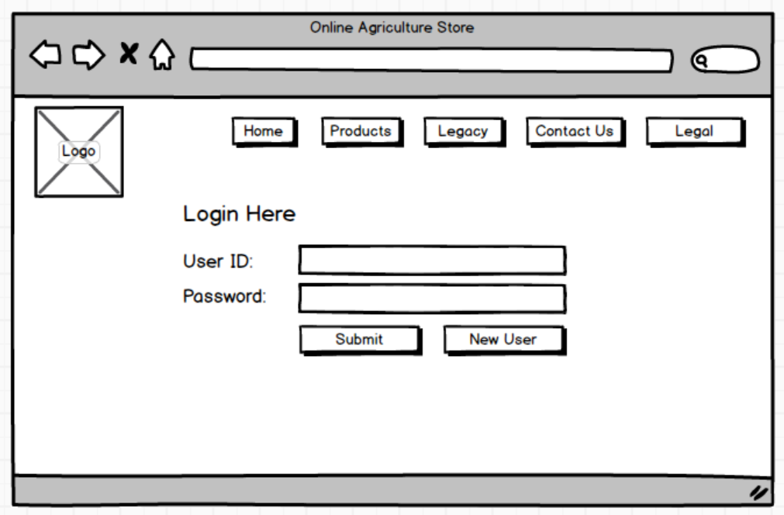

1. SignUp

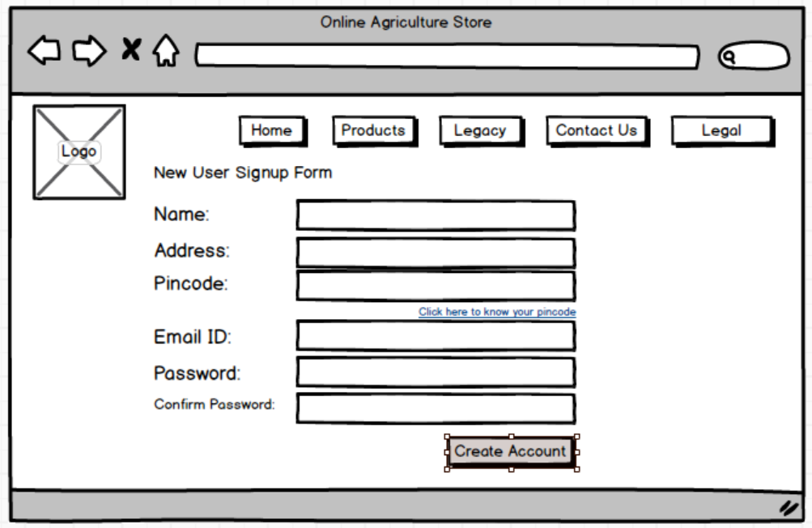

1. Search Option

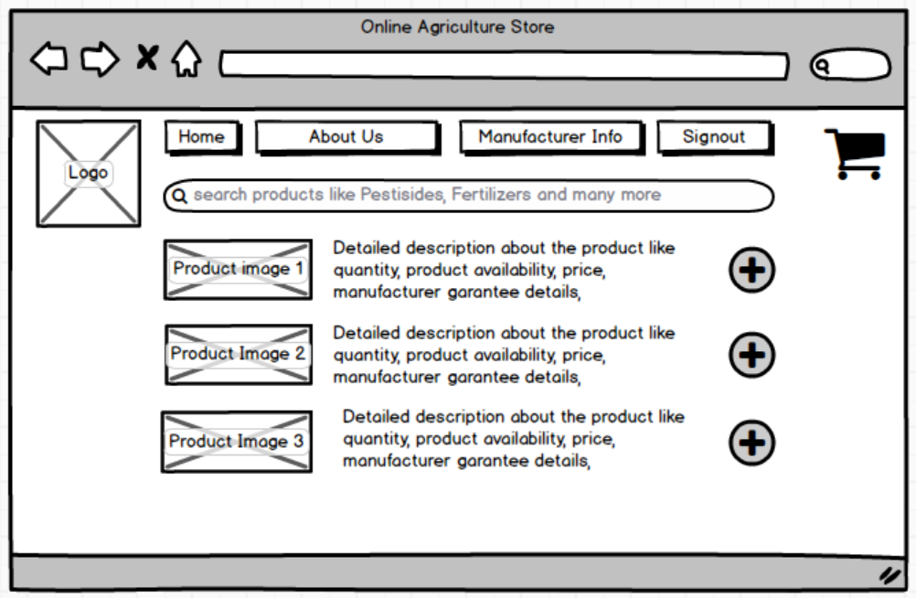

1. Order Summary

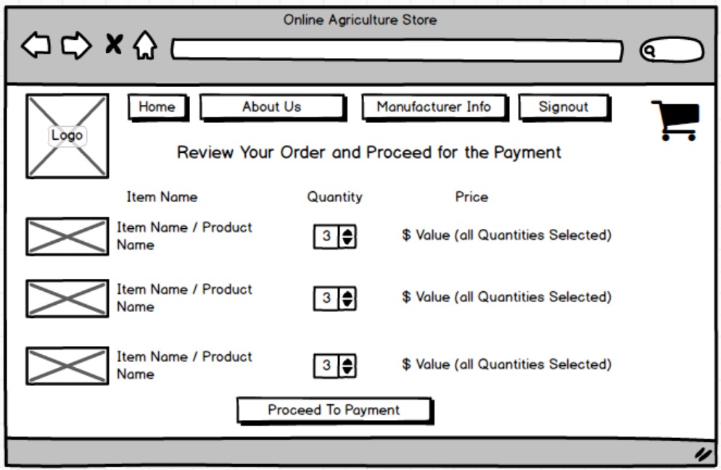

1. Payment

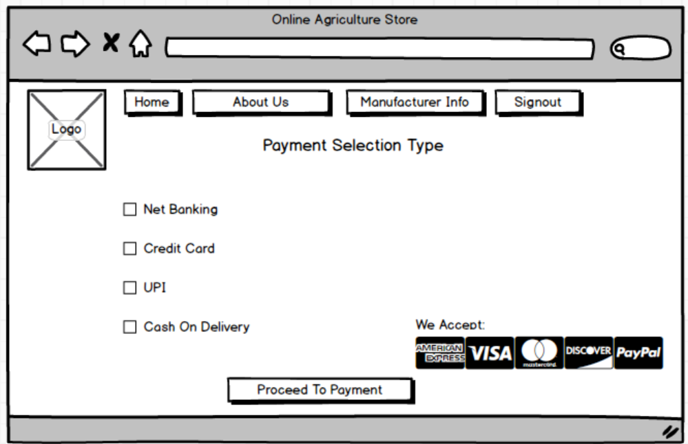

**Question 3** – Tools (Visio, Balsamiq) - 15 Marks

Make a note of the Tools, which you are using for above concepts.

**Answer:**

**Visio:**

MS Visio helps us to understand the overall process/scope of the project with the help of UML diagrams. We have Use case and activity UML diagrams and few others. Off which,

**Use case** help us to understand the whole process of the project in a simple format with primary actor and secondary actor and its data base.

**Activity diagrams** help us to understand the business logic to be applied in each stage/page of the application using decision box, fork and join, branch and merge etc.

**Balsamiq:**

This is a wireframing tool helps us to create mock-ups for the web application. With just black and white image boxes which help us to define each page layout which client is agreed upon like where the Logo should be placed in the webpage, where can be Home button be available, how can a user login with what details. Samples are given in detail in Question 2. These are just the layout with non-operational button, text, dropdown etc. whatever it is used.

**Axure:**

This is an advanced prototyping tool wherein we can update the page layout of a webpage as well as mobile application screens. These can also be used as a dummy webpage along with the flow of the website which means the tools we use can be operated. These can also have real images of client Logos, actual product of any item, etc.

**Question 4** – RTM - 6 Marks

A business analyst’s key responsibilities are to keep track of the requirements and make sure that no requirement is missed.

Mr. Henry and peter have approached you regarding the current status of the project. How will you tackle this situation?

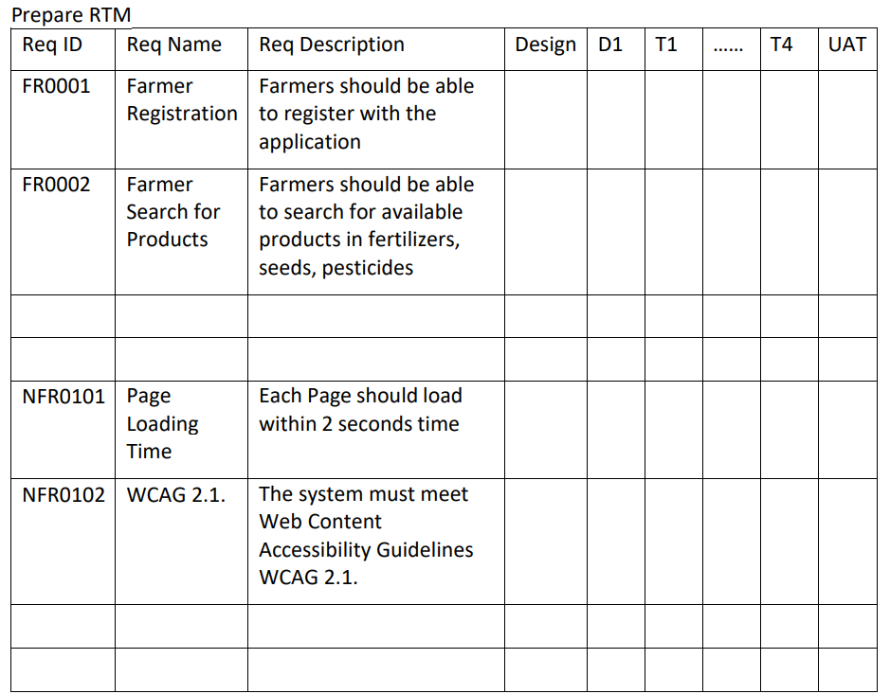

**Answer:**

RTM is Requirement Traceability Matrix. This is very important for us because it has the status of each requirement and its phase that they are currently into. And this is overlooked throughout the project cycle.

|  |  |  |  |  |  |  |  |  |
| --- | --- | --- | --- | --- | --- | --- | --- | --- |
| **Req ID** | **Req Name** | **Req Description** | **Priority** | **Design** | **Development** | **Testing** | **UAT** | **SignOff** |
| FR001 | Login/Signup registration | All user to have their unique email ID and password for login the application | 1 | Completed | Completed | Completed | Completed | Approved |
| FR002 | Search Bar | A search bar at the top of the home page to type and search any product available | 2 | Completed | Completed | Completed | Completed | Approved |
| FR003 | Product Description | User can click on "view detailed description" to view the whole information related to the searched product | 3 | Completed | Completed | Completed | CR Raised | Pending |
| FR004 | Multiple Product Pictures | User can swipe right or left to view multiple images of the product/detailing | 4 | Completed | Completed | Completed | InProgress | Pending |
| FR005 | Product Sharing Option | User can click on share button to share the available product to anyone | 5 | Completed | Completed | Pending | Pending | Pending |
| FR006 | Add quantities of a product | User can add the number of quantities which is required by clicking on add option that number of time and the quantity number will be mentioned | 6 | Completed | Completed | InProgress | Pending | Pending |
| FR007 | Decrease quantities of a product | User can decrease the number of quantities which is required by clicking on "-" button option that number of time and the final quantity number will be mentioned there after | 7 | Completed | Completed | InProgress | Pending | Pending |
| FR008 | Adding to Cart | User can click the add to cart button after the desired number of quantities are finalised | 8 | Completed | Completed | Pending | Pending | Pending |
| FR009 | Payment Procedure | User click Proceed payment and can choose the method of payment like COD, Credit Card, NEFT, UPI etc. and enter respective credentials later which it will be redirected to payment gateway for completing the payment (excl COD) | 9 | Completed | InProgress | Pending | Pending | Pending |
| FR010 | Order Tracking | User will get Order ID along with the tracking option, real time status on the order and expected delivery date post payment confirmation | 10 | Completed | InProgress | Pending | Pending | Pending |
| NFR001 | User Auth | System will ensure user authentication as soon as the user clicks on add to cart without login | 4 | Completed | Completed | Completed | Completed | Approved |
| NFR002 | Compatibility | Website compatibility in all the browsers like google, Edge and Safari along with mobile application support | 3 | Completed | Completed | InProgress | Pending | Pending |
| NFR003 | Response time | system to respond on any clicks by user in the website within 2 - 3 seconds | 5 | Completed | Completed | Completed | InProgress | Pending |
| NFR004 | Security Assurance | System must be end to end encrypted for safe usage and trust | 2 | Completed | Completed | Completed | Completed | Approved |
| NFR005 | Adherence to applicable law | Website will comply to all guidelines as per the applicable law | 1 | Completed | Completed | Completed | Completed | Approved |
| NFR006 | Payment Gateway Collaboration | collaborate with all major payment gateway for seamless online transitions | 7 | Completed | Completed | InProgress | Pending | Pending |
| NFR007 | Redirection to order summary page | System to redirect to home webpage order summary along with the order ID and the delivery status post successful transaction | 8 | Completed | Completed | Pending | Pending | Pending |
| NFR008 | Standard Order packaging | All the confirmed orders will be given standard packaging as per the packaging guidelines and address will be printed on the parcel package | 10 | Completed | Completed | Pending | Pending | Pending |
| NFR009 | Order Tracking | Third party to update the status of the order and shall be updated to the website for end user to track | 9 | Completed | Completed | Pending | Pending | Pending |
| NFR010 | Location pin | The location will be auto pinned after user authentication by the website when customer books the order for seamless delivery | 6 | Completed | Completed | InProgress | Pending | Pending |

**Question 5** – 10 Test Case Documents - 10 Marks

Prepare 10 Test Case Documents

**Answer:**

Test case documents are generally prepared by the software tester after the development of a webpage is completed. Only successful test case can be taken ahead for UAT or it needs to be reworked until the test case passes the criteria. Some of them can be as below:

1. Login:

|  |  |  |  |
| --- | --- | --- | --- |
| **Date** | MM/DD/YYYY | | |
| **Testcase ID** | 123 | **Tester Name** | XXX |
| **Project ID** | 1000123 | **Project Name** | Online Agriculture Store |
| **PM ID** | 0 | **PM Name** | YYY |
| **Webpage Link** | <https://onlineagriculture.co.in/Login>/ | | |
| **Scenario** | User must be able to login the application | | |
| **Input Data** | Provided multiple unique dummy Email ID and Password | | |
| **Behaviour** | None | | |
| **Comments** | Successful login to online store home page | | |
| **Result** | PASS | | |

1. SignUp:

|  |  |  |  |
| --- | --- | --- | --- |
| **Date** | MM/DD/YYYY | | |
| **Testcase ID** | 124 | **Tester Name** | XXY |
| **Project ID** | 1000123 | **Project Name** | Online Agriculture Store |
| **PM ID** | 0 | **PM Name** | YYY |
| **Webpage Link** | <https://onlineagriculture.co.in/signup>/ | | |
| **Scenario** | User must be able to sign the application for the first time | | |
| **Input Data** | Provided multiple unique dummy name, address, pincode, email ID and password | | |
| **Behaviour** | Password reconfirmation does not read the actual password entered | | |
| **Comments** | Unable to create new accounts | | |
| **Result** | FAIL | | |

1. Adding products to the cart:

|  |  |  |  |
| --- | --- | --- | --- |
| **Date** | MM/DD/YYYY | | |
| **Testcase ID** | 125 | **Tester Name** | XYY |
| **Project ID** | 1000123 | **Project Name** | Online Agriculture Store |
| **PM ID** | 0 | **PM Name** | YYY |
| **Webpage Link** | <https://onlineagriculture.co.in/home/viewprodcuts>/ | | |
| **Scenario** | User must be able to add products to the cart and go to cart page | | |
| **Input Data** | logged in to the account > searched the product from the search bar > selected the product > clicked on Add to cart > clicked on go to cart | | |
| **Behaviour** | None | | |
| **Comments** | Successfully able to add the products to the cart and cart page | | |
| **Result** | PASS | | |

1. Search the products:

|  |  |  |  |
| --- | --- | --- | --- |
| **Date** | MM/DD/YYYY | | |
| **Testcase ID** | 126 | **Tester Name** | YYY |
| **Project ID** | 1000123 | **Project Name** | Online Agriculture Store |
| **PM ID** | 0 | **PM Name** | YYY |
| **Webpage Link** | <https://onlineagriculture.co.in/home/> | | |
| **Scenario** | User must be able to search the products online | | |
| **Input Data** | logged in to the account > searched the product from the search bar | | |
| **Behaviour** | Multiple products visible when searched and the correct product displayed at the top | | |
| **Comments** | Successfully able search the products | | |
| **Result** | PASS | | |

1. Search non available product:

|  |  |  |  |
| --- | --- | --- | --- |
| **Date** | MM/DD/YYYY | | |
| **Testcase ID** | 127 | **Tester Name** | YXX |
| **Project ID** | 1000123 | **Project Name** | Online Agriculture Store |
| **PM ID** | 0 | **PM Name** | YYY |
| **Webpage Link** | <https://onlineagriculture.co.in/home/> | | |
| **Scenario** | User must be able to get popup on product non availability | | |
| **Input Data** | logged in to the account > searched the product from the search bar > Products displayed differently | | |
| **Behaviour** | Multiple products were displayed and no status on searched product name | | |
| **Comments** | unable to get the popup on nonproduct availability | | |
| **Result** | FAIL | | |

1. Multiple quantities of product

|  |  |  |  |
| --- | --- | --- | --- |
| **Date** | MM/DD/YYYY | | |
| **Testcase ID** | 128 | **Tester Name** | YYX |
| **Project ID** | 1000123 | **Project Name** | Online Agriculture Store |
| **PM ID** | 0 | **PM Name** | YYY |
| **Webpage Link** | <https://onlineagriculture.co.in/home/viewproducts/cart> | | |
| **Scenario** | User must be able add the number of products from cart page | | |
| **Input Data** | logged in to the account > searched the product from the search bar > products produced > added product to cart > went cart Page > added multiple quantities of same product | | |
| **Behaviour** | Able to add multiple number of same product quantities | | |
| **Comments** | No max limit of quantity mentioned or no max limit accepted from manufacturer mentioned | | |
| **Result** | FAIL | | |

1. Payment Selection Mode

|  |  |  |  |
| --- | --- | --- | --- |
| **Date** | MM/DD/YYYY | | |
| **Testcase ID** | 130 | **Tester Name** | YYY |
| **Project ID** | 1000123 | **Project Name** | Online Agriculture Store |
| **PM ID** | 0 | **PM Name** | YYY |
| **Webpage Link** | <https://onlineagriculture.co.in/home/viewproducts/cart/paymentsummary> | | |
| **Scenario** | User must be able select the payment type and hit payment gateway | | |
| **Input Data** | logged in to the account > searched the product from the search bar > products produced > added product to cart > went cart Page > added multiple quantities of same product > Payment Method > clicked Net Banking > selected Bank from Dropdown Lists > clicked proceed > page landed on new banking login screen | | |
| **Behaviour** | No | | |
| **Comments** | successfully able go to net banking login screen | | |
| **Result** | PASS | | |

1. Order ID generation

|  |  |  |  |
| --- | --- | --- | --- |
| **Date** | MM/DD/YYYY | | |
| **Testcase ID** | 131 | **Tester Name** | ZZZ |
| **Project ID** | 1000123 | **Project Name** | Online Agriculture Store |
| **PM ID** | 0 | **PM Name** | YYY |
| **Webpage Link** | <https://onlineagriculture.co.in/home/ordersummary> | | |
| **Scenario** | User must be able select get the order ID | | |
| **Input Data** | logged in to the account > searched the product from the search bar > products producsed > added product to cart > went cart Page > added multiple quantities of same product > Payment Method > clicked Net Banking > selected Bank from Dropdown Lists > clicked proceed > page landed on new banking login screen > rerouted to Home webpage after transaction > Order ID generated | | |
| **Behaviour** | No | | |
| **Comments** | successfully able go to generate order ID | | |
| **Result** | PASS | | |

1. Order Tracking

|  |  |  |  |
| --- | --- | --- | --- |
| **Date** | MM/DD/YYYY | | |
| **Testcase ID** | 131 | **Tester Name** | ZZZ |
| **Project ID** | 1000123 | **Project Name** | Online Agriculture Store |
| **PM ID** | 0 | **PM Name** | YYY |
| **Webpage Link** | <https://onlineagriculture.co.in/home/ordersummary> | | |
| **Scenario** | User must be able Track the oder with order ID | | |
| **Input Data** | logged in to the account > profile tab > order Tracking | | |
| **Behaviour** | Unable to land to order tracking page | | |
| **Comments** | error occurred while clicking on track order as "404 Error - Page Not Found" | | |
| **Result** | FAIL | | |

1. Retest of Order ID tracking

|  |  |  |  |
| --- | --- | --- | --- |
| **Date** | MM/DD/YYYY | | |
| **Testcase ID** | 131.1 | **Tester Name** | ZZZ |
| **Project ID** | 1000123 | **Project Name** | Online Agriculture Store |
| **PM ID** | 0 | **PM Name** | YYY |
| **Webpage Link** | <https://onlineagriculture.co.in/home/ordersummary> | | |
| **Scenario** | User must be able Track the oder with order ID | | |
| **Input Data** | logged in to the account > profile tab > order Tracking | | |
| **Behaviour** | successfully able to track the order status | | |
| **Comments** | no error | | |
| **Result** | PASS | | |

**Question 6** – DB Design – 8 Marks

After the requirements are thoroughly explained to the entire project team by business analyst, the Database architects have decided to do the database design and also to represent the in-flow and out-flow of data.

Draw database schema and ER diagram

**Answer:**

**DB Schema** is a blueprint of a data base structure which contain data tables, unq ID, and their relationships

**ERD or Entity relationship diagram** are visual representation of a relationship between the entities of a data tables.

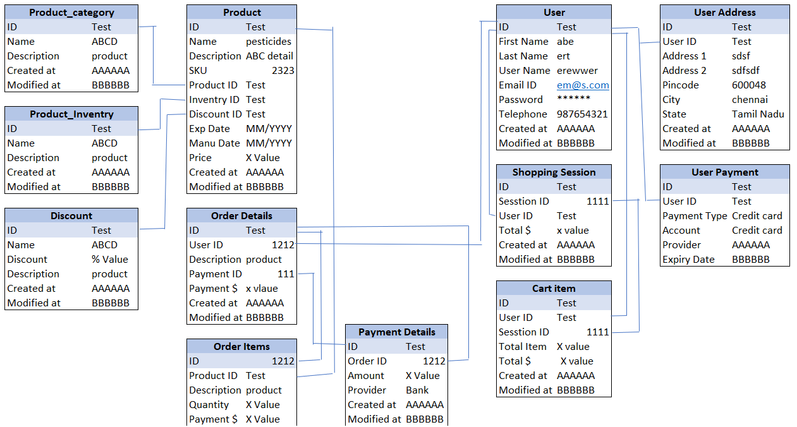

**Question 7** – Data Flow Diagram - 3 Marks

What is a data flow diagram? Draw a data flow diagram to represent the in-flow and out-flow of data when a Farmer is placing an order for the product

**Answer:**

Data Flow Diagram or DFD help stakeholder to understand how the data flows from the system and show the output of a desired product searched. It also shows how the data are stored.

DFD for Placing an order

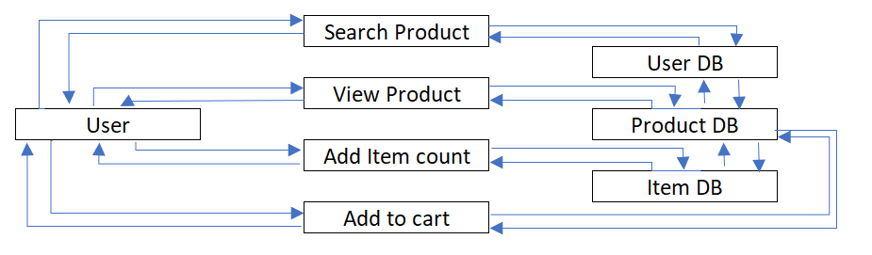

**Question 8** – Change Request - 10 Marks

Due to change in the Government Taxation structure.

we should change the Tax structure How do you handle change requests in a project?

**Answer:**

Change requests are comes in place when client requested to change some of the requirements or upgrade requirement based on their need like altering the existing process in a project. These can also be on 3rd party stake holders like in this case for change in Government Taxation structure.

1. We will understand the change request (CR) from respective stakeholder and document it in the CR form.
2. We do impact analysis on –
   1. Project scope – we study if we have impact/change on the objective of the project. In this scenario, there is no scope change in the project as this is a change in taxation structure only.
   2. Timelines – we analyse if we have any timeline issue due to this change. In this scenario, we would need detailed analysis on new taxation method with SMEs like CA resource to understand and imply the change in the project and decide accordingly.
   3. Budget – we analyse if there is an impact in cost to the company due to this CR. In this scenario, we need SME in CA or who purely understands the government taxation structure and its related documents. The resource would be available within organisation and save resource costs. however, there may be additional cost for understanding the new taxation structure and their related documents to inherit in the system.
   4. Resource - we analyse if we need any additional resource due to this change request or can handle with existing resource. In this case, we will have SMEs on CA who can understand the government taxation hence no additional resource required.
   5. Risk – on overall we analyse to see if there are any external or internal risks affecting the project overall.
3. We prioritise the CR based on the urgency / importance and impact on the project. In this scenario, as there is a change in government taxation structure, this will be the top most priority to complete as early as possible.
4. We get approval from project lead/head and then produce to project sponsor for approval along with all the above details and get formal approval via email.
5. We finally communicate the CR to all the stakeholders including the project team about the change and its importance.

**Question 9** – Change Request Vs an Enhancement - 5 Marks

As the project is in process, Ben and Kevin have contacted you. The reason is to inform you that they want the Farmers to sell their crop yields through this application i.e. Farmers should be able to add their crop yields or products and display to general public and should be able to sell them. They also want to introduce Auction system for their Crop yields. As a BA, what will be your response?

Is this a change request or an enhancement???

**Answer:**

This this an enhancement request as Ben and Kevin has requested to add new features like selling corps by introducing auction systems.

As a BA, we need to take this enhancement from the initial stage, like documenting requirement and analysing it, then take to the feasibility study on these new requirements along with the impact on the new features if any. We then take this to development team as well for adding this enhancement.

We will analyse cost, benefit or risks involved to this new ask and document it for the client. Then we take all these inputs to the client and take their concurrence to proceed with this enhancement.

**Question 10** – Estimations - 6 Marks

Come up with estimations – How many Manhours required

**Answer:**

Man hours are calculated in 3 types

1. Small – 500 hours
2. Medium – 1000 hours
3. Large – 1500 hours

For this project, we have a team of 11 members for 18 months of project time.

|  |  |
| --- | --- |
| Months | 18 |
| Members | 11 |
| hours per member | 8 |
| Hours per day as team | 88 |
| Total Hours required | 3168 |

*Considering 22 business days in a month

As we need more than 3000 hours, this will be called as a large project. The trained resources are already available in the organization so no additional trainer is required. Additionally, we have a team already set on board hence no new org structure required.

**Question 11** – UAT – 6 Marks

Project has finally completed all the stages i.e., design, development, testing etc. Now, it is the role of a business analyst to contact the client for testing of the final product and have to successfully complete it. How are you going to handle this situation? And once it is done, what will be the process to close the project?

Explain UAT Acceptance process

**Answer:**

**Planning:** With this step, we plan the implementation of UAT for each and every page and features so that the UAT goes smooth. A document on this UAT testing will be provided to fill in at the time of UAT.

**Designing:** the system is designed purely for UAT here and hence all the software packages and other real world auth will be hidden.

**UAT Tester:** these are typically the end users who have the knowledge of using the system and well know about the functionalities and its feature and ensure that all these are documents at each stage.

**Bug Fixing:** at the time of UAT, if any bugs identified then the development team should be available to fix the bug immediately and ensure the software runs error free operation.

**Signoff:** after all the successful processes above, we will fix a formal meeting with all the stakeholders and formalise the final product of the “Online Agriculture Store”. Here all stakeholder will come to the conclusion for Go Live and sign off is required.

**Question 12** – Project Closure Document - 6 Marks

Explain Project closure document

**Answer:**

Project closure document is a formal document which summarise the project from the start till end which includes key outcome, lesson learnt etc.

This is also a comprehensive report which will help the stakeholder to make use for these documents for their future projects.

Points covered in this document are:

1. Project overview
2. Achievements
3. Lesson learnt
4. Quality assurance
5. Cost used
6. Resource utilization
7. Risk management
8. Challenges

Each of these points have their detailed inputs accordingly for future references.