**6. Use Case Diagram**

Activity Diagram : 1 Login and Update Customer Address.



Activity 2- Customer Purchase Insurance

Activity 3- Customer request for ATM card Block



Activity 4- Customer request for New ATM card.

**Use Case Specification Document**

|  |  |
| --- | --- |
| **Use Case ID** | **UC001** |
| **Case Name** | Employee Log In |
| **Primary Actor** | Employee |
| **Basic Flow** | User Will enter his Employee ID & Password  User will get OTP in e-mail and mobile  User will enter the OTP  User will be able to Login |
| **Alternate Flow** | User will Click on Forgot Password Link  User will be Temporary Password in e-mail and Mobile No  User will enter Employee Id and Temporary password  User will set new Password  User Will enter his Employee ID & Password  User will get OTP in e-mail and mobile  User will enter the OTP  User will be able to Login |
| **Exceptional Flow** | User will enter wrong OTP  System will display error message |
| **Pre Conditions** | User Should be an Employee with Employee ID  User should have a registered e-mail id and mobile no.  User should be onboarded in CRM application |
| **Post Conditions** | User will be logged in |
| **Assumptions** | User Should be an Employee with Employee ID  User should have a registered e-mail id and mobile no.  User is onboarded in CRM application |
| **Constraints** | Username can only be Employee ID |
| **Dependencies** | User should have a valid Employee id and registered e-mail id and mobile number in Banks database. |
| **Inputs** | Employee ID, Password and OTP |
| **Outputs** | User will be logged in |
| **Business Rules** | User should be an Authorized Employee with Employee ID |
| **Miscellaneous Information** | Login with 2 Factor Authentication |

|  |  |
| --- | --- |
| **Use Case ID** | **UC002** |
| **Case Name** | Update Customer Address |
| **Primary Actor** | Employee |
| **Basic Flow** | User will enter Customer ID  User will fetch Customer Details  User will select Address Tab  User will update Address  Address updated successfully |
| **Alternate Flow** | User will be able to check address change request received in the app  User will check the address proof submitted and accept the new address details  Address is updated successfully. |
| **Exceptional Flow** | User will enter wrong Customer ID  System will display Incorrect Customer Id |
| **Pre Conditions** | User Should have logged in  User should have a request from Customer to update address |
| **Post Conditions** | Customer Address should be Updated |
| **Assumptions** | User is successfully logged in  User has received a request from Customer for change of Address |
| **Constraints** | User should have a valid customer id |
| **Dependencies** | User should have a valid customer request |
| **Inputs** | Customer ID  Customer Address |
| **Outputs** | Updated Customer Address |
| **Business Rules** | User should be an Authorized Employee with Employee ID  User should have a valid request from the Customer |
| **Miscellaneous Information** | Address get Automatically updated in CBS and other apps. |

|  |  |
| --- | --- |
| **Use Case ID** | **UC003** |
| **Case Name** | Buy Customer Insurance Policy |
| **Primary Actor** | Employee |
| **Basic Flow** | User will Enter Customer ID  User will fetch Customer Details  User will Buy Insurance Policy from Insurance Tab  User Will select Policy Type, Term and Policy Amount  User will generate Premium  User will make Payment  System will Generate Policy Payment Details successfully. |
| **Alternate Flow** | User will fill insurance form manually  Send it to insurance division. |
| **Exceptional Flow** | User will enter wrong Customer ID  System will display Incorrect Customer Id |
| **Pre Conditions** | User should have a valid customer id  User should have a request from Customer of Purchase of Insurance |
| **Post Conditions** | Customer Insurance should be Purchased Successfully. |
| **Assumptions** | Customer is an existing Customer  Customer should have a valid Customer ID  User should have an application from Customer for Purchase of Insurance |
| **Constraints** | Customer is an existing Customer  Customer should have a valid Customer ID |
| **Dependencies** | User should have a request from Customer for Purchase of Insurance Product |
| **Inputs** | Customer ID  Type of Policy  Term  Amount of Policy |
| **Outputs** | Customer Insurance Policy Purchased successfully |
| **Business Rules** | User should be an Authorized Employee with Employee ID  User should have a valid insurance application form. |
| **Miscellaneous Information** | Insurance App is integrated with Cross selling application. |

|  |  |
| --- | --- |
| **Use Case ID** | **UC004** |
| **Case Name** | Block Customer ATM on Customer Request |
| **Primary Actor** | Employee |
| **Basic Flow** | Enter Customer Id  Fetch Customer Details  Fetch ATM Details  Select ATM Card  Select Block ATM  System displays Are you sure you want to Block Card?  User selects YES  ATM card Blocked successfully. |
| **Alternate Flow** | Customer will call helpline to Block ATM card |
| **Exceptional Flow** | User will enter incorrect customer ID  System will display ERROR |
| **Pre Conditions** | User should be logged in  Customer should have a valid ATM card |
| **Post Conditions** | ATM card Blocked successfully. |
| **Assumptions** | User is Logged in  Customer has a valid ATM card  User has received a request from Customer to Block Card |
| **Constraints** | Customer should have a Valid Card |
| **Dependencies** | User should have a valid request to Block the card |
| **Inputs** | Customer ID  Fetch ATM card |
| **Outputs** | ATM card Blocked successfully |
| **Business Rules** | User should be an Authorized Employee with Employee ID  User should have a valid card block request. |
| **Miscellaneous Information** | ATM channel site is integrated with CRM application |

|  |  |
| --- | --- |
| **Use Case ID** | **UC005** |
| **Case Name** | Apply New ATM card on Customer Request |
| **Primary Actor** | Employee |
| **Basic Flow** | Enter Customer Id  Fetch Customer Details  Select ATM Tab  Place New Card Request  System Displays Do you want to apply new Card?  User selects YES  ATM card request placed successfully. |
| **Alternate Flow** | Customer has to place an ATM request online. |
| **Exceptional Flow** | User will enter incorrect customer ID  System will display ERROR |
| **Pre Conditions** | User should be logged in  Customer should have a valid Customer ID  User should have received a request from Customer for New ATM card. |
| **Post Conditions** | ATM request placed successfully |
| **Assumptions** | Customer should have a valid Customer ID  User should have received a request from Customer for New ATM card. |
| **Constraints** | User should have a valid customer request from Customer |
| **Dependencies** | User should be logged in  Customer should have a valid customer ID |
| **Inputs** | Customer ID  Select New Card |
| **Outputs** | ATM card request placed successfully |
| **Business Rules** | User should be an Authorized Employee with Employee ID  User should have a valid card request form. |
| **Miscellaneous Information** | ATM channel site is integrated with CRM application |

**7.Screens and Pages**

1.Login

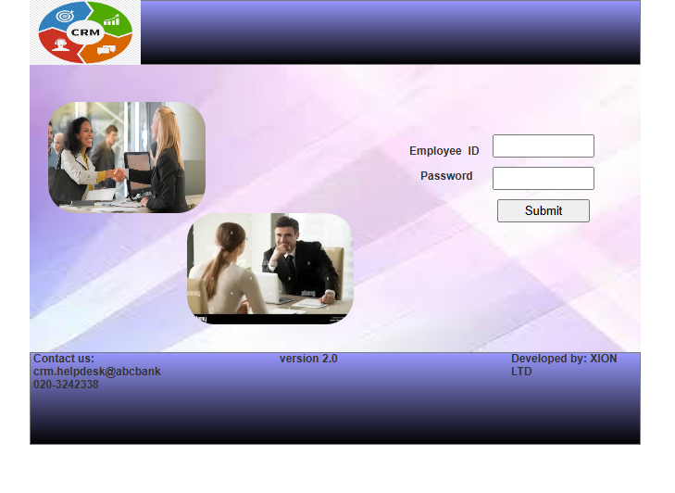

2. Factor Authentication- OTP screen

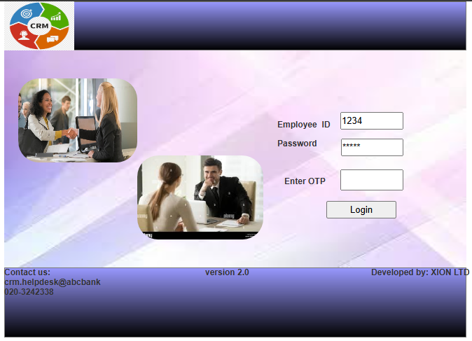

3. Home Page

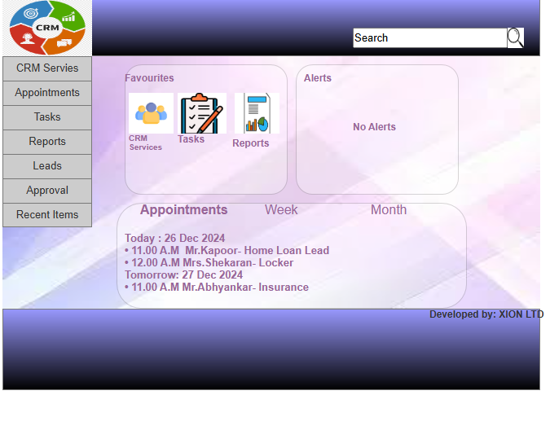

4. CRM Services Tab

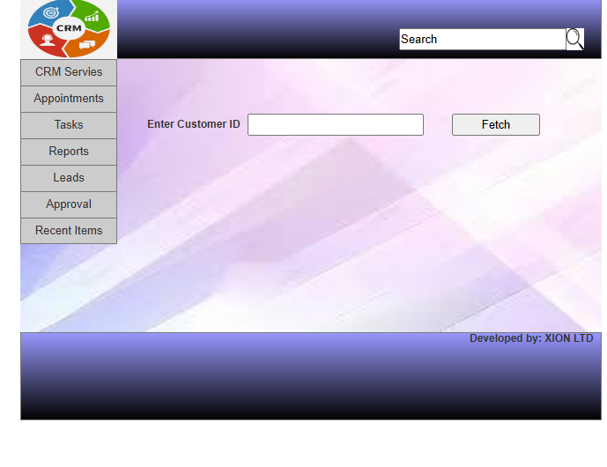

4. Fetch Customer Details

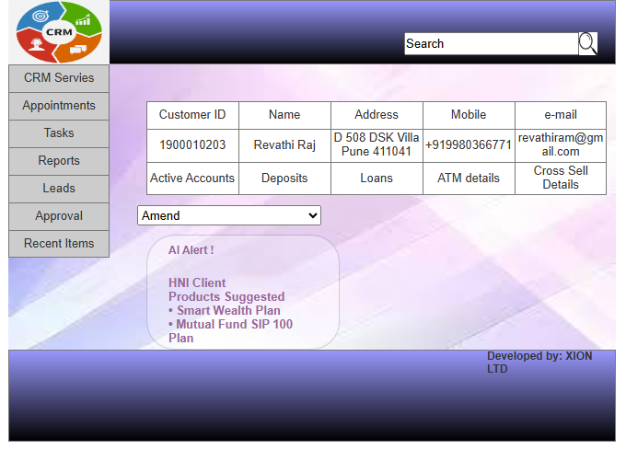

5.Udpdate Customer Address

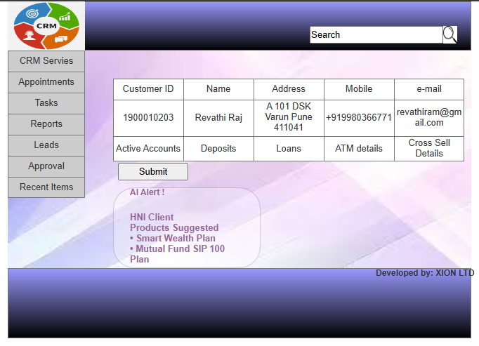

6.Address Updated Successful

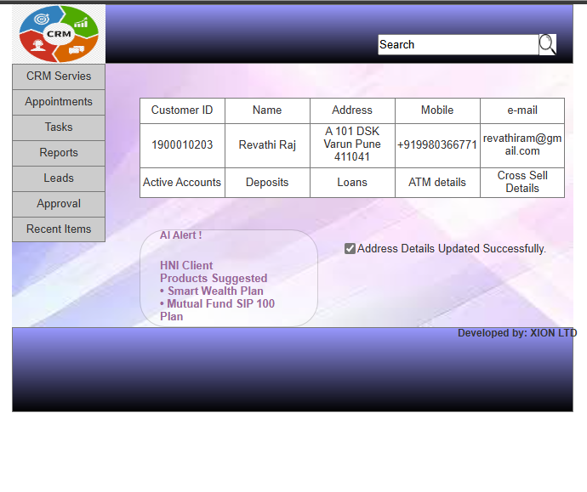

**Document 8- Write a paragraph on your experience using Visio and Axure for the project.**

In the project, I used Microsoft Visio to create Use Case Diagram and Activity Diagrams, which helped in clearly visualizing the system’s functional requirements and workflows. The Use case diagrams allowed me to map out the interactions between users and the systems, while the activity diagrams detailed the step-by step flow of the processes, helping to identify and refine key user journeys. For Wireframing, I turned to Axure for its design capabilities. Axure allowed me to structure and prototype the User interface effectively. Using Axure, I was able to create clear and intuitive wireframes that outlined the layout and interactions of the application, which helped in planning the user experience. The combination of Visio for process mapping and Axure for wireframing made the project planning phase much more structured and efficient.

**Document 9- BA experience**

My experience as a BA in the following phases:

**1.Requirement Gathering**

* I have used a combination of interviews, surveys, workshops and focus groups to gather both functional and non-functional requirements. I have also collected feedback on the CRM’s user experience.
* We have documented Business Goals, Constraints, Assumptions and Dependencies.
* The main challenges faced in the Phase was managing conflicting requirements from different stakeholders.
* Ensuring all requirements are clearly understood and agreed upon.
* Identifying hidden or implicit requirements.

**2.Requirement Analysis**

* We have used Use Case Diagrams, Process Flow Diagrams and Activity Diagrams to capture the requirements clearly.
* We have prioritized requirements based on Business Value, Feasibility and Risk. We have used the MoSCoW technique for this.
* We have Collaborated with the technical team (developers and architects) to ensure requirements are clear and technically feasible.
* We have used tools like Impact Analysis, SWOT analysis to define scope and MoSCoW for prioritization.
* Our goal was to ensure that all requirements are complete and actionable for the development team.

**3.Design**

* Collaborate with UI/UX designers and developers to define system architecture, data models, user interface and workflows.
* Create Wireframes, Data Flow Diagrams and UML diagrams to represent system designs.
* Review Design documents to align with Business Requirements
* Define technical requirements and Constraints with Design Team.
* Our goal was to ensure design solutions which are scalable, maintainable and user-friendly.

**4.Development-**

* We have worked closely with the development teams to clarify requirements during the development process.
* We have ensured that the development is progressing according to the defined specifications and requirements.
* We have addressed change requests and issues arising during Development.
* We have conducted regular meetings with the members of the Development team to tackle the issues they were facing with the requirements and come up with the solutions to streamline the process.
* Updating the members of the team about any changes in the project was done as and when required.
* We have faced challenges in ensuring timely and accurate delivery of the features without compromising quality

**5.Testing**

* We have collaborated with the QA team to prepare Test cases, acceptance criteria and test plans based on requirements.
* We have reviewed test results and identified any gaps or defects.
* We have ensured that all the stakeholders attend UAT to ensure system meets the Business requirements and needs.
* Manage and track the resolutions of any issues or bugs found during testing.
* Our goal was to ensure that all business scenarios are covered in testing.

**6.Deployment**

* Coordinate with operations, IT and other teams to ensure smooth deployment and migration.
* Ensure that any data migration, configuration settings and environment are handled correctly.
* Communicate with stakeholders about the release, including any new features. Big fixes and changes.
* Monitor the system post-deployment to ensure it works as expected and is performing well.