**Project Name: I-Connect**

**6. Use Case Diagram**

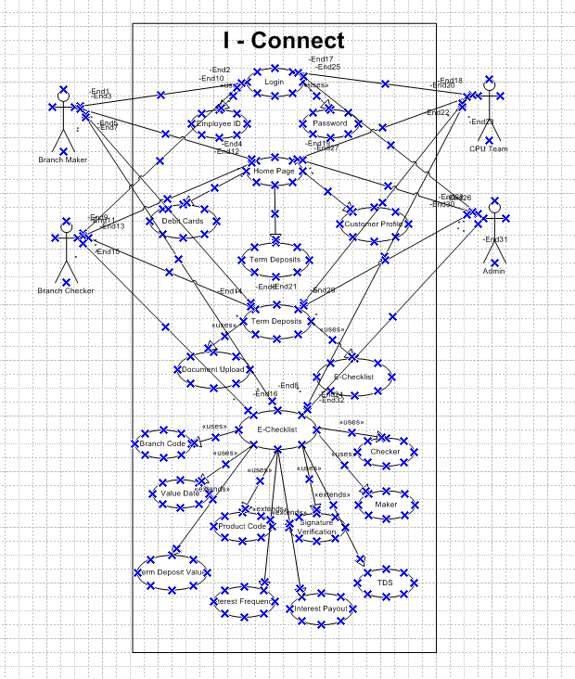

**Activity Diagram**

**Activity - Login**

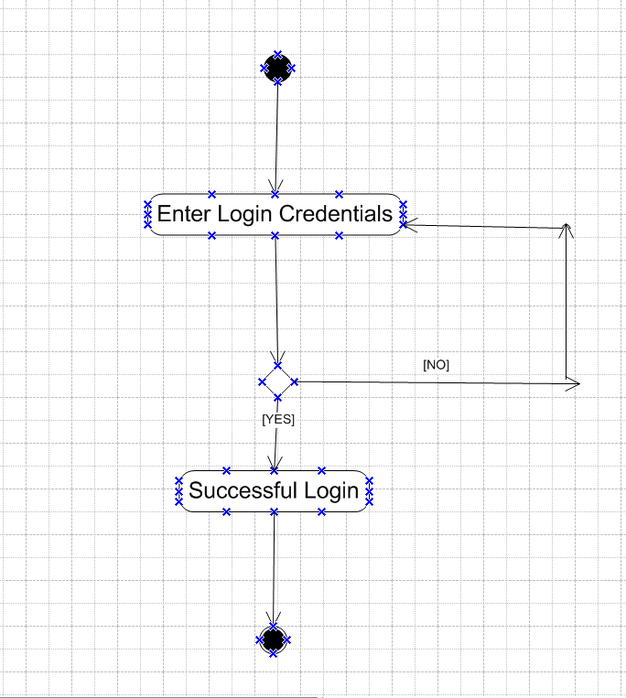

**Activity - Home Page Browsing**

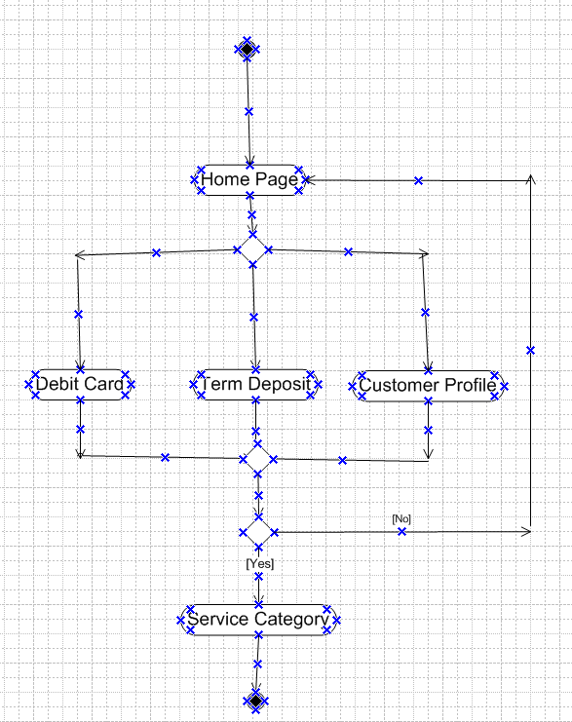

**Activity - Term Deposit**

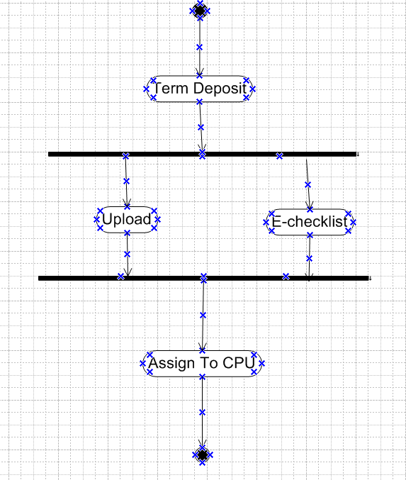

**Use Case Specs**

|  |  |
| --- | --- |
| **Use case Id** | **UC001** |
| **Use Case Name** | Employee Login |
| **Created By** | Rohit |
| **Date Created** | 31.12.2024 |
| **Actors** | Bank Employees |
| **Description** | How user will login in to the application |
| **Pre-Condition** | User will need to login into application using employee id and password |
| **Post-Condition** | Successful login post registration |
| **Normal flow of event** | Step 1. User registers on portal using his employee id  Step 2. User Sets a password |
| **Alternative flow of event** | Incase user forgets the password; user would get an option to reset the password. The new password would be generated with a new password reset page |
| **Assumptions** | Customer is tech savvy |

|  |  |
| --- | --- |
| **Use case Id** | **UC002** |
| **Use case Name** | Browsing the I –Connect Service Category Page |
| **Created By** | Rohit |
| **Date Created** | 31.12.2024 |
| **Actors** | Bank Employees |
| **Description** | How employee will browse various service categories on the application |
| **Pre-Condition** | User has logged into the system  User will need to view the service category requirements |
| **Post-Condition** | Various service category will be displayed on the application |
| **Normal flow of event** | Step 1. User logged into the application  Step 2. User sets filter for service category  Step 3. User browse service category as per his requirements.  Step 4. User selects service category |
| **Alternative flow of event** | Incase service category is not visible user will search the service category in browse option |
| **Assumptions** | All service categories are available on the application |

|  |  |
| --- | --- |
| **Use case Id** | **UC003** |
| **Use case Name** | Term Deposit E-checklist updation |
| **Created By** | Rohit |
| **Date Created** | 31.12.2024 |
| **Actors** | Bank Employees |
| **Description** | How employee will update Term Deposit E-checklist |
| **Pre-Condition** | User has logged into the application  User will select Term Deposit Category |
| **Post-Condition** | E-check list updated in application |
| **Normal flow of event** | Step 1. User logged into the application  Step 2. User updates Term Deposit E-checklist  Step 3. Use saves and assigns Term Deposit E-checklist. |
| **Alternative flow of event** | Incase E-check list is not updated, user will need to re-login and proceed with E-checklist updation |
| **Assumptions** | E-checklist is available on the application |

**7. Screens and Pages**

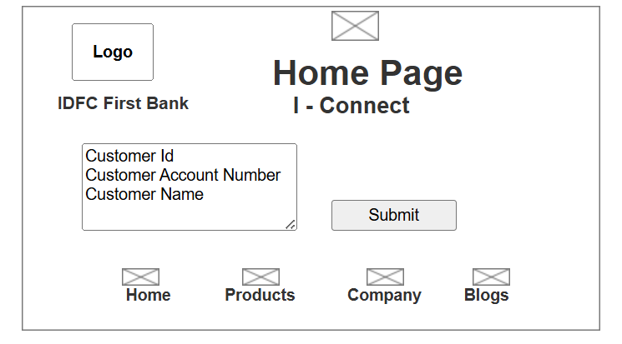

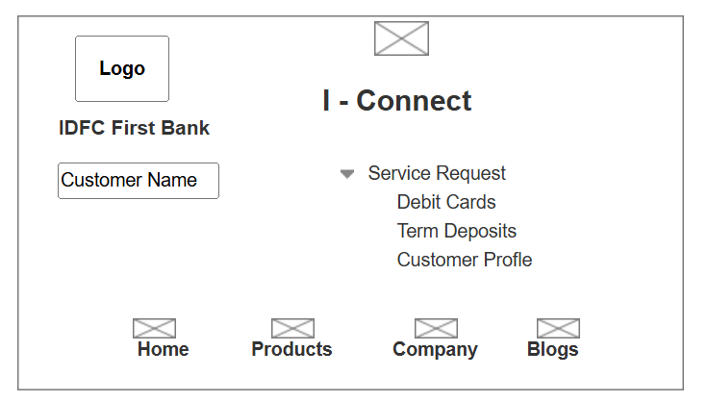

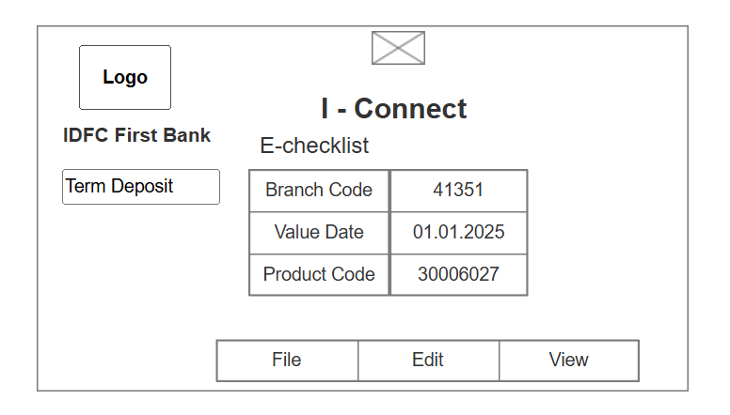

**8. Tools Visio and Axure RP**

* **Microsoft Visio -** Microsoft Visio is diagramming and vector graphics tool used to create diagrams, flowcharts and other visual representation of complex requirements. It consists of Use Case Diagram (User Perspective) and Activity Diagram (System Perspective).
* **Axure RP** – is a more advanced prototyping tool used to create high fidelity (designs with high / minute details) interactive wireframes and prototypes. In axure Graphical representation / Navigation is more better and more realistic.

**8. BA Experience**

My experience as a BA in following phases

1. **Requirement Gathering**

* Elicitation techniques used by me in this project were Document Analysis, Reverse Engineering (White Box Engineering), Brainstorming, Observation (Active)
* After the requirements were gathered we removed the all possible duplicated requirements
* Requirements were then prioritized using MoSCoW technique
* These requirements were further validated by FURPS
* Prototyping Elicitation technique was also implement to give a look and feel about the project

1. **Requirement Analysis**

* UML diagrams were used in the project such as Use Case Diagram (User Specific) and Activity Diagram (System Specific)
* These were then communicated to teams for feedback and reviews.
* Also prepared documents like BRS (Business Requirement Specifications) and SRS (Software Requirement Specifications)

| **S No.** | **SRS(System Requirement Specifications)** | **BRS(Business Requirement Specifications)** |
| --- | --- | --- |
| **1.** | Software Requirement Specification gives a high-level description of the software’s functional and technical requirements. | Business Requirement Specification gives a high-level description of the software’s functional requirements. |
| **2.** | SRS document is obtained from BRS. | BRS document is obtained by relating to the client’s requirements |

1. **Design**

* Test Cases were prepared using use case diagrams. A test case document is a detailed outline used by testers to ensure that the software application or system is working as per expectations
* Client was updated on designs and solution document
* Test Cases included Positive and Negative Test Case
* Requirement Traceability Matrix was maintained. Requirement Traceability Matrix is a document to track the requirements throughout the entire project life cycle and ensure that no requirement are missed out

1. **Development**

* Organized brainstorming sessions for idea generations. Purpose was to create as many ideas possible.
* Handled conflict management scenarios and ensured healthy team approach towards the project
* Also, arranged observation sessions with end user to understand the actual scenarios and adopted active participation for the same and maintained records accordingly.
* Assisted in assigning the designs to the coding team for development of the application

1. **Testing**

* Test cases are designed from used cases. Here the test cases are designed to hide all the possibilities of software packages in the real world scenario.
* High level testing is performed by testers. (Alpha Testing).
* RTM is updated
* Client Sign Off - All the documentations involved must have a client sign off. Which also means the client has agreed upon to
* UAT preparation

1. D**eployment**

* RTM to be shared with client along with Project Closure document
* Prepare End user manuals
* Arrange for training sessions