**Nurturing process –Proj Prep 1 Case Part 3**

**Question #1 -Functional and Non-functional Requirements**

Functional requirements define the specific behaviours, functions, or operations of a system. They describe what the system should do, outlining the necessary tasks, actions, or activities it must perform to achieve its objectives.

|  |  |  |
| --- | --- | --- |
| Req ID | Req Name | Req Description |
| FR001 | User Registration | Users should be able to register with the application. |
| FR002 | Search for Products | Users should be able to search for the available products using keywords or categories. |
| FR003 | Adding Products to the Cart | Users should be able to add the products to the cart. |
| FR004 | Adding Products to the Wishlist | Users should be able to add the products to the Wishlist for future purchase. |
| FR005 | Payment with Different Modes | Users should be able to make a payment using Cash-on-Delivery (COD), Credit/Debit Card, or UPI modes. |
| FR006 | Login for Users | Users should be able to log in to the application using their email ID and password. |
| FR007 | Order Placement | Users should be able to place orders after reviewing the cart. |
| FR008 | Delivery Tracking | Users should be able to track the delivery status of their orders. |
| FR009 | Email Notifications | Users should receive email notifications for registration, order confirmation, and delivery updates. |
| FR010 | Product Catalog | Users should be able to browse the product catalog with details such as price, description, and images. |

Non-functional requirements will describe the qualities and attributes of a system, focusing on how the system performs rather than specific behaviours or functions

|  |  |  |
| --- | --- | --- |
| **Req ID** | **Req Name** | **Req Description** |
| NFR001 | Performance | The system should be able to handle at least 500 concurrent users without performance degradation. |
| NFR002 | Usability | The application should have an intuitive and user-friendly interface to accommodate users with minimal technical knowledge. |
| NFR003 | Availability | The system should be available 99.9% of the time, excluding scheduled maintenance. |
| NFR004 | Security | The application should implement secure authentication, data encryption, and payment processing to protect user information. |
| NFR005 | Scalability | The system should be scalable to handle an increasing number of users and product listings over time. |
| NFR006 | Compatibility | The application should work on multiple platforms, including desktop browsers and mobile devices. |
| NFR007 | Localization | The application should support multiple languages to cater to users from different regions. |
| NFR008 | Maintainability | The system should have a modular architecture to facilitate easy updates and maintenance. |
| NFR009 | Response Time | The system should respond to user actions (e.g., search queries, page navigation) within 3 seconds. |
| NFR010 | Data Backup and Recovery | The system should perform daily backups and support data recovery in case of unexpected failures. |
| NFR011 | Compliance | The system should comply with local regulations and standards for data privacy and online transactions. |
| NFR012 | Accessibility | The application should adhere to accessibility standards (e.g., WCAG) to support users with disabilities. |

**------------------------------------------------------------------------------------------------------------------------**

**Question #2 -Prototype**

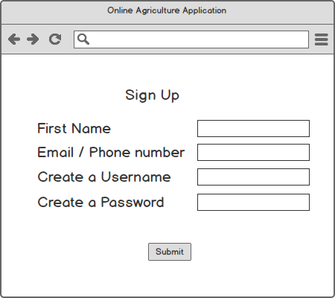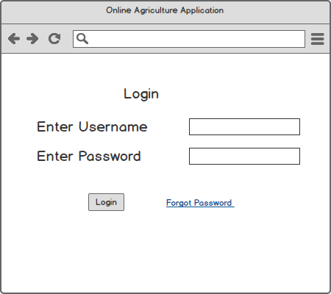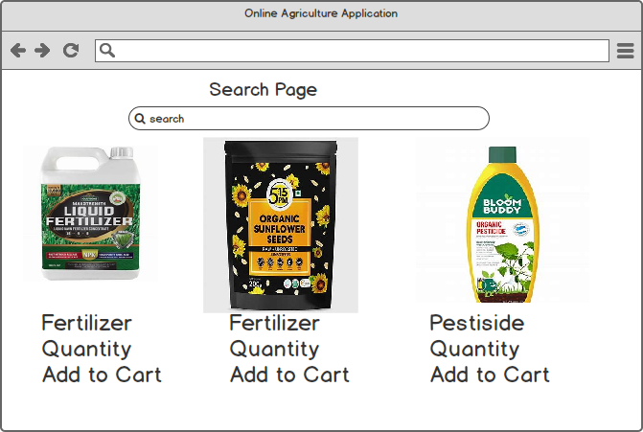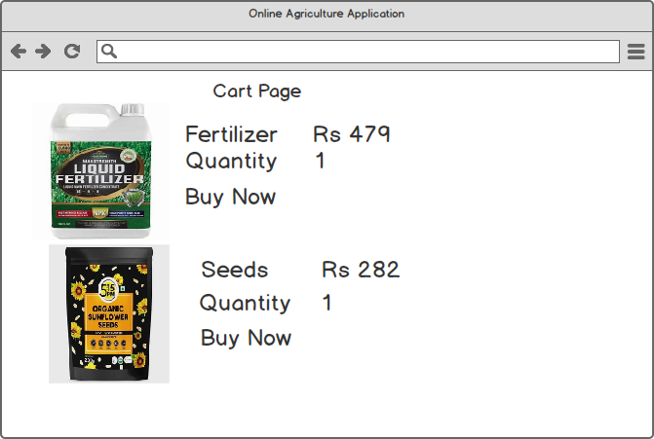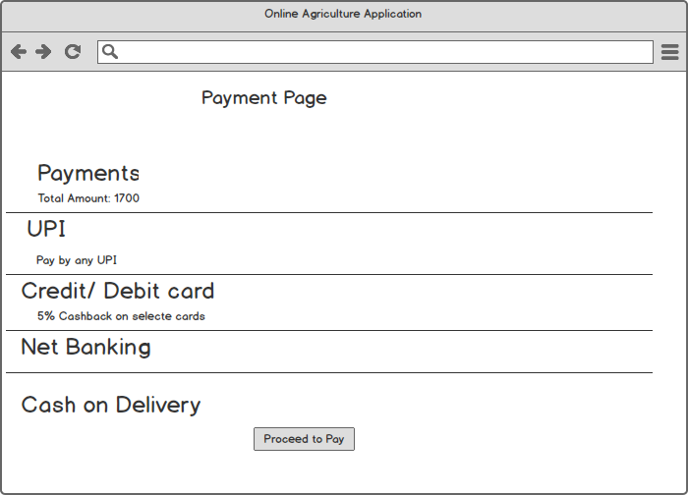

**----------------------------------------------------------------------------------------------------------------------**

**Question #3 -** **Tools (Visio, Balsamiq)**

**Microsoft Visio**

Microsoft Visio is a diagramming and vector graphics application that allows users to create a variety of professional diagrams, such as flowcharts, organizational charts, network diagrams, floor plans, and process diagrams. It offers an extensive library of templates and shapes to help users visually represent complex systems and workflows. Visio is widely used in business and IT environments for designing system architectures, process mappings, and project documentation. It integrates seamlessly with other Microsoft Office applications for enhanced productivity.

**Balsamiq**

Balsamiq is a rapid wireframing tool designed for creating user interface (UI) mockups and prototypes. It uses a simple, sketch-like design to emphasize structure and functionality over visual design. Balsamiq is ideal for brainstorming, communicating ideas, and early-stage design discussions. It supports drag-and-drop elements such as buttons, input fields, and menus to help users quickly draft web and mobile app interfaces. Its ease of use makes it a popular choice among designers, developers, and product managers for collaborative UI/UX planning.

**Question #4-** **RTM**

It is a document to track the requirements throughout the project lifecycle, ensuring that they are met and that no requirements are overlooked."

|  |  |  |  |  |  |  |  |  |
| --- | --- | --- | --- | --- | --- | --- | --- | --- |
| **Req ID** | **Req Name** | **Req Description** | **Design** | **Code** | **UT (Unit Testing)** | **CT (Component Testing)** | **SIT (System Testing)** | **UAT (User Acceptance Testing)** |
| FR001 | User Registration | Users should be able to register with the application. | Complete | Complete | Complete | Complete | Complete | Incomplete |
| FR002 | Search for Products | Users should be able to search for the available products using keywords or categories. | Complete | Complete | Complete | Complete | Incomplete | Incomplete |
| FR003 | Adding Products to the Cart | Users should be able to add the products to the cart. | Complete | Complete | Complete | Complete | Incomplete | Incomplete |
| FR004 | Adding Products to the Wishlist | Users should be able to add the products to the Wishlist for future purchase. | Complete | Complete | Complete | Complete | Incomplete | Incomplete |
| FR005 | Payment with Different Modes | Users should be able to make a payment using Cash-on-Delivery (COD), Credit/Debit Card, or UPI modes. | Complete | Complete | Complete | Complete | Incomplete | Incomplete |
| FR006 | Login for Users | Users should be able to log in to the application using their email ID and password. | Complete | Complete | Complete | Complete | Incomplete | Incomplete |
| FR007 | Order Placement | Users should be able to place orders after reviewing the cart. | Complete | Complete | Complete | Complete | Incomplete | Incomplete |
| FR008 | Delivery Tracking | Users should be able to track the delivery status of their orders. | Complete | Complete | Complete | Complete | Incomplete | Incomplete |
| FR009 | Email Notifications | Users should receive email notifications for registration, order confirmation, and delivery updates. | Complete | Complete | Complete | Complete | Incomplete | Incomplete |
| FR010 | Product Catalog | Users should be able to browse the product catalog with details such as price, description, and images. | Complete | Complete | Complete | Complete | Incomplete | Incomplete |

**Question #5-** **Test case Document**

|  |  |  |  |  |  |
| --- | --- | --- | --- | --- | --- |
| **Test case ID** | TC001 | **Test case Name** |  | | |
| **Project ID** | OnlineAgroStore | **Project Name** | Agricultural Product Store | | |
| **PM ID** | N/A | **PM name** | Mr Vandanam | | |
| **Test case strategy ID** | N/A | **Tester ID** | N/A | | |
| **Test Plan IP** | N/A | **Tester Name** | Mr Jason | | |
| **Scenario** | User Login | **Date of Test** | 28/28/2024 | | |
| **Link to that page :-** | Login Page |  |  |  |  |
| **Input Data** | Valid Email & Password | Invalid Password | Invalid email | | |
| **Expected behaviour** | Users log in successful | Login should be unsuccessful | Login should be unsuccessful | | |
| **Actual behaviour** |  |  |  | | |
| **Comments** |  |  |  | | |
| **Results )Pass/Fail)** |  |  |  | | |

|  |  |  |  |  |  |
| --- | --- | --- | --- | --- | --- |
| **Test case ID** | TC002 | **Test case Name** |  | | |
| **Project ID** | OnlineAgroStore | **Project Name** | Agricultural Product Store | | |
| **PM ID** | N/A | **PM name** | Mr Vandanam | | |
| **Test case strategy ID** | N/A | **Tester ID** | N/A | | |
| **Test Plan IP** | N/A | **Tester Name** | Mr Jason | | |
| **Scenario** | New User Registration | **Date of Test** | 28/28/2024 | | |
| **Link to that page :-** | Registration Page |  |  |  |  |
| **Input Data** | Existing Email | Invalid Email Format | Password Less Than 6 Chars | | |
| **Expected behavior** | Display "this user already exists". | Unsuccessful Registration | Unsuccessful Registration | | |
| **Actual behavior** |  |  |  | | |
| **Comments** |  |  |  | | |
| **Results )Pass/Fail)** |  |  |  | | |

|  |  |  |  |  |  |
| --- | --- | --- | --- | --- | --- |
| **Test case ID** | TC003 | **Test case Name** |  | | |
| **Project ID** | OnlineAgroStore | **Project Name** | Agricultural Product Store | | |
| **PM ID** | N/A | **PM name** | Mr Vandanam | | |
| **Test case strategy ID** | N/A | **Tester ID** | N/A | | |
| **Test Plan IP** | N/A | **Tester Name** | Mr Jason | | |
| **Scenario** | Browsing the Product Catalogue | **Date of Test** | 28/28/2024 | | |
| **Link to that page :-** | Product Catalogue Page |  |  |  |  |
| **Input Data** | Fertilizers Display | Seeds Display | Pesticides Display | | |
| **Expected behavior** | All products are displayed with categories and filters working correctly. | All products are displayed with categories and filters working correctly. | All products are displayed with categories and filters working correctly. | | |
| **Actual behavior** |  |  |  | | |
| **Comments** |  |  |  | | |
| **Results )Pass/Fail)** |  |  |  | | |

|  |  |  |  |  |  |
| --- | --- | --- | --- | --- | --- |
| **Test case ID** | TC004 | **Test case Name** |  | | |
| **Project ID** | OnlineAgroStore | **Project Name** | Agricultural Product Store | | |
| **PM ID** | N/A | **PM name** | Mr Vandanam | | |
| **Test case strategy ID** | N/A | **Tester ID** | N/A | | |
| **Test Plan IP** | N/A | **Tester Name** | Mr Jason | | |
| **Scenario** | Add to Cart | **Date of Test** | 28/28/2024 | | |
| **Link to that page :-** | Cart Page |  |  |  |  |
| **Input Data** | Add Single Product to Cart | Add Multiple Products to Cart | Add Out-of-Stock Product | | |
| **Expected behavior** | Product is successfully added to the cart with correct quantity and price. | Product is successfully added to the cart with correct quantity and price. | Error message displayed for out-of-stock items. | | |
| **Actual behavior** |  |  |  | | |
| **Comments** |  |  |  | | |
| **Results )Pass/Fail)** |  |  |  | | |

|  |  |  |  |
| --- | --- | --- | --- |
| **Test case ID** | TC005 | **Test case Name** |  |
| **Project ID** | OnlineAgroStore | **Project Name** | Agricultural Product Store |
| **PM ID** | N/A | **PM name** | Mr Vandanam |
| **Test case strategy ID** | N/A | **Tester ID** | N/A |
| **Test Plan IP** | N/A | **Tester Name** | Mr Jason |
| **Scenario** | Payment Processing | **Date of Test** | 28/28/2024 |
| **Link to that page :-** | Payment Page |  |  |
| **Input Data** | UPI Payment | Cash on Delivery (COD) | Payment Gateway Timeout |
| **Expected behavior** | Redirect to UPI | confirmation is displayed without online payment. | For timeout, retry option is provided. |
| **Actual behavior** |  |  |  |
| **Comments** |  |  |  |
| **Results )Pass/Fail)** |  |  |  |

|  |  |  |  |
| --- | --- | --- | --- |
| **Test case ID** | TC006 | **Test case Name** |  |
| **Project ID** | OnlineAgroStore | **Project Name** | Agricultural Product Store |
| **PM ID** | N/A | **PM name** | Mr Vandanam |
| **Test case strategy ID** | N/A | **Tester ID** | N/A |
| **Test Plan IP** | N/A | **Tester Name** | Mr Jason |
| **Scenario** | Order Confirmation | **Date of Test** | 28/28/2024 |
| **Link to that page :-** | Order Confirmation Page |  |  |
| **Input Data** | Order Confirmation Email Sent | Confirmation ID Generated | Payment Status Marked Paid |
| **Expected behavior** | Confirmation email is sent to the user's registered email address. | Order confirmation page is displayed with order details (Order ID, products, total amount). | Payment status is updated to "Paid." |
| **Actual behavior** |  |  |  |
| **Comments** |  |  |  |
| **Results )Pass/Fail)** |  |  |  |

|  |  |  |  |
| --- | --- | --- | --- |
| **Test case ID** | TC007 | **Test case Name** |  |
| **Project ID** | OnlineAgroStore | **Project Name** | Agricultural Product Store |
| **PM ID** | N/A | **PM name** | Mr Vandanam |
| **Test case strategy ID** | N/A | **Tester ID** | N/A |
| **Test Plan IP** | N/A | **Tester Name** | Mr Jason |
| **Scenario** | Order Tracking | **Date of Test** | 28/28/2024 |
| **Link to that page :-** | Order Tracking Page |  |  |
| **Input Data** | Valid Order ID | Invalid Order ID | Order Canceled Status |
| **Expected behavior** | The tracking page displays current order status | An error message is displayed | "Delivered" status with delivery date |
| **Actual behavior** |  |  |  |
| **Comments** |  |  |  |
| **Results )Pass/Fail)** |  |  |  |

|  |  |  |  |
| --- | --- | --- | --- |
| **Test case ID** | TC008 | **Test case Name** |  |
| **Project ID** | OnlineAgroStore | **Project Name** | Agricultural Product Store |
| **PM ID** | N/A | **PM name** | Mr Vandanam |
| **Test case strategy ID** | N/A | **Tester ID** | N/A |
| **Test Plan IP** | N/A | **Tester Name** | Mr Jason |
| **Scenario** | Request for Exchange | **Date of Test** | 28/28/2024 |
| **Link to that page :-** | Order Details |  |  |
| **Input Data** | Valid Exchange Request | Invalid Exchange Request | Out of Exchange Period |
| **Expected behavior** | the system accepts the exchange request and generates an exchange ID. | An error message is displayed. | An error message is displayed. |
| **Actual behavior** |  |  |  |
| **Comments** |  |  |  |
| **Results )Pass/Fail)** |  |  |  |
| **Test case ID** | **TC009** | **Test case Name** |  |
| **Project ID** | **OnlineAgroStore** | **Project Name** | **Agricultural Product Store** |
| **PM ID** | **N/A** | **PM name** | **Mr Vandanam** |
| **Test case strategy ID** | **N/A** | **Tester ID** | **N/A** |
| **Test Plan IP** | **N/A** | **Tester Name** | **Mr Jason** |
| **Scenario** | **Request for Product Return** | **Date of Test** | **28/28/2024** |
| **Link to that page :-** | **Order Details** |  |  |
| **Input Data** | **Order Details** | **Invalid Return Request** | **Return Approved** |
| **Expected behavior** | **The system processes the return and generates a return ID.** | **An error message is displayed.** | **return status is updated in the user account** |
| **Actual behavior** |  |  |  |
| **Comments** |  |  |  |
| **Results )Pass/Fail)** |  |  |  |

|  |  |  |  |
| --- | --- | --- | --- |
| **Test case ID** | TC009 | **Test case Name** |  |
| **Project ID** | OnlineAgroStore | **Project Name** | Agricultural Product Store |
| **PM ID** | N/A | **PM name** | Mr Vandanam |
| **Test case strategy ID** | N/A | **Tester ID** | N/A |
| **Test Plan IP** | N/A | **Tester Name** | Mr Jason |
| **Scenario** | Request for Product Return | **Date of Test** | 28/28/2024 |
| **Link to that page :-** | Order Details |  |  |
| **Input Data** | Order Details | Invalid Return Request | Return Approved |
| **Expected behavior** | The system processes the return and generates a return ID. | An error message is displayed. | return status is updated in the user account |
| **Actual behavior** |  |  |  |
| **Comments** |  |  |  |
| **Results )Pass/Fail)** |  |  |  |

|  |  |  |  |
| --- | --- | --- | --- |
| **Test case ID** | TC010 | **Test case Name** |  |
| **Project ID** | OnlineAgroStore | **Project Name** | Agricultural Product Store |
| **PM ID** | N/A | **PM name** | Mr Vandanam |
| **Test case strategy ID** | N/A | **Tester ID** | N/A |
| **Test Plan IP** | N/A | **Tester Name** | Mr Jason |
| **Scenario** | Submit a Review for a Purchased Product | **Date of Test** | 28/28/2024 |
| **Link to that page :-** | Product Details |  |  |
| **Input Data** | Submit a Text Review | Submit a Star Rating Only | Submit Text + Star Rating |
| **Expected behavior** | Valid reviews are submitted and displayed under the product’s review section. | Star rating updates the product’s overall rating | Valid reviews are submitted and displayed under the product’s review section. |
| **Actual behavior** |  |  |  |
| **Comments** |  |  |  |
| **Results )Pass/Fail)** |  |  |  |

**Question #6-** **DB Schema and ER Diagrams**

"DB Schema is a blueprint that outlines the structure of a database, including its tables, fields, relationships, constraints, and other characteristics.

An Entity-Relationship Diagram (ERD) is a visual representation of the relationships between entities in a database. It depicts the entities (such as tables), attributes (properties or fields), and relationships between them."

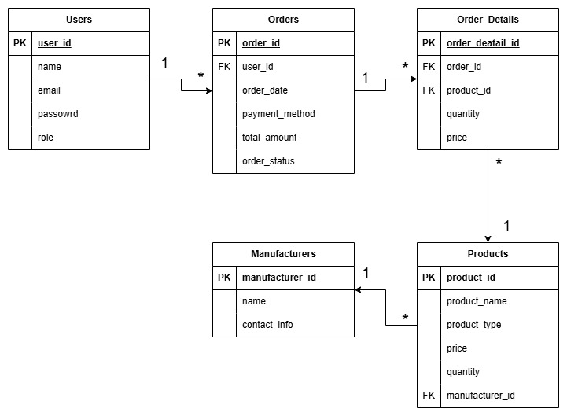

**Question #7-** **Data Flow diagrams**

A Data Flow Diagram (DFD) is a graphical representation of the flow of data within a system. It visually shows how data moves from one process to another, how it's stored, and where it ends up.

It helps analysts and designers understand the flow of data within a system, identify potential bottlenecks or inefficiencies, and communicate system requirements to stakeholders.

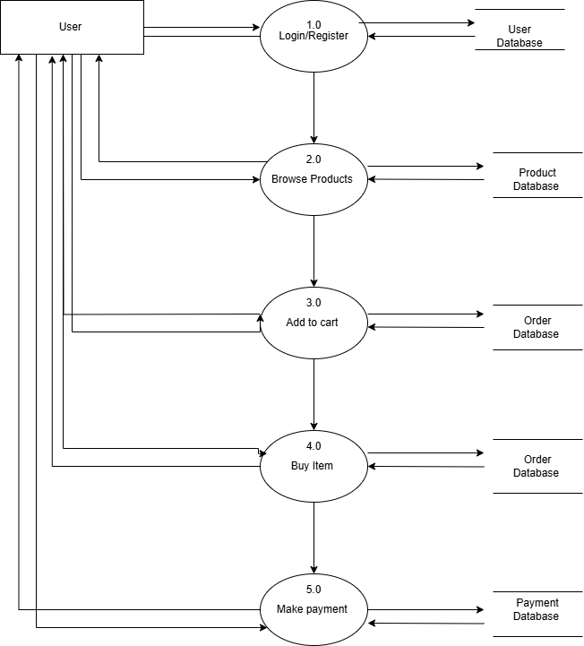

------------------------------------------------------------------------------------------------------

**Question #8-** **Change Request**

A change request is a formal proposal to alter a system, product, or project.

* Understand the scope of the change request and document the change request.
* Do the impact analysis – project scope, schedule, budget, resources, and risks.
* Prioritize change requests based on their urgency, importance, and impact on the project.
* Seek approval from the project sponsor for the change request.
* Communicate the change request and its potential impacts to all relevant stakeholders, including the project team."

**Question #9-Enhancement**

As a Business Analyst, I will document the requirements and work with the development team to determine the feasibility and impact of the new features. I will also consider the potential benefits, risks, and costs associated with the enhancements before making any recommendations to the client

-----------------------------------------------------------------------------------------------------------

**Question #10-Estimations**

**Man hours** are the required effort of the resources to complete a project. There are 3 types of projects:

* **Small**: Up to 500 hours
* **Medium**: Up to 1000 hours
* **Large**: Up to 1500 hours

**Analysis**:

* As per the case study, the duration of the project is 18 months, and the current team size is around 11. This will come under a medium project.
* As the trained resources are available, trainers are not required.
* As the structure of the project is available, new and enhanced infrastructure is not required.

-----------------------------------------------------------------------------------------------

**Question #11-UAT process**

**Planning**:  
In this step, Blueprints are made to implement UAT testing for every feature that needs to test and minimum standards for accepting the test.

**Designing**:  
Here the test cases are designed to hide all the possibilities of software packages in a real-world environment.

**UAT Testers**:  
A testing team consists of end users that meet the criteria for implementing testing. They should know the test cases to run and understand the functionalities.

**Bug Fixing**:  
Whatever bugs are found in the UAT testing, the development team should work on them and make the software error-free.

**Sign Off**:  
After removing all the bugs, the testing team indicates acceptance of the completion of the bugs. In this phase, all the stakeholders come to a conclusion that the software is ready to **GO LIVE** and sign it off.

**Question #12-Project closure Document**

A project closure document, also known as a project closure report, is a formal document that summarizes the key outcomes, lessons learned, and final details of a completed project.

It serves as a comprehensive record of the project's accomplishments, challenges, and overall performance, providing valuable insights for stakeholders and future projects.

Points to be included in the Project closure document are:  
 -Project Overview  
 -Achievements  
 -Lessons Learned  
 -Quality Assurance  
 -Resource Utilization  
 -Risk Management

|  |  |  |  |
| --- | --- | --- | --- |
| **S.NO** | **Points to include** | **Details** | **Reference Links** |
| 1. | Did the client signed off on the UAT Testing | |  |
|  | Date of the sign off | 01/03/2025 |  |
|  | Name of the resource | Ms Natalia |  |
| 2. | Objectives of the project | | |
|  | User friendliness | Achieved |  |
|  | Customer Satisfaction | ROI in 6 months |  |
|  | More categories | Achieved |  |
| 3. | Functionalities worked on | | |
|  | Secure payment processing | Achieved |  |
|  | Categories | Achieved |  |
| 4. | Infrastructure | | |
|  | Software’s installed | Achieved |  |
|  | Laptops purchased | Achieved |  |
| 5 | Funding |  |  |
|  | Amount Approved | Rs 2 Crores |  |
|  | Amount used | Rs. 1.95 |  |
| 6. | Overall project Information |  |  |
|  | Escalations | 50 |  |
|  | Customer satisfaction | High |  |
| 7. | Value to the company |  |  |
|  | positive 90% | -company has gained an edge over the competitors. | |
|  |  | -Market reach to farmers. |  |
|  |  | -New project in pipeline |  |
|  |  |  |  |

--------------------------------------------------------------------------------------------------------------------------