**Online Agriculture Products Store**

Mr. Henry, after being successful as a businessman and has become one of the wealthiest persons in the city. Now, Mr. Henry wants to help others to fulfil their dreams. One day, Mr. Henry went to meet his childhood friends Peter, Kevin and Ben. They live in a remote village and do farming. Mr. Henry asked his friends if they are facing any difficulties in their day-to-day work. Peter told Mr. Henry that he is facing difficulties in procuring fertilizers which are very important for farm. Kevin said that he is also facing the same problem in-case of buying seeds for farming certain crops. Ben raised his concern on lack of pesticides which could help in greatly reducing pests in crops. After listening to all his friends’ problems, Mr. Henry thought that this is a crucial problem faced not only by his friends but also by so many other farmers. So, Mr. Henry decided to make an online agriculture product store to facilitate remote area farmers to buy agriculture products. Through this Online Web / mobile Application, Farmers and Companies (Fertilizers, seeds and pesticides manufacturing Companies) can communicate directly with each other. 18 months Duration under CSR initiative. Peter, Kevin and Ben are helping the Committee and can be considered as Stakeholders share requirements for the Project. Mr Karthik is the Delivery Head in APT IT SOLUTIONS company and he reached out to Mr Henry through his connects and Bagged this project. APT IT SOLUTIONS company have Talent pool Available for this Project. Mr Vandanam is project Manager, Ms. Juhi is Senior Java Developer, Mr Teyson, Ms Lucie, Mr Tucker, Mr Bravo are Java Developers. Network Admin is Mr Mike and DB Admin is John. Mr Jason and Ms Alekya are the Tester. And you joined this team as a BA.

**Question 1 – BPM - 2 Marks:**

Identify Business Process Model for Online Agriculture Store – (Goal, Inputs, Resources, Outputs, Activities, Value created to the end Customer)

**ANS:** **GOAL**: An Online Web / mobile Application (online agriculture product store) to facilitate remote area farmers to buy agriculture products.

**INPUTS**: An application where the farmers can search for the desired product, select and buy, make payments, track the order and status of the delivery.

**RESOURCES**: Project manager, Senior Java developer, Java developer, Network Admin, DB Admin, Testers and BA.

**OUTPUT**: An online agriculture product store application.

**ACTIVITIES**: Register, login into the application, searching for the product, selecting and adding to cart, making payments and tracking the order and delivery of the product.

**VALUE CREATED TO THE END USES:** An user friendly application by using which the farmers can easily order their desired products from home rather than facing difficulties to find a store and buy it.

**Question 2 – SWOT - 2 Marks:**

**ANS:**

**STRENGHTS:**

1. Capable enough IT resources
2. Experienced IT professionals
3. Creative ideas and sufficient data.

**WEAKNESS:**

1. Insufficient budget
2. Insufficient data and poor roadmap.

**OPPORTUNITIES:**

1. Favourable market for the users as they can easily order from home
2. Increase in demand for the agriculture products
3. Positive feedback from the users as it will be easily accessible to them and lack of products in the offline shops.

**THREATS:**

1. Others may develop the same production in less budget
2. Users don’t find it easy to use the product.

**Question 3 – Feasibility study - 1 Marks:**

Mr Karthik is trying to do feasibility study on doing this project in Technology (Java), Please help him with points (HW SW Trained Resources Budget Time frame) to consider in feasibility Study.

ANS:

**HW**: Desktop and Wi-Fi connection.

**SW**: Programming tools

**Trained Resources:** IT professionals like Senior Java developer, Java developer, Network Admin, DB Admin, Testers.

**Question 4 – Gap Analysis - 1 Marks:**

Mr Karthik must submit Gap Analysis to Mr Henry to convince to initiate this project. What points (compare AS-IS existing process with TO-BE future Process) to showcase in the GAP Analysis

ANS:

**AS-IS:** Farmers have to wait for the fertilizers, seeds, pesticides till the time it is available on the online store, as there not enough stock they may need to visit the different stores far away from their locations.

**TO-BE:** Once the products are available, farmers can easily search for their desired product and order it through the online store from their home only.

**Question 5 – Risk Analysis - 3 Marks:**

List down different risk factors that may be involved (BA Risks And process/Project Risks)

ANS: **BA Risks:**

1. Lack of BA domain knowledge
2. Improper requirement gathering
3. Changing in the requirements.

**Project Risks:**

1. Insufficient budget
2. Lack of required resources
3. Lack of experienced skilled professionals which can impact on the performance.

**Question 6 – Stakeholder Analysis (RACI Matrix) - 3 Marks:**

Perform stakeholder analysis (RACI Matrix) to find out the key stakeholders who can take Decisions and Who are the influencers

ANS:

**Stakeholders:**

1. **Project stakeholders:**
2. **BA- Me**
3. **Delivery head- Karthik**
4. **Development Team- Ms Juhi, Mr. Teyson, Ms Lucie, Mr Tucker and Mr Bravo**
5. **Network Admin- Mr Mike**
6. **DB Admin- Mr John**
7. **Testing Team- Mr Jason and Alekya**
8. **Business Stakeholders:**
9. **Sponsor- Henry**
10. **Financial Head- Mr Pandu**
11. **Project coordinator- Mr Dooku**
12. **Influencers- Peter, Kevin and Ben**

**RACI Matrix:**

**Responsible: I as a BA will be responsible**

**Accountable: Mr. Vandanam as a PM will be accountable**

**Consulted: Ms Juhi, Mr. Teyson, Ms Lucie, Mr Tucker, Mr Bravo, Mr Mike, Mr John, Mr Jason and Alekya**

**Informed: Mr Henry, Mr Pandu and Mr Dooku.**

**Question 7 – Business Case Document - 3 Marks:**

**Help Mr Karthik to prepare a business case document**

ANS:

**Executed summary:**

Henry identified the difficulties faced by the farmers to avail required items such as pesticides, fertilizers, seeds etc. Hence he decided to make a product which is an online store application to help the farmers fulfil their needs in an easy manner.

1. **Purpose of initiating the project:**

To build an online agriculture product store to facilitate remote area farmers to buy agricultural products. Through this online web/mobile application farmers and companies can communicate directly with each other.

1. **Problems faced by the farmers at the current situation**

At the current situation farmers need to visit offline stores to buy pesticides, fertilizers and seeds far away from their homes and which caused them travelling charges and also very time consuming.

1. **Problems can be solved with this project:**

Once the product (online store application) is built, farmers can easily search for their desired product and order it through the online store from their home only which will save their money and time.

1. **Required resources:**

HW: Desktop and Wi-Fi connection

SW: Programming tools

Trained resources: IT professionals like senior Java developer, Java developer, network admin, database admin and testers.

1. **Budget and duration:** We need a budget of two crores for this project. And the duration is 18months under CSR.
2. **Stakeholders:**

**Project stakeholders:**

1. **BA- Me**
2. **Delivery head- Karthik**
3. **Development Team- Ms Juhi, Mr. Teyson, Ms Lucie, Mr Tucker and Mr Bravo**
4. **Network Admin- Mr Mike**
5. **DB Admin- Mr John**
6. **Testing Team- Mr Jason and Alekya**

**Business Stakeholders:**

1. **Sponsor- Henry**
2. **Financial Head- Mr Pandu**
3. **Project coordinator- Mr Dooku**
4. **Influencers- Peter, Kevin and Ben**

**Question 8 – Four SDLC Methodologies - 3 Marks:**

The Committee of Mr. Henry, Mr Pandu, and Mr Dooku and Mr Karthik are having a discussion on Project Development Approach.

Mr Karthik explained to Mr. Henry about SDLC. And four methodologies like Sequential Iterative Evolutionary and Agile. Please share your thoughts and clarity on Methodologies

ANS:

1. **Waterfall:**

The Waterfall Model was the first Process Model to be introduced. It is also referred to as a linear-sequential life cycle model. It is very simple to understand and use. In a waterfall model, each phase must be completed before the next phase can begin and there is no overlapping in the phases.

The Waterfall model is the earliest SDLC approach that was used for software development.

The waterfall Model illustrates the software development process in a linear sequential flow. This means that any phase in the development process begins only if the previous phase is complete. In this waterfall model, the phases do not overlap.

1. **Iterative Model:**

In the Iterative model, iterative process starts with a simple implementation of a small set of the software requirements and iteratively enhances the evolving versions until the complete system is implemented and ready to be deployed.

An iterative life cycle model does not attempt to start with a full specification of requirements. Instead, development begins by specifying and implementing just part of the software, which is then reviewed to identify further requirements. This process is then repeated, producing a new version of the software at the end of each iteration of the model.

1. **Spiral Model:**

The spiral model combines the idea of iterative development with the systematic, controlled aspects of the waterfall model. This Spiral model is a combination of iterative development process model and sequential linear development model i.e. the waterfall model with a very high emphasis on risk analysis. It allows incremental releases of the product or incremental refinement through each iteration around the spiral.

1. **Agile Model:**

Agile model believes that every project needs to be handled differently and the existing methods need to be tailored to best suit the project requirements. In Agile, the tasks are divided to time boxes (small time frames) to deliver specific features for a release.

Every iteration involves cross functional teams working simultaneously on various areas like −

1. Planning
2. Requirements Analysis
3. Design
4. Coding
5. Unit Testing and
6. Acceptance Testing.

At the end of the iteration, a working product is displayed to the customer and important stakeholders.

**Question 9 – Waterfall RUP Spiral and Scrum Models - 3 Marks:**

They discussed models in SDLC like waterfall RUP Spiral and Scrum. You put forth your understanding on these models When the APT IT SOLUTIONS company got the project to make this online agriculture product store, there is a difference of opinion between a couple of SMEs and the project team regarding which methodology would be more suitable for this project. SMEs are stressing on using the V model and the project team is leaning more onto the side of waterfall model. As a business analyst, which methodology do you think would be better for this project?

ANS:

As a BA I would be choosing Waterfall methodology because:

Waterfall model is very easy to understand and simple model the complete process in order to reach the next phase. The first phase is requirement gathering and analysis. The requirements are then documented, it is called the software requirement specification. The next is the system design phase, it is to design the entire software architecture. Next phase is the implementation phase, it is to start coding the small units. These units are combined to form the complete system and tested in the integration and testing phase. After the testing is completed the software is distributed to the market. The activities such as maintaining of the software and Adding new features come under deployment and maintenance.

Question 10 – Waterfall Vs V-Model - 2 Marks:

Write down the differences between waterfall model and V model.

ANS:

|  |  |
| --- | --- |
| **Waterfall Model** | **V Model** |
| The waterfall model is a relatively linear sequential design approach to develop software projects. | The V model is a model in which the execution of the phases happens in a sequential manner in a v shape. |
| The waterfall model is a continuous process. | The V model is a simultaneous process. |
| In waterfall model, the total defects in the developed software are higher. | In v model, the total defects in the developed software are lower. |
| In waterfall model, the defects are identified in the testing phase. | In v model, the defects are identified from the initial phase. |

Question 11 – Justify your choice - 1 Marks:

As a BA, state your reason for choosing one model for this project

ANS:

As a BA I would be choosing Waterfall methodology because:

Waterfall model is very easy to understand and simple model the complete process in order to reach the next phase. The first phase is requirement gathering and analysis. The requirements are then documented, it is called the software requirement specification. The next is the system design phase, it is to design the entire software architecture. Next phase is the implementation phase, it is to start coding the small units. These units are combined to form the complete system and tested in the integration and testing phase. After the testing is completed the software is distributed to the market. The activities such as maintaining of the software and Adding new features come under deployment and maintenance.

**Question 12 – Gantt Chart - 2 Marks:**

The Committee of Mr. Henry, Mr Pandu, and Mr Dooku discussed with Mr Karthik and finalised on the V Model approach (RG, RA, Design, D1, T1, D2, T2, D3, T3, D4, T4 and UAT) Mr Vandanam is mapped as a PM to this project. He studies this Project and Prepares a Gantt chart with V Model (RG, RA, Design, D1, T1, D2, T2, D3, T3, D4, T4 and UAT) as development process and the Resources are PM, BA, Java Developers, testers, DB Admin, NW Admin.

ANS:

**GANTT CHART**

|  |  |  |  |  |  |  |  |  |  |  |  |  |  |
| --- | --- | --- | --- | --- | --- | --- | --- | --- | --- | --- | --- | --- | --- |
| Process | WK-1 | WK-2 | WK-3 | WK-4 | WK-5 | WK-6 | WK-7 | WK-8 | WK-9 | WK-10 | WK-11 | WK-12 | WK-13 |
| RG |  |  |  |  |  |  |  |  |  |  |  |  |  |
| RA |  |  |  |  |  |  |  |  |  |  |  |  |  |
| Design |  |  |  |  |  |  |  |  |  |  |  |  |  |
| D1 |  |  |  |  |  |  |  |  |  |  |  |  |  |
| T1 |  |  |  |  |  |  |  |  |  |  |  |  |  |
| D2 |  |  |  |  |  |  |  |  |  |  |  |  |  |
| T2 |  |  |  |  |  |  |  |  |  |  |  |  |  |
| D3 |  |  |  |  |  |  |  |  |  |  |  |  |  |
| T3 |  |  |  |  |  |  |  |  |  |  |  |  |  |
| D4 |  |  |  |  |  |  |  |  |  |  |  |  |  |
| T4 |  |  |  |  |  |  |  |  |  |  |  |  |  |
| UAT |  |  |  |  |  |  |  |  |  |  |  |  |  |

**Question 13 – Fixed Bid Vs Billing - 2 Marks:**

The Committee of Mr. Henry, Mr Pandu, and Mr Dooku is now discussing about the funds and how to release the funds for development. They were studying Fixed Bid model and Billing Model.

Share your knowledge on Fixed Bid model and Billing Model.

The Committee freeze the Billing Model and agreed to release funds against the timesheets submitted for every 2 weeks. Every Alternate Friday EOB, Mr Karthik will forward the Development Team Timesheets and in 3 working days, The Committee will verify and release funds. The Committee proposed to have a Quarterly Audit on the Project progress.

ANS:

our project Budget is 2 core and time is 18 months. And in Billing mode sponsor will

give funds as per the working hours completed in each stage or on weekly, monthly

basis.

our project Budget is 2 core and time is 18 months. And in Billing mode sponsor will

give funds as per the working hours completed in each stage or on weekly, monthly

basis.

our project Budget is 2 core and time is 18 months. And in Billing mode sponsor will

give funds as per the working hours completed in each stage or on weekly, monthly

basis.

Fix Bid: Under Fix Bid the sponsor can give the budget and estimated time and we have to complete the project within that amount and given time. For example, in our project the budget is 2 crore and the duration is 18 months. And in Billing Model sponsor will give funds as per the working hours completed in each stage or on weekly, monthly basis.

Question 14,15,16,17,18,19,20 – Timesheets - 7 Marks:

Please share Sample Timesheets of a BA in various SDLC Stages RG, RA, Design, D1, T1, D2,T2, D3, T3, D4, T4 and UAT, Deployment n Implementation

➢ RG Timesheet of a BA

➢ RA Timesheet of a BA

➢ Design Timesheet of a BA

➢ Development Timesheet of a BA

➢ Testing Timesheet of a BA

➢ UAT Timesheet of a BA

➢ Deployment n Implementation Timesheet of a BA

ANS:

**➢ RG Timesheet of a BA**

|  |  |  |  |  |
| --- | --- | --- | --- | --- |
| **Date** | **Activity** | **In time** | **Out time** | **Total hours** |
| 18/2/23 | Conducted meetings with stakeholders to gather requirements | 11:00AM | 3:00PM | 5 |
| 19/2/23 | Reviewed existing system documentation to identify gaps | 12:00PM | 3:00PM | 3 |
| 20/2/23 | Conducted brainstorming sessions with project team and stakeholders | 10:00AM | 2:00PM | 4 |
| 21/2/23 | Analyzed and documented requirements | 11:00AM | 4:00PM | 5 |
| 22/2/23 | Followed up with the stakeholders for clarifications and feedbacks | 10:00AM | 5:00PM | 7 |
| 23/2/23 | Prepared and presented the requirements document to the project team | 11:00AM | 5:00PM | 6 |
| Total |  |  |  | 30 |

**➢ RA Timesheet of a BA**

|  |  |  |  |  |
| --- | --- | --- | --- | --- |
| **Date** | **Activity** | **In time** | **Out time** | **Total hours** |
| 3/3/23 | Reviewed current system documentation | 10:00AM | 3:00PM | 5 |
| 4/3/23 | Conducted stakeholder interviews | 10:00PM | 5:00PM | 7 |
| 5/3/23 | Analyzed interview findings | 10:00AM | 4:00PM | 6 |
| 6/3/23 | Created requirements documentation | 10:00AM | 3:00PM | 5 |
| 7/3/23 | Facilitated requirements review meeting with the stakeholders | 10:00AM | 4:00PM | 6 |
| 8/3/23 | Revised requirement based on feedbacks | 11:00AM | 5:00PM | 6 |
| Total |  |  |  | 35 |

**➢ Design Timesheet of a BA**

|  |  |  |  |  |
| --- | --- | --- | --- | --- |
| **Date** | **Activity** | **In time** | **Out time** | **Total hours** |
| 20/3/23 | Reviewed user requirements | 10:00AM | 5:00PM | 7 |
| 21/3/23 | Created use cases and workflows | 10:00PM | 3:00PM | 5 |
| 22/3/23 | Designing database schema | 10:00AM | 6:00PM | 8 |
| 24/3/23 | Created wireframes | 10:00AM | 3:00PM | 5 |
| 27/3/23 | Reviewed and refined design | 10:00AM | 4:00PM | 6 |
| 29/3/23 | Created design specifications | 11:00AM | 5:00PM | 6 |
| 1/4/23 | Meeting with development team | 10:00AM | 3:00PM | 5 |
| 3/4/23 | Updated design based on feedback | 11:00AM | 4:00PM | 5 |
| 4/4/23 | Finalized design documents | 10:00AM | 6:00PM | 8 |
| 5/4/23 | Reviewed and approved design | 10:00AM | 5:00PM | 7 |
| Total |  |  |  | 62 |

**➢ Development Timesheet of a BA**

|  |  |  |  |  |
| --- | --- | --- | --- | --- |
| **Date** | **Activity** | **In time** | **Out time** | **Total hours** |
| 7/4/23 | Conducted meetings with developers | 10:00AM | 5:00PM | 7 |
| 8/4/23 | Conducted a session to elucidate design of the software | 10:00PM | 5:00PM | 7 |
| 10/4/23 | Conducted a session for design development | 10:00AM | 4:00PM | 6 |
| 11/4/23 | Reviewed test plan for upcoming releases | 10:00AM | 3:00PM | 5 |
| Total |  |  |  | 25 |

**➢ Testing Timesheet of a BA**

|  |  |  |  |  |
| --- | --- | --- | --- | --- |
| **Date** | **Activity** | **In time** | **Out time** | **Total hours** |
| 13/4/23 | Conducted functional testing of feature XYZ | 10:00AM | 1:00PM | 3 |
| 14/4/23 | Collaborated with the testing team on issue ABC | 10:00PM | 3:00PM | 5 |
| 16/4/23 | Conducted regression testing of module LMN | 10:00AM | 3:00PM | 5 |
| 17/4/23 | Reviewed test plans for upcoming release | 10:00AM | 1:00PM | 3 |
| 18/4/23 | Analyzed test results and reported issues | 11:00AM | 3:00PM | 4 |
| 20/4/23 | Tested integration of Module A with Module B | 10:00AM | 1:00PM | 3 |
| Total |  |  |  | 23 |

**➢ UAT Timesheet of a BA**

|  |  |  |  |  |
| --- | --- | --- | --- | --- |
| **Date** | **Activity** | **In time** | **Out time** | **Total hours** |
| 24/4/23 | Prepared UAT plan and test cases | 10:00AM | 3:00PM | 5 |
| 25/4/23 | Reviewed UAT plan with stakeholders | 10:00PM | 4:00PM | 6 |
| 26/4/23 | Executed UAT test cases | 10:00AM | 5:00PM | 7 |
| 27/4/23 | Troubleshoot and reported defects found during UAT | 10:00AM | 1:00PM | 3 |
| 28/4/23 | Retested defects after they have been fixed by the development team | 11:00AM | 2:00PM | 3 |
| 30/4/23 | Obtained sign off from the stakeholders on UAT completion | 10:00AM | 11:00AM | 1 |
| Total |  |  |  | 25 |

**➢ Deployment n Implementation Timesheet of a BA**

|  |  |  |  |  |
| --- | --- | --- | --- | --- |
| **Date** | **Activity** | **In time** | **Out time** | **Total hours** |
| 1/5/23 | Created deployment plan | 10:00AM | 5:00PM | 7 |
| 2/5/23 | Deployed application to test environment | 10:00PM | 4:00PM | 6 |
| 3/5/23 | Deployed application to production | 10:00AM | 6:00PM | 8 |
| 5/5/23 | Performed user acceptance testing | 10:00AM | 7:00PM | 9 |
| 6/5/23 | Finalized implementation | 11:00AM | 8:00PM | 9 |
| Total |  |  |  | 39 |

Question 21 – Audits - 3 Marks:

5 Quarterly Audits are planned Q1, Q2, Q3, Q4 and Q5 for this Project What is your knowledge on how these Audits will happen for a BA?

ANS:

The 5 quarterly Audits are planned each phase by phase as follows:

**Quarter 1. Requirement gathering place**: In the requirement gathering phase auditor will check for if all the requirement is collected from the client as per their needs and check if completed or not. Check-list includes BRD template, Elicitation results report, Duplicate requirements report, grouping of functionalities/features and Client sign off.

**Quarter 2. Requirement analysis phase:** In requirement analysis phase, check if all the customer requirements are analysed and worked accordingly. Checklist includes UML Diagrams, Business to functional requirements mapping, Client sign off, RTM document version control.

**Quarter 3. In design phase:** Auditor will check if software has been designed according to the client need. Checklist includes Utilization of tools, documented evidence on client communication, Stakeholder MOM.

**Quarter 4. In development phase:** Auditor will check if website has been created according to customer requirement. Checklist includes creating detailed checklist of requirement, creating timeline and task with the list of deliverables and deadlines and meeting with project development team.

**Quarter 5. In testing phase:** Developed application will be tested and verified before handed over to real time user. If any error occurs then again handed over to development team for correction. Audit checklist will include meeting with testers to check on possible outcome. Discussion with QF team on the details such as automation codes, where to store the automation code and who will need access to it, who is running the tests and writing test cases, meeting with QA team to identify where the test will run.

Question 22 – BA Approach Strategy - 5 Marks:

Before the Project is going to Kick Start, The Committee asked Mr Karthik to submit BA Approach Strategy Write BA Approach strategy (As a business analyst, what are the steps that you would need to follow to complete a project – What Elicitation Techniques to apply, how to do Stakeholder Analysis RACI/ILS, What Documents to Write, What process to follow to Sign off on the Documents, How to take Approvals from the Client, What Communication Channels to establish and implement, How to Handle Change Requests, How to update the progress of the project to the Stakeholders, How to take signoff on the UAT- Client Project Acceptance Form )

Your Team

Project Manager - Mr Vandanam

Senior Java Developer - Ms. Juhi

Java Developers - Mr Teyson, Ms Lucie, Mr Tucker, Mr Bravo

Network Admin - Mr Mike

DB Admin - Mr John. Testers - Mr Jason and Ms Alekya

BA – You

Technical Team have assembled to discuss on the Project approach and have finalised to follow 3-tier architecture for this project.

ANS:

**What elicitation techniques do apply:** As a BA I would be using the brainstorming technique, In brainstorming and elicitation technique where a problem or topic is presented to the group and participants are asked to produce as many ideas to solve/address the topic as possible. As ideas are presented, a scribe documents the ideas and ensures the participants can see what is being captured.

**How to do Stakeholder analysis RACI / ILS:**

By conducting RACI/ILS analysis we can determine the roles and responsibilities of each stakeholder.

**RACI Matrix**

**Responsible:** I as a BA will be responsible

**Accountable:** Mr. Vandanam as a PM will be accountable

**Consulted:** Ms Juhi, Mr. Teyson, Ms Lucie, Mr Tucker, Mr Bravo, Mr Mike, Mr John, Mr Jason and Alekya

**Informed:** Mr Henry, Mr Pandu and Mr Dooku.

**Identifying key stakeholders:**

**Project stakeholders:**

1. BA- Me
2. Delivery head- Karthik
3. Development Team- Ms Juhi, Mr. Teyson, Ms Lucie, Mr Tucker and Mr Bravo
4. Network Admin- Mr Mike
5. DB Admin- Mr John
6. Testing Team- Mr Jason and Alekya

**Business Stakeholders:**

1. Sponsor- Henry
2. Financial Head- Mr Pandu
3. Project coordinator- Mr Dooku
4. Influencers- Peter, Kevin and Ben

**What documents to write:**

BRD – Business requirement document

FRD -- Functional and Non functional

Change management

Technology specification document

Risk analysis and mitigation plan

BRD – Business requirement document

FRD -- Functional and Non functional

Change management

Technology specification document

Risk analysis and mitigation plan

BRD – Business requirement document

FRD -- Functional and Non functional

Change management

Technology specification document

Risk analysis and mitigation plan

BRD – Business requirement document

FRD -- Functional and Non functional

Change management

Technology specification document

Risk analysis and mitigation plan

BRD: Business requirement document

FRD: Functional and non-functional requirement document

CRD: Change request document

FRS: Functional requirement specification

FSD: Functional Specification Document

**What process to follow to Sign off on the Documents:**

Project sign off is typically takes place during the contract closure phase, where the company presents the result of work done to the client.

**How to take Approvals from the Client:**

Whenever we seek an approval from the manager or client, we need to draft a request for an approval letter. The email should be written to the relevant stakeholders.

**What Communication Channels to establish and implement:**

1. Face to face communication.
2. Video conference
3. Phone calls
4. Text message
5. Emails

**How to Handle Change Requests:**

A change proposal is generally brought up by the client during the project, this usually happens when the client wants to change or alter the agreed upon deliverables.

As BA I will be responsible to determine the change request whether it is inside or outside scope.

To analyse the change request and clarifies exactly as a BA I will be responsible to perform some activities as follows:

1. Feasibility studies
2. Impact analysis
3. Effort estimation.

If the request is approved then the project deliverables will need to be updated. This will include plans, schedules, business process document and the requirement documents.

**How to update the progress of the project to the Stakeholders:**

We need to keep the stakeholders informed about the project's progress through regular status reports and progress meetings. Highlight any risks or issues that need to be addressed. Provide regular progress updates to the stakeholders and seek their feedback.

**How to take signoff on the UAT- Client Project Acceptance Form:**

By conducting User Acceptance Testing to validate the project's deliverables. Obtain sign-off from the client on the UAT results and the Project Acceptance Form. Ensure that the project meets the client's expectations and requirements.

**Question 23 – 3-Tier Architecture - 1 Marks:**

Explain and illustrate 3-tier architecture?

ANS:

In 3-tier architecture there are three layers. it will organizes applications into three logical and physical computing tiers: the presentation tier, or user interface, the application tier, where data is processed; and the data tier, where the data associated with the application is stored and managed.

**1. Presentation Layer:** The presentation layer is the top layer of the architecture and is responsible for presenting the user interface to the end-users. It is also known as the user interface layer or the client layer. This layer handles the interaction between the user and the system.

**2. Application layer:** The application layer is the middle layer of the architecture and contains the business logic of the system. It is also known as the logic layer or the server layer. This layer manages the application logic, data validation, and data processing. It communicates with the presentation layer and the database layer.

**3. Database layer:** The database layer is the bottom layer of the architecture and is responsible for managing the data storage and retrieval. It is also known as the data layer or the server layer. This layer is responsible for storing and retrieving data from a database management system (DBMS). The database layer provides an interface for the application layer to access and manipulate data.

Question 24 – BA Approach Strategy for Framing Questions - 3 Marks:

Business Analyst should keep What points in his/her mind before he frames a Question to ask to the Stakeholder ( 5W 1H – SMART – RACI – 3 Tier Architecture – Use Cases, Use case Specs, Activity Diagrams, Models, Page designs)

ANS:

Here is a summary of points a Business Analyst should keep in mind before framing questions to ask stakeholders:

1. **Use 5W 1H:** It stands for who, what, when, where, why and how. The business analyst should use this framework to ask questions that covers all aspects of the project and to get a complete understanding of the stakeholders’ requirements.
2. **Use SMART criteria:** It stands for specific, measureable, achievable, relevant and time bound. The business analyst should use these criteria to frame questions that are satisfying SMART criteria. This will help the stakeholders to provide clear and concise answers that will help in the project’s success.
3. **Understand RACI:** The RACI model stands for responsible, accountable, consulted and informed. The business analyst should understand the RACI model and frame questions that help to identify the stakeholders’ responsibilities and accountability in the project.
4. **Understand 3-tier architecture:** The business analyst should have a clear understanding of 3-tier architecture and how it applies to the project. Thus will help the business analyst to frame questions that are relevant and specific to the projects technical requirements.
5. **Use case and activity diagram:** Develop use case and activity diagrams to capture functional requirements and how the system will behave.
6. **Use case specification:** Write use case specifications that provide detailed description of how the system should behave in different scenarios.
7. **Models and page designs:** Develop visual models and page designs to help the stakeholders understand how the system will look and work.

**Question 25 – Elicitation Techniques - 3 Marks:**

As a Business Analyst, What Elicitation Techniques you are aware of? (BDRFOWJIPQU)

ANS:

As a business Analyst I am aware of the following Elicitation techniques:

1. **Brainstorming:** Brainstorming is a group elicitation technique where a problem or topic is presented to the group, and participants are asked to produce as many ideas to solve/address the topic as possible. As ideas are presented, a scribe documents the ideas and ensures the participants can see what is being captured.
2. **Document Analysis:** During this step of the requirements elicitation process, business analysts review existing documentation at hand, with the intent of identifying requirements for changes or improvements. Examples of document analysis sources include pre-existing project plans, system specifications, process documentation, market research dossiers, customer feedback, meeting minutes, and user manuals.
3. **Focus Group:** In a focus group, relevant stakeholders provide feedback to refine processes, ideas, or solutions that emerged as an outcome of earlier elicitation activities, such as brainstorming and document analysis.
4. **Interviews:** Interviews are one of the most effective ways of gathering information from the stakeholders and can be used to engage with stakeholders, identify, elicit, and document requirements. Business analysts can use elicitation techniques, like either structured or unstructured interviews, depending on the situation. A structured interview uses present questions, which are asked to stakeholders, and an unstructured interview uses spontaneous questions, which are not determined in advance. Interviews offer a business analyst an opportunity to establish rapport with the interviewee and get instant feedback. User stories are commonly used in Scrum projects for iterative requirements gathering and elicitation.
5. **Prototyping:** Prototyping is a requirements gathering and elicitation technique that can be used to gather preliminary requirements for building an initial version of the solution referred to as a prototype or demo. The prototype can be shown to the stakeholders, who will review and give recommendations for improvement so as to meet business requirements. Prototypes are very effective, particularly where the solution, involves the implementation of new technology and can help stakeholders visualize what the final product will look like.
6. **Survey:** A survey is a data-gathering method that is used to collect, analyze and interpret the views of a group of people from a target population. A questionnaire can be used in a survey as a cost-effective way of gathering and eliciting requirements from a large number of people in a short period of time.
7. **Use cases:** It can be used to identify all the possible scenarios in which the users will interact with the application. This can help in defining the functional requirements of the application.

**Question 26 – This project Elicitation Techniques - 1 Marks:**

Which Elicitation Techniques can be used in this Project and Justify your selection of Elicitation Techniques? Prototyping, Use case Specs, Document Analysis, Brainstorming

ANS:

1. **Prototyping:** Prototyping is a requirements gathering and elicitation technique that can be used to gather preliminary requirements for building an initial version of the solution referred to as a prototype or demo. The prototype can be shown to the stakeholders, who will review and give recommendations for improvement so as to meet business requirements. Prototypes are very effective, particularly where the solution, involves the implementation of new technology and can help stakeholders visualize what the final product will look like.
2. **Use cases:** It can be used to identify all the possible scenarios in which the users will interact with the application. This can help in defining the functional requirements of the application.
3. **Document Analysis:** During this step of the requirements elicitation process, business analysts review existing documentation at hand, with the intent of identifying requirements for changes or improvements. Examples of document analysis sources include pre-existing project plans, system specifications, process documentation, market research dossiers, customer feedback, meeting minutes, and user manuals.
4. **Brainstorming:** Brainstorming is a group elicitation technique where a problem or topic is presented to the group, and participants are asked to produce as many ideas to solve/address the topic as possible. As ideas are presented, a scribe documents the ideas and ensures the participants can see what is being captured.

I as a BA would use the Brainstorming elicitation technique and the reason is, Brainstorming can be an effective elicitation techniques for the development of an online agriculture application. Thus technique involves bringing together a group of stakeholders such as farmers, company representatives, developers and project managers to generate new ideas and solutions to the problem at hand. Brainstorming session help to identify and prioritize the features and functionalities that the online agriculture store application should have.

“Fertilizers, seeds, pesticides details from the manufacturers and should be able to display them to the Farmers.

To gather the business requirements from the client, you went to SOONY and met Mr. Henry. When Mr. Henry was asked about the project and what are they expecting from the project, Mr. Henry stated that he is expecting to have a login for all its users (fertilizers, seeds, pesticides manufacturers and Farmers) , a product catalog of fertilizers, seeds, pesticides, a search option to search for products, payment process, and delivery tracking. After doing the stakeholder analysis, you have found out that Peter, Kevin, Ben are the key stakeholders and you have scheduled an appointment to meet them. After meeting with them and trying to gather the stakeholder requirements, Kevin said that, a Farmer should be able to browse through the products catalog once they visit the website and need to have a search option so that they can search for any product they need. Peter said that, if a farmer wants to buy any product or add them to buy-later list, they need to login first using their email id and password. If it is a new user, then they can create a new account by submitting their email ID and creating a secure password. Ben added saying that, Farmers needs to have an easy-to-use payment gateway which should include cash-on-delivery (COD), Credit/Debit card and UPI options so that the user’s experience should be better. Kevin mentioned that, a user gets an email confirmation regarding their order status. A delivery tracker to track the whereabouts of their order”

Identify Business Requirements (which includes Stakeholder Requirements)

BR001 – Farmers should be able to search for available products in fertilizers, seeds, pesticides BR002 – Manufacturers should be able to upload and display their products in the application

**Question 27 – 10 Business Requirements- 5 Marks:**

Make suitable Assumptions and identify at least 10 Business Requirements.

ANS:

**ASSUMPTIONS:**

1. A platform where the farmers will easily access all the desired products such as fertilizers, seeds and pesticides.
2. This platform will facilitate farmers to browse through the products catalog once they visit the website.
3. This platform will have a search option so that they can search for any product they need.
4. This platform have a login page where farmers will need to login using their login ID and password.
5. This platform will have a sign up page where farmers can create new account by submitting their email ID and creating a secure password.
6. This platform will have an easy-to-use payment gateway which should include cash-on-delivery (COD), Credit/Debit card and UPI options so that the user’s experience should be better.
7. This platform will send an email confirmation regarding their order status. A delivery tracker to track the whereabouts of their order.

**10 BUSINESS REQUIREMENTS:**

1. **BR001:** The platform should have a catalog which includes all the desired products such as fertilizers, seeds and pesticides from the different manufacturer and vendors.
2. **BR002:** The platform should have a user friendly interface so that farmers can navigate the products easily.
3. **BR003:** The platform should allow farmers to search for the product by name, category and brand.
4. **BR004:** The platform should have login page where farmers will need to login using their login ID and password.
5. **BR005:** The platform should have a sign up page where farmers can create new account by submitting their email ID and creating a secure password.
6. **BR006:** The platform should have a wishlist if a farmer wants to buy any product or add them to buy-later list.
7. **BR007:** The platform should have an easy-to-use payment gateway which should include cash-on-delivery (COD), Credit/Debit card and UPI options so that the user’s experience should be better.
8. **BR008:** The platform should send an email confirmation regarding their order status.
9. **BR009:** The platform should have a delivery tracker to track the whereabouts of their order.
10. **BR010:** The platform should have a customer support option if farmers face any issue they can reach out to the customer care executive to seek help.

**Question 28 –Assumptions- 2 Marks:**

List your assumptions

ANS:

**ASSUMPTIONS:**

1. A platform where the farmers will easily access all the desired products such as fertilizers, seeds and pesticides.
2. This platform will facilitate farmers to browse through the products catalog once they visit the website.
3. This platform will have a search option so that they can search for any product they need.
4. This platform have a login page where farmers will need to login using their login ID and password.
5. This platform will have a sign up page where farmers can create new account by submitting their email ID and creating a secure password.
6. This platform will have an easy-to-use payment gateway which should include cash-on-delivery (COD), Credit/Debit card and UPI options so that the user’s experience should be better.
7. This platform will send an email confirmation regarding their order status. A delivery tracker to track the whereabouts of their order.

**Question 29 – This project Requirements Priority - 1 Marks:**

Give Priority 1 to 10 numbers ( 1 being low priority – 10 being high priority) to these Requirements after discussions with the stakeholders

|  |  |  |  |
| --- | --- | --- | --- |
| Req ID | Req Name | Req Description | Priority |
| BR001 | Farmer Search for Products | Farmers should be able to search for available products in fertilizers, seeds, pesticides | 8 |
| BR002 | Manufacturers upload their Products | Manufacturers should be able to upload and display their products in the application | 8 |

ANS:

|  |  |  |  |
| --- | --- | --- | --- |
| Req ID | Req Name | Req Description | Priority |
| BR001 | Product catalouge | The platform should have a catalog which includes all the desired products such as fertilizers, seeds and pesticides from the different manufacturer and vendors. | 8 |
| BR002 | User friendly interface | The platform should have a user friendly interface so that farmers can navigate the products easily. | 7 |
| BR003 | Product search | The platform should allow farmers to search for the product by name, category and brand. | 8 |
| BR004 | Login page | The platform should have login page where farmers will need to login using their login ID and password. | 9 |
| BR005 | New user registration page | The platform should have a registration page where farmers can create new account by submitting their email ID and creating a secure password. | 10 |
| BR006 | Product whilst | The platform should have a wishlist if a farmer wants to buy any product or add them to buy-later list. | 6 |
| BR007 | Payment gateway | The platform should have an easy-to-use payment gateway which should include cash-on-delivery (COD), Credit/Debit card and UPI options so that the user’s experience should be better. | 10 |
| BR008 | Confirmation E-mail | The platform should send an email confirmation regarding their order status. | 8 |
| BR009 | A delivery tracker | The platform should have a delivery tracker to track the whereabouts of their order. | 9 |
| BR010 | Customer support feature | The platform should have a customer support option if farmers face any issue they can reach out to the customer care executive to seek help. | 5 |

**“Once the requirements are finalized, as a business analyst, one of the major roles is to act as a liaison between the client and the project team. To gather the requirements correctly from the client side and then to deliver those requirements to the project team in a way they understand.**

**To make the project team understand the requirements, you need to convert those requirements into UML diagrams and screen mock-ups”**

**Question 30 – Use Case Diagram - 3 Marks:**

Draw use case diagram

ANS:

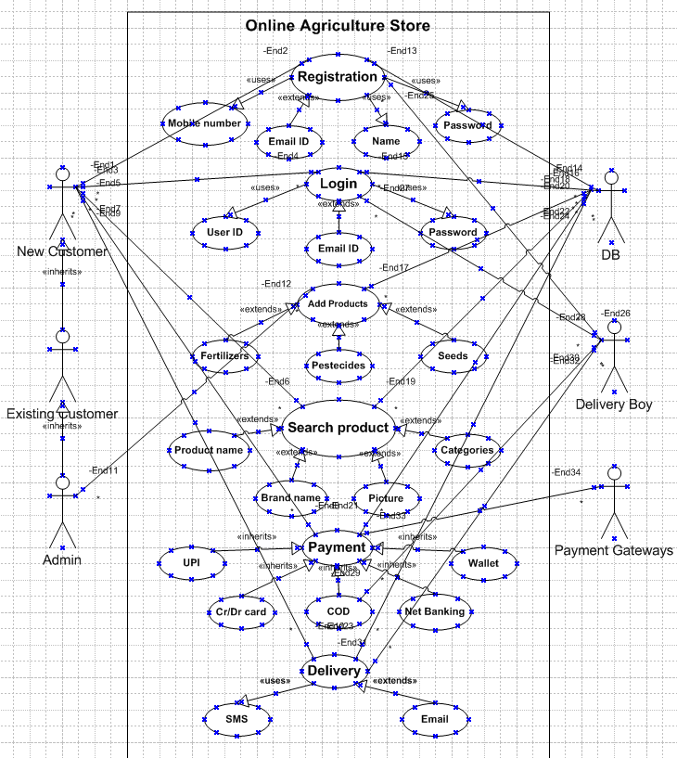

**Question 31 – (minimum 5) Use Case Specs - 3 Marks:**

Prepare use case specs for all use cases

ANS:

**Use case:1**

|  |  |
| --- | --- |
| **Use case ID** | **UC001** |
| **Use Case Name** | This use case shows how farmers can login via app after registration. |
| **Created by** | MR BISHWANATH SINHA |
| **Last Updated by** | 02-Dec-24 |
| **Date Created** | 24-Feb-24 |
| **Last Revision Date** | 01-Jan-24 |
| **Actor** | Customers/Farmers |
| **Description** | Describing how the page should respond if there is no internet |
| **Pre-condition** | Farmers must have an active internet connection |
| **Post-condition** | Success - Farmers can place the order successfully.  Failure - Farmers unable to login / logs are updated accordingly. |
| **Normal Flow of Events / Basic Flow / Happy Path** | - The use case starts when farmers register with a valid email ID and then login with ID and password.  - Use case validates the user.  - Farmers can view products, add them to the cart, and place the order. |
| **Alternative Flow** | Invalid User; Wrong account ID; Wrong password; No successful authentication via mobile number or email ID |
| **Exceptions** | If the internet connection is lost during activity, then display "Check your internet connection" |
| **Frequency of use** | High |
| **Assumptions** | It is assumed that the customer is registered and has computer knowledge. |

**Use case:2**

|  |  |
| --- | --- |
| **Use case ID** | **UC002** |
| **Use Case Name** | This use case shows how the delivery will be done. |
| **Created by** | MR BISHWANATH SINHA |
| **Last Updated by** | 02-Dec-24 |
| **Date Created** | 25-Feb-24 |
| **Last Revision Date** | 02-Jan-24 |
| **Actor** | Customers/Delivery boy |
| **Description** | Describing how delivery person will deliver the products to correct location. |
| **Pre-condition** | The user must have an active internet connection. |
| **Post-condition** | Success: The delivery will be completed on time.  Failure: The delivery will be delayed due to unforeseen reasons. |
| **Normal Flow of Events / Basic Flow / Happy Path** | The use case begins when farmer can login successfully.  In order section, he/she can see the status of delivery. |
| **Alternative Flow** | |  | | --- | | If there are issues during delivery, send an email to the vendor with the delivery status. | | Notify the user of the delivery status via email. |  |  | | --- | |  | |
| **Exceptions** | |  | | --- | | If internet connection is lost during activity, then display "Check your internet connection" |  |  | | --- | |  | |
| **Frequency of use** | High |
| **Assumptions** | It is assumed that the user has provided the full address with all required details. |

**Use case:3**

|  |  |
| --- | --- |
| **Use case ID** | **UC003** |
| **Use Case Name** | This use case shows how user can make payment from the app. |
| **Created by** | MR BISHWANATH SINHA |
| **Last Updated by** | 02-Dec-24 |
| **Date Created** | 26-Feb-24 |
| **Last Revision Date** | 03-Jan-24 |
| **Actor** | Customer/Payment gateway |
| **Description** | This use case describes how the delivery personnel will deliver products to the correct location. |
| **Pre-condition** | User should know how to make online payment & internet connection should work properly. |
| **Post-condition** | Success -User has entered his payment creds correctly.  Failure - User has entered wrong payment creds. |
| **Normal Flow of Events / Basic Flow / Happy Path** | The use case starts when user login with valid email ID and then Login with ID and password. Then user can login using OTP. User can add product to cart and proceed for payment. |
| **Alternative Flow** | User can login using OTP  App is showing incorrect amount details at the time of payment. |
| **Exceptions** | If internet connection lost during activity, then display "Check  your internet connection” |
| **Frequency of use** | High |
| **Assumptions** | It is assumed that user has all information about online payment. |

**Use case:4**

|  |  |
| --- | --- |
| **Use case ID** | **UC004** |
| **Use Case Name** | This use case shows how farmers can add products to cart |
| **Created by** | MR BISHWANATH SINHA |
| **Last Updated by** | 02-Dec-24 |
| **Date Created** | 27-Feb-24 |
| **Last Revision Date** | 04-Jan-24 |
| **Actor** | Customer/Product database |
| **Description** | Describing how to purchase products. |
| **Pre-condition** | Farmers have basic technical knowledge & internet  connection. |
| **Post-condition** | Success -Farmers can add products to cart successfully.  Failure - Farmers unable to add products to cart. |
| **Normal Flow of Events / Basic Flow / Happy Path** | Farmers search for desired products and browse the  catalogue. Farmers then select desired quantity and no of items.  Farmers add product to cart |
| **Alternative Flow** | Farmers can Wishlist the product and then add it to cart.  Farmers can directly add products from their past purchase and make similar purchase |
| **Exceptions** | If internet connection lost during activity, then display "Check your internet connection" |
| **Frequency of use** | High |
| **Assumptions** | It is assumed that Farmers have basic browsing knowledge of products. |

**Use case:5**

|  |  |
| --- | --- |
| **Use case ID** | **UC005** |
| **Use Case Name** | This use case shows how farmers can initiate return and refund. |
| **Created by** | MR BISHWANATH SINHA |
| **Last Updated by** | 02-Dec-24 |
| **Date Created** | 28-Feb-24 |
| **Last Revision Date** | 05-Jan-24 |
| **Actor** | Customer/Payment gateway |
| **Description** | Describing how to initiate refund and return |
| **Pre-condition** | Farmers have basic technical knowledge & internet connection. |
| **Post-condition** | Success -Farmers can initiate return & refund.  Failure - Farmers unable initiate refund and return |
| **Normal Flow of Events / Basic Flow / Happy Path** | Farmers go to purchase history and initiate return.  Farmers then select reason for return and agree to T&C for the same.  Farmers select mode and medium of refund. |
| **Alternative Flow** | Farmers can get refund added to their account wallet. |
| **Exceptions** | If internet connection lost during activity, then display "Check your internet connection" |
| **Frequency of use** | High |
| **Assumptions** | It is assumed that Farmers have basic browsing knowledge of products. |

**Question 32 – (minimum 5) Activity Diagrams - 3 Marks:**

Activity diagrams

1: Login into the application

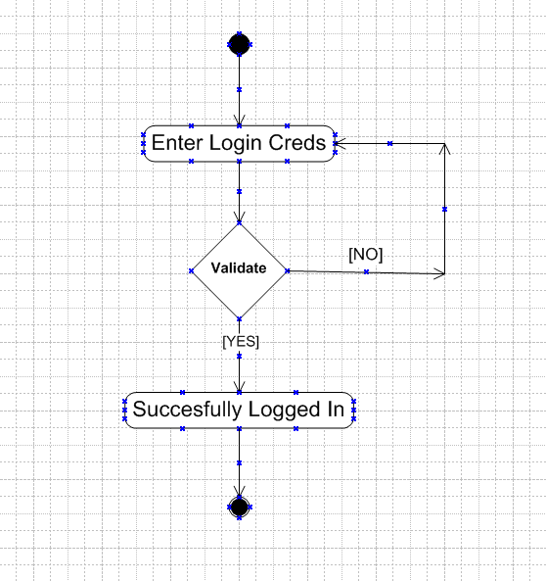

2. Search for the product:

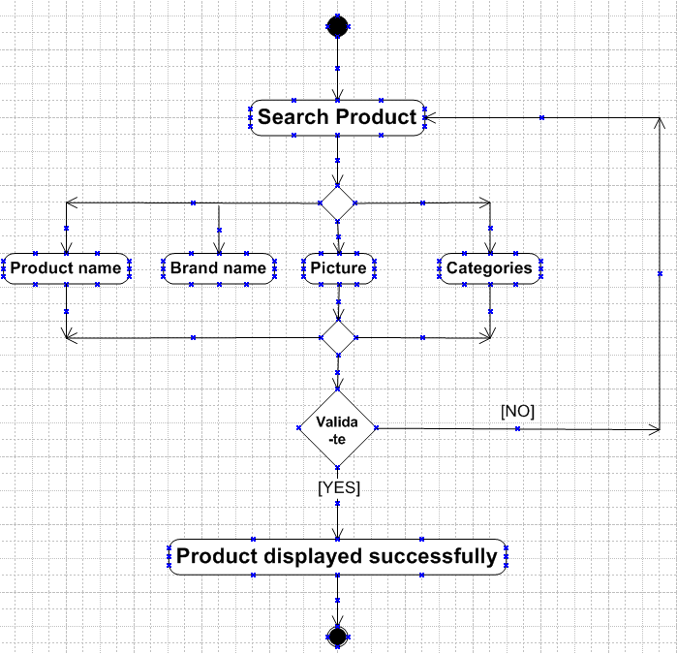

3: Add Product to the cart

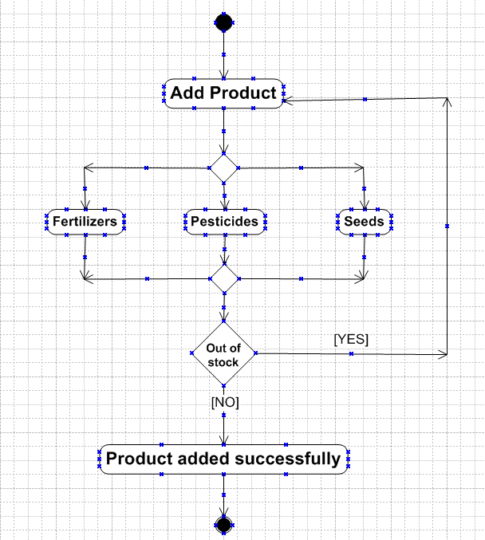

4: Payment:

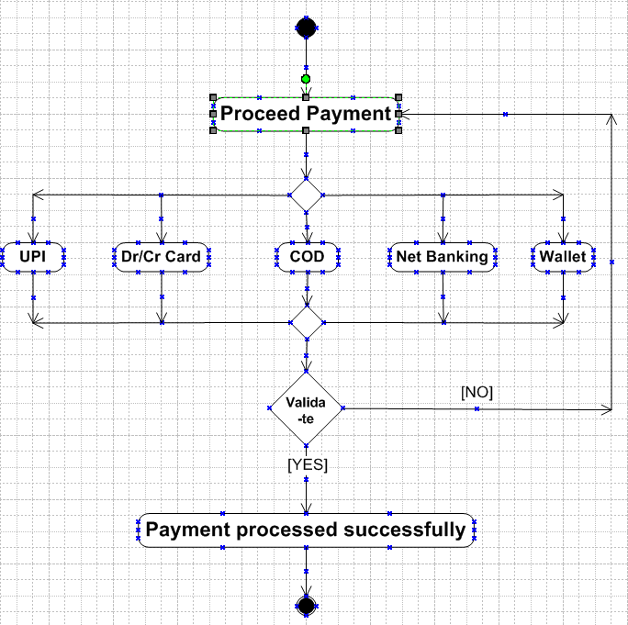

5: Product Delivery

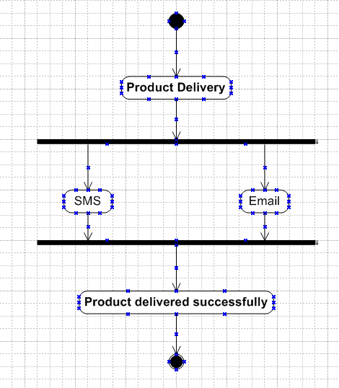

**Question 33 – Functional Requirements - 7 Marks:**

Identify minimum 20 functional requirements Example : Functional requirement: When an order is fulfilled, the local printer shall print a packing slip. Non-Functional Requirement: Packing slips shall be printed on both sides of 4”x 6” white paper, the standard size for packing slips used by local printers

|  |  |  |  |
| --- | --- | --- | --- |
| Req ID | Req Name | Req Description | Priority |
| FR0001 | Farmer Registration | Farmers should be able to register with the application | **8** |
| FR0002 | Farmer Search for Products | Farmers should be able to search for available products in fertilizers, seeds, pesticides | **8** |
|  |  |  |  |
|  |  |  |  |
| NFR0101 | Page Loading Time | Each Page should load within 2 seconds time | **9** |
| NFR0102 | WCAG 2.1. | The system must meet Web Content Accessibility Guidelines WCAG 2.1. | **8** |

**ANS:**

|  |  |  |  |
| --- | --- | --- | --- |
| Req ID | Req Name | Req Description | Priority |
| FR0001 | New A/C Registration | Farmers should be able to register a new A/C | 10 |
| FR0002 | Login Page | Farmers should be able to login | 9 |
| FR0003 | Product search | Farmers should be able to search their desired product | 9 |
| FR0004 | Product quantity | Farmers should be able to select their product quantity | 7 |
| FR0005 | Product wishlist | Farmers should be able to add a product to the wishlist to buy it later | 6 |
| FR0006 | Add to cart | Farmers should be able to add a product to the shopping cart | 8 |
| FR0007 | Add address | Farmers should be able to add their accurate address | 9 |
| FR0008 | Update address | Farmers should be able to update their address in case it gets changes | 7 |
| FR0009 | Payment options | Farmers should be able to view multiple payment options such as Cr/Dr card, UPI, Pay later and COD | 10 |
| FR0010 | Place an order | Farmers should be able to place an order | 9 |
| FR0011 | Order confirmation | Farmers should be able to get an order confirmation via email or text message | 8 |
| FR0012 | Track product status | Farmers should be able to track the product delivery status | 8 |
| FR0013 | Product unavailability | Farmers should be able to get product unavailability notification | 6 |
| FR0014 | Exchange option | Farmers should be able to exchange their products | 7 |
| FR0015 | Return option | Farmers should be able to return their product | 7 |
| FR0016 | Purchase slip | Farmers should be able to get the purchasing slip | 5 |
| FR0017 | Feedback option | Farmers should be able to give feedback about product purchased | 4 |
| FR0018 | Customer support option | Farmers should be able to get the customer support contact details | 6 |
| FR0019 | Offers on products | Farmers should be able to view the offers on products | 3 |
| FR0020 | Fast delivery | Farmers should be able to opt for fast delivery | 2 |

**Question 34–Minimum 5 page designs - 3 Marks:**

Make wireframe and prototypes

**ANS:**

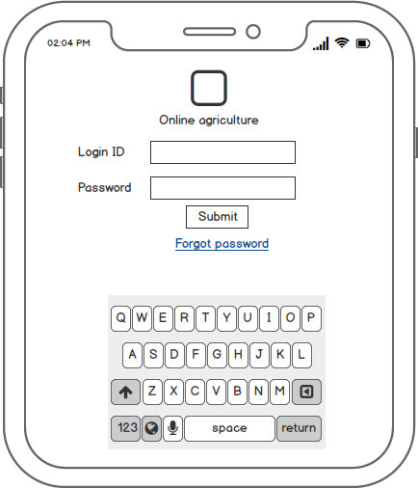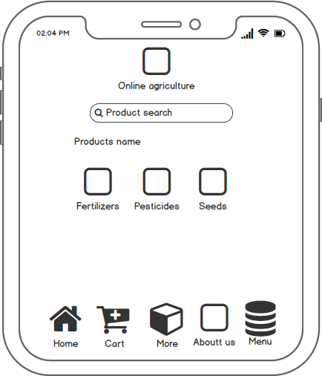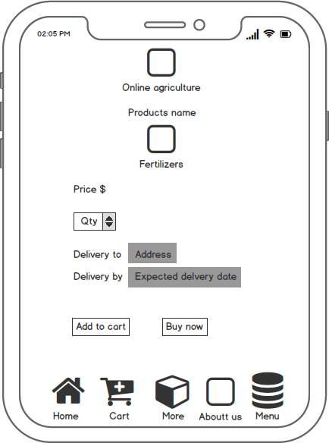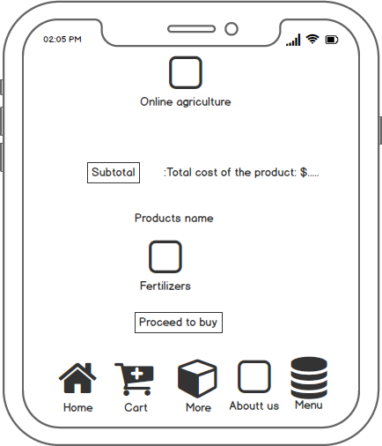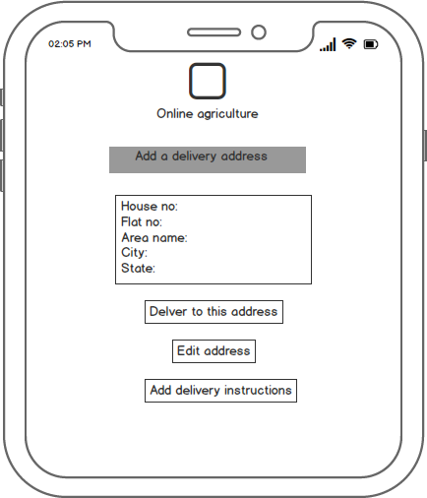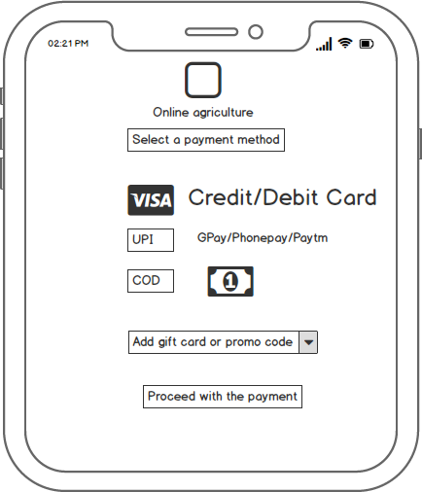

**Question 35 – Tools (Visio, Balsamiq) - 3 Marks:**

Make a note of the Tools, which you are using for above concepts.

ANS:

Microsoft Visio: Microsoft Visio is a versatile diagramming tool that allows users to create a wide range of diagrams, including flowcharts, organizational charts, and network diagrams. With its extensive library of shapes and customization options, Visio enables users to visually represent complex information and processes. It offers collaboration features, data linking capabilities, and seamless integration with other Microsoft Office applications.

Balsamiq: Balsamiq is a popular wireframing tool used for creating low-fidelity prototypes. It focuses on simplicity and sketch-like designs to quickly visualize and communicate design ideas. With its drag-and-drop interface and pre-built UI elements, Balsamiq allows users to rapidly iterate and gather feedback on the basic structure and layout of a digital product.

**Question 36 – RTM - 2 Marks:**

A business analyst’s key responsibilities are to keep track of the requirements and make sure that no requirement is missed. Mr. Henry and peter have approached you regarding the current status of the project. How will you tackle this situation?

Prepare RTM

|  |  |  |  |  |  |  |  |  |
| --- | --- | --- | --- | --- | --- | --- | --- | --- |
| Req ID | Req Name | Req Description | Design | D1 | T1 | **…...** | T4 | UAT |
| FR0001 | Farmer Registration | Farmers should be able to register with the application |  |  |  |  |  |  |
| FR0002 | Farmer Search for Products | Farmers should be able to search for available products in fertilizers, seeds, pesticides |  |  |  |  |  |  |
|  |  |  |  |  |  |  |  |  |
|  |  |  |  |  |  |  |  |  |
| NFR0101 | Page Loading Time | Each Page should load within 2 seconds time |  |  |  |  |  |  |
| NFR0102 | WCAG 2.1. | The system must meet Web Content Accessibility Guidelines WCAG 2.1. |  |  |  |  |  |  |
|  |  |  |  |  |  |  |  |  |
|  |  |  |  |  |  |  |  |  |

**ANS:**

|  |  |  |  |  |  |  |  |  |  |
| --- | --- | --- | --- | --- | --- | --- | --- | --- | --- |
| Req ID | Req Name | Req Description | Design | D1 | T1 | **T2** | T3 | T4 | UAT |
| FR0001 | New A/C Registration | Farmers should be able to register a new A/C | **Done** | **Done** | **Done** | **Done** | **Done** | **Done** | **Done** |
| FR0002 | Login Page | Farmers should be able to login | **Done** | **Done** | **Done** | **Done** | **Done** | **Done** | **Done** |
| FR0003 | Product search | Farmers should be able to search their desired product | **Done** | **Done** | **Done** | **Done** | **Done** | **Done** | **Done** |
| FR0004 | Product quantity | Farmers should be able to select their product quantity | **Done** | **Done** | **Done** | **Done** | **Done** | **Done** | **Done** |
| FR0005 | Product wishlist | Farmers should be able to add a product to the wishlist to buy it later | **Done** | **Done** | **Done** | **Done** | **Done** | **Done** | **Done** |
| FR0006 | Add to cart | Farmers should be able to add a product to the shopping cart | **Done** | **Done** | **Done** | **Done** | **Done** | **Done** | **Done** |
| FR0007 | Add address | Farmers should be able to add their accurate address | **Done** | **Done** | **Done** | **Done** | **Done** | **Done** | **Done** |
| FR0008 | Update address | Farmers should be able to update their address in case it gets changes | **Done** | **Done** | **Done** | **Done** | **Done** | **Done** | **Done** |
| FR0009 | Payment options | Farmers should be able to view multiple payment options such as Cr/Dr card, UPI, Pay later and COD | **Done** | **Done** | **Done** | **Done** | **Done** | **Done** | **Done** |
| FR0010 | Place an order | Farmers should be able to place an order | **Done** | **Done** | **Done** | **Done** | **Done** | **Done** | **Done** |
| NFR001 | Page Loading Time | Each Page should load within 2 seconds time | **Done** | **Done** | **Done** | **Done** | **Done** | **Done** | **Done** |
| NFR002 | WCAG 2.1. | The system must meet Web Content Accessibility Guidelines WCAG 2.1. | **Done** | **Done** | **Done** | **Done** | **Done** | **Done** | **Done** |
| NFR003 | Manufacturing | FAQ for farming product | **Done** | **Done** | **Done** | **Done** | **Done** | **Done** | **Done** |
| NFR004 | Website load | Online portal loading to the website takes time to confirmation. | **Done** | **Done** | **Done** | **Done** | **Done** | **Done** | **Done** |
| NFR005 | Internet issue | Multi video and picture need to upload where server issues and internet connectivity problems may be occur. | **Done** | **Done** | **Done** | **Done** | **Done** | **Done** | **Done** |
| NFR006 | Bank server support | Banking channel partners need to support the payment gateway and need support to handle the confirmation of payment. | **Done** | **Done** | **Done** | **Done** | **Done** | **Done** | **Done** |
| NFR007 | Delivery channel | Delivery channels must update which takes time to update on the website. | **Done** | **Done** | **Done** | **Done** | **Done** | **Done** | **Done** |
| NFR008 | Customer care | Help & support | **Done** | **Done** | **Done** | **Done** | **Done** | **Done** | **Done** |

**Question 37 – 10 Test Case Documents - 3 Marks:**

Prepare 10 Test Case Documents

ANS:

|  |  |
| --- | --- |
| **Test case** | **TC001** |
| **Test case name** | **Login with valid credentials** |
| **Project name** | **Online Agriculture Product store** |
| **Tester Id** | **T001** |
| **Created by** | **XYZ** |
| **Created date** | **\*\*\*\*\*\*** |
| **Peer review by** | **XYZ** |
| **Peer reviewed date** | **\*\*\*\*\*\*** |

|  |  |
| --- | --- |
| **Scenario** | **The user enters valid login credentials and clicks on the login button** |
| **Example** | **User name:** [XYZ@yahoo.com](mailto:XYZ@yahoo.com)**, Password: \*\*\*\*\*\*\*** |

|  |  |  |  |  |  |
| --- | --- | --- | --- | --- | --- |
| **Steps to execute** | **Inputs** | **Expected Output** | **Actual Output** | **Test Browser** | **Result** |
| **Enter the username and password and click on the login button** | **User name:** [XYZ@yahoo.com](mailto:XYZ@yahoo.com)  **Password: \*\*\*\*\*\*\*** | **The user should be able to login and redirected to the home page** | **User successfully logged in and redirected to the home page** | **Chrome** | **Pass** |

|  |  |
| --- | --- |
| **Test case** | **TC002** |
| **Test case name** | **Login with In-valid credentials** |
| **Project name** | **Online Agriculture Product store** |
| **Tester Id** | **T002** |
| **Created by** | **XYZ** |
| **Created date** | **\*\*\*\*\*\*** |
| **Peer review by** | **XYZ** |
| **Peer reviewed date** | **\*\*\*\*\*\*** |

|  |  |
| --- | --- |
| **Scenario** | **The user enters In-valid login credentials and clicks on the login button** |
| **Example** | **User name:** [XYZ@yahoo.com](mailto:XYZ@yahoo.com)**, Password: Invalid\*\*\*\*** |

|  |  |  |  |  |  |
| --- | --- | --- | --- | --- | --- |
| **Steps to execute** | **Inputs** | **Expected Output** | **Actual Output** | **Test Browser** | **Result** |
| **Enter the username and password and click on the login button** | **User name:** [XYZ@yahoo.com](mailto:XYZ@yahoo.com)  **Password: Invalid\*\*\*\*** | **The system should display an error message indicating Invalid credentials** | **Error message displayed**  **“Invalid username and Password”** | **FireBox** | **Pass** |

|  |  |
| --- | --- |
| **Test case** | **TC003** |
| **Test case name** | **Search for a product** |
| **Project name** | **Online Agriculture Product store** |
| **Tester Id** | **T003** |
| **Created by** | **XYZ** |
| **Created date** | **\*\*\*\*\*\*** |
| **Peer review by** | **XYZ** |
| **Peer reviewed date** | **\*\*\*\*\*\*** |

|  |  |
| --- | --- |
| **Scenario** | **The user searches for a specific product** |
| **Example** | **Search for “Seeds- Cucumber”** |

|  |  |  |  |  |  |
| --- | --- | --- | --- | --- | --- |
| **Steps to execute** | **Inputs** | **Expected Output** | **Actual Output** | **Test Browser** | **Result** |
| **Enter “Seeds- Cucumber” in the search bar and press enter** | **Search “Seeds- cucumber”** | **The system should display the list of products searched by the user** | **Products successfully displayed** | **FireBox** | **Pass** |

|  |  |
| --- | --- |
| **Test case** | **TC004** |
| **Test case name** | **Add product to shopping cart** |
| **Project name** | **Online Agriculture Product store** |
| **Tester Id** | **T004** |
| **Created by** | **XYZ** |
| **Created date** | **\*\*\*\*\*\*** |
| **Peer review by** | **XYZ** |
| **Peer reviewed date** | **\*\*\*\*\*\*** |

|  |  |
| --- | --- |
| **Scenario** | **The user selects a product and add it to the cart** |
| **Example** | **Select Fertilizers- 1kg** |

|  |  |  |  |  |  |
| --- | --- | --- | --- | --- | --- |
| **Steps to execute** | **Inputs** | **Expected Output** | **Actual Output** | **Test Browser** | **Result** |
| **Click on the desired product, select the appropriate quantity and click on “Add to cart” button** | **Product: Fertilizers**  **Quantity: 1kg** | **The user should be able to add desired product with the correct quantity selected** | **Product successfully added to the cart with correct quantity of 1 kg** | **FireBox** | **Pass** |

|  |  |
| --- | --- |
| **Test case** | **TC005** |
| **Test case name** | **Remove product from the cart** |
| **Project name** | **Online Agriculture Product store** |
| **Tester Id** | **T005** |
| **Created by** | **XYZ** |
| **Created date** | **\*\*\*\*\*\*** |
| **Peer review by** | **XYZ** |
| **Peer reviewed date** | **\*\*\*\*\*\*** |

|  |  |
| --- | --- |
| **Scenario** | **The user removes a product from the cart** |
| **Example** | **Remove Pesticides- 500gm** |

|  |  |  |  |  |  |
| --- | --- | --- | --- | --- | --- |
| **Steps to execute** | **Inputs** | **Expected Output** | **Actual Output** | **Test Browser** | **Result** |
| **Find the product on the cart and click on the remove button** | **Product: Pesticides Qty: 500gm** | **The user should be able to remove the selected product from the cart** | **Product successfully removed from the cart** | **Chrome** | **Pass** |

|  |  |
| --- | --- |
| **Test case** | **TC006** |
| **Test case name** | **Add product to the Wishlist** |
| **Project name** | **Online Agriculture Product store** |
| **Tester Id** | **T006** |
| **Created by** | **XYZ** |
| **Created date** | **\*\*\*\*\*\*** |
| **Peer review by** | **XYZ** |
| **Peer reviewed date** | **\*\*\*\*\*\*** |

|  |  |
| --- | --- |
| **Scenario** | **The user adds a product to the Wishlist** |
| **Example** | **Add “Organic- Seeds- Tomato” to the Wishlist** |

|  |  |  |  |  |  |
| --- | --- | --- | --- | --- | --- |
| **Steps to execute** | **Inputs** | **Expected Output** | **Actual Output** | **Test Browser** | **Result** |
| **Find the product and click on the “Add to Wishlist” button** | **Product: “Organic- Seeds- Tomato”** | **The user should be able to add the product to the Wishlist** | **Product added to the Wishlist successfully** | **Chrome** | **Pass** |

|  |  |
| --- | --- |
| **Test case** | **TC007** |
| **Test case name** | **Update quantity in cart** |
| **Project name** | **Online Agriculture Product store** |
| **Tester Id** | **T007** |
| **Created by** | **XYZ** |
| **Created date** | **\*\*\*\*\*\*** |
| **Peer review by** | **XYZ** |
| **Peer reviewed date** | **\*\*\*\*\*\*** |

|  |  |
| --- | --- |
| **Scenario** | **The user updates the product quantity in the cart** |
| **Example** | **Update quantity of fertilizers- 1kg to 2kg** |

|  |  |  |  |  |  |
| --- | --- | --- | --- | --- | --- |
| **Steps to execute** | **Inputs** | **Expected Output** | **Actual Output** | **Test Browser** | **Result** |
| **Find the product in the cart, update the quantity to 2kg and click on the update button** | **Product: fertilizers- 1kg**  **Quantity: 2kg** | **The user should be able to update the quantity of the product in the cart** | **Product quantity in the cart updated successfully** | **Chrome** | **Pass** |

|  |  |
| --- | --- |
| **Test case** | **TC008** |
| **Test case name** | **View the total cost in the cart** |
| **Project name** | **Online Agriculture Product store** |
| **Tester Id** | **T008** |
| **Created by** | **XYZ** |
| **Created date** | **\*\*\*\*\*\*** |
| **Peer review by** | **XYZ** |
| **Peer reviewed date** | **\*\*\*\*\*\*** |

|  |  |
| --- | --- |
| **Scenario** | **The user reviews the total cost of the product in the cart** |
| **Example** | **View the total cost of all the products** |

|  |  |  |  |  |  |
| --- | --- | --- | --- | --- | --- |
| **Steps to execute** | **Inputs** | **Expected Output** | **Actual Output** | **Test Browser** | **Result** |
| **Click on the “Items summary” button** | **Total cost of all the products** | **The system display the total cost of all the products** | **Total cost of all the products displayed successfully** | **Chrome** | **Pass** |

|  |  |
| --- | --- |
| **Test case** | **TC009** |
| **Test case name** | **Apply coupon code** |
| **Project name** | **Online Agriculture Product store** |
| **Tester Id** | **T009** |
| **Created by** | **XYZ** |
| **Created date** | **\*\*\*\*\*\*** |
| **Peer review by** | **XYZ** |
| **Peer reviewed date** | **\*\*\*\*\*\*** |

|  |  |  |  |  |  |  |
| --- | --- | --- | --- | --- | --- | --- |
| **Scenario** | **The user applies a coupon code on the product to get a discount** | | | | | |
| **Example** | **Apply coupon and save 20%** | | | | | |
| **Steps to execute** | | **Inputs** | **Expected Output** | **Actual Output** | **Test Browser** | **Result** |
| **Enter the coupon code in the “coupon code bar” and click on apply** | | **Coupon code-Save 20%** | **The system should apply the coupon code and deduct the discount amount from the total cost of the product** | **Coupon code applied successfully and discounted amount deducted from the total cost of the product** | **Chrome** | **Pass** |

|  |  |
| --- | --- |
| **Test case** | **TC010** |
| **Test case name** | **Proceed to checkout** |
| **Project name** | **Online Agriculture Product store** |
| **Tester Id** | **T010** |
| **Created by** | **XYZ** |
| **Created date** | **\*\*\*\*\*\*** |
| **Peer review by** | **XYZ** |
| **Peer reviewed date** | **\*\*\*\*\*\*** |

|  |  |
| --- | --- |
| **Scenario** | **The user proceeds to the checkout process** |
| **Example** | **Click on the proceed to checkout button** |

|  |  |  |  |  |  |
| --- | --- | --- | --- | --- | --- |
| **Steps to execute** | **Inputs** | **Expected Output** | **Actual Output** | **Test Browser** | **Result** |
| **Click on the procced to checkout on the cart page** | **Proceed with checkout** | **The user should be redirected to the checkout page** | **User redirected to the checkout page** | **Chrome** | **Pass** |

**Question 38 – DB Design - 2 Marks:**

After the requirements are thoroughly explained to the entire project team by business analyst, the Database architects have decided to do the database design and also to represent the in-flow and out-flow of data. Draw database schema and ER diagram.

ANS:

**Diagram is the design of data**

Farmers

Agricultural companies

Billing

Login

Farmers

Agricultural companies

Billing

Login

**Farmers**

Agricultural companies

Billing

Login

**Agriculture companies**

**Billing**

**Login**

|  |  |
| --- | --- |
| **Farmers** | **Agriculture companies** |
| Need farmer’s details like, name, email id, mobile no etc. | Product details |
|  | Product price and discount |
| **Billing** | **Login** |
| Payment option | Login page farmers and companies |
| Payment confirmation | Login by using email or mobile no |
| Payment slip | Open home page which product gallery |

**ERD for online shopping system**

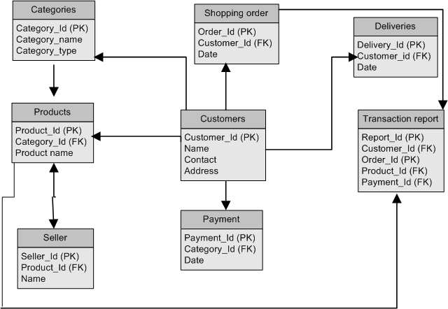

A data-flow diagram is a way of representing a flow of data through a process

or a system (usually an information system). The DFD also provides information

about the outputs and inputs of each entity and the process itself.

A data-flow diagram is a way of representing a flow of data through a process

or a system (usually an information system). The DFD also provides information

about the outputs and inputs of each entity and the process itself.

A data-flow diagram is a way of representing a flow of data through a process

or a system (usually an information system). The DFD also provides information

about the outputs and inputs of each entity and the process itself.

A data-flow diagram is a way of representing a flow of data through a process

or a system (usually an information system). The DFD also provides information

about the outputs and inputs of each entity and the process itself.

A data-flow diagram is a way of representing a flow of data through a process

or a system (usually an information system). The DFD also provides information

about the outputs and inputs of each entity and the process itself.

**Question 39 – Data Flow Diagram - 1 Marks**

What is a data flow diagram? Draw a data flow diagram to represent the in-flow and out-flow of data when a Farmer is placing an order for the product

A data-flow diagram is a way of representing a flow of data through a process

or a system (usually an information system). The DFD also provides information

about the outputs and inputs of each entity and the process itself.

A data-flow diagram is a way of representing a flow of data through a process

or a system (usually an information system). The DFD also provides information

about the outputs and inputs of each entity and the process itself.

A data-flow diagram is a way of representing a flow of data through a process

or a system (usually an information system). The DFD also provides information

about the outputs and inputs of each entity and the process itself.

A data-flow diagram is a way of representing a flow of data through a process

or a system (usually an information system). The DFD also provides information

about the outputs and inputs of each entity and the process itself.

A data-flow diagram is a way of representing a flow of data through a process

or a system (usually an information system). The DFD also provides information

about the outputs and inputs of each entity and the process itself.

**ANS:**

A dataflow diagram is a way of representing a flow of date through a process or a system. The DFD also provides information about the outputs and inputs of each entity and the process itself.

**Shopping cart**

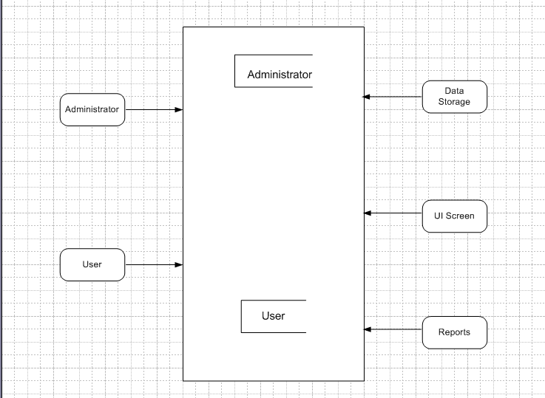

**Question 40 – Change Request - 5 Marks:**

Due to change in the Government Taxation structure. We should change the Tax structure How do you handle change requests in a project?

**ANS:**

1. **Document the change request-** The first step is to document the proposed change request including the reason for the change, the scope of the change and any potential impact on the project.
2. **Evaluate the impact of the change-** The project team should evaluate the impact of the proposed change on the project schedule, budget and aspect of the project plan. This evaluation should include identifying any additional resources that may be needed, such as additional funding, manpower or equipment.
3. **Determine the feasibility of the change-** Based on the evaluation the project team should determine whether the change is feasible within the constraints of the project plan. If change is not feasible, then team may suggest alternative solution.
4. **Obtain approval-** Once feasibility done the project manager should obtain the approval from the appropriate stakeholders such as project sponsors.
5. **Implement the change-** Once approval has been obtained the project team should implement the change in control manner, including any necessary updates, project documentation, schedule and budgets.
6. **Monitor the impact of change request-** After the change has been implemented the project team should monitor its impact on the project. Any issue that arises should be addressed promptly to minimise their impact on the project.

**Question 41 – Change Request Vs an Enhancement - 1 Marks:**

As the project is in process, Ben and Kevin have contacted you. The reason is to inform you that they want the Farmers to sell their crop yields through this application i.e. Farmers should be able to add their crop yields or products and display to general public and should be able to sell them. They also want to introduce Auction system for their Crop yields. As a BA, what will be your response? Is this a change request or an enhancement?

ANS:

As a BA my response would be that this request from BEN and Kevin is an enhancement to the existing project scope. The initial project scope was to develop an application for buyers to purchase crop yields directly from farmers, but this enhancement adds the capability for farmers to add their own crop yields to the application and sell them through an auction system.

**Question 42 – Estimations - 1 Marks:**

Come up with estimations – How many Manhours required.

ANS:

Estimating the number of manhour required to implement the enhancement depends on various factors such as the complexity of the features, the size of the development team, the development methodology and technology stack being used. However as a rough estimate we can assume that developing this features would require at least 250-300 manhours, considering the following activities:

1. Gathering requirements from farmers and buyers (25-30 manhours)

2. Conducting a feasibility study (25-30 manhours)

3. Designing the feature including UI and UX design (45-50 manhours)

4. Developing the backend functionality (125-150 manhours)

5. Testing and quality assurance (25-30 manhours)

**Question 43 – UAT – 2 Marks:**

Project has finally completed all the stages i.e., design, development, testing etc. Now, it is the role of a business analyst to contact the client for testing of the final product and have to successfully complete it. How are you going to handle this situation? And once it is done, what will be the process to close the project?

Explain UAT Acceptance process

ANS:

As a BA my approach to handling the situation of testing the final product with the client would be to first confirm with the development team that all requirements and the product is ready for user acceptance testing (UAT). I would then coordinate with the client to schedule a UAT session and ensure that they are provided with the necessary instructions and support to carry out the testing.

During UAT the client would be given access to the product and asked to test it thoroughly to ensure that it meets their requirements and expectations. Any issue or bugs found during UAT would be documented and prioritize for resolution by the development team. Once UAT is complete and all issue have been resolved the product can be considered ready for release to client.

**The project would then move to the project closure phase which involves –**

1. **Handover: -** Final deliverables and documentations are handed over to the client, and all the project resources are released.
2. **Post implementation review: -** It is conducted to evaluate the project success ax`nd identify opportunities for improvement in future projects.
3. **Project closure documentation:** - Documentation is created to close the project, including final financial reports, lessons learned and project summary reports.

**UAT acceptance process involves:-**

1. **Planning and preparation-** The UAT plan is developed which includes the scope, objectives and testing approach. The client is also engaged to identify the user scenarios and test cases.
2. **Executions-** The client executes the test cases and report any issues encountered during testing.
3. **Issue resolution-** The development team addresses and resolves any issue reported by the client.
4. **Acceptance-** The client accept the final product and provides a signoff indicating that they are satisfied with the products functionality and usability.

**Question 44 – Project Closure Document - 2 Marks:**

Explain Project closure document

ANS:

A project closure document is a formal document that outlines the final status and outcome of a project. The document is created at the end of project and it summarizes the results, achievements, challenges and lesson learned through the project lifecycle. It includes following components: -

1. **Executive summary: -** A brief summary of the project, including objectives, scope, budget and results.
2. **Project results: -** A description of the project achievements, including deliverables, milestones and performance metrics.
3. **Lesson learned: -** A detail review of project challenges, mistakes, successes and recommendations for future projects.
4. **Financial analysis: -** A summary of the project, budget and actual expenses including any variances and reasons for differences.
5. **Project closeout:** - A List of activities necessary to close out the project, including final payments, document archiving and stakeholder communication.
6. **Recommendations: -** Suggestions for improving project management process and strategies for future projects.