Question 1 – Functional Requirements

Identify minimum 20 functional requirements

Example :

Functional requirement: When an order is fulfilled, the local printer shall print a packing slip.

Non-Functional Requirement: Packing slips shall be printed on both sides of 4”x 6” whitepaper, the standard size for packing slips used by local printers

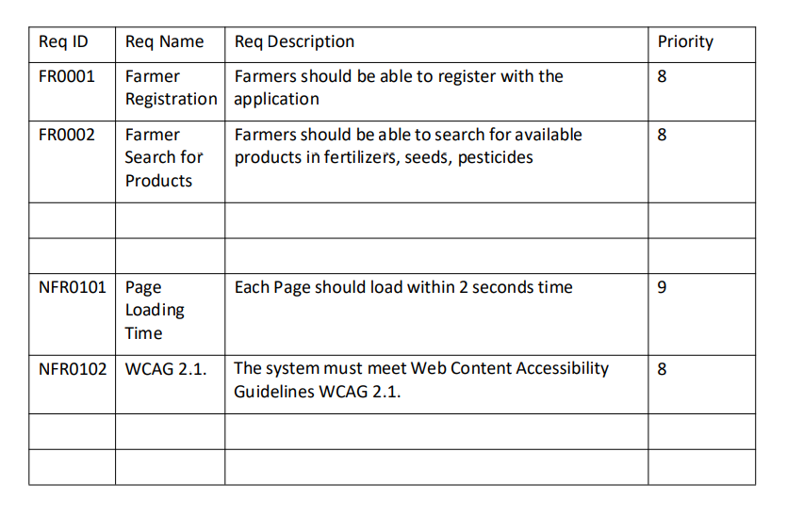

Answer -

|  |  |  |  |
| --- | --- | --- | --- |
| **Req ID** | **Req Name** | **Req Description** | **Priority** |
| FR-001 | User Login | The application should allow users (Farmers and Manufacturers) to log in using their email and password. | 10 |
| FR-002 | User Registration | New users should be able to register by providing an email ID and creating a secure password. | 10 |
| FR-003 | Product Catalog | The application should display a catalog of fertilizers, seeds, and pesticides for farmers to browse. | 10 |
| FR-004 | Search Products | Farmers should be able to search for products using keywords like name, type, or manufacturer. | 9 |
| FR-005 | Add to Cart | Farmers should be able to add selected products to their cart for purchase. | 9 |
| FR-006 | Add to Buy-Later List | Farmers should be able to save products to a "Buy Later" list for future consideration. | 8 |
| FR-007 | Product Details View | Farmers should be able to view detailed information about each product, including price, description, and availability. | 9 |
| FR-008 | Secure Payment Gateway | The application should provide payment options, including Cash on Delivery (COD), Credit/Debit Card, and UPI. | 10 |
| FR-009 | Order Confirmation Email | Farmers should receive an email confirmation regarding their order status upon successful payment. | 10 |
| FR-010 | Delivery Tracking | The application should provide a delivery tracker to monitor the order's status and location in real-time. | 9 |
| FR-011 | Manufacturer Login | Manufacturers should be able to log in to upload and manage product details. | 9 |
| FR-012 | Manufacturer Product Upload | Manufacturers should be able to add new products to the catalog with necessary details. | 9 |
| FR-013 | Manufacturer Product Management | Manufacturers should be able to edit or delete their product listings. | 8 |
| FR-014 | User-Friendly Interface | The application should have an intuitive and user-friendly interface for ease of use by farmers and manufacturers. | 10 |
| FR-015 | Multi-Language Support | The application should support multiple languages to cater to farmers from various regions. | 7 |
| FR-016 | Feedback System | Users should be able to provide feedback or reviews on products. | 7 |
| FR-017 | Notifications | Farmers should receive notifications for order updates, offers, and important announcements. | 8 |
| FR-018 | Location-Based Recommendations | The application should suggest products based on the farmer's geographical location. | 6 |
| FR-019 | Secure User Data | The application should store user data securely, adhering to relevant data privacy standards. | 10 |
| FR-020 | Report Generation | Manufacturers should be able to generate sales and inventory reports. | 6 |

Question 2–Minimum 5 page designs

Make wireframe and prototypes.

1. Sign Up page -

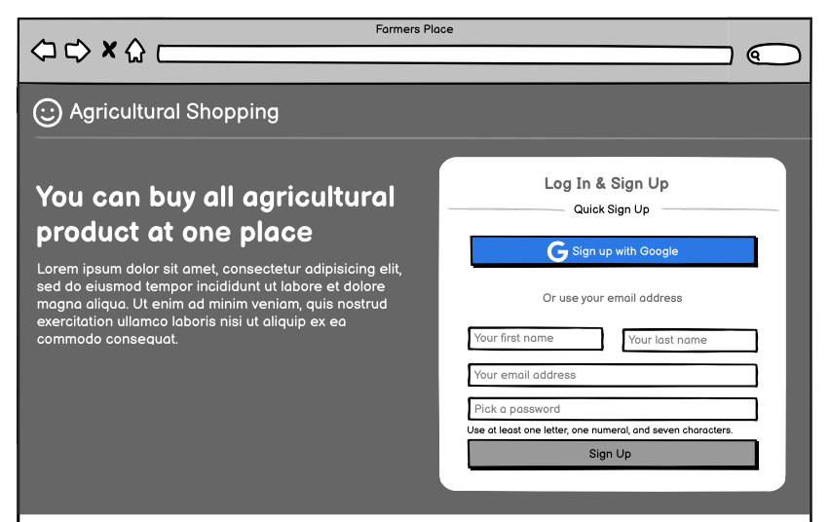

1. Home Page -

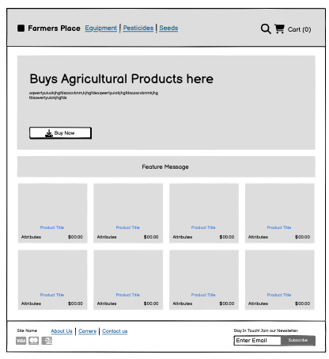

1. Product Page -

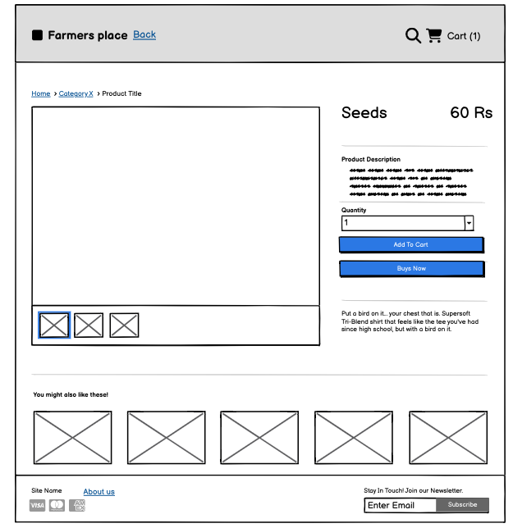

1. My Cart page -

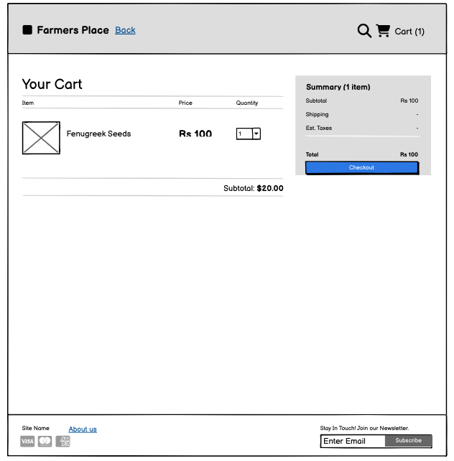

1. Payment page -

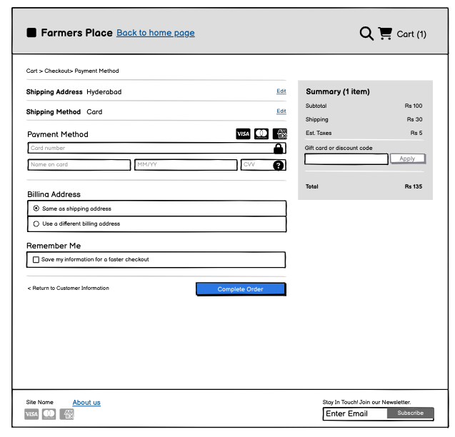

Question 3 – Tools (Visio, Balsamiq)

Make a note of the Tools, which you are using for above concepts.

Answer -

Microsoft Visio:

Microsoft Visio is a versatile diagramming tool that allows users to create a wide range of diagrams, including flowcharts, organizational charts, and network diagrams. With its extensive library of shapes and customization options, Visio enables users to visually represent complex information and processes. It offers collaboration features, data linking capabilities, and seamless integration with other Microsoft Office applications.

Balsamiq:

Balsamiq is a popular wireframing tool used for creating low-fidelity prototypes. It focuses on simplicity and sketch-like designs to quickly visualize and communicate design ideas. With its drag-and-drop interface and pre-built UI elements, Balsamiq allows users to rapidly iterate and gather feedback on the basic structure and layout of a digital product.

Axure:

An Axure wireframe tool is primarily used to create visual prototypes and low-to-high fidelity wireframes for websites and applications, allowing designers to map out the user interface (UI) and interactions of a product before development begins, making it ideal for testing and iterating design concepts with stakeholder

Question 4 – RTM - 6 Marks

A business analyst’s key responsibilities are to keep track of the requirements and make sure that no requirement is missed.

Mr. Henry and peter have approached you regarding the current status of the project. How will you tackle this situation?

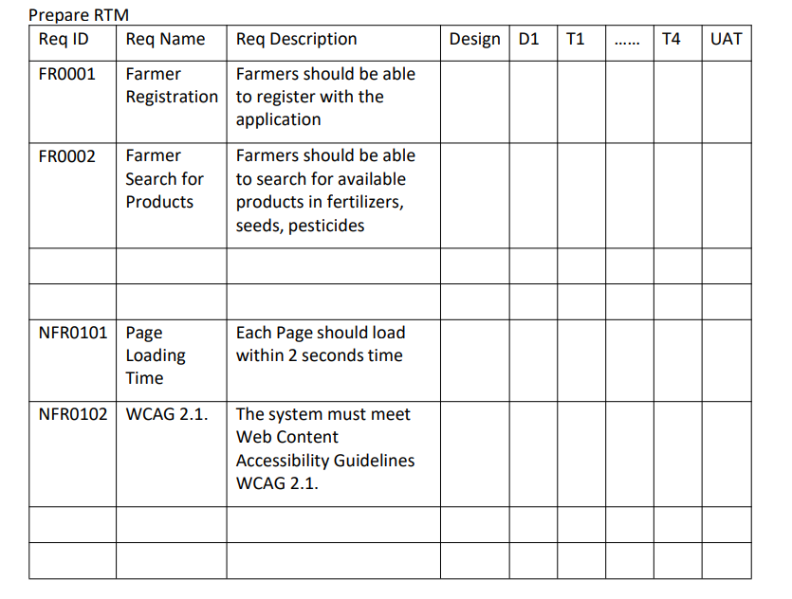

Answer -

Here’s a comprehensive **Requirements Traceability Matrix (RTM)** containing **20 Functional Requirements (FR)** and **20 Non-Functional Requirements (NFR)**. Each row includes the requirement's ID, name, and description, with placeholders for design and testing phases:

### **Functional Requirements**

|  |  |  |  |  |  |  |  |  |  |  |  |  |
| --- | --- | --- | --- | --- | --- | --- | --- | --- | --- | --- | --- | --- |
| **Req ID** | **Req Name** | **Req Description** | **Design** | **D1** | **T1** | **D2** | **T2** | **D3** | **T3** | **D4** | **T4** | **UAT** |
| FR-001 | User Login | Enable farmers and manufacturers to log in using their email and password. | Y | Y | Y | Y | Y | Y | Y | Y | Y | N |
| FR-002 | User Registration | Allow new users to create accounts with email ID and secure passwords. | Y | Y | Y | Y | Y | Y | Y | Y | Y | N |
| FR-003 | Product Catalog | Display a categorized catalog of fertilizers, seeds, and pesticides for farmers. | Y | Y | Y | Y | Y | Y | Y | N | N | N |
| FR-004 | Search Products | Provide a search functionality for farmers to find specific products. | Y | Y | Y | Y | Y | Y | N | N | N | N |
| FR-005 | Product Details View | Show detailed descriptions, images, and prices of selected products. | Y | Y | Y | Y | N | N | N | N | N | N |
| FR-006 | Add to Buy-Later List | Allow users to save products for future purchase after logging in. | Y | Y | Y | N | N | N | N | N | N | N |
| FR-007 | Add to Cart | Enable users to add products to a shopping cart for checkout. | Y | Y | Y | N | N | N | N | N | N | N |
| FR-008 | Secure Checkout | Allow users to securely place orders with selected products in their cart. | Y | Y | Y | N | N | N | N | N | N | N |
| FR-009 | Payment Gateway Integration | Implement payment options such as COD, Credit/Debit Card, and UPI. | Y | Y | Y | N | N | N | N | N | N | N |
| FR-010 | Email Order Confirmation | Send email confirmations to users regarding their order details and status. | Y | Y | Y | N | N | N | N | N | N | N |
| FR-011 | Delivery Tracking | Provide a delivery tracking feature for farmers to check their order’s location. | Y | Y | Y | N | N | N | N | N | N | N |
| FR-012 | Product Upload for Vendors | Allow manufacturers to upload product details like descriptions, prices, and stock availability. | Y | Y | Y | N | N | N | N | N | N | N |
| FR-013 | User Profile Management | Allow users to update their account information, such as email, password, and delivery address. | Y | Y | Y | N | N | N | N | N | N | N |
| FR-014 | Order History | Enable users to view past orders and download invoices. | Y | Y | Y | N | N | N | N | N | N | N |
| FR-015 | Notifications | Notify users about discounts, order status, and reminders for saved products. | Y | Y | Y | N | N | N | N | N | N | N |
| FR-016 | Multi-Language Support | Provide language options to make the application accessible to diverse farmers. | Y | Y | Y | N | N | N | N | N | N | N |
| FR-017 | Feedback Mechanism | Allow farmers to rate and review products and services. | Y | Y | Y | N | N | N | N | N | N | N |
| FR-018 | Customer Support Chat | Provide an in-app chat system for farmers to contact support. | Y | Y | Y | N | N | N | N | N | N | N |
| FR-019 | Tax Calculations | Automate tax calculations based on the farmer’s region and product type. | Y | Y | Y | N | N | N | N | N | N | N |
| FR-020 | Analytics for Vendors | Provide manufacturers with sales and user interaction analytics for their products. | Y | Y | Y | N | N | N | N | N | N | N |

**NON Functional Requirement**

|  |  |  |  |  |  |  |  |  |  |  |  |  |
| --- | --- | --- | --- | --- | --- | --- | --- | --- | --- | --- | --- | --- |
| **Req ID** | **Req Name** | **Req Description** | **Design** | **D1** | **T1** | **D2** | **T2** | **D3** | **T3** | **D4** | **T4** | **UAT** |
| NFR-001 | System Availability | Ensure 99.9% system uptime to maintain continuous access for users. | Y | Y | Y | Y | Y | Y | Y | Y | Y | N |
| NFR-002 | Page Load Time | Each page should load within 2 sec | Y | Y | Y | Y | N | N | N | N | N | N |
| NFR-003 | Security | Ensure secure data transmission using SSL and implement encryption for sensitive data like passwords and payment details. | Y | Y | Y | Y | N | N | N | N | N | N |
| NFR-004 | Technical Support | Application can be used at any given OS system | Y | Y | Y | Y | N | N | N | N | N | N |
| NFR-005 | Response Time | Ensure system response time is under 3 seconds for 95% of transactions. | Y | Y | Y | Y | N | N | N | N | N | N |
| NFR-006 | Stock Avaibility | The system should update the real time stock number on site | Y | Y | Y | Y | N | N | N | N | N | N |
| NFR-007 | SMS and Mail Confirmation | The system should send SMS and Mail confirmation notification to user | Y | Y | Y | Y | Y | Y | Y | N | N | N |
| NFR-008 | Stock Alert | Stock Alert to the manufaturer/seller to fullfil the user demand | Y | Y | Y | Y | N | N | N | N | N | N |
| NFR-009 | Data Backup | Implement daily data backups to ensure no loss of user or order data. | Y | Y | Y | Y | N | N | N | N | N | N |
| NFR-010 | Accessibility | Ensure the application is WCAG 2.1 compliant for accessibility by disabled users. | Y | Y | Y | Y | N | N | N | N | N | N |
| NFR-011 | Usability | Conduct usability testing to ensure farmers with basic tech knowledge can easily navigate the application. | Y | Y | Y | Y | Y | Y | N | N | N | N |
| NFR-012 | Reliability | Ensure data consistency and recoverability in case of server failure. | Y | Y | Y | Y | Y | N | N | N | N | N |
| NFR-013 | Deployment Time | Deployment of updates should not take more than 2 hours. | Y | Y | Y | Y | N | N | N | N | N | N |
| NFR-014 | Log Out | The system will log out the user with 3 mins of inactivity on the system | Y | Y | Y | Y | N | N | N | N | N | N |
| NFR-015 | Storage | Design the system to handle 1TB of product and transaction data initially, with scalability for future growth. | Y | Y | Y | Y | N | N | N | N | N | N |

Question 5 – 10 Test Case Documents - 10 Marks

Prepare 10 Test Case Documents

Answer -

|  |  |  |  |  |  |  |
| --- | --- | --- | --- | --- | --- | --- |
| Test Case ID | |  | | --- | | TC001 | | Test Case Name | Registration Test | | |
| Project ID | PRJ001 | Project Name | |  | | --- | | Online Agriculture Store | | | |
| PM ID | PM001 | PM Name | Mr. Vandanam | | |
| Test Strategy ID | TS001 | Tester ID | T001 | | |
| Test Plan ID | TP001 | Tester Name | Mr. Jason | | |
| Test Schedule ID | TSCH001 | Date of Test | 2024-11-26 | | |
| Scenario/Test Case | Verify that farmers can register on the platform using their email ID and password. | | | | |
| Link to that Page | Link | | | | |
| Input Data | Email: test@example.com, Password: Test@123 | | | | |
| Expected Behaviour | User should successfully register, and a confirmation email should be sent. | | | | |
| Actual Behaviour |  |  |  |  |  |
| Comments |  |  |  |  |  |
| Results(Pass/Fail) |  |  |  |  |  |

|  |  |  |  |  |  |  |
| --- | --- | --- | --- | --- | --- | --- |
| Test Case ID | TC002 | Test Case Name | |  | | --- | | Login Test | | | |
| Project ID | PRJ001 | Project Name | Online Agriculture Store | | |
| PM ID | PM001 | PM Name | Mr. Vandanam | | |
| Test Strategy ID | TS001 | Tester ID | T002 | | |
| Test Plan ID | TP001 | Tester Name | Mr. Jason | | |
| Test Schedule ID | TSCH002 | Date of Test | 2024-11-26 | | |
| Scenario/Test case | |  | | --- | | Verify that a registered farmer can log in using their credentials. |  |  | | --- | |  | | | | | |
| Link to that Page | Link | | | | |
| Input Data | Email: test@example.com, Password: Test@123 | | | | |
| Expected Behaviour | |  | | --- | | User should be redirected to the dashboard after successful login. | | | | | |
| Actual Behaviour |  |  |  |  |  |
| Comments |  |  |  |  |  |
| Results(Pass/Fail) |  |  |  |  |  |

|  |  |  |  |  |  |  |
| --- | --- | --- | --- | --- | --- | --- |
| Test Case ID | TC003 | Test Case Name | |  | | --- | | Browse Products Test | | | |
| Project ID | PRJ001 | Project Name | |  | | --- | | Online Agriculture Store | | | |
| PM ID | PM001 | PM Name | |  | | --- | | Mr. Vandanam | | | |
| Test Strategy ID | TS001 | Tester ID | T002 | | |
| Test Plan ID | TP001 | Tester Name | |  | | --- | | Ms. Alekya | | | |
| Test Schedule ID | TSCH003 | Date of Test | |  | | --- | | 2024-11-26 | | | |
| Scenario/Test Case | |  | | --- | | Verify that farmers can browse through the product catalog without login. | | | | | |
| Link to that Page | Link | | | | |
| Input Data | |  | | --- | | Email: [test@example.com](mailto:test@example.com), Password: Test@123 | | | | | |
| Expected Behaviour | |  | | --- | | Farmers should be able to browse the products and view details. | | | | | |
| Actual Behaviour |  |  |  |  |  |
| Comments |  |  |  |  |  |
| Results(Pass/Fail) |  |  |  |  |  |

|  |  |  |  |  |  |  |
| --- | --- | --- | --- | --- | --- | --- |
| Test Case ID | TC004 | Test Case Name | |  | | --- | | Product Search Test | | | |
| Project ID | PRJ001 | Project Name | Online Agriculture Store | | |
| PM ID | PM001 | PM Name | Mr. Vandanam | | |
| Test Strategy ID | TS001 | Tester ID | T002 | | |
| Test Plan ID | TP001 | Tester Name | Ms. Alekya | | |
| Test Schedule ID | TSCH004 | Date of Test | 2024-11-26 | | |
| Scenario/Test case | |  | | --- | | Verify that the search functionality works as expected for products. | | | | | |
| Link to that Page | Link | | | | |
| Input Data | |  | | --- | | Search: "Pesticides" | | | | | |
| Expected Behaviour | |  | | --- | | Relevant products should be displayed based on the search term. | | | | | |
| Actual Behaviour |  |  |  |  |  |
| Comments |  |  |  |  |  |
| Results(Pass/Fail) |  |  |  |  |  |

|  |  |  |  |  |  |  |
| --- | --- | --- | --- | --- | --- | --- |
| Test Case ID | TC005 | Test Case Name | |  | | --- | | Buy Later Functionality Test | | | |
| Project ID | PRJ001 | Project Name | Online Agriculture Store | | |
| PM ID | PM001 | PM Name | Mr. Vandanam | | |
| Test Strategy ID | TS001 | Tester ID | T001 | | |
| Test Plan ID | TP001 | Tester Name | |  | | --- | | Mr. Jason | | | |
| Test Schedule ID | TSCH005 | Date of Test | 2024-11-26 | | |
| Scenario/Test case | Verify that farmers can add products to their "Buy Later" list after login. | | | | |
| Link to that Page | Link | | | | |
| Input Data | |  | | --- | | Product ID: 123 | | | | | |
| Expected Behaviour | |  | | --- | | Selected products should be added to the "Buy Later" list and viewable later. | | | | | |
| Actual Behaviour |  |  |  |  |  |
| Comments |  |  |  |  |  |
| Results(Pass/Fail) |  |  |  |  |  |

|  |  |  |  |  |  |  |
| --- | --- | --- | --- | --- | --- | --- |
| Test Case ID | TC006 | Test Case Name | |  | | --- | | Payment Gateway Test | | | |
| Project ID | PRJ001 | Project Name | Online Agriculture Store | | |
| PM ID | PM001 | PM Name | Mr. Vandanam | | |
| Test Strategy ID | TS001 | Tester ID | T002 | | |
| Test Plan ID | TP001 | Tester Name | |  | | --- | | Ms. Alekya | | | |
| Test Schedule ID | TSCH006 | Date of Test | 2024-11-26 | | |
| Scenario | |  | | --- | | Verify that the payment gateway supports COD, Credit/Debit cards, and UPI options. | | | | | |
| Link to that Page | Link | | | | |
| Input Data | |  | | --- | | Payment Mode: COD, Card, UPI | | | | | |
| Expected Behaviour | |  | | --- | | Payment should be successfully processed, and the order should be confirmed. | | | | | |
| Actual Behaviour |  |  |  |  |  |
| Comments |  |  |  |  |  |
| Results(Pass/Fail) |  |  |  |  |  |

|  |  |  |  |  |  |  |
| --- | --- | --- | --- | --- | --- | --- |
| Test Case ID | TC007 | Test Case Name | |  | | --- | | Email Confirmation Test | | | |
| Project ID | PRJ001 | Project Name | Online Agriculture Store | | |
| PM ID | PM001 | PM Name | Mr. Vandanam | | |
| Test Strategy ID | TS001 | Tester ID | T001 | | |
| Test Plan ID | TP001 | Tester Name | |  | | --- | | Mr. Jason | | | |
| Test Schedule ID | TSCH007 | Date of Test | 2024-11-26 | | |
| Scenario/Test case | |  | | --- | | Verify that users receive an email confirmation regarding their order status after placing an order. | | | | | |
| Link to that Page | Link | | | | |
| Input Data | |  | | --- | | Order ID: ORD001 | | | | | |
| Expected Behaviour | |  | | --- | | A confirmation email should be sent with order details and tracking link. | | | | | |
| Actual Behaviour |  |  |  |  |  |
| Comments |  |  |  |  |  |
| Results(Pass/Fail) |  |  |  |  |  |

|  |  |  |  |  |  |  |
| --- | --- | --- | --- | --- | --- | --- |
| Test Case ID | TC008 | Test Case Name | |  | | --- | | Delivery Tracking Test | | | |
| Project ID | PRJ001 | Project Name | Online Agriculture Store | | |
| PM ID | PM001 | PM Name | Mr. Vandanam | | |
| Test Strategy ID | TS001 | Tester ID | T002 | | |
| Test Plan ID | TP001 | Tester Name | |  | | --- | | Ms. Alekya | | | |
| Test Schedule ID | TSCH008 | Date of Test | 2024-11-26 | | |
| Scenario/Test Case | |  | | --- | | Verify that farmers can track their order status using the delivery tracker. | | | | | |
| Link to that Page | Link | | | | |
| Input Data | |  | | --- | | Order ID: ORD001 | | | | | |
| Expected Behaviour | |  | | --- | | Farmers should be able to see the current status and location of their order. | | | | | |
| Actual Behaviour |  |  |  |  |  |
| Comments |  |  |  |  |  |
| Results(Pass/Fail) |  |  |  |  |  |

|  |  |  |  |  |  |  |
| --- | --- | --- | --- | --- | --- | --- |
| Test Case ID | TC009 | Test Case Name | |  | | --- | | Manufacturer Product Upload Test | | | |
| Project ID | PRJ001 | Project Name | Online Agriculture Store | | |
| PM ID | PM001 | PM Name | Mr. Vandanam | | |
| Test Strategy ID | TS001 | Tester ID | T001 | | |
| Test Plan ID | TP001 | Tester Name | |  | | --- | | Mr. Jason | | | |
| Test Schedule ID | TSCH009 | Date of Test | 2024-11-26 | | |
| Scenario/Test case | |  | | --- | | Verify that manufacturers can log in to upload their products (fertilizers, seeds, pesticides) with details like price and description. | | | | | |
| Link to that Page | Link | | | | |
| Input Data | |  | | --- | | Email: [manu@example.com](mailto:manu@example.com), Password: Manu@123 | | | | | |
| Expected Behaviour | |  | | --- | | Manufacturers should be able to upload product details, and they should reflect in the product catalog for farmers to view. | | | | | |
| Actual Behaviour |  |  |  |  |  |
| Comments |  |  |  |  |  |
| Results(Pass/Fail) |  |  |  |  |  |

|  |  |  |  |  |  |  |
| --- | --- | --- | --- | --- | --- | --- |
| Test Case ID | TC0010 | Test Case Name | |  | | --- | | Farmer Account Creation Test | | | |
| Project ID | PRJ001 | Project Name | Online Agriculture Store | | |
| PM ID | PM001 | PM Name | Mr. Vandanam | | |
| Test Strategy ID | TS001 | Tester ID | T002 | | |
| Test Plan ID | TP001 | Tester Name | |  | | --- | | Ms. Alekya | | | |
| Test Schedule ID | TSCH0010 | Date of Test | 2024-11-26 | | |
| Scenario/Test case | |  | | --- | | Verify that new farmers can create an account securely by submitting their email ID and creating a password meeting complexity requirements. | | | | | |
| Link to that Page | Link | | | | |
| Input Data | |  | | --- | | Email: [farmer@example.com](mailto:farmer@example.com), Password: Secure@123! | | | | | |
| Expected Behaviour | |  | | --- | | Account creation should succeed, and the farmer should receive an account confirmation email. | | | | | |
| Actual Behaviour |  |  |  |  |  |
| Comments |  |  |  |  |  |
| Results(Pass/Fail) |  |  |  |  |  |

Question 6 – DB Design – 8 Marks

After the requirements are thoroughly explained to the entire project teamby business analyst, the Database architects have decided to do the database design and also to represent the in-flow and out-flow of data. Draw database schema and ER diagram.

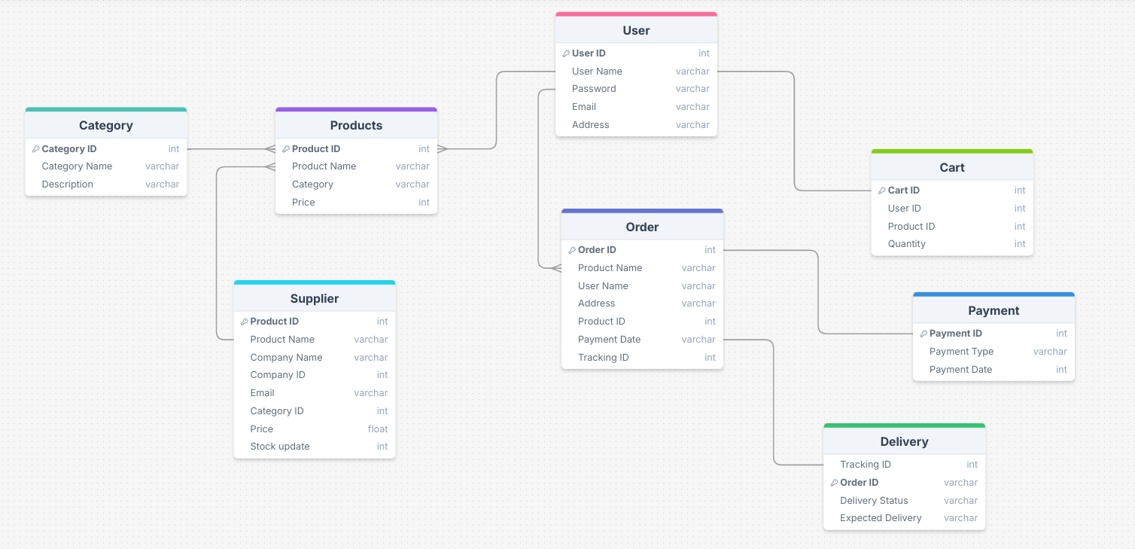

Question 7 – Data Flow Diagram - 3 Marks

What is a data flow diagram? Draw a data flow diagram to represent the in-flow and out-flow of data when a Farmer is placing an order for the product

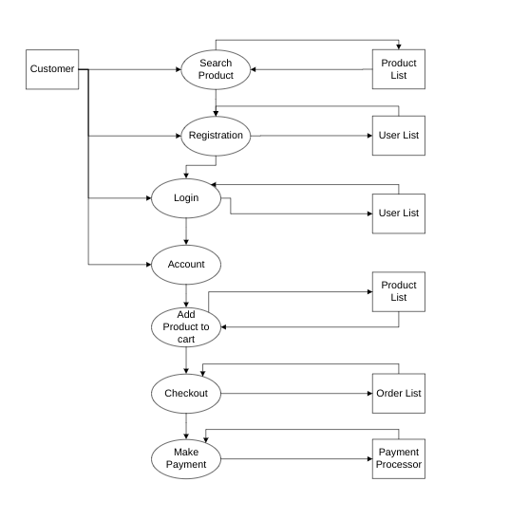

Question 8 – Change Request - 10 Marks

Due to change in the Government Taxation structure . we should change the Tax structure How do you handle change requests in a project?

Answer:

* **Document the Change Request:**
  + Capture the details of the change request in a formal document.
  + Include specific information like the new taxation structure, its implications, and the reason for the change.
* **Assess the Impact:**
  + Perform an **Impact Analysis** to understand how the taxation change will affect:
    - Product pricing.
    - Order totals and invoices.
    - Payment processing and calculations.
    - Database schemas (if tax details are stored).
    - User interfaces displaying price breakdowns.
  + Assess the impact on project timeline, cost, and resource allocation.
* **Stakeholder Communication:**
  + Communicate the change request and its impact to the stakeholders (Mr. Henry, the Committee, APT IT SOLUTIONS team, and other stakeholders).
  + Discuss how the change aligns with project objectives and identify its urgency.
* **Approval Process:**
  + Present the change request and impact assessment to the **Change Control Board (CCB)** or stakeholders for approval.
  + Include Mr. Henry, Mr. Pandu, Mr. Dooku, and other key stakeholders in the decision-making process.
* **Update Project Documentation:**
  + Once approved, update all relevant documentation, such as:
    - **Requirements Document:** Add the new tax structure requirements.
    - **Project Plan:** Adjust the timeline and milestones if necessary.
    - **Design Documents:** Update architecture and UI designs for tax display and calculations.
* **Implement the Change:**
  + Assign tasks to the development team (Java Developers like Ms. Juhi, Mr. Tyson, Ms. Lucie, etc.) to update the system:
    - Modify the database to accommodate new tax rates or structures.
    - Update APIs or backend logic to calculate taxes as per the new structure.
    - Revise the front-end interfaces to display tax details correctly.
  + Ensure the QA team (Mr. Jason and Ms. Alekya) tests all changes thoroughly.
* **Conduct Testing:**
  + Perform regression testing to ensure existing functionalities are not affected.
  + Test the new tax structure under various scenarios (different products, payment methods, locations, etc.).
* **Deploy the Change:**
  + Roll out the changes to the production environment after thorough testing.
  + Ensure the deployment aligns with the project’s release cycle.
* **Monitor and Gather Feedback:**
  + Monitor the system for any post-implementation issues or bugs.
  + Gather feedback from farmers and manufacturers using the platform to ensure the change meets their expectations.
* **Update the Change Log:**
  + Maintain a record of the change request, its approval, implementation, and resolution status for future reference.

Question 9 – Change Request Vs an Enhancement - 5 Marks

As the project is in process, Ben and Kevin have contacted you. The reason is to inform you that they want the Farmers to sell their crop yields through this application i.e. Farmers should be able to add their crop yields or products and display to general public and should be able to sell them. They also want to introduce Auction system for their Crop yields. As a BA, what will be your response?

Is this a change request or an enhancement???

Answer:

1. **Change Request:**
   1. A change request modifies existing project requirements due to external or internal factors (e.g., tax changes, compliance updates, etc.).
   2. It typically involves changes to functionality already defined in the scope.
2. **Enhancement:**
   1. An enhancement introduces new features or functionality that go beyond the originally defined project scope.
   2. It adds value to the project but is not necessary to fulfill the original project objectives.

BA responce to the Enhancement:

1. **Acknowledge the Request:**
   1. "Thank you for sharing these ideas. Enabling farmers to sell their crop yields and introducing an auction system would greatly enhance the platform and provide additional value to the farmers."
2. **Clarify and Document the Requirements:**
   1. Gather detailed information on how Ben and Kevin envision this functionality:
      1. What kind of crops or products can be sold?
      2. Who will be the buyers (public, businesses, or both)?
      3. How will the auction system work (e.g., reserve prices, time limits, bidding increments)?
      4. Payment options for sales and auctions.
      5. How will delivery of crop yields be managed, if at all?
3. **Evaluate Feasibility:**
   1. Conduct an **impact analysis** to assess:
      1. Technical feasibility: Can this functionality be added within the current system architecture?
      2. Budget impact: Does the enhancement fit within the budget of INR 2 crores, or will additional funds be required?
      3. Timeline impact: Can this be achieved within the remaining project duration of 18 months?
4. **Communicate with Stakeholders:**
   1. Present the request as an **enhancement** to Mr. Henry, the SOONY Committee (Mr. Pandu and Mr. Dooku), and APT IT SOLUTIONS (Mr. Vandanam, Mr. Karthik, etc.).
   2. Highlight the benefits and potential challenges (cost, timeline extension, resource reallocation).
   3. Seek formal approval for incorporating the enhancement.
5. **Propose a Plan:**
   1. If approved, update the project scope and reallocate resources accordingly.
   2. If the enhancement significantly impacts the project timeline or budget, propose implementing it as a **phase 2** of the project.

This is an **enhancement** because it introduces new functionalities not originally defined in the scope. It adds significant value to the platform but requires a detailed analysis and approval process to incorporate it effectively.

Question 10 – Estimations - 6 Marks

Come up with estimations – How many Manhours required.

Answer -

* The project duration is **18 months** (~390 workdays) with a **team size** of 11 as mentioned below:
  + 1 Project Manager (Mr. Vandanam)
  + 1 Senior Java Developer (Ms. Juhi)
  + 4 Java Developers (Mr. Tyson, Ms. Lucie, Mr. Tucker, Mr. Bravo)
  + 1 Network Admin (Mr. Mike)
  + 1 Database Admin (John)
  + 2 Testers (Mr. Jason, Ms. Alekya)
  + 1 BA (You)
* As per the case study, the duration of the project is 18 month and the current team team size is around 11 members.
* The team works **8 hours/day**.
* The scope includes building the web and mobile applications.
* The estimated total man-hours for the project are **4,480 hours**, which fits within the 18-month timeline, assuming a well-coordinated and full-time team.

|  |  |
| --- | --- |
| **Category** | **Man-Hours** |
| Development | 2,560 |
| QA & Testing | 480 |
| Design | 480 |
| Deployment | 160 |
| Buffer (20%) | 800 |
| **Total Effort Required** | **4,480** |

Question 11 – UAT – 6 Marks

Project has finally completed all the stages i.e., design, development, testing etc. Now, it is the role of a business analyst to contact the client for testing of the final product and have to successfully complete it. How are you going to handle this situation? And once it is done, what will be the process to close the project?

Explain UAT Acceptance process.

Answer:

As a Business Analyst (BA), our role in facilitating **User Acceptance Testing (UAT)** and ensuring the project closure is critical. Here's is step by step process:

**UAT Planning :**

* **Internal Pre-UAT Testing:** Ensure the product has passed all internal testing phases, including system, integration, and regression testing, with no critical or high-priority issues remaining.
* **Test Environment Setup:** Verify that the UAT environment mirrors the production setup. Ensure all necessary data and configurations are in place.
* **UAT Test Plan:** Collaborate with the client and testing team to prepare a detailed UAT test plan, which includes all the objective of the projects.
* **Access and Training:** Provide access to the UAT environment and offer training/documentation to stakeholders (e.g., farmers, manufacturers) for using the system.

**UAT Testing Execution :**

* **Kickoff Meeting:** Schedule a kickoff meeting with the stakeholders (e.g., Mr. Henry, Peter, Kevin, Ben) to explain the purpose, process, and expectations of UAT.
* **Testing Execution:** Guide the stakeholders as they test the application features(Login, product catalog, search, cart, payment options, order tracking, etc.)
* Capture any feedback, issues, or enhancements they raise during the testing.
* **Issue Tracking:** Use a bug-tracking tool to log issues and monitor their resolution.

Assign critical issues to the development team for immediate fixes and retesting.

**UAT Signoff :**

* **Test Completion Report:**
* Once UAT is complete, prepare a report that details:
  + UAT test cases executed.
  + Pass/fail rates.
  + Outstanding issues (if any) and their resolutions or planned timelines.
* Share this report with the client for review.
* **Sign-Off Document:** Obtain formal UAT sign-off from the client (Mr. Henry and stakeholders) to confirm the product meets their requirements and is ready for deployment.

**Project Closure :**

* **Production Deployment:** Coordinate with the deployment team to release the application to the live production environment.
* Limited period of post deployment support with regard to any issue.
* Final Review meeting with client for project closure and closure report

Question 12 – Project Closure Document - 6 Marks

Explain Project closure document

Answer :

A **Project Closure Document** is a formal document prepared at the end of a project to summarize its outcomes, validate its success, and officially mark its completion. It ensures that all stakeholders agree that the project has met its objectives and that no further work remains under its scope.

1. **Project Overview**: Summary of the project objectives, scope, and stakeholders.
2. **Deliverables**: List of completed deliverables and their statuses.
3. **Performance Metrics**: Overview of budget, timeline, and quality goals achieved.
4. **Project Scope**: Insights and recommendations for future projects.
5. **Outstanding Items**: Any open issues or pending actions.
6. **Sign-Off**: Formal acceptance by the client and key stakeholders.

|  |  |  |  |
| --- | --- | --- | --- |
| **Sr No.** | **Section** | **Details** | **Link** |
| **1.** | **Project Name** | Online Agriculture Products Store |  |
|  | **Project Sponsor** | Mr. Henry (SOONY Company) |  |
|  | **Project Manager** | Mr. Vandanam (APT IT SOLUTIONS) |  |
|  | **Start Date** | Jan 1st 2024 |  |
|  | **End Date** | Oct 30th 2025 |  |
|  | **Budget** | 2 Crores INR |  |
|  | **Scope** | Development of an online store for farmers to purchase fertilizers, seeds, and pesticides. |  |
| **2.** | **Deliverables** |  |  |
|  | - Web & Mobile Application | Fully functional application with login, product catalog, search, payment gateway, and delivery tracking |  |
|  | - Documentation | User manuals, training guides, technical documents |  |
| **3.** | **Performance Metrics** |  |  |
|  | - Budget Utilization | E.g., 95% of allocated budget utilized |  |
|  | - Timeline Adherence | E.g., Project completed within the allocated 18 months |  |
|  | - Quality | E.g., All features implemented and tested with 98% test case success rate |  |
| **4.** | **Project Scope** |  |  |
|  | Communication | Regular client communication helped clarify requirements early. |  |
|  | Testing Process | Early identification of critical bugs during UAT improved delivery quality. |  |
| **5.** | **Outstanding Items** |  |  |
|  | - Post-deployment support | E.g., 30 days warranty period for addressing minor issues |  |
| **6.** | **Sign-Off** |  |  |
|  | Date of sign off |  |  |
|  | Name of resource |  |  |
| **7.** | **Client Acceptance** |  |  |
|  | Name | Client Name - Mr. Henry |  |
|  | Signature |  |  |
|  | Date |  |  |
| **8.** | **Project Manager Approval** |  |  |
|  | Name | Project Manager Name - Mr. Vandanam |  |
|  | Signature |  |  |
|  | Date |  |  |